Student Name: Java Enderson
P Number: 1900968
Programme of Study: Illustration
Module: M4X01560

Task One: Semiotic Analysis (Ryan task) = 461
Task Two: Manifesto (Julia Task) = 517
Task Three. (Jon Task) = 0

Task One:
Semiotics is the instinctive capacity of all living organisms to produce and understand signs (Sebeok, 2001), the ability to arbitrarily connect language and the images and concepts we produce for them, and it is especially important in the modern day when so many images try their hardest to deceive. This ability to deconstruct advertisements, articles, and even pieces of artwork is an incredibly necessary thing, especially if one plans to make sense of what is going on in a world full of fast track media. Most are not actively aware of this hidden “body language” of language that is present in everyday life, but it is very prominent in advertising and media, and indeed is sometimes brought up by meta media that seeks to critique and de-familiarise the things we see so often in media.
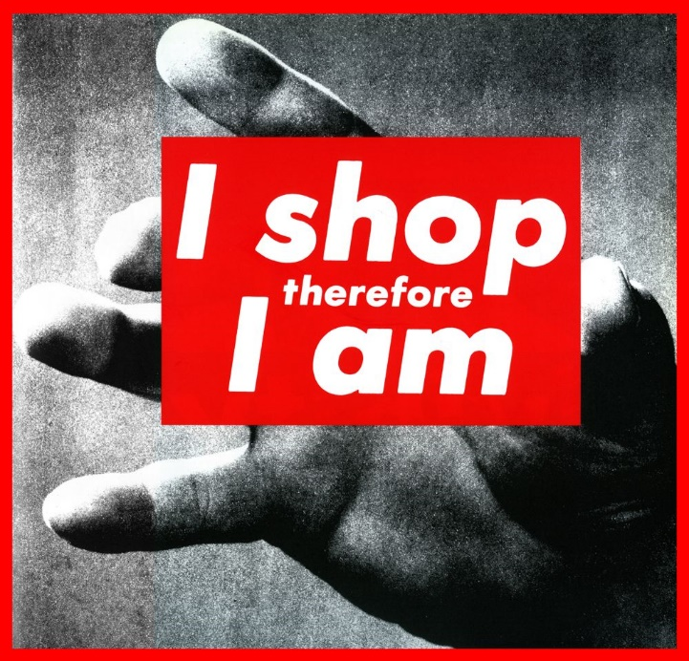

“I shop therefore I am” is a piece of simple and yet culture-critical artwork from the artist Barbara Kruger. The piece of work, and indeed most of her work collectively, focuses on statements boldly presented over greyscale images that at first glance seem to be disconnected from the tagline. In a world where the news and media often supplants information with images (Schecter, 2003) and with subtitles awash with filler content, Kruger’s work displays a stark contrast to the commonly taken-in norm. Her use of bright red suggests a spiteful connection to the biggest, boldest brands (Mcleod, 2016). The placement of the red and white statement in the clutch of a hand sends the subconscious message of treating a concept as a material object, and shows an indication that society has grown to care more and more about only buying the “best” as a way of replacing personality.
Alternatively, Kruger’s piece could be a piece on feminism, and the materialistic and narcissistic narratives that women are expected to lead. As Caitlin Moran says in her book, How to be a Woman (2011) being a woman is expensive, as they are expected to spend as they feel and any woman who cannot fulfil that stereotype is clearly off her rocker. Kruger’s piece is an attempt to rouse women, and indeed the people that put them there, from their vain and expensive lives and to realise what they’ve allowed society to do to them. It is a piece of artwork that represents the growing pandemic of consumerism that is rapidly consuming the elite and those who aspire to also be elite.
In semiotically analysing this piece of work by Barbara Kruger, it has been revealed that semiotics has been manipulated and inserted into said piece in an attempt to influence those who would pay no attention to it otherwise, in a world where media is so fast paced that attempting anything else would almost certainly end in failure.

Bibliography:
Sebeok, T.A. (2001). Signs : an introduction to semiotics. Toronto: University Of Toronto Press.
Schechter, D. (2003). Media wars : news at a time of terror. Lanham, Md. Rowman & Littlefield C.
Mcleod, J. (2016). Colour psychology today. John Hunt Publishing.
Moran, C. (2011). How to be a woman. London: Ebury Press.

‌Task Two:
- A story has an infinite number of endings.
- You must always disregard what your eyes tell you.
- Colour has a bigger voice than the pencils that laid it.
- There is a point in living a lie, but only if that lie is one that can be proven a lie, and only if you announce you are living a lie.
- Sympathy can shatter glass. Empathy can crumble quartz. Understanding can burn diamond.
- Always check if the chains that hold you down can be broken before declaring they can’t.
- Metaphors come before the literal world. Write what you think could exist, not what you are certain does exist.
- Screaming for vanity does not make you a martyr.
- The less people understand you, the more you understand yourself
- Just because two mirrors look the same, does not mean they see the same side of you.

2. You must always disregard what your eyes tell you.
Our eyes are complex, imperfect globules of biological matter. The brain can modify the sensory input it receives to gain a survival advantage, by “correcting” a blurry or unclear image. Sight is the biggest part of modern life, with so much to see and so much to do, so many colours and images and advertisements, but it can fool us. It can trick us, it can show us faux images that represent false realities, images of sorrow made from a boy posing on the beach, or a father cradling his daughter. Someone’s reputation can be crushed by a determined influencer. (Newson, 2016) The world around us cannot be trusted, we have never been able to trust it and yet so much of humanity relies almost entirely on their sight, using their eyes far more than their brains. There is a perceived shame in thinking, there is a shame in backing away from the crowd and tilting your head, shaking it to get out the clouds and numbness.
3. Colour has a bigger voice than the pencils that laid it
‌We often look up to the elite in society, treating them almost as royalty, deciding and decreeing that if we can’t have what they do, we can at least raise them to this forbidden echelon of fame as we wish we could do to ourselves. And that is merely a wish, as we throw out likes and follows and awe at photos posted on numerous websites, merely tap tap tapping away without a care for what they are, and all of society grows depressed as their brains rot. (Desjarlais, 2020) Those people are the pencils, and yet we don’t care what colours they lay. We only care that they’re pencils, that they’re people we can pretend to admire. When they draw, they lay down greys, shades of dark yellow, desaturated and crumbly and barely adhering to the paper. We don’t give thought to those of a brighter tone because we’re far too busy trying to kid ourselves that, hey, stone grey isn’t *that* bad. People refuse to listen to the colours of other people, and this is the mechanism by which intolerance propagates, which I don’t agree with.
9. The less people understand you, the more you understand yourself
Understanding others is useless. If we worry about others too much we destroy relationships. (Powell, 1997) It is unneeded, it is a waste of time. You can enjoy a presence without understanding someone’s goals, you can form a thought about someone without knowing how many times they’ve seen god. And as you purge the personalities of others from your mind, you quarantine your own self off and allow your own personality to develop. As sentient people with the powers of existence and the third dimension at our fingers, we put an awful lot of thought into others, and their atoms, and those who try so hard to understand every person on earth will ultimately fail by stretching their resources so thin so as to not have enough for themselves.
Bibliography:
Powell, T.J. and Sélection Du Reader’s Digest (Canada (1997). Free yourself from harmful stress. Montreal: Reader’s Digest Association (Canada.)
Desjarlais, M. (2020). The psychology and dynamics behind social media interactions. Hershey, Pa: Igi Global, Information Science Reference (An Imprint Of Igi Global.)
Newson, A., Houghton, D. and Patten, J. (2016). Blogging and other social media : exploiting the technology and protecting the enterprise. London: Routledge.

‌Task Three:
N/A (Not clear what’s being asked)
‌

