D

OBVERVIEW

Digital forensics is the process of using scientific concepts and procedures to examine electronically data which help to determine the steps of an event and therefore led to specific incident. It is important in this modern age of digital world for Digital Forensic professionals understand the technical scope to better prepared for the future. In past digital forensics were not known to be this dynamic. In the recent years several plan-of action, instrument and techniques are available dedicated for digital forensic principles. “Digital forensics developed as an independent field in the late 1990s and early 2000s when computer-based crime started growing with the increasing usage of computers and more so, the Internet” (Sriram Raghavan, 2013) The rapid Innovention of analysing and acquire digital evidence from Mutiple sources and tools has comes with challenges in the aspect multiple areas.

The history of digital forensic can be traced back to Hans Gross (1847 -1915), who was the first to introduce scientific examination in criminal investigations. The FBI also played a significant role by establishing a lab in order to provide forensic assistance to law enforcement agencies. One of the earliest recognitions of computer crime occurred in 1978 through the Florida Computer Crime Act. Francis Galton (1982 – 1911) conducted the initial documented investigation on fingerprints, while the term 'Computer Forensics' appeared in scholarly works for the first time in 1992. Subsequently, The International Organization on Computer Evidence was founded in 1995 and later, Regional Computer Forensic Laboratories were established by FBI starting from year 2000 onwards. In 2002, "Best practices for Digital Forensics" handbook was released by Scientific Working Group on Digital Evidence marking another milestone followed by Simson Garfinkel's emphasis on challenges faced during digital investigationsin2010. Overall, the field of digital forensics has a rich history and has evolved significantly over time to address the challenges posed by advances in technology and increasing sophistication of cybercrime.

00:5835:04
What are Digital Forensics? History, Process, Types, Challenges
By: Lawrence Williams
Updated November 4, 2023

00:5835:04

NIST SP800-86 proposes four basic phases for digital forensics process and guidelines, including collection, examination, analysis, and examination digital evidence

Introduction

The purpose of this assignment is to conduct research on digital forensics addressing the history of Digital forensic, current state of the Feild including how digital forensics and cybersecurity intersection. Moreover, this assignment will further discuss the emerging trends of digital forensics and cybersecurity. Key challenges will also be discussed in more details. Furthermore, National and international job market investigated.

- Current state of the field
- Intersection of digital forensics and cybersecurity
- Emerging trends
- Key Challenges
- National and International Job Market

Current state of the field
The current and future state of digital forensic requires more up-to-date tools to combat the ever-involving field. New tactics technique and technologies are needed to facilitate the identification, extraction, analysed and documentation of electronic evidence. As we can see in recent year, Filess Malware, which is stealthy, have abilities to hide itself from detection and using anti-forensic techniques making it very hard for law and forensic investigators professionals. Zero-day vulnerabilities is another serious threat which can be exploited and not detected for weeks, month even years.
Supply Chaing attacks is another challenge in the field since it involves third parties. Makes cybersecurity and digital forensic investigators work very difficult. The emerging of artificial intelligent (AI) and machine-learning (ML) are alternative and current opportunities trending in field field. Yet, 2023 is changing the current and potential future digital forensic and incident response, ChatGPT is one is these examples. AI and machine learning are the shaping the way. Khaitan (2023) argued that Ashish Khaitan highlights the significant impact of these two technologies on digital forensics, emphasizing their ability to enhance evidence collection and processing in real-time.
Furthermore, he notes that these technologies play a crucial role in revolutionizing network traffic analysis. Additionally, Khaitan suggests in the same article that ML algorithms, supported by Intrusion Detection Systems, can facilitate efficient real-time threat detection. (Ashish Khaitan, 2023) However, many other researchers believe that the maturity of these Technolgies still more research to fully integrated into digital forensic and its sensitivities. Nevertheless, some argued that the effectiveness and accuracy these Technolgies on digital images and videos is priceless.
(Dwivedi et al) state that although these technologies offer various advantages and applications, there are also multiple risks associated with their use in digital forensic investigation. Adhering to specific guidelines is essential to maintain the chain of custody and ensure the admissibility of evidence in court. Law enforcement agencies need to thoroughly evaluate the maturity of these technologies. OpenAI recommends exercising caution when employing GPT-4 outputs, particularly in situations where reliability is crucial. In terms of cybersecurity, AI and machine learning play a significant role in identifying anomalies and suspicious activity for uncovering hidden attacks or indicators thereof.
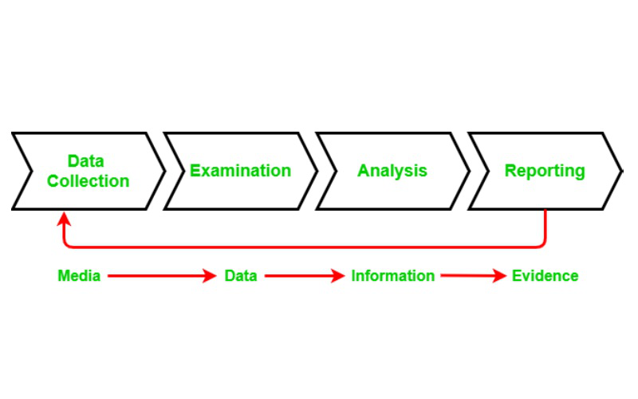

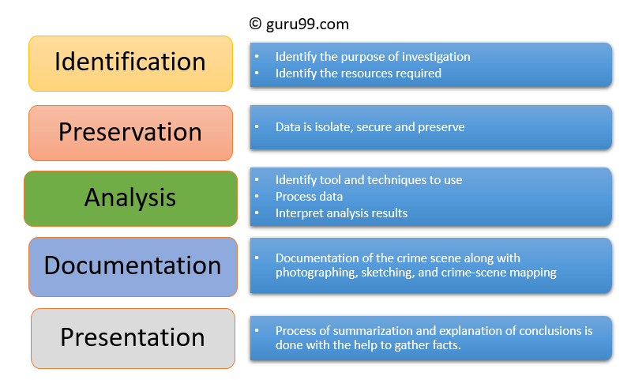

4. Expansion of digital Forensics

Intersection of digital forensics and cybersecurity
Digital forensic is the aftermath of cybercrime. Meaning event will happen after Cyber breach or some short of criminal activities using electronical devise or media. While cybersecurity is the art of preventing, criminals to gain access to unauthorised data. However, cyber security professionals can learn from digital forensic information gathered from the aftermath to better prevent future crimes. The similarities are that they use the same tools, and both focus on protecting data. One preventing and the other is helping to recover that data at some point (Mohammed I. Alghamdi, 2021)
Because digital forensic in a reactive function it mainly focuses on retrieving data from networks, systems devices for investigation. Finding out what took place as well as how far the damages has gone. Also, making sure the source of the incident is detected so how is responsible and how they accomplished it. in other hand, cybersecurity professional is protecting Data from unauthorised person. They do this by using set of tools, polices strategies necessaires to secure and protect networks and systems (Medha Mehta, 2022) approaches might be different, however the teamwork of these two fields working together on threat intelligence and security strategies can be very valuable to an organisation. The information shared and skills set can help to plan for future incidence response and protects the organisation assets.
The intersection of digital forensics and cybersecurity represents a critical area of research where the two fields overlap and complement each other. Here are key aspects to consider in this intersection:
Incident Response and Investigation:
Cybersecurity Perspective: Cybersecurity involves implementing measures to prevent and respond to security incidents.
- Digital Forensics Perspective: Digital forensics is essential for investigating and analysing the aftermath of security incidents to understand their scope, impact, and identify the attackers.
- Evidence Collection and Preservation:
- Cybersecurity Perspective: Cybersecurity focuses on real-time monitoring and prevention.
- Digital Forensics Perspective: Digital forensics emphasizes the systematic collection and preservation of digital evidence for future investigations and legal purposes.
- Threat Intelligence:
- Cybersecurity Perspective: Involves gathering and analysing information about potential threats.
- Digital Forensics Perspective: Uses threat intelligence to enhance the investigation process and understand the tactics, techniques, and procedures of adversaries.
- Malware Analysis:
- Cybersecurity Perspective: Aims to prevent and detect the presence of malware.
- Digital Forensics Perspective: Involves analysing malware post-incident to understand its functionality and how it infiltrated systems.
- Continuous Monitoring:
- Cybersecurity Perspective: Involves real-time monitoring of networks and systems.
- Digital Forensics Perspective: Provides historical data for digital forensics investigators to reconstruct events leading up to and following a security incident.
- Forensic Readiness:
- Cybersecurity Perspective: Involves preparing systems and organizations for potential incidents.
- Digital Forensics Perspective: Focuses on ensuring that digital evidence can be effectively collected, preserved, and analysed when needed.
- Legal Implications:
- Cybersecurity Perspective: Emphasizes compliance with regulations and policies.
- Digital Forensics Perspective: Addresses the legal aspects of evidence collection, ensuring that it is admissible in court.
- Training and Skillsets:
- Cybersecurity Perspective: Requires skills in intrusion detection, vulnerability management, and threat prevention.
- Digital Forensics Perspective: Involves expertise in evidence handling, data recovery, and forensic analysis.
- Collaboration:
- Cybersecurity Perspective: Focused on proactive security measures.
- Digital Forensics Perspective: Often comes into play reactively after an incident but contributes to improving overall cybersecurity strategy.
Understanding and effectively managing the intersection of digital forensics and cybersecurity is crucial for developing comprehensive security strategies, improving incident response capabilities, and ensuring the resilience of digital systems against evolving cyber threats. Researchers in this area contribute to developing tools, frameworks, and best practices that bridge these two disciplines for a more robust cybersec

Emerging trends

With help of artificial intelligent, might need ways to analysed large data because during organised crime investigation, immense volume of devices will be analysed deferent technique is needed to pullout data from these devices. The amount of time this process will take is hug. Research has been conducted to find a generic method to export data and to determine if there is a ‘common export format which would enable the various extract types to be merged for intelligence and evidence analysis purposes’ (Quick, Choo, 2016).
The researchers examined different options to export data in a variety of formats from ‘EnCase, FTK Imager, Cellebrite UFED, MSAB XRY, IEF, Oxygen, and Paraben’. As a result, a volume reduction was observed, from a total of 339.9 GB to 207.6 MB in spreadsheets (CSV, XLS, or XLSX), and to 485.4 MB for XML files, representing the exported and parsed data including contacts, calls, messages, emails, Gmail, web bookmarks, GPS coordinates, and a range of other application information’ (Quick, Choo, 2016).
Mobile devices also are often a valuable source of evidence, as there is a wealth of potential data that can be recovered from them and improve investigation processes by contributing to intelligence analysis in terrorism, child exploitation, drug trafficking, homicide, fraud, computer crime, and other investigations. Even after deletion of data by the owner or third party, certain amount of information (including sensitive) can still be recovered (Blondel et al. 2015).

Key Challenges
According to David Lillis and colleagues, a report from Juniper Research in 2015 estimated that the number of IoT devices had reached 13.4 billion, with an expected increase to 38.5 billion by 2020 (MacDermott, Á. et al., 2020) These IoT devices include smart technologies such as smartphones, smart homes, and cars, which store data either in personal or manufacturer/retailer cloud spaces. As a result, the collection of data for investigations presents challenges.
The IoT has the potential to provide valuable evidence from the physical world; however, it also introduces unique difficulties for digital forensic investigators the field of digital forensics is currently more challenging than ever before. Therefore, no indications that this will change in the near future. The rise of Cloud Forensics and Internet of Things Forensics, coupled with the lack of standardization and restricted tools in the domain, as well as persistent case backlogs within digital forensics have significantly increased challenges for investigators. Storing data in the cloud across multiple devices globally means that investigators must navigate local laws and regulations when collecting evidence, unlike traditional methods where data is collected from a single computer or network. Cross-border investigations involving evidence located in multiple countries present countless unsolved cases due to regulatory frameworks governing access to electronic evidence. Ethical and legal procedures vary between countries regarding how to exchange such evidence, while anti-forensic techniques pose further challenges by disrupting forensic analysis efforts or damaging examination tools (Garfinkel S., 2007; Simson L., 2007).
Additionally, Advanced Persistent Threats and state-sponsored Malware introduce new challenges due to their sophisticated attack techniques. Roussev indicates that creating an embedded help team for a forensic examiner may be one solution to effectively address these issues through global cooperation on laws and frameworks.

Forensic backlogs
The increasing accumulation of unresolved digital forensics cases poses a significant challenge for law enforcement agencies. This challenge extends beyond data collection to encompass the identification and analysis of time-consuming data. For example, a single cyber-crime investigation can yield hundreds of gigabytes of data, making the collection and analysis processes distinct and complex. Timely analysis of collected data presents considerable challenges. Simon Kempton, the technology lead for the Police Federation of England and Wales, emphasised that the consistent number of digital devices awaiting analysis compared to last year.
Reflects investigators. overwhelming workload due to the sheer volume of digital evidence. Law enforcement agencies are finding it difficult to recruit new detectives, resulting in mounting workloads. In 2022 alone, over 20,000 devices await examination in the UK while numerous tablets and smartphones also await inspection across the country

Scalability
This presents a critical issue in the field of digital forensics, particularly concerning scalability and its connection to the volume challenge in digital investigations. Examiners often encounter difficulties due to the quantity and complexity of metadata or sensitive information at a crime scene. The increasing volume and complexity of data or systems, coupled with limited adoption of new technology by experts, contribute to this problem. Furthermore, there is an imbalance between cybercrime incidents and available examiners in the industry, necessitating thorough investigation by every expert. Without adequate resources and efficient processes, digital forensic investigations may struggle to keep up with the growing volume of data and devices that need examination (Cahyani, W, D, N. et al., 2017)

National and International Job Market
The Landscape of Digital Forensics Employment in the United Kingdom
Introduction: The United Kingdom's job market in digital forensics is a dynamic and evolving landscape, reflecting the increasing importance of cybersecurity in various sectors. This essay explores key aspects of the UK job market in digital forensics, shedding light on demand, industry sectors, qualifications, government influence, and networking opportunities.
Demand for Digital Forensics Professionals: The demand for digital forensics professionals in the UK has seen a significant uptick in recent years. As cyber threats become more sophisticated, organizations across industries are recognizing the need for skilled experts capable of investigating and mitigating cyber incidents. This demand is particularly pronounced in sectors such as law enforcement, government agencies, financial institutions, and cybersecurity firms.
Key Industries and Sectors: Digital forensics expertise is sought after in various industries in the UK. Law enforcement agencies leverage digital forensics to investigate cybercrimes, while government organizations prioritize securing sensitive information. Financial institutions engage digital forensics professionals to combat financial fraud, and cybersecurity firms rely on their skills to fortify defenses against cyber threats. The private sector, including corporations of all sizes, increasingly integrates digital forensics into risk management and incident response strategies.
Qualifications and Certifications: In the competitive UK job market, qualifications and certifications play a pivotal role. Employers often seek candidates with relevant academic backgrounds, such as degrees in cybersecurity, computer science, or digital forensics. Certifications like Certified Digital Forensics Examiner (CDFE), Certified Cyber Forensics Professional (CCFP), and others are highly regarded, providing tangible evidence of practical skills and knowledge.
Government Initiatives and Regulations: The UK government's commitment to cybersecurity is reflected in various initiatives that influence the job market. National cybersecurity strategies and collaborations between public and private sectors create an environment conducive to the growth of digital forensics roles. Compliance with government regulations and adherence to legal frameworks are crucial aspects of digital forensics work, adding a layer of complexity to the profession.
Networking Opportunities: Networking is a key element in navigating the digital forensics job market. Professionals in the UK can engage in networking events, conferences, and industry-specific meetups to build connections. Online platforms like LinkedIn provide avenues for virtual networking, allowing individuals to stay informed about industry trends, job openings, and collaborative opportunities.
Conclusion: The United Kingdom's job market in digital forensics presents a promising landscape for professionals in the cybersecurity domain. With a growing demand for expertise, particularly in law enforcement, government, finance, and the private sector, individuals equipped with the right qualifications and certifications can carve out successful careers. Government initiatives, coupled with a proactive approach to networking, contribute to the resilience and adaptability required in this fast-paced field. As technology continues to advance, the role of digital forensics professionals

report titled "Global Digital Forensics Market 2018 - 2025" projects that the digital forensics market is expected to reach $7 billion by 2025, a significant increase from the reported $3 billion in 2017. With an expanding reliance on connected devices by both companies and general consumers, the risk of falling victim to cybercrime has also grown. (Du, X. et al., 2020) The study suggests that approximately half of the world's population engages with some form of digital device on a daily basis. As the global population grows and technology becomes more accessible at lower costs, it is anticipated that cybercrime will rise, presenting new challenges for security professionals. Encouragingly, there are several emerging technologies showing promise in assisting digital forensic investigators.
in safeguarding digital assets and investigating cyber incidents is likely to become even more prominent in the UK job market

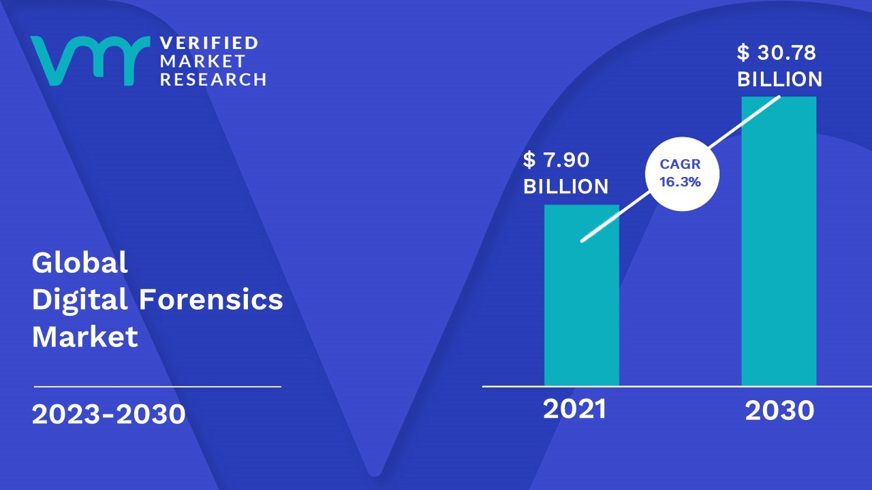

Open-source vs Commercial forensic tools, review
in the context of forensic tools typically refer to methods or procedures for analyzing and examining evidence in criminal investigations. Forensic tools, whether open-source or commercial, are essential for digital forensics, which involves the collection, analysis, and preservation of electronic evidence. Here's a comparison between open-source and commercial forensic tools:

Open-Source Forensic Tools:
Pros:
Cost: One of the primary advantages of open-source tools is that they are usually free to use. This can be particularly beneficial for smaller organizations or individuals with budget constraints.
Community Support: Open-source tools often have a community of users who contribute to their development and maintenance. This can lead to a more rapid identification and resolution of issues, as well as continuous improvements.
Transparency: Users can inspect the source code of open-source tools, ensuring transparency and allowing them to understand how the tool works. This transparency can be crucial for establishing trust in the tool's reliability and security.
Customization: Users have the ability to modify open-source tools to meet their specific needs. This can be important in forensic investigations where unique challenges or requirements may arise.
Cons:
Learning Curve: Open-source tools might have a steeper learning curve for users who are not familiar with the specific tool or the command-line interface.
Documentation: Documentation for open-source tools may not be as comprehensive or user-friendly as that provided by commercial tools.
Integration: Some open-source tools may lack integration with other forensic tools or may not provide as seamless interoperability as commercial solutions.

Commercial Forensic Tools:
Pros:
User-Friendly Interfaces: Commercial tools often come with user-friendly interfaces, making them more accessible to investigators with varying levels of technical expertise.
Comprehensive Support: Commercial tools typically offer comprehensive technical support, including regular updates, bug fixes, and training resources. This can be crucial for organizations that need reliable and up-to-date solutions.
Integration: Many commercial forensic tools are designed to integrate seamlessly with other tools and platforms, providing a more cohesive and efficient workflow.
Advanced Features: Commercial tools often come with advanced features and capabilities that may not be present in open-source alternatives. This can be especially important for handling complex forensic investigations.
Cons:
Cost: The most significant drawback of commercial tools is the cost associated with licensing and support. This can be a barrier for smaller organizations or individuals with limited budgets.
Closed Source: Commercial tools are usually proprietary, and their source code is not available for inspection. This lack of transparency can be a concern for some users in terms of trust and security.
Dependency on Vendor: Users of commercial tools are dependent on the vendor for updates, bug fixes, and new features. If the vendor discontinues support or goes out of business, it can pose challenges for ongoing investigations.
In summary, the choice between open-source and commercial forensic tools depends on various factors, including budget, user expertise, specific case requirements, and the level of support needed. Some organizations may choose a combination of both to leverage the benefi

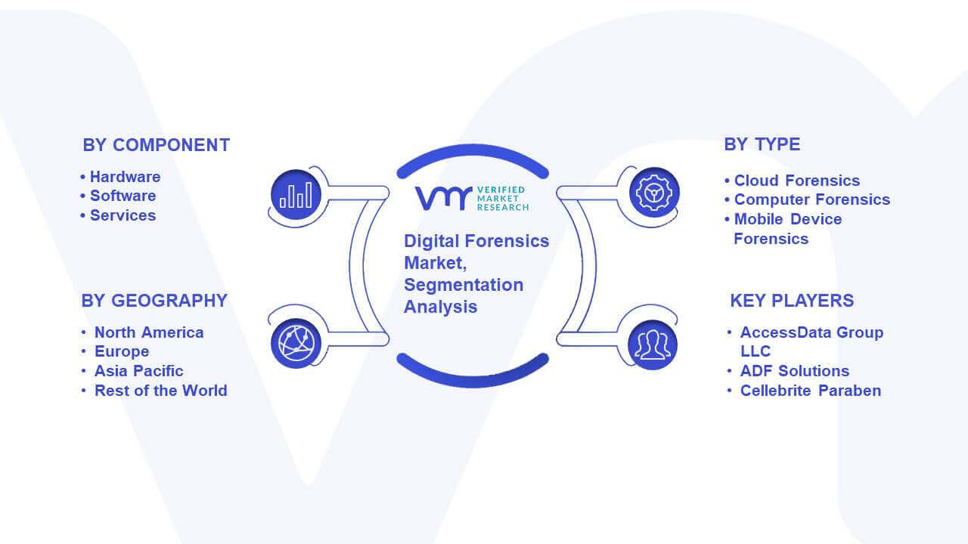

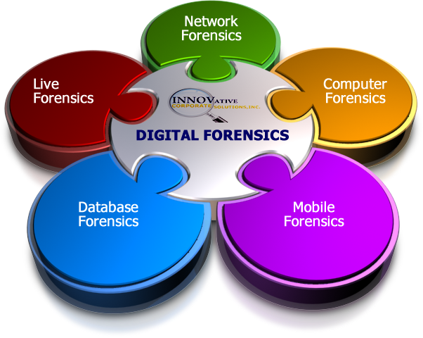

([PDF] Breaking the Performance Wall: The Case for Distributed Digital Forensics | Semantic Scholar, 2017)

(Roussev V., 2016)

Provacy issues

The main focus of this type of issue is privacy. In simple words, in most cases,
experts need to disclose the private data or information related to an organization
and a person to found the real truth. 60% of the individual users and 77% of the
enterprises (medium, small & big) produce private confidential information and
data in their daily uses and this type of information may be risky for them if the
40
Current Challenges of Digital Forensics in Cyber Security
information or data gets disclosed publicly or to attackers. So, this is an issue for
forensic examiners and court because it is very difficult to maintain privacy.

interrelation is there.

Different Data Protocols: Securing Sensitive Data vs Retrieving Lost Data
In cyber security, professionals work to make sure that sensitive and/or proprietary information is always kept secure.
This is done by system analysts and engineers^{[8]} working together to develop systems that prevent unauthorized access, defend against hacking attempts, and monitor overall system security.

Emerging trends

x and large amount of information that requires intelligent analysis and computing. For this purpose, artificial intelligence (AI) has become a well-established and crucial domain of latest computer science, which has the ability to tackle sophisticated and computationally large problems in real-time

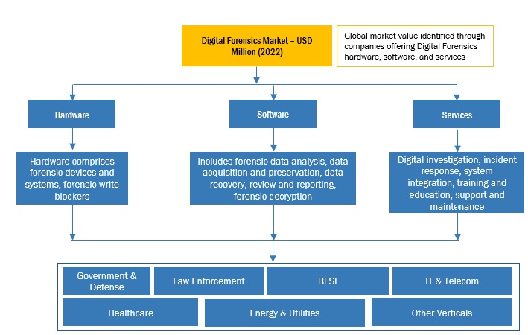

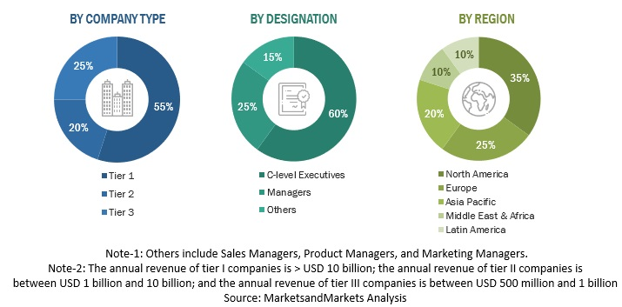

Job market



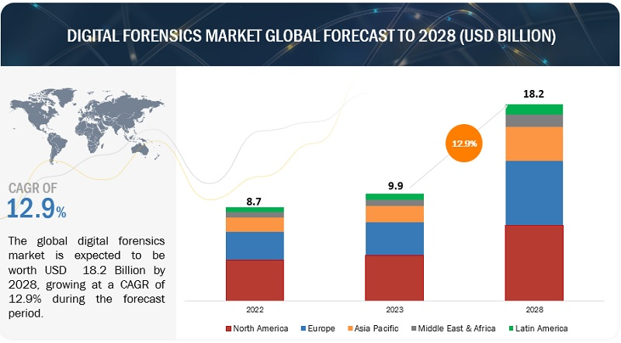

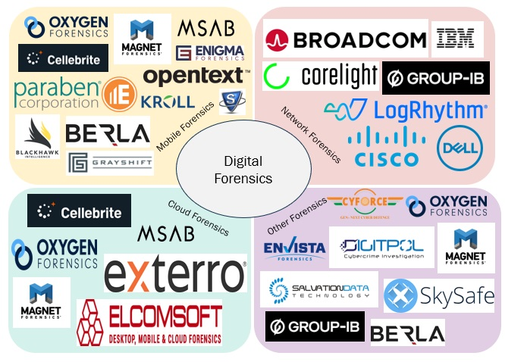

Recommendation: For Open-source vs Commercial forensic tools, review the tools you used in this course with equivalent open-source tools. In-text cite academic credible literatures, relevant Industry reports/ specifications. Discussion from a generic forum will not be considered credible.
Word Limit: 1500 words

(PDF) Digital Forensics Investigation Jurisprudence: Issues Of Admissibility Of Digital Evidence. Available from: https://www.researchgate.net/publication/342706049_Digital_Forensics_Investigation_Jurisprudence_Issues_Of_Admissibility_Of_Digital_Evidence#fullTextFileContent [accessed Nov 19, 2023].
(PDF) Digital Forensics Investigation Jurisprudence: Issues Of Admissibility Of Digital Evidence. Available from: https://www.researchgate.net/publication/342706049_Digital_Forensics_Investigation_Jurisprudence_Issues_Of_Admissibility_Of_Digital_Evidence#fullTextFileContent [accessed Nov 19, 2023]

Cellebrite’s 2022 Industry Trends Survey for Law Enforcement which found that:
- 51% of surveyed examiners agreed that case backlogs climbed in the past year
- 49% of investigators defined themselves as being either average or
HOW DEVICE BACKLOGS AND LACK OF DIGITAL FORENSIC EXPERTISE ARE CAUSING LAW ENFORCEMENT TO OUTSOURCE DIGITAL FORENSICS

How Device Backlogs and Lack of Digital Forensic Expertise are Causing Law Enforcement to Outsource Digital Forensics October 26, 2022 | Albert Robinson
https://www.guru99.com/digital-forensics.html

Growth of cloud-based digital forensics

Greater emphasis on mobile device forensics

Current Challenges and F ent Challenges and Future Resear e Research Areas for Digital eas for Digital Forensic Investigation David Lillis School of Computer Science, University College Dublin, Ireland, david.lillis@ucd.ie Brett A. Becker School of Computer Science, University College Dublin, Ireland, brett.becker@ucd.ie
https://commons.erau.edu/cgi/viewcontent.cgi?article=1346&context=adfsl

https://thecyberexpress.com/top-5-trends-for-digital-forensics-in-2023/

https://www.verifiedmarketresearch.com/product/digital-forensics-market/

https://thecyberexpress.com/top-5-trends-for-digital-forensics-in-2023/
Top 5 Trends For Digital Forensics in 2023
Digital forensics is critical in investigating and prosecuting digital crimes and protecting organizations and individuals from cyber threats.
by Ashish Khaitan

April 9, 2023 - Updated on June 26, 2023
https://www.marketsandmarkets.com/Market-Reports/digital-forensics-market-230663168.html

(Abel Yeboah-Ofori's, 2022) For digital evidence to appear at court and be legally admissible, the evidence must be authentic, accurate, complete, and convincing to the jury. https://www.researchgate.net/publication/342706049_Digital_Forensics_Investigation_Jurisprudence_Issues_Of_Admissibility_Of_Digital_Evidence#fullTextFileContent
Digital Forensics Investigation Jurisprudence: Issues Of Admissibility Of Digital Evidence
May 2020
10.24966/FLIS-733X/100045
Abel Yeboah-Ofori's

C. Beek, T. Dunton, S. Grobman, M. Karlton, N. Minihane, C. Palm, et al., Mcafee Threat Report, June 2018

Cyber Crime Costs Projected to Reach \$2 Trillion by 2019, [online] Available: https://www.forbes.com/sites/stevemorgan/2016/01/17/cyber-crime-costs-projected-to-reach-2-trillion-by-2019/.

https://ieeexplore.ieee.org/document/6641058?denied=
Emerging trends in Digital Forensic and Cyber security- An Overview

(PDF) Current Challenges of Digital Forensics in Cyber Security (researchgate.net)
Chapter 3
Current Challenges of Digital
Forensics in Cyber Security Abhishek Kumar Pandey, Mohd. Waris Khan
Et al

Crime Science & Intelligence: Mobile Devices And Digital Forensic Intelligence Analysis (crimesciencenow.blogspot.com)

Quick, D., Choo, K.R. (2016). Pervasive social networking forensics: Intelligence and evidence from mobile device extracts. Journal of Network and Computer Applications, 86, 24-33.
Statista (2016). Most popular global mobile messenger apps as of April 2016, based on number of monthly active users (in millions). Retrieved from: http://www.statista.com/statistics/258749/most-popular-global-mobile-messenger-apps/.

By Kristina V

Current Challenges of Digital Forensics in Cyber Security

https://cellebrite.com/en/how-device-backlogs-and-lack-of-digital-forensic-expertise-is-causing-law-enforcement-to-outsource-digital-forensics/

How to Combat the UK's Growing Forensics Backlog
Posted by Toby Marriott on February 6, 2023

https://www.adfsolutions.com/news/how-to-combat-the-uks-growing-forensics-backlog#:~:text=For%20example%2C%20a%20single%20cyber,prosecution's%20case%20against%20the%20offender.

Cyber Security and Digital Forensics: What’s the Difference? - InfoSec Insights (sectigostore.com)

Cyber Security and Digital Forensics: What’s the Difference? 2022
Medha Mehta

Estrela, V. & Estrela, Vania & Kanna, Kavita & Rodrigues, Joel & Rodrigues, Joel. (2021). Cybersecurity and Digital Forensics. Download citation of Cybersecurity and Digital Forensics (researchgate.net)

https://www.geeksforgeeks.org/digital-evidence-collection-in-cybersecurity/
Digital Evidence Collection in Cybersecurity

https://www.devry.edu/online-programs/area-of-study/cyber-security/computer-forensics-vs-cybersecurity.html#computer-forensics
What Is the Difference Between Computer Forensics and Cyber Security?

file:///C:/Users/PC/Downloads/Digital_Forensics_in_Cyber_Security-Recent_Trends_.pdf
Digital Forensics in Cyber Security—Recent Trends, Threats, and Opportunities Mohammed I. Alghamdi December 2021

https://www.linkedin.com/pulse/digital-forensics-market-size-current

Digital Forensics Market Size, Current Insights and Demographic Trends 2023-2031

“Mobile Forensics: Advances, Challenges, and Research Opportunities.”

https://www.computer.org/csdl/magazine/sp/2017/06/msp2017060010/13rRUx0xPSh
Recent Advancements in Digital Forensics

Wojciech Mazurczyk, Warsaw University of Technology
Luca Caviglione, National Research Council of Italy
Steffen Wendze

https://link.springer.com/chapter/10.1007/978-3-031-40118-3_8

Assessing Current and Emerging Challenges in the Field of Digital Forensics
- Zaryab Baig &
- Reza Montasari
- Chapter
- First Online: 12 September 2023

Digital forensic research: current state of the art | CSI Transactions on ICT (springer.com)

Digital forensic research: current state of the art

Digital forensic research: current state of the art
- Original Research
- Digital forensic research: current state of the art
- Original Research
- Published: 13 November 2012
- volume 1, pages91–114 (2013)
- Published: 13 November 2012
- volume 1, pages91–114 (2013)
M. Vangeti, S. K. Yadav and V. Pinnti, “Advantages of Internet of Things (Iot) For Developing Smart Services in Manufacturing Business,” Purakala with ISSN 0971-2143 is an UGC CARE Journal, vol. 31, no. 25, pp. 62-68, (2020).

] O. M. Adedayo, “Big data and digital forensics.,” In 2016 IEEE International Conference on Cybercrime and Computer Forensic (ICCCF). IEEE., pp. 1-7, (2016).

] S. Raghavan, “Digital forensic research: current state of the art.,” CSI Transactions on ICT, vol. 1, no. 1, pp. 91-114, (2013)

E. A. Vincze, “Challenges in digital forensics. Police Practice and Research,” vol. 17, no. 2, pp. 183-194, (2016).

European Union Agency for Criminal Justice Cooperation. Detailed description in Cybercrime Judicial Monitor n.6. https://www.eurojust.europa.eu/sites/default/files/Documents/ pdf/cybercrime_judicial_monitor_issue_6_2021.pdf.

https://www.sciencedirect.com/science/article/pii/S266628172300121X
ChatGPT for digital forensic investigation: The good, the bad, and the unknown

Buchanan, 2023
W.J. Buchanan
Network forensics
URL:https://asecuritysite.com/forensics (2023) Google Scholar CVE, 2014
C
CVE record | CVE-2014-0160 URL:https://www.cve.org/CVERecord?id=CVE-2014-0160 (2014) Google Scholar

Devlin et al., 2019
J. Devlin, C. Ming-Wei, L. Kenton, K. Toutanova
Bert: pre-training of deep bidirectional transformers for language understanding
Proceedings of Annual Conference of the North American Chapter of the Association for Computational Linguistics, NAACL-HLT) (2019), pp. 4171-4186

Du et al., 2021
X. Du, C. Hargreaves, J. Sheppard, M. Scanlon
TraceGen: user activity emulation for digital forensic test image generation
Forensic Sci. Int.: Digit. Invest., 38 (2021), Article 301133,

Scanlon et al., 2023
M. Scanlon, B. Nikkel, Z. Geradts
Digital forensic investigation in the age of ChatGPT
Forensic Sci. Int.: Digit. Invest., 44 (2023), Article 301543,

Thorp, 2023
H.H. Thorp
ChatGPT is fun, but not an author
Science, 379 (6630) (2023), 10.1126/science.adg7879
313–313



