Design and conduct a research study to explore the effect of neuroticism on memory for emotion-induced stimuli

Abstract
Research into personality traits and memory has stemmed far into the past and into the present. Neuroticism is one of these traits and has experienced researchers’ attention and its relationship with memory. Two opposing sides drive the notion that high levels of neuroticism on its own is enough to affect one’s memory, whilst another suggests that a combination of low neuroticism and high levels of positive personality traits may affect one’s ability to recall information. The current study seeks to investigate this debate using a three-way ANOVA study. Our results suggested that the relationship between Neuroticism and memory is null.

Introduction
Memory and emotion have shown to be equally complex functions within the brain (Buchannon, 2017). For instance, a large number of highly neurotic participants have reported that their memory possesses a poor quality. However, upon completing a series of memory recall tasks, it was found that the only correlation that could be made was not between the participant pool’s levels of neuroticism and memory, but instead with their perceived ability to recall (Buchannon, 2017). In contrast to this finding however, a study conducted by Luchetti et al. (2021) found that within his participant pool of over seventy thousand individuals hailing from twenty-seven different countries, memory recall performance was found to be much higher in individuals with low levels of neuroticism and high levels of openness and extraversion. Therefore, it is clear that the topic of memory and neuroticism being interconnected is a question still being debated.
But why is this the case? Why is it that this phantom link between neuroticism and memory is so divisive? The emerging suggestion is that the prior literature omits a fundamental factor from its research, that being emotion. Previously, researchers such as Areh (2008) attempted to analyse the accuracy of eyewitnesses’ memories with personality traits being the sole variable in mind, most notably neuroticism. However, the researcher’s results were found to be rather weak. Although he was able to find a small correlation both in men and women. However due to these participants reviewing video footage, a lack of emotional stimulation can be assumed and thus the link between said weak results and this variable may be implied.
Moreover, different memory recall tasks have been designed and utilised over the period, from watching video footage and being asked to recall particular elements of information (Areh, 2008), to spatial memory tasks like the SWM (Saylik et al., 2018). Yet once more, emotion has yet to be implemented as a variable within this research. It wouldn’t be until close to the present years, that researchers began to consider the efficiency of personality traits. For instance, Luchetti et al. (2021) found that elderly participants were much more likely to recall information if they possessed high levels of conscientiousness and low neuroticism.
It is with this idea in mind that we developed the hypothesis that an emotional stimuli may play a part in affecting one’s memory, based on their own personality type (John et al., 1991). In order to investigate this idea, a study was constructed in which, participants were asked to recount as many words from three separate lists as they possibly could. Each list was linked to a state of mind, such as positivity, negativity, and neutrality. For the basis of keeping our research concise, we narrowed our selection of personality traits down to Neuroticism alone, and initially believed that our results would suggest that the higher the level of neuroticism a participant would possess, the more likely it would be that they would most efficiently recall the words pertaining from the negative induced list compared to the other two.

Method
Participants
Thirty-two participants in total took part in this study, with a gender split of twenty-one females and eleven males. The mean average age of our focus group was 30.16, and the split between high neuroticism and low neuroticism was 15/17 (47% to 53% respectively). Thus, granting us with a slight disparity with the high neuroticism group outnumbering the low group.
Design
The study was made up of two sequences. The first half of the study involved our participant pool completing John et al.s’ (1991) Big Five Inventory questionnaire on Qualtrics. The second half of the study was conducted on Super Labs, in which each participant was asked to recall three sets of words, each relating to a particular emotion following a distractor task. Only once these steps were completed, were their neuroticism levels compared to their progress within the recollection task via an ANOVA test.
Materials
The primary material utilised within this study was the Big Five Inventory (John et al., 1991; 2008) via Qualtrics. Due to the study’s focus on neuroticism, only eight questions were necessary for the study. Aside from this fundamental piece, we were also granted a list of words which served an emotive purpose for positivity, negativity, and neutrality, which were viewed via a SuperLabs experiment.
Procedure
The experiment initially proceeded with the participants signing a consent form as well as a demographic sheet. From there, they were presented with the Big Five Questionnaire (John et al., 1991; 2008) on Qualtrics. After answering the questions via a Likert scale spanning 1-5, they were then instructed to memorise as many words as possible from a computer screen displaying each word at a one second interval. After finishing a single emotive segment, they were then given a distractor task lasting one minute, before being asked to write down as many of the displayed words as they could remember. This process was then repeated another two times for the other emotive lists.
Afterwards, the participants’ data were compiled, reversed when needed, and then being out through a reliability test. From there, the results were converted into mean scores in order to sort the participants into high and low groups with regards to their neurotic levels. An ANOVA test was then conducted through SPSS in order to gauge whether there was a correlation between Neuroticism level and capacity to remember emotion inducing words.

Results
A 2 x 3 mixed design ANOVA test was executed in order to investigate whether there was a correlation between the level of neuroticism (High/Low) and the capability to remember emotion induced words (Positive/Negative/Neutral). The correlation between the two variables were found to be non-significant, F (2, 60) = .89, P > .05 (= .42), NP = .03. Despite this, there was a significant finding related to the participants’ recollection towards the diversity of the emotionally induced words (F (2, 60) = 8.22, P < .05, (= .001), NP = .22), as well as a difference therein the separate groups of participants (F (1, 30) = 6.45, P < .05 (= .02), NP = .18).

Discussion
The results above imply that our original hypothesis was incorrect. Instead, our null hypothesis was accepted due to finding a lack of relationship between the level of neuroticism and the total emotionally induced words recalled. With regards to our participant pool, it was apparent that the threshold between high and low neurotic groups was miniscule. With the mean average score of 3.18, our participants were evenly split between the two groups, with the high neurotic group outnumbering the low group by two. Even with this small disparity, we found that the number of words remembered within the participant group were evenly distributed. It is with this information in mind, that we our inclined to support the notion that neuroticism on its own is not a powerful enough variable to effect one’s memory (Buchannon, 2017).
As whilst it is apparent that high levels of neuroticism may affect one’s confidence in their own memory (Buchannon, 2017), it is clear from active memory tasks conducted in the past, such as the forward digit span activity, high neurotic individuals were equally as capable in performing well during testing as their low neurotic counterparts. In addition to this Xu (2023) observed from prior research that neuroticism itself had no negative effects on memory or multi-tasking. However, during the latter years of life, they found that the overall speed of high neurotic participants was affected. Although, it should be mentioned that at no point was it mentioned that the participants’ memory efficiency was ultimately affected, thus implying that neuroticism is too weak a variable to dictate memory efficiency on its own.
It is with this in mind that the focus shifts to the plausibility that neuroticism is one of many personality traits working in tandem of one another. For instance, Luchetti et al. (2021) found that within seventy-one thousand participants from twenty-seven countries in Europe. With a mean age of sixty-seven, the researchers found that these elderly individuals were much more likely to efficiently recall information from their tasks if they possessed low level of neuroticism as well as high levels of extraversion and conscientiousness. Moreover, Stephen et al. (2020) supports this view as they too found that in younger participants with higher levels of extraversion and lower levels of neuroticism were much more likely to successfully recall the information required for the task within the meta-analysis. Therefore, it can be supported that the notion that the level of neuroticism alone is not enough to affect an individual’s memory, even with the added variable of the emotion induced words from our own study.
However, whilst this theory appears plausible, it should be mentioned that many studies have been published which contradict the established hypothesis. For example, Socan and Bacik (1998) found that high levels of neuroticism can affect an individual’s ability to process information at an equally efficient rate compared to individuals with low levels of the same personality trait. Moreover, Saylik et al. (2018) further supports this idea, as they discovered that high neurotic individuals were more likely to perform poorly on working memory tasks when required to alter their inhibitions, thus providing an argument that neuroticism could have an effect on memory after all.
When taking these two sides of the debate into consideration it is apparent that one side is much stronger than the other. For instance, the theory that Neuroticism alone is enough to affect one’s memory is precarious for two primary reasons. The first is that Socan and Bacik (1998) suffers from a lack of recency, compared to studies like Buchannon (2017), thus calling into the question the validity of the study’s results as we as a species are subject to change and adapt. Furthermore, the second issue lies in Saylik et al.’s (2018) study, which whilst providing an implication towards the notion that high neuroticism may affect one’s adaptability. It ultimately fails to confirm whether the personality trait affect one’s memory processes on a general scale.

Conclusion
To summarise this debate, it is apparent that over the years of research, the relationship between emotionally induced memory and level of neuroticism has been recontextualised. From Socan and Bucik’s (1998) initial findings supporting the idea that the relationship between the two variables is significant and negative, to the more recent years, such as Buchannon (2017) and Luchetti’s (2021) studies, in which they perceive the relationship between the two variables to be much more complex, with alternative personality traits such as extraversion and openness playing a more in-depth role in the primary focus of the current study. Speaking of which, whilst researching for the study at hand, it grew rather apparent that the research into the relationship between neuroticism and an emotionally induced stimuli was shown to be niche and barring on none. With this in mind, it proven to be difficult to secure precise information for this study, and thus, were forced to expand our search outwards in order to garner some knowledge about the relationship between the two variables and our shifting understanding. Between the two sides of understanding it was clear that Areh’s (2008) and Socan and Bucik’s (1998) was much weaker as their results were found to be inconclusive and refutable. In contrast, whilst our own study resulted in the acceptance of a null hypothesis, we were able to find through research that Neuroticism on its own was not enough to affect one’s memory. Instead, it is much more plausible that a combination of low neuroticism and high levels of openness and conscientiousness possesses a more definitive explanation.

References

Buchannon, T. (2017). Self – assessments of memory correlate with neuroticism and conscientiousness, not memory span performance. Personality and Individual Differences. Vol. 105 (1). 19 – 23. https://doi.org/10.1016/j.paid.2016.09.031

Xu, T. (2023). Examining the link between personality traits, cognitive performance, and consecutive interpreting. Eprints Repository

Saylik, R., Szameitat, A.J., & Cheeta, S. (2018). Neuroticism related differences in working memory tasks. PLoS ONE. 18(12). 1 – 15. https://doi.org/10.1371/journal.pone.0208248

John, O. P., Donahue, E. M., & Kentle, R. L. (1991). The Big Five Inventory--Versions 4a and 54. Berkeley, CA: University of California, Berkeley, Institute of Personality and Social Research.

John, O. P., Naumann, L. P., & Soto, C. J. (2008). Paradigm shift to the integrative Big Five trait taxonomy: History, measurement, and conceptual issues. In O. P. John, R. W. Robins, & L. A. Pervin (Eds.), Handbook of personality: Theory and research (pp. 114-158). New York, NY: Guilford Press.

Luchetti, M., Terracciano, A., Stephen, Y., Aschwanden, D., & Sutin, A.R. (2021). Personality traits memory: A multilevel analysis across 27 countries from the survey of health, aging, and retirement in europe. Psychological science. 32(7). 1047 – 1057. https://doi-org.ezproxy.uwtsd.ac.uk/10.1177/0956797621993101

Areh, I. (2008). Connection between Eyesenck’s personality traits and memory recall. Psiholoska obzorja. 17(3). 75 – 92. https://doaj.org/article/b5b387a8adcb420cb740b5ddc2a0ca40

Stephen, Y., Sutin, A.R., Luchetti, M., & Terraciano, A. (2020). Personality and memory performance over twenty years: Findings from three prospective studies. Journal of psychosomatic research. 128(1). 109885 – 109885. https://doi.org/10.1016/j.jpsychores.2019.109885

Rahmen, M.S. (2017). Does personality matter when we are sick? An empirical study of the role of personality traits and health emotion in healthcare technology adoption decision. Proceedings of the 50th Hawaii international conference on system sciences. https://scholarspace.manoa.hawaii.edu/server/api/core/bitstreams/24f3bedd-d238-48c9-a369-77c693ecfe7c/content

Socan, G. & Bucik, V. (1998). Relationship between speed of information-processing and two major personality dimensions – Extraversion and Neuroticism. Personality and Individual Differences. 25(1). 35 - 48. https://doi.org/10.1016/S0191-8869(98)00031-2

Appendices
1.1

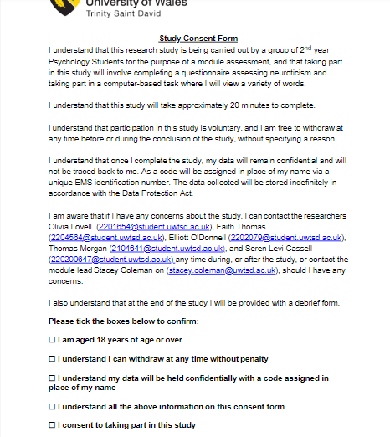

1.2
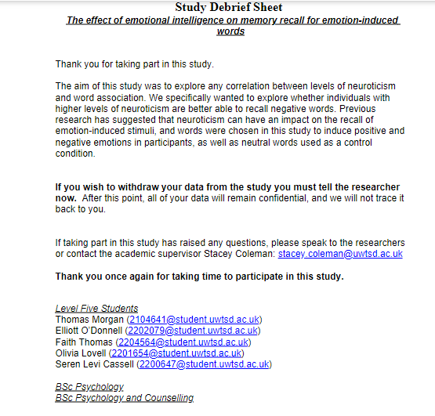

2.1

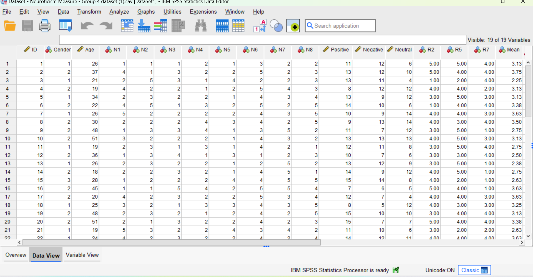

2.2
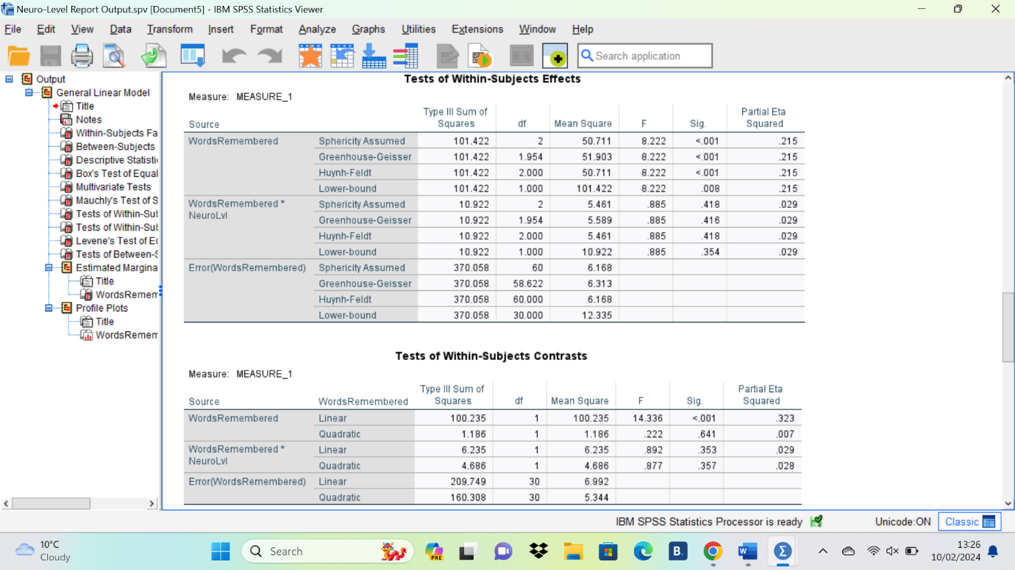

2.3
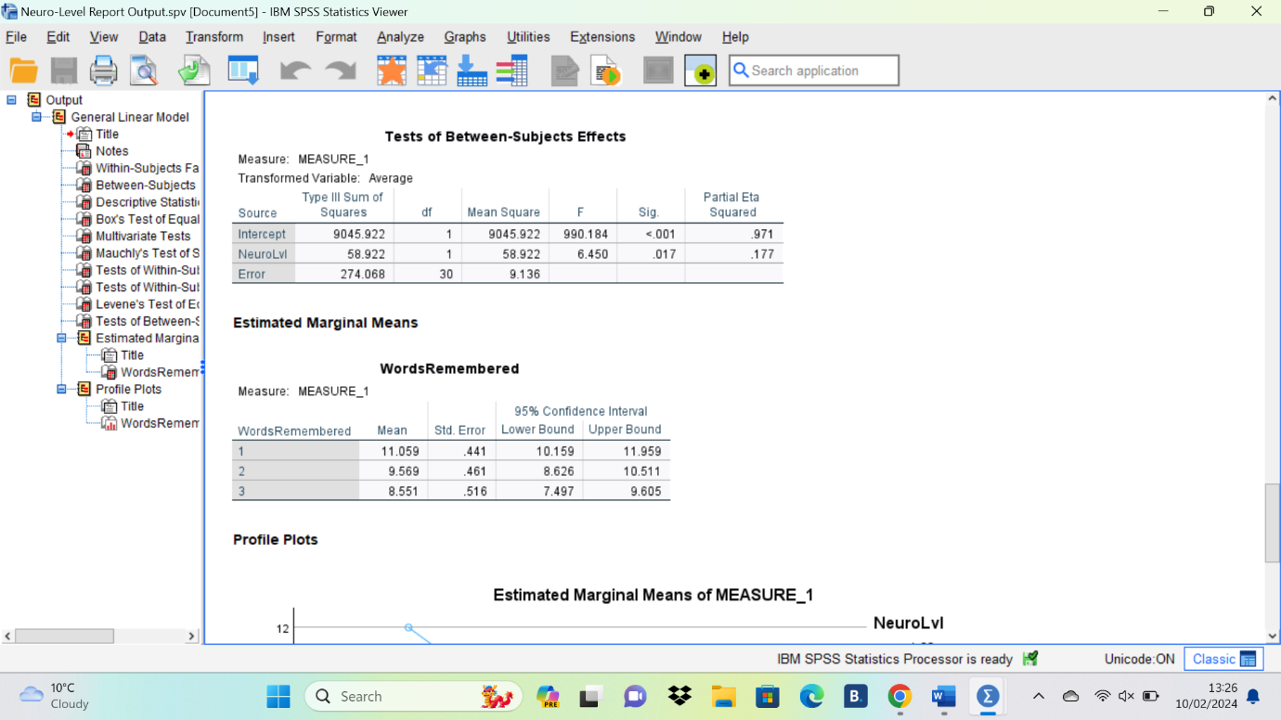

2.4
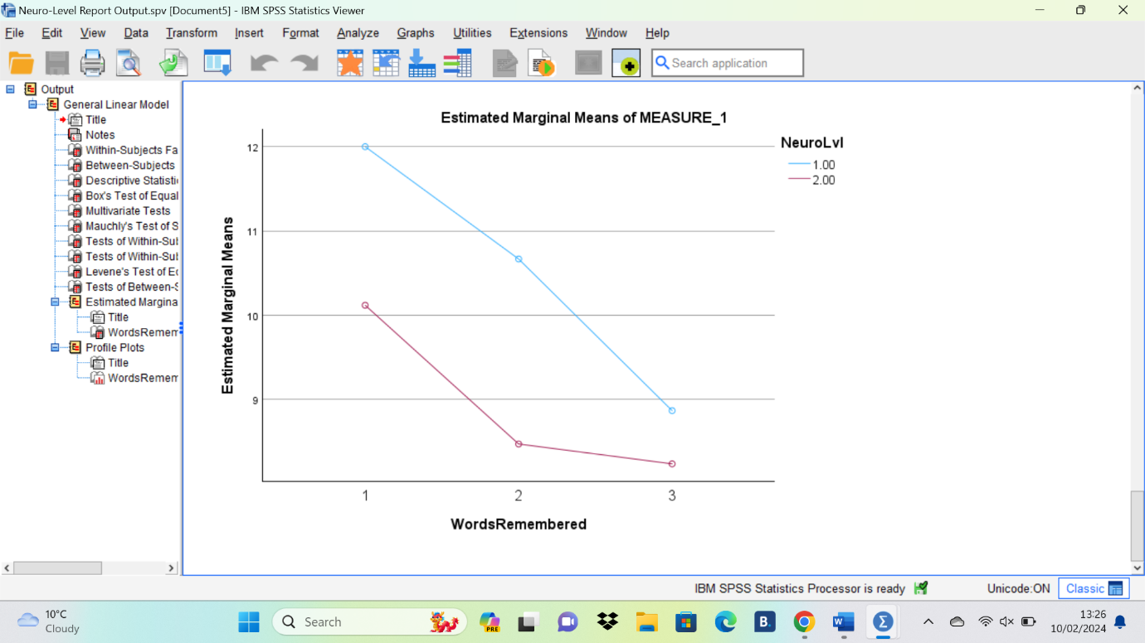

3.1
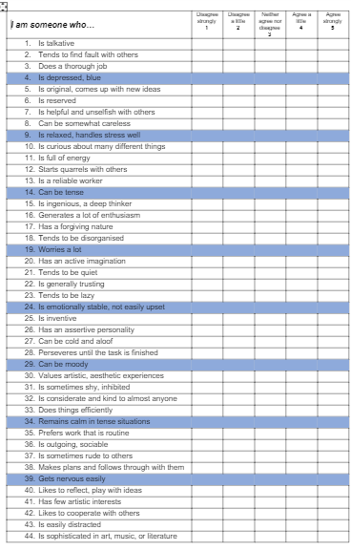

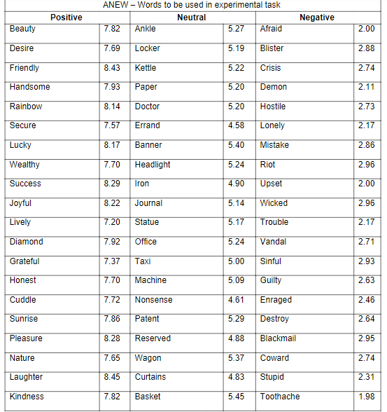
3.2

