University of Wales Trinity Saint David

School of Engineering

Six Sigma Principles for Process Improvement



Quality & Business Improvement

(ACMA4004)

Jordan Hessey

2315713

12/05/2024
Table of Contents
1 Introduction 1
1.1 Objectives 1
2 DMAIC Framework 2
2.1 Define 2
2.2 Measure 4
2.3 Analyse 7
2.3.1 Pareto Analysis 7
2.3.2 Failure Mode and Effects Analysis (FMEA) 8
2.4 Improve 10
2.4.1 Enhanced Training Programs 10
2.4.2 Implementing Advanced Quality Control Measures: 10
2.4.3 Upgrading Machinery and Equipment 11
2.5 Control 12
2.5.1 Importance of Establishing Control Mechanisms 12
2.5.2 Specific Control Measures to Monitor and Maintain Process Performance 13
3 Conclusions 15
4 References 16

List of Figures
Figure 1 - Example FPY daily report (Quality2day) 6
Figure 2 - Example of Pareto Analysis (Biotage,2024) 8

Introduction
The purpose of this report is to present a step-by-step strategy for enhancing the manufacturing process at PESC by utilizing the DMAIC (Define, Measure, Analyse, Improve, Control) framework. The existing problems faced by PESC, such as elevated defect rates, customer grievances, and rising expenses, require a systematic approach to identify and address the root causes.

Objectives
- Define the purpose of developing a clear and concise problem statement for the issues seen at PESC.
- Explain how to identify and define key performance metrics crucial for assessing the current state of the manufacturing process.
- Describe which statistical and analytical data tools would be used to help identify root causes of defects.
- Propose three targeted improvement strategies aimed at reducing defects.
- Recommend robust control mechanisms to monitor and maintain process performance.

DMAIC Framework

Define
In the world of process improvement, a clear definition of the problem statement is critical to success, particularly when using the DMAIC framework. “The problem statement should provide quantifiable estimates of the issue and its impact” (Six Sigma Demystified).
This definition serves as a beacon of light, guiding all efforts towards identifying and addressing the most pressing issues. It is an essential tool for aligning all stakeholders, ensuring that everyone is working towards a common goal. Without a clear problem statement, it is easy to become lost in a sea of competing priorities and ineffective solutions. Example of how to formulate an effective problem statement for the given manufacturing process at PESC:
Clearly define the specific defects or quality issues that are plaguing the manufacturing process. This could include defects in product components, inconsistencies in product dimensions, or deviations from quality standards.
Describe the impact of these defects on key stakeholders, such as customers, the organization's reputation, and financial performance. Quantifying the impact in terms of customer complaints, rework costs, and production delays can provide a clearer picture of the problem's severity.

Define the boundaries of the problem by specifying the affected processes, products, or production lines. This helps in focusing improvement efforts and prevents scope creep.
Provide context about the current state of the manufacturing process, including any recent changes, historical trends, or external factors that may be contributing to the problem. Understanding the context is essential for developing effective solutions.
An example of a well-defined problem statement:
“Current capacity in sales is constrained, while there are untapped opportunities for increased sales. Sales involvement in order processing should be limited to free up resources for lead follow-up and revenue generation. Errors and omissions in order processing data increase the time needed to generate marketing and software renewal e-mails to clients and prospects, further draining sales resources. Data correction requires senior sales staff, who otherwise might be engaged with clients, marketing efforts, or product development. Lost opportunity cost is significant.” (Six Sigma Demystified).

Measure
To assess the current state of the manufacturing process at PESC, several key performance metrics can be measured. These metrics provide insights into various aspects of the process, including quality, efficiency, and reliability.
“The process baseline provides a quantifiable measure of the process performance before any improvement efforts have been initiated. In establishing a process baseline, one or more suitable process metrics, related to the previously defined project deliverable, is defined and measured” (The Six Sigma Handbook).
Here is a number of key performance metrics along with methods for data collection:
- Defect Rate - The percentage of defective units produced relative to the total number of units manufactured within a specific period.
Defects can be identified through manual inspection, automated quality control systems, or customer feedback. The number of defective units is recorded and divided by the total number of units produced to calculate the defect rate.
- Customer Complaints - The number of complaints received from customers regarding product quality, performance, or other issues.
Customer complaints can be collected through various channels such as customer service hotlines, online feedback forms, or social media platforms. Each complaint is logged and categorized based on the nature of the issue.

- Rework Time - The amount of time spent on reworking defective units to bring them up to quality standards.
Rework time can be tracked using time-tracking software or manual logs. Each instance of rework is recorded along with the time spent on corrective actions.
- Production Cycle Time - The total time taken to complete one cycle of production, from raw material input to finished product output.
Production cycle time can be measured using process monitoring tools or by timestamping the start and end of each production cycle. This data can be aggregated over time to calculate average cycle times.
- Scrap Rate - The percentage of raw materials or finished products that are discarded due to defects or inefficiencies.
Scrap rate can be measured by tracking the amount of material or products discarded during various stages of the production process. This data is compared to the total amount of material input to calculate the scrap rate.
- Overall Equipment Effectiveness (OEE) - A composite metric that evaluates the performance, availability, and quality of equipment in the production process.
OEE can be calculated using data from equipment sensors, maintenance logs, and production records. This data is used to assess equipment downtime, production speed, and defect rates, which are then combined to calculate OEE.

- First Pass Yield (FPY) - The percentage of units that pass through the manufacturing process without requiring rework or corrective action.
FPY is calculated by dividing the number of defect-free units produced by the total number of units produced. Data on defects and rework instances are used to determine FPY.
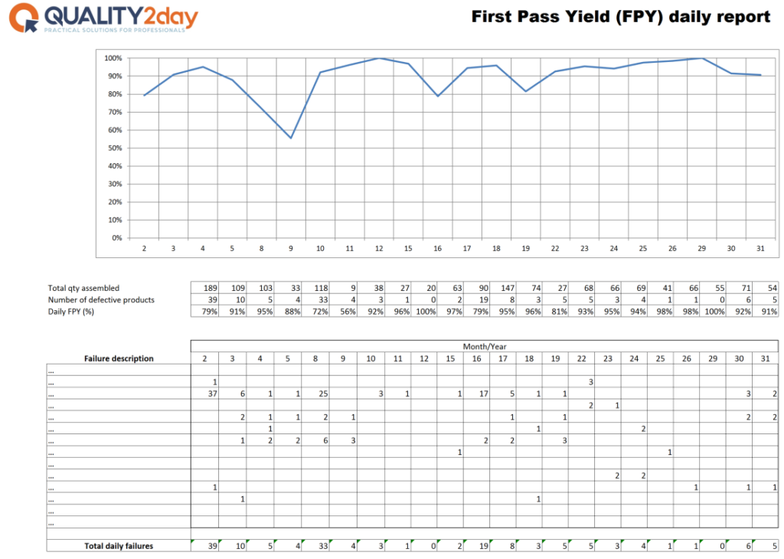
Figure 1 - Example FPY daily report (Quality2day)
Data for these metrics can be collected manually through observation and record-keeping or automatically using sensors, monitoring systems, and production software. It is important to ensure that data collection methods are accurate, consistent, and aligned with the objectives of the improvement initiative. Regular data audits and quality checks can help maintain data integrity and reliability over time.

Analyse
Once the necessary data has been collected, analysing it effectively is crucial to identify the root causes of defects in the manufacturing process at PESC. Two statistical or analytical tools that can be utilised for this purpose are Pareto Analysis and Failure Mode and Effects Analysis (FMEA). These tools are typically known as Ishikawa’s 7 basic tools (Ishikawa, 1976)

Pareto Analysis
In the context of defect analysis, Pareto Analysis helps identify the most significant contributors to defects, allowing teams to focus their efforts on addressing the vital few rather than the trivial many.
Pareto Analysis is a technique used to prioritise problems or factors based on their frequency or impact. To perform Pareto Analysis, the defects or causes of defects identified in the manufacturing process are categorised, and their frequency or impact is quantified. A Pareto chart is then created, displaying the defects/causes in descending order of frequency or impact. This chart visually highlights the most critical issues that need to be addressed first.
“if the symptoms or causes of defective output or some other ‘effect’ are identified and recorded, it will be possible to determine what percentage can be attributed to any cause, and the probable results will be that the bulk (typically 80 per cent) of the errors, waste or ‘effects’, derive from a few of the causes (typically 20 per cent).” (Total Quality management and operational excellence)

Figure 2 - Example of Pareto Analysis (Biotage,2024)

Failure Mode and Effects Analysis (FMEA)
FMEA is a systematic method for identifying and prioritizing potential failure modes in a process, product, or system, as well as their causes and effects. It helps proactively identify weaknesses in the manufacturing process that could lead to defects or quality issues. FMEA involves evaluating each potential failure mode based on its severity, occurrence likelihood, and detection difficulty to determine its overall risk priority.
In the context of defect analysis, FMEA can be applied by creating a multidisciplinary team to brainstorm potential failure modes at each stage of the manufacturing process. For each identified failure mode, the team assesses its severity (impact on product quality), occurrence likelihood (probability of the failure mode occurring), and detection difficulty (ability to detect the failure mode before it reaches the customer). These factors are then multiplied to calculate a risk priority number (RPN) for each failure mode, which helps prioritise corrective actions.
By employing these statistical and analytical tools, PESC can gain deeper insights into the root causes of defects in its manufacturing process and develop targeted strategies to address them effectively. Additionally, these tools facilitate data-driven decision-making and help prioritise improvement efforts based on their potential impact on product quality and customer satisfaction.

Improve
Based on the analysis of root causes of defects in the manufacturing process at PESC, here are three potential improvement strategies along with explanations of how each strategy can effectively address the identified root causes.

Enhanced Training Programs
Many defects in the manufacturing process can be attributed to human error, inadequate training, or lack of awareness about quality standards. By implementing enhanced training programs for employees involved in the production process, PESC can address root causes related to human factors and knowledge gaps. Comprehensive training sessions can cover topics such as quality control procedures, equipment operation, product specifications, and problem-solving techniques. By improving the skills and knowledge of employees, PESC can reduce the occurrence of errors, enhance quality awareness, and promote a culture of continuous improvement.
Enhanced training programs empower employees to identify and address defects proactively, leading to improved product quality, reduced rework, and increased efficiency. Moreover, well-trained employees are more likely to adhere to standardised processes and quality standards, resulting in fewer deviations and inconsistencies in the manufacturing process.

Implementing Advanced Quality Control Measures:
To address root causes related to process variability, material defects, and equipment malfunctions, PESC can implement advanced quality control measures at critical points in the manufacturing process. This may include the integration of automated inspection systems, real-time monitoring technologies, and statistical process control (SPC) tools.
Implementing advanced quality control measures enhances the ability to detect and prevent defects at various stages of the manufacturing process, resulting in higher product reliability and consistency. By leveraging technology and data-driven insights, PESC can minimize process variability, reduce defect rates, and improve overall process efficiency and effectiveness.

Upgrading Machinery and Equipment
Outdated or poorly maintained machinery and equipment can contribute to defects, inefficiencies, and production delays in the manufacturing process. To address root causes related to equipment failures, inaccuracies, and limitations, PESC can invest in upgrading machinery and equipment with advanced technology and improved capabilities.
Upgrading machinery and equipment enhances the reliability, accuracy, and efficiency of the manufacturing process, leading to fewer defects, higher productivity, and lower operational costs. By investing in modern technology and equipment, PESC can stay competitive in the market, meet evolving customer demands, and maintain a reputation for quality and innovation.
By implementing these improvement strategies, PESC can effectively address the identified root causes of defects in its manufacturing process, leading to higher product quality, improved customer satisfaction, and greater operational efficiency. Each strategy targets specific areas of improvement, leveraging training, technology, and infrastructure enhancements to drive continuous enhancement and excellence in the manufacturing process.

Control
Establishing control mechanisms is crucial to sustaining the improvements achieved through the implementation of improvement strategies in the manufacturing process at PESC. These control mechanisms ensure that the process remains stable, consistent, and aligned with quality standards over the long term.

Importance of Establishing Control Mechanisms
Control mechanisms help maintain consistency in process performance by monitoring key metrics and identifying deviations from established targets. Consistent performance is essential for ensuring product quality and meeting customer expectations.
Without control mechanisms in place, there is a risk of regression, where the process gradually reverts to its previous state of inefficiency or high defect rates. Control measures act as safeguards against regression, ensuring that improvements are sustained over time.
Control mechanisms provide valuable feedback on process performance, allowing for ongoing evaluation and refinement of improvement strategies. This fosters a culture of continuous improvement within the organization, driving further enhancements in process efficiency and effectiveness.

Specific Control Measures to Monitor and Maintain Process Performance
Implement SPC techniques to monitor process variability and detect any signs of instability or non-conformance. Control charts, such as X-bar and R charts, can be used to track key process parameters over time and identify trends, shifts, or outliers that may indicate potential issues.
Conduct regular performance reviews to assess process performance against established targets and objectives. Performance reviews may include metrics such as defect rates, rework time, production cycle time, and customer satisfaction scores. Any deviations from targets should be investigated promptly, and corrective actions should be taken, as necessary.
Conduct periodic audits and inspections to ensure compliance with standard operating procedures (SOPs), quality control measures, and regulatory requirements. Audits can help identify areas for improvement and ensure that corrective actions are implemented effectively. Additionally, inspections can help verify the effectiveness of control measures and identify any emerging issues before they escalate.
Provide ongoing training and skill development programs for employees to reinforce best practices, update knowledge on modern technologies or processes, and promote a culture of quality and continuous improvement. Well-trained employees are better equipped to adhere to quality standards, follow established procedures, and contribute to process optimization efforts.
Maintain up-to-date documentation of standard operating procedures (SOPs), work instructions, and quality control protocols. Documented procedures help ensure consistency and standardisation in process execution, reducing the risk of errors or deviations. Implement a documentation control system to manage revisions, approvals, and access permissions for critical documents.
By implementing these specific control measures, PESC can effectively monitor and maintain process performance in the long term, ensuring that improvements achieved through the implementation of improvement strategies are sustained and built upon over time. Control mechanisms provide the foundation for a robust quality management system, enabling PESC to deliver high-quality products consistently and maintain a competitive edge in the market.

Conclusions
In conclusion, adopting a systematic DMAIC approach can effectively address the challenges faced by PESC in its manufacturing process. By defining the problem statement, measuring key performance metrics, analysing data, implementing improvement strategies, and establishing control mechanisms, PESC can achieve sustainable improvements in process efficiency, reduce defects, and enhance customer satisfaction.

References
- Oakland, J. S. (2014). Total quality management and operational excellence : text with cases (4th ed.). Routledge.
- Voehl, F. (2014) The lean six sigma black belt handbook : tools and methods for process acceleration. 1st edition. Boca Raton: CRC Press.
Available at: https://doi.org/10.1201/b15163.
- Ishikawa, K. (1976). Guide to Quality Control. Tokyo: Asian Productivity Organization.
- Juran, J. M. (1993). Juran on Quality by Design: The New Steps for Planning Quality into Goods and Services.
New York: The free press.
- Vanzant, ST 2019, Leaner Six Sigma : Making Lean Six Sigma Easier and Adaptable to Current Workplaces, Productivity Press, Oxford.
Available from: ProQuest Ebook Central. [17 March 2024].
- George, D.R, M.P, J.M (2005) The lean six sigma pocket tool book.
New York: McGraw-Hill Education
- Automatic root cause analysis in manufacturing. [online]
Available at: Automatic root cause analysis in manufacturing: an overview & conceptualization | Journal of Intelligent Manufacturing (uwtsd.ac.uk)
[Accessed 12 May 2024]
- Segismundo, A., & Augusto Cauchick Miguel, P. (2008). Failure mode and effects analysis (FMEA) in the context of risk management in new product development: A case study in an automotive company. The International Journal of Quality & Reliability Management, 25(9), 899–912.
- Pyzdek, T. (2018). The Six Sigma handbook. McGraw-Hill.
- Robert Ulewicz (2019) Quality Production Improvement – QPI.
- First Pass Yield calculator in manufacturing. [online]
Available at: First Pass Yield calculator in manufacturing? How hard can it be? – QUALITY2day
[Accessed 12 May 2024]
- Biotage (2024) Pareto Analysis
Internal Templates. Unpublished.

