Question 2: Can Graphic Design really save your life?
Explore the association of wellbeing and personal growth in Design in your discussion.
Jesse James - 1902092
Graphic Design
Word Count - 2279
Lecturer – Donna Williams

Our main purpose as graphic designers is to problem solve, but sometimes, we’re so caught up we overlook trying to solve our own problems. Mental health is an obstacle that is consistently brought to the limelight, and for good reason, when it comes to creatives, a study published by MacCabe et al (2018) found that students that study artistic driven subjects at university have an increased risk of developing schizophrenia, bipolar disorder and depression as they progress into adulthood. The impact that our work has on us needs to be openly discussed more frequently with our peers, partners and colleagues. Our line of work can also affect those who don't struggle with mental illness, especially as Junior designers, many of us are overworking ourselves for very little pay within the industry. Not just as freelancers, but also being exploited by companies via unpaid internships, just so we can get our foot into the industry. Subsequently, I will discuss what you & I can do to help our fellow creatives.

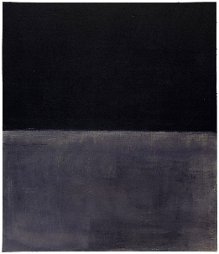
The effect a Graphic Designers work has on them is a topic I feel that has flown under the radar. Visual artists are often very expressional of their internal feelings such as Francis Bacon, Van Gogh, Francisco De Goya and Mark Rothko. Rothko is a great example of this, if you are unaware, Rothko created large canvas’ of work, often meters high, of blocks of colour that would represent his general feelings. In Meyers’ ‘Pursued by Demons: Creativity and Suicide’ (2016, p.21), the article explains his mental state, describing his body and marriage as failing. This, in turn, led him to create his piece ‘Black on Grey’ in 1970, depicting his melancholy state of mind.
Fig.1 Mark Rothko (1970), Black on Grey
Graphic Designers aren’t often given the opportunity to express themselves visually, this is due to the simple fact that we work with clients for clients. Any work that we would like to create that reflects upon our own state of wellbeing must be taken up in our own time. Of course, additionally, it’s not just graphic designers that have this problem, many people involved in the creative industry may feel that their roles can be quite restrictive in terms of what they can produce as a reflection of themselves. Makeup Artist Coster (2020) says herself that some people wear makeup as a form of expression, however, she is often judged as makeup is typically used as a cover-up of certain imperfections. She also discusses the idea that we are neglectful of time out of our day for ourselves as we are just simply too busy. We can live this way day to day, but we are disconnected from ourselves. Graphic Designer Ben Longden has found a way to express himself by creating a book entitled ‘Graphic Design is Mental’. Ben is the digital design director at the British newspaper The Guardian, experienced in his field he also taught design part-time at Shillington College over the course of two years.
I have a passion for design, design education, and mental health. I am the author of this little book. It’s a very important topic to me, and it’s one I think that as an industry we don’t talk about enough. Not to mention that I have myself suffered from a variety of things with my mental health - and I think it's time that we talk about it.
(Longden, 2019)
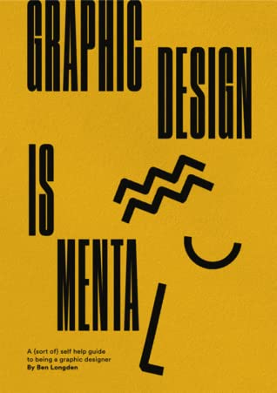
In an excerpt from his self-help book, Ben examines the idea that design is easy, it’s the learning that is hard. This hit home particularly for me, I hold myself in quite a high regard (much more than I rightfully should) so when things don’t go the way I envisioned them at the start of the project, I tend to get a bit discouraged. What I don’t take time to realise is, each project I endeavour I am learning. “The frustrating side to everything will come when you are in this play stage, when your ambition to create and your technical ability doesn’t quite match up. (Longden, 2020)”
Fig.2 Ben Longden (2020), Graphic Design is Mental

Throughout day-to-day work, as designers we must come face to face with daunting tasks such as tight deadlines, working with an awkward client and a heavy workload, if you’re working as a freelancer, you have an additional struggle in terms of the risk of having an inconsistent number of clients. Might I add, I am in no way suggesting that working within Graphic Design causes depression, anxiety, etc… however, I am suggesting that the industry is not streamlined to help those who already struggle. Bhatt (2021a) expresses in an AIGA article that in his bi-weekly therapy sessions, he struggles to bring up "design drama" such as client problems and time-management struggles. When he does, however, his therapist states that it's not his realm of expertise. If you cannot speak to a therapist about some of these things, then who can you talk to, there is a limited space to vent, so much so that many like myself use Twitter almost as a journal. “There seems to be a vacuum of the interpersonal and creative dread that is the byproduct of the design process. (Bhatt, 2021b)”

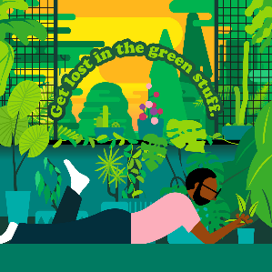
Looking closer at how working as a creative can impact us, I want to scope in on an interview conducted by Sarah Dawood for Design Week (2018). The interview took place as World Mental Health Day was around the corner, first interviewee was Ben O’Brien; Ben is a freelance illustrator who creates gorgeous, vibrant pieces of work and has collaborated with bodies such as Adobe and The Guardian. Ben begins his interview by opening up about his childhood stating that he has had problems with mental illness since being in school. Things have changed since the '90s when Ben was a teenager and mental health is less stigmatised than it used to be especially amongst men. As an experienced designer, he's found ways to manage work around his mental health however goes on to acknowledge that freelancing is tough and that it "can contribute to stress and mental health problems. (Dawood, 2018b)”
Fig.3 Ben O’Brien (2021), Mental Health Awareness Week
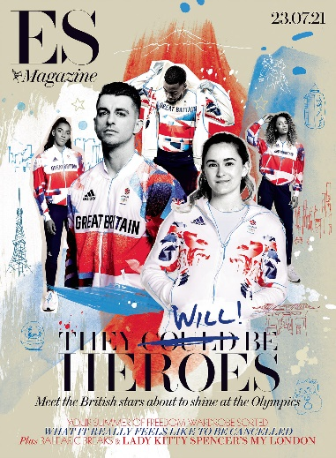
On the other side of the spectrum is Ben Tallon, an illustrator who’s worked with a large clientele such as Channel 4, WWE and The Premier League. Tallon’s work is significantly urban-inspired and ties in greatly with British culture. When speaking to Dawood (2018c) about his personal experience on mental health he starts by saying that it’s a part of the human condition. This shows his understanding that a mental illness does not make you subhuman and that he is a progressive individual. Tallon does not have any mental illnesses himself but states that his job comes with a feeling of isolation and that pressure to be ongoing with work with no sick days can be a tough load to carry.
Fig.4 Ben Tallon (2020), Evening Standard Magazine
As a freelance illustrator, Tallon has the opportunity to work remotely in his own studio, something that has become the norm since the COVID-19 Pandemic. But just how were designers impacted by the pandemic, according to a report by 99Designs (2020), 33% of designers said that they are working longer hours than they were before the initial pandemic. With the vast majority of people working 35-40 hours a week, you can see that this change in routine allows designers to create anything, but time for themselves. In addition to that statistic, 14% of designers have been asked to take on additional responsibilities in the workplace. What is even bleaker is that of the 11,000 freelance designers that were surveyed, 24% had lost either a full-time or part-time job and only 2% were furloughed by their government.
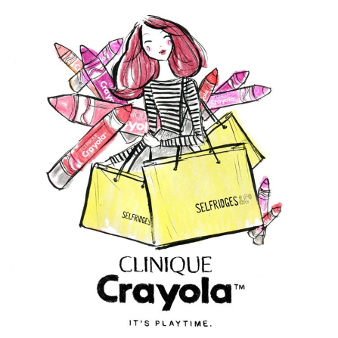
On that note, returning to the interview by Dawood (2018d) we are met with Niki Groom, who is a freelance fashion, beauty and lifestyle illustrator that creates colourful mixed media artwork using mainly watercolour and pen, her notable clients contain Selfridges, M&S and John Lewis. Similar to Tallon, Groom also does not have any history of serious mental illness, with that being said, 2017 was a challenging year for her personally due to financial stress. As she reflected upon that tense year, she goes on to mention that the consistently low level of stress without a doubt impacted her work ethic. Being creative under such pressure was out of the realms of possibility and rightfully so, with her mortgage costing £900 a month and earning as low as £300 a month that year. Groom also goes on to state that she struggled to collect overdue payments from clients.
Fig.5 Niki Groom (2017), CLINIQUE x Selfridges
Outlandish as it may sound, many freelancers experience late payment from clients, some, believe it or not, are not even paid at all. Sheffield (2019) notes that New York City only recently introduced an act of law entitled the Freelance Isn’t Free Law, and, since its introduction, has received over 760 complaints as well as recovered around $1 million in payments. The UK alone loses around £2.5 billion per year due to late payments.

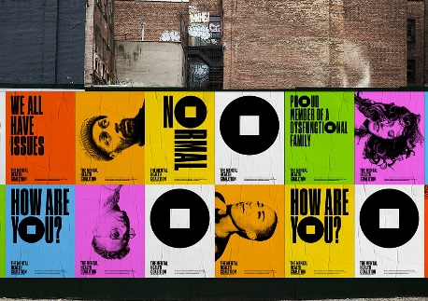
What can be done to create a more positive experience for designers, how can we help ourselves, can graphic design save a graphic designer's life? Well, to help answer that question I would like to divert your attention to a fantastic project created by Paula Scher and her team at Pentagram, collaborating with Kenneth Cole, a social activist and fashion designer, they created an identity for the Mental Health Coalition. Now as much as these designs may have positively impacted those with mental illness, I would like to talk about how thinking differently when creating projects may help designers with mental illness. Paula Scher talks about her process with Creative Boom in this article written by Katy Cowan (2020), she says that the campaign was created in the same way she would go about creating campaigns for the likes of a play or a band. She goes against using the stigma that mental health is secretive and taboo by using bright, loud colours which, in my opinion, makes me feel uplifted and that I can be comfortable with who I am. Finally, she goes on to add that the rule in which designs that focus on such dark topics must be unsaturated and dim is ridiculous, and how right is she, this work is phenomenal.
Fig.6 Paula Scher (2020), Mental Health Coalition
On a sidenote from a designer's perspective, it can be so easy to go with that's typical, and there's a reason for it, it's because 99% of the time, typical works, typical is often easy, and typical is liked by clients. I would like to encourage designers to really step out of their comfort zone when creating projects so they don't feel so boxed in. This year I made an effort to try and learn some new software, After Effects in particular, before then I was consistently getting creative blocks, I felt uninspired. Expanding my knowledge of software allowed me to explore numerous avenues that weren’t available to be me before. Having this option stopped me from feeling so bogged down when creating projects for university and client work.
Earlier in this essay, I also talked about how mental health is less stigmatised now than it once was many years ago, and this couldn’t be more true when it comes to how mental health is viewed within the workplace. I know that many freelancers don’t have the privilege, however, those who are contracted, working part-time, full-time, whatever your situation may be, please do not hesitate to take time off for your mental health, even if it’s just for a day, Pencavel (2016) concludes his article on this topic comparing humans to machines, machines tend to depreciate the more that they are used over an amount of time and requiring serving to ensure that they are running at a peak capacity. Therefore, human labour requires the same process, longer work weeks should require a longer time for 'repair', a continuous calendar of stretched-out working weeks repeatedly does not give workers the restoration they require, this, in turn, means that health and work productivity may suffer. Freelancers may find that taking 5-minute breaks every now and then may be beneficial and help improve their overall efficiency as workers. I personally struggle a lot with knowing when to take a break, it’s very easy for me to just clock the hours that I need to do and have a larger break towards the end of the day. Finally, I understand that our industry is a competitive one, and especially as a newcomer, it can be very daunting, but don’t be overwhelmed, there are numerous podcasts, articles and your fellow designers are more than likely going through the same troubles as you, the main piece of advice I can give is don’t be afraid to reach out.

In conclusion, after reading through multiple articles, interviews and studies, it can most definitely be said that the work of a Graphic Designer can be impactful on their mental health and truth be told I’ve barely scratched the surface within this piece of writing. There is still a plethora of artists that could be discussed, furthermore, we only dabbled on how COVID has influenced the industry as well as designers personally. I have also successfully highlighted that the line of work as a designer additionally can impact those who don’t struggle with mental illness within the industry. Moreover, I have discussed and shown examples of how designers and those outside our line of work, such as clients, can help us.

Bibliography
Photos:
Rothko, M. (1970) Black on Grey [Online]. Available at: https://www.guggenheim.org/artwork/3535 (Accessed 3rd December)
Longden, B. (2020) Graphic Design is Mental [Online]. Available at: https://www.goodreads.com/book/show/53295219-graphic-design-is-mental (Accessed 3rd December)
O’Brien, B. (2021) Mental Health Awareness Week [Online]. Available at: https://bentheillustrator.com/mental-health-awareness-week (Accessed 4th December)
Tallon, B. (2020) Evening Standard Magazine [Online]. Available at: https://www.bentallon.com/index.php?controller=pjLoad&action=pjActionView&id=173#stb_detail_container (Accessed 4th December)
Groom, N. (2017) Clinique x Selfridges Social Media [Online]. Available at: https://www.missmagpiefashionspy.com/ (Accessed 4th December)
Scher, P. (2020) Mental Health Coalition [Online]. Available at: https://www.creativeboom.com/inspiration/paula-scher-mental-health-coalition (Accessed 5th December)

Journals:
MacCabe, J. H., Sariaslan, A., Almqvist, C., Lichtenstein, P., Larsson, H. and Kyaga, S. (2018) “Artistic creativity and risk for schizophrenia, bipolar disorder and unipolar depression: a Swedish population-based case–control study and sib-pair analysis,” The British Journal of Psychiatry. Cambridge University Press, 212(6), pp. 370–376.

Article:
Meyers, J. (2016) ‘Pursued by Demons: Creativity and Suicide’, American imago, Vol.73(1), pp. 1–23.
Hazel Sheffield (2019) ‘How freelancers are fighting for their pay’, Available at: https://www.proquest.com/docview/2198862828?pq-origsite=primo&accountid=130472 (Accessed 4th December)
Pencavel, J. (2016) ‘Recovery from Work and the Productivity of Working Hours’, Economica (London), 83(332), pp. 545–563
Website:
Coster, M.L. (2020) Self Expression Through The Art Of Makeup. Available at: https://www.pblmagazine.co.uk/news/self-expression-through-the-art-of-makeup (Accessed 3rd December)
Longden, B. (2019) Indiegogo Fundraiser - Graphic Design Is Mental, a book by Ben Longden. Available at: https://www.indiegogo.com/projects/graphic-design-is-mental-a-book-by-ben-longden#/ (Accessed 3rd December)
Longden, B. (2019). Graphic Design is Mental: Tips for looking after your state of mind as a designer. Available at: https://www.itsnicethat.com/features/graphic-design-is-mental-ben-longden-the-guardian-opinion-graphic-design-101019 (Accessed 3rd December)
Somnath, B. (2021 The Graphic Support Group Podcast Asks Designers to Listen Deeper and Feel More Broadly. Available at: https://eyeondesign.aiga.org/the-graphic-support-group-podcast-asks-designers-to-listen-deeper-and-feel-more-broadly/ (Accessed 3rd December)
Dawood, S. (2018) “The creative world is turbulent”: designers’ stories of mental health. Available at: https://www.designweek.co.uk/issues/8-14-october-2018/the-creative-world-is-turbulent-designers-stories-of-mental-health/ (Accessed 4th December)
Cowan, K. (2020) Pentagram partner Paula Scher creates 'square peg in a round hole' identity for the Mental Health Coalition. Available at: https://www.creativeboom.com/inspiration/paula-scher-mental-health-coalition/ (Accessed 5th December)
Report:
99Designs (2020) Design Without Borders: The Freelance Revolution. Available at: https://99designs.co.uk/design-without-borders-2020

