

Name: Yuliia Klymiuk
Student ID: 2409933
Module Code: LCLM5005
Lecturer: Mustakkima Afrin

Module: Organisational Culture

Assignment Title: Component 1
Organisational Culture: Individual Report

Program: BA (Hons) Leadership and Management Skills for the Workplace

Submitted on: 10 of August 2026.

Table of Contents
Table of Contents 1
Introduction 2
Figure 1 (Key elements of organisational culture. Source: Adapted from Lecturer’s Week 1 presentation (2025).) 2
Organisational Culture in British Airways 3
How the organizational culture helps shape the company’s structure and decision-making 4
Relevant frameworks, models or theories applied to British Airways 5
Organisational culture and adaptation to the external environment 6
Figure 2 (Uncertainty in organisational environments. Source: Adapted from Lecturer’s Week 2 presentation (2025).) 7
Table 1 (British Airways operating performance, 2024–2025. Source: Adapted from International Airlines Group, 2026). 8
Organisational culture and effective functioning of British Airways 9
Evaluation of the impact of organisational culture on performance and recommendations 9
Conclusion 10
References 10

Introduction

Organisational culture is more than official rules or values written in a company document. It is the everyday way people work, communicate, solve problems and understand “what is normal” inside an organisation. In simple terms, culture shows employees how to behave when managers are watching, but also when nobody is watching. (Bogale and Debela, 2024) explain that organisational culture is based on shared values, beliefs, assumptions and practices that guide behaviour in the workplace.

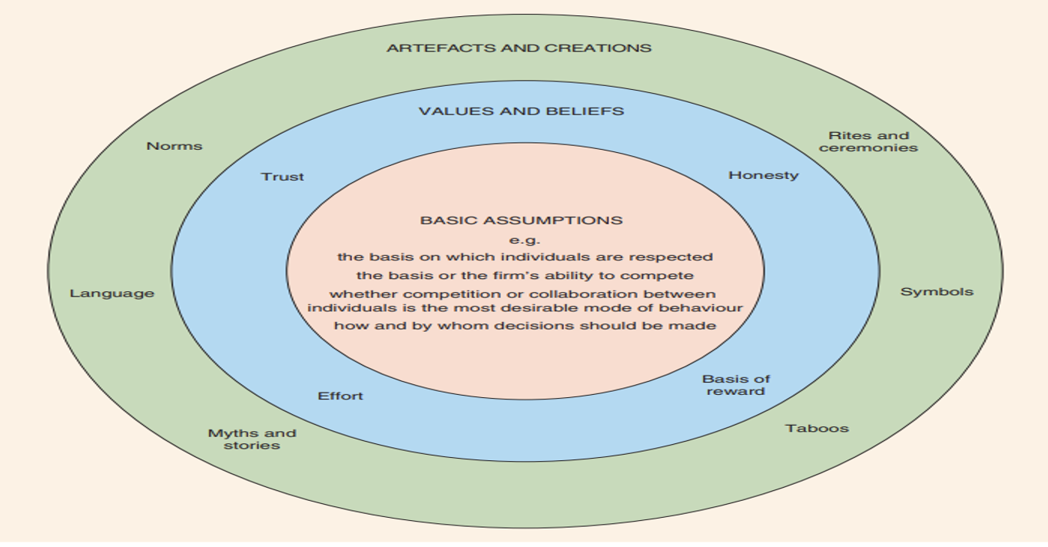

Figure 1 (Key elements of organisational culture. Source: Adapted from Lecturer’s Week 1 presentation (2025).)

Figure 1 is linked to Schein’s view of organisational culture, which suggests that culture includes both visible elements, such as behaviour and practices, and deeper hidden elements, such as shared assumptions and beliefs. Culture is important because it can influence many parts of organisational life, including leadership, employee motivation, teamwork, decision-making and performance. It also helps explain why two companies with similar rules may work in very different ways. Therefore, understanding organisational culture is necessary before analysing how a specific organisation is managed and how it responds to internal and external challenges.

Organisational Culture in British Airways
British Airways has an organisational culture that is shaped by the reality of the airline industry. The company cannot rely only on friendly service or a famous brand name; it also needs discipline, trust, safety and consistency every day. Its culture can be described as safety-focused, professional, customer-service oriented and process-driven. In simple terms, employees are expected to follow clear procedures, communicate professionally and take responsibility for their actions. This is important because in aviation, even a small mistake can affect passengers, employees, flight schedules and the reputation of the company. Organisational culture influences how people behave at work and how they understand “the right way” to do things inside an organisation (Bogale and Debela, 2024).
In British Airways, this can be seen in the way pilots, cabin crew, engineers, airport staff and managers must work carefully together. The culture is visible through uniforms, safety checks, staff training, formal communication and service standards, but it is also deeper than that. Behind the visible image, BA depends on trust between departments, accurate information, teamwork and quick problem-solving when disruption happens. Customer service is also a major part of BA’s culture because passengers expect reliability, respect and support, especially during delays or cancellations.
British Airways has been investing in operational resilience, technology, AI and machine learning to improve punctuality and reduce disruption, which shows a culture of continuous improvement rather than only following old routines (British Airways Media Centre, 2025). This is important because modern airline customers expect a smoother, faster and more reliable travel experience. At the same time, BA’s culture is quite formal and process-driven. This is suitable for an airline because safety, legal rules and operational control are essential. However, it can also create problems if the organisation becomes too slow or bureaucratic. For example, employees may need approval from several management levels before changes can happen. Therefore, BA needs to balance its strong process-driven culture with flexibility and open communication.
Another part of BA’s culture is responsibility towards people and customers. IAG reports that its success depends on skilled employees, safety, customer service and an inclusive culture where people feel valued (International Airlines Group, 2026). This culture can also be linked to a hierarchical culture because British Airways depends on clear authority, stable procedures and control to manage risk. This is important for a large airline where employees work across different airports, countries and time zones, but still need to follow the same safety and service standards. Overall, British Airways’ culture helps the company protect safety, build customer trust and maintain reliable operations. However, to stay competitive, it must keep developing a culture that is not only professional and controlled, but also adaptive, innovative and responsive to change.

How the organizational culture helps shape the company’s structure and decision-making

British Airways’ organisational culture helps shape both its structure and decision-making because the company works in an industry where safety, control and responsibility are essential. BA can be understood as having a mainly hierarchical and process-driven culture. This means that employees are expected to follow rules, respect authority, communicate clearly and understand their duties. In aviation, this is very important because mistakes can affect passengers, employees, flight schedules and the company’s reputation.
A hierarchical culture usually supports formal rules, clear procedures and a structured working environment (Mikušová et al., 2024). This fits British Airways because the airline cannot operate through informal decisions or unclear responsibilities. Pilots, cabin crew, engineers, ground staff, customer service teams and managers all need to know exactly what they are responsible for. This culture therefore supports a mainly functional structure with mechanistic features. BA is organised into specialist areas such as Operations, Engineering, Commercial, Customer Experience, Finance, People and Training, and Sustainability. IAG’s British Airways Investor Insight Day also presents areas such as Customer Experience, Commercial Transformation, Operations, Engineering, People and Training, Sustainability, and Finance and Transformation as key parts of BA’s business transformation (International Airlines Group, 2024).
This structure helps decision-making because decisions are made by people with specialist knowledge. For example, engineering and operational teams are best placed to make safety and maintenance decisions, while commercial managers are better placed to make decisions about pricing, routes and revenue. This creates stronger accountability because each department understands its own area of responsibility. Mullins and Christy argue that organisational culture affects decision-making, structure, work organisation and management control (Mullins and Christy, 2016, p. 574). This can be seen in BA because its safety-focused culture shapes a controlled structure where decisions follow expertise and authority.
There are clear advantages to this structure. It helps British Airways maintain safety, reliability, legal compliance and consistent service across different airports, countries and routes. It also reduces confusion because employees know who they report to and what standards they must follow. Hierarchy can also support decision-making by creating order and clarifying who has authority to make final decisions (Bessey, 2023).
However, there are also disadvantages. A hierarchical structure can make decision-making slower because approvals may need to move through several management levels. It can also create departmental silos, where teams focus mainly on their own function and do not share information quickly. This can be a problem during delays, technology issues, customer complaints or external crises. Overall, British Airways’ culture supports safe and controlled operations, but the company still needs flexibility, teamwork and open communication to avoid becoming too bureaucratic.

Relevant frameworks, models or theories applied to British Airways
To analyse the organisational culture of British Airways, this report uses Edgar Schein’s Model of Organisational Culture and Handy’s Four Types of Culture, with a focus on Power Culture. These models are useful because they help explain both the visible parts of culture and the way power and authority work inside the organisation.
1. Artefacts
The first level in Schein’s model is artefacts. These are the visible things that people can see, hear or notice in the organisation. In British Airways, artefacts include staff uniforms, safety announcements, formal communication, customer service standards, staff training, technology systems and standard operating procedures. These signs show that BA wants to present itself as professional, safe and reliable. For example, when passengers see cabin crew in uniform or hear safety instructions before take-off, they are seeing the visible culture of British Airways.
2. Espoused values
The second level is espoused values. These are the values that the company says are important. In British Airways, these values include safety, professionalism, reliability, responsibility and customer service. These values are important because BA works in aviation, where passengers must trust the company. If safety is a company value, it must be shown through real actions, such as training, safety checks, careful planning and clear communication.
3. Underlying assumptions
The third level is underlying assumptions. These are deep beliefs that employees may not always talk about directly, but they still influence how people think and behave. In British Airways, one key assumption is that safety must come before speed, comfort or short-term profit. Another assumption is that employees should follow procedures because mistakes in aviation can have serious consequences. This shows that BA’s culture is not only about what passengers see, but also about how employees work behind the scenes.
4. Handy’s Power Culture
Handy’s model includes four culture types: power, role, task and person culture (Cairney et al., 2026). In this report, British Airways is linked to Power Culture because important strategic decisions are strongly influenced by senior leadership. Power Culture means that authority is concentrated at the top of the organisation or around a small group of key decision-makers. This can be seen in BA through the role of the Chairman and CEO and the senior management team. Major decisions about routes, investment, transformation, safety priorities and customer strategy are not made casually by employees at lower levels. They are guided by senior leaders because these decisions can affect finance, safety, reputation and thousands of employees.
This type of culture can help British Airways because it gives clear direction and strong control. In a large airline, this is useful when fast and serious decisions are needed, especially during crises. However, Power Culture also has weaknesses. If too much authority stays at the top, decision-making can become slow for employees and departments. It may also reduce employee involvement and make the organisation less flexible. Schein’s model shows the visible and hidden layers of BA’s culture, while Handy’s Power Culture helps explain the importance of senior leadership and authority. British Airways can therefore be described as having a formal, safety-focused culture with strong power and control at the senior level.

Organisational culture and adaptation to the external environment

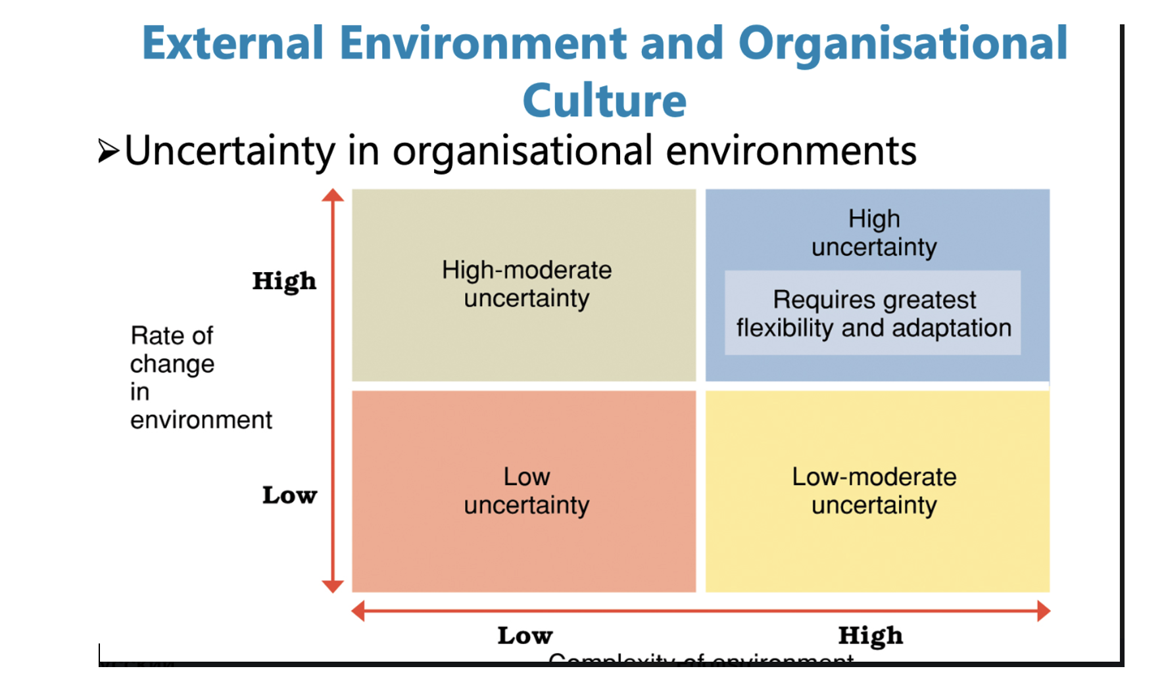

Figure 2 (Uncertainty in organisational environments. Source: Adapted from Lecturer’s Week 2 presentation (2025).)
British Airways operates in a highly uncertain external environment. This means that the company faces many outside factors that are difficult to fully control or predict. The uncertainty matrix is useful here because BA has both high complexity and a high rate of change. The company operates across many countries, airports, currencies, legal systems and customer markets. At the same time, the airline industry can change quickly because of wars, closed airspace, inflation, strikes, fuel prices, technology and environmental regulations.
A PESTEL analysis is useful because it helps organisations study the main external factors that can influence business decisions: political, economic, social, technological, environmental and legal factors (CIPD, 2024). For BA, political factors are important because war, political conflict and closed airspace can force airlines to change routes, cancel flights or avoid unsafe destinations. This can increase flight time, fuel use and operating costs. BA’s safety-focused culture helps the company respond to these risks through careful planning, risk control and formal procedures.
Economic factors also have a strong impact. Airlines are very sensitive to fuel prices, geopolitical issues and wider macro-economic changes (IATA, 2024a). Fuel is one of the biggest costs in aviation, so oil price changes can affect ticket prices, profit margins and route decisions. A process-driven culture helps BA respond in a controlled way, rather than making rushed decisions.
Year | Operating profit | Operating margin
2024 | £2,048 million | 14.2%
2025 | £2,230 million | 15.2%

Table 1 (British Airways operating performance, 2024–2025. Source: Adapted from International Airlines Group, 2026).
The table shows that British Airways improved its operating profit from £2,048 million in 2024 to £2,230 million in 2025. Its operating margin also increased from 14.2% to 15.2%. This suggests stronger organisational performance. However, this improvement should not be linked only to organisational culture, because external factors such as travel demand, fuel prices and market conditions also affect airline profitability. The IAG report states that British Airways improved operating profit by £182 million and reached an operating margin of 15.2% in 2025.
Social factors include changing passenger expectations. Customers now expect reliable flights, quick communication, fair treatment, good service and more sustainable travel. This means BA’s customer-service culture must support passengers not only during normal flights, but also during delays, cancellations and disruption.
Technological factors are also important because airlines depend on digital booking systems, mobile check-in, cyber security, aircraft technology and data systems. Technology can improve customer experience and operational efficiency, but it also requires employees to adapt and learn new systems.
Environmental factors are a major pressure because aviation contributes to carbon emissions. IATA explains that Sustainable Aviation Fuel could play a major role in reducing emissions needed for aviation to reach net zero CO₂ by 2050 (IATA, 2025). ICAO also reports global progress towards net-zero carbon emissions by 2050 and the development of frameworks for sustainable aviation fuels (ICAO, 2024). This shows why BA needs a responsible culture that supports sustainability, not only profit.
Finally, legal factors include safety rules, passenger rights, employment law, data protection and compensation rules. BA’s hierarchical culture helps with compliance because employees are expected to follow clear standards. However, this culture must not become too rigid. To adapt well, BA needs to keep its safety and control, while also improving flexibility, communication and innovation.

Organisational culture and effective functioning of British Airways
British Airways’ organisational culture mainly helps the company function effectively because airline work needs safety, teamwork and clear communication. BA is not a business where employees can work in a random or informal way. Pilots, cabin crew, engineers, ground staff, customer service teams and managers all depend on each other. If one team does not do its job properly, it can affect the whole flight experience. This is why BA’s culture of safety, professionalism and responsibility is important.
A strong culture helps employees understand what is expected from them. In British Airways, this means following safety rules, communicating clearly, staying calm under pressure and treating passengers professionally. This supports effective functioning because employees know how to behave during normal operations and during difficult situations, such as delays, cancellations, technical problems or customer complaints.
This also links to the idea of organisational health. Organisational health is about how well a company can align people, carry out its plans, adapt to change and keep improving over time (McKinsey & Company, 2024). For British Airways, this means that culture should help employees work towards the same goals: safe flights, reliable service, good customer experience and strong operational performance.
However, BA’s culture can also create problems. Because the company is quite hierarchical and process-driven, decision-making may become slow. Employees may need approval from several management levels before changes can happen. Departments may also focus too much on their own tasks and not communicate quickly enough with others. This can be a problem when the airline needs to respond fast. British Airways’ culture is mostly an enabler of effective functioning because it supports safety, consistency, trust and customer service. However, it can become a barrier if it becomes too bureaucratic. BA should therefore keep its strong safety culture, but also encourage faster communication, teamwork and employee involvement.

Evaluation of the impact of organisational culture on performance and recommendations

British Airways’ organisational culture has a clear impact on its organisational performance. Its safety-focused, professional and process-driven culture helps the company stay reliable in a complex airline industry. It supports stable growth because employees follow clear procedures, focus on safety and provide a consistent level of service.
This culture also supports customer trust. Many passengers choose British Airways because they see the company as safe, professional and reliable. Even when BA is more expensive than some low-cost airlines, customers may still choose it because of its reputation, service quality and confidence in the brand. This shows that organisational culture can support customer loyalty and market position.
Inside the company, culture also affects daily performance. Clear rules, training, teamwork and responsibility help reduce mistakes and improve coordination between departments. This is very important in aviation because one problem can affect the whole flight experience.
British Airways should keep its strong safety culture, but it should also improve flexibility. The company should encourage faster communication, more employee involvement and better teamwork between departments. This would help BA respond more quickly to delays, complaints, technology problems and changes in the external environment.

Conclusion

British Airways has a formal, safety-focused and professional organisational culture. This culture supports the company because aviation needs clear rules, strong control and responsible behaviour. It helps BA protect passengers, deliver consistent service and manage complex operations across different countries, airports and time zones.
The culture also supports BA’s reputation. British Airways is seen as a strong and trusted airline brand, and this gives the company an advantage in a competitive market. Its culture helps create reliability, customer confidence and stable performance.
At the same time, BA should avoid becoming too slow or bureaucratic. The company needs a balance between control and flexibility. It should protect its safety standards, while also supporting innovation, teamwork and open communication. This would help British Airways remain reliable, competitive and ready for future challenges.

References

Bessey, D. (2023) ‘Hierarchies and decision-making in groups: experimental evidence’, Humanities and Social Sciences Communications, 10, Article 198. Available at: https://www.nature.com/articles/s41599-023-01714-x (Accessed: 24 July 2026).

Bogale, A.T. and Debela, K.L. (2024) ‘Organizational culture: a systematic review’, Cogent Business & Management, 11(1), Article 2340129. Available at: https://doi.org/10.1080/23311975.2024.2340129 (Accessed: 24 July 2026).

British Airways Media Centre (2025) ‘British Airways improves on-time performance as world-leading technology boosts flight punctuality’, 14 May. Available at: https://mediacentre.britishairways.com/news/14052025/british-airways-improves-on-time-performance-as-world-leading-technology-boosts-flight-punctuality (Accessed: 24 July 2026).
Cairney, J., Townsend, S., Harrison, Z., Woodforde, J., Wheeler, K., Mulcahy, S. and Gomersall, S. (2026) ‘Organizational culture and sport: a narrative review and proposed synthesis framework’, Frontiers in Sports and Active Living, 8, Article 1778505. Available at: https://www.frontiersin.org/journals/sports-and-active-living/articles/10.3389/fspor.2026.1778505/full (Accessed: 24 July 2026).

CIPD (2024) PESTLE analysis. Available at: https://www.cipd.org/uk/knowledge/factsheets/pestle-analysis-factsheet(Accessed: 24 July 2026).
International Airlines Group (2026) IAG Annual Report and Accounts 2025. Available at: https://www.iairgroup.com/investors-and-shareholders/financial-reporting/annual-reports/ (Accessed: 24 July 2026).
International Airlines Group (2024) British Airways Investor Insight Day 2024. Available at: https://www.iairgroup.com/media/1d4l44gu/british-airways-investor-insight-day-2024.pdf (Accessed: 24 July 2026).
International Air Transport Association (2024) Aviation Value Chain Brief. Available at: https://www.iata.org/en/publications/economics/reports/aviation-value-chain-brief-15-february-2024/ (Accessed: 24 July 2026).
International Air Transport Association (2025) Sustainable Aviation Fuel. Available at: https://www.iata.org/en/programs/sustainability/sustainable-aviation-fuel-saf/ (Accessed: 24 July 2026).
International Airlines Group (2026) Annual Report and Accounts 2025. Available at: https://www.iairgroup.com/investors-and-shareholders/financial-reporting/annual-reports/ (Accessed: 24 July 2026).
McKinsey & Company (2024) Organizational Health Index. Available at: https://www.mckinsey.com/solutions/orgsolutions/overview/organizational-health-index/en (Accessed: 24 July 2026).

Mikušová, M., Friedrich, V., Poláková, G. and Linhart, O. (2024) ‘Are the values of family members consistent with the organizational culture of their business?’, SAGE Open, 14(2). Available at: https://journals.sagepub.com/doi/10.1177/21582440241253563 (Accessed: 24 July 2026).

Mullins, L. and Christy, G. (2016) Management and Organisational Behaviour. 11th edn. Harlow: Pearson Education Limited. Available at: https://books.google.com/books/about/Management_and_Organisational_Behaviour.html?id=B1LdtwEACAAJ (Accessed: 24 July 2026).

Mustakkima, A. (2026). Week 1: Introduction to Organisational Culture [PowerPoint presentation], LCLM5005: Organisational Culture module. UWTSD – London. Available at: Moodle VLE (Accessed: 24 July 2026).

Mustakkima, A. (2026). Week 2: Introduction to Organisational Culture [PowerPoint presentation], LCLM5005: Organisational Culture module. UWTSD – London. Available at: Moodle VLE (Accessed: 24 July 2026).

Schein, E.H. and Schein, P. (2017) Organizational Culture and Leadership. 5th edn. Hoboken, NJ: Wiley. Available at: https://www.wiley.com/en-us/Organizational+Culture+and+Leadership%2C+5th+Edition-p-9781119212041 (Accessed: 24 July 2026).

