


University of Wales Trinity Saint David
School of Engineering

Development of a Low-Cost Vision System for Collaborative Robots

Jordan Ross Jenkins
P149066
BEng Mechanical & Manufacturing Engineering
04/05/2020
Major Project
M6X00417
Declaration of Authenticity
‘This thesis is the result of the author’s original research. It has been composed by the author and has not been previously submitted for examination which has led to the award of a degree.’

Signed: Jordan Ross Jenkins Date: 02/05/2020

Acknowledgements
Firstly, I would like to pay thanks to my dissertation supervisors Dr Arnaud Marotin and Richard Morgan for their continued guidance and support throughout the course of the project. Thanks also to Arnaud and Richard for the summer project that inspired my interest in robotics and vision systems, which in turn inspired this dissertation.
I would also like to extend my sincere thanks to Andrew Tibbott and Dave Cooper for their assistance and good humour throughout the project.
Finally, I would like to thank my family for the constant moral support and encouragement.

Abstract
This study details the design, development and testing of a low-cost machine vision system for collaborative Universal Robots. Literary works around the topic areas of machine vision, vision guided robotics and computer vision are reviewed.
The design and development of the robot hardware including the end effector design, development of a robot dress kit and integration of a camera system are discussed. Development of the Robot control algorithm is achieved using MATLAB and RoboDK software, traditional and contemporary computer vision techniques are used in data acquisition and analysis for identifying the location of randomly positioned static objects. The development of a deep learning based object detector is discussed. The robot vision system is used to simulate and automate a defect detection routine.
Finally, the positional accuracy and repeatability of the vision system, as well as the performance of the object detector are tested, and the results presented.

Pandemic Impact

“The section most impacted by the COVID-19 pandemic is the results and analysis section. Data collection had just begun as the university was closed and as a result only a few results could be collected. Below is a list of tests that were planned but ultimately could not be carried out.
- Varying the camera calibration matrix to measure the affect on positional accuracy and repeatability.
- Measuring the accuracy and repeatability at differing Z-Axis hights.
- Movement analysis for accuracy and repeatability of the robot tool flange.
- Testing of the defect detection routine for false negative and false positive classifications.
- Varying the deep learning object detectors learning parameters to increase precision and decrease log average miss rate.”

Table of Contents
Declaration of Authenticity………………………………………………………………… i
Acknowledgements………………………………………………………………………… i
Abstract ……………………………………………………………………………………. i
Pandemic Impact……………………………………………………………………………ii
Table of Contents …………………………………………………………………………. iii
List of Figures and Tables ………………………………………………………………... iv

1 Introduction 1
1.1 Broad Project Aim 2
1.2 Objectives 2
1.3 Preliminary Project Time Plan 3
1.4 Case study Overview 4
2 Literature Review 5
2.1 Preface 5
2.2 Definition of Machine Vision 5
2.3 Machine Vision System Theory 7
2.3.1 Industrial Camera Systems 8
2.3.2 Image Processing Systems 9
2.4 Machine Vision Applications in Vision Guided Robotics 10
2.5 Image Processing and Computer Vision Techniques 12
2.5.1 Definition of Computer Vision and Image Processing 12
2.5.2 Image Pre-Processing 13
2.5.3 Image Segmentation 14
2.5.4 Feature Extraction 15
2.5.5 Image Classification and Object detection 16
2.6 Summary 18
2.6.1 Research Gap Determination 19
3 Methodology 20
3.1 Overview of the Project 20
3.2 Overview of resources used 22
3.3 Hardware 23
3.3.1 Collaborative Robot 23
3.3.2 Camera System 25
3.3.3 End Effector Design 26
3.3.4 Computer System/ Processing Unit Selection 29
3.3.5 Lightboard 29
3.4 Software 30
3.4.1 MATLAB 31
3.4.2 RoboDK 31
3.5 Control Algorithm Development 33
3.5.1 Preface 33
3.5.2 Camera Calibration 34
3.5.3 Robot Communication Protocol 38
3.5.4 Image Acquisition 38
3.5.5 Image Segmentation 40
3.5.6 Region Analysis 44
3.5.7 Robot Movement Commands 46
3.5.8 Deep Learning Object Detector 49
3.5.9 Hough Transform Analysis for Defect Detection. 50
4 Experimental Procedure 51
4.1 Spatial Testing 51
4.2 Rotational Testing 52
4.3 Object Detector Testing 53
5 Results and Analysis 54
5.1 Spatial Test Results 54
5.1.1 Data Visualisation 55
5.1.2 Numerical Analysis 59
5.1.3 Discussion 61
5.2 Object Test Results 62
5.2.1 Results 63
5.2.2 Object Detector Discussion 65
5.3 Cost Review 65
6 Conclusion 66
6.1 Further work 67
7 References 68
8 Appendices 74
8.1 Appendix 1 - Code and Demonstration Videos 74
8.2 Appendix 2 - Project Motivation & Relevance 75
8.3 Appendix 3 - Typical Defects In Bare Printed Circuit Boards 76
8.4 Appendix 4 - Image Sensors: CCD vs CMOS 77
8.5 Appendix 5 - Single, Stereo and Multi-Camera Systems 78
Appendix 6 - Background of Neural Networks 81
8.6 Appendix 7 - Further End Effector Design 82
8.6.1 Robot End Effector Theory 82

List of Figures
Figure 1: Preliminary Gantt Chart 3
Figure 2: Image of PCB Target Object Types 4
Figure 3: Hierarchical Pyramid Diagram of Machine Vision System techniques 6
Figure 4: Industrial Machine Vision System Diagram (Carroll, 2018) 7
Figure 5: Line Scan vs Area Scan Cameras (Manufacturing Automation, 2019) 8
Figure 6: Computer Vision Block Diagram (Ćirić, et al., 2016) 12
Figure 7: Frequency Domain Filtering Before and After (Gonzalez & Woods, 2017) 13
Figure 8: Vision System Function Flow Chart 20
Figure 9: Image of Robot Workspace 21
Figure 10: Image of Universal Robots UR10 (Universal Robots, 2020) 23
Figure 11: Annotated UR10 Diagram 24
Figure 12: Diagram of Angular and Linear Motion Type Grippers (Omega Engineering , 2018) 26
Figure 13: Annotated Diagram of PIAB VGS 2010 Vacuum Ejector (PIAB, 2018) 26
Figure 14: Annotated Diagram of Final End Effector Design 28
Figure 15: Robot Camera Mounting Diagram 28
Figure 16: Image of Type 1 PCB on the Lightboard 29
Figure 17: Photograph of UR10 workspace 31
Figure 18: 3-D Robot Workspace 32
Figure 19: 3-D Representation of UR10 Reach 32
Figure 20: RoboDK Collision Detection Example 33
Figure 21: Pinhole Camera Model Diagram (Epixia, 2020) 34
Figure 22: Checkerboard Calibration Matrix 34
Figure 23: Camera Calibration Poses 35
Figure 24: Checkerboard Calibration Matrix 35
Figure 25: Histogram of Reprojection Errors 36
Figure 26: Types of Distortion 37
Figure 27: Image distortion Before and After 37
Figure 28: Robot in Image Capture Pose 39
Figure 29:RGB Reference Image 40
Figure 30: Binary Thresholding image 41
Figure 31: Binary Thresholding at Increased Intensity 41
Figure 32: Canny Edge Detection Method 42
Figure 33: K-means Clustering Binary Image 42
Figure 34: K-Means Clustering Diagram (KRAJ, 2019) 43
Figure 35:Binary Image After Morphology 44
Figure 36: Example of Spatial Data Array 45
Figure 37:Ellipse Major Axis Orientation Diagram 45
Figure 38: 3-D Position Matrix 46
Figure 39: Images from CNN Object Detector 49
Figure 40: Hough Transform Defective vs Non-Defective 50
Figure 41: Robot Pose Test Setup 51
Figure 42: Diagram of Test Locations 52
Figure 43: UR10 Teach Pendant 52
Figure 44: Object Detector Evaluation Code 53
Figure 46:Accuracy vs Repeatability 55
Figure 47: Centre Region Results Distribution 55
Figure 48: Quadrant 1 Results Distribution 56
Figure 49: Quadrant 2 Results Distribution 56
Figure 50: Quadrant 3 Results Distribution 57
Figure 51: Quadrant 4 Results Distribution 57
Figure 52: Combined Results Distribution 58
Figure 53: Normal Distribution of Deviations in X & Y 60
Figure 54:Frequency Histogram of Deviations 61
Figure 55: Log Average Miss Rate Graph 63
Figure 56: Average Precision Graph 64
Figure 57: Vision System Costs Review 65
Figure 58: CCD vs CMOS Image Sensor Diagram (HERRES, 2019) 77
Figure 59: Diagram of a Monocular Vision System (Lin, et al., 2015) 78
Figure 60: Diagram of a Binocular Vision System (National Instruments , 2015) 79
Figure 61: Multi-Camera Vision System Diagram (Yang, et al., 2015) 80
Figure 62: Neural Network Diagram (AstroML, 2019) 81
Figure 63: Von Mises Design 2 83
Figure 64: Design 2 83
Figure 65:Stress and Displacement Design 2 84
Figure 66: 2nd Design Iteration Topology Optimisation 84
Figure 67: Final Design Von Mises Distributions 85

List of Tables
Table 1: Review of VGR Applications 11
Table 2 Table of Typical Image Segmentation Techniques 14
Table 3: Overview of Deep learning Training Methodologies 17
Table 4: Table of Resources Used Throughout the Project 23
Table 5: Universal Robots UR10 Technical Specifications (Universal Robots, 2014) 24
Table 6: Logitech C922 Pro Technical Specifications (Logitech , 2020) 25
Table 7: Technical Specifications of a PIAB VGS 2010 (PIAB, 2018) 27
Table 8: Table of PC Technical Specifications 29
Table 9:Table of Possible Software Combinations 30
Table 10: Table of MATLAB Packages Used 31
Table 11: Results Table for Spatial Test 54
Table 12: Table of Summarised Predictions 58
Table 13: Positional Accuracy Results 60
Table 14: Repeatability Results 60
Table 15: Table of Typical PCB Defects (Willis, 2016) 76
Table 16: Table of FEA results for Design Iteration 3 85

Introduction
The proliferation of low cost, user-friendly and collaborative robots as well as the continual advancement of machine vision (MV) techniques in recent years has enabled an ever increasing level of autonomy in manufacturing processes, as such vision has become an indispensable part of the manufacturing industry. Put simply, a MV system is a combination of hardware and software that uses image acquisition and analysis in order to control a process or machine. Arguably one of the most recognised applications of MV systems is vision-guided robotics (VGR), also known as visual servoing (VS). MV systems have been shown to drastically increase the flexibility and adaptability of robot programs, which is particularly advantageous in today’s lean and changeable manufacturing processes.
Vision guidance systems have been used extensively in many applications within the manufacturing industry, including; process control, automated assembly, material handling, pick-and-place operations and quality control procedures involving automated optical inspection routines.
The emergence of artificial intelligence (AI) is another significant development in MV. AI algorithms have enabled the development of more perceptive robotic systems, that can navigate their immediate environment but also interpret, learn and analyse objects and features in the vision systems field of view. Machine and deep learning algorithms have shown potential to increase efficiencies in a wide range of manufacturing applications, from supply chain forecasting and predictive maintenance to automation in quality control and VGR.
Traditional MV systems use dedicated hardware and software that is both complex and costly for small and medium-sized enterprises (SME’s) to implement. As such, the use of MV techniques is less common in SME’s than larger manufacturing enterprises. The relentless evolution of computational resources and camera technology, as well as the proliferation of artificially intelligent algorithms pose the following questions;
- Do machine vision systems used in vision-guided robotics still require dedicated and costly hardware and software?
- Can artificially intelligent algorithms, such as machine and deep learning, replace traditional computer vision techniques in computer vision applications?
(A statement of the project motivation & relevance can be found in appendix 2)

Broad Project Aim
The fundamental aim of this project is to research, design and develop a vision system for a collaborative industrial Robot. The study aims to investigate the feasibility of implementing low-cost solutions in classic robotic operations such as pick-and-place and quality control procedures. The design of the vision system will make use of knowledge gained from research in the form of a survey of key literary works, major topic areas for research include;
- Machine vision systems.
- Vision guided robotics.
- Image processing and computer vision.
The iterative build, test and learn design methodology is implemented during the practical development of the system. In order to maintain a level of industrial relevance throughout the project, a case study or scenario (discussed below) will be identified, around which the development of the robot control algorithm will be based. Validation of the vision system will include experimental testing of the positional accuracy and repeatability of the system.

Objectives
- Identify a relevant case study and target objects around which the robot control algorithm (pick-and-place and automated quality control procedure) will be based.
- Complete a comprehensive survey of research surrounding traditional machine vision systems and applications and introduce the key hardware and software theory involved in the design and development of machine vision systems.
- Investigate and review the historical and modern research around the topic of vision guided robotics, providing examples of milestones in VGR applications.
- Survey the image processing and analysis algorithms used in computer vision systems with particular attention payed to those typically used in VGR, such as; denoising, feature extraction and object detection.
- Discuss and justify the hardware and software used throughout the project, including; choice of robot, camera system, end effector, PC/Processing unit, and choice of programming environment.
- Explain the development of the robot control algorithm including camera calibration procedures, communication protocol, image analysis and processing, pose estimation methods and robot movement control etc.
- Evaluate the positional accuracy and repeatability of the control algorithm and test the performance of the chosen object detection method.
- Conclude the study and provide the scope for further work in the project.

Preliminary Project Time Plan
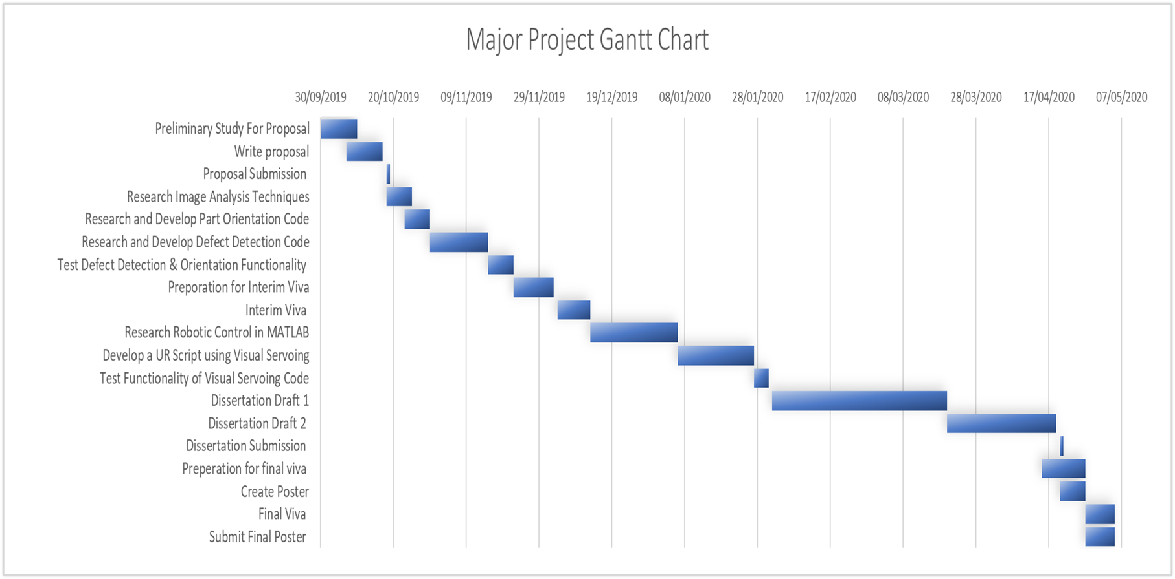
Below is a Gantt chart to show the preliminary work plan for the project.
Figure 1: Preliminary Gantt Chart

Case study Overview
Printed circuit boards (PCB’s) are essentially boards or cards used as a mounting platform to which multiple electronic components are connected. Using conductive tracks, PCBs supply power and electrical signals to components such as resistors, capacitors, diodes, and microcontrollers. A report by the British house of commons committee found that SME’s account for 51% of UK based electronics manufacturers (UK.gov, 2017).
A study by the World Electronic Circuit Council shows that SME PCB manufacturers are still heavily reliant on the use of labour-intensive product handling and offline quality control procedures, since they have a lower cost of entry and are less complex to integrate with existing manufacturing systems (WWEC, 2016).
As such, this study will use two types of bare PCB as the target objects in the development of the robot control algorithm, to investigate the feasibility of using a low-cost robot vision system in product handling procedures, such as; pick-and-place or packaging operations, the study will also aim to simulate a quality control procedure for identifying through hole defects.
Through holes are holes in a PCB for mounting components such as resistors, diodes and capacitors . (Willis, 2016) identified through hole defects as one of the typical defects in bare PCB manufacturing (see Appendix 3). Through hole defects include; missing, too many, misplaced and incorrect diameter holes.
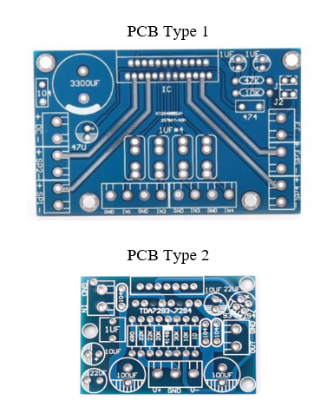
Below is an image of the PCB target objects for the robot vision system;

Figure 2: Image of PCB Target Object Types

Literature Review

Preface
In this chapter, a selection of literary works are reviewed to provide an insight as to the current state of research around the topics of machine vision systems used in vision-guided robotics and computer vision techniques, including traditional methods and concurrent artificially intelligent machine and deep learning algorithms.
This literature review considers both concurrent and historical publications. It may be argued that these early publications are outdated or not strictly concurrent, however, due to the progressive nature of many of the methodologies and principles surveyed, these early publications provide the fundamental foundations on which most of the proceeding works are based, and as such provide contextual insight to each topic. Secondly, the contemporary sources are reviewed to provide the current trends of research in each topic area, as well as to identify any gaps in the research.
A summation of the reviewed literature is provided with the aim of supplying insight to the following questions;
- Do machine vision systems used in vision-guided robotics still require dedicated and costly hardware and software?
- Can artificially intelligent algorithms, such as machine and deep learning, replace traditional computer vision techniques in computer vision applications?

Definition of Machine Vision
(Davies, 2015) clearly defines machine vision, Davies States, “Machine vision is the study of methods and techniques whereby vision systems can be constructed and usefully employed in practical applications ”.
The Automated Imaging Association give a more technical definition of machine vision, they state “The term machine vision refers to any applications in which hardware and software provide guidance to machines in order to execute multiple functions using image acquisition and analysis” (Automated Imaging Association, 2008). Davies also discusses the importance of recognising the subtle differences between machine and computer vision. Davies explains that machine vision refers to the hardware and software used to acquire images and thus control a process or machine, while computer vision describes the techniques used to analyse the acquired images. There is certainly an overlap between machine and computer vision, and as such some use the terms interchangeably, however, this is not strictly appropriate. Put simply, all machine vision systems use computer vision techniques, but not all computer vision techniques are used for machine vision purposes.
Throughout his book, the author discusses the three distinct levels of image analysis in machine vision, low-level, intermediate, and high-level systems. Low-level systems are defined as those used to recognise the presence of an object using traditional techniques such as basic image filtering, image segmentation and mathematical morphology. Intermediate level systems are those that acquire more abstract information from an object, using feature extraction techniques, such as edge and hole detection, as well as abstract pattern matching algorithms. Davies goes on to define high-level machine vision systems as those that can interpret, understand and learn complex scenes using 3-D vision, motion prediction and analysis and artificially intelligent algorithms (Davies, 2015).
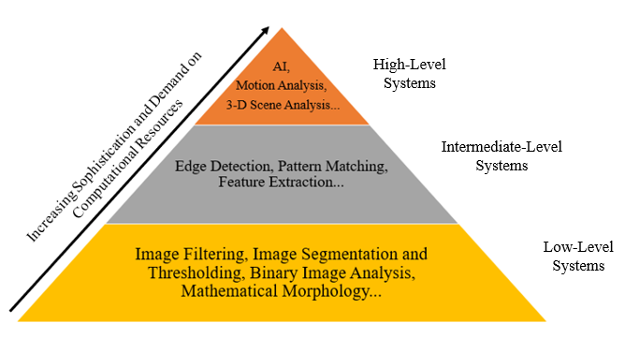
Davies’ observation of low, medium, and high-level machine vision systems essentially describes a hierarchical relationship between the sophistication of a given MV technique and the number of applications in which the technique is used. While low-level techniques are the most rudimentary methods used, they are the core of all MV algorithms. Sophisticated High-level techniques are application specific in that they are often developed for a specific task or intended application, and as such are more seldom used. Below is a diagram of this hierarchical relationship.
Figure 3: Hierarchical Pyramid Diagram of Machine Vision System techniques

Machine Vision System Theory
Machine vision is an interdisciplinary study comprising of image acquisition & analysis, optics, computer science and mechanical/mechatronics engineering. Malamasa et al.(2003) completed a comprehensive survey of industrial vision systems, the authors provided an overview of the typical hardware used in MV applications, MV hardware includes; cameras and frame grabbers (image acquisition), dedicated structured lighting equipment (glare mitigation), computers or processing units (image analysis), programable logic controllers (process control) and component manipulators (actuators, gating systems & robotic arms). (Malamasa, et al., 2003).
Rowe et al. (2002) describe how hardware used in MV applications can vary in complexity, from USB interfaced 2-D cameras, using consumer grade PC’s, up to 3-D smart cameras, dedicated image processing units and programable logic controllers (Rowe, et al., 2002).
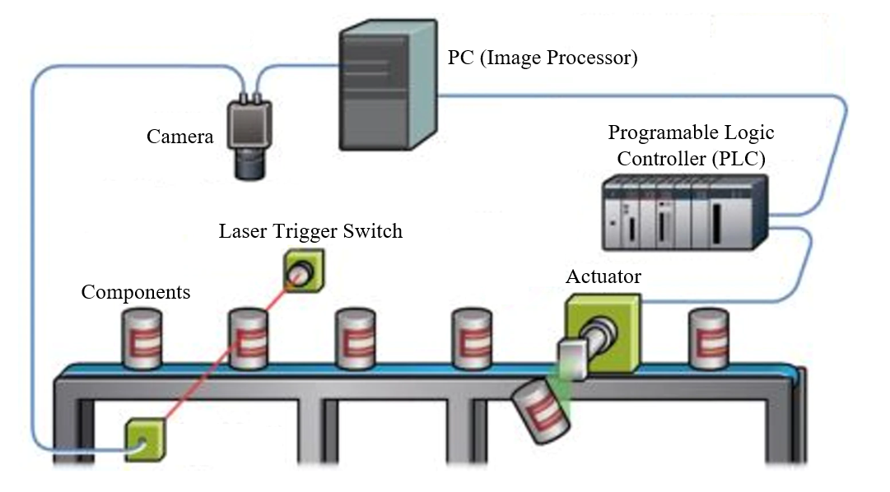
Steger et al. review multiple forms of machine vision systems in their book, the authors explain how the design of machine vision systems is largely specific to its intended application. Steger et al. also discuss how there is rarely an “off the shelf” solution to a given vision based task or activity (Steger, et al., 2018). Below is a diagram of the typical hardware used in industrial machine vision systems;

Figure 4: Industrial Machine Vision System Diagram (Carroll, 2018)
In This instance (Figure 4), components (cans) move along a conveyer belt and subsequently move through a laser trigger switch . Activation of the switch triggers the camera to take images of the component, this is known as image/data acquisition. Image analysis algorithms on the PC (or image processing unit) perform an automated inspection of the images and thus classify the component by component type or defective/non-defective. A signal is sent from the PC to the PLC (usually a true/false logical operator), the PLC is then used to activate the actuator and push the component from the conveyor belt. This is known as a product sorting procedure.

Industrial Camera Systems
One of the fundamental functions of an MV system is image acquisition, and thus the type of camera, image sensor and optical lens used is a crucial consideration. As mentioned above, the hardware used in a given MV system is largely dependent on its intended application, and as such, the types of camera, sensor and lens combinations discussed in literature are vast.
Gilblom (2011) proposed a method for categorising industrial cameras in his book. Gilblom suggested that industrial cameras be defined as either line scan or area scan variants (Gilblom, 2011).
Gilblom also defines the difference between line and area scan cameras. A line scan camera captures one row of pixels at a time, known as a row vector of pixel data. As the object moves under the camera lens, the camera sequentially adds the new pixel row vector below the former in order to create a two dimensional array of pixel data, this array becomes the captured image. An area scan camera captures the entire two dimensional array in one instance. The size of the two dimensional array is dependent upon the resolution of the camera, a 1920x1080p resolution camera for example; captures 1920 pixels in the X-direction and 1080 pixels in the Y-direction.
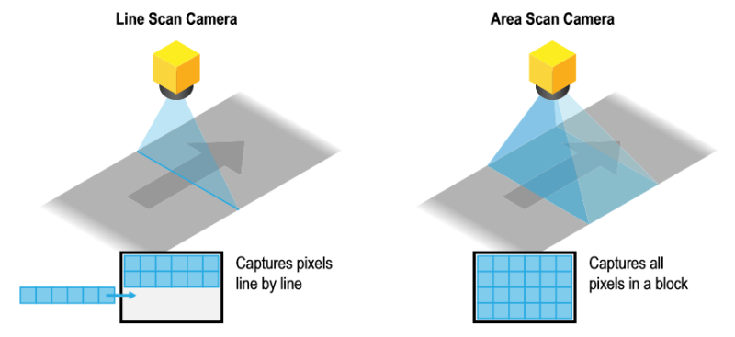
Below is a diagram showing the difference between line scan and area scan cameras.
Figure 5: Line Scan vs Area Scan Cameras (Manufacturing Automation, 2019)
Bodenstorfer, et al. (2007) provide insight as to the typical uses of line scan and area scan cameras in MV applications, the authors state that line scan cameras are used to capture high definition images of objects moving at high speed, while area scan cameras are used more generally in a vast range of image acquisition applications (Bodenstorfer, et al., 2007).
(A review of monocular, stereoscopic and Multi-camera systems can be found in Appendix 5)

Image Processing Systems
Nair et al. (2018) provide an extensive review of image processing units (IPU) used in industrial MV systems in their journal article. The study outlined three distinct types of IPU’s, these include;
- Dedicated heterogeneous embedded IPU systems.
- PC-based IPU’s using computer vision software.
- Smart cameras with integrated processing units.
The authors explain that in recent times, costly and complex embedded IPU’S are being replaced with lower cost and easier to integrate PC-Based Systems (Nair, et al., 2018).
Boyle et al, discussed the common design considerations for IPU’s in their book. The authors discussed how like many manufacturing systems, IPU design ultimately depends on a trade-off between desired system functions and performance and the cost of purchasing and maintaining the equipment required (Boyle, et al., 2014).
One of the most notable developments in PC-based image processing is the development of the compute unified device architecture (CUDA) in 2003, CUDA is a parallel computing platform that enables PC’s to share processing loads between the central processing unit (CPU) and the graphics processing unit (GPU). Park et al. (2010) provide an evaluation of image processing using CUDA enabled GPU’s in their journal article. The study used a combination of image encoding, non-photorealistic rendering (NPR) and feature extraction algorithms. The execution time for each algorithm was compared with results taken from an embedded IPU. The study concluded that CUDA enabled PC-based IPU’s could match, and in some instances; outperform the costly embedded IPU system (Park, et al., 2010).
There are many recent literary works discussing smart cameras with integrated processing units. Smart cameras can perform image analysis without the need for secondary processing units, and also typically stream the results of the analysis using Wi-Fi networks connected to the internet of things (IoT). Chalifoux (2018) explains that smart cameras were first developed in the early 1990’s; but have only become practical in recent years due to advancement in compact processing unit design. Chalifoux also notes that performance and cost are still a major barrier to entry in many applications, stating smart cameras simply don’t have the processing capacity for demanding tasks, despite this, Chalifoux predicts that smart cameras will play a significant role in the smart factory of the future (Chalifoux, 2018).

Machine Vision Applications in Vision Guided Robotics
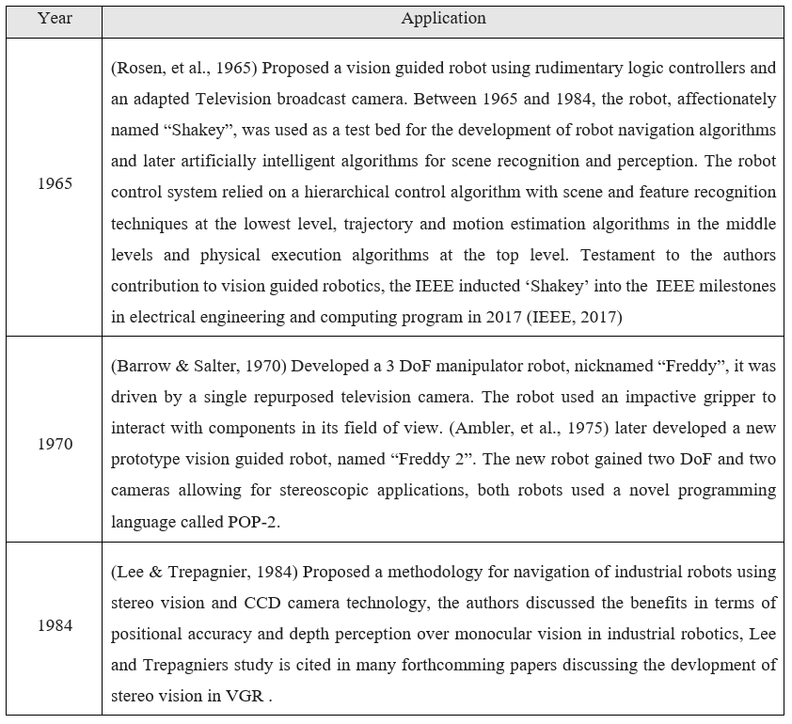
In recent years, machine vision has proliferated from purely industrial applications to a broad range of sectors, from medical applications such as vial inspections and robotic surgeries, to automotive applications such as autonomous vehicles. In this section, machine vision applications in vision guided robotics are considered. Even in this specific application, the number of literary works discussing VGR applications is expansive, as such, the method of reviewing these works differs from previous sections. Here a selection of key works and applications are tabulated in chronological order, with the aim of showing the trend of advancement in VGR systems .
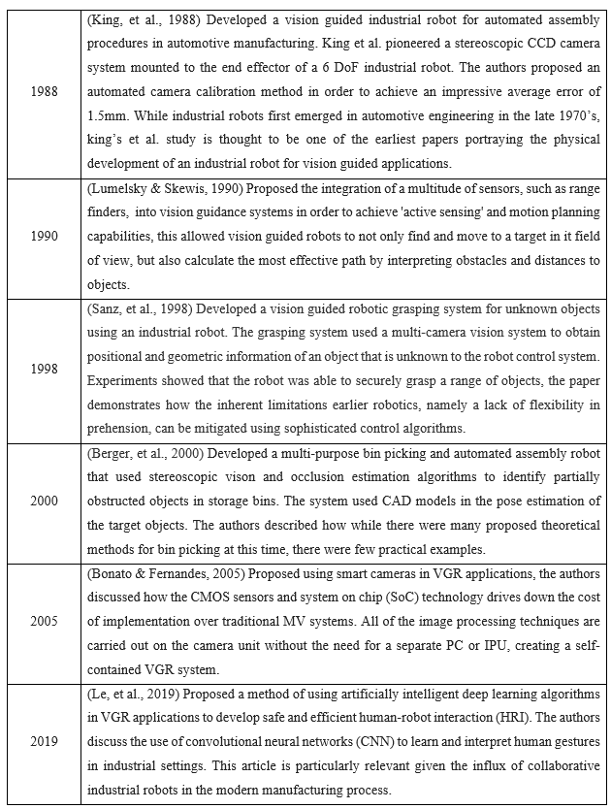
Table 1: Review of VGR Applications

Image Processing and Computer Vision Techniques
In this chapter, computer vision (CV) techniques used in machine vision applications and specifically vision guided robotics are reviewed. CV is a vast interdisciplinary study used in a multitude of applications and industries, thus it is not feasible to consider all CV techniques, as such, only techniques specific to this project are surveyed here.
Computer vision represents the image analysis and processing algorithms used in MV and thus VGR. As mentioned above, a machine vision system is a combination of both hardware and software. While it is not appropriate to say that computer vision alone defines the software elements of a machine vision application, they certainly represent the core high-level functions and are thus fundamental to the successful implementation of any MV system.
(Ćirić, et al., 2016) provide a review of the typical CV processes used in VGR applications, from image processing and segmentation to feature extraction and classification. Below is a block diagram of these processes;
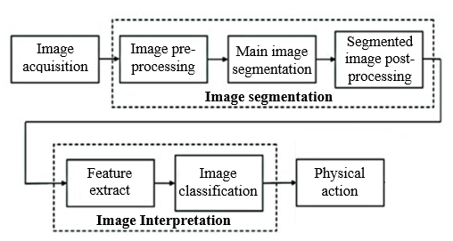

Figure 6: Computer Vision Block Diagram (Ćirić, et al., 2016)
The CV techniques used in most instances are specific to the given application, however, the vast majority rely on the same group of fundamental algorithms. Although some of these major works are many years old now, they still form the building blocks of many of today’s CV algorithms, this review will pay particular attention to these fundamental algorithms.

Definition of Computer Vision and Image Processing
Szeliski defines machine vision in his book. The author describes computer vision as a series of analysis and processing techniques, From low-level image pre-processing to high-level machine and deep learning algorithms, used to obtain useful and meaningful information from digital images and videos. The author explains how the information obtained is used to train CV systems to recognise and learn objects and features, in order to perform cognitive and perceptual tasks. (Szeliski, 2010)

Image Pre-Processing
(Klette, 2014) provides an extensive review of image pre-processing techniques in CV. Klette explains that while pre-processing procedures include generic operations such as image resizing and orientation operations, the term pre-processing is often used to describe image smoothing or denoising with the aim of refining the images to increase the effectiveness of further analysis.
(Goyal, et al., 2012) reviewed image smoothing and denoising techniques used in modern CV. The authors stated that the most common forms of image smoothing and denoising include; frequency domain filtering, spatial filtering, and the wavelet thresholding method.
Spatial filtering involves altering discrete pixel intensities according to the neighbouring pixel intensities. The authors describe sub-types of spatial filtering including bilateral, mean and median filters, for example; bilateral filtering uses an average of the pixel intensities either side of the target pixel, mean uses the four adjacent pixels and the median uses the eight surrounding pixel intensities (Goyal, et al., 2012).
(Gonzalez & Woods, 2017) explain that frequency domain filtering (figure 7) uses the Fourier transform to interpret discrete pixel intensities as Fourier coefficients, a frequency range is chosen, and all outlier frequencies are removed from the transform, frequency domain filtering is commonly used to remove ‘salt and pepper’ noise from images.
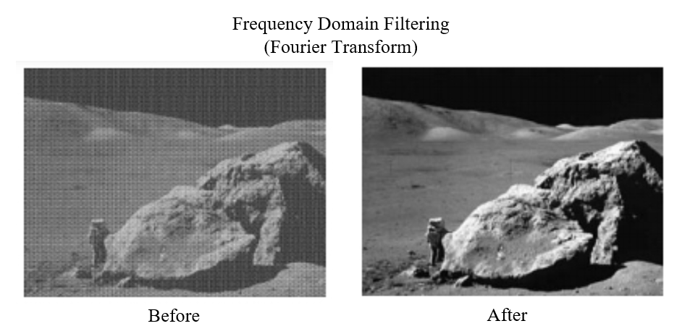
The authors summarise the wavelet thresholding method, it uses the wavelet transform to interpret pixel intensities as time/frequency data (wavelets), the wavelet thresholding method is similar to frequency domain filtering, however it differs in its ability to remove noise without compromising the definition of the edges in images.

Figure 7: Frequency Domain Filtering Before and After (Gonzalez & Woods, 2017)

Image Segmentation
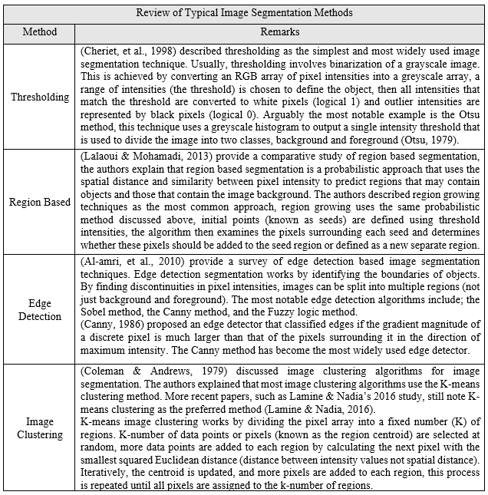
Image segmentation is the process of splitting images into segments (or masks), usually to distinguish between an object of interest and the image background. There are many proposed image segmentation methodologies in literature, however, (Narkhede, 2013) identified thresholding, region based methods, edge detection and image clustering methods as the most commonly used in her review of image segmentation techniques. A review of each method is tabulated below;
Table 2 Table of Typical Image Segmentation Techniques

Feature Extraction
(Davies, 2015) explains that feature extraction involves using classic algorithms, such as the Canny, Sobel and fuzzy logic methods, to obtain low and medium-level information from objects detected during image segmentation. Low-level features include; dots, lines, colours, generic shapes, and spatial information, such as positions and orientations. Medium-level features include edges, holes, corners, ridges, and textures for example. Feature extraction is a precursor to image classification and object detection (discussed below). (Kortli, et al., 2020) provide a review of high-level feature extraction algorithms, these algorithms aim to describe features using numerical representations, known as feature vectors. In images, feature vectors may include gradient, orientation, grayscale intensity values, areas, circularities, and length values, the authors note that LBP and HOG are two typical examples of descriptor algorithms.

Local Binary Patterns
(Ojala, et al., 1996) proposed the local binary patterns method, LBP is used for detecting textures in images and has been used extensively in machine and deep learning based human face detection algorithms. LBP thresholds discrete pixels in a grayscale image by considering the 8 neighbouring pixel intensities (known as the neighbourhood). If the surrounding intensities are smaller than the target frequency they are replaced with a 1, and if larger a 0. This combination of 8 values (or bits) form a binary string known as a byte of data. This byte is converted to decimal value and replaces the initial pixel intensity. This is carried out on every pixel in the array. A 3x3 neighbourhood has 2⁸ (256) possible patterns. Finally, a histogram of the patterns in the new array is plotted, this becomes the feature vector (Ojala, et al., 1996).

Histogram of Oriented Features
(K.McConnell, 1986) developed the histogram of oriented gradients method, however the technique became more well-known after further development by (Dalal & Triggs, 2015). The first step in the Dalal and Triggs method is to resize the image to 64x128 pixels. Then the gradient and orientation magnitudes for every pixel must be calculated by considering the adjacent X and Y-pixel intensities. the X-gradient is calculated by (X+1)-(X-1) and the Y-gradient by (Y+1)-(Y-1). The orientation is given by $\tan^{-1}{(X-gradient/Y-gradient )}$. The image is then divided into 8x8 pixel cells. A histogram of the gradient/orientation data is then created for each cell, this process is called binning. These multiple histograms are concatenated to create a feature vector (Dalal & Triggs, 2015).

Image Classification and Object detection
(Scherer, 2020) defines the subtle difference between image classification and object detection. The author explains that image classification is a means of labelling an image with contextual information as to its contents. Object detection is a subset of image classification, it also aims to provide contextual information, but is further used to localise an object within the image by supplying spatial information, such as centroid coordinates and bounding boxes. The author describes two distinct methodologies for image classifiers/object detectors, deterministic and probabilistic approaches. The author explains that although finding objects in images is a trivial task for humans, it is still a challenge in computer vision.
(Howarth, et al., 2009) provide a review of deterministic classifiers/detectors, they are a traditional approach that typically use feature-based analysis in order to either identify the presence of an object in an image or make a judgement about the object (typically defective/non-defective) based on this analysis. Feature-based algorithms involve prior definition of the features of a target object. As discussed in chapter 2.5.4, features include; gradients, orientations, grayscale intensity values, areas, circularities, and length values. The algorithm then aims to identify these features in new images to determine whether or not the image contains the target object.
(Howarth, et al., 2009) go on to explain the limitations of the feature-based approach, namely its inherent inflexibility. The authors describe that it requires significant effort to define the unique features for every target object, and that the method struggles to differentiate between similar objects. The only way to mitigate this issue is to define more features, thus increasing the complexity of the detector; in turn, the effects of external interferences such as glare and signal noise increase significantly with the complexity of the detector. Put simply, the increasing layers of criterion for successful detection mean that if any of these features become obscured by glare, noise or occlusion, there is a significant risk of false negative detections.
(Scherer, 2020) explains that probabilistic approaches typically involve artificially intelligent machine and deep learning algorithms. Scherer describes machine learning as a series of algorithms that use statistical analysis to learn from patterns in image data, without explicit coding. Deep learning is a subset of machine learning that aims to simulate the biological neural networks and neuron responses of the human brain, in order to emulate the cognitive and perceptual abilities. Scherer notes that machine and deep learning are a rapidly maturing technique in CV. (background information on neural networks is available in appendix 6)
(Voulodimos, et al., 2018) provide a review of modern machine and deep learning algorithms for computer vision applications, the authors quote that “Deep learning methods have been shown to outperform previous state-of-the-art machine learning techniques in several fields, with computer vision being one of the most prominent cases”. The authors describe convolutional neural networks (CNN’s) as the most researched and implemented AI based object detectors. Arguably one of the largest breakthroughs in research around CNN’S in recent times is the development of the AlexNet CNN by (Krizhevsky, et al., 2012). AlexNet is an open-source, eight-layer CNN developed specifically for image classification and localisation procedures. The neural network was trained using 1.2 million images from the ImageNet database. A supervised learning method (discussed below) was used to train the network. AlexNet is held in high esteem by many researchers in the field due to its significant accuracy and error rates, at the ILSVRC2012, an international event where top deep learning algorithms are tested against each other, AlexNet achieved an average error of just 15.32%, A 10.86% decrease over the second-best entry (ILSVRC2012, 2012).
(Davoine, et al., 2019) discuss how tried and tested, open-source CNN architectures, such as AlexNet, can be retrained using much smaller data sets for specific object detection tasks, this means that engineers can achieve remarkable results without needing expert-level knowledge of deep learning algorithms, below is a review of typical CNN training methodologies;
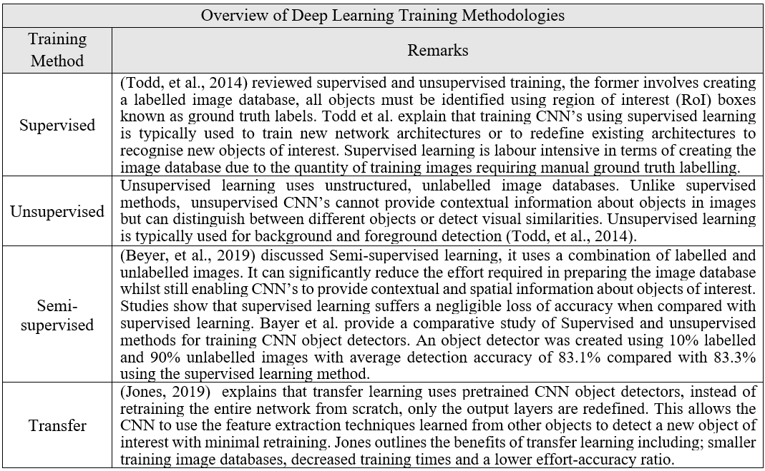

Table 3: Overview of Deep learning Training Methodologies

Summary
At the start of this survey, two questions were proposed. These questions will be discussed below using the knowledge gained from this study.
- Do machine vision systems used in vision-guided robotics still require dedicated and costly hardware and software?
MV and CV applications in VGR are mature research areas, with systems proposed as early as 1965, however advancement of computational processing power have seen PC-based image processing become common place in machine and computer vision applications and thus has overtaken dedicated image processing units in the development and implementation of machine and computer vision algorithms. The development of CUDA enabled GPU’s, that aim to share the processing load between a PC CPU and GPU have made implementation of traditional image processing and artificially intelligent algorithms a practically viable option in a large number of applications.
Many of the papers surveyed discussed the development of machine and computer vision algorithms for tasks such as image classification and object detection in open-source programming languages such as Python, Java and C/C++, so machine vision doesn’t require costly proprietary software per se, but it does require a solid understanding of one of the major programming languages, which may be seen as a disadvantage over more user friendly “plug-and- play” proprietary software.
As discussed in appendix 4, the development and proliferation of CMOS image sensors has driven down the cost of camera systems for machine vision, the advancement of CMOS technology in terms of image quality and noise reduction makes such sensors suitable for many machine and computer vision applications. When multiple camera systems are required, smart cameras with integrated processing systems have the ability to reduce the computational demand without the need for investing in multiple costly dedicated IPU’s.
Even with the advancement of computing power and camera hardware, the design of a machine vision system still ultimately depends on a trade-off between the desired system functionality and performance and complexity of implementation, For systems that require high speed imaging or ultra-high quality images, costly CCD systems with dedicated IPU’s may still offer better performance; but at an increased cost. For systems that do not require this higher-level of performance, it is certainly feasible to use lower cost, easier to integrate PC based processing using CMOS camera technology.
- Can artificially intelligent algorithms, such as machine and deep learning, replace traditional computer vision techniques in industrial applications?
To some extent, it is fair to say the machine and deep learning algorithms are already replacing traditional CV techniques such as image classification, feature recognition and object detection. The change from deterministic to probabilistic object detectors decreases the probability of false negative and false positive object detections as a result of external factors such as glare, occlusion and signal noise.
Development of open-source state-of-the-art convolutional neural network architectures, such as AlexNet, allows engineers to develop application specific object detectors with only a working knowledge of deep learning based algorithms as opposed to an expert-level knowledge. Training methods such as semi-supervised learning drastically reduce the amount of pre-processing required before training, reducing the time and effort taken to develop useful CNN’s. Furthermore, transfer learning techniques can significantly reduce the data acquisition process; and thus, the training data required, this reduces the overall training time and also decrease the programming effort required to develop useful and deployable CNN image classifiers and object detectors.
It is not likely that machine or deep learning algorithms will completely replace traditional computer vision algorithms, and many of these methods, such as smoothing and denoising methods and feature extraction and description algorithms still make up the core functions of many modern computer vision algorithms. Instead machine and deep learning should be used as a complementary tool to optimise the development and implementation of MV systems.

Research Gap Determination
All of the topics discussed, from machine and computer vision, vision guided robotics and machine and deep learning, are mature research areas with an abundance of literary works discussing the development and implementation of such systems. However, all of these papers are written with the aim of achieving a specific objective or for a specific intended application, as such the development for most robot vision systems is problem driven rather than in the interest of research. A commonly neglected topic is the cost of developing and implementing such systems. Many papers attesting to be based on the development of low-cost vision systems fail to quantify the cost of such systems, and instead simply infer that the system is low-cost because it is PC based, uses USB communication protocols or uses simplistic cameras.

Methodology

Overview of the Project
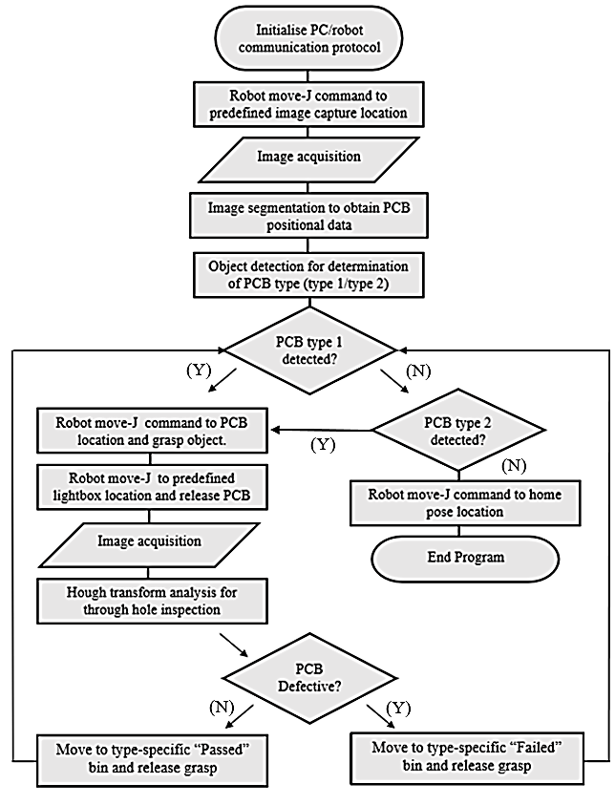
This section aims to provide a rationale as to the development and implementation of the vision system, however, firstly an overview of the obtained system functionality is provided in order to provide contextual insight.
Figure 8: Vision System Function Flow Chart

(A video demonstration is available in Appendix 1)
The functionality of the vision system is further described below;
- The robot moves to a predefined image capture pose.
- The vision system identifies the randomly positioned PCB’s (figure 9) against the black background.
- The control algorithm calculates the coordinates of all the PCB’s in the field of view.
- The robot moves to a target PCB and actuates the gripper.
- Four PCB’s are moved sequentially to the lightboard.
- Images are captured of the four PCB’s for through hole analysis.
- Each of the PCB’s are classified as defective or non-defective.
- The four PCB’s are moved to the appropriate bins for its given type and classification.
- The process is repeated until all of the PCB’s are sorted into the appropriate bins.
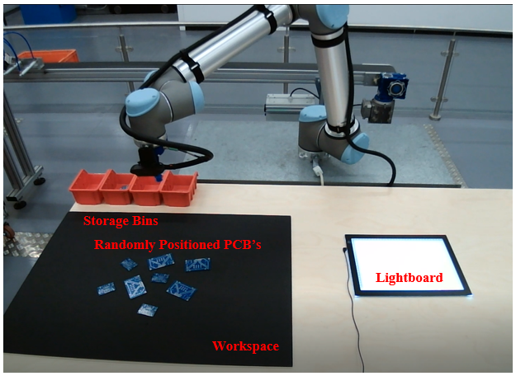
Figure 9: Image of Robot Workspace

This project can be categorised into three distinct areas of study; the development of the system hardware (robot, camera system and end effector design), bridging multiple software packages and development of the robot control algorithm, and finally the testing and validation of the key performance metrics of the vision system.

Overview of resources used
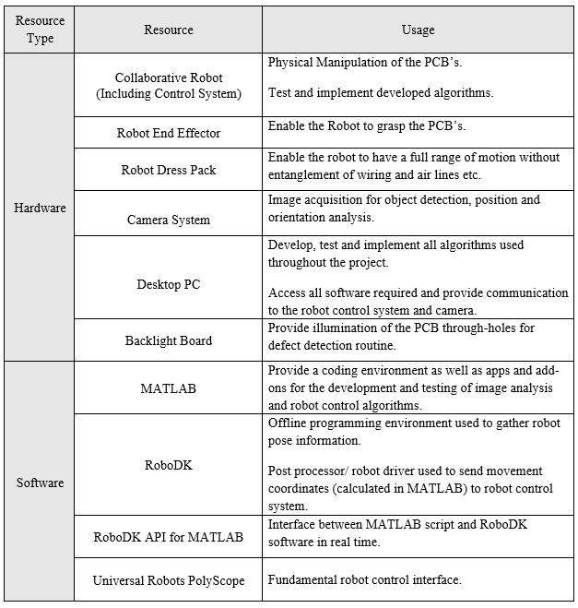
The integration of multiple hardware and software based resources was required throughout. In this section the development and integration of all of the resources used in the completion of the project are discussed. Below is a table detailing all of the resources used (each piece of equipment is discussed further in subsequent chapters).

Hardware

Collaborative Robot
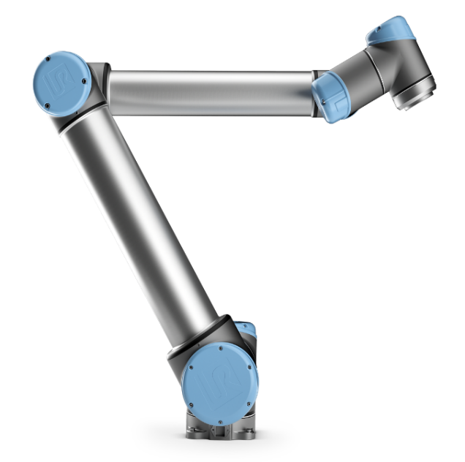
The collaborative robot used in this project was a Universal Robots UR10 (figure 10). There were two collaborative robots available in the robotics laboratory during the project, the aforementioned UR10 and a Universal Robots UR3. Although the UR3 would have had sufficient payload capabilities for this project, due to its compact size, it did not have sufficient horizontal reach. For this reason, the UR10 was chosen.
Figure 10: Image of Universal Robots UR10 (Universal Robots, 2020)
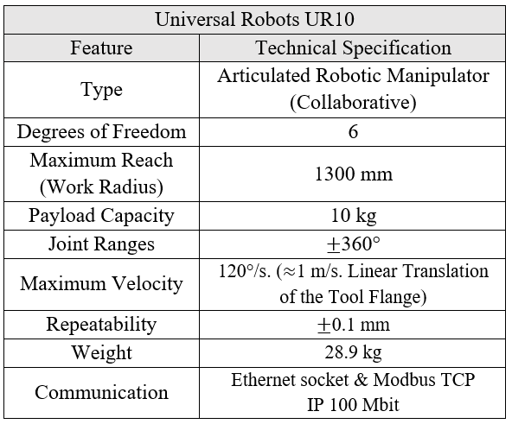
A table of technical specifications for the UR10 is found below;

Table 4: Table of Resources Used Throughout the Project
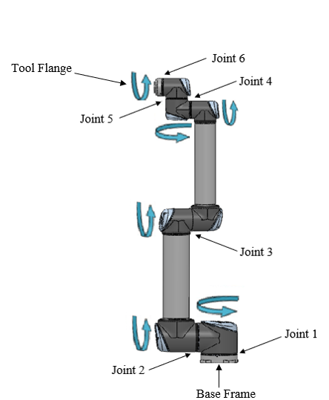
Table 5: Universal Robots UR10 Technical Specifications (Universal Robots, 2014)

Figure 11: Annotated UR10 Diagram
Above is a diagram of the 6 revolute joint locations that make up the six degrees of freedom on the universal robots UR10. Typically, the robot is programmed through a teach pendent, known as the PolyScope, however it can also be programmed with pose targets sent either to the USB 2.0 port on the PolyScope or to the TCP port in the control box.
In most industrial robotics, pose targets are calculated using forward and inverse kinematic transformation matrices. Forward kinematics calculate the tool flange (Figure 14) position coordinates for a given set of (6) joint angles, and inverse kinematics calculate the required change in joint angles to reach a given tool flange coordinate. There are various methods for calculating forward and inverse kinematics ranging in complexity, the pose accuracy and trajectory predictions, (Lenarcic, et al., 2013) identify the Jacobian inversion/transpose methods and the cyclic coordinate descent (CCD) methods as common approaches in 6 DoF robots.
Modern robots, such as the UR10, have integrated kinematic calculation facilities that only require the programmer to input the cartesian tool flange coordinates (x, y, z, yaw, pitch & roll). This greatly reduces the complexity of the control program, and thus reduces the probability of incidents of error in the pose and trajectory calculations.
Early in the project, it was realised that some form of cable management (dress kit) was needed in order to allow the robot to maintain a full range of motion; without entanglement or causing damage to sensor cables and air lines. Off the shelf Universal Robots UR+ dress kits proved costly at in excess of £500 and did not fit the low-cost ethos of the project, as such, a custom dress kit was made at the university workshops. Similar to the UR+ dress kit, the system developed in the university workshops comprises of split conduit tubing to shield the cables, quick release clamps and adjustable Velcro straps, this system proved to be a significant cost saving at £28.87 for all materials. The system was effective and reliable throughout the project.

Camera System
The camera system chosen for this project was a single Logitech C922 Pro HD USB webcam. While using a webcam is certainly not a traditional approach to MV camera systems, it posed a series of advantages in this project, including; 1920x1080p resolution at 60 Frames per second, 78-degree field of view and an autofocusing, antireflective optical lens. The primary consideration when choosing the camera system was the cost-to-functionality ratio, there are certainly more sophisticated camera systems available, but at much higher prices. Another consideration was the ease of integration, the Logitech C920 Pro has a USB connection interface, is preloaded with drivers for the windows operating system and does not require any frame grabber or IPU hardware other than a traditional PC.
A Table of Technical specifications for the Logitech C922 is found below;
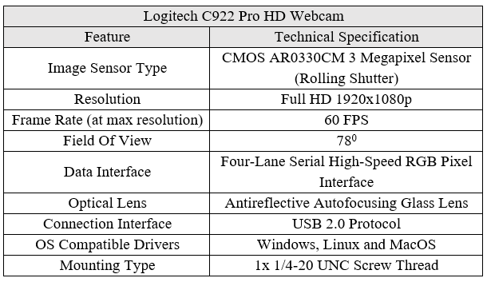

Table 6: Logitech C922 Pro Technical Specifications (Logitech , 2020)

End Effector Design
The grippers available in the robotics laboratory during the project were impactive grippers. One of the available grippers was a small two-claw angular motion type gripper, the other was a large two-claw linear motion type gripper, both types were pneumatically actuated. Below is a diagram of the two types of grippers available;
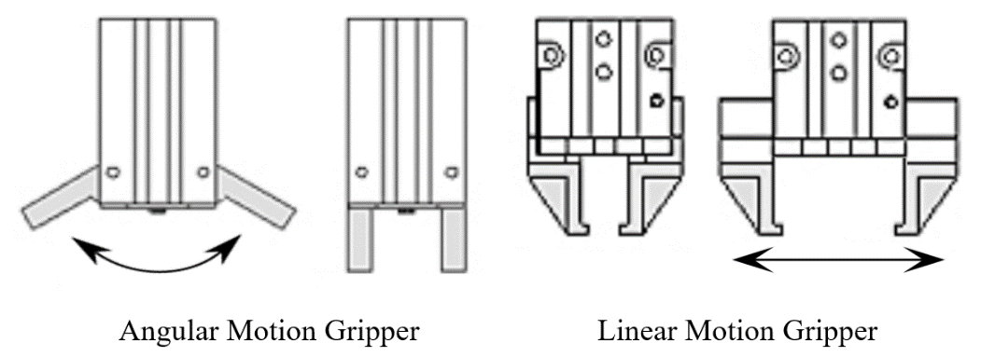

Figure 12: Diagram of Angular and Linear Motion Type Grippers (Omega Engineering , 2018)
The PCB test pieces used in this project proved particularly difficult to grasp using the mechanical grippers shown above, this was due to the fact that the PCBs were very thin and being grasped from a flat surface. A series of tests on both grippers showed that neither were suitable for use in this project, the small angular gripper could grasp the PCB’s, but frequently missed or dropped it during motion. The large linear gripper was capable of grasping the PCBs also; but was much too large and cumbersome for handling such small components.
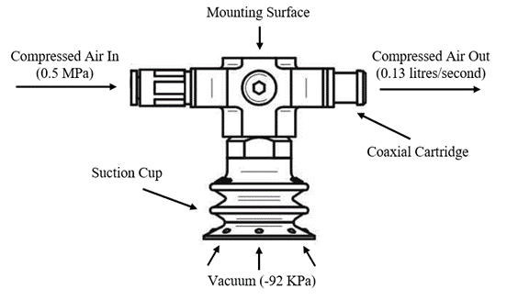
The decision was made to develop an astrictive vacuum-based end effector to mitigate the grasping issues. Vacuum was supplied to the end effector by a PIAB VGS 2010 vacuum ejector (Figure 13). The PIAB VGS 2010 cost £74.65 (including suction cups). This proved much more cost effective than purchasing the vacuum pump, gripper assembly and suction cups separately. Below is an annotated image of the PIAB VGS 2010 vacuum ejector used in the end effector design as well as a table of technical specifications;

Figure 13: Annotated Diagram of PIAB VGS 2010 Vacuum Ejector (PIAB, 2018)
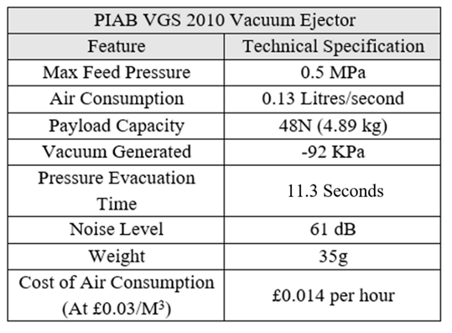

Table 7: Technical Specifications of a PIAB VGS 2010 (PIAB, 2018)
Air flow to the vacuum ejector was controlled using an electronically actuated solenoid valve. The solenoid valve was connected to the digital input/output (I/O) terminal inside the Universal Robots control box, this allowed integrated control of the end effector without any external control devices
Once the vacuum ejector and control system had been developed and tested, an adapter was made in order to mount it to the UR10 tool flange. It was decided that in order to simplify the tool centre point configuration in the robot control script, the vacuum ejector would be mounted concentrically along the central axis of the tool flange of the robot, this means that the vacuum ejector is only displaced in the Z-Axis of the tool flange and has no X or Y-axis displacement.
Due to the cost of materials and machining time required, it was not feasible to machine the adapter out of aluminium or steel, as such, the adapter was made additively using the 3-D printing facilities at the university workshops. There were three design iterations in total, each design was improved using linear static finite element analysis (FEA) and Topology mass optimisation (see appendix 7). Design iterations one and two were produced using a UniMaker fuse deposition modelling (FDM) machine, the print material was ABS plastic.
As a result of a series of print defects, namely delamination, causing premature failure of the first two designs, the manufacture of the third design was outsourced. The third design was produced using an industrial selective laser sintering machine (SLS) and was printed in fibre reinforced nylon. This design proved sufficient for the intended application and remained functional until the end of the project.

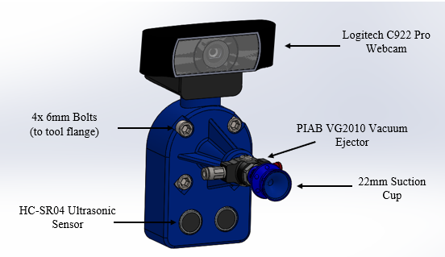
Below is a CAD representation of the final end effector design;
Figure 14: Annotated Diagram of Final End Effector Design
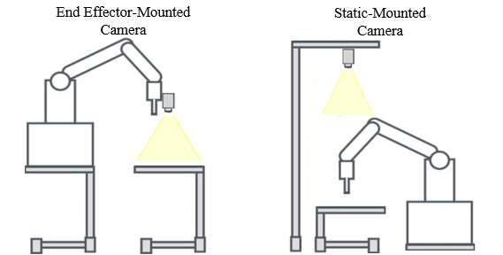
As shown in the diagram above, the camera was integrated into the end effector design, this yielded two significant benefits over mounting the camera statically (figure 15). Firstly, the camera reference frame and thus calibration with respect to the position of the robot tool centre point is made much easier. Secondly, it allowed much more flexibility in the robot program, the robot could operate in any orientation and is not limited by the cameras field of view.
Figure 15: Robot Camera Mounting Diagram

Computer System/ Processing Unit Selection
Giving details of the PC used in the project may seem excessive, however, it was an important consideration affecting both the run time of the robot control algorithm and the training time required for the training of the object detector (discussed in section 3.5.8). At the time of the project there were two computers available, a Hewlett-Packard mobile workstation with an intel i7-8550u 2.0GHz CPU and a dedicated AMD Radeon Pro WX 3200 1.295GHz GPU, and a Viglen desktop PC with an intel i5-650 3.46GHz CPU and a dedicated Nvidia Quadro K620 1.8 GHz GPU.
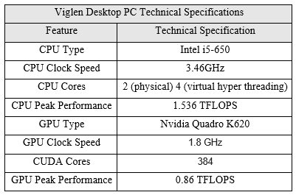
The Viglen desktop was chosen to run the control algorithm and to train the object detector, the major deciding factors were that the GPU was CUDA enabled (increased performance & decreased training times) and the desktop PC had many more USB ports for connection of the camera and lightboard.

Table 8: Table of PC Technical Specifications

Lightboard
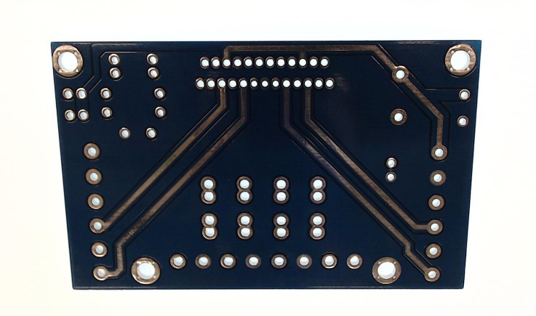
A lightboard was also needed to perform reliable and repeatable Hough transform analysis of the through holes for the quality inspection routine. A generic LED lightboard was used. Below is an image of the type-1 PCB on the light board, note how all of the through holes are easily identifiable (white circles in PCB body).

Figure 16: Image of Type 1 PCB on the Lightboard

Software
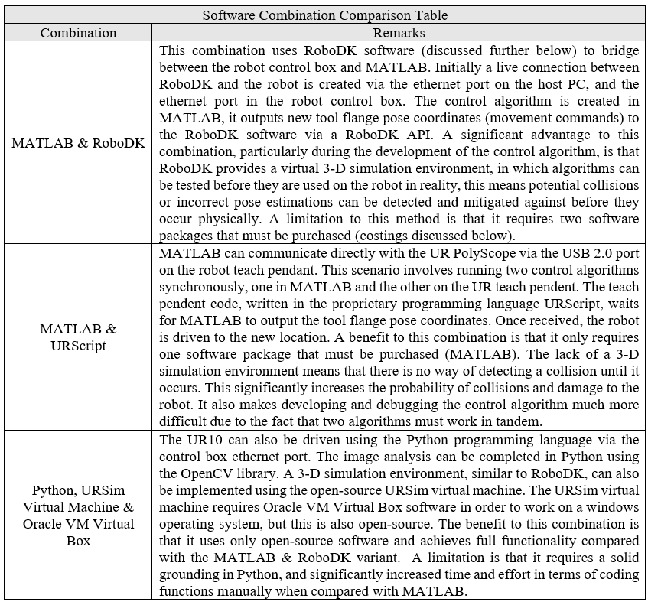
Three possible software combinations were considered in the development of the robot control algorithm, they have been tabulated below;
Table 9:Table of Possible Software Combinations
The MATLAB & RoboDK combination was chosen for this project for three reasons;
- The vast quantity of toolboxes, add-ons and built-in functions in MATLAB, combined with the increased ability to debug the algorithm using the RoboDK 3-D Simulation environment, enabled rapid prototyping and testing of new codes and functions.
- MATLAB is widely used at the university and as such it was the most familiar programming language.
- Both RoboDK and MATLAB where readily available in the robotics laboratory during the project.

MATLAB
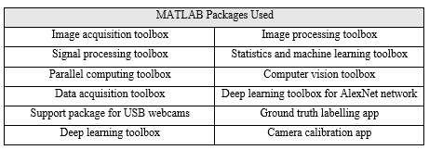
MATLAB was used in the development, implementation and testing of the robot control code. The project was subject to a tight timescale. Using a vast quantity of toolboxes, add-ons and built-in or predefined functions, as well as the supporting documentation available online, the project was achieved on this timescale. MATLAB enabled much quicker prototyping and evaluation of new sections of code, it is highly probable that this project would not have been achieved in this timescale if the Python language had to be used for example. Below is a table of toolboxes, apps and add-ons used in the completion of this project;
Table 10: Table of MATLAB Packages Used

RoboDK
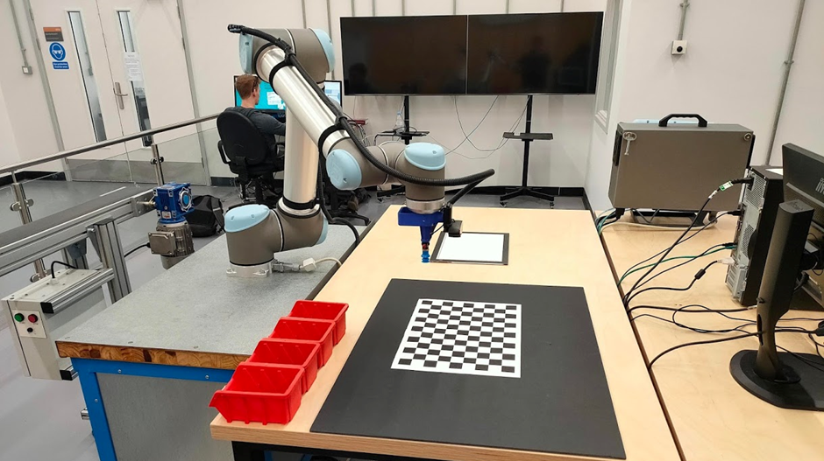
As discussed above, RoboDK was used to create a 3-D simulation environment to test new robot control codes for collisions. Building the 3-D environment involved extensive measurement and CAD modelling of the immediate surroundings of the UR10 robot. Below is a photograph of the real robot workspace followed by the simulation workspace .
Figure 17: Photograph of UR10 workspace
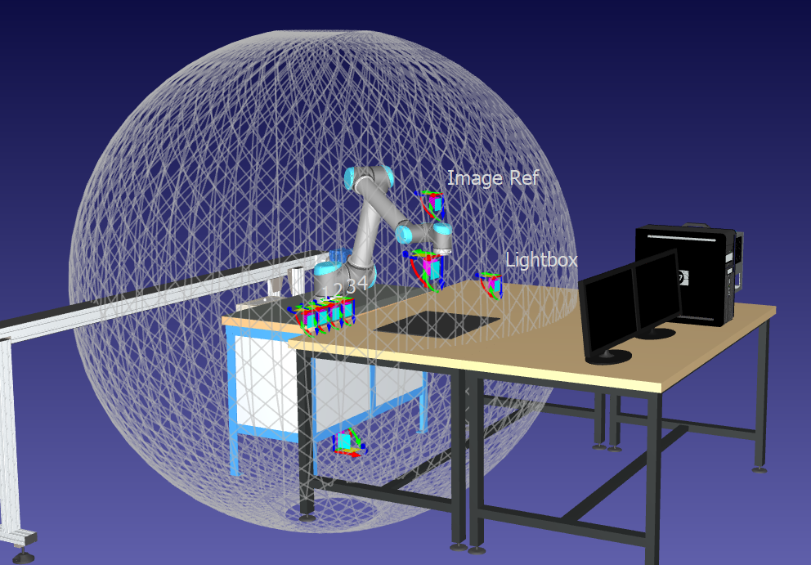
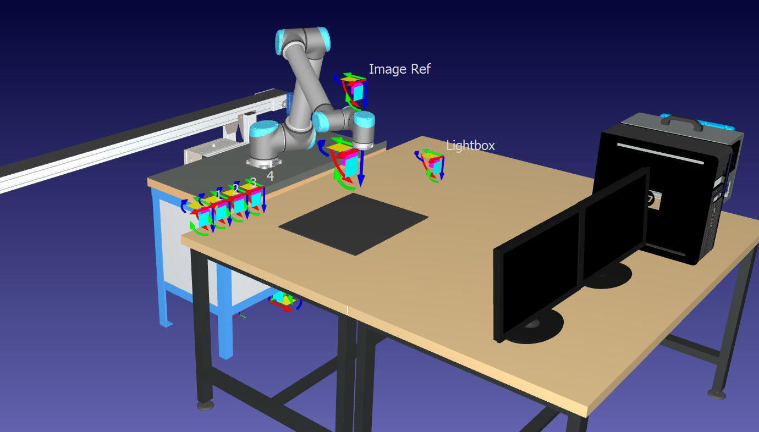
Above is the 3-D virtual representation of the robot workspace. Only significant objects are modelled here. As more objects are placed in the simulation, the demand on computational resources increases due to rendering duty. The red drop-off bin locations are represented by the cartesian reference frames as well as the lightbox and the image reference point.
Figure 18: 3-D Robot Workspace

Figure 19: 3-D Representation of UR10 Reach
The mesh globe in the image above shows the theoretical max reach of the UR10 robot, this was used to ensure nothing was placed in the robot path and that a safe working distance was maintained.
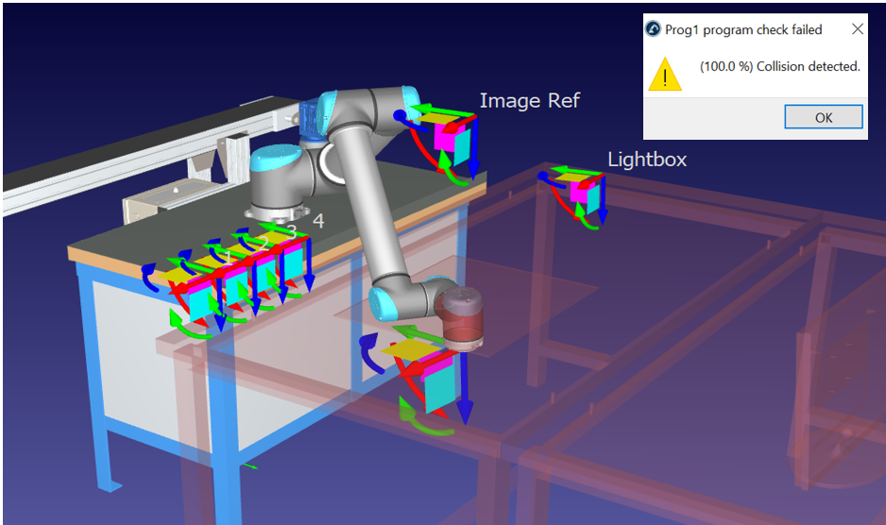

Figure 20: RoboDK Collision Detection Example
As mentioned above, the collision detection feature was also used in the robot control program, when RoboDK detects that any part of the robot is within an extremely close vicinity to a fixed object, it immediately stops the program and thus the robot, note in the above figure how the software identifies the collision point by highlighting the part of the robot and the objects that have collided in red. The sensitivity of this feature can be adjusted to stop the robot within a larger proximity range, this significantly reduces the probability of collision and thus damage to the robot or end effector.

Control Algorithm Development

Preface
(A URL link to the full code is available in appendix 1)
This section gives details on the development of the robot control algorithm used throughout this project. The code was developed using an iterative process of trial and error, while extensive research was carried out into a wide variety of computer vision techniques, the unique challenges in this project, namely lighting conditions, meant that ultimately some of these research informed techniques worked well, while others didn’t work at all.
In order to keep the explanation of the code clear and concise, only the major sections of the code are discussed here, as these represent the fundamental functions of the program. Topic areas discussed include; camera calibration and distortion mitigation, robot communication protocol, image acquisition and denoising, image segmentation and morphology, region analysis, transformation of the object pixel location to a world coordinate, Robot movement commands, development of the deep learning object detector, and Hough transform analysis for defect detection.

Camera Calibration
Before the development of the algorithm could take place, camera calibration was required to determine the intrinsic and extrinsic properties of the Logitech webcam. Intrinsic properties are camera-specific and include the focal length, principal point (centre pixel) and the skew coefficient. Extrinsic properties are not specific to the camera and describe the translation and rotation of the camera during calibration.
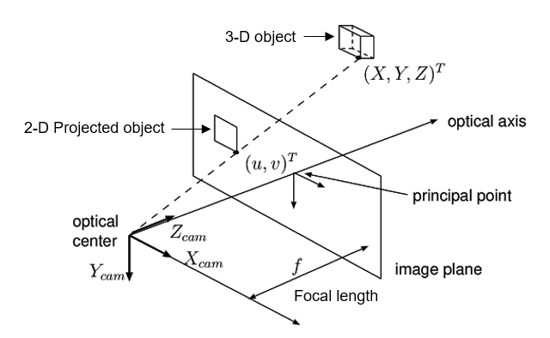
Calibration was achieved using the MATLAB camera calibration app and the pinhole camera model. The pinhole camera model calculates how the location of a 3-D object is projected onto the 2-D image plane (Sturm, 2014). A pinhole camera is defined as a camera with a small (pinhole) aperture and no optical lens, while the Logitech webcam is not strictly a pinhole camera due to its autofocussing lens, as long as autofocus is deactivated in the control algorithm, the pinhole model can be used. Below is a diagram of the pinhole camera model;

Figure 21: Pinhole Camera Model Diagram (Epixia, 2020)

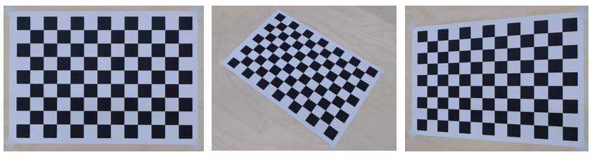
Camera calibration in MATLAB is a largely automated process, with most effort spent in collecting images. The App requires a series of images of a checkerboard calibration matrix at multiple angles and distances, 30 images were used in total.
Figure 22: Checkerboard Calibration Matrix
Below is a representation of the different camera translations and rotations used in the image acquisition for the camera calibration procedure ;
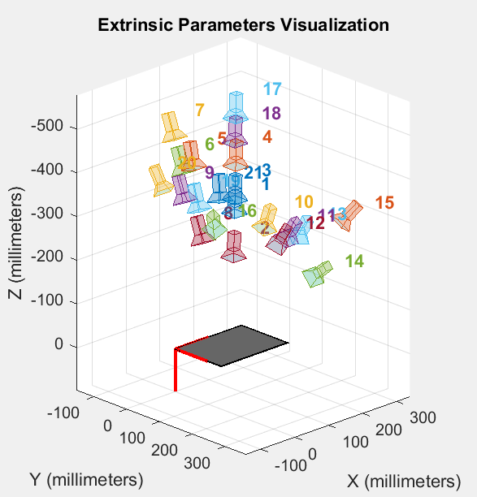

Figure 23: Camera Calibration Poses

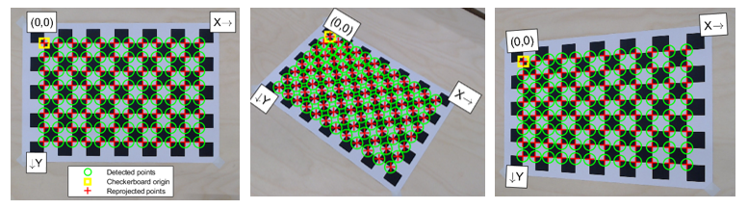
MATLAB then uses edge detection to find the corners of each square within the checkerboard matrix, the size of the squared is defined by the user (28mm).
Figure 24: Checkerboard Calibration Matrix
MATLAB uses the pixel distances between the detected points (green circles in above figure) to predict the camera intrinsic and extrinsic parameters, these parameters are then validated by reprojection (Red crosses). The difference between the detected and projected points is known as the reprojection error, images with high reprojection error are identified by a histogram (see below figure) and can be selectively removed by the user in order to increase the parameter approximation.
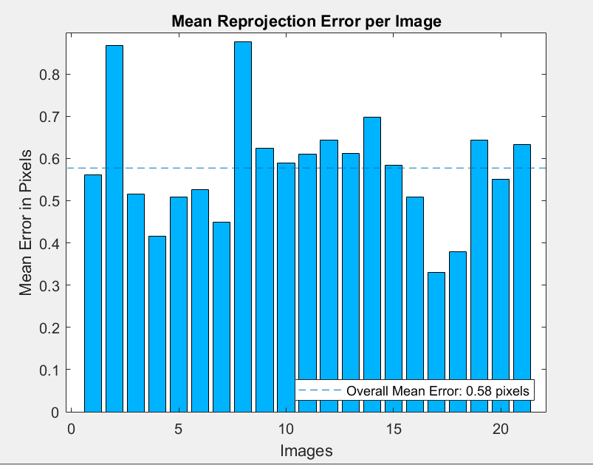
.

Figure 25: Histogram of Reprojection Errors
Once the camera calibration procedure is completed, a file called ‘Cameraparams’ is created and contains all of the predicted camera parameters. From these parameters, a matrix of the intrinsic properties is created. The intrinsic matrix is shown below;
$$KK=\left(\begin{matrix}f_{x} & 0 & C_{x} \\ 0 & f_{y} & C_{Y} \\ 0 & 0 & 1\end{matrix}\right)$$
Where $KK$ = intrinsic camera matrix, $f_{x}$ / $f_{y}$ = focal lengths in Pixels, $C_{x}$ / $C_{y}$ principal point pixels.
Below are the results of the camera calibration for the intrinsic parameters;
$$KK=\left(\begin{matrix}1438.41 & 0 & 928.71 \\ 0 & 1441.25 & 566.46 \\ 0 & 0 & 1\end{matrix}\right)$$
This intrinsic camera matrix is key in determining the location of the PCB’s in the image and thus the real world coordinates (Discussed further below). The extrinsic matrix is not determined during camera calibration, but from the pose of the robot during image acquisition, this will be discussed in chapter 3.5.7.

Distortion
(Wei & Ma, 1994) proposed that in order to achieve good accuracy and repeatability in a vision system, the radial and tangential distortion must be considered. Radial distortion occurs as a result of the convex shape of the camera lens, while tangential distortion occurs as a result of an offset angle between the camera lens and the image sensor. The Logitech webcam lens and sensor are in parallel thus only radial distortion occurs.
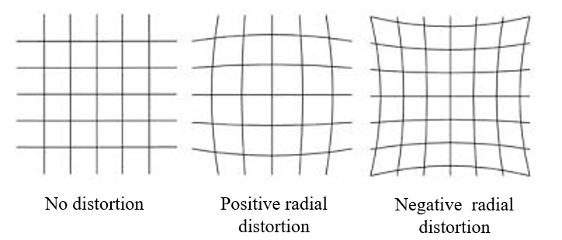

Figure 26: Types of Distortion
The MATLAB function ‘undistortimage’ was used to correct radial distortion in the control algorithm. The function inputs are the distorted image and the ‘cameraParams’ data, specifically the calculated distortion coefficients. The function outputs an undistorted image.
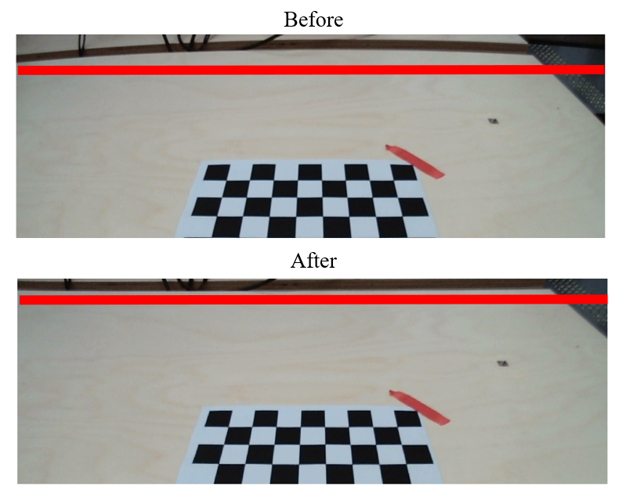
Below is an example of before and after this function has been implemented, note the distortion above the horizontal red line in the before image.

Figure 27: Image distortion Before and After

Robot Communication Protocol
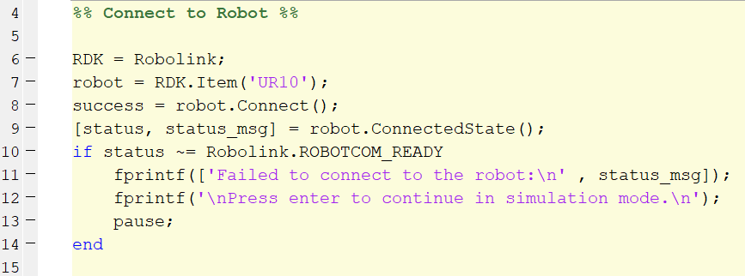
In the first fourteen lines of the robot control code, the connection between MATLAB, the RoboDK API and the UR10 robot is established. Below is the corresponding section of code;
The above section of code initialises the connection with the RoboDK software in line six with the ‘Robolink’ function. Line seven searches for live TCP connection to the UR10. If connection is successful the robot will idle until it receives a movement command, if the connection fails for any reason (unplugged ethernet cable, robot in protective stop or wrong IP configuration in RoboDK), a failure status message informs the user. The user can opt to continue without the connection to the UR10 and watch the simulation of the program in the virtual programming environment instead.

Image Acquisition
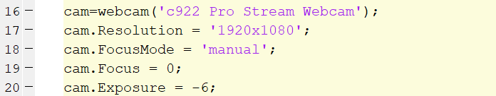
The fact that the PCB’s are static makes image acquisition simplistic in this project, The image processing techniques developed proved reliable enough so that only one image was required to identify all of the PCB’s. The MATLAB support package for USB webcams is used to interface with the Logitech Webcam. The only preliminary set-up required is to specify the desired resolution, focus mode and exposure. Below is the corresponding section of code;
As shown in chapter 3.1 (figure 8) the robot moves to a predefined image capture location in order to obtain images of the workspace, a trade-off between the quality of the captured image and the field of view of the camera was considered, the robot was able to take high quality images of the PCB’s when moved close in the Z-axis to the workspace, however this severely restricted the field of view and thus the operating range. Below is an image of the robot in the image capture pose (the red outlines show the camera field of view).
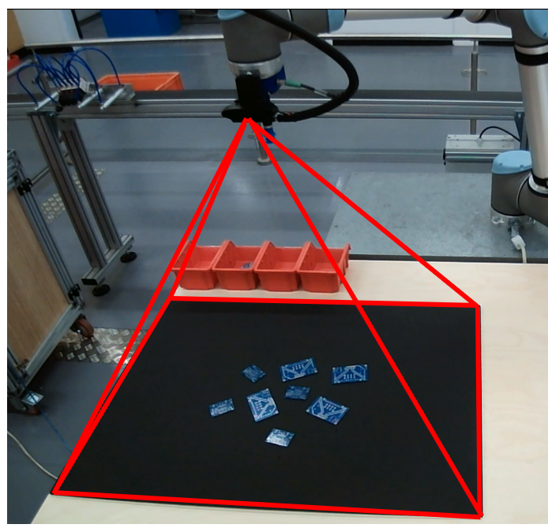

Figure 28: Robot in Image Capture Pose
The section of code below involves the robot movement command and a command to ensure the gripper is deactivated. A pause of 1 second is used to ensure the robot has stopped before the camera takes the image. Two copies of the image are stored, RGB and RGB1. RGB is used for image segmentation and further analysis and is undistorted and converted to grayscale. RGB1 is used to as a display image and thus does not require any further processing
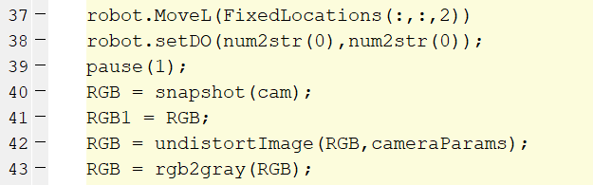

Image Segmentation
Image segmentation is arguably the most important function of the robot control algorithm, it is used to distinguish between the PCB’s and the background of an image through binarization. Some of the segmentation techniques, discussed in chapter 2.5.3, were trialled, these include;
- Thresholding
- Canny edge detection
- K-means image clustering
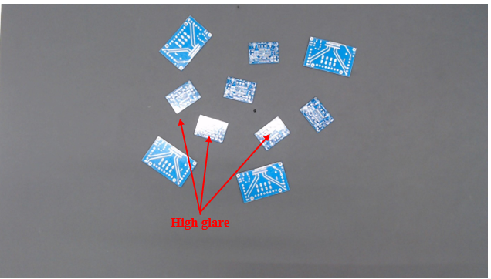
Glare and reflections from the overhead lighting caused significant issues during the development of the segmentation section of the code. While the ambient lighting environment is a key consideration in the development of a vision system, aside from covering the entire workspace to shield from the overhead lighting, there was no practical method of controlling the lighting environment in this instance. K-means image clustering was the only technique that was able to reliably differentiate between the PCB’s and the image background in the ambient lighting environment. The aim of the image segmentation code is to output a binary image with the shape of the PCB’s in white, and the background in black. The results of the three different methods are compared below, firstly the initial RGB image is shown as a point of reference .
Figure 29:RGB Reference Image
Thresholding
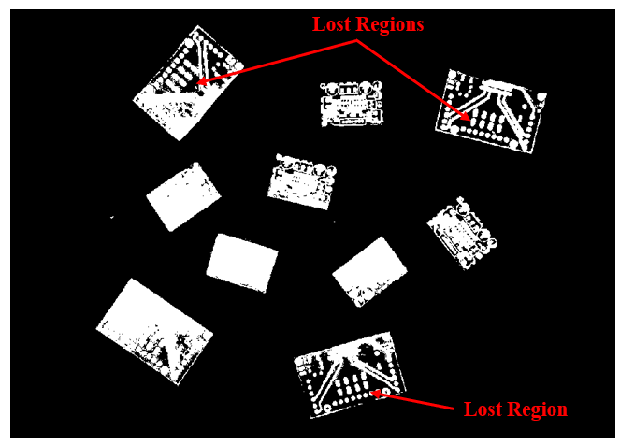

Figure 30: Binary Thresholding image
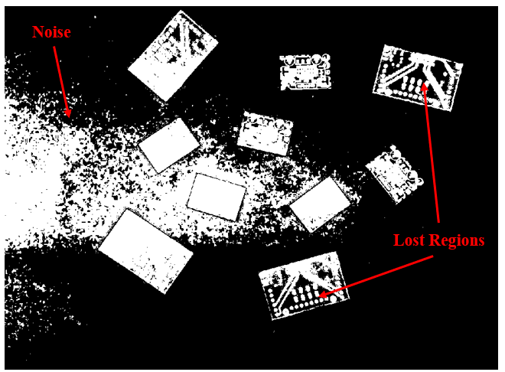
When the greyscale intensity threshold was set low, the brighter regions of the PCB were clearly visible, however hole filling and morphological dilation procedures were unable to completely fix the lost regions. A vast number of threshold intensity ranges were trialled, however, the closer the intensity became to the background intensity, more and more noise was introduced. Below is an example of a higher threshold intensity, the lost regions remain but much more noise is introduced to the binary image.

Figure 31: Binary Thresholding at Increased Intensity
Canny Edge Detection
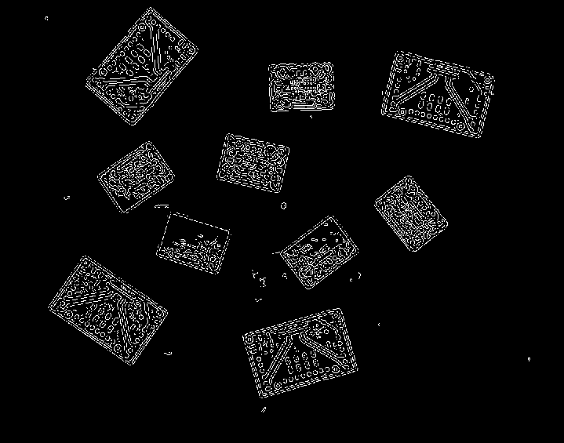

Figure 32: Canny Edge Detection Method
The Canny edge detector method appeared promising at first, the PCB’s were clearly defined, and image filtering techniques, such as median filtering, could be used to remove the small amount of noise present in the images. Unfortunately, closer inspection showed that none of the detected edges where attached or continuous and thus denoising and morphology operations were unable to create reliable binary masks for further analysis.
K-means Image clustering
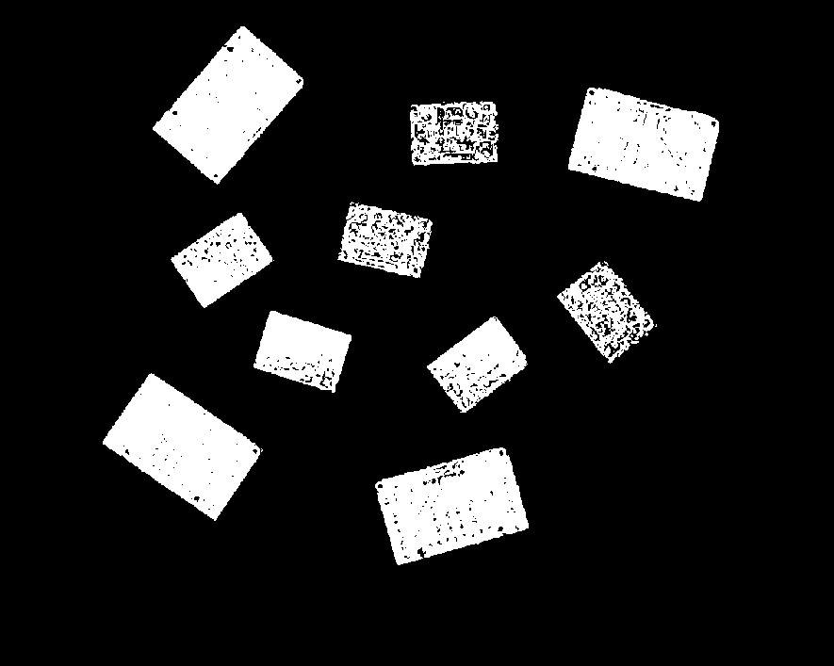

Figure 33: K-means Clustering Binary Image

The K-means method was shown to be the best performing segmentation technique of the three tested, Although the binary masks, shown in figure 33, still contain some noise, this could be fixed using morphology (Discussed Further below).
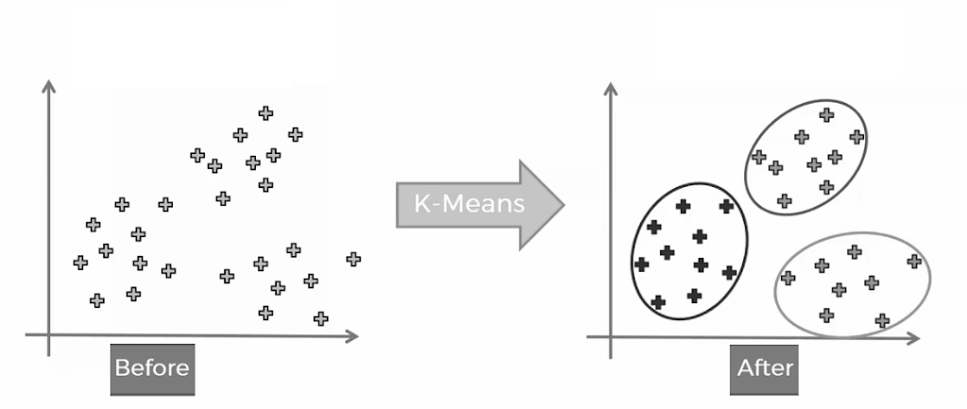
K-means (also known as Lloyds algorithm) uses a process of iterative data partitioning in order to assign $n$-number of data points (pixel intensities) to $k$-number of clusters. (MATLAB, 2019). Before using the K-means function each layer of the image matrix (R,G,B) must be converted from a 1920 x 1080 matrix into a 2,073,600 x 1 row vector and then combined to make a 2,073,600 x 3 array. The number of rows is known as the number of observations, and the number of columns as the data points. In this instance the n-number is 3 and the k number is 2. The k-value in this instance does not define the number of objects in the image but the number of clusters of pixel intensities that represent the foreground and the background. Below is a diagram showing the basic principle of K-means clustering using k=3.

Figure 34: K-Means Clustering Diagram (KRAJ, 2019)
The K-means section is found within the ‘GetPCBLocation’ function. Firstly, the matrix is reshaped as discussed above, statistical standardisation is performed on the reshaped matrix (minus the mean and divide by the standard deviation). Seed or starting points of the cluster are defined using a random number generator in lines 8-9. ‘Replicates’ in line 10 defines the number of attempts at clustering (only one is needed here). The binary array is created and reshaped in lines 11-12.
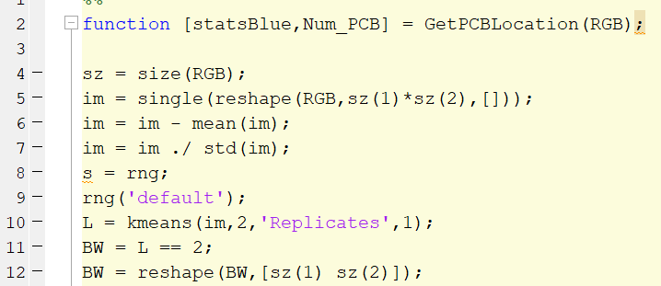

Morphology
Two procedures are used to remove noise from the binary image at the PCB locations, a hole filling procedure and a morphological dilation procedure.
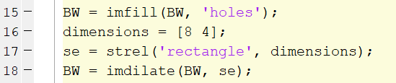

The ‘infill’ function identifies any areas within a connected white binary region that contain black areas (logical 0) or holes and flood fills them white (Logical 1). The dilation procedure (line 17-18) users a rectangular structuring element to smooth the binary values in an 8x4 region around each white pixel, below is an example of the binary image after filling and morphology, note how the white regions are clearly defined with no noise.


Figure 35:Binary Image After Morphology

Region Analysis
Once a reliable image segmentation procedure was developed, region analysis was used to obtain spatial information from the detected PCB’s. Region analysis is also found in the ‘GetPCBLocation’ function. MATLAB has many dedicated and predefined functions for region analysis, this section uses the ‘regionprops’ function to obtain the centroids, bounding boxes, orientations and area data from the binary regions.
An area filter set between a range of 5000-30000 is used to ensure only the PCB’s remain in the binary image before further analysis, although its unlikely that any other objects would be in the robots workspace and also pass through the image segmentation routine, the area filter was used for reassurance.
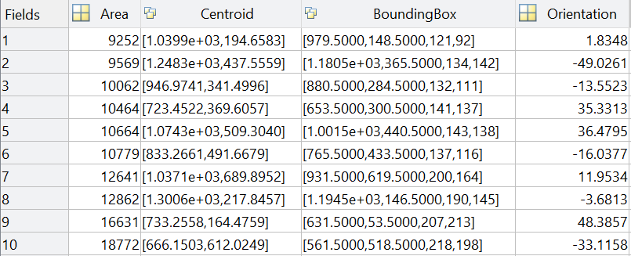
Line 30 returns a structural array called ‘StatsBlue’ of the centroids, bounding boxes, orientations and area data the number of PCB’s detected. See the example below;

Figure 36: Example of Spatial Data Array
It is important to note how the orientation feature within the regionprops function works. The MATLAB documentation states that the feature plots an ellipse over the binary region with the major axis of the ellipse matching the major axis and second-moments of the binary region (Figure 39). The angle between the major axis of the ellipse and the horizontal X-axis is measured to define the orientation of the region ranging between -90 and 90 degrees. (MATLAB, 2020)
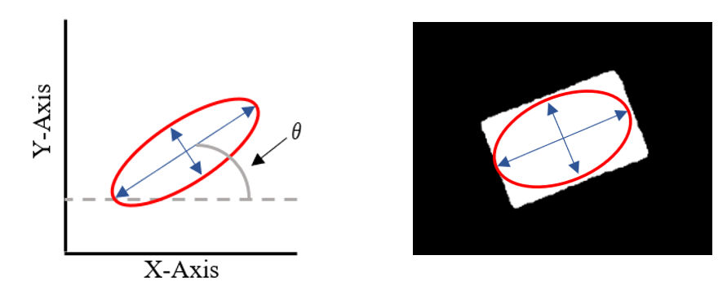

Figure 37:Ellipse Major Axis Orientation Diagram
Coincidentally, the shape of the PCB’s worked well with this method of determining orientation, because the major and minor axis are easily defined. For more complex shapes, a more sophisticated method of determining the orientation would be required, however this was not the case in this instance.

Robot Movement Commands
Movement commands in the control code can be defined into two distinct categories;
1. Predefined (or hard coded) coordinates for fixed locations, such as the image capture poses for the workspace and light box and the bin drop-off locations
2. Moving coordinates, such as the PCB locations calculated using the vision system.
Predefined coordinates were created in the RoboDK 3-D programming environment and stored as 4x4 matrices in MATLAB. This matrix is known as the homogenous transformation matrix, containing the rotational and translational data of the position of the robot end effector with respect to the base frame. The robot pose is given by the following transformation matrix, where the transformation from some frame i to frame j is given by the transformation matrix;
$${}_{Tool}^{Base}{ Pose= \left[\begin{matrix}R_{3×3} & T_{3×3} \\ 0_{1×3} & 1\end{matrix}\right]}= \left[\begin{matrix}R_{xx} & R_{xy} & R_{xz} & T_{x} \\ R_{yx} & R_{yy} & R_{yz} & T_{y} \\ R_{zx} & R_{zy} & R_{Zz} & T_{z} \\ 0 & 0 & 0 & 1\end{matrix}\right]$$
Thus, the predefined pose storage matrix is as follows;
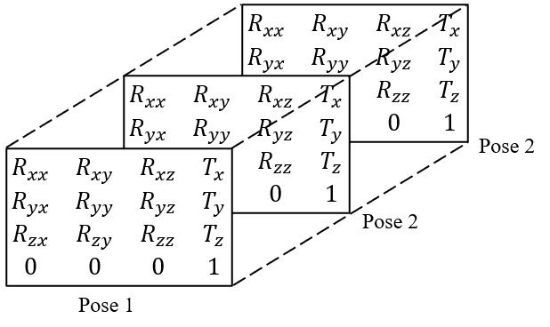

Figure 38: 3-D Position Matrix
As discussed in chapter 3.3.1, universal robots require a pose vector rather than the 4x4 matrix shown above. The pose vector is made up of the translation between the base and tool frame in x, y and z and the Euler angles of rotation, known as the roll, pitch and yaw. The universal Robots pose vector is shown below.
$${Pose}_{UR}=( X, Y, Z, R_{X}, R_{Y},R_{z})$$

Converting between the 4x4 transformation matrix for the translational elements is easy as they remain the same in both cases,
$${Transl}_{UR}= \left[\begin{matrix}T_{X} \\ T_{Y} \\ T_{Z}\end{matrix}\right]$$
Converting between rotational elements, the 3x3 rotation matrix and Euler axis angles is somewhat more involved.
Firstly, the 3x3 rotation matrix must be converted to an angle and a rotation axis, thus;
$θ= \cos^{-1}\left(\frac{R_{xx}+R_{yy}+R_{zz}- 1}{2}\right)$ and $k_{x,y,z}=\frac{1}{2\sin{θ}}\left[\begin{matrix}R_{ZY}-R_{yz} \\ R_{xz}-R_{zx} \\ R_{yx}- R_{xy}\end{matrix}\right]=\left[\begin{matrix}k_{x} \\ k_{y} \\ k_{z}\end{matrix}\right]$
Secondly, $θ$ and $k_{x,y,z}$ must be combined into a single vector, hence;$${Rotz}_{UR}=k_{x,y,z} θ=\left[\begin{matrix}k_{x}θ \\ k_{y}θ \\ k_{z}θ\end{matrix}\right]=\left[\begin{matrix}R_{X} \\ R_{Y} \\ R_{Z}\end{matrix}\right]$$
$${Pose}_{UR}= \left[\begin{matrix}T_{X,Y,Z} \\ R_{X,Y,Z}\end{matrix}\right]$$

Pixel Location to a World Coordinate
Converting the PCB centroid coordinates from image plane coordinates to a world coordinate involves the use of the Pinhole camera model and thus the intrinsic camera matrix calculated during the camera calibration procedure. (Sturm, 2014) explains that the pinhole camera model is used to define the 2-D cartesian image plane coordinates of an object using the intrinsic, translational and rotational camera parameters. This is known as forward projection. Below is the pinhole camera model (assumed no rotation).
$$\left[\begin{matrix}x \\ y \\ 1\end{matrix}\right]=KK\left[\begin{matrix}X \\ Y \\ Z \\ 1\end{matrix}\right]$$
Where $x,y$are the pixel cartesian coordinates, $X, Y,Z$are the world coordinates and $KK$ Is the intrinsic camera matrix (discussed in chapter 3.5.3).

(Sturm, 2014) also noted that inverse projection can be used to determine the world coordinates when the pixel coordinates are known. In inverse projection, the pixel coordinates are put into a homogeneous vector and multiplied by the inverse of the intrinsic camera matrix, these values are known as the normalised pixel locations. The normalised pixel locations are then multiplied by the distance between the camera and the object in the Z-axis.
Below is the section of code that performs inverse projection of the pixel coordinates in order to convert them to world coordinates.
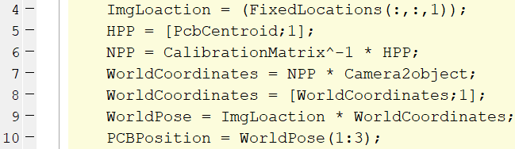

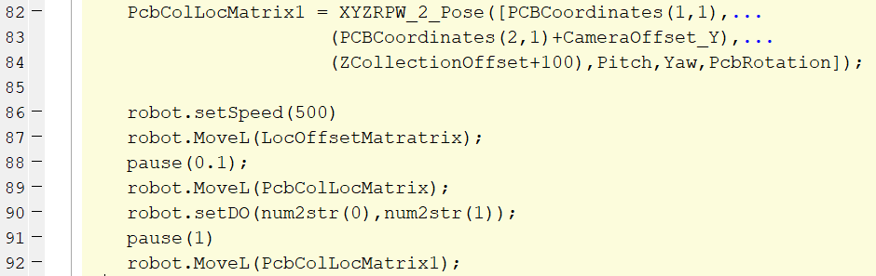
Firstly, the image capture position matrix is defined, the pixel coordinates are converted to a homogeneous vector and multiplied by the inverse intrinsic camera matrix. The normalised pixel locations are then multiplied by the Z-axis offset (Camera2object). Finally, the world coordinates are transformed to a homogeneous vector and multiplied by the image capture location to define the new tool flange coordinate.
The section of code above shows how the PCB world coordinates are added to the pose vector and then converted back to a movement matrix, using a function from the RoboDK API (line 82). The yaw, pitch and roll of the end effector remain the same throughout the program and are thus hard coded. lines 89 – 92 show the movement commands sent to the robot, including moving to the PCB, activating the gripper to grasp the PCB (line 90) and moving the PCB to the light board location (line 92).

Deep Learning Object Detector
The aim of this study was not to understand the subtle nuances of the development of neural network architecture, but rather to develop a working knowledge of how they can be implemented in procedures such as VGR, and to investigate the feasibility of using CNN’s with consumer grade PC’s and camera systems. An artificially intelligent object detector was developed, based upon the AlexNet architecture discussed in chapter 2.5.5. The intended use of the object detector was to provide contextual information about the type of PCB and crucially which face of the PCB (front or rear for each type) was being detected.
(See Appendix 6 for background information on neural networks)
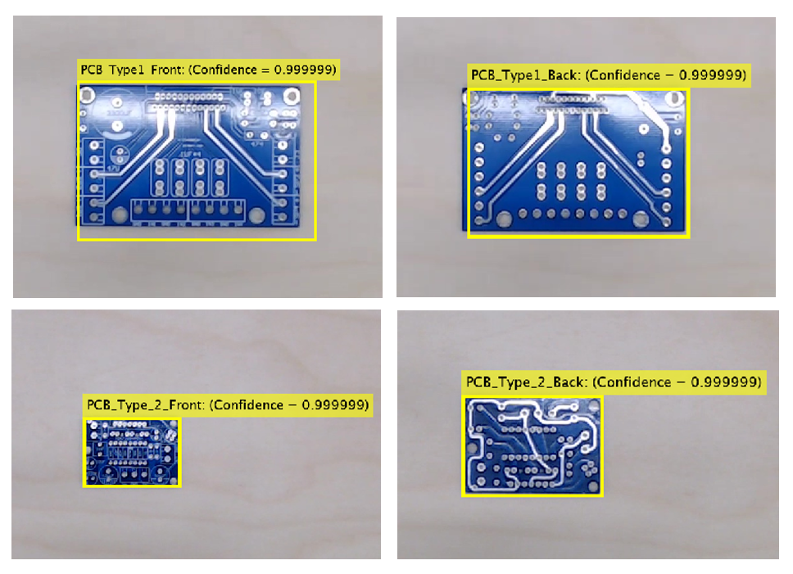
A transfer learning methodology (chapter 2.5.5) was employed to train the neural network, (Jones, 2019) identified the benefits of transfer learning, it allows programmers to develop fully functioning CNN object detectors without the expert-level knowledge of neural network architecture, this is achieved by taking pretrained state-of-the-art network architectures and retraining sections to identify the desired objects. Retraining of the AlexNet neural network involved acquisition of 750 images of each face of the two types of PCB. The training time was 121:35 hours and 14288 iterations (code available in appendix 1). The Training proved to be successful (Analyzed in chapter 4) and yielded a fully functioning object detector, see the example images below, note that the confidence score is at its maximum 99.99% in all instances.
Figure 39: Images from CNN Object Detector

Hough Transform Analysis for Defect Detection.
As discussed in chapter 3.1, a defect detection routine is also performed using the robot vision system. The robot drops the PCB onto the lightbox and the hole locations are inspected with the camera system. Depending on the results of the analysis, the PCB is either classified as defective or non-defective and subsequently moved to the appropriate storage bin.
Inspection of the through holes requires binarization using the circle Hough transform. The Hough transform identifies edges of circles by identifying significant changes in intensity between pixels. MATLAB has a function for the Hough transform called ‘imfindcircles’, the input to the function is a range of radii and the target image, the function outputs the centroids of the detected circles. (Davies, 2015) noted that the Hough transform is widely used due to its ability to work with suboptimal images with noise and occlusions.
Below is an example of the binary images created using the Hough transform;
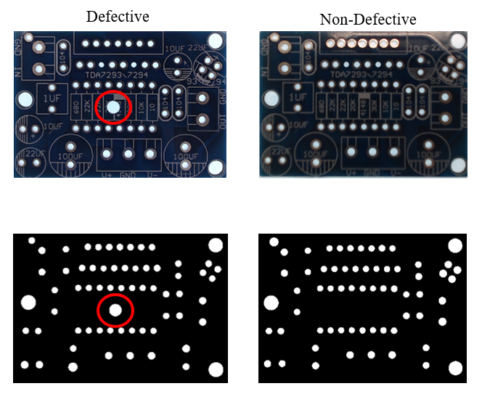

Figure 40: Hough Transform Defective vs Non-Defective
Due to the fact the project overran, and the workshops shut in response to the Covid-19 pandemic, the defect detection routine was not fully developed, as such the code could only classify either to many or too few holes. Further analysis could include comparison of diameters or positions of the through holes using image registration techniques, however this was not achievable in the time frame.

Experimental Procedure
(This section is incomplete as a result of loss of access to the robotics laboratory in response to the COVID-19 pandemic, please refer to the pandemic impact section)

Spatial Testing
Test standards for measuring performance characteristics of industrial robotics are defined in ISO 9283:1998. The ISO provides guidance for testing of many key performance metrics but stipulate that measurement of such metrics is specific to the intended application for example, low- speed applications may focus on positional accuracy and repeatability, and high-speed applications may focus on overshoot, transient drift and stabilisation time.
This application is low-speed and the fact that the pose coordinates are calculated rather than fixed, positional accuracy and repeatability are of particular importance here. The ISO suggests using laser trackers to follow and calculate the tool centre point with respect to a target location, this equipment was not available at the lab and as such a novel approach is proposed here.
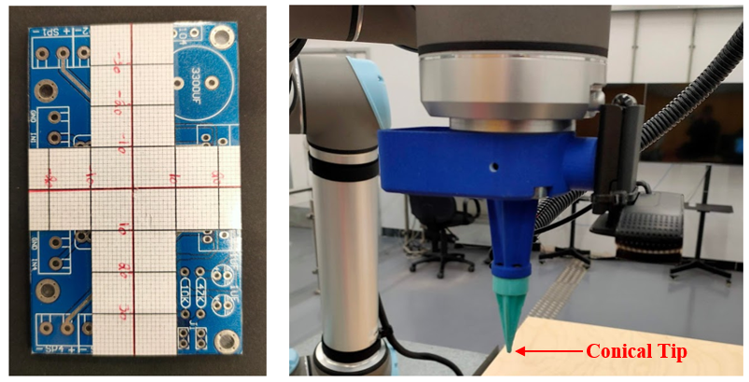
A type-1 PCB is overlaid with a 1mm² graph paper and the vacuum gripper is replaced with a conical shaped tip, see figure below;
Figure 41: Robot Pose Test Setup
As shown above, the PCB was divided into quadrants, the robot was repeatedly commanded to find the centre of the PCB from the image capture pose, the conical point was used to measure the deviation from the centre of the PCB in mm. A limitation to this method is that the smallest measurement resolution is just 1mm, compared to around 10μm for a laser tracker system.
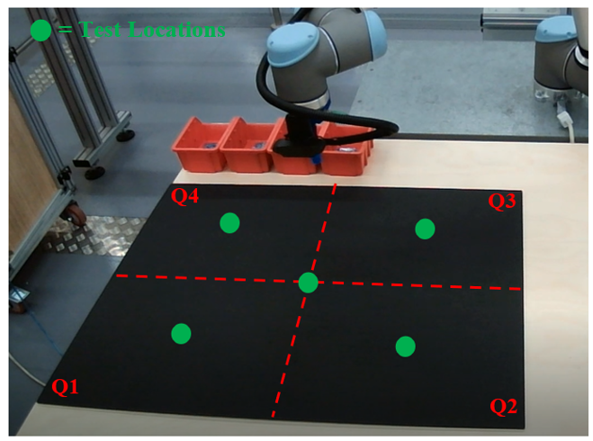
The robot workspace was also divided into four quadrants with 5 locations being tested, the centre of the workspace and the centre of each quadrant. The test was repeated 50 times in each location, see below;

Figure 42: Diagram of Test Locations

Rotational Testing
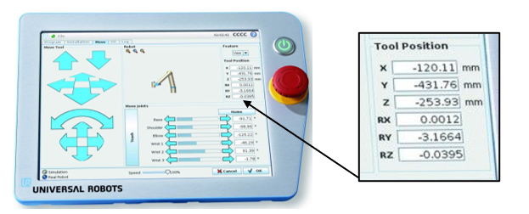
A test was also proposed to evaluate the rotation of the end effector in relation to the detected object, similar to the test methodology above, a PCB would have placed in the centre of the workspace. Tests would be carried out at angles of 85, 45, 0, -45 and -85. The deviation from this angle can be measured from the tool flange Z-axis read-out on the UR10 teach pendent.

Figure 43: UR10 Teach Pendant
Unfortunately, the laboratory was closed due to the COVID-19 pandemic. As such, no data could be collected for the rotational accuracy and precision.

Object Detector Testing
The performance of the CNN object detector discussed in chapter 3.5.8 is also tested here. During training of the object detector, a small quantity (200) of the ground truth data (Images with PCB location labels) are subtracted from the image datastore and saved as an evaluation data set. Once training Is completed, this training data set is fed into the neural network. The results of the network predictions (bounding box locations) are then compared with the user defined bounding boxes in the ground truth data.
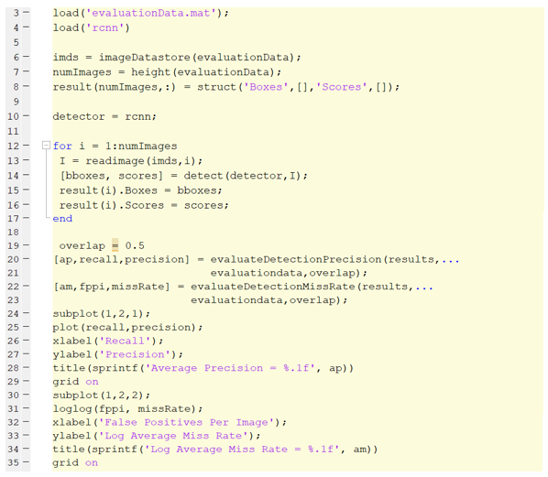
This evaluation is completed in MATLAB, below is the code for this test;
Figure 44: Object Detector Evaluation Code
Ideally, after evaluation, the neural network would be retrained with the aim of mitigating any deviation, this was not possible as it must be carried out on a CUDA enabled GPU, and access to the lab computer was lost due to the pandemic.

Results and Analysis

Spatial Test Results

Table 11: Results Table for Spatial Test

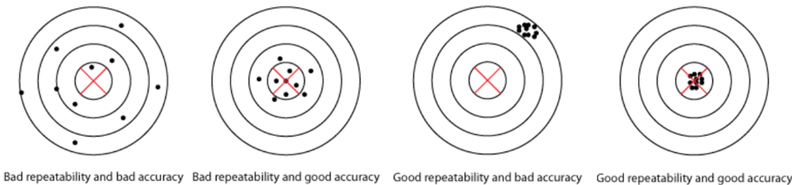
Data Visualisation
Figure 46:Accuracy vs Repeatability
Above are four representations of the possible combinations of accuracy and repeatability. Below are a series of scatter graphs created from the results of the spatial tests. A grayscale image of the test PCB has been overlaid with the scatter graphs as to provide a visual representation of the results of the tests in each quadrant, the scale (in mm) of the graphs x and y axis match that of the real Test PCB. Using the relationships in figure 46, a series of predictions as to the accuracy and repeatability can be made before numerical analysis, these predictions can then be compared to the numerical analysis as a means of validation.
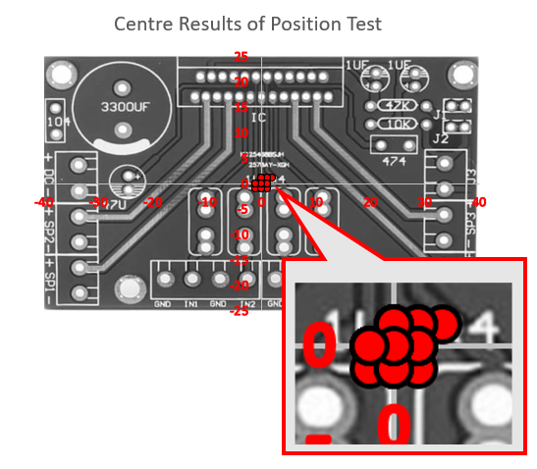

Figure 47: Centre Region Results Distribution
The diagram above shows the results (red dots) of the spatial test in the centre region of the workspace. The results show a tight cluster of points distributed around the 0x,0y coordinate with no outliers. Using figure 46, this test appears to have good accuracy and good repeatability.
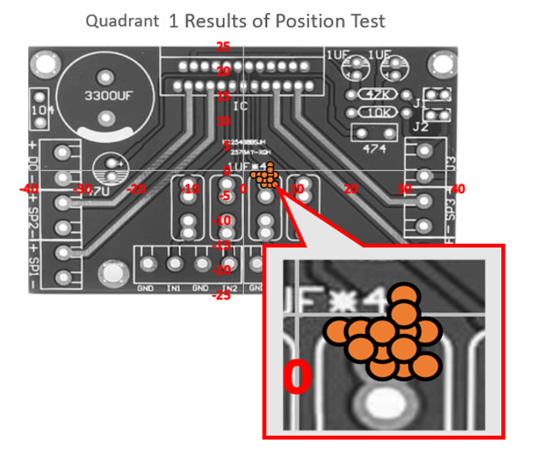

Figure 48: Quadrant 1 Results Distribution
The diagram above shows the results (orange dots) of the spatial test in quadrant 1 of the workspace. The results show a tight cluster of points, however the cluster is displaced in the +X axis and -Y axis coordinate. This test appears to have poor accuracy and good repeatability.
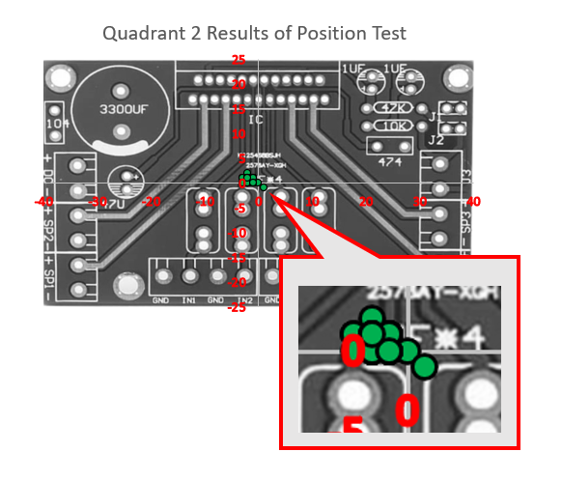

Figure 49: Quadrant 2 Results Distribution
The diagram above shows the results (green dots) of the spatial test in quadrant 2 of the workspace. The results show a distribution around the 0x,0y coordinate, but the cluster is more spread out. This test appears to have good accuracy and poor repeatability.

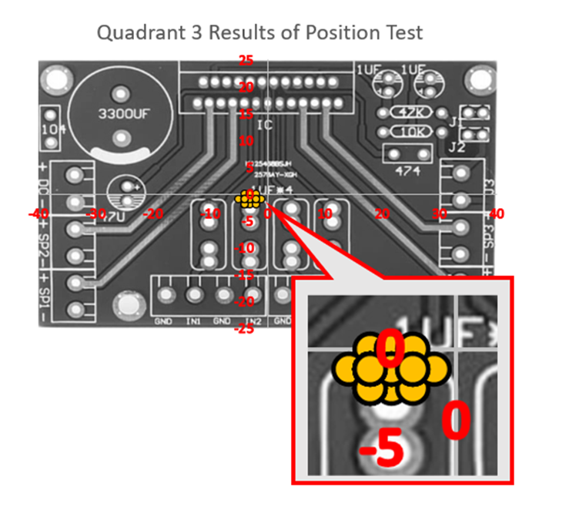

Figure 50: Quadrant 3 Results Distribution
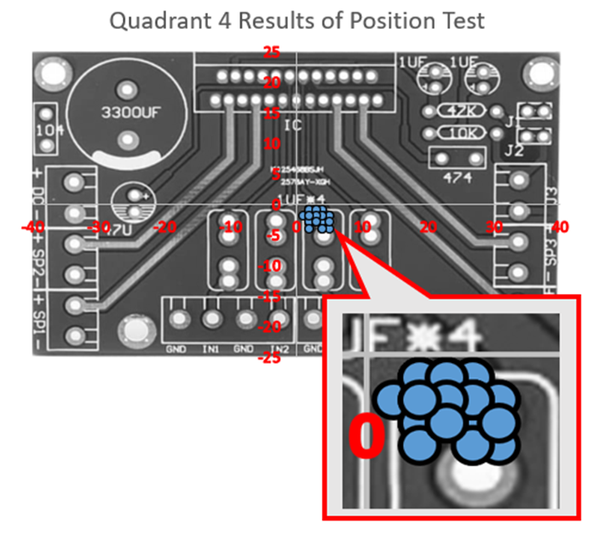
The diagram above shows the results (yellow dots) of the spatial test in quadrant 3 of the workspace. The results show a tight cluster of points with no outliers, however the cluster is displaced in the -X axis and -Y axis coordinates. This test appears to have poor accuracy but good repeatability.

Figure 51: Quadrant 4 Results Distribution
The diagram above shows the results (blue dots) of the spatial test in quadrant 4 of the workspace. The results show a broad cluster of points that are displaced in the +X axis and -Y axis coordinate. This test appears to have poor accuracy and poor repeatability
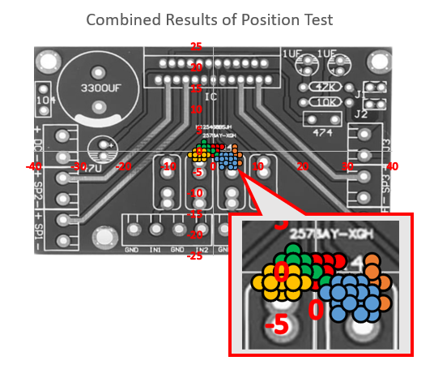

Figure 52: Combined Results Distribution

The diagram above shows the combined results of the spatial test. The results show that the centre of the cluster forms mostly around the 0x,0y point, However the cluster is broad and spreads over a large area. This test appears to show an overall good accuracy but a generally poor repeatability.
Below the predictions for each test region have been summarised and tabulated;
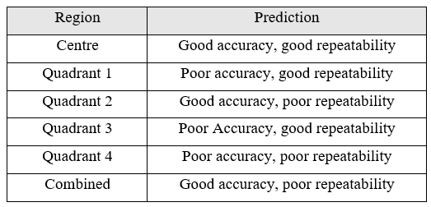

Table 12: Table of Summarised Predictions

Numerical Analysis
As discussed above, the aim of this test is to determine the positional accuracy and repeatability of the vision guidance system, the equations for these values are explained by (Císar, et al., 2016), positional accuracy is given by;
$$AP= \sqrt{AP_{X}^{2}+AP_{Y}^{2}}$$
$$AP_{X}=\overline{X}-X_{C}$$
$$AP_{Y}=\overline{Y}-Y_{C}$$
$AP_{X}$ = accuracy in x, $AP_{Y}$= Accuracy in Y, thus;
$$\overline{X}= \frac{1}{n}\sum_{j=1}^{n}{(X_{j})}$$
$$\overline{Y}= \frac{1}{n}\sum_{j=1}^{n}{(Y_{j})}$$
Where $X_{j}$ and $Y_{j}$ are the $j^{th}$ recorded tool centre point locations and $\overline{X}$ and $\overline{Y}$ are the means of the recorded locations.
(Císar, et al., 2016) also explain that repeatability is given by;
$$RP=\overline{l}+3s_{i}$$
Where $RP$ = repeatability, $\overline{l}$ = mean value of deviations between the $j^{th}$ position and the mean of the reached positions.
$$l_{i}= \sqrt{(x_{j}-\overline{x})^{2}+(y_{j}-\overline{y})^{2}}$$
$$\overline{l}= \frac{1}{n}\sum_{j=1}^{n}{l_{i}}$$

And $S_{I}=$ the sample standard deviation, given by;
$$S_{I}= \sqrt{\frac{1}{n-1}\sum_{j=1}^{n}{(}}l_{j}-\overline{l})^{2}$$
The results of this analysis is tabulated Below;
Positional Accuracy

Table 13: Positional Accuracy Results
In table 11, a lower value for accuracy is preferable, with 0 being total accuracy.
Repeatability
Table 14: Repeatability Results
In table 12, a lower value for repeatability is preferable, with 0 being totally repeatability.
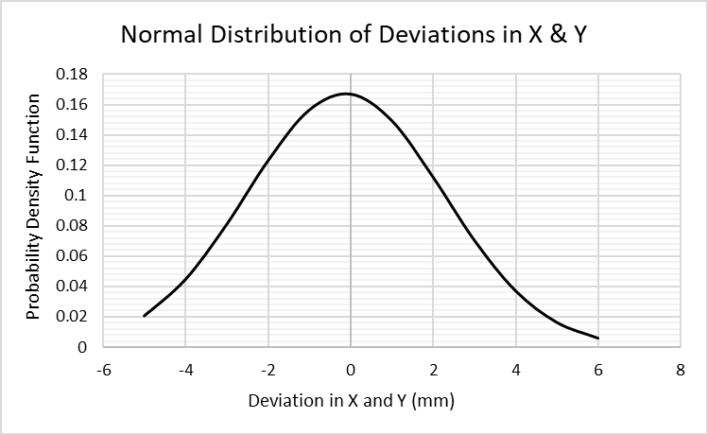
.

Figure 53: Normal Distribution of Deviations in X & Y
Above is a normal distribution of the concatenated deviations in x and y. Note how the peak is centred around the 0mm deviation, suggesting good accuracy was achieved. (Mean = 0.3 & standard deviation = 2.39).
Above is a frequency histogram of the recorded deviations in x and y. It shows that the peak deviation is -1 in x and y. Note how the frequencies increase between -3/-4 and +2 /+5 , this suggests poor general repeatability.
Figure 54:Frequency Histogram of Deviations

Discussion
The results of the numerical analysis fully concur with the predictions made in section 5.1.1, good overall positional accuracy of (0.94mm) was achieved however the quadrant specific accuracy was subject to a variance of between 0.2 mm in the centre region and 4.71mm in quadrant 1. The repeatability is generally poor as predicted with an overall repeatability of 6.98mm. the repeatability is also susceptible to a quadrant specific variance of 2.1 mm in the centre and 3.0 mm in the 4th quadrant.
The fact that good accuracy (0.20mm) and good repeatability (2.10mm) were achieved in the central region suggests the issue is not global and is local to a given quadrant. A reasonable assumption is that either the camera became misaligned or the camera calibration procedure did not fully remove the radial distortion discussed in 3.2.5.1. From experience, radial distortion is the likely culprit here, even though steps were taken to mitigate it. Radial distortion would explain why the centre is seemingly unaffected while deviation increases in all 4 quadrants.
Ideally, both of these predictions would be tested by adjusting and recalibrating the camera and performing the test again, unfortunately this could not be done as the university workshops closed in response to the COVID-19 pandemic.

Object Test Results
(Castro & D’Souza, 2019) identify two distinct metrics that are used to determine the performance of an object detector, Average precision and the log average miss-rate. Average precision is the ratio between the number of true positive detections and the total number of images in the ground truth data, Average miss-rate is the ratio of false negative detections and total ground truth images.
$$Precision= \frac{true positives}{true positives+false positives}$$

$$Recall= \frac{true positives}{true positives+false negatives}$$
Precision describes how accurate a given detection is and recall defines what percentage of detections are true positives. Average miss-rate is taken as the area under a graph plotting precision against recall. Where;
$$AP=\int_{0}^{1}{P(R)dR}$$
Where AP = average precision, P = precision and R = recall.
Log average miss-rate (LAMR) is calculated using a miss-rate vs false positive per image rate (FPPI) by averaging the mean miss-rate at nine equally spaced FPPI rates along a logarithmic scale between ${10}^{-2}$ and ${10}^{0}$ , where;
$$Miss Rate= \frac{False negatives}{True Positives+False negatives}$$

$$FPPI= \frac{False Positives}{True positives +False Positives}$$
Thus,
$$LAMR=exp\left[\frac{1}{n}\sum_{i=1}^{n}{ln{ a}_{i}}\right]$$
Where ${ a}_{i}$ = the i^{th} FPPI value between i = 1 and 9.

Results
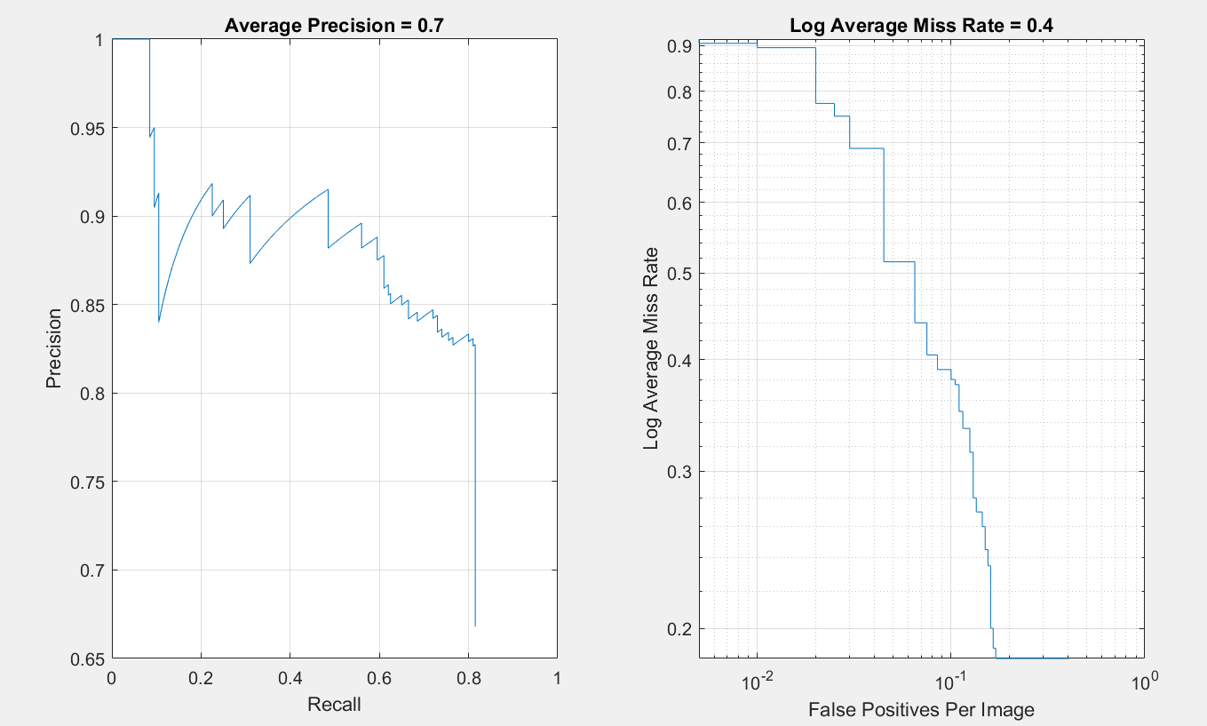
Below is the LLMR graph produced in MATLAB using the ‘evaluateDetectionMissRate’ function. The LMMR is outputted as 0.37. (Lower is better between 1-0).
Figure 55: Log Average Miss Rate Graph
Below is the average precision graph produced in MATLAB. Average precision is outputted as 0.73 using the ‘evaluateDetectionPrecision’ function. (higher is better between 0-1).
Figure 56: Average Precision Graph

Object Detector Discussion
Evaluating an object detector from one data set is not ideal, typically, training parameters such as the ground truth data, learning rates and iterations would be adjusted with the aim of showing an increase in precision or decrease in LAMR for example, as mentioned, loss of access to the lab PC meant that this wasn’t achievable.
(Krizhevsky, et al., 2012) stated that the original AlexNet network achieved an average precision of 87.40% and was trained over a course of 6 days using 1.2 million images from the ImageNet database. This retrained model achieved 72.8% precision using 3000 training images and a 120 hour training time, combined with the observed functionality of the object detector, it shown in section 3.5.8, it can be concluded that the training was successful.

Cost Review
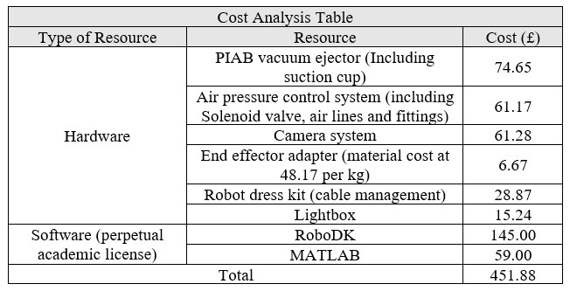

Figure 57: Vision System Costs Review
Above is a review of the costs of the developed vision system, its important to note that the use of business licences for RoboDK and MATLAB would increase the costs significantly, however as noted in section 3.4, this same vision system could be replicated using open source software’s without the loss of any functionality. If open source software were to be used, the cost of the system would be further reduced to £248.88. Previously, the cost of vision systems was not a key consideration, the companies that had sufficient resources to purchase and implement industrial robots could afford costly vision systems. Today, sophisticated DoF industrial collaborative robots, such as the XArm-6 and the Automata Eva are available for between £2500 and £5000, making the development of low cost vision systems more prevalent than ever.

Conclusion
The fundamental aim of this study was to investigate the feasibility of developing a low-cost vision system for use with collaborative robots, this paper shows there is certainly scope for the development and implementation of such systems. Preliminary reading around the major topic areas of machine vision, computer vision and vision guided robotics posed two fundamental research questions;
- Do machine vision systems used in vision-guided robotics still require dedicated and costly hardware and software?
- Can artificially intelligent algorithms, such as machine and deep learning, replace traditional computer vision techniques in computer vision applications?
A survey of modern and historical literary works went some way to answering these questions, Many of the sources surveyed discussed how the advancement of computational resources such as processing capabilities and CUDA enabled GPU’s has seen a rapid proliferation of PC based vision systems in applications that would previously require costly, dedicated hardware. Another major development discovered in the literature survey was the development and wide-scale adoption of low-cost CMOS image sensor technology over costly CCD variants.
An interesting discovery in the literature survey was the maturity of research in the field of vision guided robotics, Many non-scholarly articles discuss vision guided robotics as a recent development in the field, however it was found that autonomous robot navigation systems where being developed in research institutions as early as the mid 1960’s. Recent works in vision guided robotics are dominated by human-robot interaction and the development of deep learning techniques with the aim of developing cognitive and perceptive robot systems.
In reflection, question two is quite naive. Traditional computer vision techniques represent the core of most modern algorithms, this is certainly the case for the vision guidance system developed in this study. Put simply, it is highly improbable that artificially intelligent algorithms will completely replace traditional techniques, rather, such algorithms should be seen as complementary tools alongside these traditional methods, its important to realise the limitations of both traditional and artificially intelligent methods in order to optimise their deployment in computer vision tasks.
The Low-cost element was a key design driver in the development of the hardware and was successfully maintained throughout the project. Many of the problems faced, such as the end effector design and the development of the robot dress kit could have been solved more easily using expensive off-the-shelf solutions, however this did not correlate with the low cost ethos of the project and did not offer the unique learning opportunities that come with developing and integrating such systems. The total cost of the hardware for the vision system including; the end effector, camera system, robot dress kit, pneumatics and pneumatic control system remained below £250.
The development of the control code was the most challenging and time consuming aspect of the project. The use of MATLAB as a programming environment was key to the project’s success in the time frame, the use of pre-defined functions for many tasks, combined with the supporting literature available online allowed for timely prototyping, testing and implementation of new sections of code. The coding effort required in the development of this vision system is arguably its biggest limitation, as discussed in Appendix 2, A lack of knowledge, understanding and system complexity are barriers to entry for advanced manufacturing technologies in small and medium sized enterprises.
Testing of the vision system was not as comprehensive as planned as a result of the COVID-19 pandemic, nevertheless the system yielded respectable results. The retrained neural network used for object detection achieved 72% precision with only one training session. Spatial testing showed good positional accuracy, however repeatability was suboptimal and requires further analysis to determine the root cause.

Further work
The scope for further work in this project is vast, with potential for improving the current system or adding new functionality. Further work could include;
- Further analysis of the positional performance of the vision system in order to achieve better positional accuracy and repeatability.
- Development of a more sophisticated defect detection routine, potentially using image registration to identify the positional information of the through holes.
- Integration of a second camera to allow for stereoscopic vision tasks without the need for fixed image capture locations.
- Develop a motion estimation algorithm for procedures involving moving components.
- Develop an algorithm for bin picking operations.
- Investigate the potential of using robotic vision in machine tending operations.

References
Aguilar, J. J., Torres, F. & Lope, M. A., 1996. Stereo vision for 3D measurement: accuracy analysis, calibration and industrial applications. Measurment, 18(4), pp. 193-200.
Al-amri, S. S., Kalyankar, D. N. & S.D, D. K., 2010. IMAGE SEGMENTATION BY USING EDGE DETECTION. International Journal on Computer Science and Engineering , 02(03), pp. 804-807.
Ambler, A. P. et al., 1975. A versatile system for computer controlled assembly, Edinburgh: Edinburgh University Press.
Assured Automation, 2020. 1-Way Solenoid Valve Diagram. s.l.:Assured Automation.
AstroML, 2019. Neural Network Diagram. s.l.:AstrioML.
Automated Imaging Association, 2008. WHAT IS MACHINE VISION , Michigan: AIA.
Barreto, J. P. & Daniilidis, K., 2004. Wide Area Multiple Camera Calibration and, Pennsylvania: GRASP Laboratories.
Barrow, H. G. & Salter, S., 1970. Design of Low-cost Equipment for Cognitive Robot Research, Machine Intelligence, Edinburgh: Edinburgh University Press.
Bay, H., Tuytelaars, T. & Gool, L. V., 2006. European Conference on Computer Vision: SURF: Speeded Up Robust Features. Graz, springer.
Berger, M., Bachler, G. & Scherer, S., 2000. Vision Guided Bin Picking and Mounting in a Flexible Assembly Cell. Intelligent Problem Solving. Methodologies and Approaches , Volume 1821, pp. 109-117.
Beyer, L., Zhai, X., Oliver, A. & Kolesnikov, A., 2019. International Conference on Computer Vision: Self-Supervised Semi-Supervised Learning. Seoul, IEEE.
Bodenstorfer, E. et al., 2007. High-speed line-scan camera with digital time delay integration. Electronic Imaging 2007, Volume 6496.
Bonato, V. & Fernandes, M. M., 2005. A smart camera with gesture recognition and SLAM capabilities for mobile robots. International Journal of Electronics, 93(6), pp. 385-401.
Boyle, R., Sonka, M. & Hlavac, V., 2014. Image Processing, Analysis, and Machine Vision. 4th ed. Boston: Cengage Learning.
Canny, J., 1986. A Computational Approach to Edge Detection. IEEE Transactions on Pattern Analysis and Machine Intelligence, 6(8), pp. 679 - 698.
Carroll, J., 2018. designing a machine vision system. california: VisionSystemDesign.
Castro, S. & D’Souza, C., 2019. MathWorks: Training and Validating Object Detectors. [Online]
Available at: https://uk.mathworks.com/matlabcentral/fileexchange/69180-using-ground-truth-for-object-detection
[Accessed 03 03 2020].
Chalifoux, C., 2018. Smart Cameras in a Manufacturing Environment: Today and in the Future. Quality, 57(2), pp. 6-7.
Chen, Y.-L.et al., 2011. Binocular vision positioning for robot grasping, Phuket: IEEE.
Cheriet, M., Said, J. & Suen, C., 1998. A recursive thresholding technique for image segmentation. IEEE Transactions on Image Processing, 7(6), pp. 918 - 921.
Ćirić, I., Cojbasic, Z., Ristic-Durrant, D. & Pavlović, I., 2016. Thermal vision based intelligent system for human detection and tracking in mobile robot control system. Thermal Science, 20(5), pp. 1553-1559.
Císar, M., Kumičáková, D. & Tlach, V., 2016. Testing the Performance Characteristics of Manipulating Industrial Robots. 39 Transactions of the VŠB: Mechanical Series , 62(1), pp. 39-49.
Coleman, G. & Andrews, H., 1979. Image segmentation by clustering. Proceedings of the IEEE, 67(5), pp. 773 - 785.
Dalal, N. & Triggs, B., 2015. Histograms of Oriented Gradients for Human Detection, MONTBONNOT: INRIA.
Davies, E. R., 2015. Machine Vision : Theory, Algorithms, Practicalities. 3rd ed. Amsterdam: Elsevier.
Davoine, F. et al., 2019. Transfer learning in computer vision tasks: Remember where you come from. Image and Vision Computing, 93(1), pp. 1-6.
Epixia, 2020. Multiview Video Coding. [Online]
Available at: http://epixea.com/research/multi-view-coding-thesisch2.html
[Accessed 04 02 2020].
European Commission, 2020. European Commission: Internal Market, Industry, Entrepreneurship and SMEs. [Online]
Available at: https://ec.europa.eu/growth/smes/business-friendly-environment/sme-definition_en
[Accessed 12 01 2020].
Gilblom, D. L., 2011. Cameras. Machine Vision Handbook, 1(1), pp. 355-476.
Gonzalez, R. C. & Woods, R. E., 2017. Digital Image Processing. 4th ed. London: Pearson.
Goyal, A., Bijalwan, A. & Chowdhury, M. K., 2012. A Comprehensive Review of Image Smoothing Techniques. International Journal of Advanced Research in Computer Engineering & Technology, 1(4), pp. 316-319.
H.Golnabi & A.Asadpour, 2007. Design and application of industrial machine vision systems. Robotics and Computer-Integrated Manufacturing, 23(6), pp. 630-637.
hafner-pneumatik, 2020. Diagram of 5/2 way Solenoid Valve. Stuttgart: hafner-pneumatik.
HERRES, D., 2019. CCD vs CMOS sensor Diagram. Ohio: WTWH Media .
Hornberg, A., 2017. Handbook of Machine and Computer Vision: The Guide for Developers and Users. 2nd ed. New York: John Wiley & Sons.
Howarth, J., Bakker, H. & Flemmer, R., 2009. 2009 4th International Conference on Autonomous Robots and Agents: Feature-based Object Recognition. Wellington, IEEE.
IEEE, 2017. IEEE Milestones. [Online]
Available at: http://ieeemilestones.ethw.org/Milestone-Proposal:Shakey:_The_World%E2%80%99s_First_Mobile,_Intelligent_Robot,_1972
[Accessed 05 02 2020].
ILSVRC2012, 2012. Large Scale Visual Recognition Challenge 2012. [Online]
Available at: http://image-net.org/challenges/LSVRC/2012/results.html
[Accessed 19 01 2020].
ISO , 2015. ISO 9000 Quality Management, s.l.: ISO.
ISO , 2016. ISO 15066 Robots and Robotic devices - Collaborative Robots , Geneva : ISO.
ISO, 2014. Automation systems and integration , s.l.: ISO.
Janesick, J. & Putnam, G., 2003. Developments and Applications of High-Performance CCD and CMOS Imaging Arrays. Annual Review of Nuclear and Particle Science, Volume 53, pp. 263-300.
Jones, T., 2019. IBM: Transfer learning for deep learning. [Online]
Available at: https://developer.ibm.com/technologies/artificial-intelligence/articles/transfer-learning-for-deep-learning/
[Accessed 20 01 2020].
K.McConnell, R., 1986. Method of and apparatus for pattern recognition. United States, Patent No. US 4567610.
Kansagara, R., 2018. Basics of PCBS. s.l.:CircuitDigest.
Kern, A., 2019. CCD and CMOS detectors. International Tables for Crystallography, volume H(1), p. 48.
Khandelwal, R., 2020. Towards data Science: Evaluating performance of an object detection model. [Online]
Available at: https://towardsdatascience.com/evaluating-performance-of-an-object-detection-model-137a349c517b
[Accessed 03 03 2020].
King, F. et al., 1988. Vision guided robots for automated assembly. Philadelphia, IEEE.
Klette, R., 2014. Concise Computer Vision: An Introduction into Theory and Algorithms. 1st ed. Berlin: Springer.
Kortli, Y., Jridi, M., Falou, A. A. & Atri, M., 2020. A Comparative Study of CFs, LBP, HOG, SIFT, SURF, and BRIEF. florida, SPIE.
KRAJ, 2019. K-Means diagram. Kathmandu: KRAJ Education.
Krizhevsky, A., Sutskever, I. & Hinton, G. E., 2012. ImageNet Classification with Deep Convolutional Neural Networks, Toronto: University of Toronto.
Lalaoui, L. & Mohamadi, T., 2013. A comparative study of Image Region-Based Segmentation Algorithms. International Journal of Advanced Computer Science and Applications, 4(6), pp. 198-205.
Lamine, B. & Nadia, B., 2016. Proceedings of SAI Intelligent Systems Conference: Image Segmentation Using Clustering Methods. London, Springer.
Lee, D. E. B. & Trepagnier, P., 1984. Guiding Robots with Stereo Vision, Haarlem: Robotic Today.
Lenarcic, J., Bajd, T. & Stanišić, M. M., 2013. Robot Mechanisms. 1st ed. berlin: Springer.
Le, T. D., Huynh, D. T. & Pham, H. V., 2019. Efficient Human-Robot Interaction using Deep Learning with Mask R-CNN: Detection, Recognition, Tracking and Segmentation. Ho Chi Minh, ResearchGate.
Li, H., Zhang, X.-m., Zeng, L. & Huang, Y.-j., 2018. A monocular vision system for online pose measurement of a 3RRR planar parallel manipulator. Journal of Intelligent & Robotic Systems, 92(12), pp. 3-17.
Lin, J., Han, B. & Luo, Q., 2015. Monocular-Vision-Based Autonomous Hovering for a Miniature Flying Ball, Beijing: Beijing Institute of Technology.
Logitech , 2020. Logitech C922 Pro Technical Specifications. lucerne: Logitech.
Logitech, 2020. Image of Logitech C922 PRO. Lausanne: Logitech.
Lumelsky, V. & Skewis, T., 1990. Incorporating range sensing in the robot navigation function. IEEE Transactions on Systems, 20(5), pp. 1058-1069.
Machicoane, N., Aliseda, A., Volk, R. & Bourgoin, M., 2019. A simplified and versatile calibration method for multi-camera optical systems in 3D particle imaging. Review of Scientific Instruments, 90(3), pp. 50-62.
Malamasa, E. N. et al., 2003. A survey on industrial vision systems, applications and tools. Image and Vision Computing, 21(2), pp. 171-188.
Manufacturing Automation, 2019. Introduction To Line Scan Vision Technology. toronto: Manufacturing Automation.
Martinetae, P., Gouttefardeb, T. D. M., Andreffac, N. & Pierre-ElieHervéd, 2019. Modeling and vision-based control of large-dimension cable-driven parallel robots using a multiple-camera setup. Mechatronics, Volume 61, pp. 20-36.
MATLAB, 2019. More About K-means Clustering. [Online]
Available at: https://uk.mathworks.com/help/stats/kmeans.html#buefs04-sumd
[Accessed 10 03 2020].
MATLAB, 2020. Help Centre: regionprops. [Online]
Available at: https://uk.mathworks.com/help/images/ref/regionprops.html
[Accessed 19 02 2020].
McCulloch, W. S. & Jr., W. P., 1943. A Logical Calculus of the Ideas immanent in Nervous Activity. Bulletin of Mathematical Biophysics, 52(1), pp. 99-115.
McKinsey Global Institute , 2017. Jobs Lost, Jobs Gained: Worforce Transitions in a Time of Automation , California: McKinsey&Co.
Moeuf, A. et al., 2020. Identification of critical success factors, risks and opportunities of Industry 4.0 in SMEs. International Journal of Production Research, 58(5), pp. 1384-1400.
Nair, S. et al., 2018. Image Processing Units on Ultra-low-cost Embedded. Journal of Signal Processing Systems, 50(1), pp. 913-929.
Narkhede, H., 2013. Review of Image Segmentation Techniques. International Journal of Science and Modern Engineering (IJISME), 1(8), pp. 54-61.
National Instruments , 2015. Diagram of a Stereo Vision Sytem. s.l.:National Instruments .
Nielsen, M., 2015. Neural Networks and Deep Learning. 1st ed. San Francisco: Determination Press.
Nilsson, N. J., 2009. The Quest for Artificial Intelligence: A History of Ideas and Achievements. 1st ed. California: Morgan Kaufmann Publishing .
Ojala, T., Pietikäinen, M. & Harwood, D., 1996. A comparative study of texture measures with classification based on featured distributions. Pattern Recognition, 29(1), pp. 51-59.
Omega Engineering , 2018. Pnuematic Gripper Diagram. Manchester: Omega.
Otsu, N., 1979. A Tlreshold Selection Method. 2EEE TRANSACTIONS ON SYSTREMS, MAN, AND CYBERNETICS, 9(1), pp. 62-66.
P I Nicholson, P. W., 2007. Development of a Comprehensive In-Line Quality Control System for Printed Circuit Board Assemblies, s.l.: TWI.
Park, I. K. et al., 2010. Design and Performance Evaluation of Image Processing Algorithms on GPUs. IEEE Transactions on Parallel and Distributed Systems, 22(1), pp. 91-104.
PIAB, 2018. PIAB VGS 2010 Technical Specifications Manual. s.l.:PIAB.
PIAB, 2018. PIAB VGS 2010 Vacuum Ejector Diagram. s.l.:PIAB.
Putera, S., 2010. Printed circuit board defect detection using mathematical morphology and MATLAB image processing tools, Selangor: ICETC.
Rosen, C. A., Nilsson, N. & Adams, M., 1965. A Research and Development Program in Applications of Intelligent Automata to Reconnaissance-Phase I, Callifornia : Stanford Research Institute.
Rowe, A., Rosenberg, C. & Nourbakhsh, I., 2002. A low cost embedded color vision system, Lausanne: IEEE.
Sanz, P., Pobil, A. D., Inesta, J. & Recatala, G., 1998. Vision-guided grasping of unknown objects for service robots. Leuven, IEEE.
Scharstein, D., 1999. View Synthesis Using Stereo Vision. 1 ed. Berlin : Springer-Verlag.
Scherer, R., 2020. Computer Vision Methods for Fast Image Classiﬁcation and Retrieval. 1st ed. Lucerne: Springer International Publishing.
Steger, C., Ulrich, M. & Wiedemann, C., 2018. Machine Vision Algorithms and Applications. 2nd ed. Munich: John Wiley & Sons.
Steinmann, R., Monkman, G., Hesse, S. & Schunk, H., 2007. Robot Grippers. 1st ed. munich: John Wiley & Sons.
Sturm, P., 2014. Pinhole Camera Model. 1 ed. Boston: Springer.
Szeliski, R., 2010. Computer Vision: Algorithms and Applications. 1st ed. Berlin: Springer.
Thomas, J. R., 2018. Value Stream Mapping Lecture [Interview] (28 11 2018).
Todd, C., Olaode, A. & Naghdy, G., 2014. Unsupervised Classification of Images: A Review. International Journal of Image Processing , 8(5), pp. 325-342.
Tomatis, N. & Arras, K., 1999. Improving robustness and precision in mobile robot localization by using laser range finding and monocular vision. Zurich, IEEE.
UK.gov, 2017. Electronics and Machinery Sector Report, london : UK Government .
Universal Robots, 2014. Technical specifications UR10. Denmark: Universal Robots.
Universal Robots, 2020. Image of Universal Robots UR10. Denmark: Universal Robots.
Vickery, A. R., Brown, C. A. & Matt, D. T., 2020. SME Requirements and Guidelines for the Design of Smart and Highly Adaptable Manufacturing Systems. Industry 4.0 for SMEs, 1(1), pp. 39-72.
Voulodimos, A., Doulamis, N., Doulamis, A. & Protopapadakis, E., 2018. Deep Learning for Computer Vision: A Brief Review. Computational Intelligence and Neuroscience, 2018(1), pp. 1-13.
Vuuren, R. D. J.-v., Shahnewaz, A. & Pandey, A. K., 2019. Image and Signal Sensors for Computing and Machine Vision: Developments to Meet Future Needs. Machine Vision and Navigation, 1(1), pp. 3-32.
Wei, G.-q. & Ma, S. D., 1994. Implicit and Explicit Camera Calibration: Theory and Experiments. IEEE Transactions on Pattern Analysis and Machine Intelligence:, 16(5), pp. 469 - 480.
Willis, B., 2016. Printed Circuit Board Inspection & Quality Control, Essex: Vision Engineering.
WWEC, 2016. WECC Global PCB Production Report for 2016, s.l.: World Electronics Circuits Council .
Yang, R., Zhang, J., Deng, H. & Yu, L., 2015. Diagram of Multi-Camera Vision Systems. Xia'men: SPIE.
Yannick Verbelen, D. V. B. J. T., 2012. Experimental Analysis of Small Scale PCB Manufacturing Techniques. International Journal of Engineering Innovation & Research , 2(2), pp. 136-143.

Appendices

Appendix 1 - Code and Demonstration Videos

Code
The code is too long and includes to many functions to be listed here, Please follow the following link to a OneDrive folder which includes the entire code.
https://uowtsd-my.sharepoint.com/:f:/g/personal/jjenkins_149066_student_uwtsd_ac_uk/Esw1Ax8kekxNmBvKU-tPyBMB-jeJTvhBrqRVn5_A78xaPw?e=32gZNq

Videos
Follow the URL below for Video demonstrations of the project
https://uowtsd-my.sharepoint.com/:f:/g/personal/jjenkins_149066_student_uwtsd_ac_uk/Ei0_nBtQPlpHgWGd8WYmCbgBa0rduG8cgTelIM1n92nxBA?e=NntS3e

Appendix 2 - Project Motivation & Relevance
The (Moeuf, et al., 2020) study identifies the opportunities, success criteria and potential risks posed to SME’s in the dawn of the 4th industrial revolution. An SME is defined by the European commission as a company with up to 250 employees and an annual turnover of less than £44 million (€50 million) (European Commission, 2020).
Moeuf et al. explains that large manufacturing enterprises have shown to be early adopters of advanced manufacturing technology (AMT) in recent years, and hence supplied the demand for development of new technologies in the manufacturing sector, this can be attributed to an abundance of financial and knowledge-based resources and fluidity, as well as a need to continually improve performance metrics to maintain a competitive edge. However, SME’s have shown to be late adopters or the laggards of AMT, without the aforementioned abundance of resources, SME’s typically react to emerging technology trends only once uncertainty around the benefits and limitations of implementing such technology have been resolved. Consequently, a trickle-down effect of AMT adoption from large enterprises to SME’s is observed. (Vickery, et al., 2020) identify the cost of implementation and maintenance, a general lack of knowledge/ understanding and the complexity of integration with existing manufacturing systems as the main barriers to entry to AMT’s in SME’s, this concurs with moeuf’s et al. observations
Low-cost automation techniques can be particularly advantageous for small and medium-sized enterprises. Proper implementation of automation can lower operating costs, lead times, and overall time to market (TTM) while enabling increased productivity and output, rate of return on investment (ROI), manufacturing control and consistency and improvements to safety for employees.
Both (Moeuf, et al., 2020) and (Vickery, et al., 2020) explain that adoption of AMT in SME’s is crucial to their survival and continued prosperity. Both studies note that SME’s supply the core strength and resilience to the manufacturing supply chain infrastructure, as such, developing means of mitigating the barriers to entry of AMT’s within SME’s is arguably more prevalent now than ever, this may be achieved by;
- Development of low-cost, user-friendly systems designed around the needs of SME’s.
- Increasing the skills and knowledge and awareness of such technologies in the industry.
- Decrease the complexity of integrating such technology with existing manufacturing systems.

Appendix 3 - Typical Defects In Bare Printed Circuit Boards
As with any manufacturing process, the PCB manufacturing process is susceptible to inconsistency or variability between the desired and achieved quality of the finished product. The International Organization For Standardisation (ISO) defines a defect as “an abnormal condition fault or flaw at the component, equipment, or sub-system level which may lead to accelerated failure” (ISO, 2014).
Identification and thus elimination of defects is particularly important in the manufacture of PCBs and the wider electronics manufacturing industry in general. PCBs are a critical component in many electrical devices and thus accelerated failure of PCBs as a result of manufacturing defects may have significant consequences, particularly in automotive, aerospace, and medical applications. In a guest lecture, John Rhys Thomas of JRT Consulting discussed the 1:10:100 rule. The rule suggests that if defects are found early in the manufacturing process it costs 1𝑥 pounds to correct, late in the manufacturing process 10𝑥 pounds, and 100𝑥 pounds once the component has reached the consumer. (Thomas, 2018)
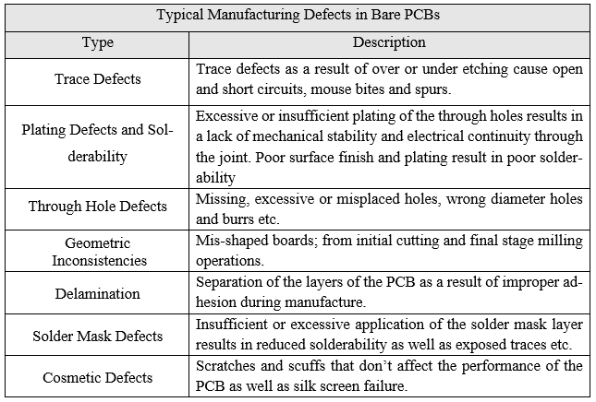
Below is a table of typical manufacturing defects in bare PCBs according to Willis et al.
Table 15: Table of Typical PCB Defects (Willis, 2016)

Appendix 4 - Image Sensors: CCD vs CMOS
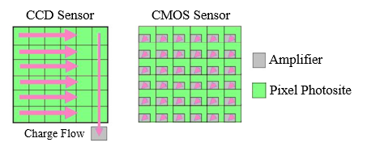
While the range of image sensor types used in MV systems is vast, charge-coupled devices (CCD) and complementary metal-oxide-semiconductor (CMOS) variants are by far the most commonly discussed in literature and used in industrial applications. Kern (2019) describes the technical differences between CMOS and CCD image sensors in his journal article titled “CCD and CMOS detectors”. Kern notes that CCD and CMOS sensors differ in the way they convert incident photon energies to electrons, and thus electrons to a voltage. Kern notes that in both CCD and CMOS sensors, photon to electron conversion occurs in the photosites within the sensor module, and charge to voltage conversion occurs in the amplifier (Figure 58), however, CCD sensors have one amplifier shared among a group of photosites, while CMOS sensors have one amplifier for each individual photosite (Kern, 2019).

Figure 58: CCD vs CMOS Image Sensor Diagram (HERRES, 2019)
Many older papers reviewing CCD and CMOS image sensors, such as Janesick’s and Putnam’s (2003) article, state that CCD sensors provide much higher image quality with less noise interference than CMOS variants. As such CCD sensors, although much more costly than CMOS variants, were favourable in industrial applications (Janesick & Putnam, 2003) .
More recent papers reviewing CCD and CMOS image sensors describe how advancement of CMOS technology in recent years has closed the gap between these sensor types, with regards to image quality and noise mitigation. Vuuren et al. (2019) provide an extensive review of modern CCD and CMOS sensors. The authors describe how the image quality difference between CMOS and CCD sensors is largely negligible, and that the lower cost of CMOS sensors makes them the favourable choice in many modern industrial applications (Vuuren, et al., 2019). Credit must be given to Janesick and Putnam, the authors predicted this eventuality in 2003. They stated, “Over the next decade, improvements [in CMOS technology] will probably close the performance gap” and “as CMOS imaging continues to develop, new applications will further increase demand.” (Janesick & Putnam, 2003)

Appendix 5 - Single, Stereo and Multi-Camera Systems
MV systems may use single or multiple cameras in order to achieve a desired function. Single camera MV systems are known as monocular vision systems, two camera configurations are called stereo or binocular vision systems, MV systems with three or more cameras are known as multi-camera vision systems.
Below is a diagram of a monocular vision system;
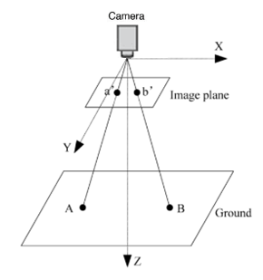

Figure 59: Diagram of a Monocular Vision System (Lin, et al., 2015)
Monocular vision systems are most commonly used in 2-D image acquisition and analysis. LI et al. (2018) present the advantages of implementing monocular vision systems in appropriate scenarios, these include; decreased demand on computational resources (such as processing power and storage capacity) during image acquisition, analysis, and storage. Monocular MV systems are low-cost and have a lower complexity of implementation and integration with existing manufacturing systems compared with stereo and multi-camera systems (Li, et al., 2018).
There are certainly limitations to monocular vision systems, historically, monocular vision systems have been deemed insufficient for complex robotic control applications involving Z-axis translation (Figure 59). Compared with stereo vision systems, monocular variants have a restricted field of view and do not have any stereoscopic capabilities (depth perception). Tomatis & Arras (1999) explain that monocular vision systems are typically used for X and Y-axis translation only in VGR applications. Tomatis & Arras go on to explain that integration of laser range finders such as lidar or ultrasonic transducers may mitigate the lack of stereoscopic capabilities in monocular vision systems (Tomatis & Arras, 1999).
Binocular or stereo vision systems are the most common configuration used in VGR applications. Chen et al. discuss the benefits of binocular vision in their paper . The authors note that the ability to obtain 3-D information of an object using stereoscopic vision allows a higher level of accuracy, precision, and repeatability in the robot path program. Throughout the paper Chen et al. reiterate the importance of following camera calibration protocols in order to achieve a high level of positional accuracy (Chen, et al., 2011).
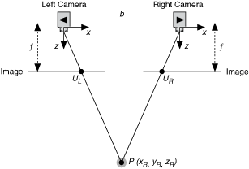
Below is a diagram of a binocular vision system;
Figure 60: Diagram of a Binocular Vision System (National Instruments , 2015)

Aguilar et al. (1996) explain the technicalities of stereoscopic computer vision in their article. Aguilar et al. noted that as long as the displacement (‘b’ in figure 60) between to cameras is known, the disparity (or distance) between the same point of interest (‘P’ in figure 60) in two separate image planes (U_{L} & U_{R} in figure 60) can be calculated, in this instance, disparity is equal to U_{L} minus U_{R.} The Z-axis distance to point P is approximated using the inversely proportional relationship between the disparity and depth. The authors also discussed how the accuracy of the depth approximation increases as the displacement between the two cameras increases (Aguilar, et al., 1996) .
Scharstein (1999) notes the importance of removing radial and tangential distortion from images in stereoscopic vision systems in his book “View Synthesis Using Stereo Vision”. Scharstein explains how distortion in camera lenses can significantly affect the accuracy of depth approximations. Scharstein proposed using the checkerboard calibration model to calculate the intrinsic and extrinsic properties of the camera (Scharstein, 1999).

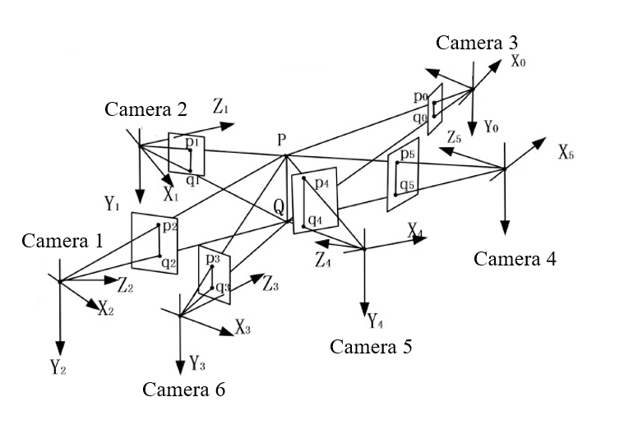
Multi-camera MV systems (figure 61) are the most sophisticated and complex vision systems out of the three types discussed, they are typically used when an application requires large fields of view or multiple viewing angles as a means of mitigating occlusion issues. Hornberg (2017) discussed the issues around the implementation and integration of multi-camera systems in his book titled “Handbook of Machine and Computer Vision: The Guide for Developers and Users”. Hornberg describes how multi-camera vision systems typically require centrally controlled embedded image processing units, which are costly to purchase and maintain. Hornberg proposed the idea of a Wi-Fi enabled smart camera network to limit the amount of cables and I/O terminals required in multicamera vision systems (Hornberg, 2017). Below is a diagram of a multi-camera vision system;

Figure 61: Multi-Camera Vision System Diagram (Yang, et al., 2015)
As with the monocular and binocular vision systems, the accuracy and repeatability of the vision system is largely dependent on how well the camera systems are calibrated. Historically, calibration of multi-camera systems is exceedingly difficult, Barreto & Daniilidis (2004) stated in their article, “calibration of cameras distributed in a wide area is a challenging task because it is impossible to use reference objects visible to all cameras and because wide field-of-view cameras suffer radial distortion” (Barreto & Daniilidis, 2004). However, in recent times, there have been multiple procedures proposed in literature with the aim of simplifying the calibration process, one such example is the novel plane by plane transformation method which links pixel coordinates to light rays proposed by (Machicoane, et al., 2019).
Martinetae et al. proposed a multi-camera vision guidance system for large 6 DoF industrial robots, the system, used for pick-and-place operations, comprised of 4 stereoscopic camera (8 image sensors). Martinetae et al. concluded the article with a summation of the results of positional accuracy tests used to validate the vision guidance system, the authors stated “an average error of $±$10mm in position and 0.5º was achieved” (Martinetae, et al., 2019).

Appendix 6 - Background of Neural Networks
(Nielsen, 2015) reviewed neural networks, Put simply, a neural network is made up of layers of artificial neurons, similar to neurons in the human brain, these neurons react to some stimuli (figure 62) . In neural networks, neurons are represented by mathematical functions and the Stimuli in this case is pixel intensity data. Each layer of neurons is connected to the next layer by channels.
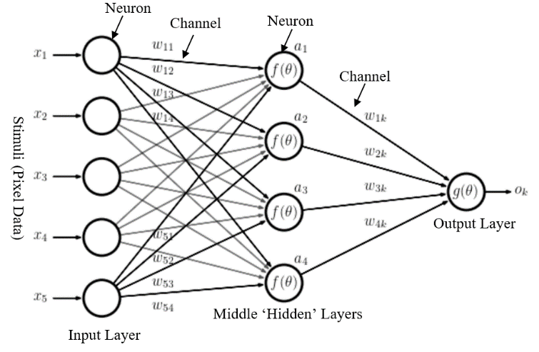

Figure 62: Neural Network Diagram (AstroML, 2019)
The channels contain random values, known as weights $w_{11,12,13…}$ . The neurons are assigned biases $a_{1,2,3…}$. The following equation describes the output of a given neuron to stimuli;
$$a_{1}=f(\sum_{i=1}^{N}{w_{ij}x_{ij}+ b_{1})}$$
Where $a_{1}$ = the neuron output, $\sum_{i=1}^{N}{w_{ij}x_{ij} }$= the sum of the input values (pixel intensities) multiplied by the channel weights and $b_{1}$ = the neuron bias.
A threshold function, known as the activation function, is used to determine whether or not the input stimuli causes activation (or reaction) of the neuron, only active neurons pass data to the next layer of neurons, this is known as forward propagation. During training, both the input stimuli and output result (classification of an object) are fed to the neural network. The error between the predicted output of the network and the desired output (ground truth) is calculated. The network then automatically adjusts the weights and biases of every neuron to decrease the error between the predicted and ground truth output, this is known as backward propagation. Over many iterations of forward and backward propagation the network learns the required waiting and biases, this is a simplified explanation of a neural network, real CNN’s may contain thousands of layers and millions of neurons. Neural networks are still somewhat of an unknown, as it is not possible to map exactly how the inner (or hidden) layers of the networks adjust its parameters mathematically, and thus the only absolutely quantifiable or interpretable values are the input and outputs of the network, this is known as the black box model. (Nielsen, 2015)

Appendix 7 - Further End Effector Design

Robot End Effector Theory
An end effector (also known as a gripper) is a device/tool that is mounted to the end of the robotic arm in order to manipulate or interact with objects. Typically, robotic end effectors are designed specifically for each application. For example, an end effector used to handle small, lightweight or fragile objects may not be able to grasp large or heavy objects and vice versa. Steinmann et al. describe the four distinct types of prehension in robotic end effector designs;
- Impactive prehension
Impactive prehension involves mechanical gripping of an object. Claws or fingers are used to provide a clamping force in order to grasp and thus manipulate the component. Impactive grippers are arguably the most common and versatile form of gripper design, however, they may not be suitable for small, fragile or irregularly shaped objects. Most impactive grippers are electromechanically or pneumatically actuated.
- Astrictive prehension
Astrictive prehension involves some form of attractive force that pulls the object onto the end effector. Vacuum grippers are the most common form of astrictive gripper, but magnetoadhesive and electroadhesive grippers are also examples of astrictive prehension. Astrictive grippers are mostly used for objects with flat, smooth surfaces such as glass and metal sheets for example. A limitation to astrictive grippers (especially vacuum variants) is that any inhomogeneities in the surface of the object, such as holes or textures, may result in a missed grasp. Most astrictive grippers rely on a supply of compressed air, or electricity in order to operate.
- Ingressive prehension
Ingressive prehension is an invasive grasping procedure. Ingressive grippers use hooks, needles or pins to physically penetrate the object in order to achieve a grasp. A common application of Ingressive grippers is handling glass/carbon fibre sheeting in automated lay-up procedures. The uses for ingressive grippers are thus very limited.
- Contigutive prehension
Contigutive grippers are the least common of the four types discussed, contigutive grippers use chemical (glue adhesives) or thermal (melting areas of the object) to adhere the object to the end effector. Applications of contigutive grippers are very rare but have been used in microelectronic assemblies and the textile industry.
(Steinmann, et al., 2007)

End Effector Adapter Finite Element Analysis
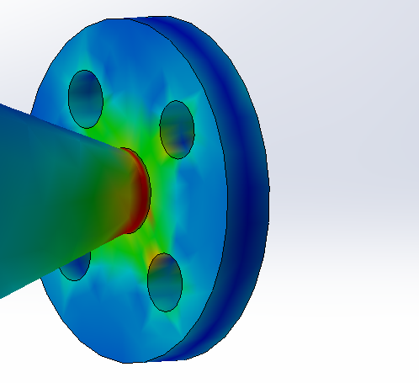
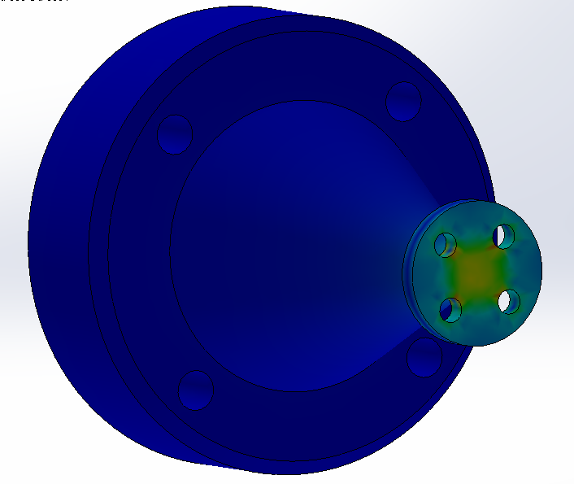
Design 1 FEA

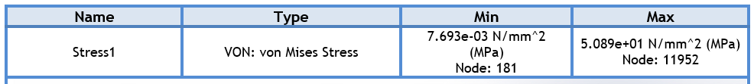
Initial inspection of the first design showed a high stress concentration on the smallest cross section at the rear of the vacuum ejector mounting surface, This was an unwanted characteristic and resulted in an increased probability of failure, this intern motivated the 2nd design iteration in order to resolve this high stress concentration.
Design 2
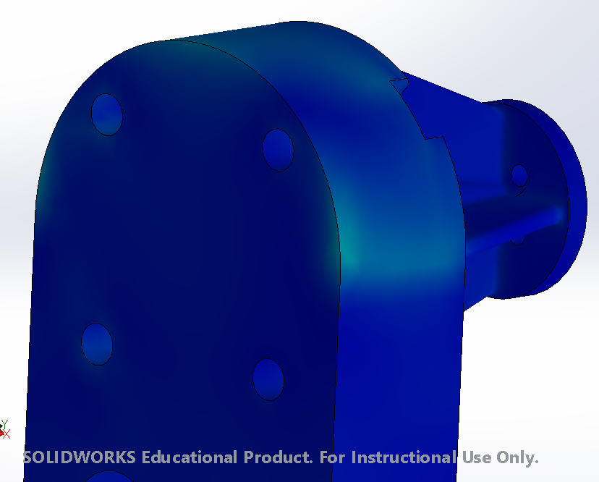
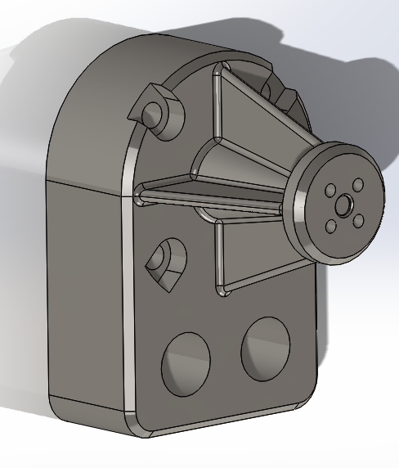
The second design iteration used four support ribs with radiused edges (see figure 64) with the aim of reducing the stress concentration on the tip of the end effector. The ribs essentially increase the cross sectional area as well as assist in dissipating forces during collision. Note that the stress concentration is much more uniform.
Figure 63: Von Mises Design 2
Figure 64: Design 2
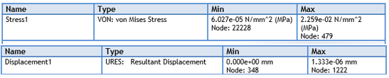
Figure 65:Stress and Displacement Design 2

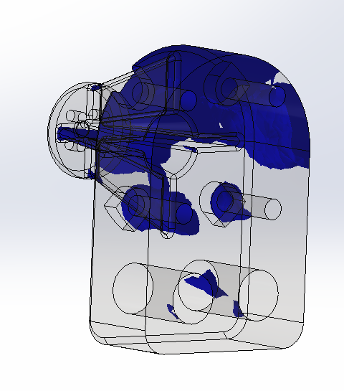
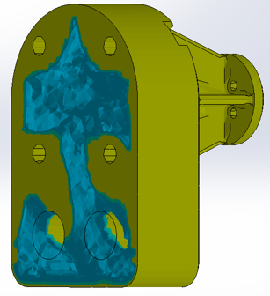
The Solidworks design insights function (See figure 66) was used to identify areas of low stress distribution and that could be mass optimised in a topology study. The areas in blue are areas of high stress concentration and this could not be removed, clear areas are suitable for mass optimisation, this motivated the 3rd design iteration.

Figure 66: 2nd Design Iteration Topology Optimisation
The first and second design iterations where solid bodies, with no thought given to mass optimisation. The topology study used the same linear static loading conditions as the structural analysis, an initial mass reduction target of 50% was used.
Design 3
For the final design iteration, the results from the topology study were used to remove excess material from the rear of the 2nd design variant. A further linear static study is used to validate the topology study and the final design as a whole.
The FEA study of the 3rd design iteration proved that the topology study and mass optimisation of the rear of the end effector design was successful. A mass reduction of 400g compared to design 2 and 400g compared with design 1 was achieved with only negligible increases in stress and displacement compared with design 2.
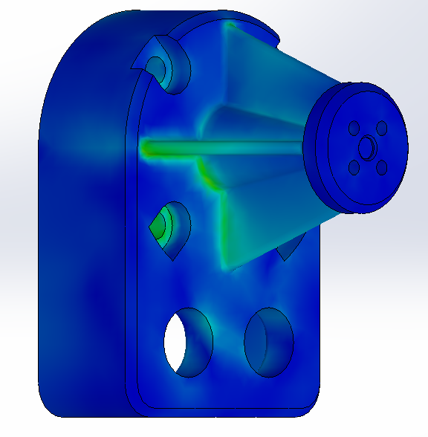
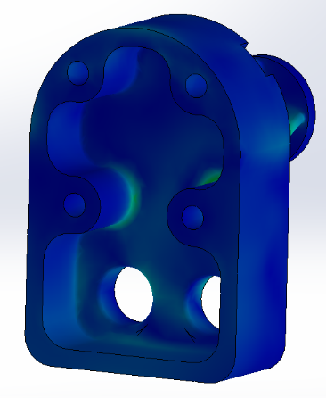
Figure 67: Final Design Von Mises Distributions
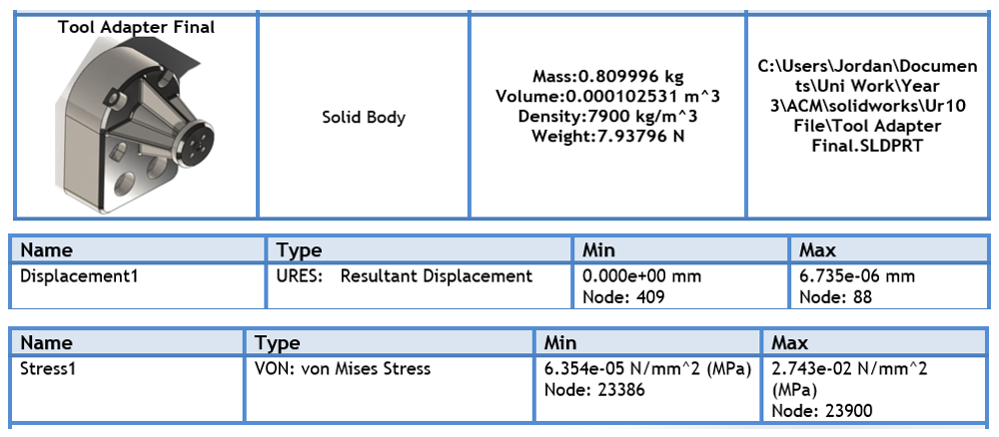
Table 16: Table of FEA results for Design Iteration 3

