TASK 1

A written summary of 300 words, with at least one supporting image, on the topic of “Preparing for Higher Education.

Initial part of this assignment focuses on the summary of the topic preparation for Higher Education. This seeks to highlight on “where and when one should study to be at their best, assessing time management skills and identifying areas to improved. It also helps to identify strategies to effectively plan and prioritised task and be able to practise strategies to overcome procrastination and perfectionist behaviours.

After securing admission and finalising finances, the next task was creating the right study environment which in this case my home, ensured it was conducive in terms of having the right furniture and temperature. Also considered was reducing the levels of distraction by turn off your phone.

Effective time Management is great way of achieving academic success, it is also a major challenge that many students faced, Moore et al (2010). Apart from the usual timetabled for lectures and seminars, students are fully responsible for organising their study time as well as managing other commitments such as family, jobs, social life, and other responsibilities.

Prioritising all given tasks by using Eisenhower's Urgent/Important Principle can help students prioritise tasks in order of importance.
To do so tasks are divided into four categories as illustrated in the diagram below, Emerald works (no date):
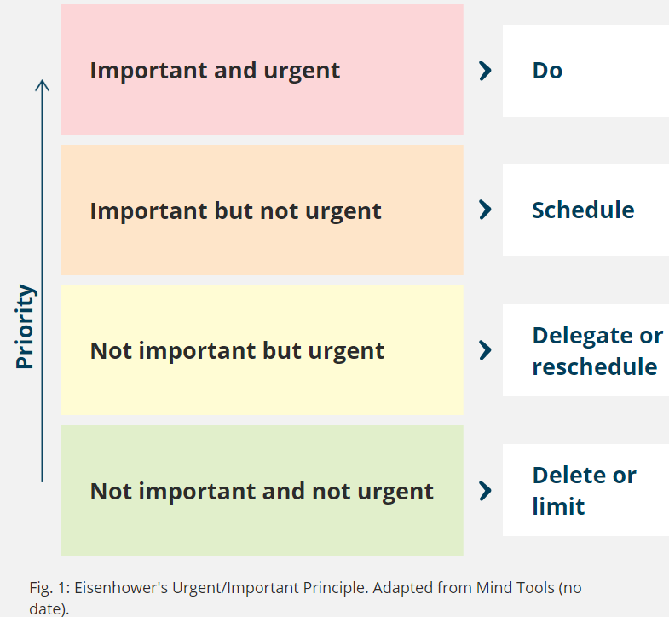

Many people tend to focus on completing urgent tasks even if they are not important, therefore using Eisenhower's Urgent/Important Principle can be useful to avoid this and ensure that only the most important urgent tasks are completed.
Also, it is necessary to practice strategies to overcome procrastination and perfectionist behaviours. Procrastination is the avoidance of starting certain tasks and to overcome it, one must first gain understanding of why they are procrastinating, Urban (2016).
Students will be expected to undertake many projects work by using different assessment methods during their study at the university. They are most required to use various software application such as Microsoft word, PowerPoint, excel, Teams and outlook. These are powerful software and are commonly used in many workplaces so having a good understanding of these applications are useful skills.
Apart from getting to understand and being able to use these software applications, it is also important for students to understand and demonstrate the importance of staying protected online Frost, (2021)
It is also important for students to acknowledge the source of information for their work by referencing it to avoid plagiarism.
Finally, students are required to demonstrate the ability to identify different methods of assessment and understand the features of Turnitin and how to apply it.

TASK 2

A mind map on the topic of “Becoming a Digital Learner”.
The second part of the assignment seeks to address how to become a Digital Learner and demonstrate how the main themes and concepts of this topic are interconnected, as well as how they contribute to preparing students to work in their chosen discipline.

In view of this, students are expected to demonstrate the foundational skills required to be a resilient and healthy independent learner and to practise the principles of learning agility as well as using suitable technology to support and enhance their learning experience within the discipline area.

The main themes and concepts of becoming a digital learner include,

- How to study effectively, this includes: being aware of when and where to study to be at your best, Time management, how to prioritise your task by using Eisenhower’s principle to create a study plan and how to overcome procrastination and perfectionist.
- Learning to think and write critically. In this contest, students should be aware of how to locate information and services, evaluating information and finding credible academic resources. Practise steps to identify fake news as well as credible academic information (CyberWise, no date). Recognise strategies to effectively use online resources and the library catalogue.

- Referencing accurately to avoid plagiarism, this involve the student being able to demonstrate an ability to integrate a range of resources by putting their findings into their own words. They are being able to recognise the consequences of plagiarism and how they can avoid this to ensure academic integrity. Understand the importance of referencing and to produce in-text citation and referencing style.

- use appropriate technology to support learning, by this, students should be able to make high quality written assessments and presentation. They should be able to use different software including Microsoft word, Microsoft PowerPoint, Microsoft outlook, Microsoft teams and Microsoft stream to create an explainer video.

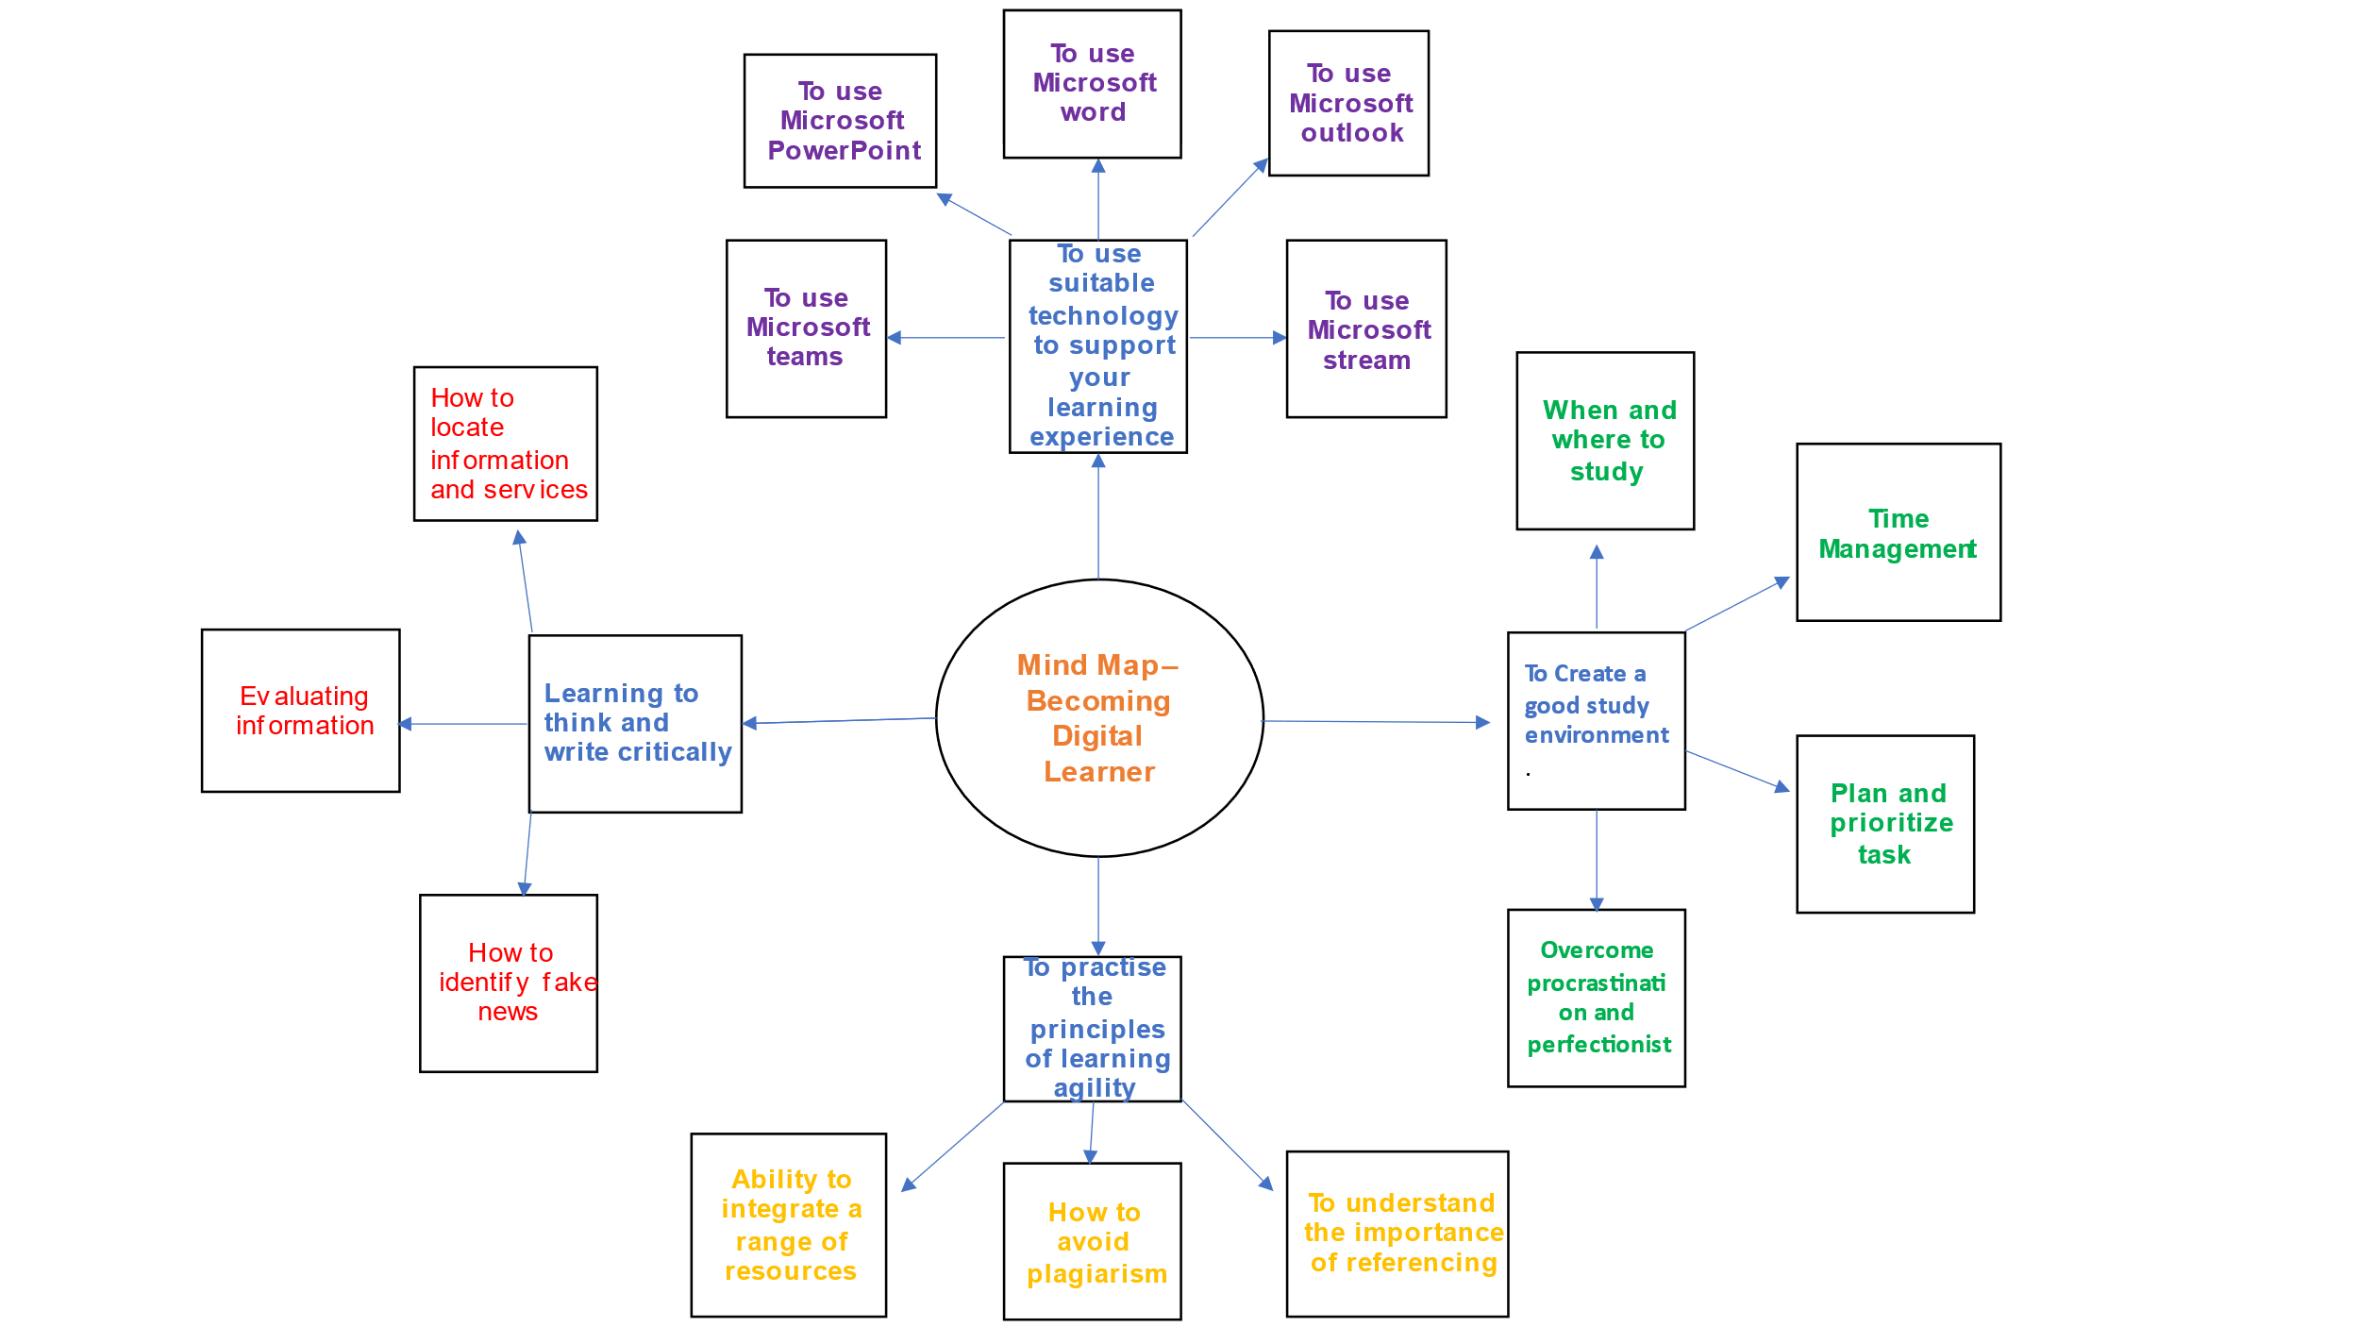

TASK 3
Please follow this link to view my presentation. https://youtu.be/nSbrFfSppmY

Your personal identity and how this is shaped by your sense of place, values and beliefs. Explain how these can make you a good team player.

Our beliefs, values, attitudes, and behaviours are all interconnected and play a significant role in shaping our understanding of the world and influencing our actions (uwtsd.hosted.panopto 2023).
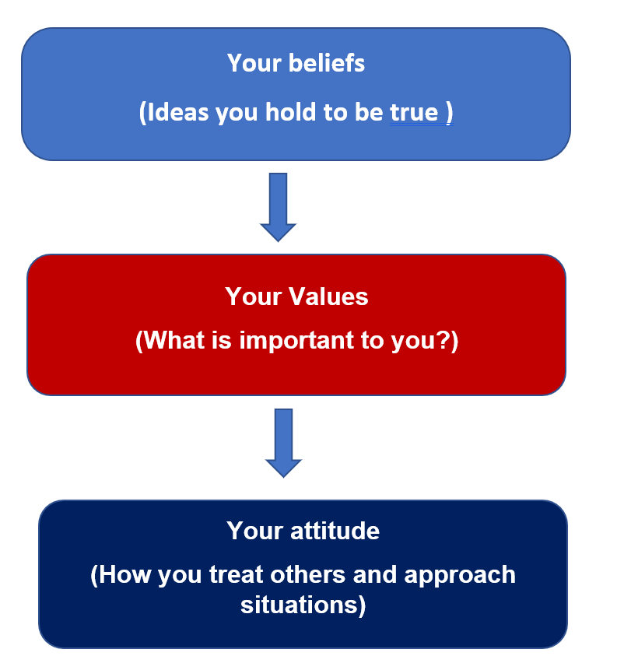
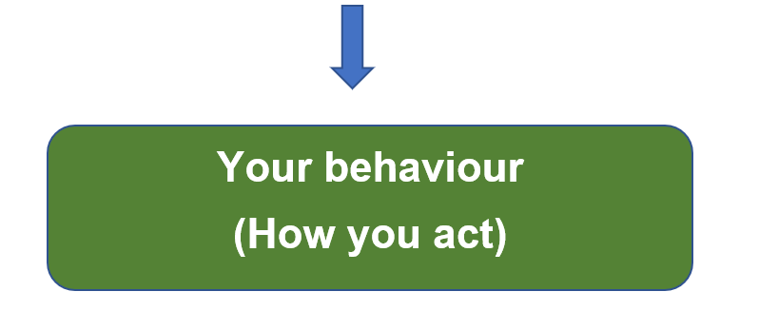

The combination of your values, beliefs and attitudes results in your behaviour. (New Zealand, (2020).

By understanding the interconnectedness of these four elements, we can become more aware of our own motivations and challenges in making more informed choices. We can also become more open to new perspectives and experiences, which can lead to personal growth, positive change, increased harmony and improve teamwork, Simmerly (1987).

As an African, my personal identity is deeply connected to my ancestry, culture, and community. It has also shaped by my Sense of Place, my Values and Beliefs as well as my Resilience and Adaptation.

Sense of Place
My profound connection in West Africa, Ghana as my homeland which serves as a repository of my cultural identity. My deep connection to Ghana has shape my personal identity by fostering my sense of belonging, grounding individual in my heritage, and instilling a profound respect for the world. Understanding my sense of place and those of other people l work with have increased harmony and improve teamwork, Simmerly (1987).
.

Values and Beliefs
My values and beliefs emphasise the importance of community, family, and collective well-being. These values and beliefs shape my personal identity by promoting social cohesion, fostering a sense of responsibility to others, and providing a moral compass for navigating life's challenges. Understanding my own values and my Christian believe that “we should love everyone as ourselves” as the bible says, have increased harmony and improve my teamwork, Simmerly (1987).

Cultural Expressions
My personal identity is vividly expressed through a rich of cultural traditions, including music, dance, storytelling, and artistic expression. These serve as vehicles for preserving history and celebrating communal values. They also provide avenues for personal expression, allowing me to connect with my heritage and affirm my identity. Understanding my own Cultural Expressions and those of my colleagues have improve my skills within the team (uwtsd Panopto 2023).

Resilience and Adaptation

My deep connection in West Africa, Ghana has been shaped by a long history of resilience and adaptation in the face of adversity. This spirit of resilience has become an integral part of my personal identity, shaping my outlook and approach to life's challenges.
In conclusion, .my resilience and adaptation has inspire me to contribute to a more just and equitable world and understanding my own values and those of other people l work with have increased harmony and improve teamwork, Simmerly (1987).
.

TASK 4

Using Borton’s reflective Model
This part of the assignment seeks to look at my experience when l started university, getting a grip of online learning and accessing resources, and the process of writing my first assignments as well as reflecting on how to resolved it. I will be using the Borton model as a reflective tool in this discussion.
According to Paul Templar (2021), Borton describes this model as a fluid process where no part of it can exclude another – it is a “continuous integrated flow” with no beginning or end. The model is based on 3 questions of the What, So what and What now?

I would say that the beginning of my tertiary education coincided with series of stressful circumstances that brought about the feeling of frustration and anxiety. Despite all adversities, l gained the ability to start it all over again by developing positive relationship with others and seeking support. The outcome was self-confidence and resilience.

Due to all the above personal circumstances, it became apparent that my focus and concentration were lagging hence, my inability to keep up with the online teaching and learning and accessing available resources.

I was constantly panicking and nervous especially during discussions in class, with colleagues and social settings. All these occur at the same time I was writing my first assignments, so I found it difficult to concentrate on my entire studies.

The above-mentioned challenges contributed to my poor assignment results, lack of understanding of online learning and resources as well as deepened financial situation.

I came to realised that, to survive and thrive during these uncertainties and challenges, I had resort to personal resilience as a coping mechanism, to remain calm and productive referring to Owen (2020) as the ability to bounce back.

According to Cooper et al (2013) resilience is based on four elements: confidence, social support, adaptability, and purposefulness. I therefore decided to build self-confidence by trying out different mini challenges. I also adapted to new lifestyle by understanding any failures, reflecting on them, being open to new ideas and situations and finding ways to complete difficult task rather than giving up.

Another change was to build social support by building positive relationship with others and seeking support and opening up in a way to talking about my feelings.

REFERENCES

C. Cooper, J. Flint-Taylor, M. Pearn (2013) Buildings Resilience for success: A resource for managers and organisations Published by: Palgrave Macmillan UK , 9 Jul 2013 - Business & Economics - 233 pages. date accessed 23/11/2023

CyberWise (No date) What is fake news https://www.youtube.com/watch?v=V4o0B6IDo50 date accessed 23/11/2023

Cottrell, S (2019) The study Skills handbook-5th edition .London: Macmillan Education.

Moo, S. et al (2010) The Ultimate study Skills handbook. Maidenhead, England: Open University Press.

Mind Tools (no date), Eisenhower's Urgent/Important Principle Using Time Effectively, Not Just Efficiently, (Article), https://www.mindtools.com/al1e0k5/eisenhowers-urgentimportant-principle

New Zealand (2020), ministry of business innovation and employment. date accessed 23/11/2023

Tim Urban (2016), Inside the mind of a master procrastinator - https://www.ted.com/talks/tim_urban_inside_the_mind_of_a_master_procrastinator/transcript?language=en) date accessed 23/11/2023

uwtsd.hosted.panopto 2023, Values, beliefs and ethics (https://uwtsd.hosted.panopto.com/Panopto/Pages/Viewer.aspx?id=ef1281b5-e062-4ba8-8660-aee001097f16) date accessed 23/11/2023

