

School of Hospitality & Tourism Management
BA International Hotel Management

BMIH5006
Sustainable Hospitality & Tourism Management

LEVEL 5

Student name: Ionica Costache
Student ID: 2246358
Word count: 1897
Module Lead: Daniel Payne

Declaration
I have used Grammarly which is an AI tool to rectify any grammatical mistakes from this study. Other than this, I confirm that I have not used any AI too in the research and creation of this assignment. I confirm that I have not presented any AI generated materials as my own work. I also confirm I have copies of my draft, notes and other resources I used, which I may be asked to provide in evidence.

Executive Summary

The role of buses in hospitality transportation is examined in this report based on environmental cost and sustainable options. Buses are used heavily for airport transfers, tours, and hotel transfers, but they release greenhouse gases, contaminate the air, and congest city traffic.

The report identifies major issues that involve CO₂ emissions, air pollution, and landscape degradation from bus transport. It also evaluates cost-effective and practical alternatives, including electric and hybrid buses, increased public transport integration, and green infrastructure investment. Industry examples, such as Marriott and Hilton's adoption of electric shuttle buses, confirm the viability of green transport initiatives.

The report states that the hospitality sector must adopt eco-friendly bus transport to reduce carbon footprint and enhance corporate sustainability. Recommendations encompass funding electric bus fleets, collaboration with public transportation systems, and implementing digital transport systems to reduce emissions and improve efficiency.

Table of Contents
Executive Summary 3
Introduction 4
Environmental Damage Caused by Road Transport 4
Greenhouse Emissions 5
Traffic Congestion and Air Quality 6
Habitat Degradation and Urban Sprawl 6
Possible Solutions 7
Introduction of Electric Vehicles (EVs) 7
Improved Public Transport Systems 7
Sustainable & Green Transport Hospitality Practices 8
Investment in Sustainable Transport Facilities 8
Government Policies and Incentives 9
Cost-effectiveness and Feasibility 9
Conclusion 10
Recommendations 10
References 11

Introduction

Hospitality transport is a phrase that refers to the various transport modes applied in the hospitality industry for the transportation of guests, staff, and commodities (Kotler, 2020). This discussion is focusing on buses as the principal road mode of transport utilised in hospitality. Buses are found to be highly utilised in airport transfers, touring, and hotel transfers due to their affordability, flexibility and convenience by having the ability to carry large groups of travellers at once (Kanwal et al., 2024). However, the growing demand for tourist transport (Gunter and Wöber, 2021) and the extensive use is the cause of significant environmental issues such as greenhouse gas emissions, air pollution, urban congestion, and land degradation, which need immediate attention and creative solutions (Chau and Yan, 2021). The report examines the environmental impact of buses in hospitality transport, how they affect landscapes and communities, and considers possible and affordable interventions that the industry can adopt to minimise its carbon footprint.

Environmental Damage Caused by Road Transport

With tourism booming, alarm over its negative impact on the environment started growing. By the 1990s, studies increasingly highlighted the environmental effect of the transport sector, particularly the carbon price of road and air transport (Gillespie, 2018). The hospitality industry, dependent on these transport networks, was being increasingly pressed to adopt sustainable approaches. Consequently, the 21st century has seen a move towards green transportation, with electric vehicles (EVs), public transport, and urban planning measures to counter congestion and pollution promoted by governments and corporations (Mihet-Popa and Saponara, 2018). Therefore, sustainable hospitality transport is the primary focus today, due to stricter environmental regulations and customer calls for green modes of transportation (IEA, 2024). Hospitality continues to shift by incorporating sustainable transport options into operations in a bid to minimise its carbon footprint.
In 2023, transportation was the second highest pollutant (Fig.1), accounting for 15% of CO₂ emissions worldwide (Tiseo, 2025). This being a consequence of the large-scale use of motor vehicles, such as shuttle buses, has resulted in massive carbon emissions, traffic patterns, and interference with natural habitats. While the tourism industry progresses, the greening footprint of road transport remains a matter of urgency (Eijgelaar and Peeters, 2024).
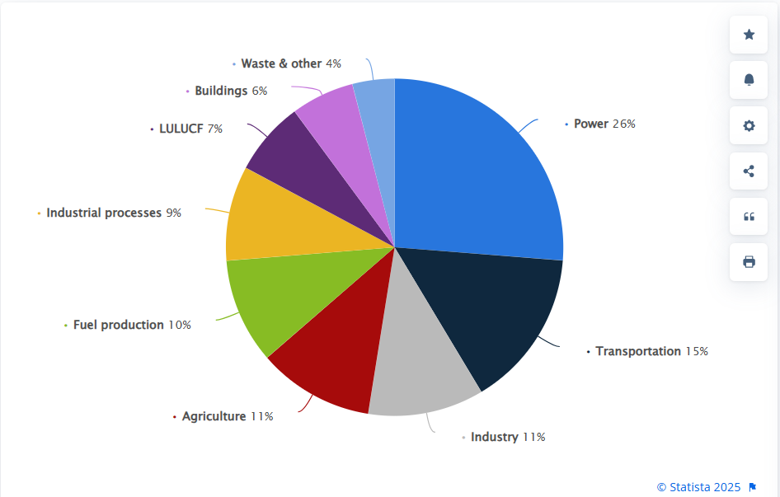
Fig.1 - Global greenhouse gas emissions shares 2023, by sector; Source: Tiseo, (2024).

Greenhouse Emissions

Road transport is among the most significant sources of greenhouse gas emissions, which are causing climate change. Road transport surpasses eight billion metric tons of CO worldwide and contributes to around 75% of all the emissions from transport globally (Tiseo, 2025) (Fig.2). In this regard, motor cars used in tourism and hospitality operations, such as taxis and shuttle buses, are a prominent source of carbon dioxide (CO₂) and other contaminating emissions (Kanwal et al., 2024).
A very good example of transportation that contributes the most to GHG emissions, accounting for 28%, from which buses contributed 6%, of overall emissions in 2022 (EPA, 2024), is the US. Similarly, same year in the European Union, transport is responsible for approximately a quarter of total CO₂ emissions - 29% (Tiseo, 2024), while 73.2% of this is through road transport and buses, approximately 9% (European Environment Agency, 2023). Despite their higher capacity than personal vehicles, the majority of buses remain reliant on diesel, one of the primary sources of air pollution (EPA, 2024). This necessitates moving toward electric and hybrid buses as an eco-friendly option (IEA, 2024).
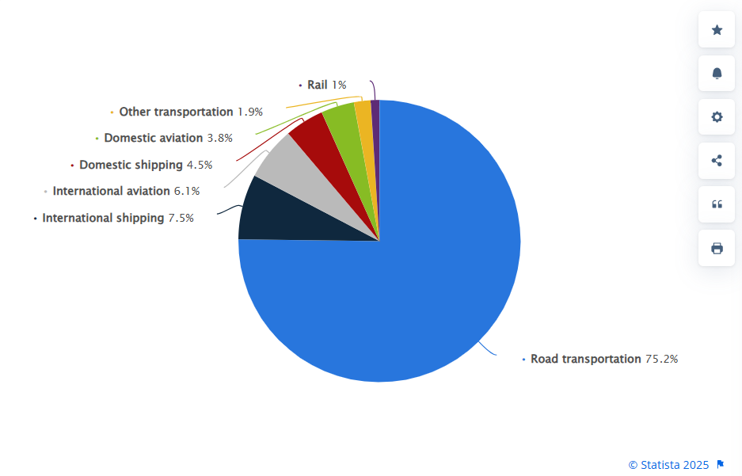
Fig.2 - Breakdown of CO₂ emissions in the transportation sector worldwide 2023, by sub sector; Source: Tiseo, (2025).

Traffic Congestion and Air Quality

Increased use of vehicles leads to traffic congestion, particularly in tourist areas (Curtale, Sarman and Evler, 2021). Congestion by buses powered by fossil fuels emits toxic substances such as air pollution by elevating the levels of harmful pollutants such as nitrogen oxides (NOₓ) and fine particulate matter (PM₂.5), which are highly detrimental to both residents and tourists (Xu, Sun and Liu, 2024).
Hotspots for travel are faced with heavy volumes of traffic resulting in congestion, which also contributes to emissions and spoils city air quality (Curtale, Sarman, and Evler, 2021). Studies indicate that tourist bus traffic zones are exposed to a maximum of 30% air pollution compared to less transport-prone areas (Khreis et al., 2020). Same studies reveal that traffic congestion not only increases vehicle emissions but also contributes to poor air quality, leading to increased respiratory diseases and cardiovascular diseases among people living near busy roads (Khreis et al., 2020). Research further indicates that traffic congestion is directly linked to premature mortality due to exposure to high levels of air pollution.

Landscape and Community Impacts

Buses require extensive road networks and parking spaces, which have the effect of disrupting habitats and urban sprawl. Expanding bus terminals and tourist transport hubs has the potential to cause deforestation and the removal of green spaces (Petrişor et al., 2020). Besides, noise pollution due to the overuse of buses affects visitors and locals alike (Opoku, 2019). Deterioration of aesthetics is also a concern because overcrowded bus routes decrease the scenic value of destinations (Schiller, Bruun, and Kenworthy, 2010). Overreliance on buses to transport tourists is also detrimental to local businesses in that it can either increase foot traffic in specific areas or produce congestion that keeps away potential tourists (Mr. Manglik, 2023). Moreover, the spread of automobile-centred urban expansion consumes agricultural land and open spaces and accelerates the habitat destruction process (Schiller, Bruun, and Kenworthy, 2010)

Possible Sustainable Solutions

Sustainable transport models are necessary to reduce environmental impact while maintaining operational effectiveness. The Sustainable Mobility Framework (Banister, 2008) assumes that reduced reliance on fossil fuels, enhanced energy efficiency, and better public transport integration are essential to achieve an environmentally sustainable transport system. In the hospitality industry, adopting sustainable transport solutions aligns with the principles of eco-tourism and corporate social responsibility (CSR), which advocate for environmental sustainability alongside profitability (Weaver, 2020). Literature also highlights that such a move towards sustainable transport strategies equals long-term cost savings as well as a company's reputational benefit amidst environmentally aware travellers (Xu and Gursoy, 2015). Thus, embracing eco-friendly substitutes for traditional buses is not only an environmental necessity but a tactical business choice for hospitality operators.

Electric and Hybrid Buses

Electric and hybrid buses reduce emissions and fuel consumption by a significant amount. According to the International Energy Agency (IEA, 2024), electric buses produce 50% less CO₂ compared to diesel buses. A perfect illustration is that of the Marriott International hotel chain, having partnered with the installers of electric vehicle charging points to facilitate effective transport choices in the industry (Mukherjee, 2023) and have begun integrating electric shuttle buses into their fleet, reducing fuel costs and enhancing sustainability. In addition, Hilton Hotels is also beginning to employ electric shuttle buses for the transport of guests, conserving fuel costs and air emissions (Powell, 2023). Electric and hybrid buses not only bring down operating costs in the long term but also enhance the image of hospitality firms that are concerned with sustainability (Kantarcıgil, 2023).

Improved Public Transport Integration

Enhancing public transport has the impact of significantly decreasing reliance on private transport, lowering congestion and emissions (Lyu, Huang and Sun, 2025). In Singapore, a unified system of public transport has made it easy for tourists to travel, reducing their carbon footprint (SPOR, 2024). Amsterdam, similarly, has successfully implemented eco-friendly trams and buses, which accommodate tourists to walk around destinations without resorting to hotel shuttles (Staff, 2024). Cooperation between hospitality organizations and government agencies to promote the use of public transport, for example, discounted public travel tickets for visitors, can also enhance environmentally friendly travel behaviours (Roxas, Rivera and Gutierrez, 2020). Electronic innovations such as clever route planning and eco-friendly driving can further reduce bus usage and pollution (Jain, 2024).

Green Transport Infrastructure Investment

Green infrastructure such as bus lanes and smart transport technologies improves efficiency and sustainability and encourages tourists to travel to locations without the need for cars (Jerkovic, 2023). Copenhagen, for example, has achieved this with the implementation of smart traffic systems that control bus routes in a manner to minimize congestion as well as fuel wastage (Liverino, 2023). Similarly, Barcelona has created low-emission zones, restricting environmentally harmful buses from entering specified zones and encouraging environment-friendly alternatives (Aaron, 2022). Not only do these investments reduce emissions, but they also promote urban sustainability and an eco-friendly environment.

Cost-effectiveness and Feasibility

The initial investment in electric and hybrid buses, green infrastructure, and improved public transport is enormous; however, sustainable fuel savings in prices, maintenance, and regulatory credits make them cost-effective (Bosch et al., 2021). For instance, studies have confirmed that electric buses, while 30% more costly to buy upfront, are 50% less costly to operate in the long run compared to diesel buses since they consume less fuel and are less demanding when it comes to maintenance (McCluskey, Druitt and Larkin, 2024).
As of 2019, UNWTO research, the transport CO2 emissions, related to tourism, are expected to increase. Therefore, policy regulations are key in promoting sustainable transport within the hospitality sector. Governments can implement tax relief programs for businesses that employ green transport technology and apply strict emissions controls on hospitality-related transport (Valenti, 2024). The offering of leasing systems for electric buses allows hospitality companies to transition more readily without substantial capital expenditure (Williams and Carter, 2023).
In Norway, for example, the government provides massive tax relief to hotels and transport firms that invest in electric vehicle facilities (OECD, 2022). Additionally, France has introduced low-emission zones in major cities, limiting access to polluting cars and encouraging eco-friendly mobility options (Lilley, 2025). Additionally, cities like Amsterdam and Copenhagen have also demonstrated that green transport policies can be successfully implemented with government leadership and public support (Abdullahi and Adnan, 2024).

Environmental Benefits of Sustainable Transport

By adopting electric buses and improving transport infrastructure, the hospitality industry can easily reduce its carbon footprint. The Green Tourism Association (2024) carried out a study that revealed hotels using electric shuttle services, reducing their transport emissions by 40% in five years. In addition, the inclusion of sustainable transport in hospitality enterprises enhances the brand image, with environmentally conscious travellers attracted to such hospitality enterprises (Xu and Gursoy, 2015).

Conclusion

Buses play a vital role in hospitality transportation, offering economic mobility for tourists. However, their widespread use causes environmental concerns such as greenhouse gas emissions, air pollution, and city congestion. To solve these, the hospitality industry must embrace green alternatives like electric and hybrid buses, more public transport collaboration, and green infrastructure investment. These measures not only satisfy environmental needs but also reduce costs and improve guest experience. The industry can therefore resolve its effect on the environment and enhance long-term sustainability by doing the above.

Recommendations

• Investment in Electric Bus Fleet: Hotel companies need to invest in electric buses to reduce emissions and operating costs.
• Public Transport Coordination: Hotels need to cooperate with local governments to coordinate public transport for tourists.
• Promotion of Sustainable Transport Incentives: Governments need to provide incentives for green transport initiatives in the hotel industry.
• Green Infrastructure Development: Expanding low-emission areas and optimizing bus routes can minimize congestion and pollution.
• Adoption of Digital Transport Solutions: Intelligent routing and energy-saving driving systems can reduce emissions further.
• Industry-Wide Certifications for Sustainability: Hotels need to adopt certification programs that recognize environmentally sustainable transport practices (Green Tourism, 2024).
With the implementation of these recommendations, the hospitality sector can render bus transport sustainable, benefiting the environment as well as long-term industry profitability.

References

Aaron (2022). Visiting Barcelona? You May Have To Leave Your Car Behind. [online] TheTravel. Available at: https://www.thetravel.com/barcelonas-new-carless-superblocks/ [Accessed 25 Feb. 2025].
Abdullahi, U., O. and Adnan, A. (2024). Sustainable Urban mobility: Lessons from European Cities. Global Journal of Engineering and Technology Advances, 21(2), pp.157–170. doi:https://doi.org/10.30574/gjeta.2024.21.2.0210.
Banister, D. (2008). "The sustainable mobility paradigm." Transport Policy, 15(2), 73-80.
Bosch, F.P., Pujadas, P., Morton, C. and Cervera, C. (2021). Sustainable deployment of an electric vehicle public charging infrastructure network from a city business model perspective. Sustainable Cities and Society, [online] 71, p.102957. doi:https://doi.org/10.1016/j.scs.2021.102957. [Accessed 15 Feb. 2025].
Chau, D.S. and Yan, D.L. (2021). Destination hospitality indicators. Journal of Destination Marketing & Management, 19, p.100537. doi:https://doi.org/10.1016/j.jdmm.2020.100537. [Accessed 02 Feb. 2025].
Curtale, R., Sarman, I. and Evler, J. (2021). Traffic Congestion in Rural Tourist Areas and Sustainable Mobility Services. The Case of Ticino (Switzerland) Valleys. Tourism Planning & Development, pp.1–25. doi:https://doi.org/10.1080/21568316.2021.2001034. [Accessed 16 Feb. 2025].
Eijgelaar, E. and Peeters, P. (2024). The Global Footprint of Tourism. pp.533–547. doi:https://doi.org/10.1002/9781119753797.ch36. [Accessed 5 Feb. 2025].
EPA (2024). Fast Facts on Transportation Greenhouse Gas Emissions. [online] US Environmental Protection Agency. Available at: https://www.epa.gov/greenvehicles/fast-facts-transportation-greenhouse-gas-emissions. [Accessed 14 Feb. 2025].
European Environment Agency (2023). Greenhouse gas emissions from transport in Europe. [online] www.eea.europa.eu. Available at: https://www.eea.europa.eu/en/analysis/indicators/greenhouse-gas-emissions-from-transport [Accessed 08 Feb. 2025].
Gillespie, A. (2018). The 1990s. [online] Oxford Scholarship Online. Oxford University Press. doi:https://doi.org/10.1093/oso/9780198819516.003.0007. [Accessed 07 Feb. 2025].
Green Tourism. (2024). About Green Tourism. [online] Available at: https://www.green-tourism.com/about-green-tourism/. [Accessed 17 Feb. 2025].
Gunter, U. and Wöber, K. (2021). Estimating transportation-related CO2 emissions of European city tourism. Journal of Sustainable Tourism, pp.1–24. doi:https://doi.org/10.1080/09669582.2021.1939708. [Accessed 08 Feb. 2025].
IEA (2024). Outlook for emissions reductions – Global EV Outlook 2024 – Analysis. [online] IEA. Available at: https://www.iea.org/reports/global-ev-outlook-2024/outlook-for-emissions-reductions. [Accessed 21 feb. 2025].
Jain, H. (2024). From pollution to progress: Groundbreaking advances in clean technology unveiled. Innovation and green development, 3(2), pp.100143–100143. doi:https://doi.org/10.1016/j.igd.2024.100143. [Accessed 20 Feb. 2025].
Jerkovic, N. (2023). Walking and Pedestrian-Friendly Initiatives - Eco Life Zone. [online] Select Insure Group. Available at: https://ecolife.zone/walking-and-pedestrian-friendly-initiatives. [Accessed 03 Feb. 2025].
Kantarcıgil, D. (2023). How are hotels using technology to coordinate transportation and shuttle services? - GuestService. [online] GuestService. Available at: https://guestservice.net/how-are-hotels-using-technology-to-coordinate-transportation-and-shuttle-services/. [Accessed 24 Feb. 2025].
Kanwal, N., Meng, C.S., Watabe, M., Nasaruddin Zainal and Siew, K. (2024). Carbon Footprint of Tourism Activities Including Transportation, Accommodation, and Infrastructure: A Critical Analysis The Need for Sustainable Tourism in an Era of Global Climate Change: Pathway to a Greener Future, 95-120. [online] doi:https://doi.org/10.1108/978-1-83608-668-020241015. [Accessed 08 Feb. 2025].
Khreis, H., Nieuwenhuijsen, M.J., Zietsman, J. and Ramani, T. (2020). Chapter 1 - Traffic-related air pollution: Emissions, human exposures, and health: An introduction. [online] ScienceDirect. Available at: https://www.sciencedirect.com/science/article/pii/B9780128181225000016. [Accessed 18 Feb. 2025].
Kotler, P. (2020). Marketing For Hospitality And Tourism. S.L.: Pearson.
Lilley, Z. (2025). Understanding France’s Low-Emission Zones and Crit’Air Stickers. [online] Connexionfrance.com. Available at: https://www.connexionfrance.com/news/2025-map-frances-new-clean-air-driving-zones-and-their-rules/602592 [Accessed 25 Feb. 2025].
Liverino, G. (2023). Bicycle-friendly Copenhagen. [online] Wonderful Copenhagen. Available at: https://www.wonderfulcopenhagen.com/wonderful-copenhagen/international-press/bicycle-friendly-copenhagen. [Accessed 19 Feb. 2025].
Lyu, S., Huang, Y. and Sun, T. (2025). Urban sprawl, public transportation efficiency and carbon emissions. Journal of Cleaner Production, [online] 489, p.144652. doi:https://doi.org/10.1016/j.jclepro.2025.144652. [Accessed 06 Feb. 2025].
McCluskey, J., Druitt, T. and Larkin, C. (2024). Sustainability in transit: Assessing the economic case for electric bus adoption in the UK. Transport Policy, [online] 162, pp.493–508. doi:https://doi.org/10.1016/j.tranpol.2024.12.019. [Accessed 18 Feb. 2025].
Mihet-Popa, L. and Saponara, S. (2018). Toward Green Vehicles Digitalization for the Next Generation of Connected and Electrified Transport Systems. Energies, 11(11), p.3124. doi:https://doi.org/10.3390/en11113124. [Accessed 06 Feb. 2025].
Mr. Manglik, R. (2023). Tourism and Hospitality Marketing. EduGorilla Community Pvt. Ltd.
Mukherjee, U. (2023). Marriott International partners with EV Connect to meet EV charging demand. [online] Hotel Management Network. Available at: https://www.hotelmanagement-network.com/news/marriott-international-partners-ev-connect/?cf-view [Accessed 25 Feb. 2025].
OECD (2022). Norway’s evolving incentives for zero-emission vehicles. [online] OECD. Available at: https://www.oecd.org/en/publications/ipac-policies-in-practice_22632907-en/norway-s-evolving-incentives-for-zero-emission-vehicles_22d2485b-en.html. [Accessed 17 Feb. 2025].
Opoku, A. (2019). Biodiversity and the built environment: Implications for the Sustainable Development Goals (SDGs). Resources, Conservation and Recycling, 141(0921-3449), pp.1–7. doi:https://doi.org/10.1016/j.resconrec.2018.10.011. [Accessed 20 Feb. 2025].
Petrişor, A.-I., Hamma, W., Nguyen, H.D., Randazzo, G., Muzirafuti, A., Stan, M.-I., Tran, V.T., Aştefănoaiei, R., Bui, Q.-T., Vintilă, D.-F., Truong, Q.H., Lixăndroiu, C., Ţenea, D.-D., Sîrodoev, I. and Ianoş, I. (2020). Degradation of Coastlines under the Pressure of Urbanization and Tourism: Evidence on the Change of Land Systems from Europe, Asia and Africa. Land, 9(8), p.275. doi:https://doi.org/10.3390/land9080275. [Accessed 20 Feb. 2025].
Powell, S. (2023). Hotel Shuttle Buses Are Back At Some Properties As Guest Numbers Increase. [online] LoyaltyLobby. Available at: https://loyaltylobby.com/2023/01/05/hotel-shuttle-buses-are-back-at-some-properties-as-guest-numbers-increase/ [Accessed 25 Feb. 2025].
Roxas, F.M.Y., Rivera, J.P.R. and Gutierrez, E.L.M. (2020). Mapping Stakeholders’ Roles in Governing Sustainable Tourism Destinations. Journal of Hospitality and Tourism Management, 45(1), pp.387–398. Available at: https://doi.org/10.1016/j.jhtm.2020.09.005 [Accessed 20 Feb. 2025].
Schiller, P.L., Bruun, E.C. & Kenworthy, J.R. (2010) An Introduction to Sustainable Transportation: Policy, Planning and Implementation. London & Washington, DC: Earthscan. Available at: epdf.pub_an-introduction-to-sustainable-transportation-poli20191027-11530-1im2wox-libre.pdf [Accessed 20 Feb. 2025].
SPOR. (2024). Transport | Singapore Public Sector Outcomes Review 2024. [online] Available at: https://spor.performancereports.gov.sg/citizens/quality-and-sustainable-living/transport.
Staff, W. (2024). 5 Ways Amsterdam Sets the Standard for Urban Sustainability. [online] Winkgo. Available at: https://winkgo.com/amsterdam-sustainable-initiatives/ [Accessed 25 Feb. 2025].
Tiseo, I. (2024). EU 28: carbon dioxide emission sources 2017 | Statista. [online] Available at: https://www.statista.com/statistics/999398/carbon-dioxide-emissions-sources-european-union-eu/. [Accessed 14 Feb. 2025].
Tiseo, I. (2025). Global Transport CO2 Emissions Breakdown. [online] Statista. Available at: https://www.statista.com/statistics/1185535/transport-carbon-dioxide-emissions-breakdown/. [Accessed 02 Feb. 2025].
UNWTO (2019). Tourism’s Carbon Emissions Measured in Landmark Report Launched At COP25. [online] Unwto.org. Available at: https://www.unwto.org/news/tourisms-carbon-emissions-measured-in-landmark-report-launched-at-cop25. [Accessed 10 Feb. 2025].
Valenti, M. (2024). Drivers and Barriers to Corporate Sustainability: The Case of Icelandic Hospitality SMEs. [online] Skemman.is. Available at: https://skemman.is/handle/1946/46831. [Accessed 06 Feb. 2025].
Weaver, D. (2020). Sustainable tourism: Theory and practice. Routledge.
Xu, X. and Gursoy, D. (2015). Influence of sustainable hospitality supply chain management on customers’ attitudes and behaviors. International Journal of Hospitality Management, 49(49), pp.105–116. doi:https://doi.org/10.1016/j.ijhm.2015.06.003. [Accessed 20 Feb. 2025].
Xu, S., Sun, C. and Liu, N. (2024). Road congestion and air pollution -Analysis of spatial and temporal congestion effects. Science of the total environment, 945, pp.173896–173896. doi:https://doi.org/10.1016/j.scitotenv.2024.173896. [Accessed 17 Feb. 2025].

