U n ive rs ity o f Wa le s Tr in ity Sa in t D a vid

MBA
Digital Entrepreneurship Assignment
(BMMB7002)
2018-2019 Sem 2
For Chris Thomas

Internal analysis of the Guardian

Jinmei Liu Student Number: 1804628

Content
Executive summary................................................................................................................................. - 2 -
1) Introduction: ........................................................................................................................................ - 2 -
2.1) Industry Overview and Analysis:................................................................................................ - 2 -
2.2) Business Model Canvas of The Guardian: .............................................................................. - 2 -
2.3) V.R.I.O. Analysis of The Guardian:............................................................................................. - 3 -
2.4) Value chain of The Guardian: ..................................................................................................... - 5 -
3) S.W.O.T. Analysis:............................................................................................................................... - 7 -
4) Summary............................................................................................................................................... - 8 -
Reference................................................................................................................................................... - 9 -
Appendix..................................................................................................................................................- 10 -

Internal analysis of the Guardian

Executive summary
This report is a critical evaluation of the Guardian’s internal environment and includes supporting materials for Assignment 1A.

1) Introduction:
The Guardian is a British daily newspaper. The newspaper focuses on reporting international news and is good at publishing analytical articles, it’s part of the Guardian Media Group, owned by the Scott Trust.

The current editor-in-chief is Katharine Viner. The newspaper includes printed newspapers, online website and APP, serving the traditional physical market, computer platforms and mobile phones respectively. Its main newsprint section has been published in tabloid form since 2018, the daily circulation of its printed edition has reached 136,834 (Press Gazette, 2019). The online version includes TheGuardian.com and two international websites, Guardian Australia (founded in 2013) and Guardian US (founded in 2011).

In June 2011, the annual loss reported by Guardian News and Media increased by 33 million and announced that it would focus on the online version of its news reports, which meant that it was probably the first full-blown British National Daily (Sabbagh, 2019). In 2014, the Guardian launched a membership system aimed at reducing financial losses without establishing a paywall, thereby maintaining open access to the website. Website readers can volunteer to make contribution and subscription to support newspaper. By 2018, this model was considered successful, with more than 1 million subscriptions or donations. For the first time in July 2018, the digital revenue outstrip print, and the Guardian is expected to break even in 2019 (Waterson, 2019).

Industry Overview and Analysis:
As it referred in the PPT, the complete PESTEL analysis is shown in Appendix1

Business Model Canvas of The Guardian:
Here is the Business Model Canvas of The Guardian, shown in Figure 1. As shown in figure, the model can be divided into two sides, the value side and the

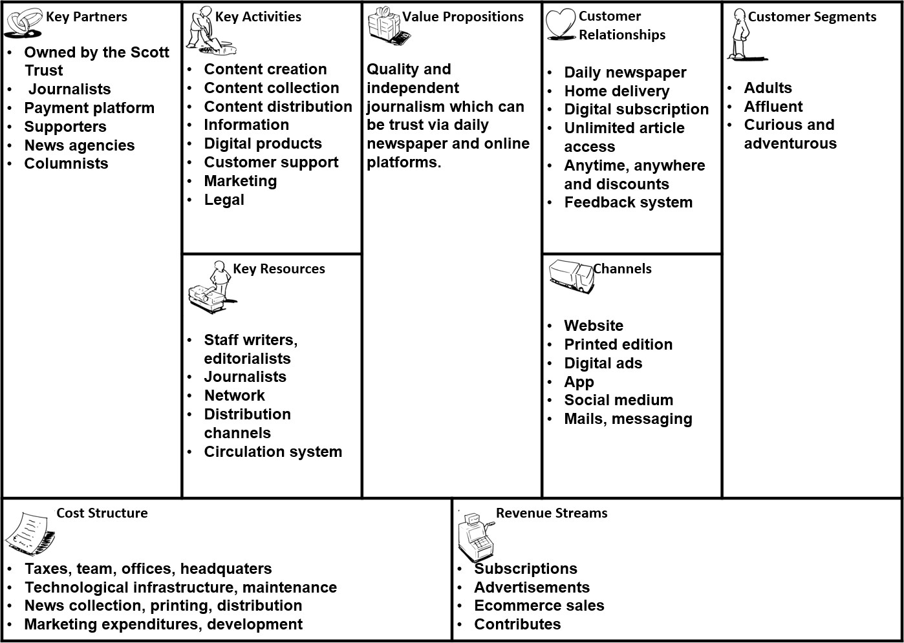
cost side. It's easy to find that the Guardian’s strategy is focusing on developing online market and cutting cost. The newspaper, which had been losing money under the impact of digital disruption and had long relied on cross-subsidies from profit-making companies of Guardian Media Group, has recently focused on its core news and media businesses and stripped off some non-core businesses, and has also reduced spending through tabloid switch. Meanwhile, The Guardian bets on its future through open access to its content without a pay wall and more international readers. Its revenue source is not entirely dependent on advertising. Besides subscriptions and donations, it can also create other revenue sources, such as e-commerce and events organising.
Figure 1 Business Model Canvas

V.R.I.O. Analysis of The Guardian:
Here is the Re-cap analysis of The Guardian to identify its resource and capability, and show their importance.

Figure 2 Re-cap Analysis
 | Resource | Capability
Threshold | - Human resource  - Infrastructure  - Experienced leadership  - Sufficient funding | - Manage online platform.  - Open access to all readers anytime and anywhere.  - Make honest and fair news.
Distinctive | - Brand reputation  - Worldwide operating scope  - Customer loyalty  - High quality journalism | - Balance reading experience with advertisement.  - Building unique culture and community.  - Top player and publisher in the UK media market

On the basis of defining the organization's resources and capabilities, as shown in Figure 3, this is the V.R.I.O. analysis, a resource-oriented analysis method to assess whether these factors can meet the key criteria to ensure competitive advantage.

Figure 3 V.R.I.O. Analysis
Re-cap | Value | Rare | Inimitable | Organization al support | Competitive implication
Brand reputation | Yes | Yes | Hard to imitate | Yes | Sustainable competitive  advantage
Human  resource | Yes | No | No | Yes | Competitive parity
Experienced  leadership | Yes | No | No | Yes | Competitive parity
Sufficient funding | Yes | Yes | No | Yes | Sustainable  competitive advantage
Customer loyalty | Yes | Yes | Costly to imitate | Yes | Medium term competitive  advantage
Infrastructure | Yes | No | No | Yes | Sustainable competitive  advantage
Worldwide  operating scope | Yes | Yes | No | Yes | Competitive parity

Value chain of The Guardian:
The value chain analysis of the Guardian links the activities of various departments and the value creation functions of the organization (Koh, 2007). Referring to Appendix 2 and Appendix 3, the value chain of traditional newspaper industry and the supply chain of electronic media are applied to the Guardian's value chain analysis, as shown in Figure 4. There are four supporting activities and five primary activities to increase value to promote income level:

management and operation,etc
Figure 4 Value Chain of the Guardian


- Subscription
- Internet broad •Open access for
readers
- Membership
print edition
pubish
- Content editing
- Online marketing •Print wholesale
- Content creation •Website and
Service
Outbound
Logistics
Marketing &
Sales
Operations
Inbound
Logistics

Supporting activities

Infrastructure--Computer, office, a series of facility support for
Human Resource Management--Deal with agencies, journalists,
Technology Development--Online website development and APP
Procurement--Pay for news and stories

Primary activities:

photographers and editors
Inbound logistics
    - Content creation in journalism needs background research and content suppliers including news agency, photographers and journalists. The Guardian's content creation is not much different from that of traditional newspapers. The difference lies in its richer formats and techniques. The online version allows more extensive use of tools, including embedded videos, pictures and even hyperlinks.
    - Today's Guardian is a global brand. The establishment of Guardian US and Guardian Australia provides readers with a broader experience,

unique perspectives and agenda setting reports.
Operation
    - The Guardian focuses on online growth, building deeper relationships with readers, reducing costs and developing new sources of revenue. It launched the "Membership" Subscription Scheme and distributed the paper version in tabloid form, actively absorbing more readers into members. With the trend of more and more advertising turning to digital platform, stable commercial advertising performance has been maintained.
Marketing & Sales
    - The organization has always insisted on digital-first, the website platform does not set up pay wall, through subscriptions, donations and advertisement to gain revenue. Instead of marketing, it adapts to the trend of digital media and people's new reading habits, and constantly manages brand identity to attract users and maintain the sustainable development of the Guardian.
Outbound Logistics
    - The digital version does not require outbound logistics and can reach the target users through the network and mobile phones. Paper edition is the same as traditional newspapers.
Service
    - The Guardian provides service (information) to consumers through print and digital media channels such as e-mail, social media, video streaming and mobile applications. Consumers participate in content, provide data and comments, feed back to the system and notify subsequent content creation and distribution.

Supporting activities:
Infrastructure--a series of facility support for management and operation, etc.
Human Resource Management
    - The Guardian has provided many opportunities to attract people from all backgrounds and has become a more inclusive and diverse organization.
Technology Development
    - The Guardian has created GMG Ventures in 2017, a fund dedicated to developing the next generation of media technology startups. Now, with more and more users -- an average of 10 million readers a month -- the company will continue to study how to utilize Guardian's assets, capabilities and networks to develop new products and generate revenue.

Procurement--Pay for news and stories.

S.W.O.T. Analysis:
From the above discussion, here is an insight of the Guardian using S.W.O.T. analysis, which can demonstrate the organization’s strength, weakness, opportunity and threat. as shown below:

Figure 5 S.W.O.T. Analysis
- Top player and strong brand
- Integrated news media
Strength •Growing digital presence
- Relatively small scale
Weakness
- Weak outlook for the UK newspaper market
- Positive outlook for digital advertising spending
- Strategic partnerships
Opportunity • Strong growth in the smartphones market
- Intense competitive market
- Decline in print advertising
Threat •High risk of substitution

Strength
The Guardian is one of the Top Players in journalism and publishing, and has a strong brand identity. According to the Publishers Audience Measurement Company in 2018, the Guardian's report is the most trusted in Britain. Moreover, the organization has good electronic transformation, perfect service and feedback mechanism, and has the ability to build a community.
Weakness
The Guardian belongs to a private holding company. In terms of financing, it is at a disadvantage compared with the public holding company and lacks financial flexibility. Private ownership limits the financing options available to companies. Furthermore, it leads to the lack of scale of the organisation compared with its competitors, which may affect its ability to maintain market pricing and competitive advantages.
Opportunity

Small and medium-sized enterprises and e-commerce enterprises continue to invest in digital advertising. The strong demand in emerging markets shows the strong potential of the market and brings new opportunities for the development of the Guardian. With smartphones replacing traditional personal computers, the company has already provided mobile application services for smartphones, which will enable them to drive strong growth in their customer base and enhance their high-end product market in the future. In addition, the Guardian has established various partnerships with other companies to strengthen its services.
Treats
In the information age, there are more ways to obtain information and endless new media platforms. Intense competition may weaken the pricing pressure of the Guardian, which has a negative impact on the company's revenue and market share. This has also led to a decline in revenue in the UK newspaper market, including print distribution, subscription and online subscription, which is expected to continue in the coming years.

Summary
In summary, The Guardian is a daily newspaper in the UK. In the turbulent and unpredictable media industry, it insists on Digitalization first and has established a free public network platform. Through membership subscriptions and voluntary donations, as well as advertising revenue, the organization survives in the market and is expected to achieve revenue and expenditure balance this year. Such a business model, coupled with spending cuts and innovation, has enabled the company to continue to grow.

Reference
Anon, 2015. MarketLine Company Profile: Guardian Media Group plc. Guardian Media Group plc MarketLine Company Profile, pp.1–24.

Anon, 2016. MarketLine Industry Profile: Digital Media in the United Kingdom. Digital Media Industry Profile: The United Kingdom, pp.1–38.

Anon, 2019. MarketLine Industry Profile: Newspapers in the United Kingdom. Newspapers Industry Profile: United Kingdom, p.N.PAG.

Hintz, Arne, 2016. Restricting digital sites of dissent: commercial social media and free expression. Critical Discourse Studies, 13(3), pp.325–341.

Koh, Chang E. (2007). A value chain perspective of internet practices, e-readiness and organizational performance. Industrial Management & Data Systems, 107(4), 519-537.

Hodgson, C. (2019). How can the Guardian's supply chain make newspapers more sustainable?. [online] the Guardian. Available at: https://www.theguardian.com/sustainability/blog/2014/may/28/guardian-supply-
chain-newpaper-sustainability.

Press Gazette. (2019). National newspaper + online ABCs: Web figures in double-digit drop as print circulation falls across the board - Press Gazette. [online] Available at: https://www.pressgazette.co.uk/national-newspaper-online-abcs-web-figures-in- double-digit-drop-as-print-circulation-falls-across-the-board/.

Sabbagh, D. (2019). Guardian and Observer to adopt 'digital-first' strategy. [online] the Guardian. Available at: https://www.theguardian.com/media/2011/jun/16/guardian- observer-digital-first-strategy?INTCMP=SRCH.

The Guardian. (2019). Working report. [online] Available at: https://www.theguardian.com/info/ng-interactive/2018/jul/24/working-report.

Waterson, J. (2019). Guardian Media Group digital revenues outstrip print for first time. [online] the Guardian. Available at: https://www.theguardian.com/media/2018/jul/24/guardian-media-group-digital- revenues-outstrip-print-for-first-time.

Appendix
Appendix 1 PESTEL analysis



Political
- Freedom of expression
  - No license required
- No government regulation

Economic
- Higher disposable income.
- People are not willing to pay for news..
Social
- People’s perception of news
has dramatically changed
  - Prefer to simply browse through the internet
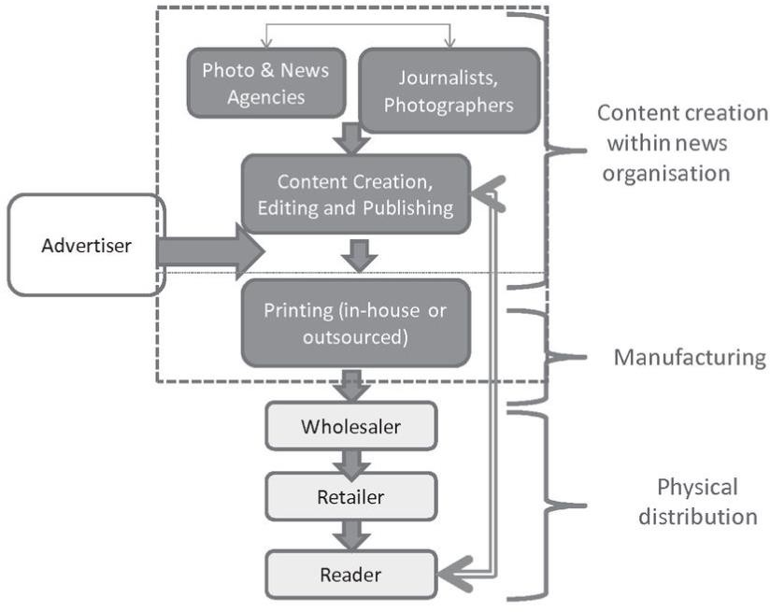

Technological
- The model of mass communication had changed
- The internet substitute print
- Various social medium, like twitter, blog, facebook.

Environmental
- .Resorce saving
- . Sustainable development

Legal
- Freedom of expression on sensitive issues
- Legitimacy of independent news reporting.
Appendix 2 Value chain of Traditional Newspaper

Source: OECD (2010), “The Value Chain and Economics of Traditional Newspaper Industry”, in News in the Internet Age: New Trends in News Publishing.

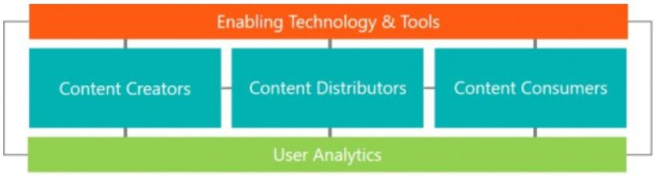
Appendix 3 Digital Media Supply Chain

Source: Camoinassociates.com. (2019). Trends in the Disruptive Digital Media Industry | Camoin Associates. [online] Available at: https://www.camoinassociates.com/trends-disruptive-digital-media-industry.

