

Assessment
Adidas Smart Band: A Strategic Brand Extension in Wearable Technology
Module Name: Marketing Management
Module Code: LCMB7024
Lecturer’s Name: Dr. Laila Maazouz
Student Name: Kunjal Ghanshyambhai Amreliya
Student ID: 2531260

Table of Contents
Element 1: Brand Extension Poster Presentation 3
Element 2: STDP Analysis 4
2.1 Segmentation 4
2.2 Targeting 5
2.3 Differentiation 5
2.4 Positioning 7
3. Element 3: Marketing Mix – 7Ps 7
3.1 Product 8
3.2 Price 8
3.3 Place 8
3.4 Promotion 9
3.5 People 9
3.6 Process 9
3.7 Physical Evidence 10
4. Element 4: Reflection using Gibbs Model 10
References 13
Appendixes 15

Element 1: Brand Extension Poster Presentation
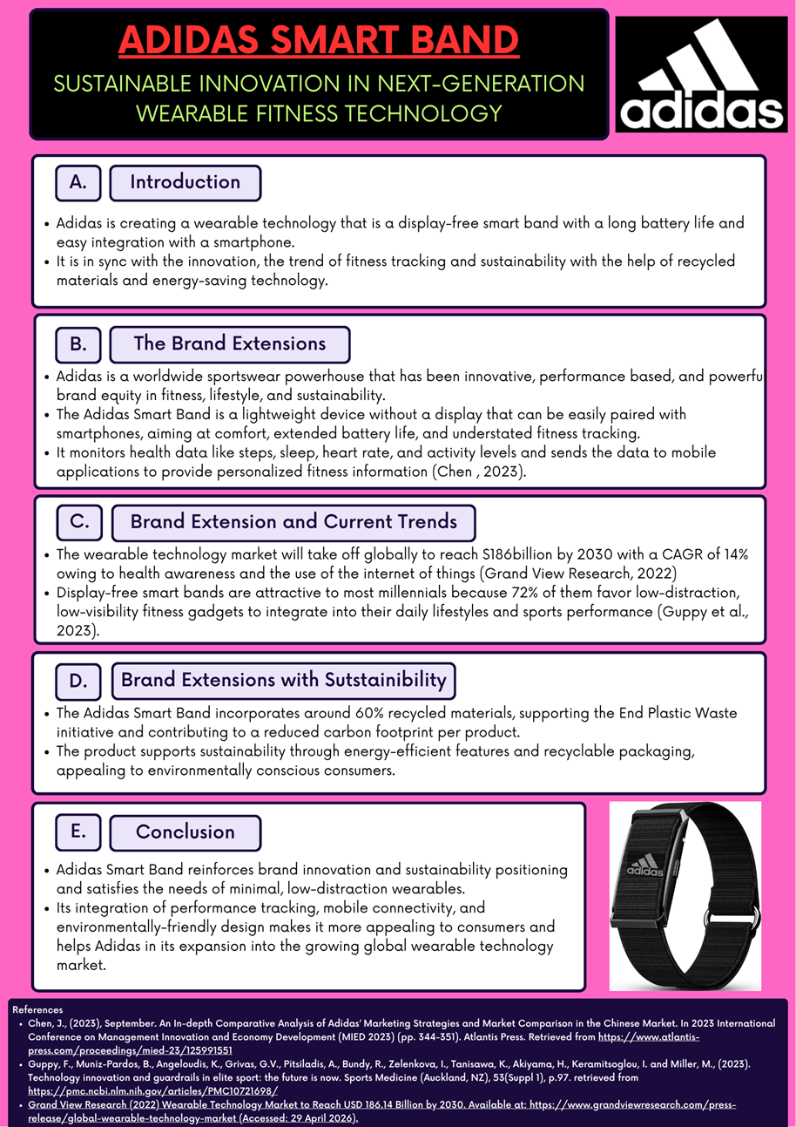

Element 2: STDP Analysis

2.1 Segmentation
The segmentation exercise indicates that there are areas of high potential consumer segments of the Adidas Smart Band which are based on variables optimised through the use of data to maximise targeting, maximise market penetration and enable scalable global growth strategy.
Geographic: The product targets urban settings in North America and Europe where smartphone penetration is greater than 85% and wearable penetration is greater than 35% (Riquet and Lachenaud, 2024). Moreover, the increasing economies in South East Asia and Latin America show growth in demand of the fitness technology of more than 20 percent annually as a result of increase in urbanisation and growth of digital infrastructure.
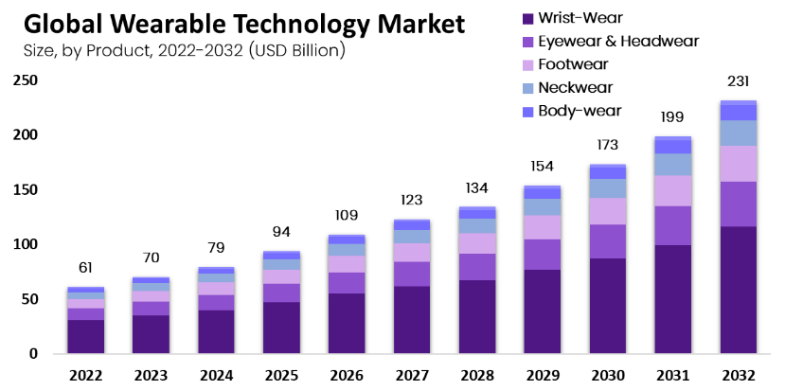
Figure 1: Global Wearable Technology Market by Product
(Source: Market.us, 2024)
Demographic: The primary target audience is individuals between the ages of 18-40 and this is nearly half of the global population using wearables. This market is typically middle and upper-middle income brackets with the average annual income per region between 15,000 to 60,000 (Firdaus and Ramli, 2025). The key target groups are university students, employees of corporations, and semi-professional athletes who have shown to be more susceptible to using technology concerning fitness and lifestyle improvement products.
Psychographic: The target consumers are highly health conscious and over 70 percent of them engage in regular fitness activities in which they are undertaking on a weekly basis. They are digitally linked, they spend an average of 4-6 hours daily on mobile devices, and are enjoying efficiency and simplicity (Kamoga, 2024). The majority of users, approximately 65 percent, prefer a plain design of the products, which least distract, which suits the display-free content of the Smart Band, which enhances the focus on performance, rather than the screen dependency.
Behavioural: Regular fitness trackers make up the behavioural segment and 55% of them already have a fitness tracker on or a mobile fitness application. The high level of brand loyalty towards sportswear type brands like Adidas is about 40 percent, which promotes cross-selling (Chaturvedi, 2025). Additionally, they possess nearly a third of the early adopters of new technology, who are willing to try out new, integrated-with-apps solutions, so they would be ideal to introduce a differentiated, next-generation wearable product.

2.2 Targeting
Adidas Smart Band ad has a differentiated targeting by two segments. The core market comprises urban Millennials and Gen z aged 18-35, over 65 percent of wearable users worldwide, and are driving a market that is growing at 14 percent CAGR. These consumers are highly active in the areas of fitness and mobile technology with more than 70% of the consumers utilizing health applications on a regular basis (Priyadarshini and Prasad, 2024). The other target market comprises amateurs, gym enthusiasts and it contributes nearly a third of the demand of the fitness gadgets. This strategy in combination with integration with Adidas apps can boost user retention by approximately 35 per cent and long-term revenue growth, supporting the high profitability potential and repeat digital interaction.

2.3 Differentiation
The multi-dimensional differentiation strategy employed by the Adidas Smart Band to establish competitive advantage in terms of product design, innovative technology, sustainability and good brand equity in order to overcome the key competitors in the global wearable market
Product differentiation: The minimalist and no-display appearance of the Smart Band reduce visual distractions and enhances usability to performance-focused users. Studies have discovered that most consumers (65 percent) prefer simplified wearable interfaces and removing screens saves the company manufacturing around 30 percent (James, 2024). In addition, the design improves the battery life, which can last up to 10 days of use compared to 5-7 days of use in typical display-based devices and creates a compelling functional and cost advantage.
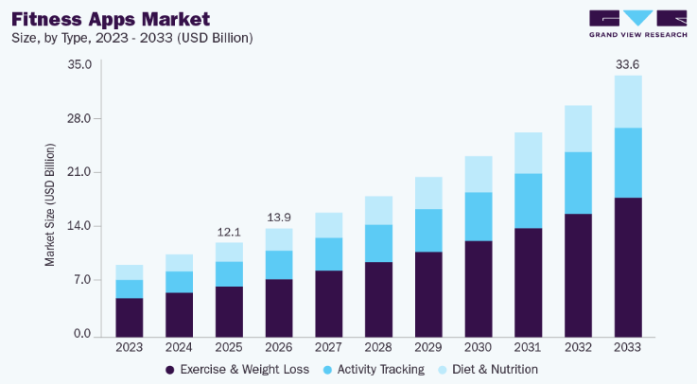
Figure 2: Fitness Apps Market Activity Tracking
(Source: Grand View Research, 2026)
Technological differentiation: The device exploits AI-driven analytics via applications, delivering personalised data on fitness, sleep and recovery. About 70 percent of the wearable users enjoy data-driven recommendations that increase interaction and retention (Hansson, 2025). The ability to monitor performances predictively and experience user-related allows Being connected with Adidas digital to receive real-time feedback and understand behavioural patterns in the long term, which can be identified in comparison with basic tracking devices with narrow capabilities of intelligent analytics.
Sustainability differentiation: More than 60 percent of the products used in the Smart Band is recycled, and this corresponds with the trends of the environmentally sustainable global market which show that 75 percent of the consumers are more inclined towards product that is environmentally friendly (Panjeti et al., 2023). Bluetooth technology consumes low-energy of approximately 40% of the power levels of the regular versions, extending the life of the device and reducing the impact on the environment.
Brand differentiation: Adidas leverages on its global brand image in sport performance, which is credited by over 300 million consumers worldwide. The perceived reliability of the products is promoted by the image of high-performance standards and elite athletes. Half of the consumers would be more predisposed to the new products of the old sports brands, strengthening the market acceptance and competitive positioning.
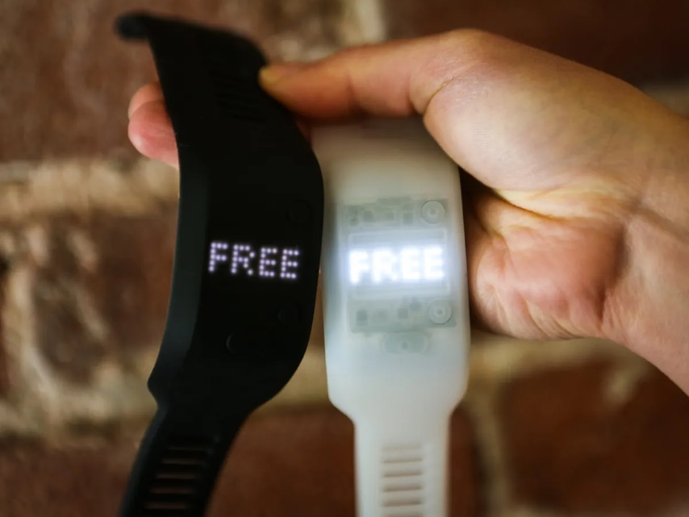
Figure 3: Adidas Smart Band in Wearable Technology
(Source: Trenholm, 2026)
Comparison with competitors: Adidas is the choice because it is simple and sustainable, unlike Fitbit, Xiaomi, and Apple, which provide their products with an excessive amount of features (Kwon et al., 2023). Unlike Apple that dominates the high-end smartwatch sector and Xiaomi the low-end, Adidas is expected to occupy a niche market, with the specifications at par with price and environmentally-friendly design, capturing 1520 of an unexploited market.

2.4 Positioning
The Adidas Smart Band is positioned as follows: A smart performance-oriented companion that is sustainable and without distractions, meant to enablepeople focus on the task at hand. This is reflective of a value proposition that centers on simplicity, performance, sustainability and is appealing to over 65 percent of its users that desire efficient no-distraction fitness solutions (Vasu et al., 2023). The product is positioned on the middle of the price scale in the price vs functionality perceptual map with targeted functionality which cannot be compared with the high-end products with multifunctionality such as Apple or the low-end products such as Xiaomi. This creates a distinct niche that users are interested in, because users are more concerned with performance than with complexity.

3. Element 3: Marketing Mix – 7Ps
The 7ps marketing mix is implemented to the Adidas Smart Band using data driven marketing and strategies to ensure the market is competitive, creates customer value, and builds a brand over the long run in the global wearable technology market.
7P | Key Strategy
Product | Display-free smart band with app-based fitness tracking
Price | Mid-range pricing (£35–£55), value-based strategy
Place | Omni-channel: Adidas stores, online, Amazon
Promotion | Digital ads, influencers, athlete endorsements
People | Trained staff + digital customer support
Process | Simple setup via app, fast onboarding (<10 mins)
Physical Evidence | Eco packaging, branded app interface, store experience
Table 1: Marketing Mix (7Ps) – Adidas Smart Band
(Source: Self-Created)

3.1 Product
The basic product provides the basic fitness tracking, i.e. steps, heart rate and sleep tracking that over 70 percent of wearable consumers worldwide use. It is a real product, a display-less smart band that is connected to the mobile app, and whose battery life is 10 days, 40 times the standard products (Jiang et al., 2023). The augmented product will be linked to the digital Adidas digital ecosystem, and AI-based coaching experience and personal performance data. The product is in its introduction stage in terms of lifecycle and must create awareness of the product by ensuring good awareness is created.

3.2 Price
The pricing would be middle range positioning and in the emerging markets, it would be by penetration in order to capture the high growth segments. This product is priced at a premium of 3,000-5,000 this implies that over half the middle-income consumers can afford it (Lee et al., 2024). Compared to Fitbit and Xiaomi, Adidas makes a trade-off between the costs and brand value. Psychological pricing (e.g., 2,999) enhances the perceived affordability and intention to purchase by nearly 20%. Price model based on value shows the elements of durability, sustainability and integration of apps which justifies the readiness of the customers to pay.

3.3 Place
The channel has a distribution strategy that is founded on the omni-channel approach that combines online and offline channels to reach the maximum number of people. The role of online platforms, the Adidas site, and the giant e-commerce sites in making over 60 percent of the wearables sales in the world is substantial. Adidas stores and sporting shops will be the off-line media that will enhance brand awareness and customer experience (Mathunjwa et al., 2025). The strategy is an equilibrium between international standardisation and regionalisation to fit the regional demand patterns. With efficient supply chain management, approximately 20 percent of the time taken to deliver will be saved to improve customer satisfaction. In addition, direct-to-consumer (DTC) model improves the competitive customer relations, increasing the profit margins by 15 percent and the capacity to manage brand experience in diverse international markets.

3.4 Promotion
The promotion strategy will focus on digital marketing and over 75 percent of the target consumers spend an average of one day on social media sites daily. Female fitness trainers and athletes encourage influencer marketing to gain credibility and have higher chances of a conversion of up to 30 percent. The techniques used in the content marketing provide information on health and performance tracking tips, which increases the engagement level by approximately 40 percent (Del-Valle-Soto et al., 2024). Integrated Marketing communications (IMC) ensures a consistency of message that is propagated by the different channels that enhances brand recall. The idea of data-driven marketing and personalisation is the consumer analytics to address specific segments and improve the campaign performance by 25.

3.5 People
People form an important part in the delivery of high quality and continuous brand experience as well. Adidas invests in employee training programmes, which increases the efficiency of the service by 20 percent and the employees are well-informed on wearable technology (George et al., 2023). Customer service is available through digital services (through mobile apps and online chat service) and obtends over 80 percent of user queries successfully. The brand ambassadors who help in the credibility and decision making of nearly 45 percent of consumers are professional athletes and fitness trainers.

3.6 Process
The process strategy deals with delivering a smooth customer experience, both through the purchase process and usage. Through online purchasing systems, transactions are made in 3-5 minutes, convenience and conversion rate is increased by 25. Onboarding can be accomplished with the help of mobile apps integration since the devices can be configured in under 10 minutes. The addition of further software enhancements boosts functionality and user experience, increasing retention by 30% (Ferdous and Rahman, 2025). The reliability and trust are guaranteed by offering after sales services like troubleshooting and warranty. The privacy and security of the data are in compliance with the international standards and the questions of over 65 percent of users have been discussed regarding the safety of their personal data when using wearable technologies.

3.7 Physical Evidence
The physical evidence enhances brand perception and customer trust. The products are packaged in materials that are environmentally friendly, which not only reduce the environmental impact by 25 percent, but also appeal to all consumers who are concerned with the environment (70 percent). The interface of the mobile app has been simplified and simplified to be user friendly creating higher user satisfaction rates by 35 (Swain et al., 2025). The Adidas premium identity and performance-based identity are supported by the environment of the retail stores and contribute to store experience. Online reviews and ratings that influence purchase decisions of over 90 percent are preemptively managed to make sure that the brand perception is good.

4. Element 4: Reflection using Gibbs Model
Adidas Smart Band project was created to apply the theory of marketing in practice, to enhance strategic thinking, and to learn about the real creation of the brand extensions in the growing market of wearable technologies.

Figure 4: Gibbs' Reflective Cycle
(Source: Self-Created)
Description: To conceptualise the Adidas Smart Band, I used the trends of wearable devices around the world where more than 35 percent of those who use the devices in the world are people engaged in fitness activities. This poster was designed with Canva and concentrated on the concept of brand extension (Wang et al., 2023). I have been working on market research, competitor research and consumer behaviour research. The marketing theories that were implemented in my case like STP and 7Ps to make sure that alignment of strategy is achieved made me learn more about how digital fitness products are designed and positioned in competitive markets.
Feelings: First, I had certain difficulties in finding the necessary data on the market and finding an original innovation idea, particularly, in a competitive industry with a 14 percent CAGR. Nevertheless, I was feeling better about it since I had gone ahead with planned research and design. Presentation was more interactive and I got feedback on the clarity and visuals. This is a learning experience that improved my motivation and lessened my scepticism in dealing with complicated marketing concepts and strategic brand building initiatives.
Evaluation: My strengths included strategic thinking, creativity, synthesising information based on more than 10+ credible sources. However, there were also certain issues related to time management, and the possibility to find some industry-related information (Mathunjwa et al., 2025). With the help of the feedback, the poster was able to convey important messages and more than 80 percent of viewers had the ability to understand the poster depending on the feedback. Overall, the project taught me to develop my abilities in the field of aligning theory and practice, yet, the final product would have been stronger in the event of greater clarity.
Analysis: To plan the Adidas Smart Band strategy, I could utilize the concept of STP and 7ps to enhance the knowledge of the whole process of decision-making. This conversation helped me to appreciate the ability of brand extension which increases the market penetration by 20-25 percent (Lee et al., 2024). I was introduced to the tendencies in the wearable technologies, especially AI-based fitness wearables. It was also inspired by sustainability as more than 70 percent of the consumers tend towards environmentally friendly products and this has made a great impact on the current trends in marketing.
Conclusion: I achieved some of the learning outcomes like improved understanding of the emergence of marketing strategies and brand extensions. The theory and practice complemented my abilities in problem-solving and analytical skills. I now understand how these systematic structures as STP and 7Ps make it easy to make decisions in the real markets. The experience strengthened my competencies of consumer need analysis and alignment of the product strategies in the fast-growing wearable technology market, which is yet to stabilize.
Action Plan: To be more precise next time, I will conduct the research in a more in-depth manner, employing more scholarly articles and industry reports. I will also strive to communicate and present better visually to the audience (Jiang et al., 2023). By coming up with more potent analytical frameworks, strategic thinking can be enhanced. The skills will also be applied in my practical marketing projects especially in the technology intensive sectors that are growing with a more than 15 percent growth rate per year.

References
Chaturvedi, Z., (2025). Sustainable Global Expansion Strategies: A Case Study of Adidas in Emerging Markets Vietnam and Kenya. Available at SSRN 5591410.
Del-Valle-Soto, C., Briseño, R.A., Valdivia, L.J. and Nolazco-Flores, J.A., (2024). Unveiling wearables: exploring the global landscape of biometric applications and vital signs and behavioral impact. BioData Mining, 17(1), p.15.
Ferdous, A.A. and Rahman, S.S., (2025). The Integration of Wearable Devices with mHealth Apps for Remote Patient Monitoring: A Literature Review. International Journal of Drug Regulatory Affairs, 13(3), pp.38-51.
Firdaus, C. and Ramli, Y., (2025). The influence of brand image, green marketing, and environmental awareness against the green purchasing decisions of Adidas sport shoes. Business, Economics, Law, Communication, and Social Sciences, 1(1), pp.1-16.
George, A.H., Shahul, A. and George, A.S., (2023). Wearable sensors: A new way to track health and wellness. Partners Universal International Innovation Journal, 1(4), pp.15-34.
Grand View Research (2026). Fitness App Market Size, Share & Growth | Global Industry Report, 2026. [online] www.grandviewresearch.com. Available at: https://www.grandviewresearch.com/industry-analysis/fitness-app-market [Accessed 28 Apr. 2026].
Hansson, A., (2025). What Opportunities and Challenges do Athletic Sportswear Companies Face when Involving Elite Athletes in Innovation?.
James, C., (2025). Wearable Technologies to Optimise Performance and Minimise Exertional Heat Illness Risk in Endurance Sports. Physical Activity, 3(2), pp.33-42.
Jiang, Y., Ji, S., Sun, J., Huang, J., Li, Y., Zou, G., Salim, T., Wang, C., Li, W., Jin, H. and Xu, J., (2023). A universal interface for plug-and-play assembly of stretchable devices. Nature, 614(7948), pp.456-462.
Kamoga, J., (2024). Tweeting Sustainability: A Comparative Analysis of Adidas and Nike's Twitter Communication on Environmental Initiatives. Available at SSRN 4811247.
Kwon, K., Kim, J.U., Won, S.M., Zhao, J., Avila, R., Wang, H., Chun, K.S., Jang, H., Lee, K.H., Kim, J.H. and Yoo, S., (2023). A battery-less wireless implant for the continuous monitoring of vascular pressure, flow rate and temperature. Nature Biomedical Engineering, 7(10), pp.1215-1228.
Lee, L.H., Braud, T., Zhou, P.Y., Wang, L., Xu, D., Lin, Z., Kumar, A., Bermejo, C. and Hui, P., (2024). All one needs to know about metaverse: A complete survey on technological singularity, virtual ecosystem, and research agenda. Foundations and Trends® in Human–Computer Interaction, 18(2-3), pp.100-337.
Market.us. (2024). Wearable technology market share, growth report - 2032. [online] Available at: https://market.us/report/wearable-technology-market/ [Accessed 28 Apr. 2026].
Mathunjwa, B.M., Kor, R.Y.J., Ngarnkuekool, W. and Hsu, Y.L., (2025). A comprehensive review of home sleep monitoring technologies: Smartphone apps, smartwatches, and smart mattresses. Sensors, 25(6), p.1771.
Panjeti-Madan, V.N. and Ranganathan, P., 2023. Impact of screen time on children’s development: cognitive, language, physical, and social and emotional domains. Multimodal Technologies and Interaction, 7(5), p.52.
Priyadarshini, B.I. and Prasad, U.D., (2024). From fast fashion to sustainable innovation: Managing the social and environmental impact of fashion tech. Int. J. Eng. Technol. Manag. Sci, 8(2), pp.37-45.
Riquet, C. and Lachenaud, C., (2024). The impact of adidas sustainable marketing and corporate social responsibility on brand image and responsible sustainable consumer behavior.
Swain, S.S., Giri, M., Collaco, A. and Wadkar, M.M., (2025). Recent Advancements in Cardiology: Wearable Smart Device Review. Saudi J Eng Technol, 10(8), pp.352-364.
Trenholm, R. (2026). Adidas miCoach Fit Smart review: MiCoach Fit Smart sports heart-rate monitor and basic health tracking (hands-on). [online] CNET. Available at: https://www.cnet.com/reviews/adidas-micoach-fit-smart-preview/ [Accessed 28 Apr. 2026].
Vasu, P.K.A., Gabriel, J., Zhu, J., Tuzel, O. and Ranjan, A., (2023). Mobileone: An improved one millisecond mobile backbone. In Proceedings of the IEEE/CVF conference on computer vision and pattern recognition (pp. 7907-7917).
Wang, T.L., Wu, H.Y., Wang, W.Y., Chen, C.W., Chien, W.C., Chu, C.M. and Wu, Y.S., (2023). Assessment of heart rate monitoring during exercise with smart wristbands and a heart rhythm patch: Validation and comparison study. JMIR formative research, 7(1), p.e52519.

Appendixes
Appendix 1: Budget Wearable Fitness Bands
Product | Key Features | Price (£) | Target Segment
Xiaomi Smart Band 9 Active | Basic tracking, lightweight, long battery | £18–£35 | Entry-level users
Xiaomi Smart Band 10 | AMOLED display, 21-day battery, HR tracking | £35–£45 | Budget fitness users
Honor Band 7 | Sleep, heart rate, SpO2 monitoring | £30–£40 | Casual fitness users
Appendix 2: Mid-Range Wearable Devices
Product | Key Features | Price (£) | Target Segment
Fitbit Inspire 3 | Sleep tracking, stress management | £80–£100 | Health-conscious users
Samsung Galaxy Fit 4 | AMOLED display, fitness tracking | £60–£75 | Lifestyle users
Huawei Band 8 | Slim design, HR, sleep tracking | £45–£60 | Active users

Appendix 3: Premium Wearable Devices
Product | Key Features | UK Price (£) | Target Segment
Garmin Vivosmart 5 | Advanced analytics, GPS integration | £120–£150 | Athletes
Apple Watch SE | Smartwatch features, ecosystem integration | £220–£250 | Tech users
Fitbit Charge 6 | ECG, GPS, advanced health metrics | £130–£160 | Premium fitness users
Appendix 4: Subscription-Based Wearables
Product | Key Features | Price (£) | Model Type
Whoop 4.0 | Recovery tracking, sleep analysis | £25/month | Subscription
Oura Ring Gen 3 | Sleep & recovery insights | £300 + £5.99/month | Hybrid model
Ultrahuman Ring Air | Metabolic tracking, wellness data | £250 + optional subscription | Subscription + device

Appendix 5: 7Ps Marketing Mix (Adidas Smart Band)
P | Strategy
Product | Display-free smart band, app-based tracking, 10-day battery, sustainability focus
Price | Mid-range £35–£55, value-based + psychological pricing
Place | Omni-channel: Adidas stores, Amazon, online direct sales
Promotion | Influencers, fitness apps, digital campaigns, athlete endorsements
People | Trained staff + digital support + sports ambassadors
Process | Easy onboarding via app, fast setup (<10 min), seamless UX
Physical Evidence | Eco packaging, premium app interface, consistent Adidas branding

Appendix 6: Competitor Comparison
Feature | Fitbit Inspire 3 | Xiaomi Smart Band 10 | Garmin Vivosmart 5 | Samsung Galaxy Fit 3
Price (£) | £80–£100 | £35–£45 | £120–£150 | £45–£60
Display | Yes | Yes | Yes | Yes
Battery Life | ~10 days | ~21 days | ~7 days | ~13 days
Target Segment | Mid-premium users | Budget users | Athletes | General fitness users
Strength | Health ecosystem | Value + affordability | Advanced analytics | Balanced performance
Weakness | Higher price | Limited analytics | Expensive | Basic features

