https://www.theguardian.com/food/2021/may/07/drink-brands-that-wont-cost-the-earth-sustainable-beer-wine
(Accessed 08-05-21)

Drink brands that won’t cost the earth
Many brands claim to be ethical these days, but how to tell which ones are really up to scratch? Here are some tipples that are worthy inside and out
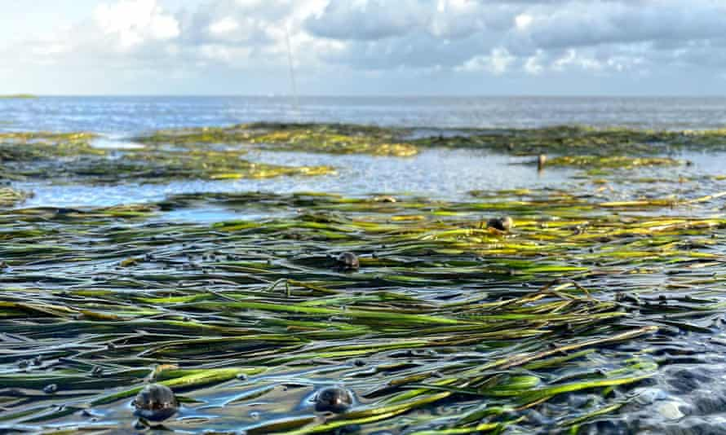
Dutch beer firm Lowlander adds a plant to its seagrass meadow (above) for every can it sells . Photograph: Lowlander

Fiona Beckett
@winematcher
Fri 7 May 2021 14.00 BST
Barely a day goes by without a press release hitting my inbox with news of a drink whose makers are claiming to be doing their bit to save the planet – or what are known in the business world as “brands with purpose”.
You won’t be surprised to learn that much of this is driven more by enlightened self-interest than by a sudden wave of altruism. Research has shown that consumers, particularly younger ones, want to know whether the companies they buy from are sustainable, and that as many as two-thirds of them support carbon labelling. As a result, an increasing number of companies are becoming B Corp-certified, which requires them, among other obligations, to consider the impact of their activities on the environment.

That said, it’s sometimes hard to evaluate just how significant that contribution is. The Dutch beer brand Lowlander, for example, says it adds a plant to a seagrass meadow for every can it sells (seagrass apparently captures carbon 35 times faster than a tropical rainforest), but how many plants would make a real difference? And in what way, exactly, does the team behind The Hidden Sea “remove the equivalent of 10 plastic bottles from the world’s oceans”? (Presumably by supporting Resea, by whom they are certified, though at a quick glance it’s not entirely clear.) Basically, you have to trust the integrity and transparency of the people involved, many of whom are new entrants to the market and share similar ethical values to their customers.

An increasing number of brands, such as Avallen, are also committing to the 1% For the Planet campaign. But is 1% enough? For instance, the Lost Explorer mezcal range, which partners with Voice for Nature, includes bottles that cost up to £140, a price point at which you feel they could perhaps afford to contribute rather more. One Gin, for example, which raises money to support charities that provide clean water, donates a more generous 10%. So, as with so much, you need to read the small print – or the QR code, if the product has one.

In general, beer, spirits and alcohol-free drinks seem to have adapted more quickly to the environmental zeitgeist than wine brands have (maybe because their target audience is younger), but the game changer for wine could be paper packaging, which is much lighter to transport than glass, recyclable and more appealing (to me, at any rate) than bag-in-box. However good the cause, though, at the end of the day, the liquid needs to taste good – and, to my mind, this week’s picks really do.

Five drinks with a mission

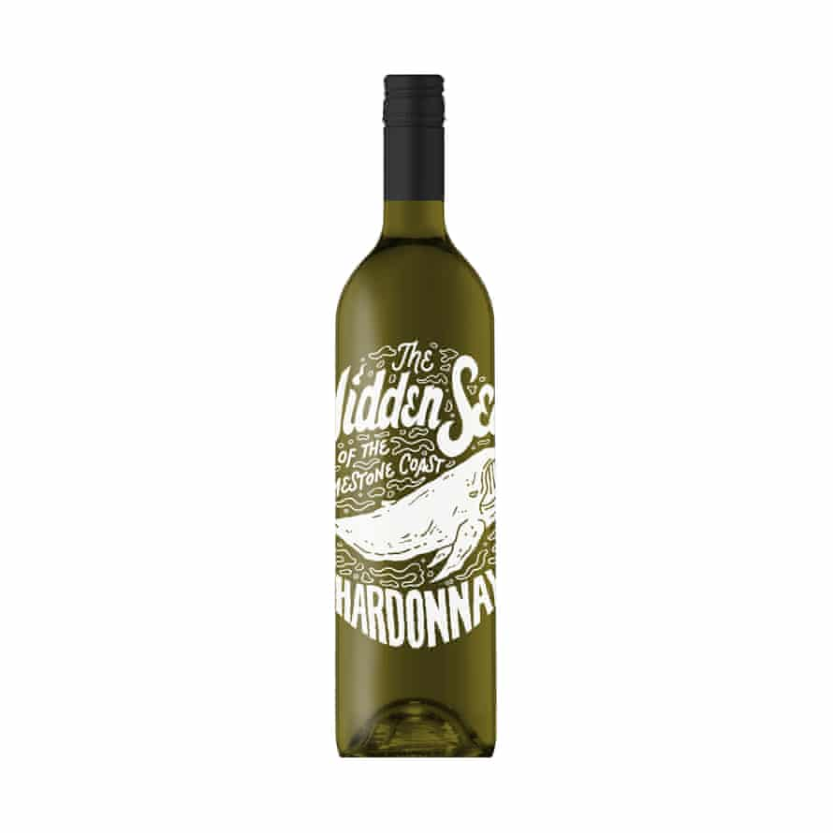
57. Hidden sea chard Photograph: Hidden Sea
The Hidden Sea Chardonnay 2020
£8 Co-op, 13.5%. A fresh, citrussy Australian chardonnay from a winery that promises to remove the equivalent of 10 plastic bottles from the sea for every bottle sold.

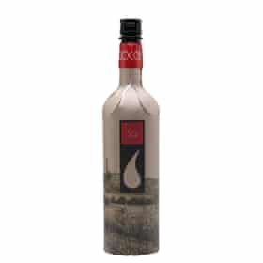
Cantina Goccia 3Q Red Blend 2017
£12.45 The Whisky Exchange, £12.50 WoodWinters, 13.5%. Could this be the future of wine bottles? A refreshing, quaffable, pizza-friendly blend of sangiovese, merlot and cabernet sauvignon in a recyclable paperboard bottle.
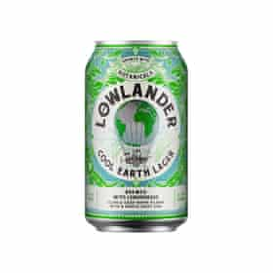

Lowlander Cool Earth Lager
£2 (330ml) Sainsbury’s, 4%. Pleasant, light, citrussy pils from a Dutch company that brews with botanicals (in this case, lemongrass) and plants seagrass in return.

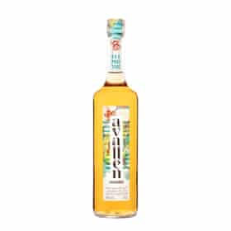
Avallen Calvados
£31.99 Virgin Wines, £33.70 Master of Malt, £35 mygreenpod.com, 40%. Deliciously fresh, young style of calvados that’s as good on the rocks as it is long with tonic from a “planet-positive” spirits company. Would be great with a good mature cheddar.

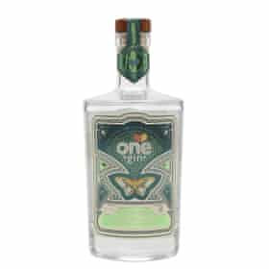
One Gin sage and apple gin
£35.05 Master of Malt, £35.95 The Whisky Exchange, 43%. Another attractive, apple-flavoured spirit, nicely balanced with the bitterness of sage. Ten percent of One Gin’s profits fund clean water projects. The 5.5% canned version with tonic (£14 for 6 x 250ml cans from socialsupermarket.org), while obviously not as ‘“ginny”, is pretty impressive, too.

