Student name: | Nicoleta Busu | Student ID number: 2025237
Programme: | BA (Hons) Leadership and Management Skills in the Workplace
Module: | Project Management
Module code: | LCLM5003
Module Leaders: | Rexon Nting, Doreen Nyaa Amundam
Assignment Title: | RECONSTRUCTION OFLOCALINFRASTRUCTURESTHAT HAVE BEENDAMAGED DUE TOUNUSUAL ATLANTICWEATHER SYSTEMFLOODING | Word count or equivalent.

Executive Summary
The scope has examined the required focus to recover the infrastructure and utilise relevant resources for flood management in the West Midlands. Internal and external stakeholders’ involvement has been required for ensuring proper allocation of resources, regulatory compliance, and the strategic consideration of potential risks to impact the ultimate success and project efficiency. The report has mentioned the key project deliverables such as totally operational local-public infrastructure, compliance with health and safety measures and appropriate stakeholder engagement. Risk assessment evaluates potential challenges, which may be optimised during the reconstruction practice, such as budget overruns, stakeholder resistance, and further climate change. Completion of the proposed project has been focused on addressing these deliverables that can help in fulfilling the project’s aim. Thus, relevant strategic considerations have been provided for the management of potential risks.

Table of Contents
Part A: Poster 7
Part B: Reflections from the feedback received from tutor and peers 8
Introduction 8
What? 9
So What? 9
Now what? 10
Conclusion 11
Part C: Report 11
1. Introduction 11
Purpose 11
Scope 11
Overview of the Plan 11
2. Project Description 12
Background 12
Deliverables 13
3. Scope 13
4. Work Breakdown Structure (WBS) 14
5. Quad Chart 16
6. Gantt Chart 17
7. Stakeholders' Involvement 18
8. Allocation of Resources 20
9. Risk Analysis 22
10. Conclusion 24
References 25

List of Figures
Figure 1: Driscoll Model of Reflection 5
Figure 1: WBS of Project Management System 11
Figure 2: Quad Chart 12
Figure 3: Gantt Chart 14
Figure 4: Internal and External stakeholders 15
Figure 5: Principles of stakeholder theory 20

List of Tables
Table 1: Action plan in response to “Now what”? 8
Table 1: Allocation of Resources 18
Table 2: Risk Matrix 20

Part A: Poster

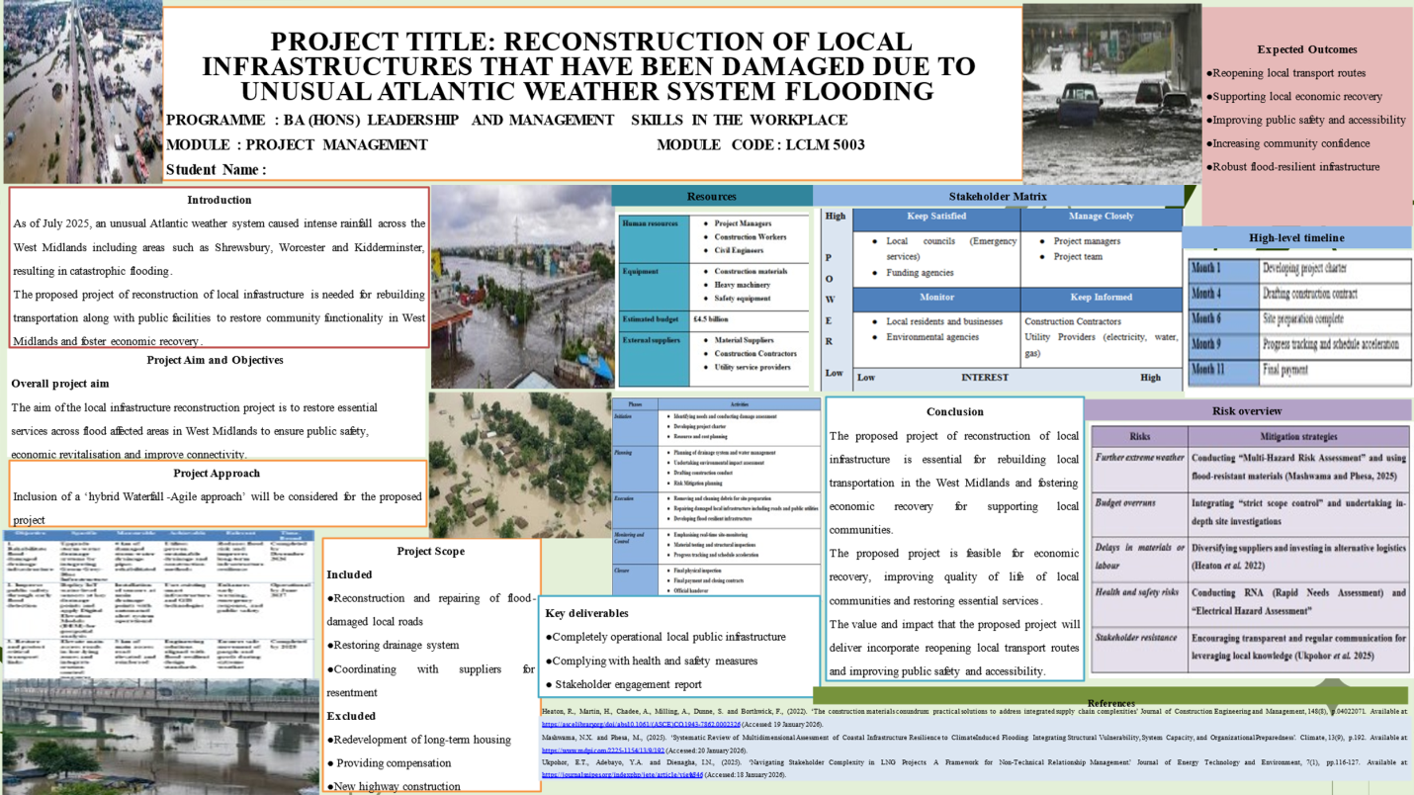

Part B: Reflections from the feedback received from tutor and peers

Introduction
Feedback concerning my academic poster also helped me to learn crucial information regarding visual presentation in terms of the impact of illustrated information on the communicative process. The following analysis utilises the Driscoll Model of reflection, which comprises three steps such as What?, So What? and Now What?. Based on the feedback, I have been able to understand the aspects of Time management, Quality and cost. Project management consists of time management, quality and cost which are commonly known as the project management triangle. Time management can be described as the proper planning, scheduling and controlling of the activities of the project to ensure that the activities are accomplished within the stipulated time (Khatib and Alzoubi, 2022). Quality is the extent to which the project results are as per the required standards, the expectations of the stakeholders, and the planned goals. Cost is described as financial resources that are needed to accomplish project activities such as budgeting, estimation and control of costs. These three factors are critical, I suppose, to be balanced since the alterations in a specific aspect can have direct impacts on the others and eventually on the overall success of the project.
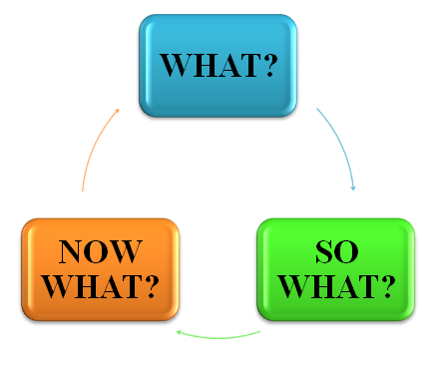

Figure 1: Driscoll Model of Reflection
(Source: Self-developed)

What?
The commentary I got on my poster by my tutor and classmates focused on the visual attractiveness of my poster as opposed to its content. I was recommended to change the landscape to a vertical orientation, as well as to have a darker shade of blue or a different colour to enhance the colour contrast and hierarchy. Bentsen and Østergaard (2025) denoted that poster format and aesthetic elements have a great impact on visual impression, and modern layout achieved higher scores on organisation. Alongside, initial impression compared to traditional design is more important which was analysed in an academic conference in which 103 posters were tested concerning visual impact. Visual communication scored more on posters with succinct textual material, coherent illustrations, and chronological arrangement. Moreover, the balanced posters do not overload the audience and help to understand the information quickly. Based on this feedback, it was clear that my design decisions can be improved in such a way that the audience can better understand major points in a shorter period of time.

So What?
This feedback is important as visual impression is very important in the engagement of the audience. According to Bentsen and Østergaard (2025), posters with modern or properly arranged visual layouts have high chances of drawing attention and easy comprehension compared to ones which depend largely on high density of text or poor contrast. The first-person experience taught me that even good academic material cannot get the intended message across in the absence of the visual design to direct the eye or highlight the most critical points in first person. This refuted my belief that content alone is what makes a difference. It has taught me that good academic communication balances the transparency of ideas with the transparency of the visual presentation to allow the audiences to interact quickly and productively with my research.

Now what?
Goals | Actions | Timeline | Outcomes or measures
To improve poster orientation skill for better visualisation | Redesign a poster in the suggested vertical format  Maintaining colour adjustment by replacing intense blue with shifter shade | Within 2 months | Alignment between my approaches and teachers’ expectations
To adopt design testing competency | Sharing the updated versions with peers and professionals to get feedbacks  Aligning the changes with clarity and proactive engagement | Within 4 months | Self-resilience regarding presentation capability
To apply my learning on visual poster presentation | Focusing on improved and mindful presentation orientation  Mastering in colour psychology for the presentations | Within 6 months | Reduction in the need of excessive revisions and securing professional dynamics
To ensure continuous improvement | Documenting the changes with appropriate rationale  Viable poster design by integrating lessons with the project | Within 8 months | Maintaining consistency in the tasks

Table 1: Action plan in response to “Now what”?
(Source: Self-assessed)

Conclusion
This reflection can strengthen the overall professional capability in terms of developing and submitting poster presentations with visual attractiveness. Reflection on my competency, skills and teachers’ feedback have helped me to understand or learn my ongoing capability for a visual presentation. Hence, I can conclude that I will do it differently next time.

Part C: Report

1. Introduction

Purpose
Intense rainfall occurred in July 2025 due to an unusual Atlantic weather system, which led to catastrophic flooding across the West Midlines. The Environment Agency has listed five warnings in Staffordshire for the management of flood in the West Midlands regions (BBC, 2026). The purpose of the study is to restore and enhance damaged infrastructure of local areas to ensure reliable safety and service continuity for the community.

Scope
The report’s scope is to examine the local infrastructure reconstruction project for restoring the essential services for the community, which have been affected in the West Midlands to ensure connectivity and safety.

Overview of the Plan
The analysis has been focused on the management plan of the reconstruction of local infrastructure through evaluating work breakdown structure and quad chart. The Gantt chart is also going to be performed, with an in-depth analysis of involved stakeholders and resource allocation. The evaluation also includes the risk analysis for reducing environmental impacts and carbon footprint during the construction.

2. Project Description

Background
The concerned project is about the reconstruction of local infrastructures which have been damaged because of catastrophic weather events and flooding due to unusual Atlantic weather. Mainly, heavy rainfall with rising water levels across the West Midland have caused road closures, transportation delays, blocked drains and infrastructural disruption (BBC, 2025). In response, the proposed project lies on the reconstruction of surrounding local infrastructure to restart the transportation and public facilities across the West Midland. For instance, the UK Environmental Agency has commenced Severn River Basin District Flood Risk Management Plan 2021 to 2027 that justify the reconstruction project in West Midland, according to existing policy frameworks (Service.gov, 2022). Regarding flood risk management, this project belongs to the responsibilities of local councils and potential infrastructure resilience measures.
Contributions and efforts from the UK Government also validate this project to ensure the repair and reconstruction of assets that have been damaged due to extreme floods. The UK Government has committed 2.6 billion GBP to develop and repair flood defense systems within the country, while 72 million GBP is to be used for the reconstruction of assets (Construction Wave, 2025). These measures can rationalise the significance and overall necessity of reconstructing local infrastructures within the areas that were mostly affected due to the heavy floods. Moreover, the project of reconstruction also constitutes over 500m upgrades of the channel, 350 homes and 230 new homes along with transportation services amidst the flood-affected areas (BBC, 2026). Therefore, the concerned project can ensure the broader protection of homes, hundreds of families and businesses from the adverse level of floods along with critical environmental situations.
Project Goals and Objectives
Project Goals
The Reconstruction of Local Infrastructure project aims at restoring key services within flood-impacted West Midlands and makes sure that people are safe, that transportation connectivity has improved, and that the economy recovers. This will be done by effective planning, resource management, and working with the stakeholders to restore infrastructure within the stipulated time and budget.
Objectives
- To restore local transportation routes by rebuilding damaged roads and bridges.
- To re-establish effective drainage systems to prevent future flooding.
- To ensure timely completion of all phases while maintaining budget adherence.
- To engage stakeholders for regular feedback and ensure their needs are met throughout the project.

Deliverables
The deliverables of the project include totally operational local-public infrastructure, compliance with health and safety measures and appropriate stakeholder engagement. For this reason, reports on damage assessments, reconstructed transportation infrastructure, utility restoration, flood defence system and emergency response system can be the main deliverables of the concerned project. As opined by Ekundayo et al. (2026), flood resilience policy, risk governance research, site-level adoption reports and multi-level arrangements can be key deliverables of a reconstruction project for flood affected areas, according to the Resilience Theory. Ensuring these key deliverables, the project stakeholders can be engaged in a viable direction to achieve the project’s aim with positive outcomes. Therefore, the completion of the proposed project is being focused on addressing these deliverables that can help in fulfilling the project’s aim.

3. Scope
The scope of the project has been classified to ensure the focused recovery and effective utilisation of resources for flood management in the West Midlands. Here, the included activities focus on critical reconstruction and repairing of flood-damaged local roads through immediate and long-term benefits spanning safety. According to Mushtaq et al. (2024), post-flooding adaptation measures for roads have been associated with rehabilitation and reconstruction, which depend on the level of damage. These aspects have been required for restoring mobility, and maintenance of the drainage system has been required for significant environmental, health, and economic benefits. Coordination with relevant suppliers has also been effective for reinstatements to ensure timely procurement of materials and enhance the resilience of logistics for each operation. The excluded activities have been associated with limited scope creep, where long-term housing redevelopment has been excluded due to the requirement of separate strategic planning and funding. As stated by Kis et al. (2022), flooding private land to provide retention aspects requires reliable compensation, which generally accrues to others than those facing cost issues. Providing financial compensation has been considered under insurance providers and government relief, which is not an infrastructure reconstruction practice. New highway construction is also excluded, as the project mainly provides restoration of existing infrastructure rather than expanding networks.

4. Work Breakdown Structure (WBS)
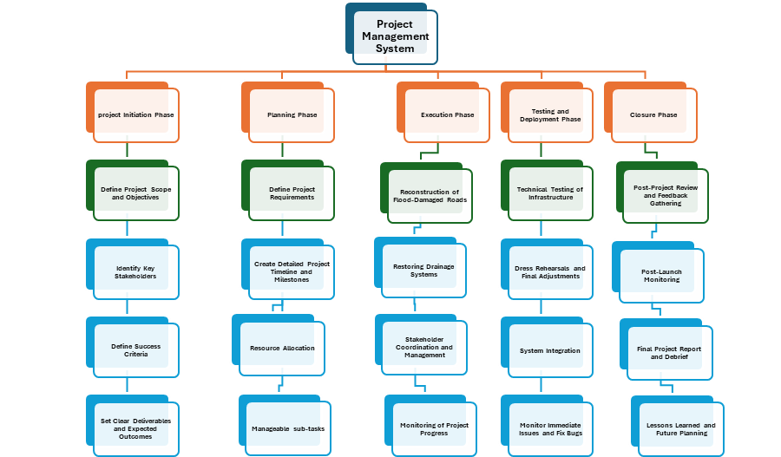

Figure 1: WBS of Project Management System
(Source: Self Developed)
Analysis
The Work Breakdown Structure (WBS) that is the basis of the reconstruction of the local infrastructure via the recent flood events in the West Midlands sets the systematic system of control over the phases of the project. The most significant phase in this process is the Initiation Phase that involves project scope definition, outlining project deliverables, and the definition of project stakeholders, and these efforts form the scaffold of the project on which the other operations will be anchored.
Planning Phase focuses on the development of a detailed timeline with milestones in between, thus making sure that every task is allocated and assigned with required resources (Odedairo, 2024). The phase highlights the importance of ensuring coordination of stakeholders and having explicit requirements that cannot afford the crop of scope creep, and managing intertask relationships.
The Central focus of the project during the Execution Phase shifts to the real activities and such real activities are restoration of the roads and drainage systems. The next stage is Testing and Deployment Phase, which helps in the verification of rehabilitated infrastructure meeting the necessary standards and simultaneously compensates any emerging problems as well as the compatibility of the rehabilitated infrastructure with the existing infrastructure.
Finally, the Closure Phase assesses the effectiveness of the project, summarises the stakeholder feedback and documents lessons learned to guide future projects. The WBS thus provides a procedural way of going through the technical and non-technical aspects keeping the stakeholder interest active so that the project at hand profiles its commitments to safety, economic recovery as well as long term sustainability.

5. Quad Chart
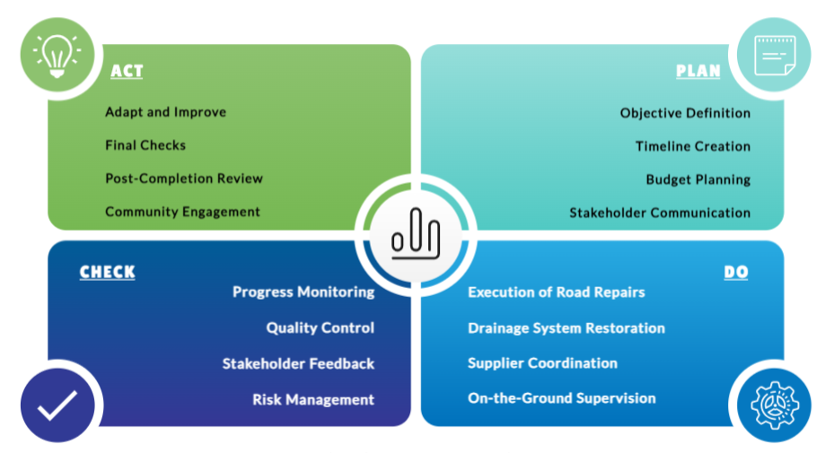

Figure 2: Quad Chart
(Source: Self Developed)
Analysis
Quad Chart is a systematic approach to delivering Reconstruction of Local Infrastructure projects in the West Midlands being the reaction to devastating flooding caused by an unusual weather pattern in the Atlantic. In the PLAN phase, the project manager defines the overall goals, with them being the fulfilment of the necessary services and improving the safety of the population. At the same time, a comprehensive time schedule and budget will be prepared, including a clear roadway repair schedule, drainage repair schedule, and communication rules to stakeholders.
At DO phase, the project manager oversees the road repair and drainage system restoration works. Close liaisons with suppliers will ensure that the right materials needed to reconstruct will be procured promptly whereas on-site check-ups will ensure that the agreed plan is followed. The stakeholders are constantly kept updated and issues addressed as well to ensure transparency is maintained (Johnson et al., 2022). Routine progress audit and quality control measures are undertaken during the CHECK stage to verify compliance with the restrictions of safety and other regulations. The feedback of the stakeholders is also collected in order to gauge the level of satisfaction and areas that need to be refined. At the same time, the project manager measures the risk exposure and triggers mitigation measures. Lastly, the ACT stage involves the process of being adaptive to the unexpected challenges and it involves recalibration of the plan where needed. A final review ensures the completion of all the project goals, wins the community back, and solves any outstanding problems in the post-completion stage.

6. Gantt Chart
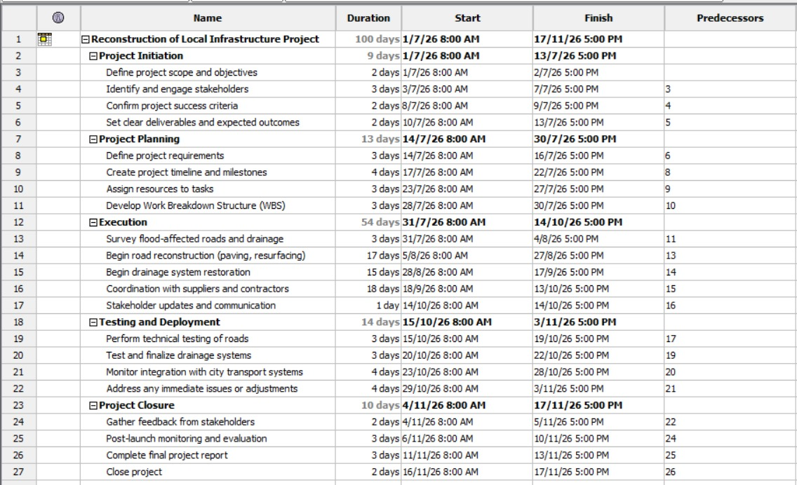
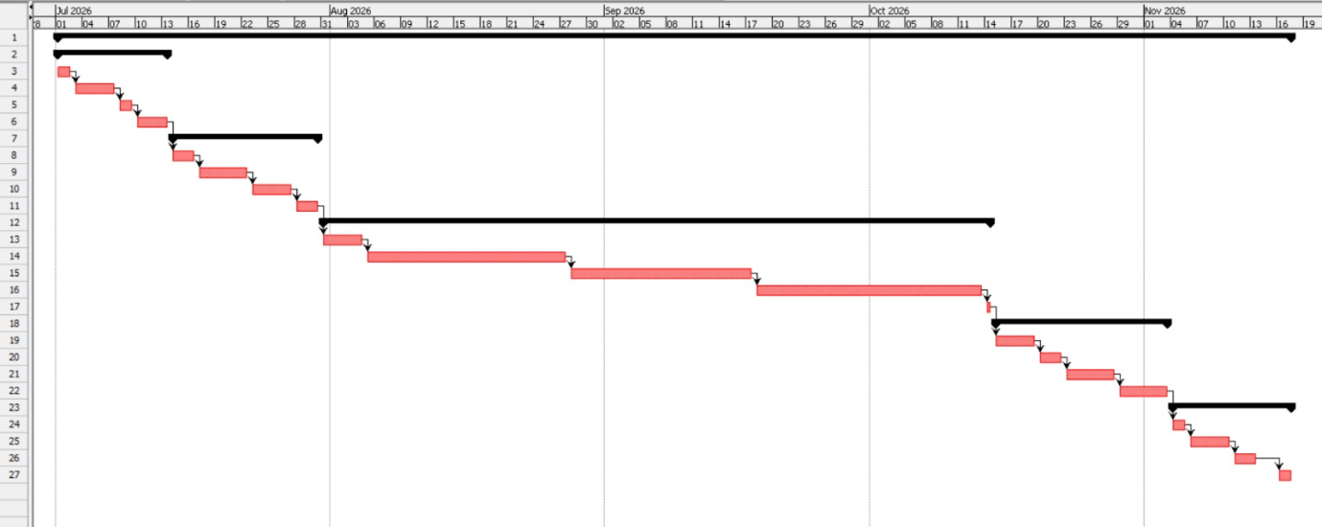

Figure 3: Gantt Chart
(Source: Self-Developed)
Analysis
The Gantt chart gives a graphical form of the project phases, the identification of the duration of the tasks, interdependencies and milestones. It clearly shows the sequence of processes of work beginning with Project Initiation and Project Closure. The predecessor of each task forms suitable sequencing, thus, preventing possible delays. Road reconstruction and drainage restoration are critical stages that cannot exist without each other as the technical testing and the final project report are the conditions to complete the project. The Gantt chart serves as an all-purpose tool in tracking the progress, resource utilisation and delivery of every stage at the right time.

7. Stakeholders' Involvement
Internal Stakeholders: Project managers and project team have been the internal stakeholders, who are required to control overall resources and influence the process of reconstruction. As mentioned by Maqbool et al. (2022), internal stakeholders are individuals or groups of people whose interest comes through direct collaboration with a company, such as investment or employees. The involvement of project managers and the project team hold high power and high interest, due to the direct engagement in planning, coordination, budgeting, risk management, and delivery of reconstruction activities. Thus, strong leadership and clear communication have been essential for internal stakeholders to achieve the projected objectives within the timeline.
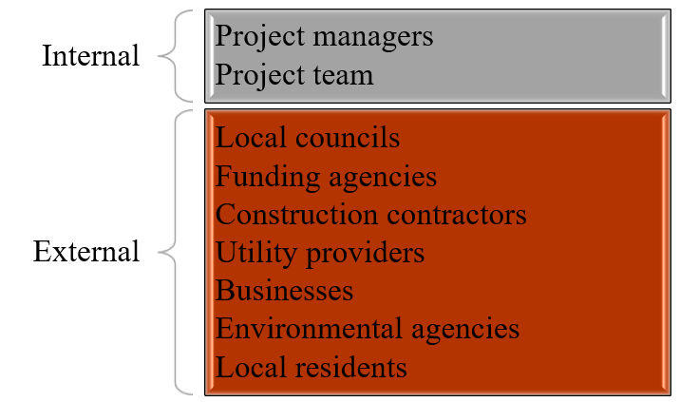

Figure 4: Internal and External stakeholders
(Source: Self-developed)
External Stakeholders: Local councils, funding agencies, construction contractors, utility providers, businesses, environmental agencies, and local residents have been external stakeholders. As per the statement of Prebanić and Vukomanović (2023), external stakeholders have been divided into private, including the local community, and public, such as regulators, and local authorities. Here, local councils and funding bodies have high power due to the regulatory authorisation, requiring strategic engagement. Contractors and utility providers have a high operational interest, which includes close coordination during the execution. Residents and environmental agencies are lower in power and interest, as it requires transparency in communication for higher trust and enhanced compliance during reconstruction practices. Thus, these stakeholders have been required for the management of the overall procedure of reconstruction of local infrastructure of the West Midlands to ensure safety and connectivity to local communities.

8. Allocation of Resources
Resource Type | Description | Details
Human Resources | Project Manager | Monitor project implementation, ensure milestones are met, and handle the team.
 | Engineers | Structural and civil engineers for designing and overseeing road and drainage work.
 | Construction Workers | Skilled labor for road resurfacing, drainage installation, and material handling.
 | Site Supervisors | Ensure quality control, safety measures, and compliance with the project’s technical specifications.
Material Resources | Construction Materials | Asphalt, concrete, steel, and other road-building materials.
 | Drainage Pipes and Culverts | Materials required for restoring the drainage system like pipes, manholes and so on.
 | Machinery and Equipment | Excavators, backhoes, bulldozers, trucks, and cranes for road repairs and drainage restoration.
Financial Resources | Labor Costs | Estimated cost of project management, engineers, supervisors, and construction workers.
 | Material and Equipment Costs | Estimated cost of construction materials, machinery, and rentals.
 | Contingency and Overheads | Budget for unforeseen expenses, insurance, safety measures, and administrative costs.

Table 1: Allocation of Resources
(Source: Self-Developed)
Analysis
The Reconstruction of Local Infrastructure project is planned to allocate resources of three main categories that are human resources, material resources and financial resources.
- Human Resources: The main employees include the Project Manager who manages the general project. Structural and Civil engineers involved in constructive implementation of the work (Rahmawati et al., 2022). Construction workers working on the real side of the construction and the site supervisors looking at the observed quality and the safety requirements.
- Material Resources: The critical resources required are construction inputs, such as asphalt, concrete and steel required to carry out the roadwork. Drainage material like pipes and culverts required to restore the drainage system and a collection of machinery and equipment such as excavators (ESMERAY et al., 2025). bulldozers and trucks are required to perform the project tasks.
- Financial Resources: The budget addresses the personnel labor cost, material and equipment spending and will provide an additional amount as contingency reserve to cater any unexpected costs including insurance and safety provisions and other miscellaneous administrative charges. These are critical resources in the successful and punctual completion of the project.

9. Risk Analysis
No. | Risk | Solvency | Probability | Impact | Mitigation Strategy
1. | Further Extreme Weather | 3 | 5 | 15 | Implementation of multi-hazard risk assessment to quantify flood vulnerability (Ming et al., 2022).
2. | Delays in Materials or Labour | 3 | 3 | 9 | Diversification of supplies and alternative routes for logistics.
3. | Stakeholder resistance | 4 | 2 | 8 | Use of stakeholder theory to build transparency in communication (Eyinade et al., 2022).
4. | Budget Overruns | 4 | 4 | 16 | Strictness in scope control and cost monitoring.
5. | Health and Safety Issues | 4 | 3 | 12 | Consideration of electric hazard assessment, regular H&S audits, and Rapid Needs Assessment for enforcement.

Table 2: Risk Matrix
(Source: Self-developed)
The reconstruction of flood-damaged infrastructure in the West Midlands has been associated with several strategic and operational challenges, which have a direct impact on cost, quality, stakeholder engagement, and schedule. Further extreme wealth can significantly increase the likelihood of compounding and severe heavy rainfall, which can damage the ongoing work in the West Midlands. As per the statement of Ming et al. (2022), an implementation of multi-hazard risk assessment helps in evaluating the flood vulnerability and compounded hazards to manage the damage. This can be an effective strategic consideration for the reconstruction project to reduce exposure of flood barriers. Additionally, delays in materials or labour can cause financial losses for the plan, and reduce customer satisfaction due to shortages. An inclusion of diversified suppliers and alternative logistics route consideration can reduce dependency risk, along with better supply resilience.
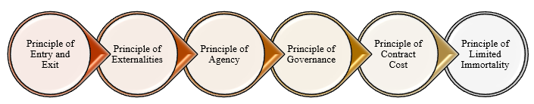

Figure 5: Principles of stakeholder theory
(Source: Self-developed)
Dissatisfaction among communities can create drastic delays in the overall reconstruction of local infrastructure. According to Eyinade et al. (2022), stakeholder theory has been efficient to support transparent communication for building stronger connections between stakeholders. An implementation of stakeholder theory helps in enhancing transparency in communication to improve understanding of local communities, which can foster trust and reduce conflicts. Unexpected site conditions and extended timelines can create financial overruns for the reconstruction project. An inclusion of strict scope control and accuracy in the cost estimation before construction can be helpful to minimise the unforeseen expenses. Health and safety risks can be managed through a rapid needs assessment and electrical hazard assessment to ensure worker and public safety. Thus, effective strategic management and consideration of relevant approaches help in reducing the identified risks during the reconstruction of local infrastructure.

10. Conclusion
The concerned plan for project management has appeared to be a substantial and distinct approach in the form of a flood defence mechanism. Based on the key deliverables, aim, scope WBS and Gantt Chart, the proposed project has been focused on being highly efficient in validating stakeholders’ involvement and resource utilisation. Completing the deliverables of the project with the dynamic application of project management techniques and approaches, the relevant stakeholders like citizens in West Midland can be benefited. The risk analysis also contributes within the project plan through contingency implication and long-term sustainability. Hence, it can be concluded that the proposed project management plan can add value within the reconstruction of local infrastructure projects by responding towards floods’ effects.

References
BBC, (2025). Heavy rain causes flash flooding with more to come. Available at: https://www.bbc.com/news/articles/c77zy0v04z8o (Accessed: 18 February 2026).
BBC, (2026). Flooding in Midlands after days of rain. Available at:https://www.bbc.com/news/articles/cvg5xlg4q1vo (Accessed: 18 February 2026).
BBC, (2026). Major flood prevention project finishes. Available at: https://www.bbc.com/news/articles/cgjwjp769d8o (Accessed: 18 February 2026).
Construction Wave, (2025). Record £2.6bn to build and repair UK flood defences. Available at: https://constructionwave.co.uk/2025/02/05/record-2-6bn-to-build-and-repair-uk-flood-defences/ (Accessed: 18 February 2026).
Ekundayo, O., Proverbs, D., Soetanto, R., Emonson, P., Cooper, J., Coddington, P., Speed, H. and Smith, C., (2026). Towards a Resilience Innovation Blueprint for Flood-Affected Schools in the UK. Water, 18(2), p.226. Available at: https://doi.org/10.3390/w18020226
ESMERAY, E. and HAMEDY, A., (2025). HYDRAULIC ASPECTS OF CULVERT CONSTRUCTION AND THE USE OF ENVIRONMENTALLY FRIENDLY DESIGNS TO PROTECT THE ECOSYSTEM. International Journal of Ecosystems & Ecology Sciences, 15(2). Available at: https://doi.org/10.31407/ijees15.223
Eyinade, W., Ezeilo, O.J. and Ogundeji, I.A., (2022). A Stakeholder Engagement Model for Strengthening Transparency in Corporate Financial Performance Reporting. Shodhshauryam, International Scientific Refereed Research Journal, 5(6), pp.236-251. Available at: https://www.researchgate.net/profile/Onyinye-Ezeilo/publication/393146077
Johnson, A., Lindgren, S.M.A. and Azlaan, M., (2024). Recommendations for policymakers: Encouraging stakeholder engagement and transparency [online] https://www.researchgate.net/profile/Maahir-Azlaan/publication/384341330_Recommendations_for_Policymakers_Encouraging_stakeholder_engagement_and_transparency/links/66f51a3bf599e0392fa30008/Recommendations-for-Policymakers-Encouraging-stakeholder-engagement-and-transparency.pdf
Khatib, M. and Alzoubi, H. (2022) ‘BIM as a tool to optimize and manage project risk management’, International Journal of Mechanical Engineering, 7(1). Available at: https://www.researchgate.net/profile/Mounir-El-Khatib/publication/358375029_BIM_as_a_tool_to_optimize_and_manage_project_risk_management/links/61fe76a7702c892cef079704/BIM-as-a-tool-to-optimize-and-manage-project-risk-management.pdf?origin=journalDetail&_tp=eyJwYWdlIjoiam91cm5hbERldGFpbCJ9 (Accessed: 16 March 2026).
Kis, A., Schindelegger, A. and Zupanc, V., (2022). Financial compensation and legal restrictions for using land for flood retention. In Spatial flood risk management (pp. 89-105). Edward Elgar Publishing. Available at: https://www.elgaronline.com/downloadpdf/edcollchap-oa/edcoll/9781800379527/9781800379527.00014.pdf
Maqbool, R., Rashid, Y. and Ashfaq, S., (2022). Renewable energy project success: Internal versus external stakeholders' satisfaction and influences of power‐interest matrix. Sustainable Development, 30(6), pp.1542-1561.https://doi.org/10.1002/sd.2327
Ming, X., Liang, Q., Dawson, R., Xia, X. and Hou, J., (2022). A quantitative multi-hazard risk assessment framework for compound flooding considering hazard inter-dependencies and interactions. Journal of Hydrology, 607, p.127477. Available at: https://doi.org/10.1016/j.jhydrol.2022.127477
Mushtaq, M., Corradi, M. and Sikdar, S., (2024). Climate adaptation of roads to flooding hazards—A review. Construction Materials, 4(4), pp.748-776. Available at: https://doi.org/10.3390/constrmater4040041
Odedairo, B.O., (2024). Assessing the influence of various work breakdown structures on project completion time. Engineering, Technology & Applied Science Research, 14(2), pp.13773-13779. https://mail.etasr.com/index.php/ETASR/article/view/7023
Prebanić, K.R. and Vukomanović, M., (2023). Exploring stakeholder engagement process as the success factor for infrastructure projects. Buildings, 13(7), p.1785. Available at: https://doi.org/10.3390/buildings13071785
Rahmawati, Y., Pradipto, E., Mustaffa, Z., Saputra, A., Mohammed, B.S. and Utomo, C., (2022). Enhancing students’ competency and learning experience in structural engineering through collaborative building design practices. Buildings, 12(4), p.501. Available at: https://doi.org/10.3390/buildings12040501
Service.gov, (2022). Severn River Basin District Flood Risk Management Plan 2021 to 2027. Available at: https://assets.publishing.service.gov.uk/media/63750f6de90e0728553b5654/Severn-FRMP-2021-2027.pdf (Accessed: 18 February 2026).

