

LCLM6005

Leadership and Management Skills in the Workplace
Improving Organisational Performance through Employee Retention Strategies at Waitrose

Abstract
This dissertation focuses on the issue of employee retention at Waitrose and how it affects organisational performance in the UK retailing industry. Primary data was gathered using a mixed-method, quantitative-dominant method in terms of the employee survey and semi-structured interviews with the result of which was backed by secondary analysis of the literature. Quantitative results provided proof of moderate employee-reported levels of leadership support, motivation through employee ownership, wellbeing, and recognition, and non-significantly weak relationships between retention variables and performance indicators in the organisation. Qualitative results evidenced discrepancies in leadership behaviours, narrow practical empowerment by owning the employees and disproportionate wellbeing and recognition assistance. The research concludes that successful retention in Waitrose has to involve consistent leadership, viable employee empowerment and integrated retentions that will facilitate sustainable organisational performance.

Table of Contents
Abstract 2
CHAPTER 1: INTRODUCTION 5
1.1 Background of the Study 5
1.2 Problem Statement 5
1.3 Research Aim and Objectives 6
1.4 Research Questions 6
1.5 Significance of the Study 7
1.6 Scope and Context of the Study 7
1.7 Structure of the Dissertation 7
CHAPTER 2: LITERATURE REVIEW 8
2.1 Introduction to the Literature Review 8
2.2 Concept of Employee Retention 8
2.3 Theoretical Frameworks on Motivation and Retention 9
2.4 Employee Retention in the UK Retail Sector 10
2.5 Employee Ownership and Engagement at Waitrose 11
2.6 Retention Strategies and Organisational Performance 12
2.7 Research Gap 12
2.8 Conceptual Framework 13
CHAPTER 3: RESEARCH METHODOLOGY 14
3.1 Research Philosophy 14
3.2 Research Approach 14
3.3 Research Design 14
3.4 Data Collection Methods 14
3.5 Sampling Strategy and Sample Size 15
3.6 Research Instrument Design 15
3.7 Data Analysis Techniques 16
3.8 Ethical Considerations 16
3.9 Reliability and Validity 16
3.10 Limitations of the Methodology 16
CHAPTER 4: RESULTS AND DISCUSSION 18
4.1 Introduction 18
4.2 Primary Analysis 18
4.2.1 Quantitative Analysis 18
4.2.2 Qualitative Analysis 24
4.3 Secondary Thematic Analysis 26
4.4 Discussion 30
CHAPTER 5: CONCLUSION AND RECOMMENDATIONS 33
5.1 Introduction 33
5.2 Summary of Key Findings 33
5.3 Conclusions in Relation to Research Objectives 33
5.4 Recommendations for Waitrose 34
5.5 Practical and Managerial Implications 35
5.6 Limitations of the Study 35
5.7 Recommendations for Future Research 35
5.8 Final Conclusion 35
Reference 36
Appendix 41
Appendix A: Interview Questions 41
Appendix B: Interview Responses 41
Appendix C: Questionnaire 45
Element 2: Research Process Reflection (Kolb’s Learning Cycle) 48
Element 3: Methodology Poster – Research Process and Findings 50

CHAPTER 1: INTRODUCTION

1.1 Background of the Study
The problem of retaining employees has emerged as a key strategic issue in the human resource management as well as in leadership practice especially in labour-intensive sectors like retail. By retaining skilled and motivated employees, organisations are able to ensure service delivery, thereby minimising the costs of recruitment and training, not mentioning the overall organisational performance (Thusi and Chauke, 2023). In terms of leadership, the retention strategies are closely connected with the concept of employee motivation, engagement, and job satisfaction, which affect the sustainability of the organisation in the long-term. The UK retailing industry has been typified by a high turnover rate amongst employees whose motivation has been influenced by unfavorable working conditions, lack of career development, wage pressure as well as work-life balance issues (Ngamkroeckjoti, Klongthong and Thavorn, 2022). Industry reports indicate that retailing has one of the highest rates of attrition in the UK sectors and thus puts a strain on operations and customer experience. Employee continuity is a crucial factor in service quality and brand image as customer-facing professions prevail in the sector. Waitrose is a supermarket chain that belongs to John Lewis Partnership; it denotes a unique organisational setting because of a system of employee ownership. Waitrose has partners who participate in profits and receive a formal voice which is supposed to boost participation and dedication. With this progressive structure Waitrose still has equal retention problems as those that affect the rest of the retail world (GOV.UK , 2023). This paper hence investigates employee retention in Waitrose in the light of determining the role played by the leadership, motivation, and organisational practices in determining performance outcomes.

1.2 Problem Statement
Turnover among employees has been a constant problem in the retail sector of the United Kingdom, with organisations registering the phenomenon of high staff turnovers that affect operations and service delivery in the companies. High turnover is very costly in financial terms since they have to recruit new employees, onboard, and train them over and over in the same positions (Strouse and Reed, 2021). Also, high turnover of staff may adversely impact on employee morale, staff integration, and uniformity of the customer service environment thus compromising on the organisational performance and competitiveness. Waitrose is not free of these challenges even having a good reputation as an ethical employer and with a form of employee ownership. The recent organisational transformation, pressure of heightened competition by the discount retailers, and pressure of rising cost of living have added to the workforce dissatisfaction within the sector. Frontline workers usually face pressures on workloads, reduced promotion opportunities and a perceived difference between organisational values and realities in day to day operations (NIH, 2023). These problems could undermine the desired motivational value of employee ownership. The main issue discussed in the study is that the model of ownership that Waitrose follows appears to be in conflict with its continuing difficulties in retaining employees. Although employee ownership is expected to promote loyalty and employee engagement, turnover rates are pointing at the existence of other factors that contribute to the likelihood of employees staying with or leaving the organisation (Scott, Waite and Reede, 2021). The acquaintance of such factors would be vital in enhancing retention techniques and boosting organisational performance in Waitrose and such like employee owned businesses.

1.3 Research Aim and Objectives
Research Aim:
This study seeks to analyse the effectiveness of employee retention strategies at Waitrose and how effective this is towards organisational performance.
Research Objectives:
- To determine the important variables that affect staff retention at Waitrose.
- To measure the perception of the employees concerning the current retention and motivation practices.
- To test whether there is a relationship between retention strategies and the outcomes of organisational performance.
- To make some evidence-based suggestions to increase the staff retention at Waitrose.

1.4 Research Questions
The main research question guiding this study is:
What are the implications of employee retention policies at Waitrose on organisational performance?
To support this inquiry, the following sub-questions are addressed:
- What have the strongest effects on retention of employees at Waitrose?
- What are the perceptions of employees on leadership, motivation, and support at the organisation?
- How does employee satisfaction, job satisfaction and organisational performance correlate at Waitrose?

1.5 Significance of the Study
The perspectives on employee retention on employee-owned organisations provided in this study contribute to the body of academic literature by advancing the knowledge on the subject matter, which has not received a lot of attention in HRM and leadership research (NIH, 2021). The study is able to contribute to the literature of retail management research by combining motivation and retention theories with empirical evidence. In practice, the research results provide useful information to the management by showing the gaps in the existing retention in practice and its areas that the management should consider in their practices. The recommendations can be used to enhance the engagement and retention strategies developed by the HR practitioners (SHRM, 2024). The work also has implications to other employee-owned organisations that aim to streamline the ownership structure in line with workforce motivation and long-term performance.

1.6 Scope and Context of the Study
This study will only cover Waitrose stores that are within the UK retail market. The research targets the staff at different levels of an organisation such as customer service assistants, the supervisory staff, and management positions. In the study employee retention is considered in terms of job satisfaction, motivation, support of leadership and organisational performance (Sinurat and Widhianto, 2023). Such outside factors as general economic conditions are recognised but not studied in detail. The focus of the study on one organisation facilitates contextual analysis of one study, but realises that the results might not be generalised completely to all retail organisations.

1.7 Structure of the Dissertation
This dissertation is designed in five chapters. Chapter 1 provides the background of the research problem, research aims, and significance of the research. Chapter 2 shows the critical analysis of related literature on the issue of employee retention, motivation theories, and organisational performance. Chapter 3 identifies the research methodology which includes the research design, the data collection, and ethical considerations. Chapter 4 provides the discussion and analysis of the findings of the research concerning available literature. Lastly, Chapter 5 gives conclusions, recommendations, study limitations, and suggestions on further research.

CHAPTER 2: LITERATURE REVIEW

2.1 Introduction to the Literature Review
This chapter critically reviews the available academic literature as well as practitioner literature pertinent to employee retention and its effects in organisational performance in the context of the retail industry. The aim of the literature review is to provide a solid theoretical ground of the research through discussing the significant concepts, models and empirical evidence on employee motivation, engagement and retention. The chapter uses synthesis of pertinent theories and earlier studies to draw gaps in the existing literature, especially in employee-owned retail organisations as Waitrose according to Wren (2020). The literature reviewed directly influences the construction of the research questions and provides empirical investigation as it frames the research framework and methodological approach embraced in the research.

2.2 Concept of Employee Retention
Employee retention can be defined as the capability of an organisation to retain its employees within a long period of time using good human resource and leadership practices as per Mey, Poisat and Stindt (2021). It comprises measures aimed at retaining the employees within the organisation by increasing the satisfaction of the job, motivation, engagement as well as organisational commitment of the organisation. Employee retention as a managed strategy that aims at fostering a conducive working environment where employees feel special, appreciated, and evaluated to commit to organisational objectives. As a leadership aspect, retention will depend on managerial encouragement, quality of communication and the ability to include personal and professional growth. In human resource management, employee retention has been considered a strategic priority, since it has a direct connection with the organisational performance. Employees with high retention rates save costs of recruitment and training, institutional knowledge and promote workforce stability. According to Siyal (2023) leadership is significant in promoting trust, psychological safety, and engagement, which are rather important in retaining employees in the competitive labour markets . Employee retention is widely associated with but different with employee turnover. Whereas retention deals with the measures to motivate the employees to remain, turnover deals with the rate on which the employees abandon an organisation. The causes of high turnover are usually associated with the problems in organisations like poor leadership, low rewards or low career advancement. On the other hand, high retention is an indicator of good HR practices and good experiences among employees. The employee retention is especially applicable to the UK retailing industry that is highly labour-intensive and encounters employee turnover as per Choy and Kamoche (2021). Frontline employees play a significant role in retail organisations as they ensure the level of customer service remains consistent, hence retention becomes important in ensuring service quality, customer satisfaction, and brand%

2.3 Theoretical Frameworks on Motivation and Retention
Herzberg’s Two-Factor Theory
According to Alrawahi et al. (2020) the Two-Factor Theory developed by Herzberg separates motivators and hygiene factors that play an important role in determining satisfaction and retention of employees. Recognition, achievement, responsibility, and personal growth are the motivators that play a part in job satisfaction as well as long-term commitment. Conversely, hygienic factors that, among others, comprise salary, working conditions, company policies, and job security, may not be a motivation to employees yet may lead to dissatisfaction when poorly managed. In the retail industry, hygiene factors hold the greatest value because of heavy workloads, working hours and competitiveness of remunerations. Nonetheless, hygiene factors on their own cannot be used to maintain employee retention. To generate interest and devotion, retail organisations need to invest in inspirers, e.g., definite career advancement ways and acknowledgment systems also. The theory by Herzberg thus brings out the necessity of having balanced HR and leadership practices that meet the extrinsic conditions as well as intrinsic motivational needs of the retail employment environments.
Maslow’s Hierarchy of Needs
According to Omodan (2022) the Hierarchy of Needs designed by Maslow offers an effective way of defining motivation to the employees by grouping the human needs into a hierarchy such as physiological needs, safety needs, social needs, esteem needs, and self-actualisation needs. Physiological and safety needs in the case of employment are associated with fair salaries, constant work hours, and job security, which are particularly important in the retail industry. The social needs are the positive workplace relationships and belonging whereas esteem needs are met by recognition, respect, and chances of progression. Self actualisation can be defined as self development, competence and purposeful occupation. To the contemporary retail staff, especially the younger ones, more advanced needs have gained relevance. The organisations that do not advocate progression, learning as well as developing the individuals, might find it hard to maintain employees as per Cottrell (2021). The model by Maslow therefore focuses on the need to have comprehensive retention plans with both the fundamental employment terms and other elevated motivation needs.
Social Exchange Theory
As per Ahmad et al. (2023) the Social Exchange Theory interprets retention in relation to the quality of reciprocal relationship between the employees and the organisation . According to the theory, employee loyalty, commitment and continued performance are likely to be achieved when employees feel fairly treated, supported, and even invested by their employer. The main part of this process of exchange is trust and mutual obligation. Corporate leaders demonstrate positive leadership behaviours, open communication and recognition in organisational contexts which lead to good perceptions of organisational support. Strong emotional attachment and commitment to the organisation ensues as the employees grow more valuable and fairly rewarded. On the other hand, the feeling of imbalance in the exchange relation may lead to dissatisfaction and turnover intentions. The relationship of exchange needs to be positive in the retail sector where employees are in high demand and interaction between staff and employers often takes place according to Jung, Yoo and Arnold (2021). The Social Exchange Theory is thus a very good theory that can be used to research on the relationship between leadership practice and organisational support and employee retention.

2.4 Employee Retention in the UK Retail Sector
One of the major issues in the UK retail industry is employee retention as the industry continually records some of the highest employee turnover rates among leading industries reported by McKinsey & Company (2022). According to the industry calculations, an average annual turnover in the retail industry is often up to 50 per cent due to the high dependency on a part-time, frontline, and customer facing job. The high rates of attrition pose long term operational challenges such as shortage of staff, higher recruitment expenses and poor service delivery, which impact on organisational performance and customer satisfaction adversely. The working conditions in the retail industry are one of the major factors that lead to the retention problem. The working hours are mostly long or uneven, jobs are physically stressful, and pressure to perform at an elevated level due to the customer demands. Pressure of payment also contributes to dissatisfaction, whereby the parameters of the retail wages are often lower than in other fields, where the efforts and flexibility demand the same amount of work as per Mas and Pallais (2020). Also job insecurity has been on the rise in recent years through organisational restructuring, automation and cost cutting policies especially after economic weathering and the escalation in operation costs. All these make employees less committed and better motivated to turn over. A comparison of the key large UK retailers shows a different strategy to retention. In the quest to increase the level of employee engagement, Tesco has invested in established career ladder, advancements and wellbeing programmes. To enhance retention, Marks and Spencer have been investing in leadership strategies, flexible working and employee recognition programmes as per Marks & Spencer (2023). By contrast, discount retailers like Aldi and Lidl tend to match with greater hourly wages but require employees to perform quite vigorously, which may curtail its prospective retention in the long term in spite of monetary advantages. Although these organisations employ varying strategies, none of them can resolve sector challenges. In the case of Waitrose, GOV.UK (2023) reported the competition in this environment is especially complicated because of the high standards of service positioning and model of employee ownership . Research on the interaction of sector-specific demands on organisational practices is thus needed to come up with powerful strategies of retention that foster workforce sustainability and thriving performance in the UK retail industry.

2.5 Employee Ownership and Engagement at Waitrose
Waitrose is a branch of the John Lewis Partnership (JLP), one of the unique employee owned business models where employees are addressed as partners and have a part in the profits and decision making of the organisations as per Shipper and Hoffman (2020). This form of ownership is aimed at creating a resounding feeling of participation, responsibility, and common ground among the staff members. The JLP model focuses on employee engagement as a strategic priority unlike standard shareholder-owned retailers that put more emphasis on democratic governance, transparency, and long-term organisational sustainability. The ownership of employees has generally been related to increase in motivation, loyalty, and commitment to the organisation. The model helps employees to be more responsible towards the quality of service provision and performance results by associating the output of each employee with the output of the entire group. In Waitrose, the employee voice and engagement are to be empowered at the workplace through profit-sharing bonuses, accessing internal communication channels as well as the ability to serve in representative councils. These mechanisms conform to the theories of motivation which lay stress on autonomy, recognition and belonging as important factors that drive retention. Nevertheless, it has been noted that employee ownership does not necessarily result in long-term engagement and a high level of retention. Lack of good leadership and adequate career development opportunities and constant development of skills can blunt the long-term motivational returns that ownership can contribute according to Ned and Umesi (2023). Frontline employees are likely to feel that there are less opportunities to advance or feel disengaged by strategic decision-making processes in retail settings even though they have formal ownership rights. Psychological contract between employees and the organisation can also be weakened by organisational restructuring, work pressures and targets. In the case of Waitrose, it signifies the necessity of complementing the employee ownership with effective leadership practices and focused development strategies. To work, ownership should be propagated by periodic managerial delivery, appreciation and investment in employee developments.

2.6 Retention Strategies and Organisational Performance
Organisational performance is closely associated with employee retention strategy, especially where organisation activities are largely service oriented like retail. The high rates of retention lead to the increased productivity due to the stability of the workforce and the minimisation of time and resources that are spent on the further recruitment and training as per Wang and Heyes (2020). The long-term employees build a greater competence with job, efficiency in their operations and the capacity to effectively handle customer contact resulting in increased productivity (personal and group). Retention is also important in improving customer satisfaction and quality of services. Within the retail setting, customers can obtain a consistent and high-quality customer service through long serving employees who have more knowledge of the products and familiarisation of the organisational procedures. Akram, Abbas and Khan (2022)stated that a high turnover rate of employees has the potential of disrupting continuity in service delivery and creating a bad perception in customers but stable teams foster trust, reliability and healthy customer experiences. Financially, efficient retention measures decrease both the direct and indirect costs linked to employee turnover, such as purchasing, onboarding and lost productivity in the period of transition. Companies that have good retention strategies are in a better position to have better cost controls and a higher profitability in the long run. Moreover, retention levels are also high, which leads to the provision of a powerful brand image that may be used to attract consumers and prospective employees. In the case of Waitrose, employee retention is of special concern, because this retailer occupies a high-end market, the quality of service and relationships with customers are in the focus of the competitive advantage.

2.7 Research Gap
Even though there is a lot of research on employee retention in the retailing sector, minimal empirical evidence on the employee owned retail organisations has been conducted as per Nguyen et al. (2022). A vast part of the literature that has been conducted is concentrated on the traditional shareholder-owned businesses and does not offer any insight into the ways in which the ownership structures impact the motivation, engagement, and retention outcomes. More specifically, no studies have investigated the effect of employee ownership alone on employee retention without effectively boosted leadership and development. The attention to Waitrose is reasonable because of the specific role the company holds in the UK retail market as a member of the John Lewis Partnership according to Shipper and Hoffman (2020). This paper fills the specified gap by empirically exploring the perceptions of a group of employees about the retention strategies in an employee owned retail environment and connecting it to organisational performance outcomes.

2.8 Conceptual Framework
Depending on the literature review and the research gap, a conceptual framework is identified to make this study. Ohunakin et al. (2020)stated that the independent variables include the retention strategies of employees, i.e. the leadership support, motivation, recognition strategies and development opportunities . The strategies are found to have an impact on the outcomes of the employees such as job satisfaction, engagement and organisational commitment as mediating variables. The dependent variable is organisational performance in terms of productivity, the quality of service, customer satisfaction and financial results. The framework offers a systematic foundation on data collection and data analysis and allows assuring coherence between theoretical views, research questions, and the practical study carried out at Waitrose.
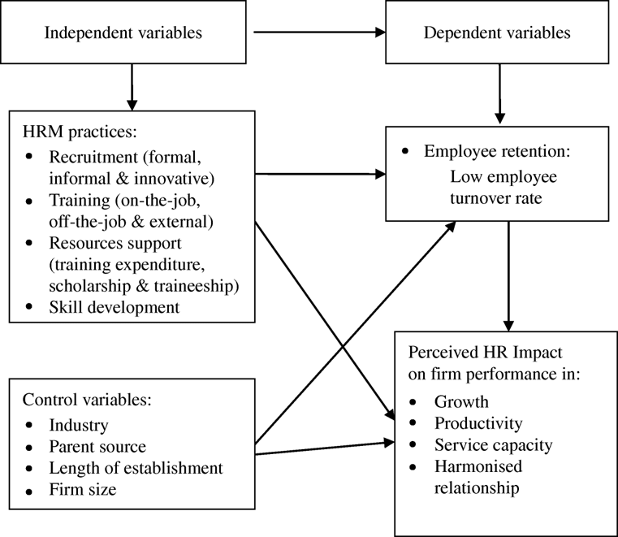
FIgure 1: Conceptual Framework
(Source: Created by the learner)

CHAPTER 3: RESEARCH METHODOLOGY

3.1 Research Philosophy
Effective research philosophy is based on a pragmatic approach and in this study the primary purpose is to focus on the application of research techniques in solving the problems encountered by the organisations in the real world. Pragmatism is suitable for research on employee retention since it enables the combination of factual information and personal perceptions of employees to come up with actionable information (Ndatshe, Mokhele and Jakoet-Salie, 2024). The philosophy resonates with the organisational performance literature, where the experience and attitudes of the employees have to be analysed so as to assess the HR strategies. Pragmatism will also enable the research to focus on methods that can best answer the research problem, instead of applying the full assumptions of positivism or interpretivism, which will assure that the information will be relevant and valuable to Waitrose.

3.2 Research Approach
The study adopts a deductive research approach because it is guided by the available theories of motivation and employee retention such as the Two-Factor Theory of Herzberg and Social Exchange Theory (Reyes, 2024). These theory systems will help to formulate the research questions and build the data collection tool. The study uses a question-led inquiry to test how existing theories are applicable in a given organisational set-up of Waitrose instead of testing formal hypotheses, which allows the application of theories to analysis of empirical data.

3.3 Research Design
The study is quantitative-dominant with aspects of a mixed-methods approach as it aims at numerical data based on the perceptions of the employees. It has a cross-sectional study design that entraps the data of the respondents during one moment. The survey-based study is warranted because it is an efficient method of collecting standardised data of many workforce as well as the ability to analyse the trends in employee attitudes (Negt and Haunschild, 2025). This design fits well in the retail workforce scenario where it has time constraints and shift-based employment requires a flexible and convenient way of collecting data.

3.4 Data Collection Methods
A structured questionnaire that entails Likert-scale questions is used to collect primary data to be used in this study. The questionnaire will be created to assess the perception of the employees regarding the retention strategies, leadership support, motivation, the job satisfaction, and the organisational performance (Sinurat and Widhianto, 2023). Likert scales also allow the respondent to give a level of assent that can be used to examine and compare results among variables in a quantitative manner. The questionnaire will be distributed using online facilitation mainly via email or online surveys links, to make the questionnaires accessible and reach the employees who might be working in wide shifts and locations. In-store distribution can also be utilised to boost the response rates where necessary. Questionnaires are suitable in that they are cost-effective, anonymous, and they allow gathering data of a large sample (Salama, Uzunboylu and El Muti, 2020). Besides the survey, two semi structured interviews are prepared to gather qualitative data as well as to obtain more information about the experiences and the perceptions of the employees. The interviews are carried out on a total of 10 employees working in various positions at Waitrose. The five open ended questions in each of the interviews will be on perception about retention practises, leadership support, motivation, and issues that affect the intention of employees to stay in the organisation. The interviews then provide deeper context of the understanding and provides triangulation of findings in opportunities to complement the quantitative survey information with the qualitative views. Secondary sources such as scholarly articles and industry reports are employed to give contextual knowledge but they are not part of the source of empirical data.

3.5 Sampling Strategy and Sample Size
In this study, employees of Waitrose in the UK retail market will be the target population. The sampling method is taken as convenience since there are limitations of accessibility and time, and participants who are easily accessible and willing to respond are considered to take part in the research. The anticipated sample size should be around 100 respondents, which will be enough to carry out descriptive quantitative analysis at undergraduate level. The inclusion criteria include the selection of current employees of Waitrose, whether frontline or supervisory or managerial. The strategy will provide a good variety of employee perspectives, and, at the same time, it will not be costly as it falls within the study time range.

3.6 Research Instrument Design
The questionnaire will be designed in well-defined blocks. The demographic section provides the first part with such details as role and length of service (Meeker, Escobar and Pascual, 2021). The following sections assess the perceptions of employee retention practices, job satisfaction, and engagement, and the performance outcomes of organisations. All the attitudinal items are measured by five-point Likert scales that would be strong disagreement to strong agreement. The questionnaire is developed based on existing literature, that is used to make the questionnaire relevant and clear. As much as possible, the tool can be pilot tested to a small population to understand any ambiguities and make the questions clear before administered to a large population.

3.7 Data Analysis Techniques
The questionnaire is analysed using a quantitative approach to data analysis. Statistical techniques of data analysis such as frequencies, percentages, and mean scores are used to determine patterns and trends on employee perceptions (NIH, 2019). The data is arranged and processed through analytical software (Microsoft Excel). This analysis aligns directly with the research objectives, and allows conducting the systematic analysis of the retention factors, employee satisfaction, and the perceived organisational performance. The results produced in the process are what will be discussed in Chapter 4.

3.8 Ethical Considerations
The research process is conducted in a strict environment related to ethical principles. The participants are made aware of the objective of the research and they make an informed consent before taking part. The interview is purely voluntary and participants are free to leave anytime without any reprisal (Bredal, Stefansen and Bjørnholt 2024). The anonymity and confidentiality are secured by making sure that no identification data are gathered. Data collection commences with the ethical approval following the regulations of the university to make sure that the data are gathered and that ethics and professional standards of research conducted are taken into consideration.

3.9 Reliability and Validity
In a bid to improve reliability, all constructs have equal Likert-scale measurements in the questionnaire. Internal consistency is facilitated by use of standardised question forms. To achieve content validity, the questionnaire items are being designed on the basis of the theories of employee retention as well as past studies (Chatzoudes and Chatzoglou, 2022). Possible biases e.g. the social desirability bias is reduced through the provision of anonymity and promotion of truthful responses. All these enhance the credibility and reliability of the research results.

3.10 Limitations of the Methodology
There are a number of methodological limitations of this study. The sample size is quite small and this could limit the generalisation of the results outside Waitrose. Convenience sampling procedure presents the risk of presence of response bias since respondents might not be fully representative of the workforce broadly (Chen et al., 2022). Also, self-reported data depends on the personal perceptions that can be affected by events or other temporary factors. Time is also an issue that prevents the conduct of longitudinal analysis of the research as the study is restricted to cross-sectional views.

CHAPTER 4: RESULTS AND DISCUSSION

4.1 Introduction
This chapter offers the results and discussion of the empirical research on employee retention at Waitrose. Chapter 4 is aimed at the analysis and interpretation of the data obtained by considering several sources to answer the research goals. Primary data was collected via the employee survey with the help of a structured questionnaire and semi-structured interview, whereas secondary data were taken based on certain academic literature as well as industry reports. The chapter has been divided into four major sections. It establishes itself to work first with quantitative analysis of survey data and then qualitative analysis of the responses of interviews. This is supplemented by secondary thematic analysis that incorporates the find out findings with the literature available. The chapter is then concluded with a discussion that summarises the important lessons learnt and sets the stage on what would be advised in Chapter 5.

4.2 Primary Analysis

4.2.1 Quantitative Analysis
Question 1: Length of Service at Waitrose
Response distribution shows that the majority of the employees have been serving Waitrose over a moderate period with the highest percentage being 2-3 years (34%). This implies a relatively stable workforce that has enough experience in an organisation to assess retention practises. Nonetheless, the lower ratio of long service employees (13% above five years) can be a pointer of the difficulty in long term retention, although Waitrose has an employee ownership scheme.
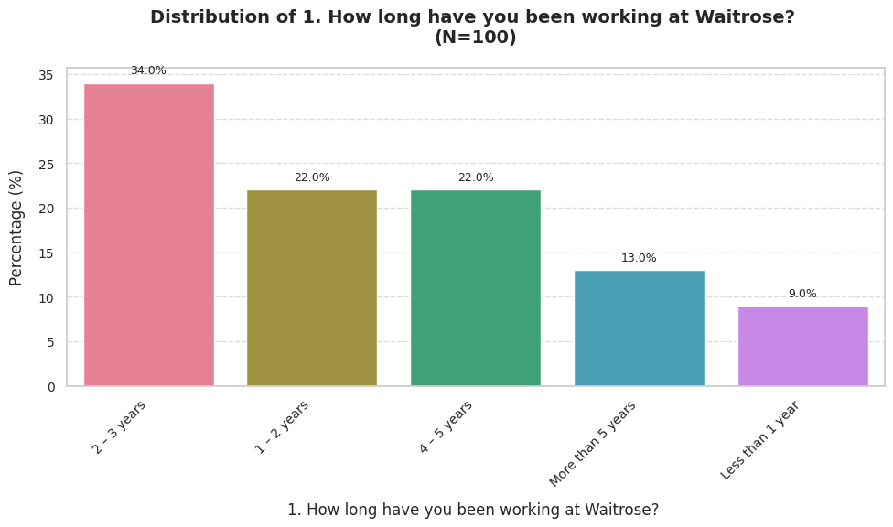
Question 2: Current Job Position Level
The sample will be diversified in job roles as the positions of supervisors (27) and duty managers (26) will constitute the biggest numbers. This implies that the representation of the middle management is high, as well as frontline and HR positions. This type of diversity increases the trustworthiness of the results, since the retention perceptions are measured on an organisational spectrum. Nevertheless, being dominated by the supervisory roles might cause the answers to be biassed in reaction to operational and leadership-related problems.
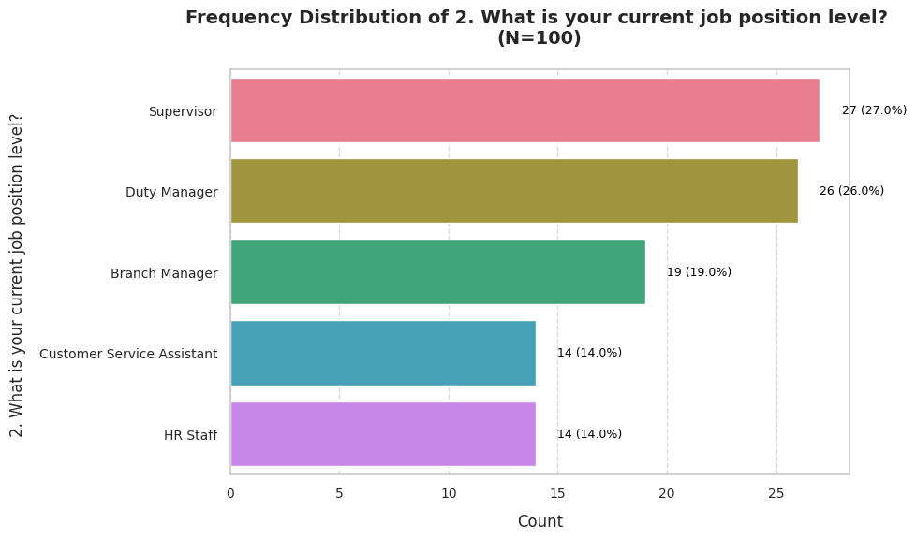
Question 3: Satisfaction with Current Role
The levels of job satisfaction are mixed. Although 35% of the respondents said they were satisfied or rather very satisfied, a significant percentage said that they were not happy, with 26 per cent of people defining dissatisfaction and 14 per cent saying that they were not very happy. The fact that the proportion of neutral and dissatisfied responses were also high indicates that employees might not have a strong engagement in their roles which raises the risk of losing some of them to the concept of retention unless there is action-taken to elevate the levels of satisfaction.
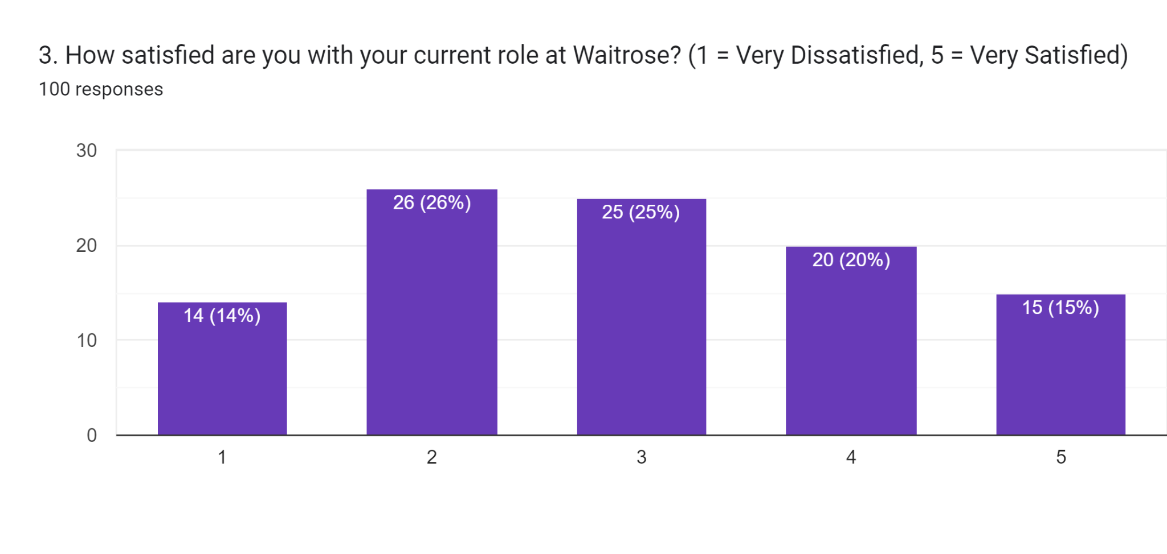
Question 4: Support and Communication from Line Manager
The line manager support was rated as poor and neutral by most of the respondents, with 43 percent of the respondents giving a rating of 2 or less. A limited percentage only had an excellent rating on support (9%). This implies that many employees believe that leadership communication is incomplete or unstable. Since line managers are an influential factor in employee experience, these results may signify a possible flaw in day-to-day leadership practises at Waitrose.
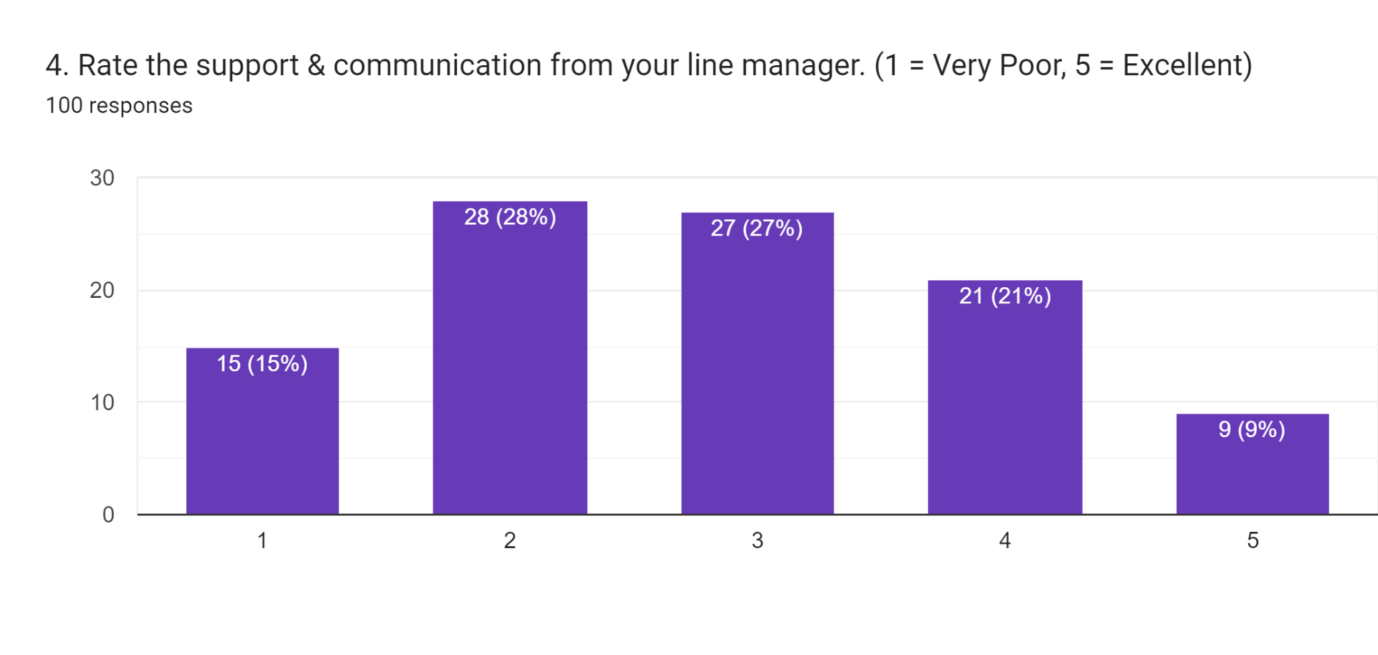
Question 5: Motivation from Employee Ownership Model
The result of employee motivation based on the ownership model is average and not high. Although 36% of the respondents were motivated or highly motivated, the percentage of low motivation was also equal. This distribution implies that the increase in motivation is not homogeneous with employee ownership. The results suggest that ownership can in itself not be compelling enough to create engagement without empowerment and development opportunities.
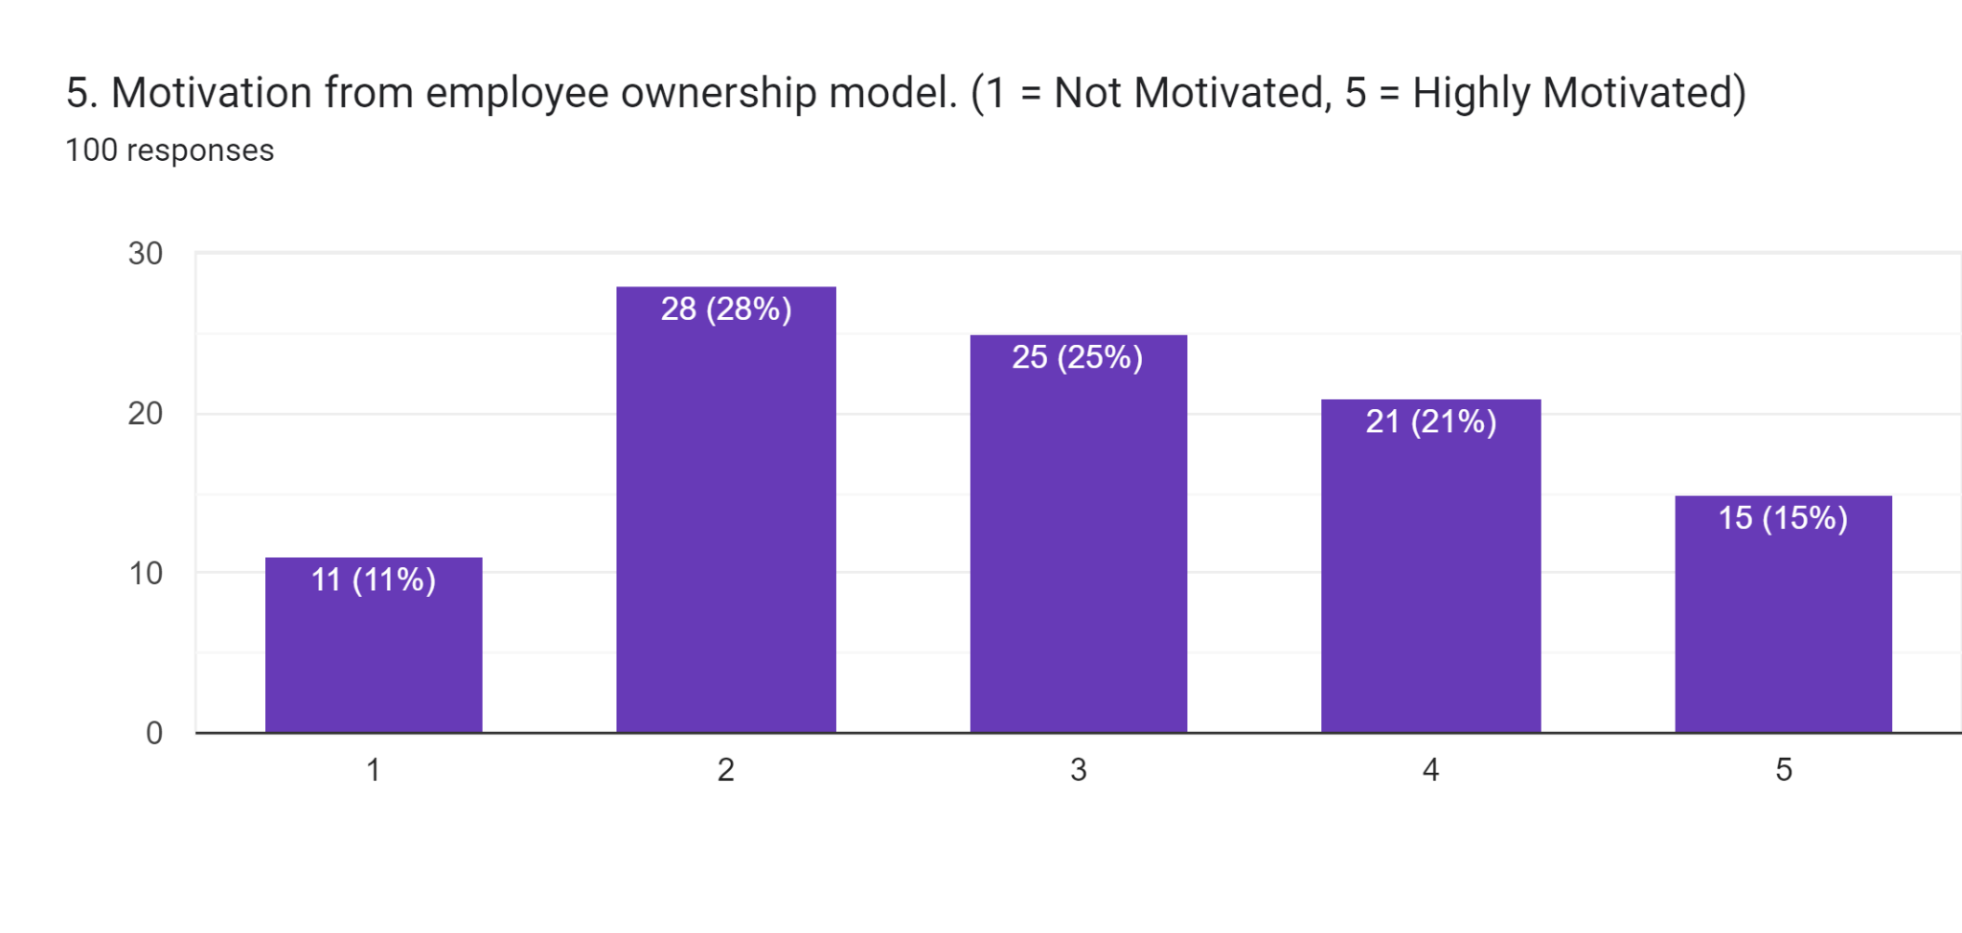
Question 6: Effectiveness of Line Manager Communication
The range is mostly between the neutral and moderate with 29% expressing the neutral and 25% obtaining the disagree options. As much as some employees feel that there is efficient communication, the fact that they had a disagreement implies that there is unbalanced management communication efficiency. This confirms previous evidence which states that leadership performance can differ within roles or geographies which can undermine credibility and reliability in employee-manager connexions.
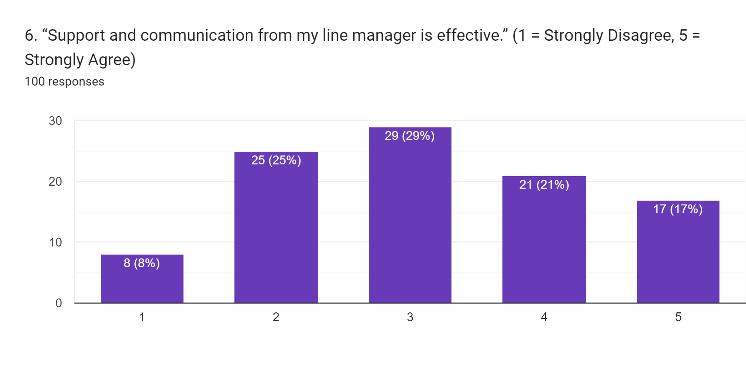
Question 7: Wellbeing Resources and Retention
The majority of respondents appropriate fairly and somewhat agreeable as wellbeing resources, and a comparatively small number strongly agreed. An aggregate of 39% concurred that there is disagreement or strong disagreement and clearly, the wellbeing initiatives might not be able to satisfy the needs of employees. These results imply that there is the presence of wellbeing support, although not always effective, which restricts its effect on the intention of employees to stay in the organisation.
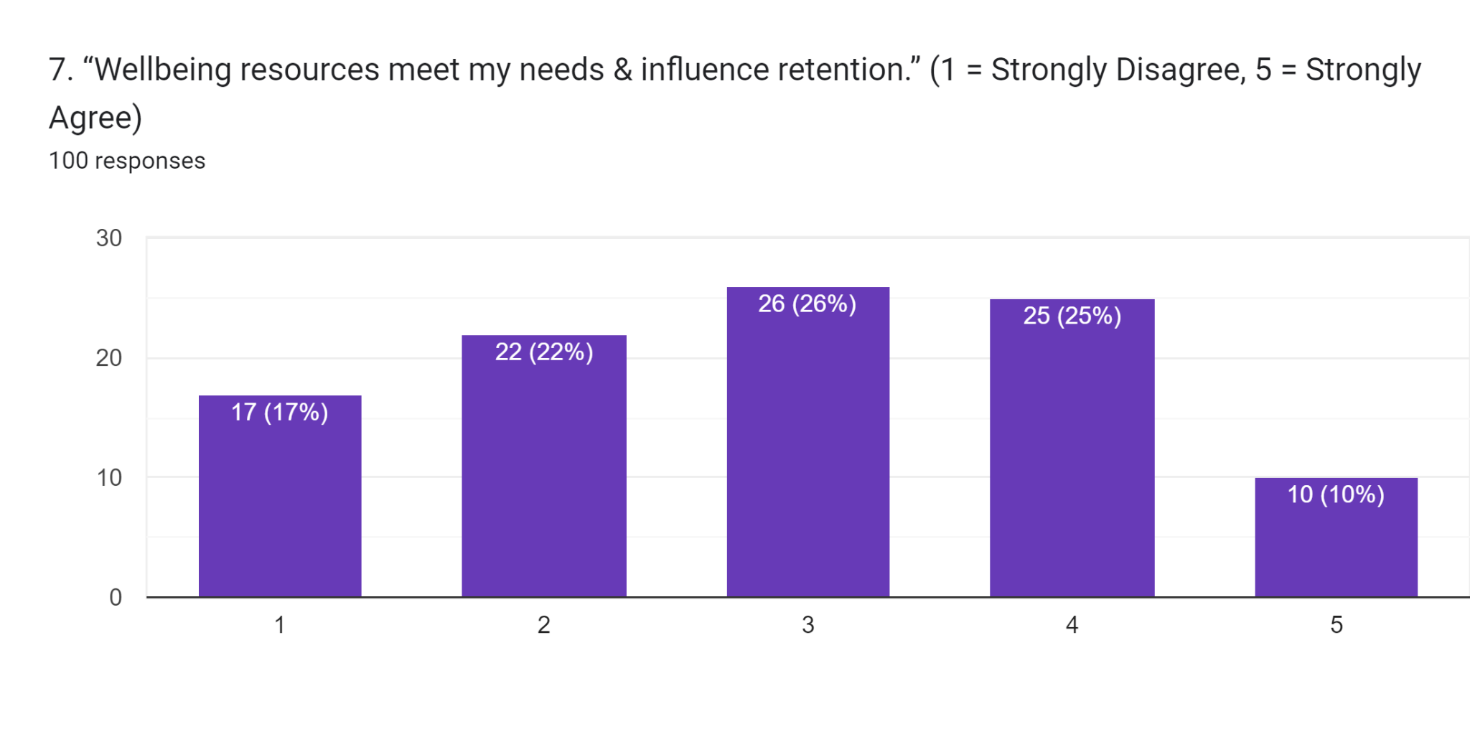
Question 8: Organisational Changes and Retention
Most of the respondents agreed or were neutral that organisational changes have the potential to enhance retention, and only a small percentage strongly disagreed. This is a sign of receptiveness of employees towards change and enhancement. The results indicate that workers are aware of the current gaps in retention policies and assume that the organisational or managerial changes can have a beneficial effect.
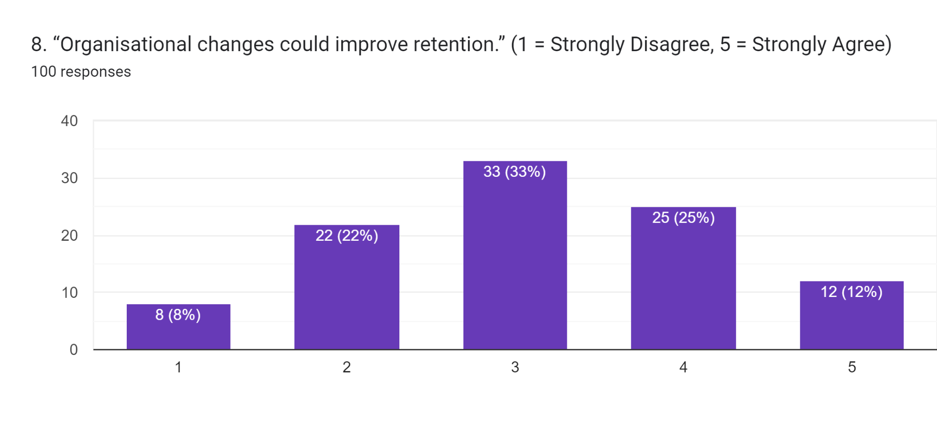
Question 9: Recognition and Feeling Valued
Perception of recognition and rewards was a minimal aspect with the highest percentage of respondents noting that there was disagreement (34). Though a portion of the employees felt they were being valued, the neutral and negative responses were more dominant which is a pointer that there is inconsistency in recognition practises. This is an implication that recognition of employees due to their contributions may not be regularly practised and that it may demoralise employees and make them less emotionally attached to the organisation.
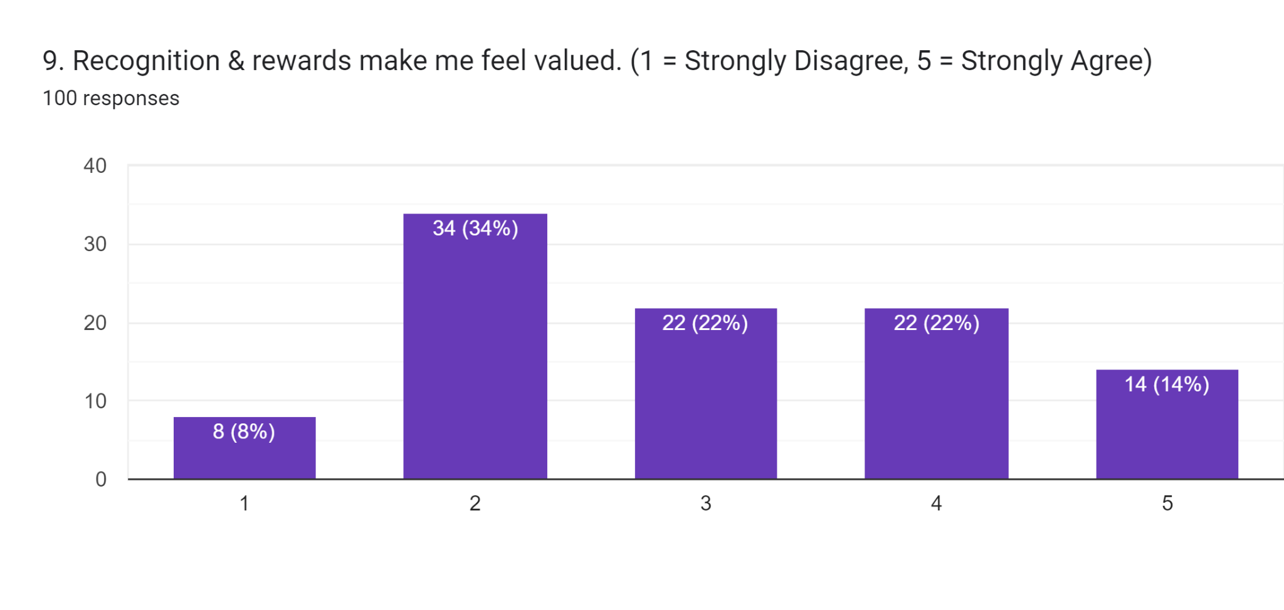
Question 10: Recommendation of Waitrose as a Workplace
Their responses indicate moderate organisational advocacy with the largest percentage of 28 percent selecting neutral. Although 37% would most likely or certainly recommend Waitrose, there was a high proportion among those who did not want to. This means that the employees are not well engaged nor committed followers. This kind of ambivalence indicates indecisive workplace experience and proposes opportunities to enhance the retention and employer branding.
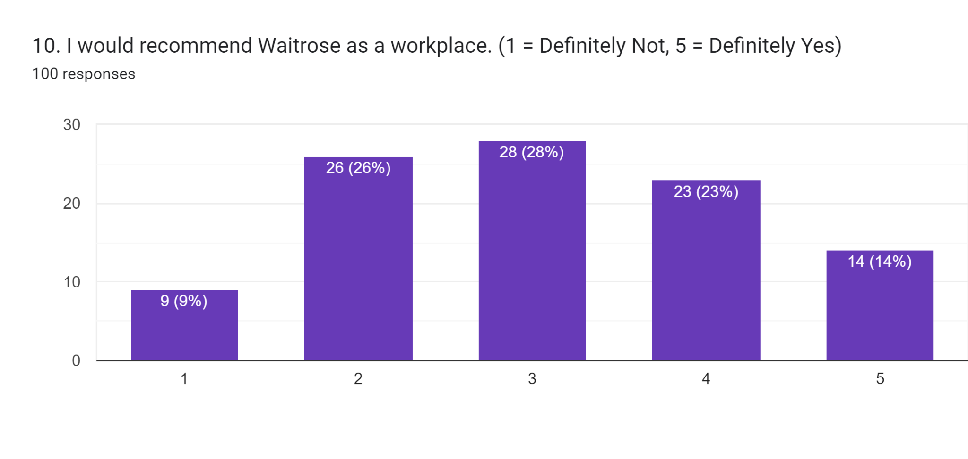

4.2.2 Qualitative Analysis
Question 1: Employee Perceptions of Retention Practices
The respondents interviewed had mixed views about the current retention practises at Waitrose. Some of the employees recognised that positive values including fairness, respect and involvement of the employees are encouraged in the organisation leading to generally favourable working environment. Nevertheless, numerous respondents reported that in most cases, retention implementation was not always encountered at the same level across stores or department. Certain employees viewed retention efforts as very symbolic meaning that there were policies on paper which were not necessarily translated into the daily practise. Others pointed out that the retention programmes were more geared towards earlier demands than it would be in developing employees over the long-term. In general, although employees understood that Waitrose planned to retain staff, it was a collective opinion that the existing practises can be better proactive, personalised, and in line with the emerging expectations of the employees.
Question 2: Leadership Support and Communication
The theme of leadership support and communication was also of high importance throughout the interviews, and participants noted an apparent difference between managerial positions and place. Employees that indicated that they enjoyed good relationships with line managers mentioned open communication, approachability, and frequency of feedback as attributes that were valued as strengths. Conversely, some reporters had little contact with managers especially when they were busy and this resulted in feelings of not being engaged. There were also observed differences in roles where the supervisory and managerial staff reported having access to more communication channels than the frontline employees. Some of the respondents observed that unstable leadership styles affected team morale and trust. These results imply that in certain regions effective leadership can be found, but to the detriment of employee engagement and retention intentions they might be undermined with inconsistent communication practises.
Question 3: Motivation and Employee Ownership
The respondents had a diverse perception on the motivational effects of the employee ownership model at Waitrose. Other employees had stated that they were proud of being with an employee owned organisation and that they felt belonging there and that they had a sense of responsibility. This emotional attachment was more pronounced to the longer serving staff. Nonetheless, there are those who considered ownership to be more symbolic, having little who impacted their daily working experience. Some respondents separated emotional ownership and practical ownership, where profit-sharing as well as formal ownership rights were not necessarily the reason to have more influence on decisions and career advancement. Therefore, although the ownership model had a positive effect on the organisational identity, the motivational effectiveness was perceived as skewed and based on the degree of its active support developed by management.
Question 4: Wellbeing and Recognition
Morale and retention were often mentioned as significant issues that are affected by wellbeing support and recognition. The respondents valued the provision of wellbeing resources and the attempt to enhance work-life balance. Nevertheless, other workers believed that these programmes were not always available or evident especially at times when workloads were high. The perception of recognition practises was still seen as being underdeveloped with informal recognition by management being more appreciated than the formal reward schemes. Some participants also stated that the absence of a consistent recognition made employees unmotivated and underrated. Generally, wellbeing and recognition were perceived to play an important role towards employee satisfaction, although, respondents stated that more frequent and tailored strategies need to be implemented to promote their influence on retention.
Question 5: Suggestions for Improving Retention
Participants provided some positive ideas when questioned on ways of enhancing retention. The general feedbacks were the suggestion to have more precise career progressions, more opportunities to train, and improve the communication of changes in the organisation. Other things that the employees stressed on to enhance trust and engagement include the use of consistent leadership behaviour and frequent feedback. Recognition on the individual and team bases was also recommended as a cheap but effective retention measure. Also, the respondents indicated the necessity of increased flexibility in workplace policies to accommodate the work-life balance. Taken together, these recommendations can be interpreted as the wish to see the retention strategy extending past formal policies and look into the concrete and daily experiences that employees go through.

4.3 Secondary Thematic Analysis
Theme 1: Leadership Support and Retention
The issue of the quality of leadership has consistently been found prevalent in the literature as a decisive factor of employee retention especially within labour-intensive industries like retail. Siyal (2023) underlines that the positive outcomes of effective leadership are that it promotes trust, psychological safety, and employee engagement, which play a pivotal role in ensuring the minimisation of turnover intentions. Nonetheless, the results of this paper demonstrate a more intricate and sophisticated connexion between the leadership support and retention in Waitrose. The quantitative data demonstrate that the attitude towards managerial support and communication was moderate (mean = 2.81) and the correlation analysis revealed no statistically significant linear connexion between leadership support and job satisfaction or referral of Waitrose to a place to work. This insignificant relationship differs with most of the literature literature that identifies leadership as a powerful indicator of retention (Choy and Kamoche, 2021). The qualitative results connote the presence of such discrepancy by highlighting significant inconsistency of the leadership practise in both roles and locations. The participants of the interview noted that some managers were accessible and supportive whereas others were mostly inaccessible owing to the influence of operation and mostly during high trading times. In terms of the Social Exchange Theory (Ahmad et al., 2023), leadership support must be viewed as a kind of investment by an organisation that can be rewarded by the involvement of the employees, who will, in turn, reward it with loyalty and commitment. Nonetheless, the lack of a statistically significant association indicates that the employees might not see the support aspect of leadership as being the same and meaningful enough to elicit the reciprocal retention behaviours. Jung, Yoo and Arnold (2021) claim that in the retail setting, when one is interacting with supervisors often, the fairness and communication expectations are increased; when these expectations do not work, the relationship in an exchange becomes weaker. Such deviation points out a severe problem: the presence of leadership is not enough without its consistency and authenticity. The results imply that Waitrose leadership is uneven, which restricts its overall effectiveness in the field of retention results. Although there are some pockets of leadership support, it does not seem to be systematically incorporated throughout the organisation. This justifies the argument by Mey, Poisat and Stindt (2021) that leadership should be experienced at the operational level on a regular basis in order to exert any meaningful impacts on retention. As such, Waitrose leadership is a contingent retention force but not a universal force.
Theme 2: Motivation, Employee Ownership and Engagement
The issue of employee ownership and its high motivational power is widely advocated especially in the John Lewis Partnership model. In theory, ownership cannot be neutral to intrinsic motivation, commitment, and engagement because it promotes autonomy, purpose, and shared success (Shipper and Hoffman, 2020). Nevertheless, the results of this research demonstrate that there is no correspondence between what theory and practise should entail and practical employee experience in Waitrose. Survey data have shown that motivation based on the employee ownership model was neutral (mean = 3.01), and correlation analysis showed that the ownership motivation was not significantly related to job satisfaction or organisational recommendation. These findings indicate that ownership is not a powerful factor that can have an impact on retention-related outcomes. The results suggested by the interviews further indicate that some of the employees were emotionally attached to the ownership model but many of them thought of the model as more of a symbolic expression as opposed to empowering them practically. The Two-Factor Theory developed by Herzberg can be used to explain this tendency. Even though in theory ownership can act as a driving force, its effectiveness will be determined by whether it yields into meaningful recognition, responsibility, and growth opportunities (Alrawahi et al., 2020). The qualitative results indicate that at Waitrose ownership is not operationalised well in the work practises of the day. The lack of control over the decision-making process and ambiguity of future career growth discouraged motivational power of ownership reported by employees. This problem is further explained by Maslows Hierarchy of Needs. Although employee ownership could fulfil higher-level needs such as belonging and esteem, many respondents seemed to still have some unmet lower-level needs, such as job security, development opportunities and fair recognition (Omodan, 2022). According to Cottrell (2021), higher-order motivational processes become ineffective in cases where the fundamental needs are not met. These data help to substantiate the thesis of Ned and Umesi (2023) according to which the outcome of ownership without empowerment can be not transformative but merely performative. In Waitrose, employee ownership seems to have a positive impact on organisational identity yet does not help to achieve a high level of engagement and retention without a good leadership structure and developmental support. This theme supports the central idea of the study that the structural ownership should be accompanied by daily management activities to bring significant retention returns.
Theme 3: Wellbeing, Recognition and Job Satisfaction
The concept of wellbeing and recognition have become important in being considered as part of contemporary retention programmes, especially in the cut-throat retail setting. The sources posit that wellbeing programmes, appreciation practises should support psychological safety and satisfaction, add to the psychological contract between the employer and its employees (Wang and Heyes, 2020). This research study findings made in quantitative terms show that the level of job satisfaction was marginally less than the neutral (mean = 2.96), which is an indicator that the staff is not hugely unhappy, but rather does not strongly engage. Results of the regression analysis indicated that wellbeing support and recognition were not significantly correlated with willingness of the employees to recommend Waitrose. Although these results might seem counter-intuitive to the available literature, the qualitative information can be used to identify significant contextual detail. Participants in this interview admitted to having wellbeing initiatives but mostly spoke about them as not being visible or accessible when there was a lot of work. The process of recognition was also seen as inconsistent and highly contingent on individual managers, which is consistent with the claim by Herzberg that recognition should be timely and meaningful to serve as a motivator (Alrawahi et al., 2020). With occasional recognition or informal recognition, the effect of recognition on retention is minimised. Regarding the Social Exchange Theory, incongruous acknowledgement dilutes the organisational support perceptions (Ahmad et al., 2023). The employees may consequently develop a sense of unbalanced exchange relationship whereby excessive efforts are not always rewarded with sympathy or concern. This imbalance is part of emotional disengagement as opposed to instant turnover which serves to explain the poor statistical associations that seem to exist. Another aspect that Maslow framework puts forward is that the wellbeing and recognition consider the safety and esteem needs. Yet, when these needs are not fulfilling completely, their role in influencing retention is not as large. Akram, Abbas and Khan (2022) claim that wellbeing programmes that have unsuccessful practise in retailing do not require nonexistence, but improper implementation and communication. This seems to be in line with the results found at Waitrose, where wellbeing and recognition are present, but these do not have adequate incorporation into the day-to-day operation culture.
Theme 4: Retention and Organisational Performance
The last theme is the connexion of the employee retention strategies to the performance of an organisation which is a central focus of this study. The current literature is heavily connected with retention and productivity, service quality, and customer satisfaction, especially in the service-oriented industries (Wang and Heyes, 2020). Nevertheless, the empirical results of the present research contradict the notion of the simple and straight correlation. The regression analysis showed that the percentage of corporate variables that explained the willingness of employees to recommend Waitrose was only 2.2 and the model proved to not be significant. Instead of weakening the study, this result estimates the complication of the relationship between retention and performance of the employees owned retail organisation. There has been some information on interviews that employees might not increase their levels of dissatisfaction enough to stop providing acceptable levels of service, which is a sign of professional commitment but not personal attachment. This is consistent with the argument of Choy and Kamoche (2021) that service quality in retail employees is usually upheld by customer-facing norms, even in the low-engagement situation. Therefore, often customer experience performance indicators do not represent retention problems on the surface. In addition, Akram, Abbas and Khan (2022) observe that the result of performance is usually affected by a variety of external factors such as the level of staffing, system of operations, and market forces. The weak statistical significance of the relationships that are found in this study might indicate that retention strategies will not bring about the improvements in performance without the accompanying organisational alignment. This theme supports the idea of considering retention as a strategic investment, and not a performance lever, as a long-term. In Waitrose, there are no well-established statistical correlations of the retention factors with the organisational recommendation, suggesting that the performance sustainability can be determined by more profound cultural and structural changes. These results can be supported by Nguyen et al. (2022), who suggest that the retention strategies in the employee-owned companies should be stronger integrated with the leadership systems to be transformed into the measurable performance results.

4.4 Discussion
The chapter has integrated findings of quantitative survey analysis, qualitative interviews data and secondary thematic analysis to investigate employee retention practises in Waitrose and their impact on performance of the organisation. The discussion has added a layer of complexity, situational and non-linearity of employee retention in an employee-owned retail organisation through the incorporation of multiple data sources. Even though literature is very keen on placing leadership, motivation, wellbeing, and recognition as the main drivers of retention, the results of this paper show that these areas do not work consistently and consistently in the Waitrose environment.
Among the outcomes of the quantitative analysis, one of the most important features is the occurrence of weak and statistically insignificant relations between the retention factors and the main outcome variables such as job satisfaction and the readiness of the employees to recommend Waitrose a place to be employed. The regression analysis also established the fact that leadership support, employee ownership motivation, wellbeing resources and recognition did not contribute significantly to organisational recommendation. Instead of negating previous studies, these findings complement the argument in support of which retention dynamics are highly contextual, and that which must be guided by the conditions specific to sectors. The retail business sector is highly operationally strained, client-facing, role-switching as Choy and Kamoche (2021) imply, potentially weakening the quantifiable effects of the individual retention programmes on the staff attitudes and behaviours.
The qualitative interview results give key explanatory evidence to these low statistical relationship. Contributors have continuously stated that the level of leadership assistance and communications differed significantly among retail outlets and management levels. Whereas other employees reported that they have had supportive and approachable leadership, other employees report that there is a lack of presence of the managers especially when the operations are at its peak. Such contradiction makes leadership as a retention driver seem less reliable. In the same manner, the employee ownership which was the main element of the John Lewis Partnership model was mostly seen as an emotionally charged, though practically constrained, notion. Interviewees often made a difference between symbolic ownership and real empowerment, showing that being a possessor did not necessarily mean having more power on decision making or definite career development.
These results share many similarities with the Social Exchange Theory that underlines the importance of employees being committed to the organisation based on the perception of fairness, consistency, and mutual organisational support (Ahmad et al., 2023). Consistency of the leadership behaviours, wellbeing initiatives or recognition practises when inconsistently applied may lead to employees feeling an uneven balance in the exchange relationship. This can cause them to carry out their functions in a professional and less emotional manner, which is why the retention factors showed a weak predictive ability in the regression model. This indicates that moderate dissatisfaction does not cause employees of Waitrose to gradually cease acceptable performance and leave the organisation at once.
These findings can also be further placed in context by comparison to previous studies. Though Alrawahi et al. (2020) and Omodan (2022) emphasise that recognition and higher-level psychological needs are motivational, the results of the given study demonstrate that they can be ineffective in case other more basic needs, including steady leadership support, opportunities to develop, and role evidentness, are not fulfilled satisfactorily. On the same note, despite the fact that employee ownership is theoretically linked to a higher level of engagement and loyalty (Shipper and Hoffman, 2020), the results confirm the statement by Ned and Umesi (2023) that ownership without a real-world empowerment will be more of a symbol than change.
This has a significant implication to the retention strategy of Waitrose. The results are that retention is impossible when isolated efforts are used, symbolic ownership structures, and sole wellbeing policies. Rather, retention strategies should be incorporated into the daily managerial practise and include the reinforcement of the same behaviour by leadership at the organisational level. Opening up and constant feedback, as well as a career development structure, seem critical in enhancing worker trust and engagement. In addition, wellbeing and recognition programmes should be operationalised on the line management level so that they can be felt on a regular basis as opposed to being felt once in a while.
Significantly, the loose correlation realised between the retention strategy and the organisational performance demonstrates the shortcoming of performance-focused retention interventions within short time span. Instead of short-term quantified results, Waitrose can gain through a long-term, systemic strategy where organisational values, leadership practise and experiences of the employee are aligned. This kind of alignment will probably bolster the psychological contract, and increase retention sustainability in the long run.
To sum it up, this discussion shows that organisational structures, leadership consistency, and employee perceptions as opposed to individual retention initiatives are the issues that define employee retention in Waitrose. The insights offer a solid basis on the recommendations on Chapter 5, which aims at ensuring the consistency of leadership, greater practical employee empowerment, and matching retention plans to organisational operational reality to contribute to sustainable organisational performance.

CHAPTER 5: CONCLUSION AND RECOMMENDATIONS

5.1 Introduction
The chapter also sums up the major findings as pertinent to the research aim and objectives. It provides evidence-based conclusions, gives practical recommendations to Waitrose, gives the implications to managers, identifies limitations of the study and gives future research direction.

5.2 Summary of Key Findings
It was found that the quantitative results indicated moderate levels of employee perceptions on the main retention variables, which comprise job satisfaction, leadership support, motivation through employee ownership, and organisation recommendation. The correlation analysis proved weak and statistically non-significant association between the variables of leadership support, ownership motivation, wellbeing, recognition, job satisfaction, and organisational recommendation. The regression analysis also revealed that the effect of all these retention factors on employees on their willingness to recommend Waitrose was not very high and this is a limit to the predictive ability of these factors. The results were further explored by the findings of qualitative interviews. Employees reported that retention practises are good intentioned but are not always applicable across roles and store. The level of leadership support and communication also appeared to be significantly different, which affected morale and engagement disproportionately. Some participants highly rated employee ownership as a sentiment but considered that it was very symbolic by other participants and had minimal effects on day to day empowerment. Wellbeing and recognition programmes were realised but perceived as inconsistently observable and reliant on managers. These findings were strengthened using the secondary thematic analysis that indicated a lack of congruence between the theoretical expectations and the organisational practise. Generally, the retention issues identified in the Waitrose case comprise unstable leadership behaviours, poor practical empowerment by ownership as well as unequal wellbeing support and poor integration between retention efforts and the performance outcomes in the organisation.

5.3 Conclusions in Relation to Research Objectives
Objective 1: Factors Influencing Retention
The paper concludes that leadership consistency, practical empowerment and recognition practises are related to the perceptions of retention in Waitrose. Nevertheless, these aspects do not work intensively and consistently enough to induce substantial foresight of the remaining outcomes, which portrays structural and execution breaks.
Objective 2: Employee Perceptions
There was a general perception of moderateness of leadership, ownership, and wellbeing among the employees as opposed to strong perception. The support of leadership and recognition were not realised equally, and the employees were seen to own their companies in theory, but not authority. These beliefs restrained the inspirational effects of retention tactics.
Objective 3: Retention and Organisational Performance
The research arrives at the conclusion that the retention strategies in Waitrose exhibit poor direct relationship with organisational performance as indicated by weak correlations and regression outputs. This implies that the retention initiatives and operational practises require a more intensive strategic alignment and that the results of the performance may be maintained using professional norms instead of high-engaging practises.

5.4 Recommendations for Waitrose
Leadership Development and Consistency
Waitrose ought to focus on standard leadership behaviours throughout stores by initiatingLine manager development programmes that are well organised. The areas that should be trained include communication, feedback, and support of the employees under the circumstances of operational pressure (Kononenko et al., 2024). There would be clear accountability mechanisms that involve leadership performance measure which is pegged on engagement results, which would be used to ensure that leadership practises are implemented throughout the organisation.
Strengthening Employee Ownership in Practice
Waitrose should enhance employee ownership by having the practise of practical empowerment, which goes above profit-sharing. This may involve better career developmental opportunities, greater participation of employees in the decision-making process as well as better communication on how the employee voice determines the results. It would be better placed to instil ownership in the day-to-day management life to make its ownership more credible and motivating (Schulze and Zellweger, 2021).
Enhancing Wellbeing and Recognition
Programmes focused on wellbeing need to be more exposed and available at all positions. The managers of the lines are supposed to be encouraged to discuss wellbeing as part of the normal interaction. Practises of recognition should aim at giving frequent, informal recognition of contributions and effort so that the employees also feel that they are represented as employees but not as isolated instances (Hancock, 2024).

5.5 Practical and Managerial Implications
The results provide practical implications to the HR managers at Waitrose by stating the significance of consistent leadership delivery and operationalised retention strategies. In the case of employee-owned retail organisations, the analysis shows that the ownership structures do not work without empowerment and development. The study has a role to play in designing retention strategies because it portrays a point of alignment to ensure from the organisational values and leadership behaviour to everyday employee experiences, the aspect of thorough retention effects can be realised.

5.6 Limitations of the Study
The research has limitations, but the sample size is too small and convenience sampling is also used; therefore, generalisability is limited. This cross-sectional will only capture the perceptions at some time and data used might be self-reported which could be bias.

5.7 Recommendations for Future Research
The future study might be done using longitudinal designs to investigate retention over time and use larger samples taking into consideration various retail organisations. It would be interesting to carry out comparative studies on employee owned and non employee owned retailers (Hancock, 2024). The use of objective performance measures would also be beneficial in further enhancing the insight into the retention-performance relationship.

5.8 Final Conclusion
Overall, this paper reveals that leadership consistency, empowerment and recognition are the areas that define employee retention at Waitrose as opposed to ownership. Through the focus on the gaps identified, Waitrose will be able to enhance the level of engagement in its employees and contribute to long-term organisational sustainability.

Reference
Ahmad, R., Nawaz, M.R., Ishaq, M.I., Khan, M.M. and Ashraf, H.A., (2023). Social exchange theory: Systematic review and future directions. Frontiers in psychology, 13, p.1015921.
Akram, M.W., Abbas, A. and Khan, I.A., (2022). Effects of perceived value, service quality and customer trust in home delivery service staff on customer satisfaction: evidence from Pakistan. International Journal of Management Research and Emerging Science, 12(4).
Alrawahi, S., Sellgren, S.F., Altouby, S., Alwahaibi, N. and Brommels, M., (2020). The application of Herzberg's two-factor theory of motivation to job satisfaction in clinical laboratories in Omani hospitals. Heliyon, 6(9).
Bredal, A., Stefansen, K. and Bjørnholt, M., (2024). Why do people participate in research interviews? Participant orientations and ethical contracts in interviews with victims of interpersonal violence. Qualitative research, 24(2), pp.287-304.
Chatzoudes, D. and Chatzoglou, P., (2022). Factors affecting employee retention: Proposing an original conceptual framework. International Journal of Economics and Business Administration, 10(1), pp.49-76.
Chen, S.W., Keglovits, M., Devine, M. and Stark, S., (2022). Sociodemographic differences in respondent preferences for survey formats: Sampling bias and potential threats to external validity. Archives of rehabilitation research and clinical translation, 4(1), p.100175.
Choy, M.W. and Kamoche, K., (2021). Identifying stabilizing and destabilizing factors of job change: A qualitative study of employee retention in the Hong Kong travel agency industry. Current Issues in Tourism, 24(10), pp.1375-1388.
Cottrell, S., (2021). Skills for success: Personal development and employability. Bloomsbury Publishing.
GOV.UK (2023) “Competition, choice and rising prices in groceries” Available at: https://assets.publishing.service.gov.uk/media/64b80adaef5371000d7aeefb/Competition__choice_and_rising_prices_in_groceries.pdf [Accessed on 15th December 2025]
Jung, J.H., Yoo, J.J. and Arnold, T.J., (2021). The influence of a retail store manager in developing frontline employee brand relationship, service performance and customer loyalty. Journal of Business Research, 122, pp.362-372.
Marks & Spencer (2023) “Reshaping” Available at: https://corporate.marksandspencer.com/sites/marksandspencer/files/marks-spencer/investor/Annual%20Report%202023/M%26S_AR23_Strategic_report.pdf [Accessed on 15th December 2025]
Mas, A. and Pallais, A., (2020). Alternative work arrangements. Annual Review of Economics, 12(1), pp.631-658.
McKinsey & Company (2022) “How retailers can attract and retain frontline talent amid the Great Attrition” Available at: https://www.mckinsey.com/industries/retail/our-insights/how-retailers-can-attract-and-retain-frontline-talent-amid-the-great-attrition [Accessed on 15th December 2025]
Meeker, W.Q., Escobar, L.A. and Pascual, F.G., (2021). Statistical methods for reliability data. John Wiley & Sons.
Mey, M.R., Poisat, P. and Stindt, C., (2021). The influence of leadership behaviours on talent retention: An empirical study. SA Journal of Human Resource Management, 19, p.9.
Ndatshe, Y., Mokhele, M.O. and Jakoet-Salie, A., (2024). The effects of employee turnover on the loss of organisational knowledge in South African municipalities: Balancing rhetoric with actual practice. International Journal of Research in Business & Social Science, 13(7).
Ned, A.E. and Umesi, C.D., (2023). Effective leadership and employee motivation for sustainable development. Journal of Education in Developing Areas, 31(2), pp.310-321.
Negt, P. and Haunschild, A., (2025). Exploring the gap between research and practice in human resource management (HRM): a scoping review and agenda for future research. Management Review Quarterly, 75(1), pp.837-879.
Ngamkroeckjoti, C., Klongthong, W. and Thavorn, J., (2022). Motivational factors influencing telework during the COVID-19 pandemic. Emerging Science Journal, 6 (Special Issue), pp.229-246.
Nguyen, D., Homolka, L., Hoang, S. and Nguyen, H., (2022). Employee retention and the moderating role of psychological ownership in retail. Operations and Supply Chain Management: An International Journal, 15(3), pp.313-327.
NIH (2019) “Selection of Appropriate Statistical Methods for Data Analysis” Available at: https://pmc.ncbi.nlm.nih.gov/articles/PMC6639881/ [Accessed on 15th December 2025]
NIH (2021) “Servant Leadership and Employee Engagement: A Qualitative Study” Available at: https://pmc.ncbi.nlm.nih.gov/articles/PMC8520456/ [Accessed on 15th December 2025]
NIH (2023) “Frontline Health Care Workers’ Mental Health and Well-Being During the First Year of the COVID-19 Pandemic: Analysis of Interviews and Social Media Data” Available at: https://pmc.ncbi.nlm.nih.gov/articles/PMC10426381/ [Accessed on 15th December 2025]
Ohunakin, F., Adeniji, A.A., Ogunlusi, G., Igbadumhe, F. and Sodeinde, A.G., (2020). Talent retention strategies and employees’ behavioural outcomes: empirical evidence from hospitality industry. Business: Theory and Practice, 21(1), pp.192-199.
Omodan, B.I., (2022). Analysis of" Hierarchy of Needs" as a strategy to enhance academics retention in South African universities. Academic Journal of Interdisciplinary Studies, 11(3), pp.366-376.
Reyes, A.G., (2024). An Analysis of Herzberg’s Two-Factor Theory of Motivation and Employee Turnover in The BPO Industry. International Journal of Management and Education in Human Development, 4(04), pp.1446-1452.
Salama, R., Uzunboylu, H. and El Muti, M.A., (2020). Implementing online questionnaires and surveys by using mobile applications. New Trends and Issues Proceedings on Humanities and Social Sciences, 7(2), pp.48-70.
Scott, J., Waite, S. and Reede, D., (2021). Voluntary employee turnover: A literature review and evidence-based, user-centered strategies to improve retention. Journal of the American College of Radiology, 18(3), pp.442-450.
Shelley, A. and Horner, K., (2021). Questionnaire surveys-sources of error and implications for design, reporting and appraisal. British Dental Journal, 230(4), pp.251-258.
Shipper, F. and Hoffman, R.C., (2020). John Lewis partnership approaching 100 years–what now?. The CASE Journal, 16(2), pp.227-271.
SHRM (2024) “Improving Employee Retention and Reducing Turnover” Available at: https://www.shrm.org/topics-tools/tools/toolkits/managing-employee-retention [Accessed on 15th December 2025]
Sinurat, V. and Widhianto, C.W., (2023). The influence of job satisfaction and employee retention on employee performance mediated by perceptions of leadership style. International Journal of Social Service and Research, 3(10), pp.2672-2680.
Siyal, S., (2023). Inclusive leadership and work engagement: Exploring the role of psychological safety and trust in leader in multiple organizational context. Business Ethics, the Environment & Responsibility, 32(4), pp.1170-1184.
Strouse, M.C. and Reed, F.D.D., (2021). Employee turnover and workforce stability. In Organizational behavior management approaches for intellectual and developmental disabilities (pp. 210-234). Routledge.
Thusi, X. and Chauke, R., (2023). Strategies for retaining scarce skills and reducing turnover in the South African public sector. International Journal of Management, Entrepreneurship, Social Science and Humanities, 6(1), pp.120-134.
Wang, W. and Heyes, J., (2020). Flexibility, labour retention and productivity in the EU. The International Journal of Human Resource Management, 31(3), pp.335-355.
Wren, D., (2020). The culture of UK employee-owned worker cooperatives. Employee Relations: The International Journal, 42(3), pp.761-776.
Kononenko, O., Ivanchenko, A., Gaivoronska, T., Khitrova, T., Semenko, S. and Kuzmin, V., 2024. Psychological and Social-Communication Aspects of HR Management Career in Wartime, Including Stress, Motivation, will and Efficiency of Working Conditions. Revista de cercetare si interventie sociala, 84.
Schulze, W. and Zellweger, T., 2021. Property rights, owner-management, and value creation. Academy of Management Review, 46(3), pp.489-511.
Hancock, P., 2024. Employee recognition programmes: An immanent critique. Organization, 31(2), pp.381-401.

Appendix

Appendix A: Interview Questions
- How would you describe your overall experience of working at Waitrose, particularly in relation to job satisfaction and motivation?
- What factors most influence your decision to remain working at Waitrose or consider leaving the organisation?
- How do leadership support and communication from managers affect your engagement and commitment to the organisation?
- In what ways does the employee ownership model at Waitrose influence your sense of belonging, motivation, and loyalty?
- What changes or improvements do you believe would be most effective in enhancing employee retention and performance at Waitrose?

Appendix B: Interview Responses
Interview Question 1
Question: How would you describe your overall experience of working at Waitrose, particularly in relation to job satisfaction and motivation?
Respondent | Response
R1 | My experience at Waitrose has been mostly positive, as the supportive culture and teamwork motivate me, although workload pressures sometimes reduce overall job satisfaction.
R2 | I feel generally satisfied working at Waitrose because the environment is respectful, but motivation can decline during busy periods due to staffing shortages.
R3 | Working at Waitrose gives me a sense of pride, especially because of the ethical values, though limited progression opportunities affect long-term motivation.
R4 | I enjoy the customer-focused nature of my role, but motivation fluctuates depending on management support and work-life balance.
R5 | Overall, I am satisfied with my job, but increasing responsibilities without corresponding rewards can impact my motivation levels.
R6 | My experience has been stable and supportive, though repetitive tasks sometimes reduce enthusiasm and long-term engagement.
R7 | I feel motivated by the team culture, but stress during peak trading periods can reduce job satisfaction temporarily.
R8 | Waitrose provides a positive working environment, but motivation would improve further with clearer development opportunities.
R9 | I value the respect shown to employees, yet motivation is sometimes affected by operational pressures and staffing gaps.
R10 | My job satisfaction is moderate overall, supported by teamwork, but motivation could improve with greater recognition of effort.
Interview Question 2
Question: What factors most influence your decision to remain working at Waitrose or consider leaving the organisation?
Respondent | Response
R1 | Factors influencing my decision include pay levels, workload balance, and whether I feel recognised for my contribution at work.
R2 | Job security and flexible working hours encourage me to stay, while limited career growth may push me to consider leaving.
R3 | Supportive colleagues and ethical values keep me at Waitrose, but rising living costs influence my long-term decision.
R4 | Management support and fair treatment strongly influence my decision to stay, more than pay alone.
R5 | I consider staying due to job stability, but stress and limited advancement opportunities sometimes make me consider alternatives.
R6 | The employee ownership model motivates me to remain, although workload pressures sometimes reduce commitment.
R7 | Positive workplace relationships encourage retention, while poor communication can influence thoughts of leaving.
R8 | Pay competitiveness compared to other retailers significantly affects my decision about staying long term.
R9 | Work-life balance and predictable shifts influence my commitment, especially alongside family responsibilities.
R10 | Feeling valued by managers is essential for retention, and a lack of recognition may increase turnover intentions.
Interview Question 3
Question: How do leadership support and communication from managers affect your engagement and commitment to the organisation?
Respondent | Response
R1 | Supportive leadership increases my engagement, especially when managers listen and respond to concerns effectively.
R2 | Clear communication from managers helps me feel valued and more committed to the organisation.
R3 | When managers provide feedback and guidance, my motivation and trust in the organisation improve.
R4 | Poor communication negatively affects morale, while supportive leadership strengthens commitment.
R5 | Leadership support makes daily challenges easier to manage and increases job satisfaction.
R6 | Engagement improves when managers are approachable and transparent about decisions.
R7 | Regular communication helps align my efforts with organisational goals and increases commitment.
R8 | Lack of communication can create uncertainty, reducing motivation and engagement levels.
R9 | Encouraging leadership positively influences my willingness to stay with the organisation.
R10 | Consistent managerial support increases trust and motivates me to perform better.
Interview Question 4
Question: In what ways does the employee ownership model at Waitrose influence your sense of belonging, motivation, and loyalty?
Respondent | Response
R1 | Employee ownership makes me feel more involved, but its impact depends on how much my voice is genuinely heard.
R2 | The ownership model increases loyalty, although daily pressures sometimes overshadow its benefits.
R3 | Knowing I am a partner gives a sense of pride and belonging at work.
R4 | Ownership motivates me, but practical benefits feel limited without visible influence on decisions.
R5 | The model encourages commitment, yet stronger communication about its impact would improve motivation.
R6 | I feel more loyal due to profit-sharing, though career development remains important.
R7 | Ownership creates a sense of responsibility towards the organisation’s success.
R8 | The concept of partnership is positive, but motivation depends more on leadership support.
R9 | Employee ownership enhances belonging, though not all employees fully understand its benefits.
R10 | The model promotes loyalty, but needs to be supported by recognition and development opportunities.
Interview Question 5
Question: What changes or improvements do you believe would be most effective in enhancing employee retention and performance at Waitrose?
Respondent | Response
R1 | Improved career development pathways would significantly enhance motivation and retention.
R2 | Increased staffing levels would reduce stress and improve performance.
R3 | Better recognition of employee contributions would strengthen engagement.
R4 | More flexible working arrangements would support work-life balance and retention.
R5 | Clear communication about progression opportunities would improve long-term commitment.
R6 | Enhanced leadership training for managers could positively influence retention.
R7 | Competitive pay adjustments would help retain experienced employees.
R8 | Greater involvement in decision-making would increase engagement.
R9 | Improved wellbeing support would enhance both retention and performance.
R10 | Consistent feedback and appreciation would motivate employees to remain longer.

Appendix C: Questionnaire
Employee Retention & Satisfaction Questionnaire – Waitrose (with 1–5 scale coding)
1. How long have you been working at Waitrose?
- Less than 1 year
- 1 – 2 years
- 2 – 3 years
- 4 – 5 years
- More than 5 years
2. What is your current job position?
- Customer Service Assistant
- Supervisor
- Duty Manager
- Branch Manager
- HR Staff
3. Satisfaction with current role
- 1 = Very Dissatisfied
- 2 = Dissatisfied
- 3 = Neutral
- 4 = Satisfied
- 5 = Very Satisfied
4. Support & communication from your line manager
- 1 = Very Dissatisfied
- 2 = Dissatisfied
- 3 = Neutral
- 4 = Satisfied
- 5 = Very Satisfied
5. Motivation from Waitrose’s employee ownership model
- 1 = Not Motivated
- 2 = Slightly Motivated
- 3 = Neutral
- 4 = Motivated
- 5 = Very Motivated
6. “The support and communication from my line manager is effective.”
- 1 = Strongly Disagree
- 2 = Disagree
- 3 = Neutral
- 4 = Agree
- 5 = Strongly Agree
7. “Wellbeing support and resources meet my needs & influence retention.”
- 1 = Strongly Disagree
- 2 = Disagree
- 3 = Neutral
- 4 = Agree
- 5 = Strongly Agree
8. “Organisational changes could improve employee retention.”
- 1 = Strongly Disagree
- 2 = Disagree
- 3 = Neutral
- 4 = Agree
- 5 = Strongly Agree
9. Recognition & rewards make you feel valued.
- 1 = Strongly Disagree
- 2 = Disagree
- 3 = Neutral
- 4 = Agree
- 5 = Strongly Agree
10. Would you recommend Waitrose as a good place to work?
- 1 = Definitely Not
- 2 = Probably Not
- 3 = Neutral
- 4 = Probably
- 5 = Definitely

Element 2: Research Process Reflection (Kolb’s Learning Cycle)
Concrete Experience
The research entailed the development and implementation of a mixed-method research to investigate employee retention practises at Waitrose. This involved the formulation of a systematic questionnaire, gathering of the responses of the surveys, interviews and analysis of data using excel. The process was initially difficult because of the complexity of matching the goals of the research with the right approach or making sure they are ethically sound. A thorough planning and organisation was necessary to manage several sources of data at a time. Practical limitations identified which included time limitations, variability of responses and anonymity also became necessary on collection of primary data among employees. These experiences gave first hand exposure to the reality of performing applied organisational research in a concrete retail environment.
Reflective Observation
Going through this experience, I realised that certain parts of the research process were strenuous than I expected especially analysis and interpretation of data. Although surveying the questionnaire appeared easy, to give meaning to the weak correlations and non-significant regression findings, there was the need to shift the perspective. My immediate reactions to these results were that I saw them as constraints but reconsideration showed that it contained important information about the issue of employee retention. The qualitative interviews also revealed discrepancies between the organisational policy and experience among employees. These results prompted me to be more critical of my assumptions and realise the critical role of contextual knowledge as opposed to the linear relationships identified in organisational research.
Abstract Conceptualisation
This reflection made me acquire a more conceptual idea of research as an iterative and interpretive process. The model proposed by Kolb helped me to realise the importance of the empirical findings interpreted in terms of the organisation and industry-specific circumstances. The learning process reinforced the theoretical knowledge on keeping employees, leading them, and motivating them by illustrating how a theory like the Social Exchange Theory or the Two-Factor Theory by Herzberg do not work perfectly in real life. It has also equipped me with an understanding of methodological rigour, specifically the importance of combining quantitative and qualitative evidence and producing further sophisticated findings. This phase has changed my perception about research as a process to a critical learning construction.
Active Experimentation
Based on these lessons to future research, I would be flexible and reflective in the lifecycle of the research. I would think more of piloting research instruments and the application of longitudinal designs in order to minimise time-dependent changes. I would also be more reflexive in the future projects especially where the findings fail to follow the expected pattern. Furthermore, I would attempt to incorporate stakeholder feedback as part of the research process as and when the research is more relevant and involved. On the whole, the given reflective learning experience has contributed to the development of my confidence, analytical abilities, and my willingness to perform the independent research more efficiently in academic and professional contexts.

Element 3: Methodology Poster – Research Process and Findings


