DIGITAL SKILLS AND
RESEARCHING METHODS

KRASIYAN KISYOV STUDENT ID:2028435
DIGITAL SKILLS AND RESEARCHING METHODS
SAQIB SANIM BSMW4003

In the last century the world and society has experienced a massive growth into the technology sector, making it an absolute must in the daily life.
Technology has become an essential part of any individual life. It assists with new inventions by making things smarter adequately for the society. (Beetham, H., & Sharpe, 2013)
Digital skills are necessary as it helps people managing professional online working practice with new and innovative ideas. These skills could be social media, cloud technology, web conferencing…
At workplace these technologies also play a huge factor, making things easier for the effective management.
In a fast developing 21st-century, digital skills help and push organizations competitiveness and innovation capacity.
Digital skills are defined as the skills needed to be used by communication apps, digital devices, and networks to manage information from any online searching and development. Digital skills are any type of skill that requires or involves technology in some sort of way.
A digital skill and research method is any type of process inside an organization that helps to increase the values and development for the future.

Any type of digital development in this century came because of the massive growth and development technology experienced the last years.

Technology can be defined as a set of skills, processes, types of commodities and services, or a scientific challenge solved in a way that benefits humans. Workplace technology refers to the application of technology in the administration of a company.
Nowadays, technology is used in every sector of every company.
Communication, control, accounting, and information are just a few examples. Success is achieved through integrating technology into the business. As a result, technology has become a critical component of every business and organisation around the world.

On this report I am going to focus on the virtual learning experience of my own university, University Trinity Saint David.
Virtual learning experience (VLE) refers to an artificial environment that replaces real life.
But virtual learning does not replace classrooms, they enhance them, they add value as they extend the space of the physical learning environment.
Virtual education is defined as instruction in a learning environment in which the teacher and the student are separated by time, space, or both. IT applications, multimedia resources, the Internet, videoconferencing, and other methods are used to deliver course information.
On this case I have prepared 10 questions as my survey, which I have used to collect primary data about the experience my colleagues had on the virtual learning experience.
As second, I will compare our experience with published material of the mentioned topic in different universities and students.

Virtual Learning Experience
1. What course are you studying at UWTSD? Certificate of higher education in skills for the workplace
2. What is your age range? Between 20-30/ Plus 35
3. Do you have adequate technical equipment? Yes/No/Not Adequate
4. Are your lectures entertaining? Very entertaining/ Entertaining/ Hardly entertaining/ Not at all
5. Are your lectures informative? Yes/ No/ Don´t know
6. What do you like the most about VLE? Flexibility/ Comfort/ Not having to travel/ Easy access
7. Did you enjoy your VLE? Strongly disagree/ Disagree/ Agree/ Strongly agree
8. Is it easier for you to distract inside an online environment? Yes/ No/ Sometimes
9. Which do you prefer between VLE and face to face? Face to face/ VLE
10. Rate your experience into the VLE from 1 to 10. 1/2/3/4/5/6/7/8/9/10

This are the questions with the possible answers I used to create my questionnaire in order to collect primary data information based on VLE.

As all of the students I have sent my questions study at the same university as me, the first question and answer are the same answer.

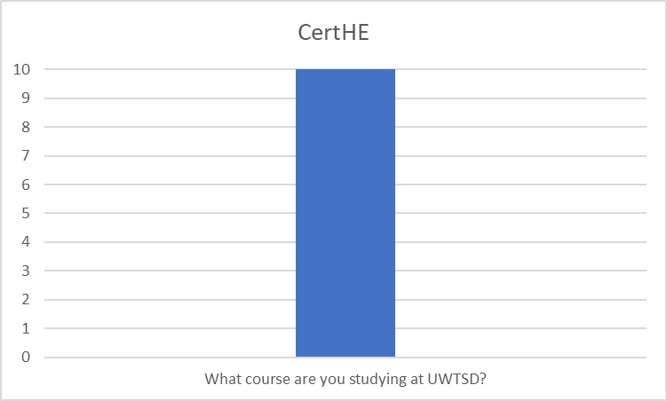
As we can see all 10 of the students, I have asked had the same answer.

In the second question this is the charts we can find.
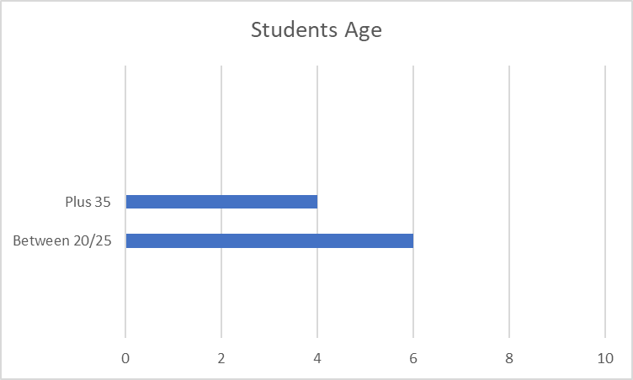

In the course there is a clear mix between younger students and more mature adults.
6 of which are between the age range from 20 to 30 years old and 4 of them are plus 35.
Within this scenario it is been argued that younger students have facilities or find it easier to dedicate themselves to the course due to the lack of other commitment they may have in their lives. From the other hand, more mature people have clear goals as well as more experience to deal with challenging situations.
In my own case I did struggle during the course because of the number of hours I work, is difficult to find energy or time to study fully.

Into question 3 I asked my colleagues about their equipment used at home.
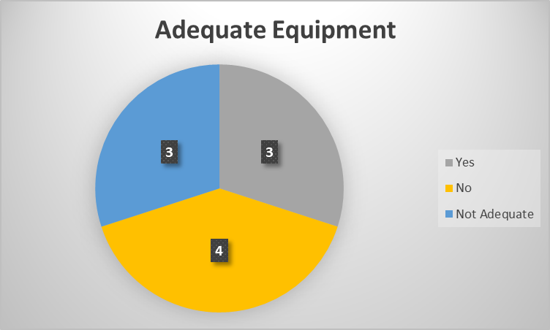

An adequate equipment, which could include not just a good working computer or laptop, but also headphones, microphone and even furniture as comfortable chairs, as sitting in a comfortable will increase the overall satisfaction during long period of hours.
We can see that just 3 of them consider having proper equipment, 4 marked a strict not, as many students now days use their smartphones to log into virtual classes, limiting the capability of their experience.
The other 3 marked not adequate which is not a strict NO, could mean they do have potentially computers and PCs, but may lack a good connection or any other feature mentioned above.

Fourth question is an interesting question to ask the students from both point of views, and it could require an important look from the lectures.
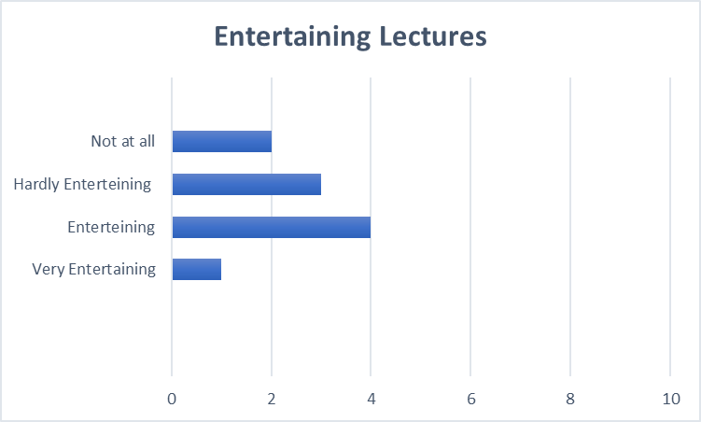

Online environments can be difficult to find entertaining for a lot of people, as they require a higher attention and offers a lot more of distractions due to factors as being at your room with your devices, and the fact that no one is watching or supervising if you are paying attention really or not, as it happens in face-to-face lectures.
In this case we can appreciate that there is a high percentage of students that do not find online classes entertaining, and this is a huge problem, because if VLE does not catch the attention of the students, those could significantly drop their marks and performance during the course.
In my case, I do find them entertaining but there is a huge number of times that I struggle to do so, making it harder to engage with the topic and rhythm of learning.
The next question is regardless how much information the students can learn from the VLE and is co-related with the previous one, as if we find something more entertaining, we will pay more attention and by that fact we will learn more about the lecture itself.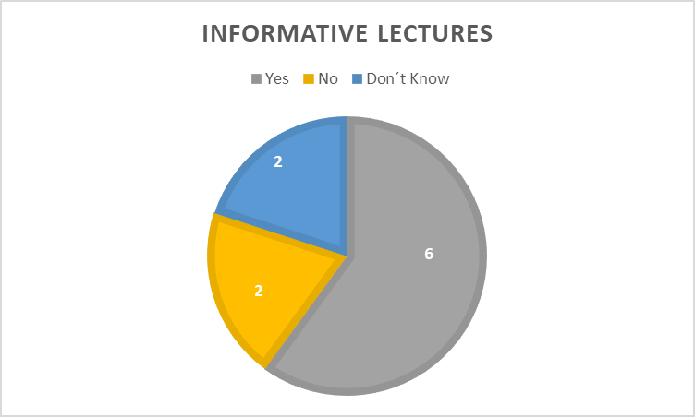
As we can see most of the class, even that may not all of them found the classes entertaining, they do find them informative in some type.
It could be argued that online classes could be more informative rather than entertaining in comparison with face-to-face classes, which are more social engaging.

The following question covers the advantages that an VL environment can offer against a face-to-face learning. The main advantage of the virtual learning itself is that you do not need to be physically present in the class, giving the student a huge flexibility with his personal circumstances. Another benefit of a virtual learning environment is the fact that students do not have to travel to the university, making this an economical factor for some as well as a time saving factor.
Those were the answer that UWTSD students provided.
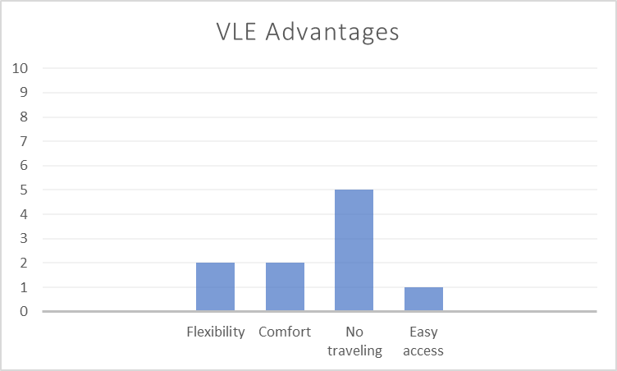

As we can see, there is a clear majority that think the biggest advantage of VL environment or experience is the fact that it is not necessary to travel to the campus, making a difference economically wise, and also the fact that many work during their week schedule, many of them still work even when they have lectures, for those who does not, having those lectures days off from work, not having to travel again from long week of work, is a positive and huge advantage of VLE against a face to face learning.
Flexibility and comfort could go hand on hand, as something more flexible is, usually, something that offer more comfort.
Factors such as avoiding traveling and the possibility of being in your own private space are examples of flexibility and comfort.

The next question is regardless the enjoyment that a virtual learning experience had or impacted the students.
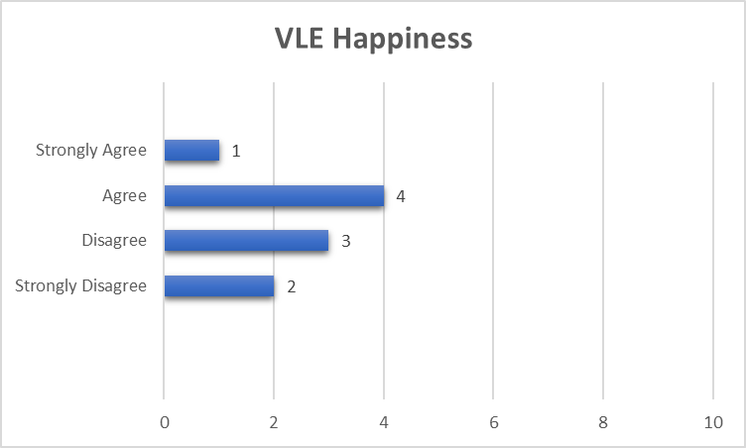
This is a close graphic, and we could argue that half of the class enjoy it and the other did not.
Even that there are some cases that are on the extremely opposite side, the rest is balanced. Is an extremely interesting graphic that shows how half of the students fluctuate between liking or disliking the virtual learning experience.
We could argue that the students that are happy with the experience usually have some other issues or personal circumstances that will make it harder for them to attended into a face-to-face classroom, making the VLE a perfect chance for them.
In the other hand, the other half of the students disagrees with a VLE or does not enjoy it as much, for reasons mentioned above, such as not being entertaining or being easier to distract inside a virtual environment while also being at home.
Many of them do also miss the social interaction not just between other students and meeting new people, but also a direct interaction with the lectures and professors.
In the following question and graphic we can see more about that.
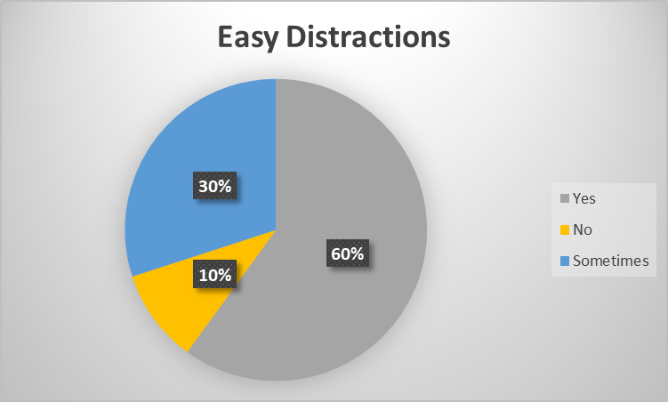
Again, we can see a clear majority of people claiming that inside a virtual learning environment they tend to distract more, as we can also include the students that just distract sometimes, this will increase the percentage to 90%, with just 10% of the students claiming that they do not have any distractions during the online lectures.
Distractions could come from anywhere, such as being and using your smartphone, the possibility to watch any type of website of a personal preference of the students, such as YouTube videos, gaming, or even the fact that the student does not need to be in his room or house to be connected to the class.
In this case we could argue that easier distractions are one big disadvantage of a virtual learning environment that students experience.

The following question is one of the most common ways to end a questionnaire, being straight to the point, and asking students about their personal preferences.
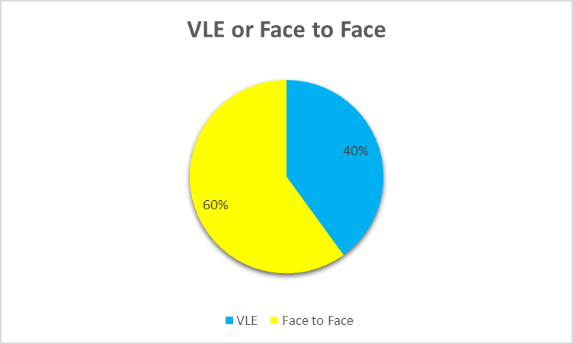
Between the choice of a virtual learning experience and environment or a face-to-face learning experience, the majority of the students chose or prefer to be in a face-to-face experience over the virtual one.
This was one of the questions, I personally wanted to ask to my colleagues, and also I did ask some students around my workplace, which is near UCL, for curiosity and also for my assignments reason, and even that I did not use that as my primary data, I can say that around 80 to 90% of the students I asked that frequent my coffee shop, prefer a face to face experience over the virtual one we had during these 2 years period due to the pandemic.

Many of them argued the same factors and reasons mentioned above, some of them added new particular reasons, such as starting to find courses not just boring but depressing, followed by a claustrophobic feel, not making or meeting any new people, and experiences of loneliness during the lectures.

The last question asked to the students was to rate their VLE from 1 to 10, 10 being the best and 1 the worst.
This is how the students rated it.
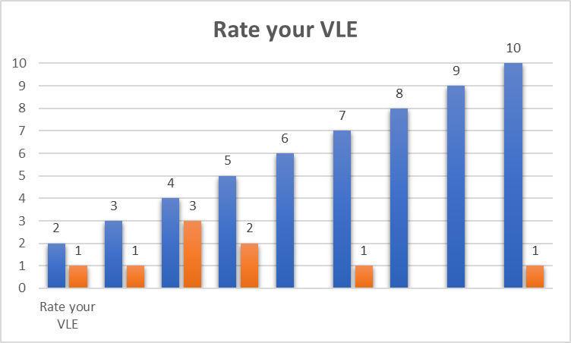
In blue colour we can see the marks from 1 to 10 and in orange, the number of students that rate the mark.
Just one of the students had an optimal experience rating VLE with a 10.
We can see that most of the numbers the students pick is from 2 to 5, rating their VLE
with an average mark. One of the students did not rate the VL experience.
Overall, with this graph we can say that it was not a positive experience inside the virtual learning environment.

In conclusion, VLE offers many and incredible advantages and helps a huge amount of people around the world specially with the factor that allows you to connect wherever you are, making this a future changing possibility for some, that cannot afford the cost of traveling to university or cannot leave their jobs to study at university or college.

In my own personal experience and not basing myself on graphics or articles about advantages or disadvantages, my VLE was more towards the negative side.
I am a person that enjoys the environment of being in the campus, living the full experience of going to university as many people, even my parents, did before me, socializing with my professors and meeting my colleagues with the possibility to speak with them in person. Some of the biggest friendships and future contacts are made in university, for me the VLE lacks this social environment and restricts they way you deal and meet people, creating a barrier for the mentioned factors.
Even with all the benefits it has, I will not choose a VLE over a real face to face experience in my university years.

References
Doan Thi Hue Dung. "The Advantages and Disadvantages of Virtual Learning." IOSR Journal of Research & Method in Education (IOSR-JRME), 10(3), (2020)

