NAME: SANNAH KAUSER
STUDENT NUMBER: 2423519
LECTURER NAME: RIZWAN NADIM
MODULE: INTRODUCTION TO PUBLIC HEALTH
MODULE CODE: LCHS4008
ASSIGNMENT TITLE: ASSESSMENT 2 - REPORT ON A HEALTH ISSUE
WHOOPING COUGH

TABLE OF CONTENTS
INTRODUCTION 3
MAIN CONSEQUENCES 3
For Families 3
For Communities 4
CONTROL OF WHOOPING COUGH 5
INFLUENCING FACTORS ON PATIENT AND FAMILY WELL-BEING 6
CONCLUSION 7
REFERENCES 8

INTRODUCTION
Whooping cough, or pertussis, is a highly contagious bacterial infection of the respiratory tract caused by Bordetella pertussis. It spreads through droplets when an infected person coughs or sneezes and is particularly dangerous for young infants (Wilmott, 2019). Early symptoms resemble a mild cold with runny nose, sneezing, tiredness and a mild cough, but after one to two weeks the illness progresses to severe bouts (paroxysms) of coughing followed by a characteristic “whoop” sound as the person gasps for breath; vomiting and exhaustion are common after these attacks (Wang et al., 2014).
Globally, the CDC estimates around 24.1 million cases of whooping cough and about 160,700 deaths each year in children under five, making it a major vaccine-preventable cause of mortality (CDC, 2024). After a temporary fall during COVID-19 restrictions, reported cases have risen sharply again. In England, laboratory-confirmed cases increased from about 856 in 2023 to nearly 14,900 in 2024, with several infant deaths, highlighting a serious public health concern in the UK (Uk Health Security Agency, 2024).

MAIN CONSEQUENCES

For Families
Whooping cough has significant consequences for individuals, families, communities and health services. For infants, especially those under three months who are too young to be fully vaccinated, pertussis can lead to pneumonia, apnoea (pauses in breathing), seizures, encephalopathy and death (Meda et al., 2025). Up to a third of infected infants may require hospital admission, often to high-dependency or intensive care units. Older children, teenagers and adults usually experience less severe disease but can still have a distressing cough lasting weeks or even months, sometimes called the “100-day cough”, causing sleep disturbance, urinary incontinence, rib fractures and prolonged absence from school or work (UNICEF, 2024).
For families, caring for a child with whooping cough is physically and emotionally exhausting. Parents may lose income due to time off work, and siblings may need to stay at home because of infection control advice. Anxiety can be intense when infants struggle to breathe or require hospitalisation, and guilt is common in parents who were unsure about vaccination or missed appointments. When outbreaks occur, social activities, childcare arrangements and school attendance can all be disrupted, placing additional strain on family life and informal support networks (Darby and Falco, 2018).

For Communities
At community level, pertussis outbreaks affect schools, nurseries, workplaces and healthcare settings. High levels of coughing illness in adults and adolescents help sustain transmission and expose unvaccinated babies and people with weakened immune systems (Darby and Falco, 2018). In Europe, more than 25,000 cases were reported in 2023 and over 32,000 in just the first three months of 2024, showing how quickly case numbers can climb when population immunity falls (European Centre for Disease Prevention and Control, 2024). In England, the recent surge to nearly 15,000 cases in 2024 was linked to reduced vaccine uptake during and after the COVID-19 pandemic and a growing number of under-immunised communities (Kasstan-Dabush, Chantler and Bedford, 2025).
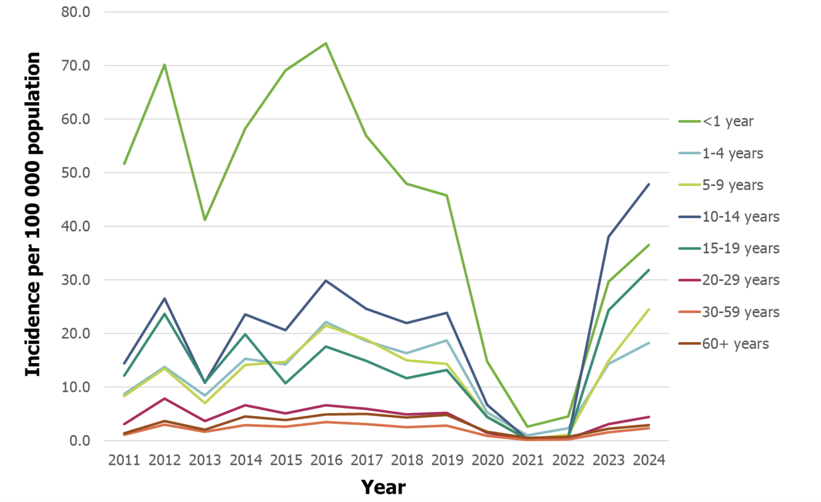
Figure 1: Incidence of pertussis cases reported to ECDC per 100 000 population, by age group and year, 2011–2024 (European Centre for Disease Prevention and Control, 2024).
For the NHS, the impact is wide-ranging. Hospital admissions for infants with severe pertussis increase pressure on paediatric wards, high-dependency beds and intensive care units. Each case requires careful infection prevention measures to protect other vulnerable patients (Kasstan-Dabush, Chantler and Bedford, 2025). In primary care, general practitioners and practice nurses spend time assessing coughing children, prescribing antibiotics where appropriate, arranging investigations and advising on isolation and return to school. Public health teams must trace contacts, offer post-exposure prophylaxis and review vaccination records, all of which require staff time and resources that could otherwise be used for other priorities. During large outbreaks, NHS services also manage increased demand for vaccination and for telephone advice from worried parentsc(Chisnall et al., 2025).
To summarise these consequences, the table below highlights key impacts on individuals, the community and the NHS:
Table 1: Key Impacts of Whooping Cough on Individuals, the Community and the NHS (Chisnall et al., 2025)
Level | Examples of Impact on Health & Well-being | Examples of Impact on Services & Society
Individuals/families | Infant pneumonia, apnoea, seizures, prolonged coughing, exhaustion, anxiety, financial strain from time off work | Repeated GP visits, emergency attendances, hospital admissions
Community | School and nursery outbreaks, disruption of education and childcare, worry in local population | Contact tracing, public health messaging, loss of productivity
NHS/health system | Pressure on paediatric wards and ICUs, increased antibiotic use, need for staff vaccination and training | Extra clinic time for catch-up vaccines, outbreak management costs

CONTROL OF WHOOPING COUGH
Control of whooping cough relies mainly on vaccination, supported by timely diagnosis, antibiotics and public health measures. The routine childhood immunisation schedule includes pertussis as part of a combined vaccine (for example the 6-in-1 vaccine in infancy and a pre-school booster), which has been highly effective in reducing severe disease and deaths where coverage is high (Decker and Edwards, 2021). Global estimates suggest around 85% of children complete the three-dose primary course of diphtheria–tetanus–pertussis vaccine, but coverage remains lower in some low-income countries and conflict zones (WHO, 2025). In the UK, pregnant women are also offered a pertussis-containing vaccine between about 20 and 32 weeks’ gestation, so that protective antibodies pass to the baby before birth. This maternal vaccination strategy has been shown to reduce the risk of severe pertussis and death in very young infants (Uk Health Security Agency, 2024).
However, declining vaccine uptake is a major challenge. In several parts of the UK, childhood vaccination rates are now below the 95% level recommended by WHO for herd immunity, and uptake of pertussis vaccination during pregnancy fell to around 59% in 2024 before beginning to recover (WHO, 2024). Reasons include appointment backlogs after COVID-19, reduced face-to-face contact with health visitors, mistrust of official information and misinformation spread through social media. As coverage falls, gaps in immunity allow periodic epidemics, which particularly endanger infants and those with chronic illness (Wang et al., 2014).
Antibiotics, usually macrolides such as azithromycin or clarithromycin, are used to treat confirmed or strongly suspected pertussis, especially in the early stages of disease. While antibiotics do not reverse damage already done to the airways, they reduce infectiousness and are important to limit spread to vulnerable contacts (Wang et al., 2014). Public health guidance in the UK recommends prompt antibiotic treatment for cases and prophylaxis for certain contacts (for example, household members of a young infant), alongside advice on staying away from school, nursery or work for a specified period. Updated UKHSA guidance in 2024 set out principles for managing cases during periods of high pertussis activity, including the length of exclusion, the window in which antibiotics are most useful and considerations for prescribing in pregnancy (UKHSA, 2024).

INFLUENCING FACTORS ON PATIENT AND FAMILY WELL-BEING
Beyond vaccination and antibiotics, broader factors influence the health and well-being of people affected by whooping cough. Socio-economic deprivation, overcrowded housing, limited access to primary care and language barriers can all delay vaccination and diagnosis, increasing the risk of severe disease and transmission. Families in insecure or low-paid work may struggle to take time off for appointments or to care for sick children, making isolation advice harder to follow. Communities with historical mistrust of institutions or past negative experiences of healthcare may be more open to anti-vaccine messages and less likely to engage with routine immunisation programmes (Godoy et al., 2016).
Psychological and social factors also play a role. Parents may feel blamed or stigmatised if their child becomes ill after missing vaccinations, which can make honest communication with healthcare professionals more difficult (Chisnall et al., 2025). Conversely, respectful discussion that acknowledges fears and provides clear, evidence-based information can strengthen trust and encourage uptake of catch-up vaccines. For older children and adults with prolonged cough, fatigue and sleep loss may worsen existing mental health problems or contribute to low mood and social withdrawal. Support from family, employers and schools is therefore important to help people cope during the long recovery phase (Decker and Edwards, 2021).
Health professionals and the wider multidisciplinary team have a key role in mitigating these factors. Practice nurses, health visitors, midwives and pharmacists can opportunistically check vaccination status, offer vaccines, and answer questions in a non-judgemental way. Community outreach, including mobile clinics and home visits, can help reach families who find it hard to attend surgeries (Godoy et al., 2016). Clear public messaging during outbreaks—explaining symptoms, when to seek help, and the benefits of vaccination—can reduce anxiety while encouraging early diagnosis and treatment. For the NHS, investing in strong immunisation programmes and public health infrastructure is a cost-effective way to reduce admissions and prevent avoidable deaths from whooping cough and other vaccine-preventable diseases (UKHSA, 2024).

CONCLUSION
In summary, whooping cough remains a serious, vaccine-preventable respiratory infection despite decades of immunisation. It is caused by Bordetella pertussis and leads to weeks of severe coughing, with infants at particular risk of life-threatening complications such as pneumonia, apnoea and seizures. Globally, millions of cases and many thousands of deaths still occur every year, and recent data show a worrying resurgence, including large outbreaks in Europe and the UK as vaccine coverage has fallen. The consequences for affected individuals, families, communities and the NHS are substantial, ranging from emotional distress and financial strain to increased pressure on hospital and primary care services. Effective control depends on high uptake of childhood and maternal vaccination, timely antibiotic treatment, good infection-control practice and strong public-health systems.

REFERENCES
CDC (2024) Pertussis in Other Countries, Pertussis (Whooping Cough). Available at: https://www.cdc.gov/pertussis/php/global/index.html (Accessed: 15 November 2025).
Chisnall, G. et al. (2025) ‘Parents’ experiences of accessing childhood vaccination services in England: A qualitative longitudinal cohort study’, Vaccine, 52, p. 126921. doi:https://doi.org/10.1016/j.vaccine.2025.126921.
Darby, J. and Falco, C. (2018) ‘Infection Control and the Need for Family-/Child-Centered Care’, Healthcare-Associated Infections in Children, pp. 57–79. doi:https://doi.org/10.1007/978-3-319-98122-2_4.
Decker, M.D. and Edwards, K.M. (2021) ‘Pertussis (Whooping Cough)’, The Journal of Infectious Diseases, 224(Supplement_4), pp. S310–S320. doi:https://doi.org/10.1093/infdis/jiaa469.
European Centre for Disease Prevention and Control (2024) ‘Increase of pertussis cases in the EU/EEA’. doi:https://doi.org/10.2900/831122.
Godoy, P. et al. (2016) ‘Factors influencing the spread of pertussis in households: a prospective study, Catalonia and Navarre, Spain, 2012 to 2013’, Eurosurveillance, 21(45). doi:https://doi.org/10.2807/1560-7917.ES.2016.21.45.30393.
Kasstan-Dabush, B., Chantler, T. and Bedford, H. (2025) ‘Decline in UK childhood vaccine uptake’, BMJ, 390, p. r1500. doi:https://doi.org/10.1136/bmj.r1500.
Meda, A.K.R. et al. (2025) ‘Pertussis Outbreaks: Causes and Consequences’, Clinical Microbiology Newsletter, 52, pp. 76–84. doi:https://doi.org/10.1016/j.clinmicnews.2025.07.002.
Uk Health Security Agency (2024) Confirmed cases of pertussis in England by month, GOV.UK. Available at: https://www.gov.uk/government/publications/pertussis-epidemiology-in-england-2024/confirmed-cases-of-pertussis-in-england-by-month (Accessed: 15 November 2025).
UKHSA (2024) Guidance on the management of cases of pertussis in England during the re-emergence of pertussis in. Available at: https://assets.publishing.service.gov.uk/media/66c4a642808b8c0aa08fa7e7/UKHSA-guidance-on-the-management-of-cases-of-pertussis-during-high-activity-august-2024.pdf (Accessed: 15 November 2025).
UNICEF (2024) What is the 100-day cough?, Unicef.org. Available at: https://www.unicef.org/eca/stories/what-100-day-cough (Accessed: 15 November 2025).
Wang, K. et al. (2014) ‘Symptomatic treatment of the cough in whooping cough’, Cochrane Database of Systematic Reviews, 9. doi:https://doi.org/10.1002/14651858.cd003257.pub5.
WHO (2024) Immunization Coverage, World Health Organization. Available at: https://www.who.int/news-room/fact-sheets/detail/immunization-coverage (Accessed: 15 November 2025).
WHO (2025) Global childhood vaccination coverage holds steady, yet over 14 million infants remain unvaccinated – WHO, UNICEF, Who.int. World Health Organization: WHO. Available at: https://www.who.int/news/item/15-07-2025-global-childhood-vaccination-coverage-holds-steady-yet-over-14-million-infants-remain-unvaccinated-who-unicef (Accessed: 15 November 2025).
Wilmott, R.W. (2019) ‘32 - Pertussis and Other Bordetella Infections of the Respiratory Tract’, in Kendig and Chernick’s disorders of the respiratory tract in children. 9th edn. Philadelphia, Pa: Elsevier, pp. 528–534.

