ACDA6001 Electronics II Assignment

Critical Evaluation of Braun’s Multiplier and Wallace Tree Multiplier Using VHDL

Charlie Rainey

2414414

Total Word Count: 2,641

Abstract
This article outlines the design, simulation, and examination of two multiplier architectures: Braun and Wallace Tree, utilizing VHDL and FPGA for their implementation. Their performance is assessed in terms of computational delay, power consumption, and resource efficiency. An in-depth comparison reveals the advantages and drawbacks of both designs, with suggestions made to enhance speed and overall design effectiveness.

Contents Page
Contents
Abstract 2
Contents Page 3
Introduction 5
Background Research 6
Brauns Multiplier 6
Wallace Tree Multiplier 6
Advantages and Applications of Multipliers 6
System Design Pseudocode and Flowcharts 7
Design 10
Methodology 19
Simulation Waves 21
Results 29
Conclusion 34
References 36
Appendix 37
Wallace Tree Code 37
Brauns Code 43

Figure 1 - Operational Flowchart of a Brauns Multiplier 8
Figure 2 - Operational Flowchart of a Wallace Tree Multiplier 9
Figure 3 - 8x8 Bit Brauns Multiplier Table 10
Figure 4 - 8x8 Bit Brauns Structure 11
Figure 5 - 8x8 Bit Wallace Tree Multiplier Table 12
Figure 6 - 8x8 Bit Wallace Tree Structure 12
Figure 7 - Brauns Multiplier Device 13
Figure 8 - Wallace Tree Multiplier Device 14
Figure 9 - Brauns Multiplier I/O Plan 15
Figure 10 - Wallace Tree Multiplier I/O Plan 15
Figure 11 - Brauns Multiplier Implementation Schematic 16
Figure 12 - Wallace Tree Multiplier Implementation Schematic 16
Figure 13 - Brauns Multiplier RTL Design 17
Figure 14 - Wallace Tree Multiplier RTL Design 18
Figure 15 - VHDL Code of Full Adder Structure 19
Figure 16 - VHDL Code of Half Adder Structure 20
Figure 17 - Pin Allocation for Brauns and Wallace Tree Multipliers 21
Figure 18 - Brauns Multiplier Simulation Wave 1 - CC x CC 21
Figure 19 - Brauns Multiplier CC x CC on Basys 3 Board 22
Figure 20 - Wallace Tree Multiplier Simulation Wave 1 - CC x CC 22
Figure 21 - Wallace Tree Multiplier CC x CC on Basys 3 Board 23
Figure 22 - Brauns Multiplier Simulation Wave 2 - D3 x 4E 23
Figure 23 - Brauns Multiplier D3 x 4E on Basys 3 Board 24
Figure 24 - Wallace Tree Multiplier Simulation Wave 2 - D3 x 4E 24
Figure 25 - Wallace Tree Multiplier D3 x 4E on Basys 3 Board 24
Figure 26 - Brauns Multiplier Simulation Wave 3 - 2A x 4A 25
Figure 27 - Brauns Multiplier 2A x 4A on Basys 3 Board 25
Figure 28 - Wallace Tree Simulation Wave 3 - 2A x 4A 25
Figure 29 - Wallace Tree Multiplier 2A x 4A on Basys 3 Board 26
Figure 30 - Brauns Multiplier Simulation Wave 4 - BD x DB 26
Figure 31 - Brauns Multiplier BD x DB on Basys 3 Board 27
Figure 32 - Wallace Tree Multiplier Simulation Wave 4 - BD x DB 27
Figure 33 - Wallace Tree Multiplier BD x DB on Basys 3 Board 27
Figure 34 - Brauns Multiplier Longest Path 29
Figure 35 - Wallace Tree Multiplier Longest Path 29
Figure 36 - Wallace Tree Multiplier Longest Path Timing Constraint 30
Figure 37 - Brauns Multiplier Longest Path Timing Constraint 30
Figure 38 - Wallace Tree Multiplier Report Timing Summary 30
Figure 39 - Brauns Multiplier Report Timing Summary 31
Figure 40 - Wallace Tree Multiplier Report Utilization 31
Figure 41 - Brauns Multiplier Report Utilization 32
Figure 42 - Wallace Tree Multiplier Report Power 32
Figure 43 - Brauns Multiplier Report Power 33

Introduction
This report compares the design, architecture and operation of two different hexadecimal multipliers:
Wallace Tree Multiplier – A ‘tree’ of half and full adders that condenses the partial products for a fast design and outcome.
Brauns Multiplier – The Braun multiplier is the most straightforward of all parallel multipliers. After being created in parallel, each partial product is gathered using a stage of adders [1].
Both models are simulated and synthesized using Xilinx Vivado on different FPGA families and delay, area and power are observed and the use of Verilog-VHDL to implement the code. A comparison of performance will be made based on hardware utilization, power and delay. The model is also implemented on a Basys3 board [2].
In FPGA-based applications and digital signal processing, multipliers are essential. In DSP and FPGA-based systems, power, speed, and area are all crucial factors that rely on multipliers, which in turn rely on adders. Adders can therefore be used to reduce the delay [3].

Background Research

Brauns Multiplier
The Braun Multiplier first designed in 1963 [4]. Usually referred to as a carry save array multiplier, it is a straightforward parallel multiplier. It can only execute signed bits. There is no requirement for logic registers because the structure is made up of an array of AND gates and adders arranged iteratively [5]. In terms of speed, power, and area, the Braun multiplier works well for unsigned operands with fewer than 16 bits. However, in contrast to the other multipliers, its structure is straightforward. The primary disadvantage of this multiplier is the possibility of a glitching issue because of the last stage's ripple carry adder [5]. The delay is determined by the whole adder's delay as well as the final adder's delay.

Wallace Tree Multiplier
The multiplier architecture most frequently found in memory units and processors is the Wallace Tree Multiplier [6]. A Wallace multiplier is a type of digital multiplier that receives binary-encoded inputs and generates binary-encoded outputs [7]. There is more addition operations needed in the traditional 8-bit Wallace tree multiplier design. To create the carry and sum, three partial product terms can be added simultaneously using the carry save adder [8]. The full adder of the subsequent level uses the sum signal. The adder that creates the subsequent output bit uses the carry signal.

Advantages and Applications of Multipliers
In contemporary electronic systems that manage massive volumes of data and perform intricate, fast calculations, multipliers are essential, particularly in DSP applications [9]. The system's dependability, efficiency, and performance can all be directly impacted by the multiplier architectural selection. With each multiplier having their own advantages and limitations.
Applications requiring high performance are better suited with Wallace Tree multipliers [10]. They are perfect for use in high-speed digital signal processing (DSP), graphics processing units (GPUs), as well as cryptographic hardware such as RSA encryption engines because they may minimise the amount of sequential addition stages [10].
The most popular parallel array multiplier is often Braun's multiplier. In order to maximise energy economy in signal processing applications, the Braun multiplier is developed with both traditional and row and column bypassing schemes [11]. They are frequently present in simpler systems.

System Design Pseudocode and Flowcharts
Figure 1 and 2 are operational flowcharts of both Braun and Wallace Tree multipliers to allow a better understanding of how they both work and breaking them both down into logical steps before creating anything on Vivado. Both the pseudocode and flowcharts help with the design stage and allow the ability to understand the design of both multipliers in more depth.
Brauns Pseudocode:
1 – Start
2 - Generate 8-bit inputs for A and B
3 – Generate partial products
4 – Initialize sum and carry
5 – Assign half adders and full adders
6 – Store sum and carry
7 – Assign product bits
8 - End

Wallace Tree Pseudocode:
1 – Start
2 – Generate 8-bit inputs for A and B
3 – Generate partial products
4 – Arrange partial products
5 – Apply full adders or half adders depending on the amount of bits
6 – Repeat until only 2 rows are remaining
7 – Apply final adder
8 – 16-bit output product
9 - End

Brauns Flowchart:
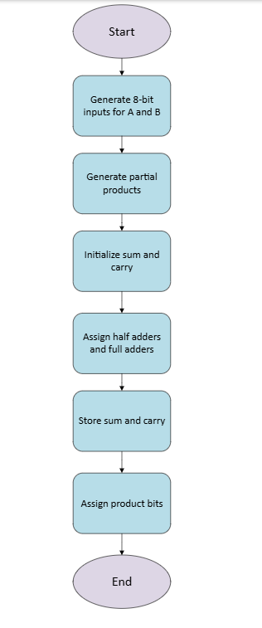
Figure 1 - Operational Flowchart of a Brauns Multiplier

Wallace Tree Flowchart:

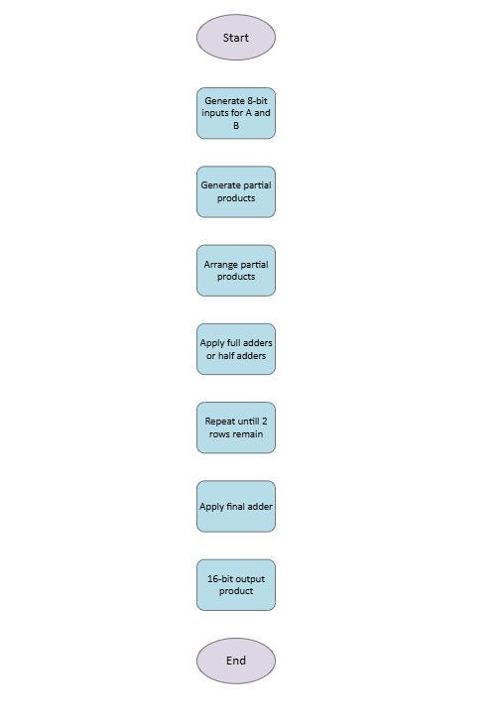
Figure 2 - Operational Flowchart of a Wallace Tree Multiplier

Design
The task was to design an 8x8-bit input Braun multiplier and an 8x8-bit Wallace Tree multiplier. Both designs acknowledge an 8-bit A input and an 8-bit B input producing a 16-bit output. Both multipliers were designed using a VHDL and on Vivado to allow an accurate comparison of the performance of both binary multipliers. A user may handle design complexity with the help of VHDL, a complete language [12]. Modern digital systems built on VLSI chips are inherently complicated, both in terms of design and the data that represents a design [12]. VHDL is the first language that makes it possible to efficiently handle data and the design process.

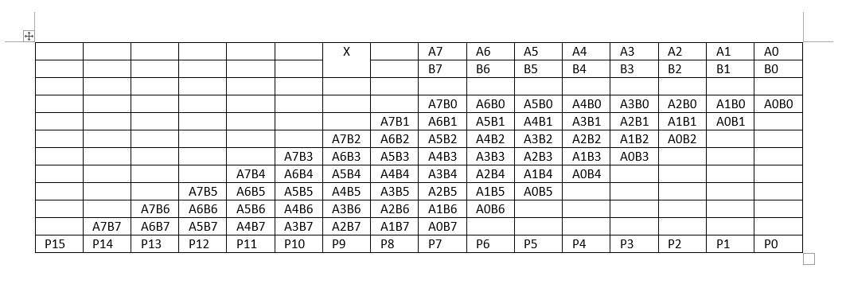
Figure 3 - 8x8 Bit Brauns Multiplier Table
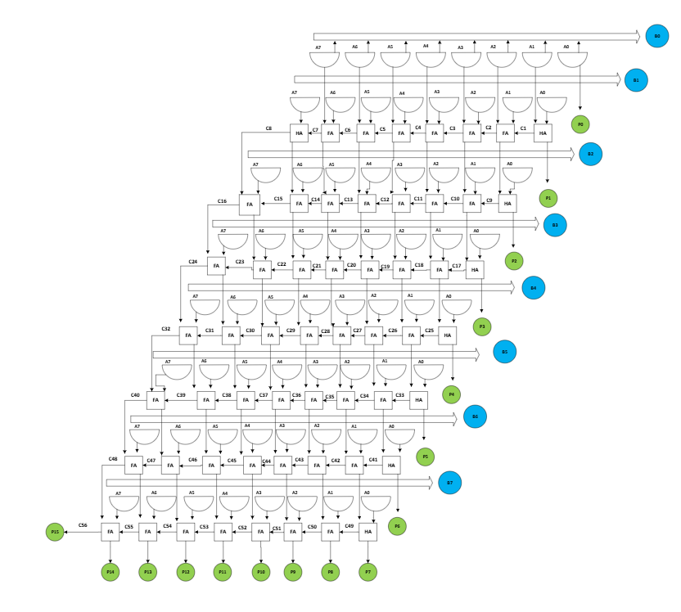
Figure 4 - 8x8 Bit Brauns Structure
Figure 3 was used to help create figure 4 which is the Braun multiplier block diagram. The Braun multiplier is an array style structure made of AND gates, half adders and full adders. Row by row, it adds the partial products, aligning each based on its binary weight. It is simpler to comprehend and implement in hardware due to this architecture.

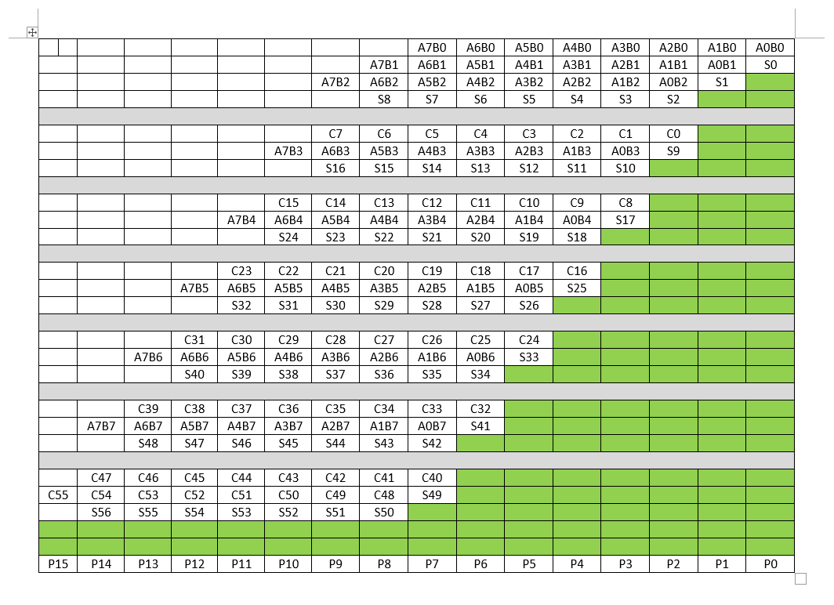
Figure 5 - 8x8 Bit Wallace Tree Multiplier Table
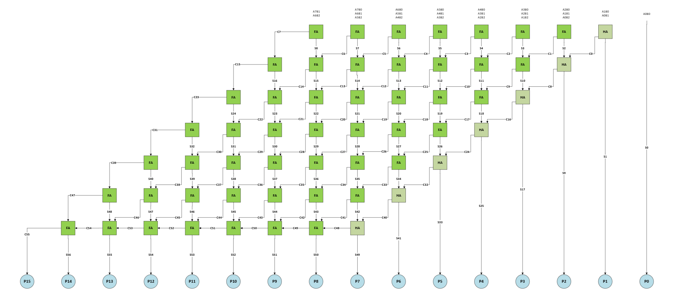
Figure 6 - 8x8 Bit Wallace Tree Structure
Figure 5 was used to help create figure 6 which is the Wallace Tree multiplier block diagram. By minimising sequential additions, the Wallace Tree multiplier enhances performance. It uses AND gates to create partial products, then layers full and half adders to compress them. This increases speed and lowers the critical path delay, making it appropriate for high-performance use.

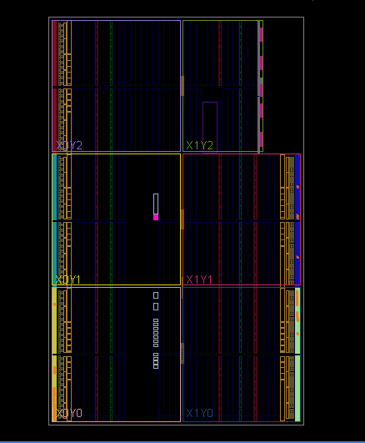
Figure 7 - Brauns Multiplier Device
Figure 7 shows the Braun multiplier device layout on Vivado. It shows clearly how my synthesised design is mapped onto the FPGA fabric. The evenly spaced vertical lines that can be seen represent columns of partial products. In Braun architecture, each column accumulates sums diagonally that’s why routing looks very regular.
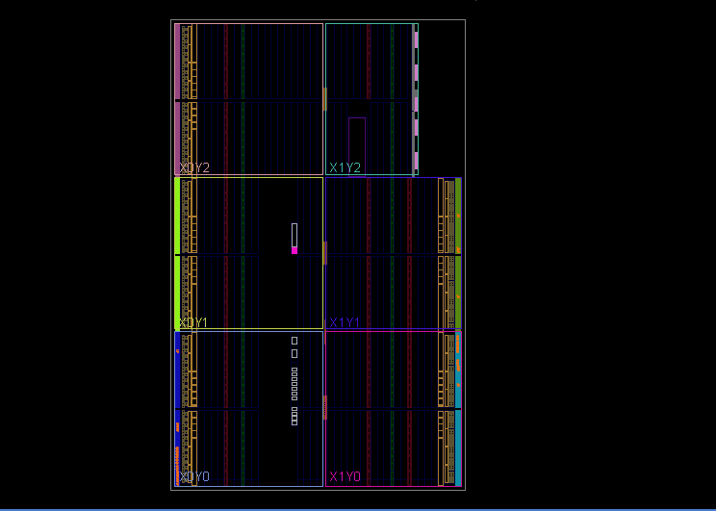
Figure 8 - Wallace Tree Multiplier Device
Figure 8 shows the Wallace Tree multiplier device layout on Vivado. Unlike the Braun multiplier the logic lines appear clustered and uneven this is because the Wallace Tree groups bits by weight and not position so the reduction happens in parallel layers and not a grid.

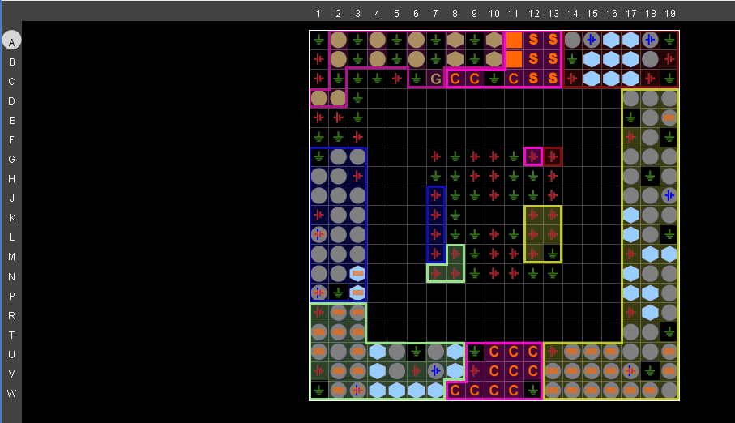
Figure 9 - Brauns Multiplier I/O Plan
Figure 9 indicates how the ports are physically assigned to FGPA pins around the chip boundary for the Braun multiplier. The inputs and outputs are grouped like this to reduce routing complexity and keep signal paths shorter; this compliments the grid like internal structure of Brauns multipliers.
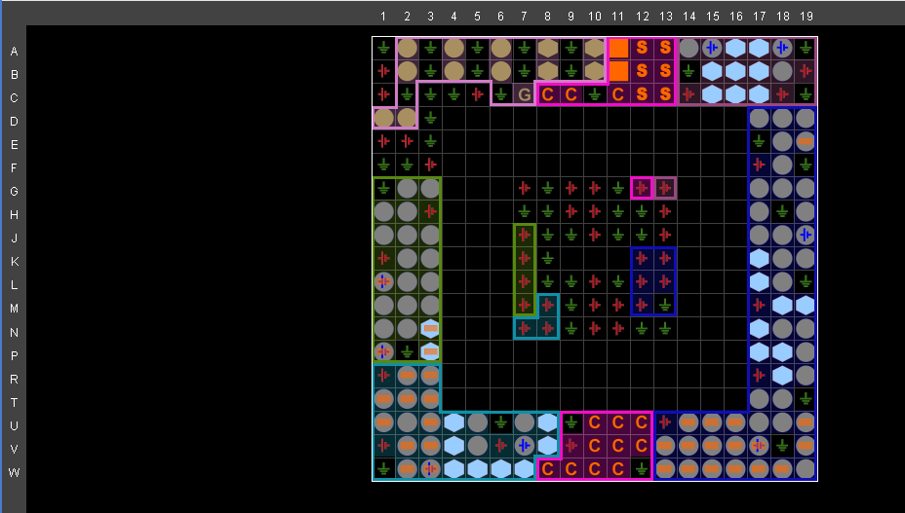
Figure 10 - Wallace Tree Multiplier I/O Plan
Figure 10 shows the I/O plan of the Wallace Tree multiplier on Vivado. This is the physical pin layout of the FPGA showing where the multiplier’s input and output signals are connected on the chip package.
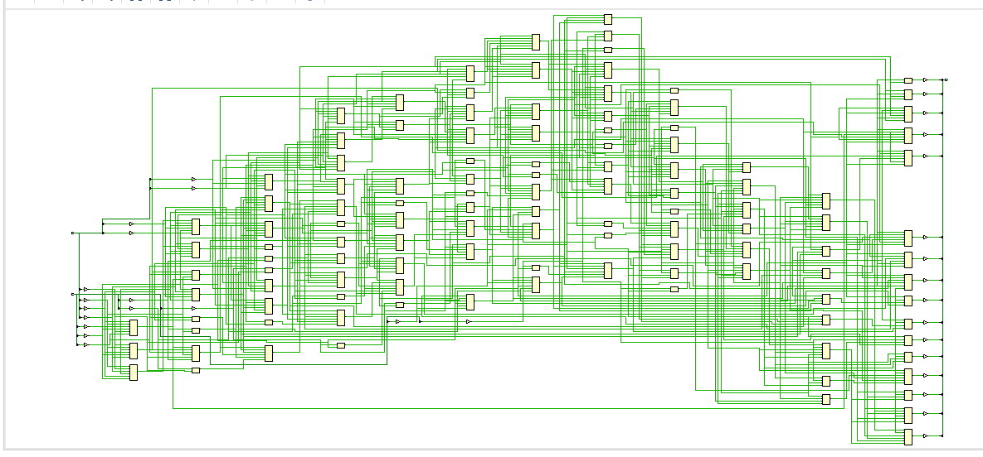
Figure 11 - Brauns Multiplier Implementation Schematic
Figure 11 represents how the multiplier is built using AND gates, adders, and routing connections inside the FPGA. The schematic shows the partial product generation and the carry-save addition adder array, spread out across the schematic.

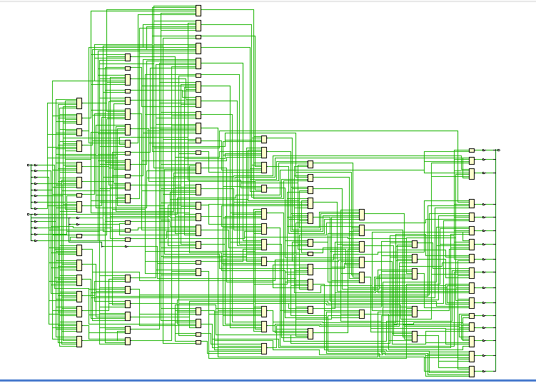
Figure 12 - Wallace Tree Multiplier Implementation Schematic
Figure 12 shows the Wallace Tree implementation schematic from Vivado. It looks even more complex than the Braun multiplier because the Wallace tree reduces partial products in a tree structure instead of a regular array.
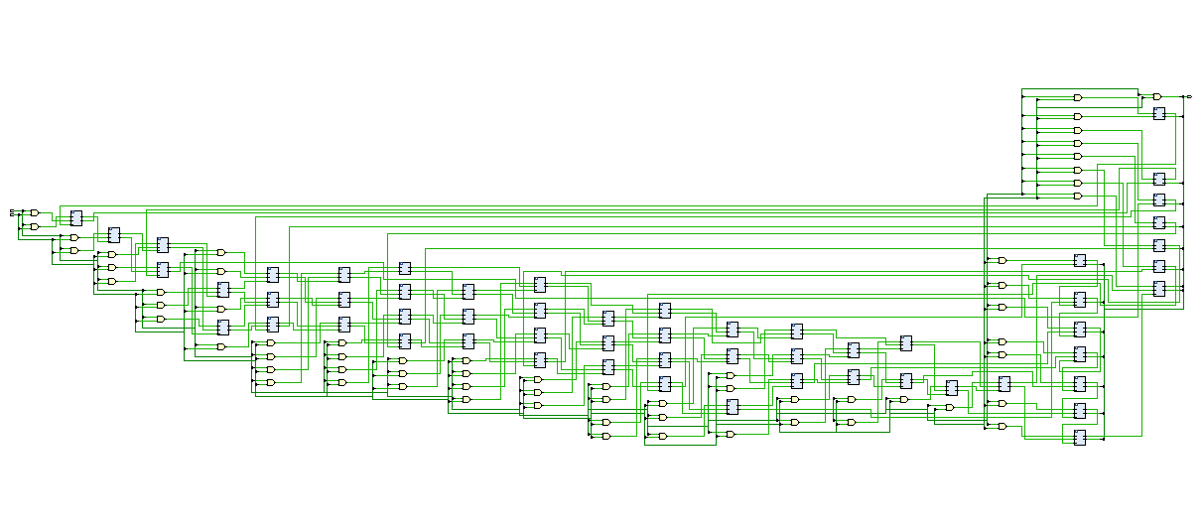
Figure 13 - Brauns Multiplier RTL Design
Figure 13 shows the register transfer level schematic of the Braun multiplier. Unlike the implementation schematic, the RTL view represents the logical design structure written in your VHDL code, not the final gate-level implementation. Because of this, the diagram looks more structured and easier to follow.

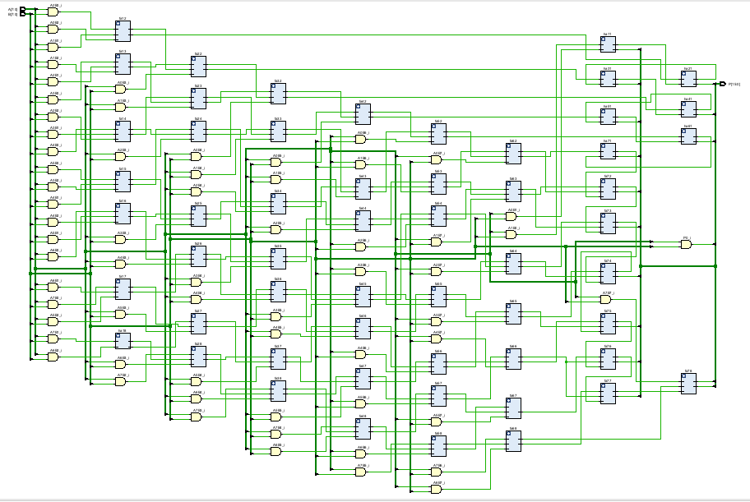
Figure 14 - Wallace Tree Multiplier RTL Design
Figure 14 is the RTL design of the Wallce Tree multiplier on Vivado. This RTL schematic shows the Wallace Tree multiplier architecture, where 64 partial products generated by AND gates are reduced through multiple stages of full and half adders arranged in a tree structure.

Methodology
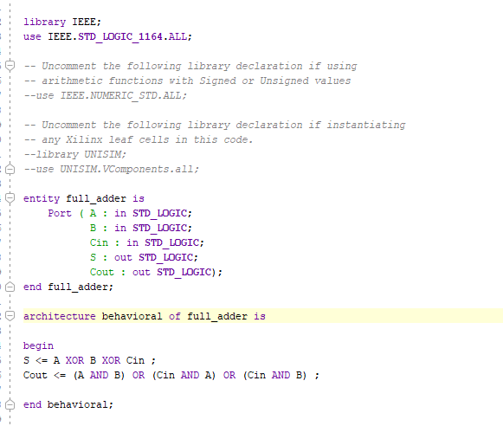
Figure 15 - VHDL Code of Full Adder Structure
Figure 15 shows a VHDL implementation of a 1-bit full adder, which is a key building block for both the Wallace Tree and Braun multiplier designs. This component gets reused in large designs like the multipliers. All inputs and outputs are defined in the full adder code.
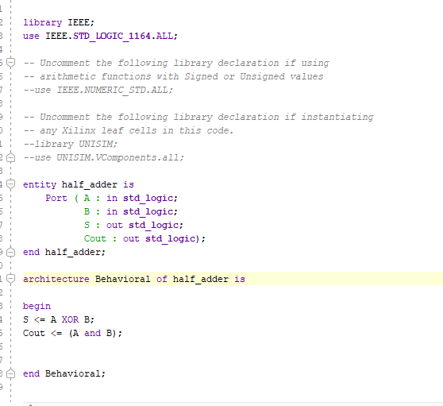
Figure 16 - VHDL Code of Half Adder Structure
Figure 16 is the VHDL implementation of a 1-bit half adder, which is another essential building block used alongside the full adder in both the Braun and Wallace Tree multipliers. Both the full adder and half adder code were written before writing the base code for each individual multiplier.

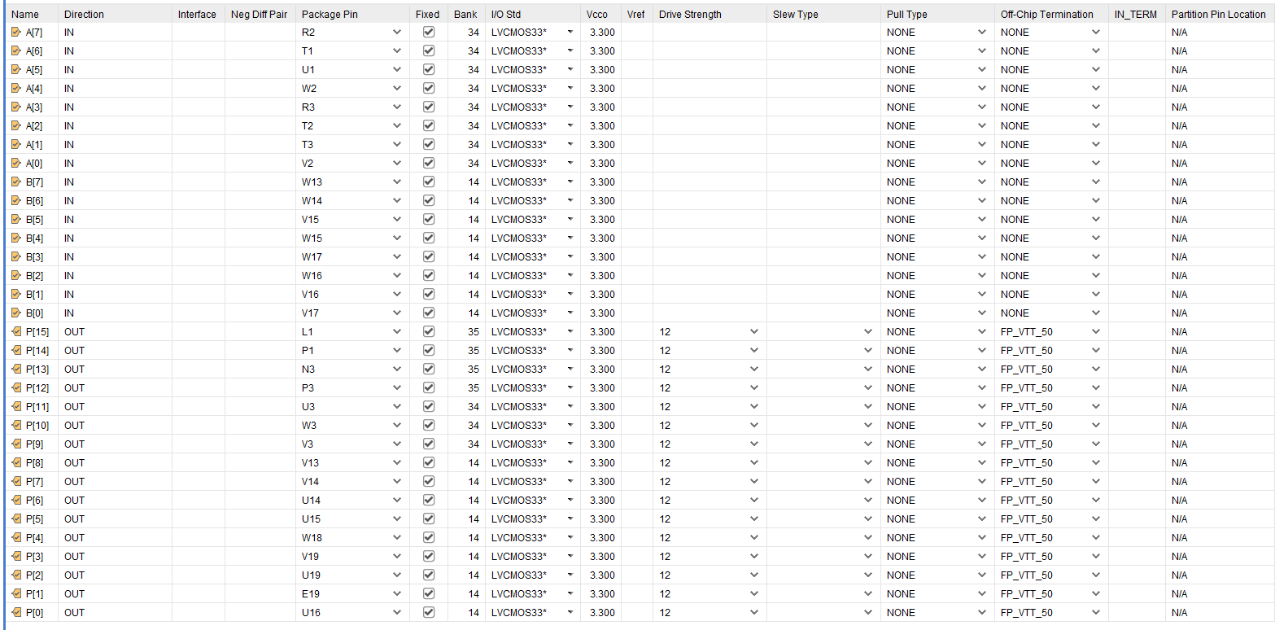
Figure 17 - Pin Allocation for Brauns and Wallace Tree Multipliers
Figure 17 is the I/O pin assignment table on Vivado for both multipliers. Each signal in the VHDL design is assigned to a physical FGPA pin. This allows the design to interact with switches, LEDs and external hardware.

Simulation Waves
The proper operation of the Braun and Wallace Tree multipliers was confirmed by functional simulations performed in Vivado and on the actual Basys 3 board. To guarantee a fair comparison, the same input values were used for both designs. All test case's waveform outputs were recorded, and each outcome was checked against the anticipated binary and hexadecimal products.

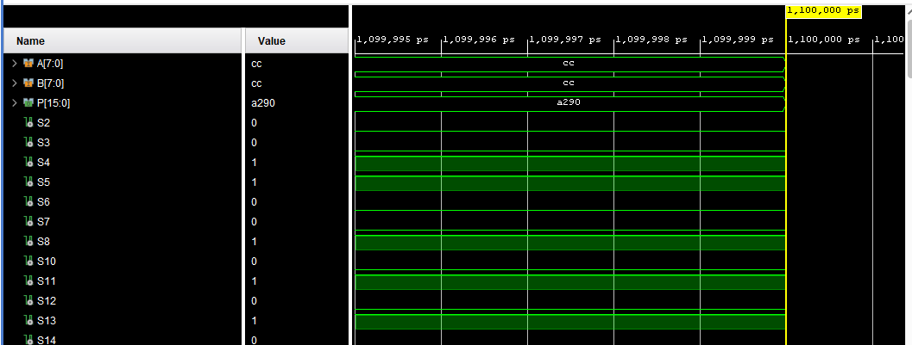
Figure 18 - Brauns Multiplier Simulation Wave 1 - CC x CC
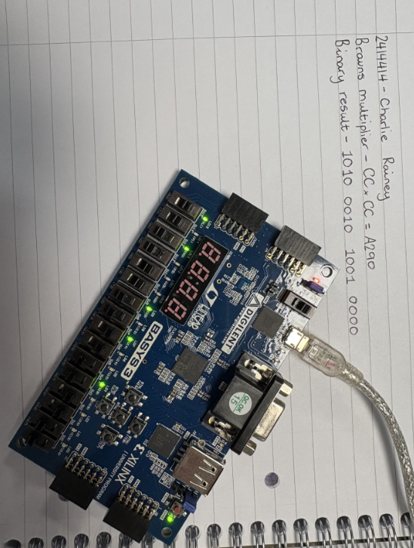
Figure 19 - Brauns Multiplier CC x CC on Basys 3 Board

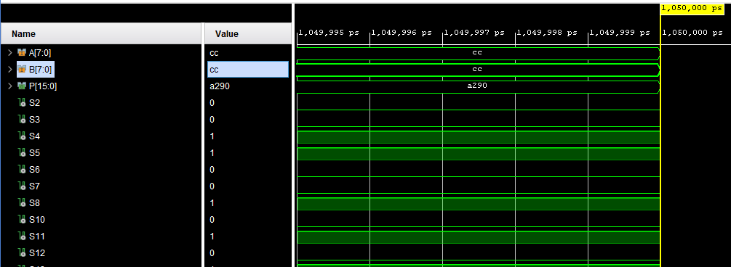
Figure 20 - Wallace Tree Multiplier Simulation Wave 1 - CC x CC
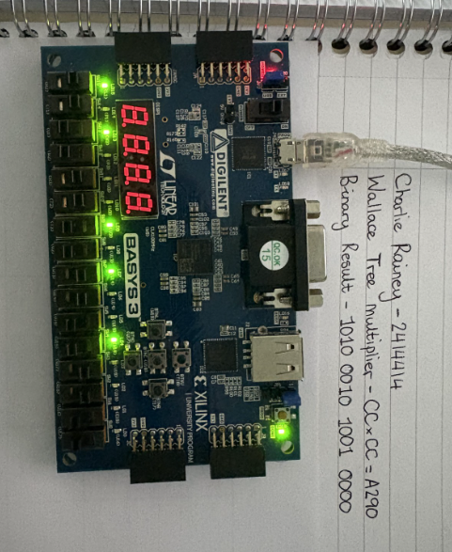
Figure 21 - Wallace Tree Multiplier CC x CC on Basys 3 Board
Figure 18, 19, 20 and 21 show the simulation wave for the CC x CC hexadecimal calculation for both the Wallace Tree and Braun multiplier. On Vivado the simulation wave gives the correct answer of A290 for both. The Basys 3 board gives the correct binary output for A290 = 1010 0010 1001 0000. Both Simulations are a pass and prove both multipliers are operating as expected.

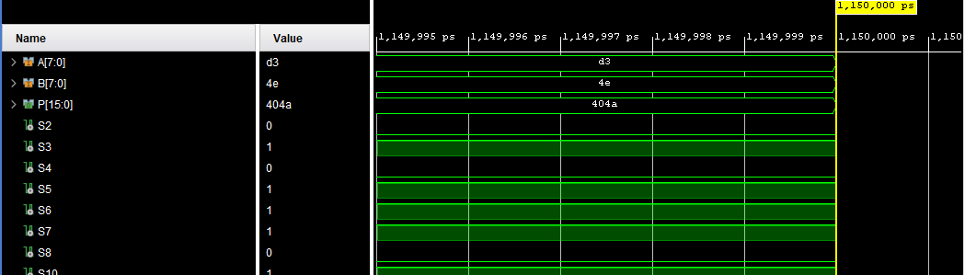
Figure 22 - Brauns Multiplier Simulation Wave 2 - D3 x 4E
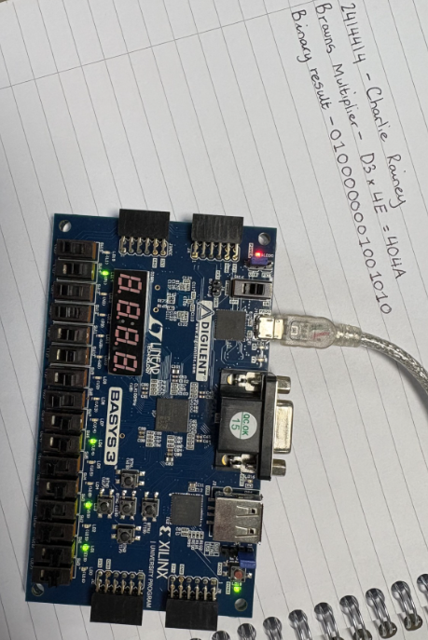
Figure 23 - Brauns Multiplier D3 x 4E on Basys 3 Board
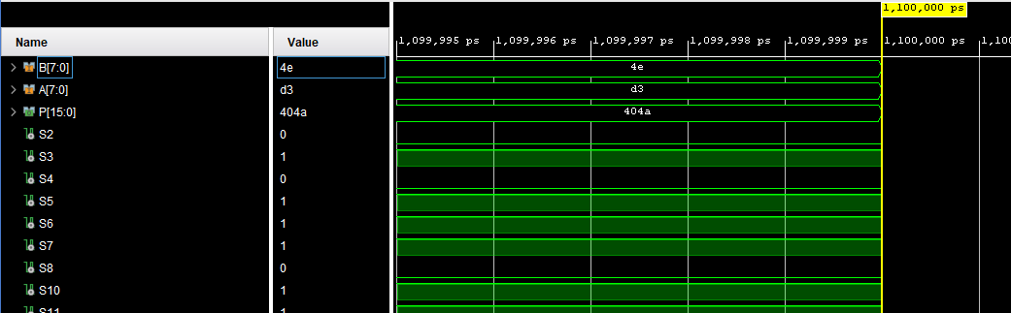
Figure 24 - Wallace Tree Multiplier Simulation Wave 2 - D3 x 4E
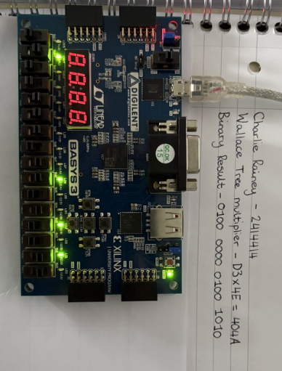
Figure 25 - Wallace Tree Multiplier D3 x 4E on Basys 3 Board
Figure 22, 23, 24 and 25 show the simulation wave for the D3 x 4E hexadecimal calculation for both the Wallace Tree and Braun multiplier. On Vivado the simulation wave gives the correct answer of 404A for both. The Basys 3 board gives the correct binary output for 404A = 0100 0000 0100 1010. Both Simulations are a pass and prove both multipliers are operating as expected.

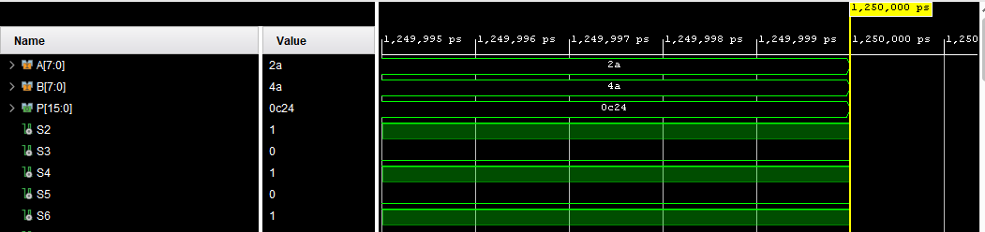
Figure 26 - Brauns Multiplier Simulation Wave 3 - 2A x 4A
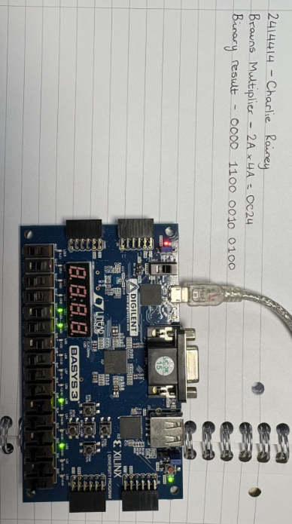
Figure 27 - Brauns Multiplier 2A x 4A on Basys 3 Board
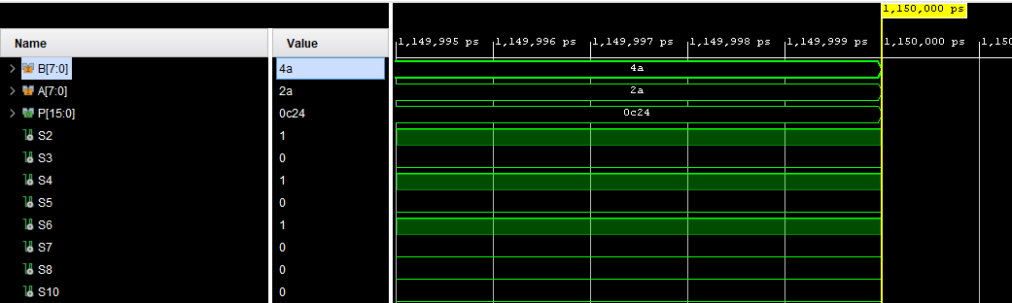
Figure 28 - Wallace Tree Simulation Wave 3 - 2A x 4A
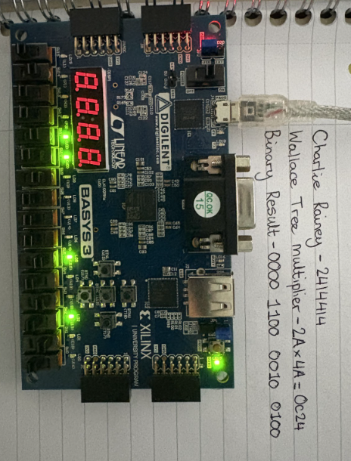
Figure 29 - Wallace Tree Multiplier 2A x 4A on Basys 3 Board
Figure 26, 27, 28 and 29 show the simulation wave for the 2A x 4A hexadecimal calculation for both the Wallace Tree and Braun multiplier. On Vivado the simulation wave gives the correct answer of 0C24 for both. The Basys 3 board gives the correct binary output for 0C24 = 0000 1100 0010 0100. Both Simulations are a pass and prove both multipliers are operating as expected.

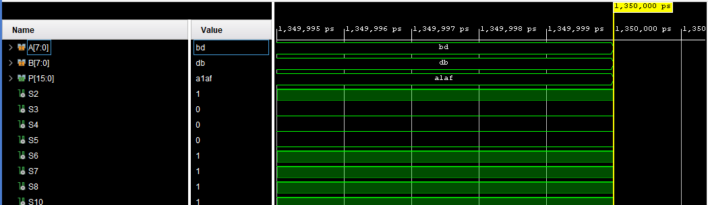
Figure 30 - Brauns Multiplier Simulation Wave 4 - BD x DB
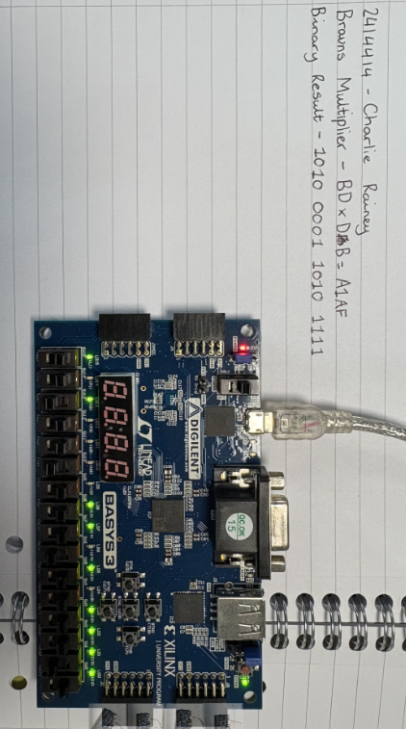
Figure 31 - Brauns Multiplier BD x DB on Basys 3 Board
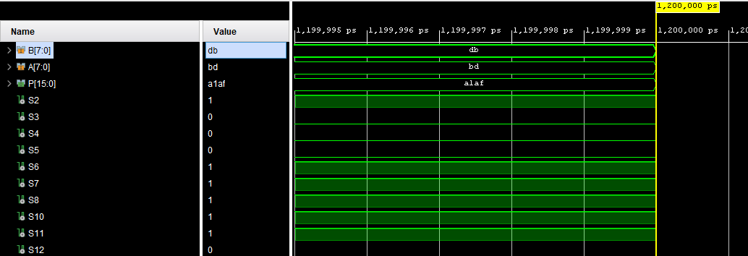
Figure 32 - Wallace Tree Multiplier Simulation Wave 4 - BD x DB

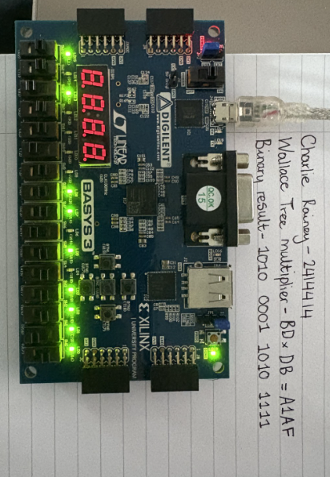
Figure 33 - Wallace Tree Multiplier BD x DB on Basys 3 Board
Figure 30, 31, 32 and 33 show the simulation wave for the BD x DB hexadecimal calculation for both the Wallace Tree and Braun multiplier. On Vivado the simulation wave gives the correct answer of A1AF for both. The Basys 3 board gives the correct binary output for A1AF = 1010 0001 1010 1111. Both Simulations are a pass and prove both multipliers are operating as expected.

Results
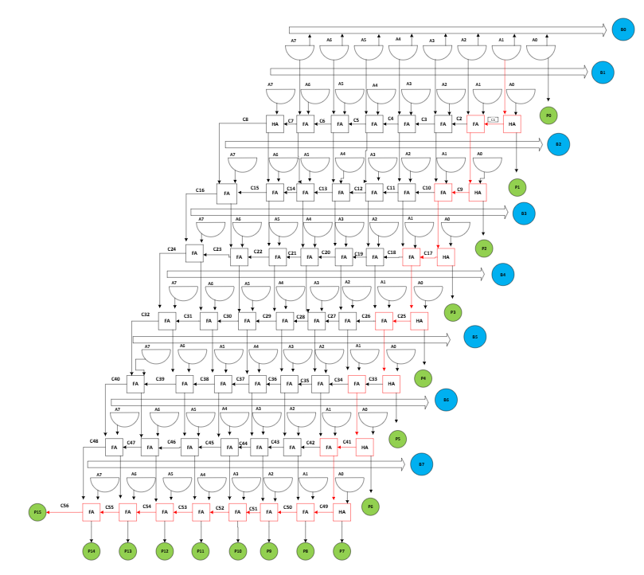
Figure 34 - Brauns Multiplier Longest Path
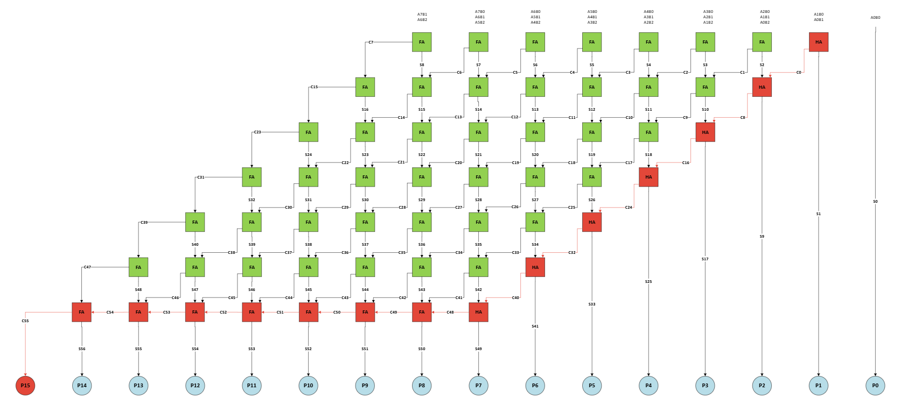
Figure 35 - Wallace Tree Multiplier Longest Path
Figure 34 and 35 shows the longest delay path for both multipliers highlighted in red. With both of these it helps calculate the longest delay times for both respected multipliers. Braun longest delay = 1ns + 20*(2ns) = 41ns. Wallace Tree longest delay = 1ns + 14*(2ns) = 29ns. As the Wallace Tree compresses its partial products and reduces logic levels this allows a shorter longest delay time to achieve P15.

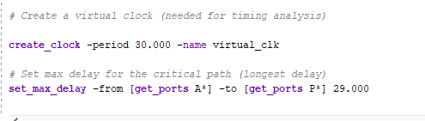
Figure 36 - Wallace Tree Multiplier Longest Path Timing Constraint
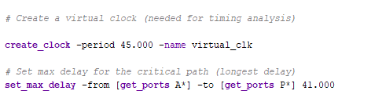
Figure 37 - Brauns Multiplier Longest Path Timing Constraint
Figure 36 and 37 shows the timing constraints on Vivado for both multipliers. The longest delay time for each multiplier was added to the code and with this it makes the report summaries achievable and accurate.
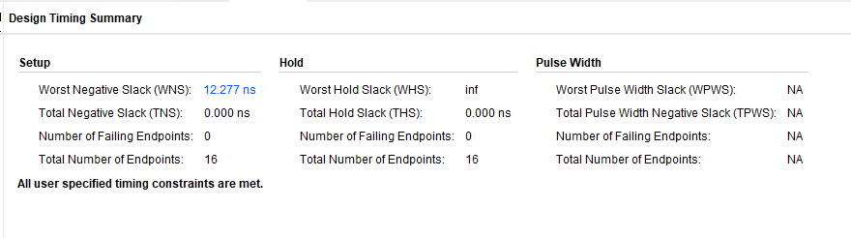
Figure 38 - Wallace Tree Multiplier Report Timing Summary
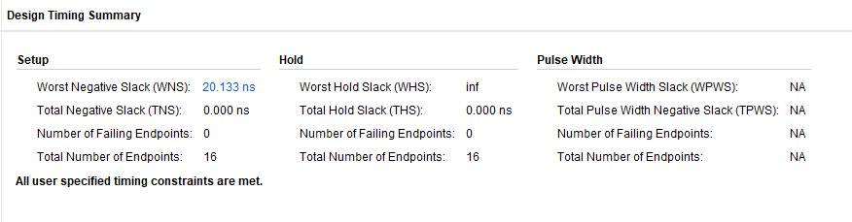
Figure 39 - Brauns Multiplier Report Timing Summary
Figure 38 and 39 show the report timing summary for both multipliers on Vivado. Both the Wallace Tree and Braun multipliers satisfy the specified timing constraints with zero setup and hold violations. The Braun multiplier has a higher Worst Negative Slack (20.133 ns) compared to the Wallace Tree multiplier (12.277 ns), indicating greater timing margin in the synthesized implementation. Although the Wallace Tree multipliers are theoretically faster due to parallel partial product reduction, synthesis and routing optimizations in FPGA implementation may lead to different timing results.

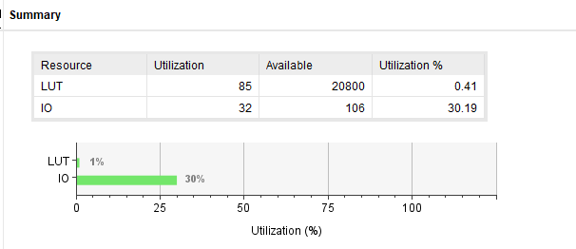
Figure 40 - Wallace Tree Multiplier Report Utilization
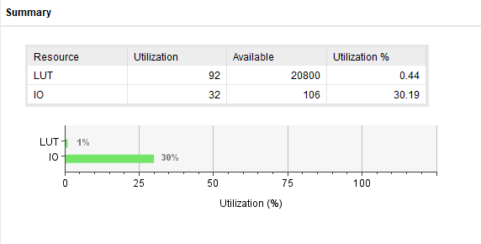
Figure 41 - Brauns Multiplier Report Utilization
Figures 40 and 41 give the report utilization from Vivado for both multipliers. The resource utilization results show that both multiplier architectures require minimal FPGA resources. The Wallace Tree multiplier uses 85 LUTs (0.41%), whereas the Braun multiplier uses 92 LUTs (0.44%), indicating that the Wallace architecture is slightly more hardware-efficient. The IO utilization is identical for both designs at 32 pins (30.19%), as both multipliers have the same input and output bit widths. Overall, the Wallace Tree multiplier achieves lower logic resource consumption compared to the Braun multiplier in the 8×8 implementation.

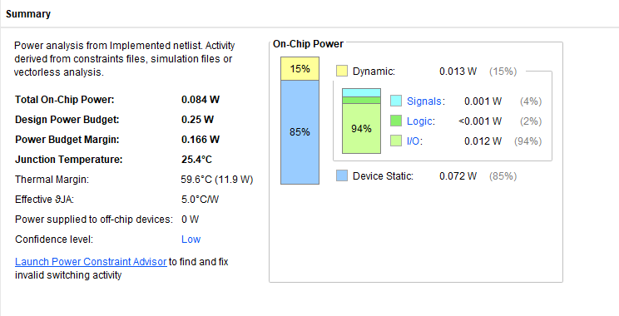
Figure 42 - Wallace Tree Multiplier Report Power
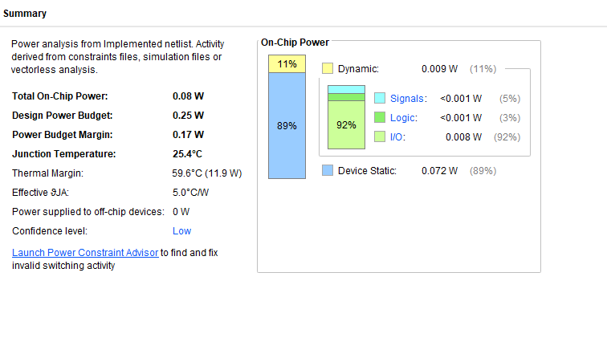
Figure 43 - Brauns Multiplier Report Power
Figures 42 and 43 show the final comparisons of the multipliers from Vivado and these screenshots are the power reports. The power analysis results indicate that both multiplier implementations operate well within the specified power budget of 0.25 W. The Wallace Tree multiplier consumes a total on-chip power of 0.084 W, while the Braun multiplier consumes slightly less power at 0.080 W. Dynamic power accounts for a small portion of the total power in both designs, with static power dominating the overall consumption. The Braun multiplier demonstrates marginally lower dynamic and total power consumption compared to the Wallace Tree multiplier.

Conclusion
This project looked at two popular digital multiplier architectures: The Braun multiplier and the Wallace Tree multiplier. Both were built as 8×8-bit multipliers using VHDL and were synthesized with the Xilinx Vivado platform. They were then deployed on a Basys 3 FPGA platform. The study aimed to evaluate and compare the architectures based on functionality, timing performance, hardware resource use, and power consumption.
The first part of the project focused on designing and modelling both multipliers. The Braun multiplier used a typical array structure made of AND gates, half adders, and full adders arranged in a grid. On the other hand, the Wallace Tree multiplier employed a tree structure for reducing partial products using multiple layers of adders. This architectural difference is important because the Wallace Tree aims to minimize the number of consecutive addition stages, which can lower propagation delay.
Functional verification took place through simulation in Vivado and practical testing on the Basys 3 FPGA board. Several hexadecimal multiplication tests were run on both multipliers, including CC × CC, D3 × 4E, 2A × 4A, and BD × DB. In all instances, the outputs from both multiplier designs matched the expected results. The simulation waveforms and hardware outputs confirmed that both designs worked correctly and reliably. This verification step showed that the VHDL implementations successfully turned the theoretical multiplier architectures into working digital circuits.
Next, performance evaluation was done using timing, utilization, and power analysis reports generated by Vivado. Timing analysis showed that both multipliers met all timing constraints without setup or hold violations. Interestingly, even though the Wallace Tree architecture is expected to be faster due to its shorter logic depth, the synthesized results indicated that the Braun multiplier had a larger worst negative slack value of 20.133 ns compared to 12.277 ns for the Wallace Tree design. This implies that in this specific FPGA setup, the Braun multiplier had a better timing margin. Such behaviour can result from synthesis optimizations, routing choices, and the relatively small operand size used in the design.
Resource utilization analysis revealed that both multipliers required very little FPGA hardware. The Wallace Tree multiplier needed 85 LUTs (0.41%), while the Braun multiplier used 92 LUTs (0.44%). This shows that the Wallace Tree architecture was slightly more efficient in terms of logic resource use. However, the difference between the two designs was minimal, and both took up less than 1% of the available FPGA logic resources. The input/output utilization was the same for both designs because they shared the same 8-bit input and 16-bit output interface.
Power analysis also indicated similar performance between the two architectures. Both designs operated well below the power budget of 0.25 W. The Braun multiplier used slightly less total power (0.080 W) compared to the Wallace Tree multiplier (0.084 W). In both cases, static power made up most of the total power consumption, while dynamic power came primarily from I/O switching activity.
Overall, the results show that both multiplier architectures are effective for small parallel multipliers on FPGA hardware. The Wallace Tree multiplier has slightly better logic efficiency, while the Braun multiplier shows slightly lower power consumption and a greater timing margin in this implementation. The choice between these architectures depends on the design priorities of the target system, especially whether speed, power efficiency, or implementation simplicity is the main focus.

References

[1]
S. P. and A. A. Khan, “Comparison of Braun Multiplier and Wallace Multiplier Techniques in VLSI,” 2018 4th International Conference on Devices, Circuits and Systems (ICDCS), pp. 48–53, Mar. 2018, Comparison of Braun Multiplier and Wallace Multiplier Techniques in VLSI | IEEE Conference Publication | IEEE Xplore

[2]
“FPGA Implementation of Area Efficient 16-Bit Vedic Multiplier Using Higher Order Compressors, FPGA Implementation of Area Efficient 16-Bit Vedic Multiplier Using Higher Order Compressors | IEEE Conference Publication | IEEE Xplore

[3]
A. Sharma, A. Mittal, A. Singh, and R. Kapoor, “Design and Implementation of Braun Multiplier using Verilog: Review,” 2024 Asia Pacific Conference on Innovation in Technology (APCIT), pp. 1–6, Jul. 2024, Design and Implementation of Braun Multiplier using Verilog: Review | IEEE Conference Publication | IEEE Xplore

[4]
T. P. Goud, “Types of Multiplier,” Scribd, 2026. Types of Braun Multipliers Explained | PDF | Computer Engineering | Computer Architecture (accessed Apr. 21, 2026).

[5]
Anitha and Bagyaveereswaran, “Brauns Multiplier Implementation using FPGA with Bypassing Techniques,” International Journal of VLSI Design & Communication Systems, vol. 2, no. 3, pp. 201–212, Sep. 2011, (PDF) Braun’s Multiplier Implementation using FPGA with Bypassing Techniques

[6]
V. Lakshmi, J. Reuben, and V. Pudi, “A Novel In-Memory Wallace Tree Multiplier Architecture Using Majority Logic,” IEEE Transactions on Circuits and Systems I: Regular Papers, vol. 69, no. 3, pp. 1148–1158, Mar. 2022, A Novel In-Memory Wallace Tree Multiplier Architecture Using Majority Logic | IEEE Journals & Magazine | IEEE Xplore

[7]
“Implementation of a 8-bit Wallace Tree Multiplier,” Arxiv.org, 2016. Implementation of a 8-bit Wallace Tree Multiplier

[8]
N. Sureka, R. Porselvi, and K. Kumuthapriya, “An efficient high speed Wallace tree multiplier,” 2013 International Conference on Information Communication and Embedded Systems (ICICES), pp. 1023–1026, Feb. 2013, An efficient high speed Wallace tree multiplier | IEEE Conference Publication | IEEE Xplore

[9]
C. Y. H. Lee, Lo Hai Hiung, S. W. F. Lee, and N. H. Hamid, “A performance comparison study on multiplier designs,” 2010 International Conference on Intelligent and Advanced Systems, pp. 1–6, Jun. 2010, A performance comparison study on multiplier designs | IEEE Conference Publication | IEEE Xplore

[10]
Kalamani C, K. V. P, B. V. R, and M. C. N, “Energy efficient Wallace multiplier using symmetric stacking counter circuit,” Measurement Sensors, vol. 35, pp. 101267–101267, Jun. 2024, Energy efficient Wallace multiplier using symmetric stacking counter circuit - ScienceDirect

[11]
“Performance Analysis of CMOS, PTL and GDI Based Braun Multiplier for Signal Processing Applications,” Ieee.org, 2021, Performance Analysis of CMOS, PTL and GDI Based Braun Multiplier for Signal Processing Applications | IEEE Conference Publication | IEEE Xplore

[12]
“VHDL: Hardware Description and Design,” Google Books, 2026. VHDL: Hardware Description and Design - Roger Lipsett, Carl F. Schaefer, Cary Ussery - Google Books (accessed Apr. 21, 2026).

Appendix

Wallace Tree Code
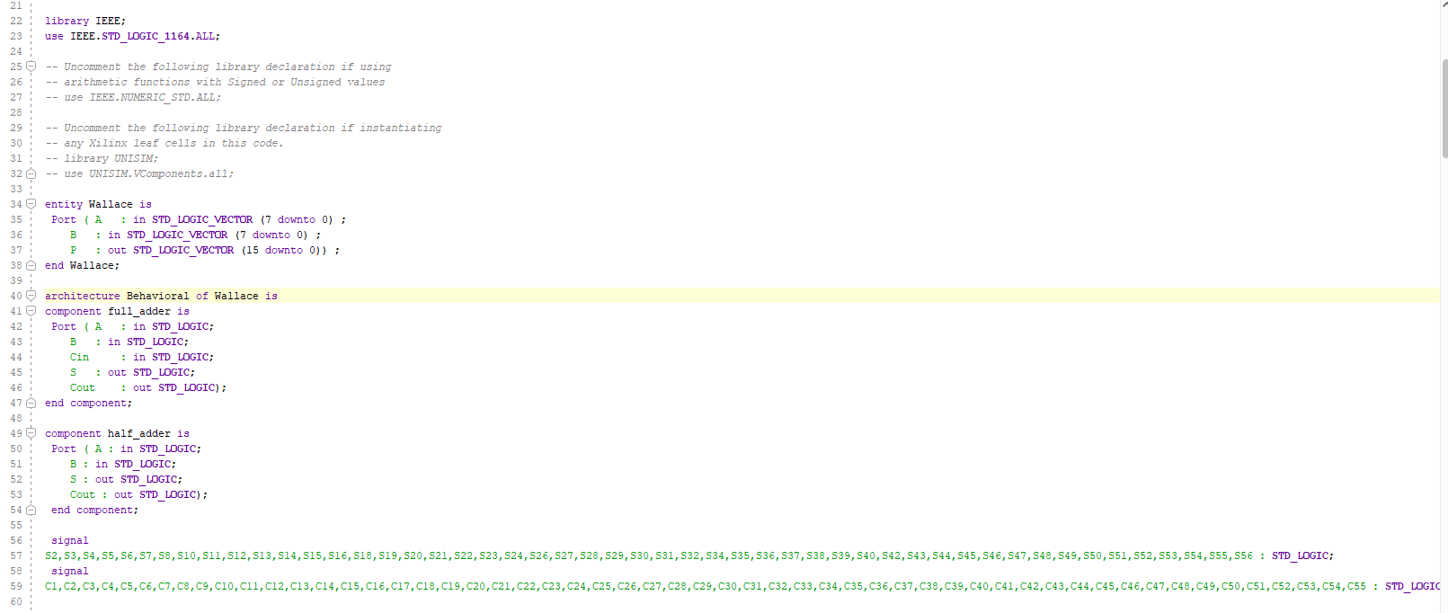
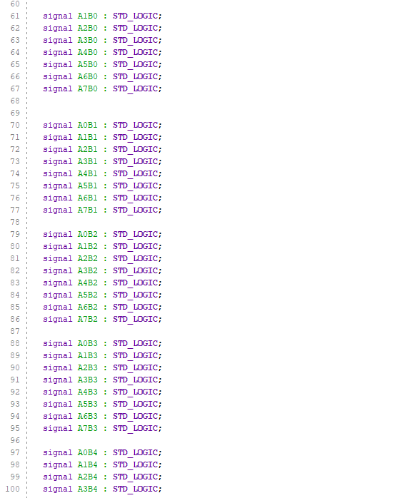
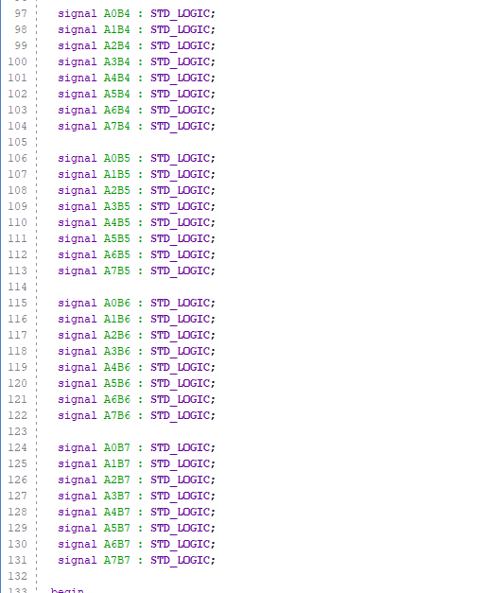
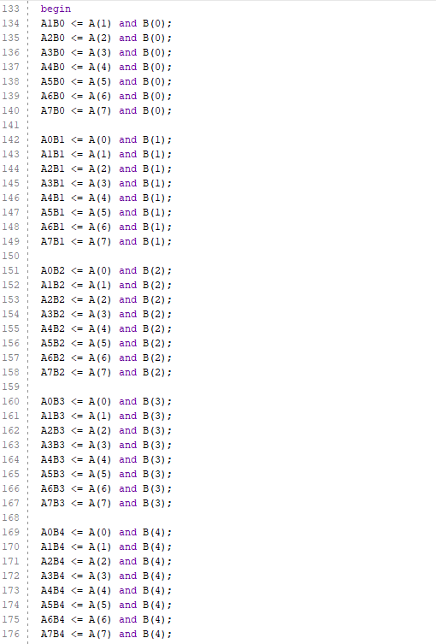
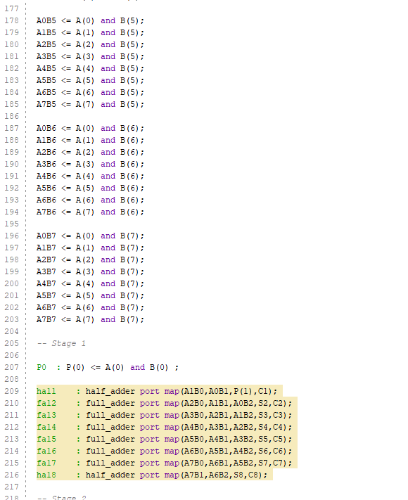
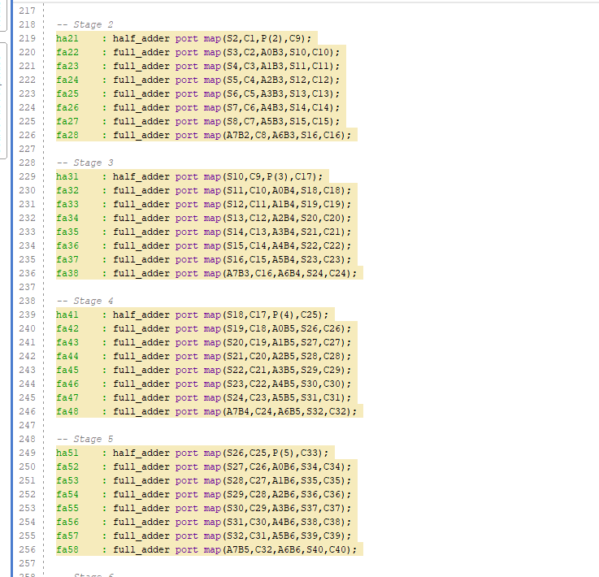
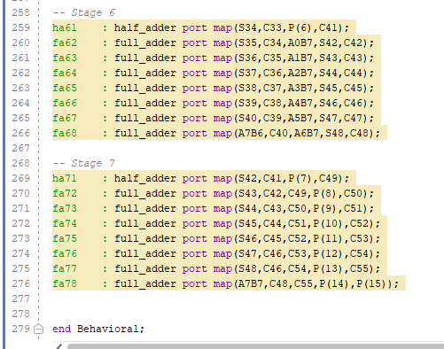

Brauns Code


