University of Wales: Trinity Saint David
Hotel Handbook for Intercultural Competence
Cultural Awareness (BMIH- 5003)

Morshida Akhtar
6/12/2021

Executive Summary
This report will show the difference between the cultures of two different countries to provide a handbook for the staff to deliver successful hotel service throughout. Understanding customer’s culture will allow hotel management to customise their service for respective guests. This will provide them competitive edge in the hospitality industry by providing information that will help employees to customise services according to country specific customers.
Research found that culturally UK is a. Individualist nation; on the other hand Singaporeans are a collective nation. Peoples from UK like to contribute to the society from an individual point however; Singaporeans are more likely to contribute to the society as a team, rather than an individual.
Due to advancement of technology and availability of information, different countries are following similar trends. However, there are still some differences visible due to the norms of the society and respective countries laws and regulations.

Table of Content
Introduction | 4
The Trinity Hotel | 5
Guests Cultural background | 5
Impact of Intercultural Knowledge | 6
Hotel handbook | 8
Conclusion | 9
Reference List | 10

Introduction
According to the World Bank (2021), in 2019 alone there are 2.28 billions of international passenger arrivals recorded. In 2019 Marriott International, sold 1,380,921 rooms all over world (Marriott Internet, 2020).
Cultural awareness is indispensable to appreciate the values and norms in Europe and other parts of the world. A solid perception of one’s own culture and a sense of identity can be the basis for an open attitude towards and respect for diversity of cultural expression. Therefore, understanding this in hospitality industry, specially for front desk department are the key of success.
Nyíri & Breidenbach (2009) believes that Geert Hofstede developed cultural dimension theory to understand the cultural view of different demography (saran, 2008). The theory identifies elements that hospitality industry should accustom with to please guests from different cultural backgrounds.
Firstly, the model talks about Power distance index to measure the degree of distance acceptance of power and authority. Through this dimension acceptance of the inequity between high and low class people identified (Kobiruzzaman, 2019). Second dimension indicates the norms of a certain countries population, whether they are individualistic or collectivistic by nature. After that, Hofstede differentiates society based on its gender roles and traits. It shows the differentiation of decisive role of a men and women in a society (Kumar, Giridhar & Sadarangani, 2019). Next, it works with uncertainty avoidance index to illustrate the way people deal with uncertain situations. Pragmatic vs normative dimension categorise people’s tendency of long or short term orientation. Finally, indulgent versus restraint stands for societies that permit members to enjoy or restrain indulgence. In the next section people’s norms will be assessed with these 06 dimensions to identify the difference between two countries.
This report will identify the importance of intercultural competence and cultural understanding in global hospitality industry. Information of this report will be used by the Trinity Hotel, located in Central London. The hotel management is expecting guests from Singapore.

The Hotel Trinity
Traditionally, UK is a very harmonised nation and developed rational customs, but, particularly as the British Empire stretched and the country engaged peoples from all over the world, British culture has been accented with assorted assistance from Afro-Caribbean’s, Asians, Muslims, and other immigrant groups.
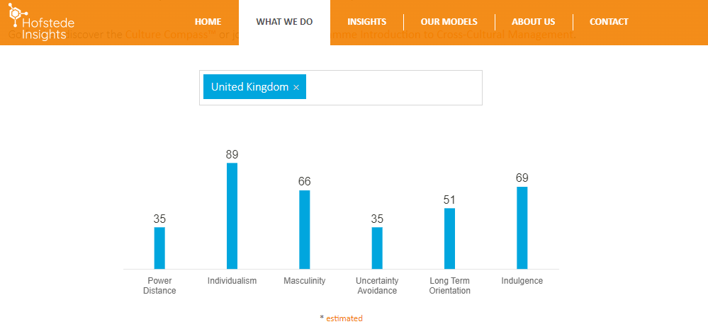
(Hofstede Insights, 2021)
Historically British society believes that every member of the society should be treated equally and inequality among citizens should be minimised. At a score of 89 the England is among the highest of the Individualist scores, compressed only by several of the commonwealth nations. Moreover, Britain is a Masculine country with a strong sense of individualism. For example, about 17% teenagers started living separately at the age of 16 (Co-oplegalservice, 2020). As a result employees born and raised in the UK are less likely to appreciate family hierarchy.
Guests Cultural Background
Singapore is a multi-ethnic country comprises with 77% Chinese, 15% Malay, 6% Indian and rests are expatriates. According to the Gov.UK (2020), there are 18 ethnic groups recommended by the government if asking for the ethnicity of the citizen.
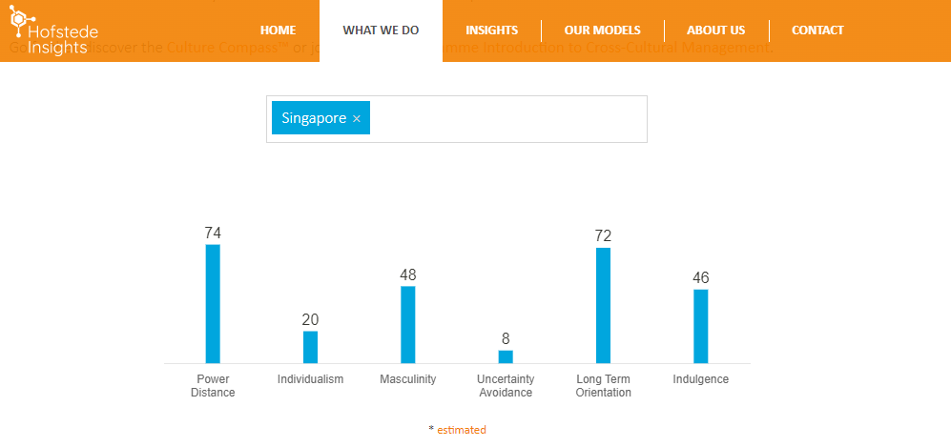
(Hofstede Insights, 2021)
According to the research of Hofstede Insights (2021), Singapore stands high on power distance dimension. With a Confucian Chinese community, they usually have a syncretic .method to religion, which is also the leading method in Singapore. Primary teaching of this is the solidity of community that depends on asymmetrical connection among citizen. Next, Singapore is a collectivistic country. ‘We’ instead of ‘I’ is important in such society; people look after each other in return of loyalty. Singapore is nose ahead of being a feminine side. They prefer softer approach, sympathy & empathy for the minnows are encouraged.
Singaporean people tend to be superstitious about position of things (Feng-Shui) and numbers. Numerical homonyms exists in Western cultures as well; however, Chinese people, with many Asian countries, consider that digit four is ghastly due to the fact that the articulation of four in Chinese is comparable to the articulation of the alphabets demonstrating decease (si). Therefore front office staffs should avoid providing Singaporean guests to offer rooms with number 04 in it.
Impact of Intercultural Knowledge
According the test of Hofstede United Kingdom and Singapore are having similar cultural norms in term of pragmatic vs normative dimension. Furthermore, due to strict laws and legislation both countries stand low in uncertainty avoidance (Hofstede Insights, 2021).
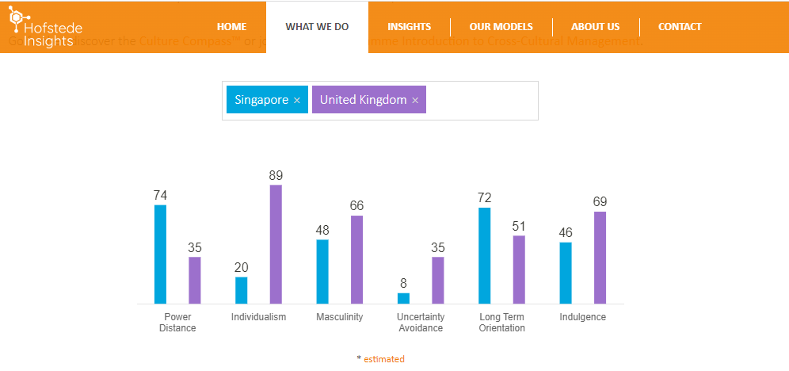
(Hofstede Insights, 2021)
Traditionally front desk of the Trinity Hotel treat customer with utmost respect. However, according to the Singaporean culture it is polite to address oneself as ‘uncle’’ or ‘aunty’. By practising such norms will delight Singaporean guests. In addition, providing them rooms with numbers like 2, 6 or 8 will also make them satisfied as Chinese community considers such numbers as lucky for them. Furthermore, Singapore culture maintains a strong hierarchical relationship. Therefore maintaining hierarchical communication during check-in and out is very important. It shows respect to guest’s respective culture and the group itself.
Many Asian nations have some small talk before getting down to any business. It can be a great ice breaker for front desk employees to start with a small talk. By doing this they can earn guests’ trust and can consider for return visit.
Hotel Handbook
First contact of the hotel and customers are in the front desk service. Therefore to get repeat business hotel front desk should carefully comply with below ‘Do’s & Don’ts’. Other departments are also need to follow these norms to satisfy overseas customer need.
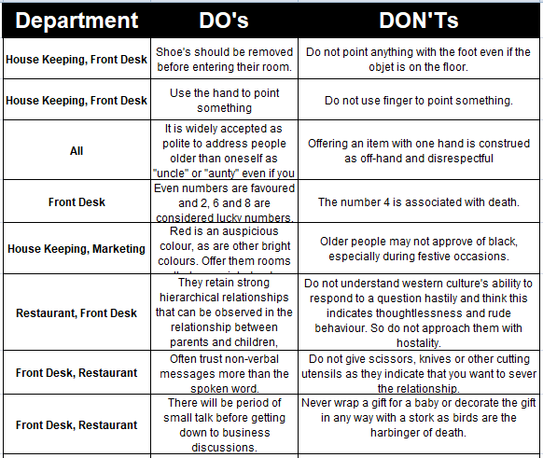
(Smith, 2016)
To retain Singaporean customer, front desk staffs should maintain above Do’s and Don’ts. As they maintain relationship hierarchy, employees should treat them as the leader of the group and provide services as per their likeness.

Conclusion
Due to intense competition in hospitality industry, it is important for hotel management and staffs to offer customised service to each guest. Therefore importance of intercultural competence along with cultural understanding became the part and parcel for any hotel. People are now-a-days are very sensitive and wants to get world class treatment from the hotels. Therefore, it is imperative to treat each customer equally and show gratitude to their respective culture.
Application of intercultural knowledge in hospitality industry is vital. Showing respect to one’s heritage can be a crucial factor for the Hotel Trinity, specially its front desk, as it located in the central London.

Reference List
- Barrow, M. (2020). Customs and Traditions. Available: http://projectbritain.com/traditions.html. Last accessed 20th Nov 2021.
- Co-oplegalservices. (2020). At What Age Can a Child Choose Who to Live With? Available: https://www.co-oplegalservices.co.uk/media-centre/articles-may-aug-2017/at-what-age-can-a-child-choose-who-to-live-with/. Last accessed 04th Dec 2021.
- GOV.UK. (2020). List of ethnic groups. Available: https://www.ethnicity-facts-figures.service.gov.uk/style-guide/ethnic-groups. Last accessed 20th Nov 2021.
- Hofstede Insights. (2021). WHAT ABOUT THE UK? Available: https://www.hofstede-insights.com/country-comparison/the-uk/. Last accessed 20th Nov 2021.
- Hofstede Insights. (2021). WHAT ABOUT SINGAPORE? Available: https://www.hofstede-insights.com/country-comparison/singapore/. Last accessed 20th Nov 2021.
- Hofsetede Insights. (2021). COMPARE COUNTRIES. Available: https://www.hofstede-insights.com/product/compare-countries/. Last accessed 21st Nov 2021.
- Kobiruzzaman, MM. (2019). Hofstede’s Cultural Dimensions- Hofstede’s 6 Cultural Dimensions Examples. Available: https://newsmoor.com/cultural-dimensions-hofstedes-cultural-dimensions-theory-with-six-dimension/. Last accessed 20th November 2021.
- Kumar, S. Giridhar, V & Sadarangani, P. (2019). A Cross-national Study of Environmental Performance and Culture: Implications of the Findings and Strategies. Global business review. 20 (04), p1051-1068.
- Lee, BG. (1991). Shared Values are adopted. Available: https://eresources.nlb.gov.sg/history/events/62f98f76-d54d-415d-93a1-4561c776ab97. Last accessed 21st Nov 2021.
- Marriott International. (2020). 2019 Annual Report. Available: https://marriott.gcs-web.com/static-files/178683c9-c9d9-47b0-b115-726588f43130. Last accessed 20th Nov 2021.
- Ministry of Foreign Affairs (MFA). (2020). About Singapore. Available: https://www.mfa.gov.sg/Overseas-Mission/Washington/About-Singapore. Last accessed 20th Nov 2021.
- Nyíri, P & Breidenbach, J (2009). Seeing culture everywhere from genocide to consumer habits. Seattle: University of Washington Press. P34-56.
- Saran, S (2018). Cultural and Civilisational Links between India and Southeast Asia Historical and Contemporary Dimensions. Singapore: Springer Singapore. p. 64- 77.
- Smith, A. (2016). Singapore - Culture, Etiquette and Business Practices. Available: https://www.commisceo-global.com/resources/country-guides/singapore-guide. Last accessed 21st Nov 2021.
- Study in UK. (2019). British Culture and Social Norms. Available: https://www.studying-in-uk.org/british-culture-and-social-norms/. Last accessed 21st Nov 2021.
- World Bank. (2021). International tourism, number of arrivals. Available: https://data.worldbank.org/indicator/ST.INT.ARVL. Last accessed 20th Nov 2021.

