Appendices

This sentence has been added only for the purpose of the Turnitin requirement to include twenty words and should not be marked.
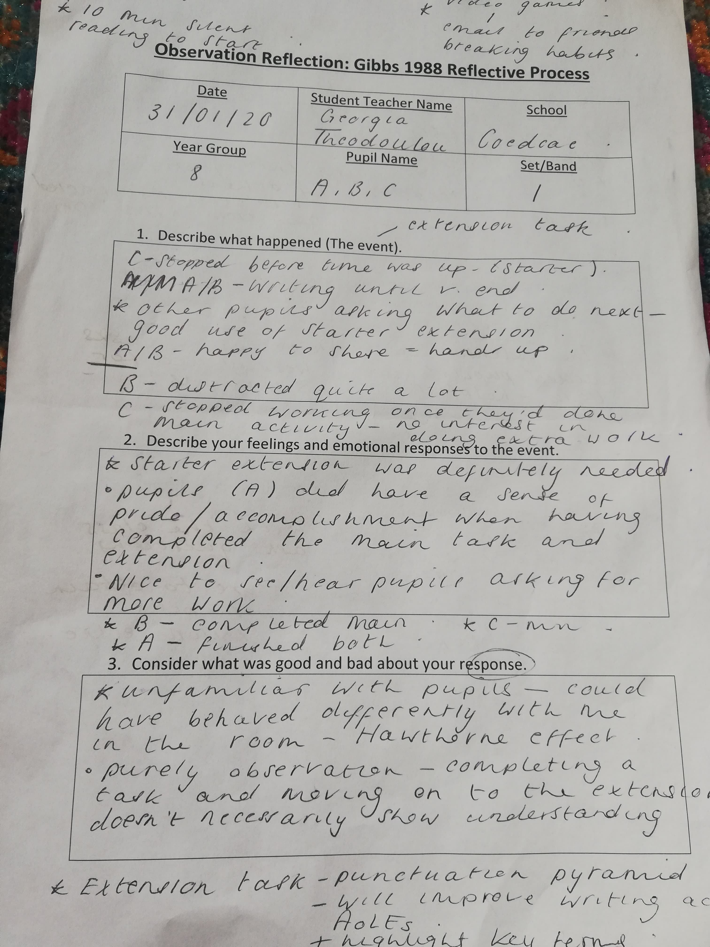
Appendix 1

Appendix 2
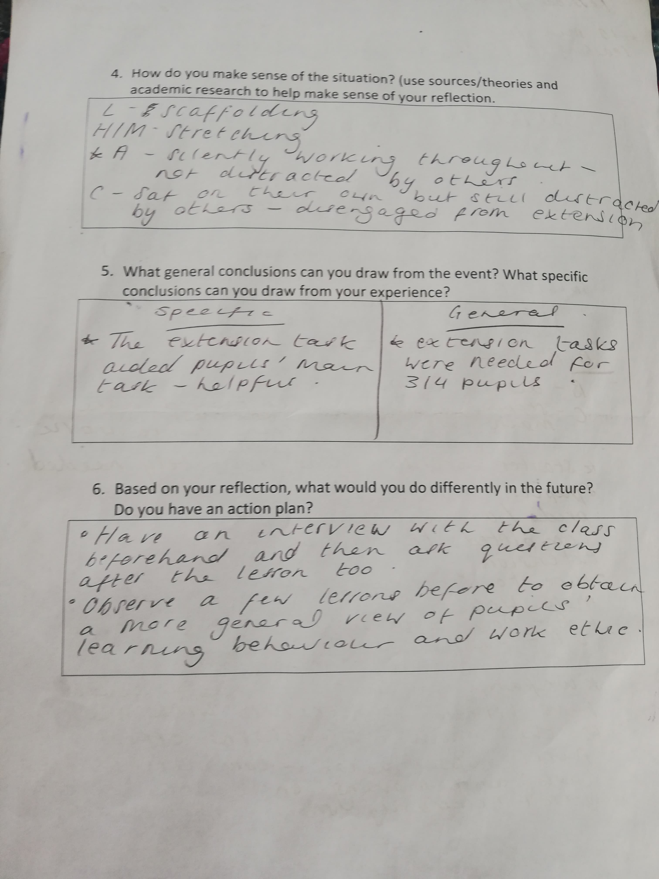

Focus Group Interview Questions

How Can We Develop Pupils’ Written Responses to an End of Main Activity Extension Task in a High Ability Group?”

Date of Interview:

Thank all participants for their contributions and remind them that they can leave the interview without explanation if and when they so choose. Mention that this will help to improve lessons and extension tasks in future lessons.

Question 1: How do you feel about your overall progress in this subject?

Interviewee | Answer
Child A
Child B
Child C

Question 2: What would you consider your strengths and weaknesses to be in English?

Interviewee | Answer
Child A
Child B
Child C

Question 3: Do you enjoy the extension tasks that are made available to you in the lesson?

Interviewee | Answer
Child A
Child B
Child C

Question 4: Do you feel that the extension tasks are challenging?

Interviewee | Answer
Child A
Child B
Child C

Question 5: Do you feel that the extension tasks help to improve your understanding of the work completed in the lesson?

Interviewee | Answer
Child A
Child B
Child C
Question 6: How do you think extension tasks can be improved? Are there any tasks that you can think of that would be more engaging?

Interviewee | Answer
Child A
Child B
Child C

Question 7: Are there any occasions that you can remember that you found the extension tasks particularly enjoyable?

Interviewee | Answer
Child A
Child B
Child C

Question 8: Do you think that having an extension task puts any pupils at a disadvantage?

Interviewee | Answer
Child A
Child B
Child C

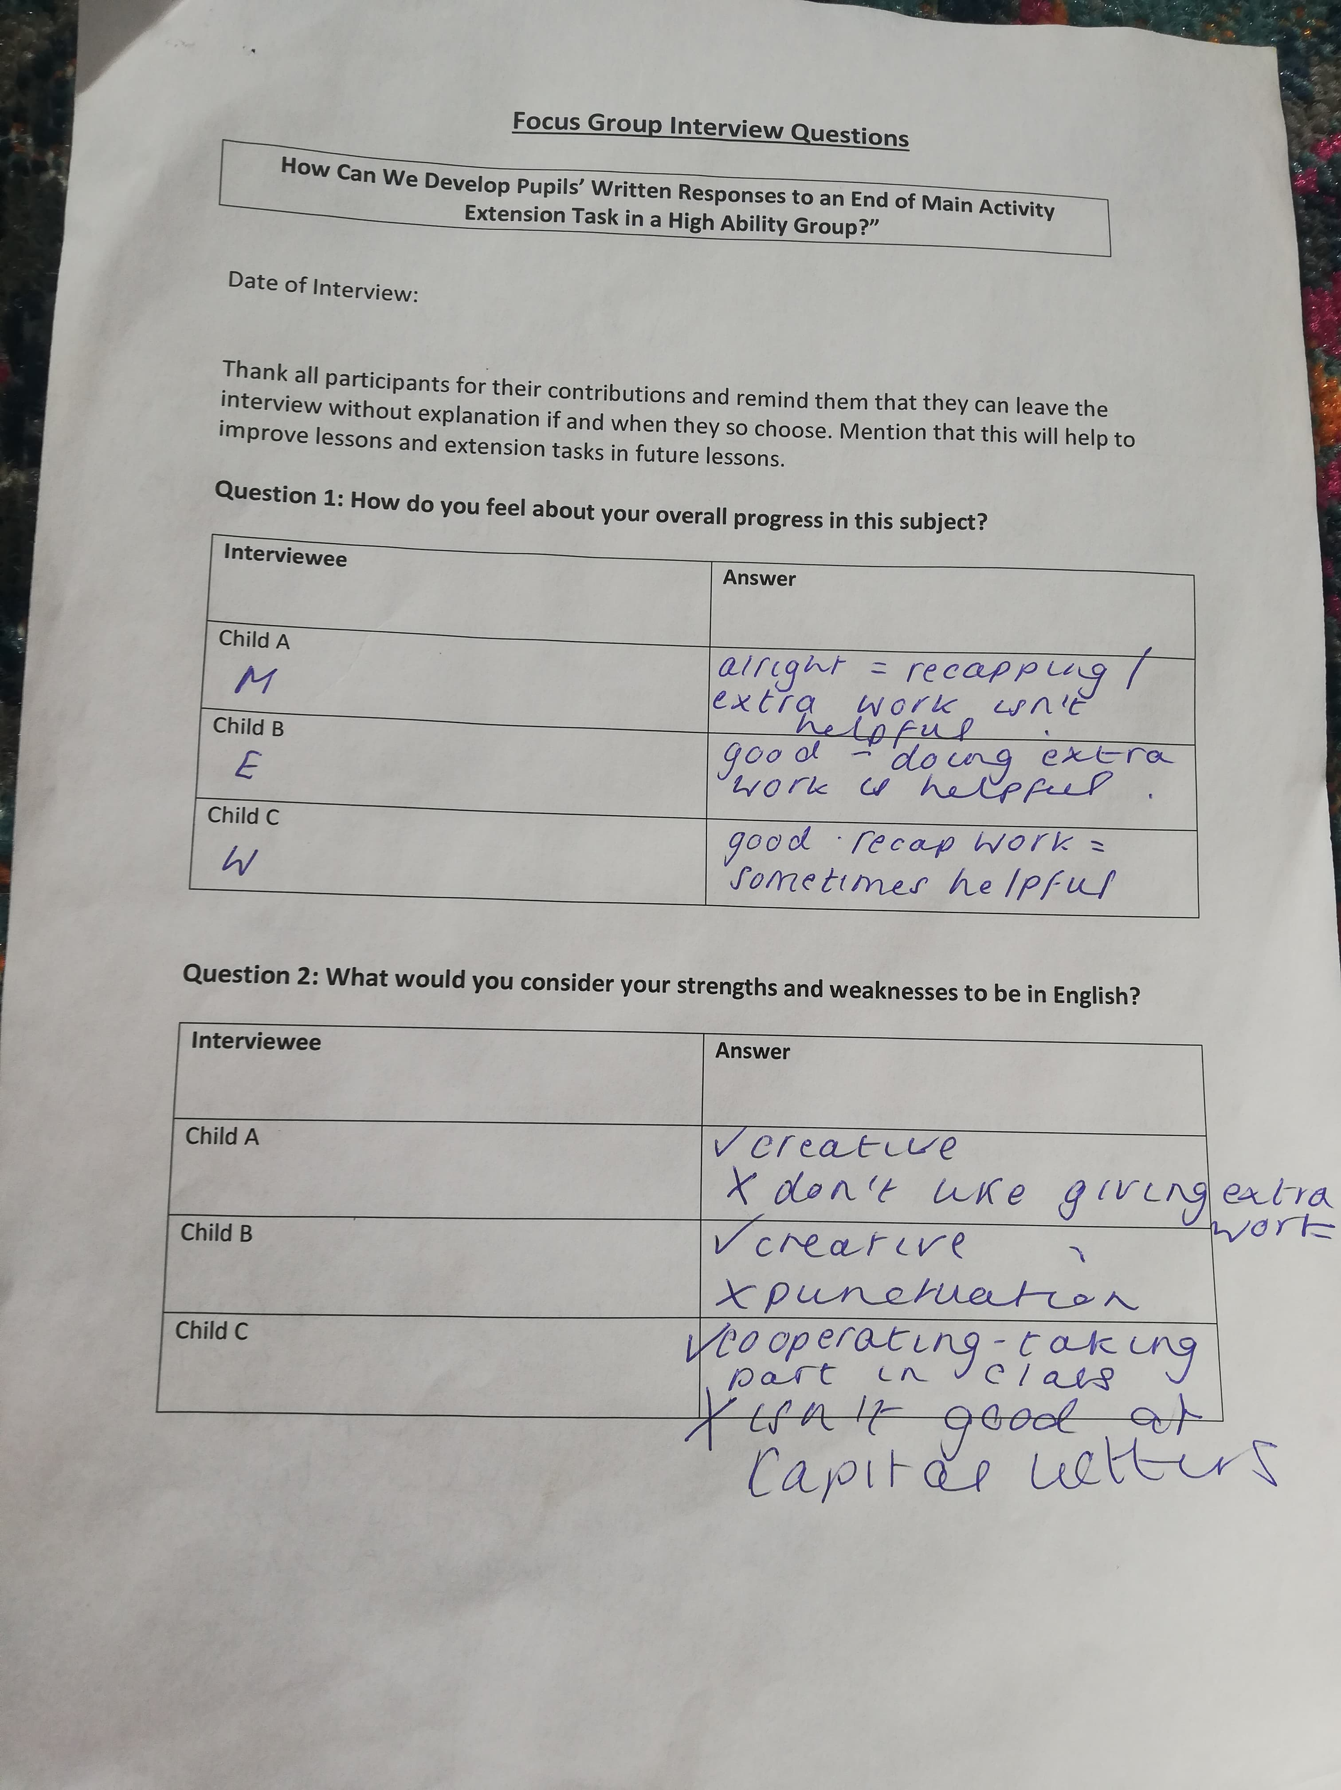
Appendix 3

Appendix 4
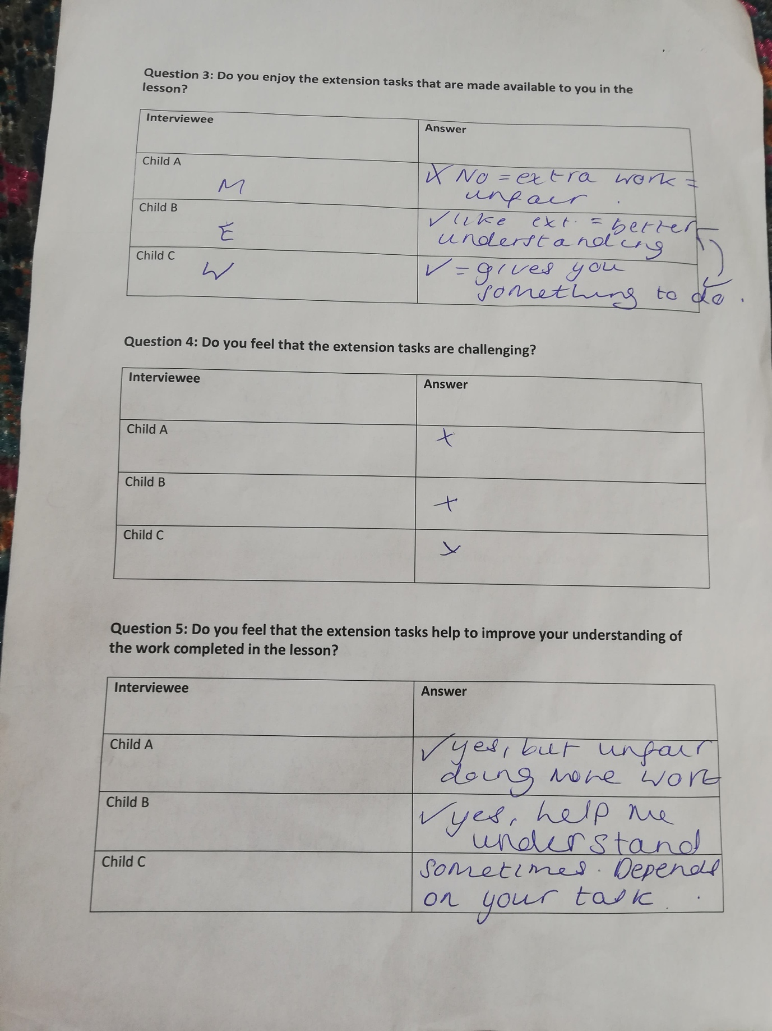

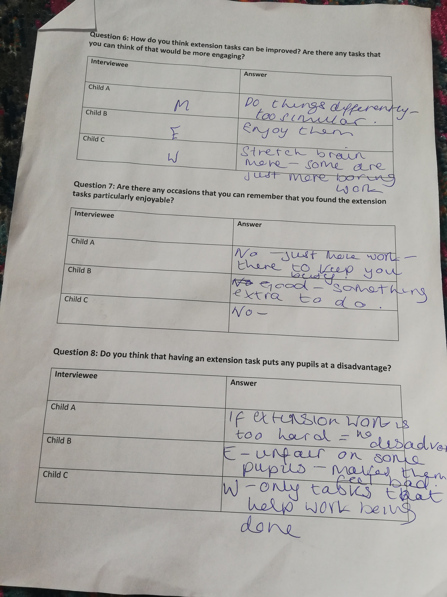
Appendix 5

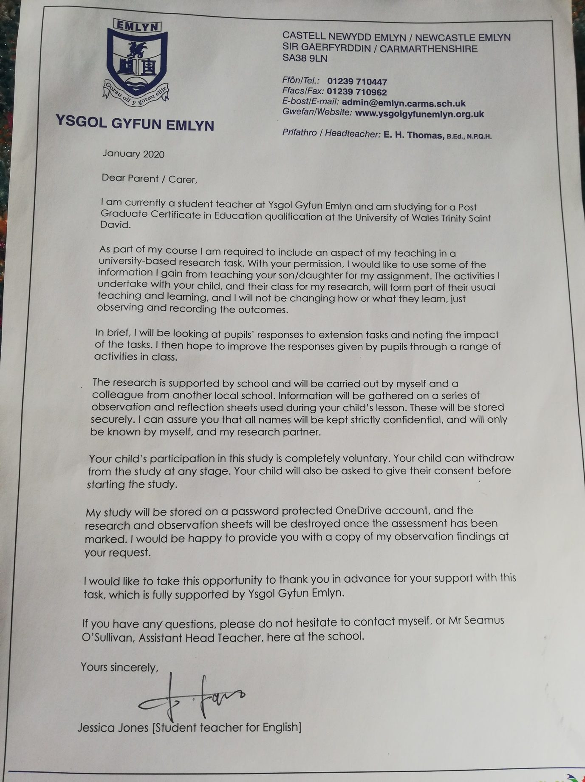
Appendix 6 – Parental Consent Letter

Appendix 7 – Lesson Study Lesson Plan
Time | Activities/Methodology/Key Concepts  (Teacher’s Role – including key teaching points and key questions differentiation strategies,, ) | Pupil Tasks  (Pupils’ role -including engagement in formative assessment and homework) | Resources  (Including Health and Safety requirement)
Opening phase (with links to prior learning) | - Starter questions and ‘challenge’ questions on the IWB.  - Explanation of today’s tasks and L.Os.  Task should take 5 minutes | - Pupils will complete two recap questions and two challenge questions. These will then be discussed with the class.  Task should take 7 minutes
Teaching & Core Learning | - There will be a PowerPoint with top tips and an outline of today’s tasks. Pupils will use this information in their planning.  - There will be a structured planning sheet given to all pupils. This will be explained at the front of the class to ensure that all pupils are aware of what goes in each box.  - Pupils will then complete this information sheet with the appropriate information.  - There will also be an extension task where pupils will analyse the speech from a settlers point of view. Pupils will write a spider diagram in their books. | - Pupils will follow a PowerPoint, which will outline today’s tasks and will have top tips for each section.  Task should take 10 minutes  - The planning sheet will be explained to all pupils from the front of the class, ensuring that all pupils are aware of what needs to be done.  Task should take 7 minutes  - Pupils will complete their planning sheets with the information that they would like to include.  Task should take 20 minutes  - There will also be an extension task for the pupils who finish their plan before the 20 minutes.
Plenary | - I will bring the class back to the front where I will go through each section. Pupils can share ideas and the information that was put in each section. | - Pupils will share their ideas from each section with the rest of the class.  Task should take 10 minutes

