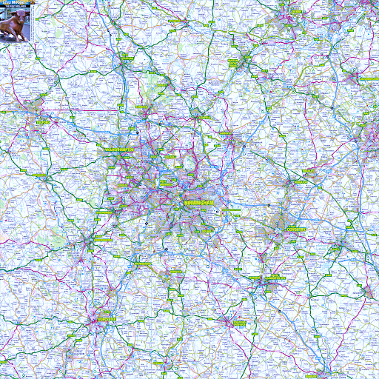

A PROJECT PORTFOLIO
Lecturer Name: Xavier Matieni
Module Code: LCLM 5004
Module Name: Project Management
Student Name: Joanita Teixeira F. A. Guterres
Student ID: 2331039


University Of Wales Trinity Saint David
London Campus
TABLE OF CONTENTS
A. POSTER 2
B. REFLECTIVE REPORT 3
C. PROJECT MANAGEMENT PLAN 5
INTRODUCTION 6
PROJECT PLANNING 7
a) Project Description 7
b) Project Scope 8
c) Work Breakdown Structure 9
d) Quad Chard 10
e) Gantt Chart 11
f) Stakeholder’s Involvement 12
g) Allocation of Resources 13
h) Risk Analysis 14
CONCLUSION 16
REFERENCES 17

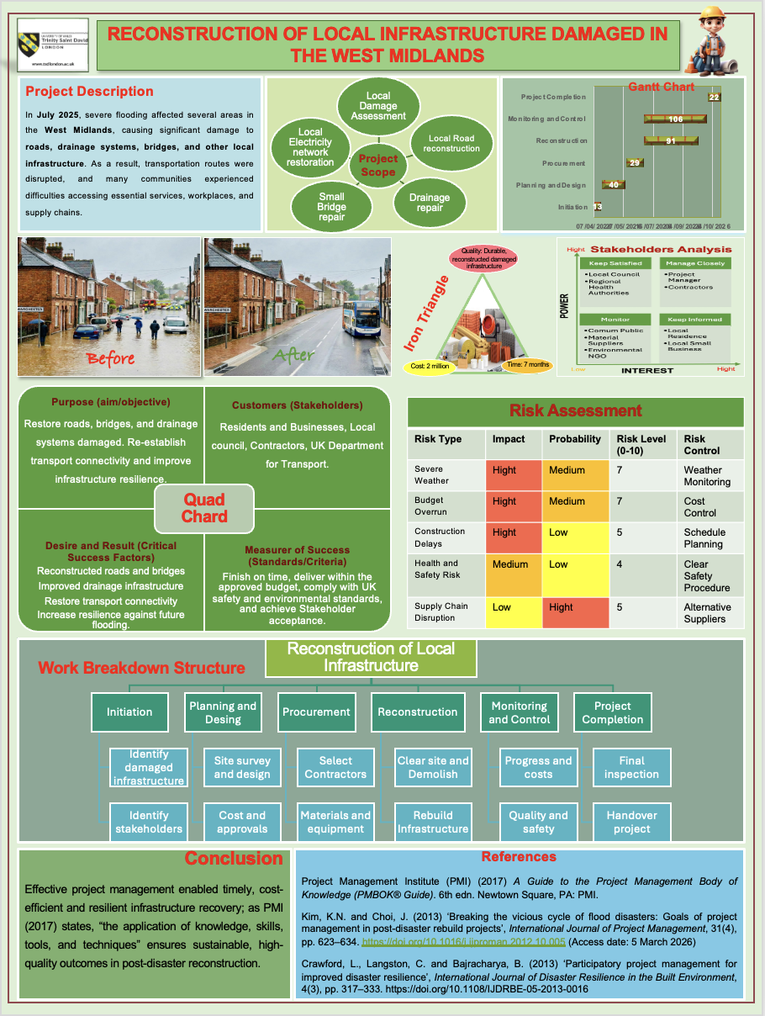

POSTER

B. REFLECTIVE REPORT

Description
The poster presentation focused on the reconstruction of infrastructure in the West Midlands following severe flooding. It included key project management elements such as scope, stakeholder analysis, a Gantt chart, and risk assessment. The aim was to present a clear overview of how project management tools can be applied in a real-world context. The poster was designed with structured sections and colour-coding to improve clarity and make the information easier to understand.
Feelings
While developing the poster, I felt confident about its structure and visual appearance. The layout was organised, and I believed the use of diagrams would support understanding. After receiving feedback, I felt encouraged that the presentation was clear and well-structured. However, I also felt concerned when the tutor pointed out an issue with the risk analysis. I realised that although the poster looked professional, some parts did not meet the expected academic standard.
Evaluation
The poster had several strengths. The content was logically organised, and the visual presentation made it easy to follow. The use of colour and diagrams helped communicate key ideas effectively, which is important in poster-based assessments. The positive feedback confirmed that these aspects were successful.
However, the main weakness was in the risk analysis section. The numerical risk levels were assigned without a clear method, which reduced the credibility of the analysis. Although the risks identified were relevant, the lack of justification meant the section lacked academic depth.
Analysis
This experience highlights the importance of applying theory to practice. In project management, risk assessment should be based on structured methods, such as evaluating probability and impact, rather than using arbitrary values. Without a clear basis, the results cannot be considered reliable. According to project management guidelines, risks should be assessed systematically to support effective decision-making (PMI, 2017).
In addition, reflection is essential for improving academic work. Gibbs’ reflective cycle emphasises the importance of analysing both strengths and weaknesses to support learning (Gibbs, 1988). In this case, I focused more on the poster's visual quality than on the justification for the content. This shows that academic work requires both clear presentation and strong reasoning.
Kolb’s learning theory also suggests that learning occurs through reflecting on experience and applying theoretical understanding (Kolb, 1984). This has helped me recognise the importance of using appropriate frameworks in future work, particularly when making decisions that require justification and clear academic reasoning.
Conclusion
Overall, the poster was effective in terms of structure and visual communication. It clearly presented the project's main elements and was easy to understand. However, the risk analysis lacked a clear academic basis, which reduced its overall quality. This reflection has shown me that both presentation and justification are equally important in academic work.
Action Plan
For future work, I will focus on improving the accuracy and depth of my analysis. Firstly, I will use recognised methods, such as probability-impact matrices, to assess risks and justify my work. Secondly, I will ensure that all decisions are clearly explained and supported by relevant theory. These steps will help me produce work that is both clear and academically rigorous.

C. PROJECT MANAGEMENT PLAN

RECONSTRUCTION OF LOCAL INFRASTRUCTURE DAMAGED IN THE WEST MIDLANDS

INTRODUCTION
Infrastructure plays a fundamental role in supporting economic development, social connectivity, and access to essential services. When these systems are disrupted, particularly by natural disasters such as flooding, the impacts can be severe, widespread, and long-lasting. In July 2025, the West Midlands experienced significant flooding following a period of intense and sustained rainfall caused by an unusual Atlantic weather system. This event caused extensive damage to roads, bridges, drainage systems, and electrical networks across several towns. As a result, transport networks were severely disrupted, access to healthcare and workplaces was restricted, and local businesses faced considerable operational challenges. Furthermore, the flooding exposed underlying weaknesses in existing infrastructure, highlighting the need for improved resilience and more effective long-term management strategies.
Such large-scale disruption emphasises the importance of adopting a structured and coordinated approach to infrastructure recovery. In response, this Project Management Plan (PMP) has been developed to provide a comprehensive, systematic framework for reconstructing the affected infrastructure. The plan is informed by established project management principles aligned with the Project Management Body of Knowledge (PMBOK), which supports effective planning, organisation, and control throughout the project lifecycle (PMI, 2017). This approach ensures that project activities are managed efficiently and that key objectives are achieved within defined constraints.
The purpose of this document is to guide key stakeholders, including local authorities, contractors, and community representatives, by clearly defining the project scope, structure, scheduling, resource allocation, and risk management strategies. By integrating essential tools such as the Work Breakdown Structure, Gantt chart, stakeholder analysis, and risk assessment, the plan supports informed decision-making and effective coordination. Ultimately, the project aims not only to restore damaged infrastructure but also to enhance long-term resilience, sustainability, and preparedness for future environmental challenges.

PROJECT PLANNING

Project Description
In July 2025, following several weeks of intense rainfall caused by an unusual Atlantic weather system, multiple towns across the West Midlands, including Worcester, Shrewsbury, and Kidderminster, experienced severe flooding. The River Severn, already at critical levels, breached its flood defences in several locations, resulting in rapid and widespread inundation. Within a short period, roads became impassable, electricity networks failed, and numerous homes and businesses were submerged. The scale of the event placed significant pressure on local councils, emergency services, and community organisations, limiting their ability to respond effectively. Although the Environment Agency had issued “Severe Flood Warnings – Danger to Life,” many residents underestimated the speed and severity of the situation. The extent of this disruption is clearly illustrated in Figure 1 (Before Reconstruction), which shows flooded streets and damaged infrastructure.
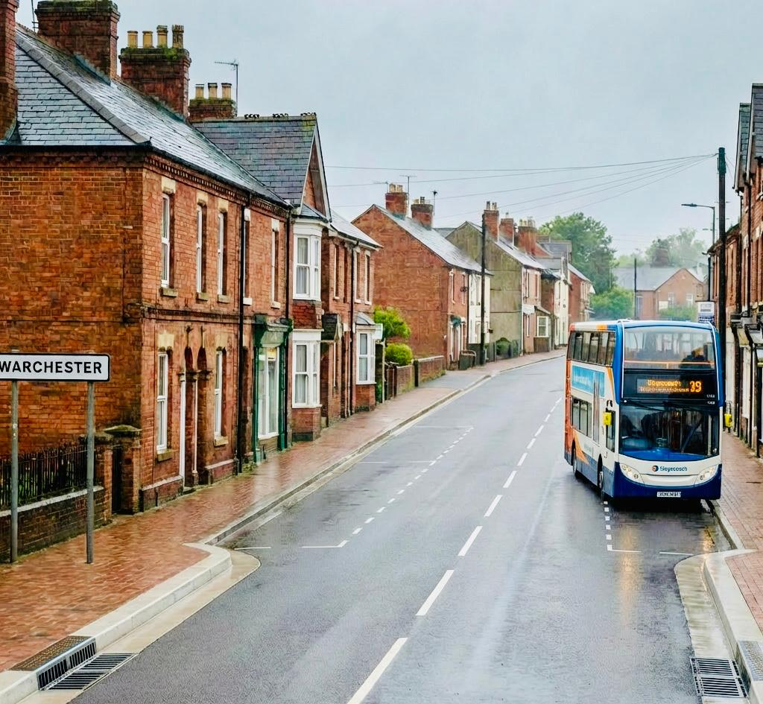
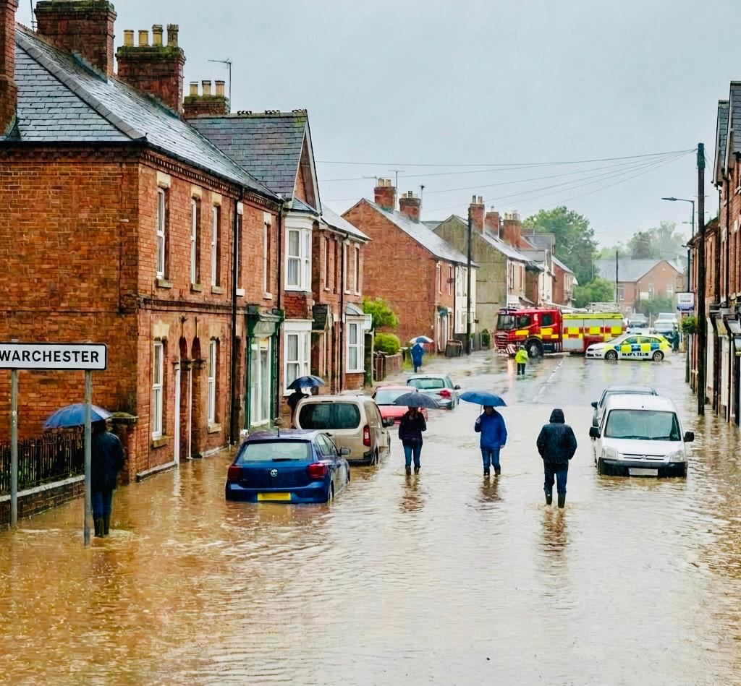

Figure 2: After Reconstruction
Figure 1: Before Reconstruction
As a result of this event, key local infrastructure was significantly damaged, leading to major disruptions in transport, utilities, and access to essential services. Roads were degraded, drainage systems became ineffective, and structural damage to bridges increased safety risks for local communities. This project therefore focuses on the reconstruction of critical infrastructure, including roads, drainage systems, bridges, and electricity networks, which are essential for restoring normal operations.
The effectiveness of these reconstruction efforts is demonstrated in Figure 2 (After Reconstruction), where improved road conditions and restored infrastructure highlight the project's positive outcomes. The aim is not only to restore functionality but also to enhance resilience against future flooding events through improved design and engineering solutions.
By prioritising infrastructure recovery, the project supports community stability, economic activity, and long-term sustainability within the affected region.

Project Scope
The project scope defines the boundaries of the work to be undertaken and ensures that all activities are aligned with the overall project objectives. A clearly defined scope is essential for maintaining control over deliverables and preventing unnecessary expansion of work, commonly referred to as scope creep.
As illustrated in Diagram 1 (Project Scope), the project includes several key activities: conducting a detailed assessment of flood-related damage; reconstructing local roads and transport routes; repairing and upgrading drainage systems; restoring the electricity network infrastructure; and repairing small bridges.
Diagram 1: Project Scope.
These activities are directly linked to restoring essential services and improving the resilience of infrastructure against future flooding events. In addition, the project incorporates quality assurance measures to ensure that all reconstruction work complies with UK safety and environmental standards. This is essential to guarantee the durability and long-term sustainability of the infrastructure, ensuring that it can better withstand similar challenges in the future.
However, the scope excludes unrelated developments, such as large-scale infrastructure projects or urban expansion initiatives. This ensures that resources remain focused on addressing the immediate impact of the flooding. Effective scope management is critical to project success, as it ensures that objectives remain clear and achievable within the available resources and timeframe (Kerzner, 2017). Any changes to the scope will be managed through a formal change control process to maintain project stability and control.

Work Breakdown Structure
The Work Breakdown Structure (WBS) is a fundamental project management tool used to divide a project into smaller, manageable components. This hierarchical structure supports effective planning, coordination, and control by breaking down complex activities into clearly defined tasks. As illustrated in Diagram 2 (Work Breakdown Structure) and supported by project management principles, the WBS enhances clarity and improves scheduling and resource allocation, both of which are essential for successful project delivery (Steinfort, 2017). The project is organised into six main phases, each representing a key stage in the project lifecycle.

Diagram 2: Work Breakdown Structure (WBS).
The role of each phase is below:
- Initiation
This phase involves identifying damaged infrastructure and key stakeholders affected by the flooding. It establishes the foundation of the project by defining objectives, determining feasibility, and outlining initial requirements necessary for successful project delivery.
- Planning and Design
During this phase, detailed site surveys are conducted to assess the extent of damage. Engineering designs are developed, cost estimates are prepared, and project timelines are established. Required approvals and regulatory permissions are also obtained to ensure compliance with standards.
- Procurement
This phase focuses on selecting qualified contractors and sourcing appropriate materials and equipment. Effective procurement ensures that resources are available on time, cost-efficient, and meet the required quality standards for reconstruction activities.
- Reconstruction
This is the core phase of the project, involving the clearance and demolition of damaged structures followed by the rebuilding of infrastructure. Activities are carefully coordinated to ensure safety, quality, and adherence to design specifications.
- Monitoring and Control
Project progress, costs, risks, and quality are continuously monitored throughout the lifecycle. This phase ensures that any deviations from the plan are identified early and corrective actions are implemented promptly.
- Project Completion
The final phase includes comprehensive inspections, quality assurance checks, and formal handover of completed infrastructure to stakeholders, ensuring that all objectives and standards have been successfully achieved.
The WBS improves clarity by clearly defining tasks and responsibilities, ensuring that all team members understand their roles within the project. It also supports effective scheduling and resource allocation, which are critical for project success.

Quad Chard
The Quad Chart provides a concise summary of the project’s key elements, making it an effective communication tool for stakeholders. It presents essential information in a structured format, enabling a clear understanding of project objectives, stakeholder involvement, and expected outcomes. As illustrated in Diagram 3 (Quad Chart), the project is defined through four key components that support effective planning and decision-making (Bello, 2025).
Diagram 3: Quad Chard

Purpose (Objectives):
The primary objective of the project is to restore damaged infrastructure and enhance resilience against future flooding. This includes re-establishing transport connectivity, improving the reliability of essential services, and ensuring that infrastructure systems are capable of withstanding similar environmental challenges. The project also aims to support long-term sustainability by incorporating modern engineering solutions and improved design standards.
Customers (Stakeholders):
Key stakeholders include local residents, businesses, local councils, contractors, and the UK Department for Transport. Each group has a direct interest in the successful delivery of the project. Their involvement is essential to ensure that project outcomes align with community needs, regulatory requirements, and operational expectations, while also supporting effective communication and collaboration throughout the project lifecycle.
Desire and Results (Critical Success Factors):
Critical success factors include the effective reconstruction of infrastructure, improved drainage systems, and increased resilience to future flooding events. In addition, maintaining quality standards, minimising disruption to communities, and ensuring efficient coordination between project phases are essential to achieving desired outcomes.
Measures of Success:
The project will be considered successful if it is completed on time, within budget, and in compliance with safety and environmental standards, while achieving stakeholder satisfaction. Success will also be measured by the long-term performance, durability, and resilience of the reconstructed infrastructure.

Gantt Chart
The Gantt chart provides a visual representation of the project schedule, clearly illustrating the sequence, duration, and overlap of key activities. According to established project management principles, it is a fundamental tool that supports effective time planning by organising tasks along a timeline and ensuring that all activities are completed within the allocated timeframe (PMI, 2017).

Figure 3: Gantt Chart
As shown in Figure 3, the project is expected to be completed within approximately seven months, beginning with the initiation phase and progressing through planning, procurement, reconstruction, monitoring, and final completion. The chart highlights that the reconstruction phase is the most time-intensive stage, reflecting the complexity of rebuilding damaged infrastructure. In contrast, phases such as initiation and procurement are shorter but remain essential in establishing a strong foundation for later stages.
The Gantt chart also demonstrates how certain phases, particularly monitoring and control, run concurrently with other activities. This continuous oversight ensures that progress, cost, and quality remain aligned with project objectives throughout the lifecycle. In addition, the chart helps identify task dependencies, allowing project managers to understand how delays in earlier stages may affect subsequent activities and overall project delivery.

Stakeholder’s Involvement
Stakeholders play a critical role in the success of any project, particularly in post-disaster reconstruction, where multiple groups are affected. Effective stakeholder management ensures that all parties are engaged appropriately and that their needs and expectations are considered.
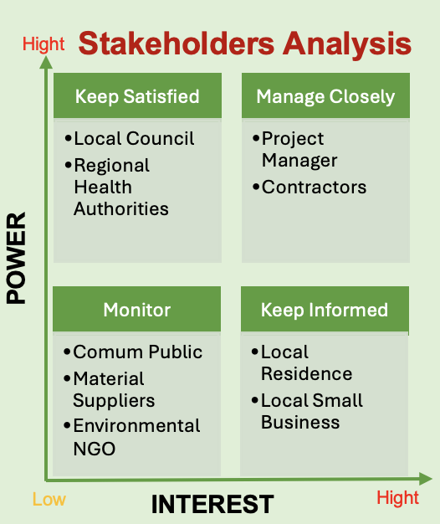
Figure 4: Stakeholder Analysis
As illustrated in figure 4, stakeholders are categorised based on level of power and interest, as explained below:
- High Power, High Interest (Local councils, project managers, contractors):
These stakeholders have significant influence over project decisions and are directly involved in its delivery. They must be closely managed and actively engaged throughout the project lifecycle, as their decisions can significantly impact project outcomes, timelines, and resource allocation.
- High Power, Low Interest (Government authorities):
Although these stakeholders may not be directly involved in day-to-day activities, they hold regulatory authority and can influence project approval and compliance. Therefore, they should be kept satisfied through regular updates to maintain their support and avoid potential obstacles.
- Low Power, High Interest (Residents and businesses):
These stakeholders are directly affected by the project outcomes but have limited influence over decision-making. It is important to keep them well-informed and engaged, ensuring their concerns are addressed to maintain trust and community support.
- Low Power, Low Interest (General public and NGOs):
These stakeholders have minimal influence and limited direct interest in the project. However, they should still be monitored to ensure that any emerging concerns are identified early and managed appropriately.
Effective stakeholder engagement improves communication, reduces conflict, and enhances project outcomes. It also helps build trust and ensure the project meets the community's needs (Fewings and Henjewele, 2019).

Allocation of Resources
Resource allocation is a key aspect of project management, ensuring that all necessary inputs are available to achieve project objectives effectively. It involves the careful planning and distribution of human, financial, material, and time resources. These elements must be managed in a balanced way, as they are closely linked to the constraints of cost, time, and quality, as shown in Figure 5 (Iron Triangle).
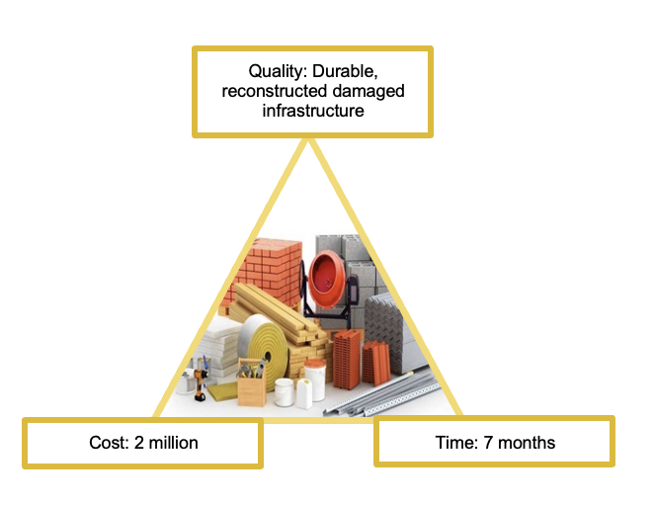
Figure 5: Iron Triangle of the Project.

Human Resources:
The project team includes project managers, engineers, construction workers, and health and safety officers. Each role contributes to delivering the project efficiently, safely, and in accordance with required standards.

Material Resources:
Essential materials such as concrete, steel, and construction equipment are required for rebuilding infrastructure. Ensuring their availability and quality is important for maintaining progress and achieving durable outcomes.
Financial Resources:
The project budget is estimated at £2 million. Effective financial management is necessary to control costs and ensure resources are allocated appropriately.
Time Resources:
The project is scheduled to be completed within seven months. Careful planning and coordination are required to meet this deadline.
Effective resource management supports successful project delivery, while poor allocation can lead to delays, increased costs, and reduced quality (Sholarin and Awange, 2016).

Risk Analysis
Risk management is a critical component of project planning, particularly in construction and post-disaster environments where uncertainty and external factors can significantly affect outcomes. Effective identification, assessment, and control of risks are essential to minimise their impact and ensure the successful delivery of the project.
Key risks identified in this project are presented in Table 1 (Risk Assessment of the Project). Each risk has been evaluated based on its level of impact and probability, allowing for the assignment of an overall risk level. This structured approach ensures that risks are prioritised and managed appropriately throughout the project lifecycle.

Risk Assessment
Risk Type | Impact | Probability | Risk Level (0-10) | Risk Control
Severe Weather | Hight | Medium | 7 | Weather Monitoring
Budget Overrun | Hight | Medium | 7 | Cost Control
Construction Delays | Hight | Low | 5 | Schedule Planning
Health and Safety Risk | Medium | Low | 4 | Clear Safety Procedure
Supply Chain Disruption | Low | Hight | 5 | Alternative Suppliers
Table 1: Risk Assessment of the Project

Severe weather has been identified as a high-impact risk with a medium probability, as adverse conditions can delay construction activities and affect resource availability. Similarly, budget overruns present a significant risk due to fluctuating material costs and potential delays, requiring strict cost control measures. Although less likely, construction delays still pose a considerable risk and must be managed through effective scheduling and planning.
Health and safety risks are assessed as moderate but remain critical due to their potential impact on workers and project continuity. Implementing clear safety procedures is essential to mitigate these risks. In addition, supply chain disruptions, while lower in impact, are more likely to occur and can affect the timely delivery of materials, making the use of alternative suppliers an important mitigation strategy.
Overall, risk management is a continuous process that involves ongoing monitoring, evaluation, and adjustment to respond to changing conditions. This proactive approach ensures that risks are effectively controlled and that the project remains on track to achieve its objectives (Hillson, 2009).

CONCLUSION
This Project Management Plan provides a structured and comprehensive framework for the reconstruction of infrastructure in the West Midlands following severe flooding. Through the application of key project management tools and techniques, including scope definition, Work Breakdown Structure, scheduling through Gantt charts, stakeholder analysis, resource allocation, and risk management, the plan ensures a coordinated and systematic approach to project delivery.
The integration of these elements supports effective planning, communication, and decision-making, enabling the project to be delivered within the constraints of time, cost, and quality. In particular, the emphasis on stakeholder engagement and risk management enhances the project’s ability to respond to uncertainties and minimise potential disruptions.
Furthermore, the plan highlights the importance of not only restoring damaged infrastructure but also improving its resilience against future environmental challenges. By incorporating sustainable practices and structured management approaches, the project contributes to long-term recovery and community stability.
In conclusion, effective project management plays a crucial role in ensuring that post-disaster reconstruction projects are delivered successfully, supporting both immediate recovery needs and future resilience (Steinfort, 2017).

REFERENCES
Bello, A.B. (2025). Adaptive project management strategies for complex multi-stakeholder environments. Available at: https://www.researchgate.net (Accessed: 9 April 2026).
Fewings, P. and Henjewele, C. (2019). Construction project management: An integrated approach. London: Routledge.
Gibbs, G. (1988) Learning by doing: A guide to teaching and learning methods. Oxford: Oxford Polytechnic.
Hillson, D. (2009). Managing risk in projects. Farnham: Gower Publishing.
Kerzner, H. (2017). Project management: A systems approach to planning, scheduling, and controlling. 12th edn. Hoboken: Wiley.
Kolb, D.A. (1984). Experiential learning: Experience as the source of learning and development. New Jersey: Prentice Hall.
Kim, K.N. and Choi, J. (2013) ‘Breaking the vicious cycle of flood disasters: Goals of project management in post-disaster rebuild projects’, International Journal of Project Management, 31(4), pp. 623–634. https://doi.org/10.1016/j.ijproman.2012.10.005
Project Management Institute (PMI) (2017) A guide to the project management body of knowledge (PMBOK® Guide). 6th edn. Newtown Square, PA: PMI.
Sholarin, E.A. and Awange, J.L. (2016). Environmental project management: Principles, methodology, and processes. Cham: Springer.
Steinfort, P. (2017) ‘Community and post-disaster program management methodology’, International Journal of Project Management, 35(7), pp. 1236–1247.

