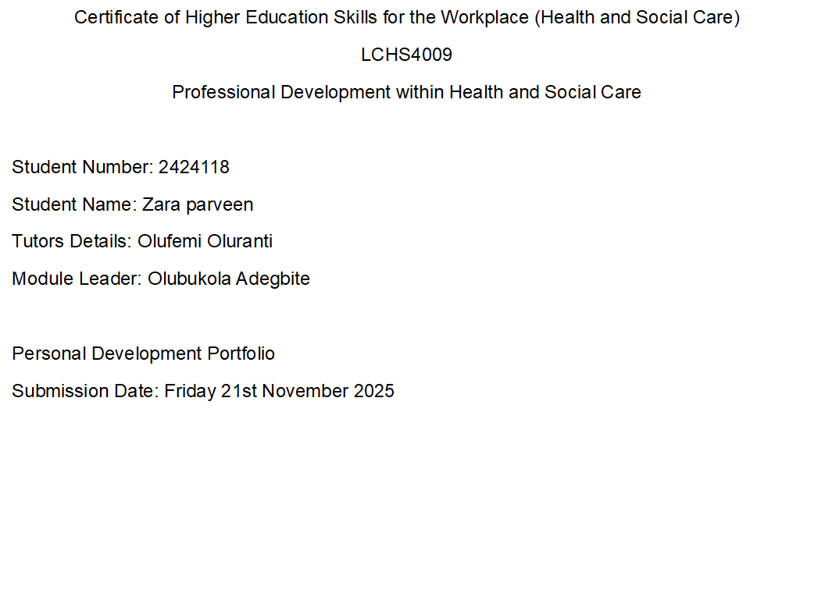

Personal Action Plan: Applying for Trainee Social Worker Role
Job Role Identification
The identified job role is Trainee Social Worker. This position is highly demanding, requiring a blend of academic knowledge, strength, and great interpersonal skills to manage complex caseloads, advocate for vulnerable individuals, and navigate statutory requirements.
Key Skills Required and How I Meet Them
Key Skill Required | Explanation of Requirement | How I Meet the Skill
Empathy and Compassion | The ability to understand and share the feelings of service users while maintaining professional boundaries (Higham, 2020). | I have experience volunteering with a local community support group, which requires me to listen actively and validate the experiences of individuals from diverse backgrounds, demonstrating genuine compassion and respect for their dignity and self-determination.
Resilience and Stress Management | Social work is emotionally taxing; the ability to manage stress and recover quickly from difficult or challenging case outcomes is crucial (Cottrell, 2021). | Throughout my degree, I have successfully managed high-pressure situations, such as simultaneous deadlines and complex group projects. I use structured planning and mindfulness techniques to maintain focus and emotional stability under pressure.
Communication and Active Listening | Effective verbal and written communication is essential for reporting, liaising with multi-disciplinary teams (MDTs), and building trusting relationships with service users (Brotherton & Parker, 2013). | I regularly participate in academic presentations and group discussions, which has refined my ability to articulate complex ideas clearly. More importantly, I practice active listening by summarising points and asking clarifying questions in collaborative settings.
Critical Thinking and Analysis | The capacity to evaluate complex information, make informed professional judgments, and apply theoretical models to practical situations (Lupton & Frohman, 2020). | My academic work consistently requires me to analyse literature critically and apply concepts like the SWOT analysis to real-world scenarios. I can process diverse data (reports, testimonies) to build a reasoned assessment of need.

Skill Gaps and How to Address Them
While I possess a strong foundation, I have identified two key areas that require specific development before and during the application process:
Skill Gap 1: Deep Legislative and Policy Knowledge
Explanation: My foundational knowledge of core social care legislation (e.g., the Care Act, Mental Capacity Act) is adequate, but I lack the detailed, working knowledge required to cite specific sections of policy quickly and confidently in professional practice.
Intended Action: I will undertake targeted, structured reading of key government and local authority documents. I will use a flashcard system to test my recall of specific statutory duties and relevant sections of law, ensuring this knowledge is internalised and readily applicable.
Skill Gap 2: Specialist Report Writing and Case Note Documentation
Explanation: I am capable in academic report writing, but the style, conciseness, and legal accuracy required for statutory social work case notes, assessments, and court reports are specific and require practice.
Intended Action: I will find online training modules or resources that offer simulated case studies and practice documentation templates. I plan to draft at least three mock social work assessment reports based on fictional scenarios and seek feedback on them from an industry mentor or experienced professional.
Personal Development Plan (PDP)
Goal | Specific Action (How) | Deadline | Resource/Support
Master Legislative Knowledge | Complete an online CPD (Continuing Professional Development) course focusing solely on the Care Act 2014 and the Mental Capacity Act 2005. | Within 8 weeks | Future Learn/Open Learn courses, Official Government Guidance documents.
Improve Statutory Documentation | Draft three full-length mock Initial Needs Assessments and request peer or mentor feedback on clarity and legal compliance. | Within 12 weeks | Online social work forums/communities for templates, Mentorship contact (if available), University Careers Service.
Enhance Crisis Intervention Skills | Research and summarise the core principles of de-escalation techniques and motivational interviewing, creating a quick reference guide for myself. | Within 4 weeks | Academic journals, Specialist social work textbooks, YouTube professional development videos.

Interview Questions and Responses
Question 1: Why have you chosen a career in social work, and why this organisation specifically?
Response: My motivation stems from a deep-seated commitment to social justice and a desire to empower individuals who are facing significant disadvantage. My previous experience has shown me the impact of systemic issues, and social work provides the most direct means to intervene and advocate for positive change. I’m drawn to your organisation because of its renowned commitment to strengths-based practice, particularly in Birmingham & Solihull Mental Health & Wellbeing Hubs. This philosophy focusing on the client's assets, not just their shortages align perfectly with my own values and approach to partnership working.
Question 2: Can you describe a challenging situation where you had to manage conflicting demands or priorities?
Response (STAR Method): Situation: During a university group project, our team had conflicting views on the research direction, and we had a very tight deadline. Task: My role was to mediate the conflict and ensure we submitted a high-quality presentation on time. Action: I didn't impose a solution; instead, I facilitated a meeting, using active listening to ensure everyone felt heard. I mapped out the pros and cons of each suggestion on a whiteboard, and we used a shared critical thinking approach to collaboratively select the most viable option. Result: We successfully merged the best parts of both ideas, delivered the presentation on time, and maintained positive working relationships, which taught me the value of structured conflict resolution.
Question 3: What do you consider your biggest weaknesses, and what are you doing to address them?
Response: I would say my biggest weakness has historically been perfectionism, which sometimes led me to over-prepare and struggle with handing over, believing it was faster to do a task myself than to brief someone else. I recognise that in a high-demand role like social work, this is unsustainable and impractical. I am actively addressing this by focusing on efficient delegation and prioritising impact over absolute perfection. For example, I now use a time-management matrix (e.g., Eisenhower Matrix) to deliberately allocate less time to lower-impact tasks, trusting my initial judgment, and focusing my energy where it will have the greatest benefit to service users.
Academic Report: The Importance of Critical Thinking in Health and Social Care Practice
Introduction
This report examines critical thinking as a fundamental skill required for professional practice within the health and social care sectors. Critical thinking is not purely about accumulating knowledge; it is the active, reflective, and evaluative processing of information to guide belief and action (Lupton & Frohman, 2020). Its importance is amplified in care settings, where professionals must navigate complex and clinical dilemmas to ensure the best possible outcomes for service users.
The Function of Critical Thinking in Assessment and Decision-Making
Critical thinking is most visible during the assessment and care planning cycle. Health and social care professionals routinely encounter situations that defy simple solutions. For instance, a social worker may receive conflicting accounts of a situation from a service user, a family member, and an external agency. Simply accepting the first or loudest narrative is insufficient and potentially harmful.
Critical thinking allows the practitioner to step back, question assumptions, and weigh evidence from multiple sources. According to Lupton and Frohman (2020), this process involves applying established theoretical knowledge (e.g., developmental or attachment theories) to the unique, individual circumstances of the client. This analytic approach ensures that care plans are evidence-based, holistic, and tailored to meet the service user’s actual needs, rather than being driven by professional bias or organisational convenience.
Interprofessional Practice and Reflective Judgement
Effective care delivery is increasingly dependent on multi-disciplinary team (MDT) working. In this context, critical thinking extends to evaluating the advice and perspectives offered by colleagues from different interests. For example, a nurse must critically evaluate a patient’s response to medication and communicate any significant change effectively to the medical team (Brotherton & Parker, 2013). This necessitates the use of reasoning and logic to connect observation (the patient's response) with potential cause (the intervention).
Furthermore, the skill is essential to professional accountability. Practitioners must critically reflect on their own practice to identify errors, biases, and areas for improvement. This reflective judgement, often taught and promoted through models of reflection, is a continuous process that eases risk and drives professional development (Tarrant, 2017).
Critical Thinking and Effective Communication
The application of critical thinking is inseparable from effective communication, particularly during sensitive interactions. Higham (2020) stresses that while communication and interviewing skills are paramount, they must be guided by a critical lens. Before asking a question or making a statement in a therapeutic setting, the professional must critically think about the potential impact, the relevance of the information requested, and the non-verbal cues being given.
Critically thinking professionals are better prepared to conduct difficult conversations, present clear and concise reports and crucially challenge inappropriate or poor practice when they encounter it. This is a crucial ethical duty within health and social care, requiring not just courage but also the well-reasoned, factual, and analytical training provided by tough critical thinking.
Conclusion
Critical thinking is not a extra skill but the intellectual scaffolding upon which safe, ethical, and effective health and social care is built. It underpins accurate assessment, guides ethical decision-making, and is essential for effective interprofessional collaboration. For any professional entering this sector, the continuous development of critical thinking skills is necessary to manage difficulty and provide the best possible service to vulnerable populations.
Critical Reflection on LCHS4009 Component 1 Presentation (ERA Model)
Introduction
This reflection uses the ERA (Event, Reflection, Action) model to critically analyse my performance in the LCHS4009 Component 1 presentation assessment. This assessment required me to apply analytical frameworks, specifically the SWOT analysis, to my professional development and employability. By reflecting on the experience and incorporating the verbal feedback received from my lecturer, I aim to create a clear plan for improving my presentation and communication skills (Tarrant, 2017).
Event (E)
The event was the LCHS4009 Component 1 presentation, where I was tasked with presenting an analysis of my personal strengths, weaknesses, opportunities, and threats (SWOT analysis) related to my future career. I prepared a set of slides and presented them to the lecturer. The core task was to demonstrate my self-awareness and planning for professional success (Cottrell, 2021). I felt a mixture of nerves and focus before the presentation, determined to cover all the required points accurately.
Reflection (R)
My overall thoughts on my performance are that I achieved a good level of content coverage, but my delivery requires significant refinement.
My Performance and Strengths
I believe my main strength was the content itself, as the lecturer noted that I covered most of the relevant areas of the task to a moderate extent. My preparation meant that I was able to evidence good knowledge and understanding of the SWOT analysis and its importance to my professional career. I also felt I identified my weaknesses effectively. Furthermore, the lecturer’s feedback confirmed that I communicated well and demonstrated good professionalism during the event, which is an important aspect of employability (Cottrell, 2021). My use of the slides was also praised as generally good, despite the content issues.
Areas for Improvement and Critical Analysis
Despite these positives, the feedback highlighted several critical areas where my presentation was significantly weak:
- Slide Design and Visuals: The lecturer pointed out that my slides were too word-heavy and that I should have included more graphics or diagrams. In reflection, I recognise that I treated the slides as speaking notes rather than visual aids. This resulted in cognitive overload, distracting from my verbal message.
- Delivery and Audience Connection: The most crucial feedback was that I was reading off the slides instead of maintaining eye contact and speaking to the lecturer directly. This passive delivery style resulted in a lack of connection and made the presentation feel like a recitation rather than an engaged discussion (Higham, 2020).
- Content Depth: While my knowledge was good, the lecturer suggested that the work could have been strengthened by including relevant examples and providing a more detailed discussion to support my points. I identified my weaknesses well, but failed to ground them with specific, practical illustrations to make them more convincing and relatable.
- Audience Engagement: The feedback indicated that for future presentations, I should aim to engage more actively with my audience. Reading from the screen reduced my ability to look up, gauge their interest, and invite participation, turning the event into a monologue.
Action (A)
Based on this reflection, I’ve established specific, measurable steps for my future presentations (Tarrant, 2017):
- Redesigning Slides: I will adopt the principle of minimal text per slide, no more than three key bullet points. I will use high-quality, relevant diagrams, charts, or images to visually support my argument, forcing me to speak the content rather than reading it.
- Practicing Delivery: I will conduct practice sessions where my notes are separate from the presentation screen. I will record myself to check that I am maintaining eye contact with the camera (or imagined audience) for at least 70% of the delivery time and consciously use vocal variety to sound less like I am reading.
- Enhancing Detail: For every main point in a presentation, I will prepare at least one detailed, real-world example or short case study. This will ensure my arguments are supported, as the lecturer suggested, and demonstrates the practical application of my knowledge.
- Active Engagement: I will incorporate planned rhetorical questions or short, two-minute polls/activities at key points to actively encourage participation and engage more actively with my audience in future opportunities.

References
Brotherton, G., & Parker, S. (2013). Your foundation in health & social care (2nd ed.). SAGE.
Cottrell, S. (2021). Skills for success: Personal development and employability (4th ed.). Red Globe Press.
Higham, P. E. (2020). Communication and interviewing skills for practice in social work, counselling and the health professions (1st ed.). Routledge.
Lupton, K., & Frohman, R. (2020). Critical thinking for nursing, health and social care. Red Globe Press.
Tarrant, P. (2017). Reflective practice and professional development (1st ed.). SAGE Publications.

