https://www.bevanfoundation.org/commentary/future-child-poverty-wales/?utm_source=Bevan+Foundation+News&utm_campaign=be5cda0b0f-EMAIL_CAMPAIGN_3_6_2018&utm_medium=email&utm_term=0_ae708a4818-be5cda0b0f-436335029

Feb 13th 2018

With no sign of child poverty disappearing, Jo Blake looks at what’s ahead for 2020
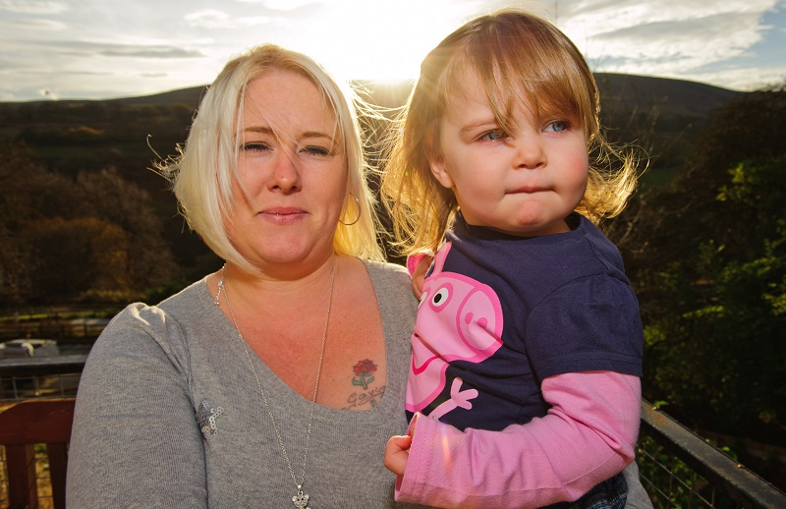
Child Poverty: The latest projections
There’s been a lot in the media recently about how child poverty is set to soar over the next few years. Although the child poverty rate in Wales has stuck at around 30 per cent for several years now, the latest projections from the Institute for Fiscal Studies suggest that by 2020, a shocking 40 per cent of children in Wales are likely to live in poverty, reversing the progress that has been made over recent decades.
Who’s most at risk?
In terms of those children who are most vulnerable to poverty, the story remains much the same as it’s ever been.
According to the Household Below Average Income data, those who live in workless households, households with three or more children, or those in single parent families, are more at risk than others. Further, children living in households where someone is disabled, or in ethnic minority households are also at a higher risk.
Why the reversing of the trend?
According to the Institute of Fiscal Studies, changes to the benefits system are responsible for the projected increases in child poverty. They predict that the introduction of Universal Credit, the two-child limit on means tested benefits, along with less generous tax credits, will cause child poverty to surge across the UK, with Wales being set to see some of the greatest increases.
What impact might this have?
If the Institute for Fiscal Studies projections are correct, by 2020 there will be more children in Wales living in poverty than there were in 1996, when child poverty was at its peak. Those children whose families rely more on benefits than earnings for their income are likely to be hit the hardest, which means that those children whose families are already on low incomes will be affected the most by the changes.
In terms of what this may mean for the day-to-day lives of those children, it may mean that a child goes to school hungry because their family cannot afford to feed them, or it may mean that a child is cold because their family cannot afford warm clothing or to adequately heat their home. It may be difficult for a child to participate in things that are taken-for-granted by their peers, such as going on school trips or having friends over to play – this in turn, may lead to feelings of shame and stigma. Research tells us that children from poorer backgrounds tend to have more physical and mental health problems than their more affluent peers. They also tend to perform less well educationally, which then impacts on their capacity to earn a decent living as an adult. In short, there is no part of a child’s life that living in poverty does not effect.
All of this means that those who live in poverty as children are more likely to live in poverty in adults, trapping them in cycle of poverty which is difficult to break.
So, what can be done?
Although the Welsh Government does not have the power to reverse changes to the welfare system, it can, and should, work to limit the impact of these changes to children by using its powers to influence those levers which can help individuals out of poverty, for example, by working to create decent jobs, with clear routes for progression, and by providing targeted support for those families who are most vulnerable (e.g. workless households). It could also work to ensure that housing, public transport, and childcare are affordable.
…………………..
Jo Blake is Policy and Research Officer at the Bevan Foundation.

