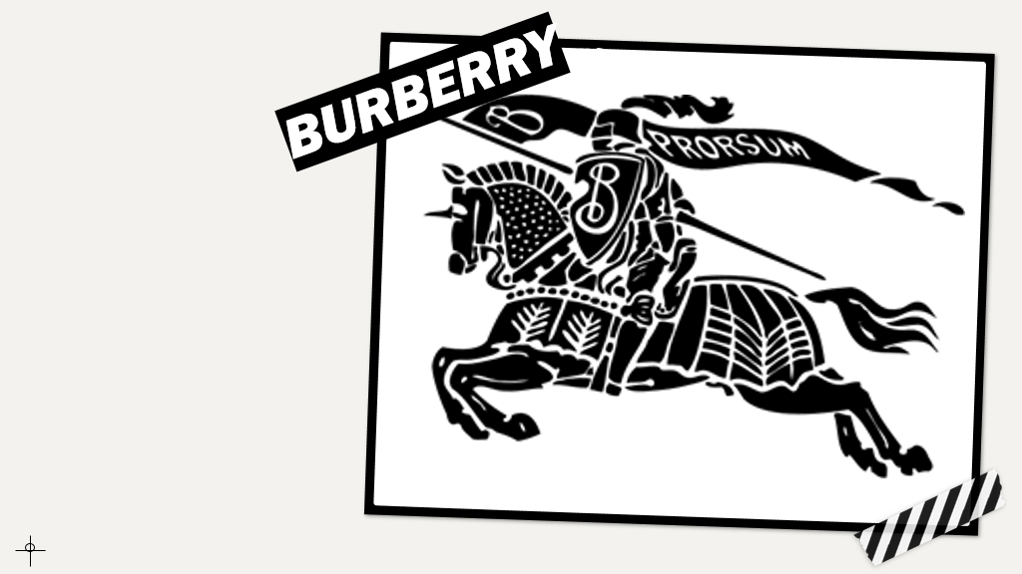

MARKETING FUNDAMENTALS
LCBB4004
ASSIGNMENT TITLE: BLOGGING TO COMMUNICATE
STUDENT: AMNA MASAUD 2113737
LECTURER: TUSHARA BALENDRAN
UNIVERSITY OF WALES TRINITY SAINT DAVID
DATE: 7/01/2022

B
L
O
G
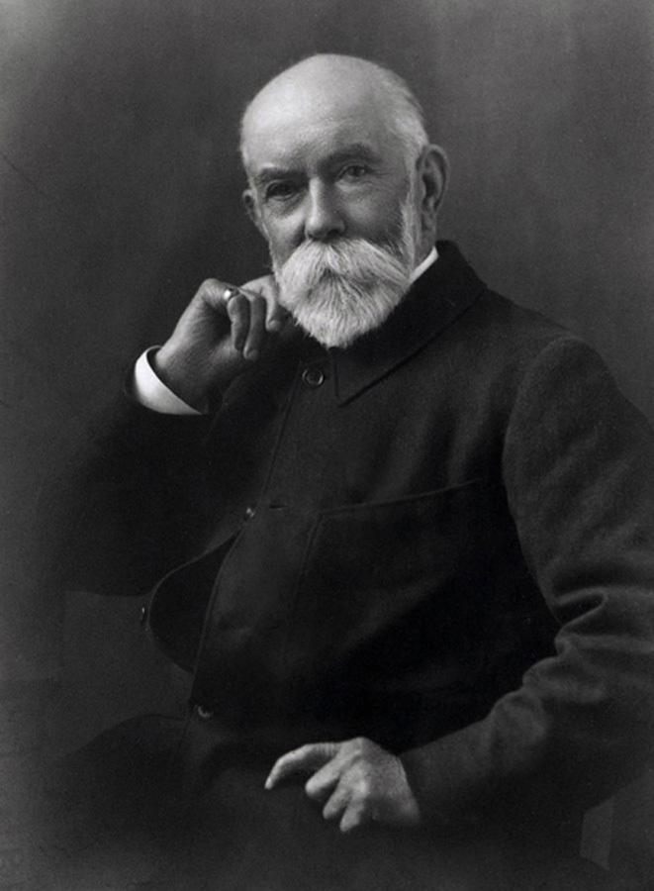
THE BURBERRY TRENCH COAT
Invented during the First World War
Designed to be useful during the war: D-rings for grenades, epaulettes to carry military equipment, gun flap
1856
- Founded by Thomas Burberry (1835-1926)
- Located in Basingstoke
- The main principle: clothes being designed to protect people against the British weather

1912
Thomas designed and patented Tielocken coat (the predecessor of the trench coat)

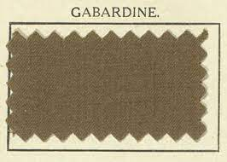
GABARDINE
- Thomas’ invention
- Waterproof and breathable material
- Protecting against rain
- Patented in 1888

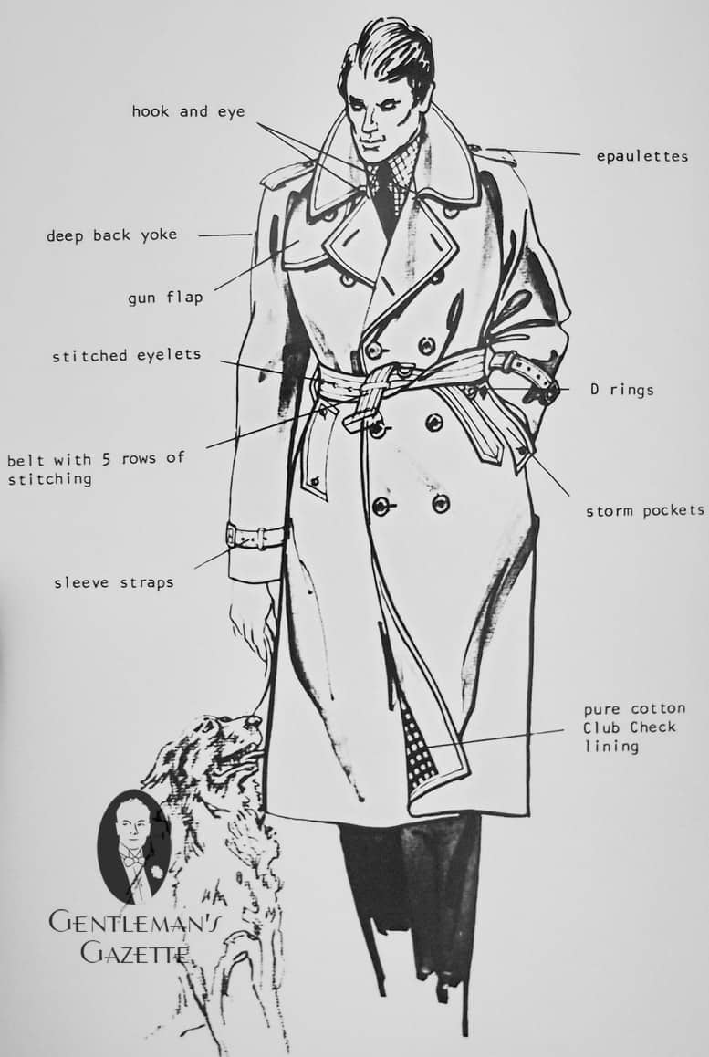

OUR HISTORY BABACKGROUND
1934 Burberry offering same-day delivery with its own vehicles in London
2010
We’ve been the first ones that livestreamed a fashion show…

2000
Opening our first store on Bond Street, London
2014
We enjoy being around YOU…
Over 500 stores around the world
2020 We will remain together…Manufacturing over 160k PPE for NHS
2021 We have over 10,000 employees worldwide
1968 WE DID IT! Our first television commercial
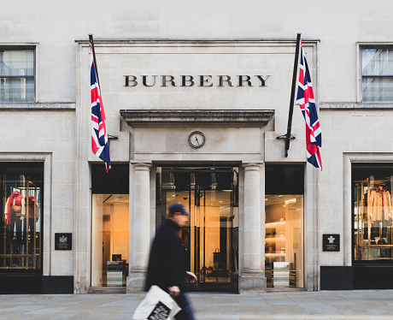

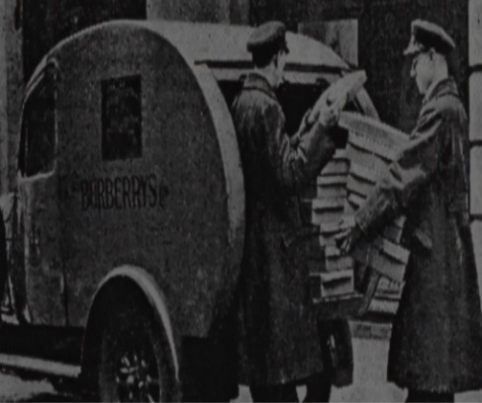
1972
Building our presence as manufactory in UK by acquiring the factory in the Castleford

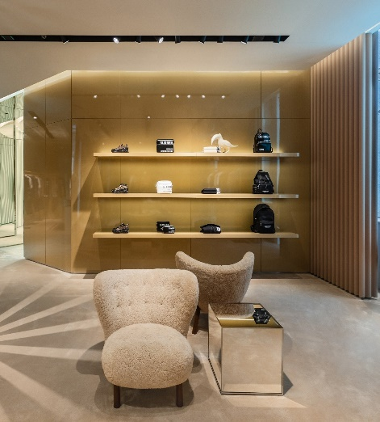
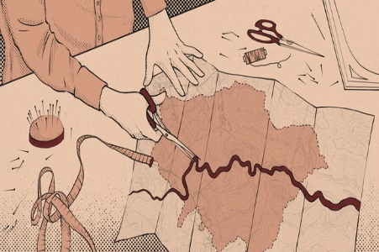
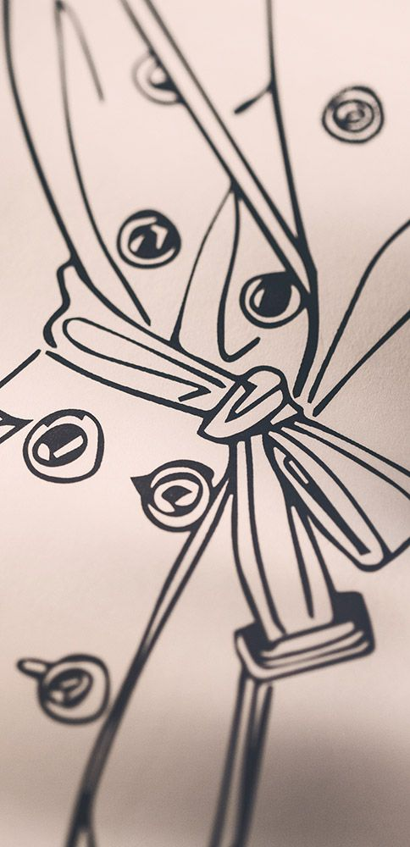
OUR PURPOSE AND VISION
PURPOSE
- push boundaries through imagination
- creating new opportunities for our customers and communities
VISION
- maintaining focus and innovation
- willing to deliver relevance and novelty

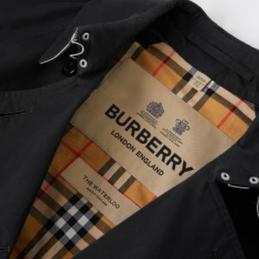

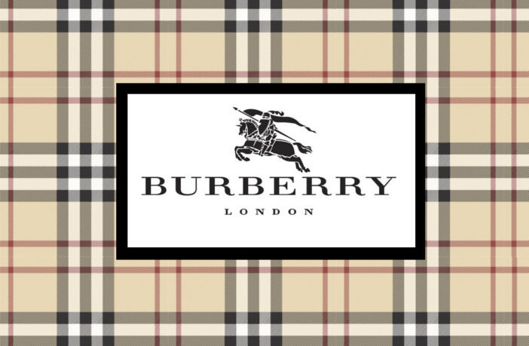


WHAT WE DO?
DESIGN: creating sustainable and durable luxury goods
SOURCE: working with our global suppliers to find the best materials for our products
MAKE: Producing our products at the Burberry manufacturing sites in UK and Italy
SELL: Our products are available in directly opperated and franchised stores

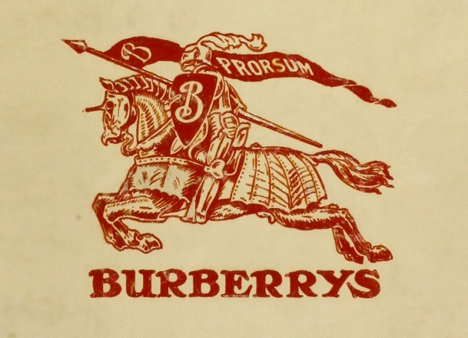
ALL ABOUT THE LOGO…
- Created in 1901
- Consists of the Equestrian Knight and the Latin word ‘Prorsum’, which means ‘forward’ (it represents company’s slogan)

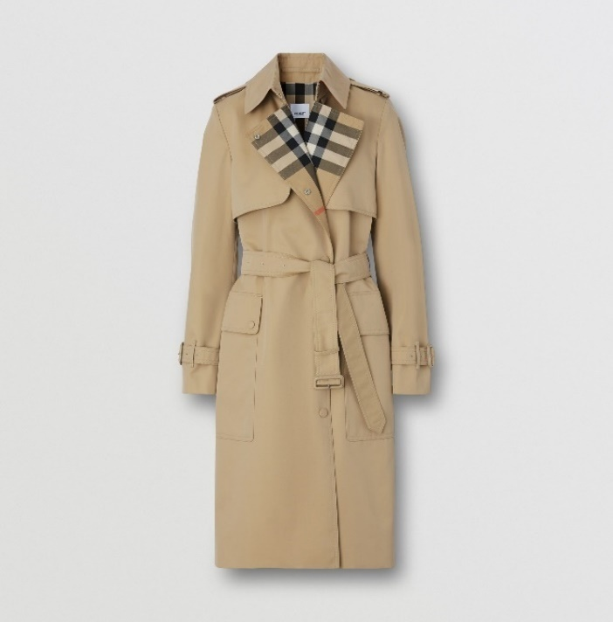
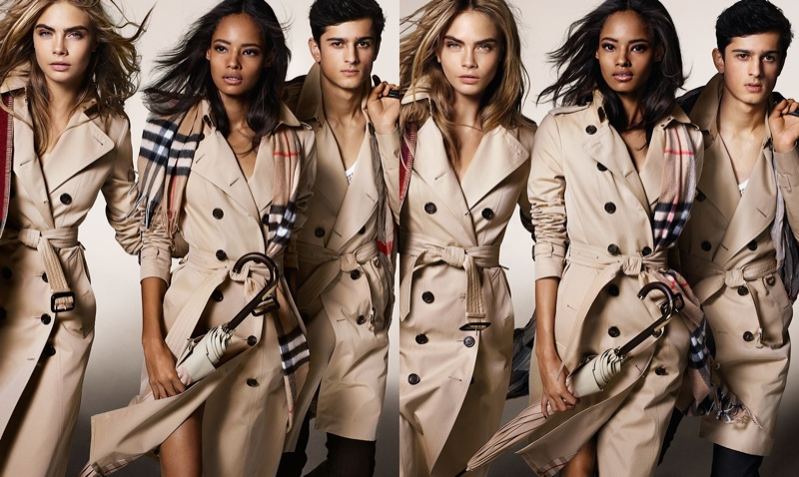
1.BURBERRY TRENCH COAT
- Has over 100 years of history
- Produced in Castleford, Yorkshire
- Represents a worldwide fashion icon
- Created from gabardine: material invented by Thomas Burberry in 1879
- Available for children and adults
BENEFITS
- Lightweight
- Has seasonal design adaptations
- The collar is the most difficult part of the product: 180 stitches need to be sewn by hand to create THE perfect collar
- Burberry offers repair and reproofing service for all their trench coats
- Obtain an accentuated waist if using the belt

We want to create a world where each of us feels that belongs. Our products have been designed to satisfy our customers’ needs, using high-quality materials. We made significative progress in developing our product strategy while managing the product flow.

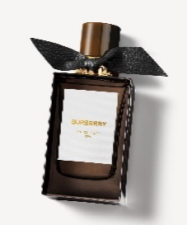
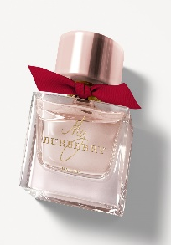
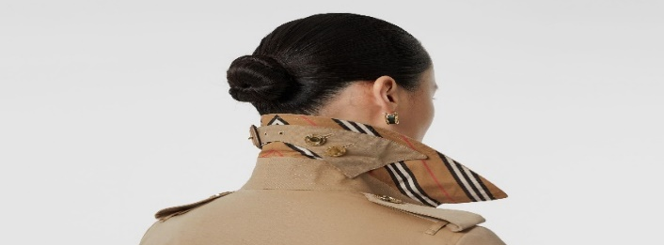
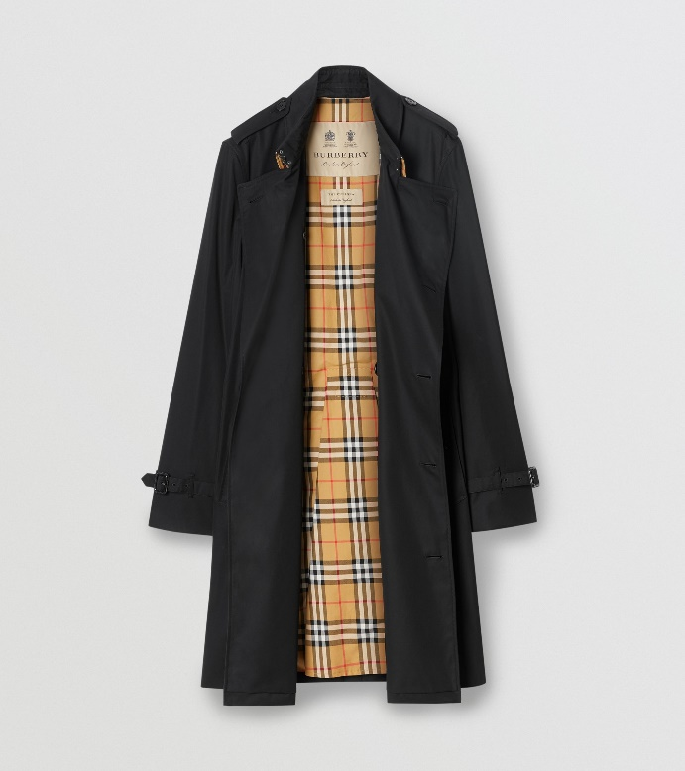
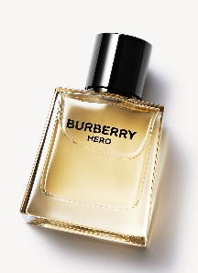
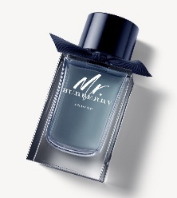
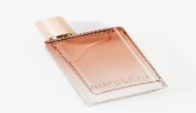
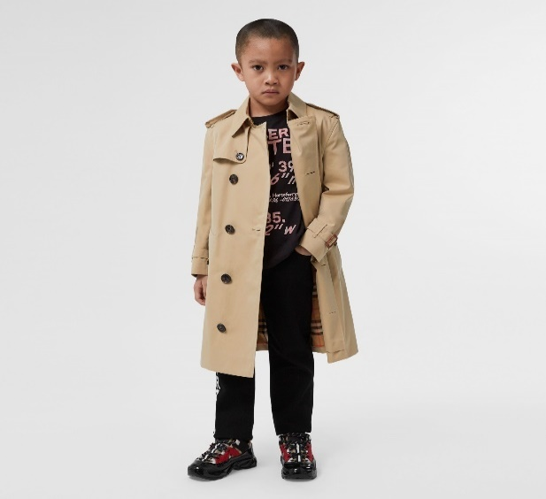
A. BURBERRY PRODUCTS
2. FRAGRANCE
- Burberry’s house codes reinterpreted in unique scents
- Possibility to engrave the bottles free of charge
- Different size bottles: 30ml / 50ml / 75ml / 90ml / 100ml / 150ml
- The notes are either fresh or sweet aiming to make the customer feel empowered, rich, and sophisticated

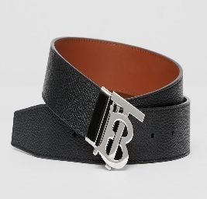
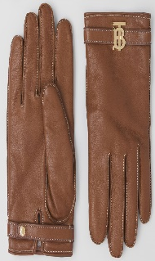
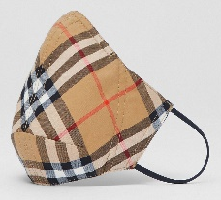
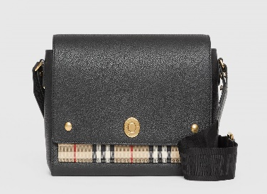
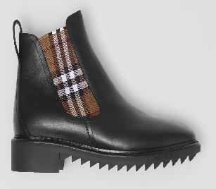
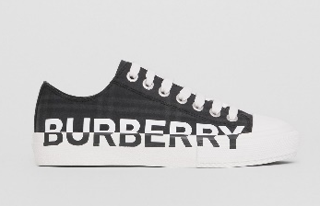
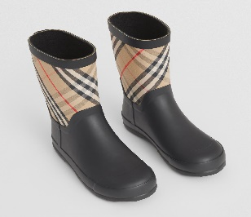
3. FOOTWEAR
- All our shoes are designed to be fashionable, good looking and comfortable
- Different categories of shoes:
Women: pumps, sneakers, boots, sandals, flats
Men: sneakers, sandal, boots, formal
Kids: rain boots, sneakers, sandals
- Variety of sizes and materials (leather, nylon, cotton, lambskin)
- Colours and patterns updated throughout the seasons

4. ACCESSORIES
- Wide range of categories: bags, wallets, hats, gloves, scarves, belts, eyewear, keychains
- Free of charge personalisation
- High-quality materials
- New motifs added frequently

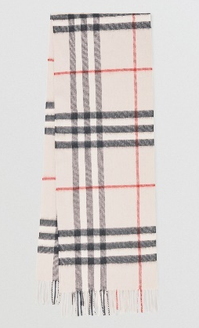
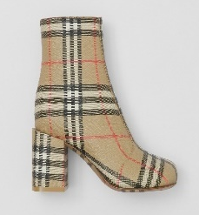

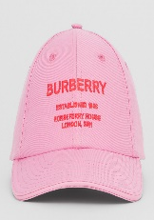
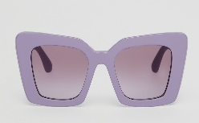
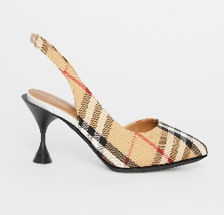
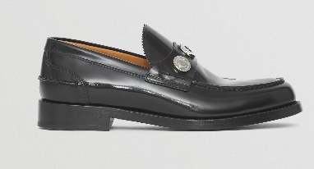
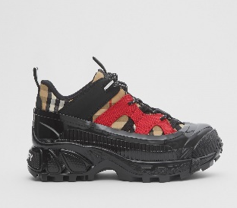
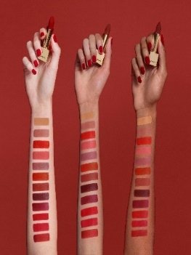
5. MAKE-UP
- Shades and looks inspired by runway collections
- Skin-enhancing products
- New releases every season
- Wide range of colours to match all types of skin tone
- Buildable textures

IF YOU WANT TO EXPLORE OUR RANGE OF PRODUCTS, YOU CAN VISIT OUR OFFICIAL WEBSITE BY CLICKING THE LINK BELOW

https://uk.burberry.com/

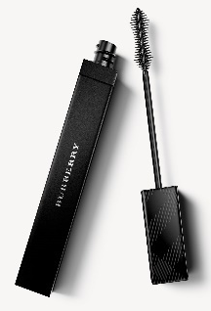

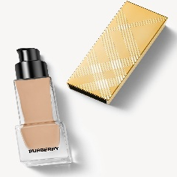
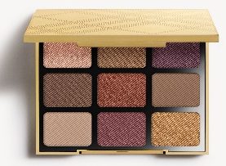

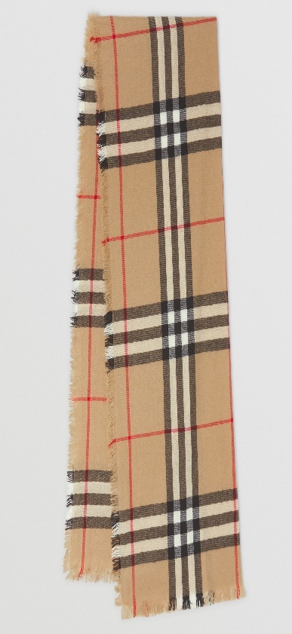
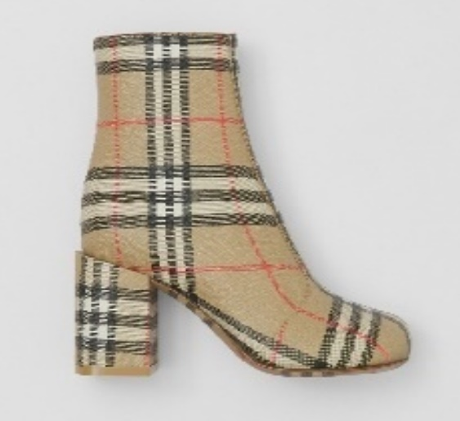
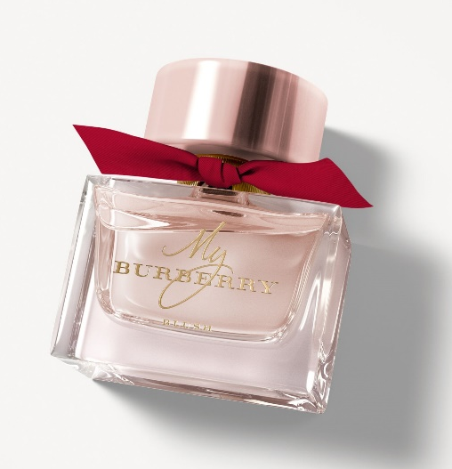
£850
B. OUR PRICES
- Premium pricing strategy
- Pricing is done by evaluating the demand and rivals’ prices
- Maintaining a consistent price

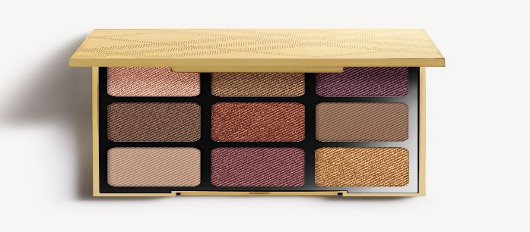
FRAGRANCE

MY BURBERRY BLUSH EAU DE PARFUM

90ml £99

Free of charge personalization

FOOTWEAR

VINTAGE CHECK BLOCK-HEEL ANKLE BOOTS

- £850

MAKE-UP

RUNWAY EYE PALETTE

- £62

ACCESSORIES

CHECK CASHMERE SCARF

- £490

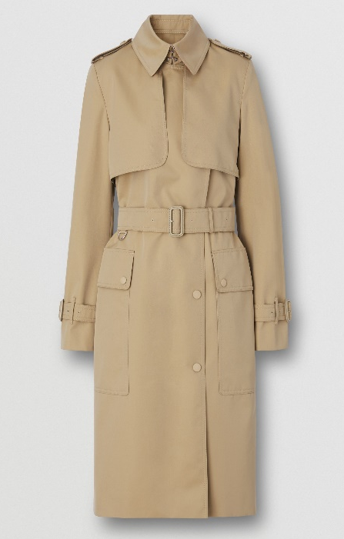

BURBERRY’S CHECK PANEL COTTON GABARDINE TRENCH COAT PRICE ACROSS THE WORLD
2021
UNITED KINGDOM £1,890
FRANCE €2,150
USA $2,590
SINGAPORE SGD 3,950

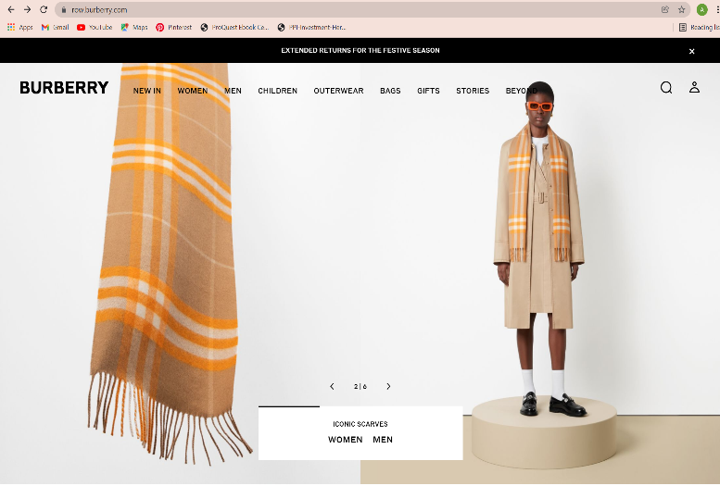
RETAIL STORES
We have a total of 459 operation stores around the world: Asia, USA and EMEIA (Europe, Middle East, and Africa)
Our physical stores remain a critical channel. We aim to remain integral to the luxury journey and our stores will incorporate a sense of community in order for the connection between brand and emotions to be strengthened. Since 2020, we opened 17 additional stores and refurbished up to 85 of our stores.
DISTRIBUTION
- In the last three years we developed our store and digital networks
- We are focusing on the direct-to- consumer channels in order to create an omnichannel experience
- Keeping customers’ engagement
- Agile supply chain
- Reaching operational efficiency

C. OUR DISTRIBUTION AND LOCATION

IN THE FUTURE
- Introducing our new store concept
- Trying to focus more on our local customers
- Putting the base of our pioneering Social Retail concept
- Supercharging digital sales

DIRECT
DISTRIBUTION
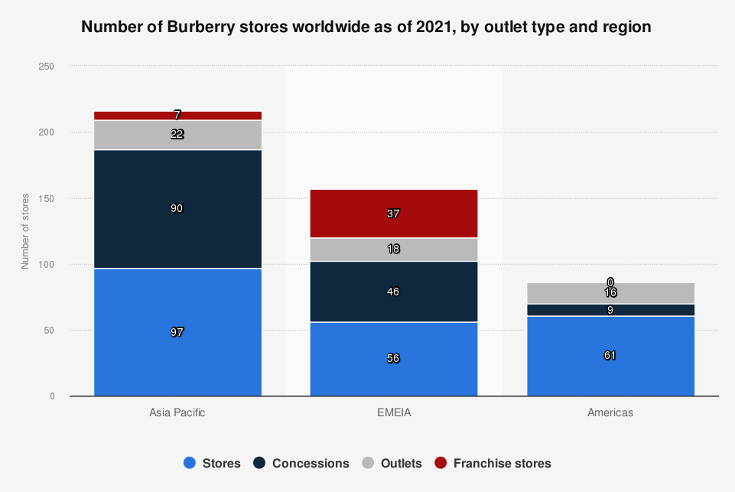
DIGITAL CHANNEL
The last year had a massive impact on our customers’ shopping habits, and it was leading to an accelerating growth of the online sales. We are expecting our online sales to increase with 30% by 2025. Our online channels were growing by 50% in 2020, managing to double our channel share compared with 2019.
We provide the same luxurious and quality experience as in the physical stores through virtual conversations with our Sales Associates. They are there to assist with styling and sizing advice and can share photographs of certain items to make your choice easier.

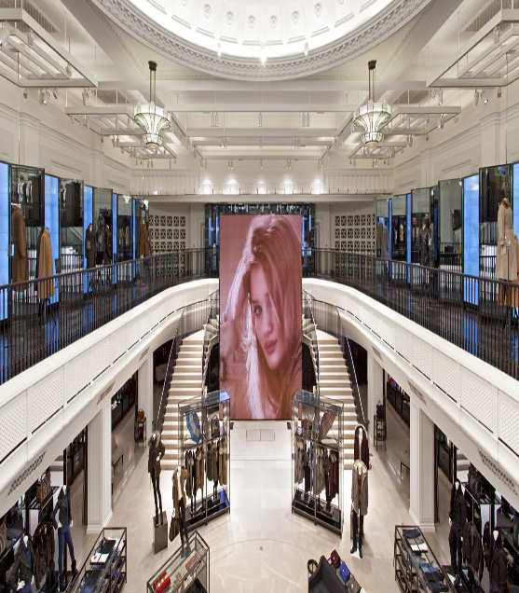
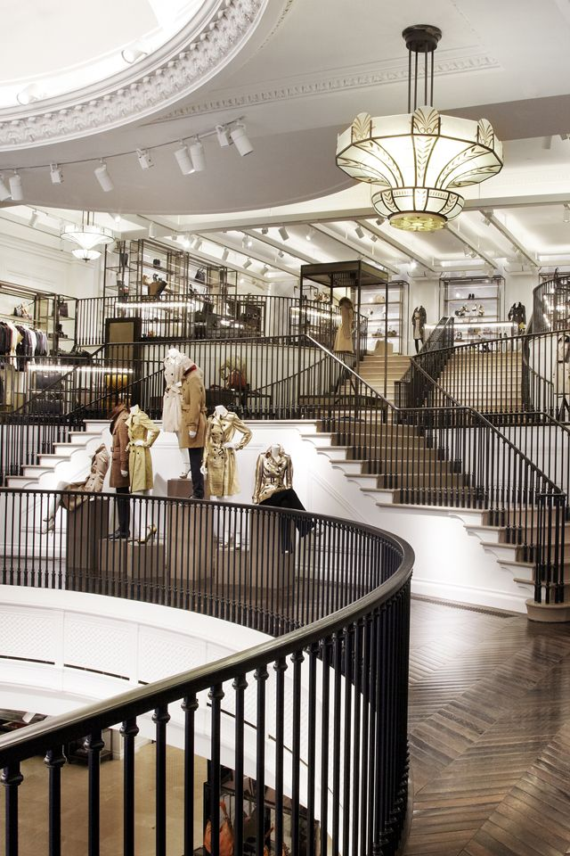
WHOLESALE DISTRIBUTION
We have numerous intermediaries are used to help generate a larger supply of the products. Indirectly, the wholesalers are selling our products with the help of the salespersons in multi-brand stores(Harrods , Selfridges) and e-commerce platforms.

87-135 Brompton Road
London SW1X 7XL
Phone: 020 7730 1234
IF YOU WANT TO SEE HOW IT FEELS TO BE IN ONE OF OUR MOST PRESTIGIOUS SHOPS, WE ARE LOOKING FORWARD TO MEETING YOU AT ONE OF THE FOLLOWING ADDRESSES.

21-23 New Bond Street
London W1S 2RE
Phone: 020 7980 8425
- Personal shopping appointments
- In store alterations
- Personal shopping styling advice

121 Regent Street
London, W1B 4TB
Phone : 020 7806 8904
The biggest Burberry store in the world (44,00 sq ft)

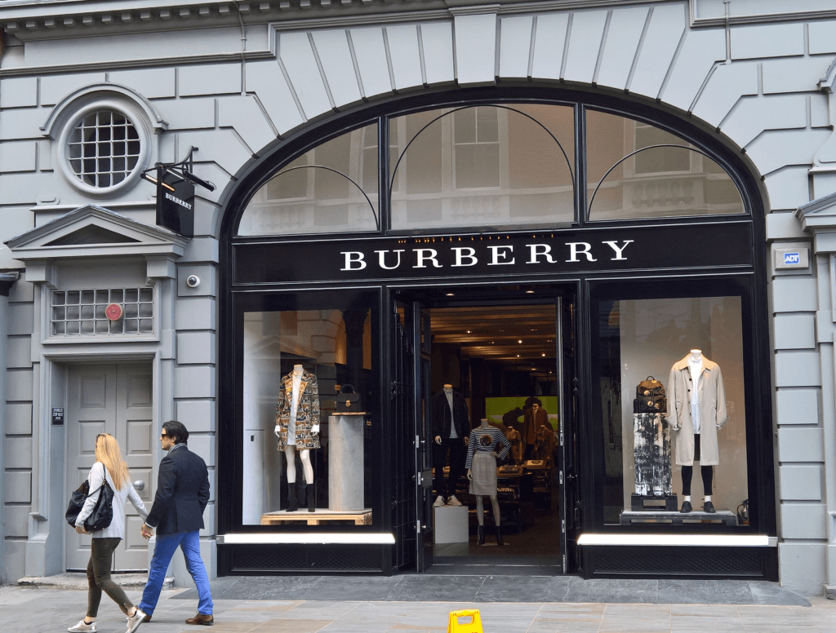
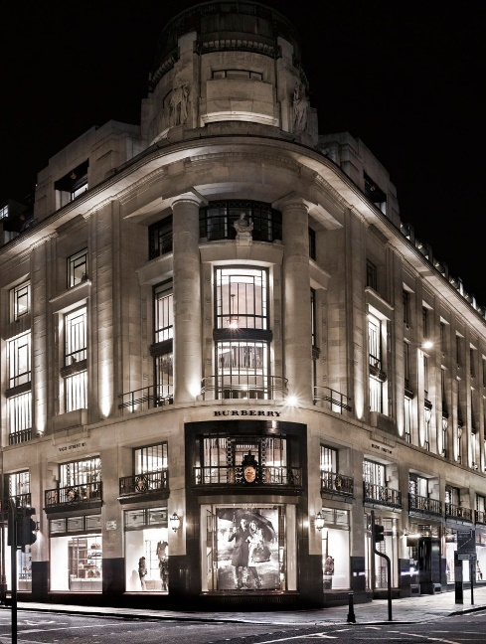

400 Oxford Street
London W1A 1AB
Phone: 020 7318 3575

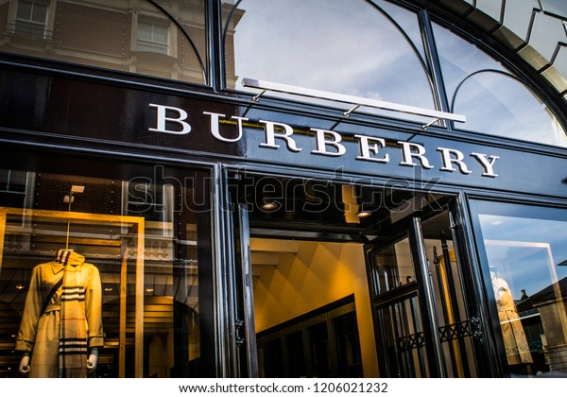



Burberry is known around the world as one of the most iconic brands of England

60% of our marketing budget goes towards digital channels: Instagram, Facebook, Twitter
The Facebook promotion are helping customers to obtain free samples of the brand’s scents via Sopost. In exchange, the brand gains the access of customers’ data.

