

Students Names:
Constantin-Danut Chinole ID: 2316293 (Leader)
Cristian Valenzuela Garcia ID: 2312699
Badru Keanene ID: 2416450
Lecturer Name: Tushara Balendran

LCBB5015
Principles of Marketing

Johnson and Johnson
UK Ltd

Table of Contents

1. Introduction on the Johnson and Johnson company……………………………………………………………2
2. Situational Analysis on the Johnson and Johnson company 3
2.1 PESTLE Analysis 3
3. Market Strategy…………………………………………………………………………………………………………5
3.1 Segmentation……………………………………………………………………………………………………..6
3.2 Targeting……………………………………………………………………………………………………………7
3.3 Positioning…………………………………………………………………………………………………………8
Marketing Mix: 7Ps………………………………………………………………………………………………………9
4.1 Product……………………………………………………………………………………………………………..9
4.2 Price…………………………………………………………………………………………………………………10
4.3 Promotion…………………………………………………………………………………………………………10
4.4 Place……………………………………………………………………………………………………………….11
4.5 People………………………………………………………………………………………………………….....11
4.6 Process ……………………………………………………………………………………………………………11
4.7 Physical evidence……………………………………………………………………………………………..12
5. Implementation and Control: KPIs…………………………………………………………………………….12
5.1 Sales and Market Growth KPIs…………………………………………………………………………….12
5.2 Market Access and Regulatory KPIs…………………………………………………………………….12
5.3 Customer and Stakeholder Engagement KPIs……………………………………………………….13
5.4 Operational and Quality KPIs………………………………………………………………………………13
5.5 Sustainability KPIs…………………………………………………………………………………………....13
Conclusion ………………………………………………………………………………………………………………14
References……………………………………………………………………………………………………………….15

1. Introduction of the Johnson and Johnson
Johnson & Johnson (J&J), founded in 1886 in New Jersey by the Johnson brothers, entered the UK in 1924 and has since established a strong industrial and healthcare presence with manufacturing facilities, renowned products, and support for the British health system (Johnson & Johnson, 2025).
According to Ross (2024), J&J operates in over 60 countries, offering pharmaceuticals in oncology, immunology, and neuroscience, alongside clinical trials, research collaborations, and patient access programmes. It also provides hospital technologies in surgery, orthopaedics, cardiology, neurovascular care, and vision, as well as consumer health products such as Johnson’s Baby, Listerine, and Neutrogena. In partnership with the UK government, J&J supports vaccination, universal health programmes, and education campaigns.
Johnson & Johnson (2025) occupies 19th place in the global market capitalization ranking, with a market value of USD $491.26 billion. In the United Kingdom, it has consolidated its position as an essential part of the British healthcare system, serving as a key provider for the NHS (National Health Service). Their mission prioritizes people’s needs and well-being, guided by “Our Credo.” It focuses on improving lifestyles through baby, skin, and oral care, delivering superior customer experiences, and supporting communities via educational programs. Its vision emphasizes health responsibility, ethical commitment, and global leadership in pharmaceuticals, medical devices, and consumer goods (Johnson, 2022).
This report aims to examine Johnson and Johnson’s marketing strategy with the objective of enhancing sales performance. It employs a PESTLE analysis to assess external opportunities and threats, applies STP (segmentation, targeting, and positioning) to define market focus, and develops an integrated marketing plan structured around the 7Ps framework. Finally, it offers recommendations designed to reinforce the company’s overall strategic approach.

2. Situational Analysis on the Johnson and Johnson company

Suggested by the Oxford College of Marketing (2016), the PESTLE methodology supports effective decision-making and long-term planning by analysing macroeconomic factors. These include direct influences such as legal, economic, and technological dimensions, and indirect ones like social behaviour, ecological considerations, and political developments. For example, Johnson & Johnson adapts its strategies to market, political, and societal events.


2.1 PESTLE Analysis

Source :(de Bruin, 2016).
Political: The political factor benefits J&J through the NHS’s strong role in contracts, pricing, and access to medicines. UK health policies ensure investment stability and collaboration with hospitals and research institutions. Yet, post-Brexit regulations may challenge supply chains, while legislative and pricing adjustments affect flexibility. Despite these risks, government support for healthcare innovation and sustainability continues to create opportunities for J&J in the UK market (Momin, 2023).
Economic: The UK economy’s fluctuations and recession negatively affect J&J’s performance, as taxes and 6.79% inflation (Macrotrends, 2024) constrain consumer capacity and public health spending. Currency variations further increase production costs and reduce profit margins. However, sustained UK investment in medical research offers strategic collaboration with the NHS, hospitals, and universities. These initiatives mitigate risks and strengthen J&J’s long-term position in the British healthcare market (Momin, 2023).
Social: Shaw (2021) highlights that social factors favour J&J’s economic development, as population growth drives demand for pharmaceutical and medical products, especially in oncology and orthopaedics. Rising health awareness among British consumers strengthens preferences for safe, ethical, and high-quality products. By aligning its portfolio with these expectations, J&J maintains trust, supports its reputation, and enhances long-term competitiveness in the UK healthcare market.
Technological: Technological advancements enable J&J to invest in digital fields, fostering growth through innovations like robotic surgery and recovery therapies. In the UK, collaborations with hospitals and universities promote biomedical innovation and strengthen healthcare roles. Tools such as telemedicine and AI in diagnosis create new business opportunities and improve patient care. These developments expand J&J’s portfolio and reinforce its competitiveness in the global healthcare market (Shaw, 2021).
Legal: Rahman (2023) notes that legal factors affecting J&J negatively are stricter regulations demand, higher safety and effectiveness standards for medicines and devices. GDPR further complicates patient data handling, requiring rigorous compliance. Moreover, intellectual property rights and patent protection generate significant costs to maintain exclusivity and defend disputes. These pressures increase operational complexity and pose challenges to J&J’s long-term strategy.
Environmental: The ecological factor indirectly impacts J&J due to social pressure and government intervention, stricter UK regulations mandate emission reductions and sustainable waste management. Consequently, J&J must reduce plastic in packaging and improve recycling processes. These sustainability measures, now embedded in UK operations, raise operational costs but enhance corporate responsibility and align with consumer expectations for environmentally conscious practices (Rahman, 2023). In conclusion, J&J faces a regulated and competitive environment, where technological innovation, sustainability, and adaptation to post-Brexit policies are essential to maintaining its leadership.

3. Marketing Strategy
A marketing strategy is a long-term plan that outlines how a company will promote its products or services and acquire customers. It includes the company's value proposition, target audience, key messaging, and the marketing channels to be used. Essentially, it serves as a blueprint for delivering value to customers and achieving broader business objectives (Barone, 2024)
Marketing Plan
A company’s marketing plan outlines the approach it will take to accomplish its marketing objectives. In this context, the strategy defines what is to be achieved, while the plan specifies how it will be carried out. However, a common mistake is that many attempt to focus on the how without first establishing the what. A marketing strategy has details on where you want to get to and explains how you are going to get there (Nordqvist, 2018).
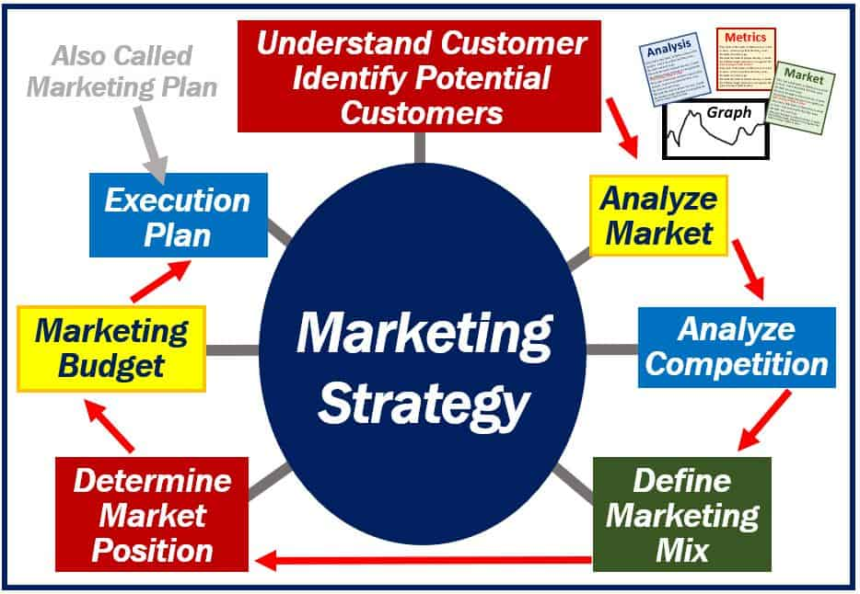
Source: (Nordqvist, 2018)
To increase sales, Johnson and Johnson should implement a new product line of child-friendly foods characterized by smooth textures, small sizes, high nutritional value, and fun shapes. For example, cereal and fruit bars in the shape of dinosaurs, low in sugar and rich in vitamins and minerals. Also create new brands of products specialising in health and hair-loss prevention by introducing a gel applied to the scalp that stimulates hair growth, increases density, and helps prevent hair loss. To achieve this Johnson and Johnson must adopt a strategic marketing plan that leverages segmentation, targeting, and positioning (STP), integrated marketing communications, and the 7Ps marketing mix.

STP

Source: (Sujan, 2025)
3.1 Segmentation
Segmentation is the process of dividing the whole market into small subgroups based on shared characteristics like age, gender, taste, and preferences. Customers having similar needs and behaviours are to be put together. A market segment is a portion of the whole market that is expected to respond similarly to a given situation (GeeksforGeeks, 2023).
Advantages of Segmentation:
- Targeted marketing achieved through customized products and promotional strategies designed for distinct customer groups.
- Optimal use of resources by concentrating efforts on the most lucrative and high-potential segments.
- Enhanced customer retention and loyalty by addressing the unique preferences of each segment (Yadav, 2023).

Disadvantages Segmentation:
- Risk of over-segmentation leading to fragmented efforts.
- Higher costs in managing multiple campaigns. (Yadav, 2023).
For Johnson and Johnson, market segmentation may be structured as follows:
Demographic: Based on age groups (infants, adults, elderly), income brackets, and occupations such as healthcare professionals or general consumers.
Geographic: Differentiating between urban and rural populations, as well as developed and emerging markets.
Psychographic: Applying the VALS framework, which categorises consumers according to their values, attitudes, and lifestyles.
Behavioural: Considering factors such as frequency of product usage, degree of brand loyalty, and specific health needs, whether related to chronic conditions or preventive care (Sujan, 2025)

3.2 Targeting
Targeting is the aiming at market segments that represent the greatest profits for the business. Market Targeting undertakes the decision of choosing the best target audience and the degree to which the target market should be targeted (GeeksforGeeks, 2023).
Johnson and Johnson should pursue a differentiated targeting strategy by emphasising consumer health products through Kenvue, a recognized global leader in this sector (Kenvue, 2023). This approach would be particularly relevant following the launch of child-friendly foods and a scalp-applied hair loss prevention gel designed to stimulate growth, enhance hair density, and reduce hair loss.
Advantages:
- Maximises relevance for each segment.
- Builds strong professional and consumer trust (c9marketing and c9marketing, 2024).

Disadvantages:
- Requires significant investment in research and marketing.
- Risk of neglecting smaller but profitable niches (c9marketing and c9marketing, 2024).

3.3 Positioning
The activity of positioning involves placing the product or service in the minds of the target customers and making the image of the product or service superior as compared to other similar products thus creating a brand image (GeeksforGeeks, 2023).
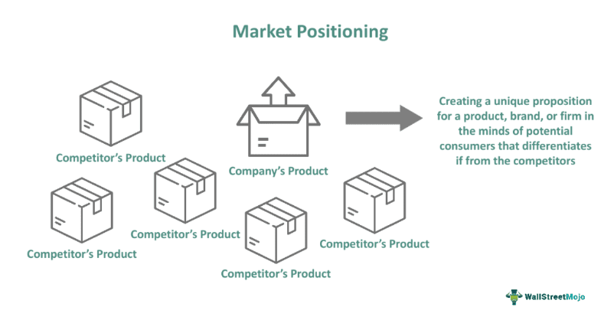
Source: (Choubey, 2024).
Positioning is broadly classified into three types: Functional, symbolic, and experiential Johnson and Johnson should adopt a functional positioning strategy, whereby its products are framed as solutions that address consumer problems and deliver tangible benefits (Zigu, 2011). This approach emphasises the utility, effectiveness, and value provided to customers. In doing so, the company can strengthen its image as a trusted innovator in healthcare, particularly following the launch of child-friendly foods enriched with essential nutrients and a scalp-applied hair loss prevention gel that combines scientific excellence with consumer confidence.
Advantages:
- Reinforces legacy of trust.
- Differentiates from competitors. With similar products (Choubey, 2024).

Disadvantages:
- Maintaining trust requires flawless execution as any product recall can damage reputation.
- Innovation positioning demands continuous Research and Development investment . (Choubey, 2024)

4. Marketing Mix 7Ps
Suggested by Bremana et al. (2025), the marketing mix is a set of strategic tools classified into the 4 Ps Product, Price, Promotion, and Place and expanded in the 7 Ps model for services, which adds People, Process, and Physical Evidence.
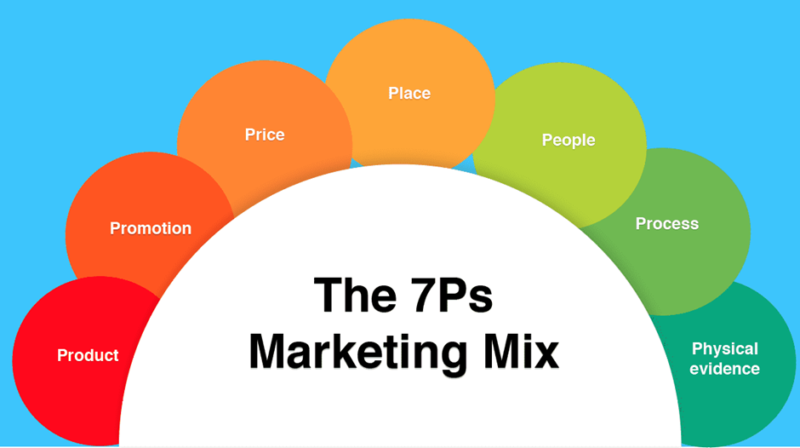
Source: (Hanlon, 2023)

4.1 Product Branding Strategies

Corporate Umbrella Branding:
According to Alyafei (2022), Corporate Umbrella Branding is a strategy where a company uses its name and image to endorse all its products and services, enhancing credibility, consumer trust, and brand recognition. For instance, J&J could implement a new product line characterized by smooth textures, small sizes, high nutritional value, and fun shapes.
Individual Product Branding:
According to Bhasin (2023), Individual Product Branding, also called stand-alone branding, is a strategy where each product has its own identity logo, name, and positioning independent of the corporate brand. Its advantages are, it allows creative freedom and protects the company’s reputation if a product fails. However, its disadvantages are, involves higher management and advertising costs, requiring stronger strategies to avoid resource waste

4.2 Price Strategies

Penetration Pricing:
Penetration Pricing is a strategy where a new product is launched at a low initial price to attract customers and gain market share, later raising the price to a sustainable level. This approach offers several advantages, such as rapid market entry, competition with established brands, early customer loyalty, and a competitive edge that pressures rivals to react.
On the other hand, disadvantages include low initial profits, possible consumer resistance to later price increases, and risk of price wars with competitors (Majka, 2024).
Bundle Pricing:
Fang et al. (2017) argue that bundle pricing strategy consists of offering various products or services grouped together at a lower price than if they were sold separately. Consequently, this approach encourages continued purchasing and facilitates the introduction of less well-known or new products alongside others that are more popular. Bundle pricing has advantages of increased perceived value, higher sales volume, simplified decision making, and cross selling opportunities. Its disadvantage includes limited customization options, perceived lack of value, difficulty in pricing, and inventory management challenges (Ana Popovic, 2019).

4.3 Promotion
IMC (Integrated Marketing Communication) is a strategic process that organizes communication within the marketing department of a company in advertising, public relations, digital marketing, promotions, sales, and sponsorships with the aim of delivering a clear and unified message that reinforces the brand identity (Nadube, 2018)
Sponsorship: According to Sela (2023), Sponsorship Promotion Strategy is based on supporting events, organizations, or influential figures. Its advantages include high brand visibility, increased sales, competitive differentiation from traditional advertising, and the disadvantages include high investment costs, especially with high-status figures, and reputational risks if the sponsored event or individual faces a crisis.
Digital Marketing: Digital marketing promotion strategy relies on online channels social media, email, search engines, blogs, and video platforms like TikTok and YouTube to increase visibility, attract customers, and build audience loyalty (Verma, 2025). Some of the advantages of digital marketing are brand development, wider reach, real time results, and improved customer insights. The disadvantages are crowded marketplace, increased competition, and negative testimonials (Jain, 2023)
Sales Promotion:
Sales Promotion Strategies are widely used in marketing communication to stimulate immediate purchases through incentives like discounts or free items (like “3-for-2” deals). They are temporary, short-term actions aimed at increasing sales, reducing excess stock, introducing new products, attracting customers, and building loyalty (Balarabe, 2024). Some of the advantages are, helps to differentiate, promotes focused marketing and probability for higher revenues. While the disadvantages are increasing sensitivity to price, short term strategy, and might tarnish brand image (A Plus Topper, 2022).

4.4 Place
Place describes where and how your customers will buy your product or service, and how it will reach them. This might be, for example, through the website, or in a particular shop.
Johnson and Johnson could adopt an indirect intensive distribution for child friendly foods to maximise accessibility in supermarkets, pharmacies, and online platforms and selective distribution for hair loss prevention gel to maintain credibility and ensure professional guidance through pharmacies, dermatologists, and specialised health retailers (Anoop, 2025).

Indirect Channels of Distribution.
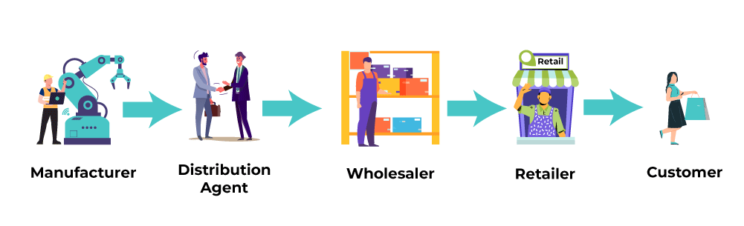
Source:(GeeksforGeeks, 2022)

4.5 People
Within the marketing mix, the element of “People” refers both to employees who engage directly with customers and to the wider organizational workforce. These individuals are central to shaping customer experiences and influencing perceptions of the brand, as they embody the company’s identity in every interaction. Staff members, particularly those in customer-facing roles, form the foundation of the marketing mix since their professionalism and positive attitude significantly affect brand image. Knowledgeable and approachable employees can transform routine transactions into meaningful experiences that build trust and loyalty, whereas poor interactions may create lasting negative impressions that drive customers away (Scott, 2025).
4.6 Processes
The “Process” element of the marketing mix emphasizes the manner in which services are delivered to customers. Streamlined and efficient processes are vital for ensuring a seamless and positive customer experience, particularly in a context where convenience and timesaving are highly valued. Lengthy delays, complicated procedures, or barriers to accessing services often result in frustration and dissatisfaction. Well-structured processes provide consistency and quality in service delivery, allowing customers to anticipate outcomes and receive timely solutions. Broadly, processes can be divided into two categories: direct activities, which involve customer-facing interactions such as transactions, technical support, or complaint resolution facilitated either by staff or digital tools like mobile banking applications; and indirect activities, which include back-office operations such as order handling, inventory control, and data analysis. These behind-the-scenes functions are crucial for maintaining smooth operations and enhancing the overall customer experience (Nasrudin, 2025)
4.7 Physical evidence
Physical evidence refers to the tangible aspects that customers encounter when engaging with a company. It extends beyond the core service to include all sensory elements that shape the customer’s perception. These factors contribute to strong first impressions and play a crucial role in influencing how customers view and feel about the company (Nasrudin, 2025).
A clean, well-designed waiting area or building creates comfort and sets a positive tone. Digital touchpoints, such as websites and mobile apps, must be visually appealing, intuitive, and easy to navigate, as poor design can discourage use. Staff appearance also reflects brand identity; whether formal uniforms or casual attire, professionalism and grooming build trust. Environmental factors lighting, colour schemes, music, and scent further influence experiences, with settings tailored to context, from medical offices to restaurants (Nasrudin, 2025).
5. Implementation and Control: Key Performance Indicators (KPIs)
Implementation is the process of turning strategy into activity, assigning responsibilities and launching champaign to achieves goals (Kotler &Keller, 2016). For Johnson & Johnson, implementation will include launching promotional activities, improving logistics, and rolling out a new eco-friendly skincare product line under the Neutrogena Naturals brand. This new line is designed to appeal to UK consumers, supporting environmental goals and sales growth.
Control is the way of monitoring marketing performance, comparing actual results with planned objectives (Paley, 2006). The stages of the marketing control strategy are:
- Setting Performance Standards
- Measuring Actual Performance
- Comparing Performance with Standards
- Taking Corrective Actions
To support growth, Johnson & Johnson UK will introduce the new products, tailored to the UK’s environmental standards. The launching plan could include targeting social media advertisements, exclusive launch in Boots and Superdrug, collaboration with eco-influencers, and instore digital campaigns.
Effective implementation of the marketing strategy requires a strong monitoring system using KPIs that measure performance across operational, and commercial dimensions (Kaplan & Norton, 1996). The following KPIs support evaluation of Johnson & Johnson’s marketing mix effectiveness in the UK market.
5.1 Sales and Market Growth KPIs
Johnson and Johnson (J&J) could use KPIs of sales and market growth, which represent both short-term revenues and long-term competitive position, to measure performance (Armstrong & Kotler,2021). The purpose of Johnson & Johnson is achieving its revenue goals and increasing product penetration in the UK market. The target is up to twelve percent annual growth is a key metric that supports J&J's leadership in high-value therapeutic areas and is in line with the global trend of industrial expansion (Ross, 2024). Moreover, increasing market shares by three percent in child nutrition and hair loss prevention products is a strategic priority. The objective of increasing online sales by twenty percent could provide a quantifiable benchmark to assess the effectiveness of e-commerce strategies and digital marketing investments in the consumer health sector (Mintel, 2023).
5.2 Market Access and Regulatory KPIs
Market access and regulatory performance determining how quickly patients and healthcare systems can benefit from new innovations (Kotler et al,.2021). For J&J to complies with UK regulation it will need number of approved SKUs by MHRA, securing NICE approval for pharmaceutical division, or UK food authorises engagement with health-economic evaluation processes (Rahman,2023). Furthermore, reducing the time between approval by 10% reflects an enhanced capacity to navigate complex access pathways and collaboration (MHRA, 2022). Maintaining 100% compliance with regulatory standards is essential to preserve corporate reputation and ensure ethical marketing practice.
5.3 Customer and Stakeholder Engagement KPIs
The purpose of customer and stakeholder engagement are necessary to measure customer satisfaction, brand loyalty and lastly, stakeholder alignment. Annual partnership surveys that measure the satisfaction of NHS stakeholders also helps to measure the ability of the organisation and to work effectively with public health authorities (Reichheld,2003). Furthermore, social media engagement rate is important along with repeat purchase rate that indicates loyalty and product success (Nadube & Didia, 2018). For the child food products, the stakeholder and parents feedback is important while engagement and trust is essential for the hair loss gel.

5.4 Operational and Quality KPIs
Having operational efficiency is critical for J&J to maintain supply and product safety for global markets, especially when they achieve 98% on-time delivery for products, which means continuity and maintaining trust with retail partners, as well as a reduction in supply chain disruptions (Slack, Brandon-Jones and Burgess, 2022). The new products line launches will be with high quality control from manufacturing and could be distributed efficiently.
5.5 Sustainability KPIs
Sustainability KPIs demonstrate the ethical responsibility of J&J and align with national and global environmental priorities, as a 25% reduction in carbon emissions by 2028 (NHS Net Zero Strategy, 2021). For the consumer health division, the goal is to increase recyclable packaging to 80% and waste reduction rate (Johnson & Johnson, 2025). All these KPIs help to ensure that sustainability initiatives are measurable, and support the overall corporate reputation of J&J.
Recommendation
Johnson and Johnson’s strategic plan to introduce health-focused baby food and a hair loss prevention gel can be effectively guided by the Ansoff Matrix, a framework that identifies growth opportunities through combinations of products and markets Two strategies product development and market development are particularly relevant to their objectives (GeeksforGeeks, 2024).
Product development involves creating new offerings for existing markets, leveraging brand equity and consumer trust to meet evolving health and wellness needs. Johnson & Johnson should invest in research and development to ensure product relevance, systematically gather consumer insights to refine design, and collaborate with suppliers and distributors to secure efficient launches. A compelling value proposition, supported by targeted marketing campaigns, will stimulate demand and reinforce loyalty (The Strategy Institute, 2024)
Market development, by contrast, entails extending existing products into new segments or geographies. This strategy allows Johnson & Johnson to adapt messaging for diverse demographics, establish a presence in untapped domestic and international regions, and partner with new retail and distribution networks. Expanding digital sales channels will further enhance accessibility, complementing traditional outlets and broadening consumer reach (Mark, 2023)
By aligning these strategies with their innovation-driven culture and consumer-centric approach, Johnson & Johnson can strengthen competitive advantage while responsibly addressing emerging health and wellness demands.

Conclusion
In summary, this marketing plan demonstrates that Johnson & Johnson operates within a complex and highly regulated UK healthcare environment that requires integrated strategic management across divisions. The PESTLE analysis highlights the significant influence of political regulation, economic pressures within the NHS, rapidly evolving technologies, and rising expectations for sustainability and ethical conduct. Through STP analysis, the company can more effectively target clinicians, healthcare institutions, retailers, and consumers, ensuring a coherent value proposition based on innovation, safety, and trust.
The application of the 7Ps shows how J&J must adapt its product, pricing, promotion, and process strategies to the specific demands of healthcare markets, while prioritising operational quality and sustainable practices. Implementation supported by KPIs ensures strategic accountability, enabling J&J to measure progress in financial performance, market access, stakeholder engagement, operational efficiency, and innovation.
Overall, the analysis confirms that J&J’s long-term competitiveness depends on its ability to balance commercial goals with regulatory compliance, customer value, and ethical responsibility.

References

ABPI (2023). ABPI Code of Practice for the Pharmaceutical Industry. London: ABPI.
Alyafei, O. (2022). ‘Concept of Corporate Branding: Challenges and Comparison with Product Branding’, International Journal of Scientific Research and Management, 10(04), pp. 3230–3242. doi: https://doi.org/10.18535/ijsrm/v10i4.em2).
Anoop (2025). Distribution Channels – A Comprehensive Guide. [online] Comport Communications. Available at: (https://www.commport.com/distribution-channels/) [Accessed 8 Dec. 2025].
Balarabe, Y. (2024). ‘Marketing and Sales Promotion’, Indian Scientific Journal of Research in Engineering and Management, 08(05), pp. 1–5. doi: (https://doi.org/10.55041/ijsrem34481) .
Barone, A. (2024). Marketing Strategy: What It Is, How It Works, How to Create One. [online] Investopedia. Available at:(https://www.investopedia.com/terms/m/marketing-strategy.asp) [Accessed 1 Dec. 2025].
Bhasin, H. (2023). Individual Branding: Definition, Examples, Strategies & Tips. [online] Marketing91. Available at: https://www.marketing91.com/individual-branding) [Accessed 29 Nov. 2025].
Bremana, A.W., Ritonga, M.A. and Dewantara, N. (2025). ‘The Influence of Marketing Mix on Customer Loyalty and Consumer Satisfaction’, Journal Limia METADATA, 7(2), pp. 115–135. doi: https://doi.org/10.47652/metadata.v7i2.617) .
Bruin, L. (2016). Scanning the Environment: PESTEL Analysis. [online] B2U - Business-to-you. Available at: https://www.business-to-you.com/scanning-the-environment-pestel-analysis) [Accessed 5 Dec. 2025].
Fang, Y., Sun, L. and Gao, Y. (2017). ‘Bundle-Pricing Decision Model for Multiple Products’, Procedia Computer Science, 112, pp. 2147–2154. doi: https://doi.org/10.1016/j.procs.2017.08.243) .
Hanlon, A. (2023). How to Use the 7Ps Marketing Mix. [online] Smart Insights. Available at: https://www.smartinsights.com/marketing-planning/marketing-models/how-to-use-the-7ps-marketing-mix/) [Accessed 2 Dec. 2025].
Johnson & Johnson (2025). Annual Corporate Report. New Brunswick, NJ: J&J.
Johnson & Johnson (2025). Our Company. [online] Content Lab U.S. Available at: (https://www.jnj.com/our-company) [Accessed 23 Nov. 2025].
Johnson, A. (2022). Health Responsibility and Corporate Vision. Oxford University Press.
Johnson, K. (2022). Johnson & Johnson Mission Statement | Vision | Core Values | Analysis. [online] Business Strategy Hub. Available at: https://bstrategyhub.com/johnson-johnson-mission-statement-vision-core-values-analysis) [Accessed 5 Dec. 2025].
Kaplan, R. and Norton, D. (1996). The Balanced Scorecard: Translating Strategy into Action. Boston: Harvard Business School Press.

Kotler, P., Keller, K. and Chernev, A. (2021). Marketing Management. 16th ed. Pearson.
Macrotrends (2024). U.K. Inflation Rate 1960–2024. [online] Macrotrends.net. Available at: https://www.macrotrends.net/global-metrics/countries/GBR/united-kingdom/inflation-rate-cpi) [Accessed 5 Dec. 2025].
Majka, M. (2024). Penetration Pricing: A Strategy for Rapid Market Entry and Growth. [online] ResearchGate. Available at: https://www.researchgate.net/publication/386086960_Penetration_Pricing_A_Strategy_for_Rapid_Market_Entry_and_Growth [Accessed 29 Nov. 2025].
MHRA (2022). Guidance on Good Distribution Practice. London: UK Government. Available at: https://mhrainspectorate.blog.gov.uk/category/good-distribution-practice/) [Accessed 10 Dec. 2025].
Mintel (2023). UK Consumer Health Market Report. Mintel Group Ltd.
Momin, A. (2023). PESTLE Analysis of The United Kingdom: 6 Factors Affecting the UK. [online] pestleanalysis.com. Available at: (https://pestleanalysis.com/united-kingdom-pestle-analysis/) [Accessed 23 Nov. 2025].
Nadube, P.M. (2018). Understanding Integrated Marketing Communication: Concepts, Definitions and Dimensions. [online] ResearchGate. Available at: https://www.researchgate.net/publication/336774744_Understanding_integrated_marketing_communication_Concepts_definitions_and_dimensions) [Accessed 5 Dec. 2025].
NHS England (2022). Innovation and Procurement Strategy. London: NHS England.
NHS Net Zero Strategy (2021). Delivering a Net Zero NHS. London: NHS England.
NICE (2023). Technology Appraisal Guidance. London: National Institute for Health and Care Excellence.
Nordqvist, C. (2018). What is a Marketing Strategy? [online] Market Business News. Available at: https://marketbusinessnews.com/financial-glossary/marketing-strategy/) [Accessed 1 Dec. 2025].
Oxford College of Marketing (2016). What Is a PESTEL Analysis? [online] Oxford College of Marketing Blog. Available at: (https://blog.oxfordcollegeofmarketing.com/2016/06/30/pestel-analysis/) [Accessed 23 Nov. 2025].
PWC (2023). Future of Healthcare and Supply Chain Report. PricewaterhouseCoopers.
Rahman, M. (2023). PESTEL Analysis of the UK | handwear. [online] Howandwhat.net. Available at: //www.howandwhat.net/pestel-analysis-uk/) [Accessed 23 Nov. 2025].
Ross, L. (2024). Global Pharmaceutical Market Analysis. McGraw-Hill.
Ross, L. (2024). A Complete List of Johnson & Johnson Brands. [online] Thomasnet.com. Available at: https://www.thomasnet.com/insights/johnson-and-johnson-brands) [Accessed 23 Nov. 2025].

Scott, C. (2025). Extended Marketing Mix: What It Is and Why Every Marketer Needs It. [online] ExpertBeacon. Available at : (https://expertbeacon.com/extended-marketing-mix-what-it-is-and-why-every-marketer-needs-it/) [Accessed 8 Dec. 2025].
Sela, R. (2023). What is Sponsorship Marketing? Why You Should Start Leveraging It. [online] Ron Sela. Available at: (https://www.ronsela.com/sponsorship-marketing) [Accessed 29 Nov. 2025].
Shaw, A.A. (2021). PESTLE Analysis of UK. [online] SWOT & PESTLE Analysis. Available at: https://swotandpestleanalysis.com/pestle-analysis-of-uk) [Accessed 23 Nov. 2025].
Sujan (2025). STP Marketing. [online]. Available at: (https://thembains.com/stp-marketing/) [Accessed 5 Dec. 2025].
The Marketing Explainer (2024). . [online] Marketing Explainers. Available at: (https://www.marketingexplainers.com/johnson-johnsons-marketing-strategy-explained/) [Accessed 23 Nov. 2025].
Verma, A. (2025). ‘Digital Marketing Strategy’, Marketing in a Digital World: Strategies, Evolution and Global Impact, pp. 290–319. doi: (https://doi.org/10.2174/9789815305456125010014) .
Zigu (2011). Positioning Definition, Importance, Example, Types, Elements & Overview. [online] MBA Skoll. Available at (https://www.mbaskool.com/business-concepts/marketing-and-strategy-terms/2762-positioning.html) [Accessed 8 Dec. 2025].
Yadav, S. (2023). Advantages and Disadvantages Of Market Segmentation. [online] Businesses Ranker. Available at: https://businessesranker.com/advantages-and-disadvantages-of-market-segmentation/3911/ [Accessed 12 Dec. 2025].
Choubey, P. (2024). Market Positioning. [online] Wallstreetmojo.com. Available at: https://www.wallstreetmojo.com/market-positioning/ [Accessed 12 Dec. 2025].
GeeksforGeeks (2022). Types of Distribution Channels. [online] GeeksforGeeks. Available at: https://www.geeksforgeeks.org/business-studies/types-of-distribution-channels/#placephysical-distribution [Accessed 12 Dec. 2025].
GeeksforGeeks (2024). Ansoff Matrix : Meaning, Benefits, Challenges and Examples. [online] GeeksforGeeks. Available at: https://www.geeksforgeeks.org/business-studies/ansoff-matrix-meaning-benefits-challenges-and-examples/#benefits-of-ansoff-matrix [Accessed 2 Dec. 2025]
The Strategy Institute (2024). The Ansoff Matrix: a Powerful Tool for Business Strategy and Growth. [online] The Strategy Institute. Available at: https://www.thestrategyinstitute.org/insights/the-ansoff-matrix-a-powerful-tool-for-business-strategy-and-growth [Accessed 2 Dec. 2025].
Mark, D. (2023). Ansoff Matrix | EBSCO. [online] EBSCO Information Services, Inc. | www.ebsco.com. Available at: https://www.ebsco.com/research-starters/business-and-management/ansoff-matrix [Accessed 15 Dec. 2025].

Ana Popovic (2019). The Advantages and Disadvantages of Bundle Pricing Strategy. [online] Price2Spy® Blog. Available at: https://www.price2spy.com/blog/the-advantages-and-disadvantages-of-bundle-pricing-strategy/ [Accessed 15 Dec. 2025].
Jain, S. (2023). Top 10 Advantages & Disadvantages of Digital Marketing in 2023. [online] soravjain.com. Available at: https://soravjain.com/pros-and-cons-of-digital-marketing/ [Accessed 15 Dec. 2025].
A Plus Topper. (2022). 10 Main Advantages And Disadvantages Of Sales Promotion | What is Sales Promotion? Merits and Demerits of Sales Promotion. [online] Available at: https://www.aplustopper.com/advantages-and-disadvantages-of-sales-promotion/#Advantages_of_Sales_Promotion [Accessed 15 Dec. 2025].

