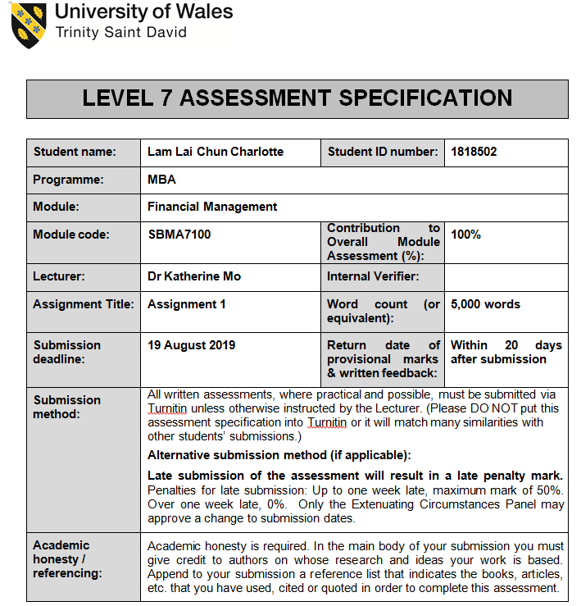

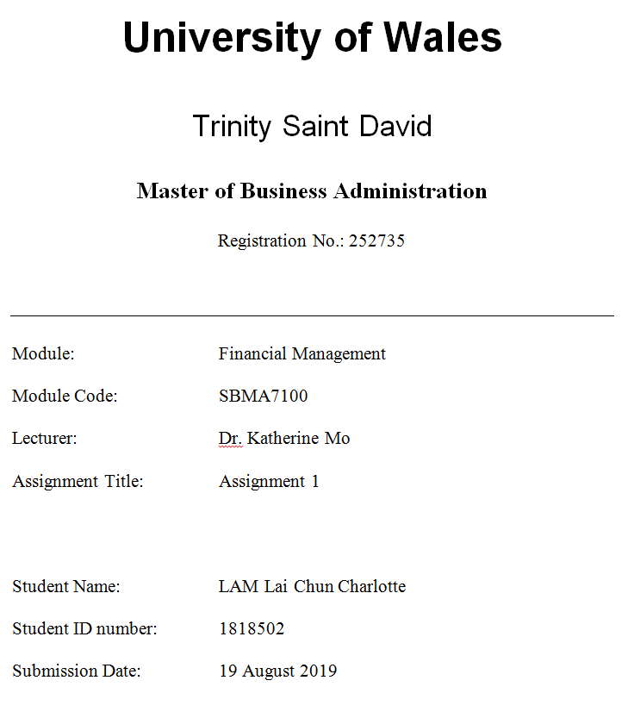

Executive Summary

The study will be learnt about Hong Kong listed Company: Yashili International Holdings Co., Ltd (1230.HK) Financial Resources Management. We will review various aspects: Introduction of company background; Operating business overview; Today’s business environment; Company structure; Financial analysis; Corporate governance assessment; Investment project appraisal; Financing and capital management.

- Table of Contents

Table of Contents
Type chapter title (level 1) 1
Type chapter title (level 2) 2
Type chapter title (level 3) 3
Type chapter title (level 1) 4
Type chapter title (level 2) 5
Type chapter title (level 3) 6

- Introduction

  - Company Background

Yashili International Holdings Co., Ltd. was founded in 1983. Yashihi has been focusing on sales and production of infant formula products and nutritious business since 1998. The Shien brand infant formula was launched in 2002. The Group is headquartered in Chaozhou City, Guangdong Province and has factories in Guangdong, Shanxi and Heilongjiang. In China, Yashili is a prominent company in the infant formula production and a leader in the soy milk powder market. Yashili's business ideal combines the high credit of brand, trade in high-quality dairy raw materials, independent research and development formulas, and is committed to forming a high-level quality control and assurance system to continuously improve quality control in supply, production and distribution chains. Measures, and strive to develop into a first-class enterprise to develop infant formula. Yashili strictly abides by nation-wide standards, develops an ample quality assurance strategy, and implements it at the enterprise level, striving to provide consumers with safe and quality products. The Group has two well-recognized brands selling its infant milk powder products for different consumer groups.

The Group strictly abides by national standards, develops a comprehensive quality assurance plan, and implements it at the enterprise level, striving to provide consumers with safe and quality products. The Group has two well-recognized brands selling its infant milk powder products for different consumer groups. The Group also sells four nutritious foods, namely Yashili brand soy milk powder, infant rice noodles and odour brand cereals, as well as Youyi brand adult and adolescent milk powder. With a product line of brands such as Yashili, Shien, Zhengwei and Youyi, the Group is committed to developing nutritional products that are worthy of users' trust, with vision to promote the vigorous growing of infants and children throughout the country and meeting the nutritional needs of adults. The Group's business model combines imported high-quality dairy raw materials, self-developed formula milk powder products, advanced production systems and professional marketing teams familiar with the local consumer market to provide consumers with products with confidence. (Yashili, 2018)

On 1 November 2010, Yashili International Holdings Ltd (Stock Code: 1230.HK) was listed on Hong Kong Stock Exchange. 3,500,000,000 shares from 644,000,000 shares with 18.4% were issued to public consists new shares: 574,000,000 and sales shares: 70,000,000 sale shares. The Company was received unrefined earnings from the global offering were approx. HKD2,411 million. (Yashili, 2010)

As of 08 Aug 2019, Yashili's stock closing price at HKD0.96, authorised share capital of 10,000 million with issued capital of 4,745,560,296 shares. The current market value of HKD4,556 million. Predicted growth rate of market value in 2018 is not applicable compare to last 5 years. (Yahoo Finance, 2019)

  - Operating Business Overview

The Group has always been committed to becoming the preferred brand of nutrition and health solutions that consumers can trust. Yashili has a solid source of funding from the major shareholders of Mengniu Group and Danone Asia which significantly enhances the business development potential. The Group's business model combines imported high-quality dairy materials, superlative milk sources and scientific research and independent research and development formula, advanced production systems, stringent quality control management systems, integrated high-grade resources and pursues dairy industry. As for quality, we provide products with confidence guarantee for consumers.

In 2018, the revenue of Yashili was RMB 3,011.2 million (RMB 2,254.7 million in 2017), recorded an increase of 33.6%. Gross profit was RMB1,193.8 million (RMB 922.2 million in 2017) recorded an increase: 29.5% and its gross-profit-margin was 39.6%, a slightly dropped 1.3% in 2017. (Yashili, 2018)

  - Today’s Business Environment

In 2018, the overall domestic economy continued to grow and consumption remained stable. During the year, China's GDP was approximately RMB 90 trillion, up 6.6% year-on-year; China's total retail sales of consumer goods was approximately RMB 38 trillion, up 9.0% year-on-year (China Statistical Information Network, 2018) As China's national economy calms, there have been lots of variations in the domestic market of infant formula milk power. The dairy industry is experiencing a "product quality revolution". New formula registration and other policies have been introduced frequently. Recognitions to the economy background of consumption progression and the countrywide implementation of the Two-Child Policy. The domestic market of infant formula milk power realizes an overall growth. Yashili takes full advantages of such context, grasps the new opportunities, and strives for a leading position in the dairy industry, bringing good health and happiness to others.

  - Company Structure

The company was founded by Li Dian Zhang, Li Ming Zhang and Li Bo Zhang in 1983 and is headquartered in Guangzhou, China. The Executive Director is Mr. Chopin Zhang.

In 2018, its substantial shareholders were recorded China Mengniu International Company Limited (51.04%) with 2,422,150,437 shares, Danone Asia Baby Nutrition Pte. Ltd. (25.00%) and Zhang International Investment Limited (6.39%).

Yashili recorded 2,920 full time employees as at 31 December 2018 (31 December 2017: 2,313). (Yashili, 2018)

  - Research Comparison Company Information

This study reviewed of two comparison of Ausnutria Dairy ("Ausnutria" Stock Code: 1717.HK) and China Mengniu Dairy Company Limited ("Mengniu" Stock Code: 2319.HK). These two companies are also engaging dairy products with Yashili but the market size and value of the enterprise are slightly difference. Hereafter, we conduct a proportional analysis by used their financial data to enable us to understand how can propose a new investment project of the company.

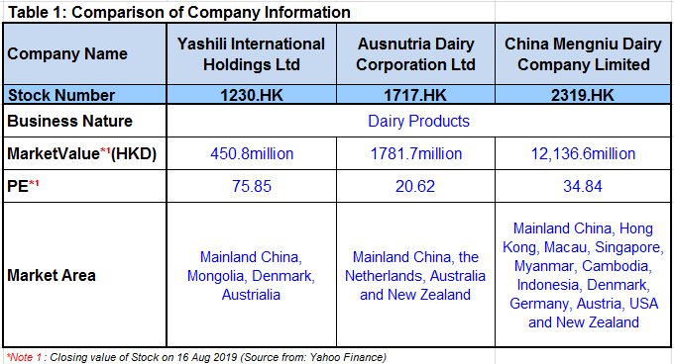

- Financial Analysis

In view of Yashili's financial report to study financial analyses, operational review and challenges ahead of the company.

2.1 Listed Companies of Bankruptcy Index (Z-Score) Analysis

Table 2.1.2 : Listed Companies of Financial Analysis
Company Name | Yashili International Holdings Ltd |  |  |  | Ausnutria | Mengniu
In million RMB (Year) | 2016 | 2017 | 2018 | (2016 - 2018) 3 years average
Net Current Assets | 1846.356 | 2107.864 | 2016.572 | 1990.264 | 883.232 | 4238.644
Total Assets | 7965.991 | 7430.576 | 7722.217 | 7706.261 | 5457.927 | 57906.719
Retained Earnings | 5302.262 | 5091.575 | 5158.473 | 5184.103 | 2035.750 | 10105.721
EBIT | -313.801 | -211.256 | 50.932 | -158.042 | 532.667 | 2420.177
Stock Value (HKD)*¹ | 1.490 | 1.500 | 1.400 | 1.463 | 5.445 | 20.617
RMB/HKD currency exchange rate*² | 1.117 | 1.201 | 1.139 | 1.152 | 1.152 | 1.152
Number of Stock (in million shares) | 4,745.560 | 4,745.560 | 4,745.560 | 4745.560 | 1361.982 | 3926.699
Total Liabilities | 2264.377 | 1939.649 | 2164.392 | 2122.806 | 3147.511 | 32685.398
Sales | 2203.315 | 2254.716 | 3011.200 | 2489.744 | 4018.765 | 60970.676
*Note 1: as of Trade-Day of Year-End (30Dec2016, 29Dec2017 & 31Dec2018) for Closing Value by dividend and stock split adjustment (Source from: Yahoo Finance)
*Note 2: RMB/HKD currency exchange rate*² on last trading day of year (Source from: Exchange Rates)

Table 2.1.2 : Listed Companies of Insolvency Index (Z-Score) Analysis
Company Name | Yashili International Holdings Ltd |  |  |  | Ausnutria | Mengniu
In million RMB (Year) | 2016 | 2017 | 2018 | (2016 - 2018) 3 years average
A = Working capital/total assets | 0.232 | 0.284 | 0.261 | 0.259 | 0,160 | 0.074
B = Retained earnings/total assets | 0.666 | 0.685 | 0.668 | 0.673 | 0.364 | 0.173
C = Earnings before interest and taxes (EBIT) / total assets | -0.039 | -0.028 | 0.007 | -0.020 | 0.094 | 0.038
D = Market value of equity /book value of total liabilities | 2.796 | 3.055 | 2.696 | 2.849 | 2.094 | 2.134
E = Sales/total assets | 0.277 | 0.303 | 0.390 | 0.323 | 0.729 | 1.056
Z-Score = 1.2A+1.4B+3.3C+0.6D+0.999E | 3.034 | 3.342 | 3.278 | 3.218 | 2.997 | 2.793

We used the Altman Z-Score to determine if a company is approaching bankruptcy.
These companies have scores above 3 which is demonstrating its financial stable with low probability of being insolvent. (Altman, 1968)

2.2 Financial Structure
Table 2.2: Financial Structure
Company Name | Yashili International Holdings Ltd |  |  |  | Ausnutria | Mengniu | 3 companies
Year | 2016 | 2017 | 2018 | (2016 - 2018) 3 years average
Fixed Asset to Long term Liability Ratio | 0.314 | 0.292 | 0.272 | 0.292 | 1.787 | 2.482 | 1.520
Current Liabilities to Net Asset Ratio | 0.395 | 0.349 | 0.387 | 0.377 | 1.117 | 0.752 | 0.749
Current Liabilities to Stock Ratio | 3.635 | 2.439 | 2.839 | 2.971 | 2.185 | 5.637 | 3.598

We accessed the changes in the "Fixed assets to long-term liability ratio" from 2016 recorded 0.314 to 2018 recorded 0.272 of Yashili and the comparatively was significantly below peers’ average of 1.520 for 3 companies over 3 years since it states weakened debt capacity, hence, no items related to long-term liabilities in its balance sheet. In the future, Yashili is required to increase the probabilities for attainment new long-term liabilities.

We accessed the changes in the "Current liabilities to net-asset ratio" from 2016 recorded 0.395 to 2018 recorded 0.387 triggered by a short-term or secured bank loans. In 2018, Yashili was significant below ratio between industry averages of 0.749. Yashili has rarer current-liabilities than current-assets are considered to be healthy.

We accessed the "Current liabilities to stock ratio" from 2016 recorded 3.635 to 2018 recorded 2.839 showing the improvement of inventory but it appears lower than the industry average: 3.598. Yashili could make better control of inventories.

The Financial structure analysis demonstrating Yashili's ratio is slightly lower than the industry average. This is a proper ratio since there is a satisfactory cash cushion without parting too much idle-fund for nutrition companies.

2.3 Paying Debt Ability

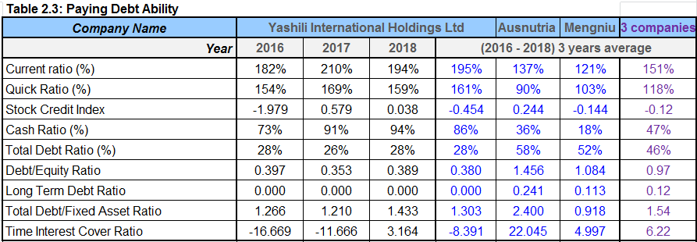

We accessed the "Current ratio/ quick ratio" that Yashili has extraordinary current ratio compared to their peers, it indicates that management may consider to use their assets competently.

We accessed the "Stock credit index" that the confidence of inventory level was negative figures: -1.979 which is higher in 2016 then tearing the average of Yashili was in negative figure: -0.454 but the index were positive: 0.579 in 2017 and 0.038 in 2018 compared to the industry average, it indicates that stock inventory level is under control.

We accessed the "Cash ratio" that the liquidity measure shows Yashili's highly ability to cover its short-term obligations using only cash and cash equivalents which compared with their peer group (average 86% versus 47%).

We accessed the "Total debt / fixed asset ratio" that Yashili was recorded better ratio of 1.303 average the past 3 years compared with the industry level average of 1.54 which reflects the overall enterprise debt service capacity is good.

We accessed the "Equity and debt ratio" that Yashili recorded lower ratio: 0.38 average the past 3 years compared with their peer group average of 0.97. In view of Yashili with a low D/E ratio is viewed as the company has financed a lower amount of its growth through borrowing.
We accessed the "Time interest cover ratio" that Yashili was recorded a negative figure which is not applicable for such ratio. For Ausnutria was recorded around 22 times as its liabilities is significantly higher than standard level average: 6.2 times. Mengniu was recorded a satisfactory figure: 5 times which is lower than the standard level: 6.2 times.

Yashil's paying debt ability is satisfactory since its current, cash ratio is higher and debt ratio is lower compared with their peer group average over 3 years.

2.4 Operational Ability

Figure: 2.4.1 Sales (Unit: in million RMB) *¹
Note1: Source from Annual Report 2016 – 2018

Yashili's total sales proceeds in the past 3 years with gradually growth from 2203.315 million in 2016, 2254.716 million in 2017 (sales growth rate of 2.3%), 3011.200 million (sales growth rate of 33.6%). Ausnutria’s sales proceeds were also recorded growth rate of 43% in 2017 and 37% in 2018. Mengniu’s sales proceeds were also recorded growth rate of 11.9% in 2017 and 14.7% in 2018.

Figure: 2.4.2 Operation (Unit: in million RMB) *¹

(Source from Annual Report 2016 – 2018)

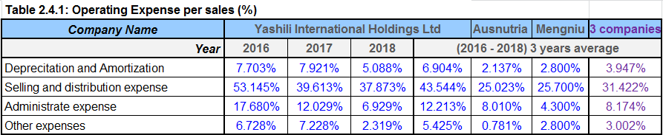

We assessed the "Operation Expense" that Yashili's selling and distribution expense was significantly higher (43.544% average over past three years) which is compared with other peers average: 31.422%. It was mainly dropped by sales revenue but staff cost and market expenses were increased.

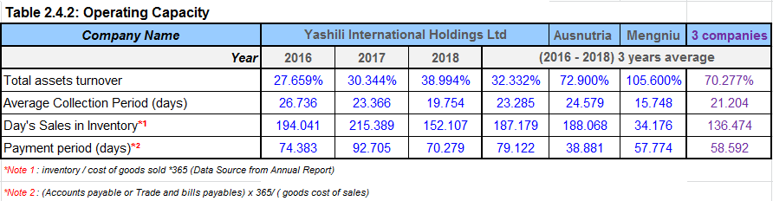

We assessed the "Total Assets Turnover" that Yashili's total assets turnover was significantly lower (32.332% average over three years) which is compared with other peers: 70.277%.

We assessed the "Accounts Payable Turnover Days" that Yashili was (79.122 days average over three years) in line with other peers' average: 58.592.

We assessed the "Inventory Turnover days" that Yashili was high (187.179 days average over past three years) other peers' average: 136.474 days. Yashili has conducting inventory control processes as shown the low figure in 2018.

Yashili's operating capacity analysis, its profit margin is lower than peers caused by significantly high operating cost. It had shown the improvement of operating costs since 2018 figure.

2.5 Profitability

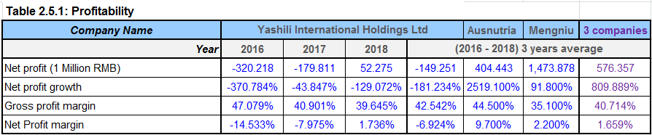

We accessed "Gross profit margin" that Yashili was 42.542% in line with their peers average: 40.714% over three years average.

We accessed "Net profit margin" that Yashili's financial not in good health as it was a negative figure -6.924% less than their peers' average: 1.659% over three years average. Since Yashili has been recorded profit loss from 2016 to 2017. The Management is required further consider review its sales and the related operating costs.
Yashili's profitability analysis demonstrating company was recorded net loss trend with negative figure: -181.234% which is compared to their peers' net profit growth of 809.889% over 3 years' average

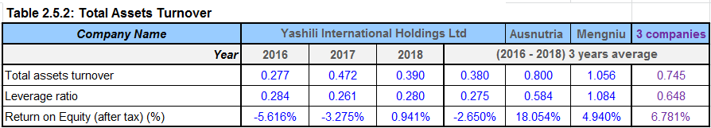

We accessed "Total assets turnover" that Yashili was 32.332% not meet ½ to compared with their peers average: 70.277% over three years average.

We accessed "Leverage ratio / Return on equity (after-tax)" that Yashili's ROE was bad as it was a negative figure -2.650% less than their peers average: 6.781% over three years average. It has shown that the management might not familiar with company assets to generate revenues.

2.6 Growth Ability

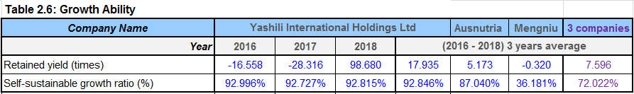

We accessed the "Retained yield" that Yashili has 17.935 times compared with the industry than average 7.596 times. Yashili has not pay out dividends to its shareholders over 3 years caused by their business incurred losses (negative figure in 2016 and 2017).

We accessed the "Self-sustaining growth" that Yashili has 92.846% higher than compared with peers average 72.022%. Yashili with high growth rate is focusing on high-margin products.

Yashili's business growth capacity levels ahead their peers. Yashili could be considered the dividend payout to enhance the confidence of company and retained profit as the retained yield was turned to positive in 2018.

2.7 Stock Market Prospects Analysis

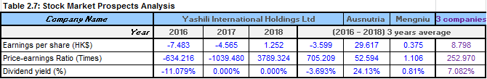

We accessed the "Earnings per share" that Yashili's P/E ratio step-to-growth from negative over 3 years to positive over 3 years with 705.209 times average, however, it demonstrating dividend return is not stable compared with peers average 252.970 times.

Yashili's Stock market prospects analysis indicated that no stable returns to investors, its stock could be taken into consideration, it may involve an extra issues impacting its capital structure decisions

- Yashili’s Corporate Governance Assessment

3.1 Corporate Governance of Business Organization and its impact and Importance

Yashili is well aware of the importance of maintaining a good corporate governance level for the company's healthy and stable development and is committed to maintaining good corporate governance practices and procedures. The Company has adopted and established a sound corporate governance structure and a modern management system in accordance with the requirements of the Corporate Governance Code in Appendix 14 of the Main Board Listing Rules of the Hong Kong Stock Exchange. The general meeting of shareholders is the authority of the company and is responsible for making decisions on major issues of the company. The company has a board of directors and is divided into a nomination committee, a remuneration committee and an audit committee. The board of directors is responsible for formulating the company's overall strategy and policies, setting performance and management objectives, assessing business performance and monitoring management performance.

3.2 Existing Corporate Governance

Yashili adheres to the mission of “gathering the best milk source in the world, focusing on improving the maternal and child nutrition and health status of China, helping the next generation of China to lead the world”, and actively integrating the “United Nations 2030 Sustainable Development Goals (SDGs)” into its own business to form Yashili. The 2030 sustainable development direction, and the concept of sustainable development among the company's employees at all levels, is committed to injecting more vitality into the environment and society while achieving commercial success, and achieving the goal of becoming a nutrition and health program for Chinese mothers and babies. The vision of the preferred brand.

Yashili believes that an efficient management organization can improve the company's operational efficiency and lay a solid foundation for sustainable development. The company integrates sustainability management with the company's existing governance structure and establishes a day-to-day management team for sustainable development: the board of directors is responsible for discussing and formulating the company's sustainable development strategy, and coordinating internal and external resources to support sustainable development management. Advance and phase review work progress; the Public Affairs Management Department, as the coordinating department, is responsible for conveying the relevant requirements of the board of directors, coordinating the relevant functional departments of the company to promote sustainable development work and reporting regularly; the management centers and production base management are responsible for supervising each specific The sustainable development work is carried out and put to the ground.

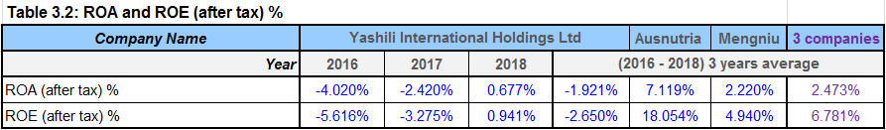

We accessed the return on assets into account (ROE) and total assets yield (ROA) of Yashili were recorded (-1.921% and -2.650%) far behind from their peers' average: (2.473% and 6.781%) over 3 years. Yashili could review the corporate performance to catch stakeholders' confidence.

3.3 Suggestions for Area of Improvement

Yashili could actively respond to the national policy of strict control of the quality of infant formula foods, and continue to contribute to the reliable and excellent infant food ecosystem. In the future, Yashili will, under the impetus of favorable trade policies, increase the development of the blueprint for the import market, closely focus on the strategic direction of “casting quality, advocating health, continuous improvement, and achieving satisfaction”, taking the wind and waves, moving forward, and constantly bringing together global resources to achieve New Yashili with new image, strong strength, big resources and strong brand power will enhance the strength of Yashili Group.

Yashili could maintain a good corporate governance to effectively communicate with shareholders, investors and potential investors to continuously improve investor relations and let investors understand the company's business performance and strategic elements. In order to give shareholders a sustainable corporate value, we will further promote brand innovation and research and development. In the future, we will launch more brands that are in line with the consumer concept, develop more innovative products suitable for Chinese babies, accelerate the improvement of brand and product structure, enhance the competitive value and brand image, and bring healthy and healthy to shareholders and investors. Corporate -value -feedback.

Yashili could ingenuity to create product quality to continue do the formulation registration of infant formula products, and optimize the quality management work in the process of producing new formula milk powder, and strive to provide world-quality milk powder for Chinese babies. At the same time, Yashili will focus on channel development, attract more cooperation channels to join the Yashili family, and deliver good milk powder for the future Chinese baby to gather global quality resources.

Yashili could create shared-value in multiple dimensionsto enhance the creativity of its employees through a more distinctive incentive system, gradually improve the development and training plan of high-latent talents, and fully affirm the outstanding employees through special glory to enhance the enthusiasm of employees in a stable and long-term manner. At the same time, Yashili could further strengthen communication with its partners, carry out strategic cooperation with key suppliers, ensure the supply of strategically important raw materials, strive to achieve common development with key suppliers, and continue to conduct customer satisfaction surveys to ensure the supply of Yashili. Chain services are always close to the market to meet the needs of the market and customers.

Yashili could continuously give back to the society and the environment to deepen cooperation with social charity organizations, actively participate in various charitable causes and charitable activities, carry out more special charity activities, and fully promote community development and build Yashili public welfare brands. For environmental and resource management, Yashili will continue to improve its management level, actively promote the construction of ecological civilization, and continuously explore resource-saving and environment-friendly development models to continuously reduce the negative impact of material transportation and production operations on the environment.

- Investment Project Appraisal

Yashili planned a major investment project with one-off investment equivalent to 5% of last fiscal year (2018)'s annual sales revenue.

4.1 Project Items Basic Information

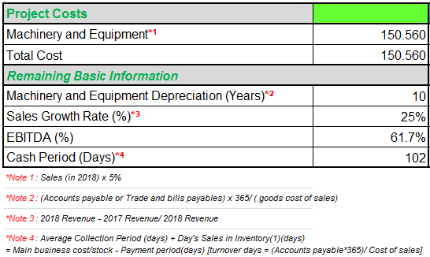

4.2 The First Year Calculation of Sales

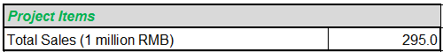

4.3 Cashflow Calculation

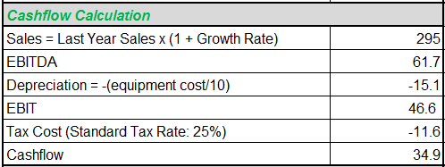

4.5 ARR and NPV Calculation

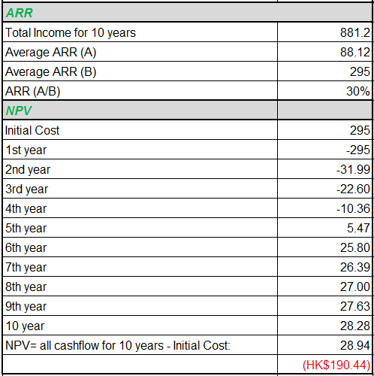

4.6 Payback Period and IRR

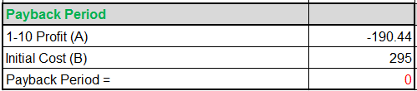

4.7 Investment Appraisal

As shown by financial data available, its reveals that the new project investment appraisal as a negative return. It is not recommended to run this investment. We found some data was unreasonable as 102 days cash period. NPV in negative figure and no payback period.

- Financing and Capital Management

5.1 Financing Methods for Analyzing

Table 5.1: Financing Methods for Analyzing
Company Name | Yashili International Holdings Ltd |  |  |  | Ausnutria | Mengniu | 3 companies
In million RMB (Year) | 2016 | 2017 | 2018 | (2016 - 2018) 3 years average
Cash and Equivalents | 1642.818 | 1748.395 | 2010.318 | 1,800.510 | 877.348 | 3,618.492 | 2098.783
Bank Loans | 1143.091 | 529.696 | 415.128 | 695.972 | 859.512 | 12,091.148 | 4548.877
Cash Ratio | 72.900% | 91.158% | 93.502% | 85.853% | 35.846% | 17.734% | 46.478%
Retained Profit | -16.558 | -28.475 | 98.680 | 17.882 | 5.173 | -0.320 | 7.578
Net Debt Ratio*¹ | -8.765% | -22.195% | -28.702% | -19.887% | -5.529% | 31.630% | 2.071%
Net Interest Expense*² | -122.378 | -116.832 | -95.831 | -79.751 | -54.589 | 267.617 | 44.426
Net Interest Expense/Turnover | -5.554% | -5.182% | -3.182% | -3.345% | -1.449% | 0.426% | -1.456%

We accessed the "Cash payments" that Yashili's financial status is stable over the past 3 years were all at net cash status but Yashili’s net debt ratio in negative: -19.887%.

We accessed the “Bank loans financing” that Yashili has lower bank loans 695.972 compared with the peers’ average of 4548.877 over 3 years.

We accessed the “Cash Ratio” that Yashili has rich cash ratio compared with the peers’ average of 46.478%.

In accordance with Annual Report from 2016 to 2018 of Yashili, we found that there is no debt record (no such item in long-term liabilities due to no credit rating of Yashili). For the newly project implementation, Yashili may consider applying for long-term loan.

- Recommendations and Audit Program

In 2018, Yashili's "Quality Year", with the worth slogan "Quality - I guarantee; Quality - I Promise" as the principal of value philosophy either the management or the front-line staff to enhance market keenness and to participate in eminence construction activities. In 2018, the passing rate of all products of the Group was 100%, and the external sampling pass rate was 100%. The risk monitoring results of the formula registration products were in line with national requirements, which proved that the Group's quality system is stable and can fully guarantee the production to meet consumer expectations. Products also strengthen consumer assurance in Yashili and its products.

Yashili focuses on training and educating employees on the quality of their knowledge and improving the quality management of each factory. In 2018, the Group Quality Management Center and the Factory Quality Department organized a series of 147 quality training activities from external experts to the central level to various levels of the factory, covering quality organisms, regulations and microbiological basics, upright functioning practices, cleanliness, laboratory supervision, production processes, etc., and specifically for the GMP regulations for infant formula milk powder industry, provide relevant training materials for reference, continue to promote the quality awareness of factory employees.

Yashili improved the Quality Management Center to strengthen internal quality operation structure and provided technical guidance and support to each factory from the central level to standardize the specific quality operations of each factory. The Quality Management Center also participated in the “Food Safety National Standards Tracking and Evaluation Collaborative Group”, and made recommendations on the revision of standards to identify and control risks from the early stage of legislation.

In 2018, the Group's factories all approved 52 external audits, including invention licenses, GMP, HACCP, FSSC22000 and organic accreditation. Yashili factories in Chaozhou, Shanghai, Shanxi and Helin also successfully approved the nation-wide infant formula for safe production of infant formulation and the on-site-verification of infant formulation record-keeping. The factory in New Zealand continues to register with CNCA to provide consumers with a strong focus on global nutrition quality and safety. Yashili also strives to support the in-house regularization with cross-audit, further to improve the quality assurance on its own plants based on external and internal standards continuously.

The Group actively promotes the development of enabling projects, and sensitivities' enhancement and effectiveness of supply chain, capacity echelon, lean invention, superior supply chain operations and management, production, strategic projects, and sales management.
The Group's sales business grew strongly during the year, boosting the Yashili's capacity consumption rate in 2018. In addition, through the model of MRP of “sales production and sales coordination”, Yashili to improve the planned supervision system, accurately managed the production materials, significantly reduced the Group's inventory assets, strengthened demand control, reduced costs and efficiency, and improved the Group's overall profitability.

The Group also strengthened the supply chain resource system, invested in new factories and approved production licenses, and strived for further innovative formulation products, and establishes special innovative product management to sort out and strengthen Yashili's innovative product management processes, to start resource strategy.

The Group completed a series of improvement and optimization projects for management processes, including improving the design of indicators in the supply chain and developing visual indicator management projects, laying the foundation for the next step of digital supply chain transformation, to keen supply chain transformation.

The Group also uses the system to build a new customer platform, and personalizes its promotion through different orientation events. Meanwhile, it uses independent QR codes aimed at each channel online and offline, and promotes it with altered communication schemes and networks.

In order to develop operational flexibility and efficiency, Yashili adopts a public-cloud application management system to enjoy its flexible and wilder technology advantages and regularly acquire data technologies such as Internet of things, big data, block-chain and artificial intelligence with capabilities for network collaboration.

The Group also established a dedicated portal "One Phase of the New OA Platform" to automate business processes and gradually coordinate with the Group's simple decentralization authority, standardize the Group's corporate business processes, achieve business process integration and automation to improve collaboration efficiency.

Yashili also exalted its in-house management system in line with divisional restructuring and the major environmental factors consists the national tax reformation to meet the demolition of operations requirements.

The Group also strengthened the supply chain resource system, invested in new factories and approved production licenses, and strived for further innovative formulation products, and establishes special innovative product management to sort out and strengthen Yashili's innovative product management processes, to start resource strategy.

The Group completed a series of improvement and optimization projects for management processes, including improving the design of indicators in the supply chain and developing visual indicator management projects, laying the foundation for the next step of digital supply chain transformation, to keen supply chain transformation.

Furthermore, Yashili is committed to improve the supply chain system for milk, particularly the strategic stream of vital milk rare materials and goat-milk raw materials. In the main rare materials that are scarce jump-in different markets, the Group's international resources integration advantage makes Yashili's products in lactoferrin. The market seized the first opportunity; in the customer service, through the network optimization of logistics and the management improvement of consumer service satisfaction, the responsiveness of the enhanced supply-chain.

In 2018, under the corporate strategy of innovative marketing model transformation and supply-chain amalgamation, Yashili business structure and business process were reorganized, and the Group's IT management system also cooperated accordingly to start the digital transformation path and further improve operational efficiency with cost control.

In 2018, the Group created a new channel management platform to improve the integrated functions of store shopping guide management and event management, member management, pull-up and re-purchase, and achieve full transparency of one-button traceability and distribution, and effectively solve product management security.

Dealers can conduct a series of business management activities such as sales, customer relationship maintenance, store management, inventory management, and promotion through the platform. It also acts as a sales manager, using sales data to recognise consumer behavior, re-shape the pricing strategy, and conduct channel assessment management.

The Group also uses the system to build a new customer platform, and personalizes its promotion through different orientation events. Meanwhile, it uses independent QR codes aimed at each channel online and offline, and promotes it with altered communication schemes and networks.

In order to develop operational flexibility and efficiency, Yashili adopts a public-cloud application management system to enjoy its flexible and wilder technology advantages and regularly acquire data technologies such as Internet of things, big data, block-chain and artificial intelligence with capabilities for network collaboration.

The Group also established a dedicated portal "One Phase of the New OA Platform" to automate business processes and gradually coordinate with the Group's simple decentralization authority, standardize the Group's corporate business processes, achieve business process integration and automation to improve collaboration efficiency.

Yashili also exalted its in-house management system in line with divisional restructuring and the major environmental factors consists the national tax reformation to meet the demolition of operations requirements.

- Conclusions and Recommendations

Yashili could actively respond to the national policy of strict control of the quality of infant formula foods, and continue to contribute to the reliable and excellent infant food ecosystem. In the future, Yashili will, under the impetus of favorable trade policies, increase the development of the blueprint for the import market, closely focus on the strategic direction of “casting quality, advocating health, continuous improvement, and achieving satisfaction”, taking the wind and waves, moving forward, and constantly bringing together global resources to achieve New Yashili with new image, strong strength, big resources and strong brand power will enhance the strength of Yashili Group.

Yashili could maintain a good corporate governance to effectively communicate with shareholders, investors and potential investors to continuously improve investor relations and let investors understand the company's business performance and strategic elements. In order to give shareholders a sustainable corporate value, we will further promote brand innovation and research and development. In the future, we will launch more brands that are in line with the consumer concept, develop more innovative products suitable for Chinese babies, accelerate the improvement of brand and product structure, enhance the competitive value and brand image, and bring healthy and healthy to shareholders and investors. Corporate -value feedback.

Yashili could ingenuity to create product quality to continue do the formulation registration of infant formula products, and optimize the quality management work in the process of producing new formula milk powder, and strive to provide world-quality milk powder for Chinese babies. At the same time, Yashili will focus on channel development, attract more cooperation channels to join the Yashili family, and deliver good milk powder for the future Chinese baby to gather global quality resources.

Yashili could create shared-value in multiple dimensionsto enhance the creativity of its employees through a more distinctive incentive system, gradually improve the development and training plan of high-latent talents, and fully affirm the outstanding employees through special glory to enhance the enthusiasm of employees in a stable and long-term manner. At the same time, Yashili could further strengthen communication with its partners, carry out strategic cooperation with key suppliers, ensure the supply of strategically important raw materials, strive to achieve common development with key suppliers, and continue to conduct customer satisfaction surveys to ensure the supply of Yashili. Chain services are always close to the market to meet the needs of the market and customers.

Yashili could continously give back to the society and the environment to deepen cooperation with social charity organizations, actively participate in various charitable causes and charitable activities, carry out more special charity activities, and fully promote community development and build Yashili public welfare brands. For environmental and resource management, Yashili will continue to improve its management level, actively promote the construction of ecological civilization, and continuously explore resource-saving and environment-friendly development models to continuously reduce the negative impact of material transportation and production operations on the environment.

- References

https://www.investopedia.com/terms/a/altman.asp (Accessed: 10 Aug 2019)

Ausnutria Dairy Corporation Ltd (2018) Annual Report 2016 -2018
http://www.ausnutria.com.hk (Accessed: 30 Jun 2019)

China Mengniu Dairy Company Limited (2018) Annual Report 2016-2018
http://www.mengniuir.com (Accessed: 30 Jun 2018)

Dyson, John (2010) Accounting for non-accounting students, 8th ed. Financial Times/ Prentice Hall
Lucy MC (2001) Reproductive loss in high-producing dairy cattle: where will it end? J Dairy Sci. 84:1277–93.

https://hk.finance.yahoo.com/quote/1230.HK/?p=1230.HK

https://finance.yahoo.com/news/must-know-yashili-international-holdings-073422655.html (Accessed: 10 Aug 2019)

https://www.investopedia.com/terms/a/altman.asp (Accessed: 10 Aug 2019)

https://www.marketscreener.com/YASHILI-INTERNATIONAL-HOL-6814992/financials/

https://www.shareinvestor.com/user/login.html?f_a=financials&f_c=fundamental

http://emweb.securities.eastmoney.com/PC_HKF10/CoreReading/index?type=web&code=01230&color=b

https://hk.finance.yahoo.com/quote/1230.HK/history?p=1230.HK

Yashili International Holdings Ltd Annual Report (2018) Annual Report 2016-2018
https://www.yashili.hk/c/ir_reports.php (Accessed: 7 Jul 2019)

