
APPENDIX GA36d

LEVEL 7 ASSESSMENT SPECIFICATION
Student name: | Hammaad Azhar | Student ID number: | 1800109
Programme: | Secondary PGCE
Module: | Curriculum Development and Enhancement
Module code: | ECSP7002 | Contribution to Overall Module Assessment (%): | 100%
Lecturer: | Helen Denny | Internal Verifier:
Assignment Title: | Research Study including Ethics Form | Word count (or equivalent): | 10.000 words in total including an Ethics form (to be given in on January 11th 2019)
Submission deadline: | May 13th 2019 | Return date of provisional marks & written feedback: | June 10th 2019
Submission method: | All written assessments, where practical and possible, must be submitted via Turnitin unless otherwise instructed by the Lecturer. (Please DO NOT put this assessment specification into Turnitin or it will match many similarities with other students’ submissions.)  Alternative submission method (if applicable):  Late submission of the assessment will result in a late penalty mark. Penalties for late submission: Up to one week late, maximum mark of 50%. Over one week late, 0%. Only the Extenuating Circumstances Panel may approve a change to submission dates.
Academic honesty / referencing: | Academic honesty is required. In the main body of your submission you must give credit to authors on whose research and ideas your work is based. Append to your submission a reference list that indicates the books, articles, etc. that you have used, cited or quoted in order to complete this assessment.

Research into developing pupils’ written analytical responses to fiction texts in Key Stage 3

Introduction
School X is a Christian faith comprehensive school in South Wales. The school holds 1252 pupils, of which 23.6% come from an ethnic minority background, 8.3% who are on Free School Meals (FSM) and 5.3% who have statemented Special Educational Needs (SEN) (My Local School, 2018). The school has a separate building on the site called The Marion Centre for those statemented SEN pupils who are unable to enter mainstream classes, in which they are taught different skills every day to help them develop into more responsible and independent individuals. School X boasts excellent academic results that are well above the national average, with 82.4% of pupils achieving the Level 2 threshold, including English and Maths, in Key Stage 4 (My Local School, 2018). Of this 82.4%, 43% of pupils achieve 5 or more A*-A grades (School X website, 2018).
That said, this project focused on developing pupils’ writing skills, and if one considers Estyn’s 2018 report of the school, it is stated that “many pupils write exceptionally well at length for a wide range of audiences and purposes” (Estyn, 2018) and that the teachers “have very high expectations of what pupils can achieve” (Estyn, 2018). Whilst I found this to be true for most pupils and all the teachers during my PTE at the school, I wanted to stretch the pupils further to see what they were truly capable of. My research was conducted on a mixed-ability year 7 class who had received mixed results in their previous assessment. The inspiration for the way I wanted to develop the pupils’ writing skills came from seeing positive results in another year 7 class, where the teacher had implemented a different higher-level writing framework to the one my year 7 class was using. Thus, to develop my pupils’ writing skills, I decided to implement the same higher-level writing framework for the class to use when analysing Romeo and Juliet, a fiction text that fitted the requirements of their scheme of work. This higher-level writing framework was accommodated by other scaffolding strategies that were slowly removed as the pupils’ understanding developed.

Literature Review
“Writing is a part of the English assessment at Key Stage 3 and Key Stage 4” (Department for Education, 2012, p. 3), and thus, plays an important role in deciding what levels/grades the pupils will achieve overall in English. In 2012, 84% of pupils achieved a level 5 in the Key Stage 3 teacher assessments in English, and 69% of pupils in Key Stage 4 who attempted a GCSE in English achieved A*-C grades (DfE, 2012, p. 3). Yet, despite these results, evidence shows that pupils perform better in areas such as reading, mathematics and science when compared to writing (DfE, 2012, p. 7). When comparing these results to that achieved by School X in 2018, it can be seen that there has been a successful rise in the grades achieved by pupils in English assessments. However, the successful rise in English assessments cannot be generalised in all schools, as School X was well above the national average in regard to the results achieved. As mentioned above, one of the reasons for this success in English assessments can be due to the teachers’ high expectations of pupils (Estyn, 2018), which has meant that the pupils have been exposed to higher-level information and tasks in lessons, allowing them to stretch and challenge their learning. To support the pupils in this challenging working environment, the teachers provided many resources that scaffolded the pupils learning, one of which being a writing framework.
According to Lewis and Wray (1996), writing frames are templates that consist of “starters, connectives and sentence modifiers which offer children a structure for communicating what they want to say” (p. 2). The writing frames provided a genre template (Hyland, 2008, p. 15), which I used to help the pupils produce an analytical response on Romeo and Juliet that best fitted the mark scheme. According to Bruner (1976), this genre template provided a scaffold which allowed pupils to complete a challenging task without the help of a teacher. By removing the level of assistance, such as the help of a teacher, the pupils were able to work independently and stretch their learning, in order to progress beyond their current level of understanding and elevate their maximum potential level even further (in Bodrova and Leong, 1998, p. 4). However, Bodrova and Leong (1998) follow up by stating that scaffolded writing is intended to be a temporary tool. Thus, at some point, all scaffolds such as writing frames would need to be eliminated for the pupils to truly work independently and perform the task unassisted (p. 7). Yet, despite Bodrova and Leong’s suggestion that scaffolded writing should only be used as a temporary tool, the results found by Wickham (1999) in his study of how writing frames impacted the teaching and learning process propose the idea that scaffolded support such as writing frames should remain. Wickham (1999) found that when studying a group of year 7 pupils in English, their results in their levelled assessments had increased after using a writing frame when compared to not using a writing frame (p. 4). Similar results were also found in Bodrova’s (1998) study, where she compared samples of unassisted and scaffolded writing from a group of 34 kindergartners and found that scaffolded writing produced more advanced writing when compared to unassisted writing (in Salehpour, Tamjid and Behnam, 2014, p. 150). By looking at the results, it could be questioned as to why the use of scaffolded writing needs to be seen as a temporary tool when the pupils produce a higher-level standard of writing when the scaffolds are used. Bodrova and Leong’s claims of independence seem to indicate that pupils are only truly independent once they are completely unassisted when attempting their tasks. This claim of a lack of independence by using scaffolds is followed up by Roberts (2003), who states that whilst being a useful tool, the use of writing frames actually limits the content and freedom of the students’ work (in Carthew, 2015, p. 19). Warwick et al. (2003) builds on this by saying that the writing frames cause pupils to produce a formulaic response that masks rather than reveals their level of understanding, which he emphasises is a particular consequence in the work produced by the More Able and Talented pupils (MAT) (in Carthew, 2015, p. 19). Thus, it could be argued that whilst the views of Bodrova and Leong, Roberts and Warwick et al. all consider writing frames to be a useful tool, they urge not to use it within every lesson in order to encourage the pupils to use their own independent thinking skills through completely unassisted tasks.
Yet, there seems to be a level of independence when the pupils are given scaffolds that Bodrova and Leong, Roberts and Warwick et al. fail to address. In Wickham’s (1999) classrooms observations of a variety of 12 lessons across the curriculum, he found that the pupils were able to use individual thinking more as they had already been given sentence starters. Thus, the pupils were able to concentrate more on the content of their work rather than worrying about how to start their response, leading them to produce a higher-quality standard of work (p. 3). Wickham’s findings in his observations draw comparisons to Lewis and Wray’s (1996) research, who suggested that writing frames help by “providing an alternative to a blank sheet of paper”. They argue that the pupils find producing a written response a daunting experience if they are given a blank sheet of paper and expected to write, particularly if they find sustained writing difficult (p. 2). Thus, the pupils are still able to use their independent thinking skills but are not forced to face the traumatic experience of having to start a written response completely from their own knowledge. Due to the scaffolds such as sentence starters that act as an alternative to a blank sheet paper, the teachers are able to provide provisions that facilitate the learning in all pupils, a task that seemed impossible as pupils had different needs (Hallam and Ireson in Mortimore, 1999, p. 80) and their own preferred ways of learning (Hallam and Ireson in Mortimore, 1999, p. 69). Thus, it could be argued that the use of writing frames has given all pupils the opportunity to progress, regardless of their writing ability or their age (Lewis and Wray, N/A, p. 5).
An alternative point of view that seems to sit in between the two opposing ideas of how long the pupils should have writing frames for comes from Lewis and Wray (N/A), who suggested that it would be unnecessary using writing frames with pupils who are already confident and fluent (p. 5). Similarly, Mulatsih (2011) proposed the idea of providing the pupils a temporary framework for learning, which would remain until the pupils would be able to develop knowledge on their own, where it would then be dismantled (in Salehpour et al., 2014, p. 148). When looking at Lewis and Wray’s suggestion along with the idea proposed by Mulatsih, it could be argued that the use of writing frameworks could be an optional scaffolding technique that could be given to each pupil for them to use until they were confident enough to produce written responses without them. However, the data collected from Wickham’s (1999) study indicated that all pupils were able to attain higher levels in their assessments when using writing frames. Thus, if one would remove the writing frames for the confident and fluent pupils as Lewis and Wray would suggest (N/A), then it could be argued that the confident and fluent pupils are not given the same opportunities as the other pupils who were given writing frames. Thus, this could lead to further issues such as limiting the attainment level of the MAT pupils and treating them differently to the other pupils. Furthermore, whilst Mulatsih’s idea seems to propose a neutral idea in regard to the time a pupil has in using writing frames to scaffold their writing, it fails to consider situations such as pupils who are able develop knowledge on their own but struggle to write it down on a blank piece of paper due to finding it a daunting experience.
There have also been debates in regard to how the writing frames should be applied. My project followed the approach of Lewis and Wray (1996), who proposed that “writing frames should always be used as a part of class topic work rather than in isolated skills lessons”, as pupils perform better when their learning is located in meaningful experiences (p. 2). The inspiration for Lewis and Wray’s proposal came from Lave and Wenger’s (1991) concept of ‘situated learning’, where they suggested that learning is always context dependent (in Lewis and Wray, N/A, p. 4). In this sense, it could be argued that the process of learning will differ depending on a number of variables, and thus, the use of writing frames needs to be used in a sequence of lessons to accommodate for each variable. As in all classes, what pupils learn will depend on what they already know, which is part of their ‘schemata’ (Bennett and Dunne in Moon and Mayes, 1994, pp. 50-51). The pupils may have some knowledge of particular concepts or literature that is relevant to the work, and thus may be able to perform slightly better than their peers in tasks. The pupils in the lesson assimilate the new information received alongside their previously held knowledge (Tanner and Jones, 2003, p. 46), and thus, add to their schemata. When looking at this process of receiving and organising information in a lesson, it would seem that using writing frames as part of a class topic work would seem most applicable. Due to the writing frame’s flexibility, it would be able to adapt to the different topics or concepts in each lesson, allowing the pupils to have an up-to-date framework that would help organise their previous and new knowledge onto paper (Wickham, 1999, p. 3). Furthermore, Lewis and Wray (1995) suggest that the use of writing frames in a sequence of lessons would be able to scaffold the new information the pupils were receiving by familiarising them with the difficult features (p. 55), making it easier to integrate into the pupils’ own schema (Carthew, 2015, p. 19).
In comparison to Moon and Mayes (1994), Mortimore (1999) focused on a different area when looking at the process of learning within the classroom. Mortimore looked at the first model of school learning proposed by Carroll (1963), where he suggested that the degree of learning was dependent on how much time the pupils were given to engage with the tasks. This time would be dependent on how well the pupils were able to understand instructions and their natural aptitude for learning a particular task. The pupils would then need to engage with the task until mastery was achieved (in Mortimore, 1999, p. 77). Mortimore’s research draws links to the ‘strategy-focused instruction’ proposed by Fitzgerald and Markham (1987), which involves “explicitly and systematically teaching pupils the necessary steps for undertaking specific writing tasks” (in Campbell and Parke, 2018, p. 49). In this process, the teachers must identify a strategy, before introducing it to the pupils through modelling and allowing them to engage with it with the help of guided practice (Campbell and Parke, 2018, p. 50). The pupils would then “finally achieve mastery through repeated practice and reinforcement” (Collins, 1998, in Campbell and Parke, 2018, p. 50). This emphasis on giving pupils time to achieve mastery in the task with practice in both Mortimore’s and Campbell and Parke’s research fits in with Lewis and Wray’s (1995) proposal of using writing frames in a sequence of lessons, as the pupils would be given time with the writing frames to perfect their written responses. Thus, whilst pupils may differ through a number of variables, they would all be given the opportunity to develop their writing skills with the help of scaffolding techniques, time and practice.

School Policy and Practice
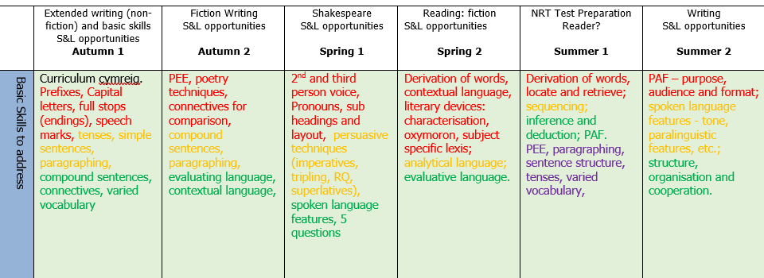
Currently, School X has no whole school or departmental policy for the implementation of writing within the curriculum. However, when looking at the English department’s Scheme of Work (SoW) for Key Stage 3, it is clear that there is an emphasis on developing pupils’ writing skills.
(Appendix A)
Appendix A shows how the English department in School X has divided the school year into six terms, with each term covering similar or different skills. Each term has a different focus point, which the teachers have to build their SoW around. It is clear that there is a big emphasis on writing, as three of the terms have the word ‘writing’ explicitly included and all of the terms explicitly state a variety of basic writing skills for the pupils to develop. This could be one of the reasons why Estyn (2018) stated that “many pupils write exceptionally well at length for a wide range of audiences and purposes”, as the pupils are given the opportunity to develop basic writing skills in all terms regardless of the focus point. Whilst the teachers have some choice in different terms on what assessments they would like to do, there is at least one assessment that is explicitly stated in each term for the pupils to produce work on. After looking at the explicitly stated assessments in further detail, I created a bar chart to represent the data I found:

(Figure 1)
When looking at Figure 1, it is clear that whilst there is an emphasis on writing in most of the terms, there is not an emphasis on analytical fiction writing in particular. The inclusion of analytical fiction writing is at its lowest in year 7, with it only being mentioned explicitly in the scheme of work twice, making it account up to 18.2% of the assessments that were explicitly stated. This percentage increases in year 8, where the inclusion of analytical fiction writing makes up 28.6% of the assessments that were explicitly stated. Finally, the inclusion of analytical fictional writing reaches its highest point in Key Stage 3, where in year 9 it makes up 33.3% of the assessments that were explicitly stated. The reason for this increase could be due to preparing the pupils for their English GCSEs, where writing makes up 40% of the English Language specification (WJEC, 2015a) and 100% of the English Literature specification (WJEC, 2015b). Furthermore, as the pupils progress from year group to year group, their schemata increases, and thus, the pupils are able to build on the writing skills they have learnt. This increase of knowledge in the pupils’ schemata combined with their developing learning aptitude means that the department needed to provide a curriculum that prepared the pupils for their eventual GCSE exams. As a result, the number of written assessments the pupils had to produce gradually increased. Whilst there is not a huge amount of emphasis on analytical fiction writing in particular, due to having to prepare the pupils for a variety of writing assessments, there is an emphasis on developing P.E.E as a basic skill, as seen from Appendix A. This links in with the research of Campbell and Parke (2018), as the teachers would need to provide support through scaffolding techniques such as the P.E.E framework when appropriate in order to help pupils accomplish specific tasks (p. 50). Thus, it could be argued that whilst School X encourages a variety of fiction and non-fiction writing assessments, there is still a priority on ensuring that frameworks such as P.E.E remain in the curriculum. This is in order to prepare pupils for their eventual GCSE exams, which is evident even further with the inclusion of P.E.E in the SoW at both the beginning and the end of the school year for each year group in Key Stage 3.

Methodology and Ethics
My research project began along the same lines as the views provided by Gibson, who argued that a “particularly productive way to begin the design process is to reflect on the various types of data that each available method may produce, and to think about how the data may be used to address the research problem” (in Hartas, 2010, p. 60). I thought about the data I wanted to collect and created a sequence of lessons that gave me an opportunity to collect a range of data from the methods I had chosen. However, whilst the data collected may have varied, they would all come together to help me answer the main question of my research:
- How does the use of writing frames improve pupils’ written analytical responses to a fiction text?

I decided that the best way to answer my research question was to collect both quantitative and qualitative data. The quantitative data would come from the results achieved by the pupils from both the pre-test, a test that judged pupils’ performance before the start of the research project, and the post-test, a test that judged pupils’ performance at the end of the research project (Cohen, Manion and Morrison, 2011, p. 481). A benefit of using quantitative methods is that it allowed me to judge how the sequence of lessons impacted the pupils, in regard to their levels achieved, through numerical data, making it easier for mathematical analysis (Hartas in Hartas, 2010, p. 66). The qualitative data would come from a small sample of an in-depth analysis of both the pre-test and the post-test. A benefit of using qualitative data is that I would have been able to look in-depth at the certain features pupils may have included in the post-test that was not in their pre-test, along with being able to contextualise information and understand what areas pupils may have been able to perform better in (Hartas in Hartas, 2010, p. 71). However, as the qualitative data required me to provide an in-depth analysis of my pupils’ work, I needed to make sure that my findings were not affected by my ‘humanistic nature’ of forgiving the mistakes of my pupils, and that I remained as objective as possible (Brooks, Riele and Maguire, 2014, p. 68).

Another big factor that I needed to consider was my sample for the research project. To ensure the validity of my study, I needed to ensure that the sample selected was representative of the individuals by their characteristics and attributes which are typical for that population (Hartas in Hartas, 2010, p. 67). The sample I selected was my mixed ability year 7 class, which was beneficial for two main reasons: One being that as the class was mixed ability, I would be somewhat able to generalise my research study to the rest of the year 7 cohort, as they were all placed in mixed-ability classes. The second benefit was that this particular year 7 class had just begun their scheme of work that was based around a Shakespearean text. Thus, I was able to begin my research project in the class without having to change the scheme of work, which ensured that the transition between the work the class teacher was doing and the work I was going to do was relatively simple and easy. After selecting my sample, I needed to ensure that I had ‘informed consent’ (Brooks et al., 2014, p. 80). This meant that the participants in the research project should have had sufficient knowledge of the research project before deciding whether they wanted to take part (Brooks et al., 2014, p. 80). Furthermore, their decision had to be freely made and they had the right to decline or withdraw from the project either before, during or after without the fear of any adverse consequences (Brooks et al. 2014, p. 80). When gaining this informed consent, I made sure I adhered to the BERA guidelines (2018). I informed the pupils about the process and aims of the research project before it had even begun. I emphasised how the pupils had a right to decline or withdraw from the research at any point, and how I would ensure that their work remained confidential and that there was no way for the research to identify specific pupils (Frater, 2004, p.22). I then gave the pupils a few minutes to think before asking them to close their eyes and put their hands up if they wanted to take part. This ensured that there was no ‘informed dissent’, an ethical issue Morrow (2005) identified as pupils feeling peer pressured in the classroom to participate in the research project (in Brooks et al., 2014, p. 84). As the pupils’ eyes were closed and their decision was made by hand movement alone, it meant that their choice was visible to only me and the other teacher in the room, and thus, limiting the peer pressure in the classroom. However, there was an ethical issue that was difficult to remove due to the nature of the research project. Due to the power roles between the pupil and the teacher (Brooks et al., 2014, p. 91), it could have meant that pupils felt an obligation to comply rather than disagree with the professionals (Brooks et al., 2014, p. 85). Furthermore, the pupils may have also felt that if they had declined or withdrew from the research project, their marks may have suffered (Brooks et al., 2014, p. 91). To try and limit these particular ethical issues, I repeatedly emphasised throughout my research project that the pupils had a right to decline or withdraw from the project at any point, to which they would receive no consequences.

The final issue I needed to consider was ensuring the validity of the research project through the pre-test and the post-test. According to Muijs (2004), the optimal interval time between tests was recommended to be around one or two weeks (in Hartas, 2010, p. 72). Therefore, I decided to conduct my research project over a span of six lessons, which did not include the pre-test as I decided to use an analytical written response the pupils had already produced shortly before the start of the research project. I also ensured that I maintained consistency by giving the pupils the same working conditions and time-limit they had in the pre-test when conducting my post-test (Hartas in Hartas, 2010, p. 71). I also decided to allow the pupils to prepare a plan to bring into the post-test, as they had the same opportunity to do so when the pre-test was conducted. Furthermore, I made sure that the question the pupils had to answer in the pre-test remained the same in the post-test, to ensure that there was not a difference in the level of difficulty of the tests (Cohen et al., 2011, p. 493). This maintained the validity of my research as the data collected would have shown the levels attained by pupils in two tests that had been conducted in an identical manner over a span of six lessons.

Evaluation
As mentioned earlier, I decided to conduct my research at the beginning of a new scheme of work, which made the pupils progress easier to identify as they had not done much work to begin with in the fiction genre. Whilst my sample was a mixed-ability year 7 class, I did not include all the pupils in the class in my research. This was because many pupils were not in on the first lesson I started the research study, and thus, I thought it would discredit the validity of my results if I had included the missing pupils’ progress with the rest of the pupils who were in for the entirety of the research study. Therefore, the findings presented in this report is only based on the work produced by seventeen pupils.
Rather than asking the pupils to write an analysis on Romeo and Juliet for my pre-test, I decided to use an analytical response they had already written on Macbeth in their previous lesson. This meant that I was able to judge the pupils’ performance before the start of the research project (Cohen et al., 2011, p.481) without making the pupils feel anxious by asking them to write another analytical response which would have been levelled. I then started my research project by introducing the higher-level framework called P.E.E.Z.C.A.T in the first lesson. I decided to do this after reading the argument made by Lewis and Wray (1996), who suggested that writing in a range of genres was most effective when used in meaningful experiences. Therefore, they argued that writing frames should be used in class topic work to make it a meaningful experience rather than just using it in an individual lesson (p. 2). I thought that as the pupils were used to using the P.E.E framework in their analytical responses, I would be able to introduce the additional aspects in the P.E.E.Z.C.A.T framework for the pupils to assimilate alongside their current knowledge of the P.E.E framework (Tanner and Jones, 2003, p. 46). However, this strategy of introducing the P.E.E.Z.C.A.T framework straight away did not work out the way I wanted it to. The pupils struggled to assimilate the additional aspects of the new framework to their original P.E.E. framework and thus, thought the P.E.E.Z.C.A.T framework was something entirely new to them. Furthermore, they became anxious and panicked after realising that I was expecting them to use the new framework in their post-test. This meant that when asked to attempt a task using the P.E.E.Z.C.A.T framework, the pupils refused as they struggled to comprehend what it was. This confusion was also noticed by my subject mentor, who noted that the pupils had lost focus, particularly the less-able pupils who were not able to keep up (Owens, 2019). Thus, it could be seen that whilst the pupils did not become dependent on the writing frame, as Wickham (1999) found in his research, they became dependent on my explanation of the writing frame and how it would be applied in tasks. Furthermore, after reflecting on the lesson, I found that Lewis and Wray’s (N.A) argument on writing frames giving all the pupils to the opportunity to progress (p. 5) was only true if the writing frame had been explained and demonstrated clearly. Otherwise, all the pupils would struggle to comprehend the correct application of the framework, as noted by Owens.
After reading the argument of Lewis and Wray (N/A), who suggested that the use of a writing frame “should always begin with discussion and teacher modelling” (p. 3), I decided to re-introduce the framework along with the use of a WAGOLL example in my second lesson. I found that this strategy worked much better than the first lesson as the pupils had a visual example to look at and see how the P.E.E.Z.C.A.T framework was applied. The pupils were then able to identify the part of the framework they were used to using and, through a process of elimination, understand the process for applying the rest of the framework unknown to them in a written response. This meant that when asking the pupils about the role of each aspect in the P.E.E.Z.C.A.T framework, they were able to explain it using the WAGOLL example that was now a part of their schemata (Bennett and Dunne in Moon and Mayes, 1994, pp. 50-51). Furthermore, the use of the WAGOLL example allowed pupils to think themselves into the style that was specific to the genre they were studying (Grabe and Kaplan, 1996, in Frater, 2004, p. 30). This meant that the pupils were able to work independently in the writing task, where they had to analyse a scene and write an analytical response, and were able to implement parts or all of the P.E.E.Z.C.A.T framework. Thus, the pupils were beginning to assimilate the P.E.E.Z.C.A.T framework into their schemata.
In the third lesson, I decided to include peer-review feedback alongside the framework and the WAGOLL example. By repeatedly reminding the pupils of the P.E.E.Z.C.A.T framework as well as how it was applied, I felt that pupils’ schemata of the framework would strengthen. Furthermore, the use of peer-review feedback alongside the verbal feedback I provided in class meant that the pupils were able to receive quick answers to their questions whilst also reminding themselves of the success criteria when trying to identify it in their partner’s work (Clarke, 2005, p. 35). I noticed that due to the repetitive nature of annotating a scene before producing a P.E.E.Z.C.A.T response, the pupils had become more aware of what evidence they required and were able to choose words or phrases that best fitted each aspect of the P.E.E.Z.C.A.T framework subconsciously. The pupils were essentially creating ‘word windows’ that allowed them to think of each word or phrase as a separate entity from the text (Bodrova and Leong, 1998, p. 5). Thus, the pupils were able to think of the connotations from that singular word or phrase before re-applying it to the scene to see the effect it had when used with context. This meant that they were able to produce P.E.E.Z.C.A.T responses independently at a faster rate compared to previous lessons. This made peer-review much more beneficial as the pupils were now aware of what was required in their partner’s work for it to be considered a successful response. The benefits found from using peer-review feedback in this lesson were similar to those mentioned by Philippakos and MacArthur (2016), who argued that during peer review, pupils were able to develop their critical evaluating skills (in Campbell and Parke, 2018, p. 50). As a consequence, the pupils would evaluate their own work when producing an analytical response, and thus, were more likely to produce a response that contained the success criteria. Furthermore, the pupils in my classroom had become motivated (Newell et al., 2011, in Campbell and Parke, 2018, p.50) as they were able to see their progress of understanding the P.E.E.Z.C.A.T framework when identifying the different parts of the framework in their partner’s response. By using a green pen, the pupils had essentially become teachers, as they were responsible for providing feedback for another pupil to improve their work (Frater, 2004, p. 25). I also found that the peer-review feedback allowed me to check the understanding of my class of whether they knew what was expected of them. After reading an example of one of my pupil’s work to the class, I was able to see what areas they were struggling in. Thus, I was able to provide further feedback to clarify any misunderstandings straight away, which was also noted by my subject mentor (Owens, 2019).
In lesson four, the pupils simply annotated the prologue using ‘word windows’ before filling in a planning sheet of all the different scenes they studied. The planning sheet was split into sections, where the pupils would have to address all the aspects of the P.E.E.Z.C.A.T framework when analysing one quote. The purpose for the planning sheet was to ensure that the pupils had the same working conditions for the post-test as they had for the pre-test, as mentioned above by Hartas (in Hartas, 2010, p. 71). The fifth lesson followed on from the planning lesson, as the pupils still had to plan but through themes. The pupils annotated a final scene using ‘word windows’ before using the P.E.E.Z.C.A.T framework for each theme on their planning sheets. By giving the pupils frequent independent time to complete a task, I felt that I naturally followed the model of learning proposed by Carroll (1963), who suggested that the learner would succeed in a task if given sufficient time and opportunity to engage with the task until mastery was achieved (in Mortimore, 1999, p. 77). As mentioned above, by strengthening the pupils’ schemata of the P.E.E.Z.C.A.T framework, I felt that the pupils would become closer to mastering the application of the framework. Finally, the sixth lesson of the research study was the post-test. As mentioned above in the ethics and methodology section, I ensured that the post-test was exactly the same as the pre-test, but with just another Shakespearean text as the focal point.
After completing the research study in class, I analysed both the pre-test and the post-test. The findings are shown in the bar chart below:

(Figure 2)
To clarify the findings, the numbers represent the levels the pupils’ achieved in both tests. The whole number represents the level band, and the number in the decimal position represents the position in the band the pupils’ scores best fit in. For example, a 4.0 represents a level 4 and the decimals are ranked in the following order: 0.1 represents a lower-tier level, 0.2 represents a middle-tier level and the 0.3 represents an upper-tier level. When looking at Figure 2, it could be seen that all the pupils who participated in the research had improved in the post-test when compared to the pre-test – resulting in a 100% success rate. These results draw comparisons to Wickham’s (1999) study, who found that pupils in year 7 had improved their English levels after using writing frames (pp. 4-5). However, whilst all the pupils increased their levels, it could be seen that the levels of certain pupils improved considerably greater than the levels of the rest of the pupils. For example, there were some pupils who only had a 0.1 increase in their tests, whereas some pupils had increases that exceeded a 0.3 difference. When looking at the findings in more detail through numerical means, I decided to compare the improvements made from the pre-test by level 4 pupils with the improvements made by level 5 pupils. To do this, I assigned each of the levels and sublevels a number. Whilst the original 0.1-0.3 decimal meanings remained the same for the sublevels, I decided to represent the jump to another level with a 0.4. Thus, anything above a 0.3 means a jump to the next level, where the lower-tier to upper-tier cycle starts again. I found that level 4 pupils had a mean average increase of 0.3, whereas level 5 pupils had a mean average increase of 0.2. Thus, it could be argued that the lower-level pupils were able to benefit more with the help of the writing framework when compared to the higher-level pupils, linking back to Lewis and Wray’s (N/A) argument where they said that writing frames gave all pupils the opportunity to progress (p. 5). There was an anomaly in the findings, with Pupil A moving from a 3.3 in the pre-test to a 6.1 in the post-test - the biggest increase in the research study. However, it is difficult to specify a reason for this increase as it could be due to a range of possible reasons. For example, the pupil could have simply integrated the P.E.E.Z.C.A.T framework into their schema and thus, was able to implement the framework in their analytical written response in their post-test (Carthew, 2015, p. 19). The pupil could have also developed their natural aptitude during the research study to a point where they were able to engage with tasks and provide responses at a higher level (Hallam and Ireson in Mortimore, 1999, p. 77). The final possible reason could simply be that the pupil just did not perform to the best of their ability in the pre-test, whereas they reached their potential in the post-test, resulting in their level to have a great increase.
To reflect on the qualitative data within the research study, I decided to analyse the work of Pupil H and Pupil N, whom both had a different range of increase in their levels.
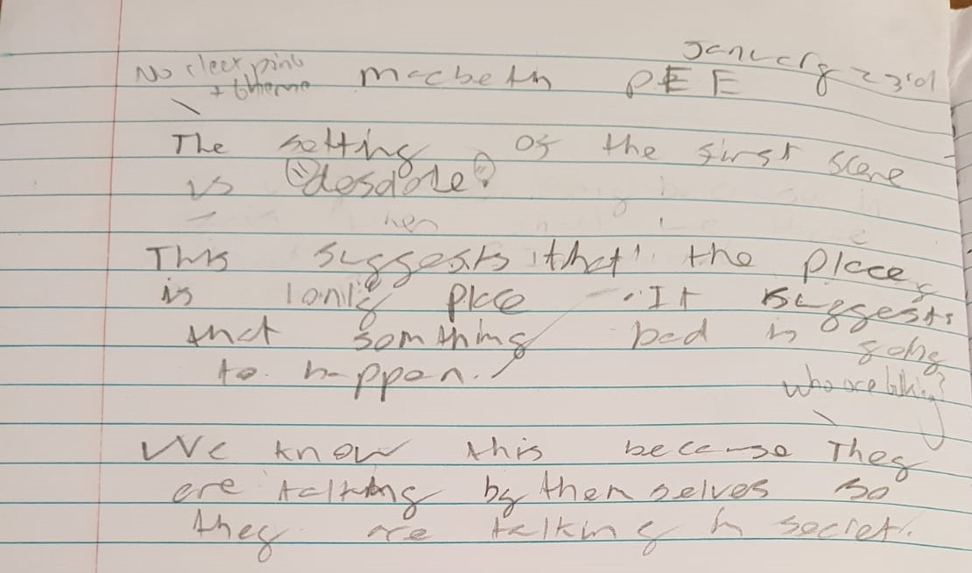

(Appendix B)
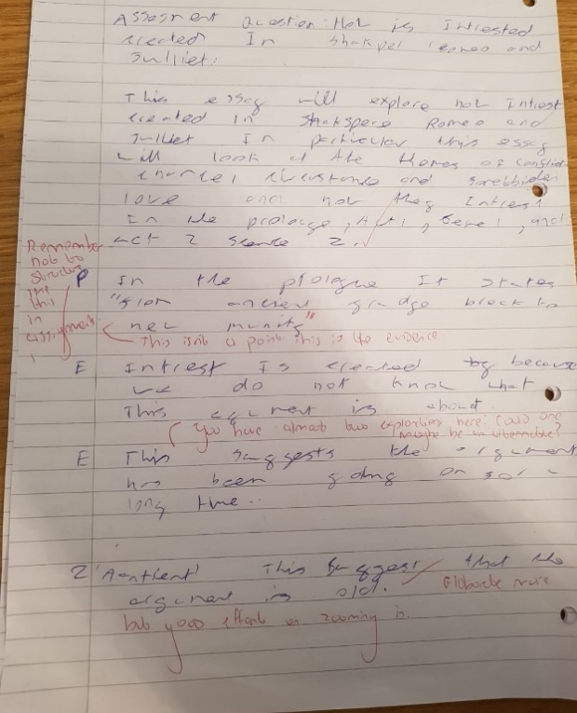

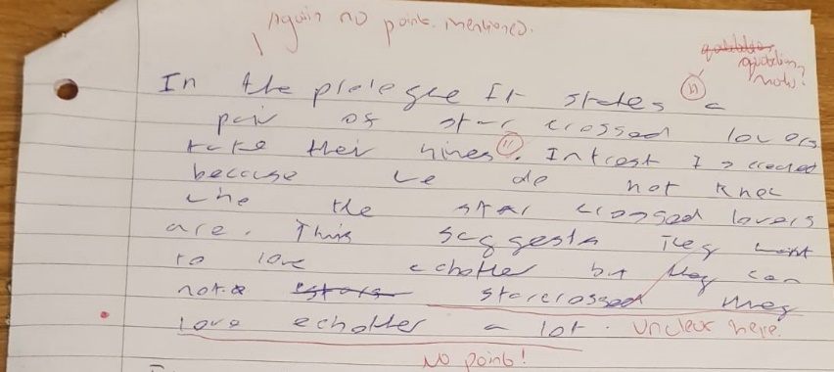
(Appendix D)

(Appendix C)

When looking at Pupil H’s pre-test in Appendix B, it could be seen that whilst the pupil used the P.E.E structure in their response, their answer was not elaborated enough. There seemed to be confusion as the pupil repeated phrases and failed to answer the question appropriately. When comparing the pre-test to the post-test, it could be seen that Pupil H was more confident in applying the P.E.E. structure and began to apply aspects of the P.E.E.Z.C.A.T framework I taught in class. The pupil attempted to elaborate on their answer and linked it back to address the question. When comparing to Pupil H’s answers to Pupil N, it could be seen that there is a large gap in regard to the quality of work produced.
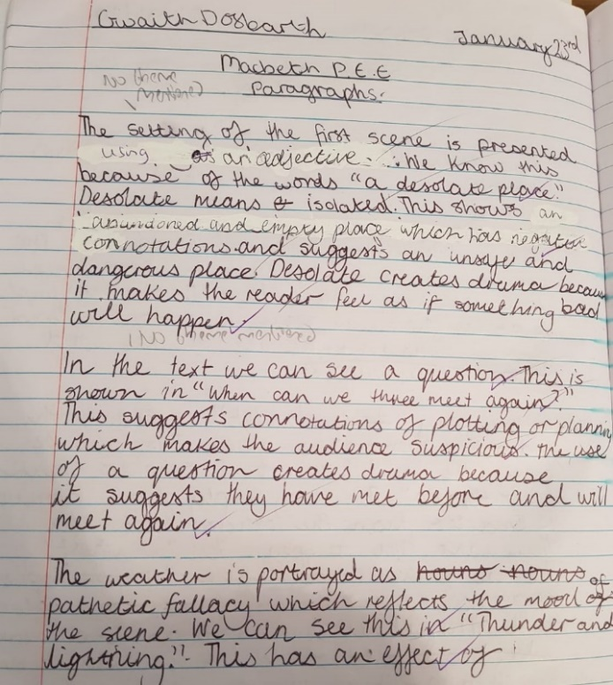

(Appendix E)

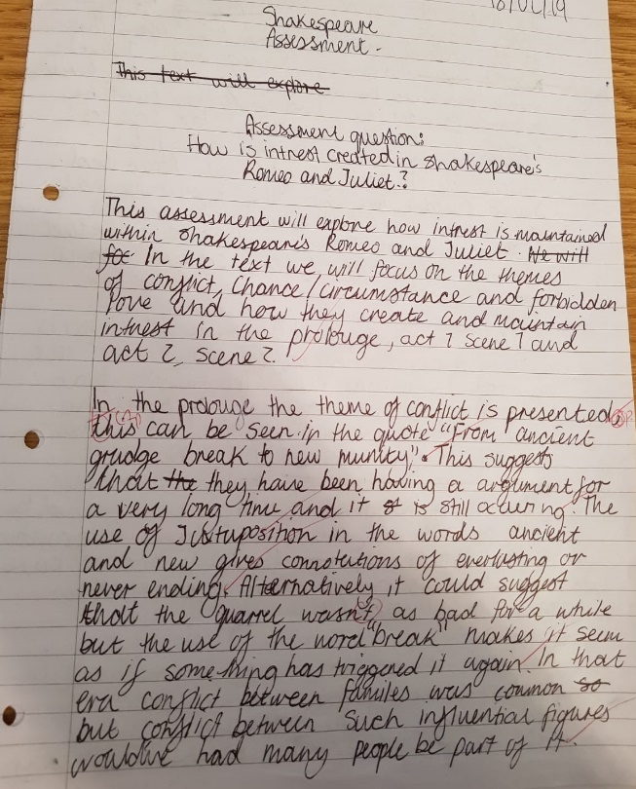
(Appendix G)

(Appendix F)

In the pre-test, Pupil N was able to integrate the P.E.E framework into their response with great effect. They were also able to elaborate on their answer to address the question. In the post-test, Pupil N was able to improve on the original framework by using the P.E.E.Z.C.A.T framework, that I introduced in the research study, with confidence, allowing them to elaborate on their response to produce a detailed and specific analysis that directly answered the question. The two answers shown as well as the numerical data in Figure 2 emphasises how writing frames can cater for the needs of a wide range of individuals of different abilities (Salehpour et al., 2014, pp. 151-152). However, the findings seem to go against the debate in the literature review, in which Warwick et al. (2003) stated that writing frames may hinder the progression of MAT pupils in particular, who may produce a formulaic response that masks the pupils understanding of the work (in Carthew, 2015, p. 19). It can be seen in Pupil N’s work along with the numerical data in Figure 2 that the work produced by MAT pupils, in particular, was at a higher level. With the help of the writing frames, the MAT pupils, in particular, were able to structure their answer and include the aspects of the P.E.E.Z.C.A.T framework in their responses that were not taught before the research study. Simultaneously then, the findings also go against Lewis and Wray’s (N/A) argument that writing frames were unnecessary for pupils who were already confident and fluent (p. 5). Whilst the lower-level pupils achieved a higher increase in regard to mean average, the MAT pupils were able to extend their answers to a much higher quality, and thus, making the implementation of writing frames in lessons necessary for improvement.

Conclusion
In conclusion, this study was carried out to investigate whether writing frames could help develop pupils’ written responses when analysing a fiction text. From the results of the post-test, where all seventeen pupils had improved from their pre-test, it could be argued that the implementation of the higher-level writing framework was a success. The results of the investigation draw comparisons to studies such as Wickham (1999) and Bodrova (1998), who observed year 7 pupils and kindergartners respectfully, where they both found the implementation of writing frames to be a success in improving pupils’ written responses.

However, when looking at the course of the investigation, it could be seen that the success of the P.E.E.Z.C.A.T framework within lessons is all dependent on the process of its implementation. If the P.E.E.Z.C.A.T framework is introduced too quickly, then the pupils’ progress will suffer and they will be unable to grasp the framework itself, as seen from lesson one. Thus, one must follow the model proposed by Carroll (1963), where the pupils must be given time and multiple opportunities to use the framework if they are to achieve a certain level of mastery in it (in Mortimore, 1999, p. 77), a view similarly shared by Collins (1998), who argued that pupils would achieve mastery through repeated practice and reinforcement (in Campbell and Parke, 2018, p. 50). The more the pupils are exposed to the P.E.E.Z.C.A.T framework, and the more they are given sufficient scaffolding when applying it, the more the pupils will be able to use it in their written responses. Furthermore, when looking at the rate of progress, in particular, it could be seen that the pupils achieved mastery and confidence in using the P.E.E.Z.C.A.T framework quicker when they had scaffolds and tasks such as WAGOLL examples and peer assessments. Thus, links can be drawn to Vygotsky’s (1978) ‘zone of proximal development’, where a learner can increase their level of understanding if they are working with or under the guidance of an individual who is of a slightly higher level than them (in Salehpour et al., 2014, p. 148). As I exposed the pupils to written responses that were of a high level through WAGOLL examples, as well as giving them the opportunity to mark and evaluate the work of their peers, they were able to step closer to achieving mastery in identifying and applying the P.E.E.Z.C.A.T framework. However, to ensure the development of the pupils’ learning, the tasks and activities given to the pupils must be at an appropriate level (Bennett and Dunne in Moon and Mayes, 1994, p. 54). Otherwise, the pupils will struggle to assimilate the new knowledge, and thus, will not be able to use the P.E.E.Z.C.A.T framework.

When looking at the implementation of writing frameworks in School X, it could be seen that the framework that is implemented in classrooms is dependent entirely on the teacher’s personal choice. Whilst there is a priority in ensuring that pupils in Key Stage 3 are exposed to the P.E.E. framework, as seen in Appendix A, it is the teacher’s choice on whether they want to use a higher-level framework such as P.E.E.Z.C.A.T. The choice may also depend on the pupils’ ability within each classroom, where some teachers may think that the P.E.E.Z.C.A.T framework is only appropriate in classes where pupils are achieving high levels. However, my investigation has shown that writing frames are helpful to pupils of all ages and abilities (Lewis and Wray, 1995, p. 61). The results of the investigation have also debunked arguments made by theorists such as Lewis and Wray (N/A), where they suggest that it would be unnecessary using writing frames with pupils who are already confident and fluent (p. 5), as the MAT pupils, in particular, were able to achieve higher levels than previously achieved. Therefore, it is recommended that School X considers applying the P.E.E.Z.C.A.T framework in classrooms, as it will give all pupils the opportunity to progress. This particular framework is also flexible enough to accommodate for all pupils as it allows pupils to remain using P.E.E if they wish and be given scaffolding that is at an appropriate level to them, a key issue to consider mentioned by Bennett and Dunne (in Moon and Mayes, 1994, p. 54). When looking at the eventual impact of the Donaldson curriculum in School X, it could be argued that the P.E.E.Z.C.A.T framework aids in creating successful learners and confident individuals (Donaldson, 2015, p. 25). This particular framework allows pupils to engage with knowledge that stretches and challenges their current understanding, giving them the opportunity to engage in their learning at a higher level. Furthermore, through reinforcement and practice, the pupils will be able to build up their writing skills and thus, feel more confident in being able to write analytical responses. Thus, not only is the P.E.E.Z.C.A.T framework easy to implement in the classroom, it also prepares both teachers and pupils for the arrival of the Donaldson curriculum, as they are already practicing skills that are expected to be practiced in the new curriculum.

For future practice, I intend to implement the P.E.E.Z.C.A.T framework wherever possible across all Key Stages in secondary school. The flexibility of the framework along with the successful results it has produced, not only in my study but in studies such as Wickham’s (1999) and Bodrova (1998), has assured me that P.E.E.Z.C.A.T framework is the way forward in developing pupils’ written responses when analysing fiction texts. However, unlike the investigation, I would not apply the P.E.E.Z.C.A.T framework in a relatively short amount of time. I would apply the framework over a long period of time, where the pupils are given multiple opportunities to use it, allowing them to truly achieve mastery of being able to apply it in their written responses (Hallam and Ireson in Mortimore, 1999, p. 77). This will help ensure that the P.E.E.Z.C.A.T framework is assimilated into the pupils’ schemata, where they are able to access it at any point in their educational life, and thus, allowing them to maintain their exceptional writing standards that were pointed out by Estyn (2018).

Limitations and Future Developments
After reviewing the positive aspects of the investigation, one must also consider its limitations. The first limitation is that the investigation cannot be generalised to a wider population as it is only based on one classroom (Cohen et al., 2011, p. 480). Whilst I tried to counter this limitation by choosing a mixed-ability classroom, it is difficult to determine whether the results would have remained the same in other classrooms. This limitation stems further when the pupils are no longer in mixed-ability classrooms, as it raises questions as to whether all the pupils in the lower-level or higher-level classes would achieve the same results as the pupils in my investigation. Furthermore, as my investigation was based on a year 7 class, it is difficult to conclude that the same results would be achieved in other year groups across the Key Stages.

Another limitation comes from the way the data was gathered and analysed. For example, the data was collected through written pre-tests and post-tests, which were then analysed solely by me. By collecting data through written means, it could lead to issues such as me not understanding what a pupil had written. Whilst I could have used online tools to make the process of data collection and analysis easier, it would have led to limitations such as not being able to remove a pupils’ work from the study if they wished as it would have been anonymous and difficult to locate (Brooks et al., 2014, p. 72). Furthermore, as I was analysing the work of a year 7 classroom that I had taught for over a term, issues such as subjective marking could have arisen. My marking may have differed to other teachers (Vanderstoep and Johnston, 2009, p. 171), and thus, the results the pupils were given could have also differed. Whilst I tried to remain as objective as possible, it is difficult to uphold the view that I was completely objective throughout the marking process.

A final limitation comes from the argument that to conduct the research, the researcher must have had informed consent from the pupils (Vanderstoep and Johnston, 2009, p. 14). Whilst I did have informed consent from my pupils, it is difficult to determine whether I truly had informed consent. For example, the pupils may have agreed to the research due to the fear of being singled out in the classroom or having negative grades as a punishment, regardless of the clarification I gave of there not being any repercussions if a pupil decided not to take part. On the other hand, the pupils’ aims may have been altered to suit the aims of the study, where they felt that they needed to achieve certain things that were stated by me to achieve success. Thus, whilst I gave the pupils complete freedom to decide whether or not they wanted to take part, it is difficult to determine whether the pupils felt completely free when making the decision to take part or not.

For future development, I would consider making this investigation a longitudinal study. As mentioned above in my conclusion, I feel that by giving pupils more time with the P.E.E.Z.C.A.T framework, there would be less stress for the pupils to master it straight away. This could possibly lead to different results as the pupils may feel more comfortable using this framework after having multiple opportunities to practice applying it in lessons. I would also consider using a variety of classes in a range of Key Stages within the investigation, as more data would be collected. This data would then hold more validity as it would cover a wide range of pupils, who differ to one another through different means, and thus, giving the opportunity for the data to be generalised. In regard to the methods chosen to collect the data, I would stick to quantitative and qualitative methods. However, I would opt for methods that could work alongside pre-tests and post-tests, such as questionnaires and class observations. This would allow the researcher to collect personal data, such as the pupils’ views on the P.E.E.Z.C.A.T framework, along with data that is collected in the classroom, where the pupils are in a natural working environment, which would build on the validity of the research. Finally, I would consider having more than one individual analysing the data collected. As mentioned above, subjective views can have an impact on the analysis process, and thus, will impact the reliability of not only the marking process, but the validity of the results published. If other individuals are able to analyse the data, there would be the opportunity to have a general consensus on all the levels/grades given, and thus, ensuring the validity of the results that were to be published.

Word count: 8519
References
Bennett, N., and Dunne, E. (1994) ‘How Children Learn – Implications for Practice’ in Moon, M., and Mayes, S. (ed.) Teaching and Learning in the Secondary School. London: Routledge.
Bodrova, E., and Leong, D. J. (1998) ‘Scaffolding Emergent Writing in the Zone of Proximal Development’, Literacy Teaching and Learning, 3(2), pp. 1-18. Available at https://www.readingrecovery.org/wp-content/uploads/2017/03/LTL_3.2-Bodrova-Leong.pdf (Accessed on 20th April 2019).
British Educational Research Association (BERA) (2018) Ethical Guidelines for Educational Research (4th ed.). London: BERA. Available at https://www.bera.ac.uk/wp-content/uploads/2018/06/BERA-Ethical-Guidelines-for-Educational-Research_4thEdn_2018.pdf?noredirect=1 (Accessed on 20th April 2019).
Brooks, R., Riele, K. T., and Maguire, M. (2014) Ethics and Education Research. London: Sage Publications Ltd.
Campbell, Y. C., and Parke, N. (2018) ‘Using Paragraph Frames to Scaffold the Text-Based Argumentative Writing Experiences of Low-Performing Eighth-Grade Students’, Journal of Teacher Action Research, 4(2), pp. 47-61. Available at http://www.practicalteacherresearch.com/uploads/5/6/2/4/56249715/using_paragraph_frames_to_scaffold.pdf (Accessed on 20th April 2019).
Carthew, M. (2015) ‘An Investigation into the Use of Writing Frames and Writing Structures to Overcome Boys’ Reluctance to Write in Geography Lessons’, The STeP Journal, 2(4), pp.17-37. Available at http://ojs.cumbria.ac.uk/index.php/step/article/view/271 (Accessed on 20th April 2019).
Clarke, S. (2005) Formative Assessment in the Secondary Classroom. Oxon: Hodder Murray.
Cohen, L., Manion, L., and Morrison, K. (2011) Research Methods in Education. Oxon: Routledge. Available at https://www-dawsonera-com.ezproxy.uwtsd.ac.uk/readonline/9780203720967 (Accessed on 20th April 2019.
Department for Education (2012) What is the research evidence on writing? Available at https://assets.publishing.service.gov.uk/government/uploads/system/uploads/attachment_data/file/183399/DFE-RR238.pdf (Accessed on 20th April 2019).
Donaldson, G. (2015) Successful Futures: Independent Review of Curriculum and Assessment Arrangements in Wales. Available at: https://beta.gov.wales/sites/default/files/publications/2018-03/successful-futures.pdf (Accessed: 25th January 2019).
Estyn (2018) report on School X.
Frater, G. (2004) Writing to Learn: A Survey of Effective Practice with Writing at Key Stages 3 and 4. London: The Basic Skills Agency. Available at https://www.academia.edu/28122658/WRITING_TO_LEARN_A_survey_of_effective_practice_with_writing_at_Key_Stages_3_and_4 (Accessed on 20th April 2019).
Gibson, W. (2010) ‘Qualitative Research as a Method of Inquiry in Education’ in Hartas, D. (ed.) Educational Research and Inquiry: Qualitative and Quantitative Approaches. London: Continuum International Publishing Group.
Hallam, S., and Ireson, J. (1999) ‘Pedagogy in the Secondary School’ in Mortimore, P. (ed.) Understanding Pedagogy and its Impact on Learning. London: Paul Chapman Publishing Ltd.
Hartas, D. (2010) ‘Quantitative Research as a Method of Inquiry in Education’ in Hartas, D. (ed.) Educational Research and Inquiry: Qualitative and Quantitative Approaches. London: Continuum International Publishing Group.
Hyland, K. (2008) ‘Writing theories and writing pedagogies’, Indonesian Journal of English Language Teaching, 4(2), pp. 91-110. Available at https://www.researchgate.net/publication/288842506_Writing_theories_and_writing_pedagogies (Accessed on 20th April 2019).
Lewis, M., and Wray, D. (N/A) An Approach to Scaffolding Children’s Non-Fiction Writing: The Use of Writing Frames. Available at https://learning.gov.wales/docs/learningwales/publications/140123-writing-frames-en.pdf (Accessed on 20th April 2019).
Lewis, M., and Wray, D. (1995) Developing Children’s Non-Fiction Writing: Working with Writing Frames. Warwickshire: Scholastic Ltd.
Lewis, M., and Wray, D. (1996) Writing Frames: Scaffolding Children’s Non-Fiction Writing in a Range of Genres. Reading: EXEL.
My Local School (2018) statistics on School X.
Owens, J. (2019) Lesson comments booklet.
Salehpour, S., Tamjid, N. H., and Behnam, B. (2014) ‘Scaffolding Advanced Writing through Writing Frames’, The Journal of Applied Linguistics, 7(14), pp. 146-170. Available at http://jal.iaut.ac.ir/article_524019_0f1ae5635319dedd8b1ad87858a9ce86.pdf (Accessed on 20th April 2019).
School X website (2018).
Tanner, H., and Jones, S. (2003) Marking and Assessment. London: Continuum.
Vanderstoep, S. W., and Johnston, D. D. (2009) Research Methods for Everday Life: Blending Qualitative and Quantitative Approaches. San Francisco: Jossey-Bass. Available at https://www-dawsonera-com.ezproxy.uwtsd.ac.uk/readonline/9780470389485 (Accessed on 20th April 2019).
Wickham, N. (1999) The Impact of Writing and Question Frames on the Teaching and Learning Process. Oldham: Failsworth School. Available at http://www.curee.co.uk/files/RMGwEUpdated/Resources/The%20impact%20of%20writing%20and%20questioning%20frames.pdf (Accessed on 20th April 2019).
WJEC (2015a) WJEC GCSE in English Language. Cardiff: WJEC. Available at https://www.wjec.co.uk/qualifications/english/r-english-language-gcse-wales/WJEC%20GCSE%20English%20Language%20Specification%202015%20(24-10-14)%20-%20Branded.pdf.pdf (Accessed on 20th April 2019).
WJEC (2015b) WJEC GCSE in English Literature. Cardiff: WJEC. Available at https://www.wjec.co.uk/qualifications/english/english-literature-gcse/WJEC_GCSE_English_Literature_-_Specification_(For_teaching_from_2015_-_WALES_ONLY).pdf?language_id=1 (Accessed on 20th April 2019).

Appendices
(Appendix A)

(Appendix B)

(Appendix D)

(Appendix C)

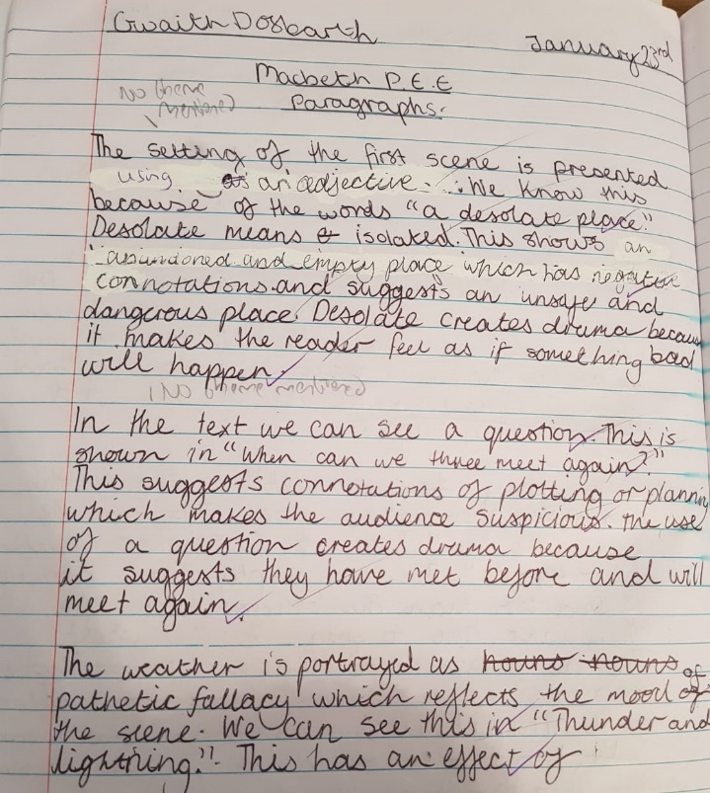

(Appendix E)
(Appendix G)

(Appendix F)

