STUDENT NAME: Halema Khatun
STUDENT NUMBER: 1808827
MODULE: Leading and implementing workplace change
MODULE CODE: BMSW6103
LECTURER: Nauman Ali

SAINSBURY’S
CLIMATE PLEDGE PORTFOLIO

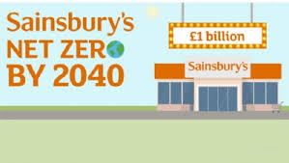

Contents
INTRODUCTION 3
BACKGROUND OF SAINSBURYS 3
Section 1: SAINSBURYS CURRENT SITUATION ANALYSIS 3
BUSINESS MODEL CANVAS 5
Fig 1. Sainsbury business model canvas, (Vizology,2021) 6
SAINSBURYS SWOT ANALYSIS 6
Fig 2: Swot analysis (Our business strategy, 2021) 7
Fig 3. Pestle Analysis (CIPD, 2020) 9
POLITICAL FACTORS 9
ENVIRONMENTAL FACTORS 10
SOCIAL FACTORS 10
ECONOMIC FACTORS 11
SECTION 2: STAKEHOLDERS AND CHANGE MANAGEMENT 11
SECTION 3. CHANGE MANAGEMENT PLAN 12
Figure 5. Lewin’s Three-Stage Process of Change (Toppr, 2021) 13
KOTTERS 8-STEP CHANGE MODEL 13
Fig 7. Kotter’s 8 Step Change Model (Lynch, 2020) 15
LEADERSHIP STYLE 16
AGILE PROJECT MANAGEMENT 16
SECTION 4. ORGANISATIONAL STRUCTURE AND CULTURE 17
LEARNING CULTURE AT SAINSBURYS 18
MASLOWS HEIRARCY OF NEEDS 19
Fig 9. Maslow’s Hierarchy of needs (Guleria, 2018) 19
SECTION 5. REFLECTION 19
BIBLIOGRAPHY 21
APPENDIX ONE – THE SUSTAINABILITY COMMITTEE 25

INTRODUCTION
The Climate Pledge, a commitment co-founded by Amazon and Global Optimism to meet the goal Net Zero Carbon By 2040 of the Paris Agreement (2016) 10 years early. Sainsburys have been chosen to be a Principal Partner of the UN Climate Change Conference, COP26. Climate change is forcing governments and businesses to explore mitigation strategies to avoid a future disaster. The climate emergency is the biggest threat facing the countryside and planet therefore it is necessary to reduce emissions of greenhouse gases dramatically. Risks associated with climate change need to be managed in global supply chains urgently (Ghadge et al, 2019). As a consultant a systematic strategic analysis of the company’s situation will be carried out to see how they have performed to date and what can be done to resolve the problems they are faced with regarding the climate pledge. The following portfolio will be looking into how Sainsbury’s is implementing this into their commitment to the pledge and the actions they are taking to execute this into their change management plan. The portfolio will be looking into aspects of the business such as the current position of the company, the stakeholders, the organisational culture the company holds and will create a change management plan to put the changes into action with proposals recommended to make the changes followed by a conclusion.

BACKGROUND OF SAINSBURYS
J Sainsbury plc or Sainsbury’s is the third largest supermarkets’ chain operating in the UK, having a 15.3% market share in the industry (Sweney 2019). John James Sainsbury was the founder of the Sainsbury brand, and he laid the foundation of the company in 1869. Sainsbury’s has a strong network of more than 2300 convenience stores and supermarkets across the UK and Ireland and growing ecommerce business. Sainsbury’s has divided the company’s operations into three main categories: Sainsbury’s Argos, Sainsbury’s Bank, and Sainsbury’s Supermarkets. Brands like Argos, TU, Nectar, and Habitat operate under the umbrella of Sainsbury’s. However, the portfolio will be focusing on the strategic business unit of Sainsburys in the UK. Sainsbury’s main products and services are forecourt shop, convenience shop, supermarket, superstore, hypermarket, food, snacks, confectionaries, soft drinks, magazines, over-the-counter drugs, tobacco, and many others.

Section 1: SAINSBURYS CURRENT SITUATION ANALYSIS
Sainsbury’s joined The Climate Pledge on April 21, 2021 and aim to become net zero by 2035 in its own operations. Sainsburys are the only UK food retailer to receive an A rating in the Climate Disclosure Project for six consecutive years. They have achieved a 42 per cent reduction in carbon emissions over fifteen years, despite a 46 per cent increase in their estate. They have committed to reduce carbon emissions within their operations to Net Zero greenhouse gas emissions, increasing the use of renewable energy. The international attention on climate change, energy conservation, and carbon reduction is only becoming more prominent. Green energy development has become a key economic goal in many countries, in light of the current economic climate (Tsai et al, 2021).
Sainsburys were the first retailer to achieve The Carbon Trust Water Standard in 2017 as well as this past year achieving the Climate Disclosure Project A-rating for water disclosure. They achieved 2020 water reduction targets early, saving one billion litres since 2005 driving to become water neutral by 2040. They have committed to reduce the use of plastic packaging by 50 per cent by 2025 and then go further. They were the first retailer to remove plastic bags from their produce aisles and bakery counters resulting in customers using their own bags or purchasing reusable bags. Sainsburys were the first retailer to achieve zero waste to landfill however more needs to be done to reduce food waste by 50 per cent by 2030. Most of their stores redistribute good quality food safely to local charities and community groups through food donation partnerships.
To be on the way to achieve the climate pledge Sainsburys have been using Aerofoil technology across all their stores and celebrated their 400,000th fitting in March. Aerofoil Formula 1 technology prevents cold air from leaving the cabinet and directing it back into the fridge, this reduces energy consumption by 15%, keeping aisles warmer and reducing food waste by maintaining products at their optimal temperature (Nd, 2020).

BUSINESS MODEL CANVAS

Key Partners | Key Activities | Value Propositions |  | Customer  Relationships | Customer  Segments
- The Range  - Brands  - Overseas suppliers  - Manufacturers  - Investors  - British Retail Consortium  - Distributors  - Environmental Action Group | - Retailing  - Procurement and logistics  - Operational management  - Merchandising  - Customer services  - Financial  - Marketing  - In- store shelf organisation  - Logistics  - Support services  - E – commerce operations | - Good food costs less at Sainsburys  - One stop shop  - Rewards and discounts  - Provide value for money  - Provide more variety to existing clients  - Find new customers in new channels  - Property investments |  | - Customer service  - Quality  - Brand awareness  - Social media  - Customer reviews and feedback  - Nectar points | - Mass market  - Public Sector  - Loyal customers  - Households  - Small & medium companies
 | Key Resources |  |  | Channels
 | - Brand  - Partnerships  - Technology |  |  | - Website  - Mobile application  - Online sales  - Nectar loyalty card  - Media  - supermarket
Cost Structure |  |  | Revenue Streams
- Stores  - Cost of goods  - Human resources  - Supply chain  - Bonus scheme  - Marketing/ branding |  |  | - Retail sales  - Online sales  - Financial income from loans  - Commissions on affiliates  Fig 1. Sainsbury business model canvas, (Vizology,2021)

SAINSBURYS SWOT ANALYSIS
To analyse the internal environment in which Iceland is operating a Swot Analysis has been conducted. To be successful, companies must adapt to ongoing trends and developments in their micro and macro environments (Camilleri, 2017). The performance of the company is influenced by many different factors, including political, economic, social, and technological factors, therefore it is important to examine these to get a better understanding of the impact they have on the company.
STRENTGHS | WEAKNESSES
Third leading grocer supermarket in UK  Carbon Trust Standard  Eco-friendly fridges and freezers  Good relationships with suppliers  Too Cool for plastic campaign  Technology  Differentiation from competitors  Highly skilled workforce  Listed on London stock exchange | Reduced profit margins  More investment in new technologies  Competitors have an advantage in the market  Lack of success outside core business  Increased prices after the pandemic
OPPORTUNITIES | THREATS
Recycle bins in all stores to recycle plastic film  To become plastic free and be the first UK supermarket to be plastic neutral  Cut food and plastic food waste  Globalisation | Government policies  Taxation policy  Competitors using new and advanced technology  Environmental regulations  The Covid 19 pandemic

Fig 2: Swot analysis (Our business strategy, 2021)
The Covid 19 pandemic had a huge impact on how businesses operated due to lockdown stores closed and therefore less energy was used more people were ordering online so therefore more deliveries were done which meant a lot more trucks on the road creating pollution which would have an impact on the environment. However, Sainsburys have made good progress to be on the way to achieving the climate pledge by investing in campaigns such as reducing plastic packaging by 50% by 2025 by taking on the following five-point approach to tackle this: -
- We will remove completely where we can
- Reduce the weight of packaging
- Replace with an alternative material without causing further detrimental environmental impact
- Make it easier for our customers to recycle
- Give customers options to reuse packaging (Nd, 2021).

POLITICAL | ENVIRONMENTAL
- Political stability and importance of Retail sector in the country's economy.  - Cop26  - Bureaucracy and interference in Retail industry by government.  - Globalisation  - Trade regulations & tariffs related to Consumer Services  - Anti-trust laws related to Retail  - Pricing regulations – Are there any pricing regulatory mechanism for Consumer Services  - Taxation - tax rates and incentives  - Wage legislation - minimum wage and overtime  - Work week regulations in Retail  - Mandatory employee benefits  - Industrial safety regulations in the Consumer Services sector.  - Product labelling and other requirements in Retail | - Weather  - Climate change  - Laws regulating environment pollution  - Air and water pollution regulations in Retail industry  - Recycling  - Waste management in Consumer Services sector  - Attitudes toward “green” or ecological products  - Endangered species  - Attitudes toward and support for renewable energy  - Carbon footprint  - Greenest grocer
SOCIAL | ECONOMIC
- Demographics  - Class structure, hierarchy, and power structure in the society.  - Education  - Culture (gender roles, social conventions etc.)  - Attitudes (health, environmental consciousness, etc.)  - Food donation to local charity | - Gross Domestic Product (GDP)  - Inflation rate  - Consumer confidence

Fig 3. Pestle Analysis (CIPD, 2020)

POLITICAL FACTORS
It is important to have political stability for organisations as the rules and regulations the Government put in place can have a positive or negative impact on the company and how they react to these can affect the operation of the organisation. Sainsburys must adhere to the legislations that are put in place from the Government to reach the climate pledge in the right way especially regards to Cop26 which has set out that companies need to do more to reduce emissions.

ENVIRONMENTAL FACTORS
The world is currently facing an environmental crisis. As a result, all businesses are expected to adhere to a process that harms the environment in the least way possible. Sainsburys are being more energy efficient and to reduce carbon footprint they aim to go green which means they need to invest more money into solutions to achieve this. Sainsbury’s committed to reduce its Scope 3 Greenhouse Gas emissions by 30% by 2030, with a long-term commitment to be net zero by 2050 across its value chain. The company rolled out a campaign called the ‘Greenest Grocer’ to save energy and encourages staff to make simple changes in behaviour such as closing fridge doors and not overfilling fridges. However, there is a cost to this as they must send their managers on a training program to learn about the changes in behaviour that were needed. The result of this was apparent as there was change in energy use and was seen to go down by 2 per cent and 10 per cent (Sainsburys, no date). Sainsbury’s will be using 100% renewable electricity across all their premises, significantly reducing its reliance on fossil fuels. They will install 100% LED lighting across its supermarkets by the end of this year, reducing lighting energy consumption by 70% and store energy consumption by 20%. This follows an extensive financial investment of £320 million in the past ten years, funding more than 3,100 sustainable initiatives.

SOCIAL FACTORS
Society’s culture and way of doing things impact the culture of an organization in an environment. Shared beliefs and attitudes of the population play a great role in how the employees of Sainsburys will understand the customers of a given market and how they design the marketing message for Retail industry consumers. Current trends, lifestyle, shared beliefs, and attitudes of society impact how Sainsburys understand their environment. This entails how they approach their consumers and the methods they use to do adapt and change to society norms to benefit the business. There is consumer who will not shop somewhere if they are seen to not practice sustainability practices such as going green, using less plastic and not wasting food, therefore Sainsburys donating food to local charities gives them a good reputation and will attract customers. The concept of Corporate Social Responsibility (CSR) meets these growing expectations and encourages businesses to modify their approaches (Tench et al, 2014).

ECONOMIC FACTORS
The growth of the economy is crucial to every country as the more money that is spent on the economy of the country the richer, they become but this does not show the damage it is causing to the environment. To grow the economy natural resources are being used faster than they can reproduce themselves, such as chopping down forests and polluting the air and with more energy being used ultimately means more fossil fuels are being burned resulting in global warming. Therefore, it is important for Sainsburys to look at where their resources are coming from as well as how their key partners are operating as consumers are also looking to make ethical and sustainable purchases.

SECTION 2: STAKEHOLDERS AND CHANGE MANAGEMENT
Sustainability of the environment for both the present and future generations call for a paradigm shift of stakeholders, especially businesses, to take measures to reduce waste and become more environmentally conscious (Gopal, 2005). For Sainsburys to be efficient in communication and successful in what they are doing and achieve the climate pledge it is imperative for them to have effective communication with their stakeholders and make the right decisions. According to Freeman, (2010) it is important to identify and manage the stakeholders as each stakeholder plays an important role in the success of the business. It is essential the employees are aware of why the change is being made and the process of the change as this will affect how they behave to achieve the change. Below is a stakeholder matrix (figure 4) to identify Sainsburys stakeholders and the importance they have on the organisation and who to prioritise when communicating.
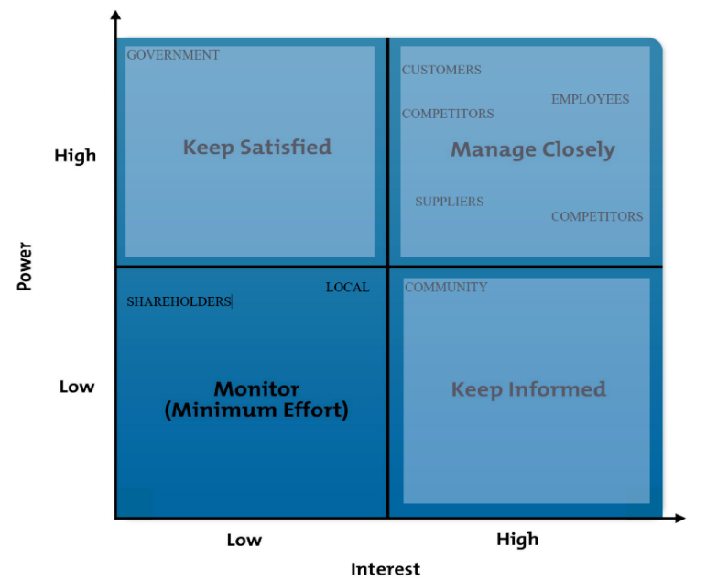
STAKEHOLDER ANALYIS – POWER INTEREST GRID
Fig 4. Power Interest Grid (MindTools, 2006-2018)
Stakeholders are important for any business to make changes especially for Sainsburys it’s important for them to make decisions and changes in alignment with aspects that will keep their stakeholders happy and invested. Especially those stakeholders such as shareholders who have high power and hight interest in the company as they may have a financial interest in the company so it is necessary to engage with them and make efforts to satisfy them whereas the local community don’t have high power it is best to keep them informed of any decisions that could affect them. Hence, if Sainsburys are performing well shareholders also benefit and will also gain a good reputation with a company that is at the forefront of doing good to achieve climate change. However, if Sainsburys are not performing well and to achieve their objectives they need to identify what is going wrong and put in a plan to make the change. As they have joined the climate pledge and are aware that changes need to occur to fulfil these objectives, a lot of practices needs to be put in place for continuous improvement to achieve this and combat any barriers they may face.

SECTION 3. CHANGE MANAGEMENT PLAN
Change, according to Armstrong (2009), is any change in structure, management, workers, procedures, or other associated activities. A company's day-to-day operations are increasingly influenced by change. Special management strategies, which may be summed up as change management, are required to control it optimally (Lauer, 2020). Therefore, it is important to implement a change management plan to make an organisational change to ensure that objectives are met as change is often met with resistance. It can be argued that the successful management of change is crucial to any organisation to survive and succeed in the present highly competitive and continuously evolving business environment (Todnem, 2005).
There are various models of change that can be used to implement changes into an organisation such as Kurt Lewin’s three stage change management model which involves unfreezing, changing and then again refreezing. Theories of change describe the effectiveness with which organizations can modify their strategies, processes, and structures (Hussain et al, 2018). Sainsburys will use this to make a change to their current organisational structure and environment for the business to grow.
- UNFREEZING – at this stage the employees are prepared for the change, it is communicated through management of why the organisational change is happening and why it is important to make changes to achieve the climate pledge. It is important to communicate the vision to the team and get feedback from them and if it is necessary any course of action can be steered in a different way at this stage before they move on to the next stage.
- CHANGE – this is where it is all put into action, set goals and deadlines of when each action should be met. To make sure the changes can be put in to practice all the staff should be trained on how all the new tasks are to be done such as making energy changes involves the staff getting used to switching off lights and appliances that are not in use.
- REFREEZING – this is where you freeze the change and the new practices become the new norm. Sustainability practices become part of everyday behaviour and you can evaluate how changes are being met and if goals are being met by monitoring progress.
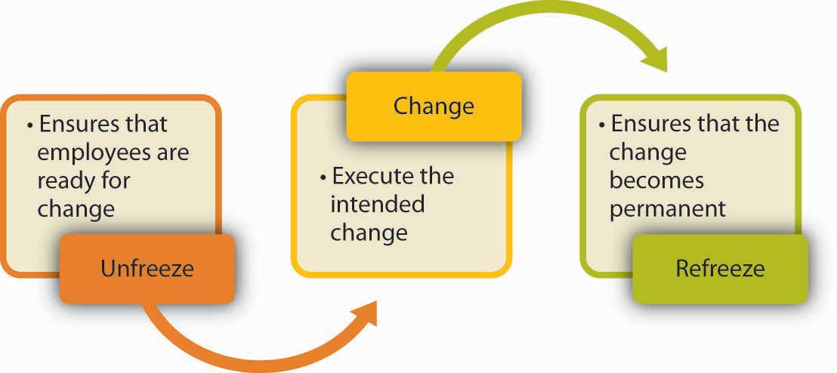

Figure 5. Lewin’s Three-Stage Process of Change (Toppr, 2021)

KOTTERS 8-STEP CHANGE MODEL
To implement changes in the company Sainsburys can follow eight steps of change management by John P Kotter (figure 6) Kotter's change model underlined the significance of a holistic strategy in dealing with change efforts, which if not considered, can result in a 70% failure rate for many firms (Jalagat, 2015).
Step 1- create a sense of urgency of the change which means that the change occurring needs to be conveyed to those who will be involved in making the change, not establishing a sense of urgency can result in a failure to implement the change. It must be made clear that the government has set a target to be net zero by 2040 and how important it is to achieve this to save the planet. Explain to the team that not making these changes would leave the company at a disadvantage against their competitors who are also working towards being sustainable.
Step 2 – forming a powerful coalition, this would be where Sainsbury’s form a strong skilled group of about 10 people from different departments who can lead the plan and implement the changes together. It is important to understand the strengths and weaknesses of the individuals so they can be placed in the best role to suit their skill set. The group would need to be committed to making the change and meet regularly to discuss the changes and see if they are on target to attain the main goals or if anything needs to be changed to achieve the goals. There would be a need for strong leadership and support from the team to work together to build the urgency for the change to happen.
Step 3 – developing a vision and strategy would give a clear purpose to the company of what they are trying to achieve, as Sainsburys aim is to be ‘better for the planet’. This vision should be a common goal across the organisation so they can work together to be proactive to achieve the climate pledge. Sainsburys want to reduce the environmental impact they are having on the planet in the way that they operate so are working with Science Based Targets Initiative (SBTi) and Carbon Trust to achieve the climate pledge. It is critical that the team managing the change works together to achieve the same goal, since this will allow them to carry out the plan.
Step 4 – communicate for buy in, to effectively make the change it is crucial to have efficient communication to convey the vision of the organisational changes across the board. The way this is done will determine the success, however if resistance is shown it is important to listen to any concerns and anxiety the team has openly and honestly.
Step 5 – empower action – with any change resistance will be met as people get used to a certain way of doings so are often hesitant to change as it may come as a shock to them, so it is important that the team is prepared for the change (Lamm and Gordon, 2010). Many types of resistance can be overcome by listening to employee feedback and adjusting the strategy as needed so that the team feels more confident and boosts morale (Kotter, 2012)
Step 6 – create short term wins which will boost the motivation of the team, they will feel good and will appreciate that their efforts have made a difference. Reward the team and make them aware of the achievements such as Sainsburys had a 14% reduction in absolute greenhouse gas emissions in one year keeping them on track to reach their targets for the climate pledge by 2035 (Nd, 2021).
Step 7 – consolidating gains and producing more changes, it is important to learn from the short term wins and changes that have already been made and see what can be done to improve the process. Make note of who is doing what to achieve and implement the changes and make this part of the culture of how things are now done so continuous changes can be made and less resistance will be met from the team.
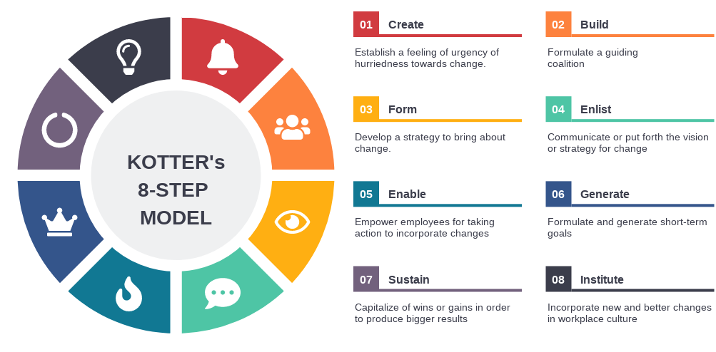
Step 8 – make change stick and let it become the central part of the organisation and all engaged with the change should continue to support the changes. Reward the staff who are accomplishing the changes and make it significant impacts for the organisation to reach its main goal of the climate pledge. This should made clear for all to see especially new starters who come in should be trained on the changes and vision right from the start.

Fig 7. Kotter’s 8 Step Change Model (Lynch, 2020)

It is imperative for Sainsbury’s that it develops some conditions for its employees as part of its change management programme through an incremental strategy for the organisational change, inspiring leadership for developing positive behaviour and attitude, and strategies for preventing resistance to change (Rainey, 2006). Sainsbury’s should keep in mind for effective and successful change management that the overall organisation’s culture, structure, practices, and incentives should be productive towards a change into a resilience and sustainable business (Kavanagh and Ashkanasy, 2006). Sainsbury’s may face various barriers and challenges that negatively affect the change management process. Sainsbury's could improve its potential and capabilities in dealing with difficult challenges by making real and innovative adjustments and producing creative solutions. By making the goal clear and explaining to those involved why it is needed and how as a collective it is going to be achieved should get those involved engaged in making the change happen and having two-way communication from the team where feedback is given. A clear communication strategy will be put in place of how the company is to reach the climate change pledge therefore a change leader will need to be employed or this can be an internal manager who will be at the forefront to champion the change. They will clearly define the strategic approach to the team and will need to make clear that if the changes are not implemented how this will affect the organisation and the negative impact this will have on the company as well as the stakeholders that are of high importance.

LEADERSHIP STYLE
Gary Yukl (2006) defines leadership as “the process of persuading others to comprehend and agree on what has to be done and how it should be done, as well as the process of assisting individual and group efforts to achieve common goals”.
Johnson et al (2020) mentions three key roles of top management in leading strategic change:
- Envisioning future strategy – establish clear communication of the strategy to all stakeholders.
- Aligning the organisation to deliver that strategy. Goals and values should be shared and committed to by all involved in making the change.
- Embodying change. Establish a need for you to have a change and the leader will be the role model for the change.

Sainsbury’s take on a democratic leadership style to envisage the change whereby they let the employees have a voice which motivates the team as they feel like they have had a say in the decision making however this can be time consuming. Ibrahim and Daniel (2019) state that the transformational leadership style is more effective, productive, innovative, and satisfying to followers as both parties work towards the good of the organization been driven by shared visions and values as well as mutual trust and respect. The leadership team must influence and direct the team and use their authority to direct the change to ultimately get the team to work together to achieve the company's objectives. Nevertheless, if all are not on board with the changes then there should be change in the structure or change in management to bring on board those who will be fully committed to delivering and making the change. Sainsbury’s have implemented a new governance structure (appendix 1) to achieve their sustainability plan and build trust with their stakeholders in becoming a sustainable retailer fit for the future.

AGILE PROJECT MANAGEMENT
To manage the change an agile management style approach will be taken, agile is a group of methodologies used to empower people to improve the processes, make them quicker and more efficient. Applying the Agile method means that everyone involved in the project knows what is going on and how the change is progressing. It allows for frequent inspection, therefore those who have high importance in making the change can regularly evaluate the process to see if all is going well or not. However, if the inspection shows that something is not right then adjustments can be made immediately and does not require you to wait till the end of the process (Layton & Ostermiller, 2017).

SECTION 4. ORGANISATIONAL STRUCTURE AND CULTURE
The culture of an organisation plays an important role in how employees are influenced and what values, attitudes, and norms they get accustomed to will ultimately influence the outcome of the business. Therefore, it is crucial to build a good workplace culture and instil in the employees the values, vision and behaviour that is expected from them which will be demonstrated from the top and motivate the rest of the team to practice the changes. Charles Handy (2007) argues that the key to successful organisations lies in a better understanding of the needs and motivations of the people within them.
Cultural web (figure 8) is a management tool discovered by Johnson and Scholes (2020) for organisations to focus on the key aspects of culture and the impact they have on any strategic issues and identifies any barriers to improve performance and gain the competitive edge. However, this may not always be the case for those who form their own cultures through their visions and ideas about how sustainability is achieved so the norms and behaviours they embed need to be align with the organisational goals. Brown (1998) highlights those differences in subcultures can be a key factor for conflict and can reduce the effectiveness of an organisation.
Hofstede (no date) suggests delving into your organisational culture can provide you with valuable and unique insights to confidently take your next steps towards your goals. Change needs to be embedded into the culture for the change to happen therefore applying the cultural web will enable Sainsburys to achieve this and create this culture of doing things in a sustainable way.

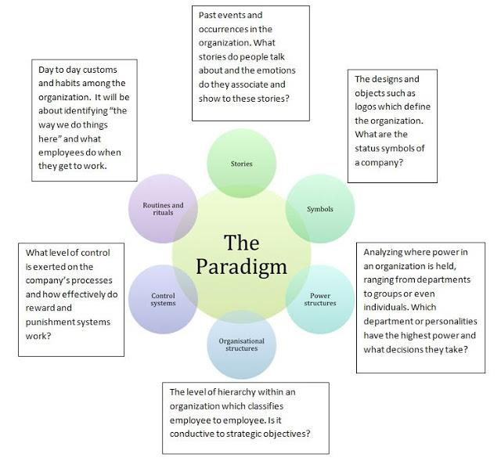 Fig 8. Cultural Web (Senidbiz, 2013)

LEARNING CULTURE AT SAINSBURYS
Learning culture is part of the organisational culture, Sainsbury’s learn from what they are doing and what is happening around them and change this accordingly. The organisation has its own culture and is unique to the organisation, so the way things are done are learnt by the people who do this everyday and becomes the normal behaviour. It is learnt over time and as part of the organisation continual learning and change becomes part of the culture. Sainsburys work in collaboration with the learning and development teams at the British Retail consortium (BRC) and the Institute of Grocery Distribution (IGD) to support research and development opportunities. Sainsbury’s has become the only retailer in the UK to win the Investors in People (IiP) Gold Standard four times in a row, it is only awarded to 3% of organisations in the UK (n.d, 2020). They invest in the training and development of the staff as they believe they are the foundations of the business and are crucial to implementing the changes.

MASLOWS HEIRARCY OF NEEDS
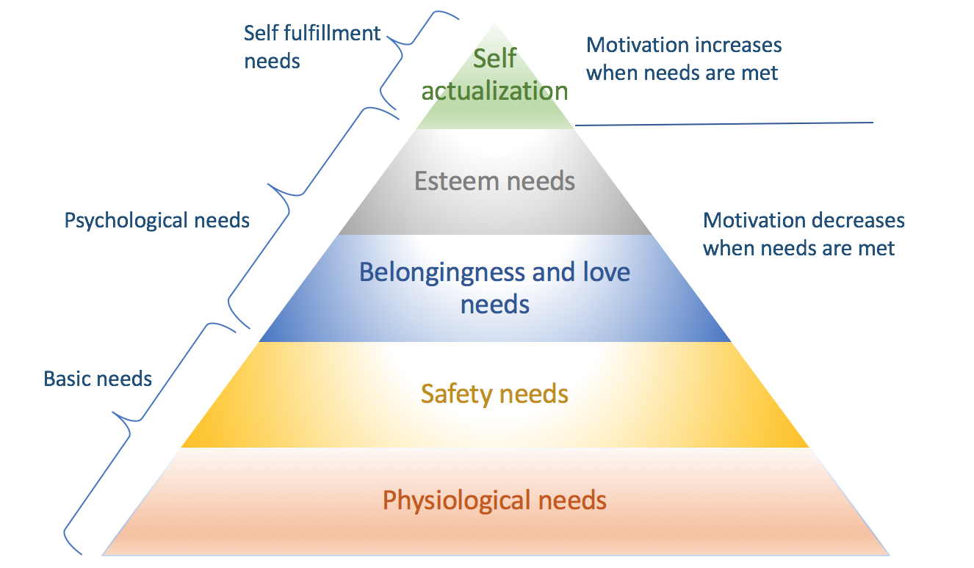
For a change of culture to happen in the company everyone must be motivated and feel committed to the beliefs and values of the organisation and to do this Maslow’s hierarchy of needs states there are five levels of human needs that need to be fulfilled. Lacking in these needs causes low motivation so following Maslow’s pyramid by starting at the bottom of the hierarchy and when each need is satisfied, they can move up to the next one. A successful company takes care of its employees' when they take care of these basic needs, people become engaged in their work when honesty, trust, dignity, and respect are an integral part the company’s culture (Kumar & Meenakshi, 2012).

Fig 9. Maslow’s Hierarchy of needs (Guleria, 2018)

SECTION 5. REFLECTION
The task given was to implement changes to how Sainsburys are to reach the climate pledge that they have joined up with the aim of becoming net zero by 2035. I felt this was a very big ask but can be achieved if all the steps in the portfolio are taken it would be possible to accomplish. From how the organisation operates by maximising on the strengths, working on the weaknesses and making the most of the opportunities also working on the external environment that has an impact on the organisation will clearly define the factors that need to be focused on.
To make the change management programmes most effective and successful, Sainsbury’s will have to consider its human and financial resources, organisational culture, and structure, as well as other aspects. In order for change to be successful, Kotter suggests that 75% of a company's management needs to support it (Galli, 2018). Getting this support is the first step towards implementing effective change process, as always with any change it was met with some resistance from the team. However, once the relevant training and communication was published it was clear for the team to see the benefits of the change, they were willing to give it a go. As a company making sure all the needs of the staff were met motivated them to change their behaviour and work towards the goals of the company. Using the relevant change models and working on these step by step will enable for the changes to happen. Acquiring a change champion to role model the changes was very crucial for the company as they were the ones who took an a leadership and set the examples of what was needed for changes to happen to achieve the main goals and keep all the stakeholders satisfied.

BIBLIOGRAPHY
About.sainsburys.co.uk. 2021. [online] Available at: <https://www.about.sainsburys.co.uk/~/media/Files/S/Sainsburys/documents/reports-and-presentations/2021/Sustainability%20Update%202020-21.pdf> [Accessed 27 November 2021].
About.sainsburys.co.uk. 2021. Sainsburys Sustainability Report. [online] Available at: <https://www.about.sainsburys.co.uk/~/media/Files/S/Sainsburys/documents/making-a-difference/Sustainability_Update_2018.pdf> [Accessed 27 November 2021].
About.sainsburys.co.uk. 2021. Our business strategy. [online] Available at: <https://www.about.sainsburys.co.uk/about-us/our-business-strategy> [Accessed 29 November 2021].

Advanced Engineering | Williams Advanced Engineering. 2020. MILLIONTH FORMULA ONE FRIDGE FITTED IN NEW SAINSBURY’S STORE AS SUPERMARKET DRIVES TOWARD BECOMING NET ZERO BY 2040 - Advanced Engineering | Williams Advanced Engineering. [online] Available at: <https://wae.com/news/millionth-formula-one-fridge-fitted-in-new-sainsburys-store-as-supermarket-drives-toward-becoming-net-zero-by-2040/> [Accessed 23 November 2021].
Armstrong, M.A. (2009). A Handbook of Human Resources Management. (11th ed.) London: Kogan Page.

Annualreports.co.uk. 2020. [online] Available at: <https://www.annualreports.co.uk/HostedData/AnnualReportArchive/s/LSE_SBRY.L_2020.pdf> [Accessed 23 November 2021]

Brown, A., 1998. Organisational Culture. 2 ed. London: Financial Times Management.
Camilleri, M., 2017. Travel marketing, tourism economics and the airline product. Msida: Springer, p.51.
Cipd.co.uk. 2021. PESTLE example for retail industry as at November 2020. [online] Available at: <https://www.cipd.co.uk/Images/7583-PESTLE-example-for-retail-industry-2020_tcm18-27108.pdf> [Accessed 29 November 2021].

Freeman, R., 2010. Strategic Management: A Stakeholder Approach. Cambridge: Cambridge University Press, p.25.
Joseph Galli, B., 2018. Change Management Models: A Comparative Analysis and Concerns. IEEE Engineering Management Review, [online] 46(3), pp.124-132. Available at:<https://ieeexplore.ieee.org/abstract/document/8486843?casa_token=elO_0k2BLnEAAAAA:saXaN9aWaJ4WVV8n4f43GokuFpLctwbRzegJLgxBxanFAb4asTUXZ537N_L6OUrWxb9os_GhgH8> [Accessed 29 November 2021].

Ghadge, A., Wurtmann, H. and Seuring, S., 2019. Managing climate change risks in global supply chains: a review and research agenda. International Journal of Production Research, [online] 58(1), pp.44-64. Available at: <https://www.researchgate.net/publication/333611003_Managing_climate_change_risks_in_global_supply_chains_A_review_and_research_agenda> [Accessed 29 November 2021].
Guleria, G., 2018. How to apply Maslow’s Hierarchy of Needs to your online business. [online] Medium. Available at: <https://blog.gluelabs.com/how-to-apply-maslows-hierarchy-of-needs-to-your-online-business-754de076c004> [Accessed 28 November 2021].
Gopal, T., 2005. Linking strategy with sustainable development. [online] Hdl.handle.net. Available at: <http://hdl.handle.net/10413/3742> [Accessed 21 November 2021].
Handy, C., 2007. Understanding Organisations. 4 edition Penguin UK.
Hofstede, G., n.d. Home - Hofstede Insights Organisational Culture Consulting. [online] Hofstede Insights. Available at: <https://hi.hofstede-insights.com/organisational-culture#> [Accessed 24 November 2021].

Hussain, S., Lei, S., Akram, T., Haider, M., Hussain, S. and Ali, M., 2018. Kurt Lewin's change model: A critical review of the role of leadership and employee involvement in organizational change. Journal of Innovation & Knowledge, [online] 3(3), pp.123-127. Available at: <https://doi.org/10.1016/j.jik.2016.07.002> [Accessed 29 November 2021].

Ibrahim A. U. and Daniel C. O. (2019). Impact of leadership on organisational performance. International Journal of Business, Management and Social Research, 06(02), 367-374.
Jalagat jr, R., 2015. The Impact of Change and Change Management in Achieving Corporate Goals and Objectives:Organizational Perspective. International Journal of Science and Research (IJSR), [online] 4(12), pp.1199-1203. Available at: <https://www.researchgate.net/publication/310828676_The_Impact_of_Change_and_Change_Management_in_Achieving_Corporate_Goals_and_Objectives_Organizational_Perspective> [Accessed 25 November 2021].
Johnson, G., Whittington, R., Scholes, K., Angwin, D. and Regner, P., 2020. Exploring strategy. 12th ed. London: Pearson.
Kavanagh, M. and Ashkanasy, N. (2006).The Impact of Leadership and Change Management Strategy on Organizational Culture and Individual Acceptance of Change during a Merger. British Journal of Management, 17(S1), pp.S81-S103
Kotter, J., 2012. Leading change. Boston, MA.: Harvard Business Review Press, p.105.
Kumar, A. and Meenakshi, N., 2012. Organizational behaviour. New Delhi: Vikas, p.410.
Lamm, E. and Gordon, J., 2010. Empowerment, Predisposition to Resist Change, and Support for Organizational Change. Journal of Leadership & Organizational Studies, 17(4), pp.426-437.
Lauer, T., 2021. Change Management. 1st ed. Berlin: Springer, pp.3-11.
Layton, M. and Ostermiller, S., 2017. Agile project management for dummies. Hoboken, NJ: John Wiley & Sons.
Lynch, W., 2020. A Comprehensive Guide to Kotter’s 8 Step Model of Change. [online] Medium. Available at: <https://warren2lynch.medium.com/a-comprehensive-guide-to-kotters-8-step-model-of-change-43d4eb86f1ea> [Accessed 27 November 2021].
Rainey, D. (2006). Sustainable business development. Cambridge: Cambridge University Press.
Senidbiz, H., 2013. Corporate Cultue. [Online]
Available at: https://hsenidbiz.com/blog/115-corporate-culture-changing-it-today-for-a-better-tomorrow

Sweney, M. (2019) “Sainsbury’s Falls Behind Asda To Become UK’s Third Biggest Supermarket Chain”. The Guardian [online] available from < https://www.theguardian.com/business/2019/apr/02/sainsburys-asda-uk-supermarket-aldi-lidl&gt; [5 November 2019]
Tench, R., Sun, W. and Jones, B. (2014) Introduction: CSR Communication as an emerging field of study. In R. Tench, W. Sun and B. Jones (ed.) Communicating corporate social responsibility: perspectives and practice. Series: Critical studies on corporate responsibility, governance and sustainability; Volume 6. Bingley: Emerald, pp. 3-21.
Todnem, R., 2005. Organisational change management: A critical review. Journal of Change Management, [online] 5(4), pp.369-380. Available at: <https://www.tandfonline.com/doi/full/10.1080/14697010500359250> [Accessed 25 November 2021].
Toppr. 2021. Change Through Management Hierarchy. [online] Available at: <https://www.toppr.com/guides/business-management-and-entrepreneurship/recent-trends-in-management/change-through-management-hierarchy/> [Accessed 29 November 2021].

Tsai, P. Chen, C. and Yang, H., 2021. Using Porter’s Diamond Model to Assess the Competitiveness of Taiwan’s Solar Photovoltaic Industry. SAGE Open, [online] 11(1), p.215824402098828. Available at: <https://journals.sagepub.com/doi/full/10.1177/2158244020988286#_i11> [Accessed 21 November 2021].
Yukl, G. (2006). Leadership in organizations (6th ed.). Upper Saddle River, NJ: Pearson-Prentice Hall
Vizologi rethinking business model design. 2021. J. Sainsbury business model canvas. [online] Available at: <https://vizologi.com/business-strategy-canvas/j-sainsbury-business-model-canvas/> [Accessed 20 November 2021].

APPENDIX ONE – THE SUSTAINABILITY COMMITTEE
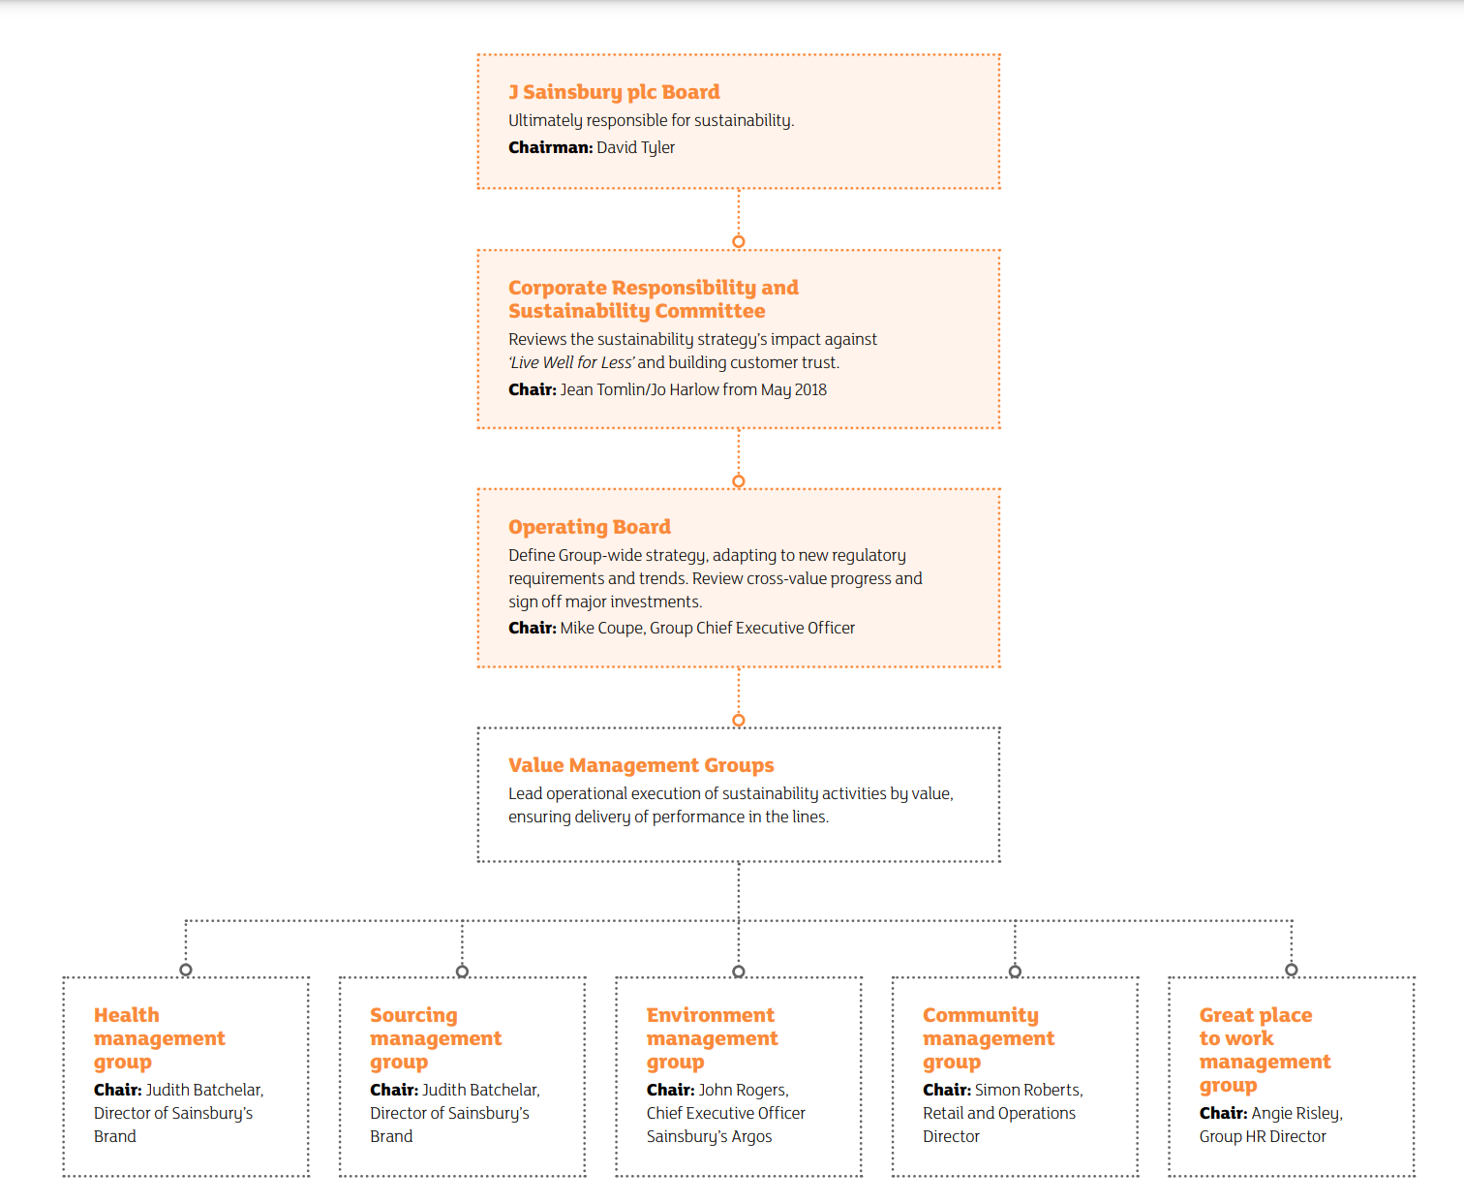Fig 10. (Sainsburys Sustainability Report, 2021)

