


Developing Relationships and Workplace Achievement

Student Name: Ramona Oana Babaciu
Student Number: 1808621 Lecturer Name: Ze Zook
Module Number: BMSW5102_LON



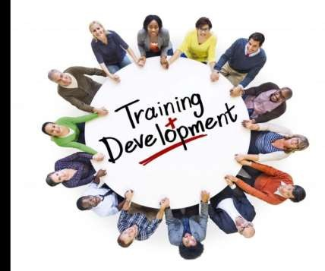
Training and Development Needs for a HR
Officer CONTENTS

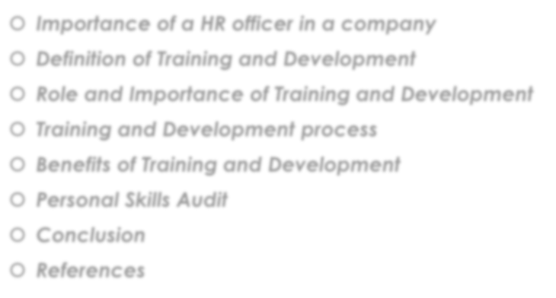
 Importance of a HR officer in a company
 Definition of Training and Development
 Role and Importance of Training and Development
 Training and Development process
 Benefits of Training and Development
 Personal Skills Audit
 Conclusion
 References


Swingers City Minigolf Club Introduction

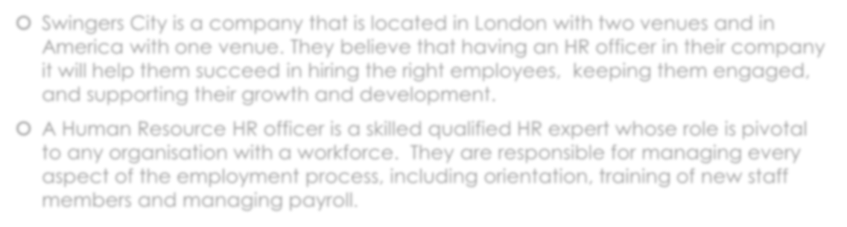
 A Human Resource HR officer is a skilled qualified HR expert whose role is pivotal to any organization with a workforce. They are responsible for managing every aspect of the employment process, including orientation, training of new staff members and managing payroll.
For example, the HR executive at the business of Swingers City has a major role to play in employing appropriate candidates to enhance the productivity and performance of the company in the market. The HR executive also helps in allocating appropriate jobs to the candidates who are newly hired according to their field of interest. This will help in enhancing their level of motivation hence in turn increases the performance of the company in the market.


Why have a HR officer in your company?

KEY REASONS WHY HR OFFICER IS IMPORTANT TO THE

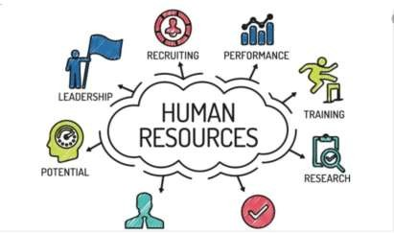
SUCCESS OF YOUR ORGANISATION
- HR helps develop an engaged workforce
- HR builds strong relationships with the employees
- HR introduces technology for the workplace
- HR leads recruiting and employee on boarding
- HR assists managers and team leaders
- HR helps employees achieve their Career goals
- HR support company growth
- Increase employee engagement with HR
- HR is at the crossroads of a business success



Training and Development

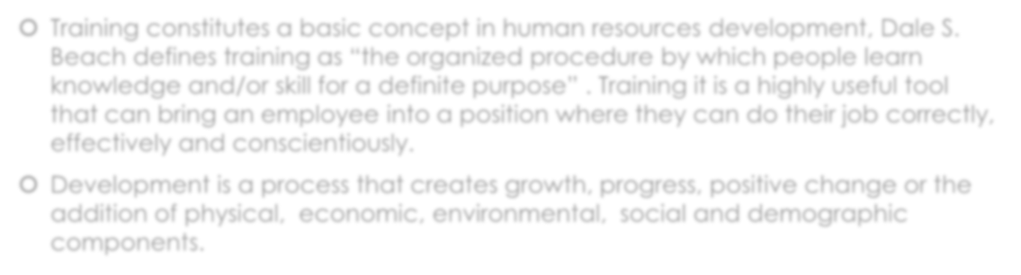
 Training constitutes a basic concept in human resources development, Dale S. Beach defines training as “the organized procedure by which people learn knowledge and/or skill for a definite purpose” . Training it is a highly useful tool that can bring an employee into a position where they can do their job correctly, effectively and conscientiously.
 The business of Swingers City gives learning and improvement culture to its workers that advance data sharing and enthusiasm for better authoritative outcomes. The business of Swingers City gives different projects and ways to deal with the consistent learning and vocation development of people.


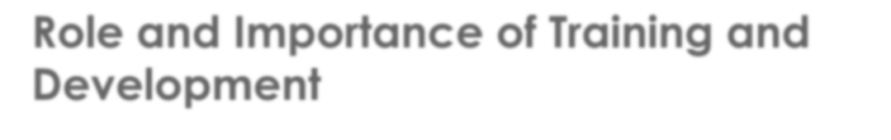
Role and Importance of Training and Development

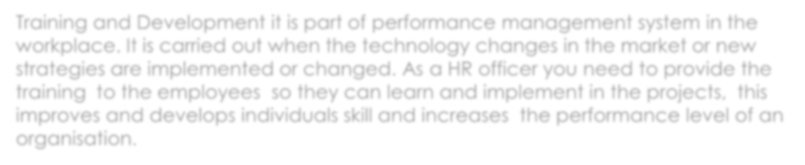
Training and Development it is part of performance management system in the workplace. It is carried out when the technology changes in the market or new strategies are implemented or changed. As a HR officer you need to provide the training to the employees so they can learn and implement in the projects, this improves and develops individual skills and increases the performance level of an organization.


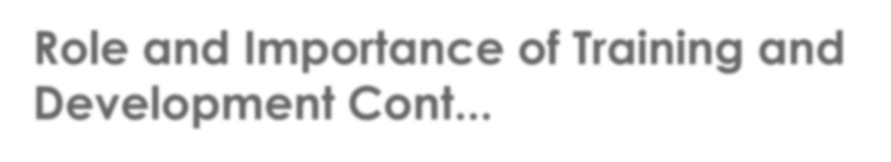
Role and Importance of Training and Development Cont...

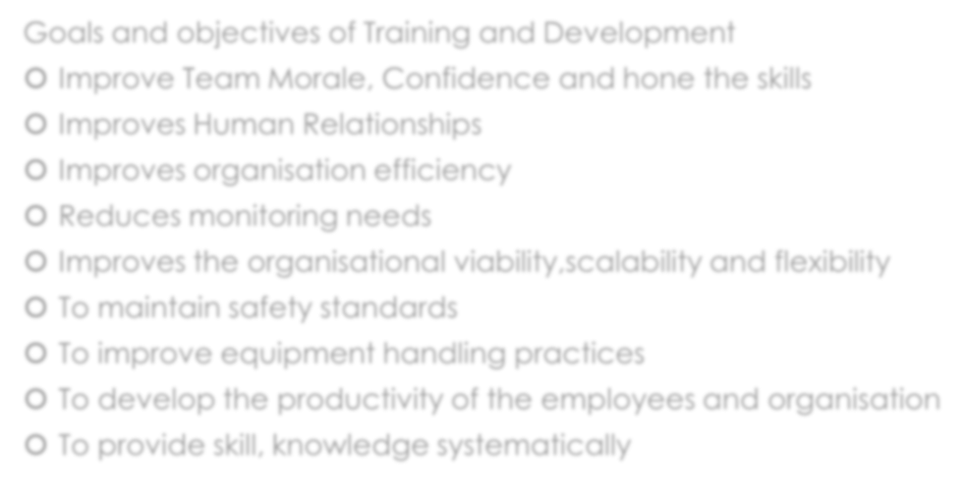
Goals and objectives of Training and Development
 Improve Team Morale, Confidence and hone the skills
 Improves Human Relationships
 Improves organization efficiency
 Reduces monitoring needs
 Improves the organizational viability, scalability and flexibility
 To maintain safety standards
 To improve equipment handling practices
 To develop the productivity of the employees and organization
 To provide skill, knowledge systematically


Training and Development process

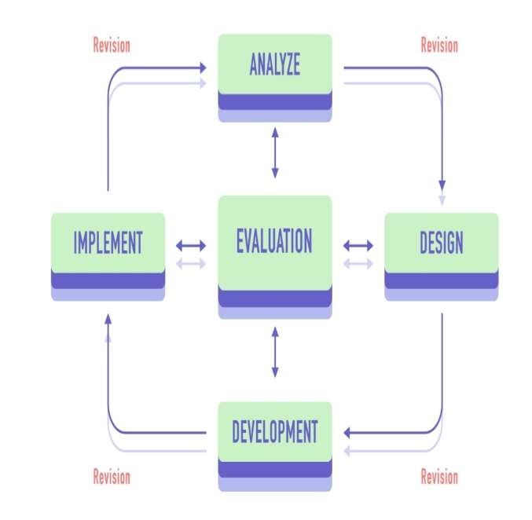
5 Steps that helps you in
achieving
Training and development for employees and business productivity




Training and Development process Cont...


Employees are an investment in your business, whether they are new to the company or seasoned workers, providing opportunities for them to grow professionally is essential to the success of your business and that is why we need a training and development process plan. Swingers City company believes that in order to thrive on the market they need to ensure that their employees are ready to face all the challenges and obstacles.
The business of Swingers City can meet the improvement needs of people by giving them professional advancement openings and ventures with the utilization of direction and discussion to give them explicit methodology or ability to read a compass for development (Armstrong and Mitchell, 2019).




Benefits of Training and Development

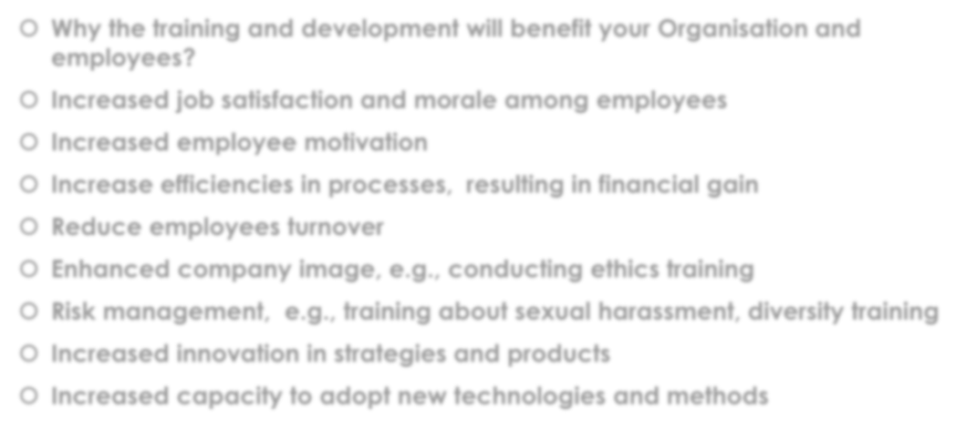
 Why the training and development will benefit your Organization and
employees?
 Increased job satisfaction and morale among employees
 Increased employee motivation
 Increase efficiencies in processes, resulting in financial gain
 Reduce employees turnover
 Enhanced company image, e.g., conducting ethics training
 Risk management, e.g., training about sexual harassment, diversity training
 Increased innovation in strategies and products
 Increased capacity to adopt new technologies and methods




Personal Skills Audit

Information technology | Very good | Good | Adequate | Little/No
Use Microsoft Office Word | ●
Use Excel spreadsheets |  | ●
Use a Database |  |  | ●
Use a Specialist HR software |  |  |  | ●
Use the internet | ●
Use e-mail | ●
Use PowerPoint | ●



Personal Skills Audit Cont.....

Communication Skills | Very good | Good | Adequate | Little/No
Drafting contracts of  employment |  | ●
Taking notes of disciplinary | ●
Write reports | ●
Produce material to support |  | ●
Delivering a training session | ●
Resolving disputes/complains | ●
Interviewing | ●
Advising on HR issues |  | ●



Personal Skills Audit Cont.....

Problem solving  Skills | Very good | Good | Adequate | Little/No
Make good use  of verbal reasoning skills, able to handle complex data and make selective use of  information | ●
Explore more  than one solution in order to solve a  problem | ●
Consider the  ideas of others  to help solve a  problem | ●

SUPERVISORY  MANAGEMENT | 1 MONTH | 1-3 MONTHS | 3 MONTHS
How much  experience have you had in your role? |  | ●
How many  people have you managed at any one time? | NONE | 1-5 | ABOVE 5
 |  | ●


CONCLUSION

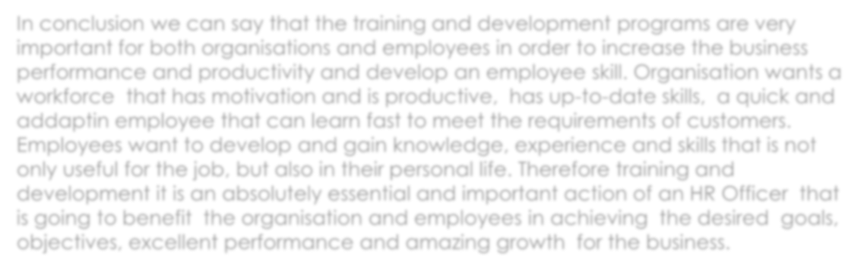
In conclusion we can say that the training and development programs are very important for both organizations and employees in order to increase the business performance and productivity and develop an employee skill. Organization wants a workforce that has motivation and is productive, has up-to-date skills, a quick employee that can adapt and learn fast to meet the requirements of customers.
Employees want to develop and gain knowledge, experience and skills that is not only useful for the job, but also in their personal life. Therefore training and development it is an absolutely essential and important action of an HR Officer that is going to benefit the organization and employees in achieving the desired goals, objectives, excellent performance and amazing growth for the business.




References


https://www.hrhelpboard.com/training-development/training-and-development-process.htm
https://www.learnupon.com/blog/addie-5-steps/
https://husys.com/blogs/importance-of-training-development-in-organizations/
https://husys.com/case-study/standard-hr-solution/
Armstrong, M. and Taylor, S., 2020. Armstrong's handbook of human resource management practice. Kogan Page Publishers.
Armstrong, S. and Mitchell, B., 2019. The essential HR handbook: A quick and handy resource for any manager or HR professional. Red Wheel/Weiser.

