Assessment Four: Image Commentary
Natalie Grueninger

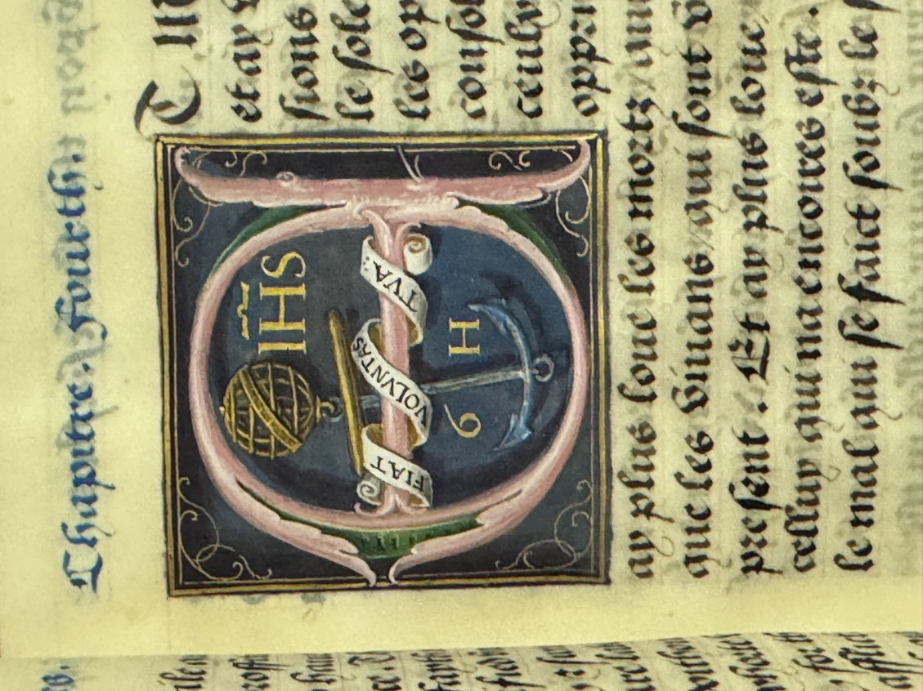

In the collection of the Duke of Northumberland at Alnwick Castle is an exquisitely illuminated manuscript that once belonged to Queen Anne Boleyn, the second wife of Henry VIII. The Ecclesiastes, also known as Percy MS 465, was made in England sometime between 1533 and early 1536.¹ At the time of its creation, this type of richly decorated manuscript already had a history that spanned around a millennium. First produced in monasteries in Europe in the sixth century, they became increasingly popular with royalty and the elite from around the 13th century onwards. The term ‘manuscript’ means ‘written by hand’ and comes from the Latin words for hand (manus) and writing (scriptus). These manuscripts were referred to as ‘illuminated’ because the pages were commonly decorated with gold leaf and silver and other vibrant colours, which reflected light and gave the appearance of being lit up or ‘illuminated’.² Although highly coveted by the rich and powerful for centuries, by the sixteenth century they were enjoying their ‘final flowering’.³ The advent of the printing press in the late fifteenth century completely revolutionised book production and ‘opened the door to cheaper, mass-produced, readily available books targeting a commercial rather than an elite market’.⁴ Nevertheless, hand-illuminated manuscripts remained popular in the upper echelons of Tudor society as they were important symbols of wealth and devotional piety.
Anne’s manuscript also provided the donor with an opportunity to translate a religious work into the vernacular – a popular pastime for the intellectuals of the day. While the biblical text is written in French, the commentary has been translated into English and is based on a printed book published in France in the early 1530s. This source text survives in the British Library and contains Jacques Lefèvre d'Étaples’ French translation of Johannes Brenz’s commentary on the Old Testament Book of Ecclesiastes, originally published in German in 1528. Brenz was a close associate of Martin Luther and his commentary was heavily influenced by Luther’s writings and lectures.
The manuscript was made for Anne at a time of great religious and political upheaval in England. Henry VIII famously broke away from the Roman Catholic Church in order to marry Anne and in 1534 established himself as Head of the Church of England. While Anne’s reformist leanings are well documented, this manuscript offers an important window into her developing religious beliefs. It speaks to her profound commitment to the word of God and her belief in the supreme authority of scripture in the church. More broadly, it also helps us understand the kinds of religious questions people were grappling with at the time. Given that Anne was fluent in French, the translation of the commentary into English also demonstrates that it was not produced for the queen’s eyes only. It was clearly intended to be shared and discussed with Anne’s household and underscores her promotion of vernacular scriptural texts. This manuscript also helps us understand the image that Anne was fashioning for herself, one very much influenced by her years spent at the glittering Burgundian and French courts. While the contents and illuminations served as a tool for private and public devotion and spiritual contemplation, the book as an object represented Anne’s status and wealth, her erudition and cultural sophistication.
Made of translucent vellum and beautifully illuminated, Percy MS 465 is divided into twelve chapters. Each chapter begins with a historiated illuminated initial 40 millimetres square or eight lines high that all ‘pay tribute to Anne’.⁵ While the The Ecclesiastes is, of course, a religious text, the illuminations also make a powerful political statement. They celebrate Anne’s marriage to Henry VIII by highlighting her royal iconography, including her falcon badge and the arms assigned to her as queen. On folio 34r. a pink historiated letter ‘E’ marks the beginning of the fourth chapter. It is lined in green and set against a slate blue background. Wrapped around the horizontal bar is a white scroll bearing the Latin motto ‘Fiat voluntas tua’, which translates to ‘Thy will be done’. In the background is a gold armillary sphere from which hangs a blue anchor, and next to the sphere, also in gold, are the letters ‘IHS’, an abbreviation for the name of Jesus Christ. The initials ‘G H’ appear below the motto and the corners are decorated with a scroll design.
According to Anne Boleyn’s biographer Eric Ives, the armillary sphere and anchor symbolise constancy and firm commitment, and together with the motto emblematize total obedience to God.⁶ More specifically, Anne’s total obedience to God. This particular image also reiterates the message contained within this section of the text. The first few verses of chapter four address the oppression and evils that exists in the world and preach that ‘truly there is nothing better than the word of God…to withstand all these quarrels and murmurations’.⁷ It is only through anchoring yourself to your faith and committing yourself fully to the word of God that one can truly find peace and contentment in the world.
Furthermore, the armillary sphere is a symbol directly linked to Anne. In one of her surviving books of hours, now housed at Hever Castle in Kent, beneath a miniature of the Resurrection of the Dead, Anne wrote ‘Le temps viendra’, (the time will come), and signed it ‘je anne boleyn’, (I Anne Boleyn). Before her name, she drew a small armillary sphere.⁸ Elizabeth I, Anne’s daughter, also adopted this particular symbol and made extensive use of it throughout her reign, probably as a way of honouring her mother’s memory.⁹
As Eric Ives noted, the illuminations are of the highest quality and the ‘technique is superb’.¹⁰ Until recently, the identity of the artist responsible for the manuscript’s decoration was unknown, but Susan James has recently convincingly argued that it is the work of the Flemish artist Gheraert Horenbout, who was active at the Tudor court in the 1520s and 1530s.¹¹ James put forward a plethora of evidence to support this assertion and demonstrated in some detail the close relationship between this work and other surviving manuscripts. For example, the mark of omission above the ‘H’, the twisted bannerole, and the blue and dusty pink colour scheme can all be found in other works illuminated by the Horenbout workshop. While Gheraert’s son Lucas and daughter Susanna were also employed at the Tudor court, Gheraert’s signature on the work, in the form of the ‘G H’ monogram, ‘makes The Ecclesiastes unarguably his.’¹²
Furthermore, at the time the manuscript was commissioned, Gheraert was one of the most experienced and sought-after manuscript illuminators and portraitists in England and abroad. This made him an obvious choice for the commission, but there may have been another reason for his selection. From 1515, Gheraert had served Margaret of Austria, Governor of the Hapsburg Netherlands, as valet de chambre and court painter.¹³ Anne too had served the indomitable Margaret from 1513. She spent around eighteen months at the regent’s court and was deeply influenced by her time there. Margaret was intellectually brilliant and a consummate politician who wielded real power. She was also a renowned patron of the arts and an avid art and book collector. Anne would have seen her vast collection of artworks, which included many lavishly illuminated manuscripts, some of which contained the celebrated work of Gheraert himself.¹⁴ Anne’s love of decorated manuscripts and taste in art more generally, developed by Margaret’s side. As queen, Anne would try to emulate the cultural and literary milieu of her court, which further strengthens James’ assertion that Gheraert produced the illuminations in Anne’s book.
While the identity of the donor is uncertain, they must have been a member of Anne’s intimate circle and also had considerable wealth, as indicated by the pigments used in this particular illumination and throughout the manuscript. The background in this case is likely azurite blue, but Gheraert also used ultramarine blue in other places, which was the most expensive pigment, as it was made from lapis lazuli and mined in Afghanistan.¹⁵ Even more costly, though, was the gold shell, which he uses to a varying degree in all of the large historiated initials. There were a number of ways of producing pink and green in the medieval and Renaissance periods, but it’s possible that in this case Gheraert used pink vermillion mixed with lead white and verdigris green.
The significance of this manuscript is multifaceted. It reveals much about the techniques and working practices of Gheraert Horenbout and exemplifies the role of art in constructing royal image and reinforcing status at the Tudor court. It also opens up a revealing window into Anne Boleyn’s interior landscape and highlights her fervent evangelicalism while also shedding light on the objects she valued and surrounded herself with. This in turn contributes to a deeper understanding of how Anne self-fashioned her identity and performed her role as queen.

^{Notes}
- Collection of the Duke of Northumberland, Percy MS 465.
- High Point University Libraries, ‘History of the Book: Illuminated Manuscripts and Block Printing’, 24 April 2023 https://guides.highpoint.edu/HistoryoftheBook [accessed 23 December 2025]
- Susan E. James, ‘Illuminating the word: Lucas Horenbout and the art of the Tudor prayerbook, 1530-1544’. Cogent Arts & Humanities, 11(1). https://doi.org/10.1080/23311983.2023.2292368
- Susan E. James, ‘Illuminating the word: Lucas Horenbout and the art of the Tudor prayerbook, 1530-1544’. Cogent Arts & Humanities, 11(1). https://doi.org/10.1080/23311983.2023.2292368
- James P. Carley, The Books of King Henry VIII and his Wives, (The British Library, 2004), p. 128.
- Eric W. Ives, The Life and Death of Anne Boleyn, (Blackwell Publishing, 2004), p. 244.
- Percy MS 465, f. 35r. [spelling modernised]
- Hever Castle, ‘Anne Boleyn’s Books of Hours’, 17 October 2021 https://www.hevercastle.co.uk/news/castle-object-of-the-month-books-of-hours [accessed 23 December 2025]
- Tracy Borman, Anne Boleyn & Elizabeth I: The Mother and Daughter Who Changed History, (Hodder & Stoughton, 2023), p. 211.
- Eric W. Ives, The Life and Death of Anne Boleyn, (Blackwell Publishing, 2004), p. 244.
- Susan E. James, ‘The Horenbout family workshop at the Tudor court, 1522–1541: Collaboration, patronage and production’. Cogent Arts & Humanities, 8(1). (2021), 1915933, (pp. 26-27) https://doi.org/10.1080/23311983.2021.1915933
- Susan E. James, ‘The Horenbout family workshop at the Tudor court, 1522–1541: Collaboration, patronage and production’. Cogent Arts & Humanities, 8(1). (2021), 1915933, (pp. 26-27) https://doi.org/10.1080/23311983.2021.1915933
- Robert Tittler, Painting for a Living in Tudor and Stuart England, (The Boydell Press, 2022), p. 31.
- Getty Museum, ‘Gerard Horenbout’ https://www.getty.edu/art/collection/person/103KAA [accessed 23 December 2025]
- I’m indebted to Dr Owen Emmerson for his help in identifying the colour palette of this particular illumination.

