Developing working relationships
Claire Edwards
1812182
Submission date 04/12/2020

Introduction
During this essay there will be an examination of the benefits for an organisation and individuals based on the four development vehicles. The vehicles that will be discussed are Training, Employee Engagement, Performance Management and Motivation. It will give examples of organisations and individuals strengths and where there is gaps to fill and how using these development vehicles can be positive within the work force. The examination will identify key skills from employees and how organisations benefit from having correctly trained staff.

Organisations of applying
Applying for roles within organisations allows opportunities for both parties. There are many benefits and advantages to applying for higher roles, whether that in internal or external. Applying for roles within certain areas of the company may have disadvantages due to areas of individuals having skill gaps. Through research the researcher will be applying development vehicles to critically access areas that can be improved within the workforce.
Motivation
Motivation theory are used to help organisations encourage employees to train and better themselves within the workplace. A motivated employee will go the extra mile for their goals that are set out by the company, it is what will make them stand out from other individuals.
To become a strong organisation, individuals within the team must feel valuable to the company. A way companies get loyalty and dedication from employees is incentives, these could be bonuses or gifts for reaching their performance targets. (Small Business - Chron.com. 2020).
Tesco is a large department store and have around 7,000 stores worldwide. Tesco are considered a valuable company to work for, it offers employees opportunities to learn and achieve the goal. This makes individuals feel valued and part of a team. Tesco have a scheme that offer employees shares within the company, thus is a big motivator for staff that are employed by them.
‘They also offer 10% discounts from their store if employed by one of their stores. You’ll get your Colleague Clubcard giving you 10% off Tesco groceries, you’ll also have the option to buy Tesco shares through our Buy as You Earn scheme…’ (Tesco-careers.com. 2020).
‘Employee motivation is key to an organisation’s success. It’s the level of commitment, drive and energy that a company’s workers bring to the role every day. Without it, companies experience reduced productivity, lower levels of output and it’s likely that the company will fall short of reaching important goals too.’ (Perkbox. 2020).
Certain companies such as Tesco use Maslow’s and Hawthorne theory to achieve better outcomes for the organisation. It is said that by using both these theories will ensure that staff take greater care of their job role and are less likely to pick up bad habits or make mistakes, this will reduce accidents and conflict. This can also show more commitment with a result of less absence for the employee. For organisations that do not motivate their employees correctly it can cause dissatisfied employees which will lead to poor performance and productivity for the company. (Business Case Studies. 2019).
However, (Peacock, L. 2008) Says that Tesco are having issues with motivating their young employees, and that giving managers extra training to help keep the younger staff engaged in their role is essential. Younger individuals have a problem with authority and it is down to Tesco to motivate them through career choices if they are to work for them.

Performance Management
Performance management is essential for any manager within an organisation, it is where individual’s communication skills play an important part. For organisations performance management is needed for interacting with employees through team building exercises to build, plan and review objectives for the organisation. The on-going process is essential, encouraging management and employees to feedback their views. (Valamis. 2020). (add Elton mayo and max webers theory)
At Tesco, they operate their own strategic performance management framework, this is known as corporate steering wheel. This wheel helps improvement of the business performance. It is a tool that the company uses to ensure the performance of the company is monitored and managed correctly. Updating this framework regularly is essential for the upkeep of performance management at the organisation.
Tesco identified a gap within their old framework so with consideration of the community came up with a new framework. The new up to date framework states that in a community they will always be fair and honest, they will ensure they get it right first time and make their jobs easier on their employees. The people they employ will have opportunities to learn to maximise profits, they will treat people how they like to be treated. (Bernard Marr. 2020).
‘We measure our performance throughout the business against this Steering Wheel. Non-financial performance measures give us a more balanced view of our performance than using financial data alone. We have a number of Key Performance Indicators for each segment of the Steering Wheel to track and monitor our performance.’ (Tescoplc.com. 2020).
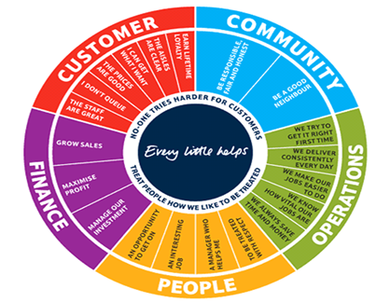 (Bernard Marr. 2020).
‘In the 1980s, Tesco main focus had been on revenue generation and the work culture in the company was dominated by fear. With a workforce of about 45,000, Tesco's average employee turnover was 75%. Leahy implemented a new strategy relating to Tesco's people as an integral part of the Tesco Steering Wheel, because he was convinced that Tesco employees were the key to success in organizational strategies and achievement of goals.’ (Icmrindia.org. 2020).
Employee Engagement
Engagement with employees needs dedication from managers and team leaders, without correctly engaging with individual throughout the workplace leaders and management will have a demotivated team. This will cause less productivity than if the employee is motivated to do their role correctly. Effective employee engagement will ensure job satisfaction for both employee and organisation, when an employee enjoys their job role the workforce runs itself therefore the employee will be fully committed to the company they work for. It is what orgaisations look for when employing their staff, theories such as Macleod and Clarke 2009 theory is an effective and successful model. This theory uses four key enablers, leadership, engaging with manages, employee voice and integrity. One of the key skills for this area of development is communication throughout the workforce.
(Archive.acas.org.uk. 2020). Acknowledges ‘Engaging managers who offer clarity, appreciation of employees’ effort and contribution, who treat their people as individuals and who ensure that work is organised efficiently and effectively so that employees feel they are valued, and equipped and supported to do their job.’
Employees at Tesco’s are to engage in their 360-degree feedback service. This gives mangers and leaders the knowledge of positive and negative responses on how the employees are engaging within their roles. Using this approach allows the company to gain knowledge of an employee’s strengths and weakness.
However, (Officevibe. 2017) states that this method of feedback is not always the best, some employees may use it to their advantage and slate an employee they may not get on with. It says that companies that use this method should be warier when doing so. It is said that 360-degree feedback can focus to much on individual’s weaknesses and not enough on their strengths.
Training
Within an organisation training is the essential part, it is what will help employees reach their full potential for the company. Training staff comes with positives and negatives, it will identify any gaps within the employee that the company can then look at the right training necessary for their role. Training individuals within a workplace can be less costly for the organisation rather than using outside resources which will lead to greater costs for the company. It will help motivate staff helping them to achieve the organistaions goals more effectively and bring out the confidence within themselves to sore through their tasks.
‘Training the employees is crucial for the organizations to ensure their smooth understanding of work, skill development, and preparedness to perform efficiently.’ (Explore Insiders - Empowering You With Creative Ideas. 2019).
‘Skilled workers are more productive. A trained workforce may attract more customers. Training and development can lead to lower staff turnover rates. This in turn leads to a more experienced and skilled workforce.’ (Business Case Studies. 2009).
When working for Tesco they employ people of all backgrounds and all employee will get the chance to learn and grow with the company. Within the company they are always evaluating the standards of their workforce, this allows managers to seek out skill gaps within their team and address them as appropriate. At Tesco they ask employees whether or not they feel like they lack skills in certain areas, and if they feel with training they will achieve better. (Hrelements.com. 2020).
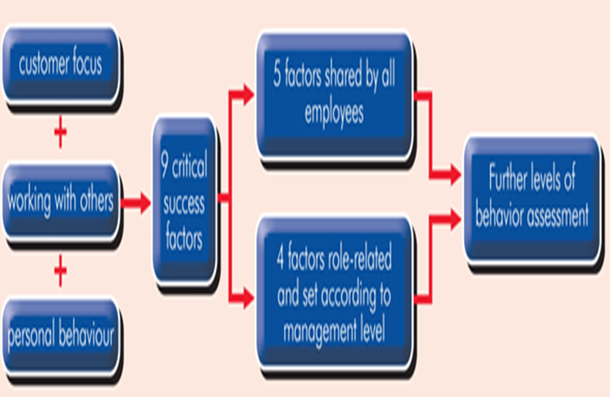 (Business Case Studies. 2019).
Says that ‘The Tesco Leadership Framework focuses on three key themes to guide appropriate behaviour in employees. These link to nine critical success factors, which break down further into various levels of assessment. This framework helps to identify those employees with the potential to be the 'best leaders of the future.’

BBC News. (2015). Reported that ‘Too many of those were allowed to go in too short a period of time and so there was a shortage of experience, the kind of experience you need to carefully navigate a business like Tesco through this very turbulent and difficult period of this long, long recession, with these changes in structure of retailing taking place.’

Individuals of receiving
Motivation
Motivation for individual’s means a sense of belonging within something that drives them to do better. Individuals need motivation for many things; e.g. work commitments, gym and other life commitments. There are many benefits of motivation for individuals within a workforce, it will enhance skills to better career choices helping the employee to achieve better for themselves.
Motivation is something everyone needs from time to time, it is what guides and maintains peoples focus day to day. Within orgainsations motivation is vital, it is what allows managers to meet company’s goals and help motivate a team they are overlooking. When employees are motivated through the workplace it will increase productivity and allow the company to soar to their goal. An old but very useful motivational theory still used in today’s industry is Maslow’s Hierarchy of needs. Maslow’s Hierarchy of needs demonstrates that within a workplace, employee will achieve goals set out in different levels of their employment.
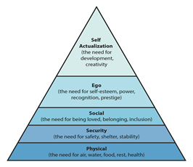 (Psychology Today. 2020).
‘Motivation refers to how driven and happy an employee is in their role. If an employee is motivated, they are more likely to do a good job and work hard. Motivation is very important for attracting employees, retaining employees and general levels of productivity in a business.’ (BBC Bitesize. 2020).
However not all motivational choices will work in the individual’s favour, if the employee becomes too focused on incentives, they will be receiving it can demotivate and change the individuals whole outlook within an organisation.
‘In other words, employees can fall into the trap of wanting to get that incentive rather than focusing on performing at a high level to please customers and clients...’ (Small Business - Chron.com. 2020).
Tesco say they are committed to training their staff for the better. With Tesco employing individuals of all cultures and backgrounds they say they are fully committed to make time to ensure opportunities for their employees. (Tescoplc.com. 2018).

Performance Management
The aim of performance management is to highlight and review individual’s performance in a workplace, theories such as Elton Mayo’s showed employees that they could get motivation and other incentives through their role. This theory suggests that if lighting and the environment they work in, employees would then work more productively and more effectively.
‘You can understand why the productivity of employees improved when the lighting was increased and decreased is apparent...’ (Management Study HQ. 2019).
‘A range of processes and techniques are placed within all Tesco stores and in the Tesco offices, which allow individual employees to know how well they are doing, and for managers to be able to monitor how well their subordinates are performing. Performance monitoring provides information, which is of value for identifying future training or promotion opportunities, and areas where insufficient skills or knowledge could be deemed a threat to an employee's efficiency.’ (Markedbyteachers.com. 2020).
At Tesco they say that ‘We know that looking after our colleagues in a culture of trust and respect is essential to the success of Tesco…’ So, whilst managing their teams Tesco say that they ‘treat people how they want to be treated,’ they work as one team always and support their staff within areas that need work. (Tesco PLC. 2020).
Employee Engagement
Employee engagement makes an individual feel a sense of belonging, interacting with employees is essential for any manager to lead and develop a team of workers. The individual needs to be consistence within their role and that will lead them to feel job satisfaction. It will give them great focus to do the task set out for them effectively, whilst having their concerns heard if needed. It builds employee relationships between managers and their team.
According to Gallup, ‘75% of workers do not quit their jobs, they quit their bosses. Communication is key to building positive manager-employee relationships. It builds trust, encourages transparency and cultivates an environment where employees are motivated and comfortable.’ (https://www.evolutionjobs.com. 2018).
Simon Sinek acknowledges that employers should focus more ‘on the why and not what or how’. In a YouTube video he says leaders should put their trust in their employees instead of telling them how to do things, let them do it their way. It will benefit the individual to learn their way. As a leader it is the manager’s job to give individuals the training to build their skills and confidence. The employees or individual will feel more of a sense of belonging and valued. (Captureyourflag. 2014).
At Tesco, they have got a system in which they communicate with their employees to benefit the individual. Calling it the listen and fix, Tesco uses this key tool as a listening exercise. Its key purpose is to ensure the company is a better place and engage with staff, to get a better understanding of what the individuals want out of the organisation. (Nelson, J. 2012).
Training
One of the most frequently used training methods used is on the job training, it offers individuals the time and abilities to train whilst shadowing another more senior member of staff. It can also be a key skill gap identifier for organisations, using this time to learn about the individuals targets and skills they already hold the company can draw up a training plan based on this.
(Arthur. L. 2018). Says that among many disadvantages, training individuals can be an expensive process for companies. Whether they decided to train internal or externally the process will be at a cost. Employer sometimes opted for internal training as this is the cheapest form, unlike external training employee will go about their job under supervision.
Tesco use a framework in which employees learn new skills in areas such as decision making and team working. Tesco has a flexible and structured approach to training and development, which adapts to individual’s needs. This allows individuals to potentially do a more senior role which will further theirs exciting skills and leadership capabilities. Using the training cycle method Tesco says that ‘Tesco arranges Training and development programs for the operative and mid-level employees at a regular interval…’ (Tesco, T. 2020).

Conclusion
To concluded this essay, the researcher believes that Tesco are committed to their employees and organisation. Using the four vehicles to support and encourage individuals benefitting both employees and their business. Using relevant theories when necessary to motivate and train staff if and when required.

References

Archive.acas.org.uk. (2020). [online] Available at: https://archive.acas.org.uk/media/4029/MacLeod-and-Clarkes-Concept-of-Employee-Engagement-An-Analysis-based-on-the-Workplace-Employment-Relations-Study/pdf/08140-MacLeod-Clarkes-Concept-of-Employee-Engagement.pdf [Accessed 22 Nov. 2020].

Arthur. L. (2018). What Are the Disadvantages in Training Employees?. [online] Available at: https://bizfluent.com/info-8026443-disadvantages-training-employees.html [Accessed 22 Nov. 2020].

BBC Bitesize. (2020). The benefits of a motivated workforce - Motivation - Eduqas - GCSE Business Revision - Eduqas - BBC Bitesize. [online] Available at: https://www.bbc.co.uk/bitesize/guides/zdn992p/revision/1#:~:text=Motivation%20refers%20to%20how%20driven,of%20productivity%20in%20a%20business. [Accessed 21 Nov. 2020].

BBC News. (2015). Tesco: Where it went wrong. [online] Available at: https://www.bbc.co.uk/news/business-30886632 [Accessed 22 Nov. 2020].

Bernard Marr. (2020). Tesco: Evolving The Strategic Performance Framework. [online] Available at: https://bernardmarr.com/default.asp?contentID=1054 [Accessed 20 Nov. 2020].

Business Case Studies. (2009). How training and development supports business growth - Business Case Studies. [online] Available at: https://businesscasestudies.co.uk/how-training-and-development-supports-business-growth-2/ [Accessed 26 Nov. 2020].

Business Case Studies. (2019). Motivational theory in practice at tesco - Business Case Studies. [online] Available at: https://businesscasestudies.co.uk/motivational-theory-in-practice-at-tesco/#:~:text=Tesco%20aims%20to%20motivate%20its,involving%20staff%20in%20decision%20making. [Accessed 19 Nov. 2020].
Captureyourflag. (2014). Simon Sinek on Managing by Turning Followers into Leaders [online video] Available at: https://www.youtube.com/watch?v=EcXe9iFsX70 [Accessed 26 Nov. 2020]
Explore Insiders - Empowering You With Creative Ideas. (2019). Top 10 Benefits of Training Employees for An Organization | EI. [online] Available at: https://www.exploreinsiders.com/benefits-of-training/ [Accessed 22 Nov. 2020].
https://www.evolutionjobs.com. (2018). Top 3 drivers of Employee Engagement. [online] Available at: https://www.evolutionjobs.com/au/blog/top-3-drivers-of-employee-engagement-123635/ [Accessed 26 Nov. 2020].
Hrelements.com. (2020). [online] Available at: http://www.hrelements.com/wp-content/uploads/2015/09/722-tesco-how-training-and-development-supports-business-growth.pdf [Accessed 22 Nov. 2020].

Icmrindia.org. (2020). Tesco's 'Steering Wheel' Strategy|Business Strategy|Case Study|Case Studies. [online] Available at: https://www.icmrindia.org/casestudies/catalogue/Business%20Strategy/Business%20Strategy%20Tesco's%20'Steering%20Wheel'%20Strategy.htm [Accessed 21 Nov. 2020].

Management Study HQ. (2019). Elton Mayo And His Key Theories. [online] Available at: https://www.managementstudyhq.com/elton-mayo-theories.html [Accessed 24 Nov. 2020].

Markedbyteachers.com. (2020). Performance management - Tesco's needs to mange the performance of its employees effectively if it is to remain as the UK's leading retailer and maintain a competitive edge. - GCSE Business Studies - Marked by Teachers.com. [online] Available at: http://www.markedbyteachers.com/gcse/business-studies/performance-management-tesco-s-needs-to-mange-the-performance-of-its-employees-effectively-if-it-is-to-remain-as-the-uk-s-leading-retailer-and-maintain-a-competitive-edge.html [Accessed 24 Nov. 2020].
Nelson, J. (2012). Employee engagement at Tesco: optimising two-way communication - Personnel Today. [online] Personnel Today. Available at: https://www.personneltoday.com/hr/employee-engagement-at-tesco-optimising-two-way-communication/ [Accessed 26 Nov. 2020].
Officevibe. (2017). The Pros And Cons Of 360 Degree Feedback. [online] Available at: https://officevibe.com/blog/what-the-heck-360-degree-feedback [Accessed 22 Nov. 2020].
Peacock, L. (2008). Tesco failing to motivate its young workers - Personnel Today. [online] Personnel Today. Available at: https://www.personneltoday.com/hr/tesco-failing-to-motivate-its-young-workers/ [Accessed 22 Nov. 2020].

Perkbox. (2020). Why employee motivation is important & how to improve it. [online] Available at: https://www.perkbox.com/uk/platform/insights/why-employee-motivation-is-important-and-how-to-improve-measure-and-maintain-it [Accessed 19 Nov. 2020].

Psychology Today. (2020). Our Hierarchy of Needs. [online] Available at: https://www.psychologytoday.com/gb/blog/hide-and-seek/201205/our-hierarchy-needs [Accessed 21 Nov. 2020].

Small Business - Chron.com. (2020). Positive & Negative Effects of Employee Motivation. [online] Available at: https://smallbusiness.chron.com/positive-negative-effects-employee-motivation-14535.html [Accessed 24 Nov. 2020].

Tesco-careers.com. (2020). Benefits | Tesco Careers. [online] Available at: https://www.tesco-careers.com/explore-our-world/benefits/ [Accessed 20 Nov. 2020].

Tescoplc.com. (2018). [online] Available at: https://www.tescoplc.com/media/476557/tesco_2018_strategic_report.pdf [Accessed 24 Nov. 2020].

Tescoplc.com. (2020). [online] Available at: https://www.tescoplc.com/media/475752/cr_report_2012.pdf [Accessed 20 Nov. 2020].

Tesco PLC. (2020). Core Purpose and Values. [online] Available at: https://www.tescoplc.com/about/how-we-do-business/core-purpose-and-values/ [Accessed 24 Nov. 2020].

Tesco, T. (2020). Training and Development Process of Tesco - CIRCLE OF BUSINESS. [online] CIRCLE OF BUSINESS. Available at: https://circlebizz.com/hrm/training-and-development-process-of-tesco/ [Accessed 27 Nov. 2020].

Valamis. (2020). Performance Management Process and it's Steps [2020]. [online] Available at: https://www.valamis.com/hub/performance-management-process [Accessed 21 Nov. 2020].

