DATA HANDLING and BUSINESS INTELIGENCE
Module code: LCBB5000
Module leader: Zahra Mohammadnazari


Student name: Eleonora Dimitrova Terzieva
Student number: 2017029

Contents
Introduction 3
Excel data 4
Mean value 4
Median value 7
Mode 10
Standard deviation 13
Variables and their variance 16
Variables and their standard deviation 22
Interpreting the outcomes 28
Pivot table 28
SPSS analysis 32
Advantages and disadvantages of SPSS, excel and Tableau 33
SPSS 33
Excel 33
Tableau 34
Data mining cycle 34
References 35

Introduction
In this assignment we will be part of a research centre studying the effects of coffee in humans and their performance as students. We will be using Excel and SPSS software to showcase our data and help us analyse it to come to conclusions. According to Guerrero et al. (2019) Excel is ‘a tool that virtually all students and professionals have access to’, this why it is such a useful software to analyse data and share it as everyone is proficient in it.
After analysing the dataset, we are going to talk about various different values and insights we will find, including the mean median and mode of different academic scores, the standard deviation for the writing score and the possible reasons behind it, etc.
We will also compare variables and talk about the largest variance one and interpret our previous outcomes to give insight into the effects of coffee.
The data will also be showcased via graphs and presented via Excel for an easier visualization to the reader, Coll et al. (1994) says that ‘there is a demonstrated need for efficient tables and graphs that display useful information’ which is why we are going to showcase it this way.
After using Excel, we will also use SPSS to further find out the correlation between writing score and reading score, showing my working with full screenshots. Then we will produce a scatterplot of both variables to better visualize the information.
Lastly, the assignment will have a second section to discuss the different pros and cons of data analysis software such as Tableau, Excel and SPSS, helping showcase the different strengths and areas of use of each software.
We will also delve into the data mining cycle to explain its meaning in depth and the importance it has for businesses and data analysis. In short, the data mining cycle is also known as the knowledge discovery in databases process, and it is a process that has many stages which lead to the transformation of raw pure data into a valuable conclusion or information.

Excel data
The mean, median, mode, standard deviation and variance are all tools and values we can use to analyse our data. According to Cao (2021) when considering mean median and mode we have to be careful as they are very similar values but ‘the three kinds of data are not only different in definition, but also different in application’.
Mean value
The mean value which can also be called the average, is a value used to measure the central tendency of a set of numbers divided by how many values there is. By doing this it provides a single value that can represent and summarize all the set of numbers.
To calculate the mean value for the reading score first we have to select a cell where to calculate our mean,
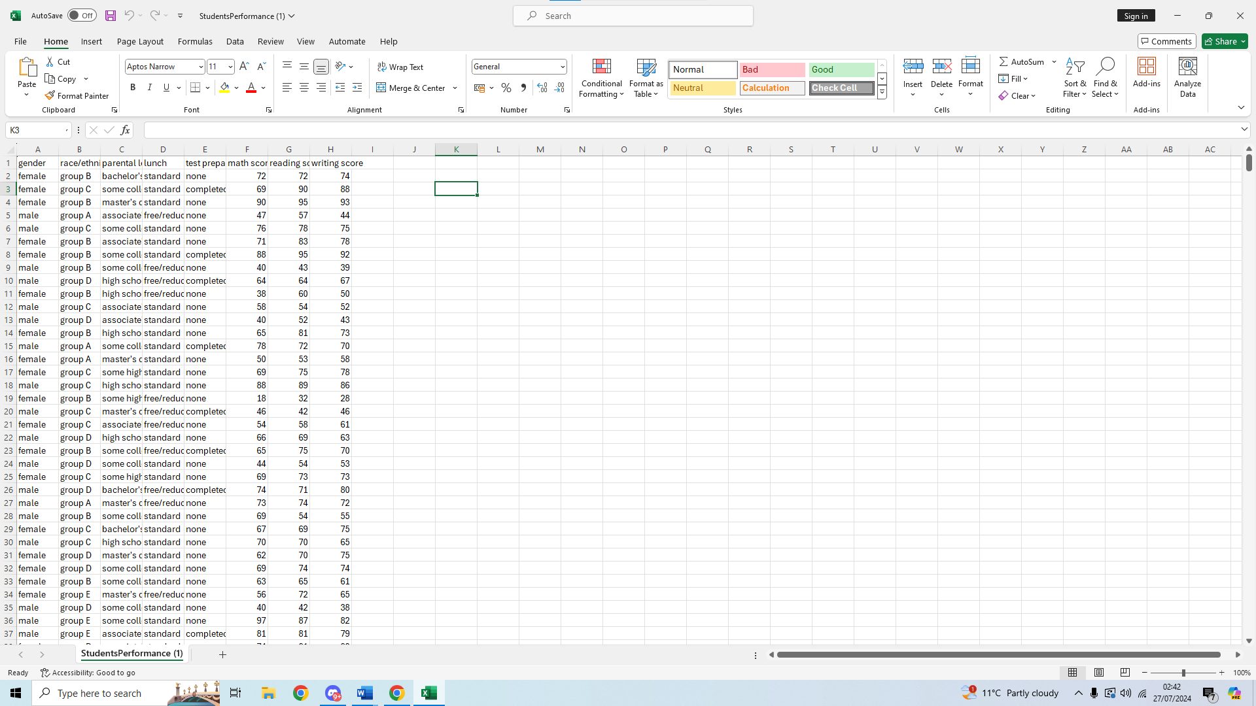
After we select our cell, we find the function bar on the top and type = to start our calculation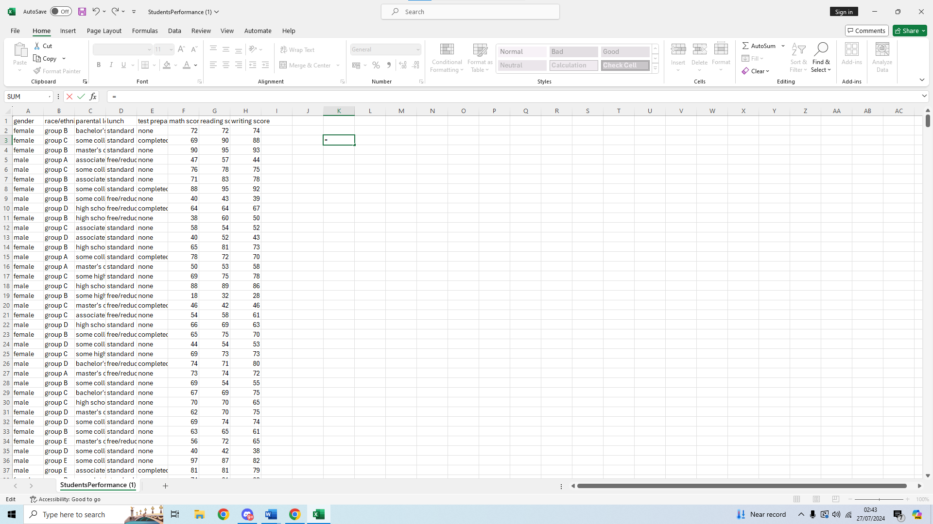
We then type AVERAGE and select our range of values starting by the first one, G2 and type : after so we can select a range, our formula will now look like =AVERAGE(G2:
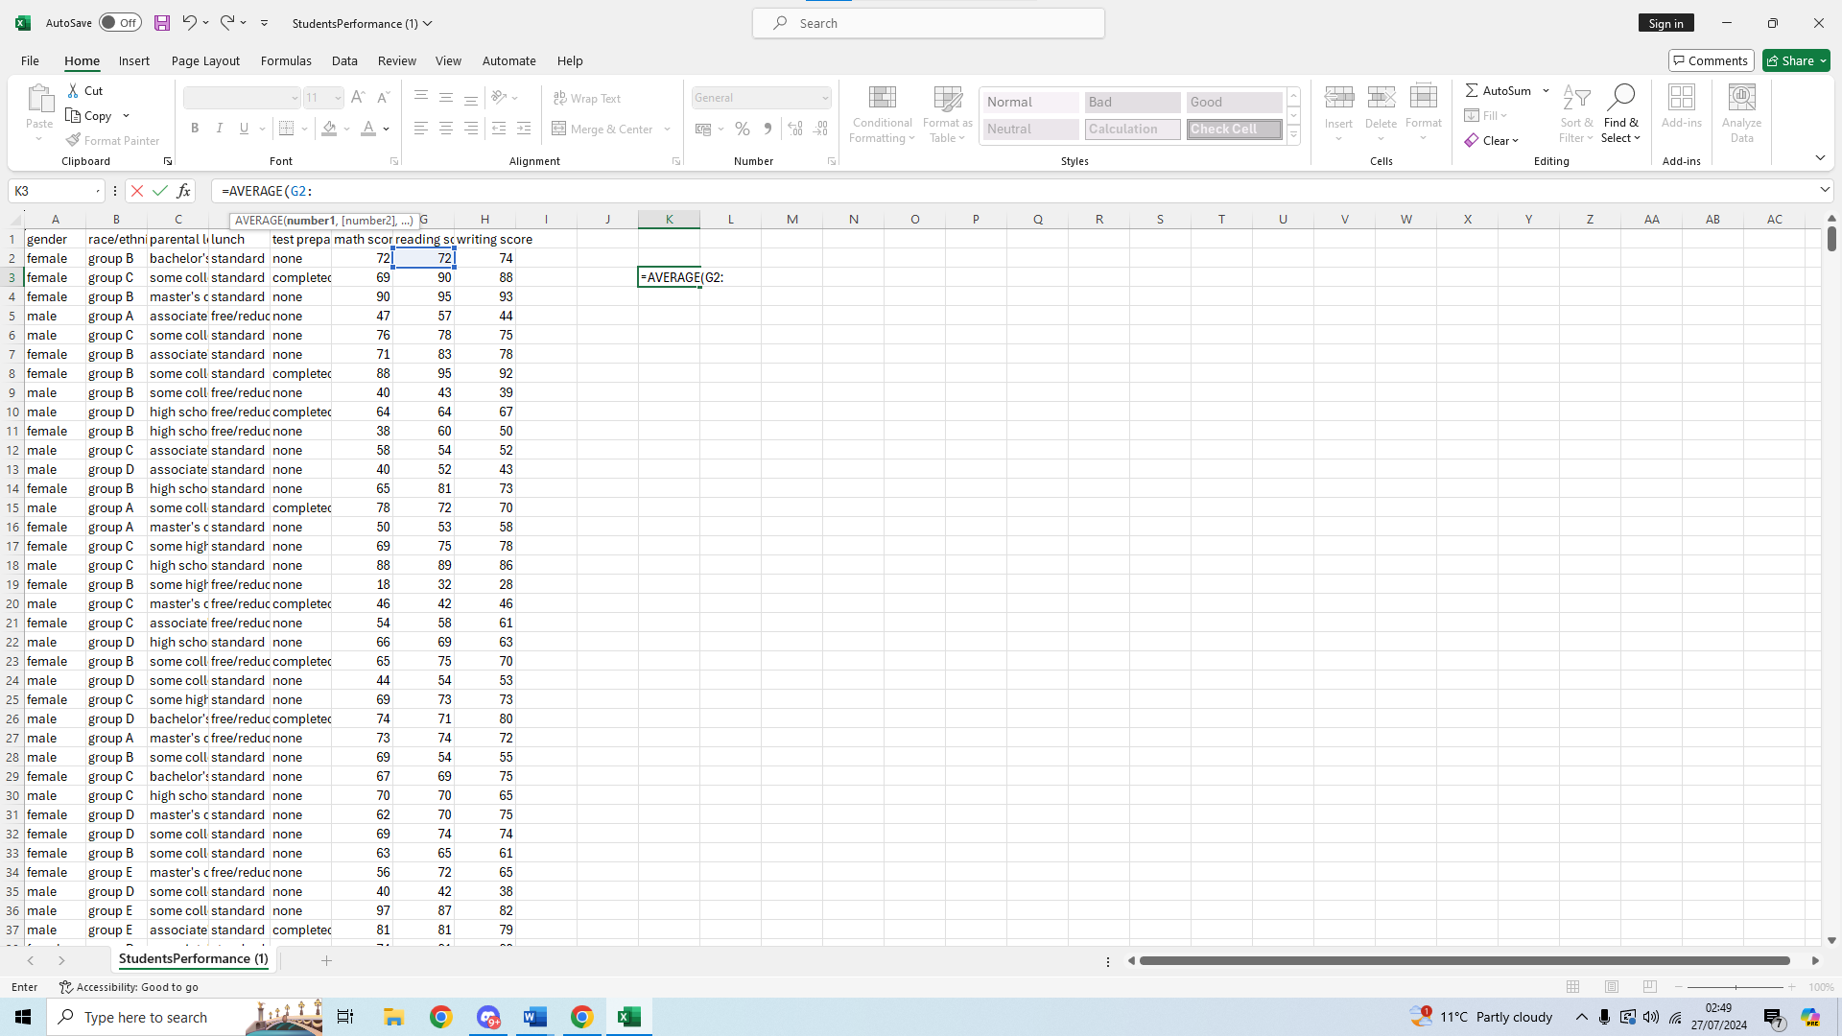
We then select our second value so that all values in between will be used to calculate the mean, we scroll all the way down and select G1001
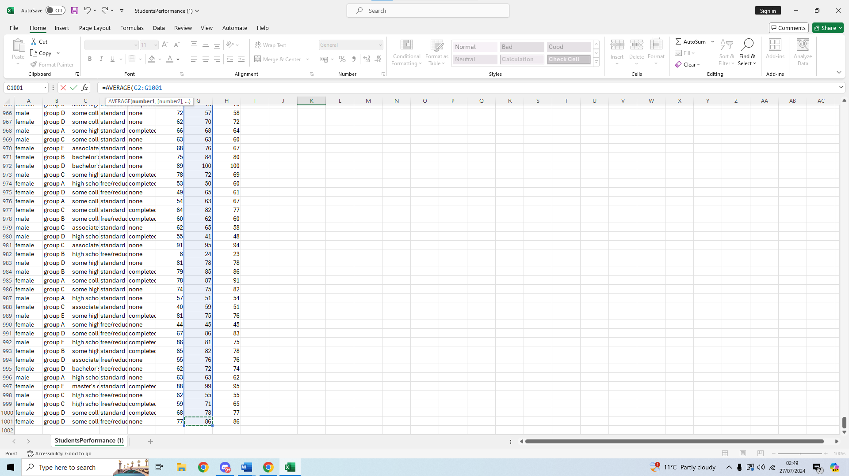
We then close the brackets and press enter to get our mean value of this range of values
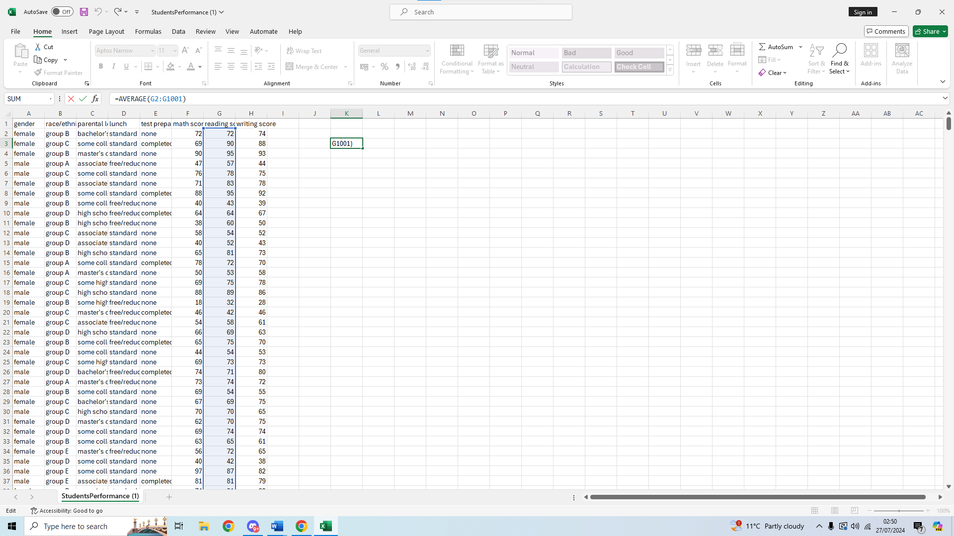
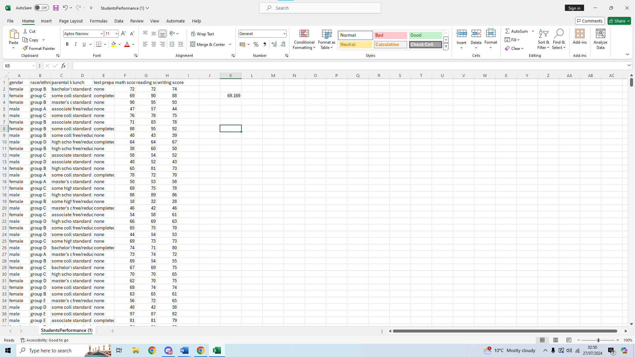
In this data set we can see the mean value is 69.169 for the reading score, giving us a base of comparison.

Median value
The median value is another measurement which can represent the exact middle value in a dataset when we arrange all the values of the data set from lowest to highest or highest to lowest. It can happen that the median falls in between two values as the data set might have an even number of values, in which case the median will be calculated as the average of the two middle numbers. This allows us to split the dataset in half for analysis purposes.
To calculate the median value for reading score we first have to select a cell where to calculate our value.
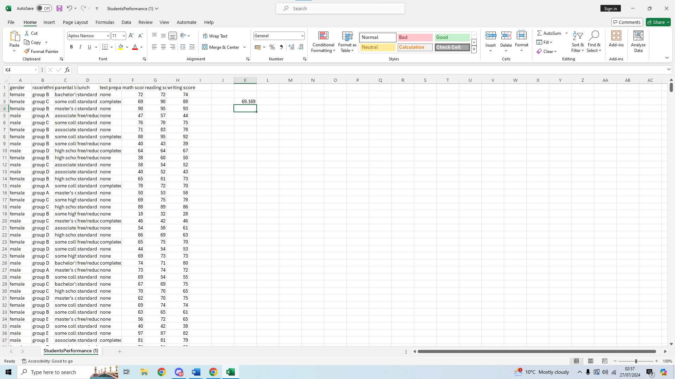
We then start typing up our formula in the function bar above, =MEDIAN(
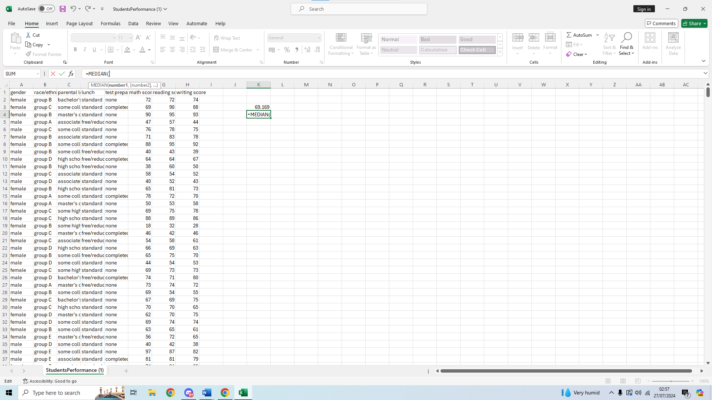
Then we select our first value, G2, now our formula looks like =MEDIAN(G2:
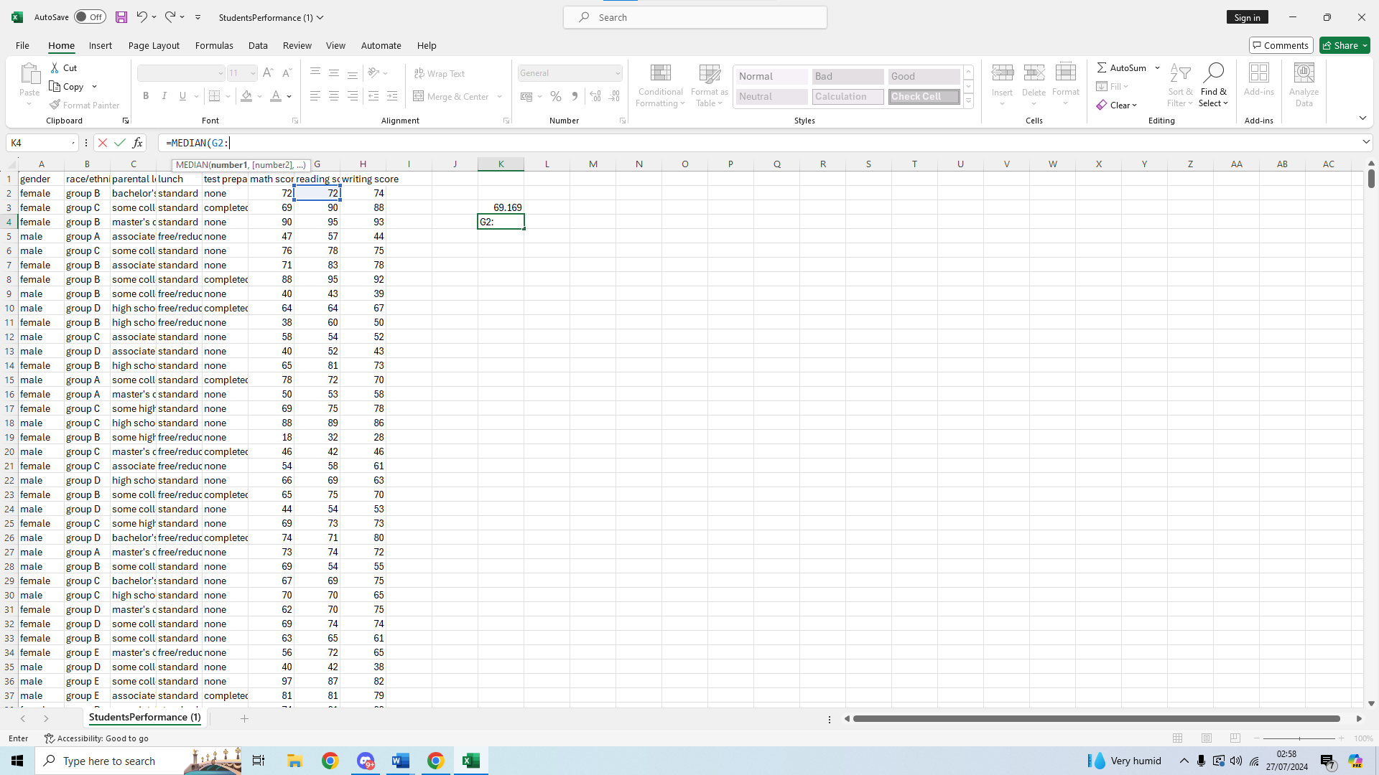
We then select our second value at the end of the reading score list, G1001
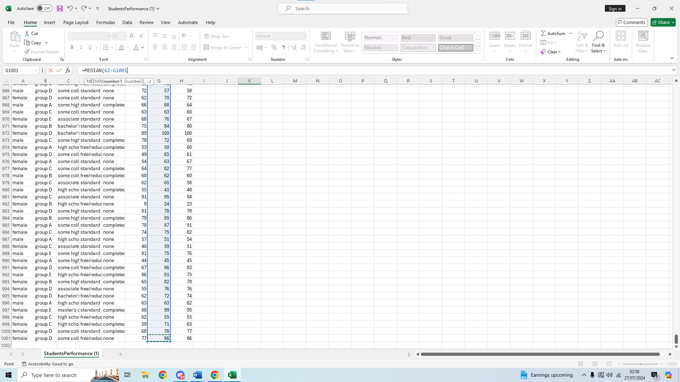
We close the brackets on our formula and press enter to get a result
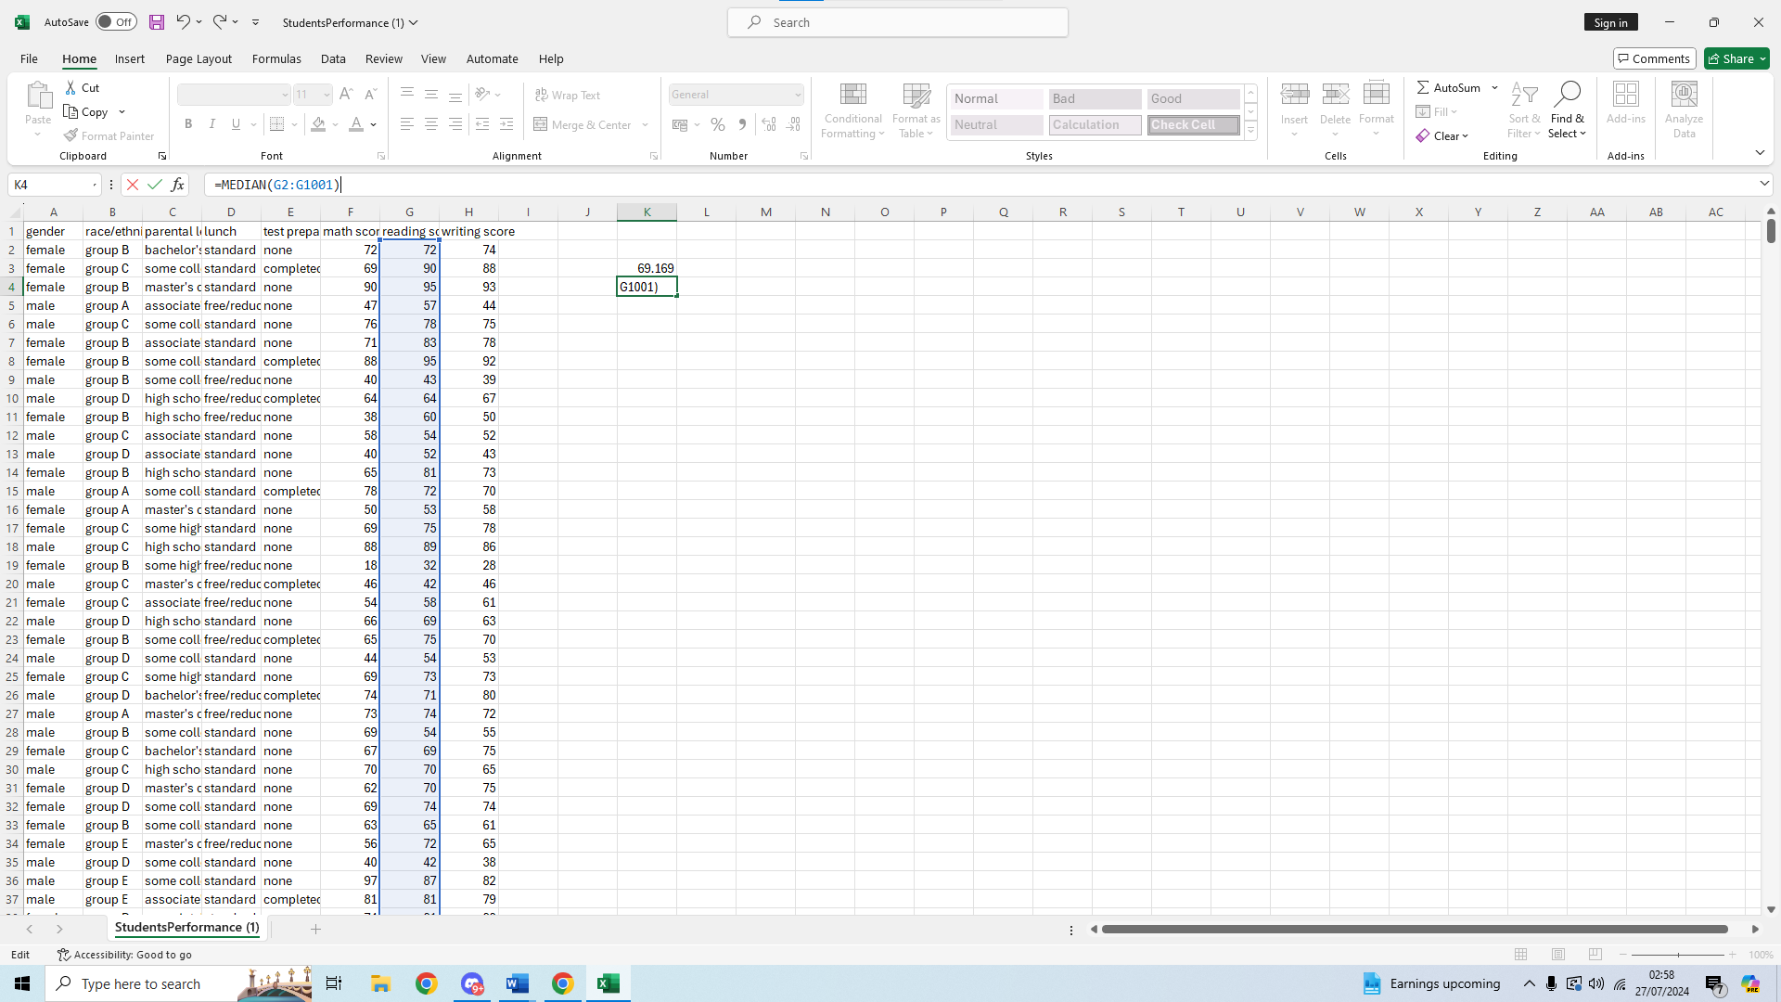
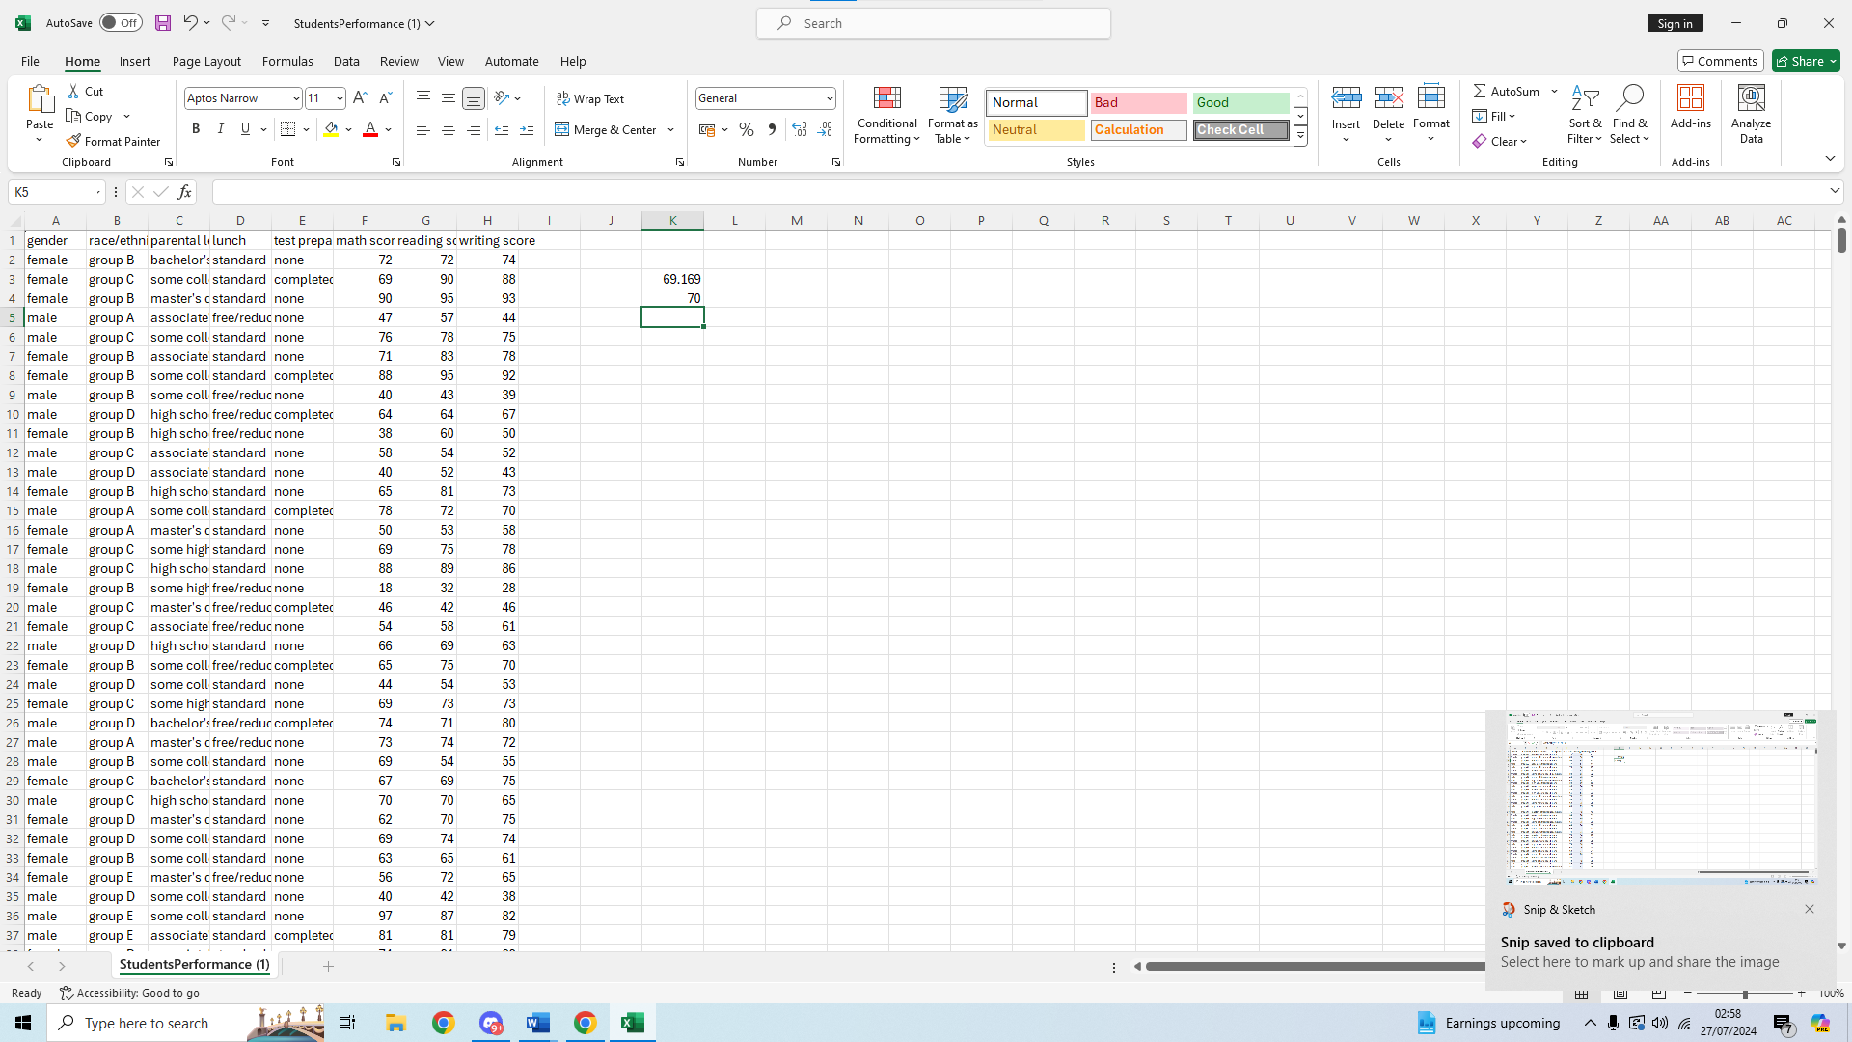
We can see the median score is 70, slightly above the mean score of 69.169

Mode
The mode is the last of the three values discussed and it represents the value or number that is most commonly appearing in a dataset. Some datasets might have more than one mode value, which will be called a unimodal data set, and some may have more than one, which are called bimodal or multimodal. It is also possible that there is no mode in a dataset if there is no repeating values.
To calculate the mode of the reading score we will again choose a blank cell where to calculate our value.
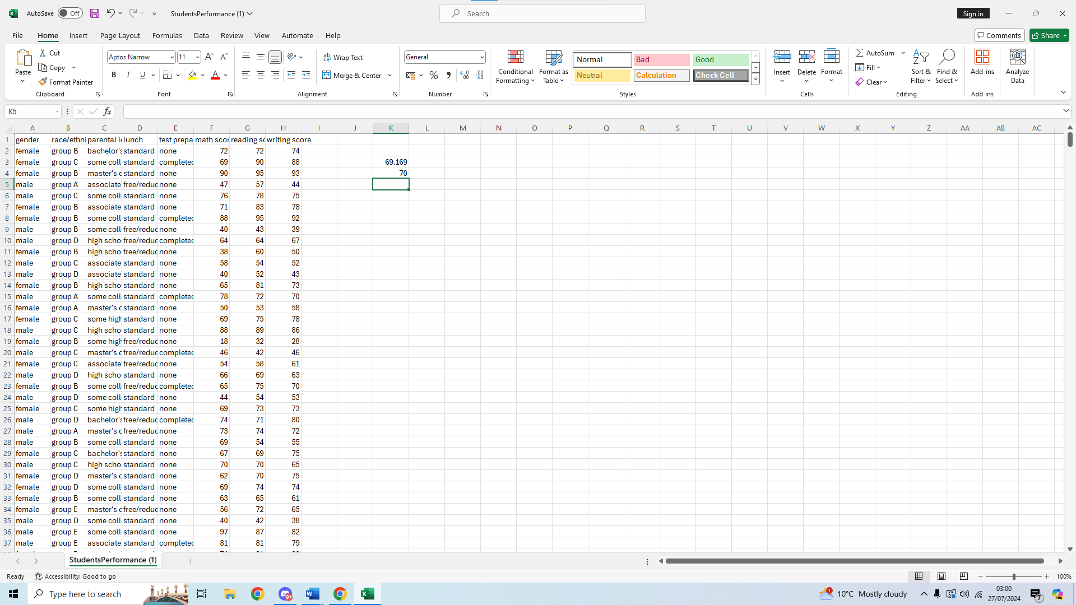We then start typing our formula on the function bar above, =MODE(
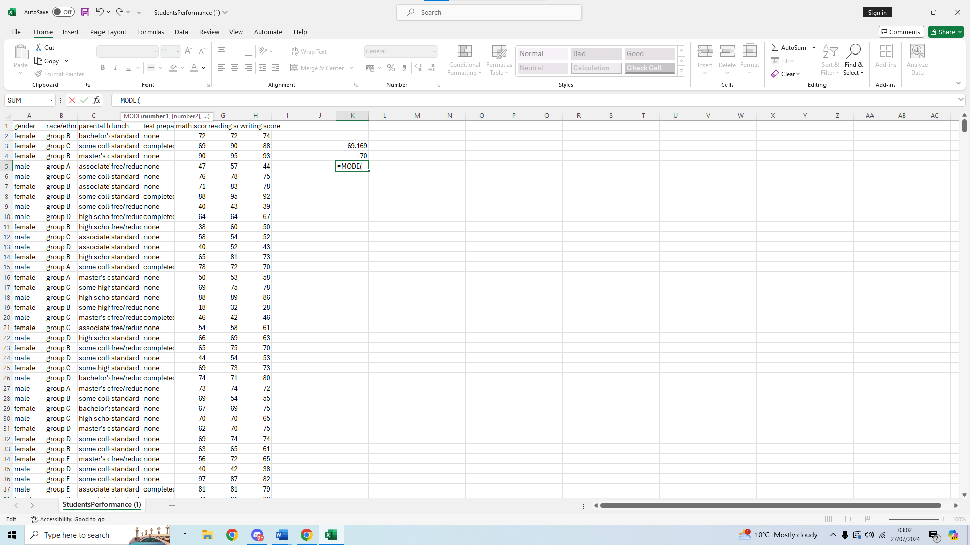We select our first value for this calculation, once again it will be G2 and we add : after to make it a range selection
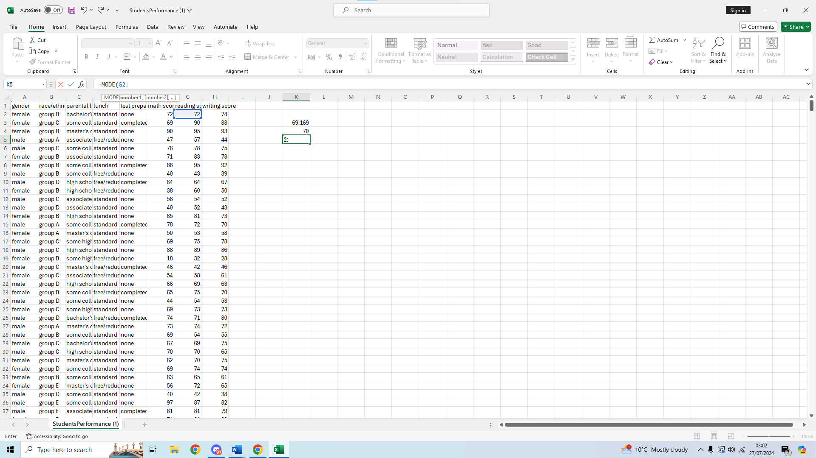
We scroll down to select the end of the range, which will be G1001
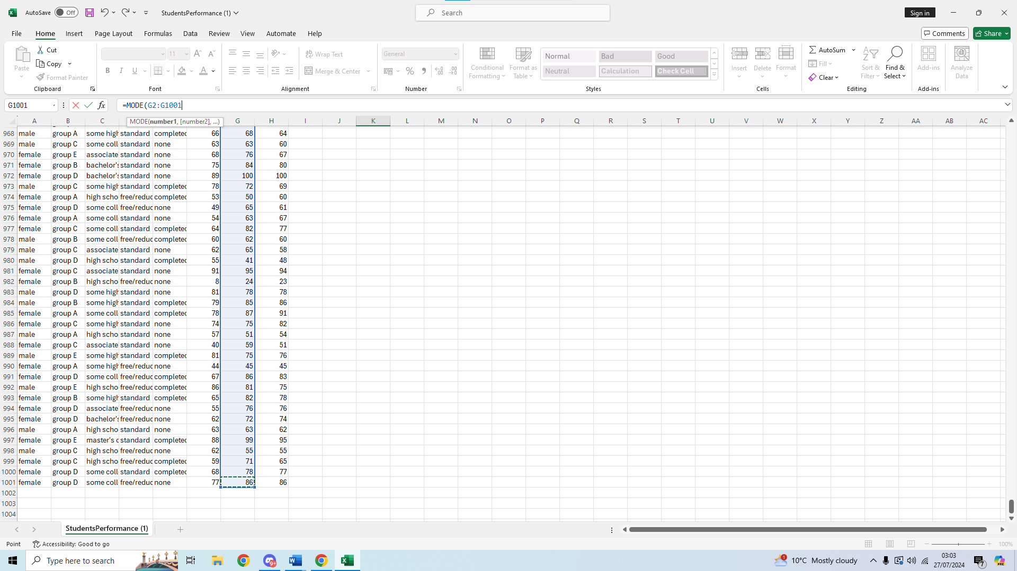
We then close the brackets and press enter to get our result of the mode for reading score
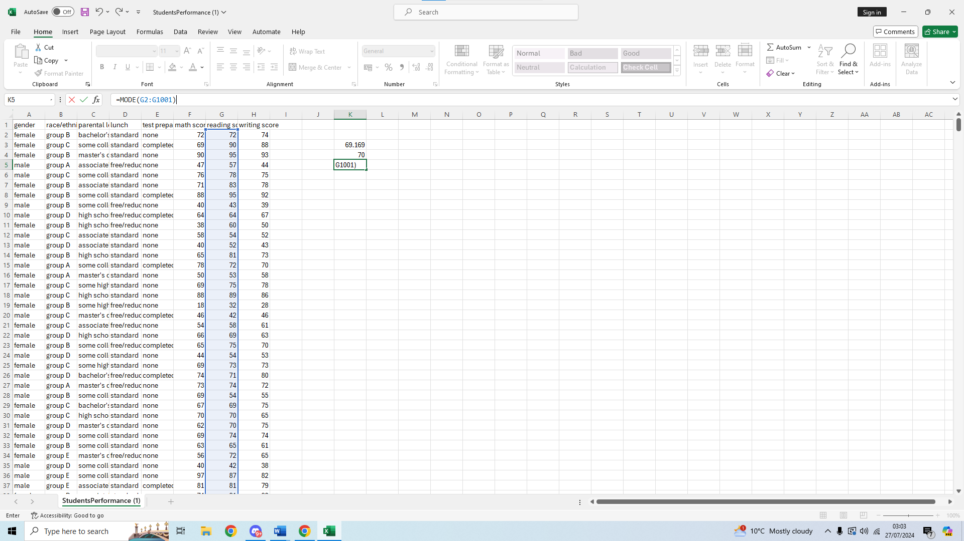
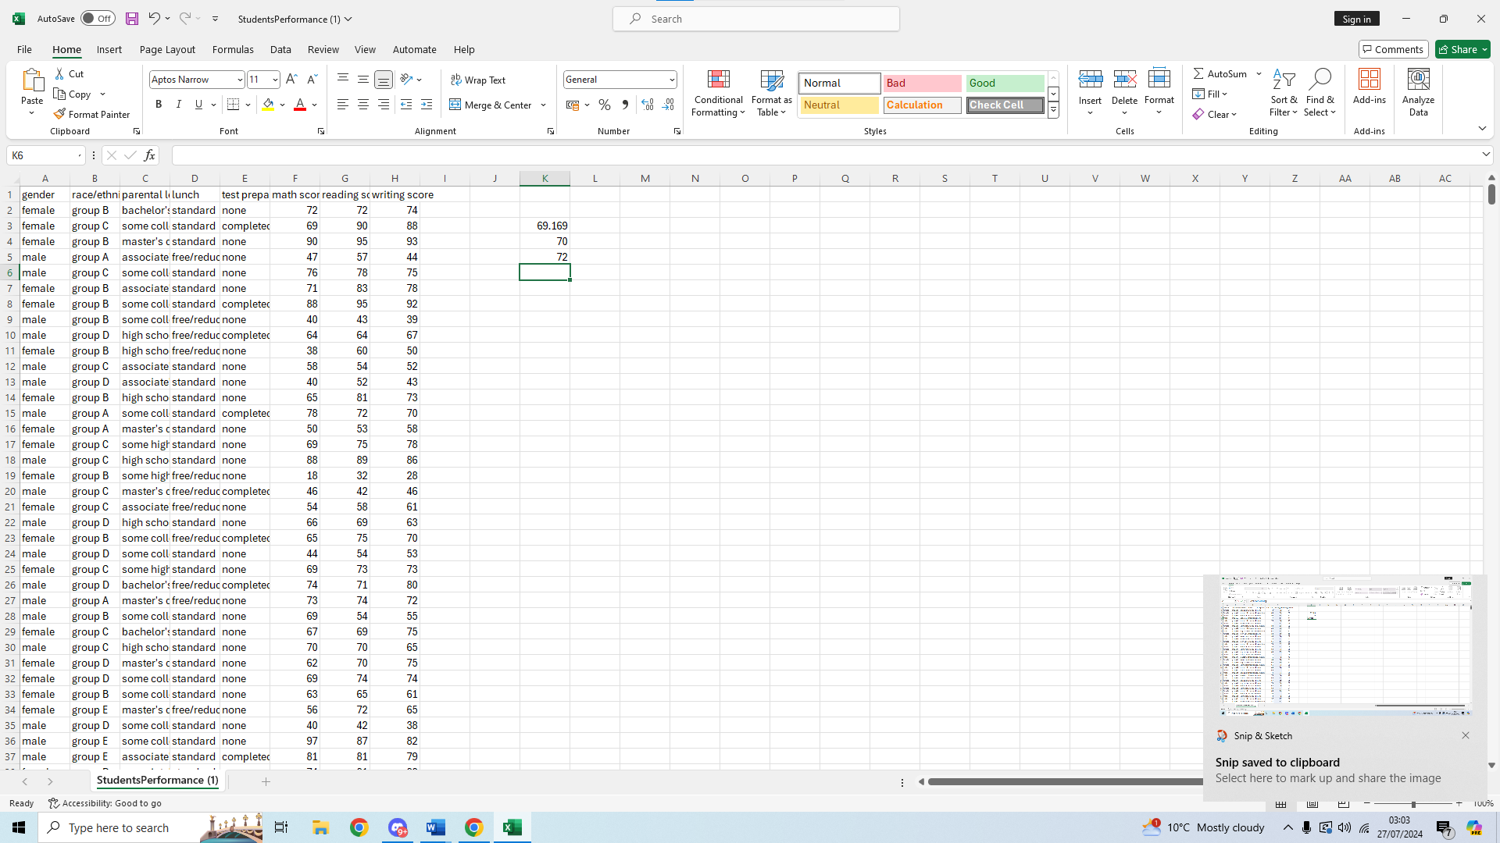
We can then see the mode for the reading score is 72, so the most common score is a bit higher than the average score and median score.

Standard deviation
Standard deviation is a value used to measure how far apart numbers are in a set of data, it is used to measure the dispersion and shows how much individual data points are away from the mean of the data. To calculate the standard deviation for the writing score we are first going to select an empty cell to put our values.
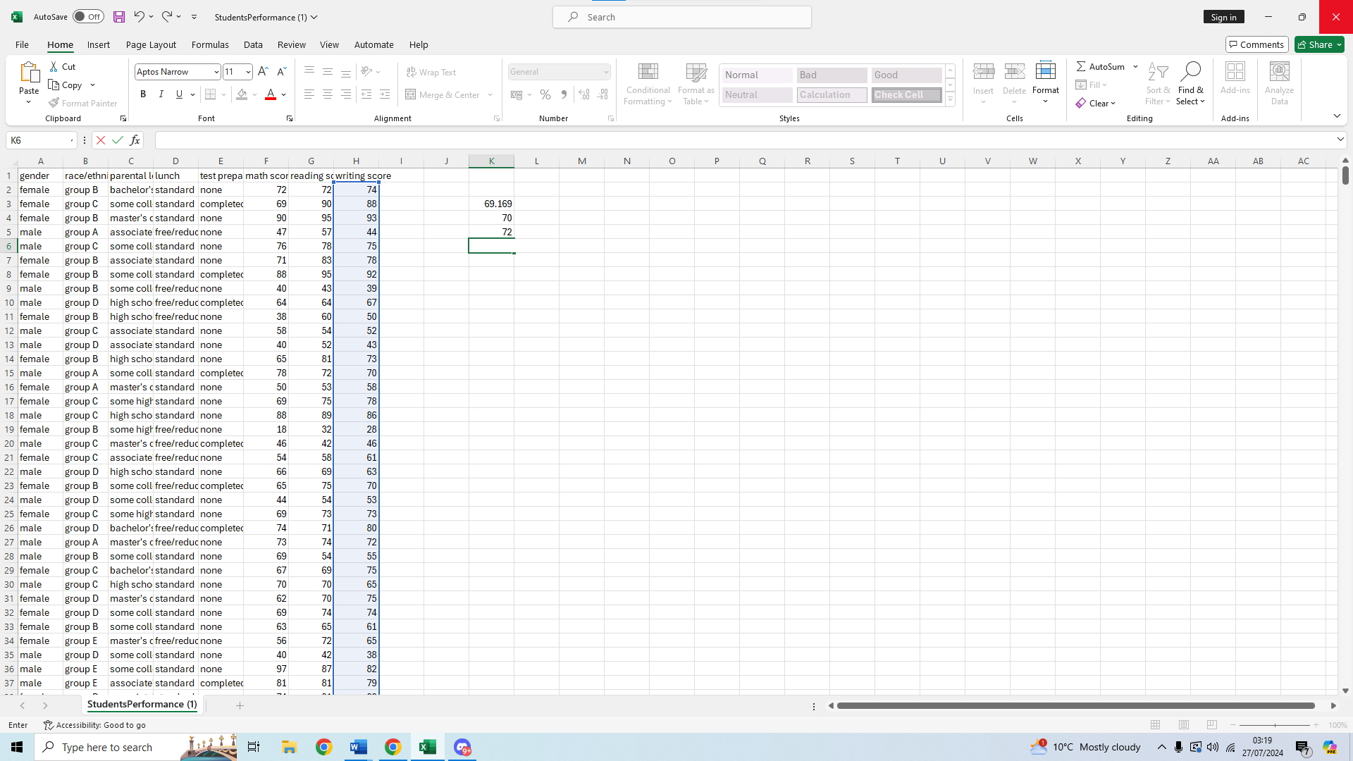We are then going to put our formula, =STDEV.P , there is also the formula =STDEV.S, these two are similar but different in the sense of the first formula calculates the standard deviation using all the data of the population, whereas the second uses a sample, only a part of the population data is used for the calculation. We will use the first formula to get a more accurate reading and put a bracket to start our range selection.
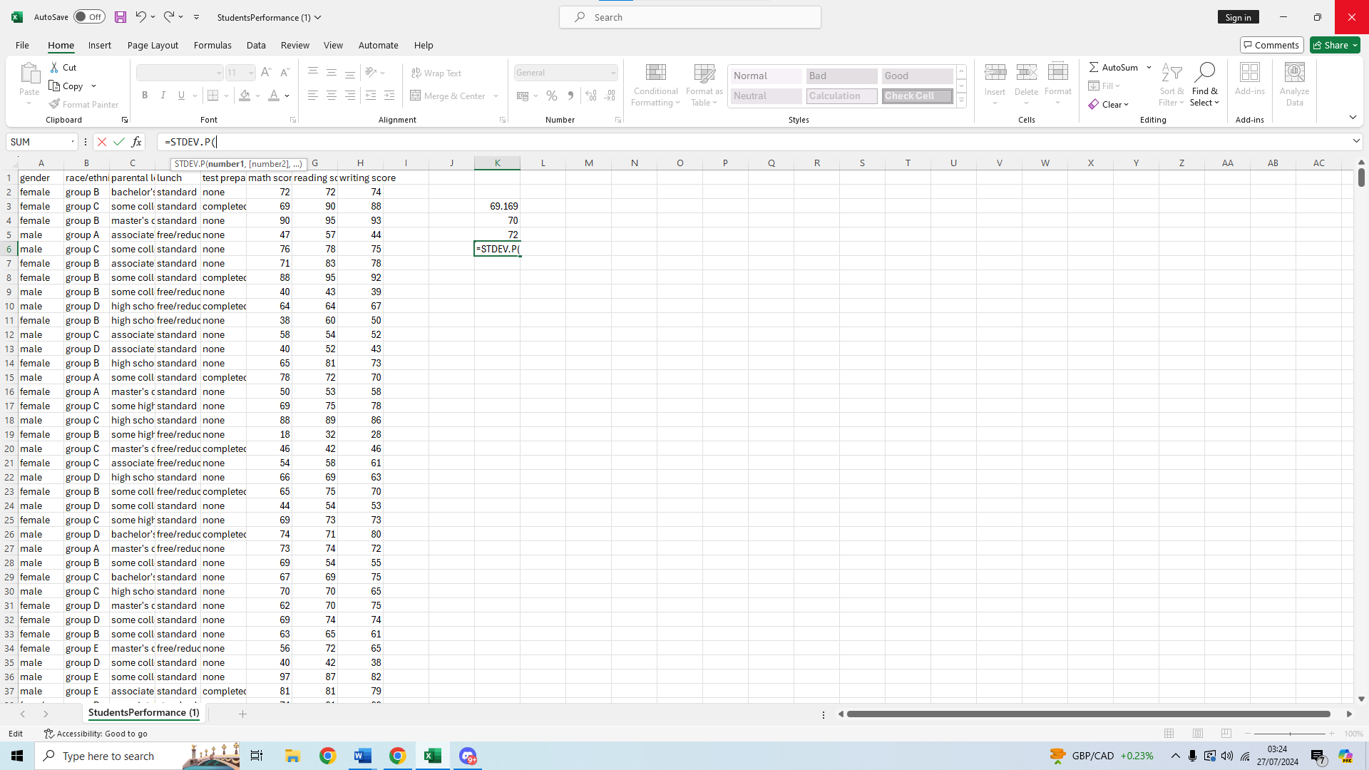
We will start selecting the first value of our range for writing score
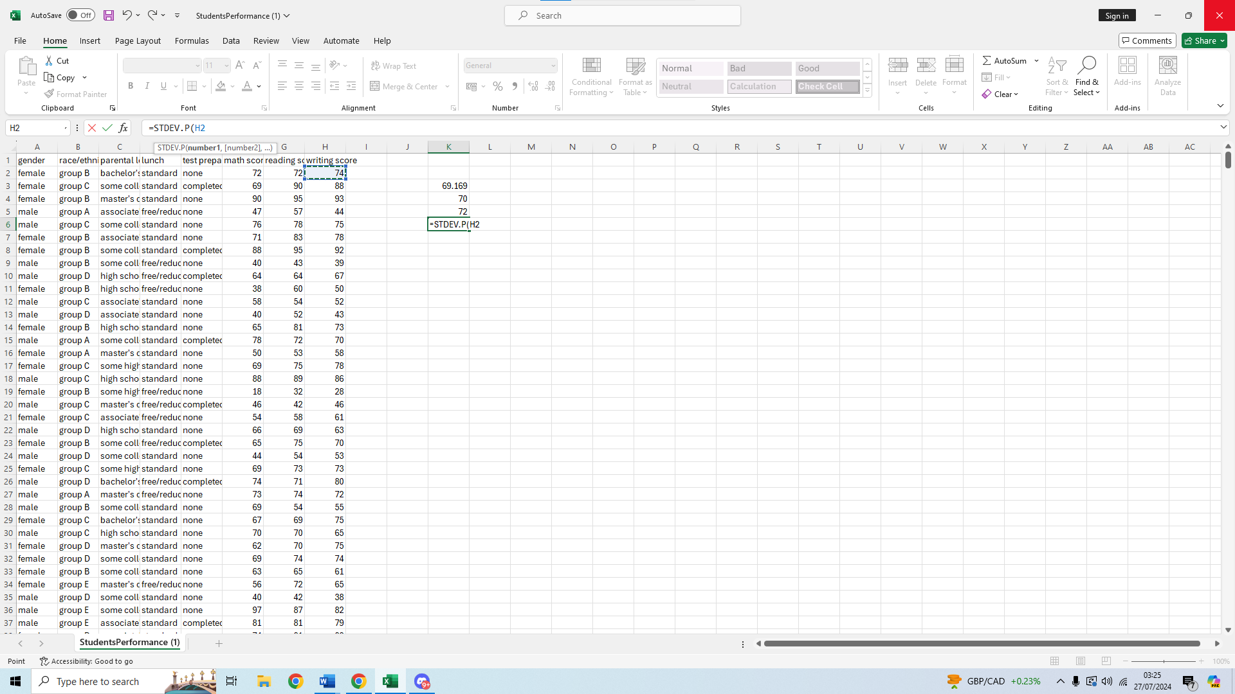
We will then put a : after and select our second value of the range, H1001 and close the formula with a bracket
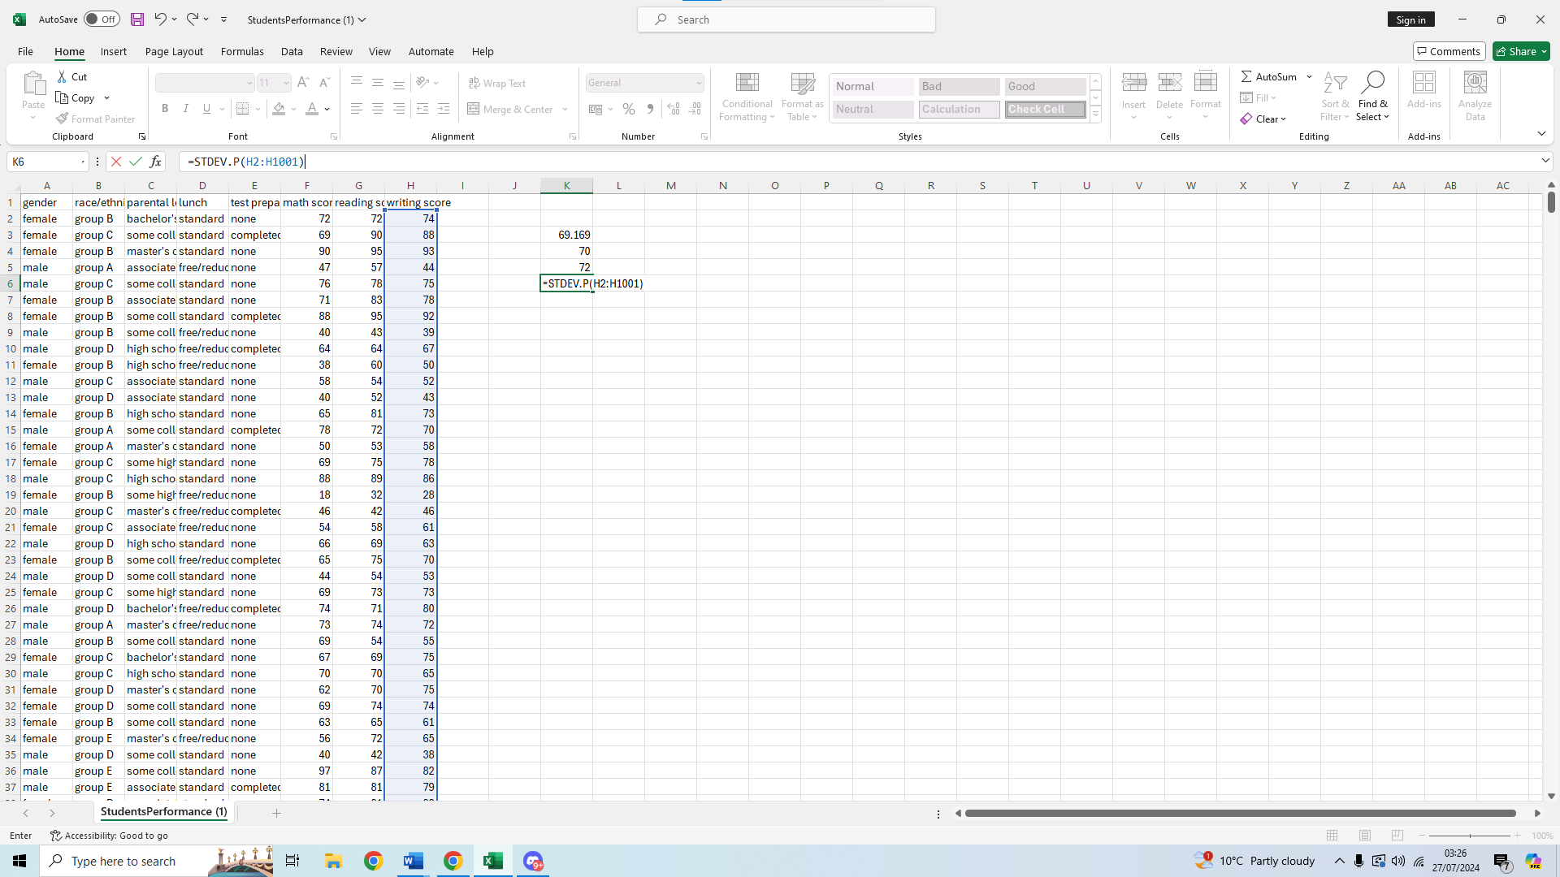
We then press enter to get our value
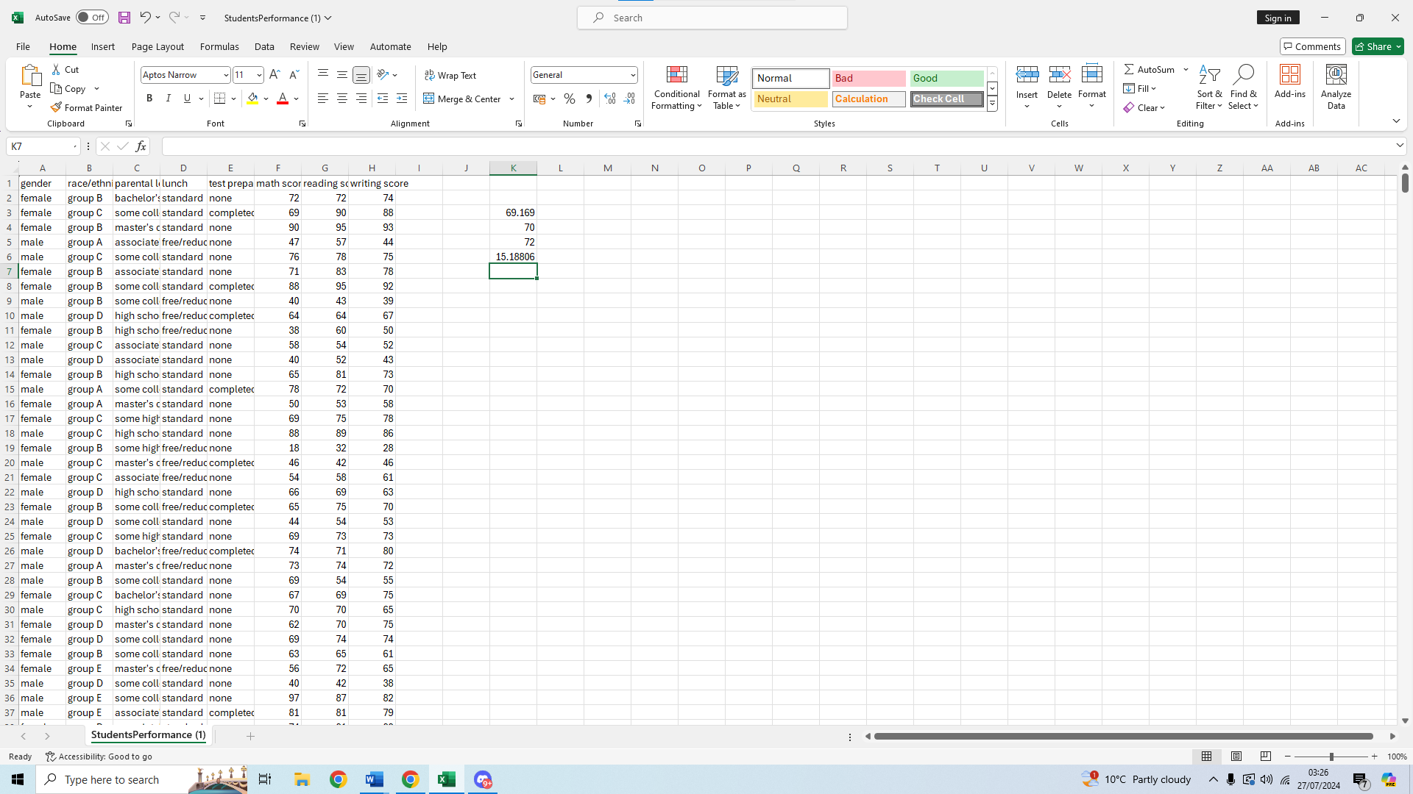We can now see the standard deviation for the writing score is 15.18806

Variables and their variance
We will now look into the variables and the variance of each one of them, to find the variable with the largest variance.
Variance is a way to quantify how much numbers of a data set are spread away from the mean; it is similar to standard deviation but standar deviation is the squared root of variance.
To calculate the variance of our variables let’s start with math score variance.
First we select an empty cell where our values will be put
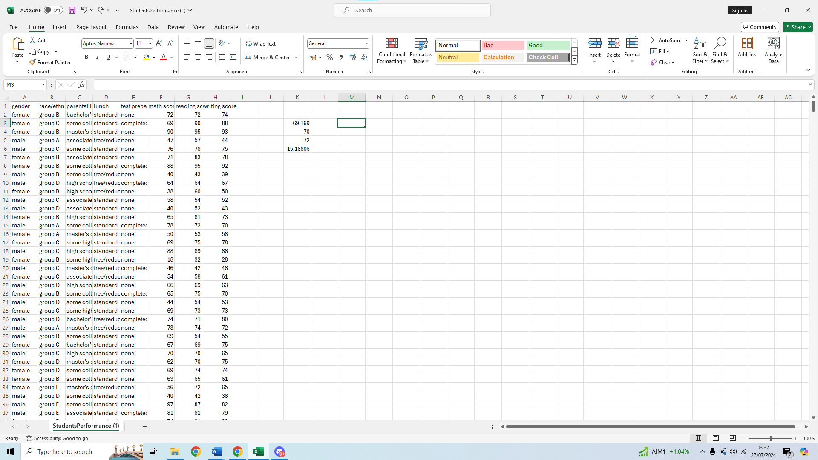

Then we type the formula on the function bar, =VAR.P which will calculate the variance of our whole data for this variable.
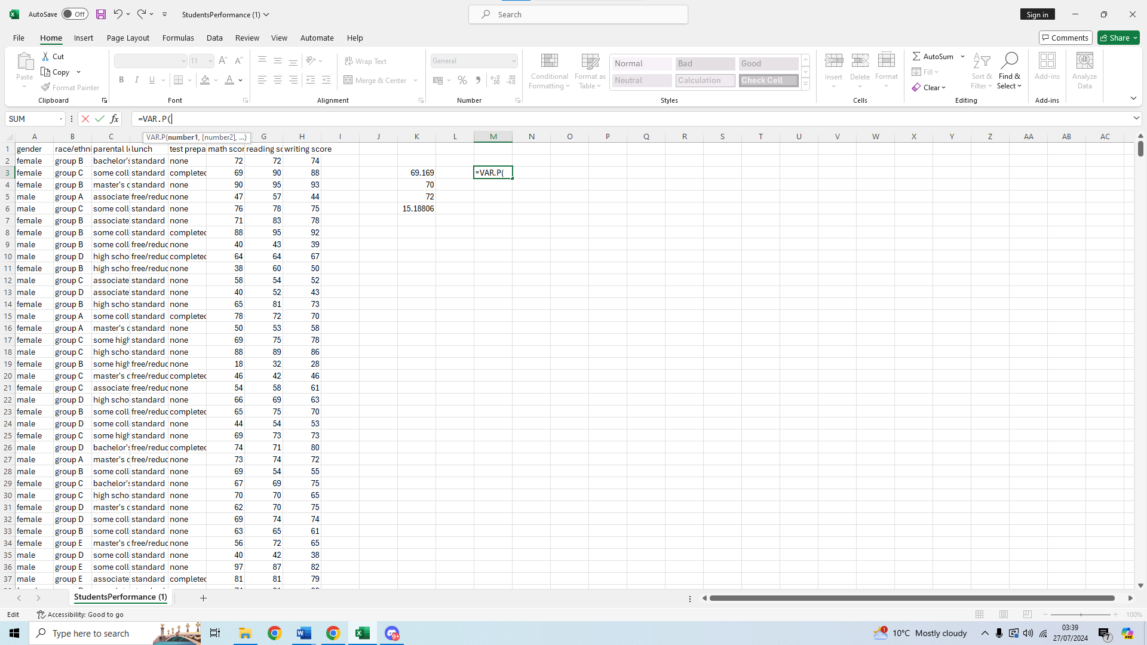
We then select our range of values, starting at F2: 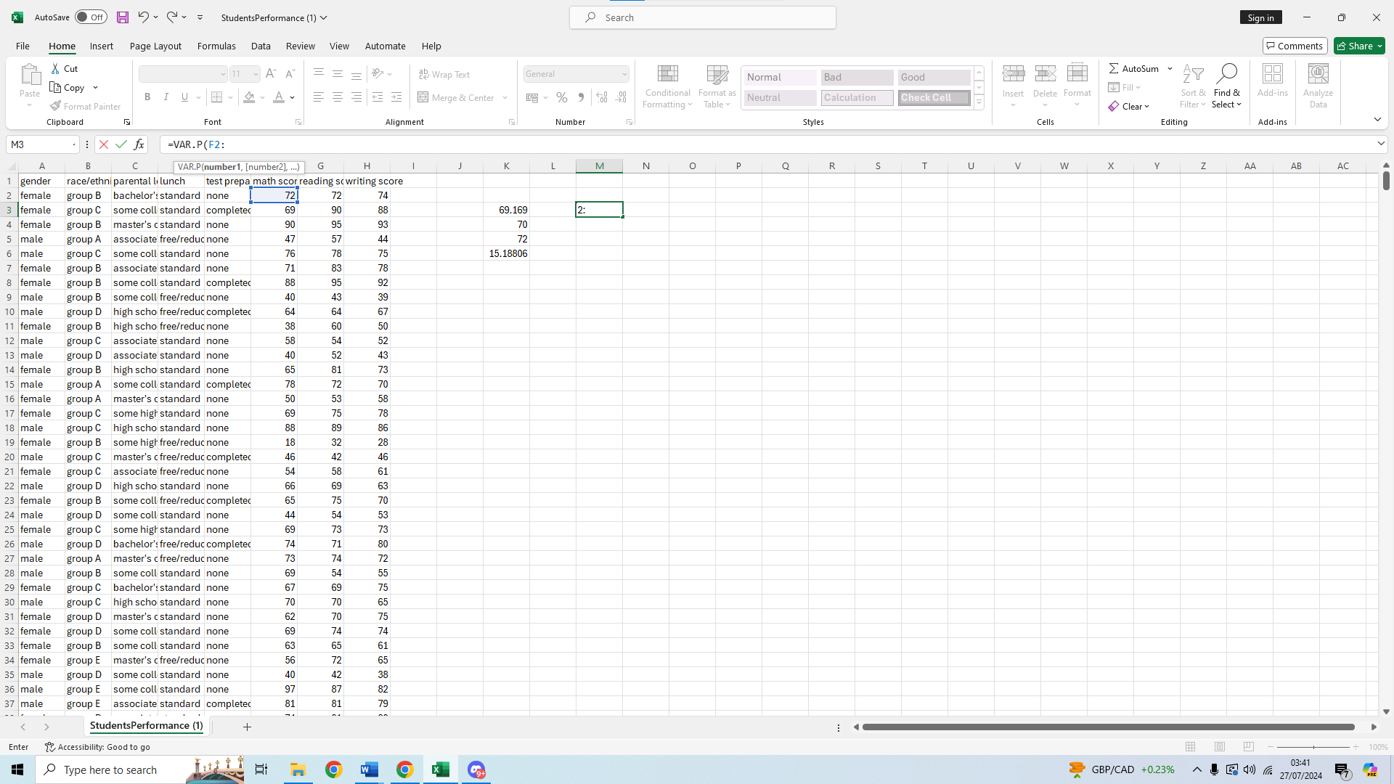
We then scroll down and select the last value of the range, F1001
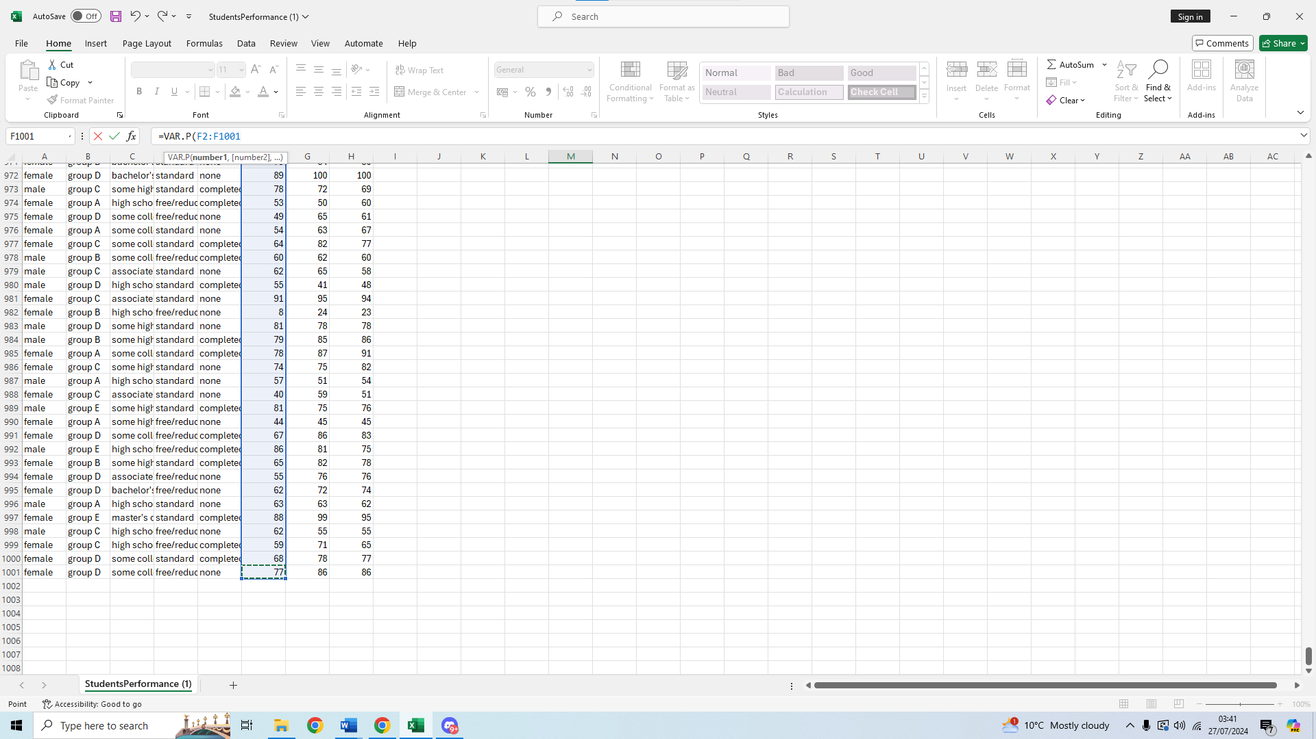We then press Enter to get our result
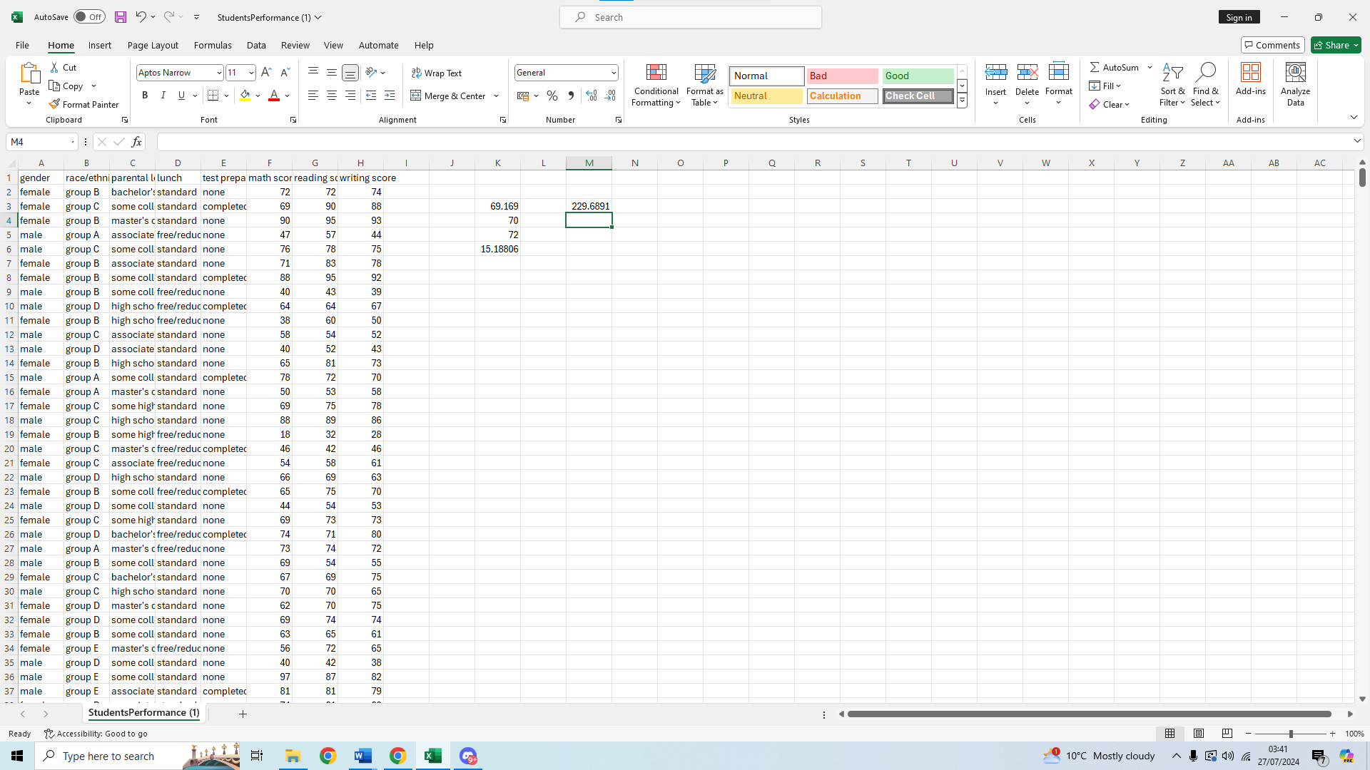We can see the variance for maths score is 229.6891
Now to calculate the variance of reading score we use the same formula =VAR.P(
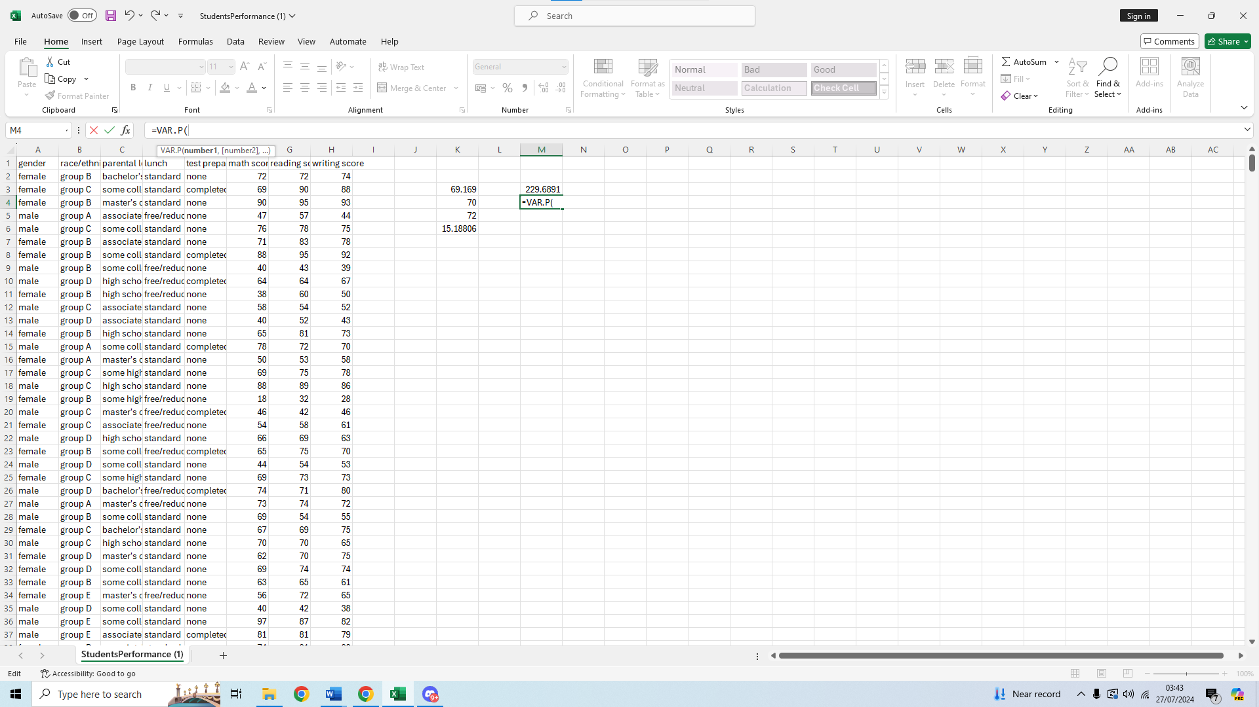
We select our first value of the range, G2
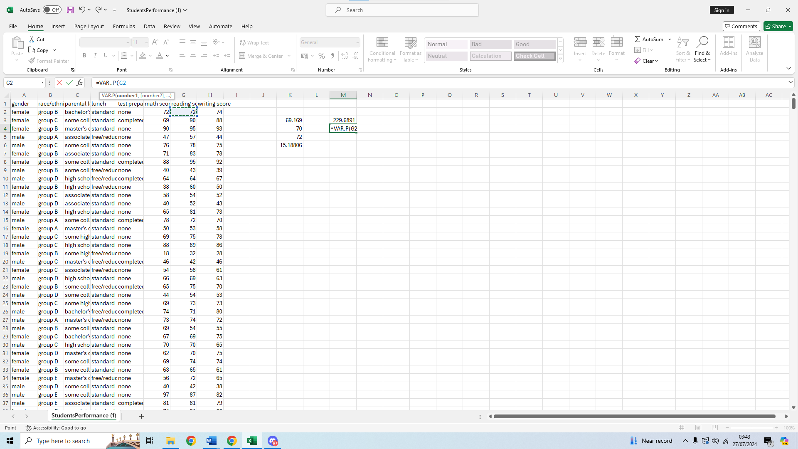We then select our last value of the range, G1001
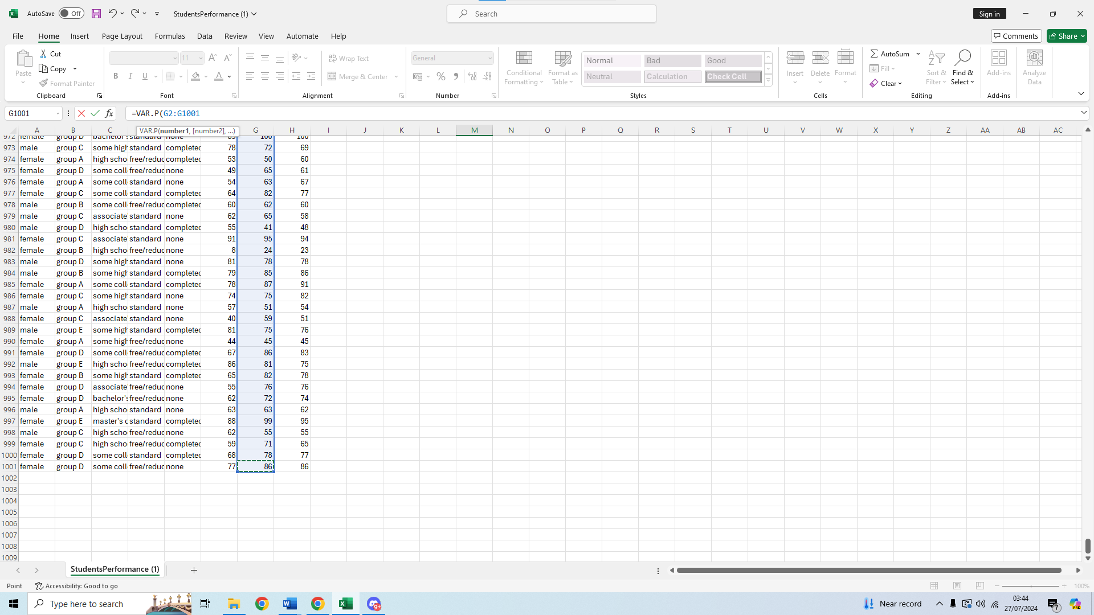We then press enter to calculate the variance of the reading score
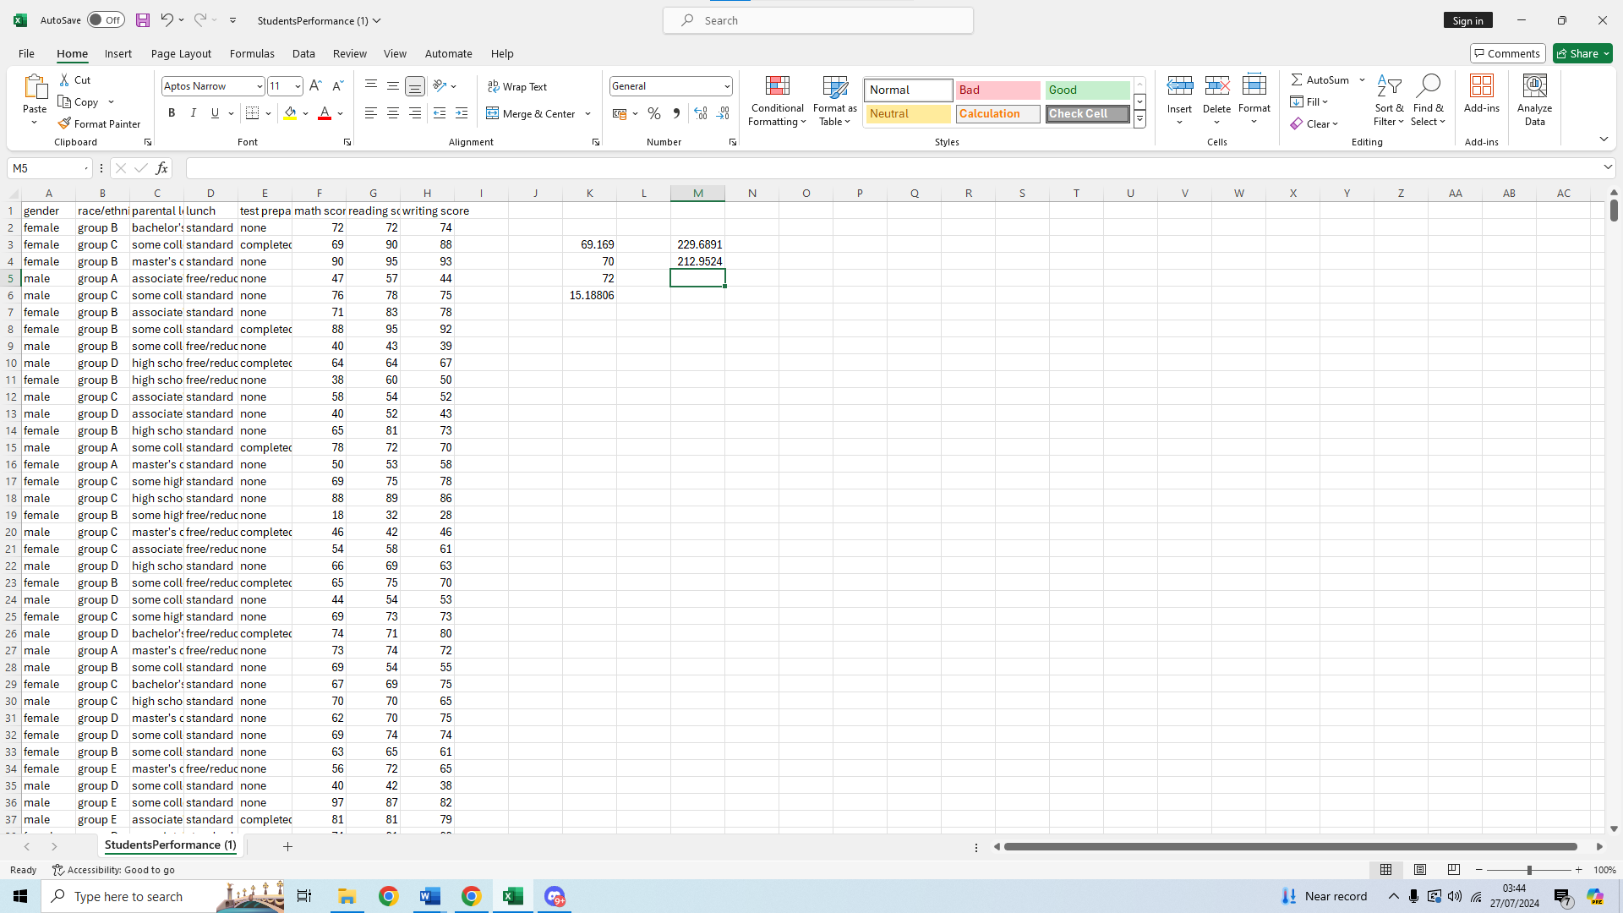We can see it is 212.9524
Lastly to get the variance for the writing score we use the same formula VAR.P(
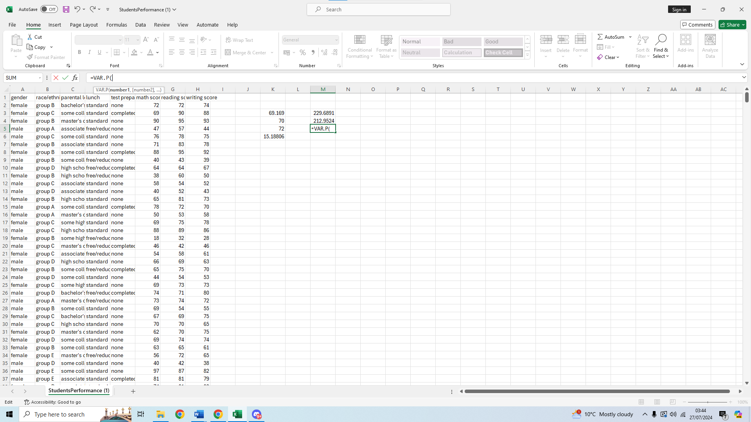We select the first value of our range, H2 and type :
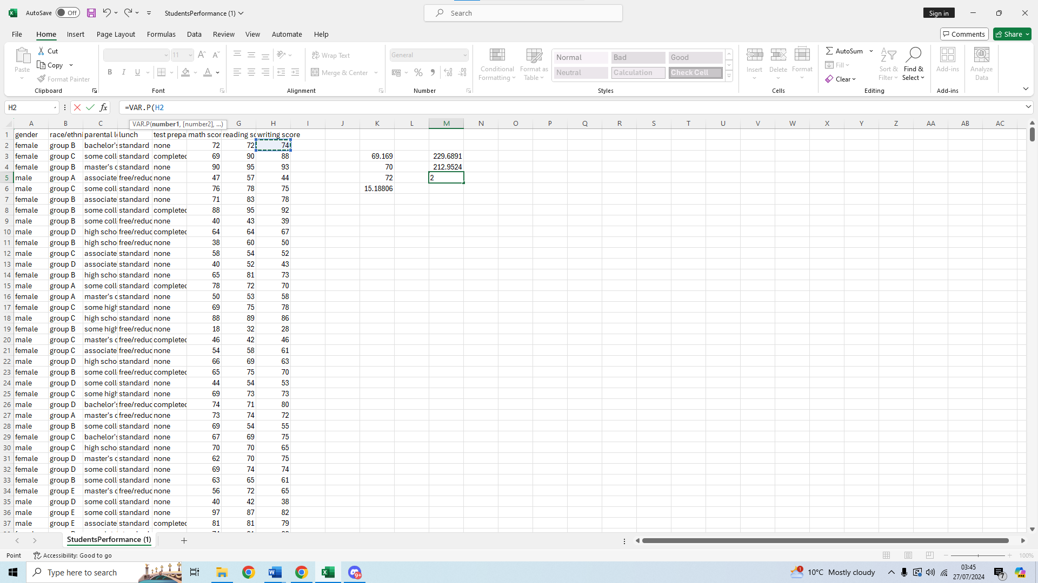Then after scrolling down we select the last value of our range
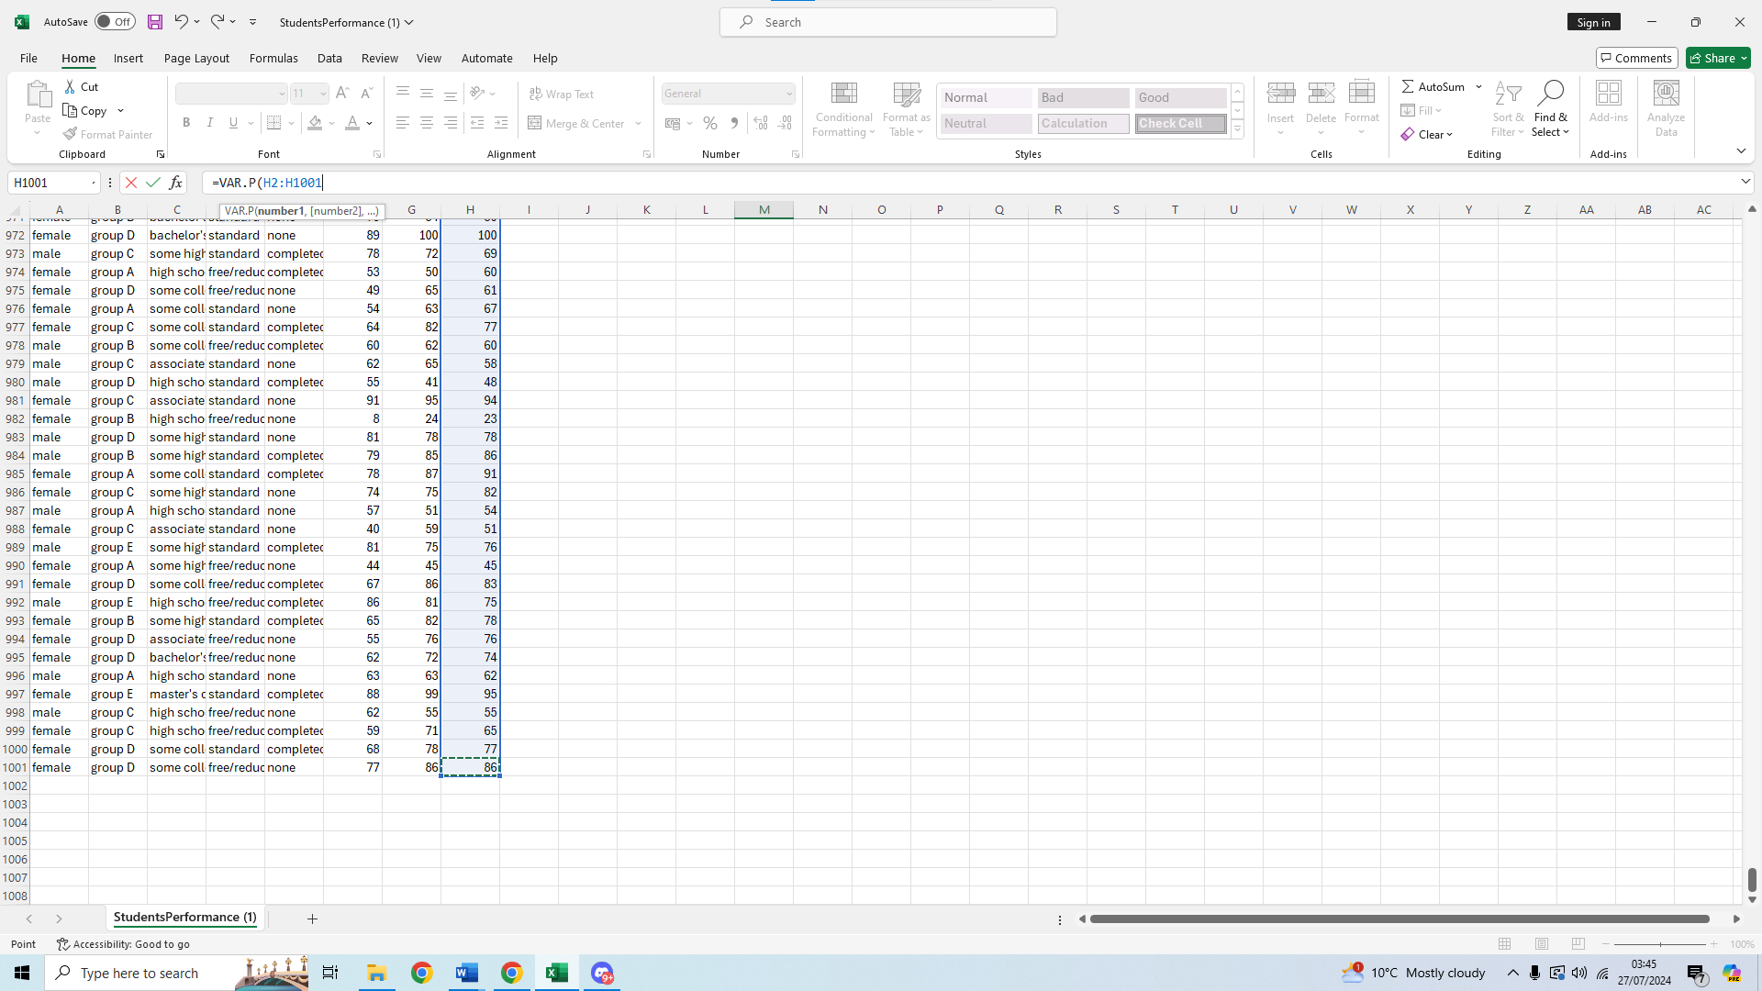
Lastly, we press enter to get our variance for the writing score
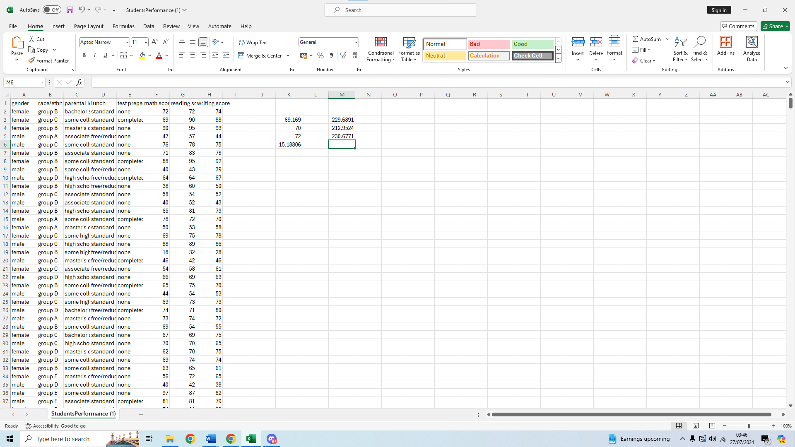We can see the variance for the writing score is 230.6771
From the three we can see that the writing score variance is the largest one.

Variables and their standard deviation
15.18806 is the standard deviation for the writing score so we do not need to calculate that one again.
To calculate the standard deviation of the reading score we will select an empty cell
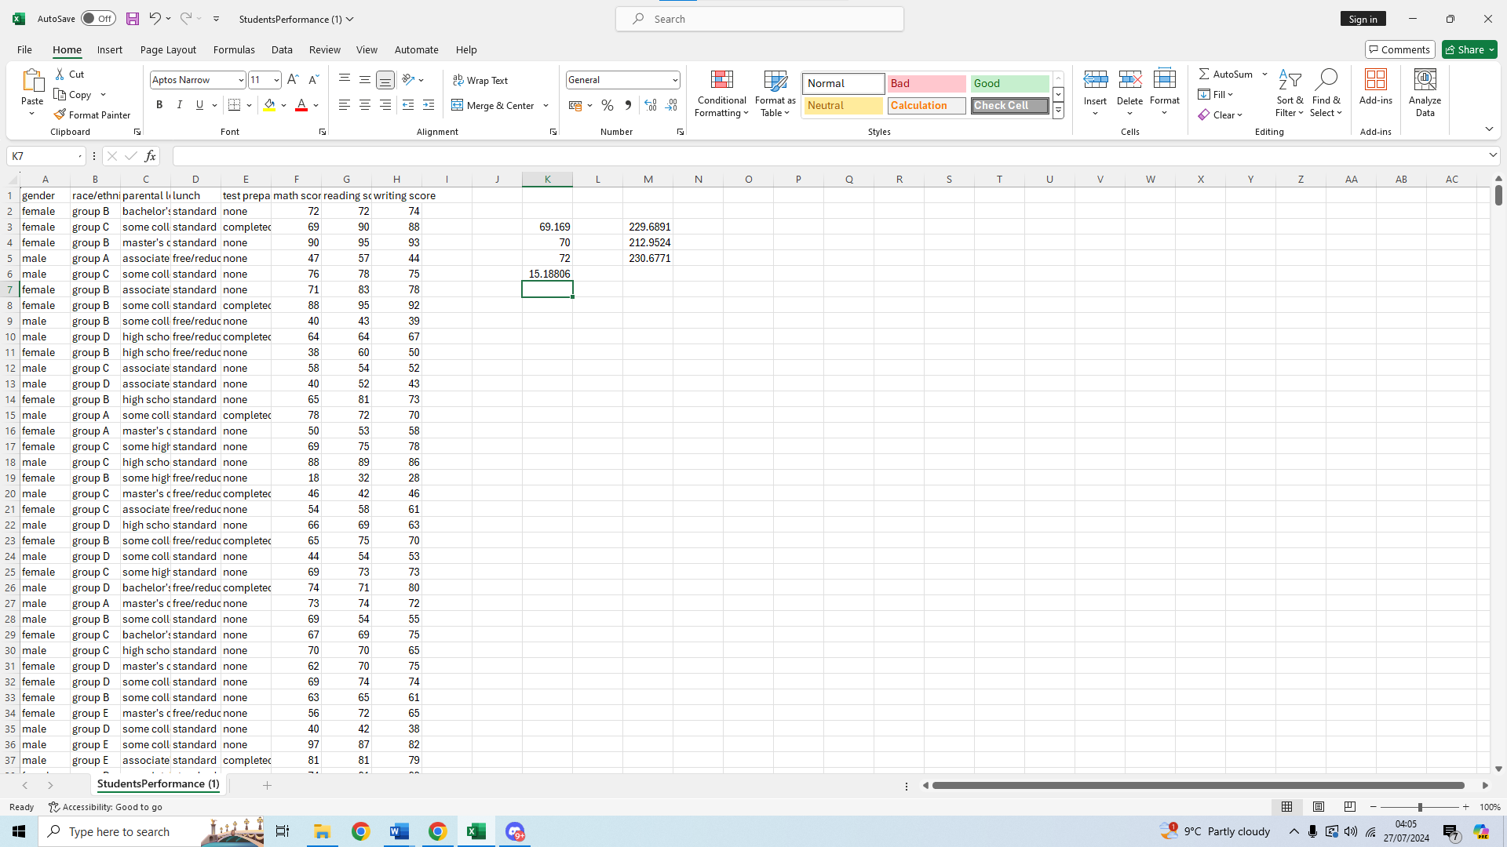
We will type our formula for standard deviation on the function bar, =STDEV.P(
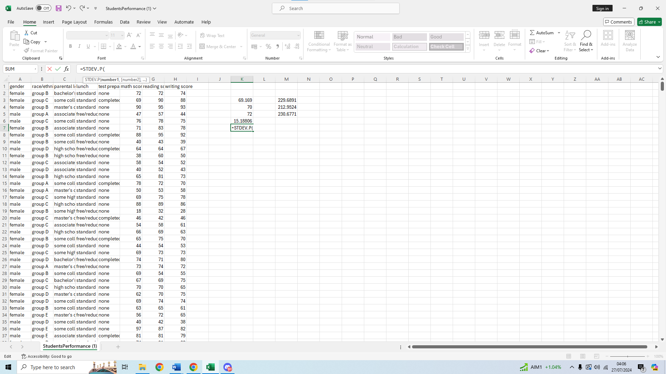
We will select the first value of our range and type : after
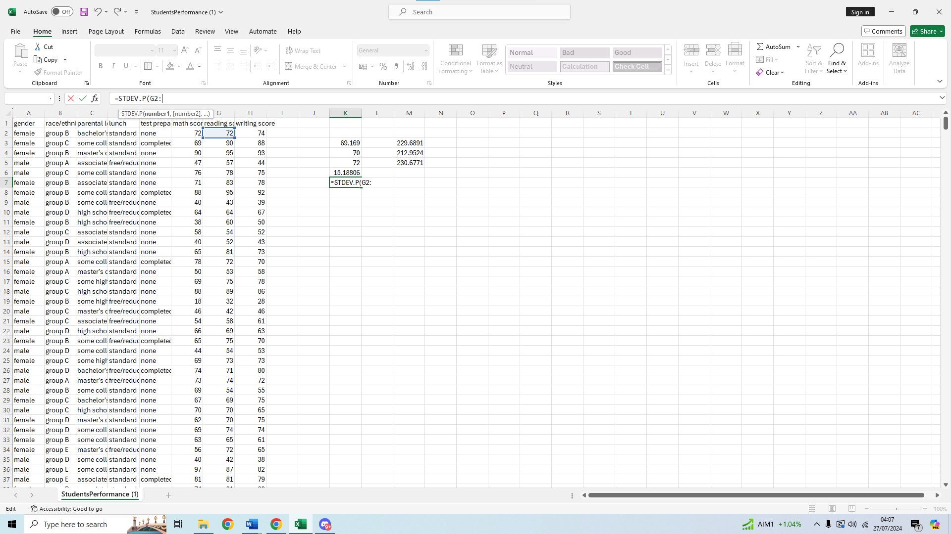
We then scroll down and select the last value of our range 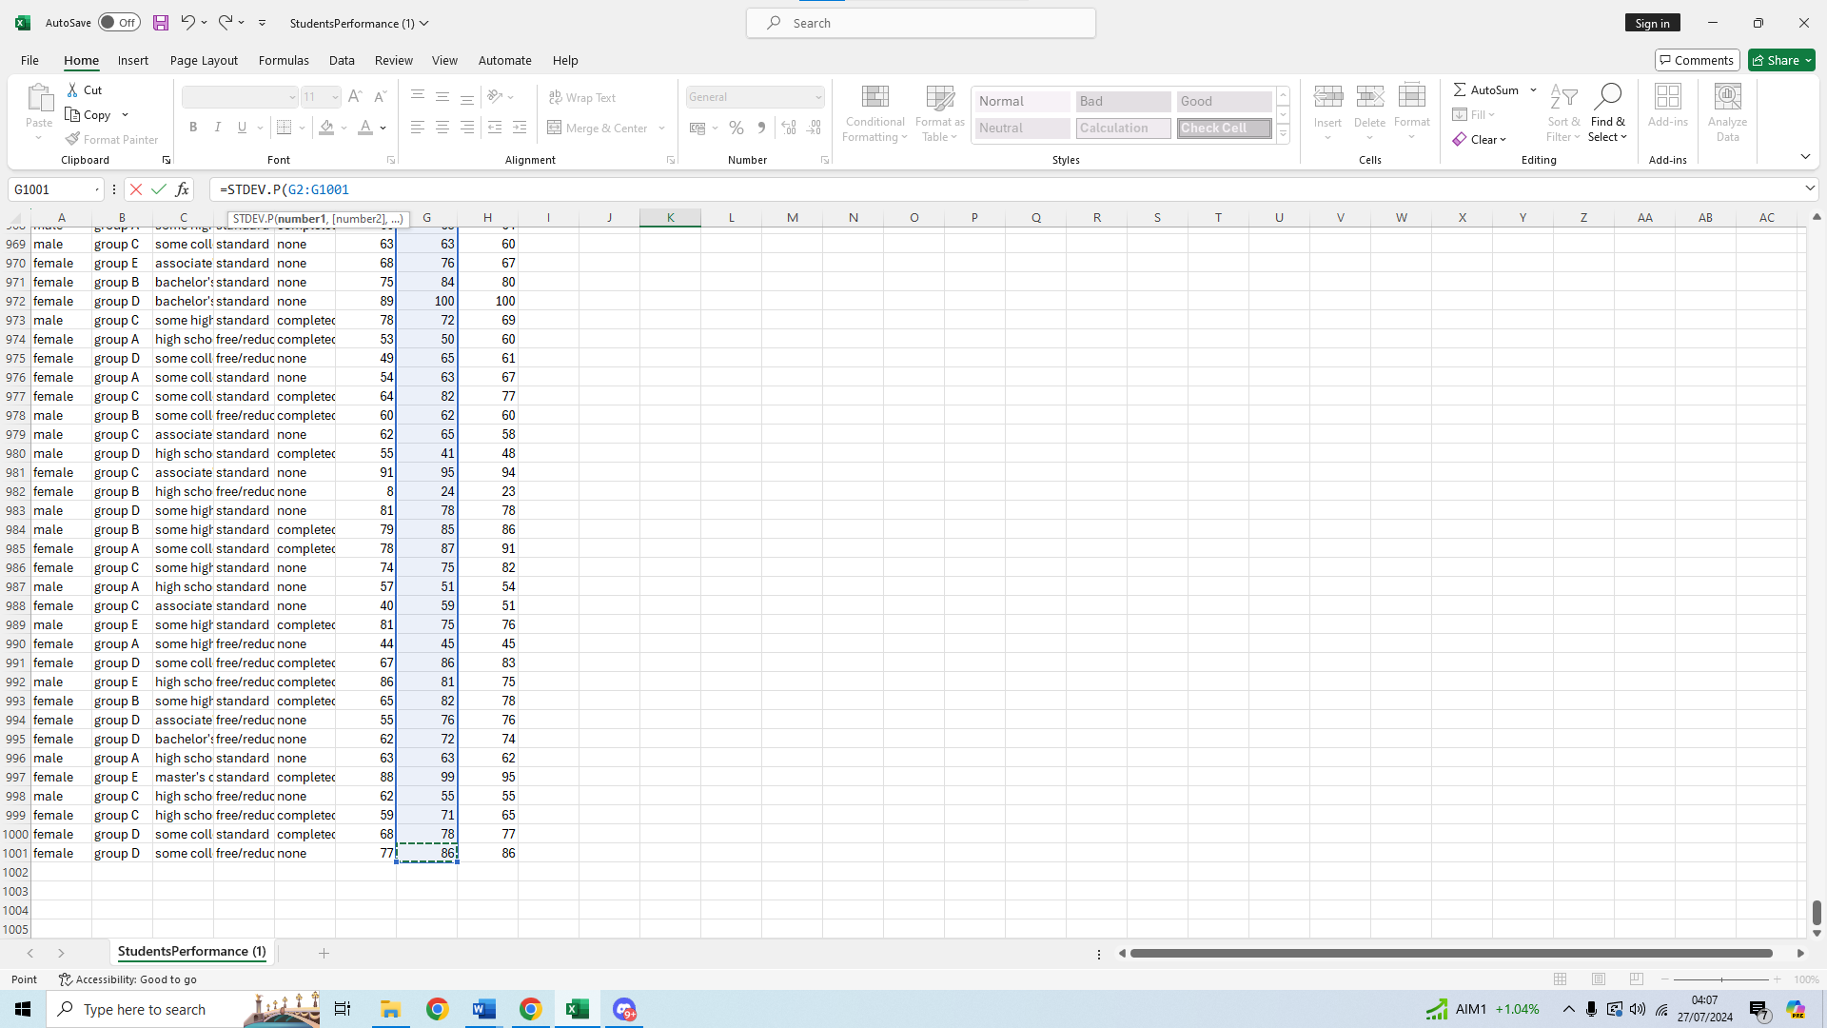We then press enter to get our result
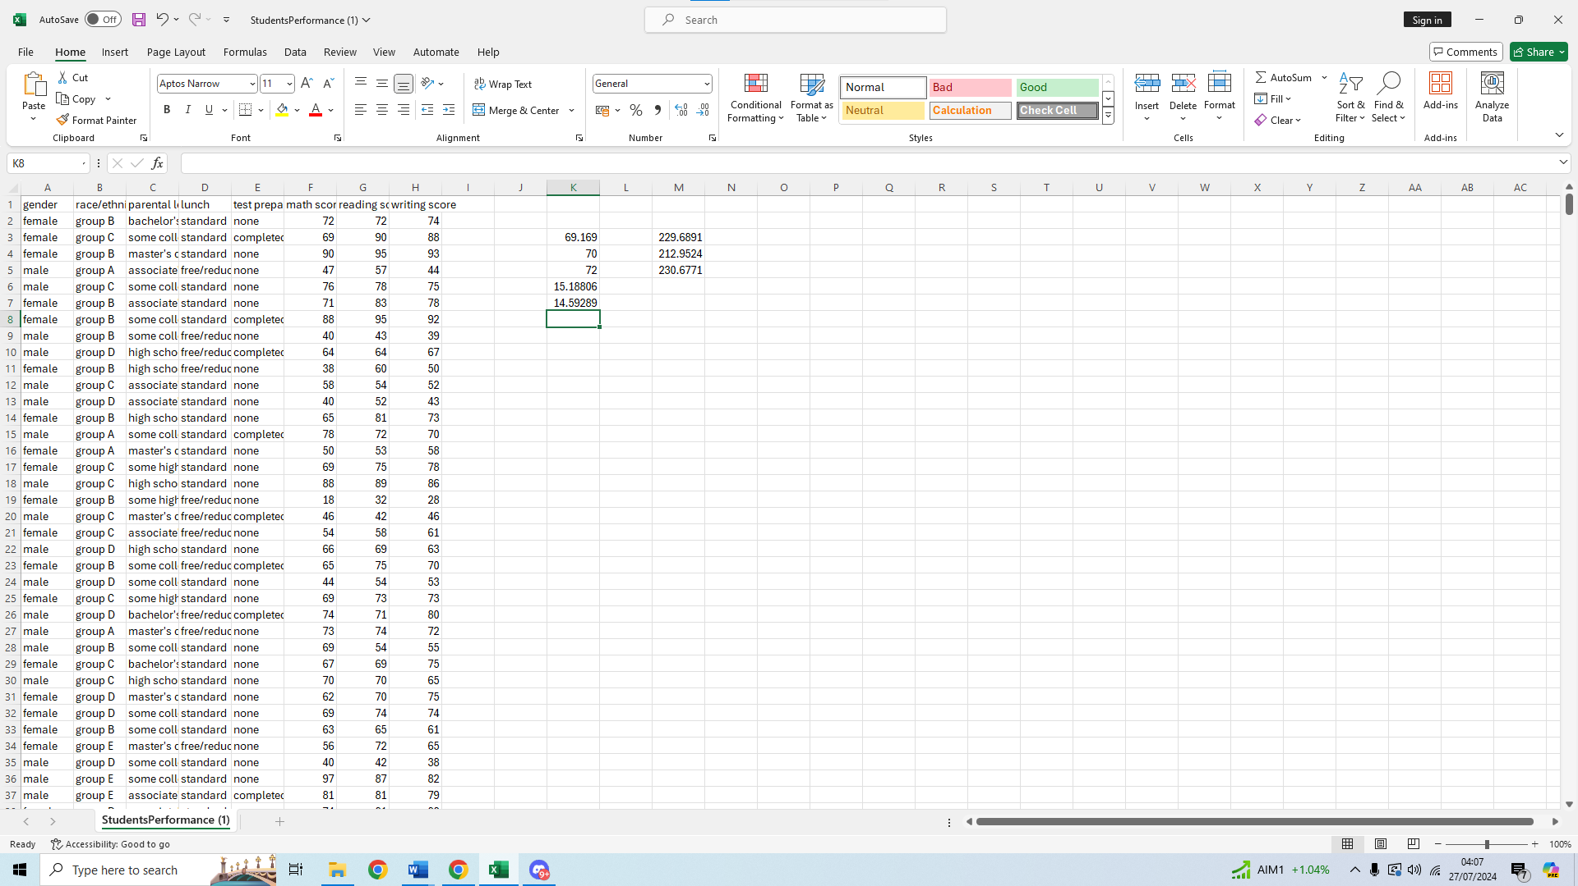
We can see the standard deviation for reading is 14.59289
Then we do the same for the math score, we select an empty cell
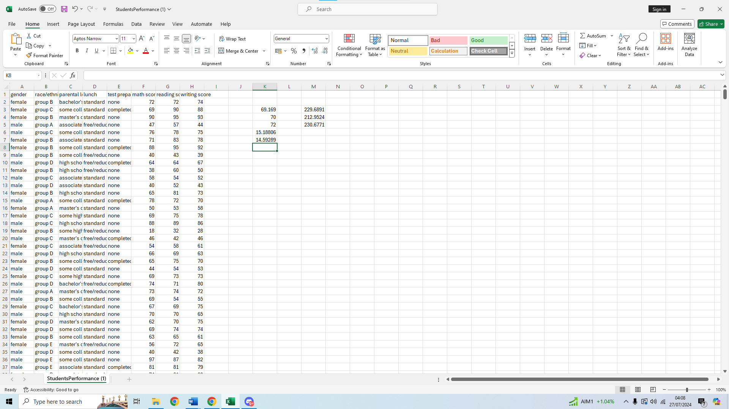
We then type our formula =STDEV.P( on the function bar
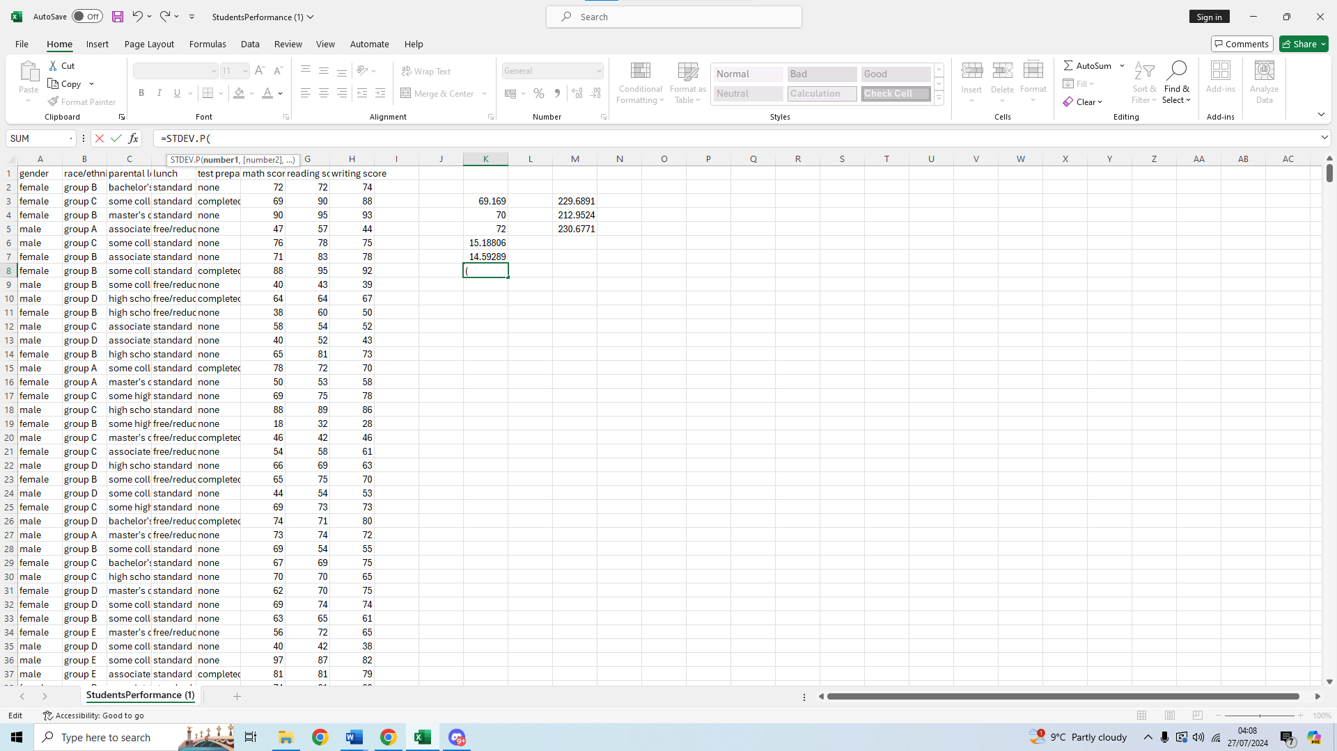
We then select our first value for the range of data and type :
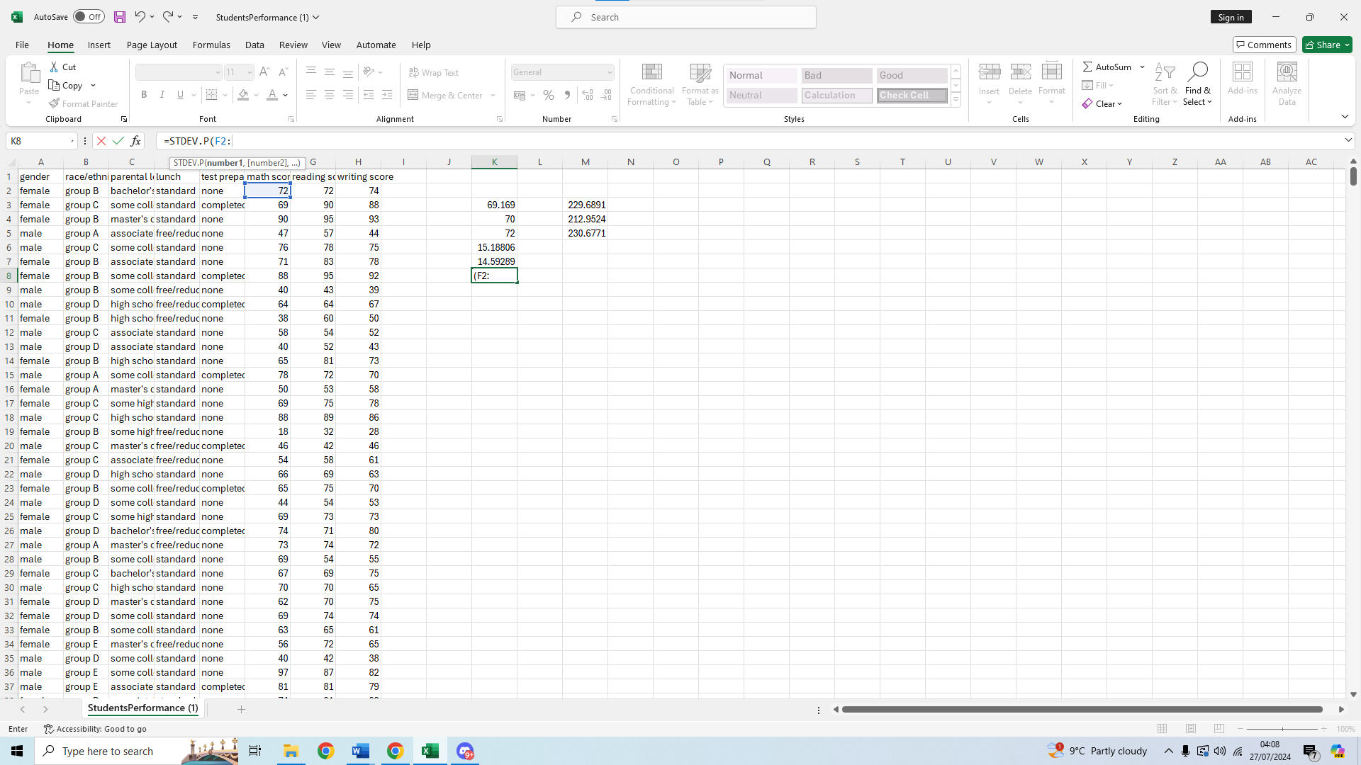
We scroll down and select the last value 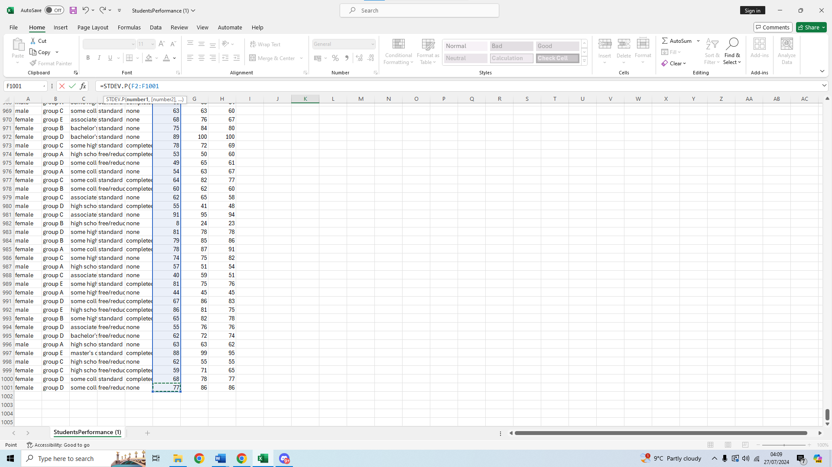We then press enter to get our result
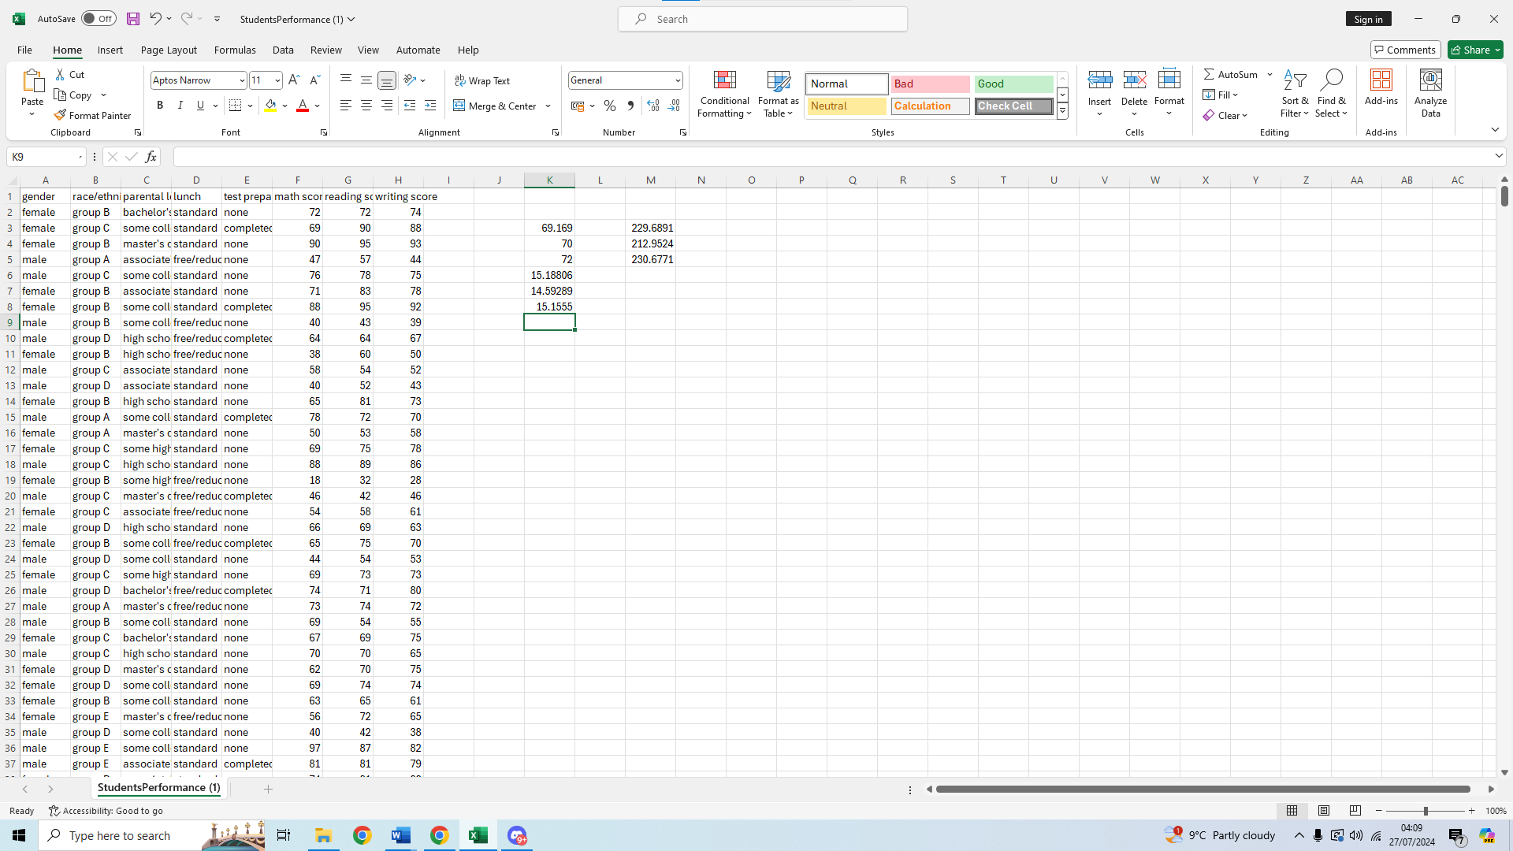We can see the standard deviation for math score is 15.1555,
This means the writing score standard deviation is the largest of the three,

Interpreting the outcomes
The standard deviation for the writing score is 15.18806, the deviation for the reading score is 14.59289, and the deviation for the math score is 15.1555.
The spread of the deviation is moderate, as the maximum score of the tests is 100, having a standard deviation higher than 14 on all three cases means that there is a lot of variance around the mean.
Usually around 70% of scores are within 1 standard deviation away from the mean, in the test scores this would mean a big difference because for example for the reading score the mean is 69.169, and the standard deviation is 14.59289, meaning a score of 74 or a score of 54 would be within the same deviation, but in practice this is a big difference in grade.
This might still be considered an okay deviation if the class is very diverse, and students are not expected to perform similarly.
The three standard deviations are close to each other, suggesting there is not much difference in performance in these subjects compared to one another, reading score deviation is the lowest but not by that much that it should be noteworthy.
The variances for the three scores are, 229.6891 for maths, 212.9524 for reading score, and 230.6771 for writing score.
This matches with the standard deviation of reading score also being the lowest. The differences between writing score and maths are too small, they are more or less the same so teachers can keep this in mind when preparing study sessions that both these subjects would need a similar amount of attention.
The reading score variance is lower by a noticeable amount, which means students are more clustered when it comes to score in this topic.

Pivot table
We will do a pivot table to better showcase our data, first we must select all our data from the top left corner to the bottom right. 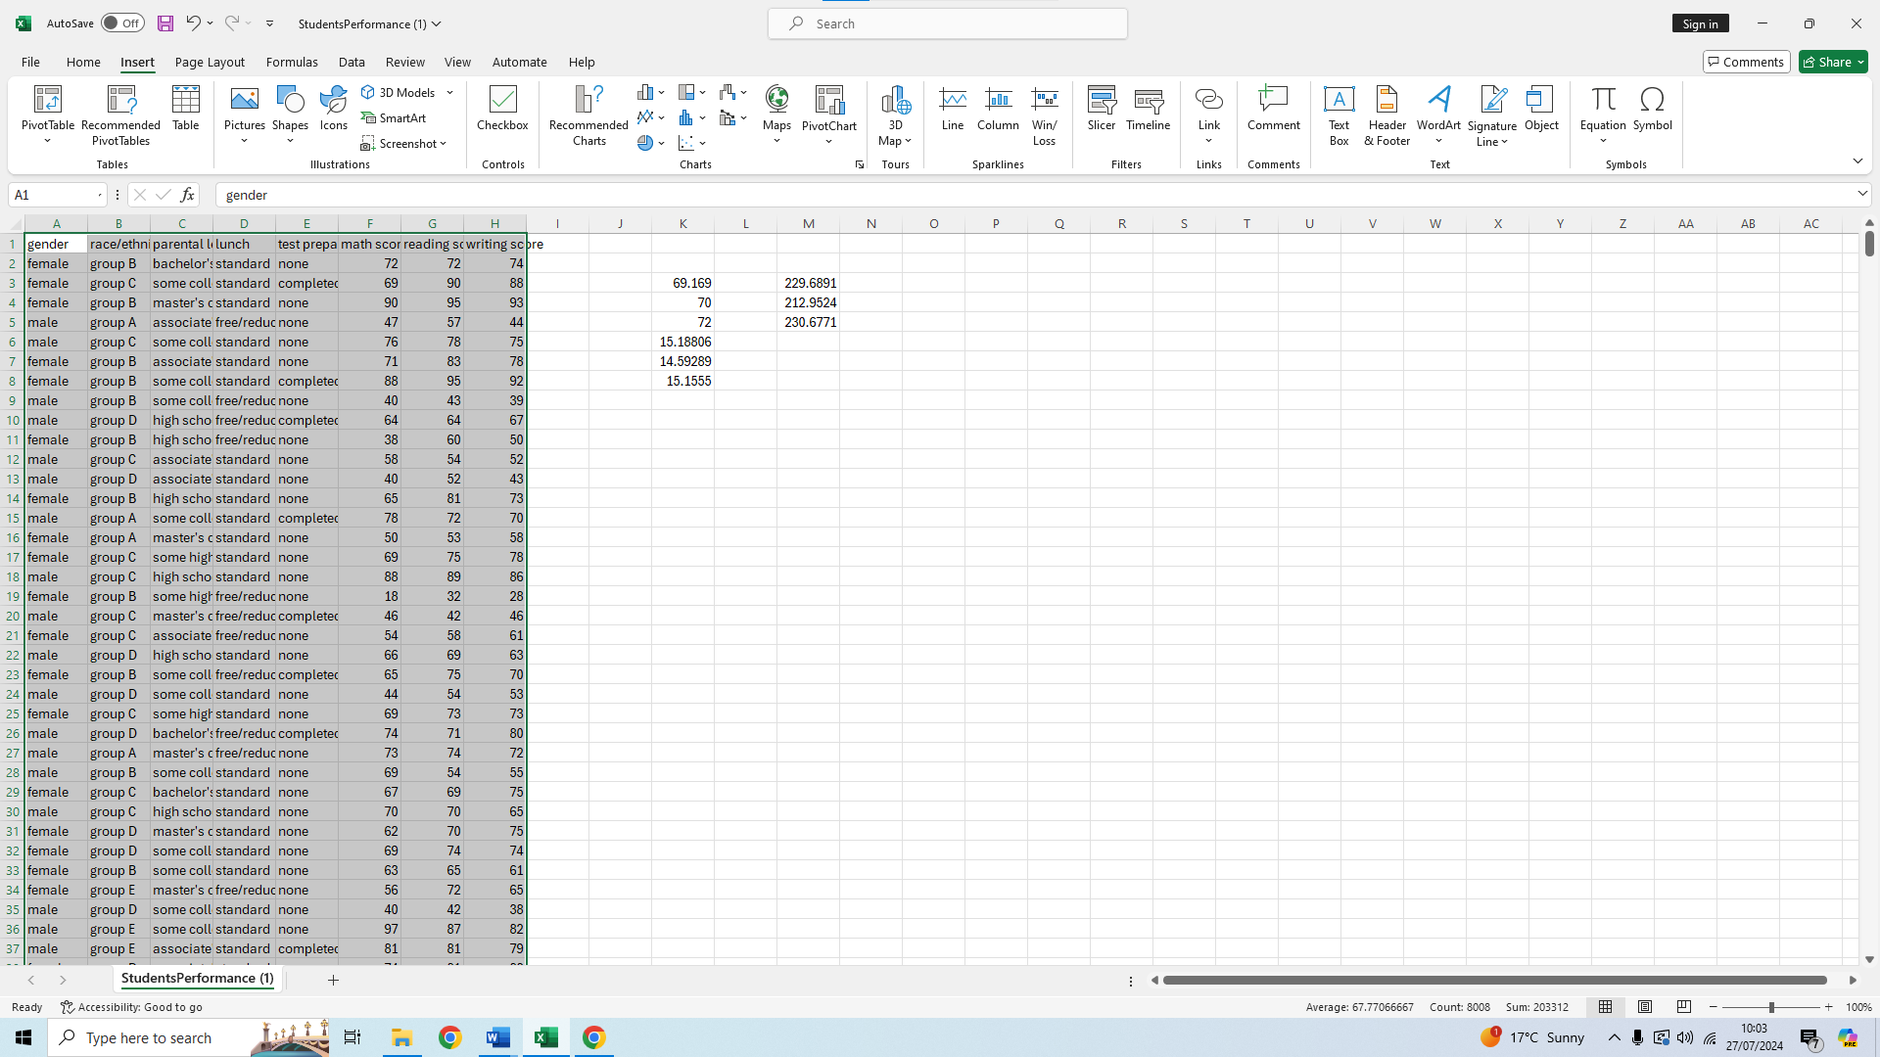
We then go to the insert tab on the top
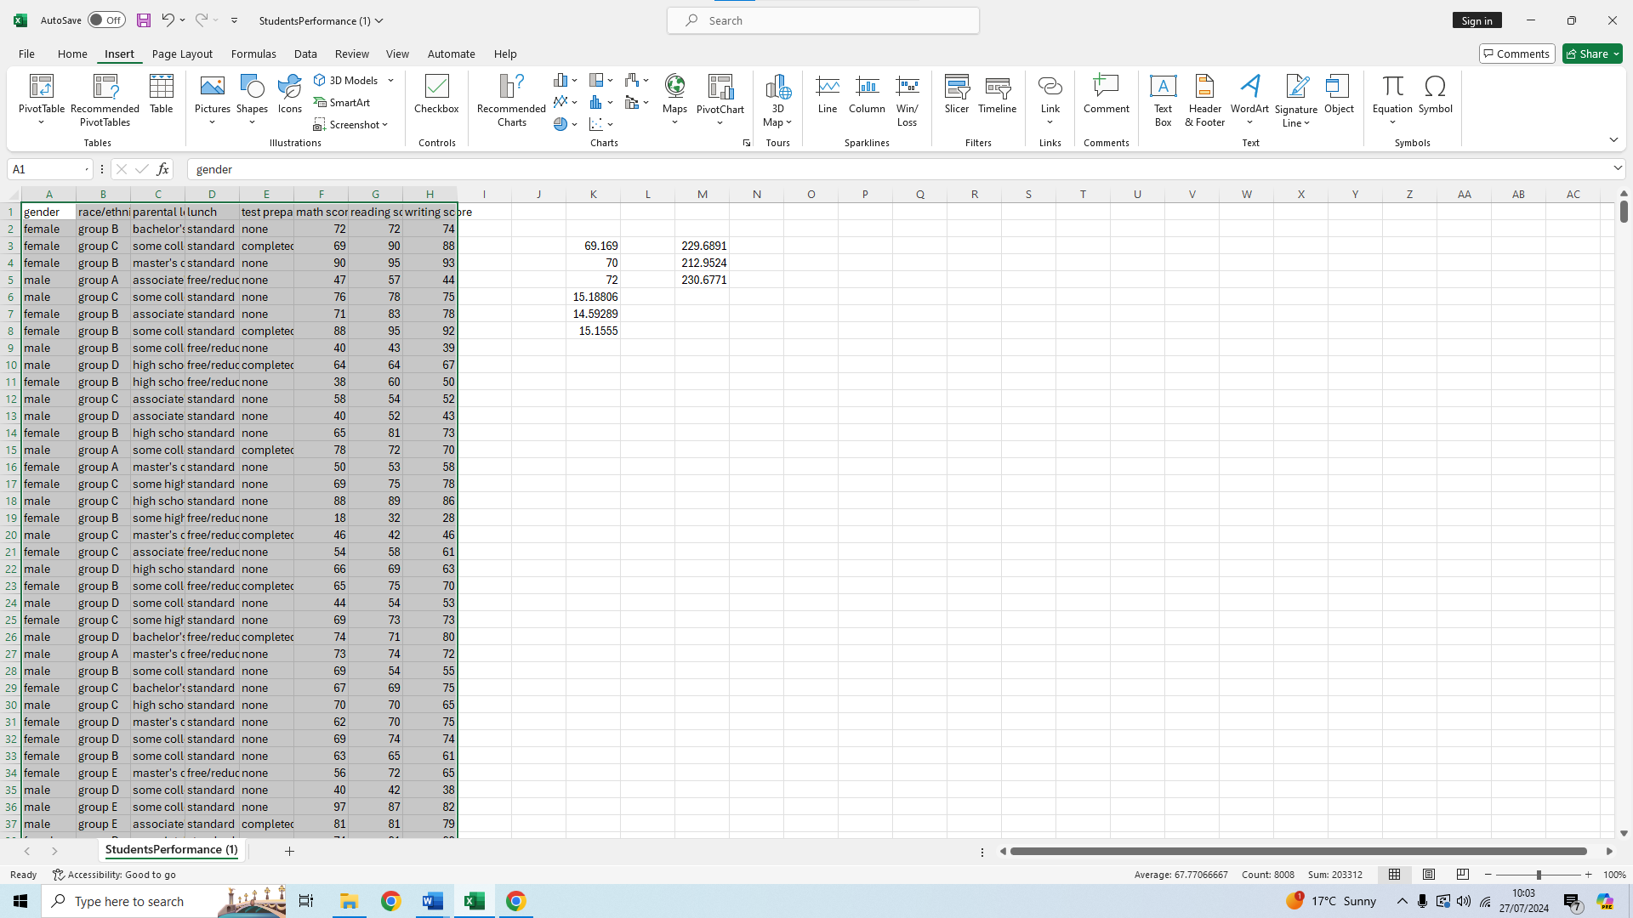
We click on pivot table
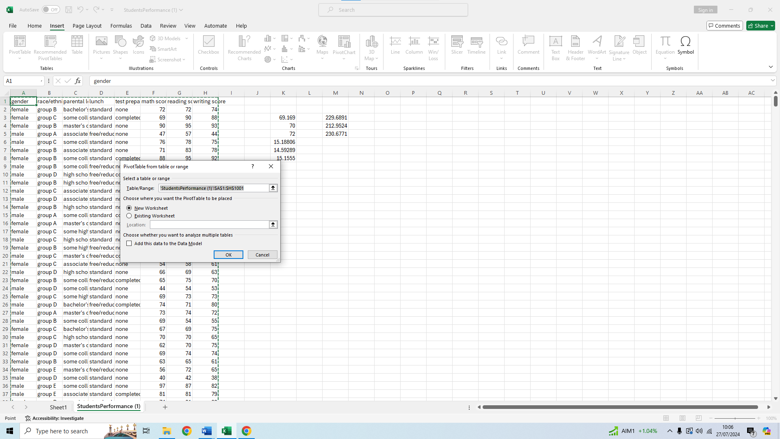We select new worksheet
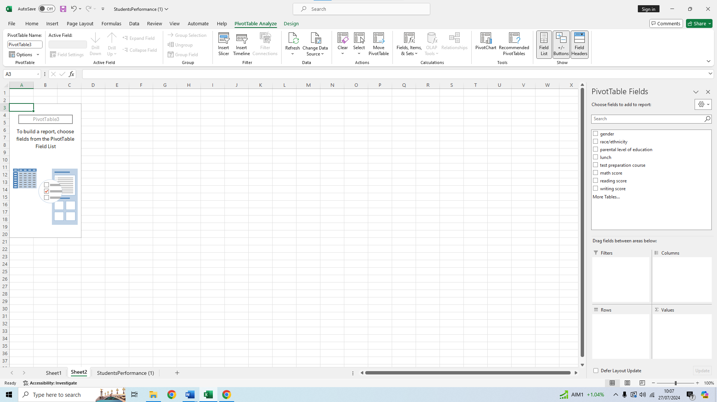We then use the filters on the right to show our data as we wish 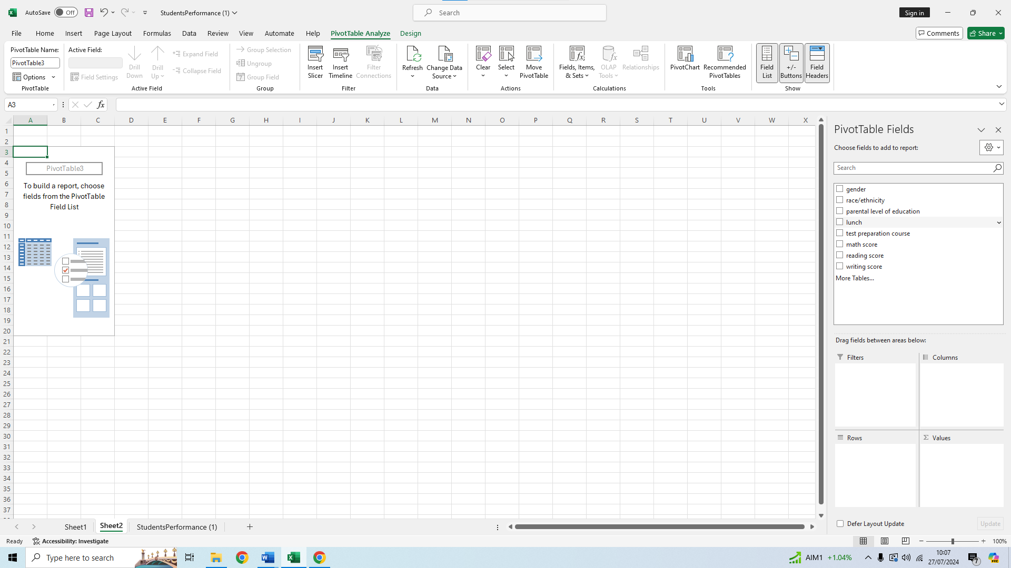For example, the sum of math score of people who completed the test preparation score and the ones that did not
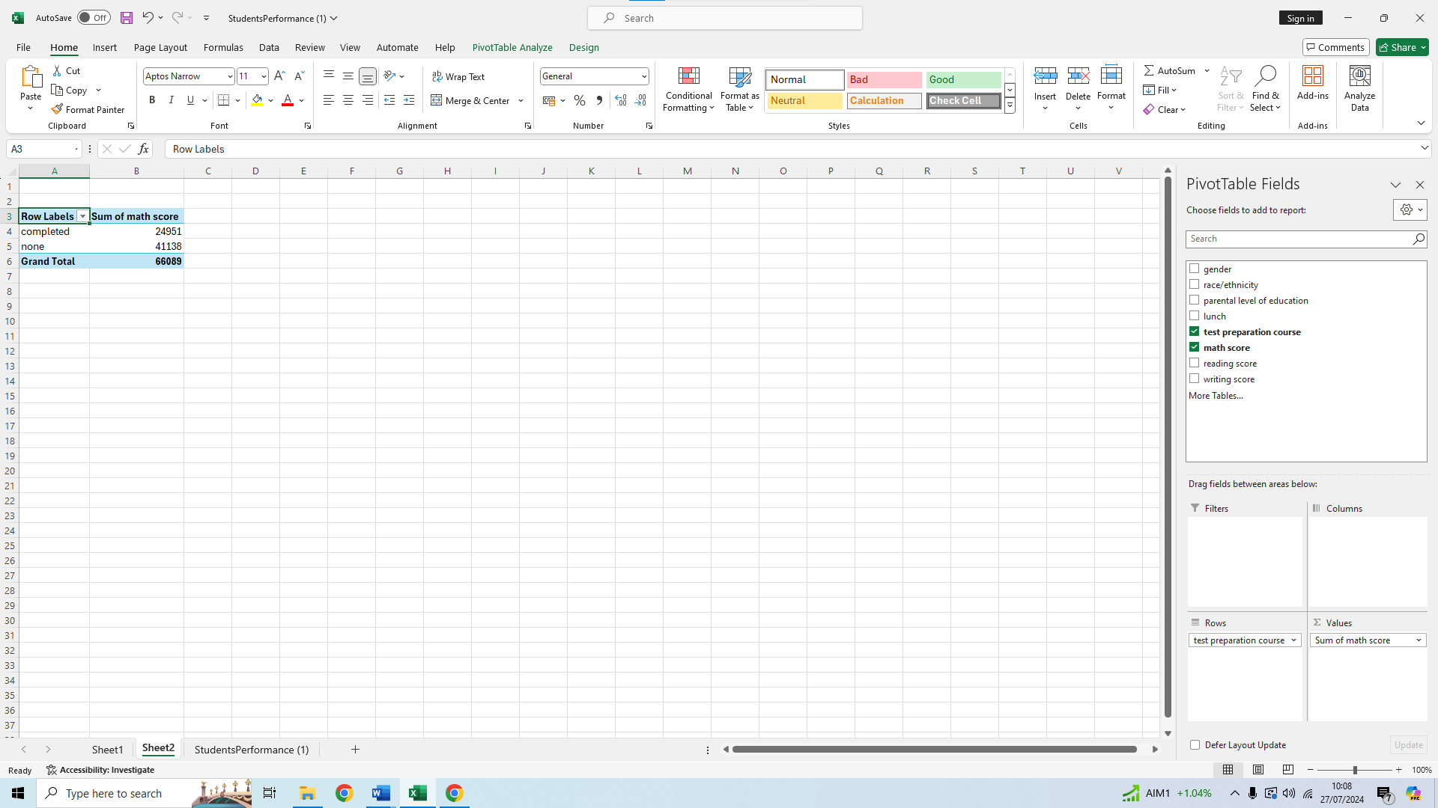
Or the writing score total of females and males
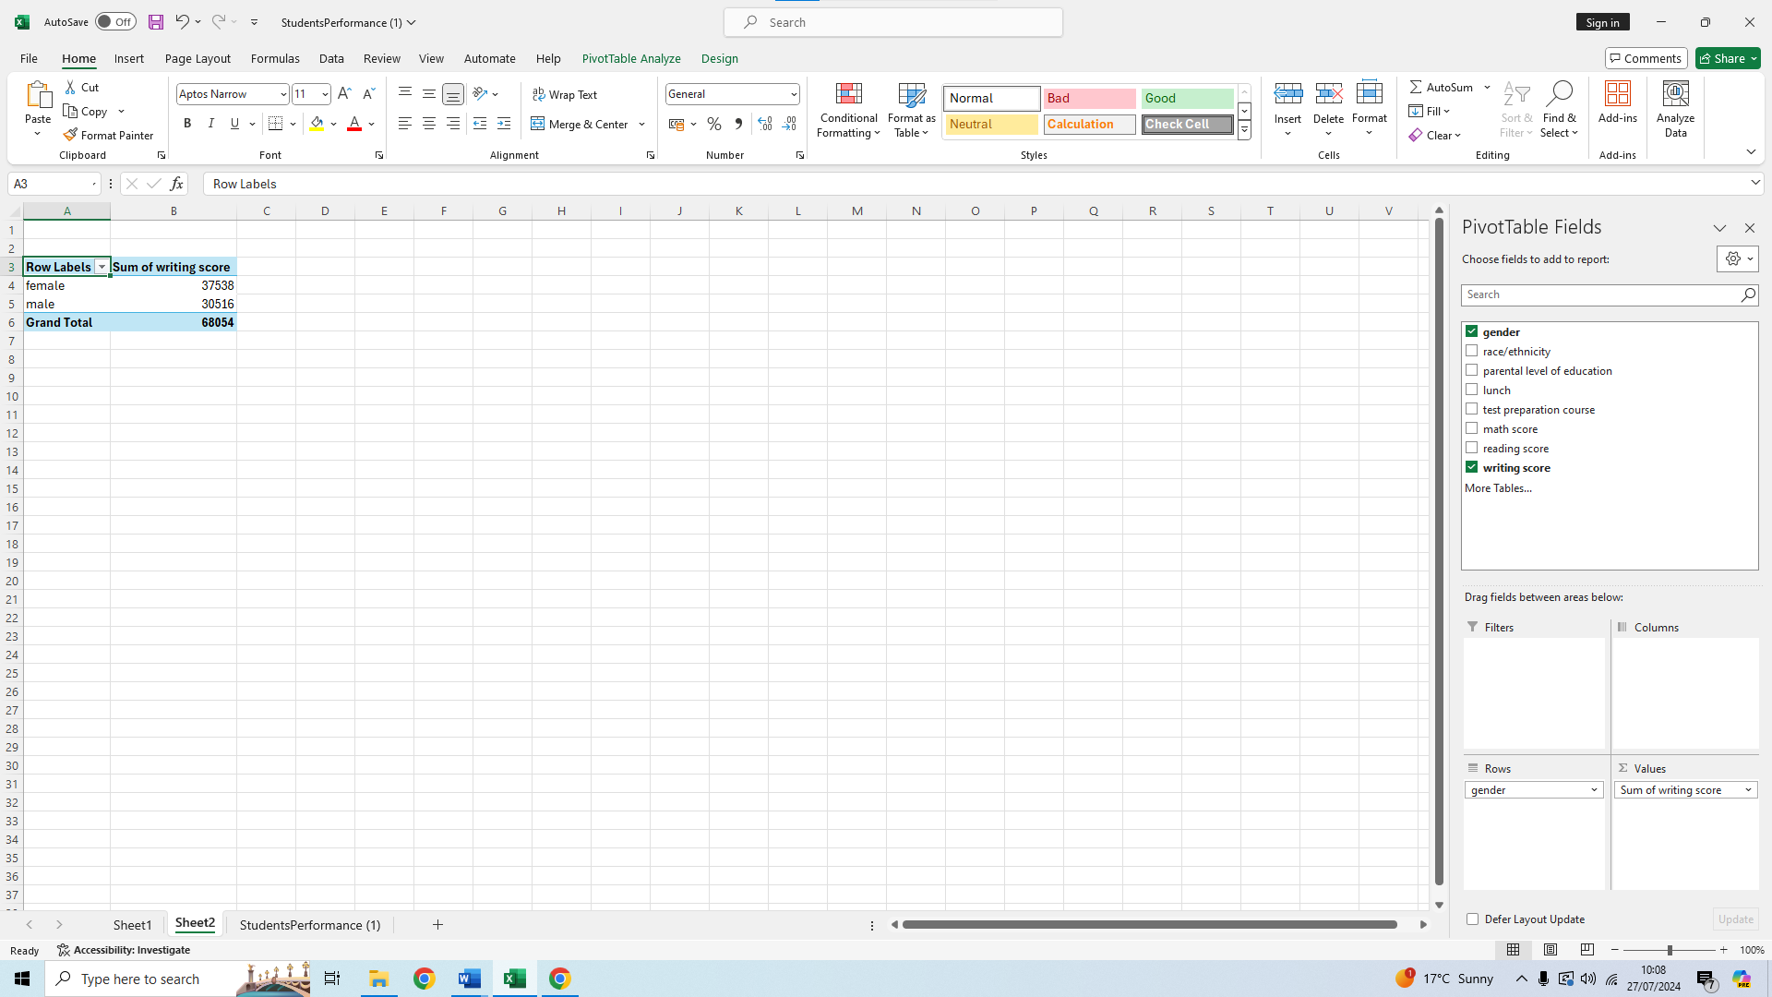
Or even more complex, sorting the writing score totals by gender, and parent level of education
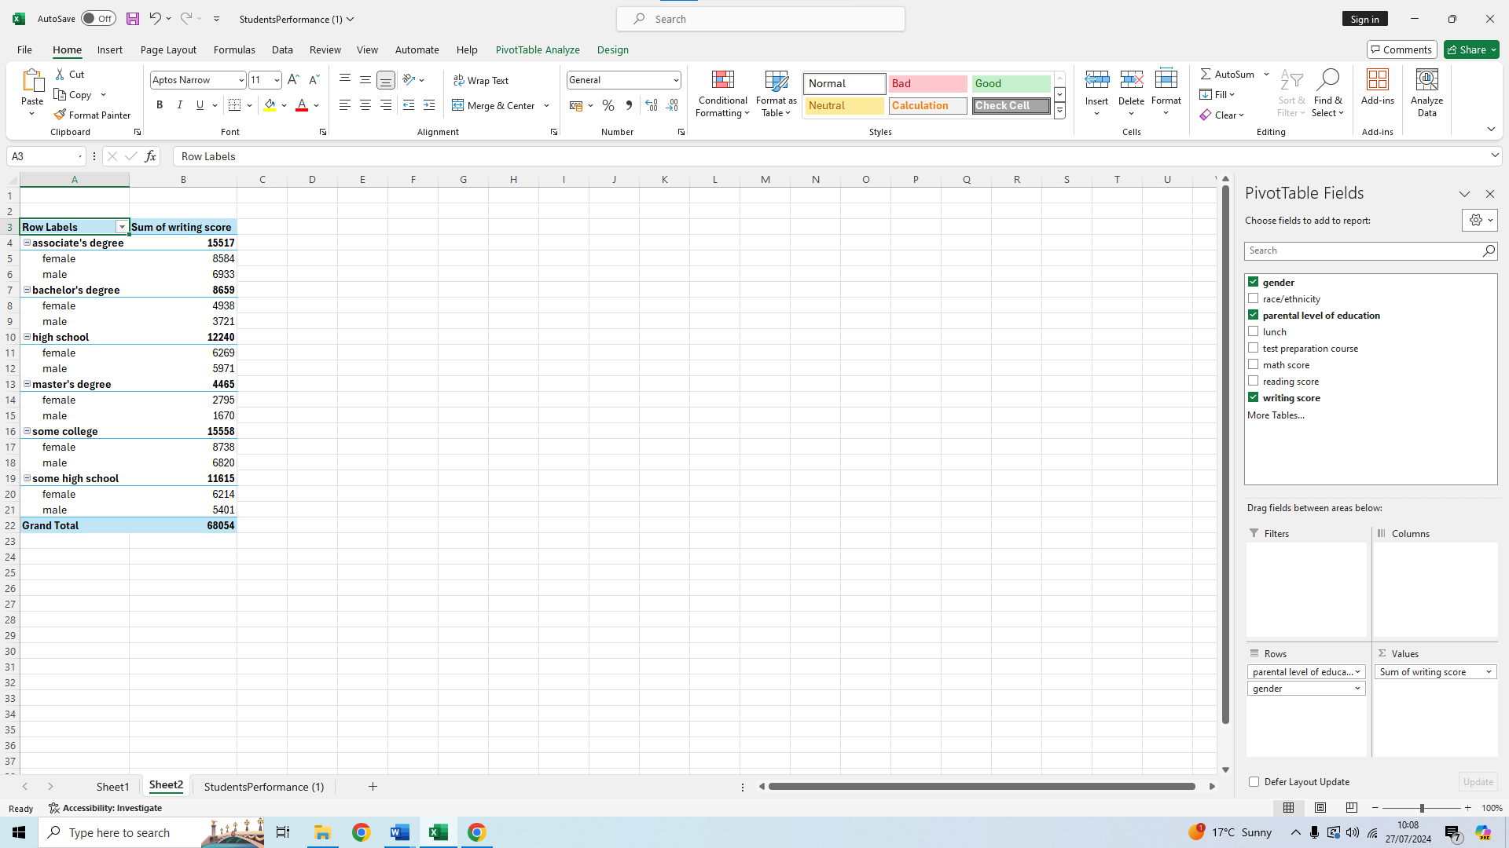
In this way pivot tables are very useful to show us exactly the comparisons we want to see, as they make a big table of data such as the one we had into a small easily customizable table.

SPSS analysis
To show the correlation between writing and reading scores we will do a Pearson correlation using SPSS, to do this first we have to open the data file,
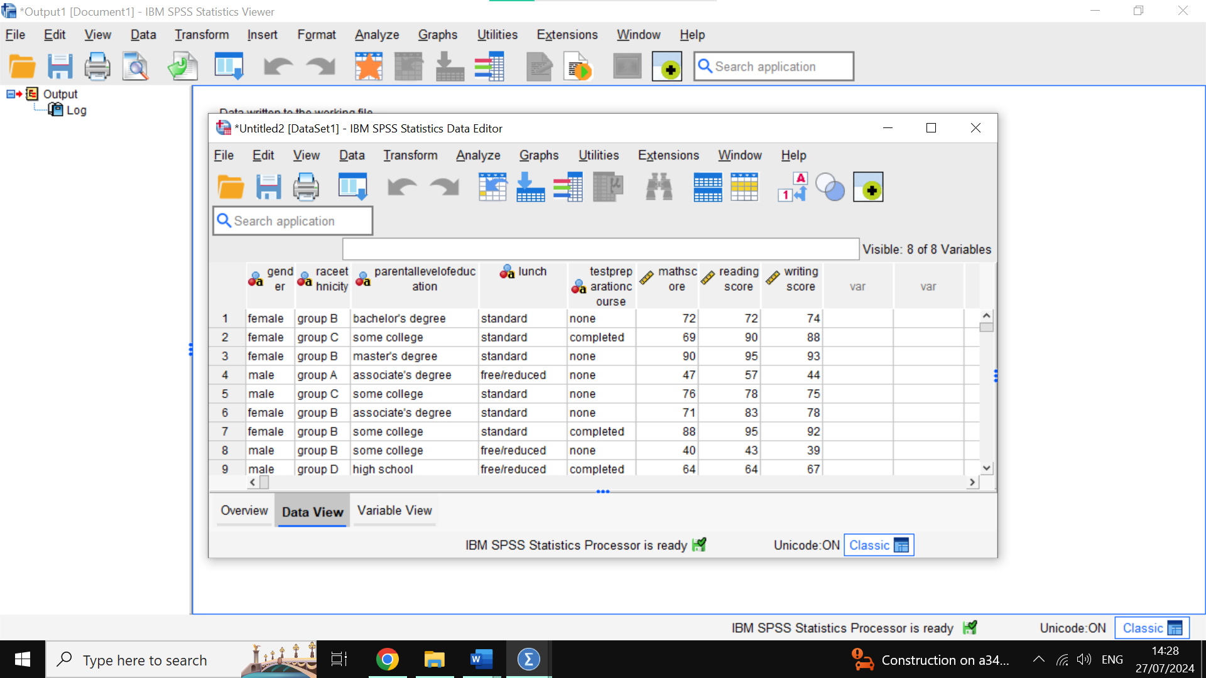
Then we click on Analyze at the top 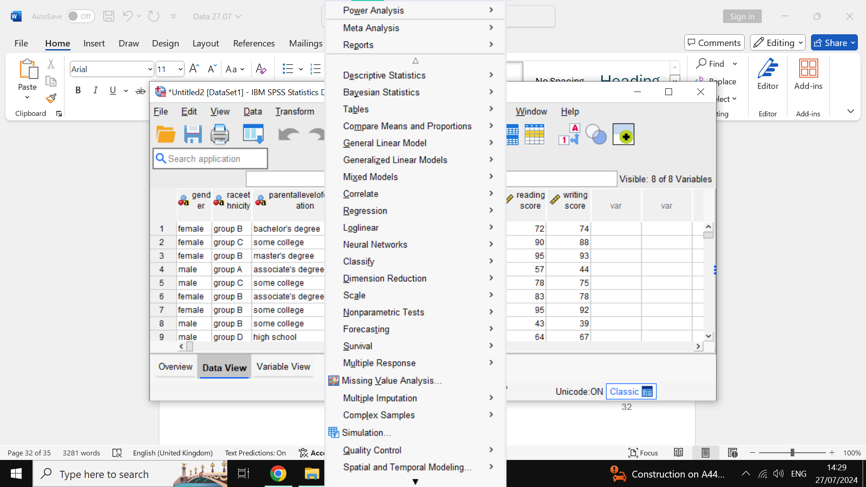then we scroll to correlate and bivariate 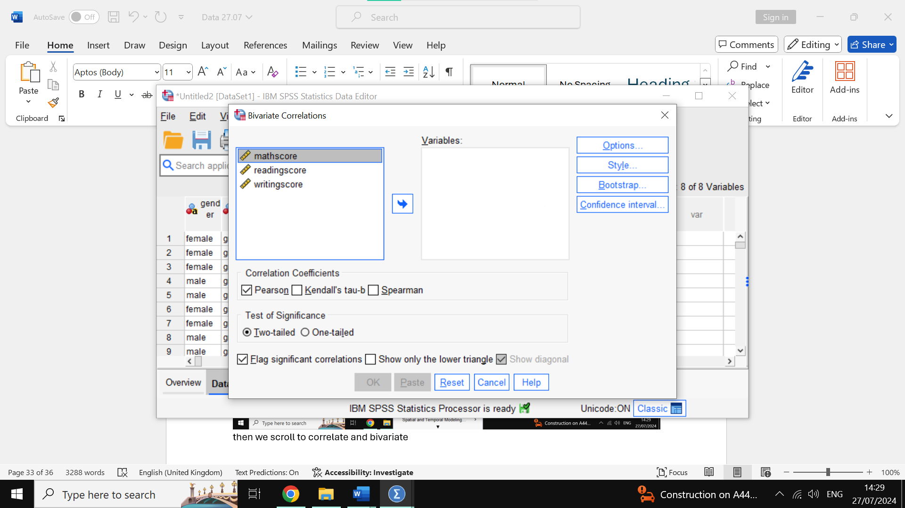We then select the reading score and click the arrow to add it to our variables list 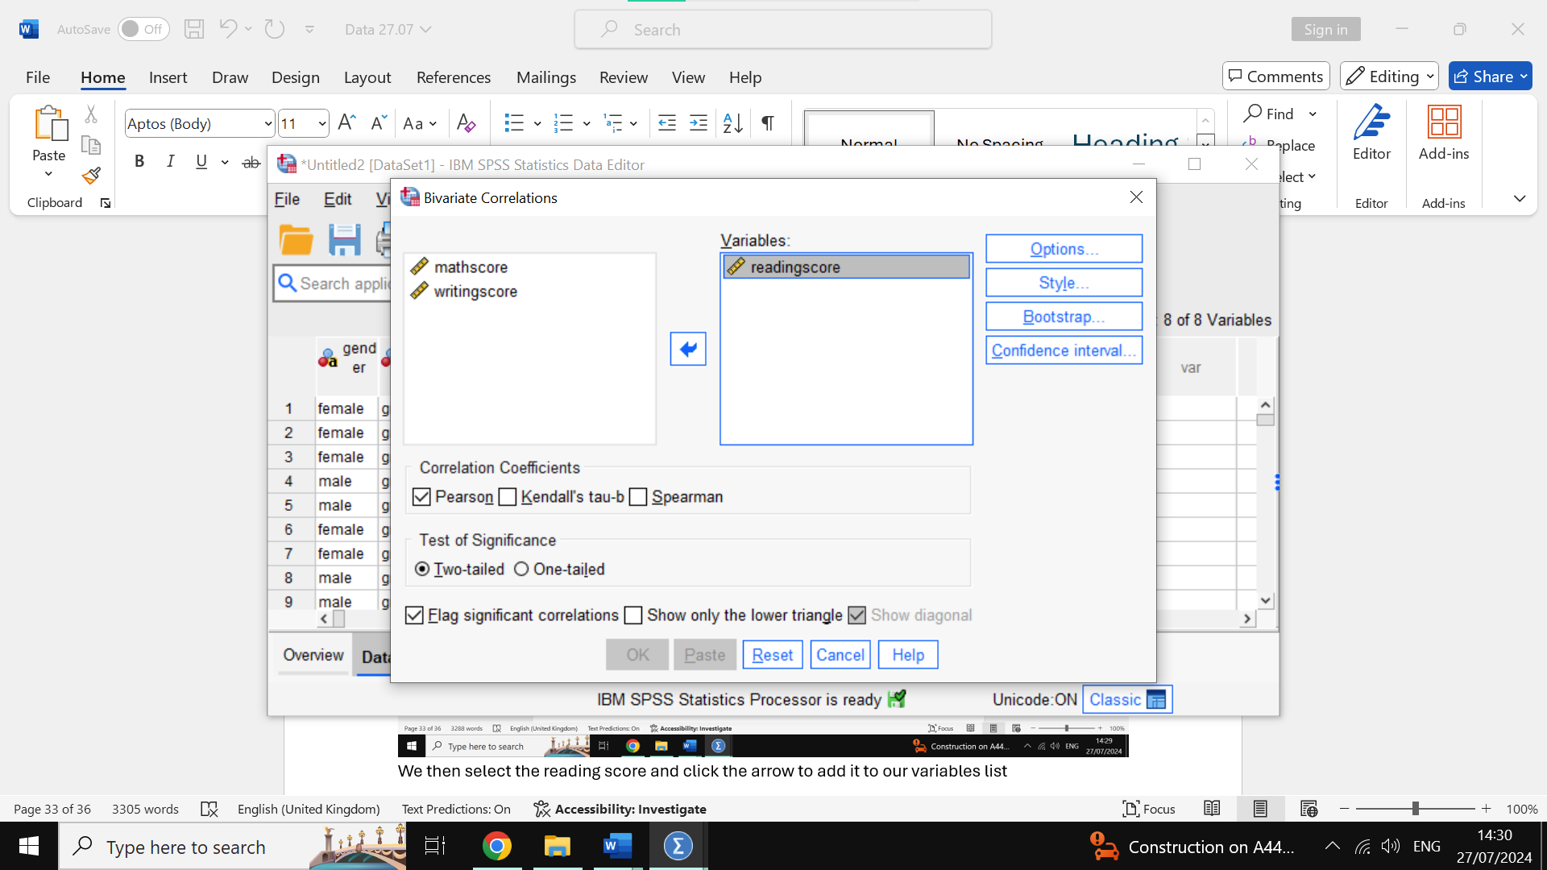We do the same for writing score 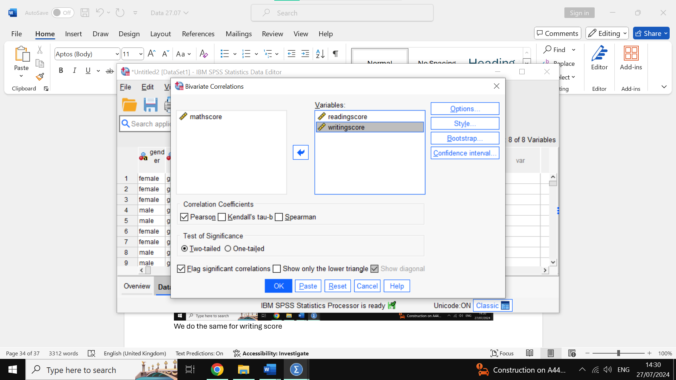Now we press okay on the bottom. 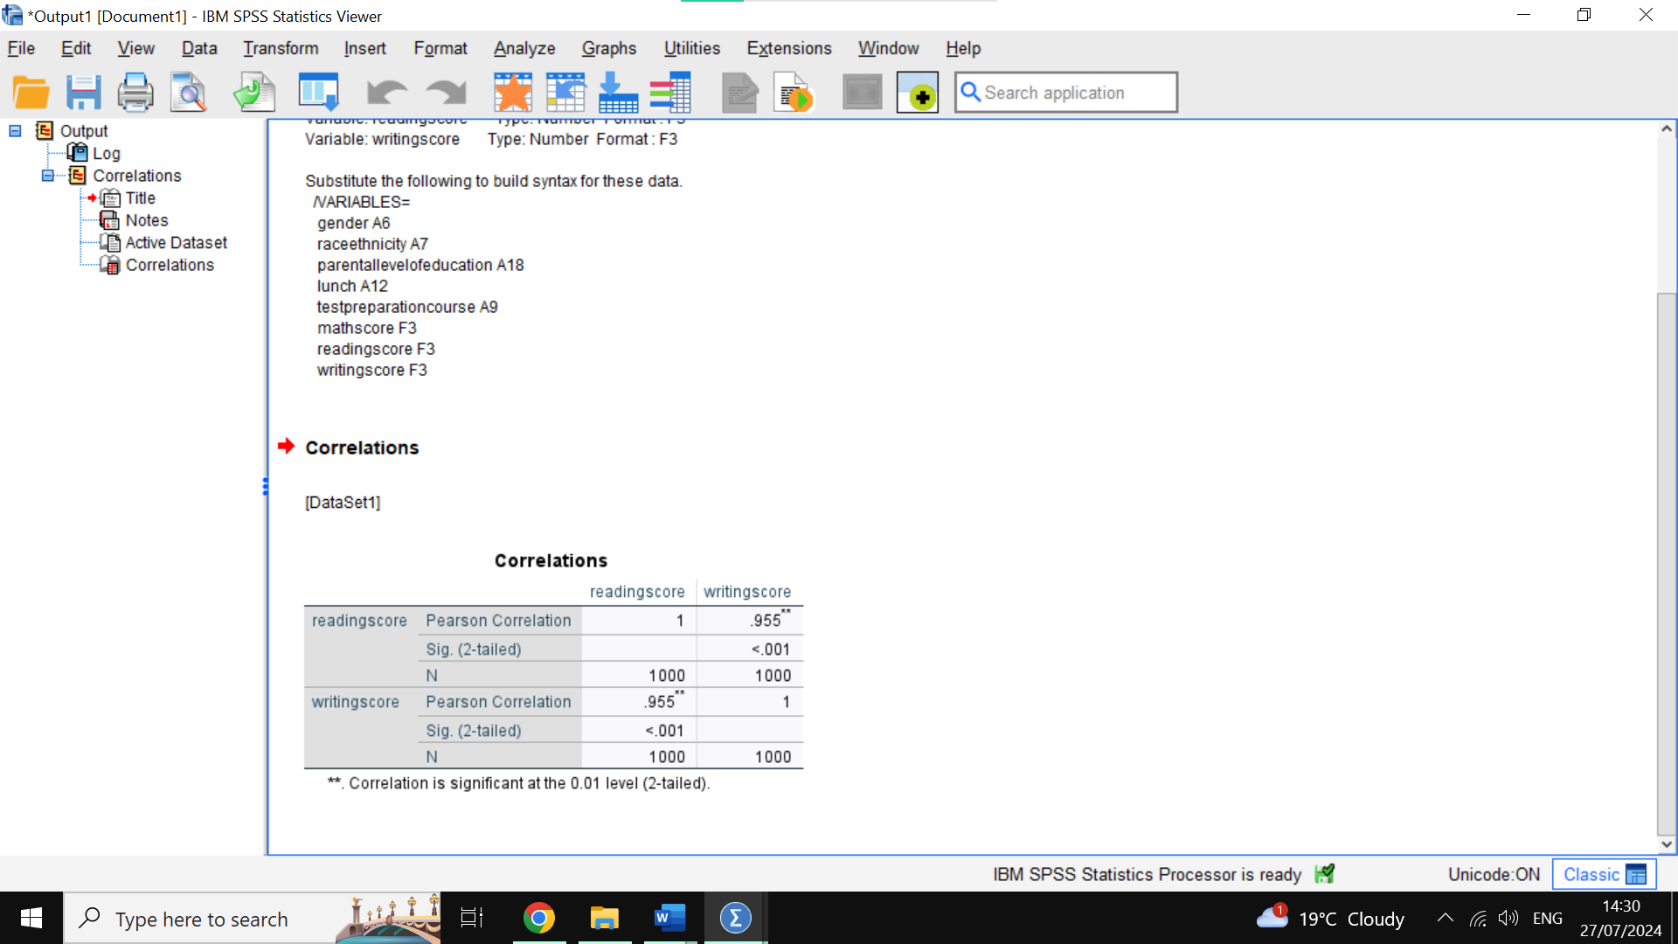Here we have our correlation of .955 which is very high, it is a direct positive correlation meaning as one score goes up so does the other.
Let’s see this in a visual way making use of a scatterplot. To do this first we click on Graphs 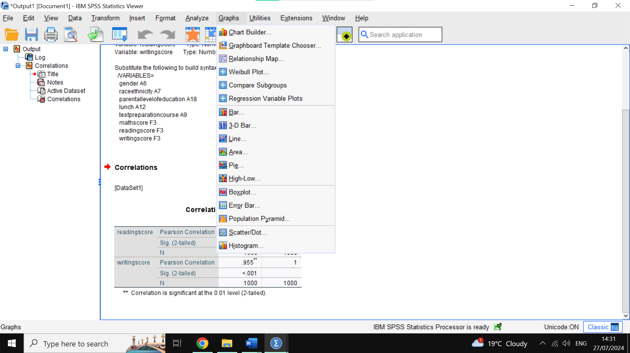Then we click on chart builder 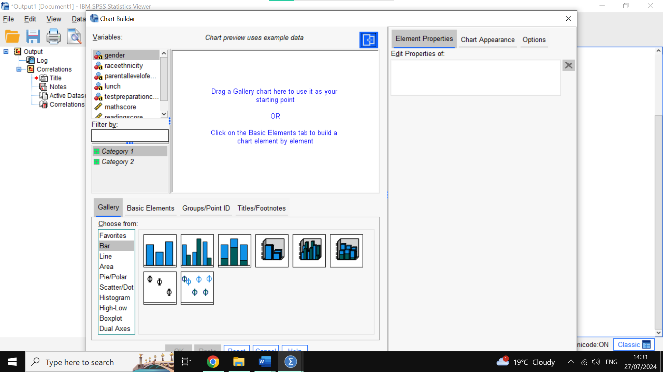We then find the scatterplot graph on the list on the bottom left 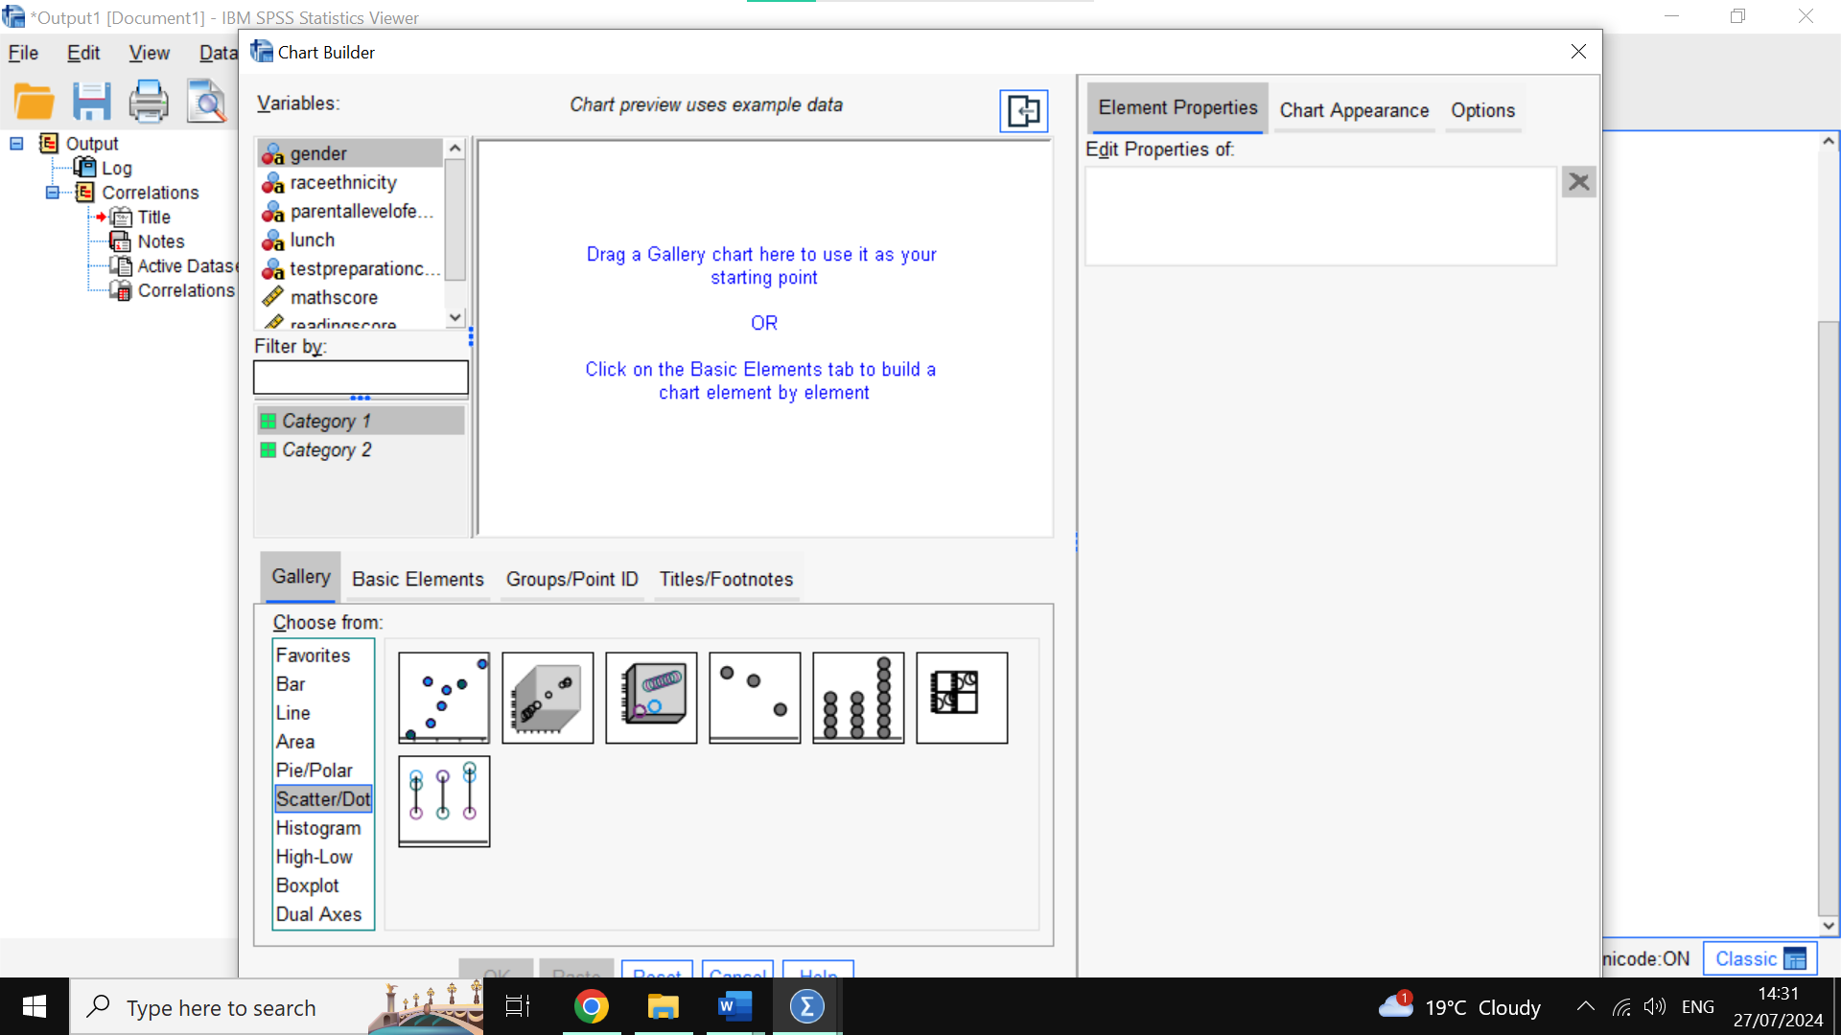 We then select the first graph and drag it above 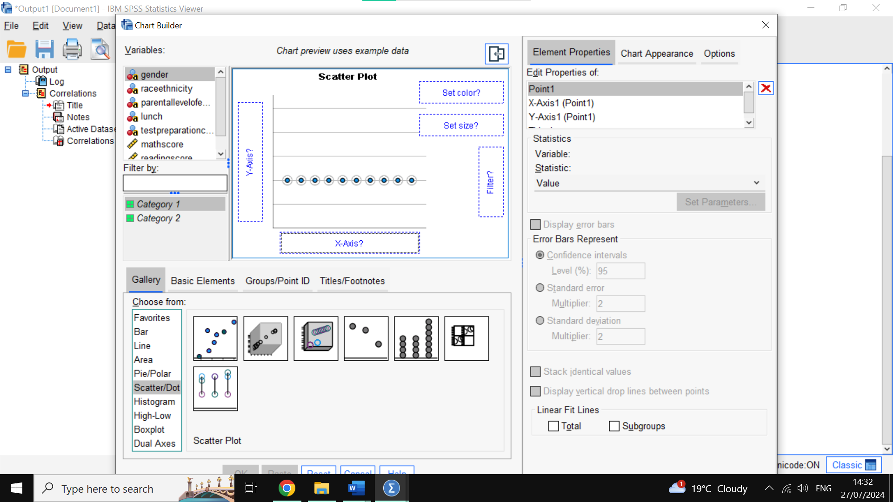We then drag writing score on the x -axis 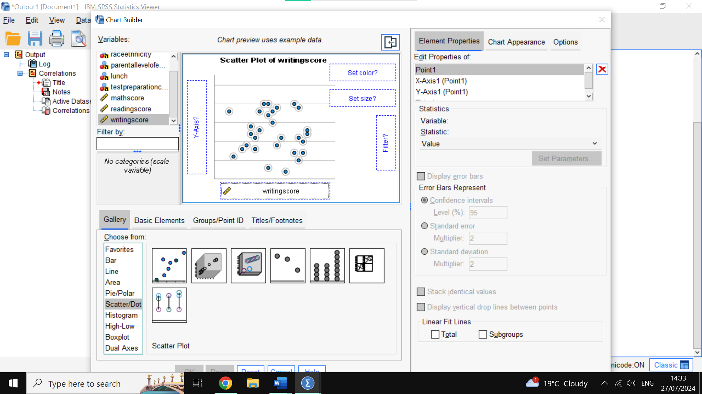We then do the same for the y-axis with the reading score 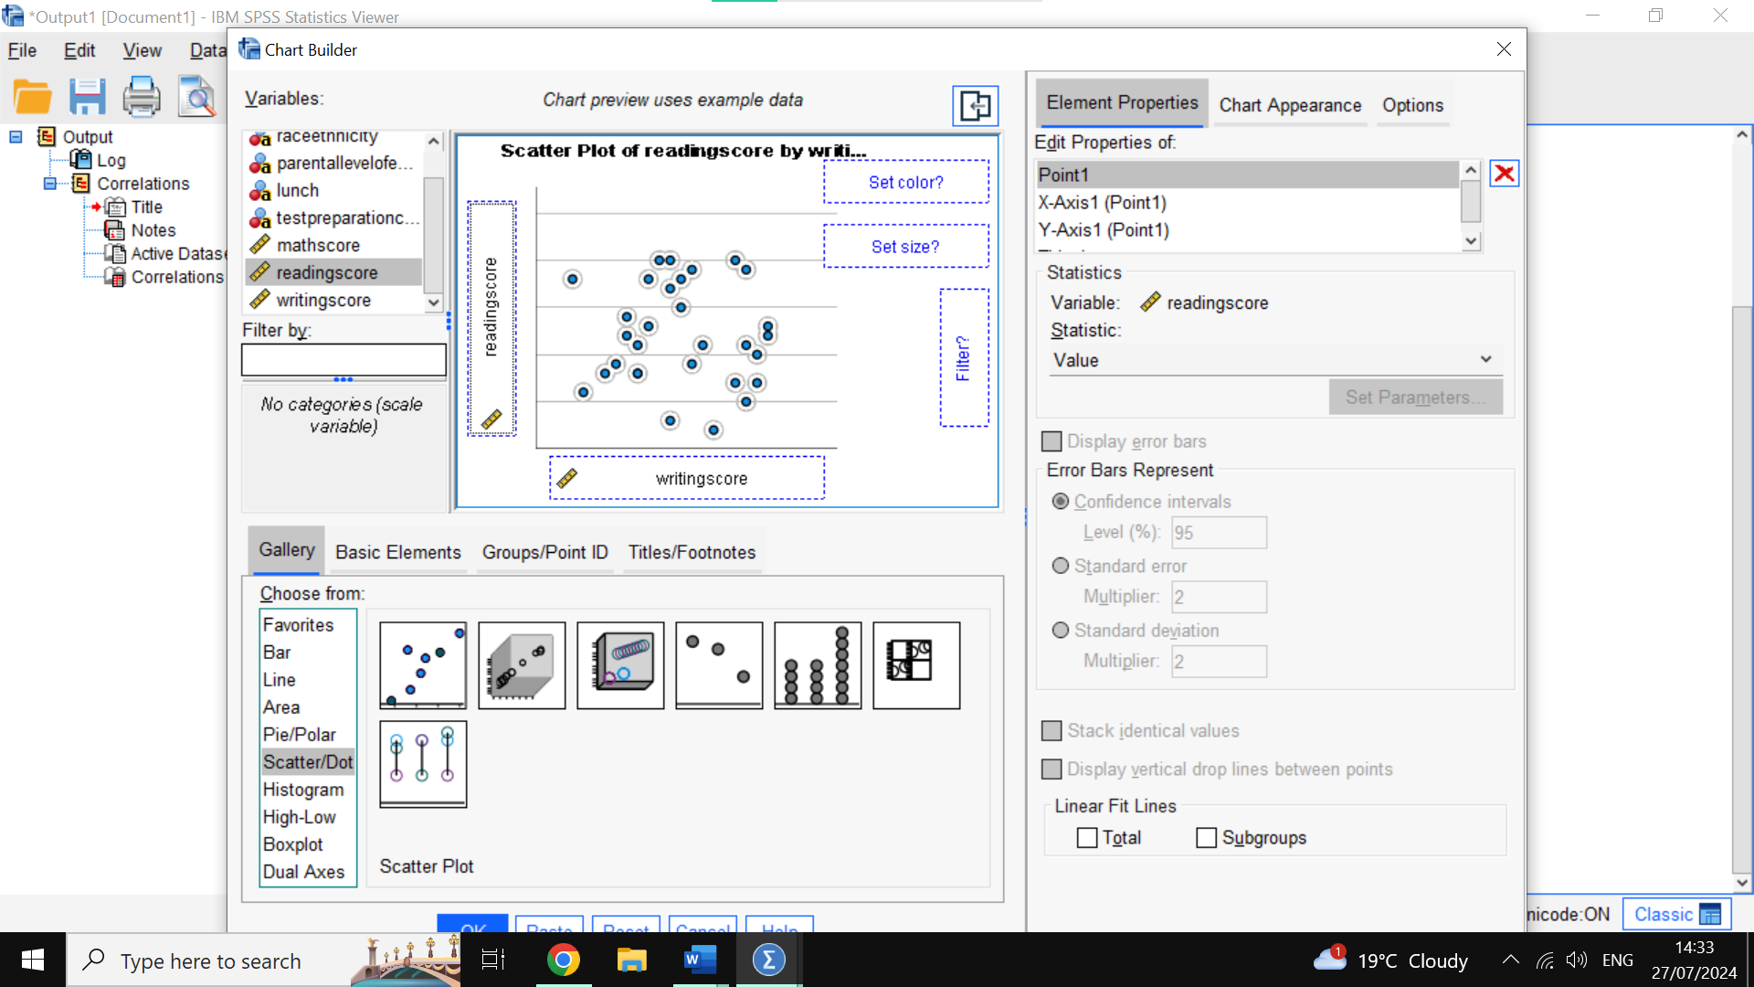And then we press okay at the bottom 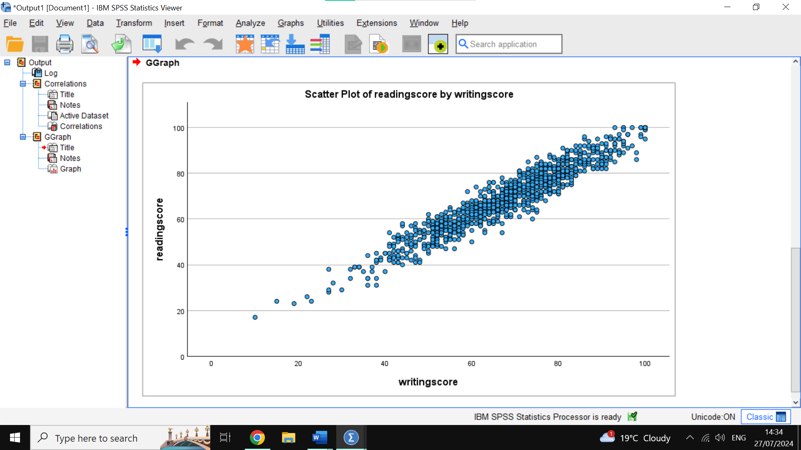Here is our scatterplot graph showing a very strong positive correlation between reading score and writing score, meaning as one score increases the other will as well. This reinforces the idea to educators that reading and writing go hand-in-hand and helps them prepare learning material according to this knowledge.

Advantages and disadvantages of SPSS, excel and Tableau

SPSS
SPSS has many advantages; it is made specifically for statistical analysis so it is a well-designed tool for professionals. However, despite that it is also easy to use for new users, because it has a user-friendly interface and options.
The program also comes with a lot of information to help users learn about statistical functions, and it has graphical representation to create charts and graphs for easier visualization of data and understanding of implications.
SPSS is also better equipped to deal with large sets of data, better than its counterparts.
The disadvantages of this advanced program are the cost of it, as it is so advanced it is being sold at a somewhat expensive price which can be a problem for single users or small businesses.
It also needs users that want to use its full capabilities to undergo training or have extensive knowledge and time to figure it out by themselves, as despite being easy to use, having full mastery of all functions requires a lot of time. For example, we can see that Morgan et al. (2004) say SPSS has many steps to understand it such as ‘outputs, data entry and checking, reliability assessment, testing assumptions, and descriptive inferential and nonparametric statistics’.

Excel
Excel is the most commonly available software for data analysis, it is very popular and thus very user-friendly, making it easy for anyone to access and understand. It is a versatile program good for simple tasks and complex analysis alike, while being widely available as it is part of the Microsoft Suite. According to LaPolla (2020) ‘because of its widespread availability, Excel offers a compelling opportunity for providing hands-on data visualization’.
This is very important because it means Excel can integrate easily with any other Microsoft applications such as word or outlook, making it easy to export and import data and share it with others. Even more so because of the editing together function where two or more people can work together in the same file.
Lastly Excel has the advanced functionality of programming scripts to help with complex or repetitive tasks, making it highly customizable for one’s own purposes.
The disadvantages however are considerable as well, mainly the fact that inputs are manually typed and this can easily lead to errors that disrupt the whole dataset or table, leading to error messages or incorrect values.
Excel also has many different versions and sometimes data can be lost or corrupted when opening a file with a different version.
It is also limited in some advanced functions and can struggle with very large data sets, where other more specialized software might be appropriate.

Tableau
Tableau’s main advantage and leading area is the fact that it can show data visually better than its competitors, it simplifies complex data into easy to understand graphs and charts for people to discuss and draw insight from.
Tableau is made in a way that it integrates well most data sources such as spreadsheets, databases and others. This means it can visualize data from other software quite well.
The speed of the program is also very high as it can handle large datasets and create visual reports quickly, helping draw conclusions faster and easily as their interface is user friendly. Carlisle (2018) states that ‘Tableau didn’t invent the interactive dashboard, but it popularized it’, which shows how well known this software is for its user friendliness and ease of use.
However, this is what most of Tableau is limited to, it has many limitations of performing statistical analysis compared to its competitors, and therefore it relies on the input data being of good quality and already analysed and sorted, otherwise the visualizations created by Tableau will be misleading.
This makes Tableau a very good software to use together with other data analysis software as the program has limited data manipulation tools by itself. The cost of Tableau is also significant and not commonly used by single users, specially as it requires more fees to unlock all the features.

Data mining cycle
The data mining cycle is the process to extract conclusions and insight from data patterns and trends, according to Reffat et al. (2004) ‘the growth of many business, government and scientific databases has begun to far outpace human’s ability to interpret and digest the data.’ Which is why ‘the increasing use of databases to store information provides the background for the use of data mining techniques.
The process of this cycle is to first have a goal or objective in mind, then cleaning the data by removing missing values or duplicates, and integrating the data collected from different sources.
Then the data can be analyzed to see trends and visualize it better, when this is done, we can then use data mining techniques to create a model.
We then apply the model and see how it performs in terms of accuracy; we may apply different models and use the most accurate one after testing.
Once we have our selected model, we can apply it to real life and monitor it to see if it is performing well, by doing this whole process we can help forecast the future.
If we do this correctly it can give us a great competitive advantage, staying ahead of trends and always prepared, this model if efficient will lead our marketing strategy and help us optimize our resources.

References

Cao, W. (2021). Discussion on mean, median, mode and its validity and table number. Journal of Contemporary Educational Research, 5(3).Available at: https://ojs.bbwpublisher.com/index.php/JCER/article/view/1949 Accessed on: 12th July 2024
Carlisle, S. (2018). Software: Tableau and microsoft power bi. Technology| Architecture+ Design, 2(2), 256-259. Available at: https://www.tandfonline.com/doi/full/10.1080/24751448.2018.1497381 Accessed on: 12th July 2024
Coll, R. A., Coll, J. H., & Thakur, G. (1994). Graphs and tables: a four-factor experiment. Communications of the ACM, 37(4), 76-87. Available at: https://go.gale.com/ps/i.do?id=GALE%7CA15313464&sid=googleScholar&v=2.1&it=r&linkaccess=abs&issn=00010782&p=AONE&sw=w&userGroupName=anon%7Ea311f1c3&aty=open-web-entry Accessed on: 12th July 2024
Guerrero, H., Guerrero, R., & Rauscher. (2019). Excel data analysis. Springer International Publishing. Available at: https://link.springer.com/book/10.1007/978-3-030-01279-3 Accessed on: 12th July 2024
LaPolla, F. W. Z. (2020). Excel for data visualization in academic health sciences libraries: a qualitative case study. Journal of the Medical Library Association: JMLA, 108(1), 67. Available at: https://www.ncbi.nlm.nih.gov/pmc/articles/PMC6919992/ Accessed on: 12th July 2024
Morgan, G. A., Leech, N. L., Gloeckner, G. W., & Barrett, K. C. (2004). SPSS for introductory statistics: Use and interpretation. Psychology Press. Available at: https://www.taylorfrancis.com/books/mono/10.4324/9781410610539/spss-introductory-statistics-george-morgan-gene-gloeckner-karen-barrett-nancy-leech Accessed on: 12th July 2024
Reffat, R. M., Gero, J., & Peng, W. (2004, November). Using data mining on building maintenance during the building life cycle. In Proceedings of the 38th Australian & New Zealand Architectural Science Association (ANZASCA) Conference (pp. 91-97). Available at: https://anzasca.net/wp-content/uploads/2014/08/ANZAScA2004_Reffat.pdf Accessed on: 12th July 2024

