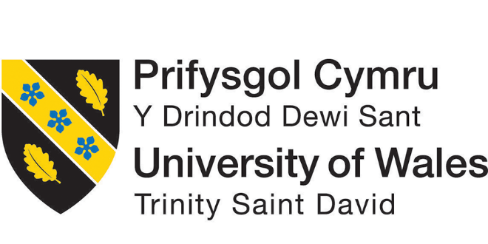

Assessment 1: Organisational Structure and Culture
Module: Introducing the modern workplace

Name student: ANA BAICU
Student Number: 2012401
Module lecturer’s name: GREGORY COWAN
Module Code: LCBB4003

Table of Contents
Introduction: 3
An Overview of Organisational Structure, Culture, and People of Accenture 4
Structure of Accenture 4
Culture of Accenture 6
People of Accenture 7
Impact of Structure, Culture, and People on Organizational Performance 8
Factors Determining Effective Management and Leadership 9
Factors Affecting Different Individual Behaviours to Evaluate Behavioural Approach to Management 10
Personal Factors 10
Environmental Factors 10
Organisational Factors 10
Conclusion 12
References 13

Introduction:
Every company has organisational structure, which refers to and regulates the relationship between the different individuals, the responsibilities people conduct, and company regulations, cultures, and leadership and managerial performances of the individuals. An organization can be identified by its culture. An organisational culture defines the assumptions, principles, traditions, and features of the people within the organization and their attitudes and behaviors. Within an organisation, structure, culture, and people have an impact on the performances of that certain organisation (Modarres, M. and Pezeshk, J., 2017). In this following report, the structure, culture, and people of Accenture UK will be evaluated and their impact on the performances. Behavioural factors and variables of managerial leadership will also be discussed herein to assist with several theories and models.

An Overview of Organisational Structure, Culture, and People of Accenture
The organizational structure is required to identify a managerial hierarchy within an organisation. It describes the company’s function, line of work, and chain of command within the organization. A structure determines the organisation to achieve its mission, vision, and goals. An organisational structure is important to the sustainability of an organization in the global marketplace. Moreover, without a structural management framework, a company is incapable of establishing a company-wide communication, the structure lacks its maximum efficiency. The standard structure, the divisional structure, the matrix structure, and the flatarchy structure are four distinct forms of organizational structure. Each hierarchical structure has specific benefits and drawbacks. These can only operate with companies in different circumstances (Bogdanovska Djurovic, 2010).

Structure of Accenture
Accenture is a professional service company. The purposes of the company are global consulting services, technological services, and outsourcing which incapable its clients to get high-performance in business. Accenture functions in more than 200 cities in over 52 countries. It has 170,000 staff. It serves clients in over 120 countries all over the world. According to the fiscal year 2009, the net revenues of the company are over US$21.50 billion (Accenture.com. 2021). It follows a flatarchy structure in four distinct levels, those levels are 1. Director 2. Manager 3. Consultant and 4. Analyst. Accenture has four different dimensions for its operation. The professionals of the Operating Group deals with understanding the industry, business trends, and technologies suitable for the company. To develop the skills and professionalism of the people of the company, Accenture emphasizes three Growth Platforms. These are managerial consultation, Outsourcing of businesses, and technology development. The Geographical Group allocates the employees with responsibilities among 4 regions in 52 countries. Corporate Function deals with all the administrative support functions as follows R&D, Marketing, Finance, Human Resource Management, Legal, Commercials, and Quality Development (Ghaffar, 2021).

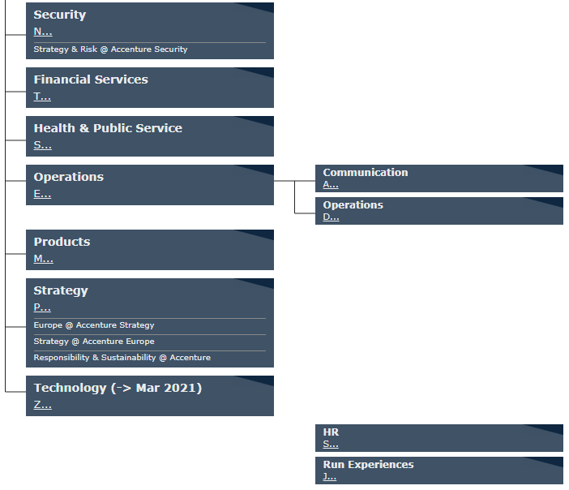
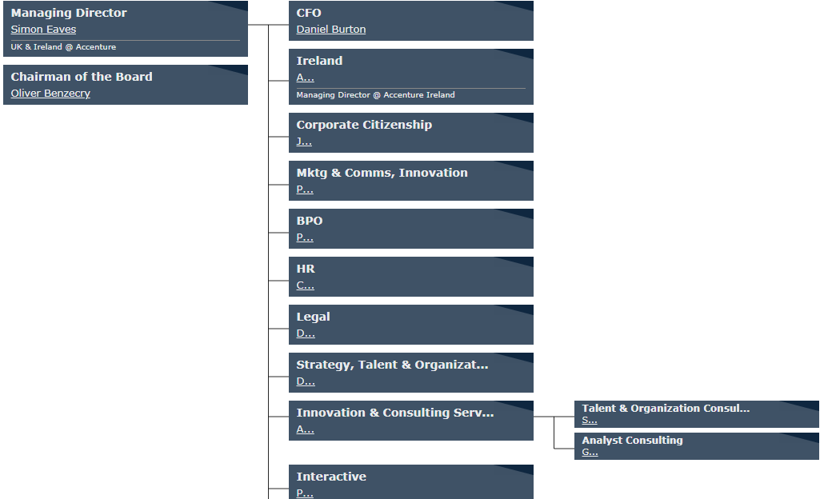
Figure 1: Structure of Accenture
Source: (Accenture.com. 2021)

Culture of Accenture
Organisational culture identities an organisation. Organizational culture is a set of beliefs, values, and behaviors which direct the activities of people within an organisation. As a set of features that make the organisation better than the competitors. A significant culture can guide the performances of people to improve. An unstructured culture of an organisation can obstruct the way of success for that organisation (CengageEMEA, 2021).
Accenture employed more than 12,500 people in the UK and Ireland. It focuses on diversity and equality in the workplace. Its remarkable contribution to establishing a favorable working environment for its people. Contributing to the African Caribbean Network, Accenture has achieved the 2015 European Diversity Award for The best Employee Network (Accenture.com. 2021). The organization includes cultural awareness programs, access to online information, and training programs. It trains for inclusiveness and diversity through workshops on racial discrimination. These sessions offer managers to create a comfortable working environment and motivate their teams. The organisation also organizes a wide range of activities to celebrate the diversity of its people. This includes celebrations of Pride Week and International Women's Day, as well as on-site training events with professionals from outside of the organisation. Networks among the people within this organization are motivated to coordinate together. The motive is to support the entire workforce rather than individuals. It took several approaches for the gender diversity, it not only focuses on the integration of maternity but also provides leadership program and proper guidance. It provides 32 weeks of parental leave for both male and female parents (Accenture.com. 2021). The organisation also offers a variety of flexible career advancement opportunities including part-time work, paid leave, and leave for study. Equality in sharing agendas, benefits, and responsibility is available in the culture of this organisation. In a survey on the 8,644 Accenture employees, agility is the most regularly expressed cultural value and creativity is the most strongly shared value (Karthick, K., 2010).

People of Accenture
People within an organisation are involved in managerial functions. These functions include Directing, Planning, Organising, Controlling, and staffing. Jeff’s philosophy on the people of an organisation is that people getting the opportunity to create something valuable, the resources to do so, and they perform their best if they get enough space for themselves. He believed in the efficiency of people and their careers give them to work effectively for the development of the organisation. The managers of an organisation involved in solving problems and the management decision-making process (Ghaffar, 2021). The process includes identifying opportunities, developing alternative solutions, selecting the most efficient alternatives, implementing a proper solution, and finally evaluating the solution for making a prominent decision for the organisation.
Accenture has developed strategic planning for its workforce for the future. This is a proactive employment strategy. It has focused on the systemic way rather than organic. Strategic planning is sufficient to create a sustainable working environment for the people to support company interests. About 60% of the employees are not properly ready the cope up with changes in different managerial skills to bring a significant development towards digitalization of the company (Accenture.com. 2021). People and computers play a significant part in the achievement of prescriptive simulation analytics models. They offer adaptability and expertise that enhance proactive workforce management. The achievement of the enormous progress in recent years by modern networking and networking technologies could not replace the advantages of co-locating employees in the workplace for few days. Making the workplace secure for employees to return is a major challenge that many organizations are finding difficult. Accenture coordinates people who are determined to be in this organisation. The people of Accenture are higher educated and competent than others. They are also trained professionally while on the job. Accenture people are dynamic, young, disciplined, and ambitious .they also desire to be properly compensated and appreciated (CengageEMEA, 2021).

Impact of Structure, Culture, and People on Organizational Performance
The global mission and vision of Accenture have an impact on the organisational skills required in different geographical areas. They stayed focused on outstanding customer experience and became the best consultation firm in the world. To emphasize the expectations of its clients the managers have different performances based on geography. It never compromises the quality of performance (Karthick, K., 2010).
Accenture always emphasises the use of technologies within the organisation to make things easier and modernize to exchange information. This information is passed from one geographical area to others to implement the best strategy to improve performance. Accenture can provide low-cost service and increase the growth rate in some areas. This growth rate can help to get the highest turnover in the global consultation market (Ghaffar, 2021).
The impact on the performances of Accenture is significantly based on cultural factors. Which includes the cultural norms, values, and beliefs of the organisation. Most of the time, Accenture contributes to focusing on the cultural factors of the company. In certain geographical areas, managers struggle to make proper decisions to find the proper way of doing business. They argue among each other that causes a negative impact on the performances of Accenture. This kind of culture downwards the growth rate and market share. This organisation believes the core values of the company help it to gain a strong position in the market. The values also influence the customers to get a consultation from this company. Even the highly educated and skilled people also find this organisation for their dream company. Accenture is continuously using technology to assist its people. The people in Human Resource and Financial Supports are getting benefited using these technologies. These supports motivate them to be responsible to increase performance (Zgrzywa-Ziemak, 2015).
The economic structure of the organisation has also an effective impact on performance. From the beginning, Accenture has valued its people. It considers as significant resources the people who have also recruited for project-based jobs and contractual works (Idowu, 2016).

Factors Determining Effective Management and Leadership
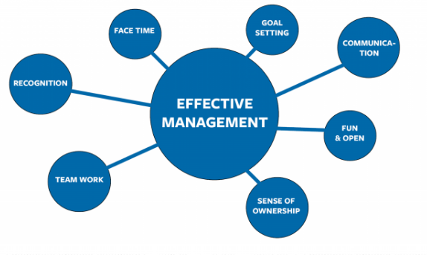
A leader as a people of an organisation required several skills that will enhance the effective management decision. To assess the performances of the leaders of an organisation is challenging for an organisation. Measuring the effectiveness of these leaders it requires time and cost. There are some models used to determine the variables to evaluate the leaders on management. A model of Seven Dimensional Factors can determine the effective management and leadership (Modarres, M. and Pezeshk, J., 2017). These are

Figure 2: Factors affecting leadership
Source: (Karthick, K., 2010)

Setting a clear goal is an effective way of preparing a perfect plan and using proper resources to improve in decision making. Engaging with other people in the organisation by team based communication can define the best leader. The leader should always seek for opportunities and guiding the people by using sense of ownership. By owning the trust leader will emphasise on team work. He/She would make the people engaged with each other to take part in decision making process. This will lead the organisation to get better performance in the market. Focusing on the target objectives the leadership must appreciate the people of his/her team which can boost them to work better and more responsible. Creating a friendly environment in the workplace can maximize idea sharing and motivate them to work hard (Journal of International Business and Management, 2020).

Factors Affecting Different Individual Behaviours to Evaluate Behavioural Approach to Management
Three major factors affect individual behaviours. These are
1. Personal Factors
2. Environmental Factors, and
3. Organisational Factors

Personal Factors
People require some characteristics which they acquire genetically and learning from the environment. The genetic or the biographic characteristics cannot be changed. When a manager can identify the qualities and limitations of an individual he/she can use it for the benefit of the organisation. Managers can identify the intelligence, experiences, and abilities to evaluate them. Whereas individuals acquire values, personalities, attitudes learning from the environment (Karthick, K., 2010).

Environmental Factors
These consist of economic, socio-cultural, political, and legal factors. Satisfactions towards the job of an individual mostly depend on these factors. Employment rate, technological advancement, and overall economic environment create a perception about individuals of a certain area. Relationships with family, friends, and work colleagues can also determine the behaviours of an individual (Modarres, M. and Pezeshk, J., 2017). The country having a stable political environment creates the opportunity for foreign investments. Individuals are afraid to invest a huge amount of capital in an unstable political environment. These political environments can determine the freedom of individuals in buying decisions.

Organisational Factors
Individual behaviors within an organisation significantly depend on the structure, culture, and working environment of the organisation. An individual looks for a proper structure of hierarchy while reporting. Individuals seek comfortability working in a flexible environment. Managerial leaders play a significant role in the behaviour. They mostly influence the behaviours of individuals by proper guidance and instructions. Getting rewards and recognition has always been a great motivation for individuals (CengageEMEA, 2021)

Conclusion
Organisational performance has a strong relationship with the structure, culture, and people of an organisation. The proper structure of reporting hierarchy, work environment, and leader of an organisation can increase the productivity of an organisation with effective performance to its customers. In this report, the structure, culture, and people of Accenture are deeply analysed adequately. The factors that affect the behaviours of the individuals can also be maintained through developing leadership skills, a flexible work environment, and proper training.

References
Accenture.com. 2021. Accenture | Let there be change. [online] Available at: <https://www.accenture.com/gb-en> [Accessed 10 March 2021].
Bogdanovska Djurovic, A., 2010. Organizational Structure and Culture and Its Impact on Knowledge Management Processes - The Case of Thomas Cookks Experience with Accenture (2002-2007). SSRN Electronic Journal,.
Cengage.com. 2021. 9781305501393 | CengageEMEA. [online] Available at: <https://www.cengage.com/c/organizational-behavior-managing-people-and-organizations-12e-griffin/9781305501393/> [Accessed 10 March 2021].
Ghaffar, F., 2021. Examples of Effective Management and Leadership. [online] MENAEntrepreneur.org - Entrepreneur Blog - Business Directory. Available at: <https://menaentrepreneur.org/2019/10/examples-of-effective-management-and-leadership/> [Accessed 10 March 2021].
Idowu, O., 2016. Understanding Organisational Culture and Organisational Performance: Are They Two Sides of the Same Coin?. Journal of Management Research, 8(4), p.12.
Journal of International Business and Management, 2020. Leadership Behaviour Influence Organisational Commitment, Organisational Culture and Job Satisfaction at Public University in Malaysia.
Karthick, K., 2010. Organisational Behaviour. New Delhi: Himalaya Pub. House.
Modarres, M. and Pezeshk, J., 2017. Impact of total quality management on organisational performance: exploring the mediating effects of organisational learning and innovation. International Journal of Business Environment, 9(4), p.356.
Zgrzywa-Ziemak, A., 2015. The Impact of Organisational Learning on Organisational Performance. Management and Business Administration. Central Europe, 23(4), pp.98-112.

