Intercultural competence and leadership

Student ID: 2130036
Student name: Denis Buzdugan
Word Count: 1193
Module title: Foreign Languages and Cultural Awareness, BMIH5003
Lecturer’s name: Giulia Chifari

Executive Summary
The study focuses on Japan's cultural and business environment for the Diversity Hotel & Spa's expansion. Japan demonstrates respect for authority, collectivist principles, and consensus-oriented decision-making, according to the GLOBE Project. It is determined that in order to guarantee visitor happiness and prevent miscommunication, hotel staff must possess cultural knowledge and sensitivity. Cultural sensitivity training, a varied staff, effective communication, and community involvement are among the recommendations. By embracing these components, the Diversity Hotel & Spa will be able to flourish in the Japanese market, building a solid reputation and a distinctive marketing proposition in an international setting.

Table of Contents
Introduction 5
Main body 6
Culture and customs of Japan 6
Country analysis on Japan 7
Cultural intelligence and sensitivity 8
Recommendations to General Manager 10
Conclusion 11
Reference 12

List of figures
Figure 1 sushi, sashimi, and tempura 6
Figure 2 Japan's scores across six cultural dimensions using Hofstede's 7
Figure 3 luxury interior of hotel in Japan 8
Figure 4 rising tourism in Japan 9

Introduction
In the comprehensive study, it delves into the cultural and business environment of Japan, a country characterized by its deep-rooted customs and traditions. As to the culture and leadership study conducted by the GLOBE Project, Japan is known for its strong sense of collectivism, deference to authority, and prioritization of harmony and agreement in decision-making. The purpose of this study is to highlight how important cultural sensitivity and intelligence are in a business environment, particularly for hotel staff. It is essential to know and respect Japanese traditions, communicate clearly, and modify services to suit each customer's tastes in order to maximize guest happiness and prevent cultural misunderstandings. The report's conclusion will be a brief set of recommendations presented to the general manager, intended to help the Diversity Hotel & Spa navigate Japan's cultural differences with success while maintaining the values of its brand.

Main body

Culture and customs of Japan
The hotel brand has expanded its portfolio with the opening of the Diversity Hotel & Spa in Japan. Japan's culture is steeped in custom and values humility, peace, and respect. The sophisticated and refined vocabulary of the nation reflects its hierarchical culture (Roden, 2023). Japanese tea ceremonies and cherry blossom gazing are two rituals that are extremely indicative of the country's deeply rooted customs and traditions. Punctuality is a mark of respect and group unity is highly prized. Japan is known for its sushi, sashimi, and tempura, which are enjoyed all over the world. Giving gifts is a crucial part of developing connections, and value comes before cost.
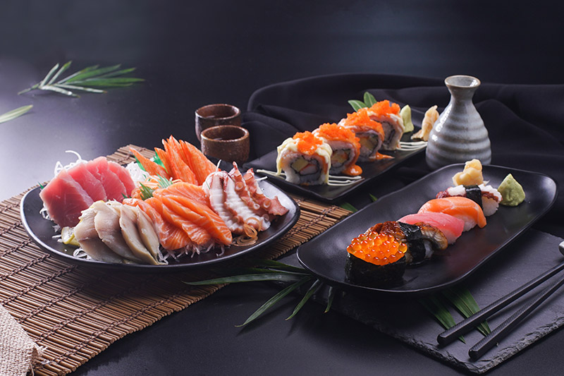
Figure 1 sushi, sashimi, and tempura
(source: Japanese-food-culture, 2023)

Country analysis on Japan
It is essential to examine Japanese culture and leadership via the prism of the GLOBE Project's culture and leadership research in order to expand the Diversity Hotel & Spa to Japan.
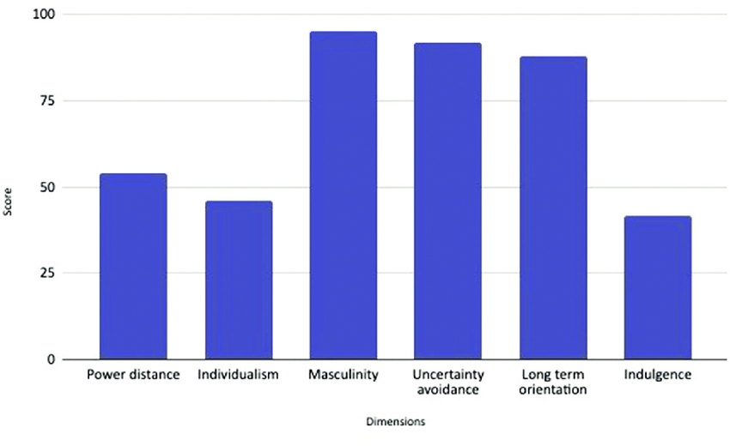
Figure 2 Japan's scores across six cultural dimensions using Hofstede's
(source: researchgate.net, 2023)
The following are some crucial aspects of culture and leadership that are extremely applicable to this situation:
Power Distance: Japan emphasizes deference to hierarchy and authority and has a moderate to high power distance culture. The general manager needs to modify their approach to leadership to take these frameworks into account (Irwin, 2020).
Collectivism: Japanese culture emphasizes collective harmony and consensus, placing a high importance on collectivism. The general manager needs to promote teamwork among employees and consensus-building in decision-making (Gnap et al., 2021).
Uncertainty Avoidance: People in Japan tend to avoid uncertainty and prefer situations that are ordered and governed by rules. For local staff, the general manager should give clear brand standards, well-documented procedures, and comprehensive training materials (Funamori, 2019).
Long-Term Orientation: Perseverance, loyalty, and sustainability are prioritized in Japan's long-term orientation. The general manager should exude a dedication to provide top-notch customer service, creating enduring connections with clients, and gradually giving back to the community.
Confucian Dynamism: Japanese culture emphasizes perseverance, economy, and respect for customs by fusing Confucian and traditional principles. The general manager is responsible for making sure that the hotel upholds and respects traditional Japanese customs and rituals in all of its interactions and services (Yokoi et al., 2022).

Cultural intelligence and sensitivity
The hotel industry requires a high degree of cultural intelligence and sensitivity, especially for brands that are expanding internationally like the Diversity Hotel & Spa. These characteristics significantly affect every aspect of the visitor experience, from the time of check-in to the time of check-out.
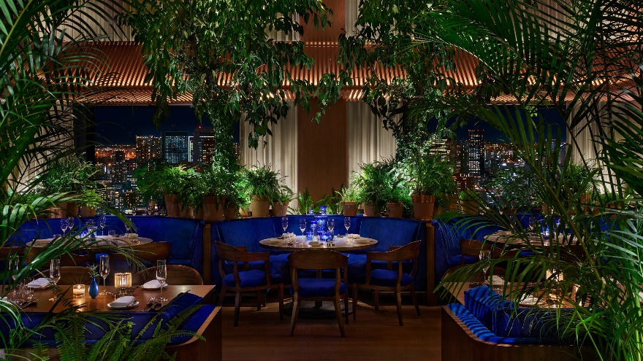
Figure 3 luxury interior of hotel in Japan
(source: cntraveler.com,2023)
Guest happiness is the cornerstone of the hotel sector. Anticipating and fulfilling the unique expectations of guests from different cultural origins requires cultural intelligence and sensitivity. Hotel staff that are aware of and sensitive to these unique cultural requirements are better equipped to make guests' stays more comfortable and joyful, which increases client satisfaction and builds loyalty. Positive evaluations and word-of-mouth referrals follow from this (Thomas et al., 2015).
Furthermore, these qualities are critical in avoiding cultural misinterpretations that could cause discomfort, offence, and reputational harm to the hotel. Staff members risk unintentionally breaking cultural conventions, using improper language, or serving food that doesn't comply with dietary requirements if they lack cultural intelligence and sensitivity. Such mistakes can have a serious detrimental effect on the visitor experience, resulting in bad press and reputational damage (Chao et al., 2017).
Understanding nonverbal clues and linguistic subtleties is made easier with the help of cultural intelligence, which improves communication. Positive relations are ensured by the ease with which disagreements can be resolved and guest issues can be addressed while honoring the guest's cultural background (Charoensukmongkol, 2015). It is equally important to personalize services based on cultural awareness. When a hotel goes above and above to offer experiences and services that suit their cultural preferences, it is much appreciated by its patrons. This not only increases their level of happiness but also distinguishes the hotel as one that cherishes and respects its varied customers.
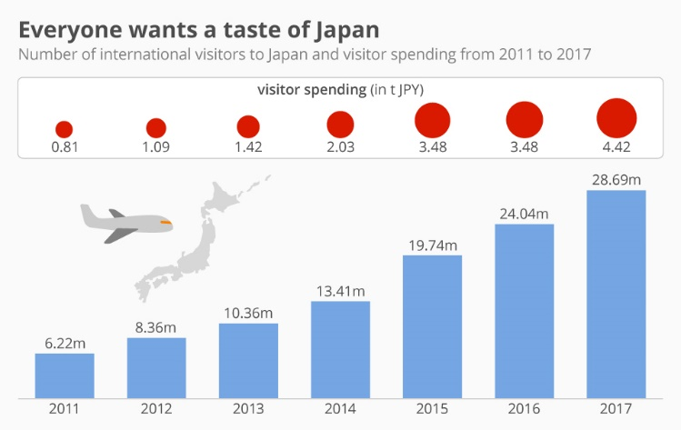
Figure 4 rising tourism in Japan
(source: statista.com, 2023)
In the hotel business, cultural acuity and sensitivity are essential for maintaining employee morale, protecting brand reputation, and satisfying guests. These attributes are critical for success in this cutthroat industry since they are crucial in today's globalized and varied globe (Livermore and Soon, 2015).

Recommendations to General Manager
- Provide workers with thorough cultural training that focuses on the unique cultural subtleties of the target market in order to improve their cultural intelligence and sensitivity (Okamoto, 2015).
- Promote variety in the staff to ensure that multilingualism is available for interactions with visitors from different origins.
- To overcome language obstacles and ensure clear communication, use multilingual signs and documentation.
- Promote service customisation to accommodate varying visitor cultural preferences, such as eating alternatives and lodging amenities.
- Create a feedback system that enables visitors to discuss their cultural experiences and contribute to ongoing efforts to increase cultural awareness (Strielkowski, 2017).
- Continually educate employees so they are aware of cultural norms and trends.
- To have a deeper understanding of the cultural backdrop, cultivate relationships with neighborhood and cultural organizations in your area.

Conclusion
The comprehensive study of cultural sensitivity and intelligence in the setting of the Diversity Hotel & Spa emphasizes how crucial these concepts are to the hotel business, especially for companies looking to expand internationally. These attributes are not only beneficial but also necessary. They guarantee a committed and varied staff, protect the brand's reputation, and raise visitor pleasure. The success of the hotel depends on its capacity to understand and respect the many cultural demands of its visitors, prevent miscommunication, and communicate clearly. The Diversity Hotel & Spa may prosper in a diverse and international environment while upholding its reputation for outstanding hospitality and inclusion by encouraging cultural intelligence and sensitivity among its staff.

Reference
Chao, M.M., Takeuchi, R. and Farh, J.L., 2017. Enhancing cultural intelligence: The roles of implicit culture beliefs and adjustment. Personnel Psychology, 70(1), pp.257-292.
Charoensukmongkol, P., 2015. Cultural intelligence of entrepreneurs and international network ties: The case of small and medium manufacturing firms in Thailand. Management Research Review, 38(4), pp.421-436.
Funamori, M., 2019, July. Thought experiment on the impact of plan s on non-plan s countries and japan. In 2019 8th International Congress on Advanced Applied Informatics (IIAI-AAI) (pp. 371-378). IEEE.
Gnap, J., Senko, Š., Kostrzewski, M., Brídziková, M., Cződörová, R. and Říha, Z., 2021. Research on the relationship between transport infrastructure and performance in rail and road freight transport—A case study of Japan and selected european countries. Sustainability, 13(12), p.6654.
Irwin, H., 2020. Communicating with Asia: Understanding people and customs. Routledge.
Livermore, D. and Soon, A.N.G., 2015. Leading with cultural intelligence: The real secret to success. Amacom.
Okamoto, T., 2015, January. Otaku tourism and the anime pilgrimage phenomenon in Japan. In Japan forum (Vol. 27, No. 1, pp. 12-36). Routledge.
Roden, D.T., 2023. Schooldays in imperial Japan: A study in the culture of a student elite. Univ of California Press.
Strielkowski, W., 2017. Promoting tourism destination through film-induced tourism: The case of Japan. MARKET/TRŽIŠTE, 29(2), pp.193-203.
Thomas, D.C., Liao, Y., Aycan, Z., Cerdin, J.L., Pekerti, A.A., Ravlin, E.C., Stahl, G.K., Lazarova, M.B., Fock, H., Arli, D. and Moeller, M., 2015. Cultural intelligence: A theory-based, short form measure. Journal of International Business Studies, 46, pp.1099-1118.
Yokoi, R., Nakatani, J., Hatayama, H. and Moriguchi, Y., 2022. Dynamic analysis of in-use copper stocks by the final product and end-use sector in Japan with implication for future demand forecasts. Resources, Conservation and Recycling, 180, p.106153.
Online
Japanese Food Culture: Exploring Tradition and Innovation in Culinary Practices 2023 [accessed through] [online] https://chocolatecherrykisses.com/japanese-food-culture/ [accessed on 6th November 2023]
The Tokyo EDITION, Toranomon 2023 [accessed through] [online] https://www.cntraveler.com/hotels/tokyo/the-tokyo-edition-toranomon [accessed on 6th November 2023]
Everyone wants a taste of Japan 2023 [accessed through] [online] https://www.statista.com/chart/15718/international-visitors-to-japan-and-visitor-spending/ [accessed on 6th November 2023]
Japan's scores across six cultural dimensions using Hofstede's published data, 2023 [accessed through] [online] https://www.researchgate.net/figure/Japans-scores-across-six-cultural-dimensions-using-Hofstedes-published-data-Hofstede_fig1_354721706 [accessed on 6th November 2023]

