Professional Career Development
Name: Mihaela Simona Catanoi
ID: 1705404

Table of Contents
Table of Contents 2
Introduction 3
Identify your own learning styles and the learning styles of another member of the team 3
Use a simple technique for identifying own development needs and the development needs of another member of the team 4
Identify potential barriers to learning 5
Explain how barriers to learning can be overcome 6
Briefly analyse learning/development options to meet needs of self and another member of the team 7
Identify support mechanisms for the development of self and another member of the team 8
Prepare a development plan to achieve a learning objective for self and another team member 9
Describe a method that could be used to monitor the development of self and another member of the team 11
Complete a job application form with cover letter (email) 13
Create a CV focused for the specific role you have chosen 15
Reflect upon recruitment interview process and techniques 15
Conclusion 16
References 17

Introduction
In order to be successful in academic and professional life, individuals should go in the process of personal development. This kind of approach is very much dependent on the capability and quality of the individuals and according to their preferences, the selection of personal development strategy has been done (Aubrey, 2010). Personal development is directly related with learning or effective life. In order to be efficient and effective in learning things especially the new things, individuals should have proper awareness about all the barriers of learning and the way those can be eliminated. Therefore, personal development, learning strategies the success of the individuals in their personal and professional life are very much related with one another. In this report below, all these aspects have been discussed thoroughly and in an understandable manner.
In order to learn something efficiently, different people have different strategies and styles of learning. According to the nature of the people, the strategies and the types of learning get changed. I always love to learn things by reading and writing and Kinesthetic styles (Lockwood, 2003).
My strategy is learning about anything with appropriate focus in it for which I need to read with proper concentration. Writing is another very important element of my study. It gives me clear idea about the lesson and help me to memorize more which is I think one of the most important parts of my learning process.
I always wanted to be very practical in my way of learning because it will definitely help me a lot in order to engage in the tasks in real life making all the concepts of reading very much clear and help me to be more efficient and effective in implementing my learning in my real life. It is also help me to be more efficient in innovating for improvising the way of doing things which ultimately help me a lot as a student to solve different kinds of problems with that particular issue.
Now, different people have different strategies of learning (Parke, 2020). Single personality has their own attitudes and approaches toward their learning processes which help them to be more efficient and effective in their academic and professional life. According to my understanding, my team member is very much focused on visual learning as they want to see what their learning and they want to experience the things by seeing in their eyes. Listening towards the teacher about the subject is an important element for them while they are learning things because it helps them to get enough knowledge and idea about different subject very clearly and efficiently without researching much. According to me, Kinesthetic learning styles should be more appropriate for the people under any circumstance to learn and memorize new things.
By the help of SWOT analysis, the strengths, weaknesses, opportunities, and threats individuals can be easily evaluated. It will definitely help the individuals to improve their performance efficiently.
As per SWOT analysis, I have excellent leadership skill which helped me to keep my group moving smoothly and efficiently without any interaction. I have an excellent communication skill which also makes me efficient in enhancing the relationship with others. My problem is in time management skill as I could not have efficiency in managing time. I also have problem in keeping my emotion under control which sometimes creates significant trouble for me. Therefore, I need to improve myself a lot in this field which will also make me a very good leader of my group in future and help me to do great in my personal and professional life. There will be lots of people in my group who will be the threat for me in order to take the leadership of my group in my professional life. I have to be efficient in order to solve this problem as quickly as possible. I need to keep focus in the improvement of miracles of communication, time management, and emotion control in order to make things work for me and my people.
According to my analysis of SWOT over other group members of my team, I have found that they have efficiency in managing their time accurately in order to complete the allocated task. They also have efficiency in finding out different ways of solving problems by ensuring appropriate collaboration and coordination. But they need to be more efficient in communication with others especially with the people outside of the group. They also need to be very strong in leadership in order to lead the team in my absence. Therefore, these skills they need to improve and this personal development they need to ensure in their academic life. Besides, if they can acquire leadership skill along with communication skill they will be able to become leaders of different teams at some point of time which will make them successful in their academic and professional life. There are lots of people who are trying to be the best in their field of work but the personal development is the thing about which people should be very much aware about in order to ensure appropriate development of their academic and professional life with others. In this regard, it is very important for the individuals to be very precise and accurate in evaluating themselves efficiently from time to time in order to find out different areas of development of their life which will make them successful in their way of work continuously from time to time.
Human life is full of learning. Individuals need to be very efficient in their way of learning things in order to use them well in their personal and professional life. But learning is a complex process with which individuals need to cope with properly. There are lots of barriers in academic and professional field for the individuals file their learning things. For instance:
Peer Pressure: Sometimes, due to lack of self confidence in comparison with others in the classrooms or organisation, individuals may find it difficult to clear their view about any subject by asking questions to the teachers and instructors results in creating trouble for them to learn properly (Bargh, & Morsella, 2008). It is one of the most common reasons for the failure of learning of the individuals.
Fear of Failure: The mindset of individuals will definitely create trouble for them to learn properly. Individuals are finding it quite difficult to break all the barriers of their mind while learning a new thing (Goodfriend, & Arriaga, 2018). In most of the cases, people are having fear of failure which keeps them behind in achieving something new and more exciting with which they have to work in order to improve their capability for academic and professional life.
Lack of Self-esteem: Lack of self-esteem one of the most common barriers for the people to learn things properly. Lack of confidence can create trouble for the people in order to memorize something or in order to understand things properly (Tattum, & Tattum, 2017). Sometimes, people are evaluating their capability to learn something or to do something efficiently which forces them behind to learn things properly.
Lack of Goals: Lack of ambition is another very big problem for the people to learn something (Tattum, & Tattum, 2017). When people do not have the ambition to be the best it will become difficult for them to accomplish new things which will be important for their life results in creating barrier in their mind for learning new things.
Previous Experiences: Sometimes, there are lots of negative things that people may have to face in their life to when they go to learn new things for the first time (Wang, & Calvano, 2018). These experiences take them behind to go for some attempts to learn the same thing in future results in creating learning barrier in front of them.
For being successful in academic and professional life, individuals have no other option but learn. If any individual has the capability to overcome all their barriers it will be easy for them to learn new things and add value in their life easily. To do so, individuals need to work with some of the activities which will help them to learn new things without thinking about the barriers. For instance:
- Individuals must have to increase self-belief by which they will be able to get the confidence of learning things efficiently and easily at any time (Wang, & Calvano, 2018). They must believe that they have the capability and skill to learn things quickly and easily.
- Getting information from the learners of previous time will give confidence to the current students as it will give them knowledge about the course, about the module, and all other activities over which they have to work in order to get a good grade (Tank, 2019). Therefore, it is important to collect information and experience in order to boost up the confidence.
- Establishment of self-reflection strategy will increase the chances of boosting the confidence of the individuals from time to time because individual will be able to evaluate their performance by their own in this process results in increasing their self-awareness before proceedings towards any kind of real life evaluation (Tank, 2019).
- Formative assessment by the instructors will also help individuals to be self-aware about the performance which will increase their motivation and enthusiasm to learn more results in increasing their chances of getting a good grade in summative assessment by learning more.
- Finding out different ways of easy learning will increase the motivation of the individuals to deal with different kinds of new issues and ideas. By the uses of Google, YouTube, Facebook or any other different kinds of social media sources individuals can easily get necessary information about the current issue which will definitely increase the knowledge and confidence as they have learnt lot of things about a specific topic.
By doing all these activities above, individuals can easily get involved in different kinds of learning procedures in order to learn new things quite easily and efficiently.
There are lots of areas where I need to improve myself as an individual and where my team members need to improve their personality in order to be efficient and effective in their way of work. First, having efficiency in reading is very important for the individual to learn things properly. It is also important for the individuals to understand something appropriately in order to find out the solution of any kind of problem (Bilohur, 2019). Second, solving problem is another very important element. Individual needs to get trained by efficient people and expert people who have experience to work with different kinds of issues which are very crucial for being successful of the individuals in academic and professional level (Bilohur, 2019). Third, communication skill is another very important element for the individual to express their opinion. A person needs to be very efficient in talking with others in order to make everything very much clear to others about their position for or against any subject. Time management is the fourth important element with which individual needs to work properly. It will not only have them to be efficient in solving problem on time but also help them to create some opportunity to do something new and creative in order to improve their value in academic and professional field by finding out some more spare time (Roberts, et. al., 2010). Managing fund is very important for anyone across the world. It is necessary for the individuals to be very careful about money because lack of efficiency in utilising money can create significant trouble for the individuals to survive in anywhere. From academic level, individual should acquire knowledge about managing funds which will give them enough knowledge and idea about how they should proceed in utilising their money in their professional life. Therefore, these skills and areas are very important for ask as a team in order to accomplish all our goals and objective successful.

Support mechanisms are very important for the individuals in order to make their learning effective. Individual has to be very efficient in picking up the right mechanism for them at the time of their learning. According to the subject or according to the required skills, the use of resources will definitely get changed. For example, individual needs to get lots of books and articles, research papers and journals, available in their hand in order to increase and improve their capability to read and understand (Jeronimus, et. al., 2014). It will definitely help them to be more efficient in understanding something very efficiently and clearly. When individual sat thinking about solving problem, it is important for the individuals to find out the way of getting trained by efficient people who have expertise in their field of work. In this regards taking support from experienced people or instructors teachers will help the individuals to be more efficient in solving different kinds of problems white easily. In organisation, job rotation strategy is one of the key and most successful strategies for making individuals efficient in solving problems of different types in different departments. Therefore, to be efficient in problem solving, coaching will be the key resource for the individuals. Communication skill will help anyone to flourish more. It will give people the opportunity to be more effective and efficient in their way of work because there will be a huge chance in front of the individuals how to learn different things properly by the help of efficient communication skills (Hettema, & Deary, 2013). The performance of the individuals in professional field will also improve by efficient communication skills. In order to be efficient in communication, the first step that individuals need to take is to communicate with families and others properly. It will help individuals to make other people convince about the issue which is in point of discord. Now, the increasing knowledge and creativity to convince others individual can also improve their capability to communicate. Time management is one of the most important elements for success of any individual. But managing time is not an easy task in the real life especially in professional life it will become very much challenging for the individuals. Having proper control over the emotion has become very difficult due to lack of efficiency in time management skill (Vukasovic, & Bratko, 2015). Therefore, behaviour, attitude and personality get influenced by lack of efficiency in time management. To solve this problem, getting involved in different kinds of training courses and tests will help individuals to be very successful in their academic and professional life. In this regard, finding out the best possible way which gives the individuals comfort to learn time management three different kinds of challenges will be the key factor of success for the individual. And finally, having proper knowledge about managing funds and finding out the sources of funds will help individual to have financial capability all the time (Klimstra, et. al., 2018). And it is their responsibility to be very efficient and effective in managing financial resources properly because lack of money will definitely reduce the confidence of the individual to do something properly with creativity and innovation. And it will be difficult for the individual to get support from others in this regard. For this reason, individuals should take proper care of this matter along with the others from the very early stage of their life.
Personal and professional development plan is very important for the individuals to be efficient in their life and achieving their target and goals and objectives. Making appropriate personal and professional development plan for myself and other team members of my group will help us to grow together and become successful as it group.
What needs to be learnt? | What needs to be done? | How will be the success measure? | Target Date for Review
It is necessary to have Effective Reading skill. | In order to improve reading skills, it is important to get involved in different types of reading process and materials. It will increase the power of understanding of the people. Reading skill is one of the most important things for the people in life. Both personal and professional life of the people may get affected by it significantly. | It is very difficult to evaluate the improvement in reading skill for any individual. But it is very easy for the individuals to realize the improvement in him or her from time to time after getting involved in reading with different kinds of materials such as books, articles, research papers, journals, online journals, and so on. But seat for IELTS will give the opportunity for the individual to measure their performance in measuring their performance in reading efficiently. | 31st January 2022
Effective Communication is must for being successful in the personal and professional life of the individuals. | Communication skill is very important for expressing our opinions to others. Efficiency in communication skill is very much required for the people who want to work in different sales or competitive environment. In addition with this, presentation and the different kinds of evaluation processes also make it essential for the individuals to have proper communication skills. I need to get involved in different kinds of online and offline training courses where communication skills have been thought with real life examples. I will also try to keep myself up to date all sorts of information of presenting individuals in front of others in order to make my communication much more attractive to others. | By giving presentation to my instructor at the end of my upcoming module, I will get the opportunity to know how much development I have made in the distance time and how well I have to do in future to be more effective and efficient in communication with others. | 31st January 2022
Time Management is skill is necessary for being successful in life. | Time management is always essential for all type of people. Individuals should have proper knowledge and understanding about managing time and its importance in their life (Manolis, et. al., 2013). Time management skills can be achieved by going to different types of training. In this regard, different kinds of courses or models are there where people have been challenged with different kinds of tasks in order to increase their capability to manage their time efficiently. I am also interested in getting involved in this kind of activities in order to improve my capability to manage my time well. | At the end of the semester, I will get the opportunity to evaluate my time management skill while I am going to give examination or presentation because there will be limited time when I have to manage my time properly for each of the task by understanding their importance. | 28th February 2022
Fund Management will be the key of productivity and efficiency in personal and professional life of the people. | Money is always a very important element for individual of all types. Without money it is difficult for human being to survive in this present world. Therefore, having proper knowledge about managing funds and property utilisation of funds is very important for any individual. In this regard, it is necessary for all of us to have some lesson about money management (Manolis, et. al., 2013). There are lots of training courses are available across the world in online and offline about managing money in personal and professional life. We need to get involved in one of those in order to make our self sufficient in managing funds in our personal and professional life. | At the end of prime semester, the opportunity to evaluate how much money I can save in comparison with others in the previous semester after the end of the management course will definitely give me an easy idea about my improvement in managing funds in my personal life which I can easily implement in my future professional life as well. | 31st March 2022
It is necessary at present for all the people to have knowledge about IT | The uses of IT are increasing day by day (Manolis, et. al., 2013). Difficult for the people to avoid it knowledge in order to do something great in their life. Online education has also made it much more essential for people of all kind (Manolis, et. al., 2013). Therefore, having knowledge of uses of different kinds of software is must. The help of efficient it skill it will be easier for individual to have efficiency in presentation, efficiency in calculation, efficiency in writing and so on. There are lots of different kinds of courses available in order to make people efficient in different kinds of activities of computer especially activities with Microsoft Office, different kinds of operating system, online classes, online software, and so on. | Throughout my courses in my academic life, there is lots of exam and presentations in online platform where evaluation of the performance of the individuals will be made on the basis of their effectiveness in using different kinds of software. So, it is going to be a very easy truck to get proper evaluation about my performance. | 31st March 2022
Personal Development Plan is basically a plan by the individuals in order to show their progress in the different fields. It helps individuals to find out their weaknesses and work accordingly with different kinds of resources to turn their weaknesses into their strengths. Personal development plan is a target basis plan by which individual can take necessary actions for their weaknesses by making appropriate plan for this. The evaluation of the improvement of the individuals in this kind of development plan is basically possible by observing their performances in the real life situation. Personal development plan is very crucial for the individuals who want to be actress successful in their personal life. In addition with this, in personal development plan, individuals can short term, medium term and long term goals which will definitely help them to be more effective in evaluating their performance from time to time (May, 2018). Therefore, formative and summative assessment can be established in personal development plan strategy by the individuals who make them efficient enough to keep themselves right on the track of accomplishing their personal and professional goals throughout their life.

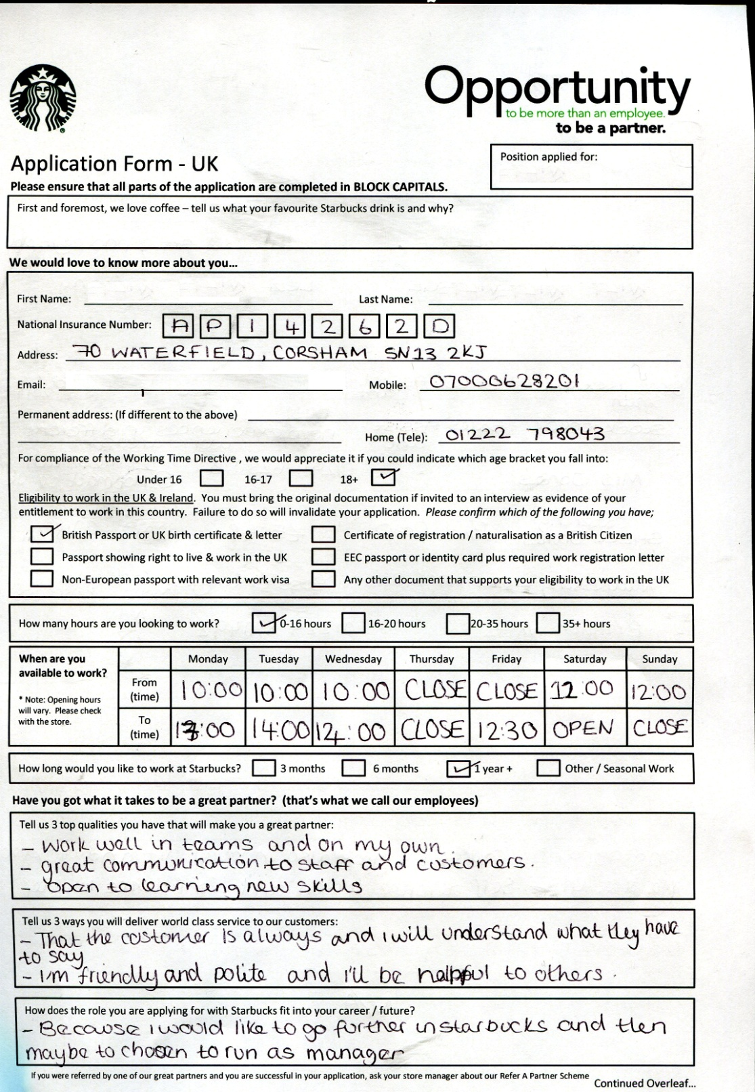
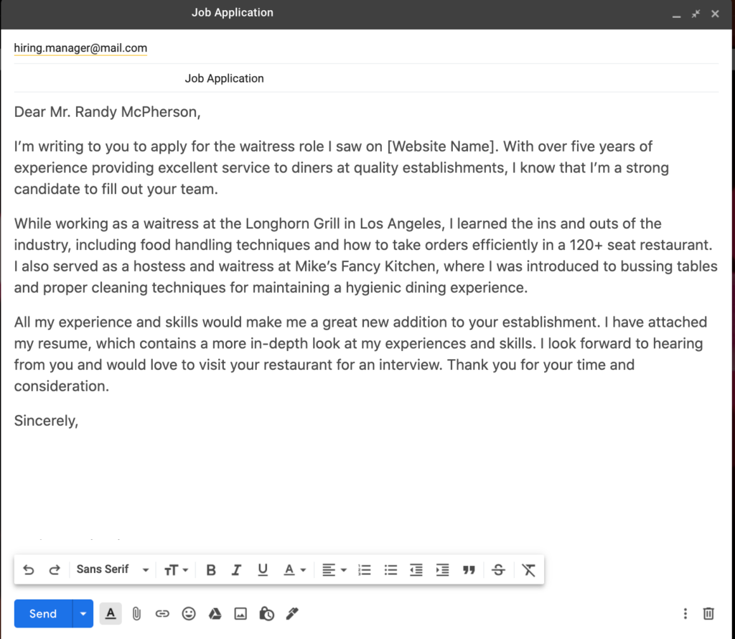

CV for HR Executive
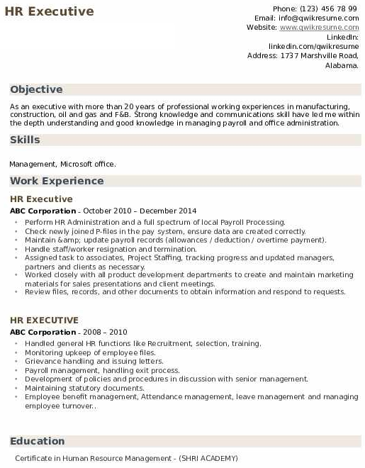
When organisation is thinking about recruitment there is the steps which organisation needs to follow in order to find out the best possible candidates among all for the vacant position. At first, recruitment planning is the key. It will give employers application knowledge and understanding about the number of people that need and according to that the planning will be made in different timeline. Second, the strategy of recruitment will be the second phase (Gates, & Mafuba, 2016). Here, according to the requirements of the job position, the recruitment strategies will be developed (Shifrer, et. al., 2013). The techniques of interview will this set accordingly. Searching for the CV will be the next step. From there, initial screening will be done in order to find the best possible candidates. Then, written screening, viva voice and some other steps according to the requirements of steps position will be the steps those help the organisation to find the best possible candidate for the vacant position of the organisation (Pritchard, 2014). By completing all these steps, organisation in the end will get the best possible employees for their business operation.
In order to test the candidates properly organisation can go with different kinds of interview process as a part of their recruitment system. For instance, organisation can go with structured interview to evaluate the subject knowledge of the employees for the particular position, they can go with unstructured interview as well in order to test the level of efficiency of Communication of the candidate (Newton, & Salvi, 2020). Organisation can also go with stress interview; panel interview, telephonic interview, and sudden interview in order to understand about the capability and quality of the candidates properly before recruiting them are the organisation.

Conclusion
In the end, it can be easily stated that although organisations have different ways of evaluating the candidates but individuals need to keep themselves prepared for all sorts environment in the workplace or potential workplace for them in order to be successful professionally in their real life. In this regard, there is no other option in the hand of the individual but personal development. By following the above strategies, it will be easy for any individual to improve their capability and knowledge from the very early stage of their academic life which will definitely support them in their future professional life has but in order to be a fairly successful individual.

References
Aubrey, Bob (2010), Managing Your Aspirations: Developing Personal Enterprise in the Global Workplace. McGraw-Hill, ISBN 978-0-07-131178-6, page 9.
Lockwood, N. R. (2003). Work/life balance. Challenges and Solutions, SHRM Research, USA, 2-10.
Parke, Ross D. (2020). "Social Development". Oxford Research Encyclopedia of Psychology.
Bargh, J. A.; Morsella, E. (2008). "The Unconscious Mind". Perspectives on Psychological Science. 3 (1): 73–79. doi:10.1111/j.1745-6916.2008.00064.x. PMC 2440575. PMID 18584056.
Goodfriend, W., & Arriaga, X. B. (2018). Cognitive reframing of intimate partner aggression: Social and contextual influences. International journal of environmental research and public health, 15(11), 2464.
Tattum, D., & Tattum, E. (2017). Social education and personal development. Routledge.
Wang, Liz; Calvano, Lisa (2018). "Understanding how service learning pedagogy impacts student learning objectives". Journal of Education for Business. 93 (5): 204–212.
Tank, Aytekin (2019). "Your obsession with self-help books could be hurting your productivity". Fast Company.
Bilohur, V. (2019). Formation and Development of Personality Established by Change and Growth. Humanities Bulletin of Zaporizhzhe State Engineering Academy, 76, 77–89.
Roberts, B. W., Wood, D., & Caspi, A. (2010). The development of personality traits in adulthood. In O. P. John, R. W. Robins, & L. A. Pervi (Eds.), Handbook of personality: Theory and research (3rd ed., pp. 375-398). New York, NY: Guilford Press.
Jeronimus BF, Riese H, Sanderman R, Ormel J (2014). "Mutual reinforcement between neuroticism and life experiences: a five-wave, 16-year study to test reciprocal causation". Journal of Personality and Social Psychology. 107 (4): 751–64.
Hettema PJ, Deary IJ (2013). Foundations of Personality. Springer Science & Business Media. p. 7. ISBN 978-94-011-1660-2.
Vukasović, Tena; Bratko, Denis (2015). "Heritability of personality: A meta-analysis of behavior genetic studies". Psychological Bulletin. 141 (4): 769–785.
Klimstra, Theo A.; Noftle, Erik E.; Luyckx, Koen; Goossens, Luc; Robins, Richard W. (2018). "Personality development and adjustment in college: A multifaceted, cross-national view" (PDF). Journal of Personality and Social Psychology. 115 (2): 338–361.
Gates, Bob; Mafuba, Kay (2016). "Use of the term 'learning disabilities' in the United Kingdom: issues for international researchers and practitioners". Learning Disabilities: A Contemporary Journal. 14 (1): 9–23. ISSN 1937-6928.
Shifrer, Dara; Callahan, Rebecca; Muller, Chandra (2013). "Equity or Marginalization? The High School Course-Taking of Students Labeled With a Learning Disability". American Educational Research Journal. 50 (4): 656–82
Pritchard, Alan (2014). "Learning styles". Ways of learning: learning theories and learning styles in the classroom (3rd ed.). Milton Park, Abingdon, Oxon; New York: Routledge. pp. 46–65. ISBN 9780415834926. OCLC 853494423.
Newton, Philip M.; Salvi, Atharva (2020). "How Common Is Belief in the Learning Styles Neuromyth, and Does It Matter? A Pragmatic Systematic Review". Frontiers in Education. 5: 270. doi:10.3389/feduc.2020.602451. ISSN 2504-284X.
May, Cindi (2018). "The Problem With "Learning Styles"".
Manolis, Chris; Burns, David J.; Assudani, Rashmi; Chinta, Ravi (2013). "Assessing experiential learning styles: a methodological reconstruction and validation of the Kolb Learning Style Inventory" (PDF). Learning and Individual Differences. 23: 44–52.

