

Name of Student: Camelia Amal Amran

Student Number: 2026695

Module Title and Code: Leading and Developing People – BMBM6012

Essay Title: Mark Zuckerberg: A Leadership Case Study

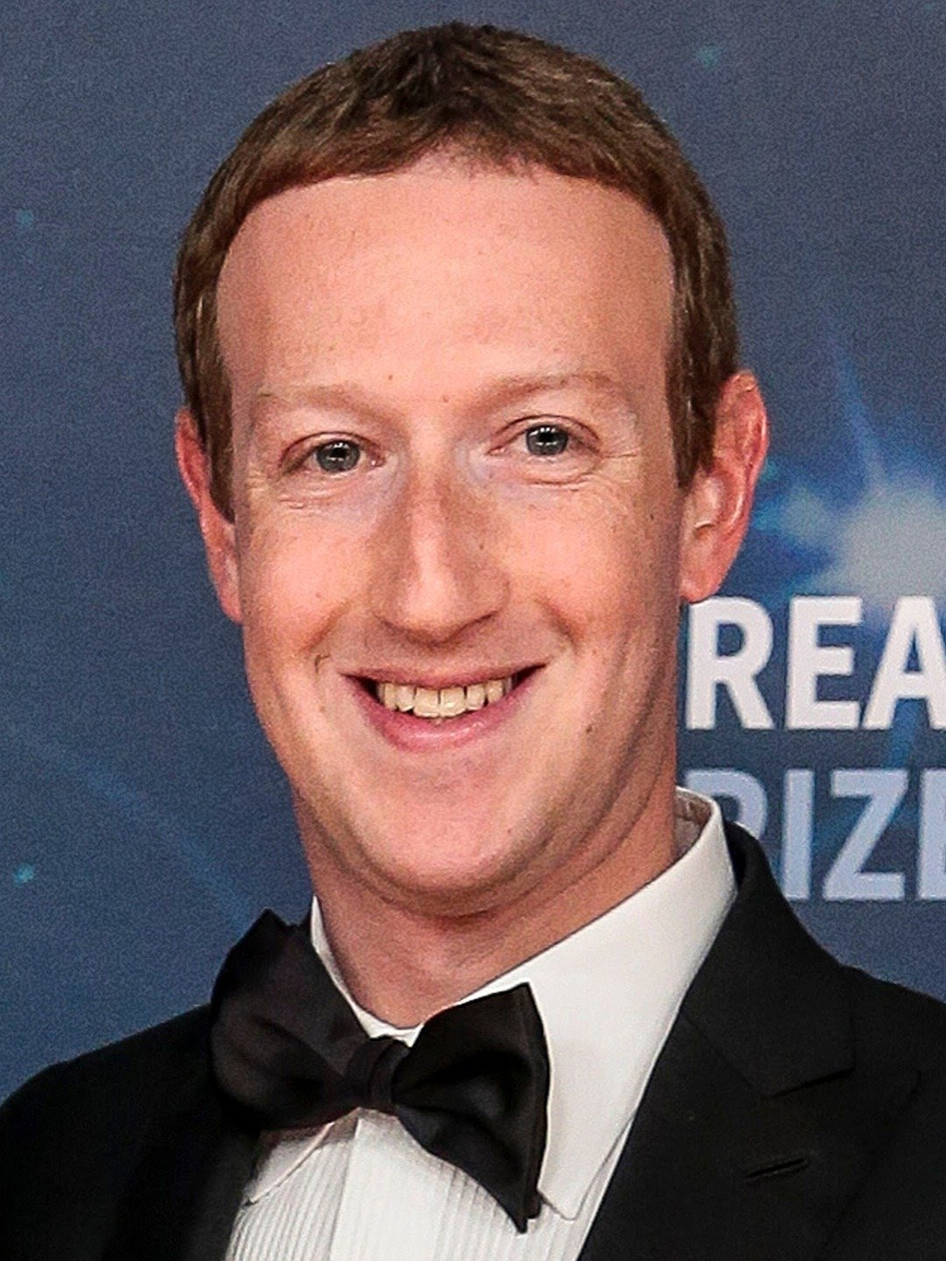

Mark Elliot Zuckerberg, by his full name, was born in White Plains, New York on May 14, 1984, to parents working in health professions. Having been labelled as a precocious child, Zuckerberg developed an interest in computers at an early age. (Vargas, J, A, 2010). He was considered someone who took up coding as a passion and hobby. Deemed The Face of Facebook, Zuckerberg has also earned a reputation as a skilled developer, whereby from the age of twelve (12) years old, he has been recorded to have built and programmed several programming systems – among them are named “ZuckNet,” “Sypnase,” “CourseMatch,” and “Facemash.” (BIOGRAPHY, 2019).
A Harvard University dropout to devote himself to Facebook full-time in 2005 (BIOGRAPHY, 2019) has undoubtedly claimed even more success. One of them includes Forbes magazine's estimates that as of July of 2023, Zuckerberg's net worth has reached an impressive whopping $115.0 billion, which has positioned him as the 7th wealthiest person worldwide. Additionally, almost a decade ago, Zuckerberg was also rewarded with the title ‘Youngest Billionaire’ in the world (Forbes, 2023). But unfortunately, he was later surpassed by newcomers. Conversely, Mark Zuckerberg is known for a particular approach to leadership which is action centered and hence, captured in the following quote:

“We may not have the power to create the world we want immediately, but we can all start working on the long term today.” (Forbes, 2023).

As of October 28, 2021, Mark Zuckerberg, the CEO of the “social network of the world” (Kraus, S, Kanbach, D.K., Krysta, P, Steinhoff, M, 2022) known to be Facebook announced a name change to “Meta.” Furthermore, that also goes to say that it was during the period when Zuckerberg not only rebranded and upgraded Facebook but also launched the so-called Metaverse, which brought several well-known apps and technologies together, namely Instagram, WhatsApp, and so on under a single organization. (Meta, 2021). Despite its overwhelming triumph, Zuckerberg faces somewhat significant megatrends which no doubt, affect the operation of the business leader.

For what is certain is that in today’s technologically and digitally driven economy, Mark Zuckerberg and Meta are under continuous unprecedented public scrutiny, widely in the area of data privacy or privacy in general. (Kozlowska, I, 2018). As stated, in today’s era, this context is sturdily shaped by digitalization. (Bharadwaj, El Sawy, Pavlou & Venkatraman, 2013). Notably, in this 21st Century, it has resulted in a more complicated and fast-changing environment in which Zuckerberg must navigate his organizations and adjust his leadership (Fitzgerald, Kruschwitz, Bonnet, & Welch, 2014) ways, styles, and models as suitable as possible.
After taking into consideration the environment in which Mark Zuckerberg leads, this essay will analyze his leadership style in depth to evaluate whether it effectively encourages innovation, adaptation, and exceptional performance.

As expected, leadership is a complex topic, which, to date, still has no concrete designation for defining it, in fact, for this reason, a saying from (Stogdill, 1974) normally goes that there are almost as “many different definitions of leadership as there are persons who have attempted to define the concept.” Moreover, it also goes to say that “these attempts to define leadership have been confusing, varied, disorganized, idiosyncratic, muddled, and according to conventional wisdom, quite unrewarding” which was commented by (Rost, 1991).
After all, respectively, some researchers, philosophers, intellectuals, and even leaders themselves claim that “leadership remains an essentially contested concept.” (Keith Grint, 2005). This means that there is no universally accepted definition of what it means. However, beyond the matter, it is arguable that leadership is as simple as an ongoing process (Leadership Theories and Studies, n.d, Stogdil, 1950; Jacod & Jacques, 1990; Malik, 2012; Kesting, Ulhol, Song & Niu, 2016) that leaders of any sort will learn and develop over time. Therefore, leadership is defined as a process by which a leader or leader (s) influences others toward the attainment of group or organizational goals. (Leadership Theories and Studies, n.d). On a simpler note, leadership seems to be a matter of aligning people toward common goals and empowering them to take the actions needed to reach them or the ability to influence others toward the achievement of common goals. (Khan, M.S, Khan, I, Qureshi, Q, A, Ismail, H.M, Rauf, H, Latif, A, & Tahir, M (2015).
Alternatively, owing to the many leadership styles that exist these days, it is still, however, a task to prove whether Mark Zuckerberg does possess a few of the styles or not. In light of this, Democratic and Transformational leadership styles will be used in the analysis of leader Mark Zuckerberg, alongside a critical evaluation of whether he, himself demonstrates the characteristics associated with emotional and social intelligence and agility.
From what can be seen through the success of Meta, his choice of leadership style has indeed become a big contributor to its overall accomplishment. This is mainly due to Zuckerberg's proclivity for emphasizing group interactions and empowering his employees to adapt their own projects and work schedules. Additionally, he is known to also encourages and motivate those under him and alongside him to also offer their thoughts, comments, and techniques on how to bring the organization further forward, instead of making and utilizing his own decisions.

As a democratic leader, Mark Zuckerberg promotes increased productivity and enhanced job satisfaction that is founded on innovation and creativity. Zuckerberg makes use of his five P's success well. These five Ps are partnerships, people, products, purpose, and passion. (Chris, 2015). In the case where each of the five Ps has a particular function and helps to illustrate why Zuckerberg is a strong leader. The first P passion, is included because it is a crucial attribute for him as a leader to possess and be a motivating component that promotes endurance. Because he is believed to be passionate about what he does, he overcomes obstacles and learns from mistakes rather than giving up. The second P, purpose, helps Zuckerberg confirms why he built the organization in the first place, which is a great help for him to recruit better employees and therefore, built better products. The third P is People, for which according to Zuckerberg himself, people should be given the freedom to be themselves and take calculated risks. The fourth P, product, is added to emphasize Zuckerberg's dedication to Facebook.

Another way to characterize Mark Zuckerberg is as a transformational leader. This is so that he can inspire his employee to work harder by setting goals, rewarding them, and giving them chances to advance. With a clear vision and goal, his employees can be led by what needs to be accomplished. Furthermore, his employees are instructed in coding techniques created by the business to help them finish tasks more quickly. As a transformational leader, Zuckerberg values intellectual stimulation (Wixson, 2016). According to the Weebly (2020) article, Mark is a transformational leader when it comes to bringing people on board with his business. His main goal was to bring people together on one platform, which had the effect of changing the world for the better. With just one idea, he was able to capture people's attention and get their approval to expand his business all over the world (Weebly, 2020). Zuckerberg does not believe that he is the only person at Facebook and that this is the cause of the success of Facebook. He has a strong sense of confidence in his team and employees and cherishes their ideas. He has always believed in building relationships with his team members so that they may adopt his company vision. He constantly creates an environment that encourages the development of new ideas. With his idea of fostering a good environment, he was able to quickly accomplish the organizational goals of his company and obtain an advantage over its competitors.

References:

Forbes (2023) Mark Zuckerberg: Cofounder, Meta Platforms. Available at: https://www.forbes.com/profile/mark-zuckerberg/?sh=6b5698e43e06 (Accessed: 1st August 2023)
Vargas, J, A (September 13, 2010) ‘THE FACE OF FACEBOOK Mark Zuckerberg opens up’, THE NEW YORKER, 1st August. https://www.newyorker.com/magazine/2010/09/20/the-face-of-facebook

BIOGRAPHY (October 25, 2019) Famous Business Leaders: Entrepreneurs Mark Zuckerberg. Available at: https://www.biography.com/business-leaders/mark-zuckerberg#synopsis (Accessed: 1st August).

Dike, Victor, E (August 17, 2015) Leadership and Management in the 21st Century Organization: A Practical Approach. Scholink Co, Ltd. DOI: 10.22158/WJSSR.V2N2P139 https://core.ac.uk/display/268085327?utm_source=pdf&utm_medium=banner&utm_campaign=pdf-decoration-v1

Kraus, S, Kanbach, D.K, Krysta, P, Steinhoff, M (January 2022) ‘Facebook and the creation of the Metaverse …. Research Gate, International Journal of Entrepreneur Behaviour & Research, 28(9), DOI:10.1108/IJEBR-12-2021-0984 . https://www.researchgate.net/publication/357635338_Facebook_and_the_creation_of_the_Metaverse_Radical_business_model_innovation_or_incremental_transformation

Meta (October 28, 2021) Introducing Meta: A Social Technology Company. Available at: https://about.fb.com/news/2021/10/facebook-company-is-now-meta/. (Accessed: 17th August 2023)

Hensellek, S. (2020) Digital Leadership: A Framework for Successful Leadership in the Digital Age. ResearchGate. Journal of Media Management and Entrepreneurs. 2(1): 55-59. DOI:10.4018/JMME.2020010104. https://www.researchgate.net/publication/338327379_Digital_Leadership_A_Framework_for_Successful_Leadership_in_the_Digital_Age

Kozlowska, I (2018) Facebook and Data Privacy … THE HENRY M. JACKSON SCHOOL OF INTERNATIONAL STUDIES. University of Washington. Available at: https://jsis.washington.edu/news/facebook-data-privacy-age-cambridge-analytica/. (Accessed: 17 August 2023)

Jackson, S. Sakuma, S. & Dr. Devol, P (n.d.) The Complexity in Defining Leadership … Available at: https://files.eric.ed.gov/fulltext/EJ1093043.pdf. (Accessed 18 August 2023)

Abid Malik, M & Azmat, S (2019) Leader and Leadership … ResearchGate. Available at:
https://www.researchgate.net/publication/337732933_LEADER_AND_LEADERSHIP_HISTORICAL_DEVELOPMENT_OF_THE_TERMS_AND_CRITICAL_REVIEW_OF_LITERATURE#:~:text=“Leadership%20can%20be%20defined%20as,group%20or%20organizational%20goals”%20(Leadership. (Accessed: 18 August 2018)

Fairhom Matthew, R (2015) Defining Leadership. ResearchGate. Available at: https://www.researchgate.net/publication/283048404_Defining_Leadership. (Accessed: 18 August 2023)

Langston.edu (n.d) Transformational Leadership. Available at: https://www.langston.edu/sites/default/files/basic-content-files/TransformationalLeadership.pdf. (Accessed: 19 August 2023)

Khan, M.S, Khan, I, Qureshi, Q, A, Ismail, H.M, Rauf, H, Latif, A, & Tahir, M (2015). The Styles of Leadership: A Critical Review. Public Policy and Administration Research. ISSN 2225-0972(Online) Vol.5, No.3. Available at: https://www.iiste.org/Journals/index.php/PPAR/article/viewFile/20878/21131. (Accessed: 19 August 2023)

Hammad, M (2020) Mark Zuckerberg- Leadership and Communication. ResearchGate. Available at: https://www.researchgate.net/publication/344177344_Mark_Zukerberg_-Leadership_and_Communication. (Accessed: 18 August 2023)

Stanton, M (n.d.) The leadership of Mark Zuckerberg. Available at: https://www.academia.edu/10320099/Leadership_of_Mark_Zuckerberg. (Accessed: 19 August 2023)

EduBirdie (n.d.) Mark Zuckerberg: Leadership Style and Qualities. Available at: https://edubirdie.com/examples/mark-zuckerberg-in-facebook-leadership-style-and-qualities/#citation-block (Accessed: 19 August 2023)

