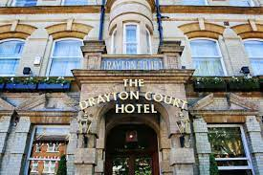

DRAYTON COURT HOTEL
Valentina Somnik on behalf of the EasyFlow Hotel Consultancy
Written for: David Josh
10 March 2023
EXECUTIVE SUMMARY

This special letter is written to you as a consulting report.

A client, his Drayton Court Hotel, was informed that communication between the hotel's front desk and other departments was at the root of the problem.

As a result, a detailed analysis of the hotel using relevant theories and methods such as his SWOT analysis and his PESTLE analysis revealed that one of the main problems was actually the components of the problem presented by the customer. It turns out that This issue is related to the communication that takes place between the receptionist and the housekeeping department. This is the result of looking at online reviews, a key factor for the company as a whole. A SWOT analysis of the internal environment reveals that the hotel's greatest strengths are its location and free breakfast service. The check-in time and the underlying problem (lack of communication) are the biggest drawbacks. Hotels have the opportunity to implement online platforms. It is also the overall solution to the main problem, among other aspects of analysis. Despite the fact that competition remains the same threat to all other hotels in the hospitality industry,

In addition to his second analysis of the external environment, the PESTLE analysis revealed significant external factors that could adversely affect his client, his Drayton Court Hotel. These external factors include government powers, laws and regulations, and social influences such as trends.

After identifying the problem, namely the lack of communication between the hotel reception and other departments, especially the cleaning department, an online system that contributes to management performance and improves communication can be a good solution to the main problem. Proposed.

There are also minor issues that may affect the hotel. However, these are Chicken Inn's procedures and arrangements, which were also addressed in the Advisory section of his report. Shortly thereafter, I was informed that my check-in time might be a little later, so I was offered to change the time from 2pm.
00-12:
00 To make our customers happier. As a result, the Housekeeping department may be affected by this change, and staff may need to change their schedules slightly to provide a clean room at 12:00 p.m.
00 instead of 14:
00. The management of the Drayton Court Hotel may decide that the staff's diligence and program changes deserve awards, but the costs are really unpredictable.

To address the main issue, it is proposed to use the online platform Monday.com. Monday.com is a website where individuals can post their tasks and track their progress and status. As a result, the issue stems from some bad reviews from people complaining that the rooms are not perfectly clean. With the help of the platform, the front desk can know which rooms have been cleaned, have been cleaned, or have yet to be cleaned as housekeeping updates the system as needed. . Not only does this make communication more effective, but tasks can be completed much easier online than on paper, so the hotel can take meaningful steps towards modernization, at least for senior management. will be

Quite unlike the small problems presented, the Drayton Court Inn's big problems cost a fortune to complete. This cost includes a monthly payment of around £200 for a Monday.com subscription. Please note that the new system may be accessible throughout the hotel. There is also an obligation to provide employees with suitable devices such as smartphones and tablets, which also costs around £2,000, so you can add it to your cost list. Internet is another consideration, and the Drayton Court Hotel already offers free Internet.

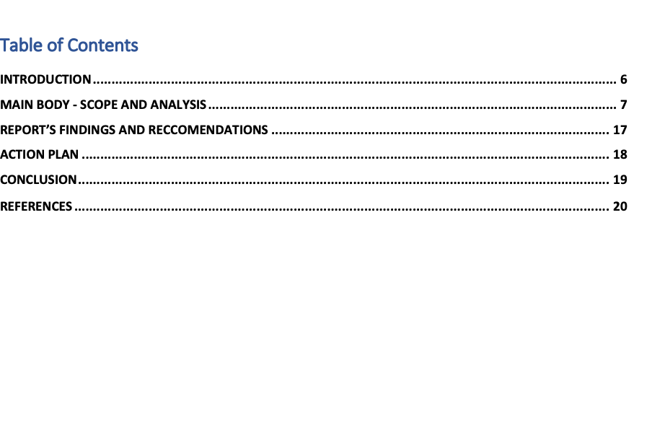

INTRODUCTION
Report formats are used to complete this particular task. Then everything is insulated and money is taken to report all important data.

Additionally, the hotel at the center of this report has the problem of not being able to generate the desired revenue. The problem with the Drayton Court Hotel in the Tamworth area is that there is little communication between the front desk and other departments of the hotel, such as human resources and marketing. However, hotel manager David Josh has requested additional guidance on how to assist and improve communication between the hotel's problematic departments, as this could adversely affect the overall functioning of the hotel. I was there.

Extensive research and analysis is therefore required to help David Josh and his Drayton Court Hotel. If the hotel doesn't do this, you won't get a proper response to actually help fix the problem. There are two specific and strategic things in the analysis.
The PESTLE analysis only covers the external environment of the hotel, and the SWOT analysis only covers the internal environment of the hotel. In this particular scenario, the problem facing the hotel is directly related to the company's internal environment. However, each analysis, along with other relevant aspects of the case, will be performed and discussed in the following sections.

In summary, the lack of communication between the front desk and other departments is the main cause of problems at the Drayton Court Hotel. Therefore, the purpose of this work is to assist hotels in resolving communication issues.

MAIN BODY - SCOPE AND ANALYSIS
As mentioned above, the purpose of this particular organizational consulting was to help the client, Drayton Court Hotel, solve the problem of lack of communication between the front desk and other hotel departments such as housekeeping, food and beverage, security, human resources and marketing departments. to help resolve Given that this issue first appeared a few months ago (roughly a year ago), it's likely more complex in nature. However, the problem is solved with the help of the necessary resources and the analysis performed. This allows the hotel to expand and become more successful.

This section also covers the hotel's internal environment (Strengths, Weaknesses, Opportunities, and Threats) both with a SWOT analysis (MindTools, 2020) and the hotel's external environment (using PESTLE analysis (CIPD, 2020)). It contains two main analyses. (political, economic, social, technical, legal and environmental factors that may positively or negatively affect the hotel).

Still, it's important to collect as much information about the hotel as possible in order to perform the analysis. This actually makes the analysis possible. Information about the hotel B. If the location is unknown, testing is not possible. As such, this section is incomplete and we are unable to provide you with the necessary advice.

However, the relevant tests are followed by a short description of the hotel.

The Drayton Court Hotel des Landes is located in the West Midlands near Birmingham. The actual name is Fazeley and it's located in the lovely area of ​​Tamworth, beautiful Georgia. The zip code is B78 3RG and the address is 65 Colehill St., just off the A4091 road.

A thorough investigation reveals that the history of the hotel dates back to his 1780s and that he has over 200 years of experience in the market. This is very impressive and shows that the Drayton Court Hotel has been working well up to this point and there were no communication issues. Otherwise, the hotel won't survive his 21st century in his 2021, even one year after the pandemic caused by his deadly COVID-19 virus.

A closer look at the place reveals that it is more than just a famous park for the people who live there. Drayton Manor Theme Park (Drayton Manor Theme Park, 2021) and Drayton Park Golf Club (Drayton Park Golf Club, 2021) are both less than a mile from his Drayton Court Hotel. These two well-known and popular attractions are popular with tourists as well as locals. Looking around, it's no exaggeration to say that the children who frequent the parks fill both parks with happiness, positive emotions, and great moods. However, due to the park's extreme segregation, parts of the park were created specifically for the entertainment of children and young people. The rest is reserved for those who want to relax, enjoy nature and take a deep breath. The results of this relevant information on locations in close proximity to the Drayton Court Hotel will later aid in his PESTLE analysis, especially of the external environment. However, apart from that, these special details are also essential for customer acquisition, so hotel managers are strongly encouraged to make use of this special section.

The description of the Drayton Court Hotel can be continued by stating that it offers its guests a sizable parking lot completely free of charge, allowing guests to choose which parking lot they prefer. Customers are not allowed to actually mark the parking lot as it is on a first come first serve basis. Before going into details of the hotel from an internal point of view, such as rooms and services offered, we can continue our description of the Drayton Court Hotel. Additionally, it's important to point out that public transport is available within the hotel area, including the fact that the hotel is only minutes from the actual bus station and can be used by non-drivers. This applies to anyone who needs to use taxis, public transport, or Uber. In addition to buses, there are no less than three different routes going in different directions. One of these lines goes straight to the city center, giving guests the extra transportation they need to get where they want to go. In fact, Arriva is the name of the most commonly used municipal transit system in the Tamworth area (Arriva, 2021).

The Drayton Court Hotel log shows a check-in time of 2 PM.
00, check-out time is 10:
30. This may have a negative impact on the company's overall results, including profits, which is further discussed in the next section of the advisory his report. Heading inside the hotel, to briefly describe it, the first thing to mention is that the hotel is designed in a country style, so the Drayton Court Hotel gives its guests the feeling of being in the countryside. The hotel is therefore ideal for those who like being in the countryside and this hotel may be the best option for these people.
The Drayton Court Hotel has 30 en suite rooms. The hotel has a variety of rooms, including double rooms, small double rooms, and intermediate rooms such as double rooms. B. Small Rooms - Please note that there are no connecting rooms.
The hotel's revenue is not reported, giving the impression that it is not as well-known as the larger hotels like Hyatt or Marriott. As a result, the Drayton Court Hotel is probably not as well known in the industry as the hotel manager intended.

In addition, one of the other amenities that hotels offer to their guests is free WiFi, which is offered to guests as an additional incentive to stay there. In addition, the Drayton Court Hotel is very child-friendly, so parents who want to give their children an unforgettable experience are strongly encouraged to bring their children there. The staff are also kid-friendly, so your children will feel safe and have fun. In addition, the Drayton Court Hotel offers all-inclusive services and room service. When it comes to room service, offering complimentary breakfast will give your guests the best experience and keep them coming back. The hotel has its own restaurant and dining area, so guests don't have to book a room or eat there. However, hotel guests do not receive discounts at hotel restaurants, with the exception of complimentary breakfast, which is available from 6 AM to 6 PM, which is beneficial for the hotel.
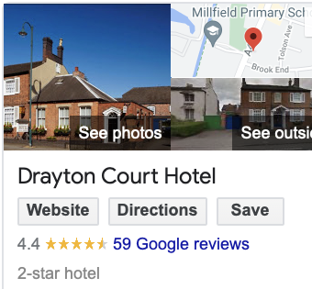

The Drayton Court Hotel is currently rated 2 stars, but the results of this survey suggest that this hotel may qualify for 3 stars as it appears to genuinely delight its guests doing. In addition to customer satisfaction, this hotel has earned his 4.4 stars on his Google reviews. This is a very high number that actually benefits the hotel.

As a result, a hotel is more than just a place to sleep, you can book a room and spend as much time as you want there. We can also book events such as weddings, baby showers and birthday parties. gathering. However, please note that the hotel has been unable to host such events in the past due to the global impact of COVID-19. People were unable to book such events due to restrictions, preventing the spread of infection (GOV.UK, 2021). Reviewing reviews and noting where customers are frustrated and where they appear to be happy is another important step in resolving Drayton Court Hotel issues. However, customers who have stayed in the hotel give the Drayton Court Hotel a perfect 5.0 star rating for its location. This was already explained in the previous section and confirmed by real hotel guests.The list continues with a very tight and high score of 4.9 stars for hotel services. Other positive points of the hotel include reviews that say they were very surprised by the hotel's location and services, such as restaurant availability and meals at baby showers. However, going back to the score, the stars are slowly declining until the room is rated 3.8 stars (Google Reviews, 2021). This could be a real problem with the Drayton Court Hotel. Poor communication between reception and other departments including the cleaning department which seems to be the most appropriate department for this review.

According to TripAdvisor, the average price for a room at Drayton Court Hotel in Tamworth is around £100, depending on the extra features each customer wants. Hotels are rated 1 out of 10 for location, cleanliness, service, and price, in order of what seems to be the highest rated location, precisely (TripAdvisor, 2021). This puts the hotel at the top of Tamworth's hotel list.
Positive comments on the website have actually earned the Drayton Court Hotel in Tamworth a badge of excellence.

SWOT ANALYSIS OF THE DRAYTON COURT HOTEL
This particular study closely examines the climate of the selected area, the quality of the accommodation, the shortcomings of the ryokan, and the openness that the ryokan may potentially take to increase the value of the ryokan if necessary. Used to take notes about doors that have been opened. We believe there are breaking changes that could hurt your business and should be removed as soon as possible (Scott, 2021).

Strengthen: These are the hotel's strengths. So after the above checks, you should name the location first. Many reviews give the hotel a 5-star rating because the hotel offers its guests many green spaces that are ideal for nature lovers. Then his second strength of the Drayton Court Hotel could be the late checkout times. This allows guests to extend their stay and not have to rush out of their room like most hotels. As a result, the Drayton Court Hotel allows guests to extend their stay. Additionally, the hotel offers complimentary breakfast with a wide range of options. Despite the quality of the ryokan, it has a wide variety of venues and also offers the ability to book large social events such as weddings and children's parties, and according to the above survey, the staff, including the café portion of the facility, is working effectively.

Weaknesses: These are the weak points of the hotel. One of the biggest concerns for hotels is the check-in date. Because it seems a little late and many people want to see their room and leave their language. The summary can be continued with a horrible survey of the accommodation rooms and how clean they are. This can affect the inn's underlying problem - an unfortunate coincidence between the front desk work area and other departments. Allocation of rooms to visitors, but if there is virtually no correspondence between the front office and housekeeping, the front office area is a dirty space for another visitor because it has not been checked by the housekeeping office There is a unique opportunity to have the first.
.
Opportunities - These are some of the variations and opportunities that the Drayton Court Hotel could consider solving a problem or enhance its success. So the biggest opportunity is to change the check-in date so people can check in earlier. Room condition, whether a particular room is clean. Another opportunity to improve your hotel's reputation is to be green and even greener. This fact attracts more customers and inspires their loyalty and attraction.

Threats - These are hotel obstacles, and this is in the hotel industry, so the biggest threat is the competition to overcome them. Therefore, it is important for hotels to use as many advantages as possible over their competitors and rivals in order to maintain their high reputation. .

PESTLE ANALYSIS OF THE DRAYTON COURT HOTEL
The purpose of this analysis is to be able to examine the external environment of a particular object (in this case the Drayton Court Hotel) in relation to that object. PESLTE analysis takes into account a variety of factors that can affect hotels, including political, economic, social, technical, legal and environmental factors (PESTLE, 2021).
Political factors: As a hotel, the Drayton Court Hotel is part of the hospitality industry, which is heavily regulated by the government. In other words, the government has many powers over the hospitality industry, including the ability to ban travel (done last year in response to the coronavirus pandemic to stop the spread of infection). that is). Another political factor is tax reform, also controlled by the government. Hotels can also be affected with each election as the new rep can change everything completely which can lead to very big problems for hotels.

Conservative Elements Again - The main thing mentioned here is that the world has witnessed large-scale accidents and emergencies as a result of the dangerous disease caused by SARS-COV-2. Because public authorities have implemented (very) many strict restrictions. Restrict freedom of expression and close all but basic stores such as groceries and medicines. Hotels were banned from hosting gatherings of any kind, which put them on hold for quite some time, resulting in huge losses for hotels (PESLTE, 2021).

Social factors: These factors directly affect individuals, and thus the general public and their preferences. The most important thing is that the hotel side will be disadvantaged if something that is not profitable becomes a trend. Airbnb, for example, is a fairly popular trend, and it can lead to losses as consumers switch to new trends in search of cheaper hotels (Bush, 2019).

Technical factors: In this case, things get even more complex and expansive, as the technology is endless. Because of this, there are no restrictions and anyone can write a review that could damage the hotel. Meanwhile, the Drayton Court Hotel was able to capitalize on the positive side of technological advancements by using digital marketing to promote their hotel. This shows that hotel managers can use digital marketing to promote their properties on various websites, including Facebook, Instagram, Twitter, and other accessible social media platforms. According to McDowel (2017), statistically over half of the world uses digital marketing to promote their goods and services. This percentage he increased by almost 20% by the end of 2016 and is even higher now (McDowel, 2017). In addition, reviews that guests post about hotels on various websites are very important as they can enhance a hotel's reputation or, at worst, irrevocably damage it (Major, 2019).

Legal factors: When it comes to the law, everything must abide by the law, including hotels and the Drayton Court Hotel. This is very important because if a hotel violates the law in some areas it will be considered an illegal operation and the hotel may be closed and fined. Governments are increasing the number of hotel laws and regulations, including health and safety regulations.

Environmental factors: This mainly concerns the area and location of the hotel, so judging by the description, it makes sense to say that the location of the hotel is a huge advantage.

It's safe to say there are some issues, but not all issues need to be addressed at this point after the analysis is complete.

The protocol arrangement at the Drayton Court Hotel could really benefit from some organizational changes. However, this is something that can be covered later if needed.

However, according to the analysis, the hotel's main problem is actually what is mentioned. The low score is because the room is not what it should be. This is a direct result of poor communication between the front desk and other departments, especially the housekeeping department. An analysis of departments, especially related departments, revealed that employees were not communicating effectively. This issue directly contributes to the shortcomings of the hotel, according to the bad reviews of the rooms on the website. It is also true that lack of communication is the main problem, as in the case of the Drayton Court Hotel. However, as mentioned above, there are other minor issues that could be fixed in the future.

Technically, the most important thing is to implement and improve communication methods between all hotel departments. This ensures good communication throughout the hotel, including between the housekeeping and front desk departments where the main issues are. However, the staff cannot benefit from it due to the non-existence of means of communication.
So the next step is to consider the different ways the problem can be resolved.

Basic staff training is not required as the staff are already familiar with the hotel environment. However, it is best to think about training programs on how to communicate using digital platforms.This is the next step in solving the problem.As a result of global technological advancements, technology is becoming more and more for the benefit of people. significantly improved, giving us more opportunities to simplify our daily lives (Pedersen, 2020).

In addition, the use of technology is very important as it remains central to new initiatives that the Drayton Court Hotel may wish to implement. According to Attala (2019), there are many ways technology can improve communication across hotels, including problem areas, such as implementing an online agenda management program.

An online platform that can contain all relevant data is another name for the aforementioned online agenda. Drayton Court Hotel offers a variety of platforms, but the Monday.com app is a good option.
Some of the best workspace navigation is on Monday.com, and accessing the dashboard is easier than it should be. Employees can assign their tasks on Monday.com to mark them on the go. For example, the housekeeping department can mark a room as "work in progress" and mark it as "complete" when the room is ready. The fact that all departments have access to the platform means every employee can use Monday.com. So, in this particular case, the front desk can track the progress of a particular room in real time. So if someone requests a specific camera, the front desk knows exactly where the room is. In addition, the number of negative reviews is reduced, which increases profits for both the hotel and its guests, allowing them to fully enjoy their stay without encountering minor issues that can impact overall customer satisfaction. You can enjoy it.
Monday.com, as its website explains, is a great management tool that can definitely improve communication, which is the main problem for the Drayton Court Hotel (Monday.com).

REPORT’S FINDINGS AND RECCOMENDATIONS
- The issue presented was seen as a lack of communication between the front desk and other departments.
- So, after a thorough investigation, we found that the real problem was the lack of communication, especially between the hotel's front desk and cleaning department.
- For this, we have to find a solution to the problem. The best strategy is to implement administrative expenses like an online platform where all departments can see what each department is doing in real time. As a result, the main issues I had to understand after reading the reviews are easier to avoid, the reception ensures that the rooms are clean and customer satisfaction is not affected.
- There are many online platforms available for good performance management. However, we recommend Monday.com because it meets all our requirements to solve our problems, but its main feature is that it is very easy to use.
- Regarding the management of the online platform:
o Implementation costs which can cost up to £99 depending on the circumstances. This could be the base cost of an enterprise package.
o Staff training to ensure everyone is familiar with how it works.
o Tools used and access to the Internet.
o The hotel already offers free internet access.
o As a result, there are costs associated with providing equipment to staff. B. A standard smartphone or tablet with the app already installed.
- In addition, all inspections revealed the following minor but serious issues with the hotel. B. Check-in date. Most of the guests are returning from very long journeys and the most common arrival time for her is around 12:00, so she has to wait 2 hours for guests to sleep in the reserved room. not.
o Because the housekeeping department will need to be even more consistent and communicative in order to change the time, Monday.com will work perfectly.

ACTION PLAN

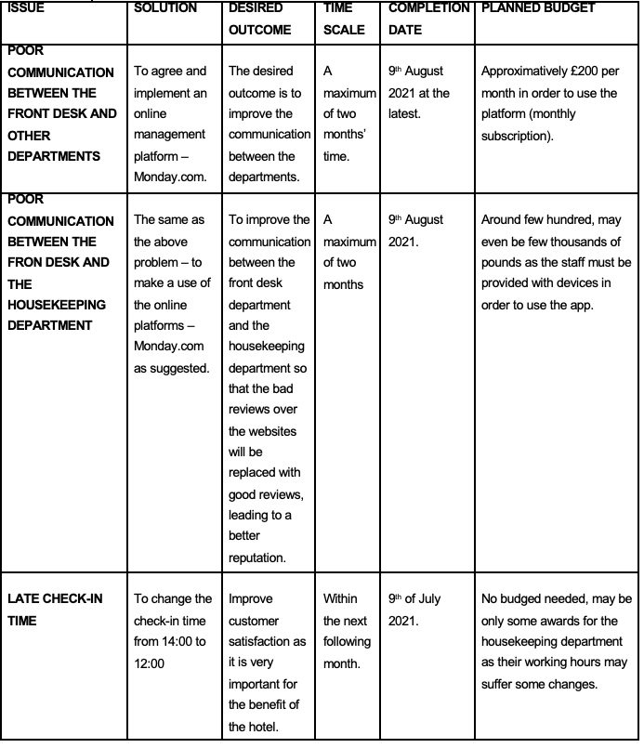

CONCLUSION
As a result, the Drayton Court Hotel's main problem isn't particularly dangerous, but it does require more attention and proper planning. As suggested, the important thing is to implement a method of communication, so a management online platform would be a good alternative.

Finally, thank you for choosing our service. We hope this advisory report answers all your questions. However, if you have any questions, feel free to contact us.

f g r t g h n b v c d s w q a s d f g b v c x z s d f g t r e w q s a d s x c v b g f g r t g h n b v c d s w q a s d f g b v c x z s d f g t r e w q s a d s x c v b g f g r t g h n b v c d s w q a s d f g b v c x z s d f g t r e w q s a d s x c v b g f g r t g h n b v c d s w q a s d f g b v c x z s d f g t r e w q s a d s x c v b g f g r t g h n b v c d s w q a s d f g b v c x z s d f g t r e w q s a d s x c v b g f g r t g h n b v c d s w q a s d f g b v c x z s d f g t r e w q s a d s x c v b g f g r t g h n b v c d s w q a s d f g b v c x z s d f g t r e w q s a d s x c v b g f g r t g h n b v c d s w q a s d f g b v c x z s d f g t r e w q s a d s x c v b g f g r t g h n b v c d s w q a s d f g b v c x z s d f g t r e w q s a d s x c v b g f g r t g h n b v c d s w q a s d f g b v c x z s d f g t r e w q s a d s x c v b g f g r t g h n b v c d s w q a s d f g b v c x z s d f g t r e w q s a d s x c v b g f
f g r t g h n b v c d s w q a s d f g b v c x z s d f g t r e w q s a d s x c v b g f g r t g h n b v c d s w q a s d f g b v c x z s d f g t r e w q s a d s x c v b g f g r t g h n b v c d s w q a s d f g b v c x z s d f g t r e w q s a d s x c v b g f g r t g h n b v c d s w q a s d f g b v c x z s d f g t r e w q s a d s x c v b g f g r t g h n b v c d s w q a s d f g b v c x z s d f g t r e w q s a d s x c v b g f g r t g h n b v c d s w q a s d f g b v c x z s d f g t r e w q s a d s x c v b g f g r t g h n b v c d s w q a s d f g b v c x z s d f g t r e w q s a d s x c v b g f g r t g h n b v c d s w q a s d f g b v c x z s d f g t r e w q s a d s x c v b g f g r t g h n b v c d s w q a s d f g b v c x z s d f g t r e w q s a d s x c v b g f g r t g h n b v c d s w q a s d f g b v c x z s d f g t r e w q s a d s x c v b g f g r t g h n b v c d s w q a s d f g b v c x z s d f g t r e w q s a d s x c v b g f
f g r t g h n b v c d s w q a s d f g b v c x z s d f g t r e w q s a d s x c v b g f g r t g h n b v c d s w q a s d f g b v c x z s d f g t r e w q s a d s x c v b g f g r t g h n b v c d s w q a s d f g b v c x z s d f g t r e w q s a d s x c v b g f g r t g h n b v c d s w q a s d f g b v c x z s d f g t r e w q s a d s x c v b g f g r t g h n b v c d s w q a s d f g b v c x z s d f g t r e w q s a d s x c v b g f g r t g h n b v c d s w q a s d f g b v c x z s d f g t r e w q s a d s x c v b g f g r t g h n b v c d s w q a s d f g b v c x z s d f g t r e w q s a d s x c v b g f g r t g h n b v c d s w q a s d f g b v c x z s d f g t r e w q s a d s x c v b g f g r t g h n b v c d s w q a s d f g b v c x z s d f g t r e w q s a d s x c v b g f g r t g h n b v c d s w q a s d f g b v c x z s d f g t r e w q s a d s x c v b g f g r t g h n b v c d s w q a s d f g b v c x z s d f g t r e w q s a d s x c v b g f
f g r t g h n b v c d s w q a s d f g b v c x z s d f g t r e w q s a d s x c v b g f g r t g h n b v c d s w q a s d f g b v c x z s d f g t r e w q s a d s x c v b g f g r t g h n b v c d s w q a s d f g b v c x z s d f g t r e w q s a d s x c v b g f g r t g h n b v c d s w q a s d f g b v c x z s d f g t r e w q s a d s x c v b g f g r t g h n b v c d s w q a s d f g b v c x z s d f g t r e w q s a d s x c v b g f g r t g h n b v c d s w q a s d f g b v c x z s d f g t r e w q s a d s x c v b g f g r t g h n b v c d s w q a s d f g b v c x z s d f g t r e w q s a d s x c v b g f g r t g h n b v c d s w q a s d f g b v c x z s d f g t r e w q s a d s x c v b g f g r t g h n b v c d s w q a s d f g b v c x z s d f g t r e w q s a d s x c v b g f g r t g h n b v c d s w q a s d f g b v c x z s d f g t r e w q s a d s x c v b g f g r t g h n b v c d s w q a s d f g b v c x z s d f g t r e w q s a d s x c v b g f
f g r t g h n b v c d s w q a s d f g b v c x z s d f g t r e w q s a d s x c v b g f g r t g h n b v c d s w q a s d f g b v c x z s d f g t r e w q s a d s x c v b g f g r t g h n b v c d s w q a s d f g b v c x z s d f g t r e w q s a d s x c v b g f g r t g h n b v c d s w q a s d f g b v c x z s d f g t r e w q s a d s x c v b g f g r t g h n b v c d s w q a s d f g b v c x z s d f g t r e w q s a d s x c v b g f g r t g h n b v c d s w q a s d f g b v c x z s d f g t r e w q s a d s x c v b g f g r t g h n b v c d s w q a s d f g b v c x z s d f g t r e w q s a d s x c v b g f g r t g h n b v c d s w q a s d f g b v c x z s d f g t r e w q s a d s x c v b g f g r t g h n b v c d s w q a s d f g b v c x z s d f g t r e w q s a d s x c v b g f g r t g h n b v c d s w q a s d f g b v c x z s d f g t r e w q s a d s x c v b g f g r t g h n b v c d s w q a s d f g b v c x z s d f g t r e w q s a d s x c v b g f

REFERENCES



 

