Nicholaston Woods and Oxwich Nature Reserve – A review of current site management and a 10 year plan for the future.

Milo Fleming 1902803
UWTSD

Table of contents
Abstract - 3
Introduction - 3
Review of existing management plan - 4
10 year future plan - 6
Conclusion – 11
References - 12

Abstract
This paper reviews the current site management for Oxwich NNR and Nicholaston wood as provided by National Resources Wales (NRW). It is found that this plan does well to continue the conservation of an important site however is lacking in ambition in improving biodiversity within the area. A 10 year plan for the future is outlined for selected habitat types using GIS software to highlight the specific areas. The new 10 year plan attempts to address this lack of ambition through a better management of the Nicholaston Pill river, the marsh area is also planned to be enlarged while the woodland and scrub area present is set to be changed over time to native from not native with the felling of planted conifers and accommodation of bees.
Introduction
This paper examines a current site management plan before producing a 10 year riprarian site management plan for the future. The site management plan that was selected for this report is for the Nicholaston woods and Oxwich Bay nature reserve. This location which the report focuses on can be seen in (Figure 1) and is part of the UK’s first AONB (Area of outstanding natural beauty). It is a relatively small area but is made up of a wide variety of nationally important SSSI habitats including wet woodland, dunes, beach, saltmarsh and lakes. Within these habitats there are a number of various transitional habitats where a high quantity of rare and uncommon species can be found such as the elusive dune gentian as well as round-leaved wintergreen and a number of orchids. Nicholaston woods also contains a mix of oak, sycamore, planted beech and ash. The flora and fauna at the site makes up a recorded 600 species and is one part of this reports focus through the management plan of the habitats that these plant and animal species relies on.
The second focus is that of a riparian corridor which is located between Oxwich Bay and Nicholaston woods and is part of the greenspace system.A Riparian zone is the interface between aquatic and terrestrial ecosystems which incorporates processes of ecology, sharp gradients of environmental factors and communities of plants which allow the creation of important wildlife habitat and buffering stream systems. Water is the main characteristic of a riparian ecosystem. These functions of buffering that are provided by riparian areas are made up of flow moderation, pollutant absorption and erosional control. These riparian areas also allow for outdoor aesthetic areas that are of high value to the general public and society as a whole. Together, these ecological characteristics, functions of buffering and value of aesthetics make riparian areas a key component situated on the landscape. Riparian ecosystems represent under 5% of the landscape, despite this they are key in ensuring biodiversity through the promotion of vegetation and also bird, fish and wildlife habitat (Allan, 1995, Hansen et al 1995, Ohmart 1996, Meehan and Platts 1978). A healthy riparian ecosystem typically enables a clean, cool area of water that has deeper pools and escape cover as required by populations of fish. They are areas which must be protected through extensive planning. Before a 10 year future plan for the site is presented this report first reviews the current site management citing literature and evaluating key text while a comprehensive conclusion follows.

Informed review of current site management
Current management of the site is undertaken by National Resources Wales (NRW) in the form of a summary management plan with the site manager being Nick Edwards who provided the plan for which this section reviews, the area can be seen in (Figure 1).Typically environmental management plans define how actions may impact the natural environment in which it is situated whilst also outlining clear commitments showing how problems may be avoided reduced and managed to ensure environmental sustainability is guaranteed. Key principles of any environmental management are that it should be balanced, unbiassed and concise, be constructed in a way that is easily understood and obviously present how the conclusions regarding risks have been reached. In this section this report will review different features of the Oxwich Bay NNR summary management plan.
The first feature reviewed is semi-natural broadleaved woodland (SAC feature) which compromises many blocks of woodland within Oxwich Bay nature reserve and Nicholaston woods. The management plans vision for semi-naturalbroadleaved woodland is for Oxwich and Nicholaston wood to be continuously covered by this habitat type with the canopy to be composed of a variety of broadleaved tree species namely sycamore and ash whilst Oak and beech will also be present. The tree canopy is not planned to be entirely closed with natural woodland processes and selective planning allowing for natural regeneration of tree canopy species. This is planned to ensure that in the long term that with the absence of major natural disturbance that trees of all ages are present within the canopy. The management plan should be praised for this vision as making sure old trees are present increases biodiversity by providing vital hollows for wildlife to den and nest in, they are the primary storehouses of carbon, offer the best seed and nectar as well as being the tree with the most aesthetic value. Lindenmayer et al. (2014) considers older trees irreplaceable as they are a keystone structure which is a disproportionately significant benefactor of resources which is critical for other species. It is good that this management plan considers the age diversity of trees as an environmental asset and not waste space. This will benefit the local ecosystem as Ashton (1975) found that trees of age produce far more flowers and seeds in comparison to younger trees and are therefore of higher importance to fauna which rely on these food sources. Furthermore at Nicholaston wood the vision is to leave dead wood standing and fallen in order to benefit fungi, invertebrates and other woodland species. This again is good that it is included in the plan as deadwood is a key component for a fully functioning forest ecosystem by being a key cog in biodiversity, energy flows, soil fertility and hydrological processes. The management plan also has the long term aim of felling the non native sycamore and beech trees as they are seen as undesirable and replace them with native species or species that enable the shrub and ground layer to return. It is important to have native trees as a 2019 study conducted by Richard Ennos determined that native species of tree are far more likely to adapt to future climate change. Also studies show that if these trees were replaced by the native oak, which supports 2,300 separate species of mosses, birds, mammals, invertebrates and fungi in the UK then biodiversity would undoubtedly increase. Whilst the management plan is praised for eventually planning to replace non native trees, it could be criticized for not specifically outlining the planned replacement species whether it be Ash or other species such as Oak.
The second feature reviewed is that of the Saltmarsh (SSSI) present within the study area. It is made up of plants from upper stages of salt marsh succession with some areas having pioneer species such as glasswort and salt marsh grass. It is historically the only ungrazed Saltmarsh on Gower however this changed in 2007 with the introduction of pony grazing. The managements plan vision for the saltmarsh is for it to be scrub free with a minimum of 75% regularly grazed. It also plans to showcase a variety of successional stages from pioneer species like glasswort and salt marsh grass to ungrazed sward as well as including sufficient populations of Golden samphire, Sea lavender and Sea Aster. Also, it is good that it clearly outlines its intention to be scrub free which can be invasive and negatively impact biodiversity. It may be criticized for stating that the quantity of sediment being added and removed from the site is critical and then not outlining any monitoring or further thought in regards to this. Objectively however it is likely that the chances of this being a large factor are low. It does well in this section to specifically outline the plant species it attempts to protect and how it plans to do this such as the rare narrow mouthed whorl snail which may be effected by scrub with grazing and manual scrub removal the outlined mitigation strategies. It also highlights the potential invasive species to look out for – Cord grass however it does not state the monitoring process for this. It also covers pollution worries at the saltmarsh which can be highly locally significant and short lived or more widley damaging with lasting effects. It points out the threat of eutrophication or an oil spill before highlighting the procedure of communication with EA and landowners should an incident occur. It is good that this section includes a rationale for the introduction of grazing and loss of the only ungrazed saltmarsh on Gower. It states how a survey for invertebrates and botanical diversity was conducted to check if it was necessary, it is good that they used data gathered from the actual site to back up their reasoning for grazing and also for how fences were quickly constructed following the decision which is not always the case.
The third feature reviewed is that of the Sand dune system (SSSI) at Oxwich and Nicholaston dunes. They are separated by Nicholaston pill river which is the route of the majority of the dynamism in an otherwise sheltered system. Nicholaston dunes contains a larger extent of mobile dunes than Oxwich, whilst also being fronted by a foreshaw with good sand SUPPLY. It is an area that has a rich lichen community which grades inland into dune oak woodland with it’s single slack being fed by lime rich spring water. The management plan considers the dune system as a feature which is made up of three sub features, the strandline and mobile dune, semi-fixed dune grassland and dune slacks. In regards to the dune slack community themanagement plan could be criticized for a lack of data with it stated that there were problems in the ascribing of slack data meaning descriptions upon flora in this part of the plan are provisional. This ideally needs to be re done so as to have a up to data and reliable management plan. The plan provides a history and past management of the dunes outlining how it arrived at the national Trust’s active management of the site which began in 2005. The plans vision for the dunes is for local dynamism resulting from wind and the tide to be welcomed particularly in the Nicholaston section with it stated how larger scale advances and retreat are to be recorded and reported. Whilst it states this will happen, it does not outline what monitoring processes are in place with no further detail given, this could perhaps be an area that the management plan could be improved. A drone could possibly be used at scheduled interviews or after dredging or large storm events in order to formally and properly asses any change. Having walked through this dune system countless times, it is apparent how many different distinct dune plant communities there is which support a large quantity of plants and insects. It is a largely unspoiled quiet part of Gower and it is commendable that the management plan intends to keep it as an area that is thriving through Bracken, Clematis and Rubus removal. These are invasive species that threated the variety within the area. It has made semi successful attempts to control these species through mowing, herbicide application and bruising.
The fourth feature reviewed is Calcareous grassland, in the management plan it states its minimum requirement of 2.5 hectares of good quality grassland which should contain a wide ranging variety of plant species. It outlines factors such as grazing, exotics, recreational disturbance, incidental disturbance and scrub encroachment which may effect the local habitat. Samples were collected in order to identify species present in order to help justify the management rationale. This section is wide ranging and thorough in its recording of differing species.
Overall the management plan is sufficient in ensuring the area is properly managed, however it can be criticized for not focusing more on flooding problems within the area with it seemingly overlooked despite it being a well known problem during the winter months, no mitigation strategies are highlighted for this with it seemingly accepted. This is a drawback of the plan which should do more to properly manage flooding at the site. Also it is felt that more could be done to further improve the biodiversity of the area. It would be good to see a plan such as this be highly ambitious in attracting new species to the area through clever yet difficult strategies. It is accepted that this may come to realism and man power however it is thought that it is better to be over ambitious and under achieve than under ambitious and simply meet targets.
10-year plan moving forward
This section follows on from the current site management review by moving on to outline a new 10 year plan for the site using GIS to highlight specific areas that are planned to be managed. Many different habitat types are presented with a description of the main features, a vision for the area and a management rationale given. In order to relate to the relevant habitat throughout the future plan, figure 1 will be used to highlight specific areas within the study area with a colour coded key provided to distinguish between habitat types.
Figure 1
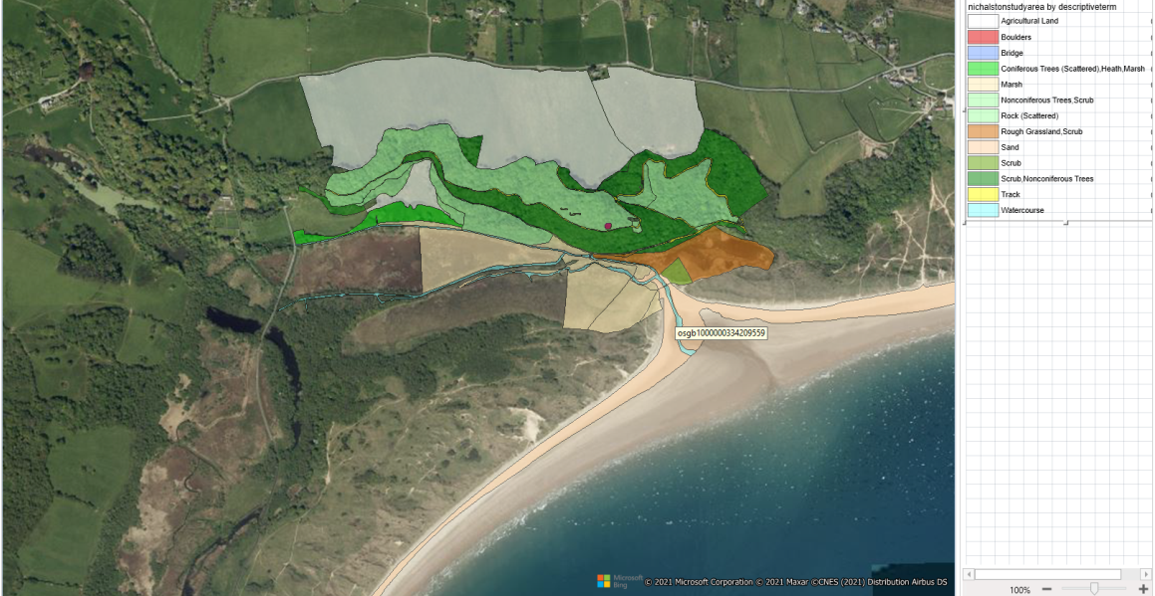
GIS image to show Oxwich Bay and Nicholaston Woods, with selected habitats distguished using a colour coded key.
B5 – Marshy grassland
The first area selected as part of this new management plan is B5 on the habitat classification scale. This area is Marshy Grassland and has Nicholaston Pill river running through the middle of it making it a riparian zone. It is highlighted in figure 1 above under Marsh on the key. Nicholaston Pill is highlighted as water course.
Feature details
There is species present such as pioneer species of salt marsh grass and glasswort with a distinctive transition zone holding the rare narrow mouthed whorl snail, wading birds are also present specifically in the winter months. Species which are found in abundance here are red fescue, mud rush, sea thrift, creeping bent grass, common sea lavender, sea milkwort, sea plantain, sea aster, sea rush, sea arrow grass, sea wormwood and long bracted sedge.
Objective/Vision
At the Saltmarsh grazing should occur at the site in order to improve biodiversity and allow the current species of Sea Lavender and Golden Samphire among others to thrive. Introducing grazing into a new vision is vital with it proven to be a key component in positively effecting seed bank characteristics (Ungar &Woodell 1996, Chang et al 2001). The Marsh area is planned to be enlarged through vegetation planting of species that are native to the area such as Cord grass and Glasswort. This will also create a larger transition zone for wildlife to travel through towards the dunes adjacent at Oxwich where the rare narrow mouthed whorl snail can continue to thrive. It is planned that with this enlargement that one specimen can be located every 10 samples from 2 10 metre plots. This enlargement of marsh should aid the populations of snails, which is seen as a priority in this plan due to their nationl importance. Pollution incidents that may effect biodiversity should be reported to the relevant contacts at NRW and the Environmental Agency Wales.
Management rationale
Saltmarsh’s have a value in both flood and coastal defence with studies finding they can reduce the height of damaging waves in storm conditions by 20% as well as being important to the ecosystem and conservation making them a vital part of coastal defence management. Oxwich Bay and Nicholaston woods typically suffer from the prevailing SW storms throughout the winter months. Large storms create metres of swell and hgh winds that batter the bay, in the long term this could become a problem as sea levels are expected to rise up to a metre by 2100. If the saltmarsh area is enlarged then over the coming years as intended then it should aid the UK priority species of the narrow mouthed snail and provide long term peace of mind in terms of coastal defence. Surveillance of the snail is vitally important if the species population is to be grown, hence the use of quadrats throughout the year to determine if methods are working.

Woodland
Figure 2
A GIS image to show the location of woodland at Nicholaston woods
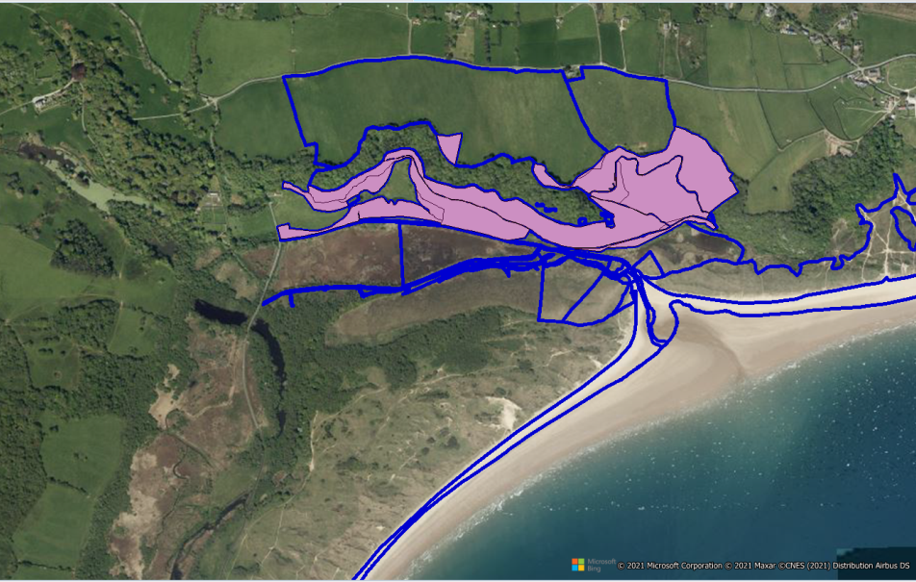

The area highlighted in the above polygon (Figure 2) is that of non-coniferoustrees. It is owned by CCW and is part of Oxwich bay NNR. It can also be seen in figure 1.
Feature details
This area is made up of specifically planted spruces, conifers and beech trees. Due to the planting the woodland is made up of both non native and native tree species. It is a semi natural woodland with an assemblage of nationally rare vascular species. There is a high variety of varied ground fauna like ramsons, dog’s mercury and hart’s tongue fern.
Vision
For the woodland the aim is for it to be dominated by ash with oak, sycamore and field maple also present in the canopy. It is planned that a shrub layer compromising sapling of ash, hawthorn and hazel will take up the space between the canopy and fauna. Over time it is the aim that the canopy will be dominated bynative species with selective felling of conifers taking place sporadically over the coming 10 years in order to allow new native young trees like ash to take their place. Fallen conifers will then be left to provide homes for fungi and invertebrates. All factors that may effect the achievement of these aims will be monitored and under control such as bracken and ash dieback. Boulders that lay in the area will be covered by hart’s tongue fern and mosses.
Management rationale
Minimal felling due to the 1950’s destruction of timber in the area, natural regeneration is the aim with selected felling of non-native planted conifers in areas where trees are all of the same age, this will happen in the short term. This should allow the creation of gaps where new ash trees can begin to flourish again. Once this has been done it is hoped natural regeneration will occur over a longer term period. Human factors such as the use of footpaths will be properly manged through the woodland, with signs directing members of the public to the correct routes in order to avoid wildlife being disturbed. It is accepted it will be difficult to change human behaviour in the area with education seen as the best tool to mitigate these problems. A woodland full of native species holds a higher biodiversity value to the area as well as being more resistant to climate change which is expected to increase in the near future.

Rough Grassland – Scrub
This habitat type can be seen in (figure 1) under an orange colour on the key.
Feature details
Plant species such as salad burnet Sanguisorba minor, wild thyme Thymus praecox, sedge Carexflacca, rib-wort plantain Plantago lanceolate, sheepsfescye Festuca ovina and birdsfoot trefoil Lotus corniculatus are located here. The grassland is surrounded by heath and scrub but these communities do not at present encroach the grassland community. This area is SSSI qualified.
Vision
For this area to support a thriving bee population flora will have to be changed over the coming 10 years. A mixture of plants for bees that survive in all seasons will be added at intervals in order to encourage a higher population within the area. Spring friendly plants like Aubretia (Aubreta), bugle (Ajuga) and spotted deadnettle will be planted in order to provide food. Winter plants such as Crocus and winter heather (Erica carnea) will supply the population during the colder months. For the summer Allium and borage will be planted while for autum Bugbane (Actaea simplex) and Caryopteris will be present. This overhaul on vegetation for the rough grassland area should add to the site as a whole. Cuting will only be carried out early and late in the year to allow flowers to grow and on a high setting in order to allow plants to spread.
Management Rationale
This will benefit populations of pollinators and provide habitats for a variety of natural pest predators. It is also of high importance that NRW and the Environmental Agency does more in trying to improve bee numbers in Wales. This is an opportunity to put that into practice and while it will be a long term process of change, it should be considered due to the benefits for the natural environment it could achieve. Over three quarters of crops currently grown for human consumption require pollinators with honey bees also responsible for 80% of all insect pollination and so bee populations should be increasing and not decreasing.

Watercourse
Nicholaston Pill river runs through the study area and can be seen as watercourse on the map. The current management plan does not have a specific riparian management plan in place.

Vision
For the watercourse of Nicholaston Pill, it is planned that enhancement of the riparian zone will take place over the next 10 years. This is planned to be done by adding different structures such as large rocks and log weirs to the banks of the river in order to change streambank structure and hydrological connectivity with new riparian vegetation. Trout and Salmon are good indicator species of a healthy river so system, so the habitat they need to survive is planned to be implemented using gravel bars the structures mentioned to better accommodate these species. By the end of the 10 years it is planned that the river will support a thriving ecosystem. Flooding is also an issue along this watercourse, with part of this plans vision to include soft engineering as part of the new plan. Historically the site and the river suffer badly from flooding events during periods of heavy rainfall specifically in the winter months. Soft engineering is recommended to be used for the site with flood warnings to be put in place on the road leading to Oxwich Bay by the Environmental Agency. Also extra trees should be planted in close proximity to the watercourse to help manage discharge levels. Following monitoring over the first few years of the plan, river restoration of problematic areas could then be completed reducing the risk of repeated flooding, this would maintain biodiversity whilst also being a low cost solution.
Management rationale
Global populations of migratory fish have decreased by 76% between 1970 and 2016, Nicholaston Pill is planned as an ecosystem that could be enhanced to accommodate trout and Salmon. It is accepted that this may be difficult, however as the last management plan could be criticized for lacking in ambition, a new future plan could make up for this by being overly ambitious. In terms of flooding, Welsh winters are typically getting wetter with this often seen at the site with flooding a problem during the winter months. Soft engineering could be used to tackle this problem as a first solution, if this does not work in the early years of the plan then GIS monitoring could show the shortcomings and a hard engineering strategy could then be devised.
Overall this new management plan tries to set out difficult targets so that the most can be gotten out of the area in terms of biodiversity. It is aimed for that this site could be transformed into an example of positive progress for a site management plan that attempts to not only conserve the site that it also looks after and monitor any changes happening, but also to be at the forefront of positive change for the environment in Wales. It is accepted that this may be difficult however no environmental problems we are currently facing in the coming years are simple. With a looming climate emergency, more needs to be done to positively change our environments and that could start with goals that are set higher such as this. As a result, even an under achievement could still be considered positive progress with more to build upon in the even longer term future.
Conclusion
This report highlights features of the current Oxwich Bay and Nicholaston woods summary management plan as provided by NRW. It is found that overall the plan is sufficient for the area hitting the requirements for an environmental site management plan. It is clear and concise, balanced and ensures environmental sustainability for the area is achieved over the coming years through its plans. Despite this there is still room for improvement through a clearer and more stringent flood management plan to be put in place, as well as more ambition shown in improving biodiversity and attracting new species to the area. Some ideas are presented in the 10 year future plan moving forward for the site with the help of GIS imagery to highlight specific habitats such as marshy grassland, scrub, watercourse and Woodland present at Oxwich Bay and Nicholaston woods. For marshy grassland, the new plan tried to improve on the existing by creating a larger transition zone for the nationally important narrow mouthed whorl snail through vegetation planting over the coming years followed by monitoring through the use of quadrats to see if progress has been made. As for Scrub, bees are planned to be attracted to the area in an improvement on the ambition towards new wildlife on the previous plan by changing the vegetation cover over time to plants that provide food for bees in all seasons of the year. This could be an important attempt to improve their dwindling numbers over the coming years. For the woodland, much of the same is needed with selective felling of non native species important in the next few years. This will allow for natural regeneration whilst also adding more dead wood to the area which is vital for the natural ecosystem. Lastly for the watercourse known as Nicholaston pill, the ambitious plan is for migratory species of trout and salmon to occupy the river through the implementation of various structures that will improve the natural habitat that they need to survive. Also, with flooding a problem during the winter months, some soft engineering is planned to be put in place in order to decrease the flooding risk and improve on the current plan which lacks in detail on how it will deal with this problem. It is hoped that the changes outlined will positively affect Oxwich Bay NNR and Nicholaston Wood in a way that can be an example to other site management plans in showing how high targets can gain good results. It is not forgotten that conservation of the area is just as vital with monitoring incorporated to ensure previous management plans progress are not lost. The current site management at the site is sufficient and should be commended for its work, however this report highlights some areas for improvement that could be used as a starting point to creating something better in the future.

References
Allan, J. David. 1995. Stream Ecology Structure and Function of Running Waters. London, England: Chapman and Hall.
Ashton, D.H. (1975) Studies of Flowering Behaviour in Eucalyptus regnans F. Muell. Australian Journal of Botany 23(3) 399 - 411
Chang, E.R., Jefferies, R.L. and Carleton, T.J., 2001. Relationship between vegetation and soil seed banks in an arctic coastal marsh. Journal of ecology, 89(3), pp.367-384.
Hansen, Paul L., Robert D. Pfister, Keith Boggs, Bradley J. Cook, John Joy and Dan K. Hinckley. 1995. Classification and Management of Montana's Riparian and Wetland Sites. Miscellaneous Publication No. 54. Missoula, Montana: Montana Forest and Conservation Experiment Station, School of Forestry, The University of Montana.
Lindenmayer, D.B., Laurance, W.F., Franklin, J.F., Likens, G.E., Banks, S.C., Blanchard, W., Gibbons, P., Ikin, K., Blair, D., McBurney, L., Manning, A.D. & Stein, J.A.R. (2014). New policies for old trees: averting a global crisis in a keystone ecological structure. Conservation Letters, 7, 61-69.
Meehan, William R. and William S. Platts. 1978. Livestock Grazing and the Aquatic Environment. Journal of Soil and Water Conservation. 33(6): 274-278.
Ohmart, Robert D. 1996. Historical and Present Impacts of Livestock Grazing on Fish and Wildlife Resources in Western Riparian Habitats. In Rangeland Wildlife. 245-279. Paul R. Krausman, ed. Denver, Colorado: The Society for Range Management.
Ungar, I.A. and Woodell, S.R.J., 1996. Similarity of seed banks to aboveground vegetation in grazed and ungrazed salt marsh communities on the Gower Peninsula, South Wales. International Journal of Plant Sciences, 157(6), pp.746-749.

