  - ACBA6003

Environmental Impact Assessment
By
Tim Rees
1807470

Table of contents.

- - Introduction – Page 3
- – Screening process – Page 4
- – Environmental Statement – Pages 5-7
- – Appendixes – Page 8
- – References – Page 9

1.0 Introduction –
As per the town and Country Planning (Environmental Impact Assessment) Regulations 2017 the aim of Environmental Impact Assessment is to protect the environment when planning for a project, which is likely to have significant effects on the environment The regulations set out a procedure for identifying those projects which should be subject to an Environmental Impact Assessment, and for assessing, consulting and coming to a decision on those projects which are likely to have significant environmental effects.
Another aim of Environmental Impact Assessment is also to ensure that the public are given early and effective opportunities to participate in the decision-making procedures.
When carrying out the environmental impact assessment the process shall be done in five stages. These stages are:

Screening – This phase will allow us to determine whether an EIA (Environmental impact assessment) is required

Scoping – this will allow us to determine the extent of the issues that should be considered in our assessment and reported in our environmental statement.

Preparing our environmental statement – Here we will prepare and submit our environmental statement which will include information required by regulation 18(3) and regulation 18(4) of the Town and Country Planning (Environmental Impact Assessment) Regulations 2017.

Making an application and consultation – Here our environmental statement will be published which will allow the statutory consultation bodies and members of the public to provide their feedback about the proposed plans.

Decision making- Once we the previous task has been carried out, we will be able to collate that information and allow the local planning authority to consider the feedback and comments when deciding whether to grant planning permission for our project.

2.0 Screening-
During the screening stage of this project under 10(b) and 10 (ii) of the Town and Country Planning (Environmental Impact Assessment) Regulations 2017 we are required able to classify the project under its correct schedule in order to decide whether an EIA (Environmental impact assessment) is required.

The proposed project is to be a PBSA (Purpose Built Student Accommodation) with containing 180 residential units and 12 retail units. As per Town and Country Planning (Environmental Impact Assessment) Regulations 2017 this project would be classified as schedule 2 as it would fall under the following legislation:

Schedule 2, Regulations of the town and county planning act 2017. Part 10 (B)(ii) Infrastructure projects such as Urban development projects in which the proposed development contains more than 150 dwellings.

As the proposed project is to contain 180 dwellings the schedule 2 classification under Regulations of the town and county planning act 2017 is justified and accurate. Appendix 1 provides an image of the mentioned classification.

3.0 Environmental statement-

3.1 Summary of Potentially Significant Environmental Effects –
Proximity to Docks (Spillage / Contamination / Water Pollution)
Increased air pollution due to increased traffic from new residents.
Increased noise pollution from traffic and increased number of residents in the area.
Potential for protected species.

3.2 Description of the development:
The proposed site is situated on a parcel of land situated south of the prince of wales dock and just north of King’s dock within the section marked “E9” in Appendix 2. The proposed site is approximately 9380m2 in size.
We will look to utilise the existing roadways and entrance to the plot at the North.
the main building will be positioned at the roadside facing the Prince of Wales dock to the North.
Smaller car park / lay-by to the front of the building along the roadside.
A larger car park for retail customers and residents that will be positioned to the rear of the building (South) with a publicly accessible garden in the same area.
The proposed building is to contain accommodation for 180 residents and 12 retails units.

3.3 Potential environmental impacts-

Proximity to Docks (Spillage / Contamination / Water Pollution) –
(G, Davies, 2022) During excavation phases of the project we will look to protect nearby watercourses through the implementation of cut off ditches, swales or silt fences that will be positioned around the perimeter of the area to divert any silt or contaminated water to a designated point for de-watering or to a settlement tank.
(G, Davies, 2022) All Chemicals, Oils or Fuels will be transported via predetermined routes to and across site and stored in the designated safe area (see site plan). These areas will be away from any draining points and will be equipped with a designated COSHH storage area for chemicals. It will also hold bunds and drip trays large enough to hold 100% of the containers capacity to capture spillages. When using any of these types of liquids, including the clearing of any spills, all employees will follow their training and site procedures, and use the correct equipment

Protected species-

(G, Davies, 2022) Any protected species discovered on site must be reported to the project Environmental Manager (Llinos Rees), who will ensure that suitable actions are taken, and the necessary authorities are alerted.
If any discoveries are made, all work in these areas will be suspended until the appropriate authorities / individuals are contacted and a rectification and/or prevention strategy is put in place to address the situation.

]
Air Pollution-

As well as the consequences to human health, Construction sites are known to be responsible for significant amounts of emissions. The majority of this comes from construction machinery and generators that run on diesel, with 1% representing dust from site activities such as demolition. Both plants and animals can sometimes struggle to thrive as a result of this contamination, causing a loss of biodiversity and disrupting the food chain in local eco systems. Some of the prevention methods we made be able to put into place to reduce the impacts of air pollution might include:

Using plant with hybrid technology in place of diggers and excavators with diesel engines. For example, Volvo is currently trialling a prototype hybrid excavator that runs on electric power generated from the downswing of its boom arm.

Using alternative fuels such as low sulphur diesel to power equipment and vehicles.
Never burn waste materials. The burning of materials is known to often produce smoke, releasing poisonous gases such as carbon monoxide into the atmosphere. In the UK, there is a risk of being fined for burning materials on building sites under the Clean Air Act 1993.
Improving existing equipment by fitting devices such as particulate filters and catalyst converters.

Wearing the correct PPE, such as the correct type of respiratory protective equipment (RPE) depending on the type of tasks being carried out by the employees.

Using water sprays or sprinkler systems to control dust and stop it spreading. This will be beneficial during tasks where dust production is prone such as the filling of skips or breaking down of concrete.

Using an on-tool adaption or attachment to control some types of dust. This is a type of exhaust or filter that fits onto some tools and removes dust as it is being produced.

Source local materials where possible to avoid the need for them to be transported hundreds of miles.

Where the transport of materials is required, we will look to ensure our logistics teams operate outside of peak road user hours in order to reduce traffic and thus reduce further pollution to the air.

Use renewable or sustainable materials where possible, such as timber from sustainably managed forests.

Noise pollution-
Noise pollution is often the type of pollution which its effects can be noticed immediately. Much of the equipment used can often be loud. This often, disturbing noise is also likely to be heard by members of the public who live nearby. As a result, this can cause local residents to experience varying levels of stress or disturbance to their sleep.
It is also very important to also consider the effects of noise pollution on the construction workers themselves. if employees use equipment that is particularly loud without using the correct PPE, they may even experience hearing loss.
Regarding environmental impact, noise pollution can also often disturb the natural cycles of animals as well as reducing the size of the habitat they can use.
Some of the prevention methods we can use to reduce these impacts might include:

Schedule work during sociable hours rather than when residents are likely to be sleeping. For example, between 8 to 6pm on weekdays. You could also notify residents of the working hours and keep them updated on the project.

Ensure plant and equipment is properly maintained and operated.
Switch off plant when it’s not in use.

Use quiet power tools and equipment to manage noise pollution. Where possible, we will look to use modern construction equipment that has been designed specifically to produce less noise.

Put acoustic barriers in place to assist with the management of the levels of noise pollution.
Ensure employees wear the correct PPE when using equipment to reduce the risk of hearing loss due to noise pollution.

4.0 Appendixes-

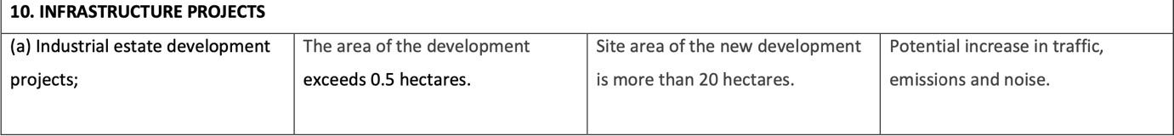

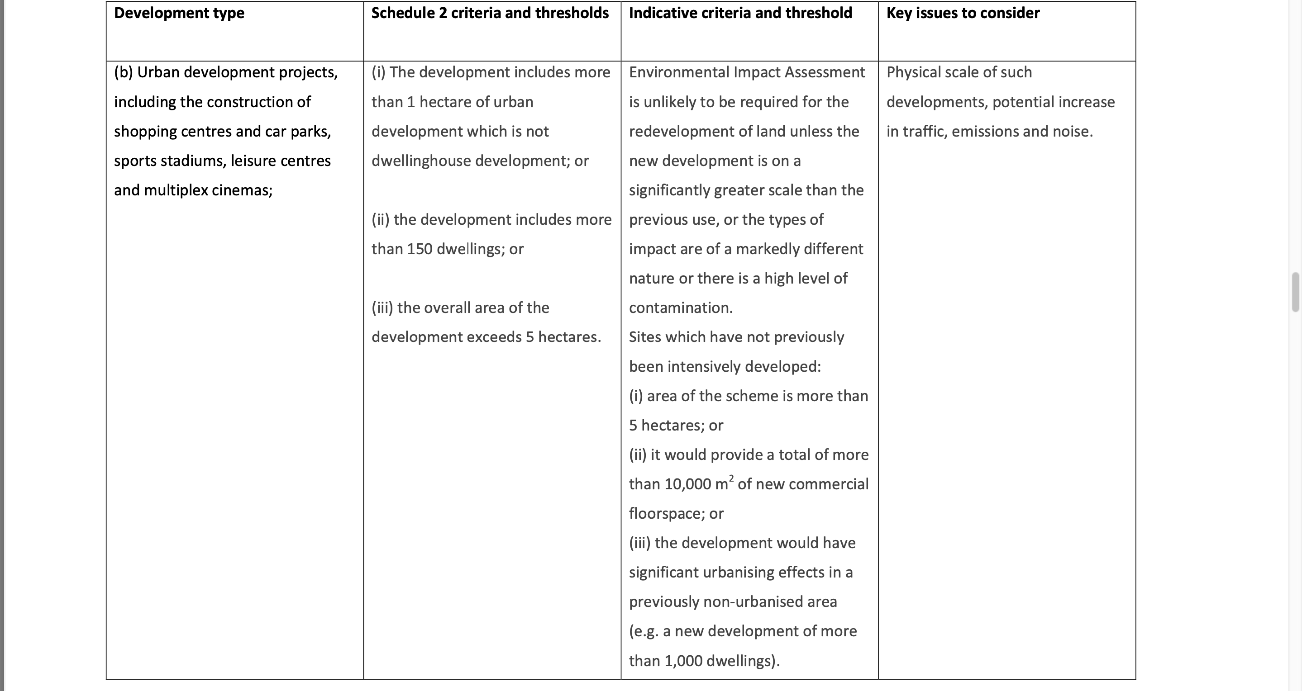

Appendix 1 showing screening criteria for EIA. (Thresholds table. 2022)

5.0 References

Legislation.gov.uk. 2017. The Town and Country Planning (Environmental Impact Assessment) Regulations 2017. [online] Available at: <https://www.legislation.gov.uk/uksi/2017/571/contents/made>.

GOV.UK. 2017. Environmental Impact Assessment. [online] Available at: <https://www.gov.uk/guidance/environmental-impact-assessment>.

Assets.publishing.service.gov.uk. 2022. [online] Available at: <https://assets.publishing.service.gov.uk/government/uploads/system/uploads/attachment_data/file/630689/eia-thresholds-table.pdf>.

