

Design and Development of a
Digital Expense Management System
by
Rachid Aboulachouaq

Supervisor: Nathan Morgan
Second Marker: Gaynor Thomas

Project submitted as part of the requirements for the award of
BSc (Hons) Computing (Software Engineering)

24th July 2026

DECLARATION

I, Rachid Aboulachouaq declare that I am the sole author of this Project; that all references cited have been consulted; that I have conducted all work of which this is a record, and that the finished work lies within the prescribed word limits.

This work has not previously been accepted as part of any other degree submission.

Date : ........23/07/2026.................

FORM OF CONSENT

I Rachid Aboulachouaq hereby consent that my Project, submitted in candidature for the B.Sc.(Hons) Computing (Software Engineering) degree, if successful, may be made available for inter-library loan or photocopying (subject to the law of copyright), and that the title and abstract may be made available to outside organisations.

Date : ..........23/07/2026.......................

Abstract
Many organisations continue to manage expense claims through e-mail alma spreadsheets or other manual processes which can create delays, errors and limited visibility. The aim of this project is the design and development of a user-friendly web-based expense management system to improve the efficiency accuracy and transparency of the expense process within the university environment.

A pragmatic and iterative software development approach were used. Requirements were identified through consultation with stakeholders and analysis of the existing process. The completed software system was developed using React, Typescript and Vite for the frontend, ASP.NET Core Web API for the backend. SQL Server with entity framework core was also used for data management. Authentication and role-based authorization were implemented to restrict access to roles. The system would allow employees to create, view and submit claims, while managers are able to review, approve and reject submissions.

Functional requirements and task-based utility testing was used to evaluate the prototype. Fix end user participants took part in the evaluation, producing a task completion rate of 90.5%. The post-test questionnaire achieved an overall mean score of four.02 out of five when unanswered responses were treated as 0, and from this the application was generally considered Leah an easy to use although issues were identified with login reliability claim action visibility validation feedback and page refreshing.
The project largely achieved its aim by delivering A functional prototype that introduced a traceable expense workflow that validated data at entry. Further development is required before its use in production, namely institutional single sign on and receipt uploads.

Contents
Abstract 3
Chapter 1: Introduction / Background (515 words) 11
1.1 Problem Statement 11
1.2 Project Aim and Objectives 12
1.3 Scope 12
Chapter 2: Literature Review (4319 words) 14
2.1 Digital Expense Management Systems (507 words) 15
2.2 Workflow Automation & Business Process Management (839 words) 16
2.3 Data Quality & Validation (767 words) 19
2.4 Human–Computer Interaction & Usability (720 words) 21
2.5 Authentication & Security (569 words) 23
2.6 Modern Web Application Architecture (501 words) 26
2.7 Chapter Summary (283) 27
Chapter 3: Methodology (1536) 29
3.1 Introduction 29
3.2 Research Methodology 29
3.2.1 Research Philosophy 30
3.2.2 Research Approach 31
3.2.3 Research Strategy and Requirement investigation 32
Chapter 4: Design & Implement (3853) 36
4.1 Introduction 36
4.2 Requirements and Design Objectives 36
4.3 System Design 38
4.3.1 Expense Workflow Design 38
4.3.2 Interface Design 40
4.3.3 System Architecture 45
4.3.4 Database Design 47
4.3.5 Authentication and Role Based Access Design 48
4.4 System Implementation 49
4.4.1 Development Iterations 49
4.4.2 Backend Implementation 51
4.4.3 Authentication and Authorisation Implementation 56
4.4.4 Front-end Implementation 59
4.5 Testing 66
Chapter Summary 66
Chapter 5: Evaluation (381) 68
5.1 Introduction 68
5.2 Usability Test Results 68
5.3 Against the Aims and Objectives 69
Chapter 6: Conclusions and recommendations (218) 70
6.1 Conclusion and Benefits 70
6.2 Recommendations for Future Work 70
Chapter 7: Reflection (603) 72
7.1 Introduction 72
7.2 Challenges and Personal Development 72
7.3 Challenges and Setbacks 73
7.4 What Could Have Been Done Better 73
Chapter 8: References 75
Appendices 79
Appendix A: Finance Meeting 79
Interview Summary 79
Transcript 89
Appendix B: Git Commit Logs 98
Front-end Git Commits 98
Backend Commit logs 102
Combined Solution For Render Deployment 107
Appendix C: Evaluation Survey 110
Employee Task Scenario 112
Manager Task Scenario 114
Post Test Survey / Final Thoughts 116
Appendix D: Initial Designs 121
Workflow and Architecture Diagrams 121
Wireframe Diagrams 123
Appendix E: Source Code 126
Backend 126
Front-end 133
Appendix F: Evaluation results 138
Post-Test Questionnaire Results 138
Post-Test Open Ended Questions 138
Task Observations 139

Figure 1: Literature Review Map (created with Lucidchart) 13
Figure 2: JWT Structure [24] 24
Figure 3: Development Workflow, made with Miro 31
Figure 4: Functional Requirements Table 36
Figure 5: Non-functional Requirements 36
Figure 6: Projected Claim Workflow, created with Miro 38
Figure 7: SPA Wireframe, created with Figma 39
Figure 8: Implemented Landing Page 40
Figure 9: SPA create claim, created with Figma 41
Figure 10: Implemented Create Clain Page 41
Figure 11: SPA manager dashboard, created with Figma 42
Figure 12: Implemented Manager Overview 44
Figure 13: Implemented System Architecture, created with Miro 45
Figure 14: Simple ERD, created with Miro 46
Figure 15: Authorisation Process of the application, created with Lucidchart 47
Figure 16: A summary of iterative development 50
Figure 17: Expense Model 51
Figure 18: Expense creation endpoint 52
Figure 19: Example of API endpoint testing with Bruno 53
Figure 20:Approval endpoint demonstrating status filtering 54
Figure 21: Implemented status filtering 54
Figure 22: JWT Token generation 56
Figure 23: Validating the JWT 57
Figure 24: User with manager role 59
Figure 25: User with employee role 59
Figure 26: Zustand Auth store and login functions 60
Figure 27: Central API handler 61
Figure 28: Refactored to function 62
Figure 29: Handler functions for row actions 64
Figure 30: Zod Validation Schema 64
Figure 31: Validation in Action 65
Figure 32: Results of the questionnaire 67
Figure 33: Future Developments, from initial scope and evaluation results 70
Figure 34: Earlier System Architecture Design, created with Miro 120
Figure 35: Initial Project Workflow Design, created with Miro 121
Figure 36 Initial wireframe, created with Lucidchart 122
Figure 37 Create claim wireframe, created with Lucidchart 123
Figure 38 Dynamic functionality of create claim, created with Lucidchart 124
Figure 39: Raw questionnaire results 137
Figure 40: Post-test open ended feedback 138
Figure 41: Task Observations 138

Chapter 1: Introduction / Background

Many organisations continue to rely on manual or semi-manual processes for handling employee expense claims, such as paper forms, spreadsheets or email-based workflows. These methods are often time consuming, prone to errors, and difficult to track or audit. In the University environment of this project, the current expense submission process lacks automation and consistency, resulting in delays in reimbursement, lost records, inefficient approval workflows, contributing to an increased administrative workload for employees, managers, and the payroll department.
To address these challenges, the project designs and develops a digital expenses system that allows employees to submit expense claims electronically and enables managers or administrators to review, approve, and manage submissions efficiently.

1.1 Problem Statement
The existing expense claim process in the workplace is inefficient and error-prone, relying heavily on manual intervention and tedious email workflows. Employees must prepare and submit claims using email and supporting documents, while managers must manually review and authorise records before they can be processed by payroll.

The current approach creates several operational challenges. Processing times can be increased due to manual review and collection, employees themselves have limited visibility of the status of their claim, and administrative staff must spend significant time tracking submitted claims and resolving any missing or incorrect information provided to them. Furthermore, the absence of an accessible centralised system reduces transparency and increases the likelihood of errors and duplicate claims.
Key Issues:
- Delays in approval and authorisation, and therefore reimbursement
- Limited transparency and tracking
- Increased administrative workload
- Greater potential for data entry errors and duplication

A digital expense management system has the potential to streamline the expense submission and approval workflows while improving transparency and reducing administrative effort for staff members.

1.2 Project Aim and Objectives
Aim:
To design, develop, and evaluate a user-friendly web-based management system that improves efficiency, accuracy, and transparency in the university expense processing.

Objectives:

- To analyse the current expense process and identify key user requirements
- To design an accessible user interface for expense submission
- To develop a web-based system for submitting, reviewing, and approving expenses
- To test the system for usability, functionality, and reliability
- To evaluate the system against user and organisational requirements

1.3 Scope

The system will include:
- User authentication and role-based access control (employee and manager/admin roles)
- A digital expense submission form with input validation, and calculation (e.g. mileage)
- Expense status tracking (submitted, approved, rejected etc)
- A dashboard for managers to manage submissions

Outside of Scope
- Payroll integration
- Email notification of claim status
- Receipt OCR
- External API integration (This would have been for vehicle information and RAC mileage calculations)

The remainder of the report is organised as follows:
Chapter 2 presents a review of the relevant literature pertaining to expense management systems, web application development, authentication, and workflow automation. Chapter 3 describes the methodology adopted during the project. Chapter 4 discusses the design implementation and testing of the proposed solution. Chapter 5 evaluates the current system against the project objectives and presents the results of user testing. Chapters 6 and 7 present the conclusions, recommendations for future developments and a reflection on the skills and knowledge developed throughout the project.

Chapter 2: Literature Review
This chapter of the report seeks to review the existing literature relevant to the development of the expense system. It examines current research surrounding digital expense management, workflow automation, data quality, usability, authentication and authorisation, and modern web application architectures. By examining these areas, an understanding is gained of the existing knowledge, technologies and methodologies that underpin the development of effective business applications.
The purpose of this literature review is to establish a theoretical background for the project, and to critically examine previous research to identify approaches that are applicable to the proposed system. The review establishes the theoretical foundations of the project and provides a justification for the design decisions taken throughout the project laid out in chapter 4.
This chapter is organised into several sections, beginning with digital expense management.
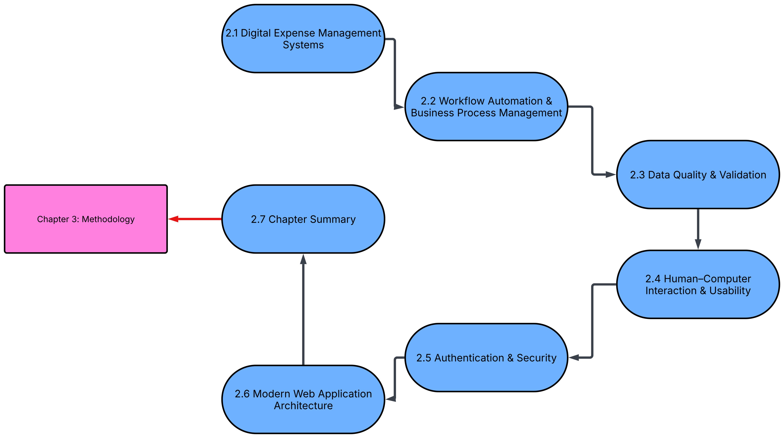
Figure 1: Literature Review Map (created with Lucidchart)

2.1 Digital Expense Management Systems

Manual expense processing often relies upon paper forms, spreadsheets, email communications and manual approval workflows. These methods often introduce delays, increases of administrative effort and reduces transparency of the entire process. A digital expense management aims to address the drawbacks by automating submission, approval and reporting aspects of the process, things which typically require significant human involvement, which align with wider organisational trends toward workflow automation. The limitations of manual administrative workflows become more apparent in environments where financial accuracy and timely reimbursement are essential.
The need to improve administrative processes in organisations has long been recognised, especially withing the field of Business Process Re-engineering (BPR). An influential contribution in this area came from Michael Hammer [1]. Hammer argues that organisation should not just automate existing manual procedure but should fundamentally redesign inefficient processes to eliminate unnecessary elements. By doing this, organisations will be able to achieve substantial improvements in performance [1]. As such, Hammer argues that technology should be used to rethink the way that work can be carried out, reducing complexity on human involved tasks and improving efficiency for the organisation.
Supporting this, Davenport and Short [2] define business process as a collection of related activities spanning multiple business function, arguing that information technology can enable the redesign of, rather than supporting, existing working practices [2]. Emphasis is placed that effective process redesign requires organisations to examine workflows holistically, rather than individual tasks, recognising the interactions between departments [2]. This is particularly relevant to administrative functions in an organisation, where expense claims can typically pass through several stages involving employees, managers and financial personnel before the process can complete.
More recent research literature demonstrates how these theoretical principles can be applied within expense management. Monteiro et al [3] highlight that traditional expense management processes rely on paper documentation and manual approval procedures, which stimulates the development of digital expense applications capable of automating submission, managing supporting documents and approval workflows [3]. Their findings demonstrate how replacing manual activities with digital systems can reduce repetitive work, while improving consistency and accessibility of expense records [3].
Similarly, Johri et al [4] identify how digital expense management systems can enhance transparency, improve record keeping and support faster financial reimbursement through providing structure workflows and more centralised access to financial information [4]. However, the research also acknowledges that success in implementation goes beyond technology alone. They identify user adoption, organisation readiness and effective design remain critical factors influencing whether a digital expense system achieves the expected organisational benefits [4].
Collectively, the literature demonstrates that a digital expense system provides significant advantages over traditional manual approaches by improving efficiency, transparency and consistency throughout the claim lifecycle. However, these improvements will only be most effective when supported by well designed business processes rather than simple digitisation of exiting workflows [1], [2], [4]. As Such, understanding how an organisational workflow can be redesigned and automated is fundamental to the successful implementation of a modern expense management solution, leading to further discussion of workflow automation and business process management in the following section.

2.2 Workflow Automation & Business Process Management

Although a digital expense management workflow would provide a platform for managing claims electronically, resolving the issue of spreadsheets and email-based communication, this by itself does not resolve the existing inefficiencies in a process. Workflow automation is concerned with the structure of how tasks, decisions and information pass between individuals, while Business Process Management (BPM) is concerned with providing a framework for analysis, implementation and continuous improvement of the processes. This becomes and important distinction as organisation may move to introduce new technologies without changing the underlying sequences of tasks, responsibilities and approvals. As a result, existing inefficiencies will simply be replicated in digital form [1], [2].
The foundations of this argument can be seen in BPR, through the content put forward by Hammer, as he challenges incremental automation of inefficient, established practices and how outdated assumptions and activities should be reconsidered [1]. Further supporting this is Davenport and Short, similarly examining information technology and process redesign as interconnected capabilities [2].
BPM has developed from these earlier approaches by treating improvement of organisation processes as a continuous process, rather than a single effort. As mentioned in a Practical Business Process Modelling and Analysis, Sinur et al [5] explores how modelling the business process is essential for preventing existing inefficiencies in redesign, as well as suggesting modern workflows must be adaptive rather than adaptive [5], building upon foundations established by Hammer and Davenport.
Lizano-Mora et al [6] identified three general stages in process management: early scientific management, growth of BPR, and the subsequent emergence of BPM as method of integrating managerial and technical methods, defining BPM as encompassing strategy, policy, tools, implementation and continuous improvement of processes [6]. BPM therefore has a wider scope than traditional management, which concerned primarily operational automation. As such, BPM additionally considers process analysis, optimisation, human involvement and administrative support [5], [6]. Although this is a broader interpretation, it is relevant to expense management as the approval process involves not only electronic movement but also organisational roles, financial policy and managerial decisions.

Similarly, Moreira et al [7] describes BPM as a multidisciplinary area, covering modelling, analysis, monitoring, and process refinement. They highlight in their systematic review that Business Process Automation (BPA) is an in established area within BPM rather than an independent solution [7]. Processes that are considered suitable for automation commonly possess repetitive, rule based, structured and standardised characteristic, especially where tasks occur frequently and are prone to human error [7]. Expense claims display several of these characteristics as they use defined information fields, follow repetitive approval stages and operate according to strict organisational rules. They identify common benefits of automation for such processes include increased effectiveness and accuracy of data, reduced processing time and cost, contributing to a wider improvement of the process and organisational benefits. Dwide and Semiring [8] produced similar findings, emphasising that selecting repetitive and rule-based activities can reduce manual errors and allow staff to focus on more high value work [8].
However, the literature does not praise automation as universally successful. Moreira et al identify certain barriers such as poor process documentation, limited digital readiness, uncertainty with selecting a process to automate, insufficient technical knowledge and the lack of ability to properly evaluate the benefits [8]. Likewise, Bartlett et al [9] contend that an effective design of a BPM system must combine modelling, automation, usability, integration and continuous improvement, supporting Moreira et al’s description [9]. However, Bartlett et al also highlights issues such as system complexity, security, resistance to change and difficulties aligning technology to human work [9]. These findings reinforce the earlier BPR argument that technology cannot independently correct a poorly understood or unsuitable process.
The continued involvement of human decision makers is particularly important in financial workflows. Kumar [10] describes Human-in-the-Loop automation as a hybrid approach in which repetitive and data intensive activities are handled automatically, while people remain responsible for judgements, verification, exceptions and sensitive decisions. This model is more applicable to expense approval than complete automation because a system can route claims, maintain statuses and record decisions without overriding the managerial responsibility to approve or reject claims [10]. Evidence from a university administrative environment also indicates that appropriately selected automation can reduce processing time and free staff to undertake higher value analytical work, although the Robotic Process Automation (RPA) approach examined by Gunawan and Wijaya [11] differs technically from a purpose-built workflow application.
Overall, the collected literature indicates that workflow automation is most effective when it is supported by prior process analysis, clearly defined responsibilities and continued evaluation. These findings directly support the project objective of improving the existing email-based expense process. Rather than merely reproducing the original form electronically, the proposed system restructures the process into defined stages of claim creation, submission, managerial approval or rejection, and status tracking. Human involvement is retained for financial decisions, while routine information handling and record management are supported digitally. However, the reliability of such a workflow also depends on the quality of the information entered and processed; the following section therefore examines data quality and validation.

2.3 Data Quality & Validation
The effectiveness of an automated workflow depends not only on how efficiently information is processed, but also on whether that information is accurate, complete and suitable purpose. Data quality is therefore a fundamental consideration in the design of information systems. Wang et al [12] describes data quality as the degree to which data is usable, and identifies accuracy, completeness, consistency, timeliness and relevance as it most important characteristics [12]. The metrics identified address different aspects of data reliability; consistency is whether information remains uniform across records, accuracy is whether the recorded value reflects reality; completeness considers whether all information required has been captured; timeliness concerns whether the data is currency or up to date; finally, relevance is whether data is appropriate for the task being performed [12].
To add, the multidimensional nature of data also means that inputted data may not be correct. For example, a claim may contain correctly formatted values but will still be unsuitable to be processed if there is missing data or the support documents do not correspond to the claim. Wang et al notes that the requirements for data quality should be considered in relation to the context and needs of the people using the information [12]. Whether the data is fit for use is particularly relevant to expense management as the same claim data has multiple uses, such as managerial review, reimbursement and potentially auditing.
Other research suggest that data quality can directly influence an organisation's performance and decision making. Suh [13] argues that even if an information system is sophisticated, it cannot produce a reliable analysis when the data it uses is incomplete, inconsistent, or insufficiently structured [13]. The study used approximately one million records and found measurable relationships between data quality dimensions and business performance indicators. This highlights that data quality is an organisational concern, not only a technical database issue [13]. Even though this research was conducted within a Customer Relationship Database, the principle can still be applied to financial administration as managers and finance personnel cannot make approval decisions when data is inaccurate or incomplete.
One method relevant to the project, and one of preventing poor quality data from entering an information system is validation. Lat [14] highlights how validation checks can ensure that data uses the correct format and type, while identifying mistakes during or after data [14]. In financial processes, human error can be reduced by standardised procedures, routine checks and automation. However, it should be noted that automated controls themselves should be monitored to ensure the remain effective [14]. As such this indicates that validation should not be viewed as a single feature of an interface, but rather as part of a wider approach to database constraints and rules.
However, the concept of the "required" field must be adapted to the actual requirements of the process for which the data are being collected. Belgacem et al [15] demonstrate that fields which remain incorrectly classified as required can compel users to enter meaningless placeholder values simply to pass validation. Although such entries may satisfy basic type and completeness checks, they can reduce the semantic quality of the collected data and introduce errors into subsequent processing. Belgacem et al therefore distinguishes between required, optional and conditionally required fields, arguing that form requirements should adapt to the user’s context and business needs [15]. This suggests that effective validation should not maximise the number of mandatory fields, but instead ensure that each requirement is relevant, necessary and meaningful.
Even so, validation cannot guarantee that submitted data is factually correct. For example, a system can confirm whether an amount is numeric, a date is present and the mandatory fields have been complete, however it may not be able to determine whether an expense is genuine or complies with organisational policy, therefore human review is a necessary component for contextual and financial judgement. Automated validation brings about the most benefits when it prevents predictable errors and illuminates anomalies, while leaving decisions that require evidence or context to authorised users [7], [12], [14].
As a collective, these findings support the project objective of improving the accuracy and reliability of the expense submission process. The proposed system uses validation rules to reduce incomplete or incorrectly formatted data from entering the approval workflow and managerial review is kept for decisions that cannot be solved through technical validation alone. As such, the system combines preventative validation measures with human decision making to improve the reliability of the of expense records. Nevertheless, this is all insufficient if users find a system difficult to understand and use, therefore the next section explores usability.

2.4 Human–Computer Interaction & Usability
The value of an information system depends on not only its technical functionality but also whether users can complete their intended tasks effectively and intuitively. In Human-Computer Interaction (HCI) usability can be explained in terms of effectiveness, efficiency and users’ satisfaction with how a system can be used. Islam et al [16] describe usability as the extent to which software can be operated efficiently, effectively and satisfactory this is a core component to the development of intuitive systems [16]. This is particularly important in administrative applications when employees and managers will interact with the system only periodically without requiring technical knowledge to submit or review a claim.
A design that is user-centred addresses this issue by placing a user's behaviours, needs and tasks at the centre of development. Verdi et al [17] argues that, by understanding user profiles, developers can create functionality that more closely aligns with a user's required tasks. The study is a combination of surveys, personas and observation of participants completing tasks rather than evaluating the interface solely from a technical perspective [16], [17]. The study highlights that functional interfaces could still create barriers to intuitive use, including unclear symbols, unreadable visualisations and mechanisms that were not sufficiently self-explanatory. As such, participants in the study frequently required assistance despite the required functionality being available to them [17]. Although the study concerns network management software its underlying principle applies to expense systems, that being that features cannot be considered usable simply because users are able to access them.
Individual elements on an interface may also affect usability. Islam et al [16] treat links, buttons, icons, symbols and images as communication artefacts between the developer and the user. Through further examination, they found that their evaluation of the semiotic interface sign design and evaluation framework identified usability problems that conventional evaluations could overlook [16]. This therefore suggests that familiar looking controls not always intuitive if their purpose or consequences remain unclear. Therefore, in an expense management application, labels such as submit, approve, reject and delete should therefore communicate distinct meanings, while status indicators should allow users to recognise the status of a claim without requiring additional interpretation.
Interface guidelines offer practical methods for improving this clarity to users. Alonso-Virgós et al [18] group web usability recommendations around principle such as reducing visual noise, utilising whitespace, concise text and highlighting the primary task [18]. The study of 20 developers found that recommendations and usability were not consistently applied without specific training, even when participants later considered those recommendations important [18]. For example, highlighting the main task was rated highly but implementation in the study remained inconsistent, while limiting menu options was frequently applied without necessarily being followed correctly, indicating that technical web development ability alone does not guarantee an effective or uncluttered interface
Another related study by Alonso-Virgós et al [19] Distinguishes between attempts to apply a guideline and complying with it successfully. They suggest that clickable areas should be immediately identifiable, adequately sized visually differentiated from non-interactive content. Their comparison of form designs shows how cramped fields, unclear buttons and poor spacing increase the effort required to complete an action by a user [19]. However, the study also found that progress reporting and grouped textual lists were among the least frequently applied guidelines, despite their potential to help users understand complex processes and information [19]. As such, usability guidelines should therefore inform design but cannot replace testing with representative users.
Usability is also closely related to data quality, as Belgacem et al Demonstrates that excessive or outdated mandatory fields may force users to enter meaningless information simply to complete the submission process, which leads to increased user burden while reducing the semantic quality of the resulting data [15], [16].
The collated literature supports the project objective of producing a user-friendly expense management system. The principles explored in the literature inform the use of structured forms, labelled actions, limited navigation options, and separate interfaces that reflect employee and manager tasks. Nevertheless, as pointed out by Alonso-Virgós et al and Islam et al, these design principles cannot establish usability by themselves, requiring evaluation through task completion and user feedback to create a user-friendly application [16],[18],[19]. As the system also processes personal financial information through role specific functions, the following section examines authentication, authorisation and security.

2.5 Authentication & Security

As expense management systems process information relating to employees, financial transactions and managerial decisions it is important control access to certain application functions, as security involves more than verifying that a user can log in. Bucko et al [20] distinguishes between identification, authentication and authorisation. Identification associates a person with an identity, authentication confirms that the person is who they say they are, an authorisation determines which actions or resources they may access [20]. This is an important distinction as indicating an employee does not entitle them to access managerial functions or other employee’s claims.
Security should also be incorporated during the design process rather than implemented after functional development. Saleem et al [21] argue that delaying security until implementation increases complexity and makes weaknesses more difficult to correct [21]. Their discussion reflects the principles of confidentiality, integrity and availability. Within an expense system, claim information must remain accessible only to authorised users, approval records must be protected from unauthorised users, and legitimate users must be able to access the service when they need [21].
Role-based access control (RBAC) provides a way of enforcing these restrictions. Ghazal et al [22] explains that RBAC assigns the permissions according to organisational roles rather than configuring individual access for every user. Where roles represent responsibilities, the permissions define the operations that can be performed on the system [20], [22]. Uddin et al [23] further argue the access may also depend on the task being performed and the current workflow stage. The task role model supports least privilege and segregation of duties by separating request submission from approval and activating permissions only when the previous required tasks have been completed. This closely aligns with the proposed system, where employees can create and manage their own claims and managers can only approve or reject claims after submission.
Token-based authentication enables identity and authorisation information to be transferred between the web client and the API. Bucko et al describes JSON Web Tokens (JWT) The widely used approach demonstrates the implementation using C# and .NET [20]. JWT contains a header, payload and cryptographic signature which allows the server to verify that the token has not been altered [20]. After authentication, the token is attached to subsequent requests, avoiding the repeated transmission of the user's original credentials [20]. Claims within the token and therefore provide the user identifier and role, among other information, required for access control decisions.
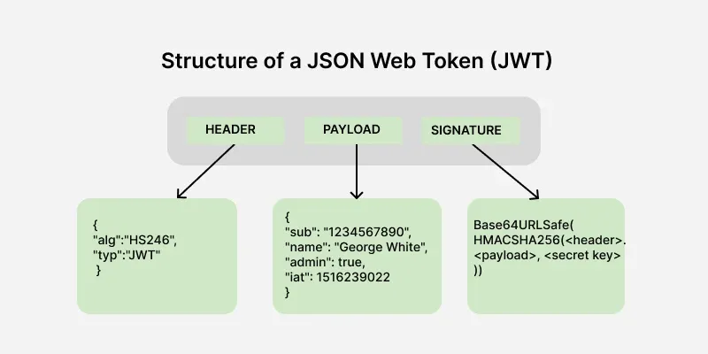
Figure 2: JWT Structure [24]

However, token-based security does present some risks as mentioned by Singh and Chaudhary [25]. They identify token forgery, replay, redirection and disclosure as common threats and emphasise that bearer tokens should be transmitted only through secure communication channels [25]. Tokens should also be validated for issuer, audience and expiry before access is granted [25]. Furthermore, JWTs may be difficult to revoke after expiration, making appropriate token lifetimes and secure handling necessary.
Security controls must ultimately be enforced by the server rather than just the interface. Almeida et al [26] demonstrate that unauthenticated requests should be rejected, while authenticated users without sufficient privileges or permissions should be prevented from performing restricted actions [22],[26]. These principles inform the use of JWT authentication and role-based API protection within the proposed expense management system. Employees and managers receive access according to their roles, supporting the project requirement to protect financial information, while maintaining distinct workflows. The following section examines the why the web application architecture supporting these controls.

2.6 Modern Web Application Architecture

The architecture of a web application influences maintainability, security, performance and capacity to adapt to changing requirements. Modern web systems commonly separate presentation from logic and data management. Kornienko et al [27] describe this client service structure as one in which the front-end manages transaction through the browser, while the backend processes business logic and communicates with the database [27]. This separation allows the interface and server-side functionality to be developed as distinct but connected parts of the web application.
A single page application (SPA) extends this approach by loading an interactive client application that updates content without repeatedly reloading the complete page. Huotala et al [28] explains that SPAs use asynchronous communication to retrieve data and provide more dynamic interaction. Kornienko et al similarly describe an SPA as a division between front-end responsibility presentation and a backend responsibility for processing requests, applying logic, and accessing stored data, with communication between them occurring through an API [27]. Its architecture is therefore suitable for workflow it's mostly between forms, dashboards and claim records.
However, SPAs also involve some trade-offs. Huotala et al note that client rendered applications may have slower loading time, while isomorphic or server rendered approaches improve the initial performance and user experience, by contrast these benefits are offset by greater complexity, additional infrastructure and difficulties synchronising state between the server and the client [28]. As the proposed expense system is an internal application rather than a public website, a conventional client rendered SPA provides a proportionate balance between responsiveness and the complexity of implementation.
Design based on modular components further supports maintainability. Lazuardy and Anggraini [29] explain that React divides interfaces into smaller reusable components, allowing elements to be implemented consistently while reducing duplicated development effort [29]. Their case study separates reusable elements, for example headers, sidebars and putters, from dynamic page content through a shared layout structure [29]. However, React applications may introduce challenges such as state persistence, routing dependencies and the movement of data between nested components [29].As such, Appropriate component boundaries and state management are therefore required to prevent modularity from creating unnecessary complexity in the project.
Another point made by Kornienko et al, is that communication between the client and server is commonly organised via RESTful APIs. REST supports client-server separation, stateless request, caching, and the standard HTTP methods for retrieving or modifying resources [27]. This improves interoperability, which is important in organisations with legacy systems, but the means that validation, authentication and authorisation must be enforced by the backend rather than trusted solely to the front-end interface.
The principles explored in the literature inform the proposes project architecture. React and Vite provide the client-side interface, while ASP.NET contains the expense workflow, validation and access control logic. The two layers communicate through REST endpoints; and Entity Framework Core (EF Core) manages access to the SQL database. This separation supports maintainability and future extension without introducing the additional complexity of other micro services or isomorphic rendering, which would be disproportionate the schedule purpose of the project

2.7 Chapter Summary
This chapter reviewed the literature relevant to the design and development of a web-based expense management system. Existing research indicates that replacing manual expense processes with digital systems and improve the submission storage and management of financial records. However, the literature also demonstrates that digitisation alone does not guarantee meaningful process improvement, and an effective system must address aspects of the underlying workflow, the reliability data collected, the usability of the interface, and the maintainability of the architecture.
BPR and BPM provide the basis for the restructure of the existing email-based process rather than just reproducing it electronically. Literature emphasises that repetitive, rule-based activities are particularly suited for digital support [1], [7]. Human-in-the-loop research further supported retaining human decision making for approval and rejection while automating routine activities such as claims submission, status tracking and record management [10].
The review also established that workflow efficiency depends on accurate and complete information. Validation can reduce predictable errors, although excessive or poorly selected mandatory fields an increase in the burden [12],[13],[15].
Literature on security distinguished authentication from authorisation and supported the use of role-based permissions, workflow access restrictions and server-side enforcement [21-23]. Modern web architecture research also justified separating React client, ASP.NET Core API and I need the base responsibilities through a component-based SPA architecture [27],[29].
Collectively, these findings support the project aim of improving efficiency, you received they also provide a theoretical justification for the system's design decisions structured such as structure claim submission, the find workflow states, managerial approval alma validation, role-based access and separate front-end and backend components. The next chapter explains the methodology used to translate these findings and the project requirements into the design, development and evaluation of the proposed system.

Chapter 3: Methodology

3.1 Introduction
This chapter explains the research and development methodologies used to produce and evaluate the proposed expense management system. The methodology was designed to investigate the limitations of the university's existing email-based expense process, translate the findings into system requirements, develop a practical web-based solution and evaluate whether the resulting prototype methods intended objectives.
The chapter will be divided into two main parts, with research methodology describing the project's philosophical position, research approach, requirements investigation and usability evaluation. The development methodology side explains the software development lifecycle, design activities, implementation approach, tools and testing methods used to construct the system.
A pragmatic research philosophy was adopted, supported by a deductive approach with inductive elements incorporated into it. Quantitative and qualitative evidence was gathered through functional testing, stakeholder discussions, usability tasks and participant feedback. The software solution was developed through an iterative life cycle incorporating agile and user-centred design principles. This combination enabled the project to address the technical operation of the system and the experience of its intended users

3.2 Research Methodology
The purpose of the research methodology was to establish how information about the existing expense process was gathered, how previous research informed the proposed solution and how evidence was collected to evaluate the completed system. The selected methods are explained in terms of their suitability, advantages, limitations and application within the project.

3.2.1 Research Philosophy
This project adopted a pragmatic research philosophy because it sought to address a practical problem within the university. The existing expense claim process relied heavily on email communication and manual administrative activities, creating issues involving efficiency, consistency, tracking and claim visibility. Therefore, the purpose of the research was not only to understand these problems, but also to use the findings who informed the design and development of a practical web-based solution.
Pragmatism focuses the consequences and practical application of research rather than requiring the researcher to follow a single methodological approach. Feilzer [30] explains that pragmatic research is concerned with producing meaningful and usable knowledge that can be linked to practical consequences [30]. This was appropriate for the project because its value depended on whether the research could be translated into a system that addressed the limitations of the existing process of expenses.
Pragmatism also allowed different forms of evidence to be used according to their suitability to the research. Quantitative evidence included pass or fail results from functional testing and numerical responses collected through the post-test questionnaire. Qualitative evidence included informal stakeholder discussions observations made throughout development and open-ended feedback from usability testing participants. Pragmatism supports the use of both objective and subjective evidence, allowing technical performance to be considered alongside experience and perceptions of users [30-31].
The main advantage of pragmatism was its methodological flexibility, for example functional testing could establish whether the system operated according to the requirements, while participant feedback could identify usability difficulties all opportunities for improvement that technical tests may have missed. The philosophy was therefore well aligned with the project's aim of producing a solution that was both functional and usable.
However, a possible disadvantage is that pragmatism may be interpreted too simplistically as using whichever method appears convenient at the time. This could potentially weaken methodological consistency or allow the researcher to select evidence that supports preferred conclusions. The research must therefore remain transparent and rigorously designed rather than becoming a justification for “whatever works” [30]. This risk was addressed by clearly defining the purpose of each method using functional test outcomes, documented the question the procedure and acknowledging the limitations of the data collected.

3.2.2 Research Approach
The project followed a primarily deductive approach, while also incorporating inductive reasoning during development and evaluation. This combination reflected the practical and iterative nature of the work that was done.
Deductive reasoning was used during the research and design stages. Existing literature concerning workflow, BPM, data validation, usability, role-based access and modern web architecture was reviewed to identify the principles most relevant to the proposed system design.
The approach was deductive as existing knowledge was used as the starting point from which the design decisions and system behaviour we're derived. The completed functionality was then tested to determine whether it operated in accordance with those requirements. Deduction generally moves from existing theory or knowledge towards propositions that can be examined through observation or testing [30], [32].
However, the project did not conduct formal hypothesis testing in the conventional experimental sense. The literature was instead used to develop an informed solution against which the prototype could be assessed. For example, research on workflow automation supported the use of structured claim states, while usability literature informed interface decisions such as clearly labelled actions and visible feedback.
Inductive reasoning was used as new findings emerged during implementation and testing. Not every technical dependency alma interface behaviour or detailed requirement could be fully established before development began. Observations made while connecting the database, API and front-end were used to refine subsequent decision. For example, changes to authentication workflow, relationship between users and expenses, dashboard actions and role restricted functionality emerged from problems observed during implementation.
The project’s own design also supported this iterative reasoning. Design artefacts such as wireframes, workflow diagrams, database models and interface prototypes will create it to represent possible solutions before full implementation. Feedback from end users later provided additional evidence from which future improvements could be identified.
The limitation of the inductive element was that development decisions could be influenced by the researcher’s personal interpretation of problems or stakeholder needs. This was particularly relevant because the researcher was also the system developer and had existing knowledge of the workplace process. The risk was reduced by documenting requirements and using define testing criteria to collect feedback from users other than the developer.
Overall, the deductive approach established initial evidence and system requirements, while inductive reasoning supported refinement as new information emerged during development and evaluation. This combination was consistent with the pragmatic focus and producing contextual and useful information.

3.2.3 Research Strategy and Requirement investigation
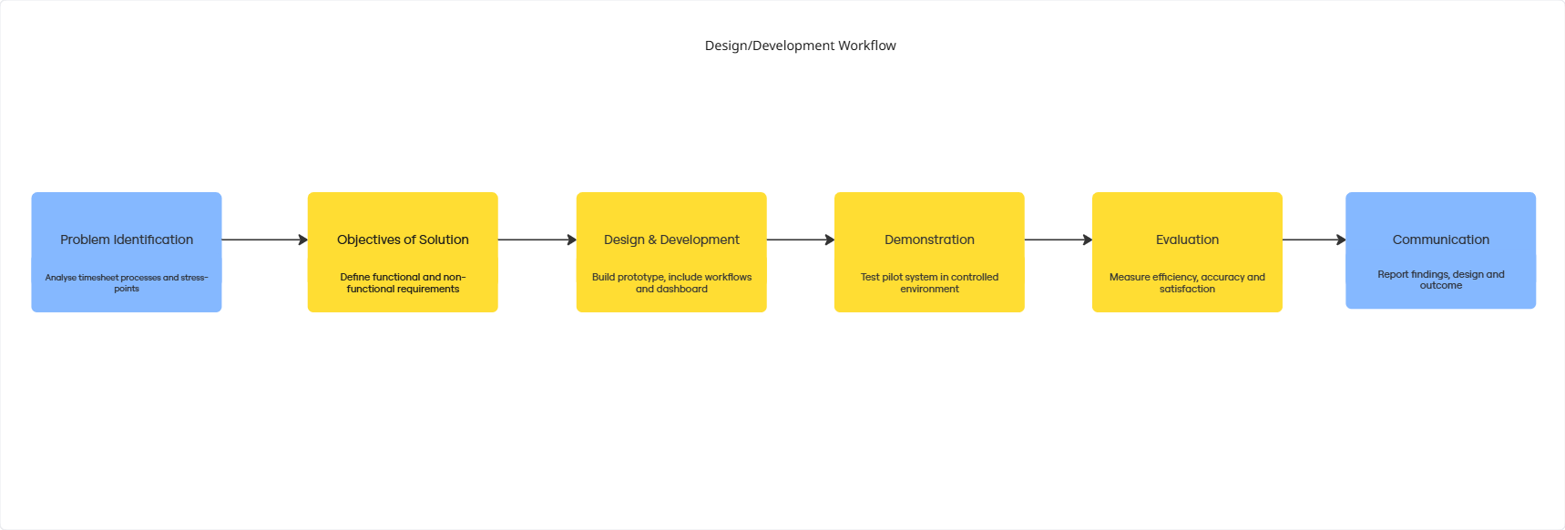
Figure 3: Development Workflow, made with Miro

An investigative strategy was used to understand the existing expense claim process and establish the requirements of the proposed system. Three organisational stakeholders contributed to the requirements investigation: the head of it, finance officer and the systems developer. These stakeholders were selected because they provide different perspectives on the proposed system finance officer contributed knowledge of the existing expense and administration process, while the head of it and systems developer provided information concerning technical feasibility, organisational systems and possible integration requirements.
A meeting with the finance officer was held to discuss the existing process, its operational problems and the information required when submitting and processing an expense claim. A Transcript of this meeting, which can be referred to in appendix A, was retained as evidence of the requirements gathering process and the discussion helped identify issues including manual email communication, incomplete or inconsistent submissions and the effort involved in correcting these errors, and the effort required to review and manage claims.
The stakeholder discussions were exploratory rather than formal standardised interviews. This allowed relevant issues to be investigated flexibly and follow up questions to be asked where clarification was needed. The advantage of this approach was that it produced detailed context regarding the current expense process from individuals familiar with it. However, the findings cannot be considered statistically representative because only a small number of stakeholders were consulted. Therefore, the discussions were used to inform the project requirements.
The investigation produced both functional and non-functional requirements:

Functional Requirements | Non-functional Requirements
Authentication | Usability, users should be able to intuitively use the application
Create and save claims | Form validation to reduce data errors
Submit Expense claims | Authentication and authorisation to protect financial information and adhere to organisation security policy
View Current Claim Status
Managers to approve/reject claims
Role-base restrictions

Early design proposals were removed or deferred as the project scope was refined. These included route calculation, external vehicle information APIs, power BI reporting, payroll integration and automatic institutional authentication. Retaining these early artefacts demonstrates how the design progressed from a broad proposed solution to a feasible minimum viable product.
A GitHub repository was used throughout development to maintain source control and the chronological record of implementation changes, which can be viewed in appendix B. The commit history provided evidence of incremental development and enabled previous versions to be recovered, when necessary, together with the weekly client meetings the supported traceability between requirements and implemented functionality.
Usability evaluation was used to assess whether the completed prototype was functional alma understandable and suitable or it's intended audience. Participants in the evaluation were provided with both employee and manager test accounts and were asked to complete a series of tasks within the deployed application.
In the employee scenario participants were required to log in Palmer create a claim, view its details and submit it for approval. The manager scenario required participants to access the manager interface approve a pending claim and reject another with an explanation why. After each task, each participant recorded where there was completed, where the help was needed, any errors encountered, the level of assistance they needed if any, and any additional comments they had about this functionality. These measures provided evidence of effectiveness and areas of user difficulty.
After the task scenarios were completed, participants were then asked to complete a questionnaire containing 8 statements rated on a 5-point scale from strongly disagree to strongly agree. The questions examined claim creation, understanding workflow states, claim information, manager workflows, predictability of actions and system responsiveness. Reopen ended questions were also added to collect feedback on useful features, confusing elements and suggested improvements the end users might have. The structure of the survey can be found in the appendix C.
Participation was voluntary and participants could withdraw before submitting their responses which were anonymised and handled confidentially in accordance with UK GDPR and university ethics requirements.

Chapter 4: Design & Implement

4.1 Introduction
This chapter will describe the design and implementation of the web-based expense system. It explains how requirements were identified during research and how they were translated into workflows, interface designs and software components.
The application was designed using a client server architecture consisting of a React/Vite and TypeScript front-end, an ASP.NET Web API and C# backend and a SQL Server database accessed through EF Core. Authentication was implemented using JSON web tokens, while role-based authorization separated employee and manager functionality.
The development was completed iteratively, with early designs considering a wider system containing mileage calculation, vehicle information APIs, BI reporting, payroll integration and institutional authentication. The scope was later refined to ensure the creation of a minimum viable product and prioritised the core expense workflow of claim creation, submission, approval and rejection.
This chapter first presents the identified requirements and design objectives of the project. It then discusses the workflow interface, architecture, database and security designs before moving on to the implementation of the backend, front to end and role specific functionality. The chapter concludes with the principal development challenges and the testing used to verify completed application.

4.2 Requirements and Design Objectives

System requirements were identified through analysis of the existing process, discussions with the head of IT, a finance officer and a systems development officer. There were also weekly progress meetings with the dissertation supervisor, acting as the project client to ensure development stayed aligned to the requirements of the project in an agile manner. The requirements were further refined throughout development as technical constraints and user needs became clearer.

Figure 4: Functional Requirements Table
Figure 5: Non-functional Requirements

The scope was prioritised around the minimum viable product. Planned features such as external mileage calculation, vehicle information retrieval, receipt OCR, payroll integration, e-mail notifications, power BI reporting and institutional single sign on were deferred. Although these features would vastly improve a future production system, they were not necessary to demonstrate improvements to the claim submission and approval process.
As such the final interface design concentrated on the three main areas of viewing claims, creating a claim, and managing claim approval to demonstrate a viable product. Wireframes show a claims dashboard, structured expense form and a manager approval page containing actions that can be performed on the claims.

4.3 System Design

By referring to the project requirements, system design of a practical structure for the application was developed. The design process considered how claims would progress through the system, how the users would interact with the system, how information would be stored and how access to protected functions would be controlled.
The principal design areas with the expense workflow, user interface, client server architecture and authentication process. These elements were developed together so that actions would correspond with the permitted workflow states and backend rules.

4.3.1 Expense Workflow Design
Project workflow replaced the existing process with a sequence of role-specific actions and defined states.
Employee begins by creating an expense claim Which are assigned the status “Draft” by default, allowing the employee to review the information before submitting it, this was also an intentional design decision as this allows for future functionality of editing claims before submission. Once the employee selects the submission action the status of the claim changes to submitted and the claim becomes available to authorised managers to review.
The manager thus reviews the submitted information makes the decision on whether to approve or reject which would change the claim status to the relevant state. Rejection changes the status to rejected and the manager is required to provide a comment explaining their decision. The employee can then view the updated status and any manager feedback to the claim dashboard enhancing traceability and transparency in the process.
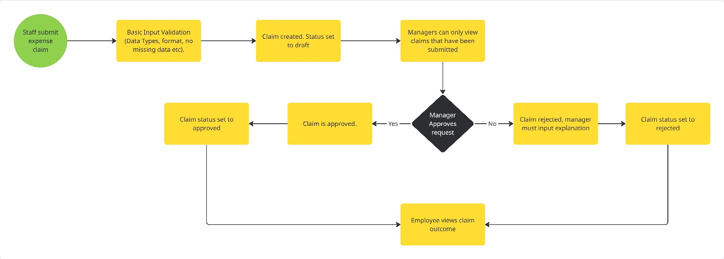
Figure 6: Projected Claim Workflow, created with Miro

The use of explicit claim states is to provide visibility and prevent ambiguity about the position of a claim within the approval process. Under the original email-based approach employees had limited means of determining whether submission had been received, reviewed or processed. As such digital workflow stores each claim and truly and allows its current state to be viewed.
Earlier designs of the workflow included additional stages such as automatic payroll forwarding, e-mail notifications alma duplicate detection and reporting. Earlier designs can be found in appendix D. These were deferred because they required further organisational integration and were not essential to demonstrate the employee to manager process and so the final workflow prioritised a complete and testable minimum viable product.
This workflow of also separates the responsibilities of employees and managers call mom wherein employees can create and submit their own claims but cannot approve or reject them. Approval functions are restricted to manager users only and apply only to claims with the submitted status during their actions are controlled by both the user's role and the position of the claim in the workflow. This access control can be used to ensure that users can perform actions according to their assigned roles and authorisation [23].
Additionally, human involvement is retained for financial decisions rather than automatically approving claims. Activities such as capturing information, storing the records, displaying submitted claims and updating statuses were automated while approval and rejection remained management responsibilities, reflecting a human in the loop financial workflows where automated processing is combined with human review for decisions that require judgement and accountability [10].

4.3.2 Interface Design
Wireframes were created before implementation who established the layout alma navigation and role specific functions of the application. Wireframe diagrams were chosen because they allow interface ideas to be developed and revised without committing time to visual styling, cutting down on development time, and provide a clear way of communicating the proposed design during weekly client meetings. Also, wireframes and prototypes are commonly used to document interface concept, supporting alignment between design and development activities [32].
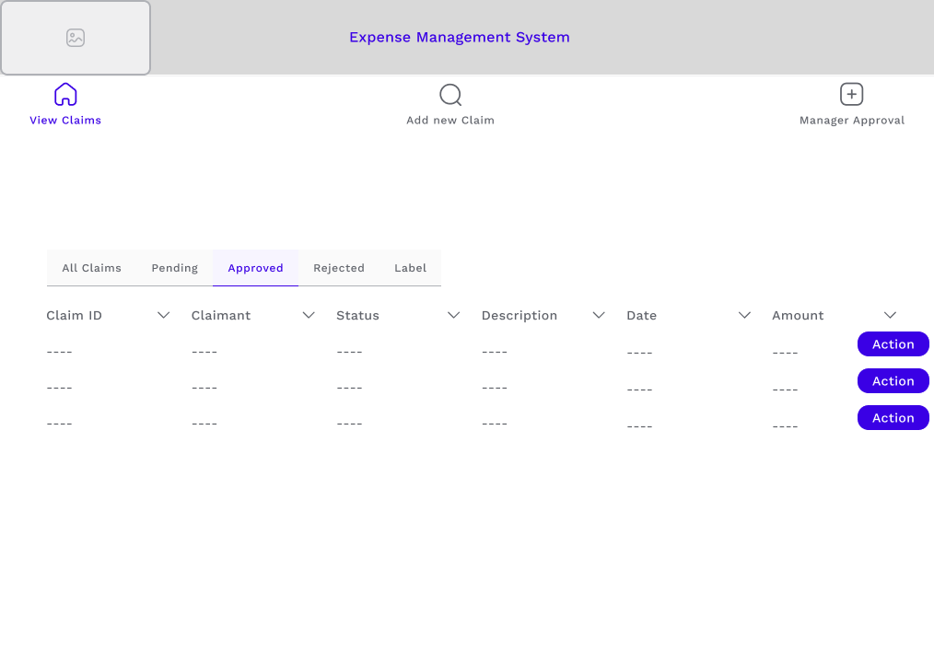
Figure 7: SPA Wireframe, created with Figma
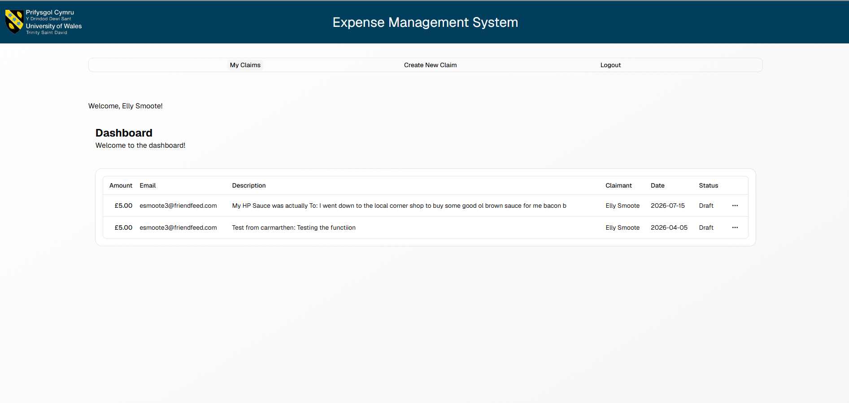
Figure 8: Implemented Landing Page
The dashboard was designed as the main location from which employees could view and manage their claims, as seen in the figure above. A tabular layout was selected because each claim contained the same categories of information, with actions being placed alongside each claim so that and view details or perform permitted operations without navigating through several pages. This supported the design objective of making claim progress visible.

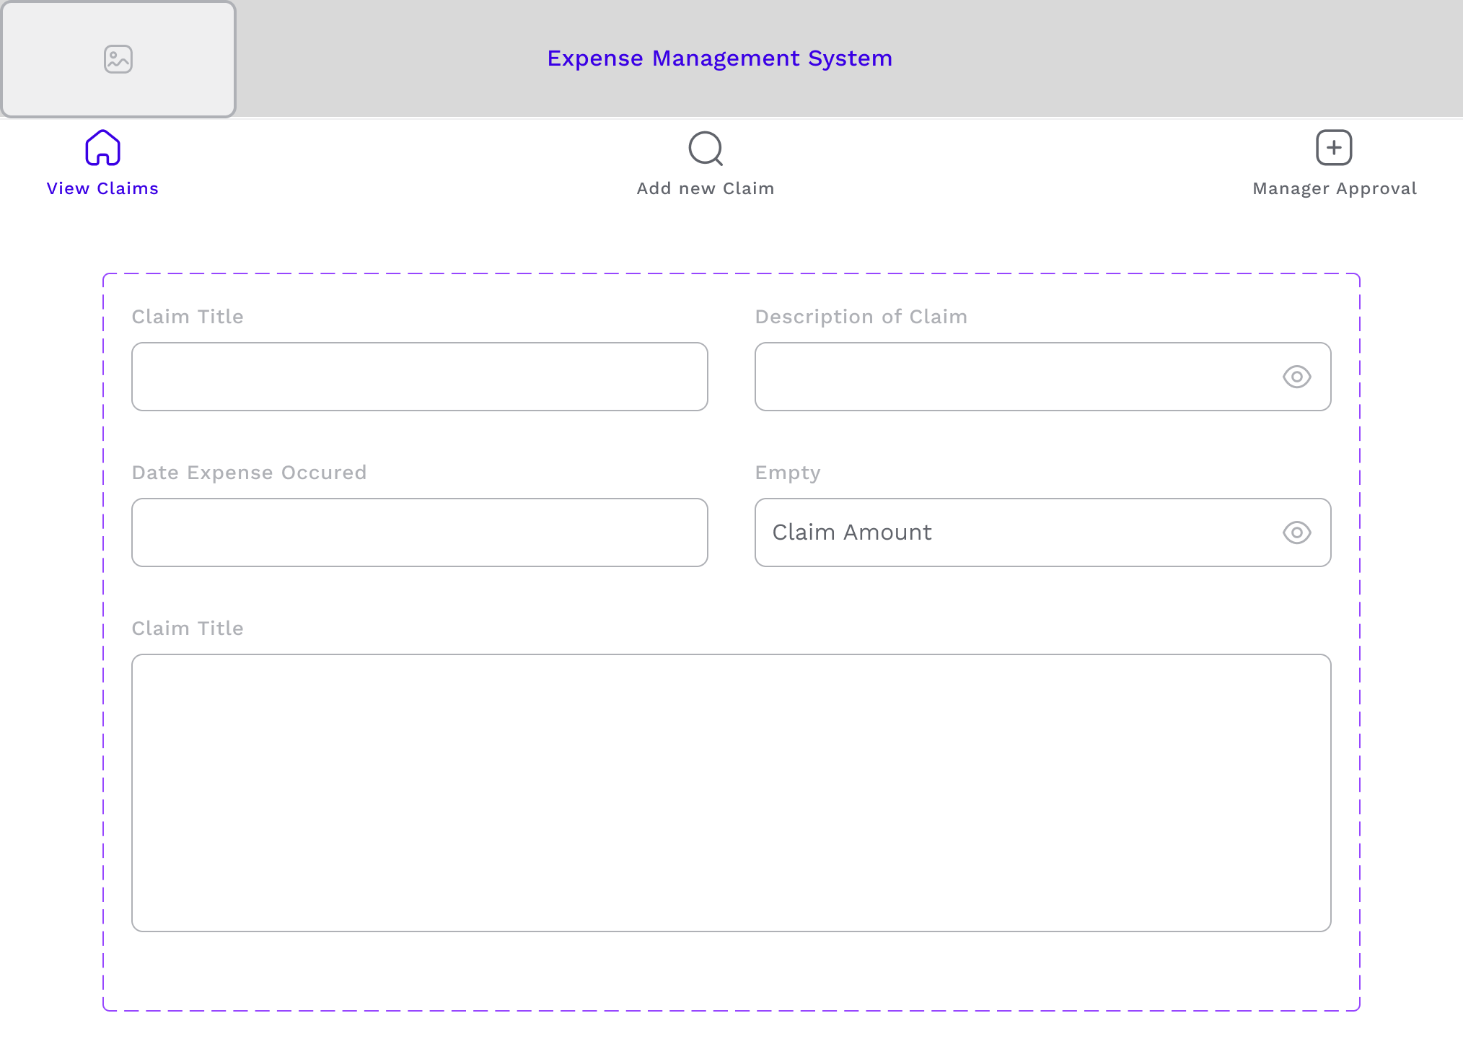
Figure 9: SPA create claim, created with Figma
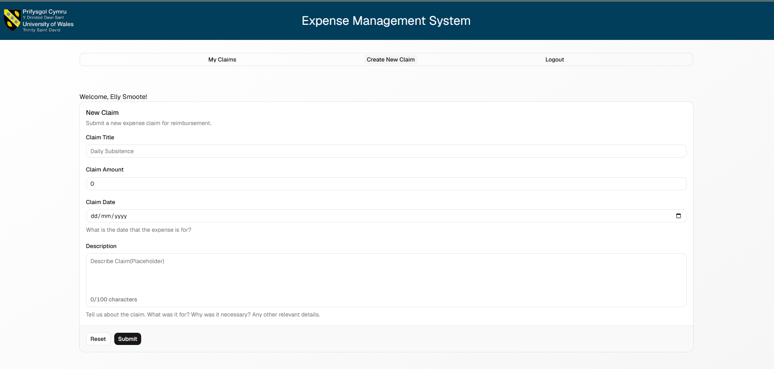
Figure 10: Implemented Create Clain Page
The claim creation interface used a structured form rather than reform e-mail content. Elaborate fields were provided for the claim title and description, expense date and amount. This approach was chosen to improve consistency and enable validation before information was submitted to the API.
In the initial designs, additional fields for mileage calculation and external vehicle information was considered, however, these were removed from the minimum viable product because they depended on external services, which would have taken up more development time, and were not essential to the central expense workflow. The simplified form reduced implementation risk and allowed development effort to be concentrated on validation it's take this management.

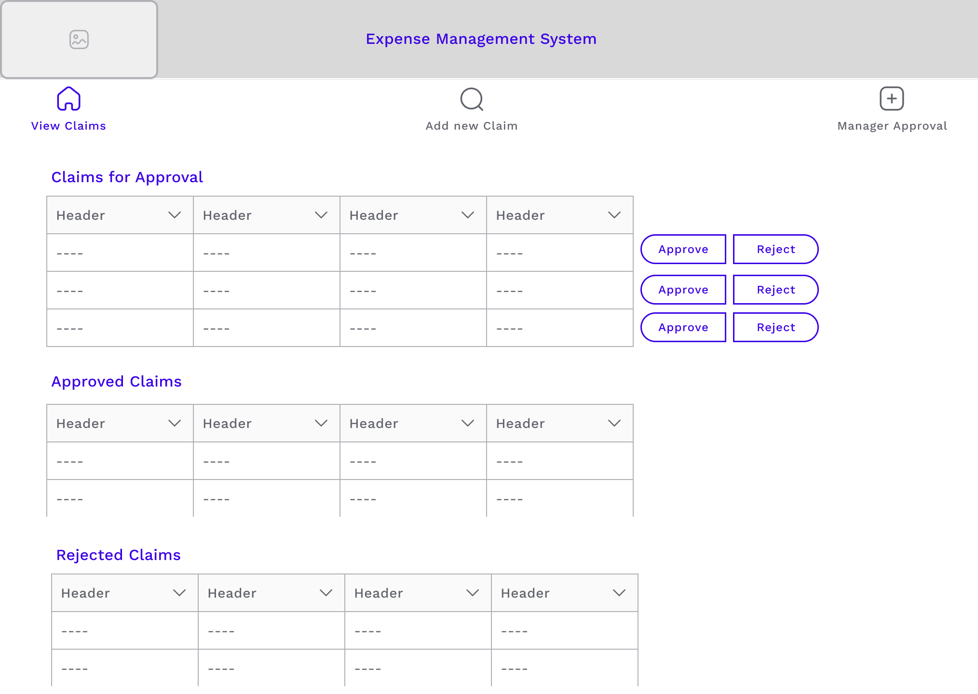
Figure 11: SPA manager dashboard, created with Figma
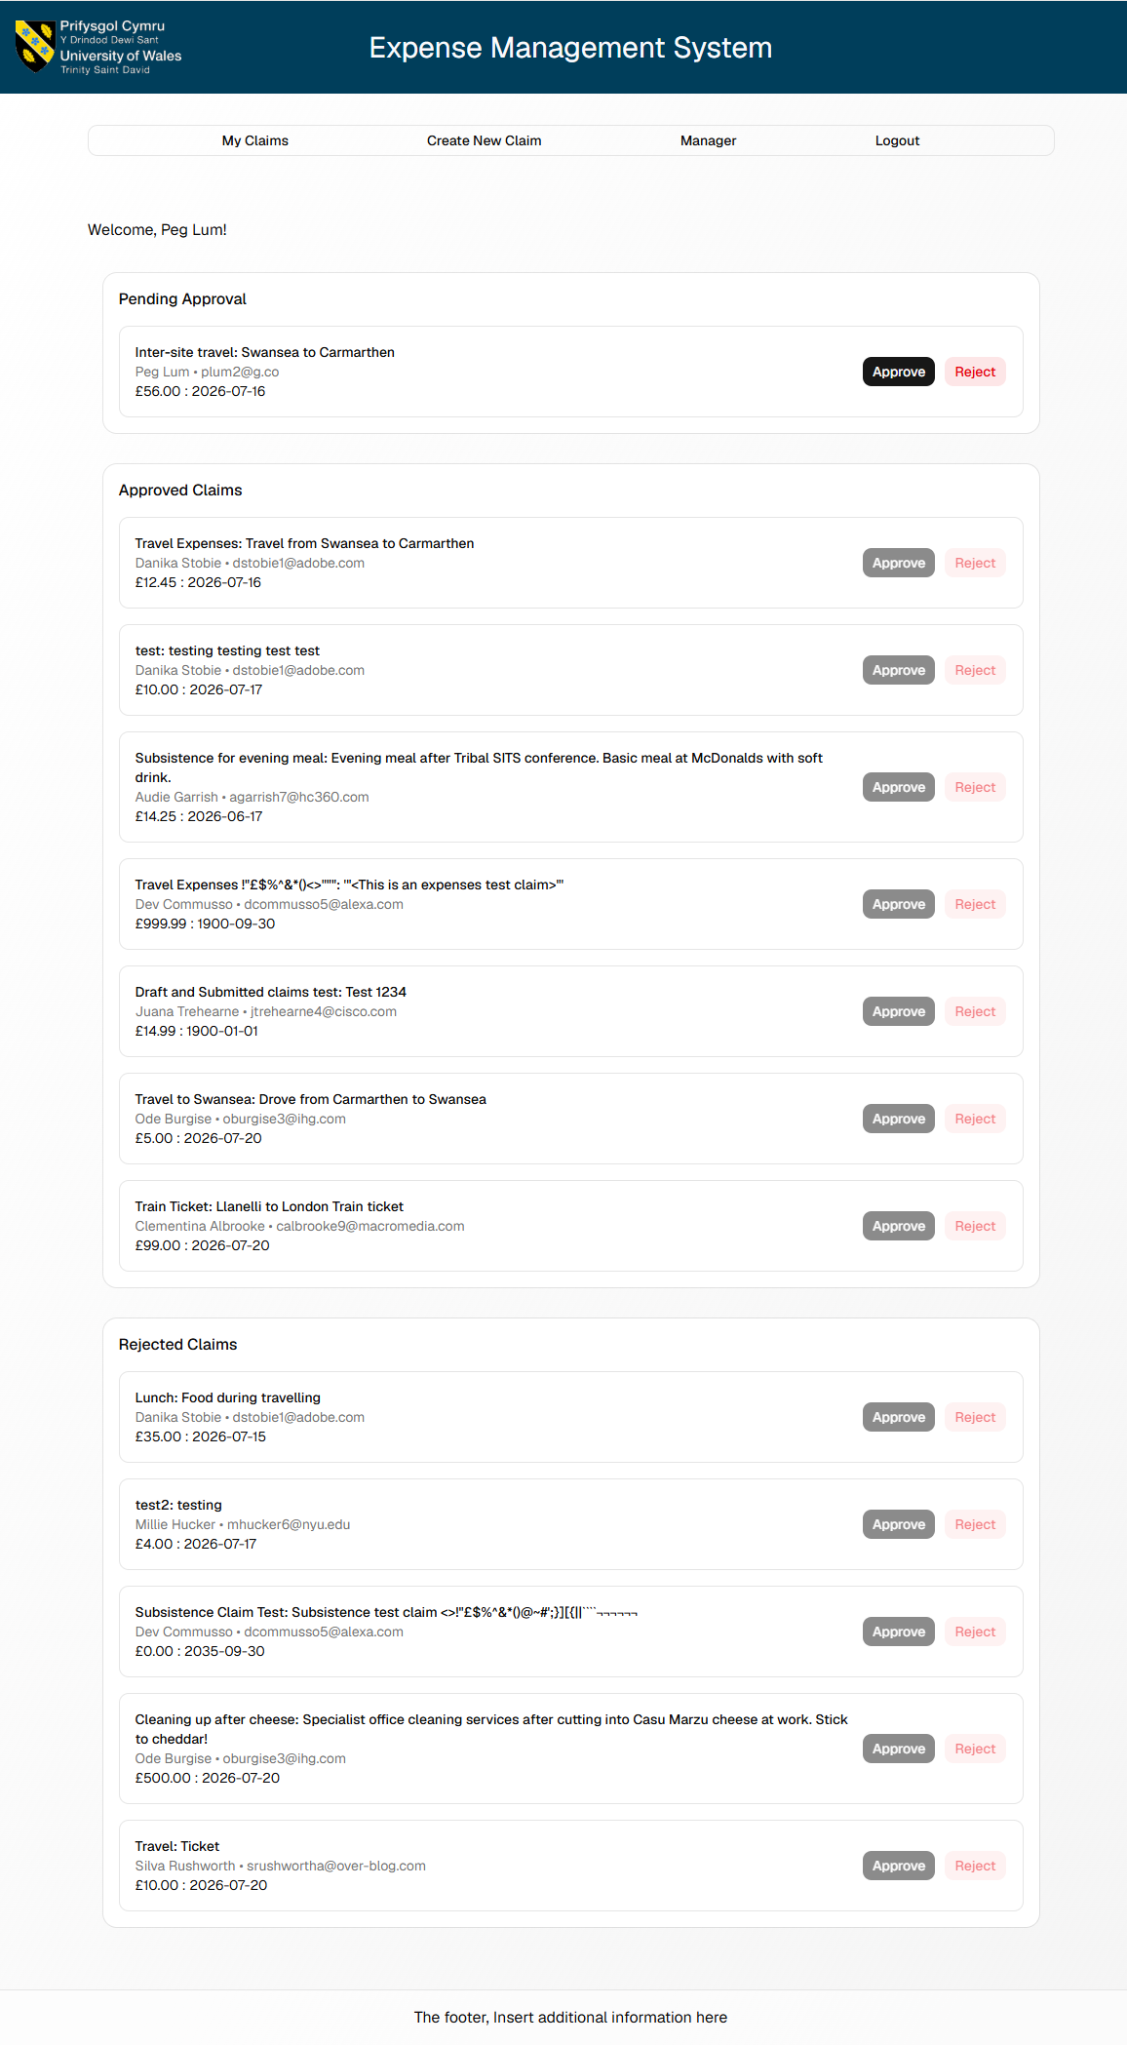
Figure 12: Implemented Manager Overview
The manager approval page provides an overview separated into pending, approved and rejected groups. The control actions were displayed beside pending claims for increased visibility. This page was kept separate from the employee dashboard as the rules had different responsibilities it's referred to in the workflow diagrams. By separating these functions interface complexity is reduced and also supports role-based access control.
Final interface did not implement every visual feature the early wireframes. Exactly Throughout development components were adapted to suit the react application, shadcn/ui component library and the data returned by the API, however, the main layout and workflow concepts remained consistent.

4.3.3 System Architecture
The application using an architecture was designed separated the user interface, application logic and data storage. The system consisted of a react and TypeScript front-end single page application, an ASP.NET and c#, EF Core backend and a SQL Server database.
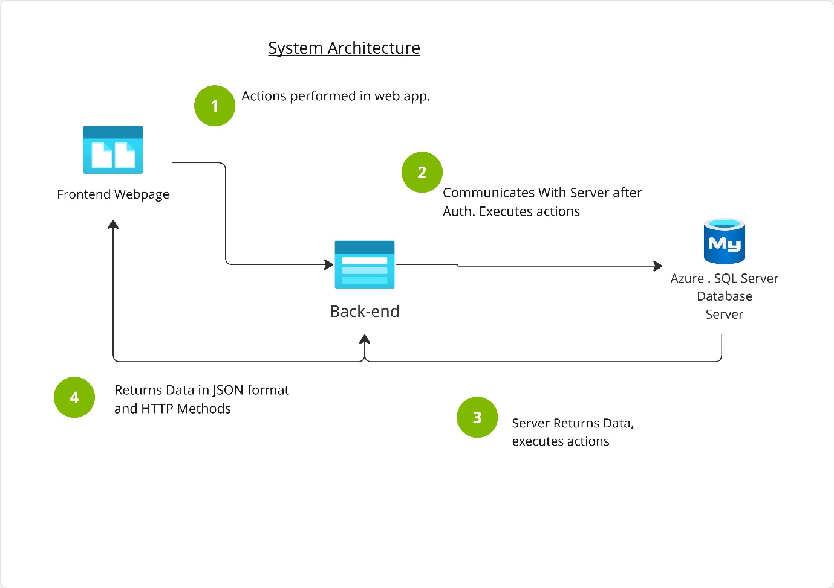
Figure 13: Implemented System Architecture, created with Miro
The react front-end maintained the presentation layer and ran within the user's web browser, displaying the interface, maintaining client-side state Watch the backend API endpoints. It did not communicate directly with the database therefore preventing credentials and data access logic from being exposed to the client.
ASP.NET Core Web API formed the application layer of the system, processing requests from the backend, applying validation and workflow rules, checking user identity and their permissions and furthermore communicating with the database through EF Core. This follows general separation used in single page design where the front-end manages presentation and the backend handles associated requests and logic [27]. It also allowed abstraction between the application database as it mapped entity models to database tables and supported asynchronous querying, reducing the need for manual SQL written within each endpoint.
Communication was achieved with the use of HTTP methods, Allowing for REST style APIs individual components to be maintained or changed independently, increasing the maintainability of the application code [29].
Application information was transferred using JSON web tokens which allowed the front-end to store the issued token and include it in the authorization header protected API requests. Validation would then be performed by the backend, using the information to verify user identity and role and determining which operations were permitted, enhancing security through server-side enforcement.
Through local development the front-end and backend ran as separate application. However, due to the scalability and ease of remote testing, the front-end and API were deployed to Render, which is cloud hosting platform, The database was hosted using Azure SQL. This allowed the application to be accessed through a normal browser without needing to install the development environment.

Initial architecture design included possible connections to the payroll system, external APIs and a power BI dashboard bomber however these features were excluded from the implemented architecture as they fell outside the final MVP, nevertheless the architecture retained the possibility of adding these future integrations. The initial architecture can be viewed in appendix D.

4.3.4 Database Design
Relational database was used to store users and expense claims as the data was able to be clearly defined relationship. SQL Server was selected to meet the requirements of the project, as this is the organisational standard, while EF 4 was used to map the C# models to the database structure.
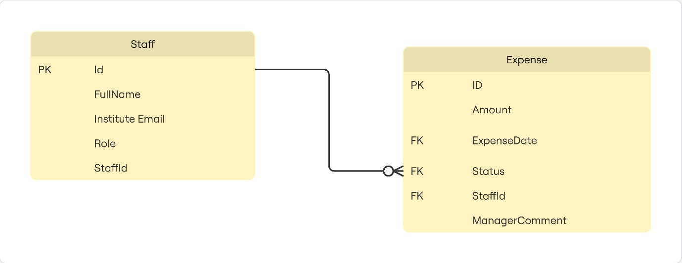
Figure 14: Simple ERD, created with Miro

4.3.5 Authentication and Role Based Access Design
As a key requirement, authentication and the authorisation were designed to protect expense information and maintain a divide between employee and manager responsibilities. The prototype used an email-based login process linked to predefined user records, after a valid account was found the backend would generate a JWT which contains user information including organisation identifier and role.
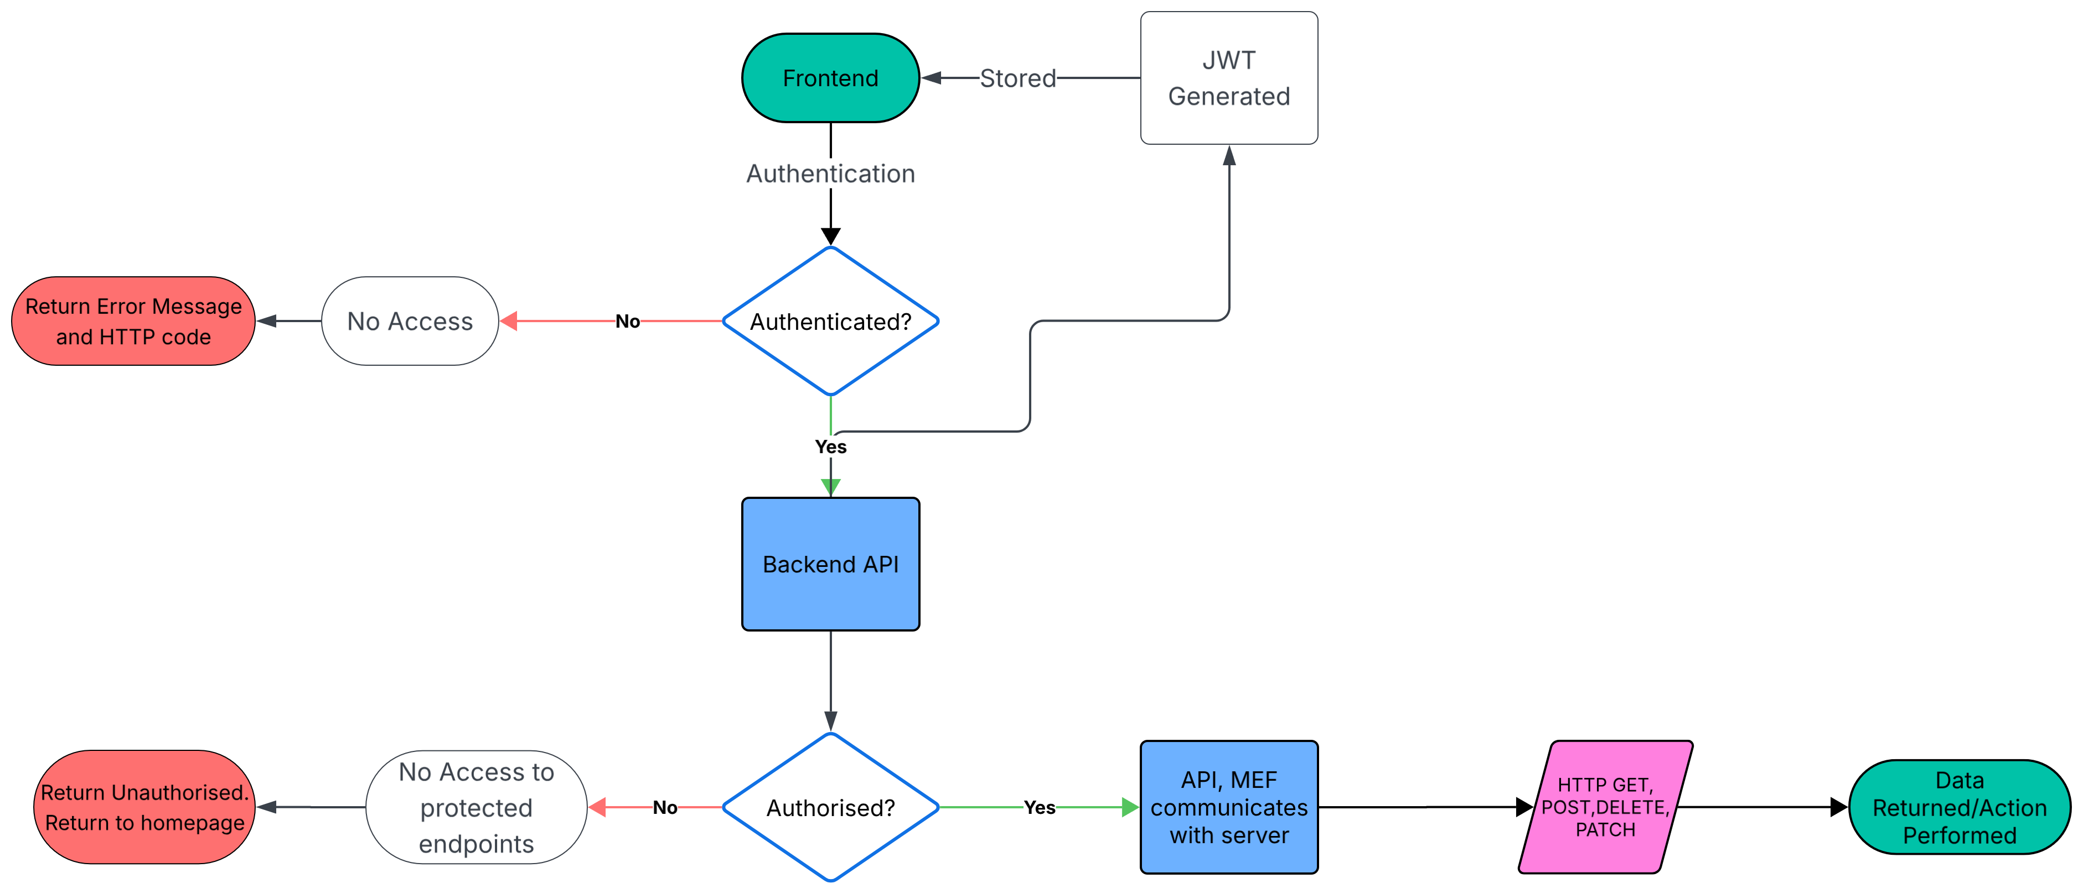
Figure 15: Authorisation Process of the application, created with Lucidchart

If the email address is verified, the token is returned to the Vite/React front-end authentication state and held which then allowed it to be included in the authorization header of protected API requests [27].

The front-end also displayed navigation and actions according to the logged-in user's role. However, hiding a manager button was not treated as a security control because front-end behaviour can be modified by a user, therefore the backend applied [Authorized] attribute’s role checks independently of the interface.
JWT design was selected instead of implementing institutional single sign-on as challenges emerged during development, development time was cut short. To implement single sign-on collaboration would have been required with other teams in the university IT department Palmer which may not have been feasible with the working hours of the project. OAuth2 would have been required to be implemented for single sign on which would have added more development effort as it is an authorisation framework, as such the decision was made to produce an MVP with a temporary login mechanism using JWT which can be replaced with the university's existing identity service (Microsoft Entra ID).

4.4 System Implementation

4.4.1 Development Iterations

The system was implemented through a series of development iterations rather than a single build, with each iteration producing a workable or testable part of the application which was then refused and refined before moving on to the next stage. Weekly meetings with the dissertation supervisor acting as the project client we used to discuss progress, technical problems and priorities of the project.
Although the development was influenced by agile principles, there were no formal sprints or scrums. Instead asks for development was selected according to the needs of the system and the importance of each feature to the minimum viable product. Agile and user-centred approaches both support iterative refinement, allowing designs and prototypes to change as feedback and knowledge develop [32].

Iteration | Period | Development focus | Outcome | Key changes
1. Backend foundation | 22–25 May 2026 | Establish core data and API structure | A working backend foundation with persistent data storage | Created user, expense and category models; configured Entity Framework and SQL Server; added relationships, migrations and category CRUD operations
2. Authentication and API security | 9–16 June 2026 | Secure the application | Authenticated users could securely access restricted endpoints | Implemented JWT login and token validation; protected API endpoints; strengthened JWT configuration; created an initial Bootstrap login prototype
3. Front-end application shell | 21–24 June 2026 | Build the React interface | A navigable front-end structure ready for API integration | Added routing, shared layouts, header, footer, dashboard, expense tables, payment views and Zustand state management
4. Claim creation and API connection | 2–4 July 2026 | Connect front-end forms to backend services | Users could begin creating and viewing claims through the React interface | Added Create Claim page, form validation, shared API handling, claim types and live claim retrieval; adjusted backend naming and CORS
5. Integrated authentication and ownership | 4–5 July 2026 | Connect user identity across the stack | Claims became securely associated with the authenticated user | Added React login, persistent authentication, protected routes, role checks and “My Claims”; backend derived claim ownership from the JWT token
6. End-to-end claim workflow | 6 July 2026 | Implement the complete business process | The first substantially complete claim lifecycle was available | Added claim submission and deletion, manager dashboard, status filters, approval and rejection actions, finance-only payment transitions and endpoint refactoring
7. Claim details and rejection feedback | 9–14 July 2026 | Improve workflow visibility and accountability | Users could inspect individual claims and understand why claims were rejected | Added claim retrieval by ID, Claim Detail page, manager rejection comments, database migration, rejection prompts and state-based button controls
8. Repository consolidation | 14 July 2026 | Prepare the application for unified deployment | The project became easier to build and host as a single deployment unit | Combined front-end and backend into one repository; updated .gitignore; added TypeScript configuration adjustments
9. Backend containerization | 14–15 July 2026 | Make the backend deployable | The backend could run inside a production-style container | Added a multi-stage .NET 8 Docker build, .dockerignore, release publishing and runtime configuration; corrected Docker syntax, publish paths and copied files
10. Cloud and environment configuration | 15 July 2026 | Remove local-environment dependencies | The application became suitable for hosted test deployment | Configured the backend to listen on 0.0.0.0:10000; added production environment settings; made CORS and API URLs environment-driven; moved from local SQL Server to Azure SQL
11. Deployment testing and fixes | 15–17 July 2026 | Resolve issues found in the hosted environment | The deployed test application became operational and better aligned with user expectations | Iteratively corrected Docker commands, runtime output paths, port configuration and front-end API connectivity; updated displayed currency to pounds
12. Final UI polish | 23 July 2026 | Refine user-facing presentation | The test deployment received minor presentation improvements | Updated footer wording and application information
Figure 16: A summary of iterative development

The iterations were not entirely independent, for example authentication changes affected the database relationship between users and expenses, while manager functionality required changes to both the API and front-end. Therefore, testing after each increment could include previously completed functionality,

GitHub was used in development for source control throughout the project Palmer with the git commit history providing evidence incremental changes as well as allowing previous versions to be recovered when I change may have caused unexpected behaviour. The full git commit history can be viewed in appendix B.
The scope was also refined during the development iteration with initial features such as external mileage and vehicle APIs were deferred so that that development could concentrate producing a deliverable product.

4.4.2 Backend Implementation

As mentioned, the backend was developed in ASP.NET Core Web API, Entity Framework Core, C# and SQL Server. Its main purpose was to manage authentication, application of workflow rules, validate requests and provide controlled access to data. By separating this functionality from the React front-end, it ensures that critically important rules were enforced by the server rather than relying on the client interface alone.
EF core was useful it was able to map C# models for the relational database (ORM). The primary models were the user entity and the expense entity, each expense contained a foreign key linking it to its owner, creating a one too many relationship in which one user could hold multiple claims. As seen below.
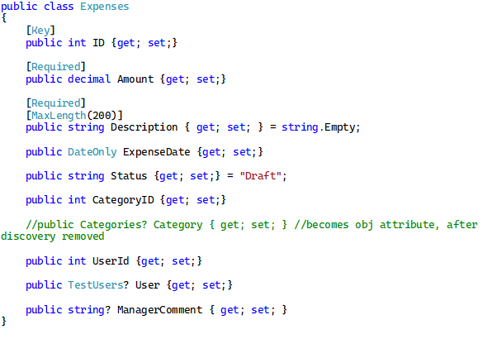
Figure 17: Expense Model

A database schema was created and updated through entity framework migrations, this allowed changes made to the models to be versioned and applied throughout development.
The expense controller exposed the rest style endpoints for interacting with the database, using HTTP Methods to perform the endpoint operations. Rest APIs commonly use HTTP operations to support CRUD functionality [27].
When creating a claim ownership was not accepted directly to the front-end, instead the backend retrieved the authenticated user’s identifier on the JWT and assigned it to the new expense. This reduced the possibility of a user creating a claim on behalf of another account by altering the request body. However, there is consideration creation of bulk claim creation as a matter of improved usability and administrative value.

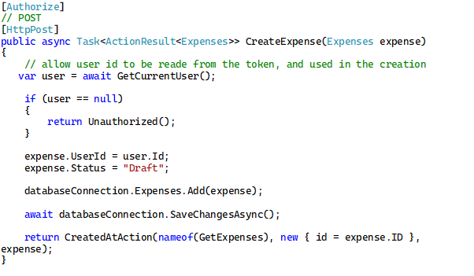
Figure 18: Expense creation endpoint
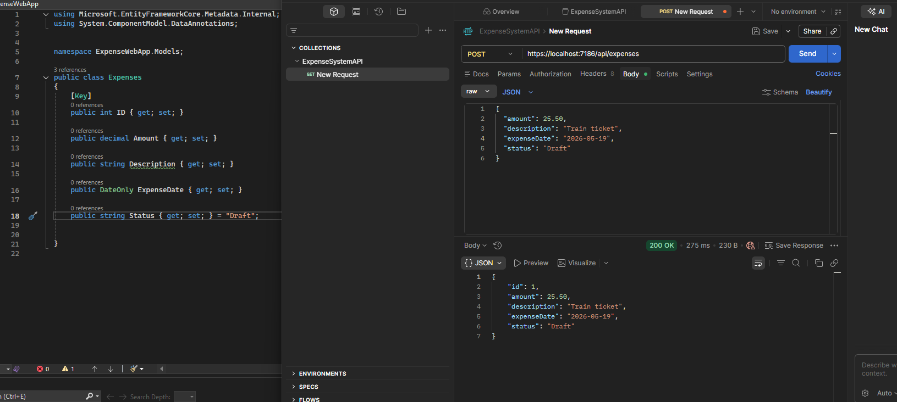
Figure 19: Example of API endpoint testing with Bruno
Retrieval of claims specific to the logged in employee was implemented by filtering expenses against the identifier contained within the JWT, thus the API returns only claims belonging to the authenticated user. Manager queries also used status filtering and included the related user record so that claimant details could be displayed in the approval interface.

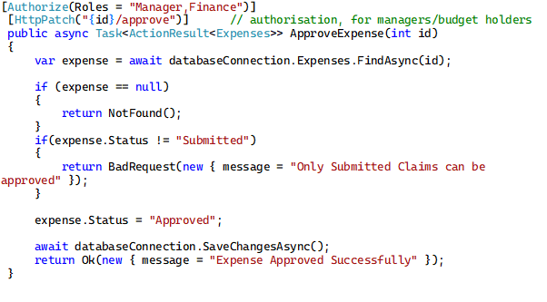
Figure 20:Approval endpoint demonstrating status filtering
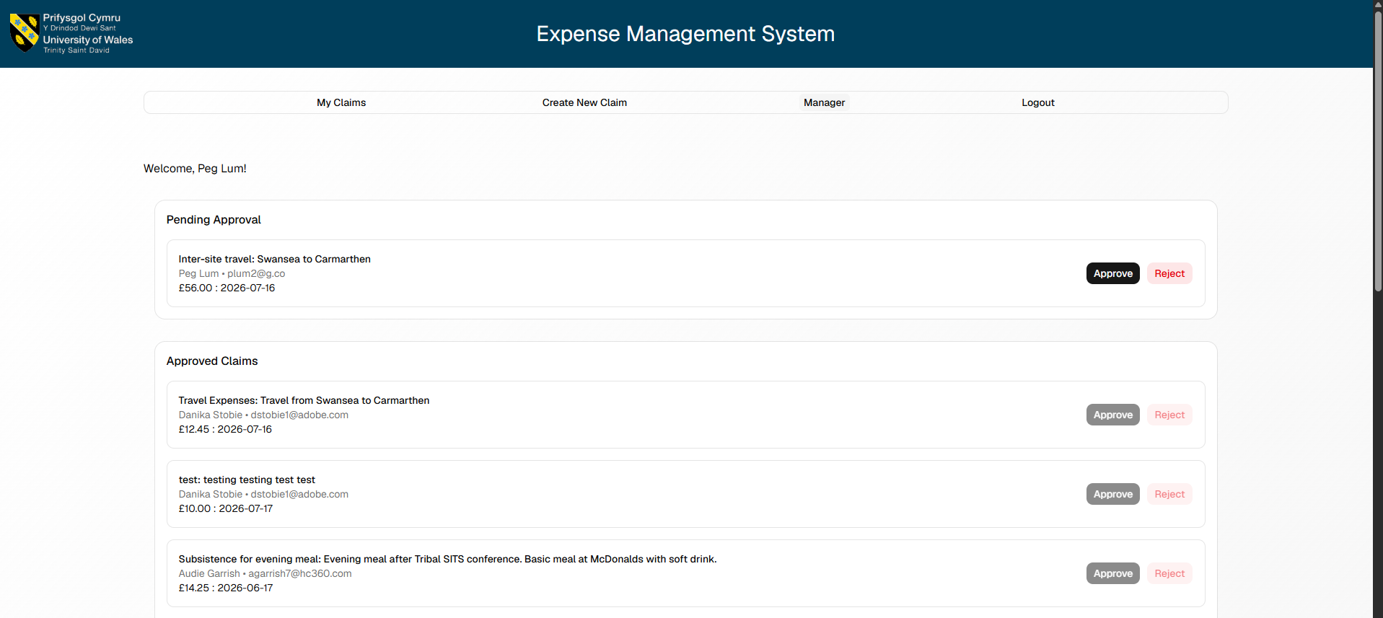
Figure 21: Implemented status filtering

Initial testing of the backend was done through local API requests before being reconnected to the react front-end, later testing then confirmed data was able to be created through the interface and was persisting in the SQL Server being correctly returned to the appropriate employee or manager view.

4.4.3 Authentication and Authorisation Implementation
API endpoints were protected through by authenticating and identifying uses making a request using JWTs. Prototype accepted an institutional e-mail address which was then matched against a user record, if a valid user was found, the backend would generate a signed token and return it with the user details to the front-end along with a successful login.
The token contained claims representing the user’s database identifier and role. The name identifies a claim was used for claim ownership, while determining access permissions was the responsibility of the role claim.

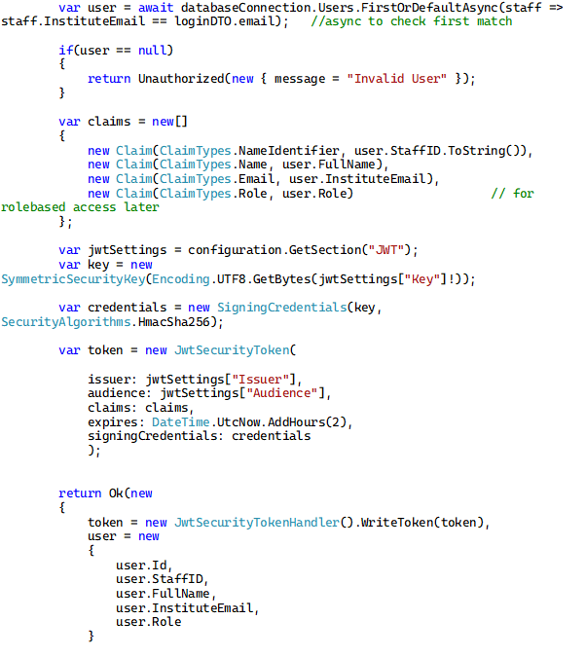
Figure 22: JWT Token generation
After login the react application stores this token and user information in a Zustand authentication store, where the front-end can pass the token in the authorization header of requests allowing access to any protected endpoints granted they have the correct authorisation
The backend would then validate each received token which includes checking parameters such as issuer lifetime and signing key. A token that's missing or expired will be rejected before the protected action was executed.
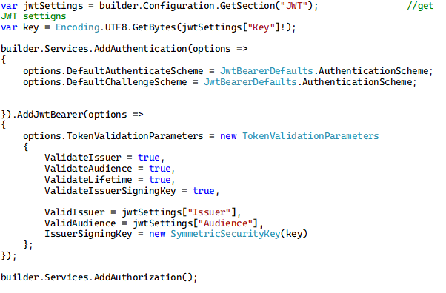
Figure 23: Validating the JWT

As seen in previous endpoints the [Authorize] attribute was applied to end points that require an authenticated user, for example claim creation, The user identifier was then read from the token rather than accepted from the request body which is important as accepting a user ID directly from the front-end could allow a modified request create or retrieve claims under another account. Another concern this solves is HTTP request manipulation by malicious actors on the internet.

This also contributes to rule-based access features implemented in the project. Although it is possible to hide navigate to manager pages in the front-end this is not reliable, if users are able to access the URL of the manager views. As such backend role restriction remains necessary.
Several issues were encountered with the implementation of authentication. For example, an initial attempt used the RS256 algorithm with a symmetric key, which was incompatible with the selected signing method such the solution was corrected by using HMAC SHA-256 instead.

Although e-mail log on with JWT authentication and role restrictions are appropriate for the prototype alma it would not provide sufficient assurance for a financial system as possession of an e-mail address alone does not verify identity, as such the production version of the solution should integrate with the universities Microsoft Entra ID, single sign and MFA.

4.4.4 Front-end Implementation
A single page application was implemented to serve as the front-end which used React, Vite and Typescript. React was used to divide the interface into reusable components, while TypeScript provided static checking for user claim and API response data whereas Vite supplied the development and build environment. Shadcn ui, a tailwind component library, was also used to develop the web app view, saving significant development time.
A single page architecture was selected because users will need to regularly move between different tabs, such as claim creation and claim viewing, without repeatedly loading server rendered pages. In this architecture presentation and interaction is managed by the front-end, while the backend API processes business logic and database requests [27]. This is also reminiscent of popular web applications across multiple sectors, such as Jira and ServiceNow.

To this end, react router was used to define the main application routes, such as the claim details page and the manager approval page. Further adhering to a single page architecture, a shared layout component was implemented to provide consistent navigation, header age structure. Navigation options were adjusted according to authenticated user roles so that manager functions were not presented to employees. As mentioned previously, front-end route visibility cannot be relied upon as a security measure and as such is enforced by the server. 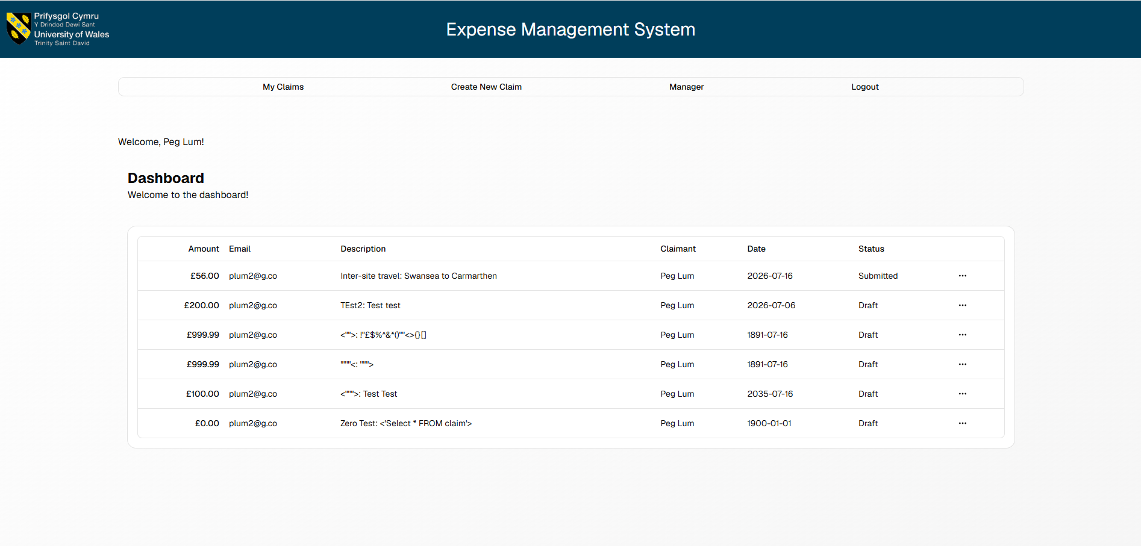
Figure 24: User with manager role
Figure 25: User with employee role

State management was implemented using zoo stand, after a successful login, the token and user details were stored centrally so that they could be accessed by other resources in the front-end and API functions without passing them manually through each component.
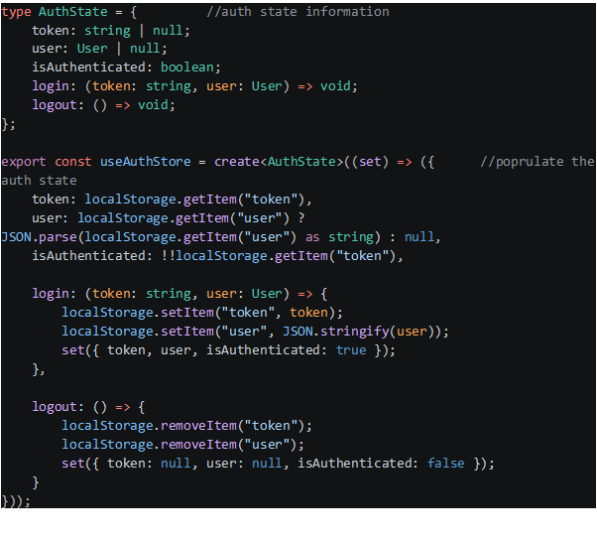
Figure 26: Zustand Auth store and login functions

Furthermore, a reusable API handler was created to centralise communication with the backend. The handler constructed the request added the token where required and processed unsuccessful responses. This contributed to a maintainable readable structure.

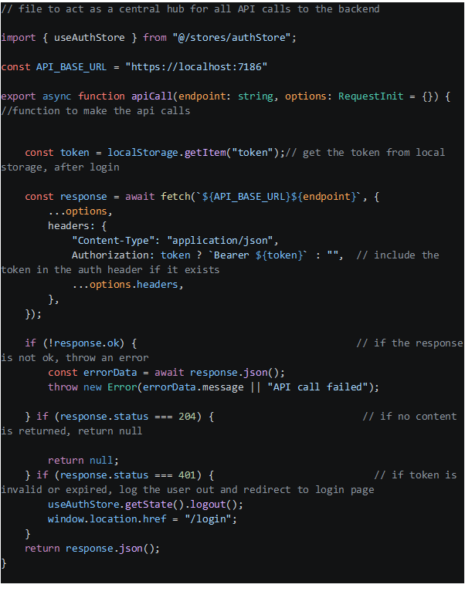
Figure 27: Central API handler

Another key feature of the front-end is the dashboard. Using the Shadcn component library a data table was implemented who receive claims and display them consistently. Column definitions corresponded to the different features of expense data. The table structure was selected as all claims need to follow the same data format, and users need to compare multiple records.
A challenge with this was setting the column definition to correspond with the expected API data as well as adding the ability to perform row actions on specific claims. This was resolved by leveraging the use of action handlers and by refactoring the column structure into accepting these handler functions to perform actions on specific rows.
Figure 28: Refactored to function
Figure 29: Handler functions for row actions

Another key implementation feature that directly addressed one of the requirements of the project was the use of validation during claim creation. This was achieved by using a validation, schema specifically Zod and React Hook Form. React hook form managed field values and submission, while the Zod validation schema defined what was considered acceptable input. This client-side validation gives users immediate feedback before invalid requests reach the API.

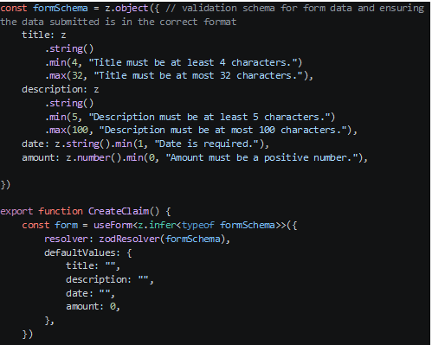
Figure 30: Zod Validation Schema

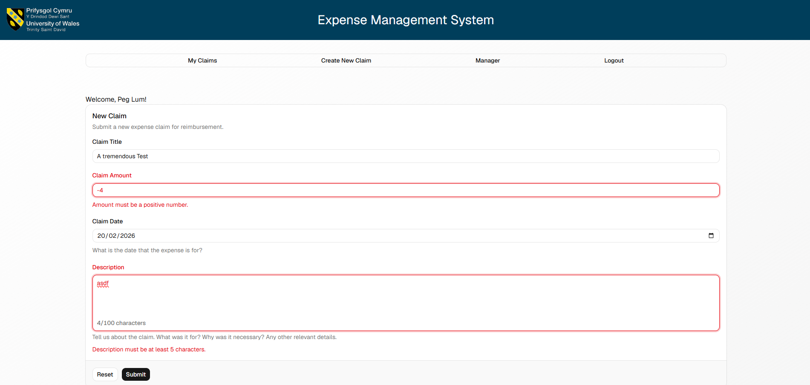
Figure 31: Validation in Action

4.5 Testing

Testing of the project occurred throughout development to confirm that individual functions and features the application operated as expected and that the completed front-end Palmer API backend and database work together as a complete system. Usability testing was also conducted on a small sample group of end users.
Task-based usability evaluation was conducted using the deployed application. The spirits were asked to complete tasks involving functions of the application involving approval and rejection. Task completion assistance, errors and comments were recorded before participants completed the post post-test questionnaire. The purpose of this test was to determine whether the interface supported the intended workflow and whether users could intuitively complete the main tasks. the complete evaluation survey is provided in appendix C. Full interpretation and detailed results are presented in chapter 5

Chapter Summary

This chapter described how the design and implementation of the web application met the requirements of the project. The design established elements such as the expense workflow Palmer interface structure, architecture, role-based access model and relational database, which supported the core requirements offline creation, submission, status tracking bomber approval and rejection while distinguishing role responsibilities.
React and TypeScript were used to implement the front-end, alongside additional tools such as Shadcn and Zod validation schema. The backend utilised ASP.NET Core, EF Core and SQL server, additionally the testing deployment to Render also required docker containerisation of the backend. JWT authentication identified users and the Enforces role access restrictions while the backend workflow cheques claim ownership and controlled status changes. With the development of the project being iterative Palmer the scope refined to prioritise a functional minimum viable product over planned features such as external APIs, payroll integration an institutional single sign on.

Chapter 5: Evaluation

5.1 Introduction
Evaluation of the completed expense system will it be explored in this chapter based on the usability test results. Participant task performance alma survey ratings and written feedback are examined to identify the pros and cons of the current system according to end users. Findings are then used to determine whether the project requirements, aim and objectives were achieved with comparisons be a maid to the relevant literature reviewed in chapter 2.

5.2 Usability Test Results
Participants completed the evaluation. Of the 42 assigned task attempts, 38 were completed, producing a task completion rate of 90.5%. Five of the participants completed both the employee and manager workflows whereas 1 participant but not login as the employee therefore could not complete all employee tasks, although the manager workflow was successful

Statement | Mean / 6
Claim creation was straightforward | 4.0
Difference between Draft and Submitted was clear | 3.8
Claim details were sufficient | 4.0
Manager comments were clear | 4.0
Approval and rejection were intuitive | 4.0
Button outcomes were predictable | 4.0
Error messages were helpful | 3.7
System response was sufficiently quick | 4.7
Figure 32: Results of the questionnaire
Across the 48 possible questionnaire answers, the mean rating was 4.02 out of five. Unanswered questions were scored 0. The highest rated area was system responsiveness with a mean of 4.67, while the lowest was the usefulness of error messages, with a mean of 3.67. Overall, the results indicate a positive perception of the system's usability although missing responses reduce the calculated average.

From the open responses distance generally describe the interface as clear, simple and easy to use. The lowest rating concerned knowing what would happen after pressing a button and this reflected comments that the submission action was hidden with an... menu and that approved or rejected claims in the manager interface did not immediately move to the correct section without refreshing. From this, suggested improvements include automatic refreshing for the manager dashboard, clearer action labels, improved validation messages and receipt upload functionality. Full finding of the evaluation can be found in appendix F.

5.3 Against the Aims and Objectives

The application was able to meet functional requirements including authenticated access, user specific claims, and the submission and approval workflows. However, the evaluation identified limitations. Approved and rejected records did not always move to the correct interface sections until the page was refreshed, and some participants found the claim action difficult to locate.

Overall, the core aim and most objectives were achieved but several interface refinements remain necessary before production use. The results therefore support the system as a successful prototype rather than a fully deployable institutional solution.

Chapter 6: Conclusions and recommendations
The chapter concludes the project by summarising development and the valuation of the proposed web-based system. It considers how the completed prototype addressed the project name and identifies the practical benefits provided by the work stop chapter also presents recommendations for improving the system and extending it towards reduction use.

6.1 Conclusion and Benefits
the project aimed to design and develop user friendly expense management system and improve the efficiency of the university expense process. This aim was achieved through the delivery of a working web application that enables employees to create, view and submit claims while allowing managers to review, approve or reject them.

It replaces an e-mail-based process that improves visibility to users and reduces reliance on manual tracking. Validation also helps prevent incomplete or invalid information from being submitted into the workflow.
The main benefit of the completed project is a more consistent submission process than the current one and reduced administrative handling. The biggest benefit however call ma is that the deliverable of this project is a maintainable foundation for future developments that has guaranteed the potential to address issues with the current university expense process

6.2 Recommendations for Future Work

Recommendation | Justification
Implement institutional single sign-on | This would replace the prototype email-only login and provide stronger identity management.
Add receipt uploads | Supporting evidence should be stored alongside each claim, as requested by participants.
Improve interface feedback | Claims should automatically move between pending, approved and rejected sections without requiring a refresh.
Make claim actions clearer | A visible Submit button and clearer action labels would reduce confusion caused by the ellipsis menu.
Strengthen validation | Clear messages should explain amount limits, invalid dates and unsuccessful submissions.
Add reporting and integration | Manager totals, exports and eventual payroll integration would reduce further administrative work.
Conduct wider testing | Testing with more employees, managers and finance staff during a real claims period would produce stronger evidence of reliability and usability.
Figure 33: Future Developments, from initial scope and evaluation results
As seen in figure 33, future improvements have been listed, with priority being given to the third design proposals and user feedback proposals.

Chapter 7: Reflection

7.1 Introduction
This chapter reflects the knowledge and skills developed throughout the project. It considers the learning gained from all the stages involved in this project. It also provides an honest assessment of the challenges encountered and how the project could have been approached more effectively

7.2 Challenges and Personal Development

This project significantly developed my full stack development skills. I had I gained practical experience in areas I'm not used to, especially in ASP.NET and Frontend web development.
On the frontend, it was my first time developing with React, TypeScript and Vite. With the guidance of my dissertation supervisor, I learned how to manage application state connect various components to API endpoints in a maintainable manner and thinking in role specific interfaces. Deploying the front end and backend through render was a key experience for me also connecting the application to Azure, this introduced me to deployment configuration (via Docker) and environment variables.
I also learned how to manage application state and next front-end components to API endpoints and how resources are shared between multiple resources and components in a web application. The exposure to multiple different development tools and libraries tools, such as shadcn, Zustand and Zod, was also a good learning experience. The integration between the front end and backend are separate entities was also a valuable challenge, urging me to investigate issues involving authentication and Cross Origin Resource Sharing (CORS) systematically rather than by trial and error.

7.3 Challenges and Setbacks
The course of this development the project faced several technical setbacks, including CORS errors and authentication configuration problems. Another challenge faced was the fact that the project was programmed in multiple languages, yet components needed to speak with one another and so for this to happen there had to be a common data format (JSON).
Another challenge was time management. The original scope was much broader than the final product, including external APIs which would have added impressive functionality to the project, receipt handling which in terms of financial processes is mandatory, reporting on expenses and institutional sign-on would have required authorisation configuration and verification by other departments. Unfortunately, implementing every feature was not realistic within the available time, thus I learned to prioritise the workflows and treat the remaining features as future developments, developing my code with extensibility in mind.
My resilience has also increased from this project. A few errors required repeated investigation particularly when the front end and backend behaved correctly but failed when integrated, and vice versa, and when components that had previously worked fine started to behave erratically when a new future was implemented. Rather than abandoning features, I became more confident in breaking the problems down, consulting the documentation and reviewing the data being passed between components to identify the issue.

7.4 What Could Have Been Done Better
In hindsight, I could have defined the final project scope a bit earlier as too much initial attention was given to grand features such as external API integration. Prioritising the minimum viable product sooner would have provided more time for refinement and testing.
We also have introduced structured testing. Most testing was done completely manually, which confirmed the main workflows and components operated as expected. However, unit and integration tests for authentication, as well as structured automated testing, would have improved reliability of the project vastly.
Deploying the solution should also have been attempted earlier as differences between the local and hosted environments revealed routing, configuration and login issues late into the project. Earlier deployment would have allowed these problems to be resolved, and more time spent polishing the final product.

Chapter 8: References

[1] M. Hammer, "Reengineering work: Don't automate, obliterate," Harv.Bus.Rev., vol. 68, no. 4, pp.104–112, 1990,
[2] T. H. Davenport and J. E. Short, "The New Industrial Engineering: Information Technology and Business Process Redesign," Sloan Manage.Rev., vol. 31, no. 4, pp.11–27, 1990, doi: 10.1016/0024630194900108.
[3] T. Monteiro, S. Abrantes and M. Ratinho, "A Solution for Submitting Expenses," vol. 237, pp.20–27, 2024, doi: 10.1016/j.procs.2024.05.075.
[4] E. Johri, P. Desai, P. Soni, H. Jain and N. Sanganeria, "Expense Management System", in 2023 4th IEEE Global Conference for Advancement in Technology (GCAT), pp. 1–6. doi: 10.1109/GCAT59970.2023.10353348.
[5] J. Sinur, Z. Misiak and B. J. Biernatowski,Practical Business Process Modeling and Analysis: Design and optimize business processes incrementally for AI transformation using BPMN, Birmingham, UK: Packt Publishing, 2025
[6] H. Lizano-Mora, P. R. Palos-Sánchez and M. Aguayo-Camacho, "The Evolution of Business Process Management: A Bibliometric Analysis," vol. 9, pp.51088–51105, 2021, doi: 10.1109/ACCESS.2021.3066340.
[7] S. Moreira, H. S. Mamede and A. Santos, "Business Process Automation in SMEs: A Systematic Literature Review," vol. 12, pp.75832–75864, 2024, doi: 10.1109/ACCESS.2024.3406548.
[8] L. S. Lubis and D. E. Sembiring, "Driving Digital Transformation: Leveraging Robotic Process Automation (RPA) to Enhance Business Process Efficiency and Reducing Manual Errors", in 2023 IEEE International Conference on Data and Software Engineering (ICoDSE), pp. 91–95. doi: 10.1109/ICoDSE59534.2023.10291662.
[9] L. Bartlett, M. A. Kabir and J. Han, "A Review on Business Process Management System Design: The Role of Virtualization and Work Design," vol. 11, pp.116786–116819, 2023, doi: 10.1109/ACCESS.2023.3323445.
[10] S. Kumar, "Human-in-the-Loop Automation Patterns for Financial Services using Camunda and Modern Java UIs", in 2026 7th International Conference on Intelligent Communication Technologies and Virtual Mobile Networks (ICICV), pp. 2074–2082. doi: 10.1109/ICICV68925.2026.11554821.
[11] A. Gunawan and M. I. Wijaya, "Robotic Process Automation to Enhance Education's Administration Process: Case of Attendance Checking and Reporting", in 2023 International Conference on Information Management and Technology (ICIMTech), pp. 1–6. doi: 10.1109/ICIMTech59029.2023.10278035.
[12] J. Wang, Y. Liu, P. Li, Z. Lin, S. Sindakis and S. Aggarwal, "Overview of Data Quality: Examining the Dimensions, Antecedents, and Impacts of Data Quality," vol. 15, no. 1, pp.1159–1178, 2024, doi: 10.1007/s13132-022-01096-6.
[13] Y. Suh, "Exploring the Impact of Data Quality on Business Performance in CRM Systems for Home Appliance Business," vol. 11, pp.116076–116089, 2023, doi: 10.1109/ACCESS.2023.3325892.
[14] J. S. Lat, Managing Data Integrity for Finance: Discover practical data quality management strategies for finance analysts and data professionals, Packt Publishing, 2024.
[15] H. Belgacem, X. Li, D. Bianculli and L. Briand, "Learning-based Relaxation of Completeness Requirements for Data Entry Forms," vol. 33, no. 3, mar 2024, doi: 10.1145/3635708.
[16] M. N. Islam, H. Bouwman and A. K. M. N. Islam, "Evaluating Web and Mobile User Interfaces With Semiotics: An Empirical Study," vol. 8, pp.84396–84414, 2020, doi: 10.1109/ACCESS.2020.2991840.
[17] F. L. Verdi, H. T. d. Oliveira, L. N. Sampaio and L. A. M. Zaina, "Usability Matters: A Human–Computer Interaction Study on Network Management Tools," vol. 17, no. 3, pp.1865–1878, 2020, doi: 10.1109/TNSM.2020.2987036.
[18] L. Alonso-Virgós, J. P. Espada and R. G. Crespo, "Analyzing compliance and application of usability guidelines and recommendations by web developers," vol. 64, pp.117–132, 2019, doi: 10.1016/j.csi.2019.01.004.
[19] L. Alonso-Virgós, J. P. Espada, O. S. Martínez and R. G. Crespo, "Compliance and application tests of usability guidelines about giving information quickly and comprehensibly," vol. 7, no. 4, pp.1823–1843, 2021, doi: 10.1007/s40747-020-00198-5.
[20] A. Bucko, Kamer Vishi, B. Krasniqi and B. Rexha, "Enhancing JWT Authentication and Authorization in Web Applications Based on User Behavior History," vol. 12, no. 4, 2023, doi: 10.3390/computers12040078.
[21] M. Q. Saleem, J. Jaafar and M. F. Hassan, "Model driven security frameworks for addressing security problems of Service Oriented Architecture", in 2010 International Symposium on Information Technology, pp. 1341–1346. doi: 10.1109/ITSIM.2010.5561580.
[22] R. Ghazal, A. K. Malik, N. Qadeer, B. Raza, A. R. Shahid and H. Alquhayz, "Intelligent Role-Based Access Control Model and Framework Using Semantic Business Roles in Multi-Domain Environments," vol. 8, pp.12253–12267, 2020, doi: 10.1109/ACCESS.2020.2965333.
[23] M. Uddin, S. Islam and A. Al-Nemrat, "A Dynamic Access Control Model Using Authorising Workflow and Task-Role-Based Access Control," vol. 7, pp.166676–166689, 2019, doi: 10.1109/ACCESS.2019.2947377.
[24] GeeksForGeeks. "JSON Web Token (JWT)." https://www.geeksforgeeks.org. [Online]. Available: https://www.geeksforgeeks.org/web-tech/json-web-token-jwt/
[25] J. Singh and N. Chaudhary, "OAuth 2.0 : Architectural design augmentation for mitigation of common security vulnerabilities," vol. 65, pp.103091, 2022, doi: 10.1016/j.jisa.2021.103091.
[26] D. S. Almeida, P. R. Barros, G. A. Júnior and T. A. M. Euzébio, "Implementation Guide for Secure RESTful Asset Management APIs Under IEC 62443-4-2: A Redfish Case Study," vol. 14, pp.42015–42038, 2026, doi: 10.1109/ACCESS.2026.3674966.
[27] D. V. Kornienko, S. V. Mishina and M. O. Melnikov, "The Single Page Application architecture when developing secure Web services," vol. 2091, no. 1, pp.012065, 2021, doi: 10.1088/1742-6596/2091/1/012065.
[28] A. Huotala, M. Luukkainen and T. Mikkonen, "Benefits and Challenges of Isomorphism in Single-Page Applications: Case Study and Review of Gray Literature," vol. 21, no. 8, pp.2363–2403, 2022, doi: 10.13052/jwe1540-9589.2186.
[29] M. C. Fariz, S. Lazuardy and D. R. Anggraini, "Modern Front-end Web Architectures with React.Js and Next.Js", 2022, in [Online]. Available: https://api.semanticscholar.org/CorpusID:269901448
[30] M. Feilzer, "A Pragmatist Approach to Mixed Methods Research," in Philosophical Foundations of Mixed Methods Research, Y. Shan, Ed., Routledge, 2023. doi: 10.4324/9781003273288.
[31] M. Elgeddawy and M. Abouraia, "Pragmatism as a Research Paradigm," vol. 23, pp.71–74, 2024, doi: 10.34190/ecrm.23.1.2444.
[32] M. Brhel, H. Meth, A. Maedche and K. Werder, "Exploring principles of user-centered agile software development: A literature review," vol. 61, pp.163–181, 2015, doi: 10.1016/j.infsof.2015.01.004.
[33] B. Daniel and G. George, "Inductive vs. Deductive Research Methods: A Comprehensive Methodological Guide for Bachelor’s and Master’s Theses," vol. 09, pp.1–9, 2025, doi: 10.55041/IJSREM52576.
[34] J. R. Lewis, "The System Usability Scale: Past, Present, and Future," vol. 34, no. 7, pp.577–590, 2018, doi: 10.1080/10447318.2018.1455307.

Appendices

Appendix A: Finance Meeting
  - Declaration of AI Use
The original audio recording of this meeting was summarised by an AI model, specifically ChatGpt by OpenAI, the text transcript was edited and refined by AI to improve clarity, readability and coherence as well as remove any personal conversation from the transcript on the 22/07/2026. The work and content discussed is still purely the researcher’s responsibility.

Interview Summary
Purpose of the Interview
The interview explored the university’s current staff expense-claim process and gathered requirements for a proposed digital expense portal. The aim of the portal is to reduce errors, simplify approvals, improve visibility and minimise the manual processing currently required by the Finance team.
Current Expense-Claim Process
Following business travel, a member of staff collects their receipts and completes an expense claim form. Each transaction must be entered separately.
The claim must be approved by the appropriate budget holder before it is submitted to Finance. Approval may currently be demonstrated through a signed form or an email from the budget holder.
Finance then:
- Checks that the form is complete.
- Confirms that the claim follows university policy.
- Verifies mileage and supporting receipts.
- Checks for duplicate claims.
- Enters the information into an Excel spreadsheet.
- Uploads the spreadsheet to the internal ResourceLink or payroll process.
Scope of the Main Expense Form
The main staff expense form primarily covers:
- Food and subsistence.
- Mileage.
- Fuel receipts for hired vehicles.
- Other approved travel-related costs supported by receipts.
Hotels, train tickets, flights and similar bookings are generally handled through a separate university travel-booking system.
Other expenses, including eye tests and company-car claims, use separate forms and may follow different payment rules.
Non-staff expenses are processed through the purchase ledger rather than the staff expense process.
Main Problems Identified
Finance receives a significant number of claims that must be rejected or returned for correction.
Common problems include:
- Missing names, addresses, staff numbers or contact information.
- Missing vehicle details.
- Missing budget-holder approval.
- Claims submitted by people who are not authorised drivers.
- Incorrect mileage calculations.
- Staff using different route-planning tools.
- Receipts that do not match the claim form.
- Incorrect totals.
- Missing receipts.
- Duplicate claims.
- Expenses that have already been paid in a previous month.
- Ineligible expenses being submitted through the travel and subsistence form.
These problems create repeated emails between Finance, employees and budget holders. They also delay payments and increase Finance’s administrative workload.
Mileage Requirements
The university uses the RAC Route Planner as its standard source for checking mileage. Using one route-planning service helps ensure that all employees are treated consistently.
Where a person begins a business journey from home, their normal home-to-work mileage must usually be deducted.
For example, where the full journey is 50 miles and the person’s normal commute is 10 miles, only 40 miles may be claimed.
However, when an employee travels from one university campus or workplace to another after arriving at work, the full campus-to-campus mileage is normally claimable.
The mileage rate also depends on the type of vehicle. Different rates may apply to petrol, diesel, hybrid, electric and company vehicles.
Only registered authorised drivers may submit mileage claims. Employees must also have the appropriate business-use insurance.
Subsistence Requirements
The amount an employee may claim depends on factors including:
- The total length of the journey.
- Departure and return times.
- Whether the employee was away during a meal period.
- Whether the journey included an overnight stay.
- Whether breakfast was already included in the hotel booking.
The exact allowances and thresholds should be taken from the university’s current expense policy.
Required Claim Information
The proposed system may need to capture the following personal information:
- Staff number.
- Full name.
- Contact telephone number.
- Home address.
- Home postcode.
- Campus.
- Institute or department.
- Post number.
- Cost centre.
- Project code, where applicable.
Most of this information already exists in university HR systems and could potentially be populated automatically when the employee signs in.
Vehicle Information
For mileage claims, the system may need:
- Vehicle registration number.
- Confirmation that the claimant is an authorised driver.
- Confirmation of whether the vehicle is hired.
- Fuel type.
- Engine size.
- Vehicle category.
The Researcher proposed using a DVLA vehicle-data service to retrieve information such as fuel type and engine size from the registration number.
The suitability of this service, including whether it reliably recognises personalised registration numbers, will need to be confirmed. A manual fallback should be available where vehicle information cannot be retrieved.
Journey Information
Each journey should record:
- Date of travel.
- Departure time.
- Return time.
- Journey purpose.
- Starting location and postcode.
- Final destination and postcode.
- Any intermediate locations.
- Total mileage.
- Normal commuting mileage to be deducted.
- Final claimable mileage.
The system must support journeys with multiple stops. For example, an employee may travel from home to a campus, then to a student placement, then to another location before returning home.
Cost Centres and Project Codes
Each employee has at least one post number linked to a cost centre. Some employees may have more than one post or may work across several departments.
The cost centre determines where the expense is charged.
A project code may also be required where an expense relates to a specific project within the cost centre. Not every employee or claim will require a project code.
The proposed portal should obtain valid cost centres and project codes from an authoritative university data source rather than allowing unrestricted manual entry.
Receipts and Audit Requirements
Receipts are mandatory for relevant expenses and must be linked directly to the corresponding claim.
Receipt values must reconcile with the claim to the penny. The system should therefore compare the entered expense amount with the uploaded receipt information wherever possible.
Receipts and approval records must be retained for audit purposes.
Foreign-Currency Claims
Finance processes expenses incurred in foreign currencies because staff may travel internationally.
The university uses the approved InfoEuro exchange-rate source. The rate may depend on the currency and the period in which the expense occurred.
The proposed portal should investigate whether approved exchange rates can be retrieved automatically through an API or another reliable technical method.
Proposed Digital Workflow
The proposed portal would allow an employee to:
- Sign in using their university account.
- Create and save a new claim.
- Have personal information populated automatically.
- Enter one or more journeys or expenses.
- Upload supporting receipts.
- Receive immediate warnings where information is missing or invalid.
- Submit the completed claim to the correct budget holder.
- Receive notifications when the claim is approved, rejected or returned.
- Track the claim’s current status.
After budget-holder approval, the claim would be sent to Finance.
By the time Finance receives it, the claim should already:
- Contain all mandatory information.
- Include the required receipts.
- Have valid mileage calculations.
- Have the correct cost centre or project code.
- Have budget-holder approval.
- Have passed duplicate checks.
Finance could then perform a final review and export approved claims as a CSV file or another format suitable for the existing ResourceLink or payroll upload process.
Validation Requirements
The portal should prevent submission where:
- Mandatory information is missing.
- A mileage claimant is not an authorised driver.
- A receipt is required but has not been attached.
- Receipt and claim totals do not match.
- A journey date is invalid.
- Mileage has been calculated incorrectly.
- An invalid cost centre or project code has been selected.
- Budget-holder approval is missing.
- A likely duplicate claim already exists.
Validation should happen as early as possible so that errors are corrected by the claimant before the claim reaches Finance.
Duplicate Detection
Finance currently checks for duplicates within the current processing spreadsheet and against claims paid during the previous month.
The proposed system should perform similar checks automatically. It may compare:
- Claimant.
- Expense date.
- Journey date.
- Journey locations.
- Receipt value.
- Mileage.
- Expense category.
- Previous payment records.
Potential duplicates should be flagged before payment.
Access and Security
Access should be controlled through the university’s existing authentication system.
Employees should only be able to view their own claims.
Managers and budget holders should only be able to view claims for employees or cost centres within their area of responsibility.
Finance should have access to the claims required for checking, processing, reporting and audit.
Reporting and Performance Measurement
Finance estimated that approximately 115 to 160 claims are processed each month.
However, rejection reasons and rejection volumes are not currently recorded systematically. This makes it difficult to establish how much time is spent correcting errors.
The new portal should record:
- Number of claims submitted.
- Number approved.
- Number rejected or returned.
- Reason for rejection.
- Number of duplicate claims detected.
- Average approval time.
- Average Finance processing time.
- Number of claims received after the monthly deadline.
- Number of claims requiring manual correction.
These measurements would allow the university to compare the process before and after implementation.
Recommended System Requirements
The proposed portal should:
- Use existing university authentication.
- Pre-populate employee information from HR records.
- Validate authorised-driver status.
- Retrieve vehicle information where possible.
- Apply the university’s mileage and subsistence rules.
- Support multi-stop journeys.
- Use RAC Route Planner mileage consistently.
- Require and store receipts.
- Match receipt values to claimed amounts.
- Support foreign-currency conversion using the approved source.
- Route claims to the correct budget holder.
- Notify users of approvals, rejections and required corrections.
- Show employees the status of their claims.
- Detect possible duplicates.
- Export approved claims for payroll processing.
- Retain a complete audit trail.
- Record rejection reasons and processing statistics.
Follow-Up Actions
Finance Officer
- Provide information from a sample month showing the number of claims processed.
- Estimate how many claims were rejected or returned.
- Where possible, group rejections by reason.
Researcher
- Confirm current subsistence thresholds and mileage rates.
- Investigate technical access to RAC Route Planner.
- Investigate DVLA vehicle-data services.
- Investigate InfoEuro exchange-rate integration.
- Investigate ResourceLink and HR integration options.
- Confirm whether personalised vehicle registrations are supported.
- Develop an initial working prototype.
Researcher and HR
- Confirm the authoritative relationship between employees, post numbers, cost centres, project codes and budget holders.
Researcher and Finance
- Review the prototype with several Finance employees.
- Conduct usability testing.
- Confirm that the proposed workflow reflects the actual Finance process.
- Agree suitable measures for evaluating whether the portal reduces errors and processing time.
Overall Conclusion
The interview demonstrated a strong case for digitising the expense-claim process.
The greatest opportunity is not simply replacing the existing form with an online version. The proposed portal should actively prevent errors by using existing university information, applying expense rules automatically, standardising mileage calculations, managing approvals and detecting duplicate claims.
A well-designed portal could reduce rejected claims, repeated emails and manual Finance checks while giving employees clearer guidance and better visibility of their claim status.

Transcript
Expense Claim Process Improvement — Cleaned Interview Transcript
Participants: The Researcher and Finance Officer
Editing note: This is a cleaned and condensed transcript rather than a strict word-for-word record. Repetition, filler words, incomplete fragments, screen-sharing difficulties and unrelated personal conversation have been removed. The automated labels “Meeting Organizer” and “Meeting Participant” have been reassigned to the correct speaker based on the surrounding conversation.
0:05–4:08 — Project Purpose and Current Claim Scope
Finance Officer: Okay, excellent.
The Researcher: Thank you. The project needs to benefit the workplace, and several people suggested that the expense process could be improved. I have started building the backend of a digital portal that could automate parts of the process for staff and Finance.
Could you give me an overview of the process, from an employee submitting expenses through to the payment being processed through payroll?
Finance Officer: After business travel, staff collect their receipts and complete an expense claim form. Each transaction is entered on a separate line. The budget holder signs the form, and it is then sent to Finance for processing.
There are rules about what can be claimed and how much can be claimed. These depend on how long the person was away, whether there was an overnight stay and whether breakfast was included. The guidance includes daily and breakfast allowances.
The Researcher: So there are clear limits on what can be spent.
Finance Officer: Yes. People cannot spend whatever they like. The form is for travel and subsistence, not equipment or unrelated purchases.
We no longer process hotel and train bookings through this form. Those bookings go through the university travel-booking system. Finance mainly deals with food, drink, mileage and fuel receipts for hired cars.
The Researcher: That narrows the scope of the portal and makes the project more manageable.
4:10–10:30 — Mileage Rules, Authorised Drivers and Common Rejections
Finance Officer: Mileage claims must show where the employee travelled from and where they travelled to, including the return journey.
Finance uses the RAC Route Planner to check the mileage. When somebody travels from home, they must deduct the mileage they would normally travel to work.
For example, if the full journey is 50 miles and they would normally travel 10 miles to work, they can only claim 40 miles.
The payment rate depends on the type of vehicle.
The Researcher: Mileage is only available to authorised drivers, correct?
Finance Officer: Correct. They must be an authorised driver. If somebody submits mileage but is not registered as an authorised driver, they will not be paid for it.
They must also have the appropriate business-use insurance.
The Researcher: What causes claims to be rejected most often?
Finance Officer: There are many rejections. Forms arrive without all the required information.
We need information including the person’s name, address, staff number, vehicle fuel type, engine size and the budget holder’s signature.
Mileage may also be incorrect because staff use different mapping programs. Finance only uses RAC so that everybody is treated consistently.
Receipts may not match the form, the form may not match the receipts, or the total at the bottom may be incorrect.
A digital form that flagged missing information before submission would remove a lot of this work. It would also help if RAC mileage could be calculated in the background from the locations entered.
The Researcher: That is exactly the kind of validation I want the system to provide.
I initially thought about using Google Maps, but I will investigate RAC Route Planner because it is the university’s standard.
10:33–19:24 — Vehicle-Data Automation and Demonstration
The Researcher: One option is to use a DVLA vehicle-data service.
After confirming that the user is an authorised driver, the portal could ask for their registration number and retrieve details such as the fuel type and engine size automatically.
That would reduce the amount of information the claimant needs to enter manually.
Finance Officer: Would it also recognise personalised registration numbers? Some services only recognise the vehicle’s original registration number.
The Researcher: It should work where the personalised registration is the current registration held by the DVLA, but I will need to confirm that. A manual option could be available if the registration lookup does not work.
I have prepared a list of the fields that the portal may need. Could we compare it with the current expense form?
Finance Officer: Yes. I will open the form so we can go through it.
Editorial note: Screen-sharing and display-setting troubleshooting has been removed.
19:25–24:50 — Personal, Vehicle and Journey Data
The Researcher: The portal will need an internal expense ID so that each claim can be identified in the database.
Finance Officer: The personal section needs the staff number, the date the form is completed, full name, contact telephone number, home address and postcode, campus, institute and department.
The Researcher: Most of that information already exists in the university’s HR systems.
When the user signs into the portal, it could populate those details automatically instead of asking them to enter everything again.
Finance Officer: That would be useful, provided that HR and the employee keep the source information up to date.
The Researcher: It would also prevent people from forgetting or misspelling their information.
Finance Officer: For the vehicle, we need the registration number, whether it is a hired car, the fuel type and the engine size.
If it is a hired car, fuel can be claimed using the receipt.
The Researcher: The registration lookup should be able to populate the fuel type and engine size. Those details could also be saved so that regular claimants would not need to enter them every time.
Finance Officer: For the journey, we need the date of the expense and the exact start and finish points, including postcodes.
They also need to record any locations visited in between.
For example, somebody might leave home, travel to a campus, visit a school or student placement, travel to another location and then return home.
The Researcher: So the form must support journeys with multiple stops rather than only one starting point and one destination.
25:16–31:40 — Journey Purpose, Cost Centres, Project Codes and Mileage Calculation
Finance Officer: The purpose of the journey is normally something such as a meeting, student visit, conference or training.
The departure and return times are important because those times determine how much the employee may receive in subsistence expenses.
The Researcher: I also need to understand cost centres and project codes.
Finance Officer: Each person has a post number. Some people have more than one post number.
The post number is linked to a cost centre. The cost centre determines where the money is charged when the person receives their salary or expenses.
Some people work across more than one department, although most people have one post and one cost centre.
The Researcher: The system may therefore need to show more than one option for some employees.
Finance Officer: Yes. A project code may also be needed when the employee is working on a particular project within the cost centre.
Everybody has a cost centre, but not everybody will need a project code. A project code is only used when the expense should be charged to a specific project.
The Researcher: I will need to confirm the exact relationship and where the source data is stored.
The portal could then present the valid cost centres and project codes linked to the employee’s post.
Finance Officer: The claim records how many miles the person travelled. The normal home-to-permanent-workplace mileage is then deducted where required.
However, if somebody travels from one campus to another after arriving at work, the normal commuting mileage is not deducted. They receive the full campus-to-campus mileage.
The Researcher: That exception will need to be included in the calculation rules.
31:41–38:48 — Other Expenses, Receipts and Foreign Currency
Finance Officer: The “other expenses” amount on the current form is the value of a receipt.
It does not calculate mileage. The mileage amount is calculated separately and then included in the overall total.
The Researcher: I originally allowed for a wider variety of expenses, such as eye tests.
Finance Officer: Eye tests use a separate medical form. Company-car claims also use a different form and different rates.
For electric company cars, the rate may depend on whether the vehicle was charged at home or somewhere else.
The Researcher: Those could potentially be added as future extensions. The first working version should focus on the main travel and subsistence form.
Are receipts mandatory?
Finance Officer: Yes. Every receipt must be accounted for and linked to the claim for audit purposes.
The values must match to the penny.
The Researcher: The system will therefore need to require receipts and compare the values with the amount being claimed.
Finance Officer: We also process foreign-currency claims because lecturers and other members of staff travel to places such as Europe, the United States, China and India.
Finance uses the InfoEuro exchange-rate source. It provides the exchange rate for the relevant period and includes a large number of currencies.
The Researcher: I will investigate whether InfoEuro has an API or another technical method that can be used to obtain the approved exchange rate.
Finance Officer: Non-staff expenses are not processed through this form. They go through the purchase ledger.
Editorial note: A temporary campus-specific mileage arrangement and unrelated discussion have been removed because they were not central to the proposed core system.
39:47–44:39 — Current Back-Office Processing and Approval Evidence
The Researcher: The system does not need to include every possible feature immediately. It can be developed iteratively.
The first objective is to understand the process well enough to create a useful working version.
How are the claims currently recorded for reporting and payroll?
Finance Officer: When claims arrive, they are entered into an Excel spreadsheet.
The spreadsheet is then uploaded to the internal system, which is ResourceLink.
The Researcher: I will speak with HR to understand what information or integration may be available.
Who normally submits the claim to Finance? Is it normally the employee or their manager?
Finance Officer: It can come from anybody, provided that we have evidence that the budget holder has approved it.
At present, we accept a signed form. We may also accept it where the budget holder has approved or sent the email.
Ideally, the claim and the approval would all be in one place.
The Researcher: That is the workflow I am aiming for.
44:42–50:30 — Proposed Portal Workflow and Duplicate Prevention
The Researcher: A member of staff would sign in and create a new claim.
They could save it, return to it and make changes before submission. They would attach their receipts and submit the claim before the monthly deadline.
The portal would only accept the correct types of information.
Finance Officer: Would it flag the claim if a required field had not been completed?
The Researcher: Yes. Ideally, the person would not be able to submit the claim until all the required information was complete and valid.
The system would also check for duplicate claims.
Finance Officer: Finance currently performs two duplicate checks.
We check for duplicates within the current spreadsheet. We also check against the previous month to make sure that the person has not already been paid for the same expense.
When we are short-staffed, claims received after the monthly cut-off may not be reviewed until the following month.
The Researcher: The portal could perform duplicate checks before submission or before Finance approves the payment.
Claimants would also be able to see the current status of their claim.
The proposed workflow would be:
- The claimant creates and submits the claim.
- The manager or budget holder reviews it.
- The budget holder approves or rejects it.
- Approved claims are sent to Finance.
- Finance performs a final review.
- The approved information is exported for payroll.
By the time Finance receives a claim, it should already be complete and approved.
Finance Officer: That would be much better.
The Researcher: Finance could download the approved claims as a CSV file or a similar format suitable for the current payroll process.
Managers would only be able to see claims for employees or departments within their area.
The claimant, post, cost centre and approver information could be obtained from the HR system.
Finance Officer: A list of budget holders exists, although HR may have the most complete version.
The Researcher: If a claim is rejected, the claimant would be notified and told what needs to be corrected.
Ideally, the system would prevent most errors before submission. Finance would then only need to perform a final check and release the payment.
Finance Officer: That would remove many of the current rejections.
50:31–54:23 — Measurement, Follow-Up and Testing
The Researcher: Do you currently record how many claims are rejected because of errors or duplicate submissions?
I need a baseline so that I can evaluate whether the new system improves the process.
Finance Officer: No. Rejection reasons are not recorded systematically.
We deal with the claims month by month. If a form is incomplete, duplicated or has already been paid, we contact the claimant and explain the problem.
We process approximately 115 to 160 claims each month.
I could review a sample month, such as May, and estimate how many email rejections there were.
The Researcher: One sample month would be very useful.
It would be especially helpful if the delays could be grouped into categories such as:
- Missing information.
- Missing approval.
- Incorrect data.
- Receipt problems.
- Duplicate claim.
- Other reasons.
That would provide a baseline that could be compared with the results after the system is introduced.
Finance Officer: I will see what information I can provide.
You can also contact me again as the project develops.
The Researcher: Thank you.
As the portal gets closer to completion, I would like members of the Finance team to test it and comment on whether it is easy to use.
Finance Officer: That would be helpful. Other members of the Finance team may also provide useful feedback.
The Researcher: Agreed. We will take it one step at a time. Thank you for your help.
Finance Officer: You are welcome. Good luck with the project.

Appendix B: Git Commit Logs

Front-end Git Commits

Commit | User | Commit Date | Commit Details
aab3100 | r-aboulachouaq | 23/07/2026 | Update footer text to provide clearer information for users,
3575a5a | r-aboulachouaq | 14/07/2026 | Add prompt for manager comment on claim rejection to enhance traceability,
c9bcb6f | r-aboulachouaq | 14/07/2026 | logic error on the reject button, fixed,
07f795b | r-aboulachouaq | 09/07/2026 | Refactor Header component layout; adjust link positioning and uncomment container div for improved structure,
136ac0c | r-aboulachouaq | 09/07/2026 | Add ClaimDetail page and update routing; implement claim retrieval by ID and enhance dashboard with claim detail view option,
4c395b7 | r-aboulachouaq | 09/07/2026 | Enhance claim rejection process; add manager comment prompt for improved traceability and disable buttons for non-submitted claims,
5c2744f | r-aboulachouaq | 09/07/2026 | Update validation schema in CreateClaim; adjust title and description minimum character requirements for better user guidance,
bc1a724 | r-aboulachouaq | 06/07/2026 | Enhance API documentation; add comments to clarify purpose of apiCall and getClaimStatus functions,
3f71c5b | r-aboulachouaq | 06/07/2026 | Fix getClaimStatus API endpoint; update URL to include 'status' for accurate claim retrieval,
ee10cab | r-aboulachouaq | 06/07/2026 | Refactor claims API and ManagerDashboard; replace getPendingClaims with getClaimStatus for improved claim loading and management,
25f6b82 | r-aboulachouaq | 06/07/2026 | Update Footer and Layout components; restore background color and remove unused imports,
60b41db | r-aboulachouaq | 06/07/2026 | Refactor App, Header, Login, and Manager components; comment out ThemeProvider usage, adjust layout styles, and improve claim display format,
2d3c346 | r-aboulachouaq | 06/07/2026 | Add Manager Dashboard and Unauthorised Page; implement role-based access control in routing and API; refactor Layout and ProtectedRoute components,
3a2ff08 | r-aboulachouaq | 06/07/2026 | Refactor Dashboard component; remove unused state and imports; streamline claim handling functions,
015400a | r-aboulachouaq | 06/07/2026 | Add delete and submit claim functionality; update Dashboard to handle claim actions with new API methods.,
6b682ba | r-aboulachouaq | 05/07/2026 | Refactor claims API calls; update Dashboard to fetch only user's claims; modify Layout menu to navigate to My Claims.,
99889ca | r-aboulachouaq | 05/07/2026 | Refactor routing in App component; implement authorization check for Manager role in Layout; remove unused imports and clean up code in CreateClaim and Dashboard pages; add isAuthorised function to authStore for role-based access control.,
fa44541 | r-aboulachouaq | 05/07/2026 | Implement protected routes for Dashboard, CreateClaim, and Manager Approval pages; enhance API error handling for unauthorized access; update Login button styling,
fb046a3 | r-aboulachouaq | 04/07/2026 | Add login functionality and update routing; implement Login page and integrate authentication state management,
865147a | r-aboulachouaq | 04/07/2026 | Implement auth store using Zustand; add user login and logout functionality with local storage management. Update apiCall to handle 204 responses.,
4d47069 | r-aboulachouaq | 04/07/2026 | Refactor Header and Layout components; update background styles and clean up commented code. Enhance CreateClaim page by integrating createClaim API and improving form validation. Update Dashboard to correctly map user email and claimant name from claims data.,
6068f25 | r-aboulachouaq | 02/07/2026 | Refactor claims API functions; enhance createClaim logic and improve comments for clarity,
38ee1f8 | r-aboulachouaq | 02/07/2026 | Refactor CreateClaim form handling; enhance validation and input management; clean up Dashboard component,
e566a07 | r-aboulachouaq | 02/07/2026 | Refactor claims-related types and API integration; update Dashboard and expenses pages to use Claim type and fetch claims data,
22f67ec | r-aboulachouaq | 02/07/2026 | Fix import path for apiCall in CreateClaim page,
bc951ca | r-aboulachouaq | 02/07/2026 | Refactor CreateClaim page and API handler; update import paths and enhance form submission logic,
beed121 | r-aboulachouaq | 02/07/2026 | Add API handler for centralized API calls; update CreateClaim page to use apiCall and adjust layout,
2041f49 | r-aboulachouaq | 02/07/2026 | Add form handling and UI components for CreateClaim page; integrate validation and state management,
fb33344 | r-aboulachouaq | 02/07/2026 | Add CreateClaim page and update routing; refactor layout to include new navigation option,
1ea8eeb | r-aboulachouaq | 24/06/2026 | Refactor dashboard and expenses pages; remove PaymentsPage component and update routing; adjust data table structure,
3490d85 | r-aboulachouaq | 23/06/2026 | Refactor routing paths and update PaymentsPage data handling; adjust layout navigation,
6f3f603 | r-aboulachouaq | 23/06/2026 | Add Zustand for state management and update theme handling in components,
fc45015 | r-aboulachouaq | 23/06/2026 | Add Expense Table component and update routing; refactor layout and UI components,
0ceb8b9 | r-aboulachouaq | 23/06/2026 | Add dashboard page and update layout and header components; include new logo assets,
c895574 | r-aboulachouaq | 23/06/2026 | Implement routing and layout structure; add dashboard page and update header/footer components,
1dd1200 | r-aboulachouaq | 23/06/2026 | Add header and footer components; include react-router-dom dependency,
3444f87 | r-aboulachouaq | 22/06/2026 | Add payment columns and data table components with dropdown actions,
8ab65c0 | r-aboulachouaq | 21/06/2026 | Initial commit,

Backend Commit logs
Commit ID | Commit Date | User | Commit Details
7b67a93 | 09/07/2026 | r-aboulachouaq | Add ManagerComment to Expenses for rejection feedback,Introduced a new DTO, `RejectExpenseDTO`, to capture manager comments when rejecting expenses. Update `ExpensesController` to accept this DTO in the `RejectExpense` method. Modify the `Expenses` model to include a nullable `ManagerComment` property. Add a migration to update the database schema with a new `ManagerComment` column and rename columns for consistency. Update `DBcontextModelSnapshot.cs` to reflect these schema changes.
a5dfcbe | 06/07/2026 | r-aboulachouaq | Add route parameter to GetClaimStatus in ExpensesController,Updated the `GetClaimStatus` method in `ExpensesController.cs`to include a specific route `[HttpGet("Status/{status}")]`.This change allows the method to handle GET requests with a status parameter, enhancing the endpoint's functionality. The method remains restricted to users with the "Manager" role.
fea4d9d | 06/07/2026 | r-aboulachouaq | Enhance ExpensesController endpoints,Updated the `ExpensesController` to improve authorization and functionality: - Changed `[Authorize]` to `[Authorize(Roles = "Manager")]` for the `GetClaimStatus` method, restricting access to managers. - Renamed `GetPendingApproval` to `GetClaimStatus` and modified it to accept a `status` parameter, allowing dynamic filtering of expenses.- Updated LINQ query in `GetClaimStatus` to use the `status` parameter instead of a hardcoded value. - Added a new `GetExpenseUnique` endpoint to fetch expenses by unique `id`, protected by `[Authorize]`.
9691c4d | 06/07/2026 | r-aboulachouaq | Enhance ExpensesController endpoints and security,Refactored and added endpoints to improve role-based access control, RESTful compliance, and workflow management. Key changes include:- Added `[Authorize(Roles = "Manager,Finance")]` to `GetExpenses`.- Removed `[HttpGet("my")]` from `GetMyExpenses`.- Introduced `GetPendingApproval` for managers to view submitted claims.- Marked `CreateExpense` explicitly as a POST endpoint.- Added `DeleteExpense` with `[HttpDelete("{id}")]`.- Introduced `SubmitExpense` with `[HttpPatch("{id}/submit")]`.- Updated `ApproveExpense` and `RejectExpense` to use PATCH and added validation for "Submitted" status.- Changed `PaidExpense` to PATCH and restricted access to "Finance" role. - Updated success responses to return JSON objects with messages.
876be2a | 06/07/2026 | r-aboulachouaq | Refactor ExpensesController for maintainability & security,Centralized user-fetching logic with `GetCurrentUser` helper method, reducing code duplication. Updated `GetMyExpenses` and `CreateExpense` to use the new helper.Modified `SubmitExpense` to:- Use `HttpPatch` for status updates.- Enforce ownership checks with `Forbid` for unauthorized submissions.- Validate that only "Draft" claims can be submitted.return consistent JSON success messages. Updated `DeleteExpense` to return JSON success messages for consistency. These changes improve maintainability, security, and adherence to RESTful principles.
ece67dd | 05/07/2026 | r-aboulachouaq | Enhance ExpensesController with role-based access,Updated the `GetExpenses` method to enforce role-based authorization, restricting access to "Manager" and "Finance" roles. Added a new `GetMyExpenses` endpoint to allow authenticated users to retrieve only their own expense claims. The new endpoint validates user identity via token claims and provides appropriate error handling for unauthorized or invalid requests. Included comments to clarify the purpose and functionality of the changes.
117ad46 | 05/07/2026 | r-aboulachouaq | Add authorization and token-based user handling,Applied the [Authorize] attribute to secure endpoints in theExpensesController. Updated the CreateExpense method to extractthe StaffId from the user's token, validate the user, and assignthe UserId to the expense. Added logic to handle unauthorizedaccess and return appropriate responses. Changed the responsefor expense creation to use CreatedAtAction for better RESTcompliance.
a3107e2 | 04/07/2026 | r-aboulachouaq | Make GetExpenses async and remove Category property,Updated the GetExpenses method in ExpensesController to be asynchronous for better performance. Removed eager loading of the Category navigation property in the database query. Commented out the Category property in the Expenses class to reflect its removal as an object attribute.
5b248e9 | 04/07/2026 | r-aboulachouaq | Fix naming inconsistencies and add UserController,Updated property names across models and controllers to use PascalCase for consistency. Modified `AuthController` to align with updated property names and fixed JWT claims. Added `UserController` for user management operations (`GET`, `POST`, `DELETE`).Updated `ExpensesController` to include `User` entity in `GetExpenses` and temporarily disabled `[Authorize]` for testing. Renamed `testUsers` to `TestUsers` in `DBcontext` and models.Added CORS configuration in `Program.cs` to allow requests from a React app running on `http://localhost:5173`. Improved code maintainability and prepared for front-end integration.
f991d76 | 16/06/2026 | Rachid Aboulachouaq | Add Bootstrap login page and static file support,Enhanced the project by adding several NuGet packages, including `bootstrap`, `Microsoft.EntityFrameworkCore`, and `Swashbuckle.AspNetCore`, to support authentication, database interaction, and OpenAPI/Swagger.Configured the project to serve static files by adding `app.UseStaticFiles()` in `Program.cs` and including static file folders (`wwwroot\css\`, `wwwroot\js\`, `wwwroot\lib\`) in `ExpenseWebApp.csproj`.Created a new `login.html` page styled with Bootstrap, featuring a login form and AJAX-based authentication using jQuery. Integrated external references to Bootstrap and jQuery for responsive design and functionality.
eafad5b | 09/06/2026 | Rachid Aboulachouaq | Enhance security and improve JWT configuration handling,Updated `AuthController` and `Program.cs` to use `["Key"]` syntax for JWT key retrieval, ensuring compatibility with the configuration structure and preventing null reference issues.Added `[Authorize]` attributes to multiple endpoints in `ExpensesController` (`GetExpenseUnique`, `CreateExpense`, `DeleteExpense`, `SubmitExpense`, `PaidExpense`) to enforce authentication and authorization, enhancing security for expense-related operations.Debugged Compiler and JWT key issues
cef7f79 | 09/06/2026 | Rachid Aboulachouaq | Enhance security and access control in API endpoints,Updated the JWT signing algorithm in `AuthController.cs` to use `HmacSha256` for improved efficiency and security. Strengthened the JWT secret key in `appsettings.json` by using a longer and more secure value.Added `[Authorize]` attributes to `GetExpenses`, `ApproveExpense`, and `RejectExpense` methods in `ExpensesController.cs` to enforce authentication and role-based authorization. Introduced the `Microsoft.AspNetCore.Authorization` namespace to support these changes.These updates align with best practices for securing APIs and managing user roles.
1238f61 | 09/06/2026 | Rachid Aboulachouaq | Add JWT authentication and authorization support,Introduced JWT-based authentication and authorization to the app:- Configured JWT settings and token validation in Program.cs.- Added AuthController with a login endpoint to generate JWTs.- Created LoginDTO to handle login request data.- Enabled middleware for authentication and authorization.
7327328 | 25/05/2026 | Rachid Aboulachouaq | Add JWT auth, EF Core, and OpenAPI support,Updated `ExpenseWebApp.csproj` to include package references for:- JWT authentication (`Microsoft.AspNetCore.Authentication.JwtBearer`).- OpenAPI/Swagger integration (`Microsoft.AspNetCore.OpenApi`).Entity Framework Core and SQL Server support.Updated `appsettings.json` to include JWT configuration:- Added `Key`, `Issuer`, and `Audience` under a new `JWT` section.
c478f96 | 25/05/2026 | Rachid Aboulachouaq | Add Users table and update Expenses and Category schema,Updated the database schema to include a new Users table withcolumns for staffID, FullName, instituteEmail, and Role. Addeda foreign key relationship between the Expenses table and theUsers table via the usersId column. Modified the CategoryNamecolumn in the Category table to have a max length of 100characters. Updated DBcontextModelSnapshot and generated amigration file (20260522133532_AddUsers) to reflect thesechanges.
4779284 | 22/05/2026 | Rachid Aboulachouaq | Added users to dbcContext and to expenses as FK,
f33532c | 22/05/2026 | Rachid Aboulachouaq | userClass Created,
827f3bf | 22/05/2026 | Rachid Aboulachouaq | Added status change enpoints and added category FK to expenses,
aeae8fd | 22/05/2026 | Rachid Aboulachouaq | Add CategoryController with CRUD operations,Refactored `CategoryController` to include dependency injectionfor `DBcontext` to enable database operations. Added HTTPmethods for CRUD functionality:GET: Retrieve all categories or a specific category by ID.POST: Create a new category and save it to the database.DELETE: Remove a category by ID. Updated namespace declaration to modern syntax and added `using Microsoft.EntityFrameworkCore` for EF Core support. Included comments for better code clarity and async handling.
3377a1c | 22/05/2026 | rachi | Add project files.,
ba811e8 | 22/05/2026 | rachi | Add .gitattributes, .gitignore, and README.md.,

Combined Solution For Render Deployment

Commit Id | Commit Date | User | Commit Details
8e06919 | 2026-07-23 | r-aboulachouaq | Update footer text to provide placeholder for additional information,
4cd009c | 2026-07-17 | r-aboulachouaq | Update claim detail amount display to use pound symbol,
1046f87 | 2026-07-15 | r-aboulachouaq | Refactor API base URL to use environment variable and add Vite type definitions,
5b0d215 | 2026-07-15 | r-aboulachouaq | Update Dockerfile for production readiness,Modified the `COPY` command to ensure published files are copied to the runtime image's working directory. Exposed port 10000 and configured `ASPNETCORE_URLS` to listen on `http://0.0.0.0:10000`. Set `ASPNETCORE_ENVIRONMENT` to `Production` to prepare the application for deployment in a production environment.
298eeb8 | 2026-07-15 | r-aboulachouaq | Update Dockerfile for improved dotnet publish behavior,Modified the `dotnet publish` command in the Dockerfile: - Added a trailing backslash to `--output /app/publish` for proper multi-line formatting.- Included `/p:UseAppHost=false` to disable the app host, reducing output size and optimizing the build process.
e6150f1 | 2026-07-15 | r-aboulachouaq | Fix Dockerfile syntax for multi-stage build,Corrected the `FROM` instruction to use uppercase `AS` for the build stage in the Dockerfile. This ensures compliance with Dockerfile syntax conventions and prevents potential build issues caused by case sensitivity.
4185545 | 2026-07-15 | r-aboulachouaq | Update connection string to use Azure SQL Database,Replaced the local development database connection string in `appsettings.Development.json` with a new connection string pointing to an Azure SQL Database. Added a comment to clarify the purpose of the new connection string. Removed the old local database configuration.
aa94928 | 2026-07-14 | r-aboulachouaq | Update CORS to use configurable front-end URL,Replaced hardcoded front-end URL with a configurable value from application settings (`Front-endUrl`), defaulting to `http://localhost:5173`. Renamed CORS policy from `AllowReactApp` to `AllowFront-end` and updated middleware to use the new policy.
34c1589 | 2026-07-14 | r-aboulachouaq | Add Docker support with multi-stage build process,Added a `.dockerignore` file to exclude unnecessary files and directories from the Docker build context, improving efficiency and security. Created a `Dockerfile` to containerize the backend application using a multi-stage build process: - Build stage: Used the .NET SDK 8.0 image to restore dependencies and publish the application in Release configuration. - Runtime stage: Used the .NET ASP.NET 8.0 image to run the application, exposing port 10000 and setting up production environment variables. This setup ensures a lightweight production image and aligns with best practices for containerized .NET deployments.
5b62eab | 2026-07-14 | r-aboulachouaq | Add ignoreDeprecations option to tsconfig.app.json,

Appendix C: Evaluation Survey

Expense Management Evaluation

Researcher: | Rachid Aboulachouaq
Contact Address: | 2237654@student.uwtsd.ac.uk / r.aboulachouaq@uwtsd.ac.uk
Participant Information and Consent Statement

Thank you for taking the time to participate in this survey. This research is being undertaken as part of a project at The University of Wales Trinity Saint David (UWTSD).
Participation in this test is completely voluntary, but before deciding to take part please read the following information closely:

- This survey aims to assess and evaluate the system and not your own ability, so there are no incorrect actions.

- This evaluation will entail you, the participant, being presented various scenarios to test the functionality and usability of the application at this point. Following that completing a short survey based on your experience.

- You are free to decline to answer any questions and may decide to stop completing the survey at any time prior to submitting your responses.

- The results will be treated and handled confidentially in accordance with UK GDPR and the UWTSD’s Research Ethics and Data Protection requirements. Personal data collected will be stored and accessed only by the researcher. The responses will be anonymised so that participants cannot be identified.

- If you have any questions about this study, please contact Rachid Aboulachouaq at 2237654@student.uwtsd.ac.uk or r.aboulachouaq@uwtsd.ac.uk.

By proceeding with the survey you confirm that:
- You have read and fully understand the above information
- You understand that participation is voluntary and you can withdraw at anytime before submitting your response
- You understand how your data will be stored, used and protected
- You voluntarily consent to participate in this research

I Agree to Participate | ☐
I do not Agree to Participate | ☐

Participant Information

Participant Name:

Application Link: https://expenseapp-9kb4.onrender.com
Please follow the link above.
Each Participant will be provided with a ‘Manager’ and an ‘Employee’ Login.

Please work through and complete the tasks below, filling in the tables as you go.

Employee Task Scenario

Task 1: Login
Login using the user account provided

Task Completed | Yes / No
If uncompleted, why?

Was Help Needed? | Yes / No
Were there any errors encountered? If so, describe or paste into box if known

Level of Assistance required | None / Minor / Substantial
Additional comments (Any confusion, expectation or suggestions about this specific task)

Task 2: Claim Creation
Create a claim.

Task Completed | Yes / No
If uncompleted, why?

Was Help Needed? | Yes / No
Were there any errors encountered? If so, describe or paste into box if known

Level of Assistance required | None / Minor / Substantial
Additional comments (Any confusion, expectation or suggestions about this specific task)

Task 3: View Claim Details
Find the claim you just created, and view it’s details.

Task Completed | Yes / No
If uncompleted, why?

Was Help Needed? | Yes / No
Were there any errors encountered? If so, describe or paste into box if known

Level of Assistance required | None / Minor / Substantial
Additional comments (Any confusion, expectation or suggestions about this specific task)

Task 4 Submit the Claim for Approval
Submit the claim for approval through ‘My Claims’

Task Completed | Yes / No
Was Help Needed? | Yes / No
Were there any errors encountered? If so, describe or paste into box if known
Level of Assistance required | None / Minor / Substantial
Additional comments (Any confusion, expectation or suggestions about this specific task)

Manager Task Scenario

Task : Login
Login as manager, navigate to the manager tab.
Task Completed | Yes / No
If uncompleted, why?

Was Help Needed? | Yes / No
Were there any errors encountered? If so, describe or paste into box if known

Level of Assistance required | None / Minor / Substantial
Additional comments (Any confusion, expectation or suggestions about this specific task)

Task 2: Approval
Confirm there are claims waiting for approval, if not, create and submit a claim yourself. In the manager overview ‘Approve’ a claim.
Confirm it disappears from the pending approval segment and appears in the approved segment.
Task Completed | Yes / No
If uncompleted, why?

Was Help Needed? | Yes / No
Were there any errors encountered? If so, describe or paste into box if known

Level of Assistance required | None / Minor / Substantial
Additional comments (Any confusion, expectation or suggestions about this specific task)

Task 3: Rejection
On the same page, with the same instructions in Task 2, attempt to reject a claim that is pending approval. Let the employee know why it was rejected.
Verify that the claim is no longer pending approval.

Task Completed | Yes / No
If uncompleted, why?

Was Help Needed? | Yes / No
Were there any errors encountered? If so, describe or paste into box if known

Level of Assistance required | None / Minor / Substantial
Additional comments (Any confusion, expectation or suggestions about this specific task)

Post Test Survey / Final Thoughts
Below are statements about certain aspects of the process. Please score them on how much they reflect your experience.
1 | Strongly Disagree
2 | Disagree
3 | Neither agree nor disagree
4 | Agree
5 | Strongly Agree

The process of creating a claim was straightforward.

1 | 2 | 3 | 4 | 5
☐ | ☐ | ☐ | ☐ | ☐

I understood the difference between Draft and Submitted claims.

1 | 2 | 3 | 4 | 5
☐ | ☐ | ☐ | ☐ | ☐

The information displayed on the Claim Details page was sufficient.

1 | 2 | 3 | 4 | 5
☐ | ☐ | ☐ | ☐ | ☐

Manager comments were easy to locate and understand.

1 | 2 | 3 | 4 | 5
☐ | ☐ | ☐ | ☐ | ☐

The approval/rejection workflow was intuitive.

1 | 2 | 3 | 4 | 5
☐ | ☐ | ☐ | ☐ | ☐

I always knew what would happen after pressing a button.

1 | 2 | 3 | 4 | 5
☐ | ☐ | ☐ | ☐ | ☐

Error messages, if any, were helpful and informative.

1 | 2 | 3 | 4 | 5
☐ | ☐ | ☐ | ☐ | ☐

The system responded quickly enough for normal use.

1 | 2 | 3 | 4 | 5
☐ | ☐ | ☐ | ☐ | ☐

Open Questions

Were there any features that you liked or stood out to you?
Were there any parts that you found confusing, overly complex or did not like?
As the application is now, what suggestions for improvement would you make?

Thank you for taking part in this study, all suggestions made will be reviewed to be added to future developments for the application.

Please return the completed surveys to r.aboulachouaq@uwtsd.ac.uk and if possible with your initials suffixed to the document title.

Appendix D: Initial Designs

Workflow and Architecture Diagrams
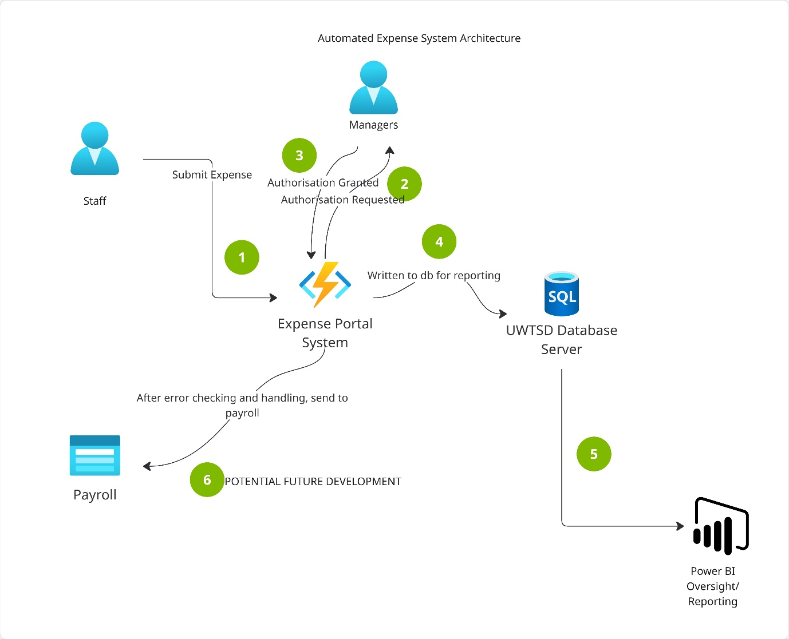
Figure 34: Earlier System Architecture Design, created with Miro

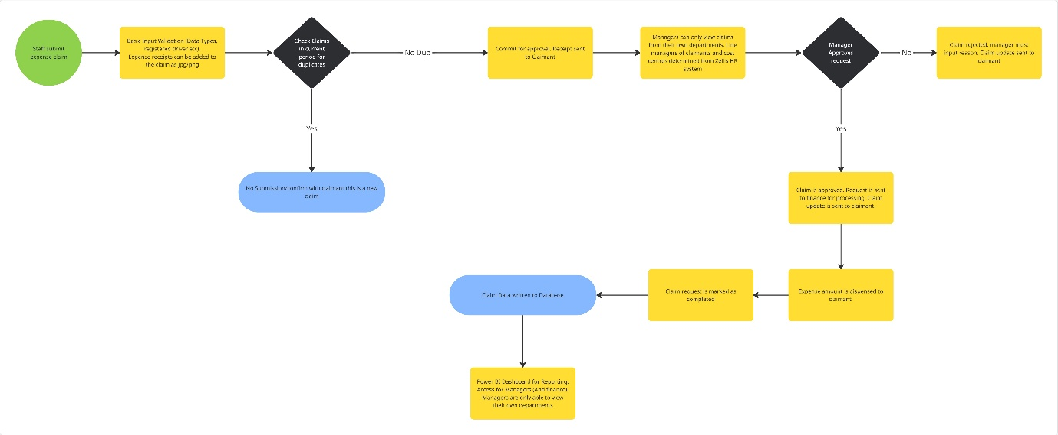
Figure 35: Initial Project Workflow Design, created with Miro

Wireframe Diagrams
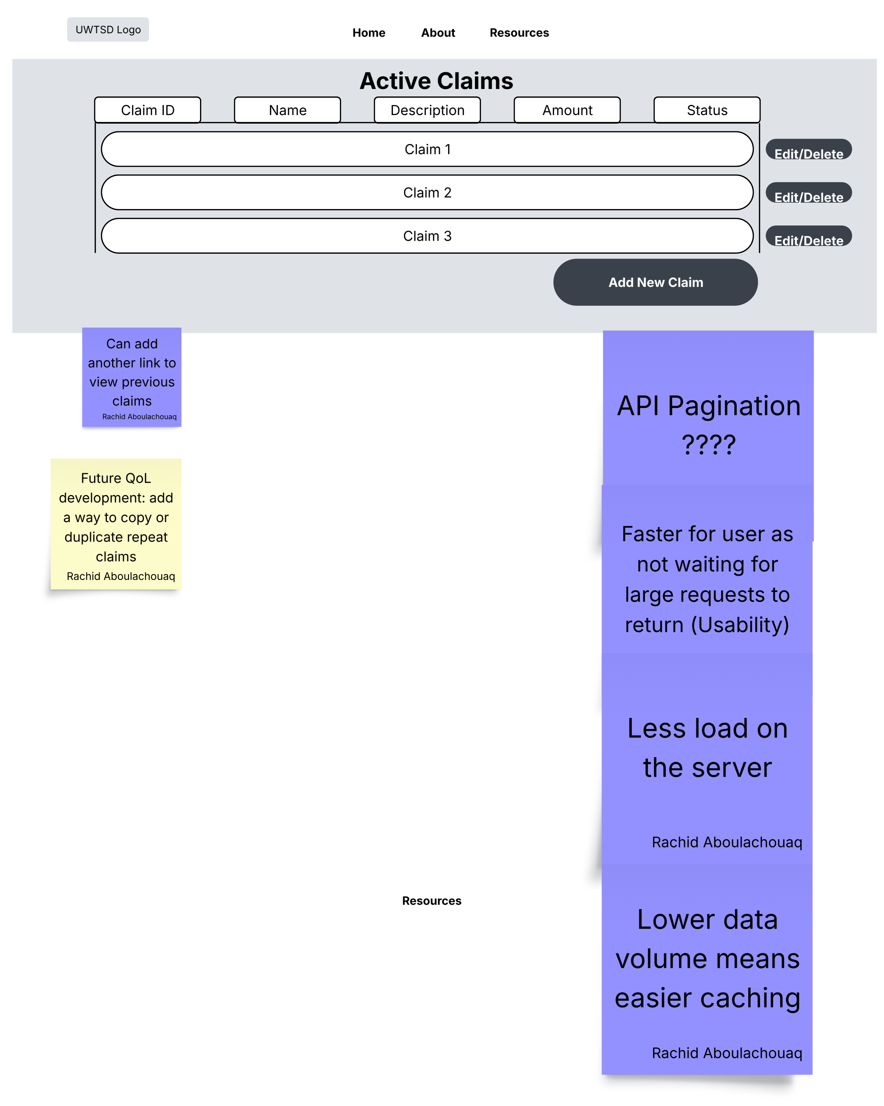
Figure 36 Initial wireframe, created with Lucidchart

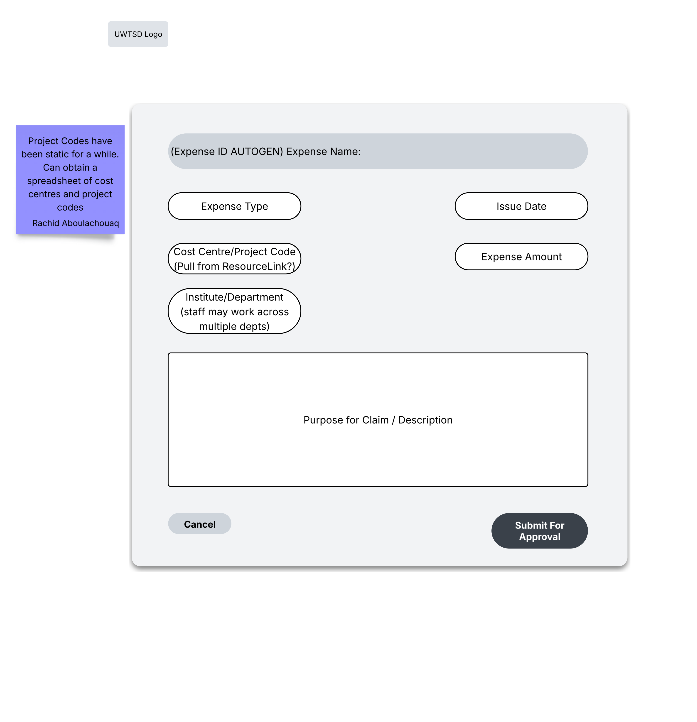
Figure 37 Create claim wireframe, created with Lucidchart

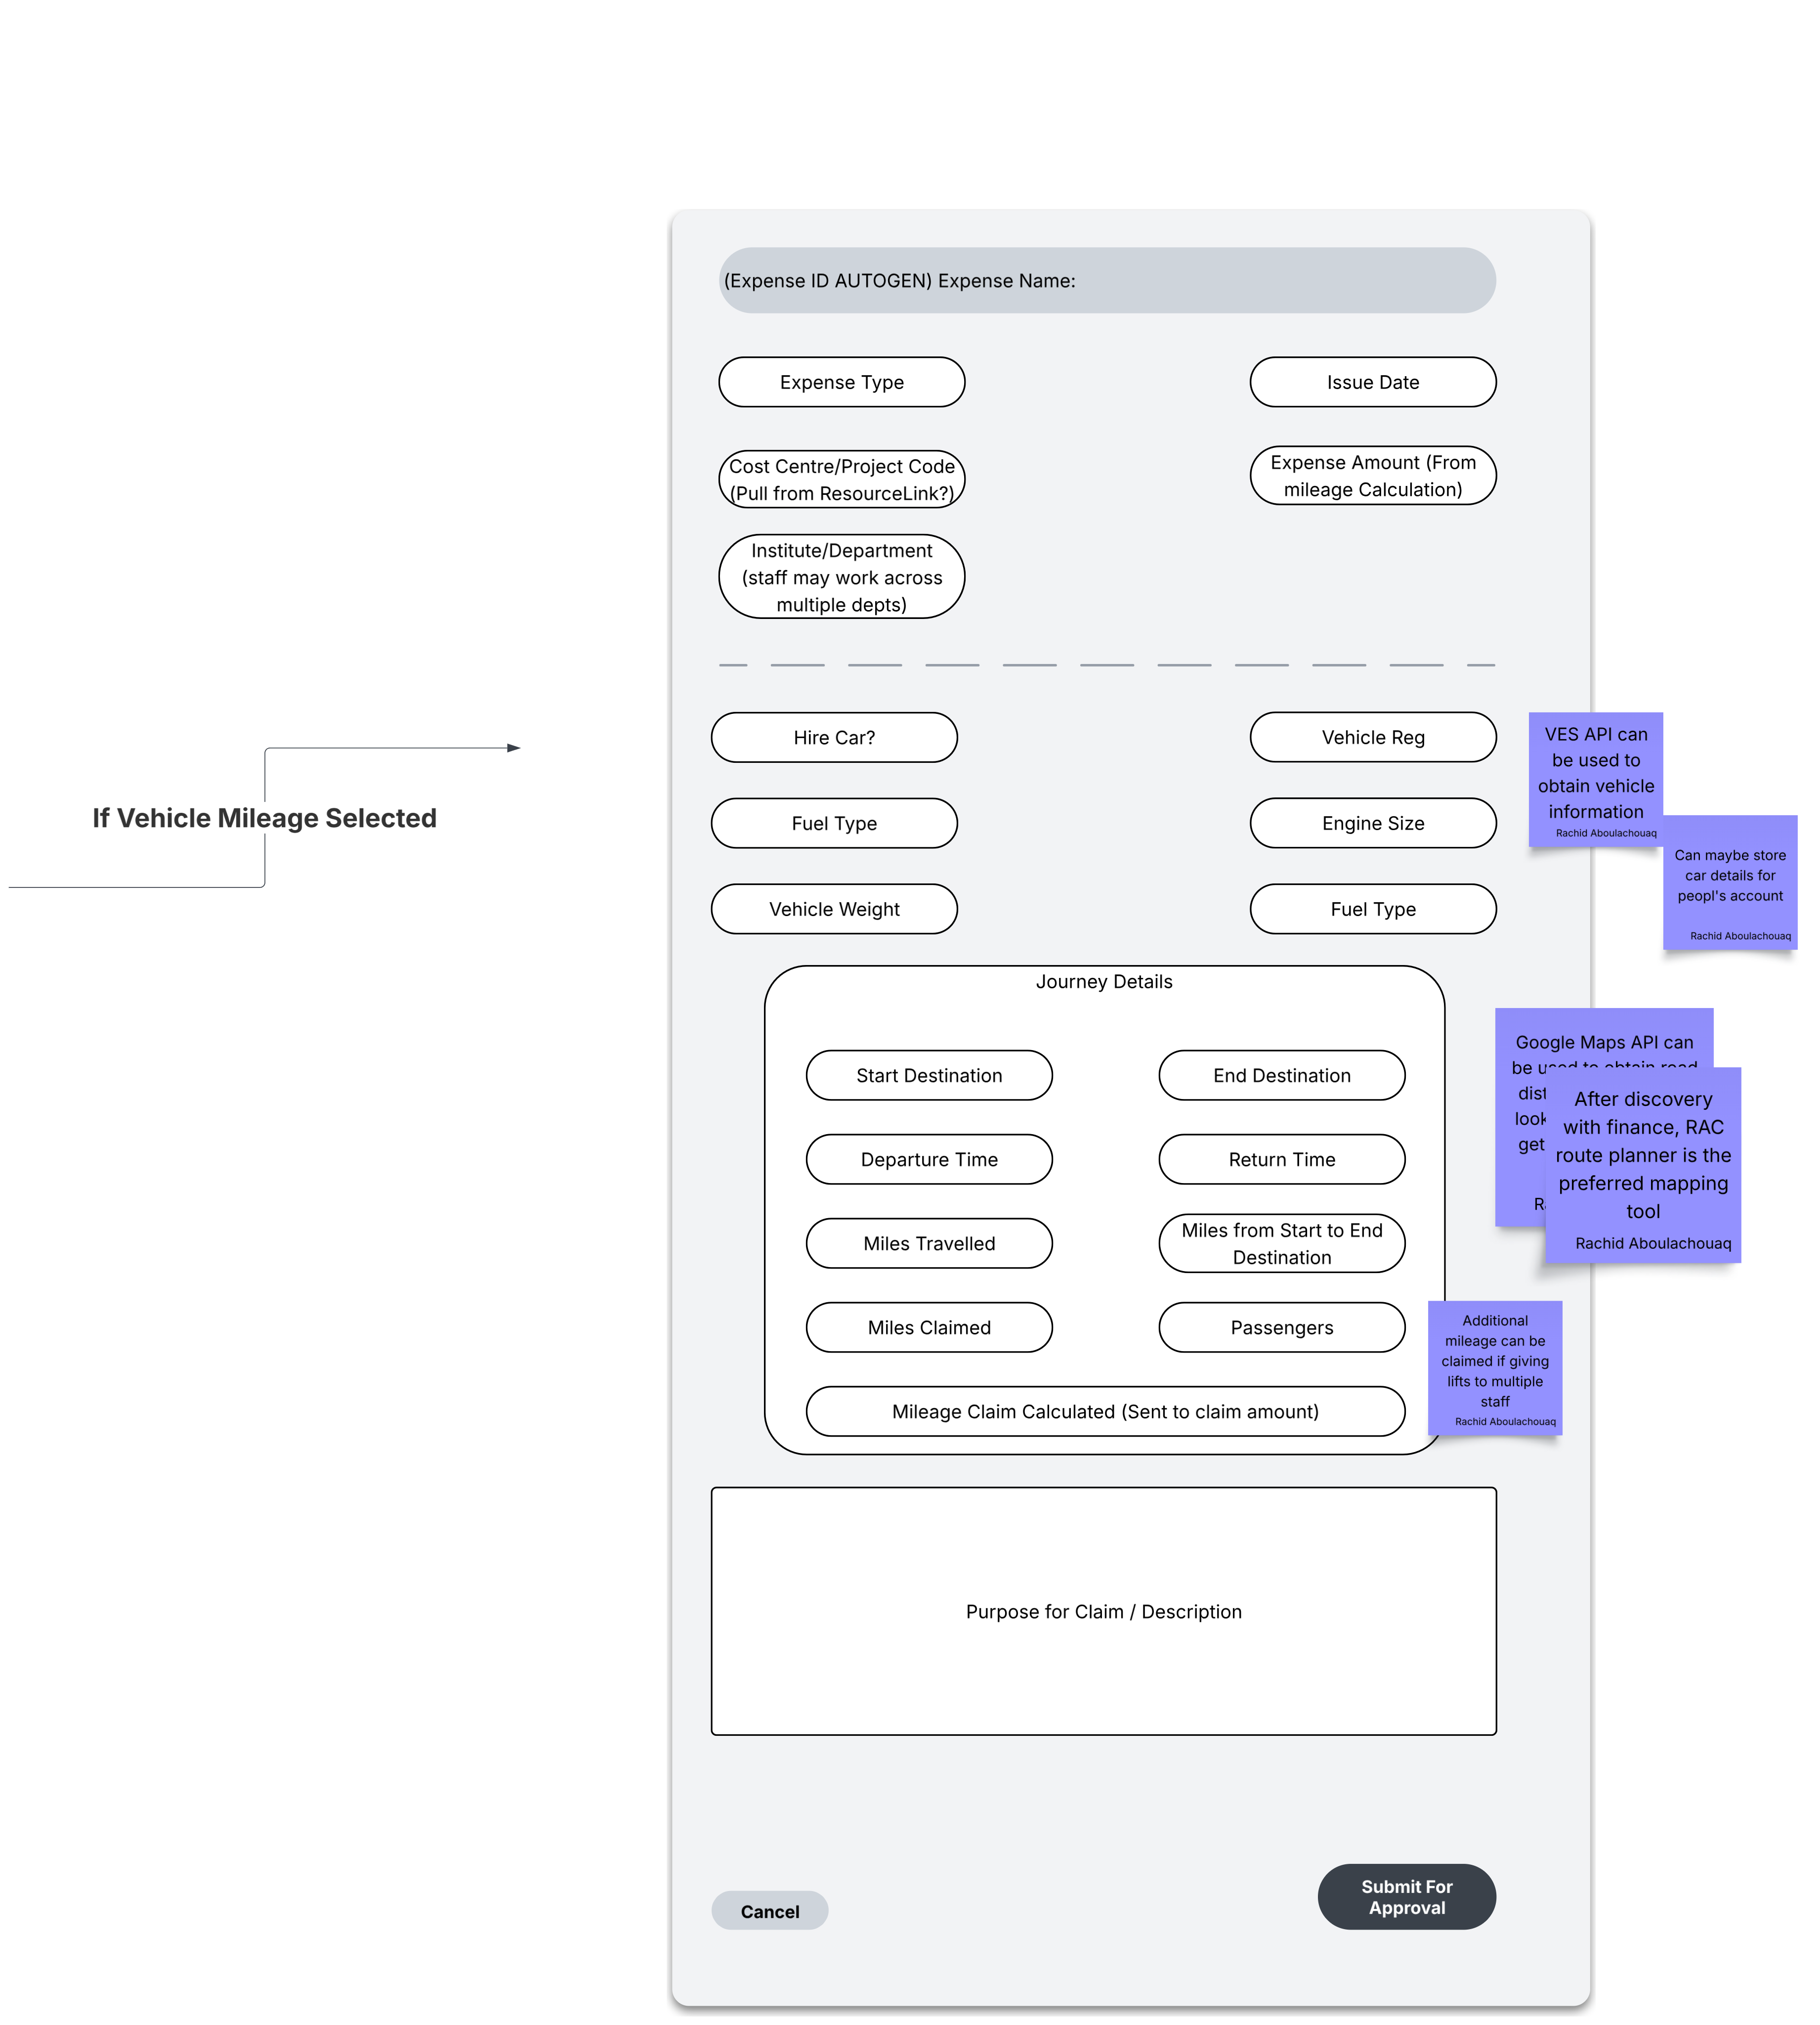
Figure 38 Dynamic functionality of create claim, created with Lucidchart

Appendix E: Source Code

Backend

Expense and User Models

User

Expense

Endpoints

Create expense
Uses JWT to read authenticated user and creates claim assigned to them

Get User Claims

Get Claims By Status

Submit Claim

Approve and Reject

Authorisation and Authentication

JWT Generation

JWT Validation

Front-end

Auth Store

Data Table Actions

API Handler

Data table

Form Validation

Appendix F: Evaluation results

Post-Test Questionnaire Results
Participant number | The process of creating a claim was straightforward. | I understood the difference between Draft and Submitted claims. | The information displayed on the Claim Details page was sufficient. | Manager comments were easy to locate and understand. | The approval/rejection workflow was intuitive. | I always knew what would happen after pressing a button. | Error messages, if any, were helpful and informative. | The system responded quickly enough for normal use.
1 | 5 | 4 | 5 | 5 | 5 | 3 | 5 | 5
2 | 5 | 5 | 5 | 5 | 4 | 4 | 5 | 5
3 | 0 | 0 | 0 | 0 | 0 | 4 | 4 | 3
4 | 5 | 4 | 5 | 5 | 5 | 4 | 4 | 5
5 | 5 | 5 | 4 | 4 | 5 | 4 | 4 | 5
6 | 4 | 5 | 5 | 5 | 5 | 5 | 0 | 5
Figure 39: Raw questionnaire results

Post-Test Open Ended Questions
Participant | Features liked | Confusing or complex areas | Suggested improvements
P1 | Modern appearance; clear separation of pending, approved and rejected claims | None reported | Improve the login page, loading feedback and automatic refreshing
P2 | Pages were clear, readable and easy to use | No major confusion reported | Automatic refresh, clearer menu links, use £ instead of $, receipt uploads and showing claims on the landing page
P3 | The system was simple to use | Submission action hidden within the ellipsis menu | Visible Submit button, clearer error messages, date picker and improved field limits
P4 | Manager screen layout | No confusion reported | Excel export, totals and monthly-spend information
P5 | Clear layout, quick performance, validation and institutional branding | Some buttons and column headings lacked explanation | Tooltips, improved validation messages, clearer action labels and better refresh handling
P6 | Clear appearance and generally easy to use | Unable to log in as an Employee | Receipt or evidence-upload functionality
Figure 40: Post-test open ended feedback

Task Observations
Participant | Task | Observation
P1 | Login | Login should appear immediately and provide a loading indicator
P1 | Manager approval | Approved claims required a page refresh before appearing in the correct section
P3 | Claim submission | The submission option was difficult to locate within the ellipsis menu
P5 | Claim creation | Validation did not clearly explain the £999.99 limit
P6 | Employee login | Login failed, preventing completion of the Employee workflow
Figure 41: Task Observations

