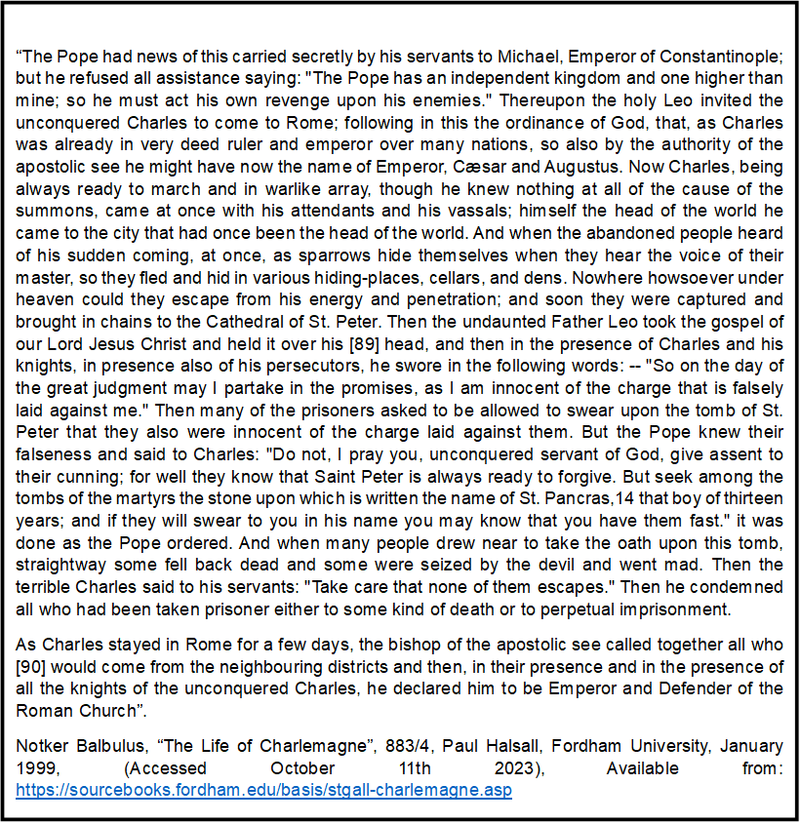
This extract is from “The life of Charlamagne”, written by Notker Balbulus (circa 883-884) and is a translation from Latin into English. Balbulus (often referred to as “the stammerer” or “the Monk of St. Gall”) was commissioned to write a detailed account of Charlamagne’s life by his great grandson, King of the Franks, Emperor Charles III (839-888). Charles, (aka Charles the Fat), was in control when Charlemagne’s substantial empire fell. This source is provided by the medieval history section of Fordham universities online source book, and features both of Notker’s books. His first detailing the piety and care Charlamagne had and demonstrated toward the church, and the second contains the wars and other military exploits undertaken by Charlamagne.
Charlamagne’s elevation from King to Holy Roman Emperor was the direct result of an assassination attempt on the life of Pope Leo III. Supporters of the previous Pope, Adrian I, saw Leo’s leaning towards the western empire of Charlamagne, instead of maintaining the balance with the eastern Byzantine empire, as misconduct and a betrayal of the practices of maintaining papal independence. As a result, during a procession in 799, Adrian I supporters attempted to blind and remove the tongue of the new pope. Leo fled to Charlemagne, and returned under the protection of a commission. Charlamagne was summoned to Rome a year later, in order to quell the confusion that still plagued the city. His seizure of conspirators and those responsible for the unrest, feature in the majority of this text. It also briefly details the actual act of declaring Charlamagne into an Emperor of Rome (800).
A very compelling point within this extract, is that Notker states that Leo I did not initially request Charlemagne’s aid. Other sources contradict this, Einhard (a scholar and courtier of Charlamagne) makes no mention of this. Einhard only writes that Charlemagne was summoned at the Popes personal request. This might be a simple oversight, even Einhard states that he could not include every detail in his account. However, Notker clearly records that the news was sent “secretly by his servants to Michael, Emperor of Constantinople; but he refused all assistance saying: "The Pope has an independent kingdom and one higher than mine; so he must act his own revenge upon his enemies”. This suggests that due to the Pope’s support toward Charlemagne, other rulers were unwilling to aid him. They even went as far as to mock Leo, by saying that their power as an Emperor was nothing compared to that of God, and it is God that should punish the enemies of the pope.
Throughout this extract Notker comments on the power that the Pope commands. Leo is so great that in his time of need, he can elicit a positive response from the illustrious Charlamagne. As a reward for his intervention, the Pope then calls all the “bishop of the apostolic see called together all who [90] would come from the neighbouring districts and then, in their presence and in the presence of all the knights of the unconquered Charles, he declared him to be Emperor and Defender of the Roman Church”. This display of Papal power, making Charlemagne a Holy Roman Emperor, confirms to his enemies that Leo was the only one anointed by God, and therefore the head of the Catholic church. Not included within this brief extract, is Notker’s summery of how unthankful Charlemagne was for such an honour.
The overall tone of this passage, and the book, is lauding of Charlamagne and his qualities. He is presented as a ruler of great ability and magnanimity, whose love for the church and Christendom is to be followed as a shining example to his people. This flattery and positivity regarding Charlamagne is exactly what is to be expected from a writer commissioned by the King’s grandson. Notker’s writing may also be an attempt to influence Charles III, by bolstering the legacy of Charlamagne, and demonstrating the attributes that kings should mirror if they wish to be as great as he was.
Notker’s writing style is rather unique, as he includes literary flourishes and often waffles. This happens when referring either to Christianity or to Charlemagne’s exploits. This might be the influence of his position as a monk, someone wishing to spread the greatness of Christianity and the legend of a great Christian king. Alternatively, this could simply be Notker’s personal feelings of admiration and reverence regarding Charlamagne, who although dead for 70 years, was still a beloved monarch.
Notker’s work is comparable to that of Einhard’s, The Life of Charlemagne, (830-33). However, as to be expected, there are distinct differences between the two pieces. Regarding the contents of the books, Einhard covers Charlemagne’s entire life, whereas Notker only examines small sections. However, both write in a revering manner of the king. Einhard likely as a way of paying homage to a man who he referred to as “my lord and foster-father, the most lent and most justly renowned King Charles”. Notker as he was commissioned to do so given that his book was for Charlemagne’s great grandson.
Both Notker and Einhard address Charlamagne’s ascension to the position of Emperor. Einhard only briefly covers the general events that took place during that momentous ceremony, Notker goes into far more detail. Einhard was able to clinically analyse events because he had witnessed them, Notker was not alive when this occurred and was thus relying on secondary information when composing his book. It is even possible, and likely, that Notker would have read Einhard’s work, as it was one of the most comprehensive accounts of the life of Charlamagne at the time. Even though Notker tends to focus on religious elements throughout the book, his analysis is often reminiscent of Einhard. An example of this being Notker’s assessment of Charlemagne’s character, “Now Charles, being always ready to march and in warlike array, though he knew nothing at all of the cause of the summons, came at once with his attendants and his vassals; himself the head of the world he came to the city that had once been the head of the world”.
Overall, this extract conveys Notker’s obvious personal affinity to the religious aspect of Charlamagne’s life. The fact that a Pope had personally declared him a Holy Roman Emperor, has impressed Notker greatly. Even though he never met the man himself, Notker’s admiration for the legend is very evident in this extract. Compared to Einhard, Notker’s account provides far more context and information regarding the coronation, detailing the actions of the Pope and other figures involved.

References
Einhard, “Einhard: The Life of Charlemagne”, cc 830-833, (Translated, Samuel Epes Turner, New York: Harper & Brothers, 1880), Paul Halsall, Fordham University, August 1996, (Accessed October 12th 2023), Available from: https://sourcebookklj;s.fordham.edu/basis/einhard.asp#EINHARD'S%20PREFACE
Notker Balbulus, “The Life of Charlemagne”, 883/4, Paul Halsall, Fordham University, January 1999, (Accessed October 11th 2023), Available from: https://sourcebooks.fordham.edu/basis/stgall-charlemagne.asp
Bibliography
Angelo Stagnaro, “Blessed Notker ‘the Stammerer,’ Pray For Us”, National Catholic Register, April 6th 2016, (Accessed October 22nd 2023), Available from: https://www.ncregister.com/blog/blessed-notker-the-stammerer-pray-for-us
Einhard, “Einhard: The Life of Charlemagne”, cc 830-833, (Translated, Samuel Epes Turner, New York: Harper & Brothers, 1880), Paul Halsall, Fordham University, August 1996, (Accessed October 12th 2023), Available from: https://sourcebookklj;s.fordham.edu/basis/einhard.asp#EINHARD'S%20PREFACE
History.com Editors, “Charlemagne”, History, November 9th 2009, (Accessed October 23rd 2023), Available from: https://www.history.com/topics/middle-ages/charlemagne
Notker Balbulus, “The Life of Charlemagne”, cc 883-884, Paul Halsall, Fordham University, January 1999, (Accessed October 11th 2023), Available from: https://sourcebooks.fordham.edu/basis/stgall-charlemagne.asp
The Editors of Encyclopaedia Britannica, “Charles III”, Britannica, July 20th 1998, (Accessed October 20th 2023), Available from: https://www.britannica.com/biography/Charles-III-Holy-Roman-emperor
The Editors of Encyclopaedia Britannica, “Einhard”, Britannica, July 20th 1998, (Accessed October 21st 2023), Available from: https://www.britannica.com/biography/Einhard
The Editors of Encyclopaedia Britannica, “Saint Leo III”, Britannica, Jul7 20th 1998, (Accessed October 24th 2023), Available from: https://www.britannica.com/biography/Saint-Leo-III

Notker Balbulus, “The Life of Charlemagne”, 883/4, Paul Halsall, Fordham University, January 1999, (Accessed October 11th 2023), Available from: https://sourcebooks.fordham.edu/basis/stgall-charlemagne.asp
Einhard, “Einhard: The Life of Charlemagne”, cc 830-833, (Translated, Samuel Epes Turner, New York: Harper & Brothers, 1880), Paul Halsall, Fordham University, August 1996, (Accessed October 12th 2023), Available from: https://sourcebookklj;s.fordham.edu/basis/einhard.asp#EINHARD'S%20PREFACE
Notker Balbulus, “The Life of Charlemagne”, 883/4, Paul Halsall, Fordham University, January 1999, (Accessed October 11th 2023), Available from: https://sourcebooks.fordham.edu/basis/stgall-charlemagne.asp

