

PROBLEM SOLVING AND DECISION MAKING
TASK 2- INDIVIDUAL REPORT

STUDENT NAME: OTILIA RAMONA PAL
STUDENT NUMBER: 1905863
MODULE CODE: BMSW4004
LECTURER: MAGDALENA WRONSKA

Table of Contents

Introduction 3
Complex Problem: its scope and impact on health and social care ……. 4
Different solutions to the problem 4
Implementation of Decision making technique for identifying appropriate solution 5
Plan for the solution 6
Communicating the plan to the stakeholders 8
Reviewing technique for successful implementation of solution 9
Conclusion 9
Reference List 10
Appendix……………………………………………………………………………………..12

Introduction
Problem solving and decision making are essential for any business organisation to resolve their challenges and issues effectively. There are different techniques in decision making which will assist in resolving a problem efficiently and come up with an effective solution. This report will focus on different problems of health and social care and how different techniques will be effective to come up with the solution of the problem in health and social care. The objective of the report is to analyse the problem of delivery of ineffective care services to the patients in the health and social care industry in the UK.

Complex Problem: its scope and impact on health and social care
The major problem which arises in a Health and Social care is their inability to provide effective and quality service to its patients. This leads in lowering the name of that particular health and social care business organisation. Unsatisfactory service to the patient may even cause them to have a reduced footfall of the patient in the health and social care which will reduce their profitability (Haendler and Frysak, 2018). There have been cases reported in the UK that a sport personnel with a broken feet and ankle was refused to have scans in NHS, which resulted in causing that sport personnel permanent pain in his feet (Pullen, 2017). Thus, it led him to go through critical risky surgery which could have been avoided if the scans were done initially on time. Thus, it can be stated that patients are not provided effective care in the health and social organisations in the UK. There are various reasons which lead to providing ineffective patient care service such as untrained and low count of healthcare staff, use of out-dated methods for treatment, lack of communication between the employees and low supply of medicines. Proper staffing in the health and social care is directly dependent on the satisfaction of the customers. Therefore, to improve this, NHS increased its staff employment by increasing the total vacancy for health care staff from 26424 in the year 2016 to 30643 in the year 2017 (Care Quality Commission, 2020). It is important to note that lack of required numbers of staff and inadequate training decreases the quality of care services provided to the patients in the UK.

Decision-Making process
Problems arising with ineffective patient care could be resolved by implementing proper decision-making skills in health and social care. The basic reason which arises in providing unsatisfactory service to the patient is untrained healthcare staff and improper communication between them. For instance, due to improper communication of the employees of the health care delayed transfer of care arises in the health care department. There is a significant increase in the delayed transfer of care, at end of 2016 there was 12% delayed transfer of care which then was increased to 15% at the end of 2017 (Care Quality Commission, 2020). Apart from this, the utilization of out-dated and primitive methods in the treatment of the patient also resists the healthcare professionals to provide proper treatment to the patients.
Different solutions to the problem
There are various solutions to resolve the problem of ineffective patient care in health and social care. Different solutions to the problems are stated below:
Problems | Solutions
Untrained and low count of healthcare staff | - Effective training  - Recruitment of skilled healthcare professional
Use of out-dated methods for treatment | - Conducting Workshop  - Implementation of electronic prescribing
Lack of communication | - Seminars to improve communication skills  - Interaction with the patient
Low supply of medicines | - Enlarging the supply chain to increase medicine supply in health and social care.
Table 1: Problems and Solution
(Source: Created by the learner)

Implementation of decision-making technique for identifying appropriate solution
Problems
Untrained Staffs
Primitive Methods
Communication
Low supply of medicine
Effective training and seminar
Advanced Technology
Extended supply chain
Figure 1: Decision tree diagram for Problem solving
(Source: Created by the learner)
With the implementation of decision-making tree technique the solution of the problems related to health and social care is achievable. Health and social care is currently facing issues like untrained staff, lack of communication, utilization of old and primitive methods and low supply of medicines. The implementation of decision- making tree technique health and social care identify a common solution to all the problems. From the decision-making tree it could be seen that giving effective training as well as conducting seminars properly allows health and social care to give an overall solution to all their problems (Takacs et al., 2016). Organising proper training sessions allows employees to develop and improve their skills thereby enabling them to provide quality care to the patients. Such training sessions also assists health and social care staff to improve their communication skills which will allow them to interact with the patients effectively. This will help the health care professionals in their prompt diagnosis and provide effective treatment to the patients. Proper training and seminar also aid the health and social care staff in increasing their knowledge about the new and innovative technology which could be used to provide error free treatment to the patient. Thus, enhancing the quality of care and service is required to be provided to the patient. The training sessions and seminars will also enable the health and social care organisations like NHS to have trained and experienced workers (Lu et al., 2016). It will also aid the healthcare care organisations to expand their supply chain to have a proper and adequate supply of quality medicine. Thus, it will enable health and social care to provide effective care and treatment to the patient.

Plan for the solution
The plan for enhancing the quality of the services in health and social care organisations like NHS has been created after brainstorming on the possible solutions of the issues identified and using a decision-making tree.
Objectives | Tasks | Success Criteria | Time Frame | Resources
To conduct effective training and seminar sessions | To improve the skills, communication and getting equipped with modern technology which will be essential for providing effective patient care. | To achieve a minimum 90% of positive feedback from both employees and patients. | 5 months | - Funding  - Proper venue  - Projector  - Sitting facility  - Electric supply
Table 2: Action Plan
(Source: Created by the learner)
The actions required
Effective training and seminar is the solution which is essential to resolve problems of health and social care like the NHS. Therefore, they are required to conduct various training, seminars and workshops for their employees. This will enable the employees to improve proper skills required for quality care, improve their communication and get equipped with various new and innovative technologies which will be required for giving better treatment to the patient. Health and social care like NHS will also have to collaborate with an organisation and form a team that will be responsible to conduct training and seminar sessions (Antoun et al., 2020). In order to conduct effective training and seminars for improving skills, communication and equipping with modern technology for their employees, health and social care will require experts and professionals in the same fields. These experts will share their experience and provide them with knowledge which when implemented by their employees will help them improve their skills, communication. These experts will also enable the employees of health and social care to access all the modern and innovative technologies which will assist them in providing effective patient care.
Time frame
Health and social care like the NHS will require almost 5 months of regular training of the employees in all the departments so that they become efficient in terms of providing standard quality services to the patients.
The resources required
Health and social care like the NHS will ensure that they provide proper funding which will assist them in conducting training and seminars effectively. Proper funding will enable them in booking a proper venue where all their employees could assemble comfortably (Russell and Kosny, 2019). They will also require proper electric supply and good quality projector to assist their employees in learning. They will also require an adequate amount of chairs to accumulate all their employees.
Measures to counter adverse consequences
Health and social care like the NHS will have to maintain the regularity of the training and seminar, as there will be certain employees who will not be able to learn as well as implement new techniques which will be required to improve their skills, communication along with knowledge of modern and innovative technology. If any employee is not interested in these training and seminars then to gain the interest of the employees’ health and special care will adopt measures like providing refreshments during training and seminars. To deal with technical issues the organisation will ensure that they have a proper power backup and a technician available during training and seminars. It will ensure the smooth running of training and seminars if some technical glitches occur during the training sessions and seminars (Antoun et al., 2020). Health and social care like the NHS will strictly follow up with the employees who will not be attending this seminar and will ensure that they have a valid reason due to which they were not attending training and seminars. If any employee is unable to attend training or seminar, they will be required to present proper documents to health and social care regarding their absence. If the employees are not able to improve their skills then they will conduct these training and seminars again.
Reviewing the plan
The team of the institution that will collaborate with the health and social care organisations like NHS will be responsible for conducting these training and seminars. They will be liable for evaluating their employees to judge whether they are able to learn and improve their skills from the training sessions and seminars (Antoun et al., 2020). Feedbacks will be taken from the employees attending training sessions regarding the topics they learnt and the effectiveness of the sessions. The team will also take feedback from patients to evaluate that effective care is given to them properly.
Success Criteria
In order to consider these training and seminars to be successful, health and social care have set 90% of positive feedback from both employees and customers.

Communicating the plan to the stakeholders
The stakeholders of health and social care are government, employees and patients. Health and social care like the NHS has to communicate and understand their stakeholders about the solutions to their problems. In order to communicate with employees, emails and memos will be used to inform about the plan in healthcare organisations (Russell and Kosny, 2019). Health and social care, like the NHS, will use digital marketing platforms to ensure that these solutions have been properly communicated to their patients and therefore inform them about their effective patient care service. For gaining necessary permission health and social care organisation’s representatives will conduct face to face meetings with government officials to implement modern and new technologies in health and social care.

Reviewing technique for successful implementation of solution
Health and social care representatives will ensure that they appoint 2 individuals as volunteers who will monitor the performance of the team who are required to organise training and seminars. The responsibilities of these volunteers will be to ensure that proper training is provided to their employees by the team who is responsible for organising these training and seminar sessions.

Conclusion
It could be concluded from this report that problem solving and decision-making are very essential in order to provide effective patient care. Health and social care use problem solving and decision-making techniques to identify their problem and then take effective measures to solve their problems.

Reference List
Antoun, J., Bou Akl, I., Halabi, Z., Bou Khalil, P. and Romani, M. (2020),”Effect of Balint seminars training on emotional intelligence and burnout among internal medicine residents”. Health Education Journal, p.0017896920911684, Sage Publication [Online]. Available from: https://journals.sagepub.com/doi/abs/10.1177/0017896920911684 (Accessed:18 August 2020).
Cqc 2020. Our fundamental standards | Care Quality Commission [Online]. Available from: https://www.cqc.org.uk/news/stories/our-fundamental-standards#:~:text=care%20and%20treatment%20must%20be%20provided%20in%20a%20safe%20way,secure%2C%20suitable%20and%20used%20properly
(Accessed: 18 August 2020).
Cqc.org.uk. 2020 [Online]. Available from: https://www.cqc.org.uk/sites/default/files/20180613_ip17_statisticalrelease.pdf
(Accessed 18 August 2020).
Haendler, T. and Frysak, J. (2018),” Deconstructing the Refactoring Process from a Problem-solving and Decision-making Perspective”, ICSOFT, pp. 397-406 [Online]. Available from: https://www.scitepress.org/Papers/2018/69159/69159.pdf
(Accessed:20 August 2020).
Lu, J., Han, J., Hu, Y. and Zhang, G. (2016),” Multilevel decision-making: A survey”, Information Sciences, 346, pp.463-487[Online].Available from: https://opus.lib.uts.edu.au/handle/10453/44134(Accessed: 20 August2020).
Pullen, E. (2017). Sport and exercise medicine in NHS England: the pathways of sport-related injury patients and social costs (Doctoral dissertation, Loughborough University).
Russell, E. and Kosny, A. (2019),” Communication and collaboration among return-to-work stakeholders”, Disability and rehabilitation, 41(22), pp.2630-2639 [Online]. Available from: https://www.iwh.on.ca/journal-articles/communication-and-collaboration-among-return-to-work-stakeholders (Accessed: 22 August 2020).
Takács, Á., Kiss, M., Hof, A., Tanács, E., Gulyás, Á. and Kántor, N. (2016),” Microclimate modification by urban shade trees–an integrated approach to aid ecosystem service based decision-making”, Procedia Environmental Sciences, 32, pp.97-109 [Online]. Available from: https://www.sciencedirect.com/science/article/pii/S1878029616001419?via%3Dihub (Accessed:18 August 2020).

Appendix1-Fishbone diagram
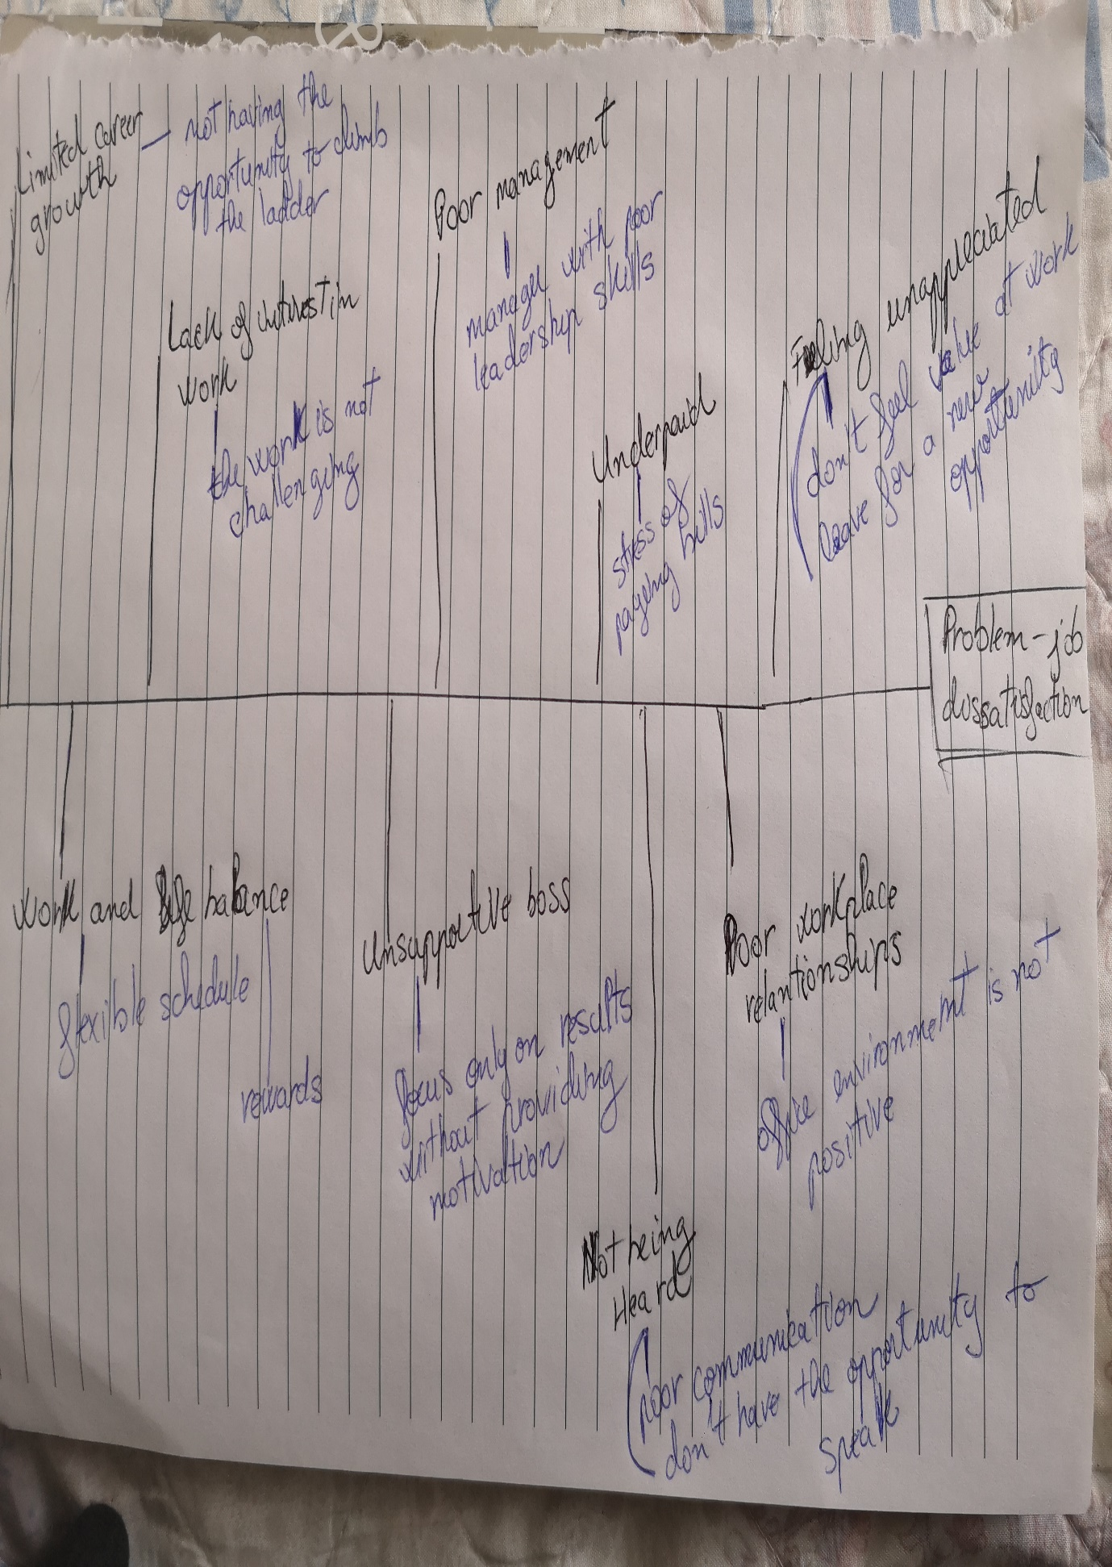

Appendix 2-PMI analysis
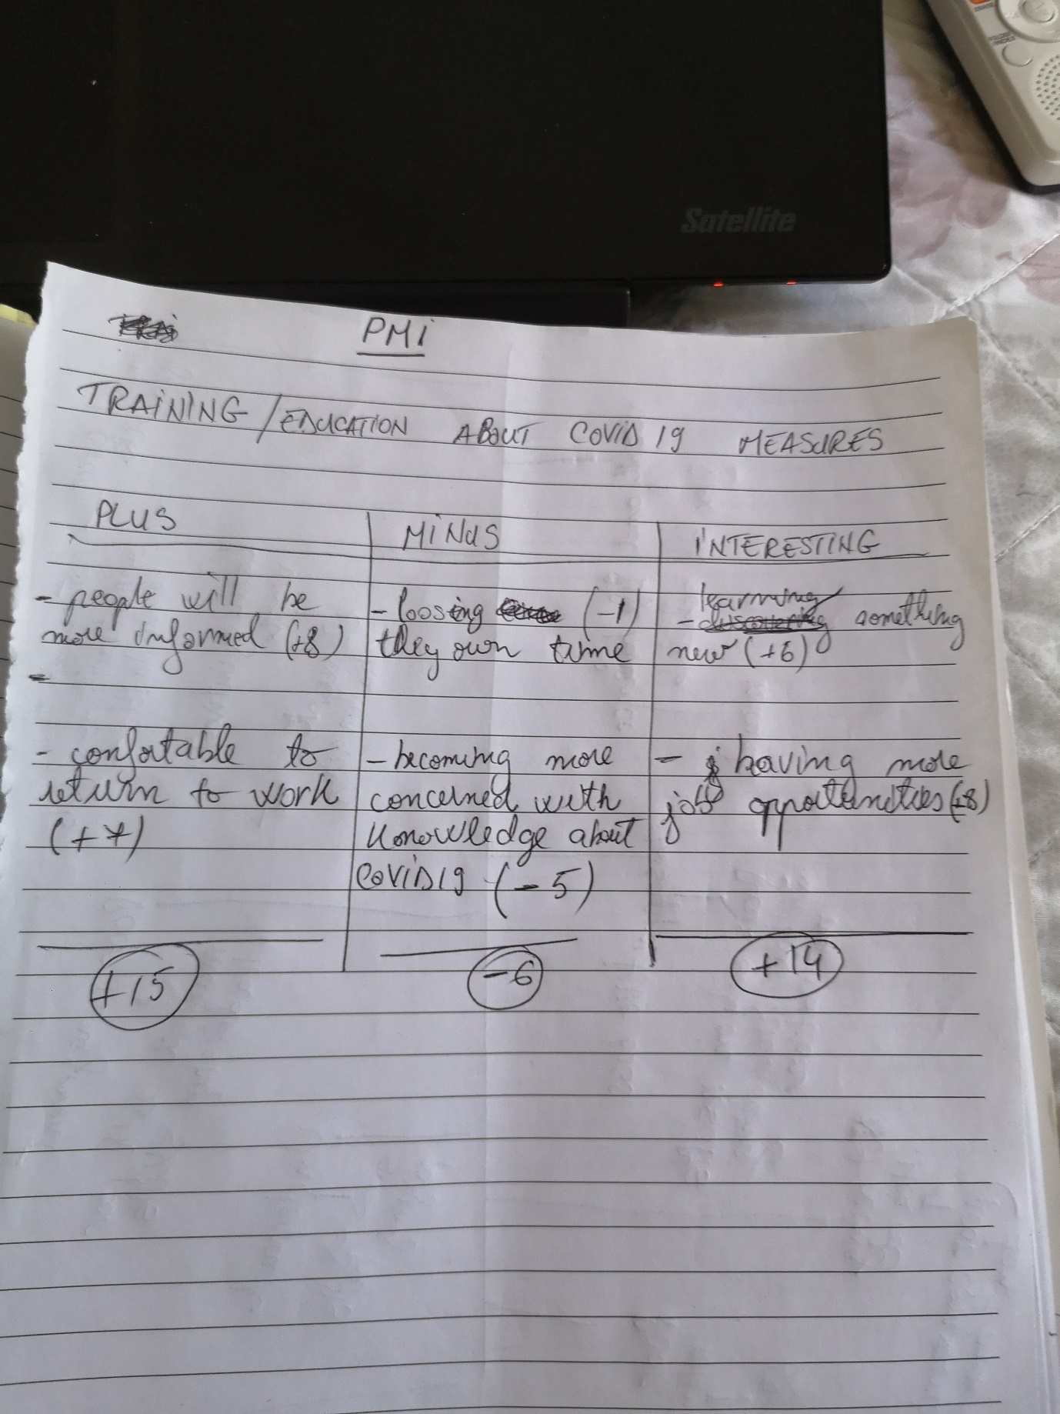

Appendix 3- Individual task


