

University of Wales Trinity Saint David
School of Engineering

Heat Exchanger Laboratory Analysis
Thermofluid Mechanics
M5X00406

Sam Alun Williams
1701794
BEng Motorsport Engineering
Contents

1 Introduction 1
1.1 Aims 1
1.2 Objectives 1
1.3 Background 1
2 Experimental Procedure 3
2.1 Experiment 1 – The Effect of Varying Water Flow Rate 3
2.2 Experiment 2 – The Effect of Varying Air Flow Rate 3
2.3 Experiment 3 – The Effect of Varying Temperature 4
3 Results 5
3.1 Excel Spreadsheet of Experiment 1 5
3.2 Excel Spreadsheet of Experiment 2 6
3.3 Excel Spreadsheet of Experiment 3 7
3.4 Equations Used in Calculation 8
3.5 Graphs of Experiment 1 10
3.6 Graphs of Experiment 2 12
3.7 Graphs of Experiment 3 14
4 Examination of Results 16
4.1 Experiment 1 16
4.2 Experiment 2 17
4.3 Experiment 3 18
5 Conclusion 19
6 Evaluation 20
7 References 21

Introduction

Aims
Within this report, the author discusses the effects of altering variables in a thermodynamic heat exchanger affects its functioning. Variables to be altered include water mass flow rate given fixed airflow and water temperature, air mass flow rates given fixed water flow and temperature and water temperature given fixed water flow. One aims to discuss the principles behind the theory and compare with results from the experiments.

Objectives
Students were given the task of completing experiments using the TecQuipment 32-tube, parallel-flow, water to air heat exchanger. The lab session is split into 3 experiments. Firstly, students were to adjust the mass flow rate of the fluid from 1.75l/min to 0.75l/min through increments of 0.25l/min. The second and third experiments adjust the air pressure from 250Pa down to 25Pa through increments of 50 until 50Pa is reached, then 25. Each experiment is to be performed at given temperatures of 60°C and 45°C, respectively.
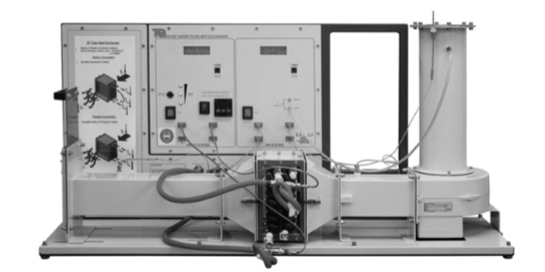

Figure 1 – TecQuipment 32 tube, water to air heat exchanger (TecQuipment, 2020)

Background

A heat exchanger is a system that is used to exchange thermal energy between two fluids. The two fluids are a part of two separate systems therefore the fluids do not mix and there is no exchange of mass across the system boundaries. Examples of heat exchangers in the automotive industry could be vehicle radiators, intercoolers, and exhaust gas recirculation valves. These help to transfer thermal energy from one fluid to another, whether that fluid be water/coolant, gases or oil. There are many different types of heat exchangers, and second year students at the University of Wales Trinity Saint David concentrate on recuperative heat exchangers. A recuperative heat exchanger is one which transfers heat from one fluid to another by way of a dividing wall, generally referred to as the ‘interface’ (Goodson, Fundamentals of Heat Exchangers, 2020). Although this report concentrates on cross flow heat exchangers, which are the most effective type, there are other widely used types such as the shell and tube type and parallel flow. The cross flow is most effective because of its design structure. The cold stream inlet enters the heat exchanger at the same side as the outlet port of the hot stream and exits at the same side as the hot stream inlet, where the temperature is greatest. This results in the cold outlet being a higher temperature than the hot outlet, thus providing increased efficiency. Early uses of crossflow heat exchangers in the automotive industry include Ford’s Kent engine, amply known as the Ford Crossflow engine. Introduced in 1967, this engine was redesigned from the original Kent engine to include a cross flow cylinder head (Wikipedia, 2020).
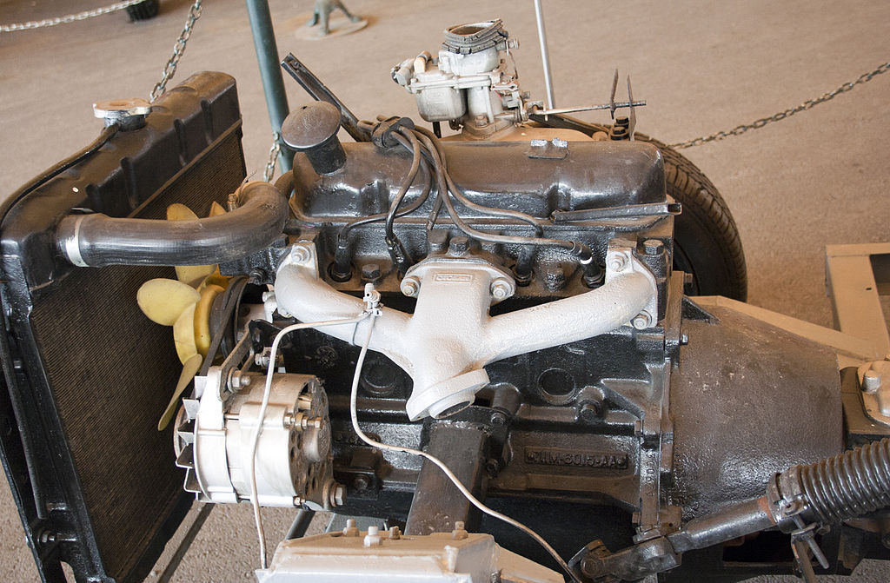

Figure 2 – 1.6 litre Ford Kent ‘Crossflow’ engine (Wikipedia, 2020)

Experimental Procedure

Experiment 1 – The Effect of Varying Water Flow Rate

Students were to connect and perform necessary checks on the heat exchanger connections before using. Then the heat exchanger should be connected for parallel flow and the temperature set to 60°C. Students should visually inspect the orifice and note its diameter, which is stamped upon the equipment as well as the ambient air pressure in the laboratory for use in future calculations. It should also be noted throughout that the inlet is at the bottom of the heat exchanger and the outlet at the top. Then, the fan situated on the apparatus should be turned on so that an orifice pressure drop of approximately 250Pa is observed. It should be noted that a tolerance of ±5Pa is allowed for this value. To achieve this, students should use the slide valve to set the airflow accordingly. Once complete, one should turn the pump on, and use the hand-operated water valve to set the flow to given values. It should be noted that students were unable to follow the assignment brief fully, as the apparatus would not reliably allow a flow rate of over 2l/min, hence beginning samples at 1.75l/min. A tolerance of ± 0.01l/min is allowed for fluid flow rate. A delay of approximately 5 minutes is to be followed before gathering data, giving the sensors time to settle and display more accurate readings. Once stabilized and consistent, students could begin to start recording temperatures of the air and water at inlet and outlet ports. Once data is collected, the procedure can be repeated for each mass flow rate until completed, observing a delay each time while the sensors stabilize. Student should stay vigilante and regularly visually examine the sensor readings as readings can change throughout the experiment and valves may need to be adjusted to stay within tolerance (Goodson, Assignment Brief, 2020).

Experiment 2 – The Effect of Varying Air Flow Rate

Much like the previous, one should consider all safety checks and connections before starting the next experiment. Set the fluid flow banks in a parallel configuration and set heater tank temperature to 60°C again. Take note of the ambient pressure of the room and examine the orifice and its diameter. Turn on he fan and use the slide valve to set the airflow to give a pressure drop of 250Pa, heeding the same tolerance. After turning the pump on, one should set its flow to 0.25l/m, within the same tolerance as before. Once the gauges have stabilized, record each temperature reading. Repeat process adjusting air flow rate to 200, 150, 100, and 50Pa each time (Goodson, Assignment Brief, 2020).

Experiment 3 – The Effect of Varying Temperature

Connect pipes securely and constructed for parallel flow. Tank temperature should be regulated at 45°C. Ensure all temperature sensors and connections are correct then proceed to note the ambient air pressure for the final time. Log the orifice diameter and follow the same guide from this point as in experiment 2. Repeat the sequence again for each pressure drop of 200Pa through 50Pa, adhering to the same tolerances as before (Goodson, Assignment Brief, 2020).

Results

Excel Spreadsheet of Experiment 1
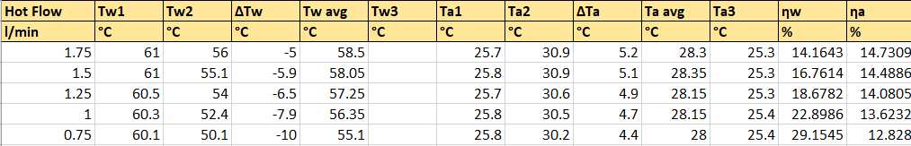
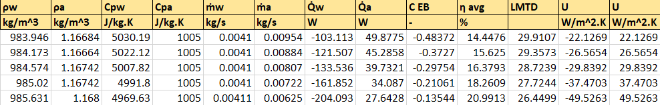

Excel Spreadsheet of Experiment 2
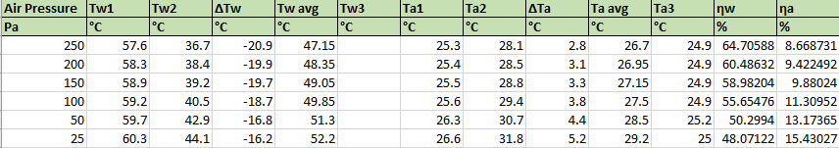
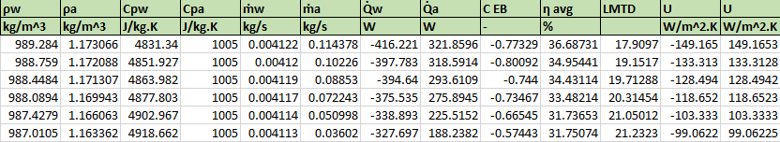

Excel Spreadsheet of Experiment 3



Table 1 – A table of constants used throughout all excel formulae and calculations
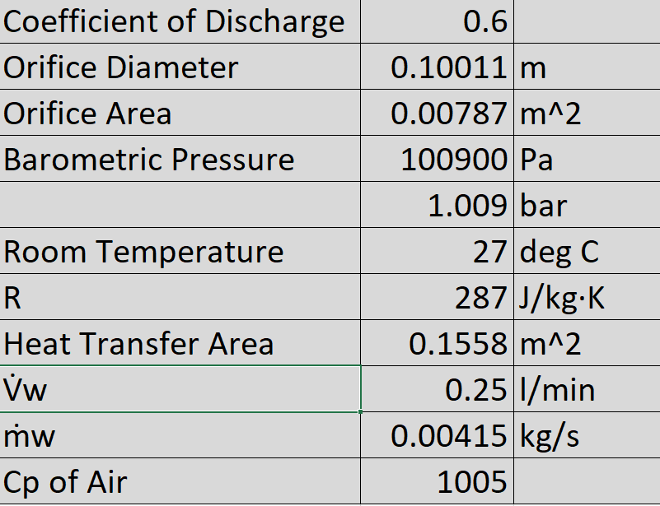

Equations Used in Calculation

Conversion of Water Flow
Mass Flow Rate of Air
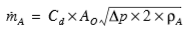
Temperature Efficiency, ƞ
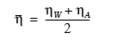
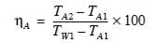
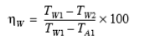

Density, ρ
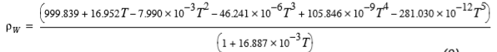
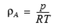

Specific Heat Capacity of Water, C_{pW}
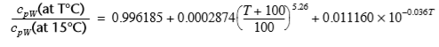
Heat Transfer, Q
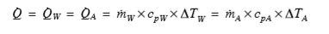
Logarithmic Mean Temperature Difference (LMTD)
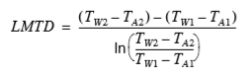

Coefficient of Energy Balance, C_{EB}
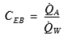
Heat Transfer Coefficient, U
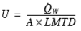

(TecQuipment, 2020)

Graphs of Experiment 1

Graph 1

Graph 2

Graph 3

Graphs of Experiment 2

Graph 4

Graph 5

Graph 6

Graphs of Experiment 3

Graph 7

Graph 8

Graph 9

Examination of Results

Experiment 1

Graph 1 depicts the heat transfer occurring within the heat exchanger, as temperature and pressure remains constant at 60°C and 250Pa, respectively. Each Y axis represents the heat emitted by the hot stream and heat absorbed by the air, the secondary axis being that of the hot stream. The negative values displayed are because of the thermodynamic sign convention. If energy leaves the system, it is considered a negative value, and positive when entering the system (University of Wisconsin, 2020). It is clearly displayed that as the mass flow rate increases, so to does the heat transferred by the hot water as well as the power absorbed by the air, suggesting that the two are proportional. A higher mass flow rate means more opportunity for the fluids to mix and heat transfer to occur. Both lines follow a positive correlation, somewhat verifying the credibility of the results.
Displayed in Graph 2 is the air, water, and average temperature efficiencies, again at constant pressure and temperature. The graph shows that as mass flow rate of water increases, the thermal efficiency of the water decreases, from approximately 29.2% to 14.2%. However, the thermal efficiency of air increases from 12.8% to 14.7%. At a water mass flow rate of approximately 0.028kg/s the two lines meet.
Graph 3 displays the overall heat transfer coefficient against the water mass flow rate. There does not seem to be much of a steady pattern to the results when looking at the graph, highlighting a possible anomalous result. The values are all between 148.5 W/m²K and 159.4W/m²K. The results convey that while thermal efficiencies have a clear relationship to the mass flow rate of water, the overall heat transfer coefficient does not.

Experiment 2

Graph 4 of experiment 2 shows similarities to that of graph 1. One can clearly see that as the mass flow rate of the air increases, so does the heat transfer that occurs in the heat exchanger. Like in Graph 1, the lines follow a very similar pattern. This is due to the fundamental concept of the conservation of energy, which states that energy can neither be created nor destroyed but only transferred and therefore transformed, meaning it remains constant throughout (National Aeronautics and Space Administration, 2020). It is clearly conveyed in the plot that as the energy leaves the hot stream, its is gained as power by the air.
In graph 5, the effect of increasing the air flow rate on the thermal efficiency is exhibited clearly. It shows the inverse pattern of that displayed in graph 2. As the air mass flow rate increases, the thermal efficiency of the water increases from 48.1% to 64.7% and the thermal efficiency of the air decreases from 15.4% to 8.7%. The average value shows a slight increase, possibly indicating that the thermal efficiency of the water is more affected by the increase in air flow. This is mainly due to the different molecular structures of both fluids, and the effect that it has on the fluid’s abilities to store energy efficiently. Air is less dense than water, so the atoms are further apart, thus hindering its ability to store energy in comparison to water.
Graph 6 shows how the overall heat transfer coefficient changes with air flow rate. In this plot, a positive correlation is clearly visible that as the flow rate increases, so too does the heat transfer coefficient. Unlike the data displayed previously in graph 3, the heat transfer coefficient increases in somewhat of a linear fashion, showing a possible proportionality between the two variables. As explained in the discussion about graph 1, the increased flow rate allows for more chance for the fluids to combine.

Experiment 3

Graphs 7, 8 and 9 help to confirm the findings of experiment 2, as each graph displays a very similar patterns to those of graphs 4, 5 and 6. Experiment 3 was carried out in the exact same manner as experiment 2, with the only difference being a temperature decrease of 25%, from 60°C to 45°C. This decrease in temperature is demonstrated in comparison to the graphs of experiment 2. The graphs of experiment 3 follow the same patterns, but at a slightly lower scale than those of experiment 2. For example, the minimum value for Q_{a} in graph 7 is 134.1W, whereas in graph 8 the minimum value is 188.21, a decrease of approximately 28%. This information suggests that heat transfer occurs at a higher rate when the water temperature is higher.

Conclusion

In conclusion, one would determine that the experiment could be considered a success as clear relationships between variables has been accomplished and thermodynamic concepts of a cross flow heat exchanger have been conveyed. The variables mentioned include the water temperature, the mass flow rate of the water and the air pressure. When water flow rates are increased, heat transfer rates show a proportional increase. The same can be said for increasing the rate of air flow. The evidence gained from the experiment also points towards a relationship between the hot stream temperature and the heat transfer occurring. Conveying that as the temperature is increased, so is the amount of heat transfer.

Evaluation

In evaluation, I, the author, believe that the subsequent calculations completed after the lab sessions were successful in displaying relevant information. However, due to the recent Covid-19 crisis, I was unable to take part in the practical element of the experiment, which means that this report is completely hypothetical, although the initial data supplied was from an actual procedure carried out at the University of Wales Trinity Saint David. Given the opportunity, I would like to perform the experiment myself to help confirm the knowledge I have gained from completing the task. I believe the experiment could be improved further by using apparatus that allows the fluid flow rate to exceed 2l/min, so that the experiment guide could be followed more intently. In addition to this, it would be interesting to see how heat transfer is affected by a broader range of fluid temperatures, possibly at smaller increments. As the only change made in the experiment was from 60°C to 45°C, it is impossible to gauge whether the relationship between the two is proportional, exponential or anything else. If repeated, the Microsoft Excel workbook could be reutilised to hypothesise more data over a broader range. Seemingly anomalous results within the experiment could be compared to data gained from the repeat, and therefore discounted.

References
Goodson, R. (2020, April 4). Assignment Brief. Swansea: UWTSD.
Goodson, R. (2020). Fundamentals of Heat Exchangers. Swansea: UWTSD.
National Aeronautics and Space Administration. (2020, April 22). Conservation of Energy. Retrieved from NASA: https://www.grc.nasa.gov/WWW/K-12/airplane/thermo1f.html
TecQuipment. (2020). TD1007 Water to Air Heat Exchanger User Guide. Nottingham: TecQuipment.
University of Wisconsin. (2020, April 20). Department of Chemistry: Thermodynamic: Systems and Sign Conventions. Retrieved from Chem Netorials: https://www.chem.wisc.edu/deptfiles/genchem/netorial/modules/thermodynamics/energy/energy4.htm
Wikipedia. (2020, April 16). Ford Kent engine: Wikipedia. Retrieved from Wikipedia: https://en.wikipedia.org/wiki/Ford_Kent_engine#Crossflow

