

International Business LCMB7014

HARLEY-DAVIDSON International Business in Australia
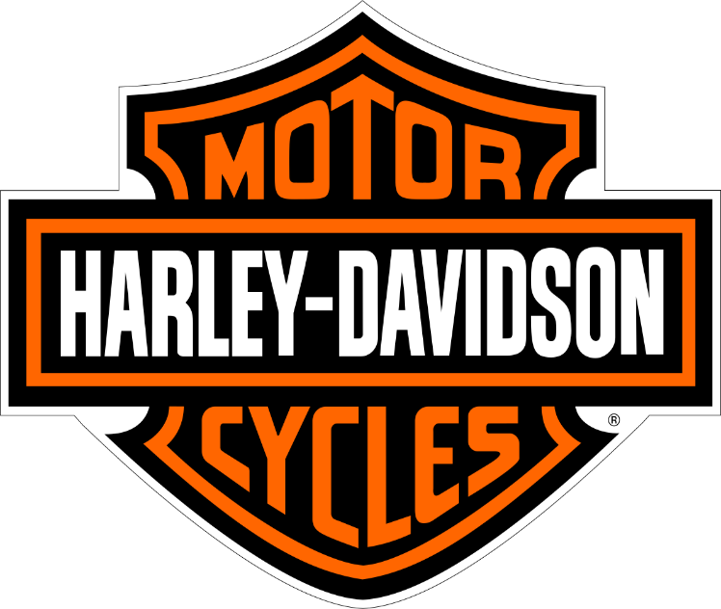
Student name: NAVEEN AVULANNAGARI REDDEPPAREDDY
Student Number: 2213721
Lecturer: Dr Hossein Shokri
Submission Date: 21/08/2023

Table of Contents
Introduction 2
Company Background 2
Company’s Objectives and Strategies 4
Countries’ Specifications 6
Home Country 6
Host Country 7
External Analysis 8
A Comparative PESTEL Analysis 8
Industry Five Forces 10
Market Analysis 11
Host Country Analysis 12
Country’s National Diamond 13
Country Business Risks 14
Internal Analysis 15
Global value chain 16
SWOT analysis 18
International Strategies 19
Entry Modes 20
Corporate Social Responsibility 21
Conclusion 22
References
Appendix 24
Appendix 1: .
Appendix 2: .

Introduction
In this report author Explain the Harley-Davidson company's internationalisation plan using several analytical frameworks, taking into account management-, industry-, and country-specific aspects. Describing the Harley-davidson MNE structures its resources and capabilities in marketing, operations, HRM, etc., in an international setting using examples. And also various entry methods and evaluate the MNE's chosen entry strategy in the target market (host country). Establish broad trends and positions, and take into account these not just in terms of market, industry, and nation characteristics, but also in terms of can deduce to be the business's objectives. Finally, take into account how country risk justifies the various management decisions. Harley-Davidson's is a motor, and how its international business expansion has reached various countries, including host country Austrlia.The business has had a significant impact on the Australian market by serving the expanding motorbike enthusiast group. Here is an overview of Harley-Davidson's overseas operations in Australia.
Prove that the company internal, external analysis and also country specifications international analysis and strategies. And brief explanation about home and host country dimonds of international business, the Harley-davidson country business risks like political risk,economic risk,legal risk. These gatherings offer a venue for motorcycle enthusiasts to interact, exchange stories, and celebrate their love of the vehicles (Harley-davidson, 2022).
Company Background
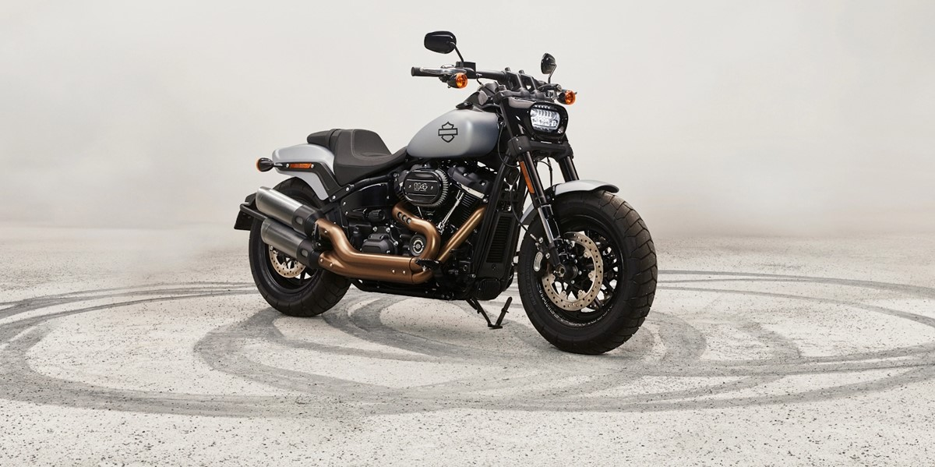
Source: (Harley Davidson, 2023)
The Harley-Davidson was founded in 1903 in Milwaukee, Wisconsin, by William S. Harley and Arthur Davidson, along with Arthur's brothers, Walter and William Davidson. The company started in a small wooden shed with a focus on producing motorcycles. Early years: Early on, Harley-Davidson had to deal with a number of difficulties, including competition from other motorcycle producers. But the firm's dedication to excellence and innovation helped them take off in the industry. Their first factory-built motorbike, with a 405cc engine, was created in 1905. (Harley-davidson, 2022)
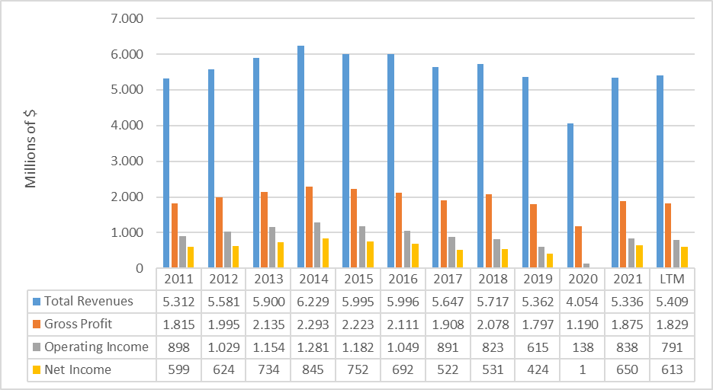
Source: (Sustainability report , 2021)
Expansion and Innovation: Harley-Davidson carried on growing and developing throughout the early 20th century. In 1909, they introduced the V-twin engine design, which later became distinctive of their motorcycles. Additionally, the business made important strides in racing, setting speed records and establishing a reputation for excellence and dependability.
Early in the 20th century, Harley-Davidson started to expand internationally by setting up dealerships and exporting motorcycles to numerous nations. After opening its first dealership in Sydney in 1917, Australia became one of Harley-Davidson's earliest export destinations.
Growth and Presence in Australia: Harley-Davidson's presence in Australia has been marked by a remarkable journey of growth and resonance. The brand's iconic image, synonymous with power and freedom, forged a deep connection with Australians, fostering a dedicated community. This rapport translated into elevated sales, propelling Harley-Davidson motorcycles to prominence on Australian roads. The brand's commitment to customer satisfaction spurred the expansion of its dealership network, encompassing pivotal urban centers across the continent. Through this strategic approach, Harley-Davidson has ingrained itself as a symbol of rugged individualism and exhilarating journeys in the hearts of Australian enthusiasts (Harley-davidson, 2022).
Local Manufacturing and Assembly: Harley-Davidson opened a regional manufacturing and assembly facility in Adelaide in 2006 to meet the needs of the Australian market.This factory created a variety of motorcycles that were specifically suited to the Australian market and complied with customer and regulatory demands (Sustainability report , 2021).
Adapting to Market Trends: In Australia, Harley-Davidson has consistently modified its product lineup and corporate strategies in response to shifting consumer preferences and market developments.To meet the tastes of Australian riders, the business has produced new models, including the increasingly popular touring and cruiser motorcycles (Harley-davidson, 2022).

Company’s Objectives and Strategies
The Global Market expansion
Increase the company's market presence and share in global marketplaces. This goal entails expanding into new nations and regions, building a solid dealer network, and customising items to meet local norms and tastes (Statista, 2021).
Brand Promotion and Image Building:
Increasing brand recognition and creating a solid brand image on a worldwide scale are the goals This goal entails marketing and advertising campaigns to promote the distinctive way of life, legacy, and principles connected to Harley-Davidson motorbikes (Statista, 2021).
Customer Loyalty and Satisfaction:
Goal: Emphasise client happiness to encourage advocacy and brand loyalty. In order to foster enduring customer loyalty, Harley-Davidson strives to offer top-notch goods, outstanding customer service, and a distinctive ownership experience.

Innovation and Product Development:
The goal is to constantly create new technologies, motorcycles, and accessories.To enhance the functionality, comfort, safety features, and environmental sustainability of its motorcycles, Harley-Davidson invests in research and development (Sustainability report , 2021).
Strategies
Market Entry and Selection:
Harley-Davidson chooses its target markets with care, taking into account things like market size, future growth, and cultural fit. To create a local presence, the corporation expands into new markets through direct subsidiaries, partnerships, or strategic alliances (Doyle & Stern, 2006).
Adaptation and Localization:
Harley-Davidson adapts its products, marketing strategies, and business practises to the market needs, cultural quirks, and legal constraints of each location. With the help of this plan, Harley-Davidson motorcycles and accessories will appeal to buyers worldwide.
Network of Distributors & Dealers:
Throughout the world, Harley-Davidson establishes and maintains a robust network of licenced stores. In order to provide extensive market presence and easy access for customers, the company works closely with dealers to provide training, support, and a consistent brand experience (Henshaw, n.d.).
Marketing and branding
Through marketing and advertising campaigns, Harley-Davidson highlights the history, way of life, and values associated with its brand.The business runs tailored advertising efforts that appeal to the emotions and aspirations of its target market (Doyle & Stern, 2006)
Customer relations and experience management:
By providing excellent client experiences, Harley-Davidson puts a high priority on customer pleasure and loyalty. The business's primary goal is to develop enduring relationships with its clients through special events, one-of-a-kind ownership opportunities, and personalised interactions
Product Development and Innovation:
Harley-Davidson makes investments in R&D to maintain and improve the quality of its motorcycles, gear, and technologies. In response to changing consumer tastes and market trends, the company releases new models and features.
Strategic Collaborations & Partnerships:
To take advantage of synergies and investigate potential commercial prospects, Harley-Davidson creates strategic relationships with other businesses in the automotive sector (Doyle & Stern, 2006).

Countries’ Specifications
A number of issues are taken into account by Harley-Davidson while conducting foreign business, including the requirements of the home country (the United States) and the host county (Australia). Here are several crucial factors for each nation.
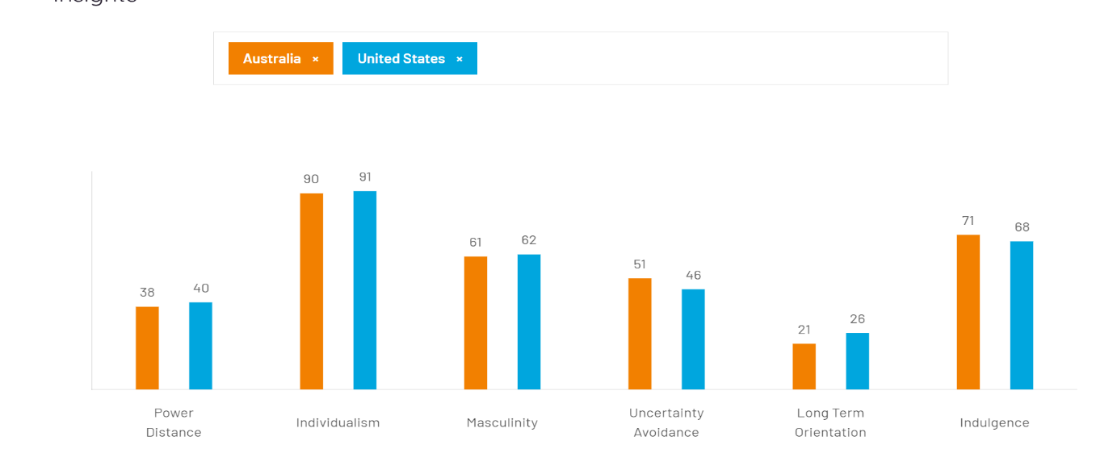
Source: Hofstedge insights.com

Home Country (The United States)
Market Size and Demand:
The motorcycle market and demand in the US are sizable, and there is a sizable market for heavyweight motorcycles like Harley-Davidson.
The preferences, consumer habits, and s pending power of the domestic market are crucial factors in Harley-Davidson's product lineup and marketing plans (Leffingwell, n.d.).
Regulatory Environment:
In terms of manufacturing standards, emissions standards, safety standards, and consumer protection legislation, Harley-Davidson complies with U.S. regulations. In its domestic operations, the corporation makes sure certain regulations are followed.
Brand Heritage and Cultural Factors:
In its native market, Harley-Davidson makes use of its cultural relevance and brand history as an iconic American brand. The corporation emphasises themes like independence, individualism, and the wide road in its marketing and message to appeal to Americans (Leffingwell, n.d.).
Host Country
Australia (Host Country):
Market Potential and Competitive Landscape:
Australia has a sizable motorcycle market, with a need for heavyweight motorcycles as well as a vibrant enthusiast scene. When increasing its presence in Australia, Harley-Davidson takes into account market potential and competitive variables while taking into account the local customer preferences and motorcycle industry competitiveness (Gingerelli, n.d.).
Regulatory Framework:
Harley-Davidson abides with Australian laws governing the production of motorcycles, safety requirements, emissions standards, and import/export laws. The business makes sure its motorcycles have the required certifications and requirements to operate inside Australia's legal system.
Cultural Fit and Consumer Preferences:
Harley-Davidson is aware of how critical it is to match the cultural preferences and purchasing patterns of the Australian market with its brand and product offerings. To appeal to Australian consumers and their distinct lifestyle choices, the corporation customises its marketing initiatives and product selection (Gingerelli, n.d.).
Distribution and Support Network:
throughout order to offer sales, service, and support to clients, Harley-Davidson builds a robust dealer network throughout Australia. In order to guarantee a flawless ownership experience and locally tailored customer assistance, the company works with nearby dealerships.
The techniques employed by Harley-Davidson in both its home country of the United States and the host country of Australia are influenced by these national characteristics. Harley-Davidson can efficiently respond to the needs and preferences of customers in each market by tailoring its operations, product offerings, and marketing activities by knowing the market dynamics, legal requirements, cultural considerations, and competitive environment in each nation (Holmstrom, n.d.).

External Analysis
International business, analysing Harley-Davidson's external environment entails looking at the forces and variables that have an impact on the operations and performance of the company. Following are important factors to take into account when conducting an outside examination of Harley-Davidson.

A Comparative PESTEL Analysis
The Let's look at the political, economic, social, technical, environmental, and legal issues in the United States and Australia to produce a comparative PESTEL analysis for Harley-Davidson in international trade. The PESTEL elements in these two nations are contrasted here (Market line, 2023):
Aspect | United States | Australia
Political | Political climate is stable, and the auto industry is subject to established rules. Government policies have an impact on things like taxation, trade agreements, and industrial standards. | Political climate is stable, with rules tailored to the automotive sector. Government policies put a lot of emphasis on things like safety standards, import/export rules, and emissions norms (Market line, 2023).
Social | The United States has a sizable market for heavyweight motorcycles and a vibrant motorcycling culture. Individualism, freedom, and the Harley-Davidson motorcycle lifestyle are important to American consumers. (Wiley, 2019) | As a representation of individual mobility and leisure, motorbikes are gaining popularity. Australians enjoy outdoor sports and the outdoor lifestyle, which is consistent with the Harley-Davidson brand.
Economic | It has a robust economy and significant consumer spending power. Since there is a mature market for heavy motorcycles, economic variables like GDP growth, interest rates, and employment rates affect consumer demand. | An advanced nation with a strong GDP growth rate. Although the motorbike market is less than that in the United States, it has room for expansion because of the expanding middle class and rising disposable income (Hill, 2019).
Technological | America is a technologically advanced country that emphasises innovation in motorbike performance, design, and safety measures. The sector is impacted by advancements in connectivity and electric automobiles. | The sector for motorcycles is adopting cutting-edge technology, such as sustainability programmes and safety features. Emerging topics of interest include electric car technology and charging infrastructure. (Hill, 2019)
Environmental | In the United States, environmental sustainability and emissions restrictions are receiving more attention. Corporate social responsibility programmes and consumer demand for environmentally friendly mobility solutions have an impact on the sector. | Environmental issues, such as air pollution and carbon emissions, are becoming more widely known. The use of electric vehicles and ecological practises is encouraged by government programmes and customer preferences.
Legal | Established regulatory frameworks for product liability, consumer safety laws, and intellectual property protection. The auto sector follows established legal regulations. | Strict laws governing consumer protection, emissions control, and car safety standards. It is essential to follow local laws and standards. (Wiley, 2019)
Porter’s Five Forces Analysis:
The Porter Five Forces model would be used to analyse Harley-Davidson and determine the competitive dynamics in the motorcycle sector. An overview of how Porter's Five Forces can be used to analyse Harley-Davidson.
Threat of New Entrants:
Due to the requirement for a sizeable capital commitment, established distribution networks, and brand recognition, the motorcycle sector has moderate entry hurdles. However, new competitors can show up with creative goods or affordable options (Grant, 2019).
Threat of new entrants of harley davidson is high
Bargaining Power of Suppliers:
Moderate: For parts, raw materials, and accessories, Harley-Davidson depends on a number of suppliers. Although there are numerous suppliers, the company's size and brand recognition may provide it some leverage to negotiate favourable terms.
Bargaining of power of suppliers is Medium
Bargaining Power of Buyers:
Due to the variety of motorbike brands and models available, customers have moderate to high bargaining power. Buyer bargaining power may be influenced by price sensitivity, product differentiation, and customer loyalty.
Bargaining power of buyers of harley davidson is high (Wiley, 2019)
Threat of Substitute Products or Services:
Moderate: Alternative goods exist in the larger transportation sector, including automobiles, public transportation, and bicycles. The distinctive riding experience and brand loyalty connected to Harley-Davidson motorbikes, however, can somewhat lessen the hazard.
Threats of substitute products or service is Medium

Intensity of Competitive Rivalry:
High: There are many domestic and international competitors offering a variety of motorcycles in the highly competitive motorcycle business. To obtain a competitive advantage, rivals concentrate on elements including price, product characteristics, brand image, and customer experience.
It's crucial to remember that the strength of each factor might change over time and in various marketplaces. Additionally, elements like brand loyalty, product differentiation, and innovation have a big impact on how the market is competitive.
It is the high of poters five forces model
It's significant to remember that each force's strength might change over time and in different marketplaces. The competitive landscape is also significantly shaped by characteristics including innovation, brand loyalty, and product differentiation (Hill, 2019).
Market Analysis
Market analysis is a tool that firms use to have a better understanding of their operating environment. It is one of the most crucial steps in developing a marketing plan. The first step is to conduct market research through direct mail, telemarketing, focus groups, internet surveys, and other means. Then comes market analysis, which is the process of critically reviewing and structuring data in order to apply it in strategic marketing decisions (Researcher, 2023).
Competitor Analysis:
Examine direct competitors like Honda, Yamaha, and BMW Motorrad in the heavyweight motorcycle market. Consider other modes of transportation or leisure pursuits that might contend for consumers' discretionary dollars, such as bicycles, boats, or cars, as indirect competitors. To identify competitors' strengths and weaknesses, examine their product lines, price plans, distribution channels, marketing initiatives, and consumer attitudes (Gunther, 2019). In June 2020, the Yamaha YTZ690 led motorcycle sales in Australia with 347 units, surpassing the Harley Davidson XG500's 205 units sold from January to June 2020 (Statista, 2021).
Market Size:
Operating in the international motorcycle industry, Harley-Davidson specialises in heavyweight motorcycles. Based on certain market segments, countries, or geographic areas, determine the market size. To determine the market's size and potential for expansion, take into account market trends, industry reports, and sales and registration statistics for motorcycles. (Chadwick, 2019)
In the Australian Motorcycles market, a substantial surge in revenue is anticipated, projected to reach US$1,229 million by the year 2023. This growth trajectory is poised to sustain an annual advancement of 3.18% through 2027 (CAGR 2023-2027), culminating in a projected market volume of US$1,393 million. Notably, the largest market segment, On-road Motorcycles, is predicted to contribute significantly, with a projected volume of US$824 million in 2023. Anticipated motorcycle unit sales are set to reach 127.20 thousand by 2027, reflecting a robust consumer demand. The market's pricing landscape is characterized by a volume-weighted average price of approximately US$11,000 in 2023. Honda Motorcycles is poised to dominate with a 23.4% unit sales share in 2023, translating to a value market share of 17.6% within the selected region (Statista, 2021).
Key factors of Harley-Davidson's Success
Strong Brand Image: The Harley-Davidson brand is well known for standing for freedom, individualism, and a way of life (Harley-davidson, 2022).
Product Differentiation: Harley-Davidson motorbikes offer a different riding experience thanks to their distinctive design, performance, and sound.
Dealer Network: A robust distribution and sales channel is made possible by a wide global network of accredited dealerships (Plunkett research, 2021).
Customer Loyalty: Building customer loyalty through experiences, events, and ownership programmes is essential for advocacy and repeat business.
Technology and innovation: Continual improvements in performance, safety features, and connection help products remain competitive (Market Research, 2021).

Host Country Analysis
National Diamonds
The National Diamond framework provides a detailed look at the factors influencing a country's competitiveness in specific industries. It provides insights for scholars, businesses, and governments to better understand and promote competitive advantages. It also helps to explain why certain sectors thrive in certain country (Porter, 1998)
The National Diamond describes the elements that can provide one national market or economy a competitive edge over another (BROCK, 2021).
Country’s National Diamond (AUSTRALIA)
Australia's competitive advantage, as exemplified by Harley-Davidson, can be understood through Porter's Diamond framework, which examines key factors shaping a nation's industry edge.
Condition Factors: Australia's robust infrastructure, skilled workforce, and technological prowess contribute to its manufacturing excellence. Abundant natural resources, like agriculture, energy, and minerals, bolster its capabilities. Ongoing investments in education and infrastructure further enhance competitiveness.
Demand Conditions: Australia's sizable domestic market, characterized by diverse demographics and strong purchasing power, creates a solid foundation for industries. The evolving population, rising incomes, and changing consumer preferences create a dynamic marketplace, encouraging innovation and tailored offerings (Porter, 1998).
Related & Supporting Industries: Ancillary sectors, supplier networks, academic collaborations, and industry clusters foster innovation and competitiveness. Collaborative ties between Harley-Davidson and local suppliers, coupled with research partnerships, amplify the brand's strength within the motorcycle value chain.
Firm Strategy, Structure & Rivalry: A culture of innovation, an entrepreneurial ecosystem, and government support contribute to Harley-Davidson's competitive strategies. Favorable regulations, financial access, and a competitive environment drive the brand's innovation and differentiation efforts.
Harley-Davidson's resonance with Australia's National Diamond aligns with its enduring appeal, as it leverages Australia's skilled labor, robust infrastructure, and supportive ecosystem. The brand's strategies are buoyed by the nation's dynamic market, fostering innovation in line with consumer trends. Collaborations within Australia's value chain contribute to Harley-Davidson's distinctiveness, while the competitive landscape encourages constant refinement. Altogether, this synergy between Australia's Diamond factors and Harley-Davidson's brand ethos propels its success in the country's motorcycle market (Porter, 1990).
Country Business Risks (Australia)
Businesses' operations, financial performance, and overall success in a certain country are all potentially exposed to dangers and uncertainties known as "country business risk." It covers a variety of variables and situations that can create adverse conditions, block business operations, or impede the achievement of corporate objectives. Domestic economic, political, social, legal, environmental, and technological factors may contribute to these threats (Kim, 2019).
Political Risks:
Policy changes: Businesses, particularly those dependent on government contracts or subsidies, may be impacted by shifting political environments and changes in government policy.
Trade policies: Changes to international trade agreements or tariffs may have an impact on companies that import or export goods or are dependent on global supply chains.
Political stability: Uncertainty for businesses can be caused by political instability, which includes changes in leadership or the direction of policy (Porter, 1990).
Economic Risks:
Economic downturns: Businesses in all industries may be impacted by economic turbulence, recessions, or modifications in consumer spending habits. Changes in exchange rates can have an impact on the profitability of enterprises focused on import and export (Statista, 2021).
Regulatory and Legal Risks:
New laws, rules, or regulatory frameworks may force organisations to modify their operations and incur costs associated with compliance. Employment laws: Businesses may find it difficult to comply with labour laws such those governing minimum wage, employment agreements, and workplace safety standards (Danials & Radebaugh, 2018).
Protection of intellectual property: the risks of intellectual property infringement and the necessity of strong trademark, patent, and copyright protection. Ref Australian Securities and Investments Commission (ASIC) - Regulator of corporations, financial services, and markets in Australia:
Environmental and Natural Disaster Risks:
Climate-related risks: Raising knowledge of climate change and the rules that go along with it can have an impact on how businesses operate, especially in sectors like agriculture, transportation, and energy.
Natural disasters: Australia is vulnerable to cyclones, floods, and bushfires, which can disrupt infrastructure, supply networks, and business operations. Refence: Australian Bureau of Meteorology - Provides information on climate and weather patterns, including warnings and forecasts (Harley-davidson, 2022).
Cybersecurity Risks:
Cyberattacks and data breaches: Companies are susceptible to cybersecurity risks such as unauthorised access to sensitive data, ransomware attacks, and data breaches (Harley-davidson, 2022).
The diamond of national competitive advantage:
The idea known as "The Diamonds of National Competitive Advantage" highlights four characteristics as crucial for dominance in the marketplace demand condition, factor condition, connected and supporting industries, firm strategy, structure, and revenue.
We have talked about these circumstances in relation to competitive advantages. Consequently, the theoretical framework is a beneficial tool for comprehending how and where internationally competitive arise and persist (Daniels & Radebaugh, 2018).
Facets of the diamonds: Typically, for an industry within a country to achieve and maintain global supermacy, all four circumstances must be beneficial.
Analysing the elements that contribute to a nation's competitive advantage in particular industries is part of determining its National Diamond. An overview of the National Diamond is shown below (Daniels & Radebaugh, 2018).

Internal Analysis
Internal analysis is a analyazing are organational resources and capabilities to help management to make better decision to take right direction

Global value chain
The value chain is the collection of interconnected tasks a business completes to design, market, distribute, and support a product (Danials & Radebaugh, 2018)
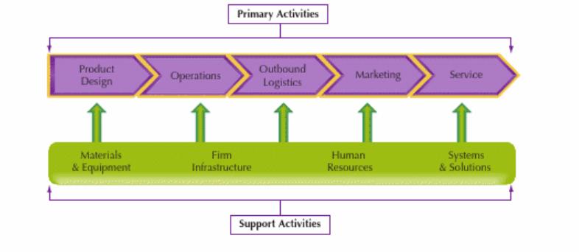
Source: (Danials & Radebaugh, 2018)
Primary Activities: In global value chain primary activity is one of activity internconnected of the harley davidson it will check their vehicles design stucture depends upon the market and checke their operations marketing services etc and providing the outbound logistics (Danials & Radebaugh, 2018)
Supportive Activities: The Harley davidson supportive activites is manufacturing of materials and equipment,company firm infrastructure and employess recuirtment process of manufacturing unit and systems and solutions (Danials & Radebaugh, 2018).
- Global Production
Importation: Motorcycles from Harley-Davidson were imported for the Australian market from the company's production plants in the US and other countries. These motorcycles were produced, and then they were imported into Australia for distribution and sales.
One goal of Harley-Davidson's operations management strategies is increasing productivity. Operations managers use a variety of metrics or criteria to assess production levels. Here are a few of Harley-Davidson's productivity metrics (Jin, 2023)
- Revenues per salesperson (productivity of H-D Dealer employees)
- Rate of supply stockouts (supplier productivity for Harley-Davidson)
- Daily motorcycle production at H-D production facilities
Distribution and Dealerships: In Australia, Harley-Davidson has a well-established network of accredited distributors and dealerships. These dealerships receive the imported motorcycles and distribute them to clients all around the nation.
Compliance and Regulations: Australian regulatory standards and requirements had to be met by Harley-Davidson motorcycles sold there. Before the motorcycles can be marketed to consumers, they must first meet strict safety, emissions, and certification requirements (Jin, 2023).
- Global Marketing
A forward-thinking band that could rework this classic song was required by the Harley-Davidson brand and the significance of their worldwide marketing launch. Tom Rowland, Sr. Vice-President, Universal Music Enterprises (UMe), said, "We thought The Strypes were the ideal choice since they brought their raw passion to the song to make a forceful statement and capture the spirit of Harley-Davidson.
Mark-Hans Richer, Senior Vice President and Chief Marketing Officer of Harley-Davidson, said, "'Come Together' is not just a song in our spot — it's an anthem for our relationship with our fans." The foundation of all we do is them. Through our motorcycles, apparel, and experiences, we support our clients' own expression. No one has a deeper emotional connection to Harley-Davidson than its supporters (Harley-davidson, 2022).
- Global HRM
Managing human resources globally while taking cultural, legal, and regulatory variances into account. Important components of Harley-Davidson's global HRM may consist of
Talent Acquisition & Recruitment: Harley-Davidson aggressively searches for top talent around the world, developing recruitment techniques to match local market demands and draw applicants who are in line with the company's culture and values.
Training and Development: Through international training programmes and region-specific initiatives, the organisation offers chances for ongoing learning and development to improve staff abilities.
Competitive compensation: Harley-Davidson creates plans that abide with regional labour regulations and link employee perks with customs in the area.
Performance management: Across all locations, an effective performance management system establishes goals, carries out frequent assessments, and gives staff members feedback.
Global Mobility and Relocation: Immigration, tax, and compliance issues related to overseas assignments or relocations are efficiently managed through global mobility and relocation (Harley-davidson, 2022).

SWOT analysis
Strengths, Weaknesses, Opportunities, and Threats, or SWOT, is a technique that the management team uses to identify the internal and external elements that have an impact on the company's and its business performances (Baltzan, 2017).

SWOT analysis of Australian international business:

Strength  As a “cult brand,” Harley-Davidson enjoys a multitude of advantages, including strong brand loyalty from both customers and staff. Its broad product line is also a key advantage because it allows it to consistently target new customers; Many good characteristics, such as excellent education, tradition, or independence, are synonymous with Harley-Davidson, which accounts for the brand’s extremely high level of consumer loyalty (Baltzan, 2017). | Weakness  More than 65 percent of Harley-Davidson's revenue comes from the US, but the market has its limits and it is getting risky for the company to concentrate only on it. This is the brand's biggest problem. Additionally, Harley-Davidson manufactures in the US, Brazil, India, and other exporting nations, which raises the cost to those nations.
Opportunity  It presents an opportunity for “green technologies” to be incorporated by motorbike manufacturers. Another significant issue is the development of “computing technologies”. For Harley-Davidson, Through these programmes, you may carry out a variety of duties, such as learn about traffic in real time (accidents, construction, traffic jams), which increases safety.  Electric Motorcycles: As the demand for electric vehicles rises, Harley-Davidson will have more opportunity to create and sell electric motorcycles that will appeal to people who are concerned about the environment (Ferrant, 2015). | Threat  The major sources of H-D's threats are market changes and legal systems. This component of the SWOT analysis addresses the external strategic elements that impede the motorcycle company's performance or growth. The following are the most significant problems for Harley-Davidson.:  - Aggressive rivalry with a variety of international players  - Imitation of motorcycle design  - growing interest in electric autos  (Cadavid & Salazar, 2021)

International Strategies
Global Distribution Network: In order to make its motorcycles and related items available in numerous nations, Harley-Davidson created a strong global distribution network. To ensure that its products were available to a larger customer base, the company collaborated with authorised dealers and distributors across the globe (Harley-davidson, 2022).
Localization of Marketing and Products: Harley-Davidson frequently localised its marketing and products to fit particular regions in order to accommodate to varied market preferences and cultural peculiarities. By employing this tactic, the business was able to connect with local clients and meet the particular requirements of each area (Nagle, et al., n.d.).
Joint ventures and Strategic Alliances: In several markets, Harley-Davidson has established joint ventures and strategic alliances with regional partners. Through these collaborations, th business has been able to better understand regional consumer preferences while navigating local restrictions and distribution issues (Choudhury & David, n.d.).
Manufacturing Facilities in Key Markets:To build motorcycles domestically, Harley-Davidson established manufacturing plants in a number of nations. This strategy let the corporation adhere to local trade laws while lowering import prices and meeting local demand (Harley-davidson, 2022).
Brand Promotion and Events: Harley-Davidson extensively promoted its brand through a variety of events, rallies, and gatherings around the world. The corporation was able to interact with clients, increase brand loyalty, and establish a worldwide community of Harley aficionados through activities like Harley Owners Group (H.O.G.) rallies.
E-commerce and Digital Presence: To reach customers around the world, Harley-Davidson made use of e-commerce platforms and a powerful online presence. The business was able to interact with prospective customers outside of actual dealership sites thanks to its online store and social media activity

Entry Modes
The numerous ways a business might enter and develop a presence in a foreign market are referred to as entry mechanisms. When a business intends to grow abroad, it must select the entry strategy that is most appropriate given the market size, desired level of control, investment necessary, risks associated, and the company's resources and capabilities.

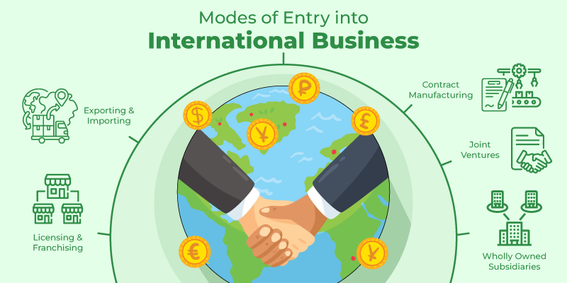
Source: Greeksforgreeks-modes of entry https://www.geeksforgeeks.org/

Entry modes
The Exporting: Selling Harley-Davidson motorbikes and associated goods directly to clients or through distributors in international markets is known as exporting. When a corporation is testing the market or when the foreign market is relatively small and can be successfully served from the home nation (in this case, the United States), this entry option is frequently adopted.
Joint Ventures: In order to create a presence and improve access to local markets, Harley-Davidson has developed joint ventures with local businesses in some countries. By employing this tactic, the business can benefit from the local partner's understanding of the market, the distribution network, and the regulatory framework. Joint ventures can also assist Harley-Davidson in overcoming entry-level obstacles like import limitations or local content specifications (Choudhury & David, n.d.).
Turnkey Projects: Delivering a project in its entirety to a foreign client, including the planning, building, and training, before turning over the finished building.
Licencing: Licencing entails allowing foreign organisations to utilise the Harley-Davidson name, logos, technologies, or intellectual property in return for royalties or other payments. The corporation can increase its footprint without making substantial investments in overseas markets thanks to this entry technique.
Direct Investment: In some circumstances, Harley-Davidson may decide to establish wholly-owned manufacturing plants or subsidiaries in international markets. With this strategy, the business has more control over operations, product quality, and brand perception. But there are also more fees and risks involved.

Corporate Social Responsibility
Corporate social responsibility (CSR) is the idea that businesses and organisations should be accountable for their effects on the environment and society. It entails incorporating social and environmental considerations into their company operations and goes beyond simply earning profits. CSR aims to benefit society while also generating long-term value for the business and its stakeholders (Market place , 2023).
Environmental Sustainability: In order to encourage environmental sustainability and lessen its carbon impact, Harley-Davidson has taken action. In an effort to find cleaner and more environmentally friendly transportation options, they have invested in the research and development of electric motorcycles like the Harley-Davidson (Sustainability report , 2021).
Community Engagement: The business has taken part in a number of community-oriented projects. In order to help a variety of causes, such as veterans and active military people, children's hospitals, and disaster relief operations, Harley-Davidson, for instance, plans philanthropic events and fundraisers (Paruzel, et al., 2023).
Workforce Development: Harley-Davidson has made investments in initiatives to train and upskill its employees. The business wants to empower its staff and foster personal development by offering training and educational possibilities.
Diversity and Inclusion: The business has made a commitment to encouraging inclusion and diversity among its workforce. Harley-Davidson is committed to establishing an inclusive work environment and cherishes the viewpoints and contributions of its workers from many backgrounds.
Responsible Sourcing: Working with vendors who uphold ethical and environmental standards, Harley-Davidson has demonstrated its commitment to responsible sourcing techniques (Sustainability report , 2021).

Conclusion
In summary, this research set out on an attempt to find out about the Harley Davidson's global performance, particularly its strategic approach to the Australian market. A thorough investigation that included both primary and secondary data produced insightful results. Notably, the business used pragmatic strategies to successfully negotiate the Australian environment. The skillful application of contemporary marketing strategies by Harley Davidson serves to highlight its prowess. The company demonstrates its flexibility and dedication to interacting with customers by utilising social media, precise targeting, and seamless connection with its website.

Recommendation
Recommendations highlight the brand's potential even more. Utilising advanced marketing techniques, particularly in the area of social media, is a possible path to long-term success. Additionally, by adapting negotiating methods, such as price strategies, in light of the economic backdrop of the host nation, Harley Davidson's competitive position may be strengthened. This research exposed the complexities of Harley Davidson's global expansion, including its advantages, tactics, and prospective areas for improvement. The future looks bright for Harley Davidson as it continues its voyage throughout the world thanks to a developing market scenario and the brand's dynamic tactics.

References
"Harley-Davidson: Chasing a New Generation of Customers" by John Foley (2019)
"Harley-Davidson: The Motorcycle, Milestones, Models, and Men" by Fred Wacker. "Harley-Davidson: An Illustrated Guide" by Peter Henshaw.
"The Art of Harley-Davidson" by Dain Gingerelli.
"The Future of Harley-Davidson: An Evolution of the Motorcycle Industry?" by Maryam Maleki and Robert L. Cross (2019)
"The Global Market Potential for Harley-Davidson Motorcycles: A Multidimensional Scaling Approach" by Steve Kopp and Rick Nelson (2017)
"The Harley-Davidson Motor Co. Archive Collection" by Darwin Holmstrom and Randy Leffingwell
"The Value of the Harley-Davidson Brand" by Arthur A. Thompson Jr., John E. Gamble, and Margaret A. Peteraf (2006)
(Hill, 2019) G.R. (2019). "Strategic Management: An Integrated Approach." Cengage Learning
"Foreign Direct Investment and Internationalization of U.S. Businesses" by P.C. Choudhury and David J. López.
"Harley-Davidson in China: A Classic American Brand in a Market with an Appetite for Motorcycles" by David Cook and William B. Neenan (2017)
A., A., Thompson Jr. & John E, 2006. The value of the Harley-Davidson Brand , s.l.: s.n.
Baltzan, P. (2017) Business Driven Technology, 7th Edition, Kindle Edition, McGraw-Hill Higher Education, USA.
Baltzan, P., 2017. Business Driven Technology. 7 ed. s.l.:Kindle Edition.
BROCK, T., 2021. Competitive Strategy: Techniques for Analyzing Industries and Competitors, s.l.: s.n.
Cadavid , L. & Salazar, S., 2021. Mapping the research landscape for Motorcycle Market policies, s.l.: A systematic literature.
Cadavid, L., & Salazar-Serna, K. (2021). Mapping the research landscape for the motorcycle market policies: Sustainability as a trend – A systematic literature review. Sustainability, 13(19), 10813.
Chadwick, E., 2019. McGraw hill education. principal and practice of marketing.
Changes in interest rates: These fluctuations can have an impact on borrowing costs and investment choices. Ref Australian Bureau of Statistics (ABS) - Official statistical agency providing economic data and reports: www.abs.gov.au
Choudhury, P. & David, J., n.d. International business. Forign Direct investment and Internationalization of U.S. Business.
Cook, D., 2017. international business. A classic American Brand in a market with an Appetite for Motorcycles .
Danials , J. & Radebaugh, . L., 2018. international business. 16 ed. s.l.:pearson Education Limited .
Doyle, P. & Stern, P., 2006. Marketing Management and Strategy. 4 ed. Essex: Pearson Education Limited.
Ferrant, A. (2015, October 6). BMW, Honda et Yamaha coopèrent autour des motos connectées. Retrieved from lerepairedesmotards.com: http://www.lerepairedesmotards.com/actualites/2015/actu_151006-connected-motorcycleconsortium-bmw-honda-yamaha-motos-connectees.php
Ferrant, A., 2015. motorcycleconsortium-bmw-honda-yamaha-motos-connects, s.l.: s.n.
Foley, J., 2019. Harley-Davidson: Chasing a New generation of customers , s.l.: s.n.
Gingerelli, D., n.d. The Art of Harley-Davidson, s.l.: s.n.
Grant, R., 2019. porters five model. Contemporary strategy Analysis .
Grant, R.M. (2019). "Contemporary Strategy Analysis: Text and Cases." Wiley.
Gunther, R., 2019. principles and Practice of Marketing .
Harley-davidson, 2022. Annual report , usa: harley davidson.
Henshaw, P., n.d. An illustrated Guide, s.l.: s.n.
Hill, C. &. J., 2019. Strategic Management: An integrated Approach.
Hill, C. W. & M.Hult, G. T., n.d. international business Competing in the Global Marketplace. s.l.:s.n.
Hill, C.W.L., & Jones, G.R. (2019). "Strategic Management: An Integrated Approach." Cengage Learning.
Holmstrom, D., n.d. The Harley-Davidson Motor Co. Archive, s.l.: s.n.
inkpen, A. & ramaswami, k., n.d. Global strategy:creating and sustaining Advantage Across Borders. s.l.:s.n.
Jin, T., 2023. Bridging reliability and operations management for superior system availability, s.l.: Frontiers of Engineering Mangement .
Jobber, D., & Ellis-Chadwick, F. (2019). "Principles and Practice of Marketing." McGraw-Hill Education.
John Daniels Pearson Education, Limited 2018-03-08 Pearson Education, Limited
jones, C., 2019. strategic Management: An integrated Approach.
Kotabe, M. & Czinkota, M. R., n.d. international strategies of japanese firms: Existing Perspectives and new Findings, s.l.: journal of International Business Studies.
Leffingwell, R., n.d. The Harley-Davidson Motor Co., s.l.: s.n.
Maleki, M. & Robert L, 2019. The future of Harley-Davidson: An evolution of motorcycle industry , s.l.: s.n.
Market Research, 2021. Motorcycles Global industry Almanac, s.l.: s.n.
MarketResearch.com. (2021). "Motorcycles Global Industry Almanac 2020-2024." MarketResearch.com..
Nagle, T., John, E. H. & Joseph, Z., n.d. The Strategy and Tactics of pricing: A Guide to profitable Decision Making, s.l.: s.n.
Nielsen, n.d. ibis world, s.l.: economic publications.
official websites "Harley-Davidson, Inc. 2022 Annual Report". investor.harley-davidson.com. February 25, 2022. Retrieved August 16, 2022 https://www.harley-davidson.com/
Paruzel, A., Schmidt, L., & Maier, G. W. (2023). Corporate social responsibility and employee innovative behaviors: A meta-analysis. Journal of Cleaner Production, 136189.
Plunkett Research Online. (2021). "Motorcycles, Motor Bikes & Parts Industry Market Research." Plunkett Research, Ltd.
Porter, M., 1990. The Competitive Advantage of Nations. s.l.:s.n.
Porter, M.E. (2008). "The Five Competitive Forces That Shape Strategy." Harvard Business Review.
Ref "Harley-Davidson: An Illustrated Guide" by Peter Henshaw.
Ref Harley-Davidson Inc. Annual Reports.
Ref: Academic Journals: Search in reputable academic journals such as the Journal of International Business Studies, Strategic Management Journal, or Harvard Business Review for articles discussing the National Diamond analysis of the USA.
Ref: Grant, R.M. (2019). "Contemporary Strategy Analysis: Text and Cases." Wiley.
Refence: Australian Government Department of Foreign Affairs and Trade - Provides information on trade policies, agreements, and political developments: www.dfat.gov.au
References: Market research reports from firms like IBISWorld, Euromonitor, or Nielsen, industry analyses, and economic publications.
Siyahhan, B. (2023). Stakeholders and corporate social responsibility: What makes firms tip over to CSR investments? Managerial and Decision Economics, 44(3), 1436-1453.
Siyahhan, B., 2023. stakeholders and corporate responsibility , s.l.: s.n.
Statista, 2021. "Motorcycles in the U.S-Statistics & Facts".
Strategic Market Management; Aaker, D.; 1998, New York : John Wiley & Sons. Document Type: book; (AN SMM.AAKER.JOHNWILEYSONS.AIIH) [Citation Record], Database: EBSCO Publishing Citations
The Strategy and Tactics of Pricing: A Guide to Profitable Decision Making" by Thomas T. Nagle, John E. Hogan, and Joseph Zale.
wacker, F., n.d. the motorcycles,milestone models, s.l.: s.n.
Wiley, 2019. contemporary strategy Analysis, s.l.: s.n.
Wind, Y., Mahajan, V., & Gunther, R. E. (2019). "Convergence Marketing: Combining Brand and Direct Marketing for Unprecedented Profits." FT Press.
Wood, M. B., 2013. Essential Guide to Marketing Planning. 3 ed. Harlow: Pearson Education Limited.

