MODULE NAME: PROBLEM SOLVING AND DECISSION MAKING​
​
MODULE CODE: LCLM4004_LON​
​
STUDENT NAME: MYRNA VILLEGAS​
​
STUDENT NUMBER: 2512501​
​
LECTURER: PROF. TOYIN ADISA​
​
Assignment 2: Report (Green Haven Florist)

- ABSTRACT

This report examines the sales and economic issues at Green Haven Florists which is in Norwich. The report uses a case study and secondary research approach to investigate the issues at Green Haven Florists. The report found that despite strong customer appreciation for quality and eco‑friendly practices, the business struggles with an outdated website, limited digital marketing, and shifting consumer expectations. These challenges highlight the urgent need for modernisation and strategic adaptation to remain competitive.

- TABLE OF CONTENTS

- Abstract
- Table of Contacts
- Introduction
- Overview of Green Haven Florist
- Two Proposed Solutions
- Solution 1
- Solution 2
- Evaluations
- Evaluation of Solution 1
- Evaluation of Solution 2
- The Best Solution
- Risk Analysis of The Best Solution
- Implementation Plan of The Best Solution
- Key Performance Indicator
- Effectiveness of the solution
- Conclusion
- References

- INTRODUCTION

Problem-solving, as outlined by the American Society for Quality (1946), involves defining an issue accurately, identifying its underlying cause, selecting an appropriate solution, implementing it, and ensuring the results are maintained over time. These skills are valuable in both personal and professional settings and contribute significantly to organisational effectiveness. According to GeeksforGeeks (2024), decision-making requires evaluating different options, considering their potential outcomes, and choosing the most suitable course of action. Good decisions enhance success and protect reputations, while poor choices can create setbacks. Using a structured decision-making process leads to more consistent and positive results. Effective problem solving and decision making are vital for small businesses operating in a competitive retail landscape. Green Haven Florists—a Norwich-based independent shop known for bespoke, sustainable floral designs—is now facing declining foot traffic, rising costs, and stronger competition from online and local rivals. These challenges have highlighted gaps in the shop’s digital presence, marketing strategy, and operational efficiency, putting its long-term sustainability at risk. This report will identify two potential solutions, evaluate them, and determine the most suitable option. Once the preferred solution is selected, a risk analysis will be conducted to support effective implementation.

- OVERVIEW OF GREEN HAVEN FLORISTS

Green Haven Florists, founded in 2016 in Norwich by Liam and Priya Patel, is known for bespoke floral designs, quality craftsmanship, and a strong sustainability ethos. The shop has built a loyal customer base across walk‑ins, corporate clients, and events. However, shifting retail conditions now pose significant challenges. Foot traffic has declined, competition from online and new local florists has increased, and rising costs for flowers and sustainable materials are straining operations. Customer feedback also highlights the need for a modernised website, stronger digital marketing, and improved delivery options. These issues signal an urgent need for strategic adaptation.

- THE TWO SOLUTIONS

Here are two well‑developed solutions that directly address Green Haven Florists’ challenges and explain how each option could resolve the issues identified:

a) Solution 1: Digital Transformation and Subscription Model

Green Haven Florists could invest in a modern, redesigning the website with integrated e‑commerce features, subscription options, and flexible delivery scheduling. By introducing a sustainable subscription service, it can secure recurring revenue. This solution directly addresses declining foot traffic by shifting sales toward online channels, where consumer demand is growing. A stronger digital presence would also help Green Haven compete with online retailers by offering convenience, transparent pricing, and personalised service. Improved online visibility and streamlined ordering could increase revenue, attract younger audiences, and strengthen the brand’s sustainable identity.

b) Solution 2: Strengthening Local Partnership and Workshops

Green Haven would collaborate with local wedding venues, corporate offices, and cafes to become their exclusive floral provider. Additionally, hosting in-store workshops, such as bouquet making or seasonal arrangement classes, would generate additional income and increase community engagement. These offerings differentiate the shop from low-cost online competitors by emphasising experience, craftsmanship, and personal connection. Diversification also reduces reliance on walk-in sales and helps offset rising costs by creating multiple income streams. This approach strengthens customer loyalty and positions Green Haven as a unique, experience driven local brand.

- EVALUATION

a) Evaluation of Solution 1: PMI Technique (Plus, Minus, Interesting)

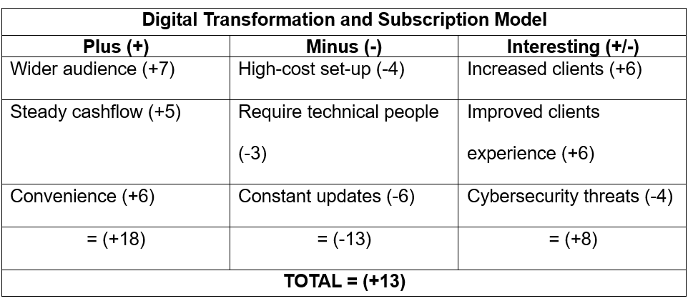

b) Evaluation of Solution 2: PMI Technique (Plus, Minus, Interesting)

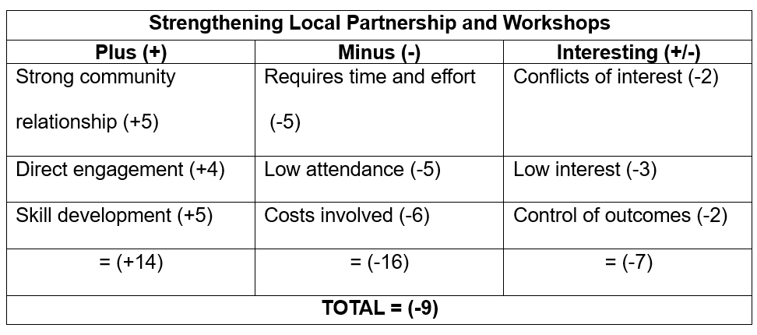
- The BEST SOLUTIONS

Digital Transformation with a subscription model is the most effective strategy for Green Haven Florists. Although community workshops in Solution 2 encourage local involvement, they fail to tackle the main causes of falling revenue: growing online competition and an outdated website. By upgrading its digital systems and launching thoughtful subscription services, Green Haven can better compete with major online retailers while maintaining its eco-friendly ethos. This approach creates a scalable, future-focused framework that addresses declining high-street traffic far more sustainably than relying solely on in-person events.

- RISK ANALYSIS
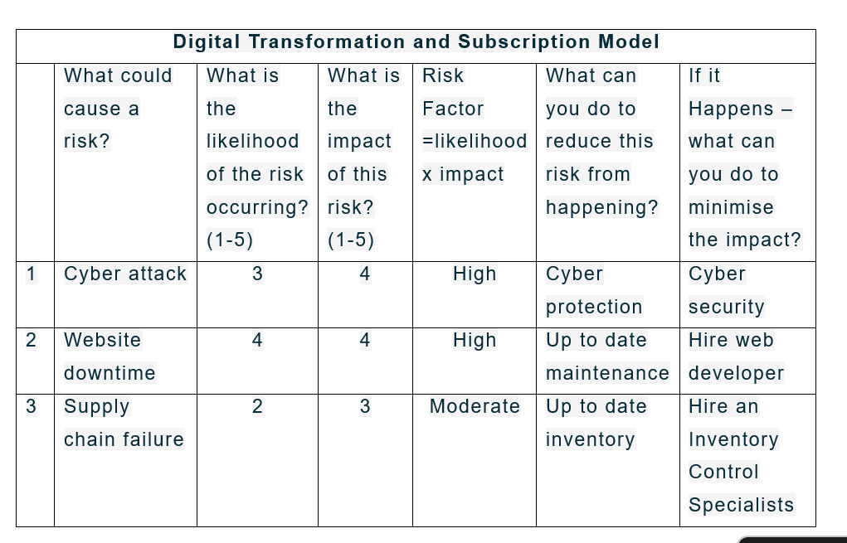
Strengthening Green Haven Florists' digital presence involves manageable risks. Financial strain is possible due to investments in redevelopment, marketing, and e-commerce tools, necessitating careful budgeting, especially during revenue dips. A lack of digital skills within the team could impede the adoption of new systems, underscoring the need for training or external expertise. Low customer adoption is another risk, which can be mitigated by ensuring the online platform is user-friendly and clear, validated through testing and feedback. Lastly, increased online activity heightens cybersecurity risks, demanding secure payment systems and regular updates to safeguard customer data.

- IMPLEMENTAION PLAN OF THE BEST SOLUTION

Problem: Decline in Sales
Chosen Solution: Digital Transformation and Subscription Model

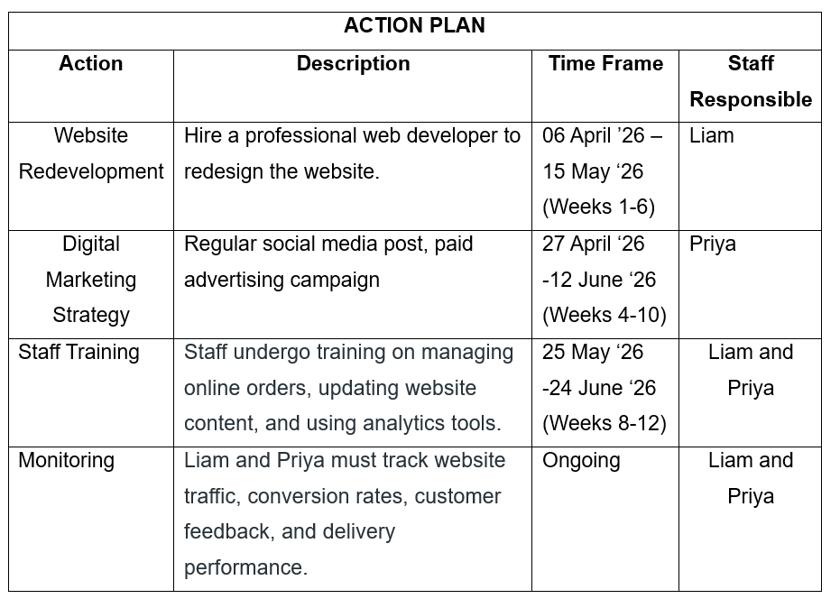
Green Haven Florists can improve its online presence step-by-step. First, they'll update their website to make it easier to shop online, look better, and get customer feedback. Then, they'll use online ads, social media, and search engine optimization to help more people find them. Next, employees will learn how to handle online orders, update the website, and understand website visitor data. Finally, they'll keep checking website traffic, sales, customer comments, and deliveries to make things even better and stay ahead of competitors.
- KEY PERFORMANCE INDICATORS
Green Haven Florists is tracking several KPIs to measure the progress of its digital transformation and subscription initiative. The business aims to lower its bounce rate by keeping visitors engaged beyond a single page. Strengthening social media activity is also a priority, with a focus on increasing interactions and follower growth. Staff training success is reflected in how regularly and efficiently website content is updated. Customer feedback scores help assess satisfaction levels, while delivery performance highlights improvements in punctuality and error reduction. Finally, the subscription rate measures how effectively customers are encouraged to join the new service.

- EFFECTIVENESS OF THE SOLUTION

Solution 1 effectively combats Green Haven Florists' declining revenue by tackling online competition and an outdated website. Upgrading digital systems provides a smoother, more competitive online experience, crucial for attracting and retaining customers. The introduction of a subscription model generates predictable recurring income and strengthens long-term customer relationships, while enhanced digital tools improve convenience, personalization, and overall satisfaction. This scalable approach supports eco-friendly values and builds resilience against declining high-street footfall, offering a more sustainable strategy than relying solely on in-person activities.

- CONCLUSION

Green Haven Florists needs to boost its online presence to combat fewer customers, rising expenses, and tough competition. The best first step is to improve their digital strategy. This means updating their website, enhancing online advertising, and offering more flexible online services. These changes will help them reach more customers, rely less on in-store sales, and become more competitive. Although there are risks, like costs and operational changes, they can be managed by introducing changes gradually, training staff, and keeping a close eye on progress. A strong online foundation will also pave the way for future growth and new services.

- REFERENCES

- ASQ (1946) Problem solving: steps, process & techniques. Available at: https://asq.org/quality-resources/problem-solving (Accessed: 26 March 2026).

- GeeksforGeeks (2024) Decision Making. Updated 27 March. Available at: https://www.geeksforgeeks.org/business-studies/decision-making/ (Accessed: 26 March 2026).

- Investopedia (2024) Risk Analysis. Available at: https://www.investopedia.com/terms/r/risk-analysis.asp (Accessed 25 April 2026).

- SMind Tools (2024) Risk Analysis and Risk Management. Available at: https://www.mindtools.com/abhkwcn/risk-analysis-and-risk-management/ (Accessed: 26 March 2026).

- Micro Focus (n.d.) Key performance indicators for Problem Management. Available at: https://docs.microfocus.com/SM/9.51/Hybrid/Content/BestPracticesGuide_PD/ProblemManagementBestPractice/Key_performance_indicators_for_Problem_Management.htm (Accessed: 20 April 2026).

- Conant, S.E. (2025) Effective decision making: An imperative for today’s leaders Available at: https://www.forbes.com/councils/forbescoachescouncil/2025/12/04/effective-decision-making-an-imperative-for-todays-laeders/ (Accessed: 16 April 2026).
- Faster Capital (2024) Stakeholder: How stakeholders influence business decision making. Available at: https://fastercapital.com/content/Stakeholder--How-Stakeholders-Influence-Business-Decision-making.html (Accessed: 16 April 2026).

- Leader Navigation (2024) The role of communication in decision making Available at: https://www.leadernavigation.com/communication-3/ (Accessed: 16 April 2026).

