Student Number: 220718
Student Name: Susan Down
Research and Innovation Part 2 Essay ADDA7000

Word count: 2723

Exploring the Role of Touch, Materiality, and Mindfulness in the Creative Process.

Our hands function as vital instruments in the creative process, acting as both a means of expression and a tool for engaging with various materials. Although always present we often overlook the extent of our dependence on them. Beyond their practical uses engaging in both simple everyday tasks, we rely on them to enable experiences that are fundamental to the act of creation. This essay explores the role of hands as tools in textiles design, highlighting their ability to create multiple sensory connections physically and conceptually. Central to this discussion is haptic theory, which I will explore through the philosophies of John Dewey and other theorists who emphasise the significance of physical engagement in art. Alongside examining case studies of artists who embody these principles, as well reflecting upon my own practice, I will further contextualise and explore the connections between touch, materiality, and the creative process.

Our hands promote a tacit understanding. This intuitive understanding that can be acquired through personal experience through pursuit and practice or inherently passed down through generations, from mother to daughter and so on, preserving as well as re shaping creative expression over time. shaping interactions with our surroundings and reinforcing relationships and connections between learning and expression.

In his book Art as A Experience, Philosopher John Dewey, outlines the significance of viewing art as an interactive and dynamic process rather than isolating the focus onto the final outcomes. He highlights the values of experimentation and exploration of physical engagement arguing that this creative process should be more appealing than the products, ‘the actual work of art is what the product does with and in experience,’ (Popova, 2016) suggesting that the journey of engagement when creating is of greater importance. His ideas surrounding Haptic theory, rooted in the study of touch and physical interaction, further expands on this concept. ‘The work of art is complete only as it works in the experience of others than the one who created it. It is recreated in the live creature’s experience’ (Dewey, 1934, p. 106). He stresses our understanding of how experience is shaped by learning through material feedback and sensory engagement, how these interactions have a greater influence on our connections between function and perception with our physical environment.

In my work, I rely on the control of my hands and familiar practices such as painting, sewing, and embroidery. These techniques provide me a sense of comfort, as each step is carefully controlled, and the outcomes are planned. This comfort stems from the ritualistic repetition of these processes until they become similar to muscle memory, allowing me to depend on the repetitive acts of setup, sketching, and executing. In working with these mediums, I’ve always envisioned the outcome and aimed to create a series of detailed mixed media pieces. While the process itself doesn't always unfold as planned, my ritual of preparation helps me enter a state of creative flow. This is where my sense of comfort lies, only once I am in this relaxed state do I feel capable of producing my best work. I believe that how I feel while creating the work is reflected in the outcome, the more I enjoy the process, the more it shows in the pieces themselves.

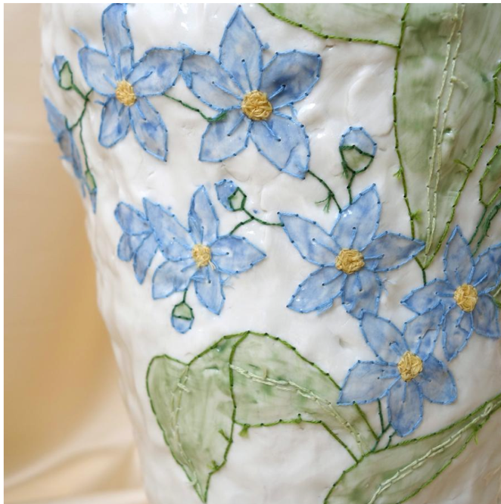
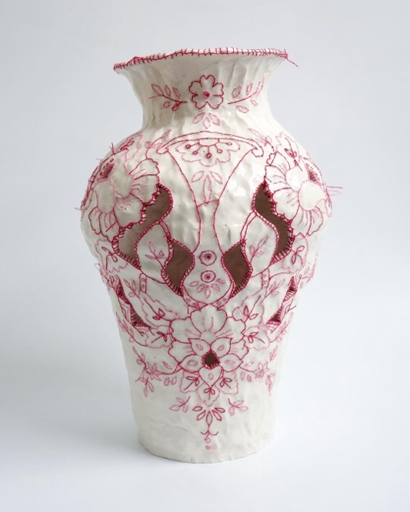
Stepping outside of my comfort zone and embracing exploration and experimentation has always been a challenge in my practice. However, in this module, I aim to overcome these difficulties by introducing elements of unpredictability and relinquishing this control. Doing so will help build confidence by shifting my mindset—seeing experimentation as something playful and enjoyable rather than daunting. This change encourages me to focus on the process rather than the result, fostering a deeper appreciation for the act of making itself.
Figure 1. Caroline Harrius (2018) To Flower, Ceramic Stitch Vases

At the beginning of my journey, I set out with the key aims of creating for enjoyment and exploring new mediums. One of my first explorations was ceramics, specifically working with clay. Ceramics required a more fluid and responsive approach. Through interacting with the clay, my hands became essential tools for shaping the material, adapting to the new medium. I chose clay for its ability to produce intricate and refined results, which aligns with the delicate aesthetic I aim to convey in my paintings. This decision reflects my desire to express fragility in my work.

The principles of haptic within ceramics exploration, where the act of shaping clay is inherently tactile and sensory. It offers a profound connection to materiality through touch, as hands mold, refine, and respond to the pliability of clay. Clay as a material begins as a shapeless mass, requiring deliberate and purposeful intervention to give it form. The process necessitates finding a delicate balance, too much pressure while throwing or too little can significantly affect the outcome. Even after successfully shaping the clay, the perception of a perfect product can be challenged during firing, where unexpected breaks or flaws may occur. Although my exploration into ceramics didn't progress further, I learned that process was more important than this idea of perfectionism. I found myself more drawn to the vibrant glazes than the ceramics themselves, with the colours adding character to the white porcelain; this experience reinforced my enjoyment of embellishing, decorating and painting, prompting me to explore these interests in a medium I felt more comfortable with.

Dewey suggests, the process of creation, with its trials and transformations, embodies the essence of lived experience in art. He asserts that ‘life goes on in an environment; not merely in it but because of it, through interaction with it, These biological commonplaces are something more than that; they reach to the roots of the esthetic in experience.’ (Leddy, 2016). This philosophy highlights that the interaction between creator and material is not solely about achieving a finished product but about engaging deeply with the process itself, fostering mindfulness and profound personal growth. Building on a previous exploration from a different module, I discovered that drawing inspiration from other practitioners such as Erin Wilson was a starting point that influenced this new direction of my worker. Her ‘hand-dyed colours, architectural imagery, and intricate patchwork’ (Wilson, 2025) textiles inspired me to explore colour, while her precise yet improvisational patchwork and mastery in slow stitch highlighted the beauty of simplicity and thoughtful colour stories. The principles of haptic theory strongly resonate with my exploration of colour, especially within the context of natural dyes, where the process is both physical and sensory. This journey forged a deep connection to materiality and process, engaging not only through touch but also through my senses of sight and smell. By physically interacting with the landscape, I carefully selected materials to forage and dye, refining my approach by responding more intuitively to the organic materials. This process requires a trust in the unknown, embracing the uncertainty that comes with it. Even when the results didn’t meet initial expectations, every step provided invaluable lessons.

Dewey suggests, the process of creation, with its trials and transformations, embodies the essence of lived experience in art ‘ways in which experience is formed as a part of natural processes to which the human being is fundamentally tied. Aesthetic experience is the highest form of this interaction. the interaction between the organism and the environment reaches a stage of fulfillment.’ (Leddy, 2016) This philosophy highlights that the interaction between creator and material is not solely about achieving a finished product but about engaging deeply with the process itself, fostering mindfulness and profound personal growth. The tactile and sensory involvement, combined with the unpredictability, transforms the act of making into a practice of mindfulness and resilience, underscoring the beauty of imperfection and deepening my appreciation for this creative journey.
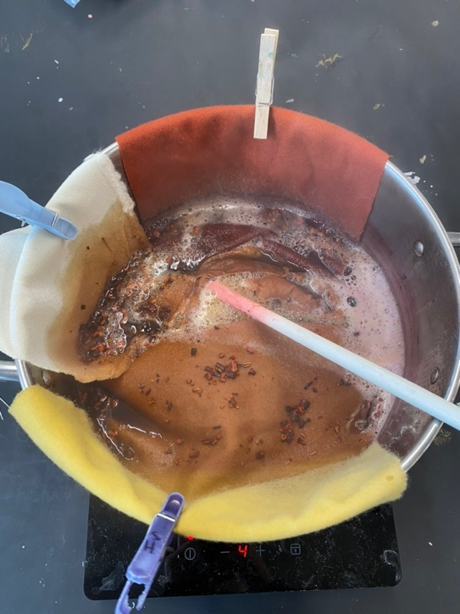
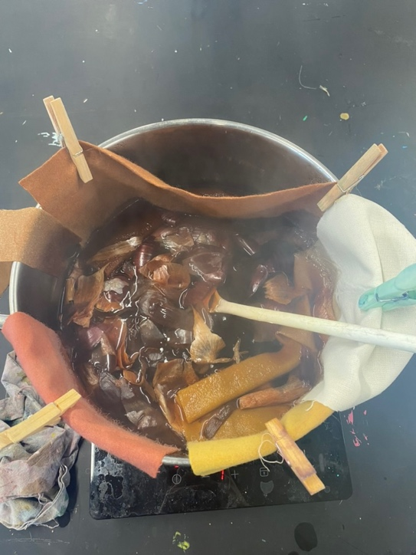
Figure 2. Own Photo Taken, 2025

‘Haptic artefacts can sense the body and its surroundings, impacting our subjectivity by shaping perceptions, actions, and be- haviours. Such ability to influence our senses is helpful in creating engaging multisensory experiences.’ (O’Nascimento, 2023)
The landscape, with its rich colours, further shaped my understanding of haptic engagement, shifting my perception of both the physical and emotional aspects of the dyeing process. The colour of the freshly foraged plant and the outcome after dyeing significantly impact my perception, influencing the mood and atmosphere of the work. Before starting I had envisioned the mood or vibe the freshly foraged plant would give off expecting a certain outcome in colour. However, the result after dyeing would be surprisingly different, sometimes conflicting with my initial expectations. The transformation from the raw, natural hues to the dyed result not only altered the visual experience but also evoked a different response.

"A subtle shift in colour has a huge impact on the senses" (Development by Opacity, 2023), a concept emphasized by CMF (Colour, Material, Finish) design research studio, which focuses on using colour and materials as agents of meaningful change. The studio highlights the importance of "harnessing colour and materials as agents of change" (Development by Opacity, 2023), specializing in trend forecasting while promoting sustainable approaches in innovative ways. The insights from this brand underscore the powerful role of colour and materiality in shaping both physical and digital experiences. Their thoughtful approach to understanding how colour and texture impact perception and engagement aligns with discussions on sensory interactions, material feedback, and the connections between art as an experience for both artist and audience. This celebration of colour will be a key area I plan to explore further.
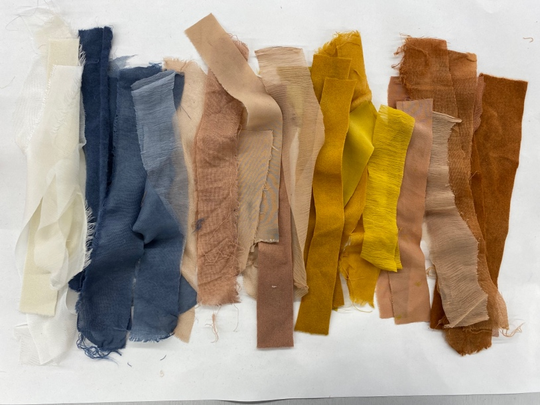
Figure 3. Own Photo Taken, 2025

With the silks and wools I had naturally dyed, I cut and composed a series of samples, such as fabric weaves and loose strips of fabric, which I then fed through an embellishing machine to create new forms of cloth. I ensured that each piece was both visually and texturally pleasing. Through this process, I discovered a new technique of embellishing that I plan to explore further throughout the rest of the academic year. This also allowed me to appreciate the simplicity of colour. The act of grouping and forming colour fields, as well as composing the samples themselves, was something I would have previously overlooked. Unlike my detailed paintings and drawings, these fabric samples contrasted by focusing on textures, colour, and materiality. Although I carefully placed each piece originally, the final outcome was beyond my control. When put through the embellisher and needle-punched multiple times the fabric shifted and moved. However, by embracing the process and appreciating it, I found that I wasn’t concerned with the final product being perfect. Instead, this creative response improved my understanding of the practical process and enriched my sensory involvement with the materials used. At times I lacked confidence in my colour sense, but by delving deeply into the simple topic of colour alone, I gained greater confidence. Unlike my detailed mixed media works, where the focus was on narrative or subject, here I concentrated solely on process and materials. Simplifying my approach allowed me to reevaluate my perception of the work. Despite the absence of intricate detail, the vibrancy, variety of shades, tones, and fabric textures created their own narrative, proving that simplicity holds its own significance. Looking back at my work now I feel a sense of accomplishment as I recognise the value of the trial and error involved. I appreciate the understanding gained and the growth from my explorations, which is something I rarely acknowledged in both myself and my work before. This journey has allowed me to truly value the process and the lessons learned along the way.

The artist E.E. Cummings, in his collection of essays A Poet’s Advice to Students, shared his wisdom on life and creativity, encouraging emerging artists to embrace their individuality without fear. Cummings an artists who ‘never cowered from being his unconventional self’ (Popova, 2017) Cummings emphasized the importance of self-reflection and emotional authenticity in the creative process. He believed that true artistic expression stems from personal experience, urging artists to remain true to their inner voices despite external pressures. At the start, I recognised certain strengths within my practice but at times, I felt they weren't enough. I would try to consistently focus on new areas of practice, even if I didn’t fully enjoy them, which kept me from embracing the process. It wasn’t until I went through these explorations that I realised I should embrace my strengths and focus on what I enjoy. By shifting my energy into improving these areas while still pushing myself to explore and grow, I began to unlock new possibilities and confidence in my work.

“To be nobody-but-yourself—in a world which is doing its best, night and day, to make you everybody else—means to fight the hardest battle which any human being can fight” (Cummings, as cited in Popova, 2017). Cummings perspective highlights the delicate balance between technical skill and the courage to express oneself honestly. Cummings reinforces the idea that creativity requires vulnerability, encouraging artists to explore both their inner and outer worlds without the fear of judgment.

Throughout this journey, I’ve learned the value of embracing mindfulness in the creative process. By focusing on the act of making rather than the outcome, I’ve developed a deeper connection to my work and a greater appreciation for the materials and techniques involved. I've realized that I often set unrealistic expectations for myself, and when I didn't meet them, I experienced overwhelming negative emotions. This mindset hindered my practice and prevented me from connecting with my work. However, through experimenting with various mediums, from ceramics and mixed media paper collages to textiles and fabrics, I discovered that despite the medium, I always returned to what I had originally explored and enjoyed. Accepting and understanding this took longer than expected, but eventually it allowed me to step back from the pressures of perfection and excessive planning, enabling me to focus on the present moment and enjoy the creative process.
Key lessons I’ve taken forward is letting go of control, particularly with mediums and processes I had once avoided. Exploring ceramics, natural dyeing, and fabric embellishment expanded my understanding of materials, teaching me to embrace imperfection and unpredictability as vital aspects of creativity. These new approaches helped me confront struggles with confidence and perfectionism, ultimately fostering growth and resilience in my practice.
Maintaining a consistent narrative throughout my work was another challenge. At times, I struggled to fuel my creativity with a clear theme. However, rediscovering my passion for natural dyeing and adopting a process-driven approach alleviated this pressure. It reminded me of the importance of returning to what I enjoyed, stepping away from overthinking, and letting my work evolve organically.
While I achieved some of my goals, such as exploring new mediums and embracing a more experimental approach there are still areas for growth. Reflecting on my progress, I can see how my confidence has grown. Through playing and experimenting, I’ve learned to handle failure with more resilience. Instead of giving up when an exploration didn’t work out, I became more curious about why it didn’t, reattempting with a fresh perspective and learning from my mistakes, something I once thought I wouldn’t be able to overcome. Moving forward, I plan to continue experimenting with unpredictability and colour, using these elements to deepen my connection with materials and refine my artistic expression. Despite hearing this feedback from my peers and viewers, it's only now that I'm truly embracing the positives; this project has not only taught me the importance of embodying the process and connecting with my work, but it has also built my confidence in both my skills and mindset, leaving me with a new sense of excitement and interest, and with my hands and knowledge as tools, I look forward to delving deeper into my practice, feeling that the connection to my work is now visible. Ultimately, I aim to keep cultivating a mindset that values the creative journey over the final product.

Charny, D. (2011). Power of making : the importance of being skilled. London: V & A Publ.

Cummings, E.E. and Firmage, G.J. (2018). E.E. Cummings : a miscellany. New York: Liveright Publishing Corporation, a Division of W.W. Norton & Company.

Dezeen. (2024). FranklinTill lists nine principles for a shift to regenerative materials. [online] Available at: https://www.dezeen.com/2024/03/20/regenerative-materials-franklin-till-principles/ (Accessed 15 Feb 2025)

Development by Opacity (2023). Colour of Saying. [online] Colourofsaying.com. Available at: https://www.colourofsaying.com (Accessed 12 Feb. 2025).

Dewey, J. (1934) Art as Experience. New York: Minton, Balch & Company.

Gadsby, F. (2023). By My Hands. Ten Speed Press.
Iands.design. (2019). How Haptics and Color Affect Us. [online] Available at: https://www.iands.design/interior-design/article/10168662/how-haptics-and-color-affect-us (Accessed 17 Feb. 2025).

jensen, amber m (2024). amber m. jensen. [online] amber m. jensen. Available at: http://www.ambermjensen.com [Accessed 17 Feb. 2025].

HAMILTON, J. (2025). JULIE HAMILTON. [online] JULIE HAMILTON. Available at: https://www.juliehamiltoncreative.com [Accessed 17 Feb. 2025].

Kassia St. Clair (2019). The Golden Thread: How Fabric Changed History. Liveright Publishing.

Kassia St. Clair. (2018). The Secret Lives of Colour. Hodder.

Leddy, T. (2016). Dewey’s Aesthetics (Stanford Encyclopedia of Philosophy). [online] Stanford.edu. Available at: https://plato.stanford.edu/entries/dewey-aesthetics/. (Accessed 17 Feb 2025)

O’Nascimento, R. (2023). ‘I am feeling blue… and red’: Exploring alternative ways of feeling colours through a wearable haptic artefact. Multimodality & Society, 3(4), pp.444–452. doi:https://doi.org/10.1177/26349795231194746. (Accessed 16 Feb 2025)

Perryman, L. (2021). The colour bible : the definitive guide to the history, use and meaning of colours. London: Ilex Press.

Polanyi, M. (1966) The Tacit Dimension. New York: Doubleday.

Popova, M. (2016). Art as Experience: John Dewey on Why the Rhythmic Highs and Lows of Life Are Essential to Its Creative Completeness. [online] The Marginalian. Available at: https://www.themarginalian.org/2016/02/11/art-as-experience-john-dewey/. (Accessed 12 Feb 2025)

Wilson, E. (2025). Erin Wilson. [online] Erin Wilson. Available at: http://www.erinwilsonquilts.com/about [Accessed 17 Feb. 2025].

www.franklintill.com. (n.d.). Franklin Till. [online] Available at: https://www.franklintill.com/about. (Accessed 10 Feb 2025)

Figure 1. Carolineharrius.com. (2018). Caroline Harrius. [online] Available at: https://carolineharrius.com [Accessed 17 Feb. 2025].

