http://www.gameranx.com/features/id/9633/article/14-most-offensive-video-games-ever/?utm_source=zergnet.com&utm_medium=referral&utm_campaign=zergnet_32236

14 Most Offensive Video Games Ever

Here are the top ten most offensive games in existence. Read it and weep.
by Josh Wanamaker on 28th Sep, 2012
Use your ← → (arrow) keys to browse
Previous1 of 15Next

Most Offensive Video Games
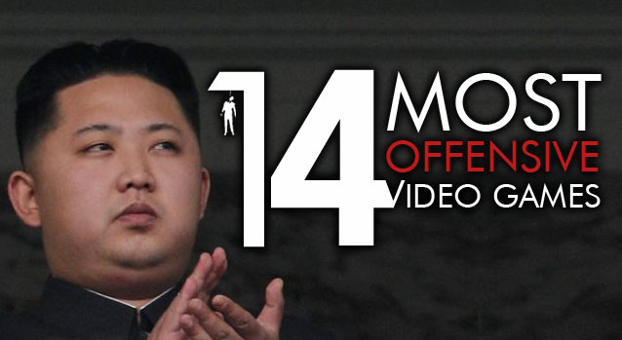
As a guy who is almost impossible to offend, writing up a list of the 10 most offensive games I could think of was a bit of a challenge. None of these particularly offended me due to to their content, but the fact that a few of them even exist at all kind of makes me want to plumb the depths of the human psyche.
These games range from the unnecessarily gory, to those which offend for the sake of being offensive. It’s bad enough that they manage to stir up the press into covering games as if every game were like this—they’re also not very fun to play.
Think about it; what kind of broken mind would think that putting money into producing some of these things was a GOOD IDEA, and just how great these troubled individuals must be at bullshitting management to secure funding in the first place?
Without further ado, here are the top ten most offensive games in existence. Read it and weep.

14. The Torture Game 2
While it’s not really a game since you can’t win or lose, it’s part of the list since you do “play” it in a sense. If the title wasn’t obvious enough, the object of this game is to torture an eerie-looking rag doll using the tools available. You can shoot at it wit guns, stab and hack at it with chainsaws and blades, or you can do it the old-fashioned way and just beat it senseless.
Out of all the games in the list, this might be a tame one due to it not stepping on some moral ethics code, but still offensive nonetheless.

13. Muslim Massacre: The Game of Modern Religious Genocide
This game goes hand-in-hand with “Ethnic Cleansing,” but this one targets a whole demographic by itself. The game – as its title offensively suggests – wants you to massacre as many Muslims as possible. It even has the gall to callously call itself a “game of modern religious genocide.”
What’s even more pathetic is the game’s creator – Eric “Sigvatr” Vaughn – even attempts to tug at peoples’ patriotic side by having you control an “American hero” who kills and wipes the world of the Muslim race menace with an armament of weapons.
Vaughn and Ethnic Cleansing creators Resistance Records should really meet someday and shoot each other in the face to make the world a better place. Now, that would be a game that might not be as offensive as you might think!

12. V-Tech Rampage
This one is all kinds of crass. Capitalizing on Virginia Tech student Seung-Hui Cho’s sick campus shooting spree which killed 32 people, this Flash-based game is not only offensive, it’s crappy-looking too. It allows you to shoot dozens of pixelated, poorly-rendered students with no rhyme or reason for doing so. You should give this as much playing time as its creator (Ryan Lambourn) gives respect to the victims: which is fair to say is none.
This goes on to prove that people will capitalize on everything – no matter how crass – just to get their 15-minutes of fame.

11. Ethnic Cleansing
As if the title wasn’t a dead giveaway, Ethnic Cleansing lets you play as a Klansman (or someone equally as repulsive) whose goal is to kill the “Blacks, Jews, Latinos” and other races that aren’t white. This racist game was developed in 202 by Resistance Records…a fitting name to a studio whose game is offensive to everyone except White Supremacy advocates.

10. SimCopter
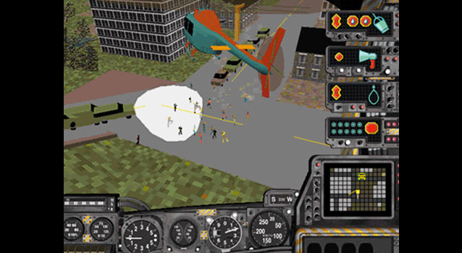
I’m betting most people are all “SimCopter? What’s that?”, and that’s understandable, but not excusable. SimCopter was a helicopter simulation made by Will Wright and Maxis, and it was utterly brilliant. Aside from integrating the player into the Sim Universe unlike any other game before it, SimCopter could convert a map from SimCity 2000 into a 3D environment to fly around in, and vice versa. It did this so well that any changes that occurred to the city’s layout while playing in SimCopter, like, say, fire or a nuclear explosion, would also be saved and converted to SimCity 2000. You really didn’t want to let a fire destroy a nuclear power plant. SimCopter was controversial for a short time thanks to the work of one of the game’s engineers, openly-gay Jacques Servin. Jacques secretly inserted code into the game that changed all pedestrians into speedo-clad, shirtless dudes, which would run around and kiss each other, making funny noises. The fact that their nipples were essentially flashing airport runway lights helped to make them especially noticeable. On certain dates these guys would appear and make everything FABULOUS. Jacques included this unauthorized content as a sort of protest against the discriminatory behavior he was receiving from his “aggressively heterosexual” boss at Maxis during his work on the game. I’d like to think he wasn’t referring to Will Wright, whom I’ve effectively had a man-crush on for basically my whole life.

9. JFK: Reloaded
If you’re the type of person that likes to play repetitive games, have we got a zinger for you! JFK: Reloaded allows players to recreate the assassination of President JFK...only you can do it in basically any way you want. Whether or not the developers’ claims of the game actually being a simulated attempt at proving the findings of the Warren-Commission investigation are true, what it actually turns out to be is a hilarious physics-driven sandbox. Players are put in the role of Lee Harvey Oswald, and their score is determined by how close their actions compare to those of the Warren-Commission’s findings. What actually happens is that once the player takes the first shot, the game explodes into a chaotic mess, with NPCs running and driving all over the place, often into bystanders and walls and other such things. The only offensive content here is that it allows players to shoot a guy that happened to be President in 1963. Considering the man was dead for 41 years at the point, I really doubt he would have minded. Did I mention the game was released on November 22, 2004, The 41st anniversary of the assassination? Classy!

8. Custer’s Revenge/General Retreat
What better way to celebrate the humiliating slaughter of General George Armstrong Custer at the hands of a Native American warband than to depict him essentially raping the women those people who slaughtered him? In Custer’s Revenge, players move a naked white man with an enormous erection, presumed to be Custer, through a field of incoming arrows until he arrives at the tied up, also-naked Native American woman at other side of the screen. The share a single frame in which Custer is being his rapey-ist (rapiest?), and the player gets some points.That’s the whole game. In General Retreat, the game is exactly the same, except players now control the woman, because apparently Native American women of the time wanted nothing more than to screw a dude responsible for killing thousands of her people. So, other the obvious misogyny involved, it’s racist, to boot. Huzzah for a lack of publishing standards, I suppose.

7. Soldier of Fortune
Released in 2000, Soldier of Fortune was, at the time, probably the single most graphically violent game that existed. While the engine was nothing fancy (just a modified version of the Quake 2 engine) it was the first implementation of Raven Software’s proprietary GHOUL damage modeler, which allowed for some really awesome gore, the likes of which are still not often matched to this day. Shoot a dude in the stomach with a shotgun, out spill his intestines. Shoot a dude in the head, and depending on what part of the head you hit, a different part of the back of his skull would be blown-out. Every part of a character model could be destroyed in hideous fashion, and while back then everyone was all “WOW!” Today people would be more like “meh”. Just...just don’t let your kids play it, okay? Let them watch porn instead. They’ll thank you for it.

6. GTA San Andreas
Ah, Rockstar. The now “infamous” Hot Coffee modification, which allowed users to access GTA San Andreas’ purportedly removed sex minigame, really set the world on fire! While I’m a fan of Rockstar’s various efforts, whoever it was that decided to leave the mechanics for the sex game in there have better had gotten sacked. Rockstar has been around since the 90’s, and any employee there has GOT to know that a popular game being released to the PC will result in mods being made for it. That’s just how it works. Popular game + PC = Mods. This has been going on since Wolfenstein. The fact that the mod eventually made its way to pirated copies of the PS2 and Xbox versions of the game simply fueled the massive public outcry of this non-issue. At the end of it all, many people to came to two realizations: 1) Americans are fine with a game that’s about murdering cops, but if it even IMPLIES sex, let alone out-rightly depict it, it’s evil and obscene and degenerate (although this wasn’t exactly news to most people), and 2) Every game ever released should have a disclaimer included saying something along the lines of WARNING: IF YOU CHANGE THIS GAME IT WILL BE DIFFERENT. I don’t think that second bit has ever been implemented.

5. Duke Nukem Forever
I was tempted to add Duke Forever to the list simply because its total lack of quality offends me, but it does, in fact, contain some hilariously awful sexual content and just generally awful misogyny. What’s the first thing the player sees when starting up a new game? Why, two blonde bimbos giving Duke an implied blowjob. How lovely! That really shows us he’s popular with the ladies. Next, walk Duke into a bathroom so he pick feces out of a toilet! Lovely! We’re not done yet, though, as Duke really puts on the class-act when he makes abhorrent fun of said aforementioned bimbos as their stomachs explode with alien spawn. You sure showed those girls what-for, Duke! Imagine all that repeating for another six hours and you’ll have intimate knowledge of Duke Nukem Forever’s entire experience.

4. Manhunt
Manhunt was an otherwise decent stealth-based survival-horror game, containing violent content somewhat more excessive in its brutality than most other titles at the time. Players sneak around maze-like levels and were tasked with killing dudes in various gruesome ways, getting points for violence, essentially. Suffocating dudes with plastic bags, stabbing dudes in the face with knives, knocking dudes in the head with bats, sticking axes into dudes, etc. It’s all really standard fair, actually, but the big difference is that back then there was this totally insane blowhard lawyer named Jack Thompson that was trying to make name for himself by engaging in anti-games litigation. Remember that guy? No? Good. Jackie-boy labeled Manhunt a “murder simulator”, just one of many ignorant, fear mongering statements that led to the game being pointlessly banned in a number of countries.

3. Super Columbine Massacre RPG!
Because it’s FUN to make light of the one worst instances of school violence in American history! That is, of course, a gross generalization and oversimplification of both the game and the developer and, not to mention, the medium. Whilst obviously the topic and event are very controversial, the message the game is trying to spread is clear: Games can serve as social commentary on real-world events. It puts players in the mindset of the killers, and makes an attempt to put the audience in a place to understand where those two idiots that did the killing were coming from. The fact that people don’t WANT to be put in that place and think other people shouldn’t even have the option is nothing new, and the only reason the game was controversial and “offensive” is because society at large still views games as, well, GAMES, and not as an artistic form of expression. I’m pretty sure the word attributed to the medium is responsible for that.
http://youtu.be/Vdgl1iHVONE

2. Postal 2
I was sorely tempted to make Postal 2 my number-one choice. It represents probably the most blatant attempt in game development history to cash-in on the baser aspects of the 13-24 year-old male demographic: Xenophobia, racism, and violence. The game is nothing but a sandbox of senseless slaughter, hate, and pissing on people’s heads. I’m not even kidding about that last part. Do you like the idea of running into a convenience store and screaming “Rag Heads” whilst shooting up a bunch of Arabs? How about sticking a shotgun up a cat’s anus to use the animal as a silencer? What about a “mission” objective to get yourself treated for gonorrhea? If these things sound like fun to you, then you should probably get to playing this game as soon as possible. This sort of content is apparently all the developer Running with Scissors is capable of producing, as Postal 3 is basically exactly the same thing, but worse. I’m convinced that the founder of RWS used money laundered by the mob to get Postal 2 developed.
http://youtu.be/WNIgKH80o8M

1. RapeLay
Finally, and I’m sure more than a few of you saw this coming, is RapeLay; the crummy, horrible “rape simulator” eroge (erotic game) from Illusion Software, released in Japan in 2006. It’s highly probable that most readers only know of this horrible thing because of the semi-recent controversy the game drummed up in the US and elsewhere in 2009. By this point the game was pretty much forgotten by almost everybody, but if there’s one thing you can count on it’s politicians acting out in hindsight to further their careers.. RapeLay put players in the “shoes” of a rapist! Surprise! Stalk women on trains and through train-stations, as well as train-station bathrooms and other train-related environments until you corner and rape them mercilessly. Don’t screw up, though, because if you rape them “incorrectly”, the girl will twist around and stab you in the chest until you die. That part is actually kind of awesome, rapists getting what they deserve. I approve of that. Sadly, RapeLay is just one of a myriad of eroges containing horrible, misogynistic content that Japan’s thriving hentai game industry produces every year.
http://youtu.be/a54Pu9dTJfQ

