Entrepreneurs and Entrepreneurship World

By Ionela Madalina Saiz

Module: Entrepreneurship (LCMB7004)
Student Number: 1605699
Lecturer: Nandish Patel

May 2021

Table of Contents
Introduction 1
Importance 2
Difference between Enterprise and Entrepreneur 3
Most Considerable Models related to Entrepreneurship 3
Theory of Innovation 4
Critical Evaluation 4
Need for Achievement Theory 5
Critical Evaluation 5
Theory of Leadership 6
Critical Evaluation 7
Physiological Theory 7
Critical Evaluation 8
Theory of Systematic Innovation 8
Critical Evaluation 9
Non-profit and profit-Making Organization 9
Common Differences: 10
Contextual Examples 10
Conclusion 11
References 12

Introduction

Entrepreneurship refers to business setups and innovation. It is all about taking steps to create setups to earn a profit under the legal framework of the country.
The purpose of this report is to express a clear understanding regarding entrepreneur’s and entrepreneurship. Their importance for the economy as well as for any sector of the country as it has never-ending benefits for the community.
The objective of this is to critically analyze the theory model, what drawbacks they serve and where they need to combine and work on. The main purpose is to establish finding and understanding considering theories related to entrepreneurship, that are:
- Innovation Theory
- Theory of need of achievement
- Theory of leadership
- Physiological theory
- Economic Theory
Further to understand the need of entrepreneurs for enterprise is also considered, as mostly it is misunderstood and confuse the two terms; enterprise and entrepreneurs.

Importance
Endeavor and business are the fundamental mainstays of any nation's economy. The business venture is critical not exclusively to the economy, that is from elevating social change to driving development (Chell, 2020, pp. 17-19). They are the public resource of any country; it is imperative to rouse them and do all potential endeavors to improve them and help them as could be expected (Evans, 2019). The business venture is significant, as it can expand the coating principles of the general public, yet additionally all the connected business-related substances.
The significant thing that assists the market with improvement is business people and their new advancing thoughts. Business help to make work and by implication the monetary turn of events. Entrepreneurial activities assistance makes innovative bounty (Langroodi, 2017). Current associations may continue bound to current business parts and might success a cutoff in regards to wage. Over someone's mind belongings, organizations, or development from currency executives enable new commercial parts to be made and new abundance to be made (Bhidé, 2018).
Further the models help us in every regard a lay man person can take guidance from it and make himself better in many ways and also work over their weaknesses (Emden, 2019).This is also to be considered these theories are the foundation that can help us. The entrepreneurial ideas serve the basis to it (Kwabena, 2019).

Moreover, lengthy work and advanced benefits add to improved open compensation as advanced cost pay and higher administration spending. This pay can be used by the community place to place assets into other endeavouring territories and HR. (Lumpkin, 2015). Despite the way that it may a few existing players repetitious, the public expert can conciliate the authorization late forwarding flood wealth to re-educate workforces (Manalel, 2015).

The key abilities that should be available in a business person are motivation, imagination, vision to accomplish objectives, ought to be prepared to face determined challenges, should realize which steps to be taken at the ideal time and where to make changes in procedures (Reissman, 2018). When out of luck, advancement is supposed to be the need expertise for them to have. These skills make a business go for long as it's obvious, ideas without skills are nothing, and skills without ideas. All these elements are important for one another (Timmons, 2015).

Difference between Enterprise and Entrepreneur
There is a clear and profound difference between these two terms; An enterprise is a occupational venture whereas an entrepreneur is a person who starts an enterprise (Shane, 2019). The process of doing the business, planning, innovation, usage of skills, and learning is known as entrepreneurship.
Entrepreneurs support financial growth by giving creative innovations, items, and organizations (Kwabena, 2019). Extended rivalry from business people moves existing firms to turn out to be more serious. Business people give new positions open doors in the short and extensive pull (Lumpkin, 2015).

Most Considerable Models related to Entrepreneurship
Entrepreneurship has always been found to a vital factor in economic development (Langroodi, 2017). It involves an individual taking risk, since there is no theoretical explanation of what risk will bring what outcome, economists haven’t provided any factual or analytic interpretation on entrepreneurship or its supply. Therefore, no matter how much any theory provided the factualness of entrepreneurship, they still have their drawbacks, and assumption which gives room to critical evaluations (Emden, 2019).
Several different schools of thought have evolved regarding the understanding of entrepreneurship so many different theories emerge. Some of the salient entrepreneurship theories are as following:

Theory of Innovation
The theory of innovation is given by J.A Schumpeter. In this, it is said that an entrepreneur is an innovator that he introduces a new idea. (Mishra, 2015). This theory covers some important aspects of the business as it is introducing a thing that is new for the consumer; he is not familiar with. The methods manufacture that hasn’t been introduced for long or maybe never are also covered in this theory (Strauss, 2016). Creating such a market which was never started by someone in addition to this new source of supply or any raw materials. The creation of monopoly is also under this theory (Manalel, 2015).
For example, when automobiles were becoming a big part of economy Ford Motor company just focus on providing cheap cars in the market but Alfred Sloan was more focused on retaining customer's relationship and looked for innovation in its product, resulting his company to outgrowing the cheap products of provided by Ford Motors.

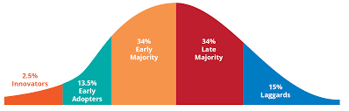
Figure 1-Theory Of innovation
Source: (Langroodi, 2017).

Critical Evaluation
In the Schumpeterian hypothesis, the principal topic is development. He makes a qualification between a trailblazer and an innovator. As per him, a designer finds new techniques and new materials. Subsequently, pioneering improvement brings the monetary turn of events (Langroodi, 2017). Entrepreneurship adds not only self-governing manufacturers but also managers and subordinates, who are up in advanced function (Reynolds, 2020).

Need for Achievement Theory
This is represented by David. C. McClelland and is related to economic growth and the factors that affect human values, motives that can lead to exploit opportunities (McClelland, 2018).
This theory refers to do well in business but not at a level to make yourself recognize. The people are not much interested much for social recognition. He further says high motivation comes from high standards (McClelland, 2018).
For example, a person who is eager to bring change, and introduce something new into market must have achieved all type achievement in order to be at it full at dull potential, only than this individual can take risk that bring in potential outputs.

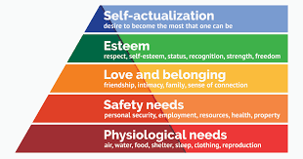
Figure 2- Need to Achieve
Source: (McClelland, 2018).

Critical Evaluation
The experiential apparatuses of idea used by him are founded to be highly suspected. Moreover, in practice in present days. One thing required to keep under consideration, it is difficult to measure as it works under reinforcing circumstances (McClelland, 2018).

Theory of Leadership
This theory is presented by Hoselitz, and according to him, entrepreneurship is a purpose of executive services and management after considering finance (Timmons, 2015). It elaborates that a person who wants to be manufacturing entrepreneur has more purpose than the drive to make profits like the ability to manage and lead. It further explains three types of leadership (Emden, 2019).
Therefore, he proves that entrepreneurship is more than just making profits, the risk factor is always there (Reynolds, 2020). Leadership is basically influencing others, creating vision showing a bigger and clearer prospective to the people. Moreover, guiding them to achieve the goals with the strategies presented by them. Leadership is more like a strength when you know you can do anything taking risks, calculated risk and put efforts to do a thing without relying on others.
According to theory leadership can be learned but not thought. The closer you get to learning the more you will let open your teammates to this. Learning can make a person leader. Human learn from the experience they get, the hardships they face and the way they get out of them. The more a person experience the more he learns to clear the prospective and vision to him and even others. He learns how to handle things, how to make other work at 11th hour, how he can motivate others. The only person who can motivate, understand support other is the one who have been all through it and the difficult times, who learnt from his mistakes that where was he wrong and how it should have been done or could make it better. This is because he was once at that stage of learning and making mistakes or even blunders. To make others influence and guide experiencing and learning is needed.
For example, Google one of the most prestigious firms in the world recognizes the importance of leadership and how it brings amazing entrepreneurial skill to table hire managers who have leadership skills or give proper training to them to develop leadership skills.


Figure 3- Theory of Leadership
Source: (Chell, 2020).

Critical Evaluation
Indeed, peripheral men or groups appreciating an abstruse culture and social position having no captivity from ritual express more entrepreneurship expansion. Moreover, it is absurd to say that entrepreneurship is gender-oriented as women are as much capable of bringing in change and bearing risks as men (Evans, 2019).

Physiological Theory
This sector explains that psychological factors are the main source of entrepreneurship growth. Similar physiological characteristics among groups can lead towards entrepreneurship development. Some of the psychological theories are Joseph A. Schumpeter Theory, David C. McClelland Theory, Everett E. Hagen’s Theory, John Kunkel Theory, etc. these theories are pretty much similar to each other but the most significant (McClelland, 2018).
According to him, the real purpose of an entrepreneur is to find revolution in the undertaking, this venture is derived from will control, self-intuitions, open-mindedness capacity determination, risk-taking, coordination, and creativity leading to innovation, which includes the outline as in manufacture, new market, the new source of raw materials, and a new source of an organization.

For example, Mark Zuckerberg was not only the inventor of Facebook but also is the innovator as well, because with consumer's changing preferences he added the certain features and design, and always provided something new for its users.
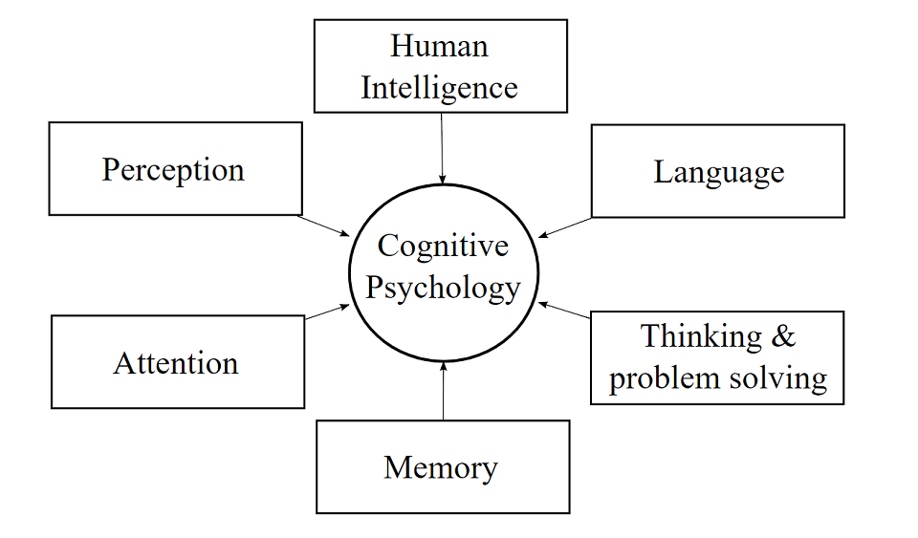
Figure 4-Physiological Theory of Entrepreneurship
Source: (Melanie Sovann:2019).

Critical Evaluation
The hypothesis has the primary subject of transformation and clarifies the qualification among a trend-setter and a designer. As indicated by it, an innovator decides new strategies and new materials. Be that as it may, a trailblazer applies these new developments (Strauss, 2016).
With the application, a pioneer produces fresher and better merchandise which acquire fulfillment as well as produce profits well. Notwithstanding, Schumpeter's idea of portraying business venture is very wide and is only an overall portrayal of occasions (Langroodi, 2017). Despite the fact that, it just incorporates the autonomous financial specialists yet additionally chiefs and supervisors who attempt oversee, and control these inventive capacities. The whole hypothesis needs reasonableness as execution isn't just founded on physiological variables (Lucy, 2017).

Theory of Systematic Innovation
Prof. Drucker has established the theory of systematic innovation. According to him Systemic innovation is all about purpose and chances of future (Emden, 2019).
These four source areas are:
- The unforeseen set ups and experience.
- The inappropriateness.
- Innovation is based on the problem on hand.
For example, many construction companies Dascon Construction company, Stonepoint Constriction Company, use this theory in order analyses the internal and external situation of the environment.

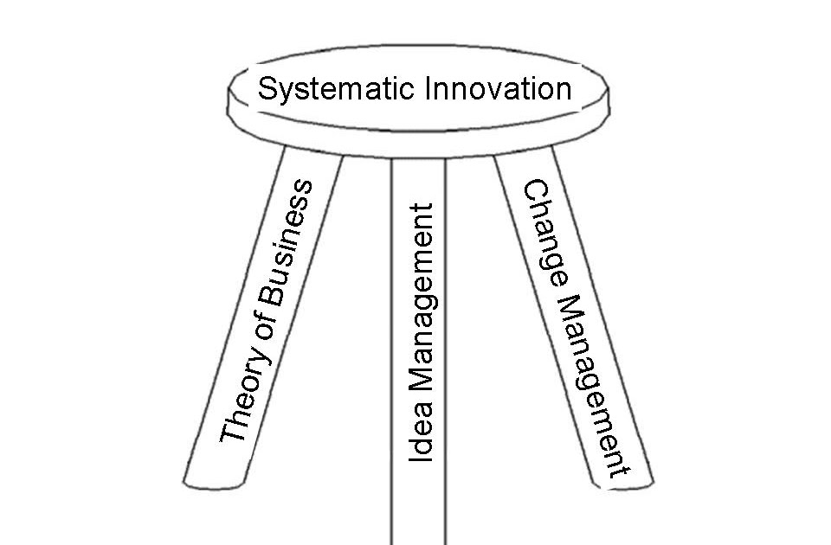
Figure 5-Systematic Inovation in Enterpreneurship
Source :(John Terninko ,2018).

Critical Evaluation
The theory of systematic innovation is proven to be the most comprehensive one because the entrepreneur is required to classify dissimilar foundations of modification. Therefore, the entrepreneur is anticipated to coordinate these changes with the opportunities available within and outside the enterprises. But the most important problem attached the question of reliability and predictability of seven sources as these seven sources are not measurable or presumable factors.
For example, new technical information is not the most consistent or most predictable source of positive inventions as scientific knowledge may make room for new inventions but this invention turning into huge success is still yet to be discovered after implementation. However, it still should be acknowledged that this theory tries to provide a comprehensive framework to entrepreneurship and gives a systematic process to understand how to examine the behavioral traits of an entrepreneurs.

Non-profit and profit-Making Organization
Non-profit Organizations are united not for earning some income from their doings rather their chief motivates to allow actions that are usually for assisting or advancing the society at large. Whereas, Profit Organizations are those elements that are joined with an essential target of making monetary advantages either straightforwardly or helping with making profits in that cycle (Bhidé, 2018, p. 12).


Figure 6- Non-Profit Organizations
Source: (Tariq Mehmood, 2019).

Common Differences:
• Non-profit associations human progress starts essential; singular reasons come straightaway. Revenue driven associations, the motivation behind producing profits start things out (Tagiuri, 2016, p. 16).
• Non-profit associations income is acquired by membership, participation charges, commitments, and so on Revenue driven associations, the types of revenue are gotten by selling products and ventures.
• In respects to charges, profit associations are required to cover charges, however not non-profit associations (Evans, 2019).
• As per budget reports, non-profit associations have income proclamations, pay articulations, and monetary records are utilized. Though, profit associations use incomes and instalments’ record, pay and use record, and accounting report (Lucy, 2017, pp. 67-90).

Contextual Examples
Firms those serve themselves for humanity without any interest of returns are known as non-profit making firms as their core motive is to provide shelter, humans right, water to the underprivileged people and to do good for the society (Bhidé, 2018).
A company like Coke, Unilever, Nestle, etc., provides good and services to the customers and are good examples of profit-making organizations as their core motive is to generate more sale and earn profits.

Motivation Entrepreneurs: Profit and Non-Profit making Organization
Concerning entrepreneurship, this skill is required by both types of business because innovation is an important factor for a functionally operating business whether its goods or services being produced for profit generation or society welfare because demands changes and consumers wants something new to endure, therefore entrepreneurs are motivated because to provide new to the society as innovation always makes room for adaption which brings in a lot of profit. So, entrepreneurs are always looking for new opportunities to serve the society and generate not only lumps sums of profit but creates a name for them which also gives them goodwill that keeps them motivated (Reynolds, 2020).

Conclusion
No doubt, entrepreneur psychology makes more difference as it describes the approach and vision of the complete business towards progress. It may contribute to immense failure or success at the same time. Every theory has its importance, powers that make it different from others. And obviously, they have limitations that are different from others. The best thing an entrepreneur can consider is to make all the theories a throughout and consider work on it as a combination to minimize the possibility of the lacks. Further, Profit and non-profit organizations have different worth according to every entrepreneur out there. The most important thing is that we must learn to consider the different views and further work on the limitations.

References

- Bhidé, A., 2018. The Origin and Evolution of New Businesses., New york: Oxford University.

- Chell, E., 2020. Entrepreneurship: Globalisation, London: Innovation and Development..

- Emden, C., 2019. Conducting a Narrative Analysis. Collegian, 5(3), pp. 34-39.

- Evans, J., 2019. Enterprise and small business; principles, practice and policy. third ed. England: Pearson.

- Kwabena, N., 2019. Entrepreneurship theories and Empirical research. Entrepreneurship, 6(1), pp. 90-100.

- Langroodi, F. E., 2017. SCHUMPETER'S THEORY OF ECONOMIC DEVELOPMENT: A STUDY OF THE CREATIVE DESTRUCTION AND ENTREPRENEURSHIP EFFECTS ON THE ECONOMIC GROWTH. Historical and Normative Foundations of Economics, 2(1), p. 70 89.

- Lucy, T., 2017. Entrepreneur ; how to start small business. 1 ed. England: Capstone Publishing Ltd.

- Lumpkin, G. a. G. G. D., 2015. Clarifying the Entrepreneurial Orientation Construct and linking it to performance. Academy of Management Review, 21(1), pp. 135-172.

- Manalel, J., 2011. Evolution of Entrepreneurship theories through different schools of thought. Ahmedabad, Joseph Cherukara.

- McClelland, D., 2018. The Achieving Society., Van Nostrand: Princeton..

- McClelland, D. a. D. C. W., 2018. Motivating Economic Achievement, Newyork: Free Press.

- Miller, D. a. P. H. F., 2019. Archetypes of Strategy Formulation. Management Science, 24(9), pp. 921-933.

- Mishra, R. K. Z. a. C., 2015. The Theory of Entrepreneurship. Entrepreneurship Research Journal, 5(1), pp. 4-9.

- Reissman, C. (., 2018. Narrative Analysis. London, Sage Publications.

- Reynolds, P. D. S. M. C. .. D. B. E. A. a. M. H., 2020. Global Entrepreneural Monitor, kansas: Kauffman Centre for Entrepreneural Leadership.

- Shane, S. E. L. a. C. J. C., 2019. Entrepreneurial Motivation. Human Resource managment Review, 5(2), pp. 240- 271.

- Strauss, A., 2016. Qualitative Analysis.. Newyork, Cambridge University Press..

- Tagiuri, R. a. J. D., 2016. Family. On the Goals of Successful Family Companies, 5(1), pp. 43-65.

- Tariq Mehmood, D. M. T. A. a. H. M. A., 2019. SCHUMPETERIAN ENTREPRENEURSHIP THEORY: EVOLUTION AND RELEVANCE. Academy of Entrepreneurship Journal , 4(1), pp. 1-10.

- Timmons, J. A., 2015. A Guide to Entrepreneurship. 4th ed. Homewood: Irwin.: New Venture Creation.

