Vacancy

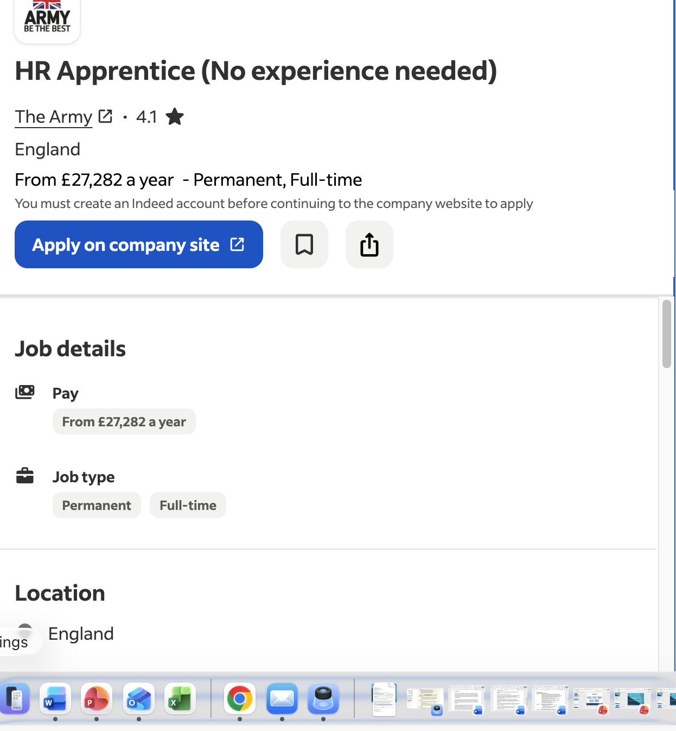

Cover Letter

Dear Sir/Madam,

I am writing to apply for the role of HR Apprentice, currently being advertised on the Indeed website. A highly experienced and customer-focused professional with over 20 years of experience across reception, administration, customer service, retail supervision, catering, and care services.
In my current role as Receptionist (Guest Service) at Network Rail, I have been responsible for welcoming visitors, managing visitor sign-in procedures, booking meeting rooms, answering and directing telephone calls, and aiding staff, contractors, and visitors. All of this coupled with my enthusiasm and dedication. I gained extensive experience in customer service, problem-solving, teamwork, and building positive relationships with customers and colleagues.
I am proficient in Microsoft Office 365, including Excel, Word, PowerPoint, Outlook, and Teams, and I am confident using technology to support business operations and maintain accurate records.
I am confident that I can bring my experience with me to your company and help with strong work ethic, and commitment to excellent service to the Business Assistant role.
I look forward to hearing from you.
Kind Regards,
Paulina Leon

CV
PAULINA LEON MONTEROS
4 Kent House, 112 Hardy Road, South Wimbledon, SW19 1HZ
📧 pleon2644@gmail.com

PROFILE
- A highly experienced and customer-focused professional with over 20 years of experience across reception, administration, customer service, retail supervision, catering, and care services.
- Currently working as a Receptionist at Network Rail, providing exceptional front-of-house support, managing visitor services, coordinating meeting facilities, and ensuring smooth day-to-day operations.
- Effective communicator with people at all levels, handle multiple tasks in fast-paced environments.
- Excellent organisational skills, attention to detail, and a strong commitment to delivering outstanding service.
Education
Oct 2025-Present University of Wales Trinity Saint David (UWTSD), London
Certificate OF Higher Education (CertHE)-Business Skills for Workplace

WORK EXPERIENCE
July 2023 Receptionist- Networkrail
Present • Main point of contact for visitors and the company’s employees
• Greeting and welcoming guests/visitors on arrival at reception.
• Ensuring that all visitors sign in and providing badges when required
• Providing information and assistance to all visitors and employees
• Answering phone calls and replying to emails promptly
• Booking and allocating meeting room spaces.
• Ensuring meeting rooms are clear, set up for the next meeting
• Arranging catering for meetings when needed
Feb 2024-  June | Catering Assistant Cover Blue Arrow  - Delivering a quality catering service in line with the health, safety, and hygiene procedures  - Preparing meals and using the equipment correctly  - Working under pressure to deliver orders on time.  - Taking orders, serving customers
Nov 2004 –  Jan 2023 | Visual Merchandiser Supervisor - Primark LTD  - Delegating work to team members and providing training to ensure all members of staff adhere to company standards.  - Delivering high visual standards to meet customer expectations and maximize sales.  - Liaising with all department managers and coordinating changes required for new campaigns to promote the latest trends.  - Responsible for maintaining visual displays and windows with eye-catching products.  - Providing excellent customer service and dealing with complaints  - Placing orders to ensure stock promoted on displays is always available for customers to purchase.
Feb 2004 – Jun 2020 | Senior Care Assistant - Gate Lodge Residential Home  - Running checks and writing daily reports  - Administration of medication for Services Users as they need it  - Helping Service Users with daily personal care such as dressing, using the toilet, and feeding themselves  - Carrying out general tasks such as housework and laundry
INTERESTS
I maintain a consistent gym routine, demonstrating discipline, resilience, and a strong commitment to physical and mental wellbeing. I practice yoga regularly, which supports mindfulness, emotional regulation, and the ability to remain calm under pressure. I also enjoy baking and cake decorating, reflecting patience, care, and attention to detail—qualities that support delivering high standards of person-centered care.

Reference available upon request

