
Module Name: Academic Skills in the Digital Era
Module Code: BMSW4013
Assessment 1: E-Portfolio
Student Name:
Student Number:
Lecturer: Jaliya a sliva
Deadline: Friday 21st November 23:59PM

AI Acknowledgement
Examples of statements If you have not used AI
I confirm that I have not presented any AI generated materials as my own work.
I confirm that I have copies of my drafts, notes, and other resources I used, which I may be asked to provide in evidence.
Examples of AI statements if you have used AI
Example 1:
I acknowledge the use of Grammarly (https://www.grammarly.com/) on Date to check my work using the prompt(s):
1. Please check the following text for readability, grammar and syntax.
I confirm that I have not presented any AI generated text as my own work. I confirm that I have copies of my drafts, notes, and other resources I used before, and after the use of AI tools which I may be asked to provide in evidence.
Example 2:
I acknowledge the use of SciSpace (https://typeset.io/) on 7 March 2024 to support my research using the prompt(s):
1. Please provide me with materials on the biology of the liver.
2. Please provide me with materials on liver cells.
I confirm that I have not presented any AI generated text as my own work. I confirm that I have copies of my drafts, notes, and other resources I used before, and after the use of AI tools which I may be asked to provide in evidence.
Example 3:
I acknowledge the use of ChatGPT (https://chatgpt.com/) on 13 April 2024 to write my notes into submission format using the prompt(s):
1. Please write up these bullet points as an essay paragraph at university level.
I confirm that I have not presented any AI generated text as my own work. I confirm that I have copies of my drafts, notes, and other resources I used before, and after the use of AI tools which I may be asked to provide in evidence.
*You must provide an AI statement

Contents
Component 1 – Research and Planning Template (500 words) 4
Source Exploration (200 words) 4
Key Challenge for Students (100-150 words) 4
Key Opportunity for Students (100-150 words) 4
Planning Your Report (100 words) 4
Timeline for Component 2 4
Component 2 – Answering the Question (800 words) 5
Introduction (100-150 words) 5
Challenges Students Face (150-200 words) 5
Opportunities Digital Tools Provide (150-200 words) 5
How Students Can Adapt (200-250 words) 5
Conclusion (100-150 words) 5
Component 3 – Reflective Presentation 6
Slide 1 (Overview) 6
Slide 2 (Research) 6
Slide 3 (Planning & Writing) 6
Slide 4 (Challenges) 6
Slide 5 (Successes) 6
Reference List 7

Component 1 – Research and Planning Template

Source Exploration
The source chosen is ‘university students self-regulated learning using digital technologies’ written by C.Yot-dominguez and C. Marcelo and was published in 2017.
The main point of the article is that digital tools only help when students can plan accordingly and have some self-discipline to avoid distractions and monitor that they are progressing in an orderly manner. Digital tools are helpful in many ways, but they can be a distraction as well. It also requires the student to be focused, but the authors found that a lot of students lacked motivation and focus.
This source was chosen because it is on a trusted website and is written by a recognised expert, and the article was CRAAP tested (Refer to Appendix 1) and was made sure the source was reliable.
This source will help answer the main question because it will show me the positive and negative effects, giving a better understanding. It shows real-life examples that can be used. The source covers a lot of the main points that can be shown.

Key Challenge for Students
One massive challenge for students is that it is very easy to get distracted by technology and do something we aren’t supposed to be doing. When using any type of technology, it is very easy to get distracted by social media, games, or watching videos or movies.
From personal experience, when I was doing mock papers at home, I would get distracted and go play games with my friends and forget that I was even studying. Within the article, I read that it mentions a lot of students have digital overload, which stresses them out, lowering the quality of their work.
This challenge is important because it affects students’ performance and their effective use of digital tools. Students need to have the capability to not be distracted and focus, and to create a plan (Pintrich, 2004)

Key Opportunity for Students
One major benefit is that it allows a lot of students to learn in new and different ways to suit their needs. Students can learn using video, blogs, and presentations. Students like to use recorded lectures to study (Gorissen et al.,2012). The article highlights that digital tools improve teamwork platforms like Zoom and Microsoft Teams. Also, according to the article, students can access information online via databases, eBooks, academic videos, and other resources that can be found online.
This opportunity is valuable because people need to be able to navigate the internet correctly without being distracted and handing in lower-quality work. Digital tools can help students improve their overall work.

Planning Your Report
In the report, I will focus on opportunities and challenges equally because having a firm understanding of both because they are just as equally important. Students need to refrain from distractions and use digital tools correctly.
I plan to include tools like Zoom and Google Docs because they are used a lot in education and examples of digital distractions.

The report will follow this structure: Introduction, then main challenges, discussion of key opportunities, strategies students can use to beat any challenges, then conclusion Timeline for Component 2
Task | Date/ Deadline
Finish research | 26th October
Draft first section | 7th November
Complete first draft | 14th November
Final editing | 20th November

Component 2 – Answering the Question

Introduction
In today’s world, technology has become the norm and is essential to student learning. From digital tools u can find online, too videos and articles and things like ChatGPT, while these tools offer a lot of advantages, we need to understand the harm and challenges they may bring with them, which can affect student success. Understanding both the benefits of and the harm of digital learning. Students need to manage distractions, find ways to surf the internet and evaluate information online, and use these tools to succeed academically. This report will explore one challenge students face with using digital tools, with two opportunities that technology provides, offering practical strategies to adapt to digital learning.
digital tools, with two opportunities that technology provides , offering practical strategies to adapt to digital learning.

Challenges Students Face
One challenge student’s face in the digital era is distraction caused by being online. When we have things like TikTok, YouTube, social media, and gaming all trying to keep Ur attention on their apps. When I study in my room, I sometimes get tempted to go and play games or relax on my phone and not concentrate on my task. People are constantly getting notifications on their phones and not being able to pay attention to the task at hand, which harms productivity.
Another related challenge is the vast amount of information on the internet, and not all sources are credible. (Yot-Dominguez and Marcelo, 2022) Many students struggle to find reliable information online, which can affect their work, and can also lead to students spending more time looking for reliable information. These challenges are important because they can affect Ur focus and Ur grades. Without proper strategies in place, it will affect students’ concentration, grades, and their ability to learn diminish.

Opportunities Digital Tools Provide
The digital tools offer so many opportunities to students, like having a wide access and range of videos and online materials, things like databases, videos. The ability to find all these digital tools online with a click of a button is a big advantage to students who may learn faster or slower than others. For example, I use YouTube to find videos explaining things that I may not have understood in class, which helps me learn better.
Another opportunity is that digital tools increase academic engagement with their work. According to (Lin and Yu 2023), digital reading tools improve students’ enthusiasm, which leads to higher motivation and better academic outcomes. These opportunities are valuable because they make the student more confident and enthusiastic, which increases productivity. When used correctly, these digital tools can boost a student's productivity and understanding of their work.

How Students Can Adapt
To be successful in today’s digital age, students need to be mindful of using technology. Here are 3 methods of adapting.
1. Time management
One effective approach is trying to improve Ur time-management skills through tools like planners and calendars. These tools can help students break down their tasks into multiple parts that are manageable to them and to maintain consistent studying (Santiago & Gurat, 2023). Students using the Pomodoro technique performed better.
2. A.I tools
A.I. tools can be very useful, but u must cross-reference the information they used to ensure it is correct. But if u know how to use A.I I think you can avoid this by inputting more information into the A.I. Tell the A.I I need to look at specific certified websites that Ur teachers recommend. But always cross-reference Ur information.
3. Academic support services
Students can benefit a lot from accessing support services, such as digital workshops and online videos. Many educational institutions offer these things to their students, which helps them develop research skills and boost confidence in using their digital literacy skills. Some people are visual learners and need to see the video to learn more effectively, which gives them the personalised digital learning they need.
If students follow these 3 suggestions, they can more effectively research and improve their learning and digital skills.

conclusion
In today’s day and age of digital era, students face a lot of challenges and opportunities when using tools online for learning. Distractions and information overload can stop Ur productivity if not properly dealt with, but digital tools offer a lot of important benefits like increased access to learning resources like videos and personalised learning. To succeed in this digital era, need to manage Ur time effectively, use AI tools responsibly, and practice ongoing digital literacy, which will then develop the necessary skills to succeed in a digital learning environment, and develop skills for after education and in the workplace.

Component 3 – Reflective Presentation


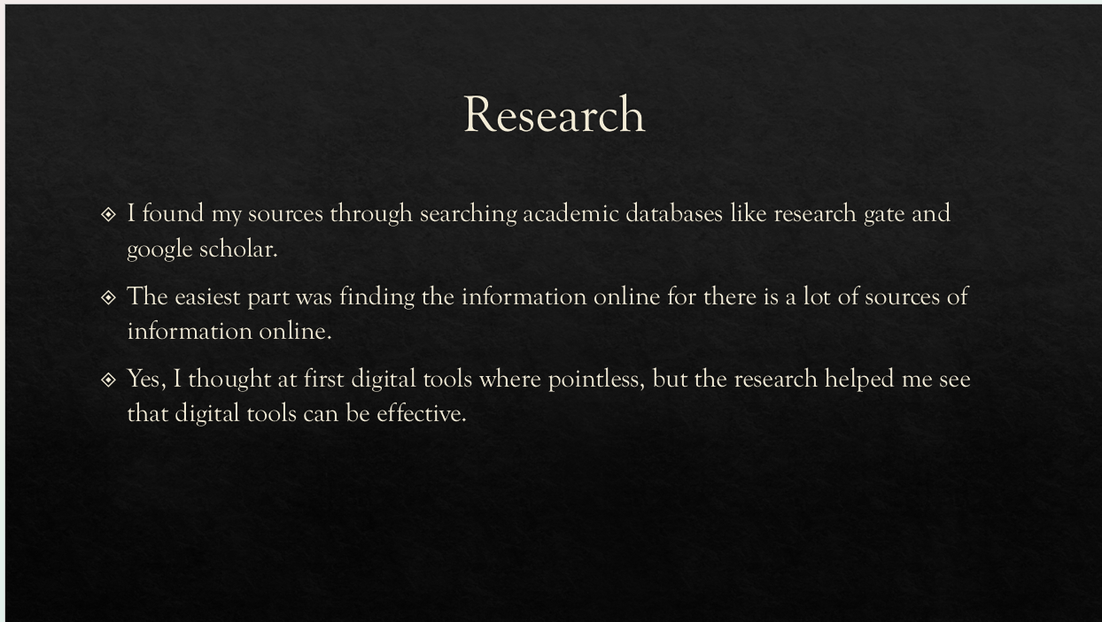
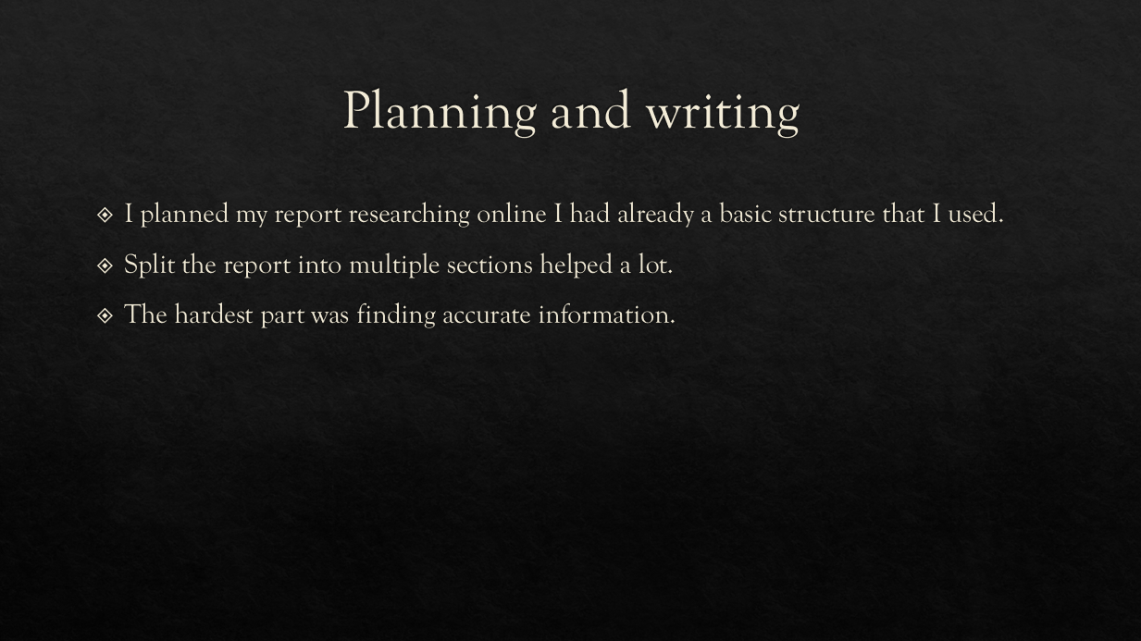
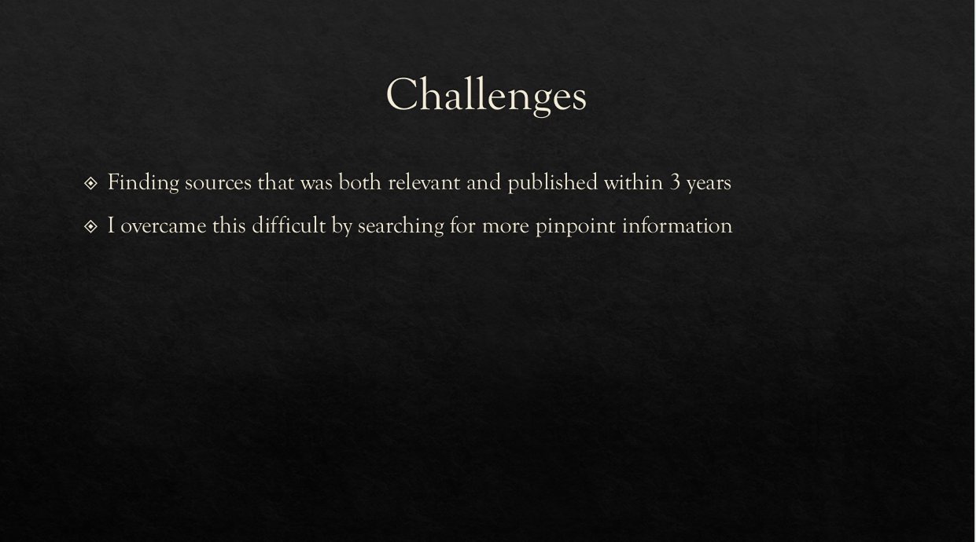
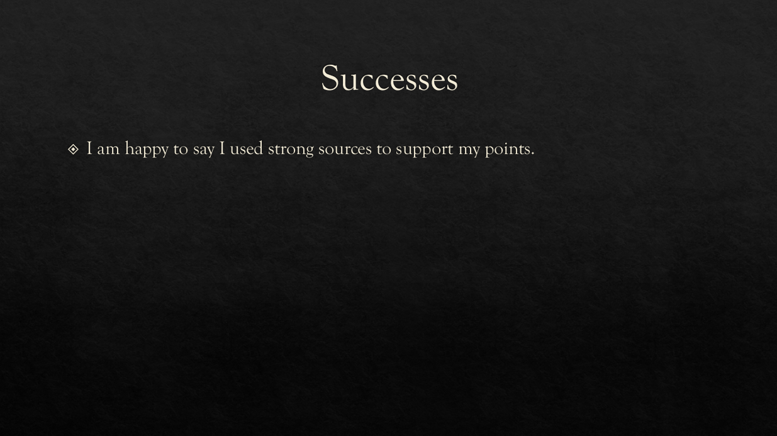
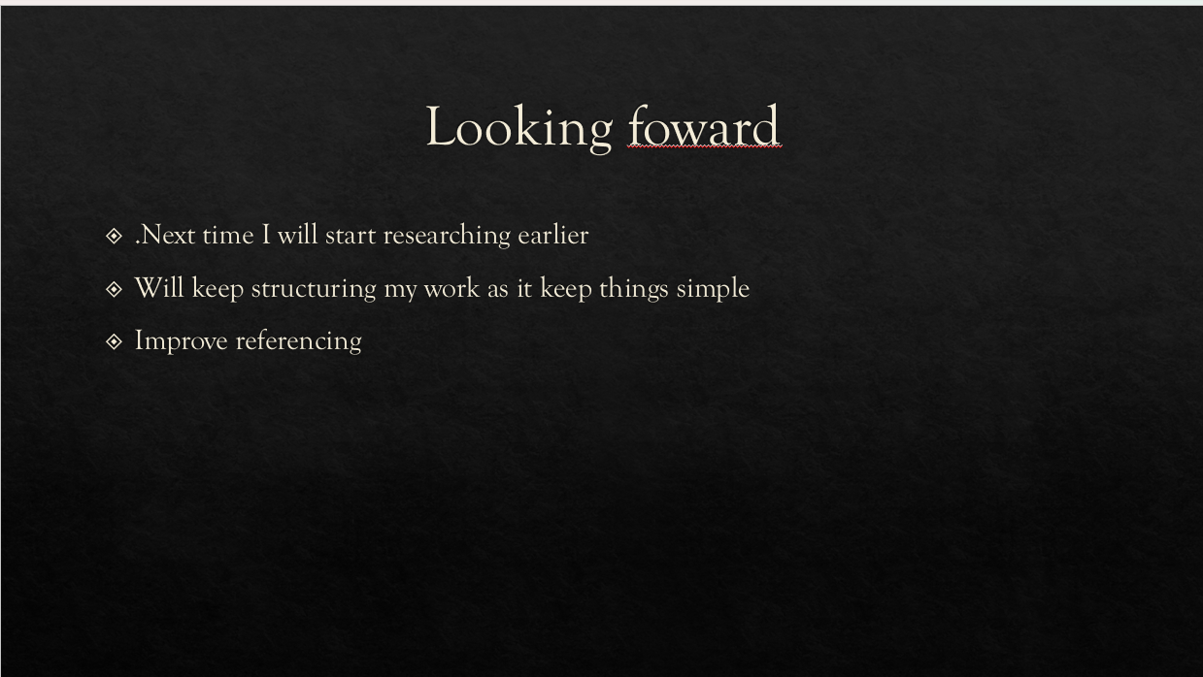

Reference List
https://educationaltechnologyjournal.springeropen.com/articles/10.1186/s41239-017-0076-8
Pintrich, P. R. (2004). A conceptual framework for assessing motivation and self-regulated learning in college students. Educational Psychology Review, 16(4), 385–407. doi:10.1007/s10648-004-0006-x.
Gorissen, P., van Bruggen, J., & Jochems, W. (2012). Students and recorded lectures: Survey on current use and demands for higher education. Research in Learning Technology, 20, 297–311. doi:10.3402/rlt.v20i0.17299.
https://educationaltechnologyjournal.springeropen.com/articles/10.1186/s41239-023-00403-8
https://media.neliti.com/media/publications/571767-the-effect-of-pomodoro-technique-on-stud-a804598b.pdf
Appendices

Appendix 1: CRAAP Test

- Currency: The article was published in 2021, so it is quite recent and up-to-date. This is important because technology and digital learning tools change quickly.

- Relevance: The article directly discusses how technology affects student learning, which is exactly what the assignment asks for. It is written for educators and students, making it relevant and useful.

- Authority: Youki Terada is a recognised education writer who frequently contributes to Edutopia, a well-respected website supported by The George Lucas Educational Foundation. This adds credibility to the source.

- Accuracy: The article provides clear examples and references research studies to support its points. Edutopia is known for fact-checking and providing reliable educational information.

- Purpose: The purpose of the article is to inform and help educators and students understand the benefits and challenges of using technology in learning. It is not trying to sell a product or promote a specific company, so the information is likely unbiased and trustworthy.

