The Flower Fairy
(Business Plan)

Managing Enterprise in the 21’st Century-BMSW4006

Team leader: Cristina Creciun
- Tamara Brylewicz (1915163)- Business Description; Operations; Technology Plan.
- Cristina Raluca Torjir (2012059)- Business Structure; Product or Service Description.
- Cristina Creciun (2011283)- Market Analysis and Trends; Marketing Strategy.
- Dado Maria Balde (2009504)- Social Responsibility and Sustainability; Development, Milestones, and Exit Plan.
- Eduard Mihai Cozma (2011267)- Financial Data.

Lecturer: Malani Gunaratnam

Cover letter

Cristina Creciun (Marketing manager)
Tamara Brylewicz (Operation manager)
Eduard Mihai Cozma (Financial operation)
Dado Maria Balde (General manager)
Cristina Raluca Torjir (Director)
The Flower Fairy LLP
Acton, 257 High Street, W3 9BY
Halifax 41 The Broadway, Greenford UB6 9PQ

26 April 2021

Dear Malani Gunaratnam
I want to thank you for opportunity to present our new business initiative ‘The Flower Fairy’. The business plan presents a wealth of information about our business, analysis, and our plans. The Flower Fairy is an online shop where we will sell soap flower. We will sell boxes, bouquets and separate flowers for customers who want to create something personal.
We are 5 partners and we have all together a budget of 30000 £. Because the soap flower market is not very large in the UK, we believe that we will be able to grow this business to make enough profit to grow and become a successful company.

Thank you so much for your involvement in this. I understand how important your time is. If you would like to meet with us to review our business proposal, we are always happy to make an appointment. Thank you once more.

Sincerely,
The Flower Fairy teams

Table of content
- Cover letter
- Executive summary
- Introduction
- Business description
- Operations
- Technology plan
- Business structure
- Product and service description
- Management and organisation
- Market analysis and trends
- Marketing strategy
- Appendix

Introduction
Purpose of this report is to show our business plan detailed. Present how it is going to work and how we plan to grow it.
The Flower Fairy is a soap flower trading business based in Acton. The company will sell soap flowers bouquets and boxes, that are uniquely designed and delivered to the buyers. The business will be sourcing a range of common and rare flowers from our suppliers Alibaba. In this report, discussions have been made on our business plan for a better understanding of the business model.
Executive summary
This report describes our business plan. The Flower Fairy is going to be a web site where we will sell soap flower, bouquets, boxes, etc. The actual product involves various premium quality and uniquely designed soap flowers and flower bouquets packed with aesthetically designed boxes.
We will have a clear and simple menu, will have a customer service chat and payments will be made by bank cards and PayPal service. We will have 7- 10 members of staff: Director, marketing manager, general manager, finance manager, manager, and 5 members of team workers. The products will be delivered by Royal Mail service. Our sales territory includes West and North West London.
The Flower Fairy will have discounts at different times of the year. For example, Valentine's Day, Easter and Mother's Day. Also, the clients coming from the social networks, where we will have the pages of our company, will have a 10 percent discount.
Soap and detergent production in the United Kingdom industry are rising 2015-2020: 0.6%. In addition, majority of shops goes to online selling and this field is continuously growing. For this reason, we are confident that we will be able to succeed in the UK market.
According to Porter’s Five Forces research and SWOT analysis, there are some risks, but also we could see advantages, as result we will make all possible to overcome all risks and issues and use all possibilities and opportunities to grow our business.

Tamara Brylewicz
Business description
On this topic I had to explain what this topic is and what is his main purpose and what it is made off, well this product is made out of soap and the Rose or the Cala lily is then dipped into the boiled scented soap and left to dry and the flowers dry then they are placed into the main box itself, The product is mainly used for hot baths but can also be set for a nice design to the bathroom as it smells nice it gives out a nice sweet or clean smell it all depends on what scent you pick ,the business has only one owner and there are around 7-10 staff employed, this business has a online website so this business is partially based on online shopping as for now but maybe in the future once the profit jumps up the scale it might even be considered to open a store, but first we have to see how it will go on via the online shopping, we have a small budget we are not willing to spend a lot of the money to open a store if the business will go downhill a lot of our budget and profit might go downhill also that’s why you always have to think through everything before you open any business,
It is also a restricted environment in this business , there are aa few popular and successful like for example the fragrance direct they do those flower soaps also and they usually start the cost from £10 and they can go up, also the prezzbox have lovely prices and amazing stock with the same business in the field as our flower fairy have, the flower fairy also comes in different boxes and all the boxes have different costs and the scents have different prices and so do the type of flowers you wish to order, our online website is all the best and most beautiful the best in advertising and it explains and shows all what you need to know and it is very easy to access and as it is a certified and trusted website there is no need to be scared as and when you can use your credit card because our website is secured and no one can ever hack nor buy it off , The website was best invented because you don’t really see a lot of this types of shops in the field yes fragrances shop or supermarkets but not a lot of flower soap shops , Lush the big organization also sell flower soaps but again not in the same idea we are offering to the population , it is hard to find the right scent to have a nice bath yes you have lavender but why can’t you have a nice strawberry or a nice other sweet scent and then not only does your bath feel better and calmer but also your skin feels refreshed and shiny, all our products are tested before anything goes out for sell we make sure it does not harm anyone in anyway and it also labels keep out of reach from children as it is a dissolving scented flower and kids like to put everything in there mouths and touch everything best kept out of reach, as I mentioned the prices are different and so are the scents there are also nice deals which you can catch every so often and nice sales like buy one and get the other half price or buy 3 for 2 , we all love sales and deals I know if I had a sale every day on bags I would probably lose around 200 pound every day and so I say people not only pay but can also benefit from the deals and sales as it is worth it,
In my opinion this job would suite as a part time job because the job hours are 6 hours of working, The deliveries are also delivered by Royal Mail and Herms, So for express next day delivery the order would be delivered by a member of the staff because they can drive up and give the customer the product straight to their hands and for standard delivery the product would be send by the Royal mail or Herms , I know how it can be hard when you buy something last minute and it doesn’t come on the special day you are supposed to have it for that’s why we made a deal with our staff for express deliver they personally have to deliver the packages so no one feels left out on Christmas or Valentine’s Day or a birthday, the express delivery are fast and safe so don’t worry your package will not be damaged, the return policy only comes in hand if the box was opened before our customers receive their orders and our agreement with royal mail and herms is to always take photos of any delivery they make so at the end of the day there are no problems and no mistakes, our employed staff also know this number one rule , our express deliveries come next day even on a Saturday or Sunday and our standard deliveries take 3-5 working day yes of course they do not have to take 3-5 day they can come in 4 days 3 days we are just estimating that is why it says 3-5 working days, if it take any time longer we are very sorry just give us a quick call on the provided land line which is listed on our website online call us and we are always there to help you with anything you need help with all our calls are recorded.
The products audience is for a woman or a young lady best gifted for valentine’s day or birthday or Christmas, Age audience would be from 16 and on words, anyone can buy it but best gifted for a woman or a young lady.
OPERATIONS
On the operations subject I have talked about what type of delivery methods the business has , and what areas they would cover, for now we said we would only cover West and North West London areas and if everything goes well the business expands they might even open a store nearby and cover more areas more postcodes this business only covers certain areas because of the low budget they have and if they grow more profit they might procced to cover more areas and now they only have a online website that is certified and trusted and the website has a contact us if any one need any information about the product something wrong with the delivery or any other queries.
The main suppliers will be Alibaba and Amazon, why because they have good products and great prices and with the low budget that the flower fairy company have it all adds up and they still have a bit money set aside for the staff and if they need more product, they can just stock it all.
TECHNOLOGY PLAN
The technology plan we as a group picked out was.
Phone
Laptop/computer
And most have internet for the legal website the Flower fairy has, as it is only a online store meaning you can only buy and order the products through a website, the website is safe and secured so no one has to worry,
There will always be updates on the websites for great deals and sales and new products that can always jump on the trends as we a humanity know that there are new trends nearly every day and who doesn’t like something new, something that not all have, something better, the website will be updated every day so don’t worry about it being delayed,
There will also be a landline for customers queries or if something happens to the product etc you can always call and there will always be someone gladly to help you.
The laptop will also be used to buy new products and search for new scents that can also be made home and procced onto the flower like I said before.
There is one person who takes the time to make the product and someone who can answer phone calls from customers and someone who can order more stock for the product to be successfully made and safely send off.
Summarising
The flower fairy is a good idea not a lot of places sell products like our flower fairy it is flower soap scented and when the flower is placed into the water it dissolves in the water making the water all nice and warm with different colours and different scents a nice beautiful romantic even bath if not bath it is also nicely presented and a object bringing the bathroom or toilet looking even more cleaner and prettier and if you like you can take one out and leave it out as the beautiful scent can spread and the lovely scent can be felt and it warms your home as your hearts, best gifted to loved one or as a birthday present for daughter or mother, there are dissolving flowers and flowers where you can have for decorations for the bathroom, why we picked out the areas we picked in our defence it is a small business and its all through the website, if the profit starts rising they might even open a store and of the business goes really great and there are a lot more sells they can open more stores and expand the areas and there for get even more works and more products and newer trends and more deals and more profit, if I was supposed to open a store and sell the flower soaps you never know how it might go and there for if the store ends up closing more money would be lost, and like this first having a website then if everything goes as planned they can go and then open up stores, the products have different pricings and different scents and for the express delivery next day delivery you pay a bit for as in if you pay for a standard deliver 3-5 working days it would cost you less for delivery fees.
They are worth your money and worth your time.
Why we picked Alibaba for the main suppliers because they have great products that cost less money and less outcome means more income but of course you will not buy a product that might harm you in any way they will be tested before anything goes out for sell, so you can bare that in mind.

Cristina Raluca Torjir

Business structure
The business will go by the name, the Flower Fairy. The name will be trademarked as soon as the business plan gets the approval from the investors. Currently, there are no businesses in the soap flower industry with the same name. The company is also in the process of purchasing the www.theflowerfairy.com website. The catchy name and product relevant website name will be useful for securing a strong position in the online space (Zacharakis, Corbett and Bygrave, 2019).
The company’s mission and vision statements are following:
Mission statement:
We offer the finest soap flowers in England, and we ensure that our customers get the best value possible.
Vision statement:
“1. To own up the largest market share for soap flowers in England.
2. To offer the best value through a customer-oriented business model.”
The business will be located in Acton and Harrow Thus, the business operations will be focused on these parts of London. The company will be positioned in a way so that it can easily expand into other parts of London once the business takes off successfully (Westhead, McElwee and Wright, 2011). The company will mainly operate online, and therefore, its sales will not be limited in a small geographic area.
The official business hours will be 9:30 to 6 pm, five days a week. However, the online customer support operations will remain available 24 hours and 7 days a week. The company’s owners will share the online customer support activities with the marketing staffs to ensure that a seamless customer service experience is ensured (Westhead, McElwee and Wright, 2011).
The business will not be seasonal. It will operate throughout the year. However, some products might have seasonal supply, which is why, they will be replaced with other items when they are unavailable.
By nature, the Flower Fairy is an ecommerce based premium product seller. It is a product-based business, and therefore, the main business operations will consist of procurement, packaging, operations, and distribution.
The business will succeed by ensuring a personalized shopping experience, and with commitment to quality. A lean management strategy will also be integral to the success of the business. Lean management strategy involves implementing a plan of actions to keep the business overheads less so that the profit margins are at the desirable levels (Westhead, McElwee and Wright, 2011).
The company market for soap flower in the UK is growing at the rate of 8% since 2018. Therefore, there is a decently growing market that can be captured (Hisrich, Peters and Shepherd, 2019). Secondary, the premium skin care sector in the UK has an 11% growth rate on an average, which is also an indication for the business’s success in the UK market (Westhead, McElwee and Wright, 2011). The growth strategy that the company will follow is the market penetration strategy. Bu definition, market penetration strategy involves “the successful selling of a product or service in a specific market. As for its approach to market growth” (Hisrich, Peters and Shepherd, 2019). The company will not be developing its own products at this point, and therefore, product development and diversification strategies will not be pursued (Zacharakis, Corbett and Bygrave, 2019). Given the growing demands for the products in specific market segments, the features of the products will be kept at the talking point for making more customers aware of the products. Aggressive marketing and promotion strategies will be carried out to increase the sales of the products (Hisrich, Peters and Shepherd, 2019).
The company will need to hire moderately skilled staffs for its operations. It won’t spend heavily on HR functions since the company will have to maintain a decent profit margin. Therefore, moderately skilled employees would be suitable for the business (Hisrich, Peters and Shepherd, 2019).
Currently the business is being funded by the owners and the investors. Since the operations have not officially started yet, therefore, the business is not making any profits yet either. However, the company will start generating a decent amount of profit after year 1 of operation. The business should have at least 5% market growth rate in year 2, given the market projections (Lambing and Kuehl, 2019). In the long run, the company has plans to cover the entire UK market, and if possible, export the items in other countries in Europe (Maida, 2021). Therefore, there are scopes for market development strategy in this business.
The company will trademark the logo and the name of the business. However, since the products are manufactured by others, therefore, the company itself will not have any patent. (Westhead, McElwee and Wright, 2011) But if the company can come up with any unique idea for product packaging and designing, then it will apply for patent rights in the UK.

Management and organization
The Flower Fairy will debut as a partnership business, B to C, that means is business to customers. The founding owners and the key members of the executive management team of the company will be Tamara (Operation Manager) Cristina Torjir (President) Cristina Creciun (Marketing Manager), Eduard (Finance Manager) and Dado (General Manager). The owners will take responsibility of each business function including marketing, finance, and operations (Zacharakis, Corbett and Bygrave, 2019). Thus, the company will have a functional structure. The functional structure will facilitate the management activities. Each founding member has skills in specific functional area, which will help specialize the management functions. The functional structure will also have good impact on the strategy development and execution process. Each functional manager will develop strategies for the department (Westhead, McElwee and Wright, 2011). Following is an illustration of the company’s management structure.

Figure: The above is an illustration of the management structure
As the management structure shows, Christina Torjir will oversee the Product or services and the coordination of the management activities to the business operations. This way, each part involved will have their own set of roles and responsibilities: Tamara (Operation Manager)1. Business Description 2. Operation 3. Technology plan. Cristina Torjir (President)1. Business Structure 2. Product Description 3. Management and Organization. Cristina Creciun (Marketing Manager) 1. Market analysis and trends 2. Marketing Strategy. Dado (General Manager)1. Social Responsibility and Sustainability 2. Development milestone and exit plan. Eduard (Finance Manager)1. Finance, cash flow, current assets, and capital investment.

Product description
The core products that the business is going to sell are soap flowers and other floral gift items. The core benefit that the business will offer include soap flowers and flower bouquets. The actual product involves various premium quality and uniquely designed soap flowers and flower bouquets packed with aesthetically designed boxes and containers (Lambing and Kuehl, 2019). The augmented benefit that the products will offer is that the customers can make their purchase online and will get product delivery whit Royal Mail delivery service and will get product delivery within 3 to 6 hours maximum. The potential product is that the business could also be offering vegan soap flowers specifically targeting the ethical and sustainable consumers in the UK (Westhead, McElwee and Wright, 2011). Thus, the product levels will be designed to create the perfect value proposition for the customers. The customers will be able to find all the information they need regarding the product on the company’s website before they make a purchase. The business acknowledged ingredients of the items.
The market of soap flowers in the UK has grown by 8% since 2018, which gives it a good reason to invest in. The UK customers are fashion lovers by nature, and therefore, they will find the products to be perfect match to their preferences (Maida, 2021).
The products will be sourced from trusted and reliable suppliers on Alibaba. The company will mainly focus on purchasing the products that are not currently available in the UK so that there is something unique it can offer to the British consumers. The company does not intend to directly compete with other market rivals in a head-to-head rivalry. Therefore, the company will focus on purchasing the products that are rare in the UK market, and of course, offer premium quality. The product procurement strategy will have a key impact on the company’s market performance, and therefore, this function will be properly carried out.

Value proposition
The value proposition here is the artistically designed soap flowers and flower bouquets with unique aroma and premium feel (Zacharakis, Corbett and Bygrave, 2019). The pains of the customers that the business will fulfil include the difficulties in finding the soap flowers that maintain their aroma and premium feel even after being kept outside for a couple of days (Zacharakis, Corbett and Bygrave, 2019). Most of the current products in the market lose their aroma within a few days, soon after they have been unpacked. But the Flower Fairy will source the premium products from the most trusted suppliers. The gains of this product involve the ecommerce purchase facility, fast delivery, and premium quality (Hisrich, Peters and Shepherd, 2019). Following is the value proposition map of the product.
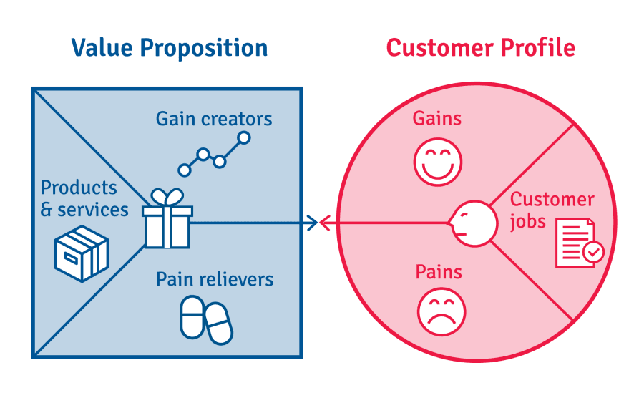
Soap flower
Flower bouquet
Other floral gift items
Sourced from trusted suppliers.
Ecommerce model
Quick response time
Premium quality
Select product online.
Make a purchase.
Difficult finding the right products.
Some products include risky ingredients.
Premium quality
Fast delivery
Online purchase
Figure: Value proposition map (Zacharakis, Corbett and Bygrave, 2019)
The value proposition map shows the values to be offered by the product to its target consumers.
The target market segments can be defined as the following.
1. Demographic market segment: Male and female between the age group of 16 to 45 (studies reveal that the mentioned age groups are the largest segments purchasing soap flowers and flower bouquets in the UK (Maida, 2021). Therefore, the business will be targeting the most profitable market segment). Upper income class and middle-income class (the products will come at different premium price points for the customers to choose from based on their spending pattern (Zacharakis, Corbett and Bygrave, 2019). However, customers willing to purchase premium products will be the key target demography).
2. Geographic market segment: England (As a start-up business, the company will mainly target the market in England) (Maida, 2021)
3. Behavioural market segment: Value seekers, convenience seekers, premium buyers, regular purchasing pattern
4. Psychological segment: Demand for premium items (Maida, 2021).
The products will be developed following differentiation focus and cost focus for the separate line of items. There will be a higher premium line of products that will be augmented through differentiation focus (Lambing and Kuehl, 2019). On the other hand, there will be a mid-premium line of products that will be introduced with cost focus strategy. The differentiation focus strategy will be followed by collecting finer items from exclusive sellers and augmenting the items with uniquely designed and personalized packaging (Hisrich, Peters and Shepherd, 2019). Thus, the customers will get the feel that the products are specifically designed to cater to their needs. The higher end products will be perceived more exquisite by the customers compared to other similar products in the market (Zacharakis, Corbett and Bygrave, 2019). Thus, the differentiation focus strategy will be pursued.
Cost focus strategy will be followed by sourcing some of the items from the local suppliers and packaging them in a cost-effective way. By definition, in cost focus “a firm seeks a cost advantage in its target segment” (Hisrich, Peters and Shepherd, 2019). The company realizes that there is a good demand for the products in the mid-range market as well. If the prices of some of the products are somehow dropped, the budget concerned customers would be intrigued to buy the items (Lambing and Kuehl, 2019).

Cristina Creciun
Market analysis and trends

According to Office for National Statistics, business spending in the United Kingdom increased by 1.3 percent quarter on quarter in the final three months of 2020, compared to an upwardly estimated 14.5 percent increase in the previous quarter, according to preliminary figures. It plummeted 10.3 percent year on year. In general, corporate spending plummeted 10.7 percent in 2020, after a 1.1 percent raise in 2019.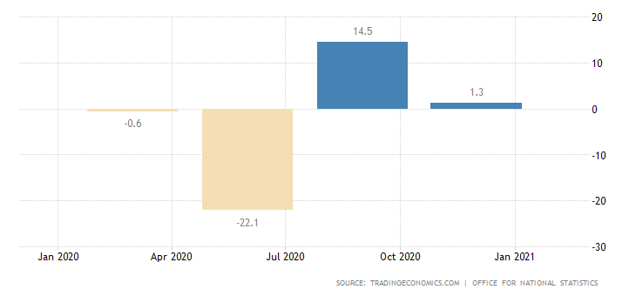
The global soap market is expected to grow by 5% between 2021-2025. Global population growth is driving the global bath soap industry. The diversification of materials fuels the market. Customers are now looking for soaps with a wide range of scents and moisturizing properties.
The global bath soap industry is extremely competitive, with the top three companies holding about 29% of the market. The top three companies in the industry are Procter & Gamble, Unilever PLC, and Colgate-Palmolive Company (Expertmarketresearch,2021).
Soap and detergent production in the United Kingdom industry are rising 2015-2020: 0.6%. Due to demand for COVID-19, which raises soap demand. The soap and detergent industry grew strongly in the last five years. Industry sales in the last five years, hit 1.9 billion pounds, are forecast to increase at a compound annual level of 2.6 percent by 2020-2021 (IBISWorld, 2021).

PESTLE analysis
PESTLE analysis is a structure or method used to evaluate and track macro-environmental variables that can have a significant effect on the success of an enterprise. It is also used with other methods, such as SWOT analysis and Porter’s five. PESTLE is an acronym which expresses political, economic, social, technical, environmental, and legal aspects (Business-to-you, 2016).
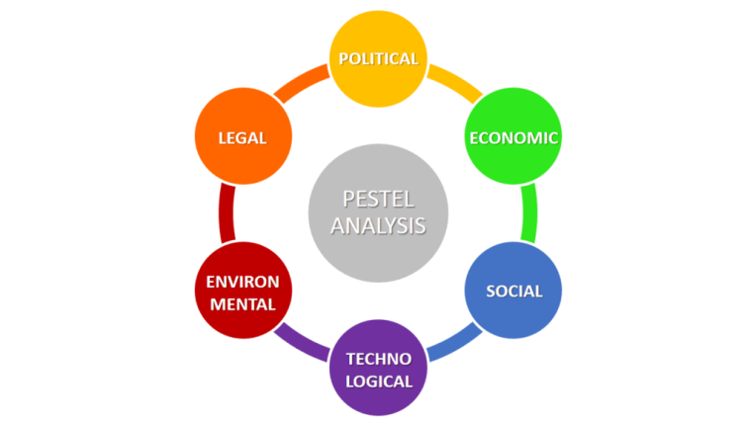

Political
The latest political instability and lack of certainty about the UK’s expected exit from the EU have created difficulties for retailers. When the UK leaves the EU, World Trade Organization (WTO) tariffs will apply to imports and exports between the UK and the EU. This is likely to increase the level of administration and additional costs. The impact of customs duties can also be a major issue for UK retailers. If no agreement can be reached for the UK to be a member of a customs union with the EU, customs duties can be levied (Conley, 2017). Because we want to import our flowers from non-EU countries, this will be a problem for us.
Economic
Because the economic downturn has affected the economy, companies have had to reorganize their sales and marketing projects considerably. They also had to reduce profits domestically and re-evaluate how to expand the market (Investopedia, 2020).
The current global situation and the local blockchain offer advantages to online sales, as many stores are closed. Many of these stores switched to virtual sales, and entrepreneurs were forced to change their development direction and marketing plans.
Social
Social factors have a major impact on online sales because everything around us is changing and evolving. Almost everything we use every day goes into the virtual environment, as well as sales. The situation with coronavirus pandemic has also influenced this type of business. People are depressed because they must stay at home, and they try to bring pleasant moments to families and friends by making small gifts, this offers opportunities for online stores to have a successful start-up.
Technological
With the advent of the new era in technology, companies have fully integrated with all the changes that have taken place. Almost every business goes to “Social Media” because each of us uses them, so a new sales market opens up, along with those that have existed so far in the online environment. The emergence of social media has brought a positive change and also the connection between them helps to distribute promotions and brings new comparators. The Flower Fairy will also have a direct connection with social media and we will offer some promotions for consumers who will promote us there.
Legal
There can be many legal implications for online sales, but this type of business certainly has a future. Our store will have a loyal policy towards our customers and, obviously, consumer rights will be respected first and foremost.
Under the UK online shopping law, before placing an order, the seller must: clearly show how shoppers can pay for distribution options and tariffs; include a description of the goods, services or digital content-Include as much detail as you should; includes transparent pricing and fulfilment costs and other details. Once the order has been placed, the seller must validate it, send the order receipt by e-mail, and deliver the order within 30 days (Gov, 2021).
Environment
Because in United Kingdom there are few sunny days a year, and it rains very often, people are happy to buy flowers to enjoy in their homes, especially since soap flowers have a long shelf life. These flowers are not made of plastic and do not have a negative effect on ecology and boxes are biodegradable.
SWOT analysis
Some of the strengths of our business are accessibility, prices, and a not so wide market. Therefore, the biggest strength of online commerce companies is accessibility. In the past, shopping meant travel to a certain place. With the advent of online stores, shoppers can access all the goods that interest them online. Being sold online, prices also fall due to lower service costs such as premises and staff services. Soap flowers are less common on the UK market, so we believe this business will be successful.
This type of business has a great industry specific weakness. This is because some products sell less well online, and especially a new product. Buyers usually prefer to see this product. For this reason, it can be difficult to develop this business.
In recent years, the florist industry has suffered, especially during the pandemic. External rivalry and a quickly evolving industry have devalued the florist’s specialist expertise, as they have with many other retail sectors. IBISWorld forecasts that business sales will fall at a compound annual rate of 8.4 percent to GBP 769.1 million in the five years to 2020-21, with a reduction of 26.3 percent this year (IBISworld, 2020).
One of the biggest opportunities for the online shopping industry is the growing market. In recent years, online commerce has grown significantly and continues to grow. Furthermore, retailers’ success is expected to increase over the next five years, according to IBISWorld, 2020. Owing to the expertise needed for intricate floral arrangements and catering for weddings, funerals, and other events, the specialist nature of flower retailing is likely to ensure that florists maintain a large market presence.
Here are some threats to the online soap flower business. The first is that we have competitors, so we are not the first on the market. The second is that there are risks of fraud working online. In addition, large stores, like Amazon that offer the same product as us, even if at a higher price but have the advantage of good advertising and a wide market.

Porter’s Five Forces
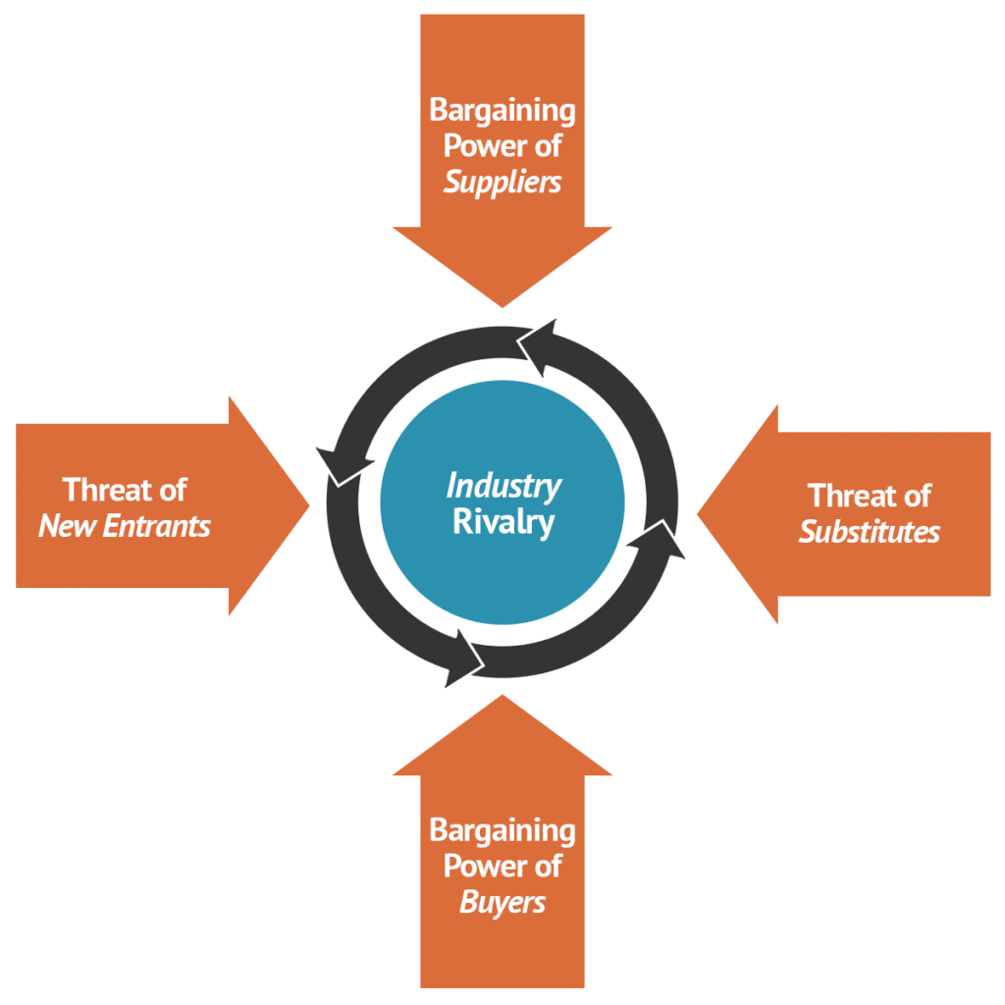
Threats of new entrants is moderate because to enter the market of online flower shops does not require huge investments. You need to have knowledge in the field of business, technology, and marketing. For this reason, it is not very difficult to enter this market, but this is also a weakness because the competition is high.
Bargaining Power of Suppliers is generally low to moderate, in the e-commerce industry. We plan to have the online store “Alibaba.com” as a supplier, this is a wholesaling business. They offer advantageous prices and do not have strict rules. In addition, it is possible to negotiate with the sellers and we can have some discounts on purchase and delivery. As a result, online shopping brands have an opportunity, and distributors’ negotiating power is reduced.
The main Threats of Substitutes of our business can be our competitors who have online or physical stores. They can gain the advantage of attracting customers by offering lower prices. In addition, some of the competitors have more experience. Customers can easily switch from one seller to another. Even if our competitors have some advantages, being new to the market and having new visions we can have some promotions, unique products that you cannot find in any other store for example sets where each client could make their own bouquet, according to their own preferences. Therefore, threats of substitutes are medium.
Bargaining Powers of Buyers is moderate in the online sales industry. This is because many online stores selling flowers or gift boxes have appeared. All brands aim to keep every customer and invest in technology, support to consumers and marketing campaigns for that purpose. We may give discounts to reduce our loyal customers’ costs. We may also include loyalty coupons to our clients, allowing them to get cheaper rates. Buyers’ bargaining power is moderately strong because of both factors. Factors that may moderate their bargaining power include market value, product and service efficiency, and price.
The level of Industry Rivalry in the industry is high due to the large number of companies. The number of local and global stores on the market has enlarged and this has also directed to bigger competition. Stores like Amazon, Ebay and Alibaba are global competitors but there are also local competitors like FloristSuppliesUK, BonneBombe and others. Therefore, the general rivalry in the artificial flower market is becoming very high.
Marketing strategy
Soap companies usually purchase flower baskets, bouquets, boxes, as a show of gratitude, typically for a variety of purposes. People normally buy flowers as a present, with more than half of the sales going on around holidays.
There are a lot of various “soap flower box” online and normal stores in London. The Flower Fairy can be distinguished by the prices on their boxes. Flower boxes, along with a personalized box choice and cheaper prices, would be a success for The Flower Fairy.
The Flower Fairy will be a B2C Business, it has a distinct group of consumers, both men and women aged 16-45 years. Our office is going to be in Acton (W39BY), this is west London and we are planning to cover west and northwest London: Ealing, Hounslow, Richmond upon Themes, Kensington and Chelsea, Brent, Hammersmith and Fulham. There are living 640372 people 16-45 years old, respective 330124 men and 310248 women according to Office for National Statistics.
Therefore, a cost focus strategy will be effective for increasing the sales of the company. The company will follow market penetration strategy as for its approach to market growth. Thus, the features of the products will be kept at the talking point for making more customers aware of the products.

7 P’s
Product
Our products are soap flowers and boxes or bouquets of them. The more detailed product description can be seen in Cristina Raluca’s section. 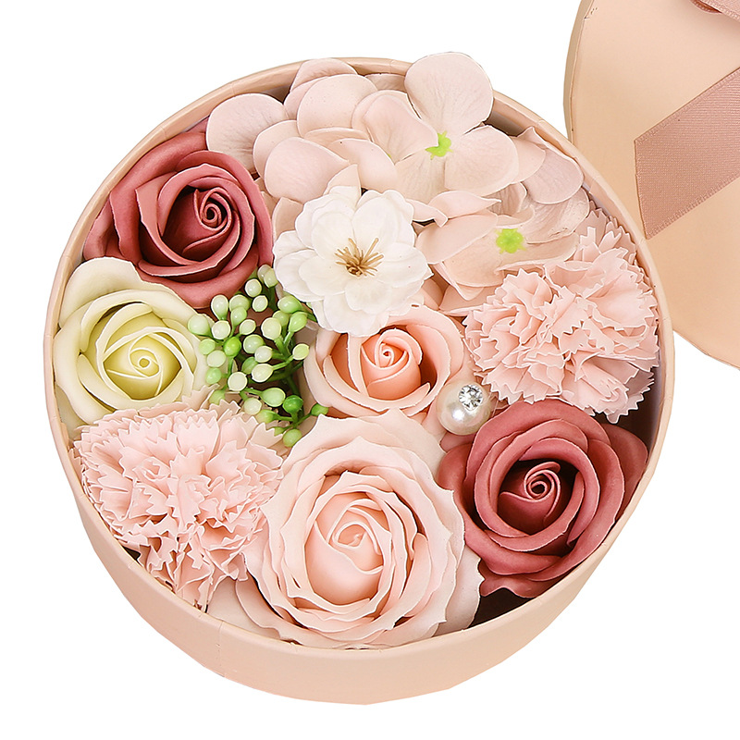
Price
We want to have a convenient price for our customers. For example, we buy a flowers box for £ 3.01 and plan to sell it for £ 14-15. Even if our competitors have similar prices, we want to offer unique, new products to attract customers. In addition, there will be delivery costs. We want to work with Royal Mail delivery service. Delivery prices start at £ 0.66 for a single delivery and can reach £ 6.75 if the customer requests special delivery. The type of delivery will be chosen by the buyer and payment for the product and delivery will be online by bank card or by PayPal service.
Place
Because we are an online store, our sales space is a web site and the purchases will be delivered to the buyer. Furthermore, we will have social media accounts where we will show our products and give a link to our web site.
Promotion
We want to offer a 10% discount on the first purchase to make a good first impression. On our social media accounts, we can also provide a code that the buyer can enter on the next order to get a discount.
In addition to these, we will also have holiday promotions: Mother’s Day, Valentine’s Day, Christmas, and Easter. For example, on Mother’s Day we plan to offer a 15% discount for women. On Valentine’s Day, entering the code “Love” could also get a 15% discount on the order.
People
On our site we will have the function of chat with customer service to help our customers with any information about our product or delivery. Moreover, we will have 10 staff members to help customers.
Process
Our customers will be able to place the order quite quickly, they only need to choose the desired product and the payment method. On our website, at the end of the order, the buyer will be able to choose independently the type of delivery where the information about the approximate waiting time will be written.
Physical evidence
On the main page of our site will be the menu key where the buyer can choose exactly the desired section either bouquets, boxes, or separate flowers. Upon completion of the order, they will receive a check on their email. The order will be carefully packaged to arrive safely.

Conclusion

In conclusion the fairy flower is going to be a B2C business. Our produces are soap flowers, boxes with flowers and bouquets of unique and qualitative flowers. Based in Acton, we will cover West and Noth West London, our target customer are people 16-45 years old. Our shop will be online and we will have a web site with clear and easy menu. Produces are going to be delivered by Royal Mail.
The Fairy Flower will have 7-10 staff, 5 managers and rest of staff. This is 5 friends business plan and we want to have one of us with most experience to be our director and rest of us managers, because all of us have studies in this field.
We will promote our produces in social media environment and will give discounts to attract clients. The fairy flower is going to have a clear and easy to access menu, checkout will be simple and at final will send a receipt on the customer’s email. Customers can pay by card or PayPal service. Offering diversity, quality and affordable prices, we wish you a successful business.

References
1. Business-to-you (2016) Scanning the Environment: PESTEL Analysis [Online]. Available from: https://www.business-to-you.com/scanning-the-environment-pestel-analysis/(Accessed: 18 March 2021).
2. Casson, M. (2010) Entrepreneurship. Cheltenham: Edward Elgar.
3. Conley, A. (2017) Political Uncertainly in the UK Impacts Retail Industry [Online]. Available from: https://www.macintyrehudson.co.uk/insights/article/political-uncertainty-in-the-uk-impacts-retail-industry(Accessed: 21 March 2021).
4. Expert market research (2021) Global Bath Soap Market to Grow at a CAGR of 5% between 2021-2025 [Online]. Available from: https://www.expertmarketresearch.com/reports/bath-soap-market(Accessed: 29 March 2021).
5. Gov (2021) Online and Distance Selling [Online]. Available from: https://www.gov.uk/online-and-distance-selling-for-businesses/online-selling(Accessed: 21 March 2021).
6. Hisrich, R., Peters, M. and Shepherd, D. (2019) Entrepreneurship.
7. IBISWorld (2021) Soap & Detergent Manufacturing in the UK industry trends (2015-2020) [Online]. Available from: https://www.ibisworld.com/united-kingdom/market-research-reports/soap-detergent-manufacturing-industry/(Accessed: 30 March 2021).
8. IBISWorld (2020) Florists in the UK- Market Research Report [Online]. Available from: https://www.ibisworld.com/united-kingdom/market-research-reports/florists-industry/(Accessed: 22 March 2021).
9. Investopedia (2020) The Impact of Recessions on Businesses [Online]. Available from: https://www.investopedia.com/articles/economics/08/recession-affecting-business.asp(Accessed: 20 April 2021).
10. Lambing, P. and Kuehl, C. (2019) Entrepreneurship.
11. Maida, J., (2021) Organic Soap Market 2019-2023 [Online]. Available at: https://www.businesswire.com/news/home/20191106005633/en/Organic-Soap-Market-2019-2023-Evolving-pportunities-with-Dr.-Bronners-Magic-Soaps-and-Forest-Essentials-Technavio (Accessed: 21 March 2021).
12. Office for National Statistics (2021) Office for National Statistics, Northern Ireland Statistics and Research Agency, National Records of Scotland and Welsh Government [Online]. Available from: https://www.ons.gov.uk/visualisations/dvc1119/fig07/pyramids/pyramids.html#2/0/0/null/null/false/false/na/1(Accessed: 23 March 2021).
13. Office for National Statistics (2021) Overview of the UK Population: January 2021 [Online]. Available from: https://www.ons.gov.uk/peoplepopulationandcommunity/populationandmigration/populationestimates/articles/overviewoftheukpopulation/january2021(Accessed: 23 March 2021).
14. Price, R. (2010) Entrepreneurship. New York: McGraw-Hill.
15. Royal Mail (2021) UK Services Ways to Send Parcels and Letters in the UK [Online]. Available from: https://www.royalmail.com/sending/uk(Accessed: 25 March 2021).
16. Westhead, P., McElwee, G. and Wright, M. (2011) Entrepreneurship. Harlow: Pearson Education UK.
17. Zacharakis, A., Corbett, A. and Bygrave, W. (2019) Entrepreneurship.

PowerPoint Presentation


